COST VETTING REPORT

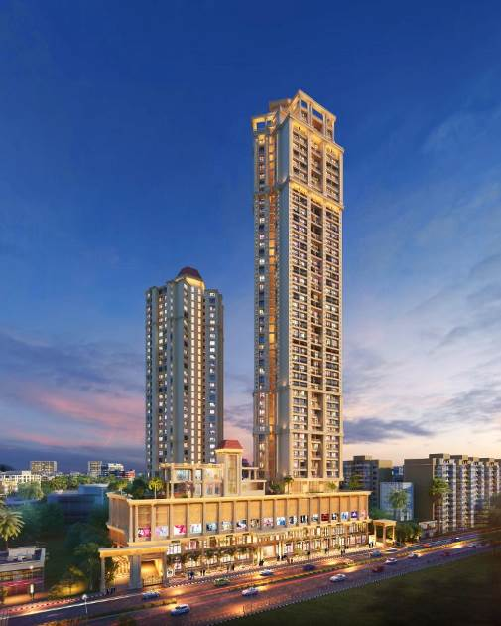

**Details of the property under consideration:**

**Name of Project: "Highland Sky Towers"**

**"Highland Sky Towers",** Proposed Residential & Commercial Complex on Plot bearing Survey No. 15, 47, 48, 49, 59 & 63, L. B. S. Marg, Damani Estate, Village – Naupada, Thane (West), Taluka & District – Thane, Pin Code – 400 602, State – Maharashtra, Country – India.

**Latitude Longitude: 19°11'24.7"N 72°57'59.4"E**

**Valuation Done for:**

**State Bank of India**

**Wagle Ind. Est. Branch**

Regional Business Office, Region-II, Wagle Ind. Area, Plot No. B-35, 2nd Floor,

Wagle Circle, Thane (West) - 400 604, State - Maharashtra, Country - India.

|  |
| --- |
| Vastu/SBI/Thane/09/2023/3980/2302686 23/05-330-PY  Date: 23.09.2023  To,  **The Branch Manager,**  **State Bank of India**  **Wagle Ind. Est. Branch**  Regional Business Office, Region-II,  Wagle Ind. Area, Plot No. B-35, 2nd Floor,  Wagle Circle, Thane (West) - 400 604,  State - Maharashtra, Country - India.  **Sub:** Cost Vetting for "**Highland Sky Towers**" at Thane (West), Pin Code – 400 602.  Dear Sir,  In accordance with your Mail as stated above, we enclose our Report on Cost Vetting **"Highland Sky Towers",** Proposed Residential & Commercial Complex on Plot bearing Survey No. 15, 47, 48, 49, 59 & 63, L. B. S. Marg, Damani Estate, Village – Naupada, Thane (West), Taluka & District – Thane, Pin Code – 400 602, State – Maharashtra, Country – India.  The project is being developed by M/s. Providence Realty LLP. Providence Realty LLP is a leading player in Thane real estate industry. Everyone dreams to have their own home & they help many of them to make their dreams come true. They build each home painstakingly, with focus on Quality, Useful detailing & ensure Value for money. They desire to earn people's trust and confidence while they create whenever they launch their new product and services.  M/s. Providence Realty LLP is developing a Residential & Commercial Complex on Plot bearing Survey No. 15, 47, 48, 49, 59 & 63, L. B. S. Marg, Damani Estate, Village – Naupada, Thane (West), Taluka & District – Thane, Pin Code – 400 602, State – Maharashtra, Country – India. Project is comprising of two Buildings Wing A & B.  Wing A is Residential cum Commercial Sale Building is proposed of Basement + Ground Floor + 1st to 6th Podium Floor + Service Floor + 1st to 48th Habitable Floor and Wing B is Residential Rehab Building is proposed of Basement + Ground Floor + 1st to 6th Podium Floor + Service Floor + 1st to 26th Habitable Floor with total RERA carpet area of 4,19,225.51 Sq. Ft. which consists 2 BHK, 3 BHK Flat & Shops with total 245 nos. of Sell flats, 19 nos. of Sell shops, 5 nos. of land owner flats, 156 nos. of Tenant Flats & 7 nos. of Tenants shops along with all the Amenities.  In this regard, State Bank of India, Wagle Ind. Est. Branch Regional Business Office, Region-II, Wagle Ind. Area, Plot No. B-35, 2nd Floor, Wagle Circle, Thane (West) - 400 604 has approached Vastukala Consultants (I) Pvt. Ltd. (VCIPL) to conduct a Cost Vetting of the said project.  Our analysis of the cost vetting is enclosed in this report. This Report forms an integral whole and cannot be split in parts. The outcome of the report/ study can only lead to proper conclusions if the Report as a whole is taken into account.  The information used by Vastukala Consultants (I) Pvt. Ltd. (VCIPL) in preparing this report has been obtained from a variety of sources and other relevant documents provided by the client & bank. As agreed, we have performed our cost vetting exercise with the data available related to the business, considering the market prospects and projections. Our results are dependent on documents provided by client & bank, the underlying assumptions, which has been analyzed at a broader level by VCIPL while assessing their reasonableness.  Total Project Cost for the completion of Project will be **` 436.86 Cr.**  **For Vastukala Consultants (I) Pvt. Ltd.** Manoj B. Chalikwar Registered Valuer  Chartered Engineer (India)  Reg. No. IBBI / RV / 07/2018/10366  Reg. No. CAT-I-F-1763  SBI Empanelment No.: SME/TCC/2021-22/86/3  **About the Project:**  It is an under construction Proposed Residential & Commercial Complex on Plot bearing Survey No. 15, 47, 48, 49, 59 & 63, L. B. S. Marg, Damani Estate, Village – Naupada, Thane (West), Taluka & District – Thane, Pin Code – 400 602. It is about 1.90 Km. travelling distance from Thane Railway station. Near Damani Estate. |

**AREA STATEMENT AS PER APPROVED PLAN:**

| **Sr. No.** | **Description** | **Area (Sq. M.)** |
| --- | --- | --- |
| 1 | Area Of Plot (Minimum Area Of A, B, C To Be Considered) | 12,591.65 |
| A | Area Of Plot (As Per 7/12) | 25,744.78 |
| B | Area As Per Measurement Sheet | 22,319.53 |
| C | Area As Per Site | 22,319.53 |
| I | Area Not in Possession (Sub Plot-A) | 57.04 |
| II | Less Area of Sub Plot B Including Road Area as Per 0.C. Dt. 20/12/1996 | 9,582.65 |
| III | Less Area Under Sub Plot B (As Per Sanctioned Plan Dt. 25/11/1986) | 88.78 |
| IV | Total (I + II + III) | 9,728.47 |
|  | BALANCE PLOT AREA (1b-1civ) | 12,591.06 |
| 2 | Deduction For | - |
| A | Proposed D.P/9.00 M. D.P Road Widening Area/Service Road/Highway Widening | 3,976.21 |
| B | Any DP Reservation Area |  |
|  | Total (A + B) | 3,976.21 |
| 3 | Balance Plot Area (1 - 2) | 8,614.85 |
| 4 | Amenity Open Space (If Applicable) | N.A. |
| A | Required As Per UDCPR | - |
| B | Adjustment Of 2(B) If Any | - |
| C | Balance Proposed | - |
| 5 | NET PLOT AREA (3) - (4c) | 8,614.85 |
| 6 | Recreational Open Space (If Applicable) | N.A. |
| A | Required | 861.48 |
| B | Proposed | 1,790.47 |
| 7 | Internal Road Area | - |
| 8 | Plotable Area | - |
| 9 | Permissible Built-Up Area with Reference to Basic FSI As Per Front Road Width (5) X (1.10) | 9,476.33 |
| 10 | Addition For |  |
| A | Additional Of FSI on Payment of Premium Maximum Permissible Premium FSI - Based on Road Width / Tod Zone (0.5x1) =12591.06 X 0.50 = 6295.53 |  |
| **B** | Proposed FSI on Payment of Premium | 6,295.53 |
| C | Maximum Permissible TDR 1.15 On (1) 12591.06 X 1.15 = 14479.71 Sq. M. 70% Open TDR = 14479.71 X 70% = 10135.80 | - |
|
| D | Additional Area Under Road as Per I.R.D.P. (3976.21-1143.67 Area Under Road of Sub Plot a As Per Sanctioned Plan Dated 25/11/1986) = 2832.54 X 2.05 = 5806.71 | 5,806.71 |
| E | In Suit Area Against Amenity Space in Handover |  |
| F | Additional 10% Of FSI Consumed by The Existing Authorized Building as Per Sanctioned Plan Dated 25/11/1986 (As Existing Building Is Dilapidated) i.e., 50% Of 8087.54 | 4,043.77 |
| G | Total (B + C + F) | 16,146.01 |
| 11 | Total Entitlement of FSI in Proposal | 25,622.34 |
| A | TOTAL (9 + 11g) |  |
| B | Considering 80% As Commercial And 60% As Residential Ancillary Area |  |
| 1 | Entitlement FSI For Commercial (8938.76/1.8) | 4,965.98 |
| 2 | Commercial Ancillary Area (11b1 x 0.80) | 3,972.78 |
| 3 | Total (1 + 2) | 8,938.76 |
| 4 | Balance for residential (11a-13b1) | 20,656.36 |
| 5 | Residential ancillary area (11b4 x 0.60) | 10,289.89 |
| 6 | Total (4 + 5) | 30,946.25 |
| 7 | Total Entitlement (3+6) | 39,885.01 |
| 12 | Maximum Utilization Limit of FSI in Proposal | 55,865.74 |
| 13 | Total Built Up Area in Proposal (Excluding Area At Sr.No.17b) |  |
| A | Existing Built Up Area (As Per P-Line) Sr. No. 17b) |  |
| B | Proposed Built Up Area (As Per P-Line) Sr. No.14 | 39,755.05 |
|  | Total (A + B) | 39,755.05 |
| 14 | F.S.I. Consumed (15/14) | 0.99 |
| 15 | Area For Inclusive Housing If Any |  |
| A | Required (20% Of Sr.No.5) |  |
| B | Proposed |  |

**AREA STATEMENT AS PER CONCESSION DRAWING PLAN:**

| **Sr. No.** | **Description** | **Area (Sq. M.)** |
| --- | --- | --- |
| 1 | Area Of Plot (Minimum Area Of A, B, C To Be Considered) | 12,591.65 |
| A | Area Of Plot (As Per 7/12) | 25,744.78 |
| B | Area As Per Measurement Sheet | 22,319.53 |
| C | Area As Per Site | 22,319.53 |
| I | Area Not in Possession (Sub Plot-A) | 57.04 |
| II | Less Area of Sub Plot B Including Road Area as Per 0.C. Dt. 20/12/1996 | 9,582.65 |
| III | Less Area Under Sub Plot B (As Per Sanctioned Plan Dt. 25/11/1986) | 88.78 |
| IV | Total (I + II + III) | 9,728.47 |
|  | BALANCE PLOT AREA (1b-1civ) | 12,591.06 |
| 2 | Deduction For | - |
| A | Proposed D.P/9.00 M. D.P Road Widening Area/Service Road/Highway Widening | 3,976.21 |
| B | Any DP Reservation Area |  |
|  | Total (A + B) | 3,976.21 |
| 3 | Balance Plot Area (1 - 2) | 8,614.85 |
| 4 | Amenity Open Space (If Applicable) | N.A. |
| A | Required As Per UDCPR | - |
| B | Adjustment Of 2(B) If Any | - |
| C | Balance Proposed | - |
| 5 | NET PLOT AREA (3) - (4c) | 8,614.85 |
| 6 | Recreational Open Space (If Applicable) | N.A. |
| A | Required | 861.48 |
| B | Proposed | 1,790.47 |
| 7 | Internal Road Area | - |
| 8 | Plotable Area | - |
| 9 | Permissible Built-Up Area with Reference to Basic FSI As Per Front Road Width (5) X (1.10) | 9,476.33 |
| 10 | Addition For |  |
| A | Additional Of FSI on Payment of Premium Maximum Permissible Premium FSI - Based on Road Width / Tod Zone (0.5x1) =12591.06 X 0.50 = 6295.53 |  |
| **B** | Proposed FSI on Payment of Premium | 6,295.53 |
| C | Maximum Permissible TDR 1.15 On (1) 12591.06 X 1.15 = 14479.71 Sq. M. 70% Open TDR = 14479.71 X 70% = 10135.80 | 14,479.71 |
|
| D | Additional Area Under Road as Per I.R.D.P. (3976.21-1143.67 Area Under Road of Sub Plot a As Per Sanctioned Plan Dated 25/11/1986) = 2832.54 X 2.05 = 5806.71 |  |
| E | In Suit Area Against Amenity Space in Handover |  |
| F | Additional 10% Of FSI Consumed by The Existing Authorized Building as Per Sanctioned Plan Dated 25/11/1986 (As Existing Building Is Dilapidated) i.e., 50% Of 8087.54 | 4,043.77 |
| G | Total (B + C + F) | 24,819.01 |
| 11 | Total Entitlement of FSI in Proposal | 34,295.34 |
| A | TOTAL (9 + 11g) |  |
| B | Considering 80% As Commercial And 60% As Residential Ancillary Area |  |
| 1 | Entitlement FSI For Commercial (8938.76/1.8) | 4,965.98 |
| 2 | Commercial Ancillary Area (11b1 x 0.80) | 3,972.78 |
| 3 | Total (1 + 2) | 8,938.76 |
| 4 | Balance for residential (11a-13b1) | 29,329.36 |
| 5 | Residential ancillary area (11b4 x 0.60) | 17,597.62 |
| 6 | Total (4 + 5) | 46,926.98 |
| 7 | Total Entitlement (3+6) | 55,865.74 |
| 12 | Maximum Utilization Limit of FSI in Proposal | 55,865.74 |
| 13 | Total Built Up Area in Proposal (Excluding Area At Sr.No.17b) |  |
| A | Existing Built Up Area (As Per P-Line) Sr. No. 17b) |  |
| B | Proposed Built Up Area (As Per P-Line) Sr. No.14 | 55,306.94 |
|  | Total (A + B) | 55,306.94 |
| 14 | F.S.I. Consumed (15/14) | 0.99 |
| 15 | Area For Inclusive Housing If Any |  |
| A | Required (20% Of Sr.No.5) |  |
| B | Proposed |  |

## Construction Area for Wing A & B

|  |  |  |
| --- | --- | --- |
| Sr. No. | Particulars | Total Construction Area in Sq. M. |
|
| 1 | Commercial BUA Area | 8,938.76 |
| 2 | A Building (Resi.) BUA Area | 33,489.94 |
| 3 | B Building (Resi.) BUA Area | 13,918.99 |
| 4 | Basement | 6,519.58 |
| 5 | Ground Level | 432.54 |
| 6 | 1st Podium | 211.66 |
| 7 | 2nd Podium | 4,793.40 |
| 8 | 3rd Podium | 4,726.42 |
| 9 | 4th Podium | 4,835.47 |
| 10 | 5th Podium | 5,528.93 |
| 11 | Service Floor (A Building) | 1,288.13 |
| 12 | Recreational Floor (A Building) | 1,403.20 |
| 13 | Club House | 155.20 |
| 14 | Vipsahyana Hall | 42.89 |
| Total Area in Sq. M. | | **86,285.11** |

## Project Cost

|  |  |  |  |
| --- | --- | --- | --- |
| Sr. No. | Particulars | Total Estimated Amount in ` | Total Estimated Amount  in ` Cr. |
| 1 | **Land Cost** |  |  |
|  | Acquisition Cost of Land or Development Rights, and Legal Cost. | 4,87,11,580.00 | 4.87 |
|  | Rent to Tenants, Lease premium, Lease Rent, interest cost incurred or payable on Land Cost | 28,23,97,352.00 | 28.24 |
|  | Amount of Premium payable to obtain development rights, FSI, additional FSI, fungible area, and any other incentive under DCR from Local Authority or State Government or any Statutory Authority. | 48,73,58,563.00 | 48.74 |
|  | Acquisition cost of TDR (if any) | 27,80,05,235.00 | 27.80 |
| 2 | **Cost of Construction** |  |  |
| 1. I | Estimated construction cost of rehab cum sale building including site development and infrastructure for the same. | 256,26,67,767.00 | 256.27 |
|  | On site expenditure for development of entire project excluding cost of construction as per(i) above, |  |  |
| a. | Architect Fees & Consultant fees | 3,84,40,017.00 | 3.84 |
| b. | Admin Cost includes salaries, site overheads, development works, cost of services (including water, electricity, sewerage, drainage, layout roads etc.), cost of machineries and equipment including its hire and maintenance cost, consumables etc. All costs directly incurred to complete the construction of the entire phase of the project registered. | 12,81,33,388.00 | 12.81 |
| c. | Marketing Cost | 15,82,23,702.00 | 15.82 |
| 3 | Interest during the Project | 30,78,00,000.00 | 30.78 |
| 4 | Contingency Cost | 7,68,80,033.00 | 7.69 |
|  | **GRAND TOTAL:** | **436,86,17,637.00** | **436.86** |

## Manoj B. Chalikwar

Registered Valuer

Chartered Engineer (India)

Reg. No. IBBI / RV / 07/2018/10366

Reg. No. CAT-I-F-1763

SBI Empanelment No.: SME/TCC/2021-22/86/3

**Comments on each element of Cost of Project**: -

1. **Land Cost:**

As per Present Ready Reckoner rate the Project Land Value is ` 68.75 Cr. considering Land Rate @ ` 54,600.00 per Sq. M. & Net Plot Area of 12,591.06 Sq. M.

As per document cost of land and stamp duty is ` 4,87,11,580.00 i.e., ` 4.87 Cr. which is 1.12% of Total Project Cost.

|  |  |  |  |  |  |
| --- | --- | --- | --- | --- | --- |
| Sr. No. | Agreement Name | Date | Particulars | Total Amount in ` | Incurred Amount in ` |
| 1 | Development Agreement | 19.11.2018 | Purchase Cost | 3,00,00,000.00 | 3,00,00,000.00 |
| 2 | Stamp Duty | 1,86,78,000.00 | 1,86,78,000.00 |
| 3 | Reg. Fees | 30,000.00 | 30,000.00 |
| 4 | 3,580.00 | 3,580.00 |
|  | **TOTAL** | | | **4,87,11,580.00** | **4,87,11,580.00** |

1. **Payment Payable to Rehab Tenants (Rent Cost):**

Since it is a having some redevelopment flat from the date of shifting of 160 Tenants till handing over their respective new flats as per the Tenant Agreement. Further the rent keeps on increasing as per agreement. The existing Tenants has to be given total rental of ` 28,23,97,352.00 i.e., ` 28.24 Cr. Builder has paid ` 16.64 Cr. which is 6.46 % of Total Project Cost.

Existing Tenants Carpet Area & Rent per month for Flat are as follows:

| Sr. No. | Particulars |  | Unit |
| --- | --- | --- | --- |
| 1 | No. of Residential Tenants | 148.00 | Nos. |
| 2 | No. of Commercial Tenants | 12.00 | Nos. |
| 3 | Rent for Residential Tenants / Month for April 19 - March 20 | 20,000.00 | Rupees |
| 4 | **Rent per month for April 19 - March 20 Year** | **3,55,20,000.00** | **Rupees** |
| 5 | Rent for Residential Tenants / month for April 20 - March 21 | 20,000.00 | Rupees |
| 6 | **Rent per month for April 20 - March 21** | **3,55,20,000.00** | **Rupees** |
| 7 | Rent for Residential Tenants / month for April 21 - March 22 | 20,000.00 | Rupees |
| 8 | **Rent per month for April 21 - March 22** | **3,55,20,000.00** | **Rupees** |
| 9 | Rent for Residential Tenants / month for April 22 - March 23 | 22,000.00 | Rupees |
| 10 | **Rent per month for April 22 - March 23** | **3,90,72,000.00** | **Rupees** |
| 11 | Rent for Residential Tenants / month for April 23 - March 24 | 24,200.00 | Rupees |
| 12 | **Rent per month for April 23 - March 24** | **4,29,79,200.00** | **Rupees** |
| 13 | Rent for Residential Tenants / month for April 24 - March 25 | 26,620.00 | Rupees |
| 14 | **Rent per month for April 24 - March 25** | **4,72,77,120.00** | **Rupees** |
| 15 | Rent for 17 tenant per month for 9 Months | 15,000.00 | Rupees |
| 16 | **Rent for 17 tenant for 9 Months** | **22,95,000.00** | **Rupees** |
| 17 | Rent for Commercial Tenants / Month for April 19 - March 20 | 30,000.00 | Rupees |
| 18 | **Rent per month for April 19 - March 20 Year** | **21,60,000.00** | **Rupees** |
| 19 | Rent for Commercial Tenants / month for April 20 - March 21 | 33,000.00 | Rupees |
| 20 | **Rent per month for April 20 - March 21** | **43,20,000.00** | **Rupees** |
| 21 | Rent for Commercial Tenants / month for April 21 - March 22 | 36,300.00 | Rupees |
| 22 | **Rent per month for April 21 - March 22** | **47,52,000.00** | **Rupees** |
| 23 | Rent for Commercial Tenants / month for April 22 - March 23 | 39,930.00 | Rupees |
| 24 | **Rent per month for April 22 - March 23** | **52,27,200.00** | **Rupees** |
| 25 | Rent for Commercial Tenants / month for April 23 - March 24 | 43,923.00 | Rupees |
| 26 | **Rent per month for April 23 - March 24** | **57,49,920.00** | **Rupees** |
| 27 | Rent for Commercial Tenants / month for April 24 - March 25 | 48,315.00 | Rupees |
| 28 | **Rent per month for April 24 - March 25** | **63,24,912.00** | **Rupees** |
| 29 | Shifting per Tenant | 23,000.00 | Rupees |
| 30 | **Shifting Cost** | **36,80,000.00** | **Rupees** |
| 31 | **Corpus Fund** | **1,00,00,000.00** | **Rupees** |
| 32 | **Additional corpus fund** | **20,00,000.00** | **Rupees** |
| 33 | **Total Rent Cost (4 + 6 + 8 + 10 + 12 + 14 + 16 + 18 + 20 + 22 + 24 + 26 + 28 + 30 + 31 + 32)** | **28,23,97,352.00** | **Rupees** |

1. **Building Cost of Construction of Wing A & B:**

Construction area = 86,285.11 Sq. M.

Total estimated cost for construction of Building (includes cost of RCC work, manpower, lift, material, painting, finishing work, site development, etc.) is ` 232,96,97,970.00 i.e., ` 232.97 Cr. which comes ` 27,000.00 per Sq. M. on construction area for building, cost of deep excavation & piling work is ` 23,29,69,797.00 i.e., ` 23.30 Cr. which comes 10% of cost of construction. **Hence, total cost of construction (Cost of Construction of Building + Cost of Deep Excavation & Piling Work) is ` 256,26,67,767.00 i.e., ` 256.27 Cr.**

The total construction area is 86,285.11 Sq. M., projected cost of ` 256.27 Cr is 58.66% of total project cost

|  |  |
| --- | --- |
| **Particulars** | **Rate per Sq. M.** |
| **Excavation Work** | 1,500.00 |
| **Total RCC Work** | 13,500.00 |
| **Final Finishing Work** | 7,000.00 |
| **Other Work** | 5,000.00 |
| **Cost of Construction** | **27,000.00** |
| **Cost of Deep Excavation & Piling Cost** | **10% of Cost of Construction** |

1. **TDR Charges:**

The TDR charges is ` 27,80,05,235.00 i.e., ` 27.80 Cr. which is 6.36% of Total Project Cost.

|  |  |  |  |  |  |
| --- | --- | --- | --- | --- | --- |
| Sr. No. | Agreement Name | Date | Area in Sq. M. | Particulars | Total Amount in ` |
| 1 | TDR Purchase of Agreement | 24.01.2020 | 2,363.08 | Purchase Cost | 2,21,00,000.00 |
| 2 | Stamp Duty | 6,63,000.00 |
| 3 | Reg. Fees | 30,000.00 |
| 4 | 1,120.00 |
| 5 | TDR Purchase of Agreement | 25.01.2023 | 3,731.00 | Purchase Cost | 3,34,29,760.00 |
| 6 | Stamp Duty | 10,03,000.00 |
| 7 | Reg. Fees | 30,000.00 |
| 8 | 740.00 |
| 9 | TDR Purchase of Agreement | 25.01.2023 | 1,155.00 | Purchase Cost | 1,03,48,800.00 |
| 10 | Stamp Duty | 3,10,600.00 |
| 11 | Reg. Fees | 30,000.00 |
| 12 | 740.00 |
| 13 | TDR Purchase of Agreement | 25.01.2023 | 2,755.00 | Purchase Cost | 2,46,84,800.00 |
| 14 | Stamp Duty | 7,40,700.00 |
| 15 | Reg. Fees | 30,000.00 |
| 16 | 740.00 |
| 17 | Non-Slum TDR |  | 274.00 | Purchase Cost | 67,32,180.00 |
| 18 | Stamp Duty | 2,01,965.00 |
| 19 | Slum TDR |  | 3,949.00 | Purchase Cost | 17,24,92,320.00 |
| 20 |  | Stamp Duty | 51,74,770.00 |
| TOTAL | | | **14,227.08** |  | **27,80,05,235.00** |

1. **Approval Charges:**

The Total Approval Cost (Fungible Cost & Development Cess Premium) as per information provided by the developer is ` 48,73,58,563.00 i.e., ` 48.74 Cr. which is 11.16% of Total Project Cost.

| Sr. No. | Particulars | Total Amount in ` |
| --- | --- | --- |
| 1 | Proposal Submission Fee | 2,46,247.00 |
| 2 | Revised Plan | 1,83,020.00 |
| 3 | Development Charges Fee | 49,44,357.00 |
| 4 | Development Charges for Metro Project | 49,44,357.00 |
| 5 | Cess for worker welfare on building construction | 32,40,000.00 |
| 6 | Additional FSI Government Share | 75,19,224.00 |
| 7 | Ancillary FSI Premium | 1,46,01,408.00 |
| 8 | Development Fund (50% of premium) | 75,19,224.00 |
| 9 | Fire Premium Charges | 13,33,562.00 |
| 10 | Fire Infrastructure Charges | 57,33,936.00 |
| 11 | Fire Service Fee | 71,353.00 |
| 12 | Fire Premium Charges | 56,766.00 |
| 13 | Fire Service Fee | 12,485.00 |
| 14 | Development Charges Fee | 29,11,946.00 |
| 15 | Development Fund (50% of premium) | 45,11,534.00 |
| 16 | Development Charges for Metro Project | 29,11,946.00 |
| 17 | Cess for worker welfare on building construction | 71,48,036.00 |
| 18 | Additional FSI Government Share | 45,11,534.00 |
| 19 | Ancillary FSI Premium | 87,60,845.00 |
| 20 | Scrutiny Fees | 2,00,000.00 |
| 21 | Revised Plan | 1,98,776.00 |
| 22 | Fire Infrastructure Charges | 34,335.00 |
| 23 | Fire Service Fee | 8,896.00 |
| 24 | Fire Infrastructure Charges | 15,46,664.00 |
| 25 | Fire Service Fee | 23,568.00 |
| 26 | Development Charges fee | 44,39,860.00 |
| 27 | Development Charges for Metro Project | 44,39,860.00 |
| 28 | Cess for worker welfare on building construction | 60,05,896.00 |
| 29 | Scrutiny Fees | 38,115.00 |
| 30 | Scrutiny Fees | 38,115.00 |
| 31 | Scrutiny Fees | 90,915.00 |
| 32 | Scrutiny Fees | 90,915.00 |
| 33 | Scrutiny Fees | 1,23,123.00 |
| 34 | Scrutiny Fees | 1,23,123.00 |
| 35 | Fire Service Fee | 59,995.00 |
| 36 | Fire Infrastructure Charges | 47,37,482.00 |
| 37 | Fire Service Fee | 49,231.00 |
| 38 | Fire Infrastructure Charges | 48,38,720.00 |
| 39 | Scrutiny Fees | 7,00,000.00 |
| 40 | Developers Registration Fee | 10,000.00 |
| 41 | Proposal Submission Fee | 12,97,632.00 |
| 42 | Scrutiny Fees | 14,63,489.00 |
| 43 | Permission Deposit | 9,47,634.00 |
| 44 | Existing Structure Demolition Charges | 3,50,000.00 |
| 45 | Infrastructure Improvement Charges | 34,27,374.00 |
| 46 | Debris Charges | 11,19,931.00 |
| 47 | Development Charges fee | 86,18,998.00 |
| 48 | Development Charges for Metro Project | 86,18,998.00 |
| 49 | Vacant land Tax | 6,49,894.00 |
| 50 | Fire Service Fee | 85,000.00 |
| 51 | Fire Infrastructure Charges | 2,21,220.00 |
| 52 | Fire Premium Charges | 1,80,117.00 |
| 53 | Fire Premium Charges | 13,52,568.00 |
| 54 | Fire Infrastructure Charges | 45,01,047.00 |
| 55 | Fire Service Fee | 1,41,081.00 |
| 56 | Fire Service Fee | 2,04,702.00 |
| 57 | Security Deposit | 10,00,000.00 |
| 58 | Security Deposit | 25,000.00 |
| 59 | Pollution Fees | 6,92,000.00 |
| 60 | Property Tax | 7,20,793.00 |
| 61 | Royalty charges | 36,97,250.00 |
| 62 | Survey charges | 1,02,000.00 |
| 63 | Revised Plan charges | 3,01,665.00 |
| 64 | Revised Plan charges | 12,20,310.00 |
| 65 | Cess for worker welfare on building construction | 20,00,000.00 |
| 66 | Margin Condonation Premium | 2,52,072.00 |
| 67 | Society Office Deposit | 4,06,800.00 |
| 68 | Development Charges | 4,51,95,954.00 |
| 69 | Metro Cess Charges | 4,51,95,954.00 |
| 70 | Ancillary FSI charges | 3,37,97,363.22 |
| 71 | Premium FSI charges | 8,95,23,675.35 |
| 72 | Ancillary FSI charges | 10,03,12,518.18 |
| 73 | Other Development Charges | 2,07,76,153.86 |
| Total | | **48,73,58,563.00** |

1. **Architect Cost, RCC & Other Professional Charges:**

The total Architect charges of ` 3,84,40,017.00 i.e., ` 3.84 Cr. is 1.5% of total construction cost & it is on lower side because developer have their inhouse team for professional work.

The professional charge consists of Architect & Legal which in lower side than the market trend which is in the range of 2% - 5% of Total Construction cost of the project.

1. **Administrative Expenses:**

Salaries, site overheads, development works, cost of services (including water, electricity, sewerage, drainage, layout roads etc.), cost of machineries and equipment including its hire and maintenance cost, consumables etc. All costs directly incurred to complete the construction of the entire phase of the project registered is estimated 5% of total construction cost which comes to ` 12,81,33,388.00 i.e., ` 12.81 Cr.

The admin charges which in market is in the range of 4% - 6% of Total Construction cost of the project.

1. **Marketing Expenses:**

Marketing costs directly incurred to complete the construction of the entire phase of the project registered is estimated at 2% of total Sale income from the project which comes to ` 15,82,23,702.00 i.e., ` 15.82 Cr.

The marketing charge consists of brokerage & commission which in market is in the range of 2% - 4% of Total Sale income of the property.

1. **Interest Costs:**

The Interest cost for the term loan is expected to be ` 30,78,00,000.00 i.e., ` 30.78 Cr., which is 7.05% of total project cost.

As per information provided by the client.

1. **Contingency Costs:**

The contingency charges estimated at 3% of total cost of construction which comes to ` 7,68,80,033.00 i.e., ` 7.69 Cr.

**Observation and Construction**: -

**Total estimated cost of project i.e., ` 436,86,17,637.00 (Rupees Four Hundred Thirty Six Crore Eighty Six Lakh Seventeen Thousand Six Hundred Thirty Seven Only) i.e. ` 436.86Cr. is fair & reasonable.**

The project cost is including land premium payable to concern authorities, Fungible FSI Premium, Cost of Construction of rehab & Sale Building, on site expenses including admin & marketing expenses, premiums / charges to be paid to competent authority and Bank interest, etc. we have not independently verified interest cost hence not consider in cost vetting.

As per present sanctioned building plan, permissible built-up area on the said plot is 39,755.05 Sq. M. The rehab cum sale building (Wing A & B) is presently sanctioned for Basement + Ground Floor + 1st to 6th Podium Floor + Service Floor + 1st to 25th Habitable Residential Floors only. The Developer has submitted the concession drawing plan to the competent authority for utilization of total permissible Built-up area and fungible FSI. The rehab Wing B is proposed for Basement + Ground Floor + 1st to 6th Podium Floor + Service Floor + 1st to 26th Habitable Residential Floors and sale building Wing A is proposed for Basement + Ground Floor + 1st to 6th Podium Floor + Service Floor + 1st to 48th Habitable Residential Floors only. Estimated cost of entire project of 48th upper floor for Wing A & 26th upper floor for Wing B is considered.

Total estimated cost of construction for Wing A & B Building as per concession drawing plan up to Wing A is Basement + Ground Floor + 1st to 6th Podium Floor + Service Floor + 1st to 48th Habitable Residential Floors and Wing B of Basement + Ground Floor + 1st to 6th Podium Floor + Service Floor + 1st to 26th Habitable Residential Floors is ` 232,96,97,970.00 i.e., ` 232.97 Cr. which comes ` 27,000.00 per Sq. M. on construction area for building, cost of deep excavation & piling work is ` 23,29,69,797.00 i.e., ` 23.30 Cr. which comes 10% of cost of construction. Hence, total cost of construction (Cost of Construction of Building + Cost of Deep Excavation & Piling Work) is ` 256,26,67,767.00 i.e., ` 256.27 Cr. which is fair & reasonable considering the present status of project, type & quality of construction & specification of the building materials to be used, height of the structure, amenities to be provided in proposed building.

**Assumptions & Remarks-**

* The adequacy of Engineering / Structural design is beyond the scope of our assignment.
* Estimated project completion date is as per below table. The cost is certified based on the assumptions that the project will be completed within time frame. Few assumptions are made regarding inflation & cost rise etc. during construction period.

|  |  |  |
| --- | --- | --- |
| **Tower** | **RERA No.** | **Expected Completion Date** |
| **Wing A** | **P51700032367** | **31.12.2026** |
| **Wing B** | **P51700032859** | **30.04.2025** |
| **Arcade (Commercial Shops)** | **P51700029045** | **31.08.2024** |

Photo copy of following document is provided to us & this report should be read along with it:

|  |
| --- |
| * Copy of Development cum Sale Agreement Reg. No. TNN - 12/11420/2018 dated 03.11.2018 and agreement dated 10.09.2018 between M/s. Surajratan Fatehchand Damani Janhit Nidhi (The Landlord / Owner), Damani Co-operative Housing Society Limited (The Society) and M/s. Providence Realty LLP (The Developers). |
| * Copy of Charity Commissioner Order No. CC/621/2018 dated 31.07.2018 issued by Charity Commissioner, Maharashtra State |
| * Copy of Property Card |
| * Copy of TDR Agreement Reg. No. TNN – 12/9228/2020 dated 24.01.2020 and agreement dated 24.01.2020 for Area 2,363.08 Sq. M. between M/s. Surajratan Fatehchand Damani Janhit Nidhi (The Transferor) and M/s. Providence Realty LLP (The Transferee). |
| * Copy of Deed of Transfer Reg. No. TNN – 5/1175/2023 dated 25.01.2023 and agreement dated 24.01.2023 for Area 3,731.00 Sq. M. between Mrs. Kanina Rajdaksh Sharma & Mrs. Kshama Kapil Sharma (The Transferors) and M/s. Providence Realty LLP (The Transferee). |
| * Copy of Deed of Transfer Reg. No. TNN – 5/1178/2023 dated 25.01.2023 and agreement dated 24.01.2023 for Area 1,155.00 Sq. M. between M/s. Anjur Warehouse Pvt. Ltd. (The Transferors) and M/s. Providence Realty LLP (The Transferee). |
| * Copy of Deed of Transfer Reg. No. TNN – 5/1176/2023 dated 25.01.2023 and agreement dated 24.01.2023 for Area 2,755.00 Sq. M. between Mrs. Kanina Rajdaksh Sharma & Mrs. Kshama Kapil Sharma (The Transferors) and M/s. Providence Realty LLP (The Transferee). |
| * Copy of Approved Plan No. V.P./SO2/0217/18/TMC/TD-DP/TPS/4012/22 dated 30.03.2022 issued by Thane Municipal Corporation (TMC).   **Approved upto:**  **Wing A: Basement + Ground Floor + 1st to 6th Podium Floor + Service Floor + 1st to 25th Habitable Floor**  **Wing B: Basement + Ground Floor + 1st to 6th Podium Floor + Service Floor + 1st to 25th Habitable Floor**  **Club House: Ground + 1st Floor** |
| * Copy of Commencement Certificate No. V.P. No. SO2/0217/18/TMC/TDD/4174/22 dated 12.08.2022 issued by Thane Municipal Corporation (TMC).   **Approved upto:**  **Wing A: Basement + Ground Floor + 1st to 6th Podium Floor + Service Floor + 1st to 25th Habitable Floor**  **Wing B: Basement + Ground Floor + 1st to 6th Podium Floor + Service Floor + 1st to 25th Habitable Floor**  **Club House: Ground + 1st Floor** |
| * Copy of LOI / Concession Drawing Plan dated 09.03.2022 issued by Thane Municipal Corporation (TMC).   **Approved upto:**  **Wing A: Basement + Ground Floor + 1st to 6th Podium Floor + Service Floor + 1st to 48th Habitable Floor**  **Wing B: Basement + Ground Floor + 1st to 6th Podium Floor + Service Floor + 1st to 26th Habitable Floor**  **Club House: Ground + 1st Floor** |
| * Copy of Fire NOC Certificate No. TMC/CFO/M/137/125 dated 10.08.2022 issued by Thane Municipal Corporation (TMC). |
| * Copy of No Objection Certificate for Height Clearance NOC ID No. SNCR/WEST/B/032423/748692 dated 10.04.2023 valid upto 09.04.20231 issued by Airports Authority of India. |
| * Copy of Environment Clearance Certificate dated 14.09.2017 issued by Ministry of Environment, Forest and Climate Change Department. |
| * Copy of Strom Water Drainage NOC Certificate No. TMP/KA/INDP/527 dated 28.01.2022 issued by Thane Municipal Corporation (TMC). |
| * Copy of STP NOC Certificate No. TMP/MN/Other NOC/02 dated 15.02.2022 issued by Thane Municipal Corporation (TMC). |
| * Copy of Tree NOC Certificate No. Mukhya – 1/U.V.Vr.P.V-23-15 dated 15.10.2020 issued by issued by Thane Municipal Corporation (TMC). |
| * Copy of Water Supply NOC Certificate No. TMC/WSI EE/38 dated 21.12.2021 issued by Thane Municipal Corporation (TMC). |
| * Copy of Draft Geotechnical Investigation Report dated 27.04.2019 issued by M/s. Ochre Drillers India Pvt. Ltd. |
| * Copy of CA Certificate dated 23.09.2023 issued by M/s. P. Somani & Co. |
| * Copy of Legal Title Report dated 30.06.2021 issued by Adv. Prashant G. Kadam. |
| * Copy of RERA Certificate No. P51700032367 dated 12.08.2022 for Wing A issued by Maharashtra Real Estate Regulatory Authority. |
| * Copy of RERA Certificate No. P51700032859 dated 12.08.2022 for Wing B issued by Maharashtra Real Estate Regulatory Authority. |
| * Copy of RERA Certificate No. P51700029045 dated 09.06.2023 for Arcade (Commercial Shops) issued by Maharashtra Real Estate Regulatory Authority. |

**Actual Site Photographs**

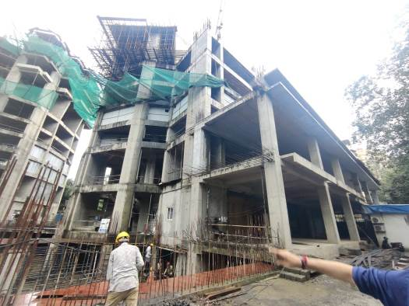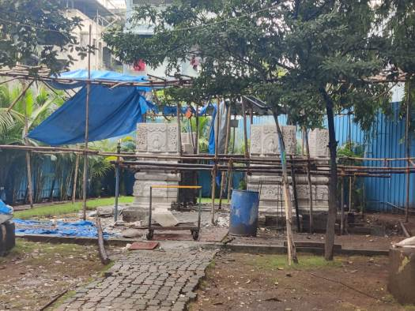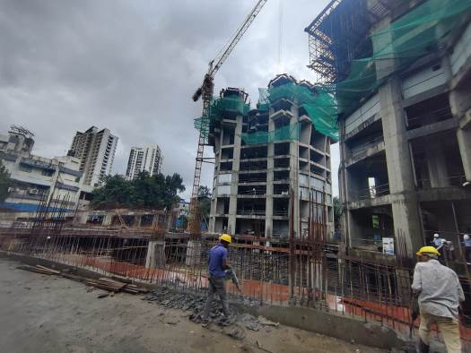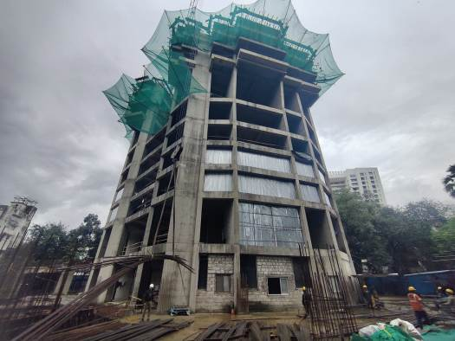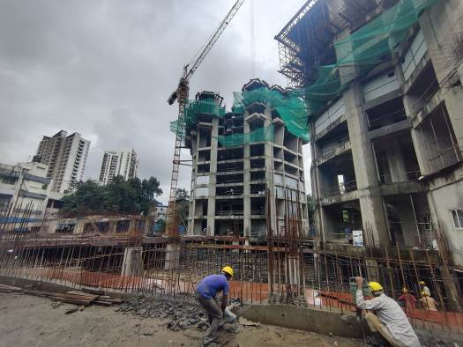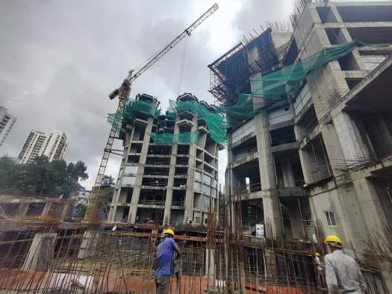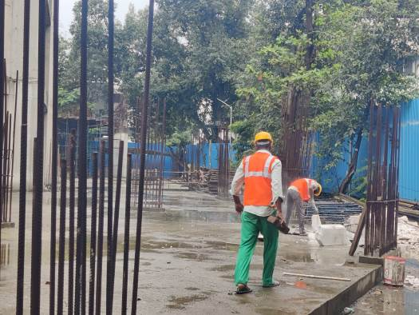

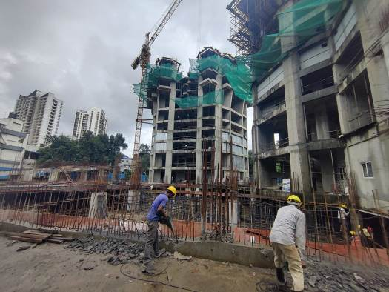**Actual Site Photographs**

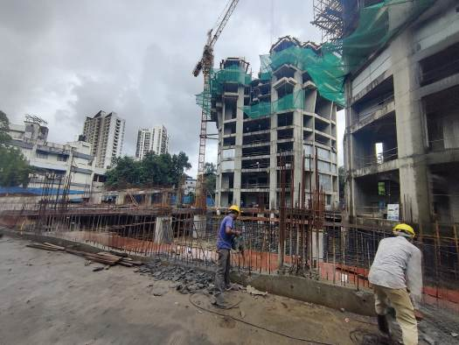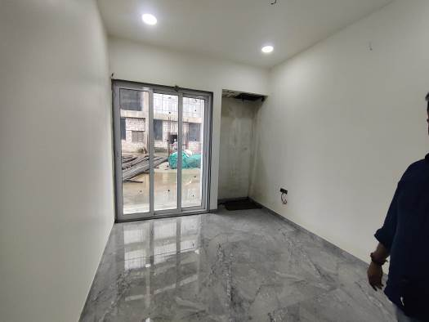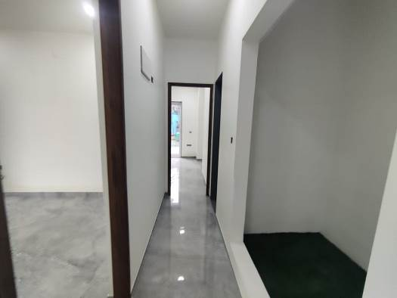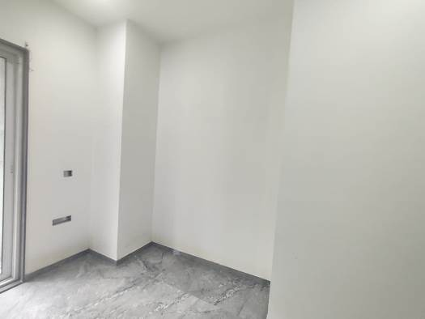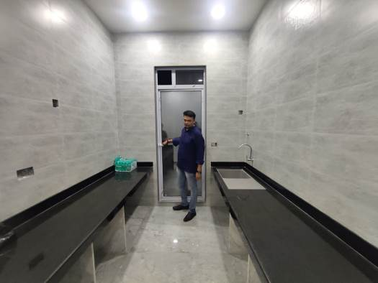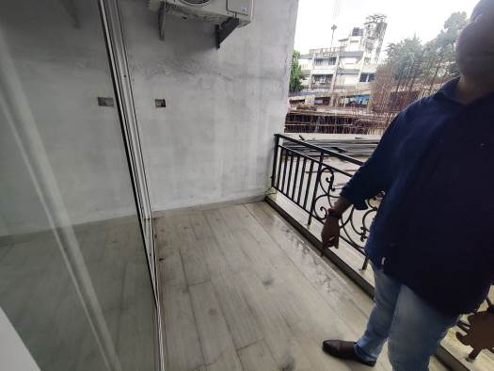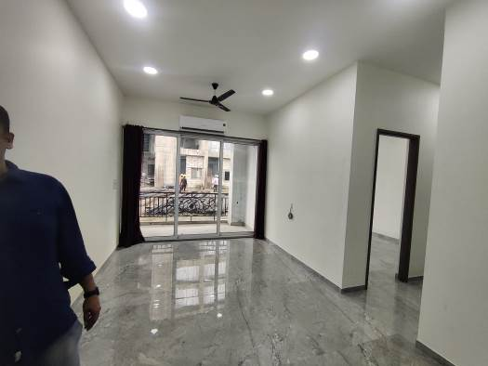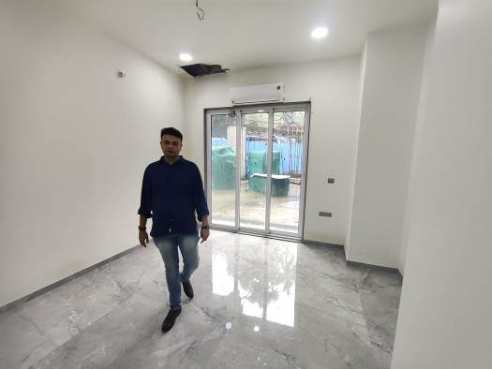**Actual Site Photographs**

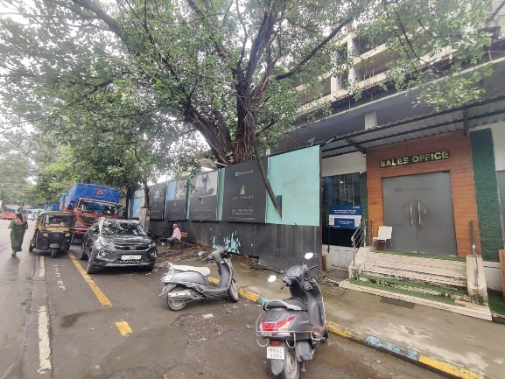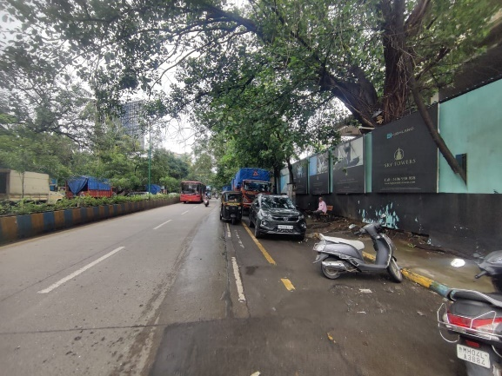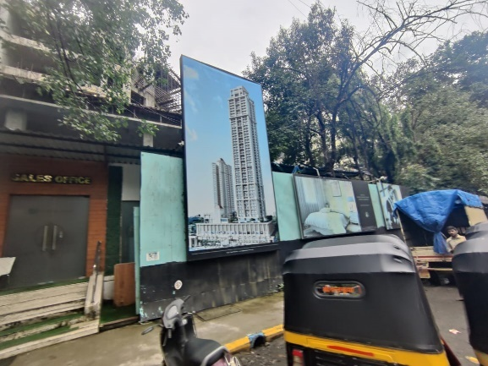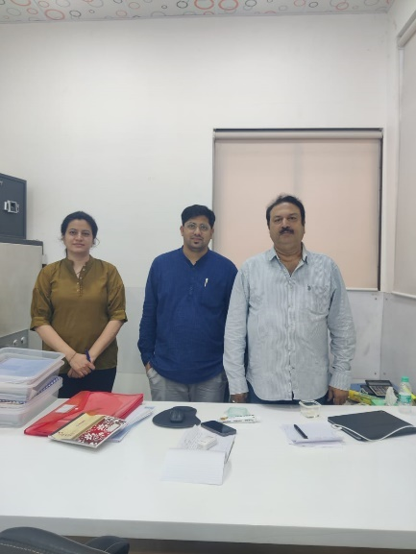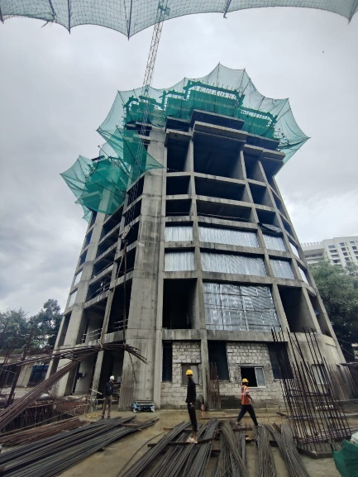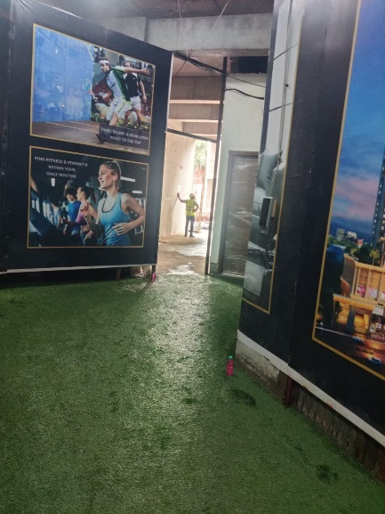**Route Map of the property**

**Site u/r**

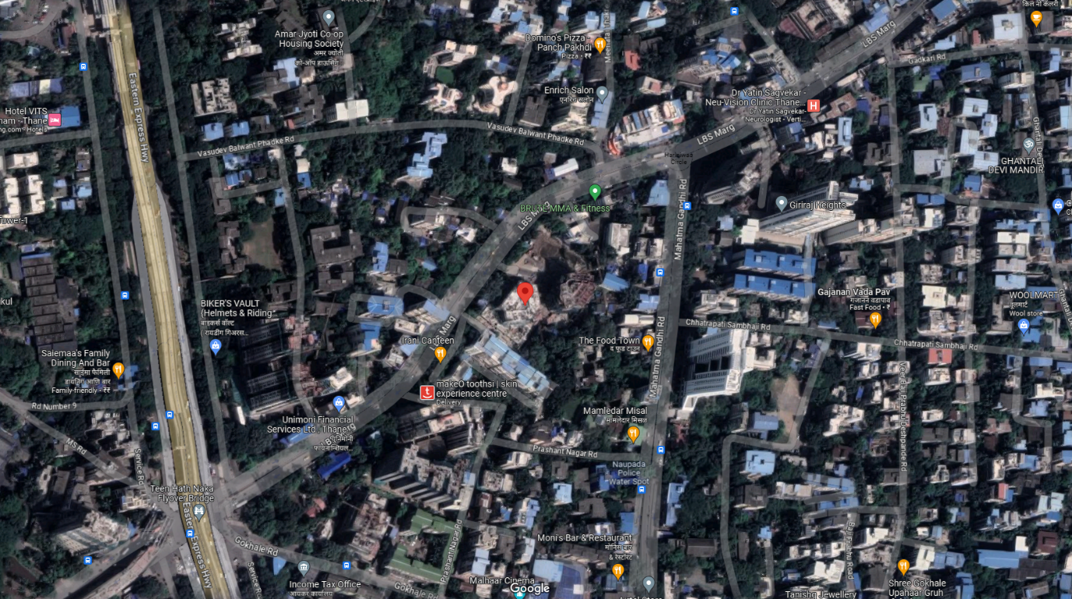

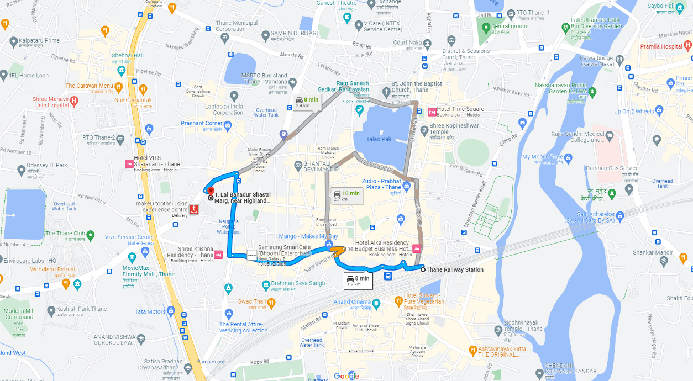

# **Latitude Longitude: 19°11'24.7"N 72°57'59.4"E**

# **Note:** The Blue line shows the route to site from nearest railway station (Thane – 1.90 Km.)