Site Details
Site Visit Date – 17.01.2022
Name of the Owner – JB Advani
Purpose – Capital Gain
Boundaries
North – Open Plot
South – Filix Tower
East – Chawl & Road
West – Lal Bahadur Shastri Road

Structure Details – All the structure are in diplacated condition
Structure Measured area SS are attached in the file below
All the structure were rcc building with GI sheet roofing

Contact Person – Mr. Arvind Tembar ( Supervisior) Mb. No. +91 98339 80846 / +91 89283 00685
Plot Measured Area
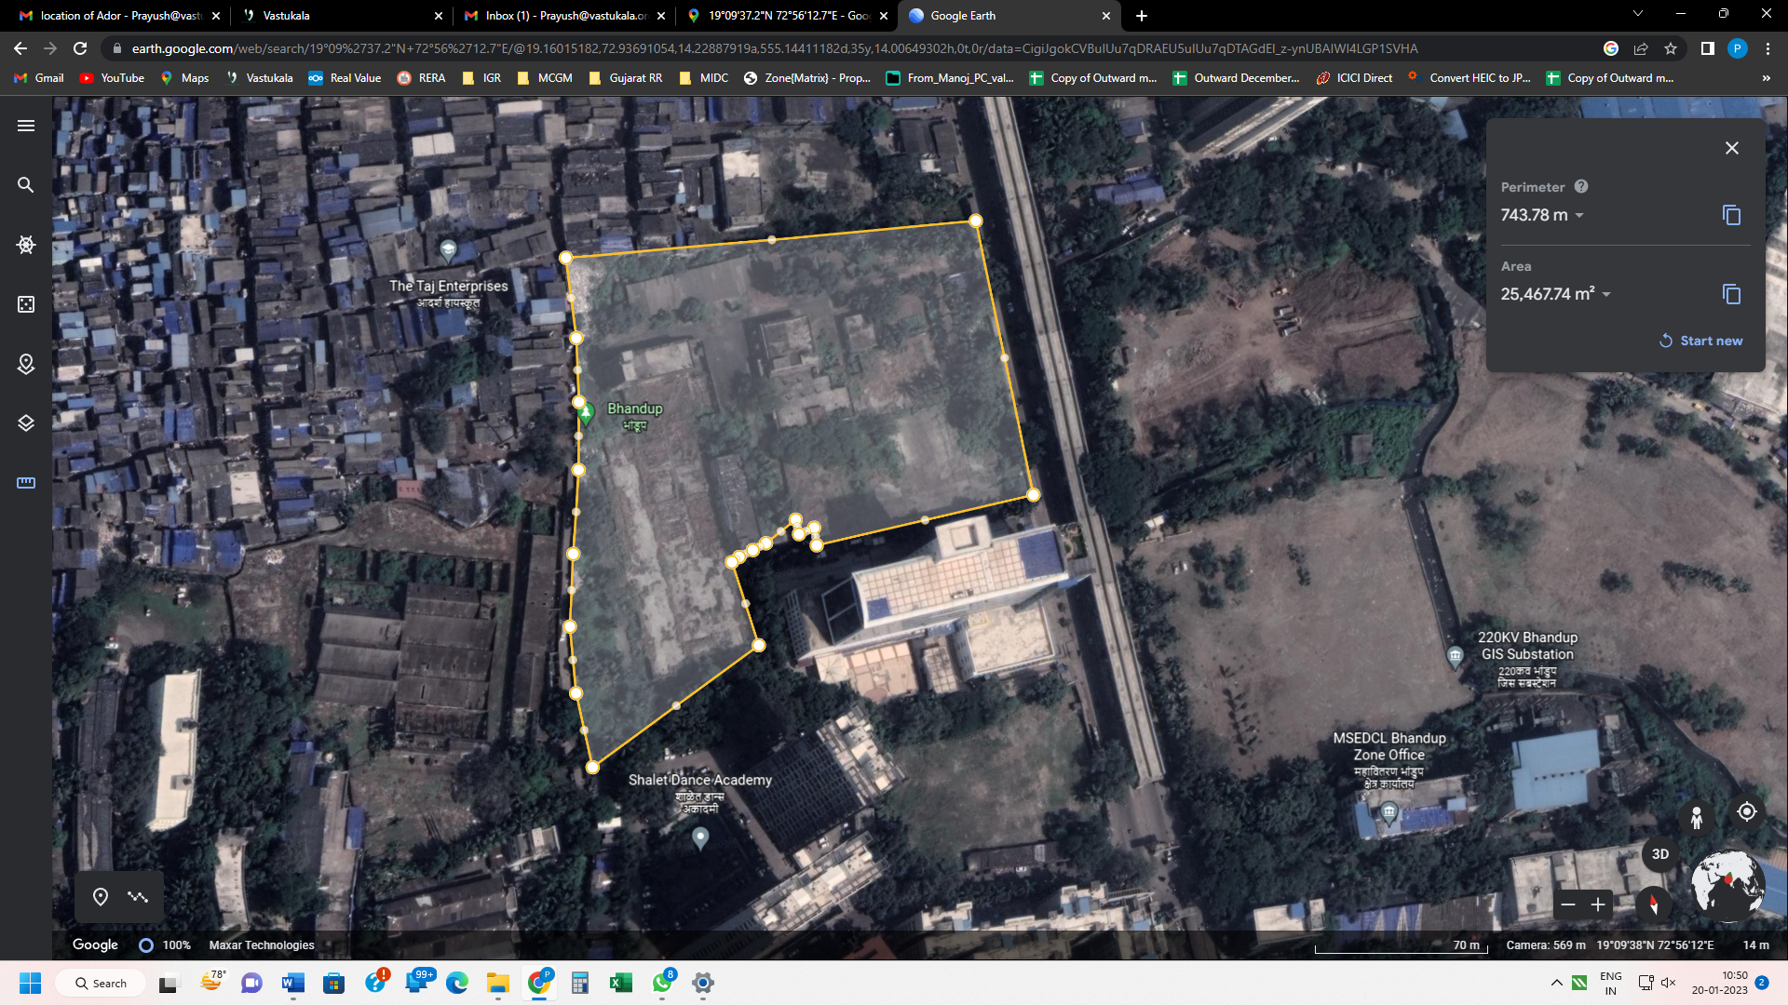

Structure Area Measured