Vastu/Nashik/09/3966/2302672
22/9-316-CHVBS
Date: 22.09.2023

To,
Bank of Baroda
Regional Office
BSNL Building, Datta Mandir Road, Nashik Road,
Nashik, PIN – 422 101, State - Maharashtra, Country - India.

Sub: Vetting of Estimate

Sir,

With reference to above subject, we have evaluated the Estimate for Residential Land and Proposed Bungalow on Plot No.49, Survey No.553/1/1, Near Green City Row Houses, Pimpalgaon Jopul Road, Mouje – Pimpalgaon Baswant,
Taluka – Nifad , District – Nashik,Pin Code – 422 209, State - Maharashtra, Country – India belongs Smt.Pushpa Sitaram Potinde.

We have verified the rates quoted as per current market rates. Details of Estimate considered as per copy of Estimate Provided by Arya Consultants received on dated 22.09.2023. The Estimate amount is Rs.22,00,000/- (Rupees Twenty-Two Lakh Only.)

Note:1) The said Cost Vetting Certificate is valid upto next 6 months Only.
2) Estimate Submitted for Verification is Much More in Cost with Respective prevailing Market Rate.
3) The Value of Construction given in the Report is as per the Specification to be provided and with
respect to Prevailing Market Rate

Thanking you

Sincerely yours

Manoj B. Chalikwar
Registered Valuer
Chartered Engineer (India)
Reg. No. CAT-I-F-1763
Reg. No. IBBI/RV/07/2018/10366
BOB Empanelment No.: ZO:MZ:ADV:46:941
Encl: Valuation Report

Estimate
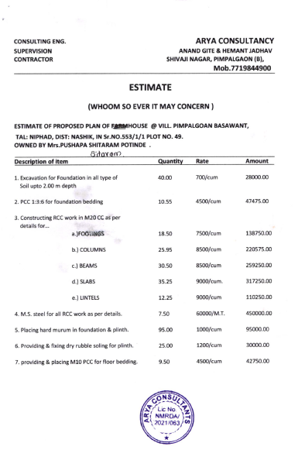

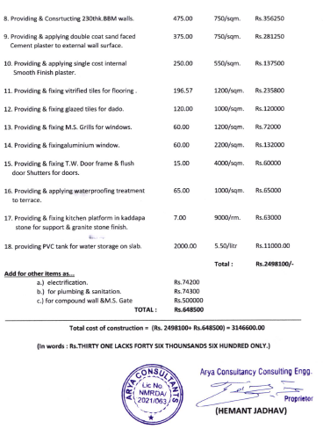
Estimate

The Estimate amount is Rs.22,00,000/- (Rupees Twenty-Two Lakh Only)

