Vastu/Mumbai/10/3933/2302902
09/02-99-VSB
Date: 09.10.2023

To,
The Branch Manager,
State Bank of India
RBO Sanpada
SMEC VASHI, E/202, 2nd Floor,
Sanpada Railway Station Complex,
Navi Mumbai - 400 705, State - Maharashtra, Country - India.

Sub: Cist Vetting of Proposed Residential Row House

Sir,

With reference to above subject, we have evaluated the Estimate for Proposed Residential Row House of Ground + 3 upper floors on Plot No. E-91, Sector No. 12, Kharghar, Navi Mumbai, Taluka Panvel, District – Raigad, PIN Code – 410 210, State – Maharashtra, Country – India belongs to Mr. Ajaykumar R. Chauhan & Mrs. Sayali Ramchandra Zore wife of Mr. Ajaykumar R. Chauhan.

We have verified the values quoted as per current market rates. Details of estimates of Cost & details specification of the construction of row house considered as per copy of Quotation vide Ref. No. AV / 2022-23 / ARC / 009 dated 13.03.2023 of A. V. Construction received as on 07.10.2023. The Estimate amount is Rs. 40,00,000/- (Rupees Forty Lakh Only)

The said Cost Vetting Certificate is valid upto next 6 months Only.

Thanking you

Sincerely yours

Sharadkumar B. Chalikwar
Govt. Reg. Valuer
Chartered Engineer (India)
Reg. No. (N) CCIT/1-14/52/2008-09

Quotation
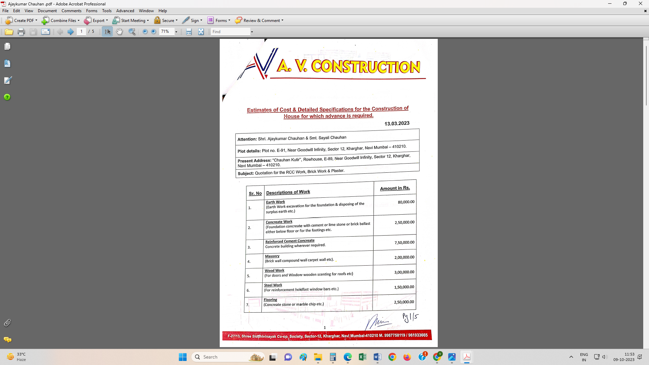
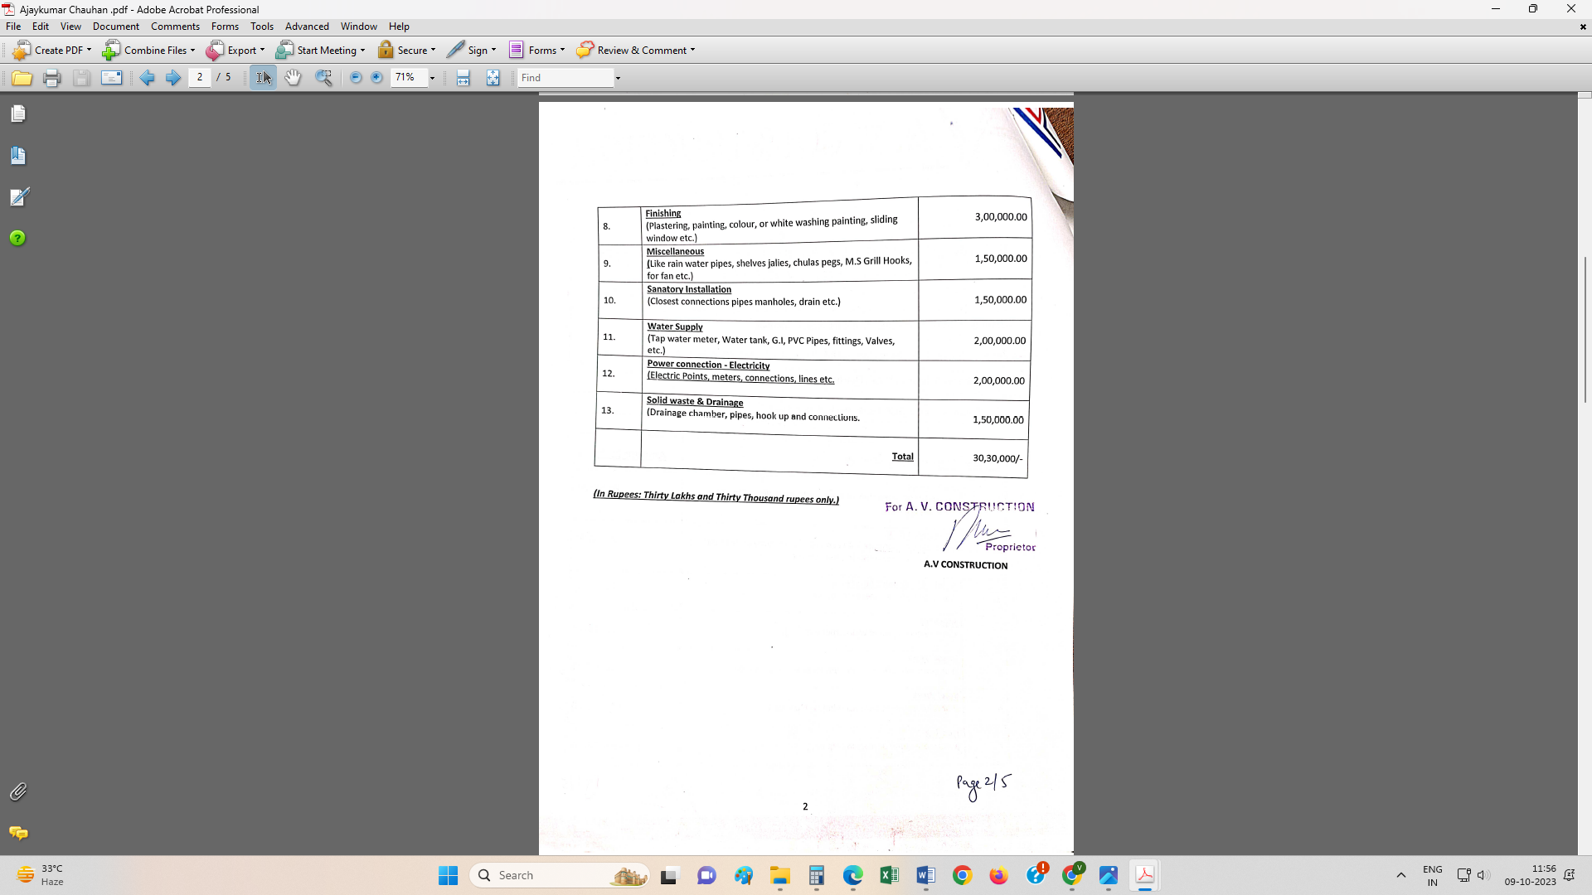

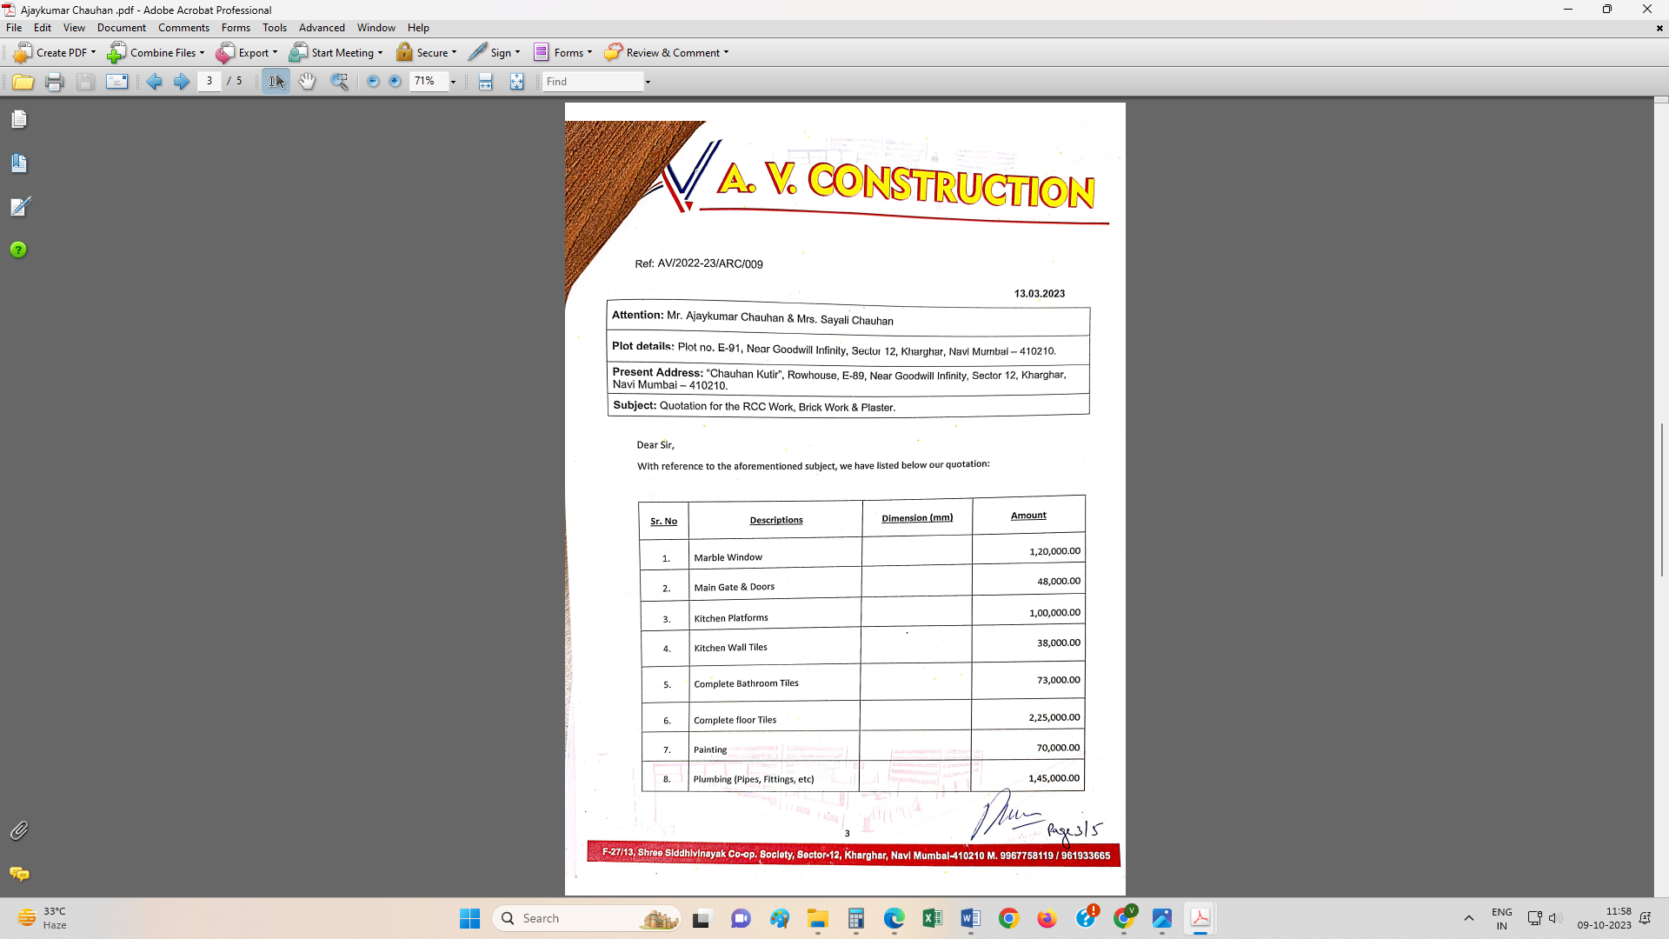
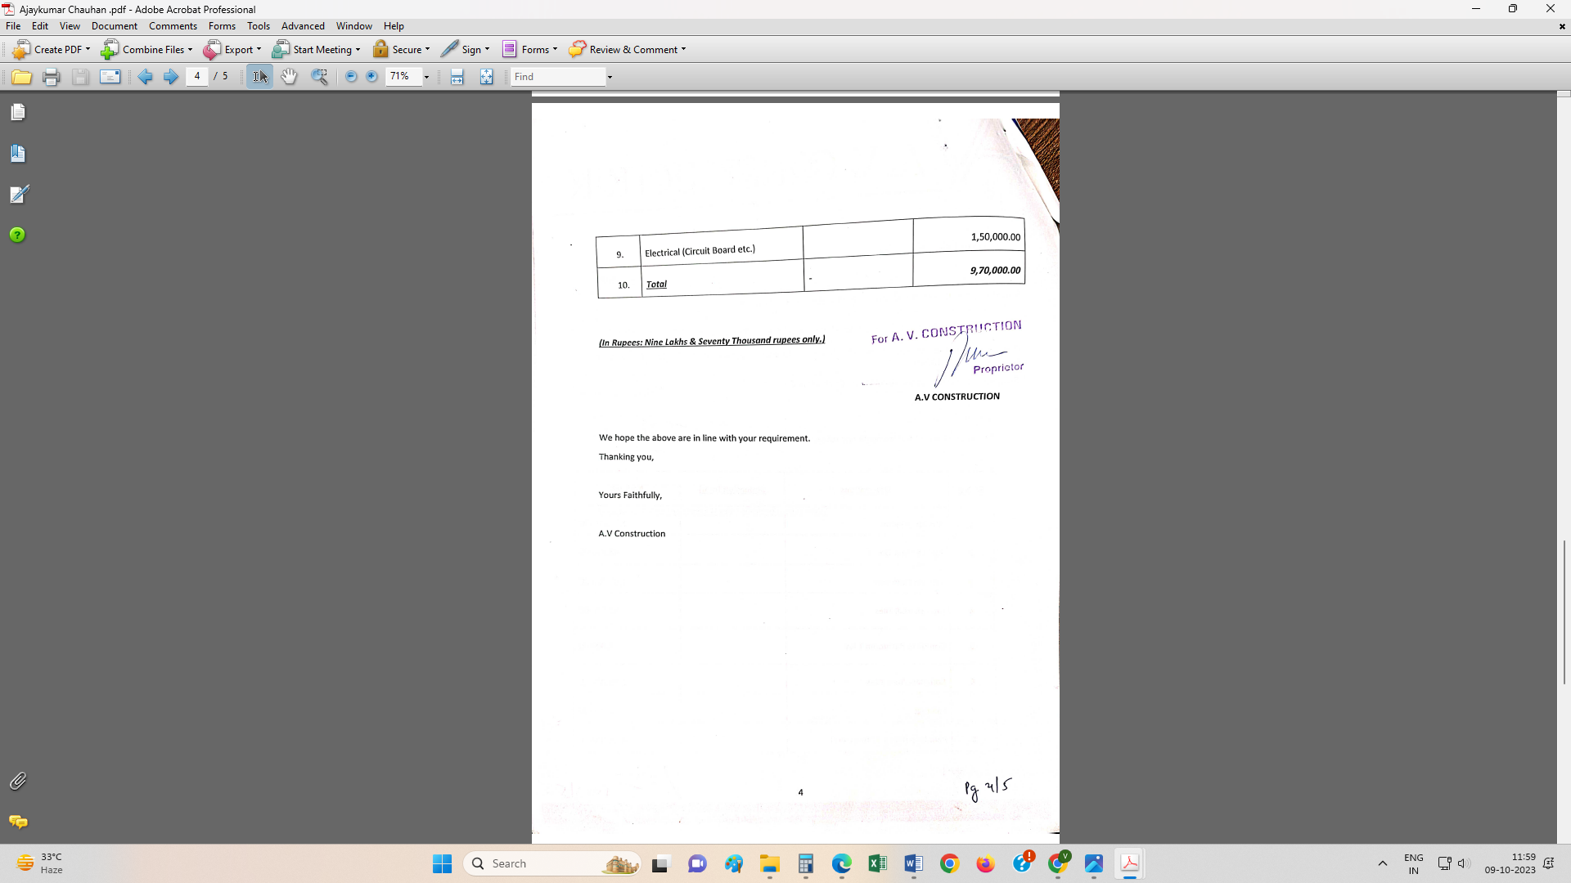

The Estimate amount is Rs. 40,00,000/- (Rupees Forty Lakh Only)

