Vastu/Nashik/09/2023/3875/2302588
16/11-232-CHV
Date: 16.09.2023

To,
The Branch Manager
Union Bank of India
Panchavati Branch
Shop No. 1 2 3 Rupashri Apartment Opp, Taxi Stand Dindori
Road Panchavati, Nashik - 422 003, State – Maharashtra, Country – India.

.

Sub: Vetting of Estimate

Sir,

With reference to above subject, we have evaluated the Estimate for Residential Land and Proposed Bungalow on Plot No.177 + 178, Survey No.4,5,7 to 10,281 & 282, Behind Dalvi Farm, Warvandi Link Road, Village – Mhasrul, Taluka & District - Nashik, PIN Code – 422 004, State – Maharashtra, Country – India belongs M/s. Real Land Developers and Builders. Name of Proposed Purchaser: Smt. Nita Rajesh Sangle.

We have verified the rates quoted as per current market rates. Details of Estimate considered as per copy of Estimate Provided by Ar. Hemant Bhavsar received on dated 05.09.2023. The Estimate amount is Rs. 9,30,000/- (Rupees Nine Lakh Thirty Thousand Only)

The said Cost Vetting Certificate is valid upto next 6 months Only.

Thanking you

Sincerely yours

Sharadkumar B. Chalikwar
Govt. Reg. Valuer
Chartered Engineer (India)
Reg. No. (N) CCIT/1-14/52/2008-09
Encl: Vetting Report.

Estimate
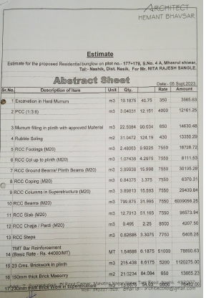
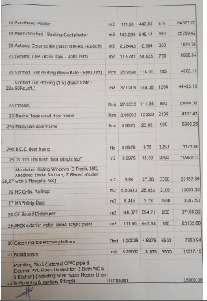

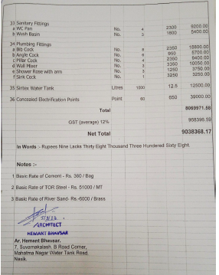

The Estimate amount is Rs. 9,30,000/- (Rupees Nine Lakh Thirty Thousand Only)

