Vastu/Nashik/09/2023/3787/2302536
14/08-180-CHSH
Date: 14.09.2023

To, `
The Branch Manager,
State Bank of lndia
Maharashtra Eng. Research institute Branch
Dindori Road, MERI, Nashik, Maharashtra,
Nashik - 422004, State - Maharashtra, Country - lndia.

.

Sub: Vetting of Extra Amenities

Sir,

With reference to above subject, we have evaluated the Extra Amenities for Residential Row House No. B, Ground + First Floor “Jai Hari Row Bungalow”, Survey No. 245 / 28, Plot No. 30 / B, Near Shree Pushpavinayak Mandir & NMC Garden, Hari Har Colony, Prabhat Nagar, Mhasrul Link Road, Village – Mhasrul, Taluka & District – Nashik, PIN – 422 004, State – Maharashtra, Country – India belongs to Name of Proposed Purchaser: Shri. Chetan Jayram Chaure. Name of Owner: Shri. Pravin Subhash Dokhale.

We have verified the rates quoted as per current market rates. Details of work and Extra Amenities considered as per copy of Agreement for Extra Amenities issued by Shri. Chetan Jayram Chaure (First Party) and Shri. Pravin Subhash Dokhale (Second Party) received on dated.08.09.2023. The Extra Amenities amount is Rs.5,50,000/- (Rupees Five Lakh Fifty Thousand Only.)

The said Cost Vetting Certificate is valid upto next 6 months Only.

Thanking you

Sincerely yours

Manoj B. Chalikwar
Registered Valuer
Chartered Engineer (India)
Reg. No. CAT-I-F-1763
SBI Empanelment No.: SME/TCC/2021-22/86/3
Encl: Valuation report.

Agreement for Extra Amenities
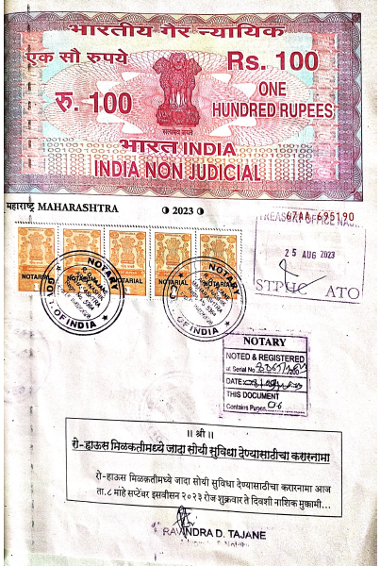
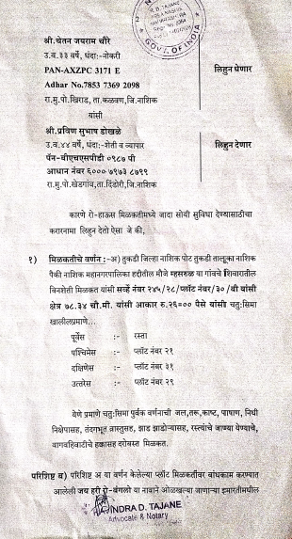

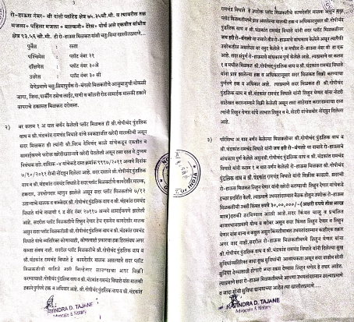
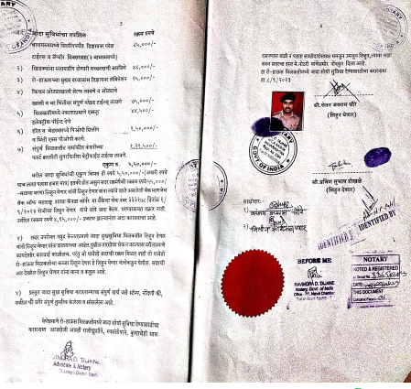

The Extra Amenities amount is Rs.5,50,000/- (Rupees Five Lakh Fifty Thousand Only.)

