Valuation Report of the Immovable Property
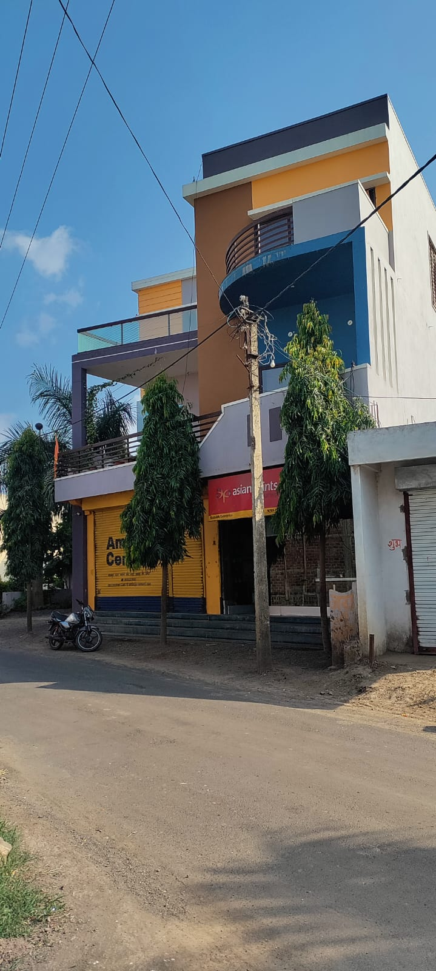

Details of the property under consideration:

Name of Owner: Mr. Ashok S/o Bherulal

Commercial Land & Structure bearing Survey No. 1062/2/3, P.H. No. 67 (Old 27), Kod-Koteshwar Road,
Gram - Kod, Tehsil - Badnawar, District - Dhar, PIN – 454 665,
State – Madhya Pradesh, Country – India

Latitude Longitude - 22°53’02.9”N 75°11’04.6”E

Valuation Done for:

Bank of Maharashtra
Pithampur (Sagar Kuti), Branch
Sagor Kuti Chouraha's House, Mhow Neemuch-
Highway Pithampur, Sector 3 Dhar – 454 774
State – Madhya Pradesh, Country – India.

Vastu/Indore/09/2023/003775/2302564
15/5-208-AKT
Date: 15.09.2023

VALUATION OPINION REPORT

The Commercial property bearing Commercial Land & Structure bearing Survey No. 1062/2/3, P.H. No. 67 (Old 27), Kod-Koteshwar Road, Gram - Kod, Tehsil - Badnawar, District - Dhar, PIN – 454 665, State – Madhya Pradesh, Country – India belongs to Mr. Ashok S/o Bherulal.

Boundaries of the property:
Boundaries | : | As per Actual at Site
North | : | Kod-Koteshwar Road
South | : | House of Eshwar Katare Ji
East | : | Kalu Ram Patidar House
West | : | House of Eshwar Katare Ji

Considering various parameters recorded, existing economic scenario, and the information that is available with reference to the development of neighborhood and method selected for valuation, we are of the opinion that, the property premises can be assessed and valued for banking purpose at ` 2,28,94,275/- (Rupees Two Crore Twenty-Eight Lakh Ninety-Four Thousand Two Hundred Seventy Five Only).

The valuation of the property is based on the documents produced by the concern. Legal aspects have not been taken into considerations while preparing this valuation report.

Hence certified

Manoj B. Chalikwar
Registered Valuer
Chartered Engineer (India)
Reg. No. CAT-I-F-1763
BOM Emp. No. AX40/Empanelment: Valuer/VCPL/2021-22

VALUATION REPORT IN RESPECT OF IMMOVABLE PROPERTY

1. | Date of Inspection | : | 06.09.2023
2. | Purpose of valuation | : | As per request from Bank of Maharashtra, Pithampur (Sagar Kuti) Branch to assess Fair Market Value of the property under reference for Banking purpose.
3. | Name and address of the Valuer. | : | Manoj B. Chalikwar  Vastukala Consultants (I) Pvt. Ltd.  106, 1st Floor, Gold Star Tower, Opp. Treasure Island Mall, M.G. Road, Indore – 452 001
4. | Copy Of Documents Handed Over to The Valuer by The Bank | : | - Sale Deed, Registration No. 5732 dated 31.03.2008 between Shri. Pritesh Pratap Singh S/o Jagdish Pratap Singh & Shri. Vijendra Kuvar S/o Shri Jagdish Pratap Singh (the Sellers) AND Mr. Ashok S/o Bherulal & Others (the Purchaser).  - Approved Plan Gram Panchayat Kod, Tehsil Badnawar, District Dhar, janpad Panchayat Badnawar, Signed by Sachive & Sarpanch.  - Certificate of Khasra No. 1062/2/3, Sr. No. 790/2020, dated 21.02.2020, Named Ashok Kumar S/o Bherulal, signed by Sachive & Sarpanch Ground Floor  - Commencement Latter of Khasra No. 1062/2/3, Gram Panchayat Kod, Tehsil Badnawar, District Dhar, dated 14.02.2012, P.H.N. 27, Gram Panchayat Kot, Janpad Panchayat Badnawar, Signed by Sachive & Sarpanch  - Diversion Order of Khasra No. 1062/2/3 Sr. no. 07/ A-2 /2011.12, Dated 13.02.2012, Applicant Mr. Ashok S/o Bherulal, Sub-Divisional Officer, Revenue Department, Badnawar, District Dhar.  - Online Recorded Batankan Map of Khasra No. 1062/2/3, Named Ashok S/o Bherula.
5. | Details of enquiries made/ visited to govt. Offices for arriving fair market value. | : | Market analysis and as per sub-registrar value.
6. | Factors for determining its market value. | : | Location, development of surrounding area, facilities provided and its prevailing market rate.
7. | Any Critical Aspects Associated with Property | : | No
8. | Present/Expected Income from the property | : | ` 76,000/- Expected rental income per month
 | Property Details: | :
9. | Name(s) of the Owner and Postal address of the property under consideration. | : | Mr. Ashok S/o Bherulal
 |  | : | Commercial Land & Structure bearing Survey No. 1062/2/3, P.H. No. 67 (Old 27), Kod-Koteshwar Road, Gram - Kod, Tehsil - Badnawar, District - Dhar, PIN – 454 665, State – Madhya Pradesh, Country – India.  Contact Person:  Mr. Arpit (Representative of owner)  Contact No. +91 99934 44644
10. | If the property is under joint ownership/ co-ownership share of each such owner/ are the share is undivided. | : | Sole Ownership
11. | Brief description of the property:  The immovable property comprises of Commercial land and structure thereof. The property is located in a developed area having basic infrastructure, well connected by road and train. It is located at 750 M. travelling distance from nearest Bus Station.  Plot:  As per Diversion Order / site inspection, the Land area is 0.060 Hectare, i.e. 6,459.00 Sq. Ft. which is considered for valuation.  Structure:  The property consists of Commercial Land & Structure of Ground + 2 upper floor. It is a R.C.C. Framed Structure with RCC beams, columns, slabs and RCC staircase is provided for access to the upper floor.  The composition of the Commercial Land & Structure as per Site Inspection is as below -  As per actual site measurement, the area is as below -  As per Sanctioned Map, constructed area is as below –  The composition of the Commercial Land & Structure as per Approved Plan is as below -  As per Approved Building Plan, the construction area is a below-  As per Approved Building Plan, the structure is of Ground + 1 upper floor but on the site the owner has constructed Ground + 2nd Part Upper Floor. For the purpose of valuation, we have considered the Ground + 1 upper floor only.
  Floor | Composition
  Ground Floor | Passage + Shop + 3 Godown
  First Floor | 4 Bed Rooms + Hall + Dining + Drawing Hall + Kitchen + Balcony + 4 Toilets
  Second Floor | 2 Bed Rooms + Hall + Toilet + Balcony
  Floor | Built up Area in Sq. Ft.
  Ground Floor | 5,603.43
  First Floor | 2,339.22
  Second Floor | 1,725.00
  Total Area | 9,667.65
  Floor | Built up Area in Sq. Ft.
  Ground Floor | 5,603.43
  First Floor | 2,339.22
  Total Area | 7,942.65
  Floor | Composition
  Ground Floor | Passage + Shop + 3 Godown
  First Floor | 4 Bed Room + Hall + Dining + Drawing Hall + Kitchen + Balcony + 4 Toilets
  Particulars | Sq. Ft.
  Built-up on Ground Floor | 5,603.43
  Built-up on First Floor | 2,339.22
  Total Built Up Area | 7,942.65
12. | Location of the property. (C.T.S. No., Survey No., Hissa No., Plot No., etc.). | : | P. H. No. 27
13. | Boundaries of the property | : | As per Actual at Site |  | As per Certificate Latter
13. | North | : | Kod-Koteshwar Road |  | Kod-Koteshwar Road
13. | South | : | House of Eshwar Katare Ji |  | House of Eshwar Katare Ji
13. | East | : | Kalu Ram Patidar House |  | Kalu Ram Patidar House
13. | West | : | House of Eshwar Katare Ji |  | House of Eshwar Katare Ji
14. | Route map | : | Enclosed
15. | Any specific identification marks | : | Nori Maszid Kod
16. | Whether covered under Corporation/ Panchayat/ Municipality. | : | Gram Panchayat Kod, Tehsil Badnawar, District Dhar
17. | Whether covered under any land ceiling of State/ Central Government. | : | No
18. | Is the land freehold/ leasehold? | : | Freehold
19. | Are there any restrictive covenants in regard to use of Land? If so attach a copy of the covenant. | : | As per Sale Deed
20. | Type of the property- Whether | :
 | Residential | : | No
 | Industrial | : | No
 | Commercial | : | Yes
 | Institutional | : | No
 | Government | : | No
 | Non – Government | : | No
 | Other (Specify) | : | N.A.
21. | In case of Agricultural land
 | Any conversion to House site is obtained | : | N.A.
 | Whether the land is dry or wet. | : | N.A.
 | Availability of irrigation facilities | : | N.A.
 | Type of crops grown | : | N.A.
 | Annual yield or income. | : | N.A.
22. | Year of acquisition/ purchase. | : | Sale Deed, Registration No. 5732 dated 31.03.2008
23. | Whether the property is occupied by owner or tenant. If occupied by tenant since how long he is staying, and the amount of rent being paid. | : | Owner Occupied
24. | Classification of the site. | :
 | a. Population group. | : | Urban
 | b. High/ Middle/ Poor class | : | Middle class
 | c. Residential/ nonresidential. | : | Non Residential
 | d. Development of surrounding area. | : | Developed
 | e. Possibility of any threat to the property. (Floods, calamities etc.). | : | No
25. | Proximity of civic amenities.  (Like school, hospital, bus stop, market etc.). | : | All available nearby
26. | Level of the land (Plain, rock etc.) | : | Plain
27. | Terrain of the Land. | : | Leveled
28. | Shape of the land (Square/ rectangle etc.). | : | Irregular
29. | Type of use to which it can be put (for construction of house, factory etc.). | : | Commercial Purpose
30. | Any usage restrictions on the property. | : | Commercial
31. | Whether the plot is under town planning approved layout? | : | Yes
32. | Whether the building is intermittent or corner? | : | Corner
33. | Whether any road facility is available? | : | Yes
34. | Type of road available (B.T. / Cement Road etc.). | : | Intermitted Plot
35. | Front Width of the Road? | : | More than 20 ft.
36. | Source of water & water potentiality. | : | Good
37. | Type of Sewerage System. | : | Septic Tank and Connected to Gram Panchayat Sewerage System
38. | Availability of power supply. | : | Yes
39. | Advantages of the site. | : | Located in developed Commercial area
40. | Disadvantages of the site. | : | No
41. | Give instances of sales of immovable property in the locality on a separate sheet, indicating the name & address of the property, registration No. sale price and area of land sold. | : | As per Sub-Registrar of Assurance records
 | Valuation of the property:
42. | Dimensions of the plot | :
A
As per the Certificate / Actuals

 | North |  | 68’
 | South |  | 52’
 | East |  | 93’2”
 | West |  | 122”
43. | Total area of the plot | : | 6,459.00 Sq. Ft.  (As per Diversion Order Letter)
44. | Prevailing Market Rate/Price trend of the Property in the locality/city from property search sites viz magickbricks.com, 99acres.com, makaan.com etc. if available | : | ` 1,500/- to ` 2,000/- per Sq. Ft.  Details of online listings are attached with the report.
45. | Government Rate obtained from the online government records of Land | : | ` 7,200/- per Sq. M. i.e.  ` 669/- per Sq. Ft.
46. | Building |  | ` 1,500/- per Sq. Ft. on Built-up Area
B) Structure

Floor | Built up Area in  Sq. Ft. | Year Of Const. | Total Life of Structure | Replacement Rate (`) | Age Of Build. | Depreciated Rate (`) | Depreciated Value (`) | Full Value (`)
Ground | 5,603.43 | 2020 | 60 | 1,500/- | 3 | 1,500/- | 84,05,145/- | 84,05,145/-
First | 2,339.22 | 2020 | 60 | 1,500/- | 3 | 1,500/- | 35,08,830/- | 35,08,830/-
Total | 7,942.65 |  |  |  |  |  | 1,19,13,975/- | 1,19,13,975/-

47. | - Government Value
 | Particulars | : | Area in Sq. Ft. | Rate in ` |  | Value in `
 | Plot | : | 6,459.00 | 669/- |  | 43,18,395/-
 | Structure |  | As per valuation table |  |  | 1,19,13,975/-
 | Total |  |  |  |  | 1,62,35,046/-
 | 5) Assessed/ adopted rate of valuation. |  | ` 1,700.00 per Sq. Ft. for Commercial plot
48. | - Fair Market Value
 | Particulars | : | Area in Sq. Ft. | Rate in ` |  | Value in `
 | A) Plot |  | 6,459.00 | 1,700/- |  | 1,09,80,300/-
 | B) Building |  | As per valuation table |  |  | 1,19,13,975/-
 | 6) Total Value (A + B) |  |  |  |  | 2,28,94,275/-
 | a. Technical details of the Plot:
49. | Type of Plot (Residential/ Commercial/ Industrial). | : | Commercial
50. | Year of construction. | : | 2020 (As per Site Information)  Age of the Building - 3 Years
51. | Future life of the property. | : | 57 years, Subject to proper, preventive periodic Maintenance & structural repairs
52. | No. of floors and height of each floor including basement. | : | Ground + 2 Upper Floors
53. | Plinth area of each floor | : | As per Approved Building Plan, the construction area is a below-
  Particulars | Sq. Ft.
  Built-up on Ground Floor | 5,603.43
  Built-up on First Floor | 2,339.22
  Total Built Up Area | 7,942.65
54. | Type of construction.  (Load bearing/ R.C.C. / Steel framed). |  | RCC framed structure
 | Condition of the building. | :
55. | External (excellent/ good/ normal/ poor). | : | Good
56. | Internal (excellent/ good/ normal/ poor). | : | Good
 | Remarks: | :
57. | b. Specifications of Construction:
 | Foundation. | : | R.C.C
 | Basement. | : | N.A.
 | Superstructure. | : | R.C.C. frame work with 9" thick B. B. Masonry for external walls. 6" Thk. B.B. Masonry for internal walls
 | Joinery/ Doors & Windows. | : | Powder coated Aluminium sliding windows, Teak Wood door frames with solid flush shutters
 | RCC work. | : | Footings, Columns, Beams, Slab
 | Plastering. | : | Cement plastering
 | Flooring, Skirting. | : | Vitrified tiles flooring
 | Kitchen Pantry Platform | : | Granit kitchen platform
 | Whether any weather proof course is provided. | : | R.C.C. Slab
 | Drainage. | : | Connected to Gram Panchayat Sewerage System
 | Compound wall (Height, length and type of construction). | : | R.C.C
 | Electric installation (Type of wire, Class of fittings) | : | Concealed wiring  As per requirements
 | Plumbing installation (No. of water closets & wash basins etc.) | : | Concealed plumbing  As per requirements
 | Bore well. | : | No
 | Wardrobes, if any. | : | No
 | Development of open area | : | Yes

1,

 | Summary of Valuation
 | Fair Market Value | ` 2,28,94,275/-
 | Realizable Value | ` 2,06,04,848/-
 | Distress Sale Value | ` 1,83,15,420/-
 | Insurable value of the property  (Full Replacement Cost - (1,19,13,975/–) - Subsoil structure cost (15%) | ` 1,01,26,879/-
e) | Remarks: As per Approved Building Plan, the structure is of Ground + 1 upper floor but on the site the owner has constructed Ground + 2nd Part Upper Floor. For the purpose of valuation, we have considered the Ground + 1 upper floor only.

Justification for price /rate
The Market Value of the property is based on facts of markets discovered by us during our enquiries, however the government rate value in this case is less than the market value arrived by us. We are of the opinion that the value arrive by us will prove to be correct if an Auction of the subject property is carried out. As far as Market Value in Index II is concerned, it is not possible to comment on same, may be government rates are fixed by sampling during same point of time in part and whereas, Market values change every month.
In most of the cases the actual deal amount or Transaction value is not reflected in Index II because of various Market practices. As Valuer, we always try to give a value which is correct reflection of actual transaction value irrespective of any factors in market.
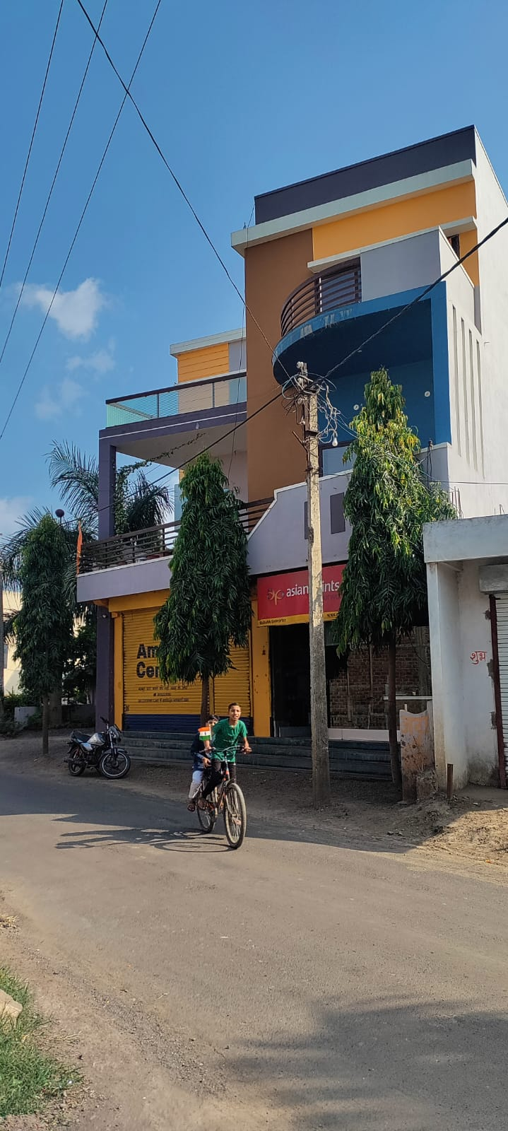
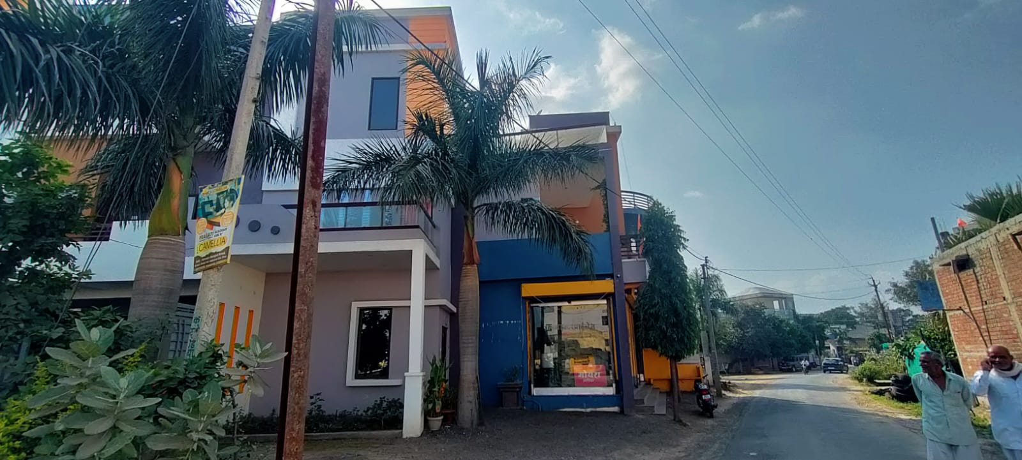
Actual site photographs

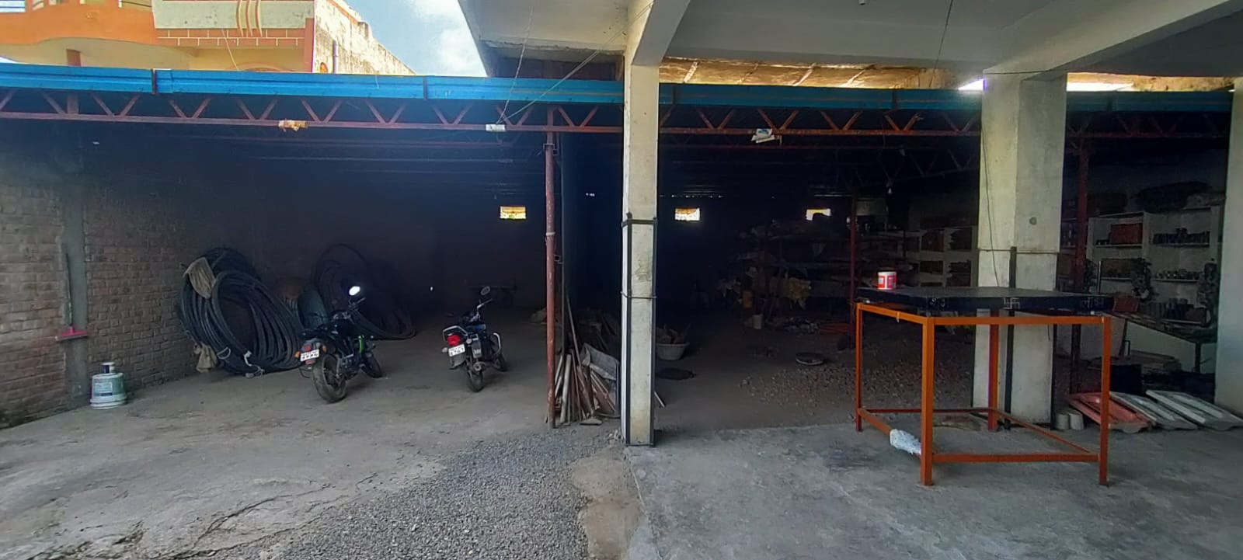
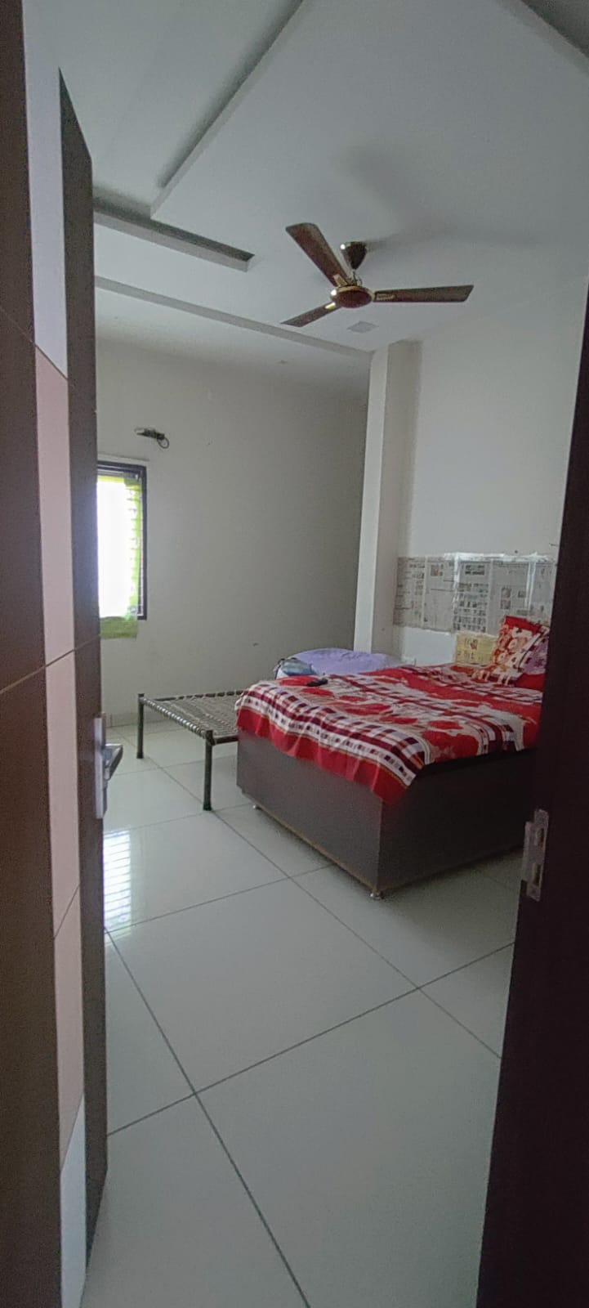

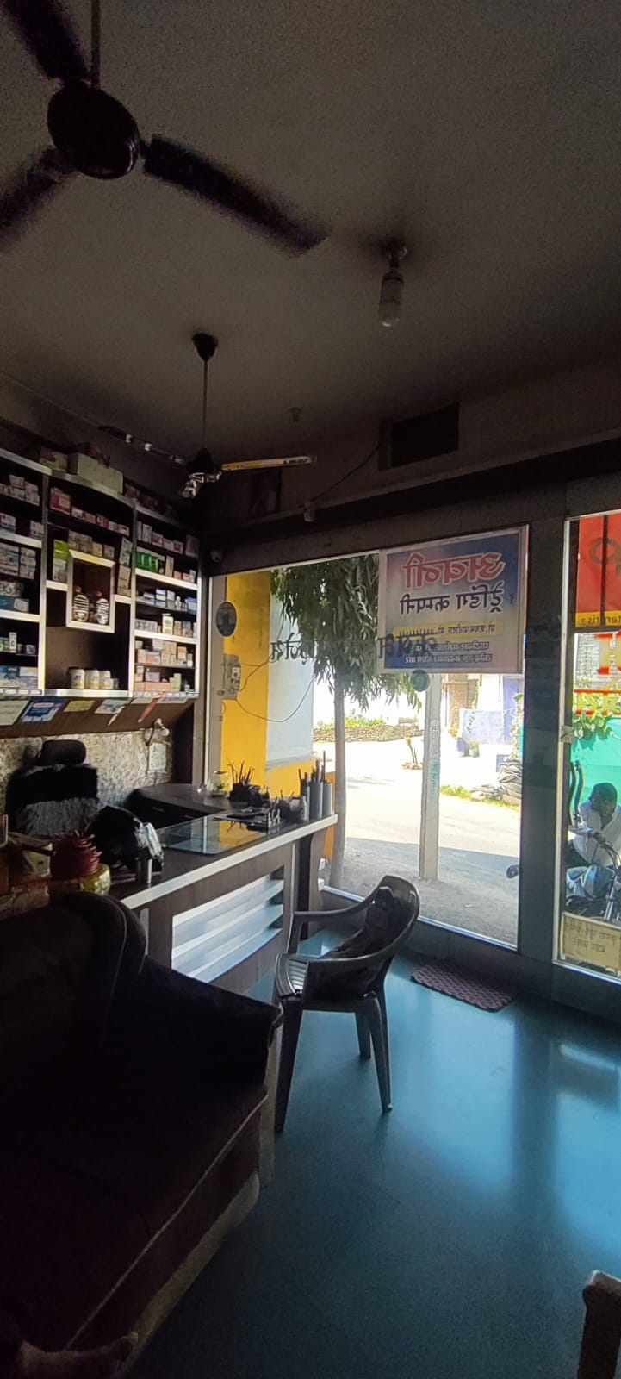
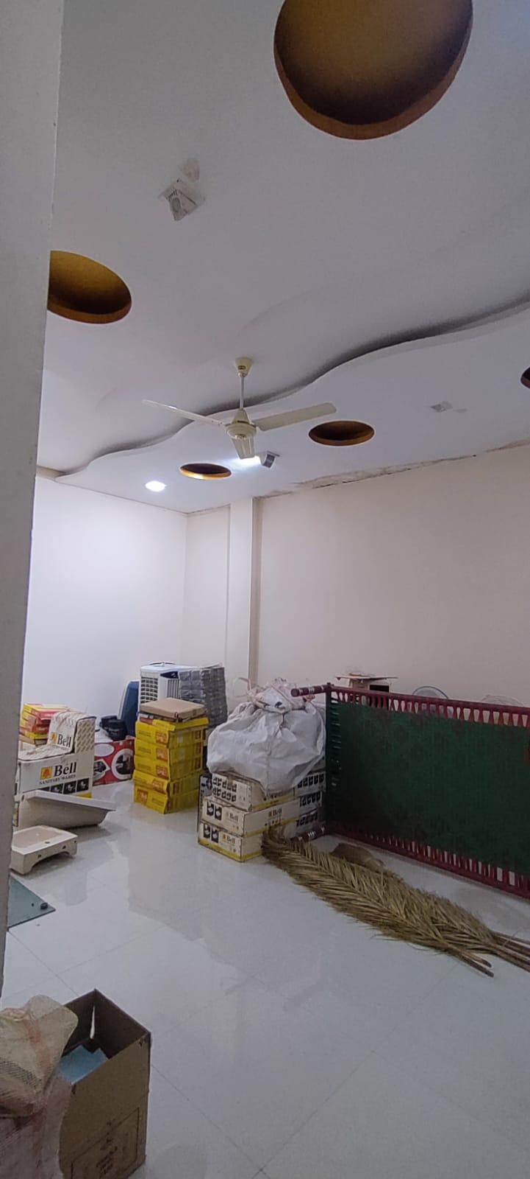
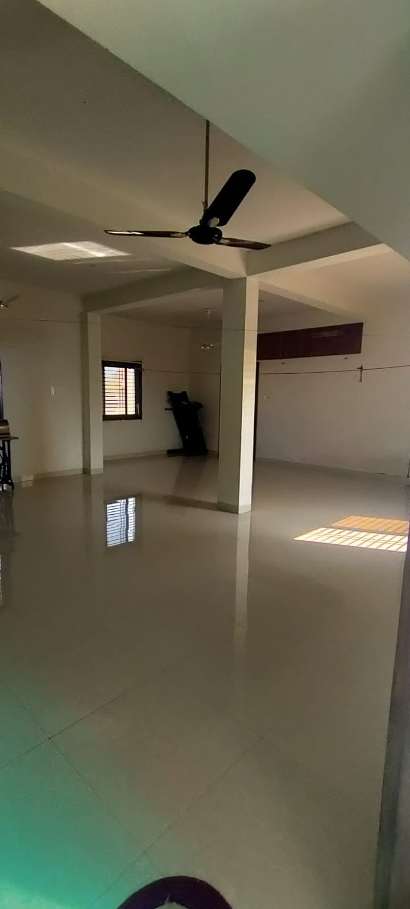
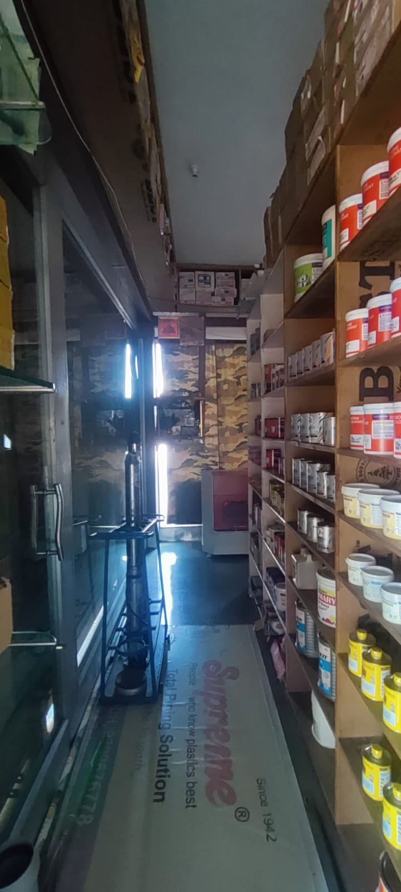
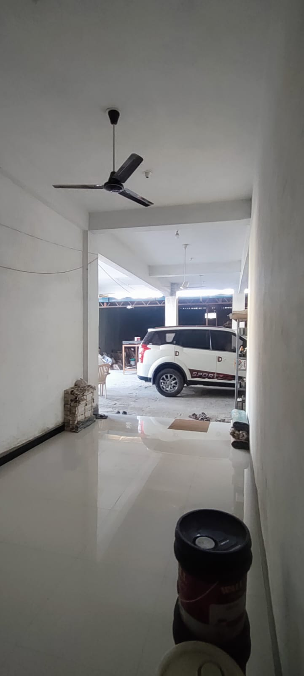
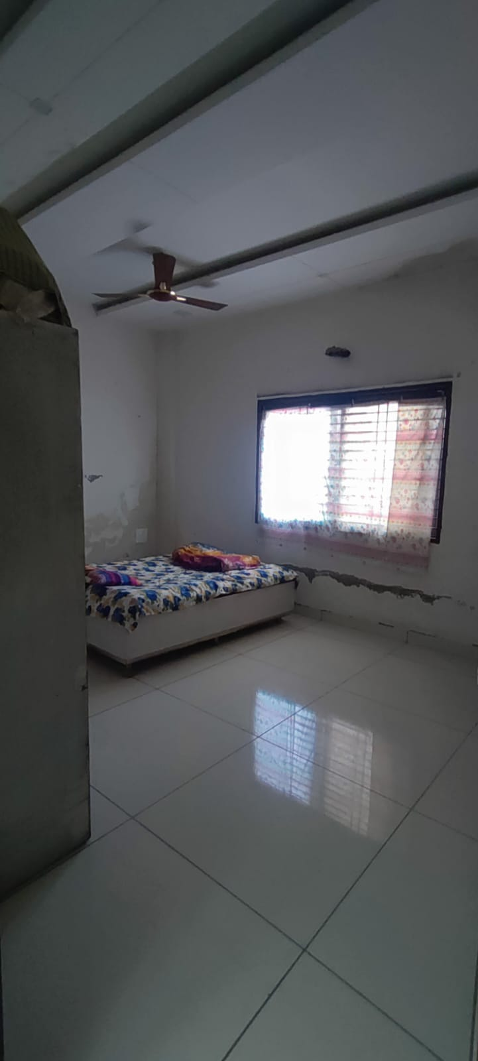

Actual site photographs
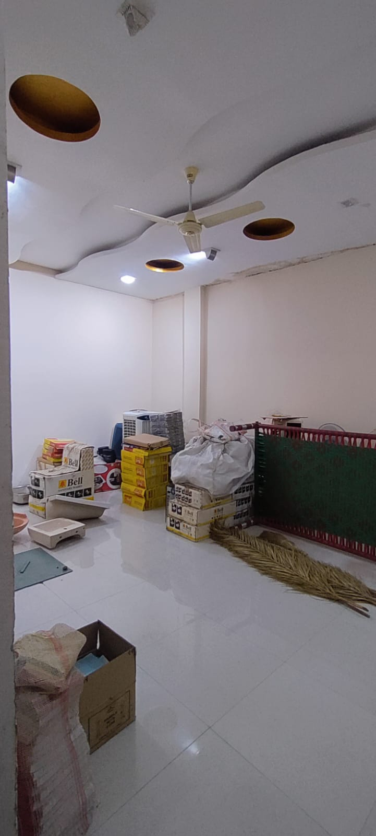
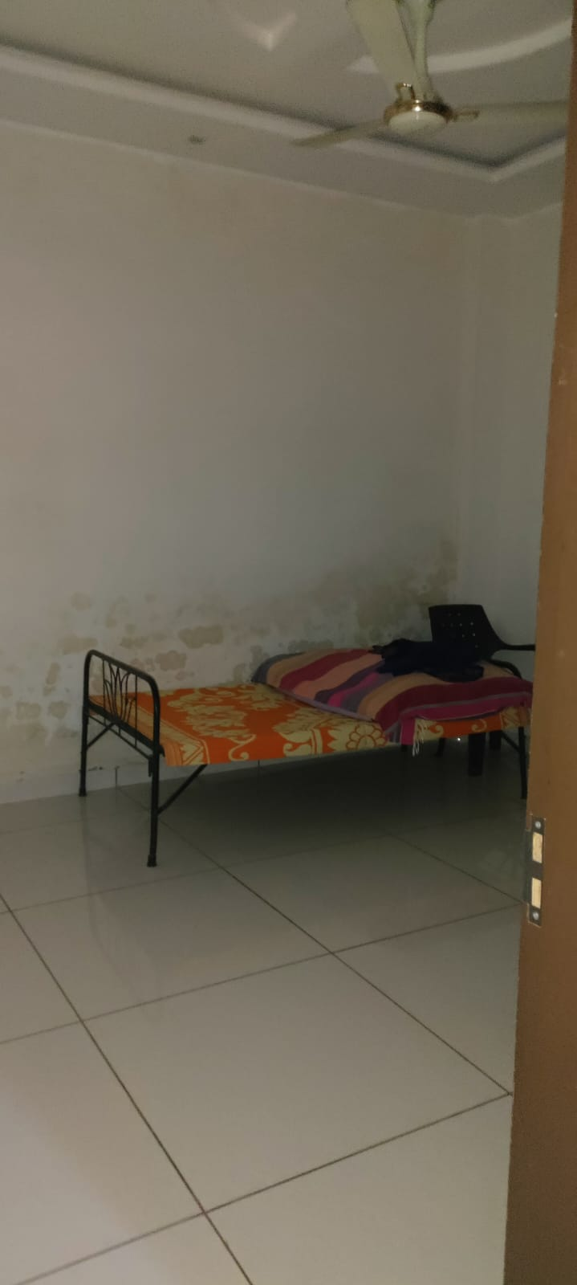
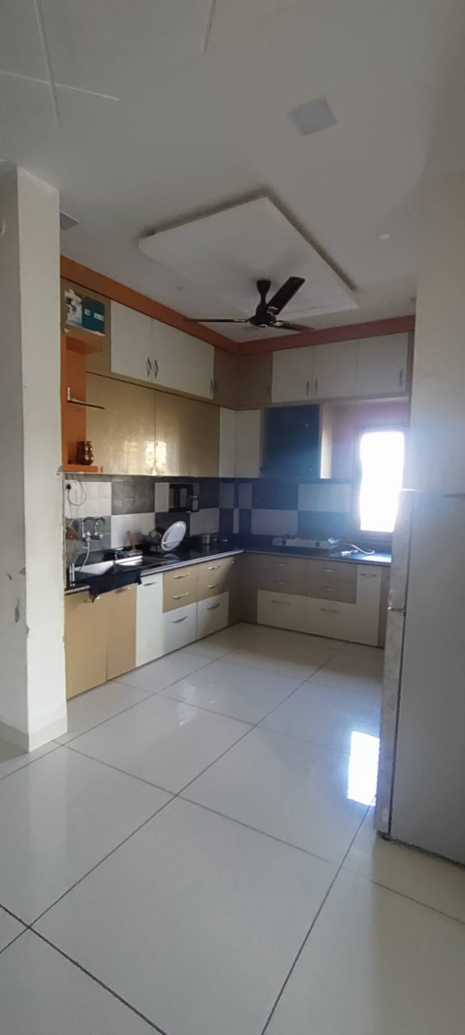

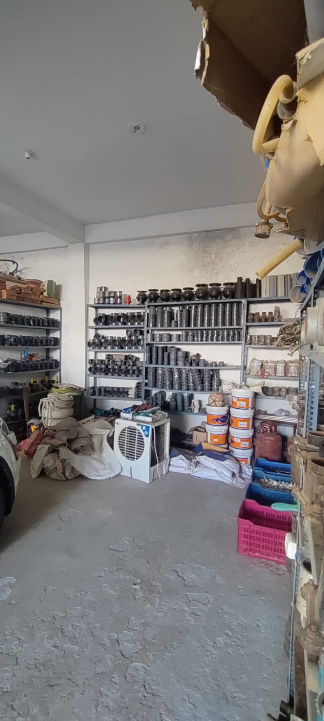
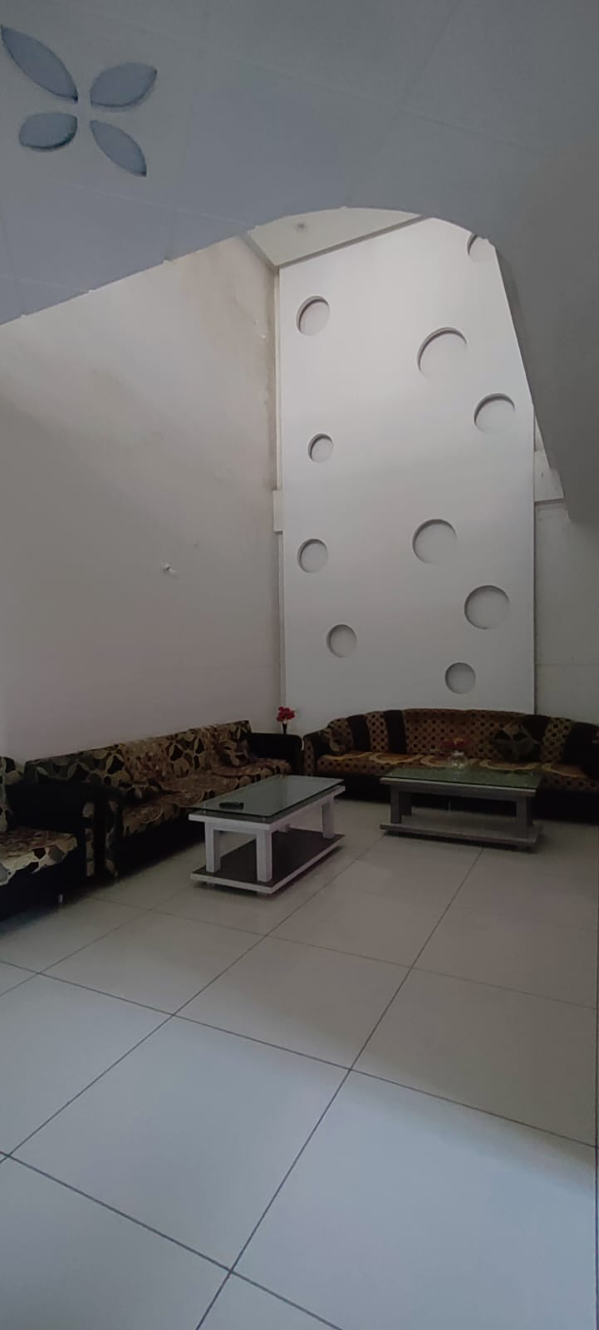
Route Map of the property
Site u/r
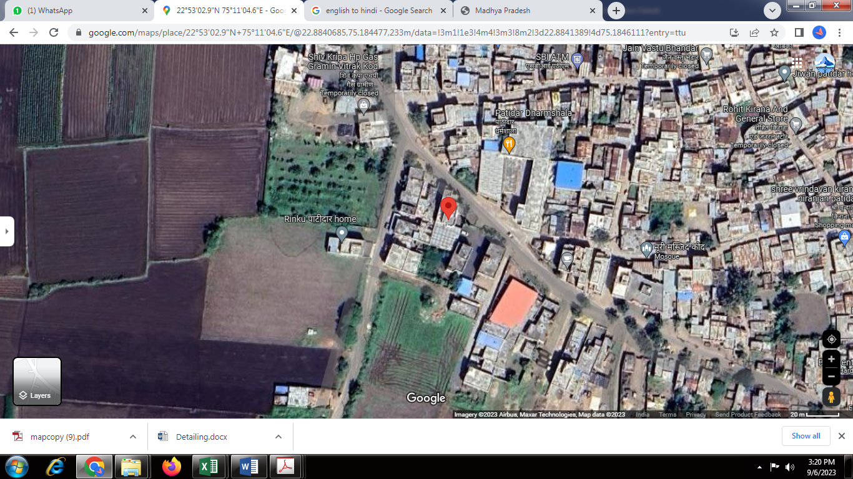

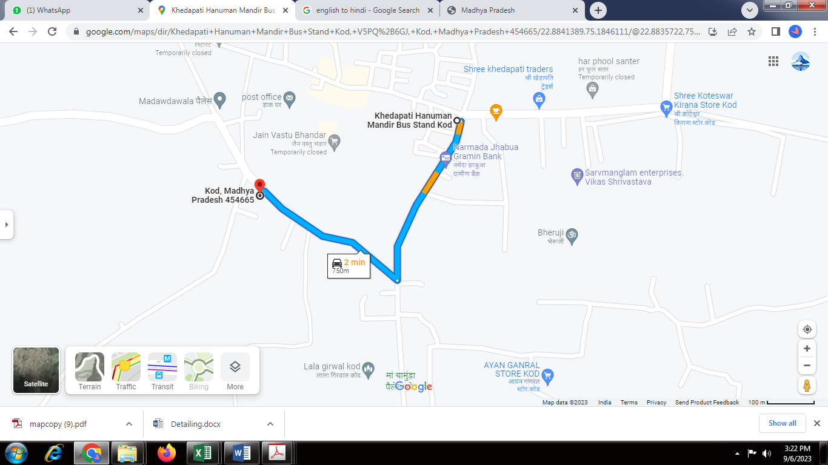

Latitude Longitude - 22°53’02.9”N 75°11’04.6”E

Note: The Blue line shows the route to site from nearest Bus station ( Khedapati Hanuman Mandir – 750 M.)

Government Guideline Rate
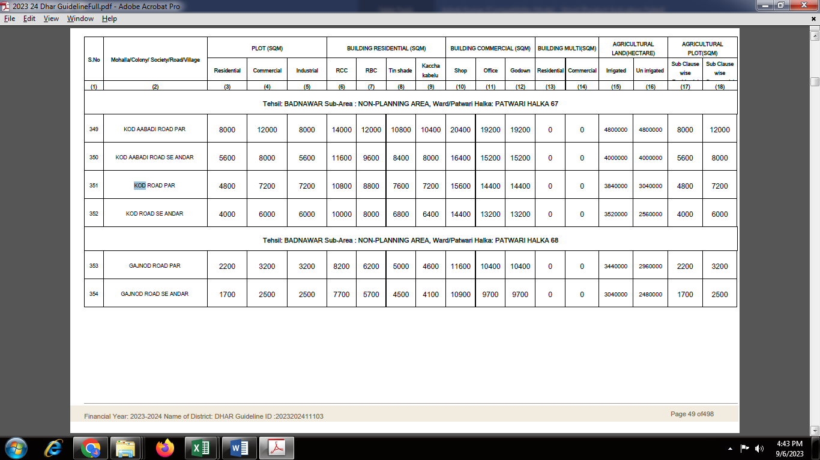

DEFINITION OF VALUE FOR THIS SPECIFIC PURPOSE

This exercise is to assess Fair Market Value of the property under reference for purpose as on 15th September 2023.

The term Fair Market Value is defined as

"The most probable price, as of a specified date, in cash, terms equivalent to cash, or in other precisely revealed terms for which the specified property rights would sell after reasonable exposure in a competitive market under all conditions requisite to a fair sale, with the buyer and seller each acting prudently knowledgeably and for self-interest assuming that neither is under undue duress"

Fundamental assumptions and conditions presumed in this definition are:

- Buyer and seller are motivated by self-interest.

- Buyer and seller are well informed and are acting prudently.

- The property is exposed for a reasonable time on the open market.

- Payment is made in cash or equivalent or in specified financing terms.

ASSUMPTIONS, CAVEATS, LIMITATION AND DISCLAIMERS
- We assume no responsibility for matters of legal nature affecting the property appraised or the title thereto, nor do we render our opinion as to the title, which is assumed to be good and marketable.
- The property is valued as though under responsible ownership.
- It is assumed that there are no hidden or unapparent conditions of the subsoil or structure that would render it more or less valuable. No responsibility is assumed for such conditions or for engineering that might be required to discover such factors.
- There is no direct/ indirect interest in the property valued.
- The rates for valuation of the property are in accordance with the Govt. approved rates and prevailing market rates.

Manoj B. Chalikwar
Registered Valuer
Chartered Engineer (India)
Reg. No. CAT-I-F-1763
BOM Emp. No. AX40/Empanelment: Valuer/VCPL/2021-22

