|  |
| --- |
| Techno-Economic Viability    Study Report On  The Empire Nashik  Name of Owner : M/s. Bhavik and Saraf Ventures  *S.No. 646/7B/1/2/A2, CTS No. 6821 to 6824. F.P. No. 250, TPS­2*,  *Sharanpur Road, Tilakwadi, Nashik -422002 Maharashtra*  TEV Report for :Union Bank of India, SSI Finance Branch (Nashik)  Consultants **:** Vastukala Consultants (I) Pvt. Ltd.  *B1 – 001, Upper Basement, Boomerang Building, Chandivali Farm Road, Andheri (East), Mumbai - 400 072* |
|  |

**Table of Contents**

Executive Summary 4

Scope of the Work 13

Methodology 14

Segments in the Indian Real Estate Sector 23

Market Size of the India Real Estate 24

Demand for Residential Space 25

About Nashik 27

Connectivity with nearby localities 27

Civic Amenities & Infrastructure 28

Price Trends in Nashik 31

Price Trends in Nashik 32

Project Details 33

Location & Connectivity 34

Land Details 35

Project Cost 38

Means of Finance 39

Project Approvals and their Status 39

Current Status of the Project 40

Implementation Schedule 40

Economic Viability 41

Construction Area As per Approved Plan 41

Inventory 43

Profitability Projections 45

Cashflow Statement 46

Financial Analysis 46

Debt Equity Ratio 46

Loan-to-Sale Value (LTSV) 47

Debt Service Coverage Ratio (DSCR) 47

Internal Rate of Return (IRR) 47

Sensitivity Analysis 48

Swot Analysis 49

Risk Analysis and Mitigation 50

Conclusion 52

Annexure – 1 Projected Profitability Statement 53

Annexure – 2 Projected Balance Sheet 54

Annexure -3 Projected Cashflow Statement 55

Annexure - 4 Debt Service Coverage Statement 58

Annexure - 5 Repayment of Term Loan 58

Annexure – 6 Booking Details till September 30, 2023 59

Annexure - 7 Photographs 60

Photographs 62

Disclaimer 63

Vastu/UBI/Nashik/02/2024/3758/2304961

14/03-183-PY

Date: 14.02.2024

# Executive Summary

**Union bank of India, SSI Finance Branch (Nashik)** has appointed **Vastukala Consultants (I) Private Limited (VCIPL)** for undertaking the Techno-Economic Viability (**TEV**) study of the real estate project, namely, **The Empire** in Nashik owned by **BHAVIK & SARAF VENTURES.**

The study would be to assess the technical, commercial and financial viability of the said real estate project through a detailed analysis of the project and evaluation of the constraints and future potential.

**Bhavik & Saraf Ventures a partnership firm** is developing Residential Project in Nashik in the name of **“THE EMPIRE”.**  The proposed project is located on the pieces and parcel of land admeasuring 3902.86 Sq. Mtr. Bearing S.No.646/7B/1/2/A2, CTS No.6821 to 6824 F.P. No. 250, TPS-2, Sharanpur Road, Tilakwadi, Nashik-422002.

**THE EMPIRE** is an ongoing residential real estate project being developed by “M/s **Bhavik & Saraf Ventures** (Developers)”. The project consists G+21 storied Buildings (G + 20 Floors) will have total 56 units, 36 - 3BHK + Terrace units, 18 - 4BHK + Terrace units, 2 - 8BHK + Terrace (Penthouse) Units. The RERA Registration number for the project “THE EMPIRE” is P51600025617. The firm will start the project in 2021 and the same has been completed by end of December 2025.

The project offers Apartment with perfect combination of contemporary architecture and features to provide comfortable healthy living in post Covid era with best of the amenities to match the lifestyles.

|  |  |  |  |
| --- | --- | --- | --- |
| **Building** | **Proposed Completion** | **Levels** | **Present stage of Construction and approval status** |
| **Sale Building** | June – 2026 | 2 Basement + Ground Floor + 1st to 21st Upper Residential Floor | Excavation work & Plinth work is completed and RCC upto 21st Slab |

|  |  |
| --- | --- |
| **Parameter** | **Details** |
| Asset Class | Residential |
| Category | Mid Segment |
| Location | Bearing S.No.646/7B/1/2/A2, CTS No.6821 to 6824 F.P. No. 250, TPS-2, Sharanpur Road, Tilakwadi, Nashik-422002. |
| Land Area | Net Plot area – 3902.86 Sq. M. |
| Land Purchased in | Land registration date 05-08-2011 |
| Land Financed by | - |
| Project Type | Residential |
| Applicable DCRs | Nashik Municipal Corporation Nashik |
| Development Potential | As per table attached |
| Sales begun in | 2023 |
| Saleable Area | As per table attached |
| Construction Start Date | 2021 |
| Construction End Date as per information uploaded by the Developer on the RERA Website | 30/09/2026 (Needs to update in RERA site) |
| Architect and Planning | As per table attached |
| Key Project Consultants |
| Landscaping Consultant |
| Structural Consulting |
| Project Contractors |

**Project Cost**

The total project cost estimated by **Bhavik & Saraf Ventures** works out to **INR 77.91 Crore**. The detailed acquisition cost is as tabulated below:

**INR in Crore**

|  |  |  |
| --- | --- | --- |
| Particulars | Total Project Cost | %tage of Total |
| Land & Stamp Duty | 9.45 | 12.13% |
| Construction Cost | 50.00 | 64.17% |
| Approval Cost (FSI charges) + DC + Stair case + PT + (BMC Premium) | 8.80 | 11.29% |
| Architect & Consultancy Expenses | 1.95 | 2.51% |
| Admin & Marketing Expenses | 2.50 | 3.21% |
| Contingency | 0.26 | 0.33% |
| Interest to Bank Finance (till construction period) | 4.95 | 6.35% |
| Total | **77.91** | **100.00%** |

**Cost Incurred till September 30, 2023**

The cost incurred on project the till **September 30, 2023** is as tabulated below:

**INR in Crore**

|  |  |
| --- | --- |
| Particulars | Cost incurred till 30/09/2023 |
| Land & Stamp Duty | 9.45 |
| Construction Cost | 23.57 |
| Approval Cost (FSI charges) + DC + Stair case + PT + (BMC Premium) | 8.25 |
| Architect & Consultancy Expenses | 2.50 |
| Admin & Marketing Expenses |
| Contingency | 0.00 |
| Interest cost | 0.00 |
| Total | **43.77** |

**Balance Cost to Complete the Project**

The balance cost to complete the project budgeted by **Bhavik & Saraf Ventures is** as tabulated below:

**INR in Crore**

|  |  |
| --- | --- |
| Particulars | Balance Cost to be Incurred |
| Land & Stamp Duty | - |
| Construction Cost | 26.43 |
| Approval Cost (FSI charges) + DC + Stair case + PT + (BMC Premium) | 0.55 |
| Architect & Consultancy Expenses | 1.95 |
| Admin & Marketing Expenses |
| Contingency | 0.26 |
| Interest to Bank Finance upto construction period | 4.95 |
| Total | **34.14** |

**Means of Finance**

The means of finance proposed for the said project cost shall be as tabulated below:

**INR in Crore**

|  |  |  |
| --- | --- | --- |
| Particulars | Total Funds to be Raised | %tage of Total |
| Promoters Contribution |  |  |
| Owners Contribution | 21.00 | 27.00% |
| Unsecured Loan | 21.00 | 27.00% |
| Bank Loan |  |  |
| Term Loan | 20.00 | 25.70% |
| Customer Advances | 15.91 | 20.40% |
| Total | **77.91** | **100.0%** |

**Analysis on Project Sales**

The analysis for project sales is as tabulated below:

**Flat Inventory: -**

|  |  |  |  |  |
| --- | --- | --- | --- | --- |
| Type | RERA Area | | Inventory as on 30th September’ 23 | |
|  | | In Sq. M. | | **Saleable units** |  |  |
| 3BHK+Terrace | 173.09 | | 18 | |
| 3BHK+Terrace | 179.31 | | 18 | |
| 4BHK+Terrace | 233.84 | | 18 | |
| 8BHK+Terrace | 449.28 | | 1 | |
| 8BHK+Terrace | 663.50 | | 1 | |
| Total |  | | **56** | |

**Profitability Statement**

The project sales from receivables on sold inventory and sale of unsold inventory is as tabulated below:

**INR in Crore**

|  |  |  |  |  |  |  |
| --- | --- | --- | --- | --- | --- | --- |
| Particulars | FY 23-24 | FY 24-25 | FY 25-26 | FY 26-27 | FY 27-28 | FY 28-29 |
| Revenue |  |  |  |  |  |  |
| Sales | - | - | - | - | - | 96.68 |
| Closing WIP – The Empire | 49.71 | 61.49 | 74.77 | 77.90 | 77.90 | - |
| Total Revenue | 49.71 | 61.49 | 74.77 | 77.90 | 77.90 | 96.68 |
|  |  |  |  |  |  |  |
| Expenses |  |  |  |  |  |  |
| Expenses incurred during the year | 5.94 | 11.78 | 13.27 | 4.12 | 1.06 | 0.08 |
| Closing WIP – The Empire | 43.77 | 49.71 | 61.49 | 74.77 | 77.90 | 77.90 |
|  |  |  |  |  |  |  |
| Operating Profit | - | - |  | **-0.99** | **-1.06** | 18.70 |
|  |  |  |  |  |  |  |
| PBT | - | - | - | **-0.99** | **-1.06** | **18.70** |
| Tax | - | - | - | **-** | **-** | **5.61** |
| PAT | - | - | **-** | **-0.99** | **-1.06** | **13.09** |

**Balance Sheet**

The projected Balance sheet of the project is as tabulated below:

**INR in Crore**

|  |  |  |  |  |  |  |
| --- | --- | --- | --- | --- | --- | --- |
| Particulars | FY 23-24 | FY 24-25 | FY 25-26 | FY 26-27 | FY 27-28 | FY 28-29 |
| Shareholder Funds | **13.29** | **14.24** | **21.00** | **20.01** | **18.95** | **32.04** |
| Share capital | 13.29 | 14.24 | 21.00 | 21.00 | 21.00 | 21.00 |
| Reserve & Surplus | - | - | - | (0.99) | (2.05) | 11.04 |
|  |  |  |  |  |  |  |
| Noncurrent Liabilities | **5.00** | **15.00** | **19.50** | **15.00** | **5.00** | **-** |
| Term Loan | 5.00 | 15.00 | 19.50 | **15.00** | 5.00 | - |
| Promotors Loan | - | - | - |  |  |  |
|  |  |  |  |  |  |  |
| Current Liabilities | **32.02** | **33.30** | **35.16** | **47.89** | **70.59** | **6.04** |
| Unsecured loan | 19.95 | 20.57 | 21.00 | 21.00 | 21.00 | - |
| Advance received | 11.49 | 11.72 | 13.36 | 25.92 | 48.17 | - |
| Sundry Creditors | 0.25 | 0.65 | 0.35 | 0.45 | 0.66 | 0.28 |
| Provision | 0.10 | 0.12 | 0.18 | 0.17 | 0.26 | 5.61 |
| Duties & Taxes | 0.23 | 0.24 | 0.27 | 0.35 | 0.50 | 0.15 |
|  |  | - |  |  |  |  |
| Total Liabilities | **50.31** | **62.54** | **75.66** | **82.90** | **94.54** | **38.08** |
|  |  |  |  |  |  |  |
| Asset |  |  |  |  |  |  |
| Non-Current Assets |  |  |  |  |  |  |
| Fixed Assets | - | - | - | - | - | - |
|  |  | - | - |  |  |  |
| Project WIP | 49.71 | 61.29 | 74.77 | 77.90 | 77.90 | - |
|  |  |  |  |  |  |  |
| Current Assets |  |  |  |  |  |  |
| Sundry Debtors |  |  |  |  | - | - |
| TDS and Advance tax | 0.10 | 0.22 | 0.35 | 0.60 | 1.08 | 1.96 |
| Loans & Advances | 0.48 | 0.79 | 0.45 | 0.37 | 0.34 | 4.08 |
| Cash & Cash Equivalent | 0.014 | 0.03 | 0.10 | 4.03 | 15.22 | 32.04 |
| Total Current Assets | **50.31** | **62.54** | **75.66** | **82.90** | **94.54** | **38.08** |
|  |  |  |  |  |  |  |
| Total | **50.31** | **62.54** | **75.66** | **82.90** | **94.54** | **38.08** |

**Debt Service Coverage Ratio**

The Debt service coverage ratio of the project is tabulated below: -

**INR in Crore**

|  |  |  |  |  |  |  |
| --- | --- | --- | --- | --- | --- | --- |
| Particular | FY24 | FY25 | FY26 | FY27 | FY28 | FY29 |
| Closing Cash Balance | 0.01 | 0.03 | 0.10 | 4.03 | 15.22 | 32.04 |
| Interest on Term Loan | 0.10 | 1.37 | 2.26 | 2.19 | 1.06 | 0.08 |
| Repayment of Term Loan | - | - | - | 5.00 | 10.00 | 5.00 |
| Coverage | 0.12 | 1.40 | 2.36 | 11.23 | 26.28 | 37.12 |
| Debt Service | 0.10 | 1.37 | 2.26 | 7.19 | 11.06 | 5.08 |
| DSCR | **1.14** | **1.03** | **1.04** | **1.56** | **2.38** | **7.31** |
| Average DSCR | **2.41** | | | | | |

**Internal Rate of Return**

The **IRR** for the project is worked out for the following scenarios:

**INR in Crore**

|  |  |  |  |  |  |  |
| --- | --- | --- | --- | --- | --- | --- |
| Particular | FY24 | FY25 | FY26 | FY27 | FY28 | FY29 |
| Cash Inflow |  |  |  |  |  |  |
| Amount Received | 11.49 | 0.23 | 1.64 | 12.56 | 22.25 | 48.51 |
| Promoter Funding Inflow | 33.24 | 1.57 | 7.19 | - | - | -21.00 |
| Cash Outflow |  |  |  |  |  |  |
| Cash outflow | 49.71 | 11.78 | 13.27 | 9.12 | 11.06 | 5.08 |
| Net Cashflow | **-4.99** | **-9.98** | **-4.44** | **3.44** | **11.19** | **22.43** |
|  |  |  |  |  |  |  |
| Internal Rate of Return | **20.03%** | | | | | |

The **IRR** is comfortably greater than the weighted average cost of capital which works of to **20.03%**.

**Sensitivity Analysis**

A sensitivity analysis was carried out to assess the impact of the following scenarios on the following major parameters.

* Average Debt Service Coverage Ratio (**Average DSCR)**
* Minimum Debt Service Coverage Ratio (**Min. DSCR)**
* Internal Rate of Return (**IRR**)
* Cash Break-Even Point (**BEP**)

|  |  |  |  |
| --- | --- | --- | --- |
| Particulars | Average DSCR | Min. DSCR | IRR |
| Base Case | 2.41 | 1.10 | 20.03% |
| Sales reduce by 5% | 2.32 | 1.10 | 16.47% |
| Price reduces by 5% | 2.28 | 1.10 | 16.47% |
| Cost increase by 5% | 2.26 | 1.10 | 17.05% |
| Interest cost increase by 2% | 2.32 | 1.10 | 18.78% |

The sensitivity analysis shows that the project **IRR,** average and minimum **DSCR** are sensitive to reduction in the ***Sales & Price*** and increase in the ***Operating Expenses***.

In all scenarios, the **IRR**, average **DSCR** are not adversely affected by a drastic change in the scenarios.

**Project Status**

|  |  |
| --- | --- |
| **Building** | **Present stage of Construction** |
| **Sale building** | Commencement Certificate is obtained for upto 21st floor. Work is started completed till 21st floor. |

**Approvals Status of the Project**

|  |  |  |  |
| --- | --- | --- | --- |
| Approval/ Consent | Approving Authority | Status | Doc. No. / Dated |
| NA Permission | Collector Office Nashik | Obtained | Mah/Kaksh-3/4/Bi. She Pra. Kra/212/2008 dated 14.09.2009 |
| Previous Plan Approval | Nashik Municipal Corporation | Obtained | A1/BP/05/2020 dated 20.05.2020 |
| Amend Plan Approval | Nashik Municipal Corporation | Obtained | A1/BP/308/2022 dated 04.02.2022 |
| Commencement Certificate | Nashik Municipal Corporation | Obtained | A1/BP/308/2022 dated 04.02.2022 |
| Fire NOC Certificate | Fire Safety Department, Nashik Municipal Corporation | Obtained | NMC/FIRE/WS/II/Resi-2021-22 dated 14.01.2022 |
| Plinth Occupancy Certificate | Nashik Municipal Corporation | Obtained | LND/WS/A1/PC/06/2020 dated 05.08.2020 |

**Conclusion**

***Vastukala Consulting (I) Pvt. Ltd. believes that the promoters have the financial and technical capability and have tied up with Bhavik & Saraf Ventures to construct the real estate project and to market the same successfully. In view of adequate promoter experience, fair market conditions, proper project planning and the ability of the project to service the debt within a reasonable time, the proposal for real estate project of Bhavik & Saraf Ventures is considered Technically Feasible and Economically Viable.***

# Scope of the Work

**Union Bank of India** has appointed **Vastukala Consulting (I) Pvt. Ltd.** for assessing the technical, commercial and financial viability of real estate project, namely, **“THE EMPIRE”** in Nashik being developed by the **Company**. The study would be to assess the techno-economic viability of the project through a detailed techno – financial analysis of the project and evaluation of the constraints and future potential.

The scope of work was finalized a under:

• **Vastukala Consulting (I) Pvt. Ltd.** will validate the cost of the proposed project, given the specifications on CIRP Cost and payment to Secured & Unsecured lenders.

• **Vastukala Consulting (I) Pvt. Ltd.** will analyse the revenue and cost estimates for the project. Various financial tools such as debt service coverage ratio (**DSCR**), internal rate of return (**IRR**), etc., will be used to arrive at a conclusion on the viability of the project.

# Methodology

The techno-economic viability study assigned to **Vastukala Consulting (I) Pvt. Ltd.** was carried out in the following sequence:

* Verification of the documents provided by the client, identification of missing information, and requesting for the revised list of documents required from **BHAVIK & SARAF VENTURES.**
* Visit to the project sites.
* Assessment of the project cost reasonableness for the proposed project.
* Assessment of revenue and cost estimates of the project.
* Secondary research to understand industry specific benchmarks.
* Assessment of financial projection and to derive various financial ratios to assess viability of the financial project.
* To carry out sensitivity analysis, **SWOT** analysis and to identify risk & its mitigation pertaining to the project.

**Bhavik & Saraf Ventures**

**Bhavik & Saraf Ventures,** a Partnership firm through a Partnership deed agreement with 2 partners with the prime objective to carry on the business as builder and property developers and civil contractors, etc. and other allied / or any ancillary business and may carry on any other business.

Presently there are 2 partners, all family members, in the Deed and the sharing of Profits and Losses between partners has been decided in the LLP Agreement as mentioned hereunder: -

|  |  |  |
| --- | --- | --- |
| **S. No.** | **Partners Name** | **Profit sharing Ratio** |
| 1 | Mr. Pinkesh Bhupendra Shah | 50.00% |
| 2 | Mr. Bhairav Shirish Shah | 50.00% |
|  | **Total** | **100.00%** |

**About the Promoters and Partners:**

No. in years

|  |  |  |  |  |  |  |
| --- | --- | --- | --- | --- | --- | --- |
| **Sr. No.** | **Name** | **Age** | **Profit Sharing Ratio** | **Educational Qualification** | **Designation** | **Experience** |
| 1 | Mr. Pinkesh Bhupendra Shah | 37 | 50.00% | MBA | Partners | 11 years |
| 2 | Mr. Bhairav Shirish Shah | 32 | 50.00% | B.com, D.T.L | Partners | 7 years |

**Bhavik & Saraf Ventures is subsidiary company of the Bhavik Group.**

**ABOUT THE Bhavik GROUP: -**

**About the Group –**

A well-established and renowned enterprise in Nashik, Bhavik Group is at the helm of several residential, commercial and industrial construction projects. Sowing seeds for business in 1976, Shri Bhupendra S. Shah, the first-generation entrepreneur in the family, remains the guiding light of the group, and has provided the company with visionary leadership during its forming days. With a large amount of strategic land in its possession, the group continues to venture into construction of townships, multi-facility residential complexes and commercial spaces.

Bhavik Group is a rapidly growing business group based in Nashik with significant operations. The business operations of the group currently encompass five business sectors going forward, the group is focusing on new technologies and innovation to drive its business in Nashik, as well as in the country and internationally. The group aims to build a series of world class, world scale businesses in select sectors. Anchored in Nashik and wedded to its traditional values and strong ethics, the group is building a multiple business which will achieve growth through excellence and innovation.

Today, Bhavik group has successfully completed more than 50 projects, while several other projects are in the pipeline. In addition to contributing towards the construction industry, the company also plays an important role in the upliftment of the socio – economic status of the society.

**Vision**

The Vision Put in place ar Bhavik Group, ‘to become an icon in land development and construction fields’, speaks volumes of our commitment towards shaping the city’s real estate scenario into a profitable situation for us as well as for our residential clients, corporate customers and industrial partners. Portraying and practicing strong belief in innovation, modernization, qualitative project delivery, and professionalism, we work to add significant value for its clients, thereby creating sustainable growth models for itself.

**Philosophy**

**The Group** don’t just build structure, but build relations! Bhavik Group remain true to our founding values of driving quality-oriented honest work, instilled right from the outset by our founder. By virtue of our endeavour to adhere to the highest ethical standards in the industry, we are recognized as a trustworthy business in the real estate and construction industry. Being consistently focused on integrity, quality of service and client relations has helped us to become synonymous with ‘reliability’!

**COMPLETED PROJECTS: -**

|  |  |  |  |  |  |  |  |
| --- | --- | --- | --- | --- | --- | --- | --- |
| S. No. | Name of Project | Location | Type of Project | Name of the company | Saleable area in Sq. Ft. | Completion Year | Value of the project construction cost |
| 1 | Bhavik Bellegio | Makhmalabad Road, Panchvati | Residential | Bhavik Buildcon | 53000 | 2012 | 6.6Cr |
| 2 | Bhavik Aqua | Makhmalabad Road, Panchvati | Residential / commercial | Bhavik developers | 19580 | 2017 | 2.3Cr |
| 3 | Bhavik Riverside | kathe Gali | Residential / commercial | Bhavik Buildcon | 31320 | 2018 | 4.46Cr |
| 4 | Bhavik Arina | Madhubhan Colony, panchvati | Residential / commercial | Bhavik Realtors LLP | 64847 | 2023 | 17.02Cr |
| 5 | Metro Mall | Tapovan Road | Commercial | Bhupendra Shah / bhavik Shah / Pinkesh Shah | 60000 | 2018 | 5.53Cr |
| 6 | IAC | MIDC Satpur | Commercial | Bhavik and Niraj Energy Pvt Ltd | 60000 | 2018 | 9.21Cr |
| 7 | IAC-II | MIDC Satpur | Commercial | Bhavik and Niraj Energy Pvt Ltd | 15000 | 2023 | 2.11Cr |

**ONGOING PROJECTS: -**

|  |  |  |  |  |  |  |  |  |  |
| --- | --- | --- | --- | --- | --- | --- | --- | --- | --- |
| S.No. | Project Name | Location | Type of project (Residential / Commercial) | Name of the firm / company | Total Saleable Area in Sft. For developer | Sold area in sft. | Start (mm / yy) | Expected Completion (mm / yy) | Current Selling Rate per sft |
| 1 | Central Paark | Untwadi Road | Residential | Bhavik and Khetwani Ventures LLp | 750000 |  | 1-Dec-20 | 1-Dec-25 | 5000 |
| 2 | Empire | Tilak wadi | Residential | Bhavik and Saraf Ventures | 125563 | 43768.29 | 1-Mar-21 | 1-Dec-24 | 10000 |
| 3 | Mithila | Agratakli | Residential / Commercial | Bhavik Realtors LLp |  |  | 1-Dec-23 | 1-Dec-28 |  |

**Real Industry Analysis**

**Introduction**

In India, the real estate sector is the second-highest employment generator, after the agriculture sector. Real estate sector in India is expected to reach US$ 1 trillion in market size by 2030, up from US$ 200 billion in 2021. By 2025, it will contribute 13% to country’s GDP. Emergence of nuclear families, rapid urbanisation and rising household income are likely to remain the key drivers for growth in all spheres of real estate, including residential, commercial, and retail. Rapid urbanisation in the country is pushing the growth of real estate. >70-75% of India’s GDP will be contributed by urban areas by 2020.

Around 40 million square feet were delivered in India in 2021. It is expected that the country will have a 40% market share in the next 2-3 years. India is expected to deliver 46 million square feet in 2022.

As per ICRA estimates, Indian firms are expected to raise >Rs. 3.5 trillion (US$ 48 billion) through infrastructure and real estate investment trusts in 2022, as compared with raised funds worth US$ 29 billion to date.

India’s real estate sector saw over 1,700 acres of land deals in the top 7 cities in 1 year. Foreign investments in the commercial real estate sector were at US$ 10.3 billion between 2017-21. As of February 2022, Developers expect demand for office spaces in SEZs to shoot up after the replacement of the existing SEZs act.

Private market investor, Blackstone, which has significantly invested in the Indian real estate sector (worth Rs. 3.8 lakh crore (US$ 50 billion), is seeking to invest an additional Rs. 1.7 lakh crore (US$ 22 billion) by 2030.

India's Global Real Estate Transparency Index ranking improved by five notches from 39 to 34 since the past six years from 2014 until 2020 on the back of regulatory reforms, better market data and green initiatives, according to property consultant JLL.

According to Savills India, real estate demand for data centres is expected to increase by 15-18 million sq. ft. by 2025.

The institutional investments in the Indian real estate sector are expected to increase by 4% to reach Rs. 36,500 crore (US$ 5 billion) in 2021, driven by rising interest of investors towards capturing attractive valuations amid the pandemic. Between January 2021 and September 2021, private equity investment inflows into the real estate sector in India stood at US$ 3.3 billion. In the first quarter of 2022, the gross leasing volume of India’s top seven office markets was at 11.55 million sq. ft.

The office market in top eight cities recorded transactions of 22.2 msf from July 2020-December 2020, whereas new completions were recorded at 17.2 msf in the same period. In terms of share of sectoral occupiers, Information Technology (IT/ITeS) sector dominated with a 41% share in second half of 2020, followed by BSFI and Manufacturing sectors with 16% each, while Other Services and Co-working sectors recorded 17% and 10%, respectively. The office space leasing activity is expected to pick up in 2021 and is likely to be at par with the 10-year average, i.e., 30-31 million sq. ft. Of the total PE investments in real estate in Q4 FY21, the office segment attracted 71% share, followed by retail at 15% and residential and warehousing with 7% each.

Demand for residential real estate revived in Q4 FY21 as homebuyers took advantage of low mortgage rates and incentives rendered by developers. Residential sales in this quarter recovered to >90% volumes recorded in 2020 across the top seven cities. In the first half of 2022, office absorption in the top 7 cities stood at 27.20 million Sq. ft.

Home sales volume across seven major cities in India surged 113% YoY to reach ~62,800 units in the third quarter 2021, from 29,520 units in the same period last year, signifying healthy recovery post the strict lockdown imposed in the second quarter due to the spread of COVID-19 in the country.

According to the Economic Times Housing Finance Summit, about 3 houses are built per 1,000 people per year compared with the required construction rate of five houses per 1,000 population. The current shortage of housing in urban areas is estimated to be ~10 million units. An additional 25 million units of affordable housing are required by 2030 to meet the growth in the country’s urban population.

The Government of India has been supportive towards the real estate sector. In August 2015, the Union Cabinet approved 100 Smart City Projects in India. The Government has also raised FDI (Foreign Direct Investment) limits for townships and settlements development projects to 100%. Real estate projects within Special Economic Zones (SEZ) are also permitted for 100% FDI. Construction is the third-largest sector in terms of FDI inflow. FDI in the sector (including construction development & activities) stood at US$ 55.18 billion from April 2000-September 2022.

Exports from SEZs reached Rs. 7.96 lakh crore (US$ 113.0 billion) in FY20 and grew ~13.6% from Rs. 7.1 lakh crore (US$ 100.3 billion) in FY19. Indian real estate is expected to attract a substantial amount of FDI in the next two years with US$ 8 billion capital infusion by FY22. As of June 30, 2021, India formally approved 427 SEZs.

In the first-half of 2021, India registered investments worth US$ 2.4 billion into real estate assets, a growth of 52% YoY.

Share of the top listed developers in the Indian residential market is expected to increase to 29% in FY24, from 25% in FY21, driven by a strong pipeline for residential project launch.

Between July 2021-September 2021, a total of 55,907 new housing units were sold in the eight micro markets in India (59% YoY growth).

Between July 2021-September 2021, housing sales in the NCR surged 97% to reach 10,220 units compared with the same period last year.

In the third quarter of 2021 (between July 2021-September 2021), new housing supply stood at 65,211 units, increased by 228% YoY across the top eight cities compared with ~19,865 units launched in the third quarter of 2020.

In 2021-22, the commercial space is expected to record increasing investments. For instance, in October 2021, Chintels Group announced to invest Rs. 400 crore (US$ 53.47 million) to build a new commercial project in Gurugram, covering a 9.28 lakh square feet area.

Government of India’s Housing for All initiative is expected to bring US$ 1.3 trillion investments in the housing sector by 2025. As of December 2019, under Pradhan Mantri Awas Yojana (Urban) [PMAY (U)], 1.12 crore houses were sanctioned in urban areas, with a potential to create 1.20 crore jobs. The scheme is expected to push affordable housing and construction in the country and give a boost to the real estate sector. On July 09, 2020, Union Cabinet approved the development of Affordable Rental Housing Complexes (AHRCs) for urban migrants and poor as a sub-scheme under PMAY–U.

In October 2021, the RBI announced to keep benchmark interest rate unchanged at 4%, giving a major boost to the real estate sector in the country. The low home loan interest rates regime is expected to drive the housing demand and increase sales by 35-40% in the festive season in 2021.

Government has also released draft guidelines for investment by Real Estate Investment Trusts (REITs) in non-residential segment.

The Ministry of Housing and Urban Affairs has recommended all the states to consider reducing stamp duty of property transactions in a bid to push real estate activity, generate more revenue and aid economic growth.

In July 2021, the Securities and Exchange Board of India lowered the minimum application value for Real Estate Investment Trusts from Rs. 50,000 to Rs. 10,000-15,000 to make the market more accessible to small and retail investors.

Construction is the third-largest sector in terms of FDI inflow. FDI in the sector, including construction development and construction activities stood at US$ 42.66 billion between April 2000 and June 2020. Government of India’s ‘Housing for All’ initiative is expected to bring US$ 1.3 trillion investment in the housing sector by 2025.

***Source: KPMG, World Bank, Census 2011, Credai-JLL report, United Nations World Urbanization Prospects 2018, CBRE, India’s Urban System: Sustainability and Imbalanced Growth of Cities***

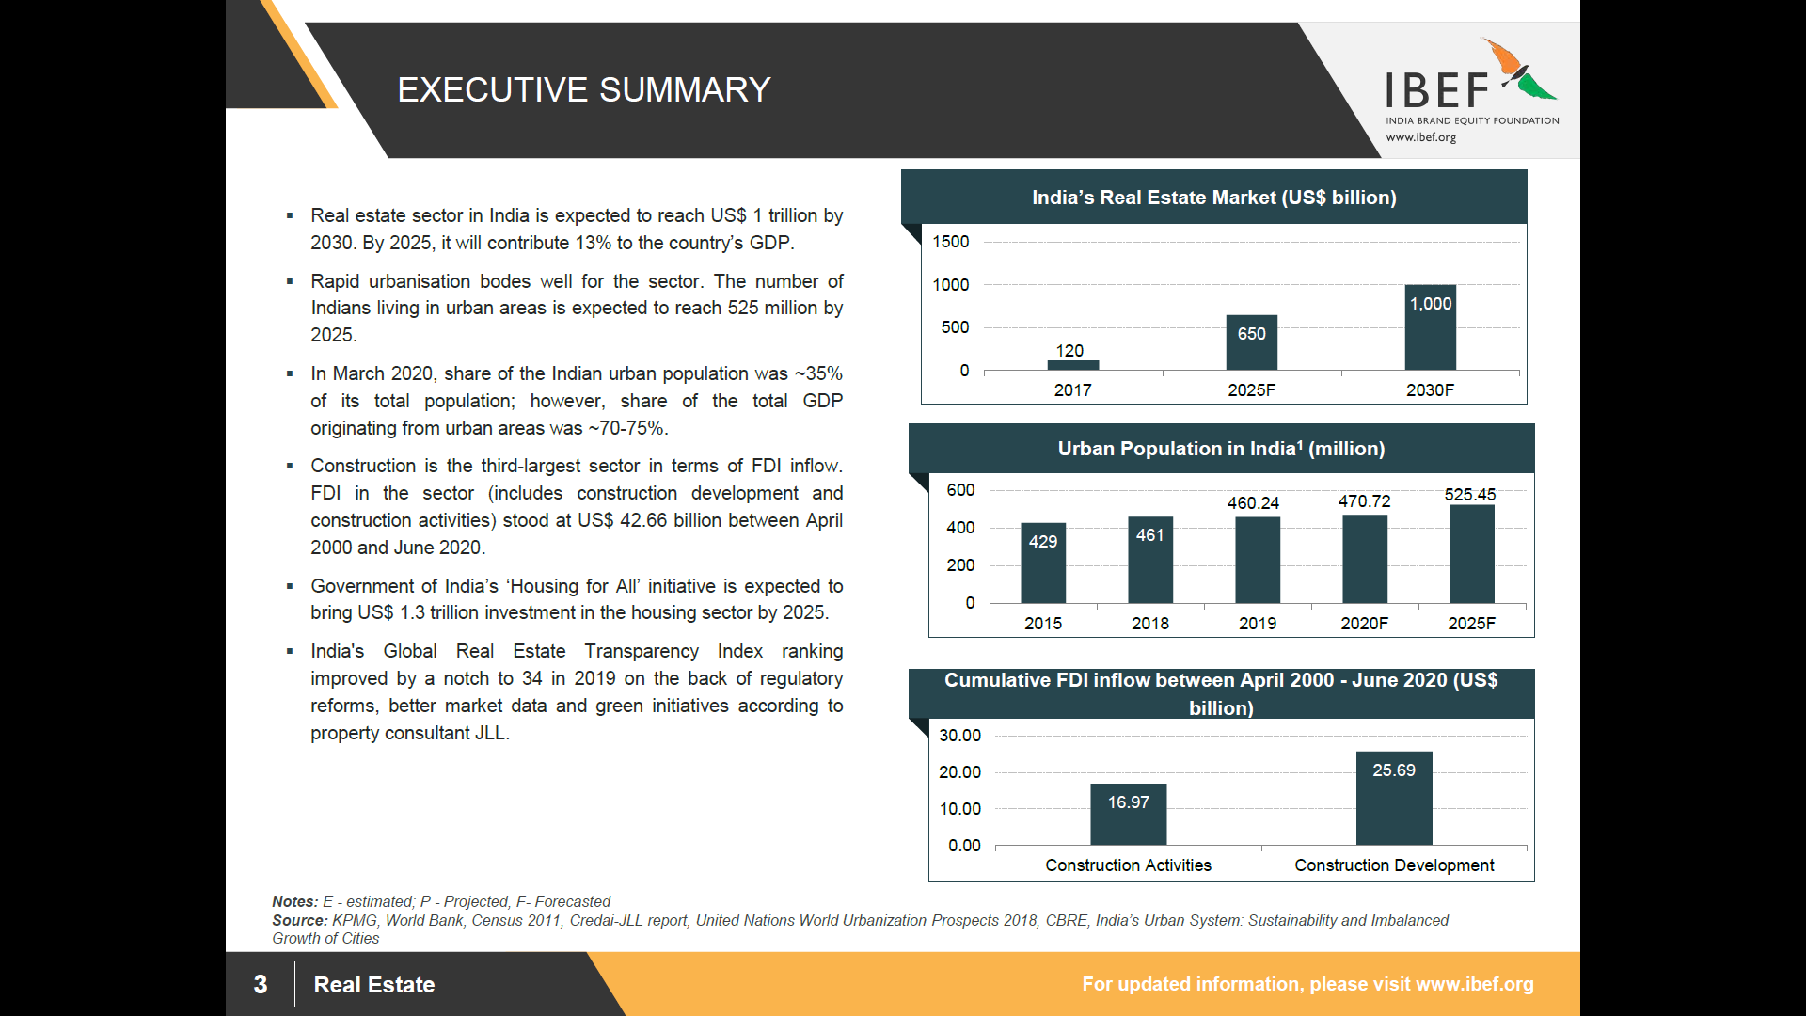

**Advantage India**

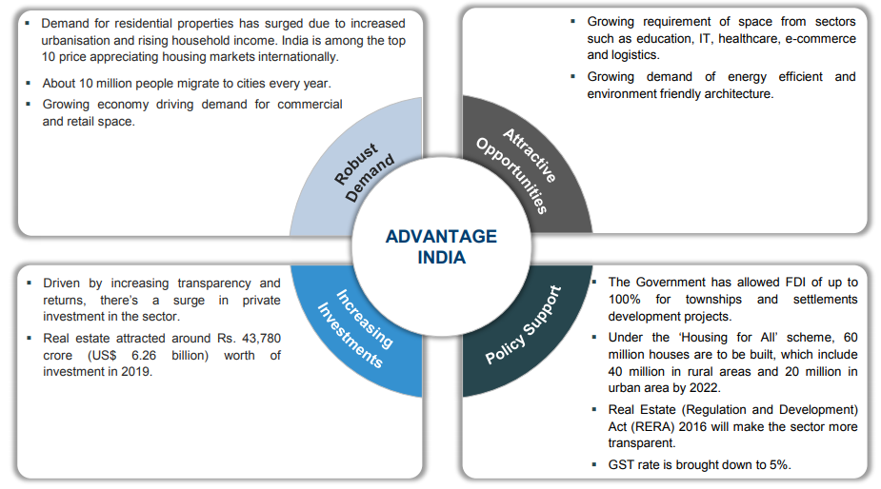

## Segments in the Indian Real Estate Sector

The Real Estate Sector is divided into several market namely residential, commercial, retail space, hospitality & Special Economic Zones (SEZs). The residential segment contributes approximately 80 per cent to the real estate sector. New housing launches across top eight cities in India are expected to increase by 23 per cent year-on-year by 2019 to 2,23,325 units. As far as the commercial segment is concerned, there are only a few players with presence across India and most of the activity is in the leasing segment. FDI in multi brand retail is expected to boost demand.

In 2019, Retail segment in Indian attracted private equity (PE) investment of around US$ 1 billion and supply of around another 39 million sq. ft. is expected in 2022. In the hospitality segment, Supply of Hotel room in India has increased 5.4 per cent year-on-year in 2019, totalling to 133,359 rooms at the end of 2019. The sector is likely to attract an annual investment between US$ 0.5-0.6 billion during 2018-2022, with total investment reaching US$ 2.8 billion by 2022. As on July 31, 2020, India had formally approved 423 SEZs, of which 248 were in operation. Majority of the SEZs are in the IT/ ITeS sector. In March 2020, the Government had approved proposals from TCS and DLF to set up SEZs for IT sector in Haryana and Uttar Pradesh.

## Market Size of the India Real Estate

The Real Estate sector in India is expected to reach a market size of US$ 1 trillion in market size by 2030, up from US$ 120 billion in 2017. It has been estimated that India’s real estate market will grow at a CAGR of 19.5% during 2017- 2028. Increasing share of real estate in the GDP would be supported by increasing industrial activity, improving income level and urbanization. The government also launched 10 key policies for real estate sector, namely: Real Estate Regulatory Act, Benami Transactions Act, boost to affordable housing construction, Interest subsidy to home buyers, change in arbitration norms, service tax exemption, Dividend Distribution Tax (DDT) exemption, Goods and Services Tax, Demonetization & PR for foreign investors.

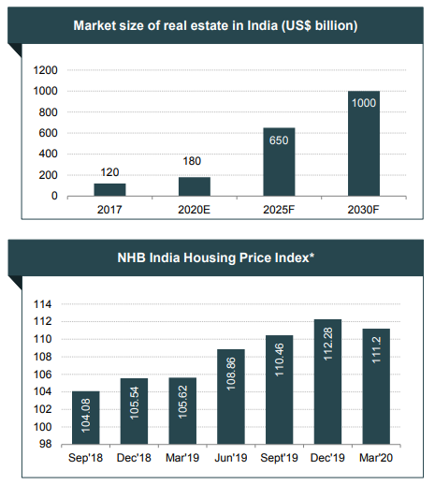

***CAGR - Compounded Annual Growth Rate***

***\*average of indices of all cities***

## Demand for Residential Space

A localized, fragmented market presents opportunities for consolidation with only few large, pan-India players such as DLF. More foreign players might enter the market as FDI norms have eased. Furthermore, norms on land acquisitions are expected to be relaxed. Key drivers for the increase in demand are rapid urbanization, growth in population, rise in the number of nuclear families, easy availability of finance, repatriation of NRIs and HNIs & rise in disposable income.

Housing sales reached 2.61 lakh units in 2019 across seven major cities. NCR (National Capital Region) is expected to generate maximum demand in MIG and HIG category followed by Bengaluru. Developers are now focussing on affordable and mid-range categories to meet the huge demand.

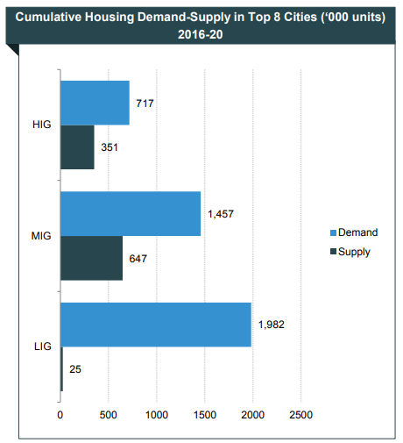

***Source : Cushman and Wakefield, Anarock Property Consultants***

**Factors driving the Residential Demand Revival**

Stress in real estate sector and the covid-19 pandemic in a way has been a blessing in disguise for the end users and disciplined. These have led to consolidation and segregation of projects while the smaller un-organised developers without financial closures are finding it difficult to sell, there is already up surge in take up for the apartments with certainty of completion.

The factors driving the apartments demand are:

The interest rates are at 15 years low, making purchase of homes much more affordable.

The stamp duty reduction by government of Maharashtra has provided impetus for new to Apartment purchases as well as faster registration

Covid pandemic has underlined the advantages of owning a good quality apartment

**Strategies Adopted**

A few strategies adopted are mentioned in brief. Having a diverse portfolio of residential, commercial and township developments is vital. Companies have projects in various strategic geographic locations in order to diversify risks. There is focus on the growth of lease business. Housing finance companies and private equity companies have started focusing on affordable housing.

The execution has been superior through outsourced support functions, focus on delivery capability, rationalizing costs and development of world class infrastructure.

## About Nashik

CREDAI Nashik Metro has been instrumental in the overall infrastructural development in the city as it closely works with the corporation and the government towards planned execution of the various projects to ensure timely completion with minimal interference in civic life. As per the CREDAI report, Nashik has over 2000 residential projects and 200 commercial projects underway at different stages of development – so nearly 10,000 new homes will be available over the next two–three years. Here are some key highlights about Nashik which make it an ideal real estate destination.

Nashik was once known as the pilgrim city. But in the last decade, the city has vastly improved its infrastructure, real estate, industrial corridor and also created quality healthcare and educational hubs, thus making it one of the fastest growing cities in India. The rising cost of living in the metropolitan cities and since Mumbai and Pune, seemingly have a saturated real estate market, Nashik became the next probable choice of destination for investors.

For any city, connectivity is paramount and the geo-location of Nashik, naturally makes the city easily accessible. Its proximity to Pune and Mumbai and the city’s connectivity to all nearby towns and locations in Maharashtra, in addition to the airport, makes Nashik super-connected. We also have the Samruddhi highway going to Mumbai and Nashik is a key element on that highway – connected at three-four junctions.

## ****Connectivity with nearby localities****

* Nashik Road railway station is city railway station along with Deolali which lies within the city boundary.
* Nashik is served by National Highway 60. Mumbai-Nashik Expressway connects Nashik to Mumbai.[63] India's first 10 lane expressway is going to be built between Nashik & Pune. Surat-Nashik-Chennai expressway goes through Nashik city. The Samruddhi Highway also goes 15 km from Nashik city.
* Nashik Municipal Corporation (NMC) has rolled out its city bus service Citilinc on 8 July 2021.The previous state government had given its nod to the NMC to take over the city bus service from the ailing Maharashtra State Road Transport Corporation (MSRTC).
* Metro – Greater Nashik Metro is proposed by Maharashtra Metro Rail Corporation Limited. It will be operational in 2024.
* Trams [1889-1933] - Nashik was the third city in India after Kolkata and Mumbai to get trams. Trams started operation in 1889.It originated from the Old Municipal Corporation building located on Main Road, and terminated at the Nashik Road railway station (8–10 km). It is passed through areas of Ganjamal (the now defunct bus stop was earlier a tram stop) and behind the Fame Multiplex. Brady's; a private company funded the project and later introduced India's first petrol engine driven tram under the aegis of Nasik Tramway Co. The tramway closed down in around 1933 owing to the successive years of famine and plague, it had run into heavy losses.
* Autorickshaws - The city has a huge number of autorickshaws that work on sharing as well as direct fare basis.
* Nashik has its airport located at Ozar and an old airport at Gandhinagar which connected Nashik to Mumbai. The Gandhinagar Airport is now reserved for the military. Nashik Airport is a domestic airport and is connected to Ahmedabad, Delhi, Goa, Hyderabad, Indore, and Nagpur.

## ****Civic Amenities & Infrastructure****

Nashik city is governed by the Nashik Municipal Corporation. Nashik is the district headquarters of the Nashik District, 185 km (115 mi) away from Mumbai. The city has developed on both banks of the Godavari, which divides the city into almost equal halves.

The municipal commissioner of Nashik is Ashok Karanjkar.

The ward committee consists of councillors representing the electoral wards within the territorial area of the ward committee.[38] There are six ward committees namely Nashik (E), Nashik (W), Nashik Road, Panchavati, CIDCO and Satpur. The main function of the committees is to approve the cost of works for the wards, incorporate the expenses in the budget etc.

The Nashik Municipal Corporation (NMC) is planning to start major civic projects in 2020. Projects like the creation of more smart roads, setting up of 800 CCTVs, installation of LED streetlights, Goda beautification project, construction of two major water treatment projects (WTPs), upgradation of STPs, making smart parking operational, etc. would be given priority by the municipal corporation.

In early 1925, the table grape revolution was started in Ojhar, a small town near Nashik, by Raosaheb Jairam Krishna Gaikwad. Today, table grapes are exported to Europe, the Middle East, and Asia. Onion is one of the majorly produced crop in Nashik district.

The total cultivable area in Nashik district is 864,000 hectares, of which the average Kharip crop area is 663,200 hectares, while the average Rabbi crop area is 136,500 hectares. The sown area is 658,763 hectares (99%) and the forest land is 340,000 hectares (21.75%). The uncultivable area is 23,000 hectares (1.48%).

The Igatpuri-Nashik-Sinnar investment region is an important node in the US$90 billion Delhi Mumbai Industrial Corridor Project.

Nashik is a defence and aerospace manufacturing hub with Hindustan Aeronautics Limited aircraft manufacturing plant located at Ozar. The Currency Note Press and India Security Press are on Nashik Road, where Indian currency and government stamp papers are printed respectively.

Existing industrial areas in Nashik district are Satpur, Ambad, Sinnar, Igatpuri, Dindori and Vinchur. The proposed additional areas are Sinnar, Malegaon and Rajur Bahula.

Large-scale industries present in Nashik district are Atlas Copco, Robert Bosch GmbH, CEAT Limited, Crompton Greaves, Graphite India, ThyssenKrupp, Epcos, Everest Industries, Gabriel India, GlaxoSmithKline, Hindustan Coca-Cola, Hindustan Unilever Limited, Jindal Polyster, Jyoti Structures, Kirlosker Oil Engines, KSB Pumps, Larsen & Toubro, Mahindra and Mahindra, Mahindra Sona, United Spirits Limited, Perfect Circle Industries, Mahindra Ugine Steel, Samsonite, Shalimar Paints, Siemens, VIP Industries, Indian Oil Corporation, XLO India Limited and Jindal Saw.

Apart from manufacturing, Nashik is an emerging investment destination for Information Technology companies. Tata Consultancy Services has invested in Nashik under the government of India BPO promotion scheme (IBPS). Also, WNS, Accenture, TCS has set up Digital Impact Square, or DISQ, which is a social innovation center.

Nashik has a textile industry. National Bank for Agriculture and Rural Development has selected Yeola Block for development of Paithani Cluster. To facilitate exports, a container freight station was started at MIDC Ambad by the Central Government. Nashik has been described as "The Wine Capital of India". The Nashik region reportedly produced 10,000 tonnes of grapes per year.

In 2013, there were 22 wineries in Nashik, out of 46 wineries throughout India. The largest vineyard in Nashik is the Sula Vineyards.

In the harvest season, Nashik is home to several wine festivals, such as the India Grape Harvest and SulaFest.

In February 2016, The Statue of Ahimsa, a 108 ft idol of first Jain tirthankara Rishabhdev carved in monolithic stone was consecrated at Mangi Tungi nearyly 122 km from Nasik city. It is recorded in the Guinness Book of World Records as the tallest Jain idol in the world.

The Trirashmi (Pandavleni) Caves, or Nashik Caves, are a group of 24 caves carved between the 1st century BCE and the 2nd century CE, representing the Hinayana Buddhist caves.

Gangapur Dam is on the river Godavari near Gangawadi village and is an earthen dam, Nashik.

Chankapur dam on the Girna river is one of the big dams built by the British in the 19th century. It is 3 km from the village Abhona in Kalwan tehsil and 60 km from Nashik.

Kashypi Dam is on the Kashypi river near Rajapur, Nashik.

Girna Dam is an earthfill dam on river Girna near Nandgaon, Nashik District.

Darna Dam is a gravity dam on Darna River near Igatpuri, Nashik district.

The Kumbh Mela is celebrated every six years at Haridwar and Prayagraj and Maha Kumbh takes place every twelve years at four places: Prayagraj, Haridwar, Ujjain, and Nashik. According to the Puranas, it is believed that Kumbh derives its name from an immortal pot of nectar, which the devatas (Gods) and rakshasas (Demons) fought over. The four places where the nectar fell are at the banks of river Godavari in Nashik, river Kshipra in Ujjain, river Ganges in Haridwar and at Triveni Sangam of Ganga, Yamuna and invisible Saraswati River in Prayagraj.

## Price Trends in Nashik

# 

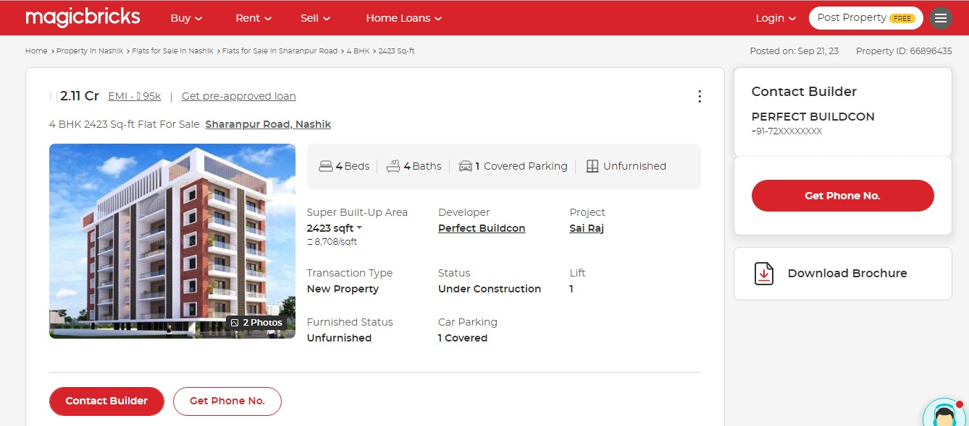

## Price Trends in Nashik

# 

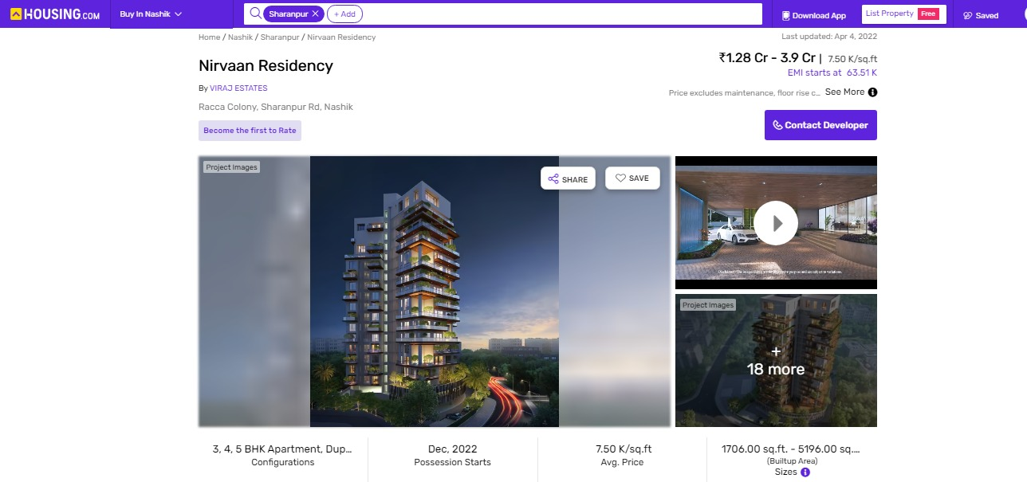

# Project Details

**Bhavik & Saraf Ventures a partnership firm** is developing Residential Project in Nashik in the name of **“THE EMPIRE”.**  The proposed project is located on the pieces and parcel of land admeasuring 3902.86 Sq. Mtr. Bearing S.No.646/7B/1/2/A2, CTS No.6821 to 6824 F.P. No. 250, TPS-2, Sharanpur Road, Tilakwadi Nashik-422002**.**

**The project land is acquired by Bhavik & Sarad ventures via**

**THE EMPIRE** is an ongoing residential real estate project being developed by “M/s **Bhavik & Saraf Ventures** (Developers)”. The project consists 2 Basement + Ground + 21 storied Buildings will have total 56 units, 36 - 3BHK + Terrace units, 18 - 4BHK + Terrace units, 2 - 8BHK + Terrace (Penthouse) Units. The RERA Registration number for the project “THE EMPIRE” is P51600025617. The firm will start the project in 2021 and the same has been completed by end of December 2025

**Land History:**

The project has been developed on the land which is acquired by M/s **Bhavik & Saraf Ventures** (Developers)” via registered sale agreement dated 05-08-2011. The total area of land is 3902.86 Sq. Mtr.

M/s. Bhavik & Saraf Ventures purchased land from the Shri. Hemant Vitthal Waje at consideration amount of Rs. 9.25 Cr. Through sale deed dated 05.08.2011 through registered agreement Doc. No. 9695 on 05.08.2011.

As per ME No. 300232 dated 04.11.2017 as per order dated 20.07.2017 passed by the civil judge senior division, Nashik in civil suit no. 511/2013, the remark such as “Status Quo to be Maintained till matter is decided” appearing in the other rights column of the 7/12 extract of subject land was cancelled / deleted.

As per ME No. 302316 dated 28.05.2020, M/s. Bhavik & Saraf Ventures transferred portion of land admeasuring 40.32 Sq. M. out of Survey No. 646/7B/1/2/A/2 in favour of Nashik Municipal Corporation for road widening purpose through letter no. Javak No./NNV/Vashi/252/2020 dated 21.05.2020.

For full land history reference Title Search Report dated 24.08.2023 issued by Ramesh S. Giri.

The brokerage amount for purchasing the land was paid the amount of Rs. 0.20 Cr.

**About Residential Building**

The project is a RERA registered project. RERA registration number of Commercial cum Residential building is P51600025617.

Details of the apartments are as below

**Flat Inventory: -**

|  |  |  |
| --- | --- | --- |
| Type | RERA Area | Inventory as on 30th September’ 23 |
|  | In Sq. M. | **Saleable units** |  |  |
| 3BHK+Terrace | 173.09 | 18 |
| 3BHK+Terrace | 179.31 | 18 |
| 4BHK+Terrace | 233.84 | 18 |
| 8BHK+Terrace | 449.28 | 1 |
| 8BHK+Terrace | 663.50 | 1 |
| Total |  | **56** |

Amenities available for the convenience of residents are closed car parking areas, open area for fire protection system, Fire sprinklers, fire safety equipment, well-lit internal roads, regular supply of water, and other facilities are provided in the complex. All work related to solid waste management and disposal, treatment of sewage and sullage water, sewerage chamber, lines, septic tank, and STP are taken care with the best technology in the premises. Water conservation, energy management, and rainwater harvesting, recreational activities, landscaping and tree planting are under taken to make buildings sustainable, protect the environment & optimize the resources.

## Location & Connectivity

**Project The Empire** is located on the pieces and parcel of land admeasuring 3902.86 Sq. Mtr. Bearing S.No.646/7B/1/2/A2, CTS No.6821 to 6824 F.P. No. 250, TPS-2, Sharanpur Road, Tilakwadi, Nashik-422002**.** The satellite location of the site is 19.139041 North and 72.871081 East.

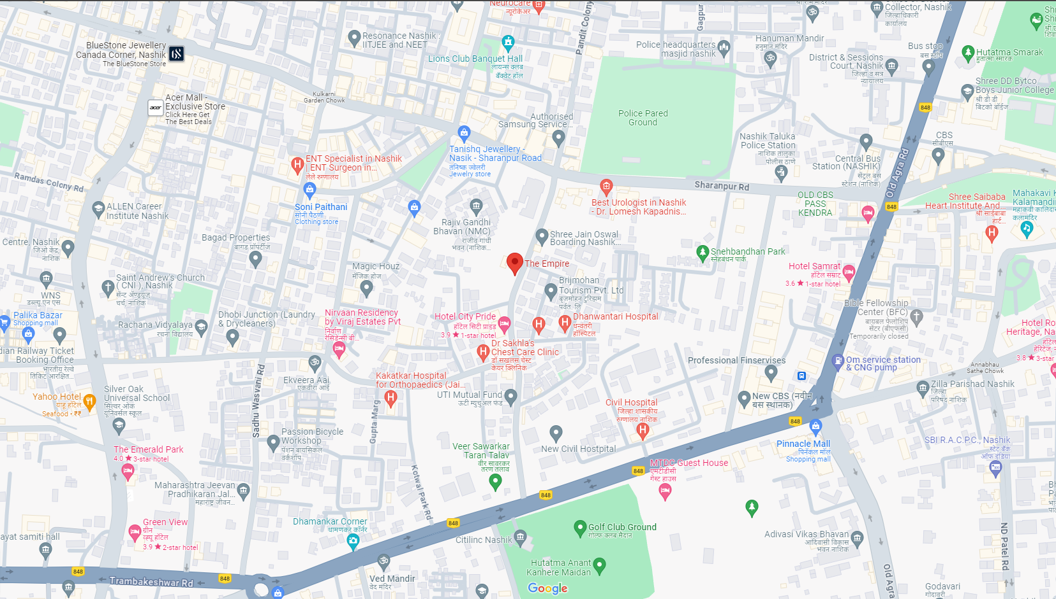

**Location**

The project is closely connected with railways and city roads. The Nashik Road Railway Station is about 10.10 Km from the project site. The said property is located in a mixed-use development area where there are residential and commercial establishments. The site is accessible by road. There are buses, taxis and richshaws available to reach the site.

## Land Details

* The land is given Sale Agreement (registered agreement vide No. BDR 9695 dated 05-08-2011) between Hemant Vithal Vaje (The Vendor) and M/s. **Bhavik & Saraf Ventures** (The Purchasers).

**Land History:**

* The project has been developed on the land which is acquired by M/s **Bhavik & Saraf Ventures** (Developers)” via registered sale agreement dated 05-08-2011. The total area of land is 3902.86 Sq. Mtr.
* M/s. Bhavik & Saraf Ventures purchased land from the Shri. Hemant Vitthal Waje at consideration amount of Rs. 9.25 Cr. Through sale deed dated 05.08.2011 through registered agreement Doc. No. 9695 on 05.08.2011.
* As per ME No. 300232 dated 04.11.2017 as per order dated 20.07.2017 passed by the civil judge senior division, Nashik in civil suit no. 511/2013, the remark such as “Status Quo to be Maintained till matter is decided” appearing in the other rights column of the 7/12 extract of subject land was cancelled / deleted.
* As per ME No. 302316 dated 28.05.2020, M/s. Bhavik & Saraf Ventures transferred portion of land admeasuring 40.32 Sq. M. out of Survey No. 646/7B/1/2/A/2 in favour of Nashik Municipal Corporation for road widening purpose through letter no. Javak No./NNV/Vashi/252/2020 dated 21.05.2020.
* For full land history reference Title Search Report dated 24.08.2023 issued by Ramesh S. Giri.

Project Area Statement as per Approved Building Plans

As per Approved Plan Built – Up Area Statement as below:

|  |  |  |  |  |
| --- | --- | --- | --- | --- |
| Floor | Total Built Up Area of Floor as per outer construction line | FSI | Ancillary FSI | Remark |
| Basement | 0 | 0 | 0 | Retained |
| Ground | 0 | 0 | 0 | Retained |
| 1st Floor | 490.05 | 490.05 | 0 | Retained |
| 2nd Floor | 490.05 | 490.05 | 0 | Retained |
| 3rd Floor | 490.05 | 490.05 | 0 | Retained |
| 4th Floor | 490.05 | 490.05 | 0 | Retained |
| 5th Floor | 704.43 | 440.27 | 264.16 | UDCPR |
| 6th Floor | 717.79 | 448.62 | 269.17 | UDCPR |
| 7th Floor (Refuge Floor) | 704.43 | 440.27 | 264.16 | UDCPR |
| 8th Floor | 717.7 | 448.62 | 269.17 | UDCPR |
| 9th Floor | 704.43 | 440.27 | 264.16 | UDCPR |
| 10th Floor | 717.7 | 448.62 | 269.17 | UDCPR |
| 11th Floor (Refuge Floor) | 704.43 | 440.27 | 264.16 | UDCPR |
| 12th Floor | 717.7 | 448.62 | 269.17 | UDCPR |
| 13th Floor | 704.43 | 440.27 | 264.16 | UDCPR |
| 14th Floor | 717.7 | 448.62 | 269.17 | UDCPR |
| 15th Floor | 704.43 | 440.27 | 264.16 | UDCPR |
| 16th Floor (Refuge Floor) | 717.7 | 448.62 | 269.17 | UDCPR |
| 17th Floor | 704.43 | 440.27 | 264.16 | UDCPR |
| 18th Floor | 717.7 | 448.62 | 260.17 | UDCPR |
| 19th Floor (Recreational Floor) | 0 | 0 | 0 | UDCPR |
| 20th Floor (Refuge Floor) | 615.38 | 384.61 | 230.77 | UDCPR |
| 21st Floor | 540.98 | 338.11 | 202.87 | UDCPR |
| Total Pline Area | 13071.56 | 8905.15 | 4157.95 | 0 |

Note: -

* Approved plan is provided.

## Project Cost

The total project cost estimated by **BHAVIK & SARAF VENTURES works** out to **INR 77.91 Crore**. The detailed acquisition cost is as tabulated below:

**INR in Crore**

|  |  |  |  |  |
| --- | --- | --- | --- | --- |
| Particulars | Total Project Cost | Cost incurred till 30/09/2023 | Balance Cost to be Incurred | %tage of Total |
| Land & Stamp Duty | 9.45 | 9.45 | - | 12.13% |
| Construction Cost | 50.00 | 23.57 | 26.43 | 64.17% |
| Approval Cost (FSI charges) + DC + Stair case + PT + (BMC Premium) | 8.80 | 8.25 | 0.55 | 11.29% |
| Architect & Consultancy Expenses | 1.95 | 2.50 | 1.95 | 2.51% |
| Admin & Marketing Expenses | 2.50 | 3.21% |
| Contingency | 0.26 | 0.00 | 0.26 | 0.33% |
| Interest to Bank Finance (till construction period) | 4.95 | 0.00 | 4.95 | 6.35% |
| Total | **77.91** | **43.77** | **34.14** | **100.00%** |

* The land cost works out to **12.13 %** of the total project cost incurred till **September 30, 2023**. This cost generally ranges from **15%** to **20%** for comparable projects. The total land cost on the consolidated level for the said project shall work out to about **12.13%**.
* The approval cost incurred in the project till **September 30, 2023** works out to about **11.29%.** This cost generally ranges from **10%** to **15%** for comparable projects. The total approval cost on the consolidated level for the said project shall work out to about **11.29%**.
* The total construction cost works out to about **64.17%** of the total project cost. This cost generally ranges from **50%** to **70%** for comparable projects.
* The admin, marketing cost incurred in the project till **September 30, 2023** works out to about **3.21%.** This cost generally ranges from **5%** to **10%** for comparable projects. The total admin, marketing cost on the consolidated level for the said project shall work out to about **3.21%**.
* The interest during construction (**IDC**) incurred in the project works out to about **6.35%.** This cost generally ranges from **10%** to **20%** for comparable projects.
* Total cost incurred till **September 30, 2023** is **INR 43.77 Crore** and balance cost to complete work out to **INR 34.14 Crore**
* Considering all the cost we feel that the project cost seems reasonable.

## Means of Finance

The means of finance proposed for the said project cost shall be as tabulated below:

**INR in Crore**

|  |  |  |
| --- | --- | --- |
| Particulars | Total Funds to be Raised | %tage of Total |
| Promoters Contribution |  |  |
| Owners Contribution | 21.00 | 27.00% |
| Unsecured Loan | 21.00 | 27.00% |
| Bank Loan |  |  |
| Term Loan | 20.00 | 25.70% |
| Customer Advances | 15.91 | 20.40% |
| Total | **77.91** | **100.0%** |

The means of finance proposed to fund the balance cost of construction for the project seems justified.

## Project Approvals and their Status

|  |  |  |  |
| --- | --- | --- | --- |
| Approval/ Consent | Approving Authority | Status | Doc. No. / Dated |
| NA Permission | Collector Office Nashik | Obtained | Mah/Kaksh-3/4/Bi. She Pra. Kra/212/2008 dated 14.09.2009 |
| Previous Plan Approval | Nashik Municipal Corporation | Obtained | A1/BP/05/2020 dated 20.05.2020 |
| Amend Plan Approval | Nashik Municipal Corporation | Obtained | A1/BP/308/2022 dated 04.02.2022 |
| Commencement Certificate | Nashik Municipal Corporation | Obtained | A1/BP/308/2022 dated 04.02.2022 |
| Fire NOC Certificate | Fire Safety Department, Nashik Municipal Corporation | Obtained | NMC/FIRE/WS/II/Resi-2021-22 dated 14.01.2022 |
| Plinth Occupancy Certificate | Nashik Municipal Corporation | Obtained | LND/WS/A1/PC/06/2020 dated 05.08.2020 |

## Current Status of the Project

* To have actual feel of the project we have visited the site on 13.09.2023 following person were present

|  |  |  |  |
| --- | --- | --- | --- |
| Sr. | Name |  | Contact No |
| 1 | **Saurabh Shinde** | **Site Engineer**  Bhavik & Saraf Ventures | **+91 9156569171** |
| 2 | **Swapnil Wagh** | **Valuation Engineer**  Vastukala Consultants (I) Pvt. Ltd. | **+91 9822660633** |

* The RCC work for Sale Building has completed.

## Implementation Schedule

The implementation schedule is stretched over **20 months** starting from **July, 2021**. The bottleneck of all tasks is Building Construction and Statutory approvals but enough contingency time has been allocated for each activity so that if there is any time overrun it can be taken care off. The time line allocated for each activity/ task is found to be adequate. We believe that this time frame is reasonable for completion of the project and the proposed completion date of **June, 2026** for Residential project sale building is realistic provided the company adheres to the timelines projected in this TEV Report.

**As per information shared by the developer the balance work for completion of the construction it must be completed in the next quarter 4 of the FY 2023 – 2024 and quarter 1 of the FY 2024 – 2025.**

# Economic Viability

## Construction Area As per Approved Plan

The total construction area of the project are as follows: -

**Sale Building**

|  |  |
| --- | --- |
| Floor | Construction Area in Sq. M. |
| Basement-1st | 2344.83 |
| Basement-2nd | 2344.83 |
| Ground Floor | 2344.83 |
| 1st Floor | 704.43 |
| 2nd Floor | 717.79 |
| 3rd Floor | 704.43 |
| 4th Floor | 717.79 |
| 5th Floor | 704.43 |
| 6th Floor | 717.79 |
| 7th Floor | 704.43 |
| 8th Floor | 717.79 |
| 9th Floor | 704.43 |
| 10th Floor | 717.79 |
| 11th Floor | 704.43 |
| 12th Floor | 717.79 |
| 13th Floor | 704.43 |
| 14th Floor | 717.79 |
| 15th Floor | 704.43 |
| 16th Floor | 717.79 |
| 17th Floor | 704.43 |
| 18th Floor | 717.79 |
| 19th Floor | 842.45 |
| 20th Floor | 615.38 |
| 21st Floor | 540.98 |
| Total | **21,833.28** |

**Construction Cost: -**

Total Construction area = 21,833.28 Sq. M.

Total estimated cost for construction of Building (includes cost of RCC work, manpower, lift, material, painting, finishing work, site development, etc.) is ` 50,00,09,637.00 i.e., ` 50.00 Cr. which comes ` 22,900.00 per Sq. M. on construction area for building.

VCIPL opinion the construction cost of 22,900/- Per Sq. M. which is in line with Market-Trend.

As per Engineer Certificate dated 16.05.2023 issued by Sagar S. Shah, the construction cost of the project is certified by him is Rs. 42.00 Cr.

The Estimate vetting for the balance work of construction of building issued by CA. Nirav Shailesh Shah & Co. dated 08.12.2023, the estimated cost is Rs. 31.43 Cr., it is fair and justified for the completion of pending construction.

Hence, the cost of construction for pending and other Contingous work the cost to be incurred will be Rs. 31.43 Cr.

**Approval Cost: -**

The Total Approval Cost (Fungible Cost & Development Cess Premium & TDR Cost) as per architect letter will be Rs. 8.80 Cr. Builder has paid Rs. 8.25 Cr.

After verifying the incurred cost statement with the developer, it is observed that builder has paid the payment to NMC from dated 24.11.2020 to 03.01.2022.

The Stamp Duty required for the purchase of land is also considered in the approval cost.

Balance paid will be utilise for the obtaining the occupancy certificate.

**Architect Cost, RCC & Other Professional Charges:**

The total Architect charges of Rs. 1.95 Cr. is 4% of total construction cost building & it is line up with Market trend.

The professional charge consists of Architect & Legal which in market is in the range of 2% - 5% of Total Construction cost of the project.

**Administrative & Marketing Expenses:**

Salaries, site overheads, development works, cost of services (including water, electricity, sewerage, drainage, layout roads etc.), cost of machineries and equipment including its hire and maintenance cost, consumables, marketing etc. All costs directly incurred to complete the construction of the entire project is estimated 5% of total construction cost Building which comes to Rs. 2.50 Cr.

The admin charges which in market is in the range of 3% - 6% of Total Construction cost of the project.

**Contingency Costs:**

The contingency charges estimated at 0.52 % total construction cost of building which comes to Rs. 0.26 Cr., because in construction cost also contingency cost amount is considered, so separate 1% of contingency is considered.

## Inventory

**BHAVIK & SARAF VENTURES offers** apartment with perfect combination of contemporary architecture and features to provide comfortable living. It offers Apartment in 1 BHK configurations. Details of the units are as below: -

**Flat Inventory: -**

|  |  |  |
| --- | --- | --- |
| Type | RERA Area | Inventory as on 30th September’ 23 |
|  | In Sq. M. | **Saleable units** |  |  |
| 3BHK+Terrace | 173.09 | 18 |
| 3BHK+Terrace | 179.31 | 18 |
| 4BHK+Terrace | 233.84 | 18 |
| 8BHK+Terrace | 449.28 | 1 |
| 8BHK+Terrace | 663.50 | 1 |
| Total |  | **56** |

**Projected Revenue**

The proposed revenue from the sale of flats are as follows: -

|  |  |  |  |  |  |  |  |  |  |
| --- | --- | --- | --- | --- | --- | --- | --- | --- | --- |
| Particulars | Units | Till sept-23 | FY24 | FY25 | FY26 | FY27 | FY28 | FY29 | Total |
|  |  |  |  |  |  |  |  |  |  |
|  |  |  |  |  |  |  |  |  |  |
| Sale Building | No. | 11 | 2 | 7 | 10 | 9 | 8 | 9 | 56 |
| Total | **11** | **2** | **7** | **10** | **9** | **8** | **9** | **56** |
|  |  |  |  |  |  |  |  |  |  |
| Revenue |  |  |  |  |  |  |  |  |  |
| Sale Building | INR in Cr. | **11.48** | **0.05** | **0.23** | **1.64** | **9.51** | **34.50** | **39.27** | 96.68 |
| Total Revenue to collected | **11.48** | **0.05** | **0.23** | **1.64** | **9.51** | **34.50** | **39.27** | **96.68** |

**Sale Projection:**

|  |  |  |  |  |  |
| --- | --- | --- | --- | --- | --- |
| Quarter | No of Units Estimated to be Sold | Estimated Cumulative Units to be Sold | Estimated Carpet Area to be Sold in Sq. Ft. | Rate considered per Sq. Ft. on Carpet Area | Sale value to be booked in Quarter in Rs. Cr. |
|  | - | - | - |  |  |
| Till Sept-23 | 11 | 11 | 24,166 | - | 15.56 |
| 2023-24 Q3 | 1 | 12 | 1,863 | 8,000 | 1.49 |
| 2023-24 Q4 | 1 | 13 | 1,930 | 8,000 | 1.54 |
| 2024-25 Q1 | 1 | 14 | 2,517 | 8,000 | 2.01 |
| 2024-25 Q2 | 1 | 15 | 1,930 | 8,000 | 1.54 |
| 2024-25 Q3 | 2 | 17 | 4,380 | 8,000 | 3.50 |
| 2024-25 Q4 | 3 | 20 | 5,656 | 8,000 | 4.53 |
| 2025-26 Q1 | 3 | 23 | 6,243 | 8,000 | 4.99 |
| 2025-26 Q2 | 2 | 25 | 4,380 | 8,000 | 3.50 |
| 2025-26 Q3 | 4 | 29 | 7,452 | 8,000 | 5.96 |
| 2025-26 Q4 | 1 | 30 | 2,517 | 8,000 | 2.01 |
| 2026-27 Q1 | 2 | 32 | 4,447 | 8,000 | 3.56 |
| 2026-27 Q2 | 1 | 33 | 4,836 | 8,000 | 3.87 |
| 2026-27 Q3 | 4 | 37 | 12,798 | 8,000 | 10.24 |
| 2026-27 Q4 | 2 | 39 | 4,447 | 8,000 | 3.56 |
| 2027-28 Q1 | 1 | 40 | 1,863 | 8,000 | 1.49 |
| 2027-28 Q2 | 2 | 42 | 4,447 | 8,000 | 3.56 |
| 2027-28 Q3 | 2 | 44 | 3,793 | 8,000 | 3.03 |
| 2027-28 Q4 | 3 | 47 | 6,377 | 8,000 | 5.10 |
| 2028-29 Q1 | 3 | 50 | 6,897 | 8,000 | 5.52 |
| 2028-29-Q2 | 6 | 56 | 12,621 | 8,000 | 10.10 |
| Total | **56** |  | **1,25,562** |  | **96.68** |

**Sales and Cost Working**

**INR in Crore**

|  |  |  |  |  |  |  |  |  |
| --- | --- | --- | --- | --- | --- | --- | --- | --- |
| Particulars | Till Sept-23 | FY24 | FY25 | FY26 | FY27 | FY28 | FY29 | Total |
| Sale Building sales in units | 11 | 13.00 | 7.00 | 10.00 | 9.00 | 8.00 | 9.00 | 56.00 |
| Total | **11** | **13** | **7** | **10** | **9** | **8.00** | **9.00** | **56** |
|  |  |  |  |  |  |  |  |  |
|  |  |  |  |  |  |  |  |  |
| Revenue |  |  |  |  |  |  |  |  |
| Sale Building | 11.48 | 0.05 | 0.23 | 1.64 | 9.51 | 34.50 | 39.27 | 96.68 |
| Total Revenue | **11.48** | **0.05** | **0.23** | **1.64** | **9.51** | **34.50** | **39.27** | **96.68** |
|  |  |  |  |  |  |  |  |  |
| Construction Cost | **Till Sept 23** | **FY24** | **FY25** | **FY26** | **FY27** | **FY28** | **FY29** | **Total** |
| Land & Stamp Duty | 9.45 | - |  |  |  |  |  | **9.45** |
| Construction Cost | 23.57 | 5.00 | 10.00 | 10.00 | 1.43 | - | - | **50.00** |
| Approval Cost (FSI charges) +  DC + Stair case + PT + (BMC Premium) | 8.25 | 0.44 | - | - | 0.11 | - | - | **8.80** |
| Architect & Consultancy Expenses | 1.10 | 0.10 | 0.16 | 0.44 | 0.16 | - | - | **1.95** |
| Admin & Marketing Expenses | 1.40 | 0.23 | 0.20 | 0.49 | 0.18 | - | - | **2.50** |
| Contingency | - | 0.07 | 0.06 | 0.08 | 0.05 | - | - | **0.26** |
| Rent Cost | - | - | - | - | - |  |  | **-** |
| Interest to Bank Finance | - | 0.10 | 1.37 | 2.26 | 2.19 | 1.06 | 0.08 | **7.06** |
| Interest on Unsecured Loan | - | - | - | - | - |  |  | **-** |
| Total Cost Incurred | **43.77** | **5.94** | **11.78** | **13.27** | **4.12** | **1.06** | **0.08** | **80.03** |

## Profitability Projections

The projected profitability statement for the said project is as follows:

|  |  |  |  |  |  |  |
| --- | --- | --- | --- | --- | --- | --- |
| Particulars | FY 23-24 | FY 24-25 | FY 25-26 | FY 26-27 | FY 27-28 | FY 28-29 |
| Revenue |  |  |  |  |  |  |
| Sales | - | - | - | - | - | 96.68 |
| Closing WIP – The Empire | 49.71 | 61.49 | 74.77 | 77.90 | 77.90 | - |
| Total Revenue | 49.71 | 61.49 | 74.77 | 77.90 | 77.90 | 96.68 |
|  |  |  |  |  |  |  |
| Expenses |  |  |  |  |  |  |
| Expenses incurred during the year | 5.94 | 11.78 | 13.27 | 4.12 | 1.06 | 0.08 |
| Closing WIP – The Empire | 43.77 | 49.71 | 61.49 | 74.77 | 77.90 | 77.90 |
|  |  |  |  |  |  |  |
| Operating Profit | - | - |  | **-0.99** | **-1.06** | 18.70 |
|  |  |  |  |  |  |  |
| PBT | - | - | - | **-0.99** | **-1.06** | **18.70** |
| Tax | - | - | - | **-** | **-** | **5.61** |
| PAT | - | - | **-** | **-0.99** | **-1.06** | **13.09** |

## Cashflow Statement

The Cashflow statement of the project are as follows: -

**INR in Crore**

|  |  |  |  |  |  |  |  |  |
| --- | --- | --- | --- | --- | --- | --- | --- | --- |
| Particulars | Till Sept-23 | FY24 | FY25 | FY26 | FY27 | FY28 | FY29 | Total |
|  |  |  |  |  |  |  |  |  |
| Revenue |  |  |  |  |  |  |  |  |
| Sale Building | 11.48 | 0.05 | 0.23 | 1.64 | 9.51 | 34.50 | 39.27 | 96.68 |
| Total Revenue | **11.48** | **0.05** | **0.23** | **1.64** | **9.51** | **34.50** | **39.27** | **96.68** |
|  |  |  |  |  |  |  |  |  |
| Construction Cost | **Till Sept 23** | **FY24** | **FY25** | **FY26** | **FY27** | **FY28** | **FY29** | **Total** |
| Land & Stamp Duty | 9.45 | - |  |  |  |  |  | **9.45** |
| Construction Cost | 23.57 | 5.00 | 10.00 | 10.00 | 1.43 | - | - | **50.00** |
| Approval Cost (FSI charges) + DC + Stair case + PT + (BMC Premium) | 8.25 | 0.44 | - | - | 0.11 | - | - | **8.80** |
| Architect & Consultancy Expenses | 1.10 | 0.10 | 0.16 | 0.44 | 0.16 | - | - | **1.95** |
| Admin & Marketing Expenses | 1.40 | 0.23 | 0.20 | 0.49 | 0.18 | - | - | **2.50** |
| Contingency | - | 0.07 | 0.06 | 0.08 | 0.05 | - | - | **0.26** |
| Interest to Bank Finance | - | - | - | - | - |  |  | **-** |
| Total Cost Incurred | - | 0.10 | 1.37 | 2.26 | 2.19 | 1.06 | 0.08 | **7.06** |
|  |  |  |  |  |  |  |  |  |
| Work Completed | 57.04% | | 73.74% | 92.54% | 98.39% | 99.89% | 100% | 100% |
| Sales Completed | 0.00% | | 0.24% | 1.94% | 14.93% | 37.94% | 88.12% | 100% |

# 

# Financial Analysis

## Debt Equity Ratio

As per **Vastukala** assessment, the debt-equity ratio of the balance project shall be **0.47** times based on the promoter’s contribution of **INR 42.00 crore including unsecured loan** and construction loan of **INR 20.00 crore**.

**Vastukala** believes a debt-equity ratio of **0.47** is positive for a lender, considering the size of the project the same is justified.

## Loan-to-Sale Value (LTSV)

The total construction loan proposed by **BHAVIK & SARAF VENTURES** is to the tune of **INR 20.00 crore**. The sale of the total area available to the developer shall result in cash inflow of **INR 96.68 crore.** Thus, the **LTSV** works out to **20.69%**. We believe, this provides the lender with a comfortable cushion in case of a severe correction in the real estate sector.

## 

## Debt Service Coverage Ratio (DSCR)

The **average Cash DSCR** of the projects is **2.41.**  The Cash debt service coverage ratio (**DSCR**) working of the project is as given in the table below:

**INR in Crore**

|  |  |  |  |  |  |  |
| --- | --- | --- | --- | --- | --- | --- |
| Particular | FY24 | FY25 | FY26 | FY27 | FY28 | FY29 |
| Closing Cash Balance | 0.01 | 0.03 | 0.10 | 4.03 | 15.22 | 32.04 |
| Interest on Term Loan | 0.10 | 1.37 | 2.26 | 2.19 | 1.06 | 0.08 |
| Repayment of Term Loan | - | - | - | 5.00 | 10.00 | 5.00 |
| Coverage | 0.12 | 1.40 | 2.36 | 11.23 | 26.28 | 37.12 |
| Debt Service | 0.10 | 1.37 | 2.26 | 7.19 | 11.06 | 5.08 |
| DSCR | **1.14** | **1.03** | **1.04** | **1.56** | **2.38** | **7.31** |
| Average DSCR | **2.41** | | | | | |

We feel that the **Cash** **DSCR** for the project is in the acceptable range.

## Internal Rate of Return (IRR)

The post-tax internal rate of return (**IRR**) for the projects works out to 22.08**%.**

**INR in Crore**

|  |  |  |  |  |  |  |
| --- | --- | --- | --- | --- | --- | --- |
| Particular | FY24 | FY25 | FY26 | FY27 | FY28 | FY29 |
| Cash Inflow |  |  |  |  |  |  |
| Amount Received | 11.49 | 0.23 | 1.64 | 12.56 | 22.25 | 48.51 |
| Promoter Funding Inflow | 33.24 | 1.57 | 7.19 | - | - | -21.00 |
| Cash Outflow |  |  |  |  |  |  |
| Cash outflow | 49.71 | 11.78 | 13.27 | 9.12 | 11.06 | 5.08 |
| Net Cashflow | **-4.99** | **-9.98** | **-4.44** | **3.44** | **11.19** | **22.43** |
|  |  |  |  |  |  |  |
| Internal Rate of Return | **20.03%** | | | | | |

The **IRR** is comfortably greater than the weighted average cost of capital which works of to **20.03%**.

The **IRR** is in line with industry standards for similar real estate projects.

## Sensitivity Analysis

A sensitivity analysis was carried out to assess the impact of the following scenarios on the following major parameters.

* Internal Rate of Return (**IRR**).
* Average Debt Service Coverage Ratio (**Average** **DSCR).**
* Minimum Debt Service Coverage Ratio (**Min** **DSCR).**

The summary of sensitivity analysis is provided in the following exhibit.

|  |  |  |  |
| --- | --- | --- | --- |
| Particulars | Average DSCR | Min. DSCR | IRR |
| Base Case | 2.41 | 1.10 | 20.03% |
| Sales reduce by 5% | 2.32 | 1.10 | 16.47% |
| Price reduces by 5% | 2.28 | 1.10 | 16.47% |
| Cost increase by 5% | 2.26 | 1.10 | 17.05% |
| Interest cost increase by 2% | 2.32 | 1.10 | 18.78% |

The sensitivity analysis shows that the project **IRR,** average **DSCR** and **ICR** are sensitive to reduction in the selling price and increase in the construction cost. However, in all the scenarios, the **IRR** andaverage **DSCR** are not adversely affected by a drastic change in the scenarios.

# Swot Analysis

**Strengths**

* The promoters have vast experience in real estate and infrastructure development and have already successfully delivered several projects in Nashik.
* The loan-to-sale value (**LTSV**) of the project is only **20.69%**. This covers the lenders in case of any eventuality faced in project completion.

**Weakness**

* The said projects are targeted for the Middle-Income Group segment. Currently, the demand for this segment is tepid on account of excess supply.

**Mitigation**

* The Company has been consistently achieving sales for the said project by leveraging the Brand and quality construction coupled with amenities.
* The project is able to offer products across various configurations and stages of construction which helps in offering larger choice to customer and in turn achieving sales.

**Opportunities**

* In case the property market improves over the next **12-18 months**, as is expected**,** the company will stand to gain from the sale of the property, thus, further boosting the profitabilityof the project.
* The company can leverage on this project and capture the Nashik micro-market which looks quite promising.

**Threats**

* There are number of real estate players developing residential projects in Nashik. There is a possibility of the supply increasing beyond the demand.

**Threat Mitigation**

* The developer shall deal with competition by delivering a quality product with various amenities like club house, gym, swimming pool, etc. At the same time the developer will also price the project attractively to ensure and maintain an edge over the competition.

# Risk Analysis and Mitigation

Risk management strengthens the robustness of the business. Risk Analysis and management refers to the formal processes whereby risks associated with a project are managed. Risk analysis and mitigation encompasses the following sequence

* Identification of risk and risk carrier
* Evaluation of the risks as to the likelihood and consequences
* Assessment of options for mitigating the risks
* Authorization for implementation of the risk management plans
* Implementation and review of the risk management efforts

Some of the risks associated with the project and the related mitigation plans are discussed hereunder.

|  |  |  |  |  |  |
| --- | --- | --- | --- | --- | --- |
| **Key Risk** | | **Risk Carrier** | | **Proposed Mitigation of Risk** | |
| *Experience & Capability* | | ***BHAVIK & SARAF VENTURES*** | | *The partners have experience in real estate project.*    *Promoters have appointed requisite technical consultants and staff with adequate knowledge of executing the said project.* | |
|  | |  | | *Land for the project is already in the possession of* ***BHAVIK & SARAF VENTURES.*** *During our visit the work on the work on the projects was in progress. The project is being executed as per the implementation schedule.*  ***BSV*** *should adhere to the proposed implementation schedule so as to ensure no time overrun.* | |
| *Time Overrun* | | ***BHAVIK & SARAF VENTURES*** | | *The partners have experience in real estate project.*    *Promoters have appointed requisite technical consultants and staff with adequate knowledge of executing the said project.* | |
| *Funding Risk* | | ***BHAVIK & SARAF VENTURES*** | | *The total promoter’s contribution towards project cost shall* *be* ***INR 20.00 Crore****. We do not envisage any funding risk to the said project.* | |
| *Cost Overrun* | | ***BHAVIK & SARAF VENTURES*** | | *We do not expect a cost overrun in the said project. We have made contingencies provision of 5%. However, we recommend the lenders to insist any cost overrun in the project to be funded by the promoters. We suggest the lenders to Appoint Lender’s Engineer to monitor the cost of the project* | |
| **Key Risk** | **Risk Carrier** | | **Proposed Mitigation of Risk** | |
| *Demand Risk* | ***BHAVIK & SARAF VENTURES*** | | *The company was already doing great business and APIPL* has *set up a professional team of marketing executives to sell the flats proposed in the said project. Promoter have great knowledge in marketing and running the business.* | |
|  | ***BHAVIK & SARAF VENTURES*** | | *We do not envisage off-take or demand risk for this project of* ***BSV****.* | |
| *Statutory Approvals* | ***BHAVIK & SARAF VENTURES*** | | *We believe,* ***BSV*** *has necessary approval for undertaking the construction at the site.* | |
| *Pricing Level & Sustainability* | ***BHAVIK & SARAF VENTURES*** | | *The selling price per sq. ft. is based on market trends. A significant drop in price below the assumed price will adversely affect the project. However, considering the demand potential of the project,* ***Vastukala*** *believes that the assumed prices are sustainable.* | |
| *Force Majeure Risk* | ***BHAVIK & SARAF VENTURES*** | | *The lender may insist the company to take adequate insurance cover for insurable Force Majeure risks.* | |

# Conclusion

The objective of the study was to assess techno – economic viability of the proposal of Residential comprising buildings The Empire in Nashik in used development by Bhavik & Saraf Ventures

**Vastukala** had to evaluate the capability of the company to repay the term loan which they propose in the CIRP process. **Vastukala** has assessed the techno – economic viability of the project based on the data provided by the company and other market information based on primary and secondary research.

While assessing the viability of the project, **Vastukala** considered the following major factors:

* Project specific attributes – both positive and negative.
* The promoter group companies background analysis was not identified in our scope of work
* Appropriate revenue assumptions and projections.
* Reasonable assessment of the Repayment capabilities of Secured loan and unsecured loan.

***Vastukala believes that the promoters have the financial and technical capability to operate the said project and to market the same successfully. In view of adequate promoter experience, fair market conditions, proper project planning and the ability of the project to service the debt within a reasonable time, the proposal for Real estate project of Bhavik & Saraf Ventures in Nashik is considered Technically Feasible and Economically Viable.***

For **Vastukala Consultants (I) Pvt Ltd.**

Manoj B. Chalikwar

Registered Valuer

Chartered Engineer (India)

Reg. No. IBBI / RV / 07/2018/10366

Reg. No. CAT-I-F-1763

**Annexure – 1 Projected Profitability Statement**

**INR in Crore**

|  |  |  |  |  |  |  |
| --- | --- | --- | --- | --- | --- | --- |
| Particulars | FY 23-24 | FY 24-25 | FY 25-26 | FY 26-27 | FY 27-28 | FY 28-29 |
| Revenue |  |  |  |  |  |  |
| Sales | - | - | - | - | - | 96.68 |
| Closing WIP – The Empire | 49.71 | 61.49 | 74.77 | 77.90 | 77.90 | - |
| Total Revenue | 49.71 | 61.49 | 74.77 | 77.90 | 77.90 | 96.68 |
|  |  |  |  |  |  |  |
| Expenses |  |  |  |  |  |  |
| Expenses incurred during the year | 5.94 | 11.78 | 13.27 | 4.12 | 1.06 | 0.08 |
| Closing WIP – The Empire | 43.77 | 49.71 | 61.49 | 74.77 | 77.90 | 77.90 |
|  |  |  |  |  |  |  |
| Operating Profit | - | - |  | **-0.99** | **-1.06** | 18.70 |
|  |  |  |  |  |  |  |
| PBT | - | - | - | **-0.99** | **-1.06** | **18.70** |
| Tax | - | - | - | **-** | **-** | **5.61** |
| PAT | - | - | **-** | **-0.99** | **-1.06** | **13.09** |

# Annexure – 2 Projected Balance Sheet

|  |  |  |  |  |  |  |
| --- | --- | --- | --- | --- | --- | --- |
| Particulars | FY 23-24 | FY 24-25 | FY 25-26 | FY 26-27 | FY 27-28 | FY 28-29 |
| Shareholder Funds | **13.29** | **14.24** | **21.00** | **20.01** | **18.95** | **32.04** |
| Share capital | 13.29 | 14.24 | 21.00 | 21.00 | 21.00 | 21.00 |
| Reserve & Surplus | - | - | - | (0.99) | (2.05) | 11.04 |
|  |  |  |  |  |  |  |
| Noncurrent Liabilities | **5.00** | **15.00** | **19.50** | **15.00** | **5.00** | **-** |
| Term Loan | 5.00 | 15.00 | 19.50 | **15.00** | 5.00 | - |
| Promotors Loan | - | - | - |  |  |  |
|  |  |  |  |  |  |  |
| Current Liabilities | **32.02** | **33.30** | **35.16** | **47.89** | **70.59** | **6.04** |
| Unsecured loan | 19.95 | 20.57 | 21.00 | 21.00 | 21.00 | - |
| Advance received | 11.49 | 11.72 | 13.36 | 25.92 | 48.17 | - |
| Sundry Creditors | 0.25 | 0.65 | 0.35 | 0.45 | 0.66 | 0.28 |
| Provision | 0.10 | 0.12 | 0.18 | 0.17 | 0.26 | 5.61 |
| Duties & Taxes | 0.23 | 0.24 | 0.27 | 0.35 | 0.50 | 0.15 |
|  |  | - |  |  |  |  |
| Total Liabilities | **50.31** | **62.54** | **75.66** | **82.90** | **94.54** | **38.08** |
|  |  |  |  |  |  |  |
| Asset |  |  |  |  |  |  |
| Non-Current Assets |  |  |  |  |  |  |
| Fixed Assets | - | - | - | - | - | - |
|  |  | - | - |  |  |  |
| Project WIP | 49.71 | 61.29 | 74.77 | 77.90 | 77.90 | - |
|  |  |  |  |  |  |  |
| Current Assets |  |  |  |  |  |  |
| Sundry Debtors |  |  |  |  | - | - |
| TDS and Advance tax | 0.10 | 0.22 | 0.35 | 0.60 | 1.08 | 1.96 |
| Loans & Advances | 0.48 | 0.79 | 0.45 | 0.37 | 0.34 | 4.08 |
| Cash & Cash Equivalent | 0.014 | 0.03 | 0.10 | 4.03 | 15.22 | 32.04 |
| Total Current Assets | **50.31** | **62.54** | **75.66** | **82.90** | **94.54** | **38.08** |
|  |  |  |  |  |  |  |
| Total | **50.31** | **62.54** | **75.66** | **82.90** | **94.54** | **38.08** |

# Annexure -3 Projected Cashflow Statement

**INR in Crore**

|  |  |  |  |  |  |  |  |  |
| --- | --- | --- | --- | --- | --- | --- | --- | --- |
| Particulars | Till Sept-23 | FY24 | FY25 | FY26 | FY27 | FY28 | FY29 | Total |
|  |  |  |  |  |  |  |  |  |
| Revenue |  |  |  |  |  |  |  |  |
| Sale Building | 11.48 | 0.05 | 0.23 | 1.64 | 9.51 | 34.50 | 39.27 | 96.68 |
| Total Revenue | **11.48** | **0.05** | **0.23** | **1.64** | **9.51** | **34.50** | **39.27** | **96.68** |
|  |  |  |  |  |  |  |  |  |
| Construction Cost | **Till Sept 23** | **FY24** | **FY25** | **FY26** | **FY27** | **FY28** | **FY29** | **Total** |
| Land & Stamp Duty | 9.45 | - |  |  |  |  |  | **9.45** |
| Construction Cost | 23.57 | 5.00 | 10.00 | 10.00 | 1.43 | - | - | **50.00** |
| Approval Cost (FSI charges) + DC + Stair case + PT + (BMC Premium) | 8.25 | 0.44 | - | - | 0.11 | - | - | **8.80** |
| Architect & Consultancy Expenses | 1.10 | 0.10 | 0.16 | 0.44 | 0.16 | - | - | **1.95** |
| Admin & Marketing Expenses | 1.40 | 0.23 | 0.20 | 0.49 | 0.18 | - | - | **2.50** |
| Contingency | - | 0.07 | 0.06 | 0.08 | 0.05 | - | - | **0.26** |
| Interest to Bank Finance | - | - | - | - | - |  |  | **-** |
| Total Cost Incurred | - | 0.10 | 1.37 | 2.26 | 2.19 | 1.06 | 0.08 | **7.06** |
|  |  |  |  |  |  |  |  |  |
| Work Completed | 57.04% | | 73.74% | 92.54% | 98.39% | 99.89% | 100% | 100% |
| Sales Completed | 0.00% | | 0.24% | 1.94% | 14.93% | 37.94% | 88.12% | 100% |

**Quarterly Cashflow**

|  |  | **Mar-24** | **Mar-24** | **Mar-25** | **Mar-25** | **Mar-25** | **Mar-25** | **Mar-26** | **Mar-26** | **Mar-26** | **Mar-26** | **Mar-27** | **Mar-27** | **Mar-27** | **Mar-27** | **Mar-28** | **Mar-28** | **Mar-28** | **Mar-28** | **Mar-29** | **Mar-29** |
| --- | --- | --- | --- | --- | --- | --- | --- | --- | --- | --- | --- | --- | --- | --- | --- | --- | --- | --- | --- | --- | --- |
|  | Total | Till Date | Mar-24 | Jun-24 | Sep-24 | Dec-24 | Mar-25 | Jun-25 | Sep-25 | Dec-25 | Mar-26 | Jun-26 | Sep-26 | Dec-26 | Mar-27 | Jun-27 | Sep-27 | Dec-27 | Mar-28 | Jun-28 | Sep-28 |
| **Unit sale** |  |  |  |  |  |  |  |  |  |  |  |  |  |  |  |  |  |  |  |  |  |
| Sale Building | 56.00 | 11 | 2 | 1 | 1 | 2 | 3 | 3 | 2 | 3 | 2 | 3 | 1 | 3 | 2 | 1 | 2 | 2 | 3 | 3 | 6 |
| **Cash inflow** |  |  |  |  |  |  |  |  |  |  |  |  |  |  |  |  |  |  |  |  |  |
| Sales Receivables | - |  |  |  |  |  |  |  |  |  |  |  |  |  |  |  |  |  |  |  |  |
| Sale Building | 96.68 | 11.48 | 0.01 | 0.03 | 0.05 | 0.04 | 0.11 | 0.06 | 0.27 | 0.41 | 0.90 | 1.60 | 1.46 | 5.50 | 4.00 | 3.50 | 4.25 | 4.50 | 10.00 | 15.00 | 33.51 |
| **Total Revenue** | **96.68** | **11.48** | **0.01** | **0.03** | **0.05** | **0.04** | **0.11** | **0.06** | **0.27** | **0.41** | **0.90** | **1.60** | **1.46** | **5.50** | **4.00** | **3.50** | **4.25** | **4.50** | **10.00** | **15.00** | **33.51** |
| **Cumulative Inflow** |  | **11.48** | **11.49** | **11.51** | **11.57** | **11.60** | **11.72** | **11.78** | **12.05** | **12.46** | **13.36** | **14.96** | **16.42** | **21.92** | **25.92** | **29.42** | **33.67** | **38.17** | **48.17** | **63.17** | **96.68** |
| **Cash out flow** |  |  |  |  |  |  |  |  |  |  |  |  |  |  |  |  |  |  |  |  |  |
| **Land Cost** | 9.45 | 9.45 | - | - | - | - | - | - | - | - | - | - | - | - | - | - | - | - | - | - | - |
| **Construction Cost** | 50.00 | **23.57** | **5.00** | **2.50** | **2.50** | **2.50** | **2.50** | **2.50** | **2.50** | **2.50** | **2.50** | 1.00 | 0.43 | - | - | - | - | - | - | - | - |
| **Approval Cost (FSI charges) + DC + Stair case + PT + (BMC Premium) cost** | 8.80 | **8.25** | **0.44** | **-** | **-** | **-** | **-** | **-** | **-** | **-** | **-** | **-** | **0.11** | **-** | **-** | **-** | **-** | **-** | **-** | **-** | **-** |
| **Architect & Consultancy Expenses cost** | 1.95 | **1.10** | **0.10** | **0.04** | **0.04** | **0.04** | **0.04** | **0.06** | **0.06** | **0.16** | **0.16** | **0.12** | **0.04** | **-** | **-** | **-** | **-** | **-** | **-** | **-** | **-** |
| **Admin & Marketing Expenses cost** | 2.50 | **1.40** | **0.23** | **0.05** | **0.05** | **0.05** | **0.05** | **0.10** | **0.13** | **0.13** | **0.13** | **0.13** | **0.05** |  |  |  |  |  |  |  |  |
| **Contingency cost** | 0.26 | **-** | **0.07** | **0.01** | **0.01** | **0.02** | **0.02** | **0.02** | **0.02** | **0.02** | **0.02** | **0.02** | **0.03** |  |  |  |  |  |  |  |  |
| **Interest Cost till construction period** | 4.94 | **-** | **0.10** | **0.23** | **0.30** | **0.38** | **0.46** | **0.53** | **0.56** | **0.58** | **0.59** | **0.60** | **0.61** |  |  |  |  |  |  |  |  |
| **Total Cost** | **77.90** | **43.77** | **5.94** | **2.83** | **2.90** | **2.99** | **3.06** | **3.21** | **3.27** | **3.39** | **3.40** | **1.87** | **1.27** | **-** | **-** | **-** | **-** | **-** | **-** | **-** | **-** |
|  |  |  |  |  |  |  |  |  |  |  |  |  |  |  |  |  |  |  |  |  |  |
| **Profit Before Interest & Tax** | **18.78** | **-32.29** | **-5.94** | **-2.80** | **-2.85** | **-2.95** | **-2.95** | **-3.15** | **-3.00** | **-2.98** | **-2.50** | **-0.27** | **0.19** | **5.50** | **4.00** | **3.50** | **4.25** | **4.50** | **10.00** | **15.00** | **33.51** |
|  |  |  |  |  |  |  |  |  |  |  |  |  |  |  |  |  |  |  |  |  |  |
| Interest to Bank Finance | 2.13 | - | - | - | - | - | - | - | - | - | - | - | - | 0.53 | 0.46 | 0.38 | 0.30 | 0.23 | 0.15 | 0.08 | - |
| DSRA | - | - |  |  |  |  |  |  |  |  |  |  |  |  |  |  |  |  |  |  |  |
| Income Tax | - | - |  |  |  |  |  |  |  |  |  |  |  |  |  |  |  |  |  |  | 5.61 |
| **Total Outflow** | **85.64** | **43.77** | **5.94** | **2.83** | **2.90** | **2.99** | **3.06** | **3.21** | **3.27** | **3.39** | **3.40** | **1.87** | **1.27** | 0.53 | 0.46 | 0.38 | 0.30 | 0.23 | 0.15 | 0.08 | **5.61** |
| **Cumulative Cash Flow** | **-** | **43.77** | **49.71** | **52.54** | **55.44** | **58.43** | **61.49** | **64.70** | **67.98** | **71.36** | **74.77** | **76.63** | **77.90** | **78.43** | **78.89** | **79.27** | **79.57** | **79.80** | **79.95** | **80.03** | **85.64** |
| **Net Cash Outflow** | **-** | 32.29 | 38.23 | 41.03 | 43.88 | 46.83 | 49.78 | 52.93 | 55.93 | 58.90 | 61.40 | 61.67 | 61.48 | 56.51 | 52.97 | 49.85 | 45.90 | 41.63 | 31.78 | 16.86 | -11.04 |
| Owners Fund | 21.00 | 12.94 | 0.35 | 0.10 | 0.30 | 0.30 | 0.25 | 0.55 | 2.00 | 2.25 | 1.96 | - | - | - | - | - | - | - | - | - | - |
| Unsecured Loan | 21.00 | 19.35 | 0.60 | 0.20 | 0.17 | 0.15 | 0.10 | 0.10 | 0.10 | 0.10 | 0.13 | - |  | - | - | - | - | - | - | - | -21.00 |
| **Total Promotor Funding** | **42.00** | 32.29 | 0.95 | 0.30 | 0.47 | 0.45 | 0.35 | 0.65 | 2.10 | 2.35 | 2.09 | - | - | - | - | - | - | - | - | - | -21.00 |
| **Cumulative Promotors Funding** | **42.00** | 32.29 | 33.24 | 33.54 | 34.01 | 34.46 | 34.81 | 35.46 | 37.56 | 39.91 | 42.00 | 42.00 | 42.00 | 42.00 | 42.00 | 42.00 | 42.00 | 42.00 | 42.00 | 42.00 | 21.00 |
| **Term Loan** | **20.00** | - | 5.00 | 2.50 | 2.50 | 2.50 | 2.50 | 2.50 | 1.00 | 0.50 | 0.50 | 0.25 | 0.25 |  |  |  |  |  |  |  | - |
| **Repayment** | **-** | - | - | - | - | - | - | - | - | - | - | - | - | 2.50 | 2.50 | 2.50 | 2.50 | 2.50 | 2.50 | 2.50 | 2.50 |
| **Loan Balance Outstanding** | **-** | - | 5.00 | 7.50 | 10.00 | 12.50 | 15.00 | 17.50 | 18.50 | 19.00 | 19.50 | 19.75 | 20.00 | 17.50 | 15.00 | 12.50 | 10.00 | 7.50 | 5.00 | 2.50 | - |

# Annexure - 4 Debt Service Coverage Statement

**INR in Crore**

|  |  |  |  |  |  |  |
| --- | --- | --- | --- | --- | --- | --- |
| Particular | FY24 | FY25 | FY26 | FY27 | FY28 | FY29 |
| Closing Cash Balance | 0.01 | 0.03 | 0.10 | 4.03 | 15.22 | 32.04 |
| Interest on Term Loan | 0.10 | 1.37 | 2.26 | 2.19 | 1.06 | 0.08 |
| Repayment of Term Loan | - | - | - | 5.00 | 10.00 | 5.00 |
| Coverage | 0.12 | 1.40 | 2.36 | 11.23 | 26.28 | 37.12 |
| Debt Service | 0.10 | 1.37 | 2.26 | 7.19 | 11.06 | 5.08 |
| DSCR | **1.14** | **1.03** | **1.04** | **1.56** | **2.38** | **7.31** |
| Average DSCR | **2.41** | | | | | |

# Annexure - 5 Repayment of Term Loan

|  |  |
| --- | --- |
| **Particulars** | **INR in Crore** |
| Secured Loan | 20.00 |

**Disbursement & Repayment Schedule of the INR 20.00 Crore Secured Loan are as follows: -**

**INR in Crore**

|  |  |  |  |  |  |  |  |
| --- | --- | --- | --- | --- | --- | --- | --- |
| Particular | Till Sept -23 | FY24 | FY25 | FY26 | FY27 | FY28 | FY29 |
| Loan Disbursement | - | 5.00 | 10.00 | 4.50 | 0.50 | - | - |
| Rate of Interest | 12.15% | | | | | | |
| Interest Payment | - | 0.10 | 1.37 | 2.26 | 2.19 | 1.06 | 0.08 |
| Loan Repayment |  | - | - | - | 5.00 | 10.00 | 5.00 |

Bhavik & Saraf Ventures has initially proposed a moratorium period of **36 months** for the term loan from last disbursement. We have assumed that the repayment of the term loan shall start in **December 2026.** Although, the company is required of money for the construction, we feel the moratorium till **September 2026** is reasonable. The rate of interest for the loan is considered by 12.15%

# Annexure – 6 Booking Details till September 30, 2023

|  |  |  |  |  |  |  |  |  |  |  |
| --- | --- | --- | --- | --- | --- | --- | --- | --- | --- | --- |
| Sr. No. |  | Sale Area (in Sq. M.) | | | | | Date of Booking | Transaction Amount (Rs. in Crore) | | |
| **Flat No.** | **Comp.** | **RERA Carpet Area** | **Balcony** | **Alt. Terrace** | **Total Carpet** | **Agreement**  **Value** | **Received**  **Amt.** | **Receivable**  **Amt.** |
| 1 | 101 | 4 BHK + Terrace | 190.00 | 26.2 | 17.64 | 233.84 | 21.12.21 | 1.65 | 1.28 | 0.37 |
| 2 | 201 | 4 BHK + Terrace | 190.00 | 26.2 | 17.64 | 233.84 | 1.86 | 1.86 | 0.00 |
| 3 | 1001 | 4 BHK + Terrace | 190.00 | 26.2 | 17.64 | 233.84 | 1.77 | 1.27 | 0.50 |
| 4 | 1003 | 3 BHK + Terrace | 143.65 | 19.07 | 16.59 | 179.31 | 05.01.21 | 1.27 | 0.82 | 0.45 |
| 5 | 1202 | 3 BHK + Terrace | 143.65 | 19.07 | 16.59 | 179.31 | 01.09.21 | 1.24 | 1.25 | 0.02 |
| 6 | 1203 | 3 BHK + Terrace | 143.65 | 19.07 | 16.59 | 179.31 | 01.09.21 | 1.24 | 1.11 | 0.13 |
| 7 | 1403 | 3 BHK + Terrace | 143.65 | 19.07 | 16.59 | 179.31 | 05.01.21 | 1.27 | 0.82 | 0.45 |
| 8 | 1601 | 4 BHK + Terrace | 190.00 | 26.2 | 17.64 | 233.84 | 09.02.21 | 1.35 | 0.22 | 1.13 |
| 9 | 1701 | 4 BHK + Terrace | 190.00 | 26.2 | 17.64 | 233.84 | 07.12.21 | 1.37 | 0.35 | 1.02 |
| 10 | 1802 | 3 BHK + Terrace | 143.65 | 19.07 | 16.59 | 179.31 | 17.05.22 | 2.53 | 2.51 | 0.02 |
| 11 | 1803 | 3 BHK + Terrace | 143.65 | 19.07 | 16.59 | 179.31 | 17.05.22 |  |  |  |
| TOTAL | | | **1811.90** | **245.42** | **187.74** | **2245.06** | **0.00** | **15.55** | **11.49** | **4.09** |

# Annexure - 7 Photographs

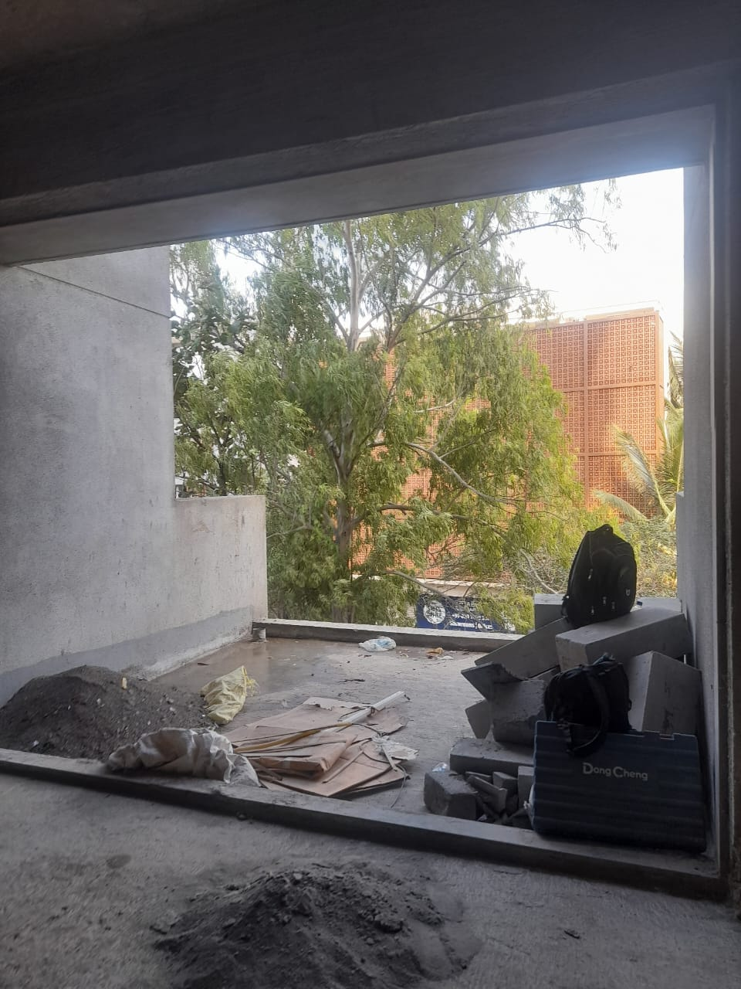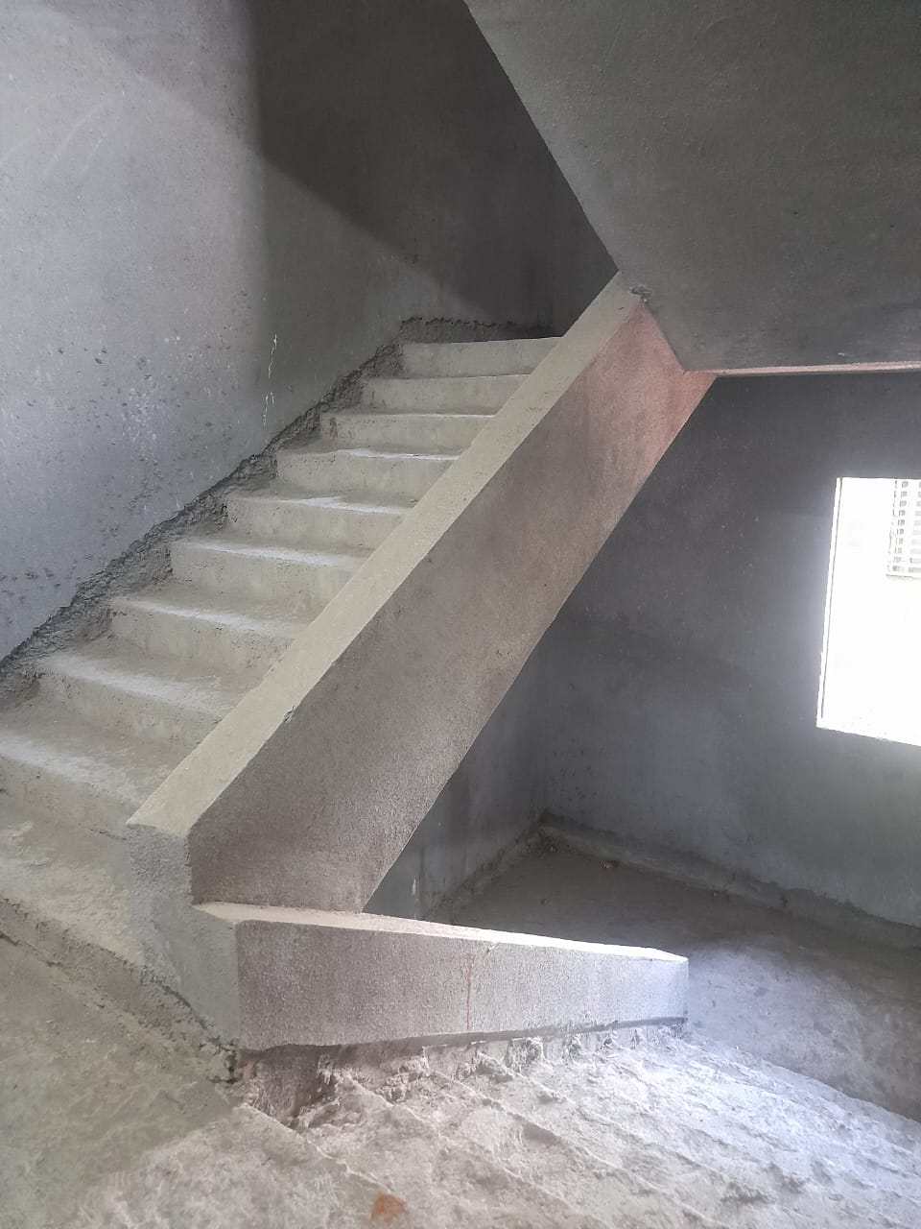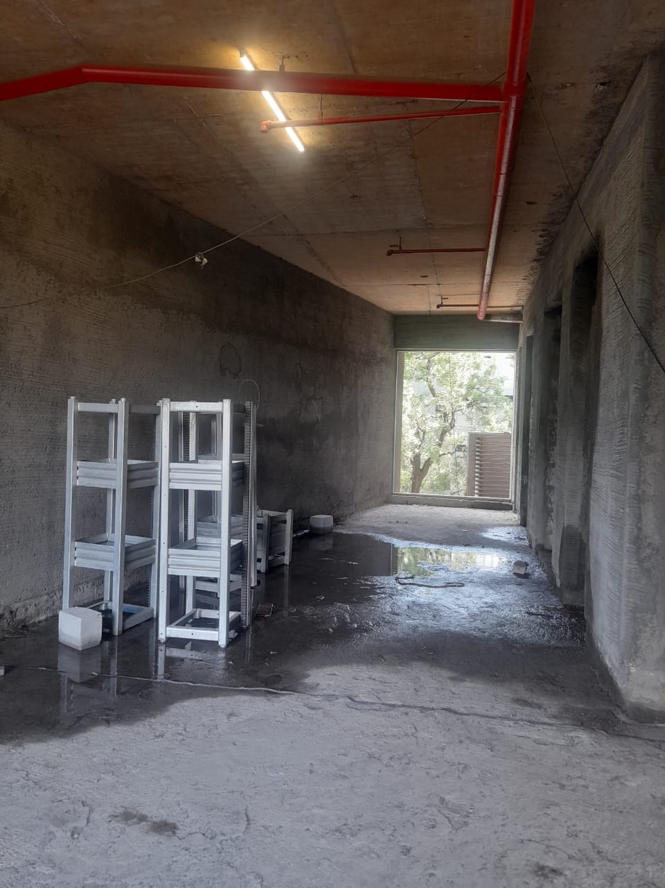

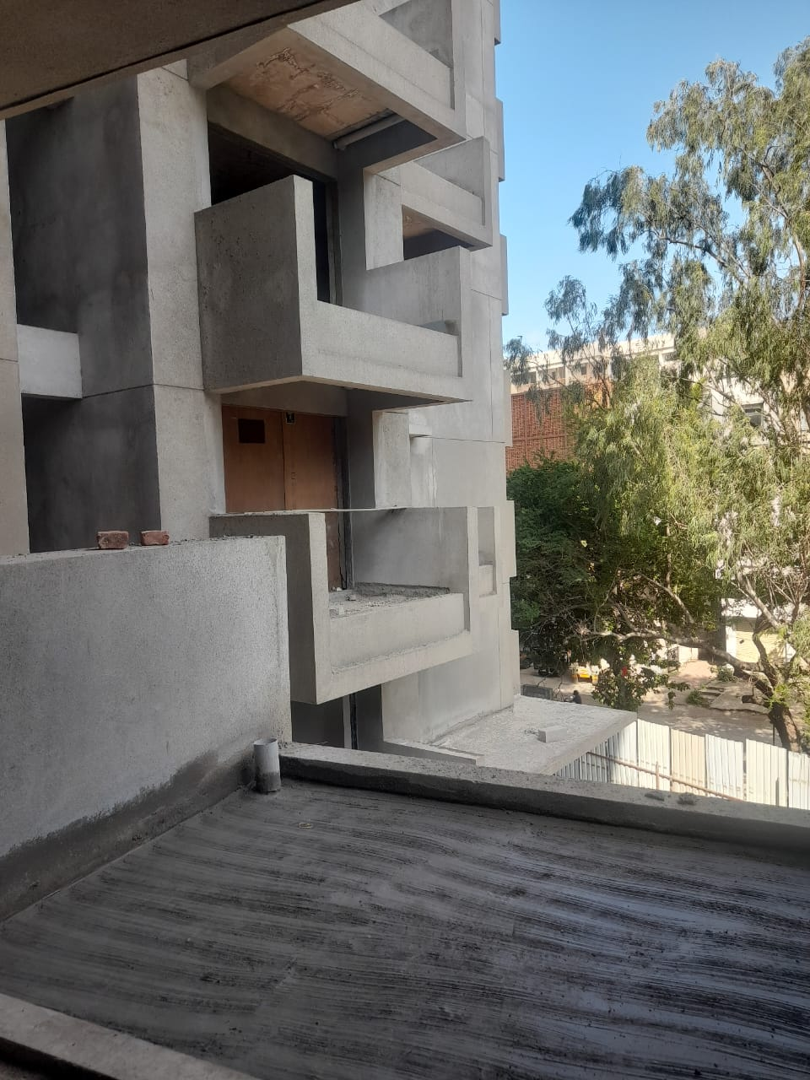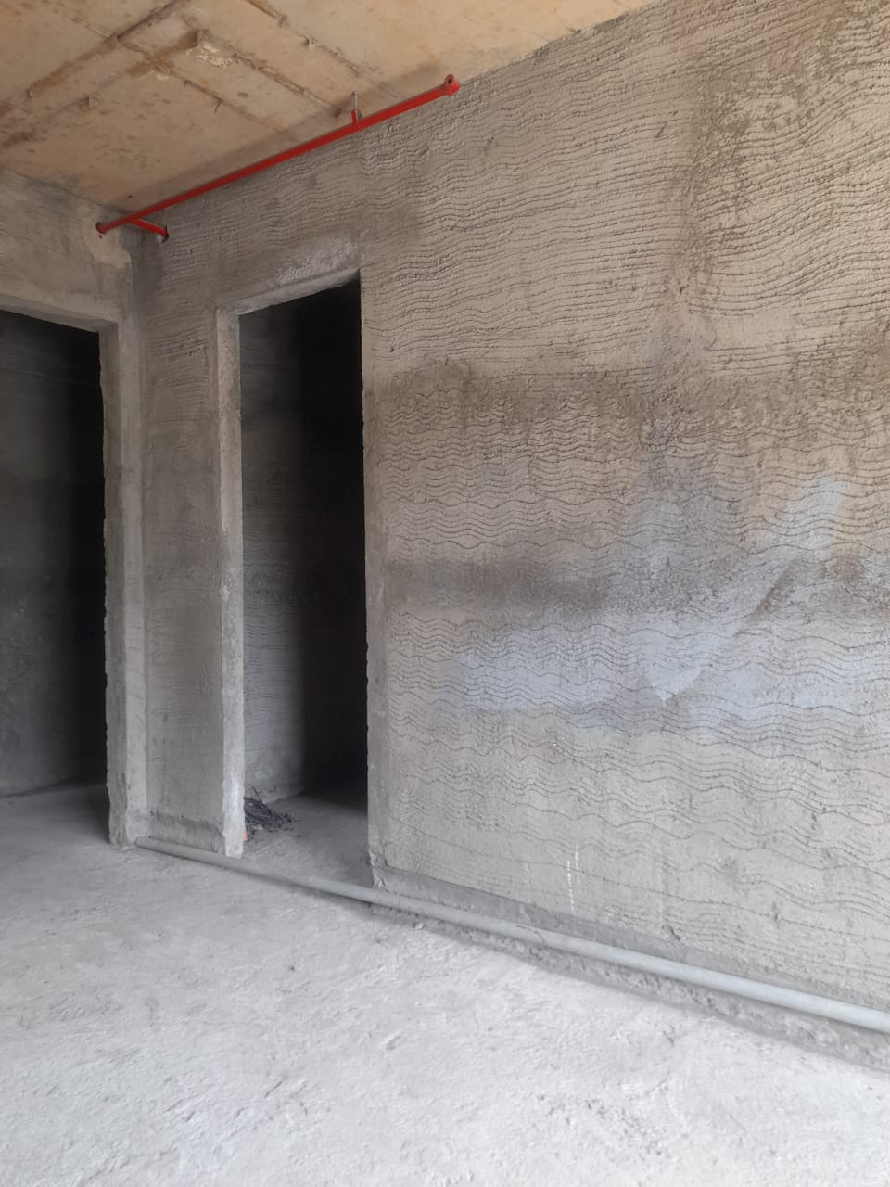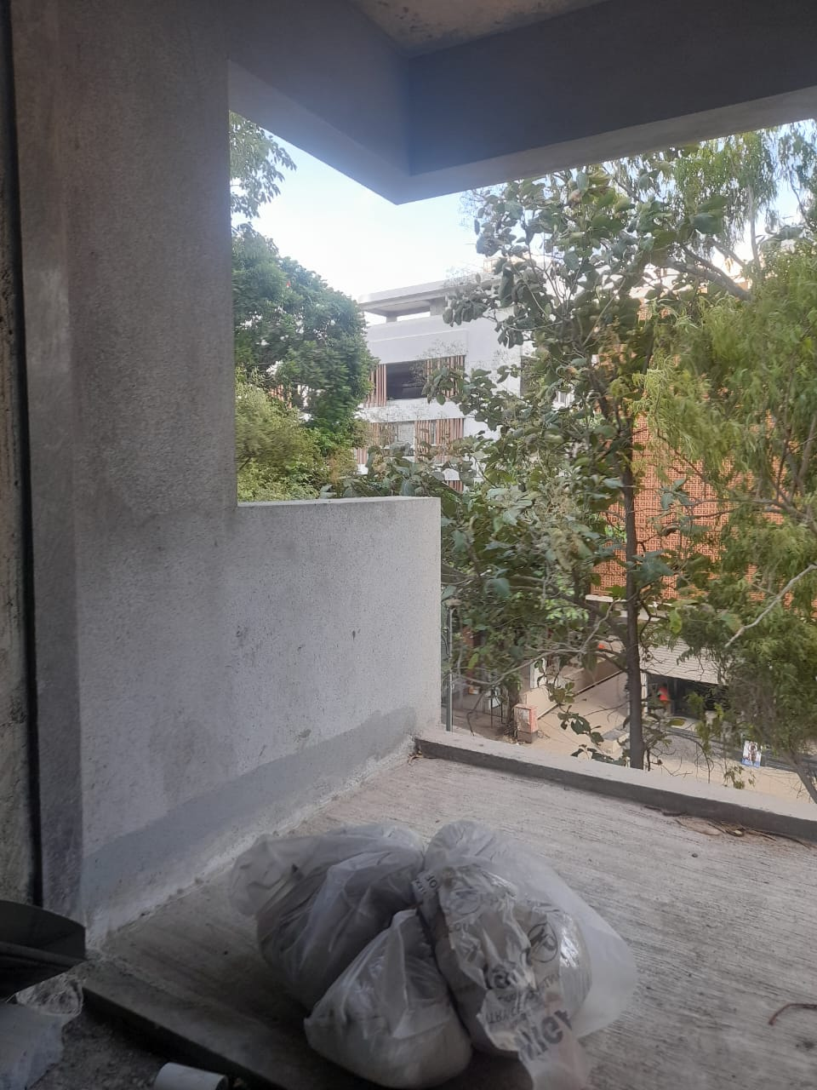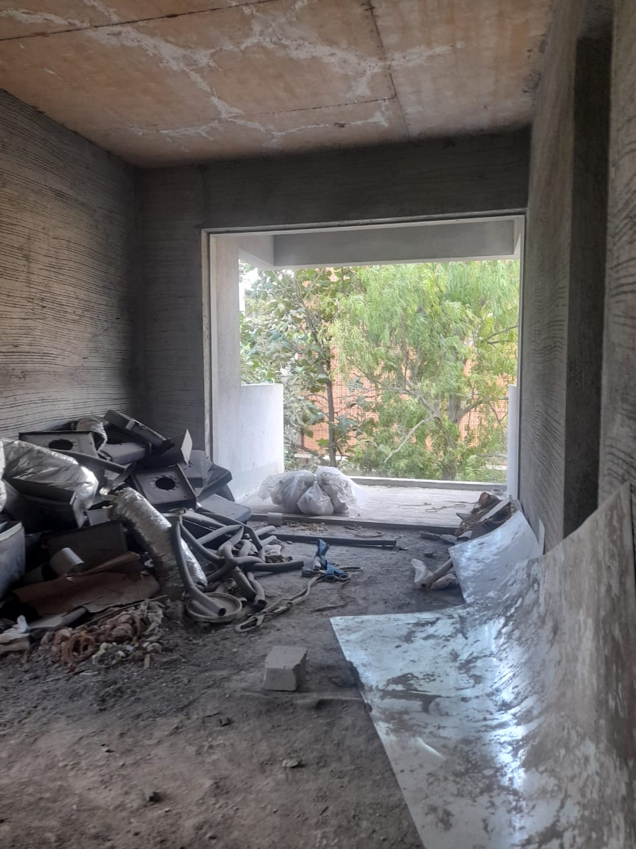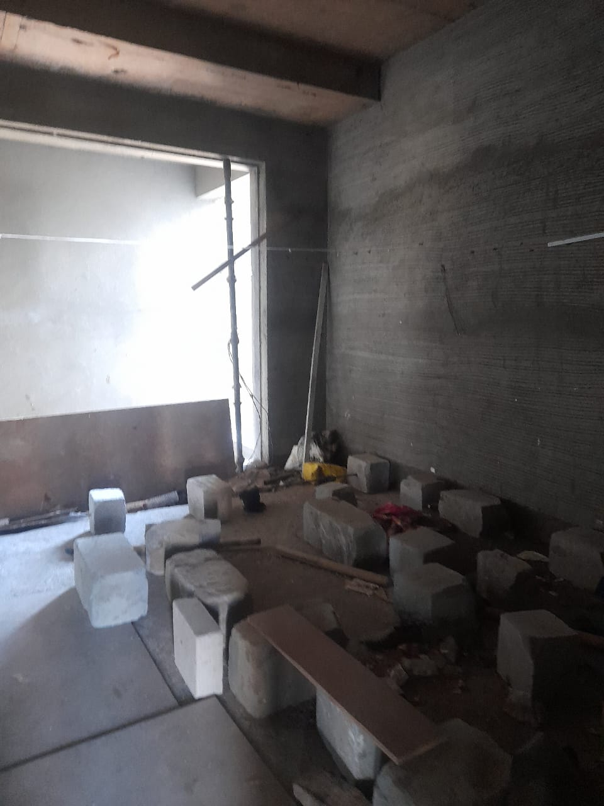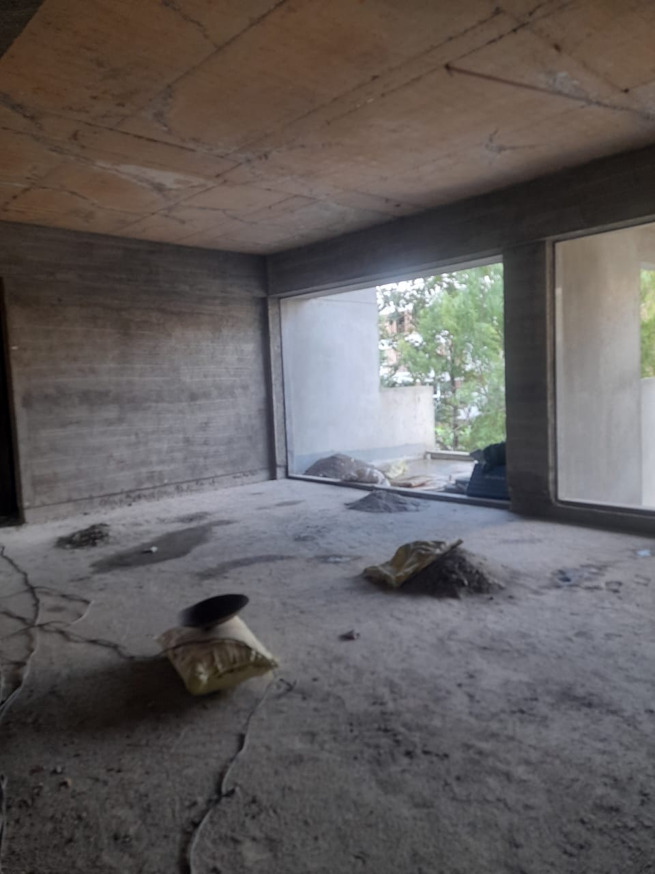**Photographs**

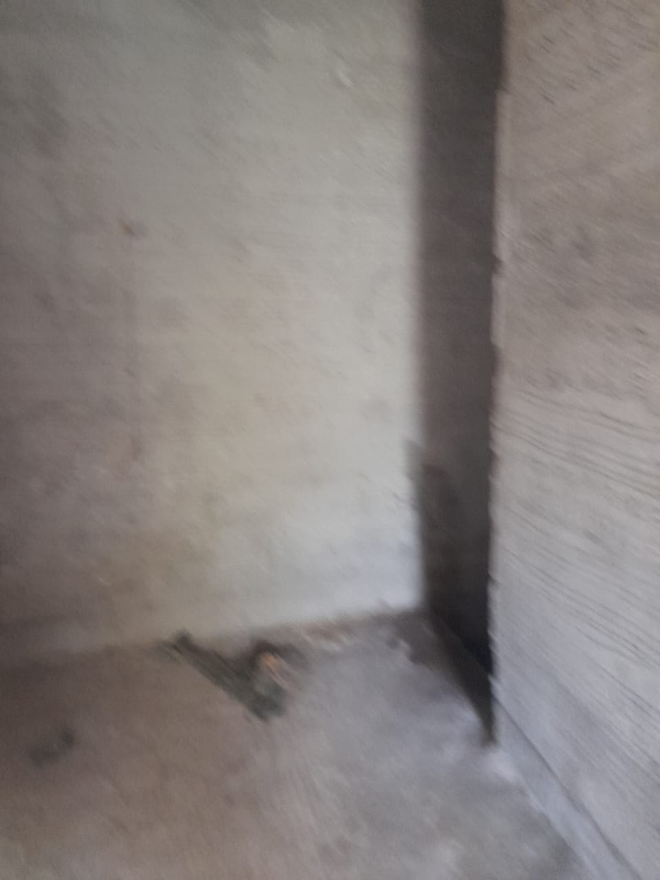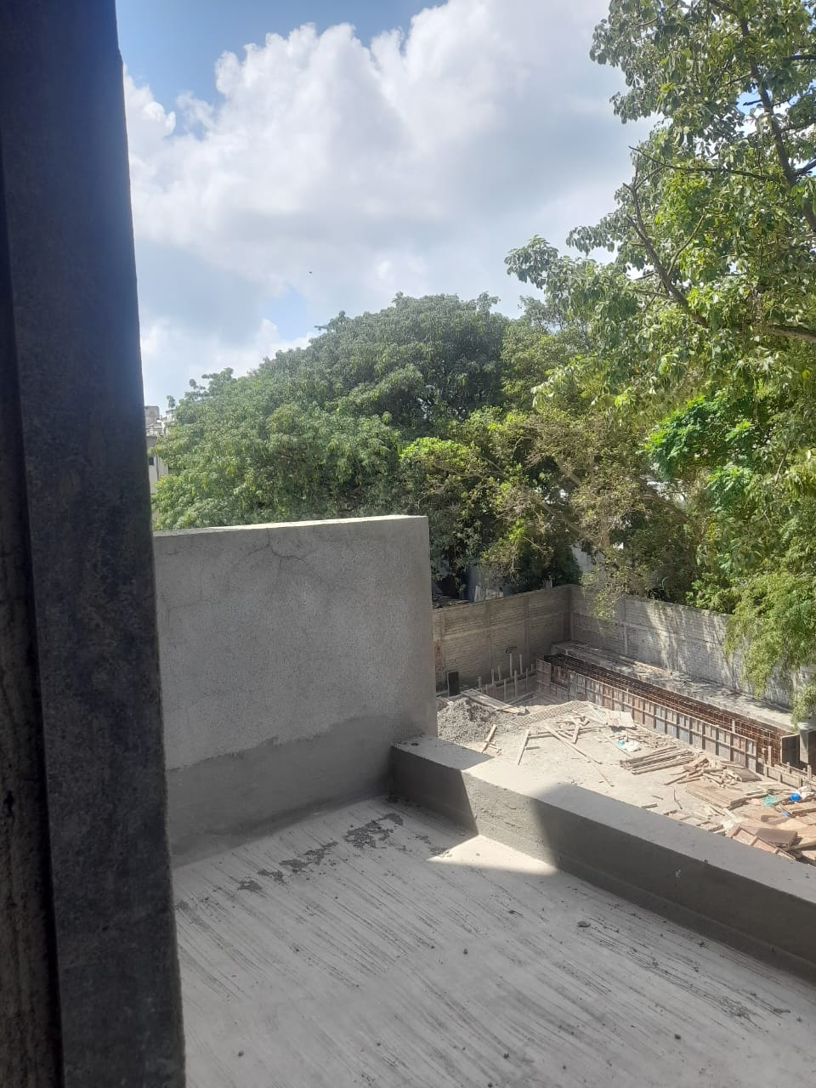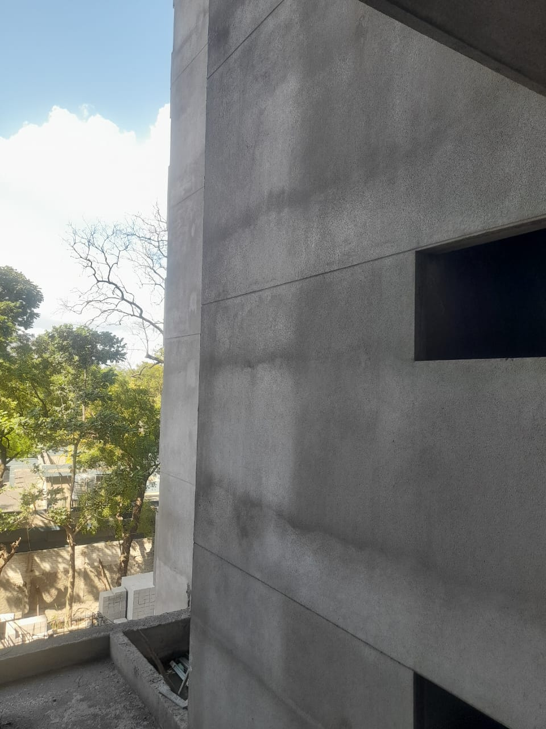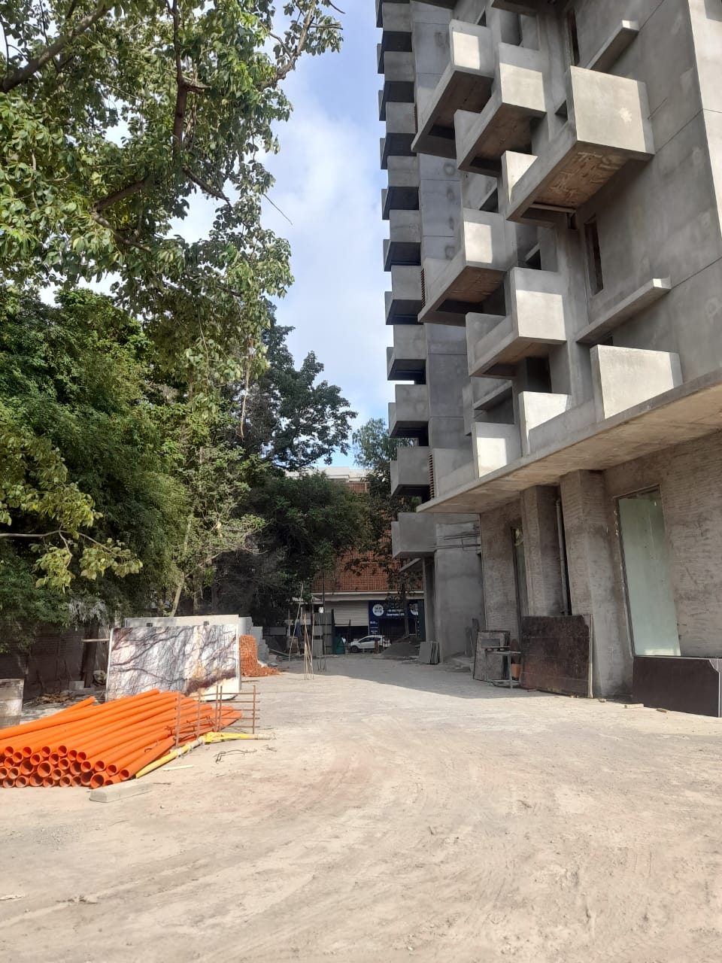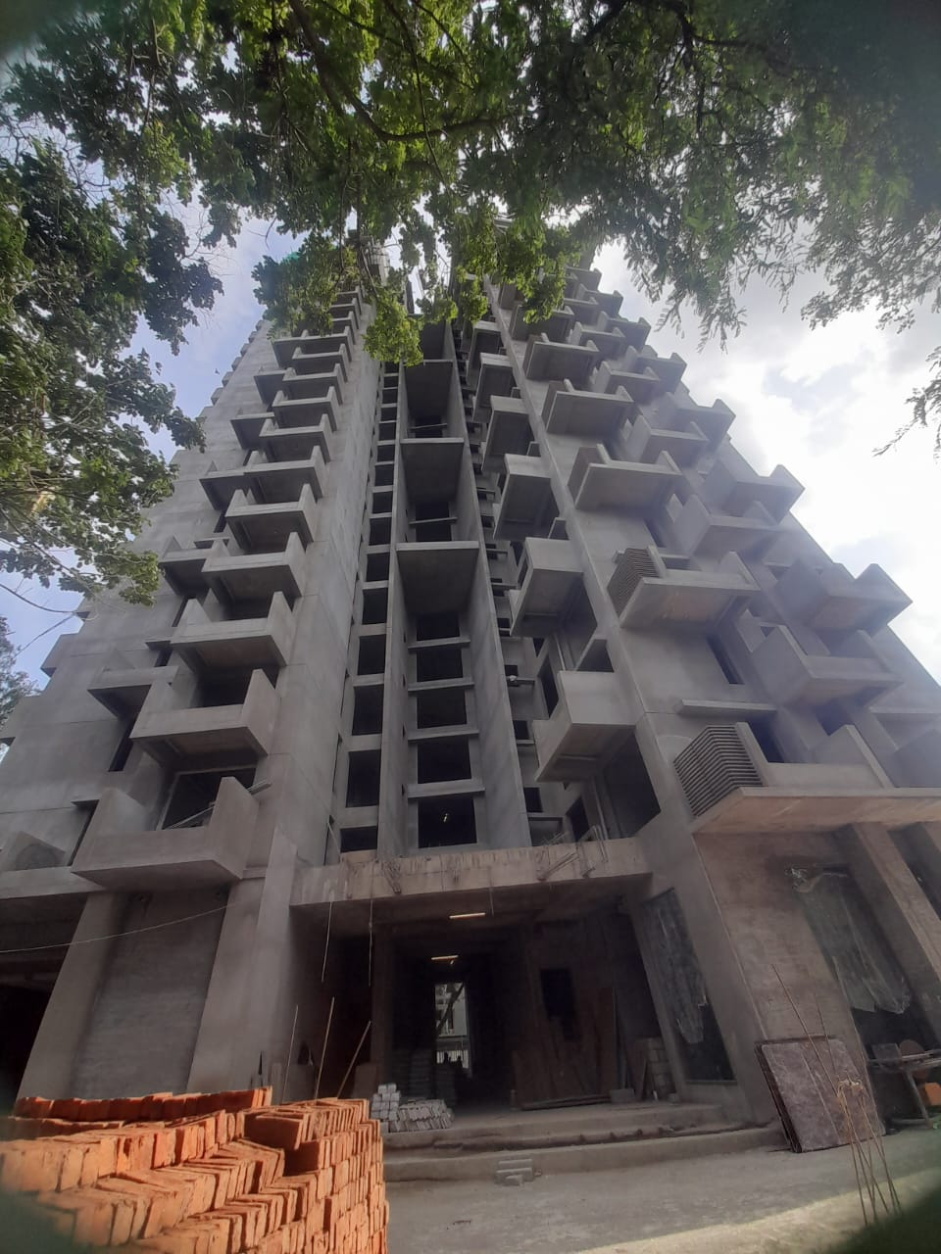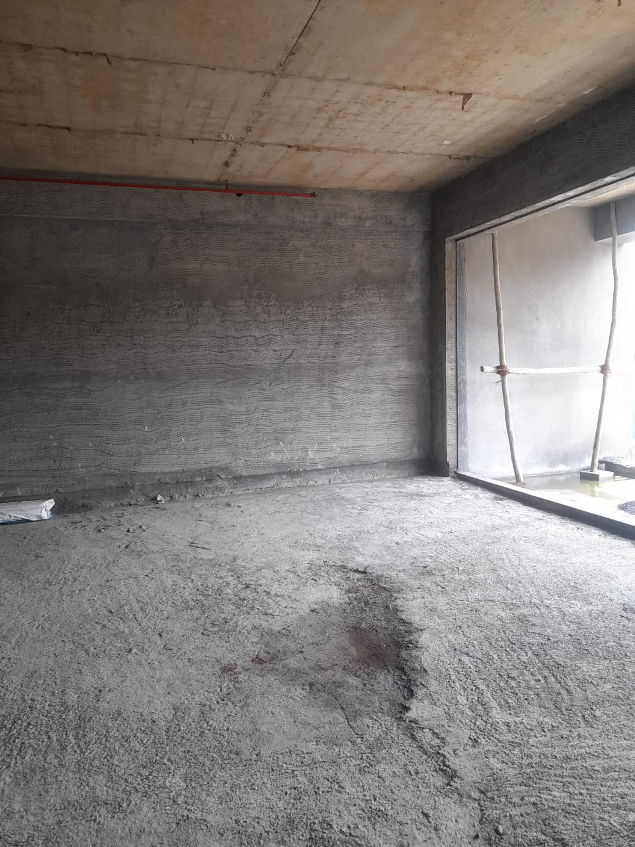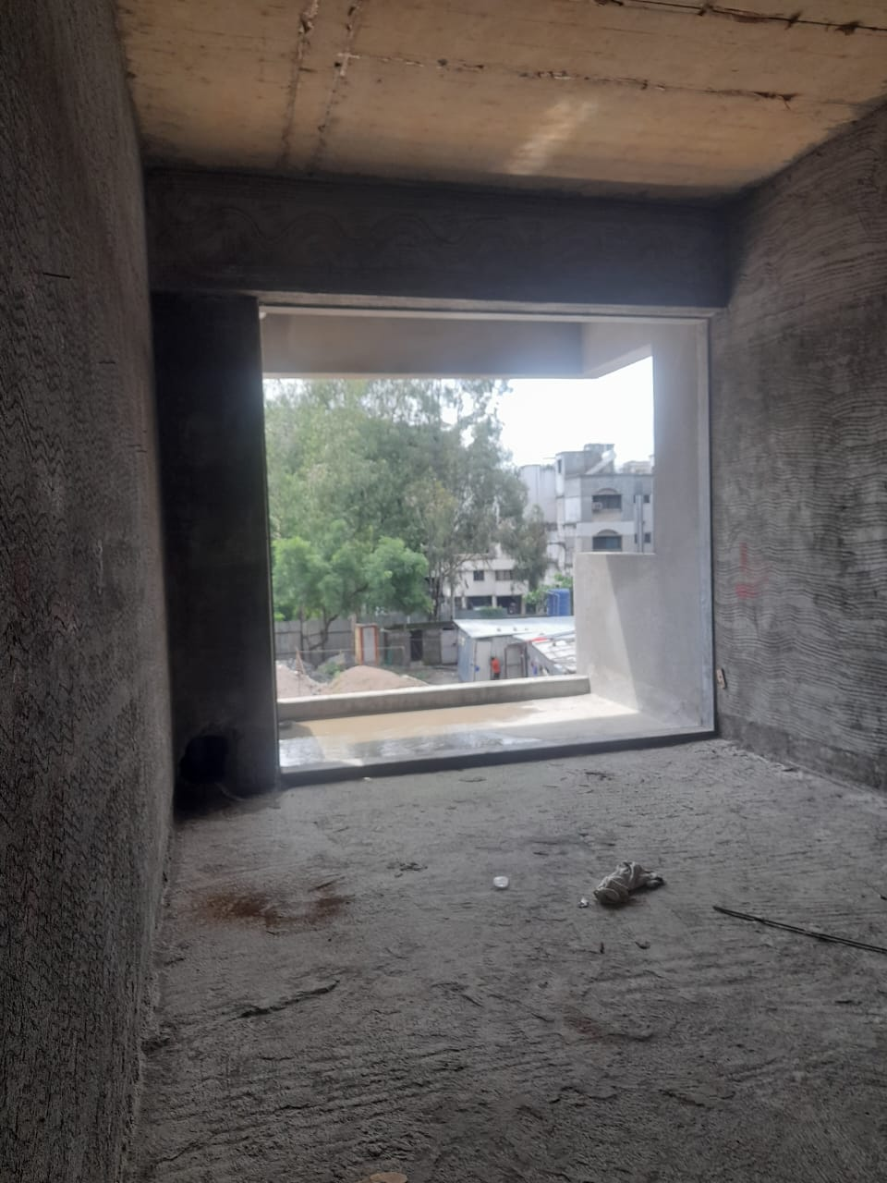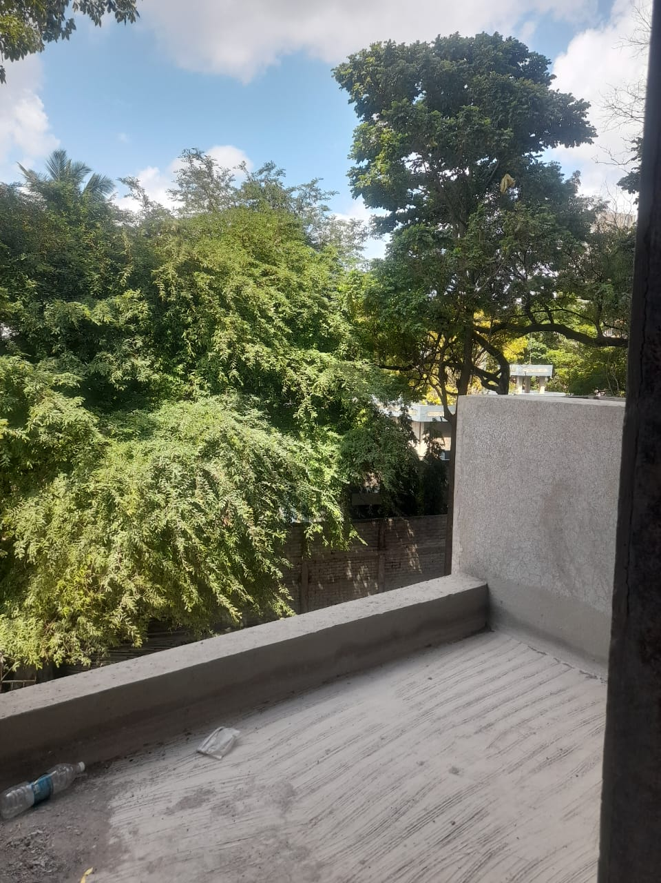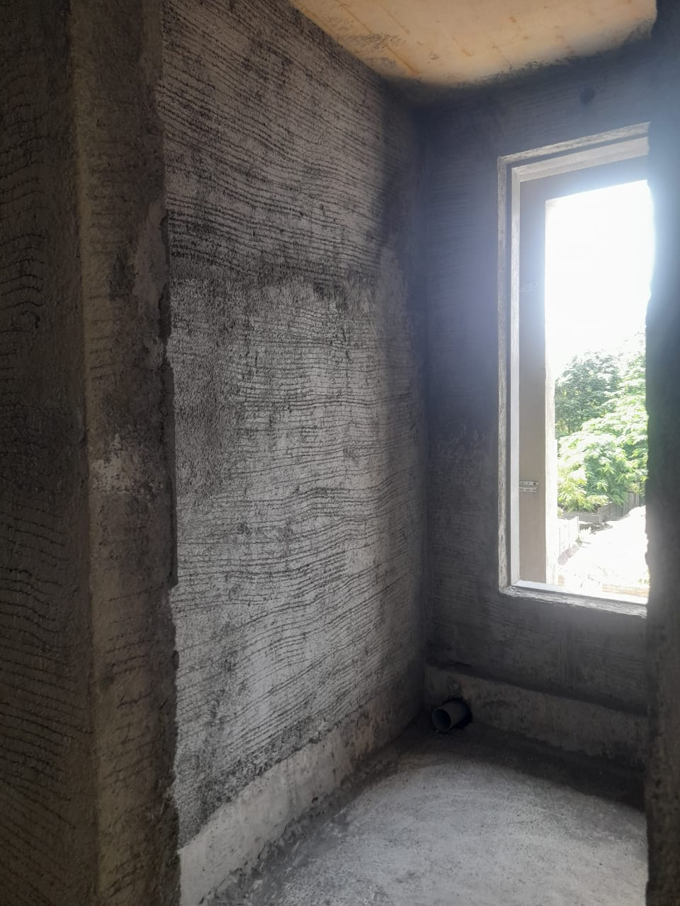

# Photographs

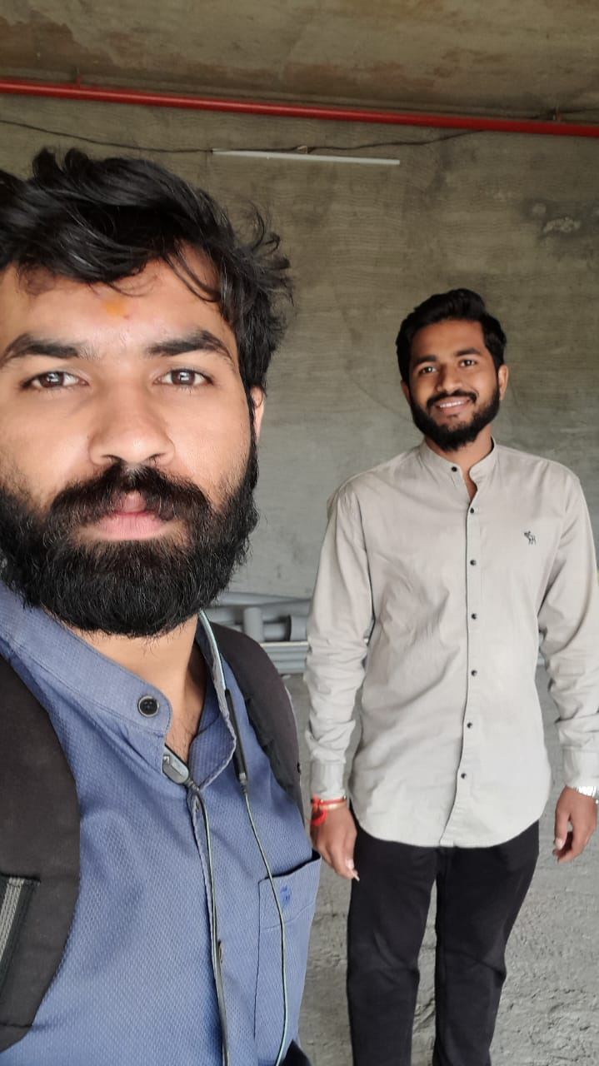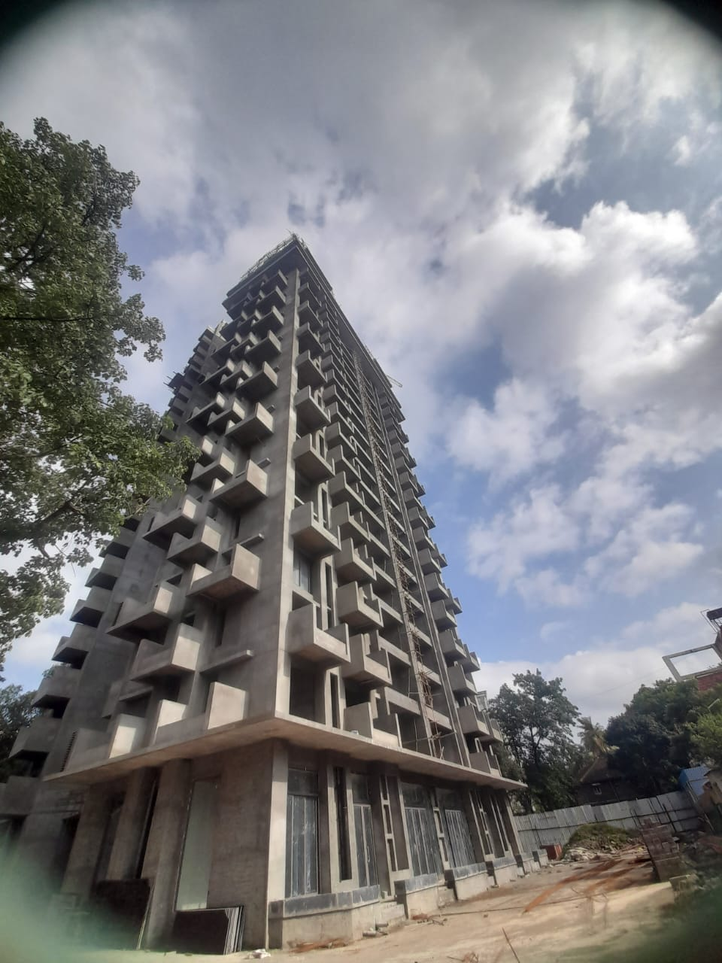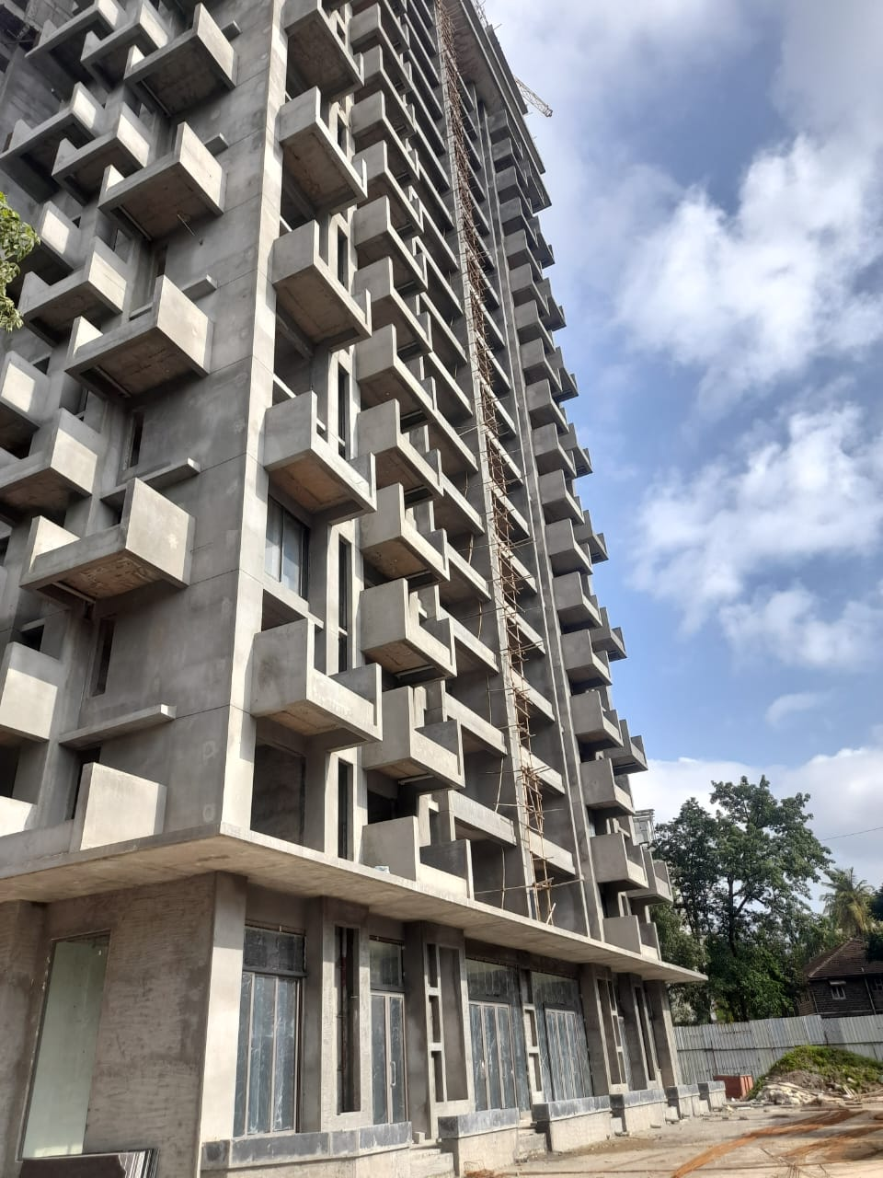

# Disclaimer

This Techno Economic Viability (**TEV**) Report is submitted on the basis that this Report and its contents will be held in complete confidence. Accordingly, by accepting a copy of this report, the recipient agrees to keep its contents and any other information, which is disclosed to such recipient, confidential and shall not divulge, distribute or disseminate any information contained herein, in part or in full, without the prior written approval of **Vastukala Consultants (India) Pvt. Ltd.**

The Report has been prepared for private circulation as required by the Union Bank of India **(UBI)** for evaluating the proposed ongoing Real estate project by **Bhavik & Saraf Ventures.** This report has been prepared on the basis of details provided by the company and discussions held with **BHAVIK & SARAF VENTURES** ’s officials. The industry norms, studies and other information / documents obtained by **Vastukala Consultants (India) Pvt. Ltd.** from various sources available publicly, which **Vastukala Consultants (India) Pvt. Ltd.** believes to be reliable, were the basis of this report. **Vastukala Consultants (India) Pvt. Ltd.** has not carried out any independent verification for the truthfulness of the same. We have tried our best to independently verify the same. We have not checked the title clearance or the legality of the documents of the said property or the invoices / quotations of the machinery submitted by **BHAVIK & SARAF VENTURES** to us. The net worth of the promoters of the company has been provided to us and **Vastukala Consultants (India) Pvt. Ltd.** has not independently verified the same. This report is purely an opinion and has no legal or contractual obligation on our part. We have no direct or indirect interest in the company, its directors, their suppliers / vendors and / or the said project.