Valuation Report of the Immovable Property

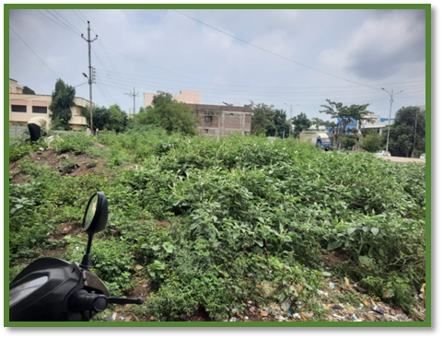

Details of the property under consideration:

Name of Owner: Mr. Balaji Ganpatrao Kanthewad

Residential Land Plot No. 01 (part) (West portion of Plot No. 01), S. No. 55, Gat No. 173 (part), “Nalanda Magasvargiya Co-Op. Hsg. Soc. Ltd.”, Sana School Airport Road, Village – Sangvi Budruk, Taluka & District – Nanded - 431605, State – Maharashtra, Country – India.

Longitude Latitude: 19°11'05.3"N 77°18'48.2"E

Valuation Done for:
Bank of Baroda
Taroda Br., Nanded.

Vastukala Consultants (I) Pvt. Ltd.
Mumbai • Delhi NCR • Aurangabad • Nanded • Indore • Pune Raipur • Jaipur • Ahmedabad • Rajkot • Thane • Nasik

Vastu/BOB/Taroda Br./07/2023/11206 Date: 06.07.2023

VALUER’S OPINION REPORT

This is to certify that the property bearing Residential Land Plot No. 01 (part) (West portion of Plot No. 01), S. No. 55, Gat No. 173 (part), “Nalanda Magasvargiya Co-Op. Hsg. Soc. Ltd.”, Sana School Airport Road, Village – Sangvi Budruk, Taluka & District – Nanded - 431605, State – Maharashtra, Country – India belongs to Mr. Balaji Ganpatrao Kanthewad.

Boundaries of the property.

North | : | Part of Plot No. 01
South | : | Road from Sangvi to Workshop Old RTO Office
East | : | Plot of Khanderao Haibatrao Hasnalkar
West | : | Taroda Budruk Shiv Road
Considering various parameters recorded, existing economic scenario, and the information that is available with reference to the development of neighborhood and method selected for valuation, we are of the opinion that, the property premises can be assessed and valued for this particular purpose as under.

Guideline value of the property | Rs. 13,47,862.00
Fair Market value of the property | Rs. 44,30,200.00
Realizable Value of the property. | Rs. 39,87,180.00
Distress / Forced Sale Value of the property. | Rs. 35,44,160.00
The valuation of the property is based on the documents produced by the concern. Legal aspects have not been taken into considerations while preparing this valuation report.

Hence certified.

For, Vastukala Consultants (I) Pvt. Ltd.

Sharadkumar B. Chalikwar
B.E. (Civil), M.E. (Civil), M.Sc. (Real Estate Valuation), M.Sc. (P&M Valuation), FIE (I), FIV, FIWRS
Chairman & Managing Director
Govt. Reg. Valuer
Chartered Engineer (India)
Reg. No. (N) CCIT/1-14/52/2008-09
IBBI Reg.No. IBBI/RV/07/2019/11744

Encl: Valuation report.
VALUATION REPORT
(IN RESPECT OF LAND / SITE & BUILDING)
I. | General
1. | Purpose for which the valuation is made. |  |  |  |  |  |  | To Assess Fair Market Value of the Property.
2. | a) |  |  | Date of inspection |  |  |  | 06.09.2023
 | b) |  |  | Date on which the valuation is made |  |  |  | 11.09.2023
 | c) |  |  | Date of Valuation Report |  |  |  | 11.09.2023
3. | List of documents produced for perusal
 | 1 |  | Copy of Sale Deed dated 20.10.2020 between Mr. Balaji Ganpatrao Kanthewad (Purchaser) and Khanderao Haibatrao Hasnalkar (Seller)
 | 2 |  | Copy Grampanchayat 8A Extract
 | 3 |  | Copy of 7/12 Extract
 | 4 |  | Copy of Certificate for Regularization of Development of gunthawise plot issued by Nanded Vaghala City Municipal Corporation.
 | 5 |  | Copy of DP Location Plan vide No. 7181 dated 23.05.2023 issued by Nanded Vaghala City Municipal Corporation.
4. | Name of the owner(s) and his / their address (es) with Phone no. (details of share of each owner in case of joint ownership) |  |  |  |  |  |  | Mr. Balaji Ganpatrao Kantewad  Address:  Residential Land Plot No. 01 (part) (West portion of Plot No. 01), S. No. 55, Gat No. 173 (part), “Nalanda Magasvargiya Co-Op. Hsg. Soc. Ltd.”, Sana School Airport Road, Village – Sangvi Budruk, Taluka & District – Nanded - 431605, State – Maharashtra, Country – India  Contact Person:  Mr. Azar Qazi (Owner’s representative)  Mobile No.: 98690 17769
5. | Brief description of the property (Including Leasehold / freehold etc.)
The property is located in a developing Residential area having good infrastructure, well connected by road and train. The immovable property comprises of Freehold Residential land. The plot under valuation is undeveloped, covered with small bushes and trees. It was without demarcation and compound wall. It is a road touch plot. It is located at about 4.3 km. travelling distance from Nanded Railway Station.

As per Agreement total plot area of Plot No. 01 (part) (West portion of Plot No. 01), is 378.43 Sq. M., which is considered for valuation.
6. | Location of property
 | a) |  |  | Plot No. / Survey No. |  |  |  | Plot No. 01 (part) (West portion of Plot No. 01), S. No. 55, Gat No. 173 (part)
 | b) |  |  | Door No. |  |  |  | Not applicable
 | c) |  |  | T.S. No. / Village |  |  |  | Village – Sangvi Budruk
 | d) |  |  | Taluka |  |  |  | Taluka – Nanded
 | e) |  |  | Mandal / District |  |  |  | District – Nanded.
7. | Postal address of the property |  |  |  |  |  |  | Residential Land Plot No. 01 (part) (West portion of Plot No. 01), S. No. 55, Gat No. 173 (part), “Nalanda Magasvargiya Co-Op. Hsg. Soc. Ltd.”, Sana School Airport Road, Village – Sangvi Budruk, Taluka & District – Nanded - 431605, State – Maharashtra, Country – India
8. | City / Town |  |  |  |  |  |  | Wadi (Bk.).
 | Residential area |  |  |  |  |  |  | Yes.
 | Commercial area |  |  |  |  |  |  | No.
 | Industrial area |  |  |  |  |  |  | No.
9. | Classification of the area
 | i) High / Middle / Poor |  |  |  |  |  |  |  | Middle Class
 | ii) Urban / Semi Urban / Rural |  |  |  |  |  |  |  | Rural.
10. | Coming under Corporation limit / Village Panchayat / Municipality |  |  |  |  |  |  |  | Village – Sangvi Budruk  Nanded Waghala City Municipal Corporation
11. | Whether covered under any State / Central Govt. enactments (e.g., Urban Land Ceiling Act) or notified under agency area/ scheduled area / cantonment area |  |  |  |  |  |  |  | No
12. | In Case it is Agricultural land, any conversion to house site plots is contemplated |  |  |  |  |  |  |  | Not applicable
13. | Boundaries of the property |  |  |  |  | As Per Documents |  |  |  |  |  | As Per Actual
 | North |  |  |  |  | Part of Plot No. 01 |  |  |  |  |  | Part of Plot No. 01
 | South |  |  |  |  | Road from Sangvi to Workshop Old RTO Office |  |  |  |  |  | Road from Sangvi to Workshop Old RTO Office
 | East |  |  |  |  | Plot of Khanderao Haibatrao Hasnalkar |  |  |  |  |  | Plot of Khanderao Haibatrao Hasnalkar
 | West |  |  |  |  | Taroda Budruk Shiv Road |  |  |  |  |  | Taroda Budruk Shiv Road
14 | Dimensions of the site in meter |  |  |  |  |  |  | As per Sale Deed |  |  |  |  |  | As per Gunthewari Regularization Plan
 | North |  |  |  |  |  |  | 12.19 m. |  |  |  |  |  | 12.19 m.
 | South |  |  |  |  |  |  | 15.24 m. |  |  |  |  |  | 15.24 m.
 | East |  |  |  |  |  |  | 29.26 m. |  |  |  |  |  | 29.26 m.
 | West |  |  |  |  |  |  | 25.90 m. |  |  |  |  |  | 25.90 m.
14.1 | Extent of the site in Sqm. |  |  |  |  |  |  | 378.43 Sqm. |  |  |  |  |  | 378.43 Sqm.
14.2 | Latitude, Longitude & Co-ordinates |  |  |  |  |  |  | 19°11'05.3"N 77°18'48.2"E
15. | Extent of the site considered for Valuation (least of 14.1 A & 14.1 B) |  |  |  |  |  |  | 378.43 Sqm.
16 | Whether occupied by the owner / tenant? If Occupied by tenant since how long? Rent Received per month. |  |  |  |  |  |  | Open land.
II | CHARACTERSTICS OF THE SITE
 | Classification of locality |  |  |  |  |  |  | Middle class.
 | Development of surrounding areas |  |  |  |  |  |  | Residential.
 | Possibility of frequent flooding/ sub-merging |  |  |  |  |  |  | No.
 | Feasibility to the Civic amenities like School, Hospital, Bus Stop, Market etc. |  |  |  |  |  |  | All available near by
 | Level of land with topographical conditions |  |  |  |  |  |  | Plain
 | Shape of land |  |  |  |  |  |  | Leveled
 | Type of use to which it can be put |  |  |  |  |  |  | Residential purpose.
 | Any usage restriction |  |  |  |  |  |  | Residential zone.
 | Is plot in town planning approved layout? |  |  |  |  |  |  | No. But Property is Regularized under Gunthewari Act Rule 4 (1) by Gunthewari Department Collector office, Nanded.
 | Corner plot or intermittent plot? |  |  |  |  |  |  | Corner
 | Road facilities. |  |  |  |  |  |  | Yes.
 | Type of road available at present. |  |  |  |  |  |  | Pucca Road.
 | Width of road – is it below 20 ft. or more than 20 ft. |  |  |  |  |  |  | West |  |  |  |  | 10 M. Wide road
 | Is it a Land – Locked land? |  |  |  |  |  |  | No.
 | Water potentiality. |  |  |  |  |  |  | No
 | Underground sewerage system. |  |  |  |  |  |  | Septic Tank.
 | Is Power supply is available in the site. |  |  |  |  |  |  | Yes, available.
 | Advantages of the site. |  |  |  |  |  |  | No.
 | Special remarks, if any like threat of acquisition of land for publics service purposes, road widening or applicability of CRZ provisions etc. (Distance from sea-cost / tidal level must be incorporated) |  |  |  |  |  |  | No.
Part – A (Valuation of land)
1 | Size of plot. |  |  |  |  |  |  | As per Sale Deed  12.19 m.  15.24 m.  29.26 m.  25.90 m.  378.43 Sqm.
2 | Total extent of the plot. |  |  |  |  |  |  | 378.43 Sqm.
3 | Prevailing market rate (Along With details / reference of at least two latest deals / transactions with respect to adjacent properties in the areas) |  |  |  |  |  |  | Rs. 28,000.00 to 35,000.00 per Sqm according to location, approach road and infra structure facilities available.
4 | Guideline rate obtained from the Registrar’s Office |  |  |  |  |  |  | Rs. 8,700.00 per Sqm.
5 | Assessed / adopted rate of valuation |  |  |  |  |  |  | Rs. 30,000.00 per Sqm.
6 | Estimated value of land |  |  |  |  |  |  | Rs. 1,13,52,900.00
Part – B (Valuation of Building)
1 | Technical details of the building
 |  | Type of Building (Residential / Commercial / Industrial) |  |  |  |  |  |  |  | Not applicable being valuation of plot only
 |  | Type of construction  (Load bearing / RCC / Steel Framed) |  |  |  |  |  |  |  | Not applicable being valuation of plot only
 |  | Year of construction. |  |  |  |  |  |  |  | Not applicable being valuation of plot only
 |  |  |  |  |  |  |  |  |  | Age of the Building |  |  |  |  |  | -
 |  |  |  |  |  |  |  |  |  | Future Life of the Building |  |  |  |  |  | -
 |  | Number of floors and height of each floor including basement, if any. |  |  |  |  |  |  |  | Not applicable being valuation of plot only
 |  | Plinth area floor-wise
 |  | Sr. No. |  |  | Particulars |  | As per Gunthewari Regularization Plan |  |  |  |  |  |  |  | As per Actual
 |  | 1. |  |  | - |  | - |  |  |  |  |  |  |  | -
 |  | - Built up Area Considered for Valuation : Not applicable being valuation of plot only
 |  | Condition of the building
 |  | i. Exterior : Excellent, Good, Normal, Poor |  |  |  |  |  |  |  |  | Not applicable being valuation of plot only
 |  | ii. Interior : Excellent, Good, Normal, Poor |  |  |  |  |  |  |  |  | Not applicable being valuation of plot only
 |  | Date of issue and validity of layout of approved map. |  |  |  |  |  |  |  |  | Copy of DP Location Plan vide No. 7181 dated 23.05.2023 issued by Nanded Vaghala City Municipal Corporation.
 |  | Approved map / plan issuing authority
 |  | Whether genuineness or authenticity of approved map / plan is verified` |  |  |  |  |  |  |  |  | Yes
 |  | Any other comments by our empanelled valuers on authentic of approved plan |  |  |  |  |  |  |  |  | No.
Specifications of construction in respect of
Sr. No. |  | Description | Ground Floor
 |  | Foundation | Not applicable being valuation of plot only
 |  | Basement | Not applicable being valuation of plot only
 |  | Superstructure | Not applicable being valuation of plot only
 |  | Joinery / Doors & Windows | Not applicable being valuation of plot only
 |  | RCC Works | Not applicable being valuation of plot only
 |  | Plastering | Not applicable being valuation of plot only
 |  | Flooring, Skirting, dado | Not applicable being valuation of plot only
 |  | Special finish as marble, granite, wooden paneling, grills etc. | Not applicable being valuation of plot only
 |  | Roofing including weather proof course | Not applicable being valuation of plot only
 |  | Drainage | Not applicable being valuation of plot only
2. |  | Compound Wall | Compound wall not found
 |  |  | Side |  | Length | Height
 |  |  | North |  | - | -
 |  |  | South |  | - | -
 |  |  | West |  | - | -
3. |  | Electrical installation
 |  | Type of wiring | Not applicable being valuation of plot only
 |  | Class of fittings (superior / ordinary / poor) | Not applicable being valuation of plot only
 |  | Number of light points | Not applicable being valuation of plot only
 |  | Fan points | Not applicable being valuation of plot only
 |  | Spare plug points | Not applicable being valuation of plot only
 |  | Power point | Not applicable being valuation of plot only
4. |  | Plumbing installation
 |  | - No. of water closets and their type | Not applicable being valuation of plot only
 |  | - No. of wash basins | Not applicable being valuation of plot only
 |  | - No. of urinals | Not applicable being valuation of plot only
 |  | - No. of bath tubs | Not applicable being valuation of plot only
 |  | - Water meters, taps etc. | Not applicable being valuation of plot only
 |  | - Any other fixtures | Not applicable being valuation of plot only
Part – C (Extra Items) |  |  |  | Amount in Rs.
 | Porch |  |  | Not applicable being valuation of plot only
 | Ornamental front door |  |  | -
 | Sit out / Verandah / Parking with steel grills |  |  | -
 | Overhead Water tank |  |  | -
- - | Staircase Head Room |  |  | -
 | Total
Part – D (Amenities) |  |  |  | Amount in Rs.
 | Wardrobes |  |  | Not applicable being valuation of plot only
 | Glazed tiles |  |  | -
 | Extra sinks and bath tub |  |  | -
 | Marble / ceramic tiles flooring |  |  | -
 | Interior decorations |  |  | -
 | Architectural elevation works |  |  | -
 | Paneling works |  |  | -
 | Aluminum works |  |  | -
 | Aluminum hand rails (S.S. Railing) |  |  | -
 | False ceiling |  |  | -
 | Granite Kitchen Platform including Kitchen sink, sink taps, ceramic tiles, Commercial ply wood shutters with laminates facia etc. |  |  | Not applicable being valuation of plot only
 | Solar Power System. |  |  | Not applicable being valuation of plot only
 | Total |  |  | NIL
Part – E (Miscellaneous) |  |  |  | Amount in Rs.
 | Separate toilet room |  |  | Not applicable being valuation of plot only
 | Separate lumber room |  |  | -
 | Separate water tank / sump |  |  | -
 | Trees, gardening |  |  | -
 | Total |  |  | -
Part – F (Services) |  |  |  | Amount in Rs.
 | Water supply arrangements (Bore well) |  |  | Not applicable being valuation of plot only
 | Drainage arrangements |  |  | -
 | Compound wall & M.S. Gate. |  |  | -
 | C.B. deposits, fittings etc. |  |  | -
 | Site Development (Pavement) |  |  | -
 | Total |  |  | -
Total abstract of the entire property
Part – A | Land | Rs. 1,13,52,900.00
Part – B | Building | -
Part – C | Extra Items | Rs. Nil
Part - D | Amenities | Rs. Nil
Part – E | Miscellaneous | Rs. Nil
Part – F | Services | -
 | Total | -
Particulars |  | Value in Rs.
Fair Market Value of the Property |  | Rs. 1,13,52,900.00
Realizable Value of the Property |  | Rs. 1,02,17,610.00
Distress / Force Sale Value |  | Rs. 90,82,320.00
Guideline Value As per Ready Reckoner |  | Rs. 32,92,341.00
The cost approach is a Real Property Valuation method which considers the value of a property as the cost of the land plus the replacement cost of the building (construction costs) minus the physical and functional depreciation.
This approach is most commonly used for real estate properties that are not easily sold like schools, hospitals, and government buildings.
Land cost can be estimated using the Sales Comparison Approach by studying recent sales of land close to the subject property, and these sales should be comparable in size and location with subject property.
There are different ways to estimate replacement costs, the most common being finding out the cost to build a square foot of comparable properties multiplied by the total square footage of the building. The cost approach is commonly used for Residential Bungalow, Industrial Building and properties mentioned above.
As the property is only plot of land, we have adopted Sale Comparison Method for the purpose of valuation. The Price for similar type of property in the nearby vicinity is in the range of Rs.28,000.00 to Rs.35000.00 per Sq. M. for land Considering the rate with attached report, current market conditions, demand and supply position, Land size, location, upswing in real estate prices, sustained demand for Plot, all round development of commercial and residential application in the locality etc. We estimate Rs. 30,000.00 per Sq. M. for Land

The salability of the property is : Normal

Rental Income : Nil.

Any likely income it may generate: Rental Income.

For, Vastukala Consultants (I) Pvt. Ltd.

Sharadkumar B. Chalikwar
B.E. (Civil), M.E. (Civil), M.Sc. (Real Estate Valuation), M.Sc. (P&M Valuation), FIE (I), FIV, FIWRS
Chairman & Managing Director
Govt. Reg. Valuer
Chartered Engineer (India)
Reg. No. (N) CCIT/1-14/52/2008-09
IBBI Reg. No. IBBI/RV/07/2019/11744

Date : 11.09.2023

For Branch/SMS Use

The undersigned has inspected the property detailed in the valuation report dt. 11.09.2023, we are satisfied that the Fair and reasonable value of the property is Rs. 1,13,52,900.00 (Rupees One Crore Thirteen Lakh Fifty Two Thousand Nine Hundred Only).

Name of the inspecting officer:

Signature of the inspecting officer:

Designation of the inspecting officer:
Employee code:
Branch:

Seen and Noted
Name of the branch head/unit head:

Signature of the Branch head/Unit head:

Designation:
Employee code:

Actual site photographs

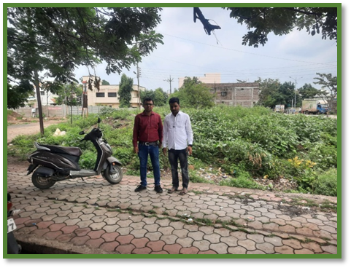
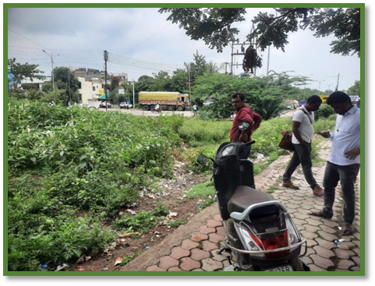
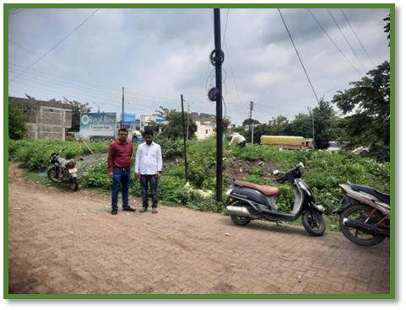
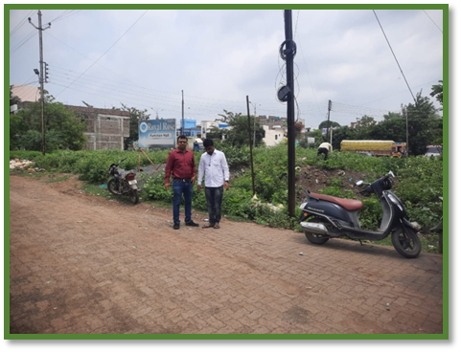
Actual DP Location Plan
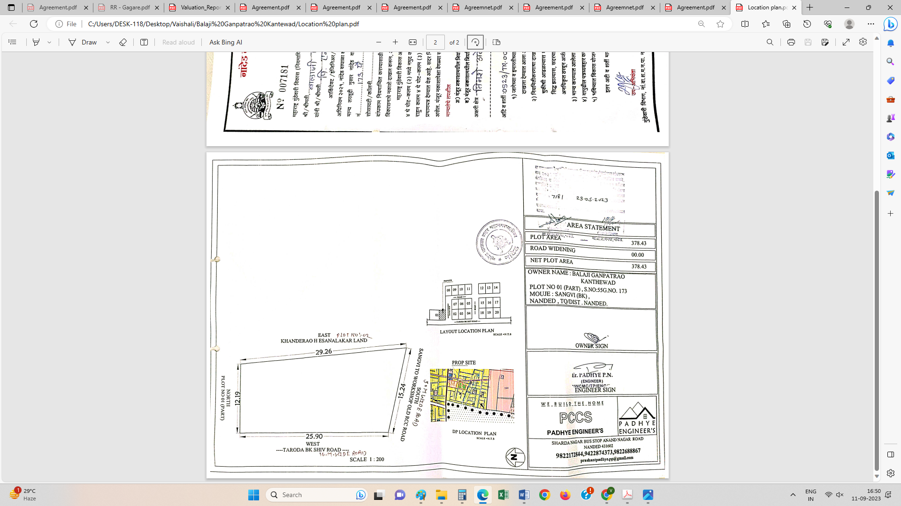

Route Map of the property
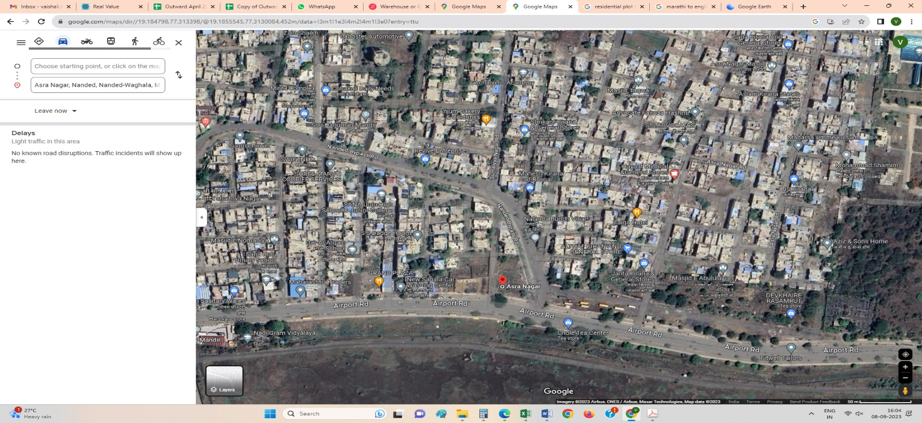

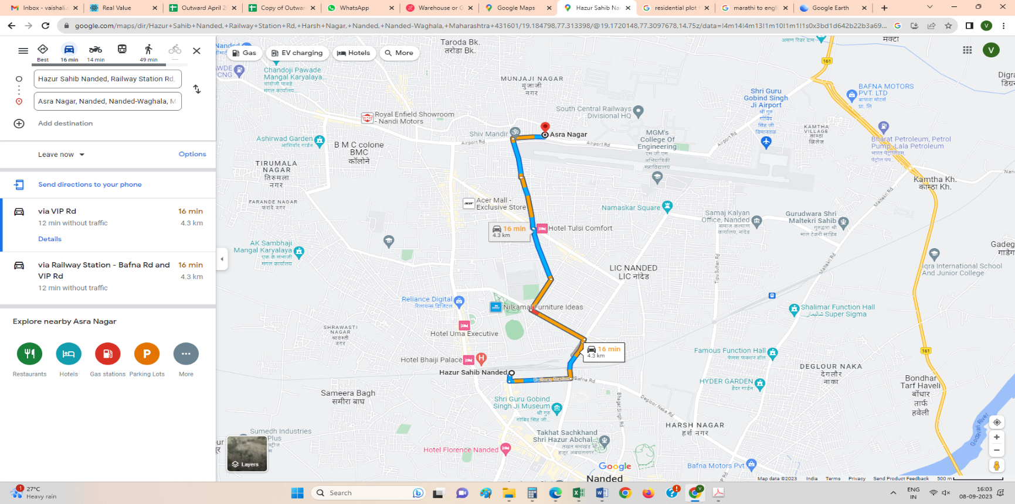

Longitude Latitude: 19°11'05.3"N 77°18'48.2"E
Note:
- Red Pointer shows Approx. Property Location
- Blue line shows Route from Nanded Railway Station & 5.0 Km.

Ready Reckoner Rate

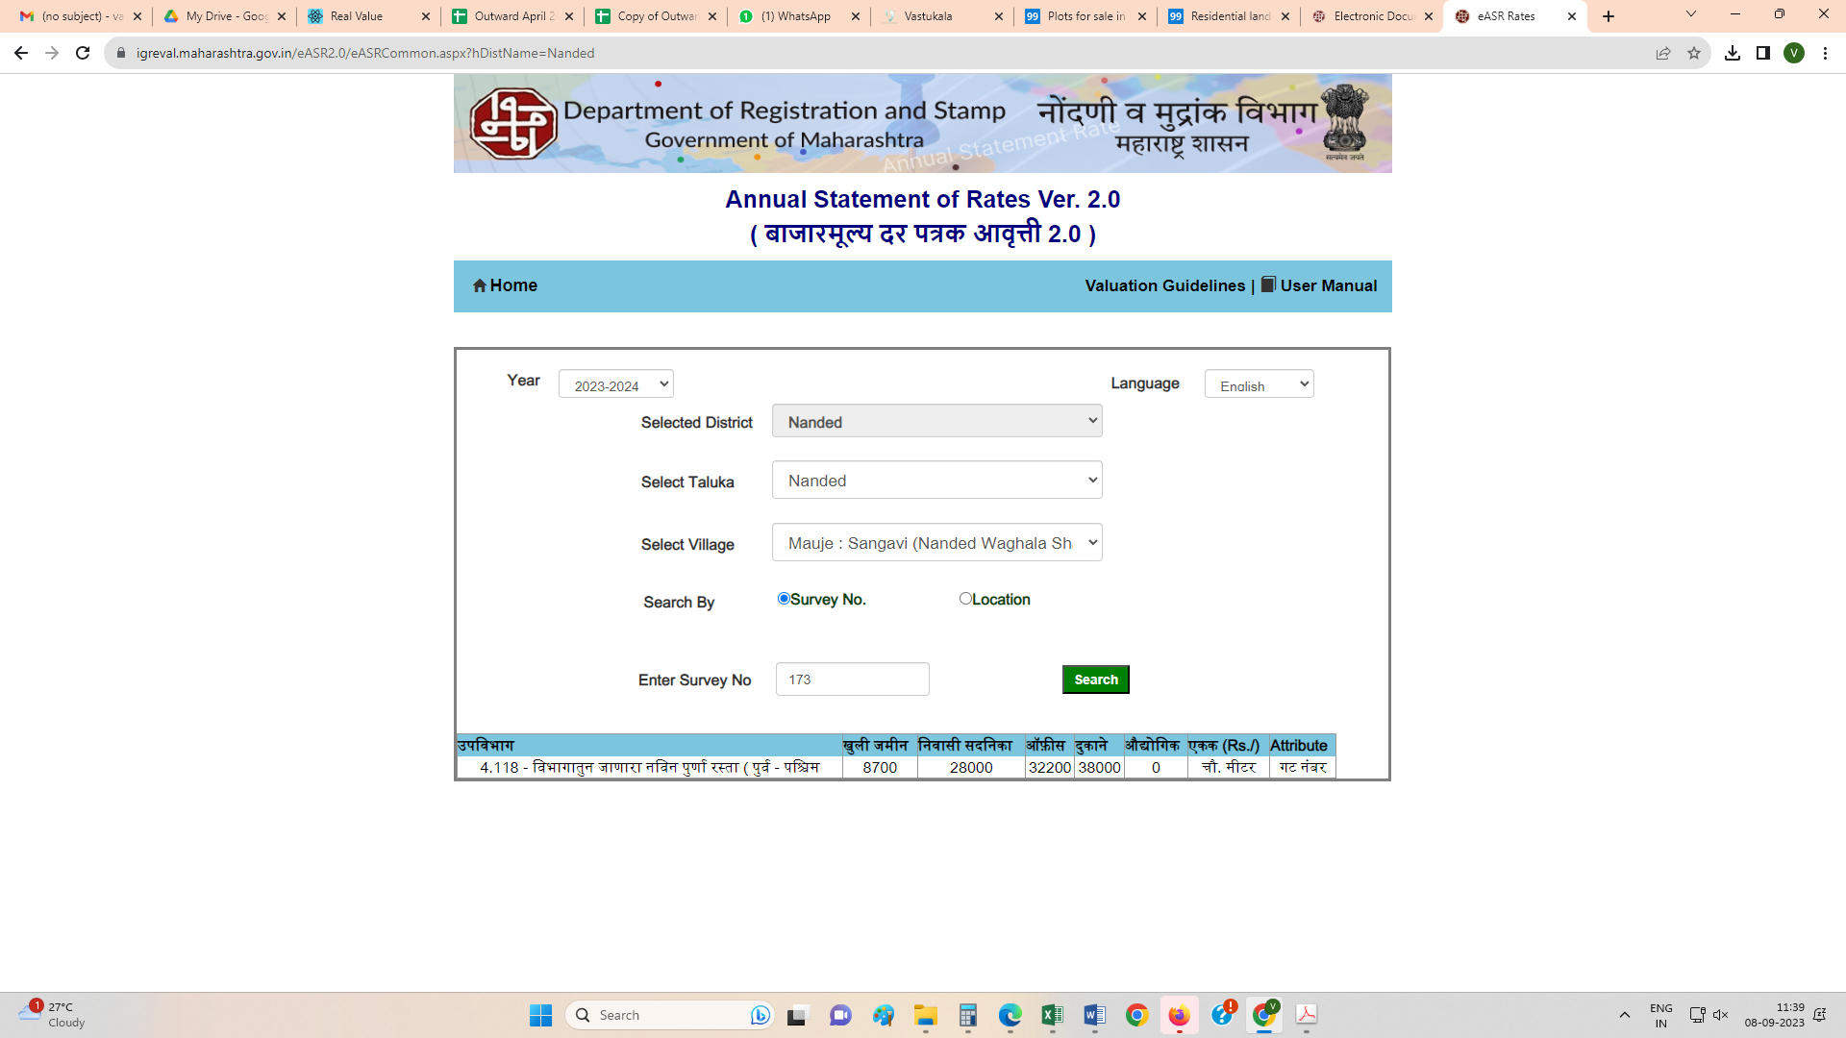

Annexure A
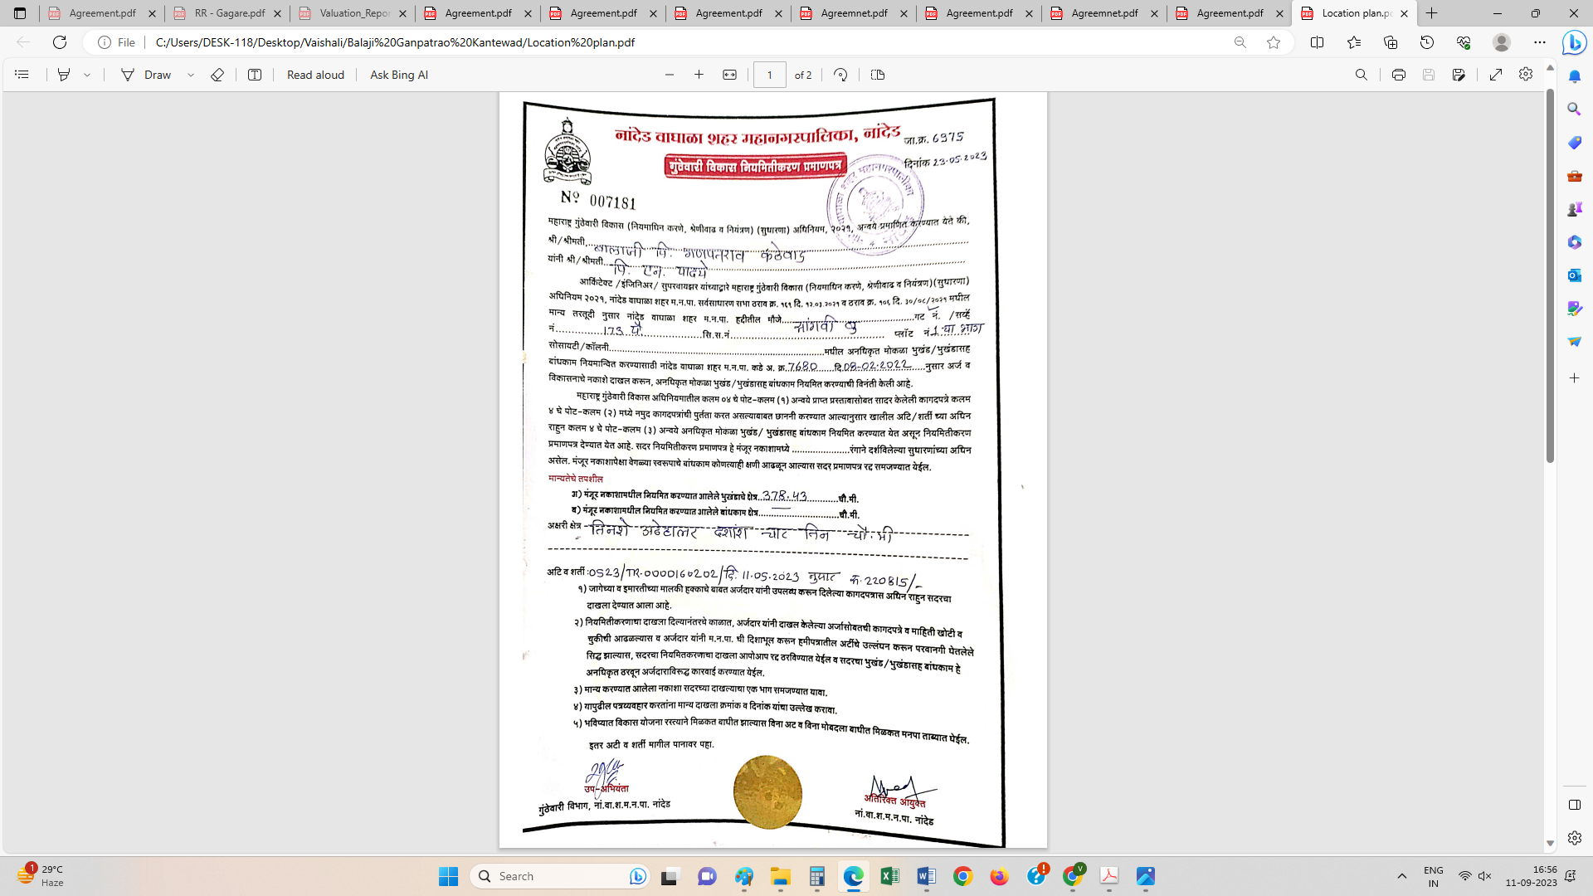
Sales Instances
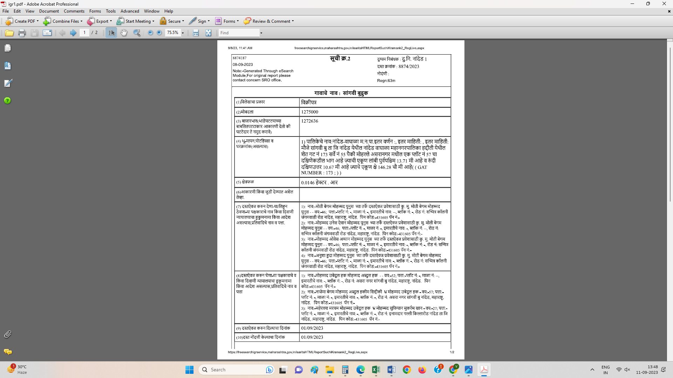

Sales Instances
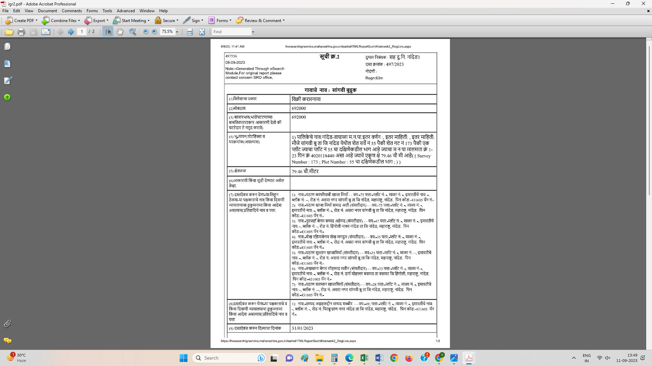

PRICE INDICATORS
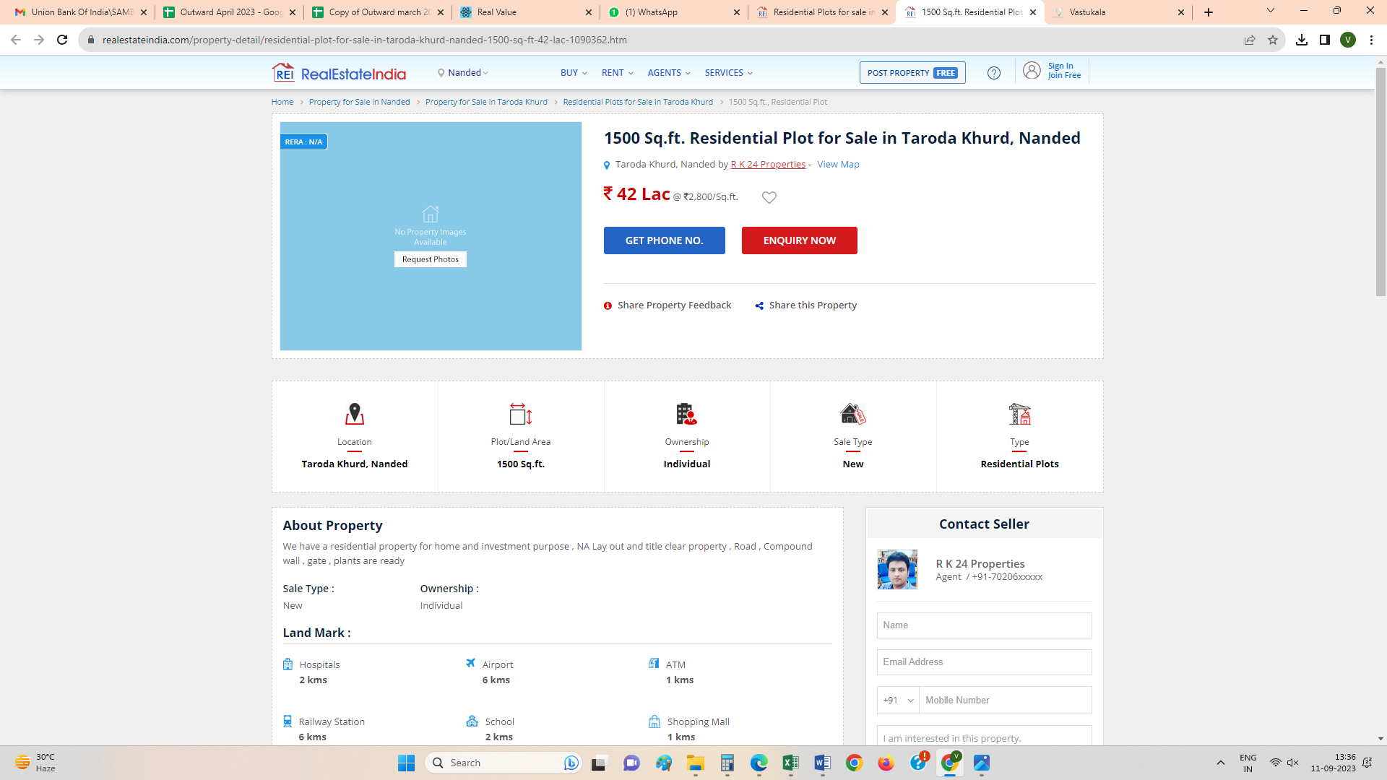

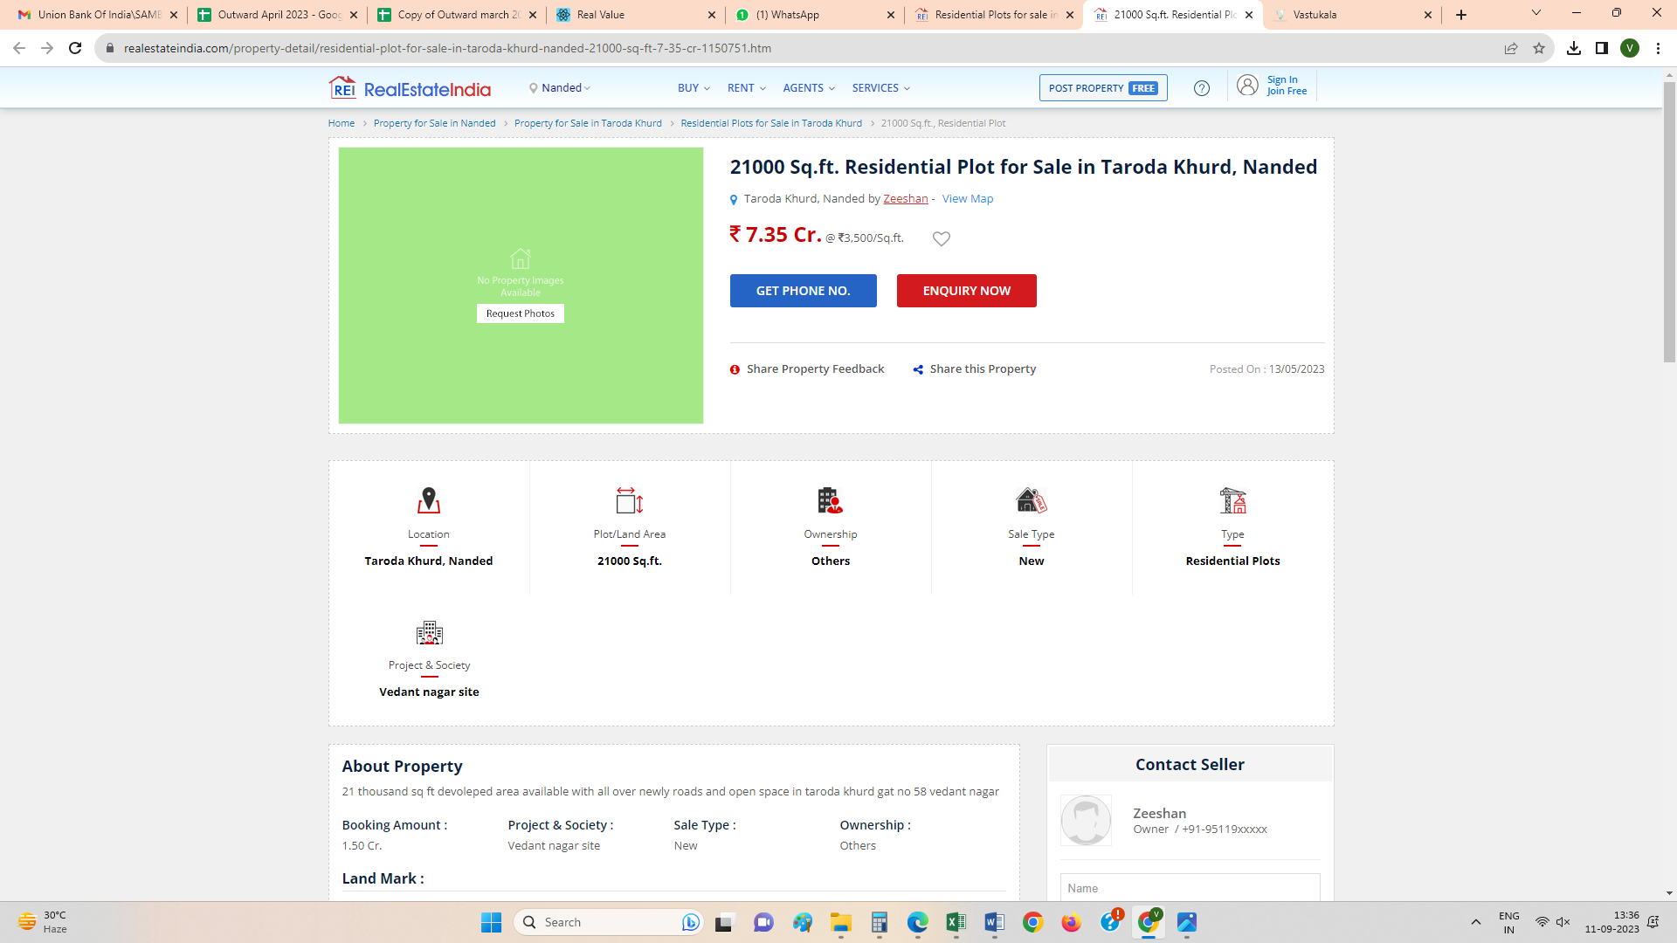

(Annexure-I)
DECLARATION-CUM-UNDERTAKING
I, Sharadkumar Chalikwar son of Shri. Baburao Chalikwar do hereby solemnly affirm and state that:
- I am a citizen of India.
- I will not undertake valuation of any assets in which I have a direct or indirect interest or become so interested at any time during a period of three years prior to my appointment as valuer or three years after the valuation of assets was conducted by me.
- The information furnished in my valuation report dated 11.09.2023 is true and correct to the best of my knowledge and belief and I have made an impartial and true valuation of the property.
- I/ my authorized representative have personally inspected the property on 06.09.2023 The work is not sub - contracted to any other valuer and carried out by myself.
- Valuation report is submitted in the format as prescribed by the bank.
- I have not been depanelled / delisted by any other bank and in case any such depanelment by other banks during my empanelment with you, I will inform you within 3 days of such depanelment.
- I have not been removed / dismissed from service / employment earlier.
- I have not been convicted of any offence and sentenced to a term of imprisonment
- I have not been found guilty of misconduct in my professional capacity.
- I have not been declared to be unsound mind
- I am not an undischarged bankrupt, or has not applied to be adjudicated as a bankrupt;
- I am not an undischarged insolvent.
- I have not been levied a penalty under section 271J of Income-tax Act, 1961 (43 of 1961) and time limit for filing appeal before Commissioner of Income-tax (Appeals) or Income-tax Appellate Tribunal, as the case may be has expired, or such penalty has been confirmed by Income-tax Appellate Tribunal, and five years have not elapsed after levy of such penalty
- I have not been convicted of an offence connected with any proceeding under the Income Tax Act 1961, Wealth Tax Act 1957 or Gift Tax Act 1958 and
- My PAN Card number as applicable is AEAPC0117Q
- I undertake to keep you informed of any events or happenings which would make me ineligible for empanelment as a valuer
- I have not concealed or suppressed any material information, facts and records and I have made a complete and full disclosure
I have read the Handbook on Policy, Standards and procedure for Real Estate Valuation, 2011 of the IBA and this report is in conformity to the "Standards" enshrined for valuation in the Part - B of the above handbook to the best of my ability.
- I have read the International Valuation Standards (IVS) and the report submitted to the Bank for the respective asset class is in conformity to the "Standards" as enshrined for valuation in the IVS in "General Standards" and "Asset Standards" as applicable. The valuation report is submitted in the prescribed format of the bank.
- I abide by the Model Code of Conduct for empanelment of valuer in the Bank. (Annexure V - A signed copy of same to be taken and kept along with this declaration)
- I am registered under Section 34 AB of the Wealth Tax Act, 1957.
- I am valuer registered with Insolvency & Bankruptcy Board of India (IBBI)
- My CIBIL Score and credit worthiness is as per Bank's guidelines.
- I am Chairman & Managing Director of the company, who is competent to sign this valuation report.

- I will undertake the valuation work on receipt of Letter of Engagement generated from the system (i.e. LLMS / LOS) only.
- Further, I hereby provide the following information.
Sr. No. | Particulars | Valuer Comment
 | background information of the asset being valued; | The subject property under valuation is Residential Land Plot No. 01 (part) (West portion of Plot No. 01), S. No. 55, Gat No. 173 (part), “Nalanda Magasvargiya Co-Op. Hsg. Soc. Ltd.”, Sana School Airport Road, Village – Sangvi Budruk, Taluka & District – Nanded - 431605, State – Maharashtra, Country – India.
 | Purpose of valuation and appointing authority | As per the request from Bank of Baroda, Taroda Br., Nanded to assess fair market value of the property.
 | Identity of the valuer and any other experts involved in the valuation; | Sharadkumar B. Chalikwar | Regd. Valuer
 |  | Manoj B. Chalikwar | Regd. Valuer
 |  | Umang Patel | Regd. Valuer
 |  | Mr. Akash Pardeshi | Engineer
 |  | Mr. Md. Shareq Salim Md.Jilani Pasha | Technical Assistant
 | disclosure of valuer interest or conflict, if any; | We have no interest, either direct or indirect, in the property valued. Further to state that we do not have relation or any connection with property owner / applicant directly or indirectly. Further to state that we are an independent Valuer and in no way related to property owner / applicant
 | date of appointment, valuation date and date of report; | Date of Appointment |  | 06.09.2023
 |  | Valuation Date |  | 11.09.2023
 |  | Date of Report |  | 11.09.2023
 | inspections and/or investigations undertaken; | Physical Inspection done on 30.06.2023
 | nature and sources of the information used or relied upon; | Market Survey at the time of site visit  Ready Reckoner rates / Circle rates  Online search for Registered Transactions  Online Price Indicators on real estate portals  Enquiries with Real estate consultants  Existing data of Valuation assignments carried out by us
 | procedures adopted in carrying out the valuation and valuation standards followed; | Sales Comparative Method
 | restrictions on use of the report, if any; | This valuation is for the use of the party to whom it is addressed and for no other purpose. No responsibility is accepted to any third party who may use or rely on the whole or any part of this valuation. The valuer has no pecuniary interest that would conflict with the proper valuation of the property.
 | major factors that were taken into account during the valuation; | current market conditions, demand and supply position, Residential Plot size, location, upswing in real estate prices, sustained demand for Residential Plots, all round development of commercial and residential application in the locality etc.
 | Caveats, limitations and disclaimers to the extent they explain or elucidate the limitations faced by valuer, which shall not be for the purpose of limiting his responsibility for the valuation report. | Attached.

(Annexure - II)
MODEL CODE OF CONDUCT FOR VALUERS
Integrity and Fairness
- A valuer shall, in the conduct of his/its business, follow high standards of integrity and fairness in all his/its dealings with his/its clients and other valuers.
- A valuer shall maintain integrity by being honest, straightforward, and forthright in all professional relationships.
- A valuer shall endeavour to ensure that he/it provides true and adequate information and shall not misrepresent any facts or situations.
- A valuer shall refrain from being involved in any action that would bring disrepute to the profession.
- A valuer shall keep public interest foremost while delivering his services.

Professional Competence and Due Care
- A valuer shall render at all times high standards of service, exercise due diligence, ensure proper care and exercise independent professional judgment.
- A valuer shall carry out professional services in accordance with the relevant technical and professional standards that may be specified from time to time.
- A valuer shall continuously maintain professional knowledge and skill to provide competent professional service based on up-to-date developments in practice, prevailing regulations / guidelines and techniques.
- In the preparation of a valuation report, the valuer shall not disclaim liability for his/its expertise or deny his/its duty of care, except to the extent that the assumptions are based on statements of fact provided by the company or its auditors or consultants or information available in public domain and not generated by the valuer.
- A valuer shall not carry out any instruction of the client insofar as they are incompatible with the requirements of integrity, objectivity and independence.
- A valuer shall clearly state to his client the services that he would be competent to provide and the services for which he would be relying on other valuers or professionals or for which the client can have a separate arrangement with other valuers.
Independence and Disclosure of Interest
- A valuer shall act with objectivity in his/its professional dealings by ensuring that his/its decisions are made without the presence of any bias, conflict of interest, coercion, or undue influence of any party, whether directly connected to the valuation assignment or not.
- A valuer shall not take up an assignment if he/it or any of his/its relatives or associates is not independent in terms of association to the company.
- A valuer shall maintain complete independence in his/its professional relationships and shall conduct the valuation independent of external influences.
- A valuer shall wherever necessary disclose to the clients, possible sources of conflicts of duties and interests, while providing unbiased services.
- A valuer shall not deal in securities of any subject company after any time when he/it first becomes aware of the possibility of his / its association with the valuation, and in accordance with the Securities and Exchange Board of India (Prohibition of Insider Trading)Regulations,2015 or till the time the valuation report becomes public, whichever is earlier.
- A valuer shall not indulge in "mandate snatching" or offering "convenience valuations" in order to cater to a company or client's needs.
- As an independent valuer, the valuer shall not charge success fee.
- In any fairness opinion or independent expert opinion submitted by a valuer, if there has been a prior engagement in an unconnected transaction, the valuer shall declare the association with the company during the last five years.
Confidentiality
- A valuer shall not use or divulge to other clients or any other party any confidential information about the subject company, which has come to his / its knowledge without proper and specific authority or unless there is a legal or professional right or duty to disclose.
Information Management
- A valuer shall ensure that he/ it maintains written contemporaneous records for any decision taken, the reasons for taking the decision, and the information and evidence in support of such decision. This shall be maintained so as to sufficiently enable a reasonable person to take a view on the appropriateness of his /its decisions and actions.
- A valuer shall appear, co-operate and be available for inspections and investigations carried out by the authority, any person authorized by the authority, the registered valuers organisation with which he/it is registered or any other statutory regulatory body.
- A valuer shall provide all information and records as may be required by the authority, the Tribunal, Appellate Tribunal, the registered valuers organization with which he/it is registered, or any other statutory regulatory body.
- A valuer while respecting the confidentiality of information acquired during the course of performing professional services, shall maintain proper working papers for a period of three years or such longer period as required in its contract for a specific valuation, for production before a regulatory authority or for a peer review. In the event of a pending case before the Tribunal or Appellate Tribunal, the record shall be maintained till the disposal of the case.
Gifts and hospitality:
- A valuer or his / its relative shall not accept gifts or hospitality which undermines or affects his independence as a valuer.
Explanation: For the purposes of this code the term 'relative' shall have the same meaning as defined in clause (77) of Section 2 of the Companies Act, 2013 (18 of 2013).
- A valuer shall not offer gifts or hospitality or a financial or any other advantage to a public servant or any other person with a view to obtain or retain work for himself / itself, or to obtain or retain an advantage in the conduct of profession for himself / itself.
Remuneration and Costs.
- A valuer shall provide services for remuneration which is charged in a transparent manner, is a reasonable reflection of the work necessarily and properly undertaken, and is not inconsistent with the applicable rules.
- A valuer shall not accept any fees or charges other than those which are disclosed in a written contract with the person to whom he would be rendering service.
Occupation, employability and restrictions.
- A valuer shall refrain from accepting too many assignments, if he/it is unlikely to be able to devote adequate time to each of his/ its assignments.
- A valuer shall not conduct business which in the opinion of the authority or the registered valuer organization discredits the profession.
Miscellaneous
- A valuer shall refrain from undertaking to review the work of another valuer of the same client except under written orders from the bank or housing finance institutions and with knowledge of the concerned valuer.
- A valuer shall follow this code as amended or revised from time to time.

For, Vastukala Consultants (I) Pvt. Ltd.

Sharadkumar B. Chalikwar
B.E. (Civil), M.E. (Civil), M.Sc. (Real Estate Valuation), M.Sc. (P&M Valuation), FIE (I), FIV, FIWRS
Chairman & Managing Director
Govt. Reg. Valuer
Chartered Engineer (India)
Reg. No. (N) CCIT/1-14/52/2008-09
IBBI Reg. No. IBBI/RV/07/2019/11744

Date : 06.07.2023
Place: Nanded

