Valuation Report of the Immovable Property

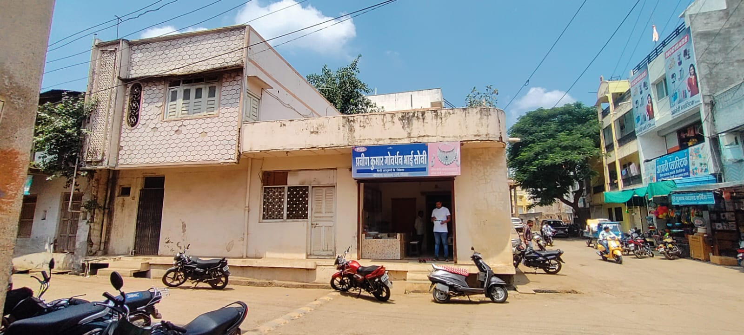

Details of the property under consideration:

Name of Owner: Shri. Ashok Kumra Tayal S/o Shri Bihrarilal Tayal

Residential House No. 150, “Molana Azad Marg”, Niwali Raod, Triveni Chowk,
Village & Tehsil Sendhwa, District Barwani, PIN – 451 666,
State – Madhya Pradesh, Country – India

Longitude Latitude - 21°41’04.0”N 75°05’40.8”E

Valuation prepared for:

Punjab National Bank
MID Corporate Centre
2nd Floor, C 21, Business Park, Opp. Raddison Hotel, Indore,
PIN – 452 001, State – Madhya Pradesh, Country – India

Vastu/PNB/Indore/06/2023/002147/2301321
28/9-422-BS
Date: 08.09.2023

VALUATION OPINION REPORT

This is to certify that the property Residential House No. 150, “Molana Azad Marg”, Niwali Raod, Triveni Chowk, Village & Tehsil Sendhwa, District Barwani, PIN – 451 666, State – Madhya Pradesh, Country – India belongs to Shri. Ashok Kumra Tayal S/o Shri Bihrarilal Tayal.

Boundaries of the property.
Particulars | As per Site Inspection
North | Kamal Patil House
South | Road
East | Road
West | Brajlal Mansukh Shah House

Considering various parameters recorded, existing economic scenario, and the information that is available with reference to the development of neighborhood and method selected for valuation, we are of the opinion that, the property premises can be assessed and valued for this particular purpose at
Particulars | Fair Market Value In (`) | Realizable Value In (`) | Distress Sale Value In (`) | Insurable Value In  (`)
Residential Flat | 82,54,928/- | 74,29,435/- | 66,03,942/- | 19,07,400/-

The valuation of the property is based on the documents produced by the concern. Legal aspects have not been taken into considerations while preparing this valuation report.

Hence certified

Manoj B. Chalikwar

Registered Valuer

Chartered Engineer (India)

Reg. No. IBBI / RV / 07/2018/10366
Reg. No. CAT-I-F-1763
Encl: Valuation report.
Valuation Report of Immovable Property

Sr. No. | Particulars | Content
 | Introduction
 | Name of Valuer | Manoj B. Chalikwar  Vastukala Consultants (I) Pvt. Ltd.  106, 1st Floor, Gold Star Tower, Opp. Treasure Island Mall, M.G. Road, Indore – 452 001.
 | Date of Inspection | 03.09.2023
 | Sale Deed Number and Date | Sale Deed, dated 25.07.2013
 | Date of Valuation | 08.09.2023
 | Purpose of Valuation | As per request from the client for Punjab National Bank, MID Corporate Centre to assess Fair Market value of the property for Banking Loan Purpose.
 | Name of Property Owner/s  (Details of share of each owner in case of joint & Co-ownership) | Shri. Ashok Kumra Tayal S/o Shri Bihrarilal Tayal
 | Name of Bank/FI as applicable | Punjab National Bank
 | Name of Developer of the Property  (in case of developer built properties) | N.A. as the property is a residential open plot only.
 | Whether occupied by the owner / tenant? If occupied by tenant, since how long? | Vacant plot under owner’s possession
 | Physical Characteristics of the Property
 | Location of the Property
 | Plot No. / Survey No. | -
 | Door No. | House No. 150
 | T. S. No. / Village | Kasba - Sendhwa
 | Ward / Taluka | Ward No. 11 Jawaharlal Nehru Wardwa
 | Mandal / District | District - Barwani
 | Brief description of the property:
The immovable property comprises of freehold residential plot of land owned by Shri. Ashok Kumra Tayal S/o Shri Bihrarilal Tayal. As per site inspection the property is an open plot only. The property is located in a developing area having basic infrastructure, well connected by road and train. It is located at 1.6 KM. travelling distance from Sendwa New Bus Stand.

Nearby Landmark: K.K. Electronics

Land:
As per Sale Deed, the plot of land area is 138.98 Sq. M. i.e. 1,496.00 Sq. Ft, which is considered for valuation. The Plot is demarcated by small cement poles.

The composition of the Residential Row House as per site is as below -
Floor | Composition
Ground | Drawing Room + Kitchen + Shop + 2 Room + Toilet + Verandah
First | Store + 2 Room

As per Site Measurement, the structure area is as below-
Floor | Built up Area in Sq. Ft.
Ground | 1,496.00
Open Area | 544.00.00

 | Municipal Ward No. | Ward No. 11 Jawaharlal Nehru Ward
 | City / Town | Sendhwa, Barwani
 | Residential Area / Commercial Area / Industrial Area | Residential Area
 | Classification of the area:
 | High / Middle / Poor | Middle
 | Metro / Urban / Semi Urban / Rural | Urban
 | Coming under Corporation limit/ Village Panchayat/ Municipality | Nagar Palika Sendhwa
 | Postal Address of the Property | Residential House No. 150, “Molana Azad Marg”, Niwali Raod, Triveni Chowk, Village & Tehsil Sendhwa, District Barwani, PIN – 451 666, State – Madhya Pradesh, Country – India.
 | Latitude, Longitude and Coordinates of the site | 21°41’04.0”N 75°05’40.8”E
 | Area of the plot/land  (Supported by a plan) | Plot of land area = 1,496.00 Sq. Ft.  (Area as per Sale Deed)
 | Layout plan of the area in which the property is located | Approved building Plan No. 994 Dated 15.07.1965 Passed by Municipal Officer, Municipal Council Sendhwa.
 | Development of surrounding areas | Developing
 | Details of Roads abutting the property | Balwadi - Sendhwa Road
 | Whether covered under any State / Central Govt. enactments (e.g., Urban Land Ceiling Act) or notified under agency area / scheduled area /cantonment area | N.A.
 | In case it is an agricultural land, any conversion to house site plots is contemplated | N.A.
 | Boundaries of the property | As per actual at site | As per Sale deed
 | North | Kamal Patil House | Kamal Patil House
 | South | Road | Road
 | East | Road | Road
 | West | Brajlal Mansukh Shah House | Brajlal Mansukh Shah House
 | Extent of the site considered for valuation (least of 14 A & 14 B) | N.A.
 | Description of Adjoining properties
 | North | Kamal Patil House
 | South | Road
 | East | Road
 | West | Brajlal Mansukh Shah House
 | Survey no. if any | Details not available
 | Type of Building (Residential/ Commercial/ Industrial) | N.A. as the property is a residential open plot only
 | Details of the building / buildings and other improvements in terms of area, height, no. of floors, plinth area floor wise, year of construction, year of making alterations / additional constructions with details, full details of specifications to be appended along with building plans and elevations | N.A. as the property is a residential open plot only
 | Plinth area, Carpet area and Saleable area to be mentioned separately and clarified | N.A. as the property is a residential open plot only
 | Any other aspect. | No
 | Town Planning parameters
 | Master Plan provisions related to property in terms of land use | Residential
 | Date of issue and validity of layout of approved map / plan | N.A. as the property is a residential open plot only
 | Approved map / plan issuing authority | N.A. as the property is a residential open plot only
 | Whether genuineness or authenticity of approved map / plan is verified | N.A. as the property is a residential open plot only
 | Any other comments by our empanelled valuers on authenticity of approved plan | No
 | Planning area/zone | Nagar Palika Sendhwa, Barwani
 | Development controls | As per Nagar Palika Sendhwa, Barwani
 | Zoning regulations | As per Nagar Palika Sendhwa, Barwani
 | FAR/FSI permitted and consumed | N.A. as the property is a residential open plot only
 | Ground coverage | N.A. as the property is a residential open plot only
 | Transferability of developmental rights if any, Building by-laws provision as applicable to the property viz. setbacks, height restriction etc. | As per Nagar Palika Sendhwa, Barwani
 | Comment on the surrounding land uses and adjoining properties in terms of uses | Residential
 | Comment on unauthorized constructions if any | N.A. as the property is a residential open plot only
 | Comment on demolition proceedings if any | N.A. as the property is a residential open plot only
 | Comment on compounding / regularization proceedings | N.A. as the property is a residential open plot only
 | Comment on whether OC has been issued or not | N.A. as the property is a residential open plot only
 | Any other Aspect | No
 | Legal Aspects
 | Copy of Ownership Documents
- Sale Deed, dated 25.07.2013. between Biharila S/o Gopilal Tayal (Agrawal) Shri. Ashok Kumra Tayal S/o Shri Bihrarilal Tayal (the Owner)
- Approved building Plan No. 994 Dated 15.07.1965 Passed by Municipal Officer, Municipal Council Sendhwa.
- Court Order 29A1/13 Dated 27.07.2023 L.L. other than Civil Judge Sendhwa, District Barwani.
 | Names of Owner/s  (In case of Joint or Co-ownership, whether the shares are undivided or not?) | Shri. Ashok Kumra Tayal S/o Shri Bihrarilal Tayal
 | Comment on dispute / issues of landlord with tenant / statutory body / any other agencies, if any in regard to immovable property. | Information not available
 | Comment on whether the IP is independently accessible? | Yes
 | Title verification, | N.A., being TIR copy not provided for our verification.
 | Details of leases if any | N.A.
 | Ordinary status of freehold or leasehold including restriction on transfer, | Freehold
 | Agreements of easements if any, | Not apparent from the documents provided
 | Notification for acquisition if any, | Not apparent from the documents provided
 | Notification for road widening if any, | Not apparent from the documents provided
 | Possibility of frequent flooding / sub-merging | No
 | Special remarks, if any, like threat of acquisition of land for public service purposes, road widening or Applicability of CRZ provisions etc. (Distance from sea-coast / tidal level must be incorporated) | N.A.
 | Heritage restrictions if any, | No
 | All legal documents, receipts related to electricity, water tax, property tax and any other building taxes to be verified and copies as applicable to be enclosed with the report. | All the provided documents are enclosed with the valuation report.
 | Comment on transferability of the property ownership | Easily transferable as per norms
 | Comment on existing mortgages/ charges / encumbrances on the property if any | Details not available. The bank is requested to  independently verify the same.
 | Comment on whether the owners of the property have issued any guarantee (personal/corporate) as the case may be | Details not available. The bank is requested to  independently verify the same.
 | Building plan sanction, illegal constructions if any done without plan sanction / violations. | N.A. as the property is a residential open plot only.
 | Any other aspect | No
 | Economic Aspects
 | Details of ground rent payable, | Information not available
 | Details of monthly rents being received if any, | N.A. as the property is a residential open plot only.
 | Taxes and other outgoings, | Information not available
 | Property insurance, | N.A. as the property is a residential open plot only.
 | Monthly maintenance charges, | N.A. as the property is a residential open plot only.
 | Security charges, etc. | N.A. as the property is a residential open plot only.
 | Any other aspect | No
 | Socio-cultural Aspects
 | Descriptive account of the location of the property in terms of social structure of the area, population, social stratification, regional origin, economic level, location of slums, squatter settlements nearby, etc. | Not applicable
 | Functional and Utilitarian Aspects
 | Description of the functionality and utility of the property in terms of:
 | - Space allocation | N.A. as the property is a residential open plot only.
 | - Storage Spaces | N.A. as the property is a residential open plot only.
 | - Utility spaces provided within the building | N.A. as the property is a residential open plot only.
 | - Any other aspect | No
 | Infrastructure Availability
 | - Description of aqua infrastructure availability in terms of
 | - Water supply | N.A. as the property is a residential open plot only.
 | - Sewerage/sanitation System | N.A. as the property is a residential open plot only.
 | - Storm water drainage | N.A. as the property is a residential open plot only.
 | - Description of other physical infrastructure facilities viz.
 | - Solid waste management | N.A. as the property is a residential open plot only.
 | - Electricity | N.A. as the property is a residential open plot only.
 | - Road and public transport connectivity | All well connected with public transport like bus, taxi and private vehicles.
 | - Availability of other public utilities nearby | All available nearby
 | - Social infrastructure in terms of  - School  - Medical facilities  - Recreational facility in terms of parks and open space | All available nearby
 | Marketability of the Property
 | Analysis of the market for the property in terms of
 | - Locational attributes | Located in developed area
 | - Scarcity | Good
 | - Demand and supply of the kind of subject property | Good
 | - Comparable sale prices in the locality | Price Indicators from online property portals attached.
 | Engineering and Technology Aspects
 | Type of construction | N.A. as the property is a residential open plot only.
 | Material & technology used | N.A. as the property is a residential open plot only.
 | Specifications, | N.A. as the property is a residential open plot only.
 | Maintenance issues | N.A. as the property is a residential open plot only.
 | Age of the building | N.A. as the property is a residential open plot only.
 | Total life of the building | N.A. as the property is a residential open plot only.
 | Extent of deterioration | N.A. as the property is a residential open plot only.
 | Structural safety | N.A. as the property is a residential open plot only.
 | Protection against natural disaster viz. earthquakes, | N.A. as the property is a residential open plot only.
 | Visible damage in the building | N.A. as the property is a residential open plot only.
 | Common facilities viz. lift, water pump, lights, security systems, etc., | N.A. as the property is a residential open plot only.
 | System of air-conditioning | N.A. as the property is a residential open plot only.
 | Provision of firefighting | N.A. as the property is a residential open plot only.
 | Copies of the plan and elevation of the building to be included | N.A. as the property is a residential open plot only.
 | Environmental Factors | N.A. as the property is a residential open plot only.
 | Use of environment friendly building materials, Green Building techniques if any | N.A. as the property is a residential open plot only.
 | Provision of rain water harvesting | N.A. as the property is a residential open plot only.
 | Use of solar heating and lightening systems, etc., | N.A. as the property is a residential open plot only.
 | Presence of environmental pollution in the vicinity of the property in terms of industry, heavy traffic etc. | No
 | Architectural and aesthetic quality
 | Descriptive account on whether the building is modern, old fashioned, plain looking or decorative, heritage value, presence of landscape elements etc. | N.A. as the property is a residential open plot only.
XIII. | In case of valuation of industrial property
 | 1) Proximity to residential areas | N.A.
 | 2) Availability of public transport facilities | Private Vehicles, Bus, Auto etc.
XIV. | Valuation
 | Methodology of valuation – Procedures adopted for arriving at the valuation. Valuers may consider various approaches and state explicitly the reason for adopting particular approach and assumptions made, basis adopted with supporting data, comparable sales, and reconciliation of various factors on which final value judgment is arrived at. | Land cost can be estimated using the Sales Comparison Approach by studying recent sales of land close to the subject property, and these sales should be comparable in size and location with subject property
 | Prevailing Market Rate/Price trend of the Property in the locality/city from property search sites viz magickbricks.com, 99acres.com, makaan.com etc. if available | ` 5,500/- per Sq. Ft. on Built-up Area  ` 5,450/- per Sq. Ft. on Built-up Area after depreciation.
 | Guideline rate obtained from the Register’s Office (evidence thereof to be enclosed) | ` 26,400/- per Sq. M. i.e. ` 574.00 per Sq. Ft.

 | COMPOSITE RATE ADOPTED AFTER DEPRECIATION
a | Depreciated building rate | :
 | Replacement cost of flat with Services (v(3)i) | : | ` 1,500/- per Sq. Ft.
 | Age of the building | : | 60 Years
 | Life of the building estimated | : | 60 Years (Subject to proper, preventive periodic maintenance & structural repairs.)
 | Depreciation percentage assuming the salvage value as 10% | : | 90.00%
 | Depreciated Ratio of the building | : | -
b | Total composite rate arrived for Valuation | :
 | Depreciated building rate VI (a) | : | 218/- per Sq. Ft.
 | Rate for Land & other V (3) ii | : | 5,282/- per Sq. Ft.
 | Total Composite Rate | : | 5,500/- per Sq. Ft.

3 | Summary of Valuation
3 | - Government Value
3 | Particulars | Area in Sq. Ft. | Rate in ` | Value in `
3 | Plot | 1,496.00 | 2,453/- | 36,69,688/-
3 | Structure | As per valuation table |  | 2,24,400
3 | Total |  |  | 38,94,088/-
3 | Fair Market Value
3 | - Plot | Area in  Sq. Ft. | Rate in ` | Fair Market Value in `
3 | - Plot | 1,496.00 | 5,300/- | 79,28,800/-
B. Structure
Floor | Total BUA Area in  Sq. Ft. | Year Of Cost | Total Life of Structure | Replacement Rate (`) | Age Of Build. | Final Depreciated Rate (`) | Final Depreciated Value (`) | Full Value (`)
Ground | 1,496.00 | 1966 | 60 | 1,500/- | 57 | 218/- | 3,26,128/- | 22,44,000/-

Justification for price /rate
The Market Value of the property is based on facts of markets discovered by us during our enquiries, however the government rate value in this case is less than the market value arrived by us. We are of the opinion that the value arrive by us will prove to be correct if an Auction of the subject property is carried out. As far as Market Value in Index II is concerned, it is not possible to comment on same, may be government rates are fixed by sampling during same point of time in part and whereas, Market values change every month.
In most of the cases the actual deal amount or Transaction value is not reflected in Index II because of various Market practices. As Valuer, we always try to give a value which is correct reflection of actual transaction value irrespective of any factors in market.
Total abstract of the entire property
Part – A | Plot | : | 79,28,800/-
Part – B | Structure | : | 3,26,128/-
Part – C | Compound wall | : | -
Part - D | Amenities | : | -
Part – E | Pavement | : | -
Part – F | Services | : | -
 | Market Value | : | 82,54,928/-
Remarks | - Approved Building Plan Permission is for Ground Floor But On the site The owner has constructed Ground Floor & First Floor For the purpose of valuation, we have considered the approved Ground Floor area as Approved Building Plan.  - Our civil engineer Mr. Somesh Nahar visited the property along with Mr. Nikunj Tayal (Owner, Mobile No. 9425088717).
As a result of my appraisal and analysis, it is my considered opinion that the present market value of the above property in prevailing condition with aforesaid specifications is ` 79,28,800/- (Rupees Seventeen Nine Lakh Twanteen Eight Thousand Eight Hundred Only).

- Date of purchase of immovable property | : | Sale Deed, dated 25.07.2013
- Purchase Price of Immovable Property |  | ` 12,751/-
- Book value of immovable property |  | -
- Realizable Value of immovable property | : | ` 74,29,435/-
- Distress Sale Value of immovable property | : | ` 66,03,942/-
- Guideline Value (value as per Circle Rates), if applicable, in the area where Immovable property is situated | : | ` 4,06,250/-
- Insurable value of the property  (Full Replacement Cost (22,44,000/-) – Subsoil structure cost (15%) |  | ` 39,95,816/-

Enclosures
 | Declaration from the valuer - appendix iv | Attached
 | Model code of conduct for valuer - appendix v | Attached
 | Photograph of owner with the property in the background | Site Photographs Attached
 | Screenshot (in hard copy) of Global Positioning System (GPS)/Various Applications (Apps)/Internet sites (e.g., Google earth)/etc | Provided
 | Layout plan of the area in which the property is located | Latitude and longitude provided along with satellite image of the land
 | Building plan | N.A. as the property is a residential open plot only.
 | Floor plan | N.A. as the property is a residential open plot only.
 | Any other relevant documents/extracts | No

Actual Site Photographs
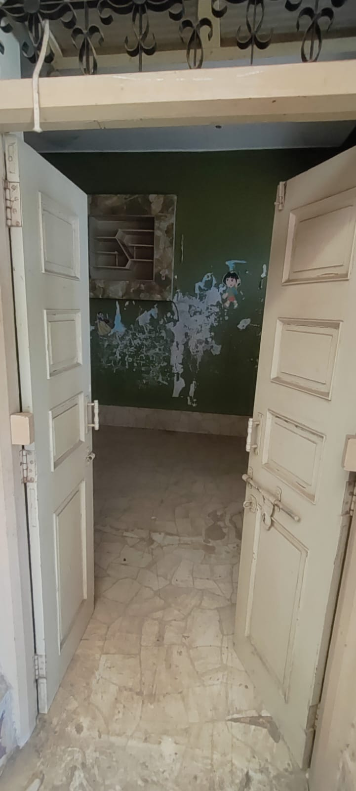
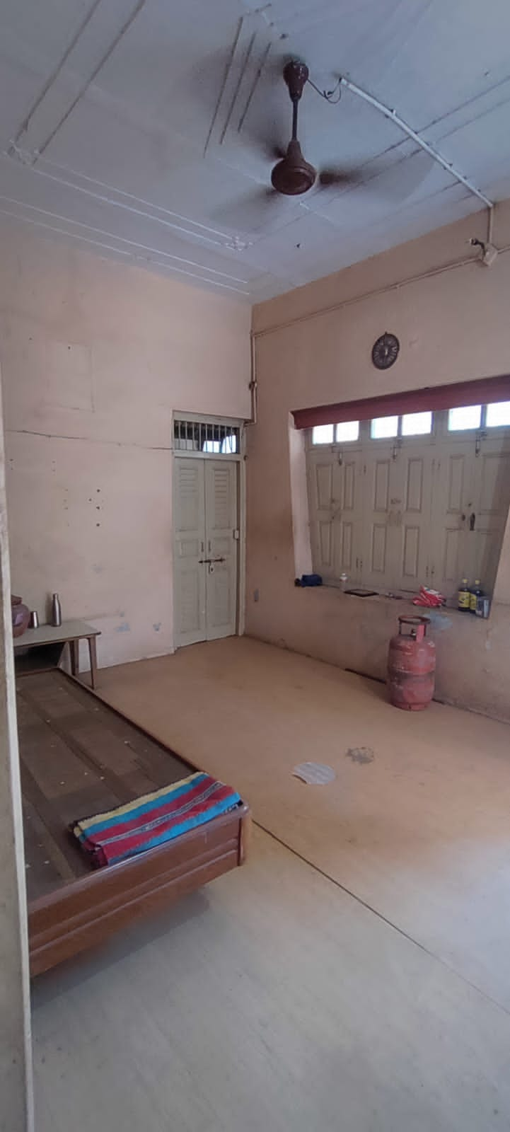
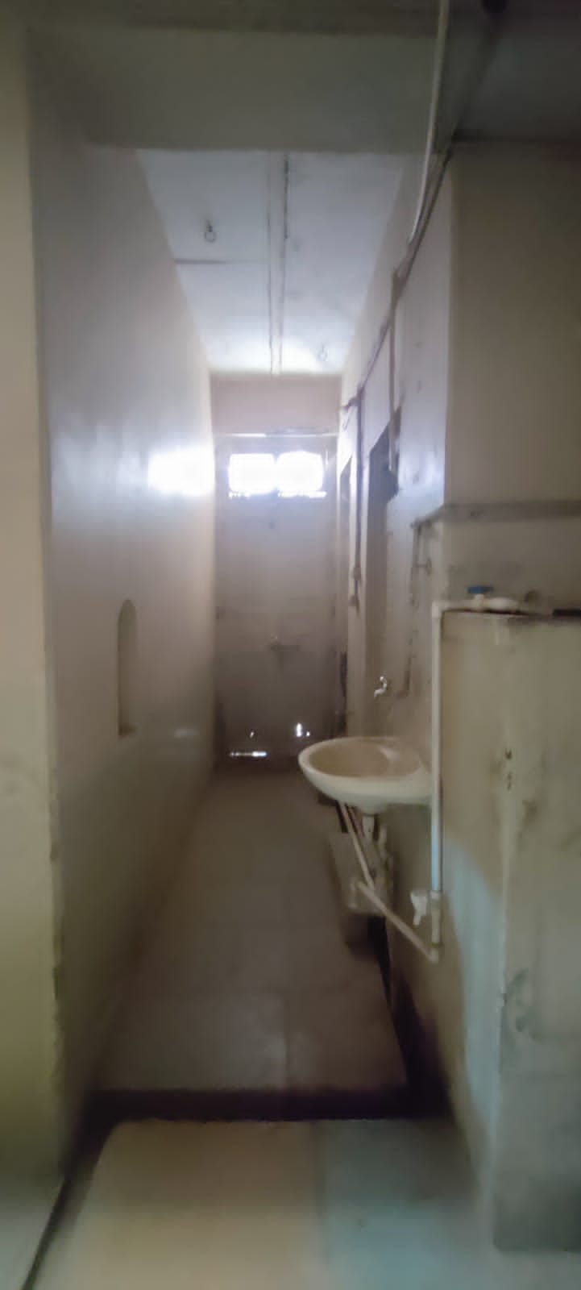

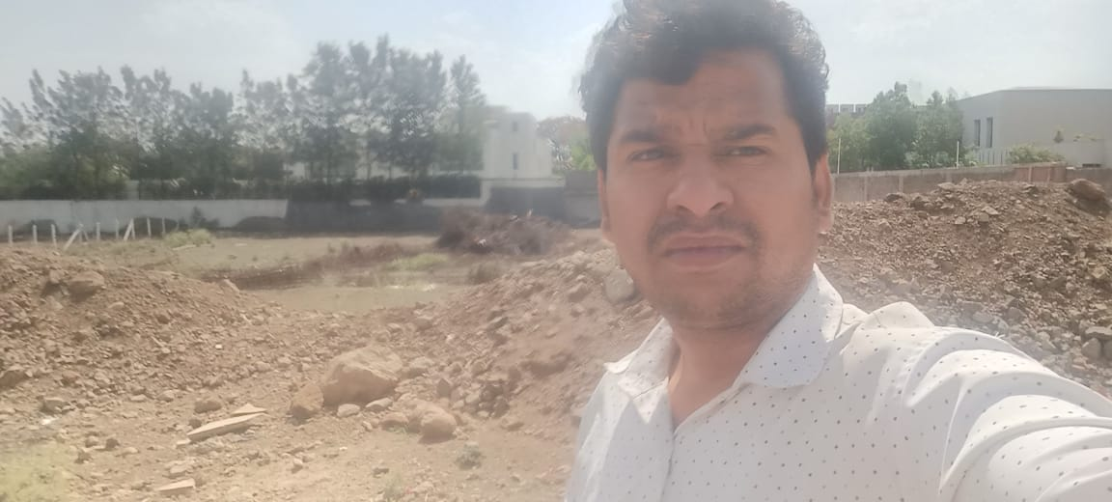
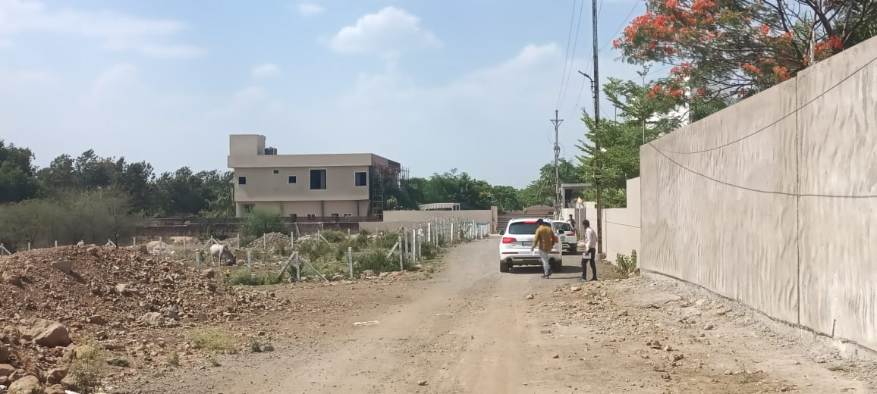
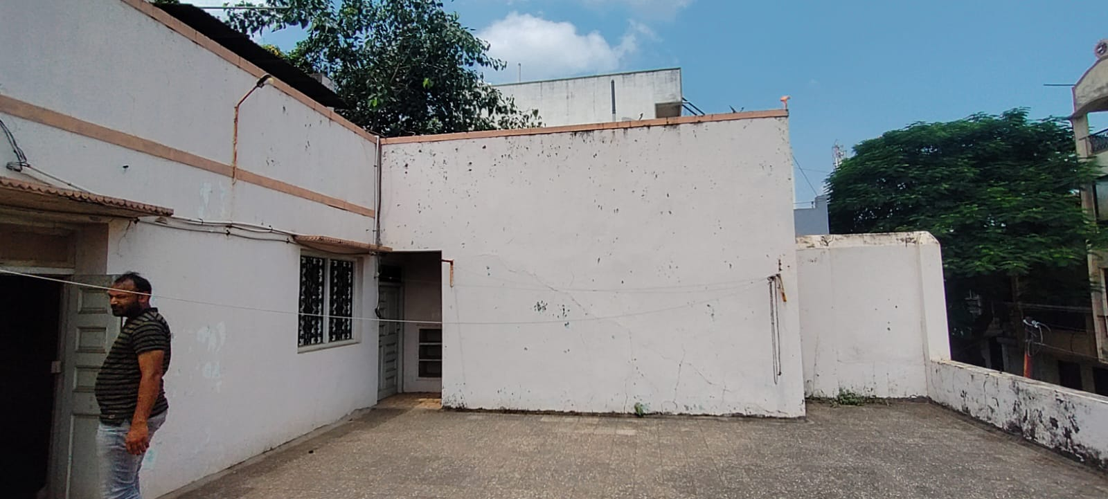
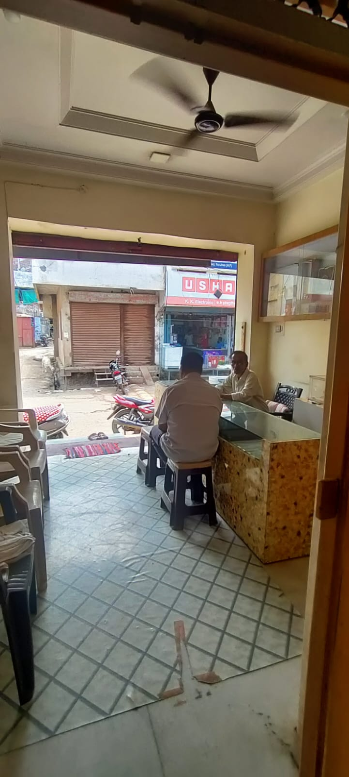
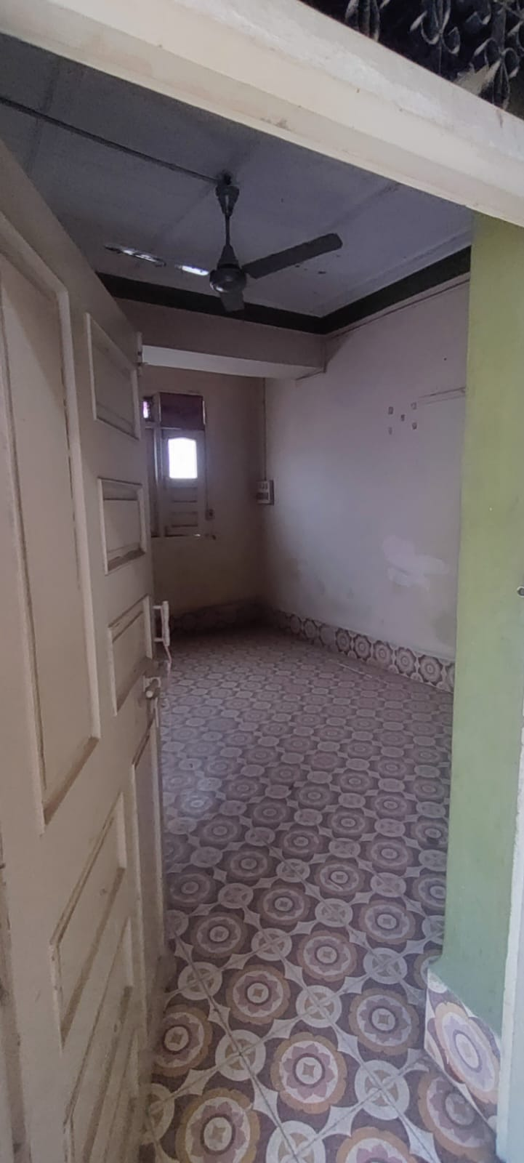
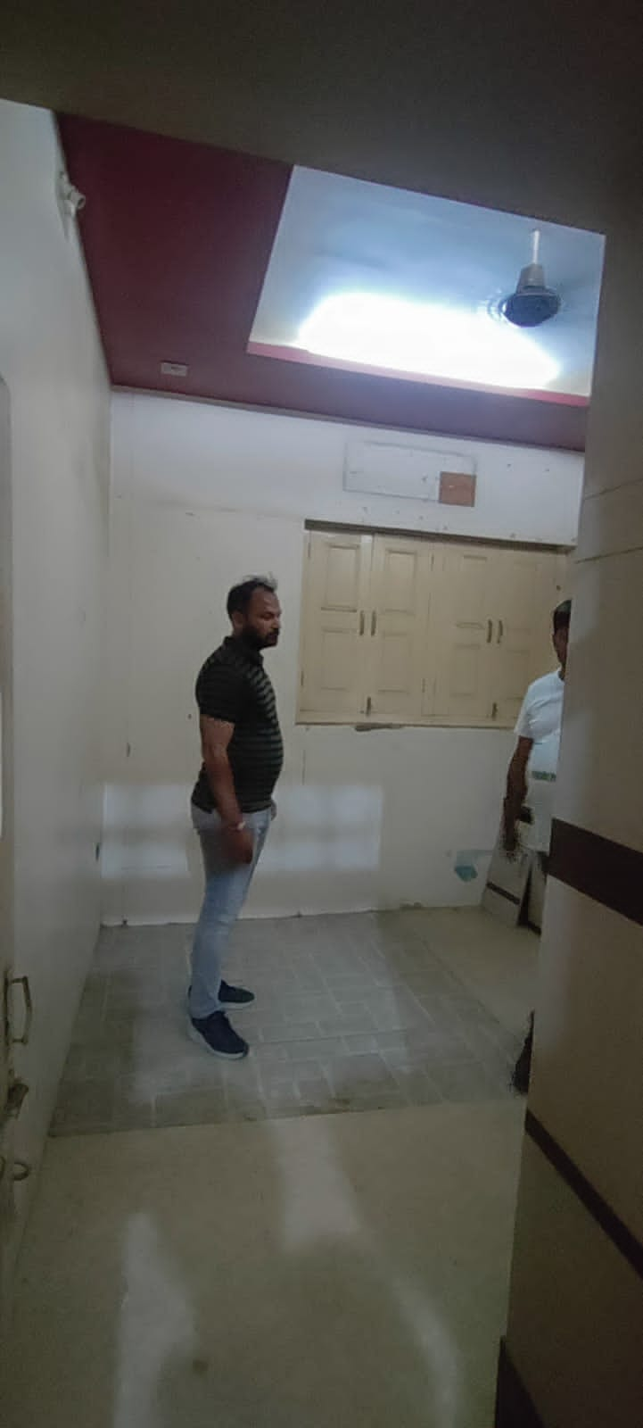
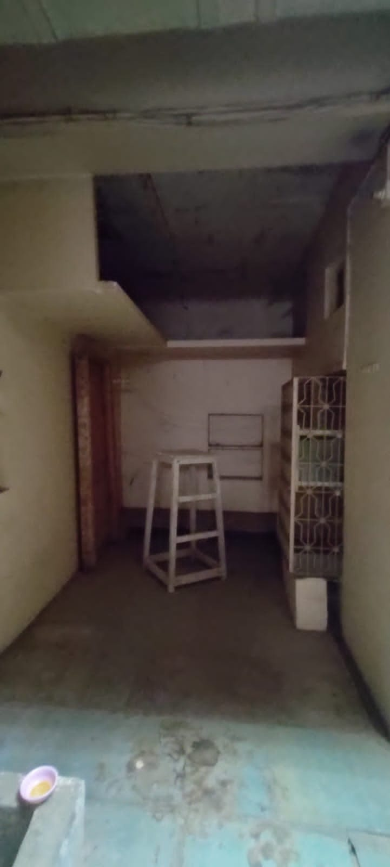
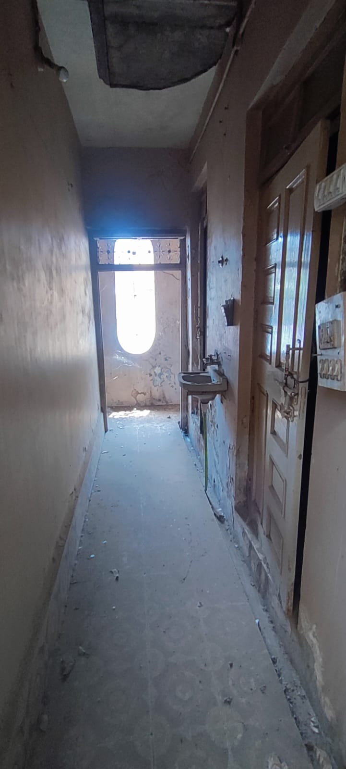

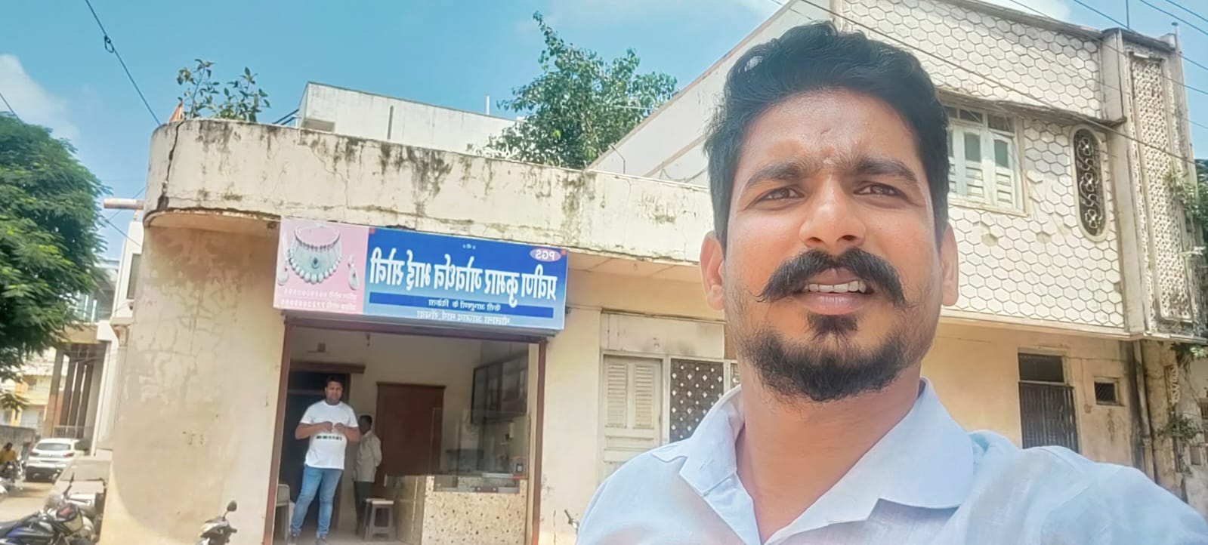

Route Map of the property

Site u/r
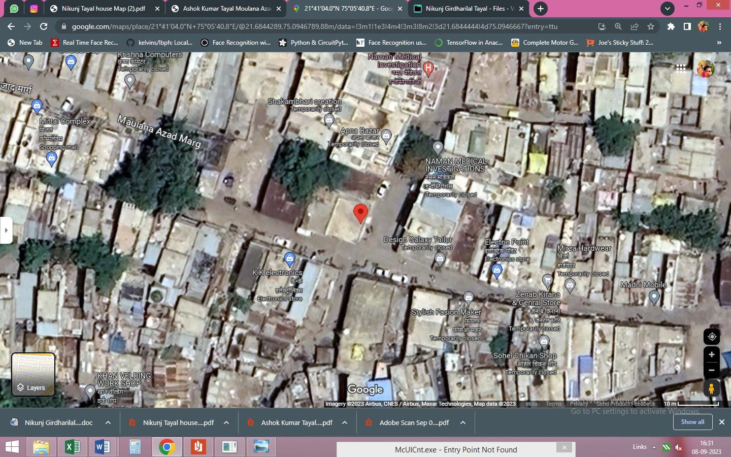

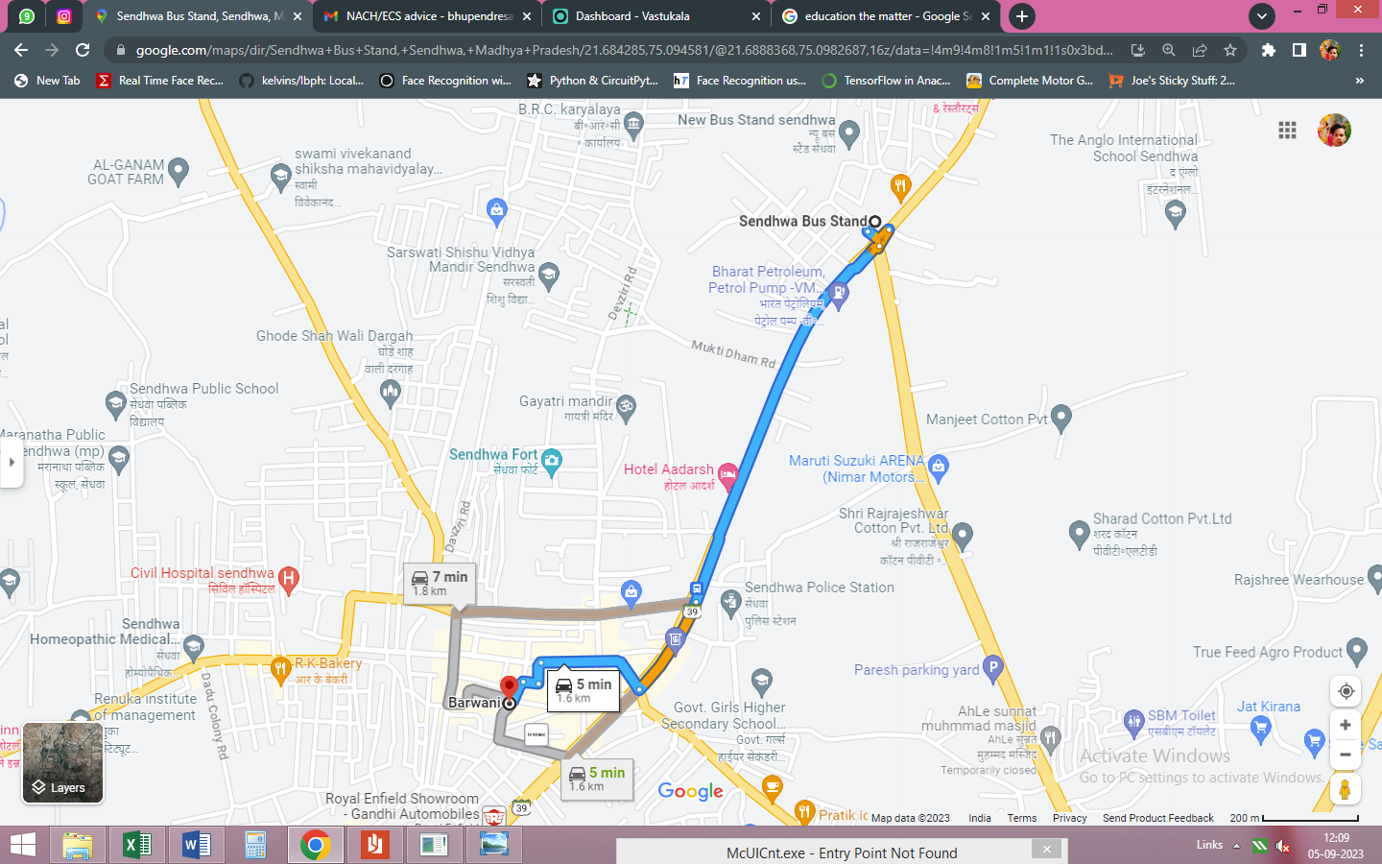

Longitude Latitude - 21°41’04.0”N 75°05’40.8”E
Note: The Blue line shows the route to site from nearest Bus Stand New (Sendhwa – 1.6 K.M.)

Ready Reckoner Rate
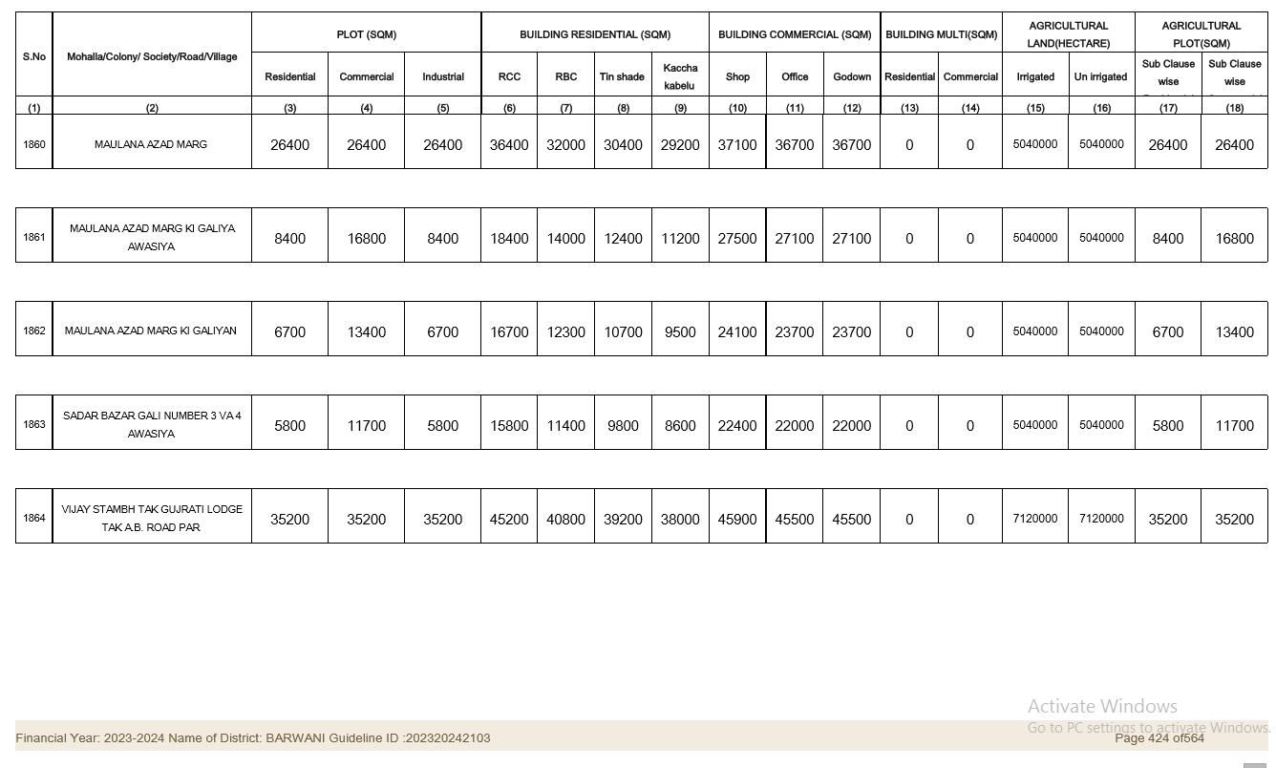

Price Indicator
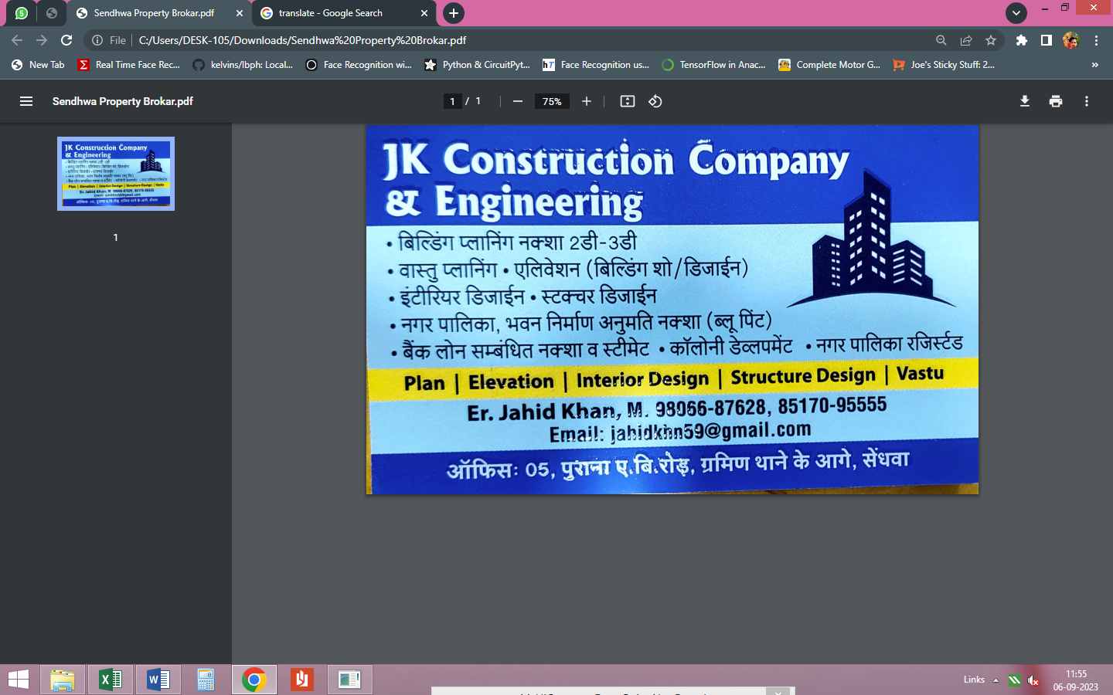

APPENDIX IV

DECLARATION FROM VALUERS

I, Manoj Chalikwar son of Shri. Baburao Chalikwar do hereby solemnly affirm and state that:

- The information furnished in my valuation report dated 08.09.2023 is true and correct to he best of my knowledge and belief and I have made an impartial and true valuation of the property.

- I have no direct or indirect interest in the property valued;

- I/ my authorized representative has personally inspected the property on 03.09.2023 the work is not sub - contracted to any other valuer and carried out by myself.

- I have not been convicted of any offence and sentenced to a term of imprisonment.

- I have not been found guilty of misconduct in my professional capacity.

- I have read the Handbook on Policy, Standards and procedure for Real Estate Valuation, 2011 of the IBA and this report is in conformity to the "Standards" enshrined for valuation in the Part - B of the above handbook to the best of my ability.

- I have read the International Valuation Standards (IVS) and the report submitted to the Bank for the respective asset class is in conformity to the "Standards" as enshrined for valuation in the IVS in "General Standards" and "Asset Standards" as applicable.

- I abide by the Model Code of Conduct for empanelment of valuer in the Bank. (Annexure III - A signed copy of same to be taken and kept along with this declaration).

- My PAN Card number as applicable is AERPC9086P

- I am valuer registered with Insolvency & Bankruptcy Board of India (IBBI).

- I am the Director of the company, who is competent to sign this valuation report.

- Further, I hereby provide the following information.

- Valuer/authorized representative have visited & valued the right property.

Sr No. | Particulars | Valuer comment
 | background information of the asset being valued; | The freehold residential plot is owned by Shri. Ashok Kumra Tayal S/o Shri Bihrarilal Tayal, as per Sale Deed, dated 25.07.2013
 | purpose of valuation and appointing authority | As per the request from Punjab National Bank, MID Corporate Centre to assess Fair Market Value of the property for banking purpose.
 | identity of the valuer and any other experts involved in the valuation; | Manoj B. Chalikwar – Regd. Valuer  Dinesh Kanere – Regional Technical Manager  Somesh Nahar – Valuation Engineer  Akhilesh Yadav – Technical Manager  Bhupendra Sanoriya - Technical Officer
 | disclosure of valuer interest or conflict, if any; | We have no interest, either direct or indirect, in the property valued. Further to state that we do not have relation or any connection with property owner / applicant directly or indirectly. Further to state that we are an independent Valuer and in no way related to property owner / applicant
 | date of appointment, valuation date and date of  report; | Date of Appointment – 03.09.2023  Valuation Date – 08.09.2023  Date of Report – 08.09.2023
 | inspections and/or investigations undertaken; | Physical Inspection done – 03.09.2023
 | nature and sources of the information used or relied upon; | - Market Survey at the time of site visit  - Online Price Indicators on real estate portals  - Enquiries with Real estate consultants
 | procedures adopted in carrying out the valuation and valuation standards followed; | Comparative Sales Method / Market Approach (For Land component)
 | restrictions on use of the report, if any; | This valuation is for the use of the party to whom it is addressed and for no other purpose. No responsibility is accepted to any third party who may use or rely on the whole or any part of this valuation. The valuer has no pecuniary interest that would conflict with the proper valuation of the property.
 | Major factors that were taken into account during the valuation; | current market conditions, demand and supply position, Land size, location, upswing in real estate prices, sustained demand for Commercial Unit, all-round development of commercial application in the locality etc.
 | Major factors that were not taken into account during the valuation; | Nil
 | Caveats, limitations and disclaimers to the extent they explain or elucidate the limitations faced by valuer, which shall not be for the purpose of limiting his responsibility for the valuation report. | Attached

Assumptions, Disclaimers, Limitations & Qualifications
Value Subject to Change
The subject appraisal exercise is based on prevailing market dynamics as on 8th September 2023 and does not take into account any unforeseeable developments which could impact the same in the future.
Our Investigations
We are not engaged to carry out all possible investigations in relation to the subject property. Where in our report we identify certain limitations to our investigations, this is to enable the reliant party to instruct further investigations where considered appropriate or where we recommend as necessary prior to reliance. Vastukala Consultants India Pvt. Ltd. (VCIPL) is not liable for any loss occasioned by a decision not to conduct further investigations
Assumptions
Assumptions are a necessary part of undertaking valuations. VCIPL adopts assumptions for the purpose of providing valuation advise because some matters are not capable of accurate calculations or fall outside the scope of our expertise, or out instructions. The reliant party accepts that the valuation contains certain specific assumptions and acknowledge and accept the risk of that if any of the assumptions adopted in the valuation are incorrect, then this may have an effect on the valuation.
Information Supplied by Others
The appraisal is based on the information provided by the client. The same has been assumed to be correct and has been used for appraisal exercise. Where it is stated in the report that another party has supplied information to VCIPL, this information is believed to be reliable but VCIPL can accept no responsibility if this should prove not to be so.
Future Matters
To the extent that the valuation includes any statement as to a future matter, that statement is provided as an estimate and/or opinion based on the information known to VCIPL at the date of this document. VCIPL does not warrant that such statements are accurate or correct.
Map and Plans
Any sketch, plan or map in this report is included to assist the reader while visualising the property and assume no responsibility in connection with such matters.
Site Details
Based on inputs received from Client's representative and site visit conducted, we understand that the subject property is currently a contiguous land parcel admeasuring 1,496.00 Sq. Ft. and is a freehold plot of land in the name of Shri. Ashok Kumra Tayal S/o Shri Bihrarilal Tayal. Further, VCIPL has assumed that the subject property is free from any encroachment and is available as on the date of the appraisal.

Property Title
Based on our discussion with the Client, we understand that the subject property is a Freehold plot of land in the name of Shri. Ashok Kumra Tayal S/o Shri Bihrarilal Tayal. For the purpose of this appraisal exercise, we have assumed that the subject property has a clear title and is free from any encumbrances, disputes and claims. VCIPL has made no further enquiries with the relevant local authorities in this regard and does not certify the property as having a clear and marketable title. Further, no legal advice regarding the title and ownership of the subject property has been obtained for the purpose of this appraisal exercise. It has been assumed that the title deeds are clear and marketable.

Environmental Conditions
We have assumed that the subject property is not contaminated and is not adversely affected by any existing or proposed environmental law and any processes which are carried out on the property are regulated by environmental legislation and are properly licensed by the appropriate authorities.
Town Planning
The permissible land use, zoning, achievable FSI, area statement adopted for purpose of this valuation is based on the information provided by the Client's representative and the same has been adopted for this valuation purpose. VCIPL has assumed the same to be correct and permissible. VCIPL has not validated the same from any authority.
Area
Based on the information provided by the Client, we understand that the subject property is a contiguous land parcel admeasuring 1,496.00 Sq. Ft.

Condition & Repair
In the absence of any information to the contrary, we have assumed that there are no abnormal ground conditions, nor archaeological remains present which might adversely affect the current or future occupation, development or value of the property. The property is free from rat, infestation, structural or latent defect. No currently known deleterious or hazardous materials or suspect techniques will be used in the construction of or subsequent alteration or additions to the property and comments made in the property details do not purport to express an opinion about, or advise upon, the condition of uninspected parts and should not be taken as making an implied representation or statement about such parts
Valuation Methodology
For the purpose of this valuation exercise, the valuation methodology used is Direct Comparison Approach Method and proposed Highest and Best Use model is used for analysing development potential.
The Direct Comparison Approach involves a comparison of the property being valued to similar properties that have actually been sold in arms - length transactions or are offered for sale. This approach demonstrates what buyers have historically been willing to pay (and sellers willing to accept) for similar properties in an open and competitive market and is particularly useful in estimating the value of the land and properties that are typically traded on a unit basis.
In case of inadequate recent transaction activity in the subject micro-market, the appraiser would collate details of older transactions. Subsequently, the appraiser would analyse rental / capital value trends in the subject micro-market in order to calculate the percentage increase / decrease in values since the date of the identified transactions. This percentage would then be adopted to project the current value of the same.
Where reliance has been placed upon external sources of information in applying the valuation methodologies, unless otherwise specifically instructed by Client and/or stated in the valuation, VCIPL has not independently verified that information and VCIPL does not advise nor accept it as reliable. The person or entity to whom the report is addressed acknowledges and accepts the risk that if any of the unverified information in the valuation is incorrect, then this may have an effect on the valuation.

Not a Structural Survey
We state that this is a valuation report and not a structural survey
Other
All measurements, areas and ages quoted in our report are approximate
Legal
We have not made any allowances with respect to any existing or proposed local legislation relating to taxation on realization of the sale value of the subject property. VCIPL is not required to give testimony or to appear in court by reason of this appraisal report, with reference to the property in question, unless arrangement has been made thereof. Further, no legal advice on any aspects has been obtained for the purpose of this appraisal exercise

Property specific assumptions
Based on inputs received from the client and site visit conducted, we understand that the subject property is currently contiguous land parcel admeasuring 1,496.00 Sq. Ft.

ASSUMPTIONS, CAVEATS, LIMITATION AND DISCLAIMERS
1. We assume no responsibility for matters of legal nature affecting the property appraised or the title thereto, nor do we render our opinion as to the title, which is assumed to be good and marketable.
2. The property is valued as though under responsible ownership.
3. It is assumed that the property is free of liens and encumbrances.
4. It is assumed that there are no hidden or unapparent conditions of the subsoil or structure that would render it more or less valuable. No responsibility is assumed for such conditions or for engineering that might be required to discover such factors.
5. There is no direct/ indirect interest in the property valued.
6. The rates for valuation of the property are in accordance with the Govt. approved rates and prevailing market rates.

APPENDIX V

MODEL CODE OF CONDUCT FOR VALUERS

{Adopted in line with Companies (Registered Valuers and Valuation Rules, 2017)}

All valuers empanelled with bank shall strictly adhere to the following code of conduct:

Integrity and Fairness
- A valuer shall, in the conduct of his/its business, follow high standards of integrity and fairness in all his/its dealings with his/its clients and other valuers.
- A valuer shall maintain integrity by being honest, straightforward, and forthright in all professional relationships.
- A valuer shall endeavour to ensure that he/it provides true and adequate information and shall not misrepresent any facts or situations.
- A valuer shall refrain from being involved in any action that would bring disrepute to the profession.
- A valuer shall keep public interest foremost while delivering his services.

Professional Competence and Due Care
- A valuer shall render at all times high standards of service, exercise due diligence, ensure proper care and exercise independent professional judgment.
- A valuer shall carry out professional services in accordance with the relevant technical and professional standards that may be specified from time to time.
- A valuer shall continuously maintain professional knowledge and skill to provide competent professional service based on up-to-date developments in practice, prevailing regulations / guidelines and techniques.
- In the preparation of a valuation report, the valuer shall not disclaim liability for his/its expertise or deny his/its duty of care, except to the extent that the assumptions are based on statements of fact provided by the company or its auditors or consultants or information available in public domain and not generated by the valuer.
- A valuer shall not carry out any instruction of the client insofar as they are in compatible with the requirements of integrity, objectivity and independence.
- A valuer shall clearly state to his client the services that he would be competent to provide and the services for which he would be relying on other valuers or professionals or for which the client can have a separate arrangement with other valuers.

Independence and Disclosure of Interest
- A valuer shall act with objectivity in his/its professional dealings by ensuring that his/its decisions are made without the presence of any bias, conflict of interest, coercion, or undue influence of any party, whether directly connected to the valuation assignment or not.
- A valuer shall not take up an assignment if he/it or any of his/its relatives or associates is not independent in terms of association to the company.
- A valuer shall maintain complete independence in his/its professional relationships and shall conduct the valuation independent of external influences.
- A valuer shall wherever necessary disclose to the clients, possible sources of conflicts of duties and interests, while providing unbiased services.
- A valuer shall not deal in securities of any subject company after any time when he/it first becomes aware of the possibility of his / its association with the valuation, and in accordance with the Securities and Exchange Board of India (Prohibition of Insider Trading)Regulations,2015 or till the time the valuation report becomes public, whichever is earlier.
- A valuer shall not indulge in "mandate snatching" or offering "convenience valuations" in order to cater to a company or client's needs.
- As an independent valuer, the valuer shall not charge success fee (Success fees may be defined as a compensation / incentive paid to any third party for successful closure of transaction. In this case, approval of credit proposals).
- In any fairness opinion or independent expert opinion submitted by a valuer, if there has been a prior engagement in an unconnected transaction, the valuer shall declare the association with the company during the last five years.
Confidentiality
- A valuer shall not use or divulge to other clients or any other party any confidential information about the subject company, which has come to his / its knowledge without proper and specific authority or unless there is a legal or professional right or duty to disclose.
Information Management
- A valuer shall ensure that he/ it maintains written contemporaneous records for any decision taken, the reasons for taking the decision, and the information and evidence in support of such decision. This shall be maintained so as to sufficiently enable a reasonable person to take a view on the appropriateness of his /its decisions and actions.
- A valuer shall appear, co-operate and be available for inspections and investigations carried out by the authority, any person authorised by the authority, the registered valuers organisation with which he/it is registered or any other statutory regulatory body.
- A valuer shall provide all information and records as may be required by the authority, the Tribunal, Appellate Tribunal, the registered valuers organisation with which he/it is registered, or any other statutory regulatory body.
- A valuer while respecting the confidentiality of information acquired during the course of performing professional services, shall maintain proper working papers for a period of three years or such longer period as required in its contract for a specific valuation, for production before a regulatory authority or for a peer review. In the event of a pending case before the Tribunal or Appellate Tribunal, the record shall be maintained till the disposal of the case.
Gifts and hospitality:
- A valuer or his / its relative shall not accept gifts or hospitality which undermines or affects his independence as a valuer.
Explanation, - For the purposes of this code the term 'relative' shall have the same meaning as defined in clause (77) of Section 2 of the Companies Act, 2013 (18 of 2013).
- A valuer shall not offer gifts or hospitality or a financial or any other advantage to a public servant or any other person with a view to obtain or retain work for himself / itself, or to obtain or retain an advantage in the conduct of profession for himself / itself.
Remuneration and Costs.
- A valuer shall provide services for remuneration which is charged in a transparent manner, is a reasonable reflection of the work necessarily and properly undertaken, and is not inconsistent with the applicable rules.
- A valuer shall not accept any fees or charges other than those which are disclosed in a written contract with the person to whom he would be rendering service.
Occupation, employability and restrictions.
- A valuer shall refrain from accepting too many assignments, if he/it is unlikely to be able to devote adequate time to each of his/ its assignments.
- A valuer shall not conduct business which in the opinion of the authority or the registered valuer organisation discredits the profession.

Manoj B. Chalikwar

Registered Valuer

Chartered Engineer (India)

Reg. No. IBBI / RV / 07/2018/10366

Reg. No. CAT-I-F-1763

