Vastu/Nashik/03/2023833/30490/46262
22/24-455-SGV
Date: 08.09.2023

To,
The Branch Manager,
Bank of Baroda
Regional Office
BSNL Building, Datta Mandir Road, Nashik Road,
Nashik, PIN – 422 101, State - Maharashtra, Country - India.

Sub: Vetting of Extra Work

Sir,

With reference to above subject, we have evaluated the Extra Work Cost Sheet for Residential Row House No. 04, On Plot No. 3 / 1, Ground + 1 upper floor, " Shri Kalpataru Row Houses ", Survey No. 17 / 1, CTS. No. 2904, Plot No. 3 / 1, 3 / 2, 3 / 3, Behind H.P Petrol Pump, Front of Dream Houses, Tirumla Nagar, Sawata Mali Road, Village – Wadala, Taluka – Nashik, District - Nashik, PIN Code – 422 009, State – Maharashtra, Country – India belongs to Name of Proposed Purchaser: Asif Ahemad Shaikh. Name of Owner: Shri. Aditya Sunil Gite

We have verified the rates quoted as per current market rates. Details of Extra Work Cost Sheet considered as per copy of Extra Work Cost Sheet by Er.Aditya Sunil Gite received on dated 08.09.2023. The Extra Work Cost Sheet amount is Rs.2,80,000/- ( Rupees Two Lakh Eighty Thousand Only. )

Note:1)The said Cost Vetting Certificate is valid upto next 6 months Only.

Thanking you

Sincerely yours

Manoj B. Chalikwar
Registered Valuer
Chartered Engineer (India)
Reg. No. CAT-I-F-1763
Reg. No. IBBI/RV/07/2018/10366
BOB Empanelment No.: ZO:MZ:ADV:46:941
Encl: Vetting Report
.
Extra Work Cost Sheet
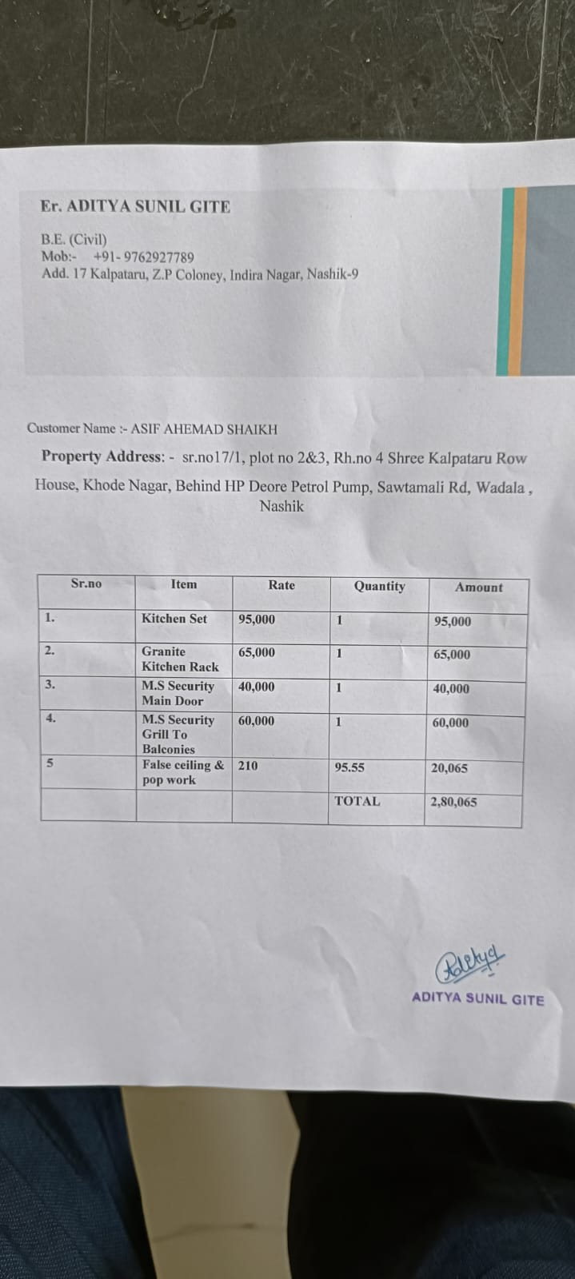

The Extra Work Cost Sheet amount is Rs.2,80,000/- ( Rupees Two Lakh Eighty Thousand Only. )

