Vastu/Nashik/08/2023/3426/2302281
28/17-427-CHV
Date: 06.09.2023

To,
The Branch Manager,
Punjab National Bank

Canada Corner Branch

Shop No.2,3,4 Prestige Point, Opp. Vasant Market, Canada Corner
Nashik – 422 005, State – Maharashtra, Country – India.

Sub: Vetting of Extra Work Amenities

Sir,

With reference to above subject, we have evaluated the Extra Work Amenities for Residential Land & Bungalow on CTS No. 4855A, Ground + Second Floor,Near Famous Bakery , Koliwada, Kathada Area, Old Nashik, Village- Nashik Gaothan, Tal & Dist- Nashik, PIN Code – 422 001, State - Maharashtra, Country - India belongs to Sau.Anjanabai Vanji Badgujar. Name of Proposed Purchaser : Shri.Sunil Prabhakar Salunke

We have verified the rates quoted as per current market rates. Details of Extra Work Amenities considered as per copy of Extra Work Amenities Agreement between Shri.Sunil Prabhakar Salunke (Claiming Party ) Shri.Harish Limbaji Renuke (Executing Party) received on dated 04.09.2023. The Extra Work Amenities Agreement amount is Rs. 2,80,000/- (Rupees Two Lakh Eighty Thousand Only.)

Note:1) The said Cost Vetting Certificate is valid upto next 6 months Only.

Thanking you

Sincerely yours

Sharadkumar B. Chalikwar
Govt. Reg. Valuer
Chartered Engineer (India)
Reg. No. (N) CCIT/1-14/52/2008-09
PNB Empanelment No. ZO:SAMD:1138
Encl: Vetting report

Extra Amenities Work Notarized Agreement
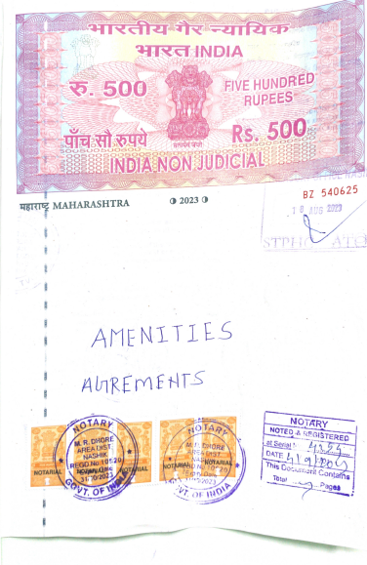
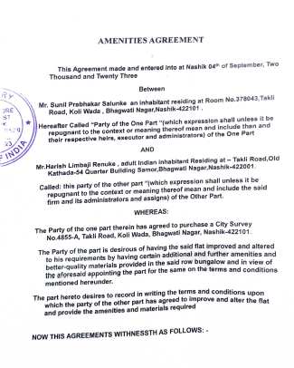

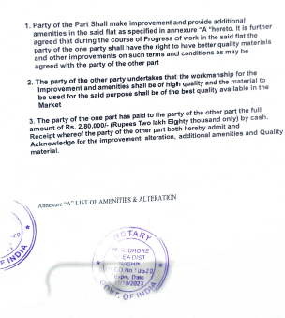
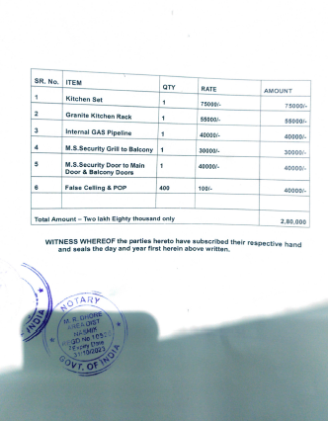

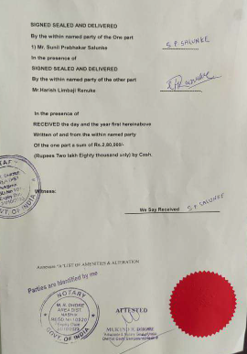

The Extra Work Amenities Agreement amount is Rs. 2,80,000/- (Rupees Two Lakh Eighty Thousand Only.)

