COST VETTING REPORT

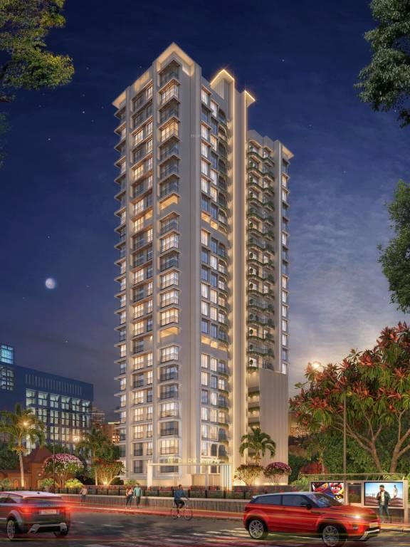

**Details of the property under consideration:**

**Name of Project: "Aria Park"**

**"Aria Park",** Proposed Residential Building on Plot bearing C.T.S. No. 481, 482, 485 & 486, T Ward,

Mahatma Phule Road, Hanuman Chowk, Village – Mulund – E, Mulund (East), Mumbai – 400 081,

State – Maharashtra, Country – India.

**Latitude Longitude: 19°10'20.2"N 72°57'39.5"E**

**Valuation Done for:**

**State Bank of India**

**Wagle Ind. Est. Branch**

Regional Business Office, Region-II, Wagle Ind. Area, Plot No. B-35, 2nd Floor,

Wagle Circle, Thane (West) - 400 604, State - Maharashtra, Country - India.

|  |
| --- |
| Vastu/SBI/Thane/09/2023/3568/2302409 05/03-53-PY  Date: 04.09.2023  To,  **The Branch Manager,**  **State Bank of India**  **Wagle Ind. Est. Branch**  Regional Business Office, Region-II,  Wagle Ind. Area, Plot No. B-35, 2nd Floor,  Wagle Circle, Thane (West) - 400 604,  State - Maharashtra, Country - India.  **Sub:** Cost Vetting for "**Aria Park**" at Mulund (East), Mumbai, PIN Code – 400 081.  Dear Sir,  In accordance with your Mail as stated above, we enclose our Report on Cost Vetting **"Aria Park",** Proposed Residential Building on Plot bearing C.T.S. No. 481, 482, 485 & 486, T Ward, Mahatma Phule Road, Hanuman Chowk, Village – Mulund – E, Mulund (East), Mumbai – 400 081, State – Maharashtra, Country – India.  The project is being developed by M/s. Konark Realtors. Konark Realtors carries a rich legacy of over 3 decades built on the trust and belief of our customers and stakeholders. We have developed in excess of 1 million sq. ft. of prime real estate in Mumbai and have provided homes to more than 800 families in Mumbai. Timely completion of projects coupled with strong planning and design innovation gives the group an edge over its competitors.  M/s. Konark Realtors is developing a Residential Building on Plot bearing C.T.S. No. 481, 482, 485 & 486, T Ward, Mahatma Phule Road, Hanuman Chowk, Village – Mulund – E, Mulund (East), Mumbai – 400 081, State – Maharashtra, Country – India. Project is comprising of Residential Sale Building and Staff Quarter Building.  Wing B is Staff Quarter Building and Wing A is Residential Sale Building is proposed of Ground Floor + 1st to 22nd Upper Floors with total RERA carpet area of 63,070.00 Sq. Ft. which consists 2BHK & 3 BHK Flat with total 71 nos. of Sell flats along with Amenities.  In this regard, State Bank of India, Wagle Ind. Est. Branch Regional Business Office, Region-II, Wagle Ind. Area, Plot No. B-35, 2nd Floor, Wagle Circle, Thane (West) - 400 604 has approached Vastukala Consultants (I) Pvt. Ltd. (VCIPL) to conduct a Cost Vetting of the said project.  Our analysis of the cost vetting is enclosed in this report. This Report forms an integral whole and cannot be split in parts. The outcome of the report/ study can only lead to proper conclusions if the Report as a whole is taken into account.  The information used by Vastukala Consultants (I) Pvt. Ltd. (VCIPL) in preparing this report has been obtained from a variety of sources and other relevant documents provided by the client & bank. As agreed, we have performed our cost vetting exercise with the data available related to the business, considering the market prospects and projections. Our results are dependent on documents provided by client & bank, the underlying assumptions, which has been analyzed at a broader level by VCIPL while assessing their reasonableness.  Total Project Cost for the completion of Project will be **` 74.40 Cr.**  **For Vastukala Consultants (I) Pvt. Ltd.** Manoj B. Chalikwar Registered Valuer  Chartered Engineer (India)  Reg. No. IBBI / RV / 07/2018/10366  Reg. No. CAT-I-F-1763  SBI Empanelment No.: SME/TCC/2021-22/86/3  **About the Project:**  It is an under construction Proposed Residential Building on Plot bearing C.T.S. No. 481, 482, 485 & 486, T Ward, Mahatma Phule Road, Hanuman Chowk, Village – Mulund – E, Mulund (East), Mumbai – 400 081. It is about 550 M. distance from Mulund Railway station. Near Mulund Railway Station. |

**AREA STATEMENT AS PER APPROVED PLAN:**

|  |  |  |  |  |  |
| --- | --- | --- | --- | --- | --- |
| Sr. No. | | Area Statement | Area | | |
| 1 | i) | Area of plot (As per P.R.C) | 4408.00 | | |
|  | ii) | Area of plot (As per Conveyance Deed) |  | | |
|  |  | Area of Plot Considered |  | | |
|  | a) | Area of Reservation in Plot |  | | |
|  | b) | Area of Road Set Back | 151.56 | | |
|  | c) | Area of D.P. Road |  | | |
|  | d) | Encroachment Area | 343.36 | | |
| 2 |  | Deduction For |  | | |
| (A) |  | For Reservation / Road Area |  | | |
|  | a) | Road Set- Back Area to be handed over (100%) |  | | |
|  | b) | Proposed D.P. Road to be handed over (100%) |  | | |
|  | c) | i) Reservation Area to be handed over (100%) |  | | |
|  |  | ii) Reservation Area to be handed over as per AR |  | | |
| (B) |  | For Amenity Area |  | | |
|  | a) | Area of Amenity Plot to be handed over as per DCR 14(A) |  | | |
|  | b) | Area of Amenity Plot to be handed over as per DCR 14(B) |  | | |
|  | c) | Area of Amenity Plot to be handed over as per DCR 35(ABEYANC) |  | | |
| (C) |  | Deduction for Existing Built-Up Area to be retained if any |  | | |
|  | a) | Land to be handed over to MCGM along with BUA [1691.70 × 40% = 676.68] | 676.69 | | |
| 3 |  | Total Deduction [{2(A) + 2(B)} + 2(C)] | 1171.60 | | |
| 4 |  | Balance Area of Plot | 3236.40 | | |
| 0 |  | Add Road Set Back Area | 0.00 | | |
| 5 |  | Plot Area under development (4) | 3236.40 | | |
| 6 |  | Zonal (Basic) FSI | 1.0000 | | |
| 7 |  | Built Up Area as per Zonal (Basic) FSI (5 × 6) | 3236.40 | 676.68 | 3913.08 |
| 8 |  | Built Up equal to area of land handed over as per regulation 30(A) |  |  | -- |
|  | (i) | As per 2(A) And 2(B) Except 2(A) (C)(ii) above with in CAP of "Admissible TDR" as column 6 of table - 12 on remaining / balance plot (2 × 2 A(a)) |  |  |  |
|  | (ii) | In case of 2 (A) (C) (ii) permissible over and above permission BUA on remaining / balance plot |  |  | -- |
| 9 |  | Built Up area in Lieu of cost of construction of Built-Up amenity to be handed over (within the limit of permissible BUA on remaining plot) |  |  | -- |
| 10 |  | Built Up area due to "Additional FSI on payment of premium" as per table no. 12 of regulation no. 30 (A) on remaining / Balance plot  Permissible additional FSI (39.13.08 × 0.50 = 1956.54), Already purchased - 1587.27 |  |  | 1587.27 |
| 11 |  | Built Up Area due to Admissible "TDR" As per table no. 12 of regulation no. 30(A) and 32 on remaining / balance plot  Permissible TDR (3913.08 × 0.90 = 3521.77), Claiming now - 1501.67 |  |  | 1501.67 |
| 12 |  | Road Set Back Hand over area |  |  |  |
| 13 |  | Permissible BUA (as the case my with / without BUA as per 2 © [7 + 8 + 10 + 11 + 12] |  |  | 7002.02 |
| 14 |  | Proposed BUA (as the case my with / without BUA as per 2 (C) |  |  | 6829.96 |
| 0 |  | Building 01 - Wing A (Residential) |  |  | 4614.60 |
| 0 |  | Building 01 - Wing B (Hospital Staff quarter Handover) |  |  | 845.47 |
| 0 |  | Building 02 - Hospital |  |  | 1369.89 |
| 15 |  | Built Up Area of Amenity to Be H/O To MCGM Free of Cost In Lieu Of Development Permission Granted as Per Change of User from Industrial to Commercial U/N- Ch. E/B.P./12977 Dt. 16th Feb 2019built Up Area of Amenity to be H/O To MCGM Free of Cost In Lieu Of Development Permission Granted As Per Change Of User From Industrial To Commercial U/N- Ch. E/B.P./12977 Dt. 16th Feb 2019 |  |  | -- |
| 16 |  | TDR generated if any as per regulation 30(a) and 32 |  |  | -- |
| 17 |  | Fungible compensatory area as per regulation no 31(3) |  |  | -- |
|  | i) | Permissible fungible compensatory area for rehab component without charging premium |  |  | -- |
|  | ii) | Fungible compensatory area availed for rehab component without charging premium |  |  | -- |
|  | b) |  |  |  |  |
|  | i) | Permissible fungible compensatory area by charging premium  (14 x 35%) |  |  | 1612.54 |
|  | ii) | Fungible compensatory area availed on payment of premium |  |  |  |
| 18 |  | Total built up area proposed including fungible compensatory area (13+17(a)(ii) +17(b)(ii)) |  |  | 8442.50 |
| 19 |  | FSI consumed on net plot (14/4) |  |  | 2.11 |
| II) |  | Other Requirements |  |  |  |
|  | (A) | Reservation / Designation |  |  | -- |
|  | a) | Name of Reservation |  |  | -- |
|  | b) | Area of Reservation Affecting the plot |  |  | -- |
|  | c) | Area of reservation land to be handed/handed over as per Regulation No.17 |  |  | -- |
|  | d) | Built Up Area of amenity to be handed over as per Regulation No. 17 |  |  | -- |
|  | e) | Area / Built Up Ara Designation |  |  | -- |
|  | (B) | Plot area /built up amenity to be handed over as per Regulation No. |  |  |  |
|  | i) | 14(A) |  |  | -- |
|  | ii) | 14(B) |  |  | -- |
|  | iii) | 15 |  |  | -- |
| (C) | | Requirement of recreational open space in layout/plot as per regulation no.27 |  |  | -- |
| (D) | | Tenement Statement |  |  |  |
|  | i) | Proposed Built Up area (13 above) |  |  | 8442.50 |
|  | ii) | Less Deduction of Non - Residential Area (Shop ETC) |  |  | 1369.89 |
|  | iii) | Area Available for Tenements [(I) Minus (ii)] |  |  | 7072.61 |
|  | iv) | Tenements permissible (Density of Tenements / Hectare) |  |  | 318 |
|  | v) | Total Number of Tenements Proposed on the plot |  |  | 95 |
| (E) | | Parking Statements |  |  |  |
|  | i) | Parking required by regulations for- Car, Scooter/Motor Cycle, outsiders (visitors) |  |  | 70 NOS |
|  | ii) | Covered Garage Permissible |  |  | -- |
|  | iii) | Covered garage proposed Car Scooter/ Motor Cycle outsider (visitors) |  |  | -- |
|  | iv) | Total Parking Provided |  |  | 71 NOS |
| (F) | | Transport Parking Provided |  |  |  |
|  | i) | Space for transport vehicles parking required by regulation |  |  | -- |
|  | ii) | Space for transport vehicles parking space provided |  |  | -- |

## Construction Area

**Wing B: -**

|  |  |  |  |  |  |  |  |
| --- | --- | --- | --- | --- | --- | --- | --- |
| **Sr. No.** | **Floor** | **Net Built Up Area in Sq. M.** | **Free FSI / Premium FSI Area in Sq. M.** | | | | **Total Construction Area in Sq. M.** |
| **Staircase / Lift / Lobby Area** | **Refuge Area** | **Stilt Area** | **Amenities Area** |
| 1 | Ground | 9.88 | 30.46 | - | - | - | 40.34 |
| 2 | 1st | 119.37 | 30.46 | - | - | - | 149.83 |
| 3 | 2nd | 119.37 | 30.46 | - | - | - | 149.83 |
| 4 | 3rd | 119.37 | 30.46 | - | - | - | 149.83 |
| 5 | 4th | 119.37 | 30.46 | - | - | - | 149.83 |
| 6 | 5th | 119.37 | 30.46 | - | - | - | 149.83 |
| 7 | 6th | 119.37 | 30.46 | - | - | - | 149.83 |
| 8 | 7th | 119.37 | 30.46 | - | - | - | 149.83 |
| 9 | OHT / LMR | - | 30.46 | - | - | - | 30.46 |
| **Total Area in Sq. M.** | | **845.47** | **274.14** | **-** | **-** | **-** | **1,119.61** |

**Wing A: -**

| **Sr. No.** | **Floor** | **Net Built Up Area in Sq. M.** | **Free FSI / Premium FSI Area in Sq. M.** | | | | **Total Construction Area in Sq. M.** |
| --- | --- | --- | --- | --- | --- | --- | --- |
| **Staircase / Lift / Lobby Area** | **Refuge Area** | **Stilt Area** | **Amenities Area** |
| **1** | Ground | - | 58.74 | - | 340.02 | - | 398.76 |
| 2 | 1st | 199.93 | 58.74 | - | 140.09 | - | 398.76 |
| 3 | 2nd | 199.93 | 58.74 | - | 140.09 | - | 398.76 |
| 4 | 3rd | 199.93 | 58.74 | - | 140.09 | - | 398.76 |
| 5 | 4th | 199.93 | 58.74 | - | 140.09 | - | 398.76 |
| 6 | 5th | 199.93 | 58.74 | - | 140.09 | - | 398.76 |
| 7 | 6th | 199.93 | 58.74 | - | 140.09 | - | 398.76 |
| 8 | 7th | 199.93 | 58.74 | - | 140.09 | - | 398.76 |
| 9 | 8th | 142.84 | 57.18 | 88.61 | - | 111.32 | 399.95 |
| 10 | 9th | 341.58 | 57.18 | - | - | - | 398.76 |
| 11 | 10th | 341.58 | 57.18 | - | - | - | 398.76 |
| 12 | 11th | 341.58 | 57.18 | - | - | - | 398.76 |
| 13 | 12th | 341.58 | 57.18 | - | - | - | 398.76 |
| 14 | 13th | 341.58 | 57.18 | - | - | - | 398.76 |
| 15 | 14th | 341.58 | 57.18 | - | - | - | 398.76 |
| 16 | 15th | 244.25 | 57.18 | 97.33 | - | - | 398.76 |
| 17 | 16th | 341.58 | 57.18 | - | - | - | 398.76 |
| 18 | 17th | 341.58 | 57.18 | - | - | - | 398.76 |
| 19 | 18th | 341.58 | 57.18 | - | - | - | 398.76 |
| 20 | 19th | 341.58 | 57.18 | - | - | - | 398.76 |
| 21 | 20th | 341.58 | 57.18 | - | - | - | 398.76 |
| 22 | 21st | 341.58 | 57.18 | - | - | - | 398.76 |
| 23 | 22nd | 341.58 | 57.18 | - | - | - | 398.76 |
| 24 | OHT / LMR | - | 57.18 | - | - | - | 57.18 |
| **Total Area in Sq. M.** | | **6,227.14** | **1,384.80** | **185.94** | **1,320.65** | **111.32** | **9,229.85** |

## Project Cost

|  |  |  |  |
| --- | --- | --- | --- |
| Sr. No. | Particulars | Total Estimated Amount in ` | Total Estimated Amount  in ` Cr. |
| 1 | **Land Cost** |  |  |
|  | Acquisition Cost of Land or Development Rights, and Legal Cost. | 2,19,35,290.00 | 2.19 |
|  | Rent to Tenants, Lease premium, Lease Rent, interest cost incurred or payable on Land Cost | - | - |
|  | Amount of Premium payable to obtain development rights, FSI, additional FSI, fungible area, and any other incentive under DCR from Local Authority or State Government or any Statutory Authority. | 13,00,00,000.00 | 13.00 |
|  | Acquisition cost of TDR (if any) | 3,22,41,865.00 | 3.22 |
| 2 | **Cost of Construction** |  |  |
| 1. I | Estimated construction cost of sale building including site development and infrastructure for the same. | 36,03,90,720.00 | 36.04 |
|  | Estimated construction cost of staff quarter building including site development and infrastructure for the same. | 3,02,29,470.00 | 3.02 |
|  | On site expenditure for development of entire project excluding cost of construction as per(i) above, |  |  |
| a. | Architect Fees & Consultant fees | 2,34,37,211.00 | 2.34 |
| b. | Admin Cost includes salaries, site overheads, development works, cost of services (including water, electricity, sewerage, drainage, layout roads etc.), cost of machineries and equipment including its hire and maintenance cost, consumables etc. All costs directly incurred to complete the construction of the entire phase of the project registered. | 6,40,00,000.00 | 6.40 |
| c. | Marketing Cost | 5,30,13,943.00 | 5.30 |
| 3 | Interest during the Project | 1,70,00,000.00 | 1.70 |
| 4 | Contingency Cost | 1,17,18,606.00 | 1.17 |
|  | **GRAND TOTAL:** | **74,39,67,105.00** | **74.40** |

## Manoj B. Chalikwar

Registered Valuer

Chartered Engineer (India)

Reg. No. IBBI / RV / 07/2018/10366

Reg. No. CAT-I-F-1763

SBI Empanelment No.: SME/TCC/2021-22/86/3

**Comments on each element of Cost of Project**: -

1. **Land Cost:**

As per Present Ready Reckoner rate the Project Land Value is ` 29.76 Cr. considering Land Rate @ ` 67,520.00 per Sq. M. & Net Plot Area of 4,408.00 Sq. M.

As per document cost of land and stamp duty is ` 2,19,35,290.00 i.e., ` 2.19 Cr. which is 2.95% of Total Project Cost.

|  |  |  |  |  |  |
| --- | --- | --- | --- | --- | --- |
| **Sr. No.** | **Agreement Name** | **Date** | **Particulars** | **Total Amount in `** | **Incurred Amount in `** |
| 1 | Conveyance Deed | 08.05.2012 | Purchase Cost | 25,00,000.00 | 25,00,000.00 |
| 2 | Stamp Duty | 3,47,150.00 | 3,47,150.00 |
| 3 | Reg. Fees | 30,000.00 | 30,000.00 |
| 4 | 1,160.00 | 1,160.00 |
| 5 | Conveyance Deed | 25.09.2012 | Purchase Cost | 25,00,000.00 | 25,00,000.00 |
| 6 | Stamp Duty | 3,47,200.00 | 3,47,200.00 |
| 7 | Reg. Fees | 30,000.00 | 30,000.00 |
| 8 | 1,400.00 | 1,400.00 |
| 9 | Conveyance Deed | 19.03.2011 | Purchase Cost | 18,00,000.00 | 18,00,000.00 |
| 10 | Stamp Duty | 4,55,000.00 | 4,55,000.00 |
| 11 | Reg. Fees | 30,000.00 | 30,000.00 |
| 12 | 920.00 | 920.00 |
| 13 | Conveyance Deed | 31.05.2012 | Purchase Cost | 61,00,000.00 | 61,00,000.00 |
| 14 | Stamp Duty | 20,34,000.00 | 20,34,000.00 |
| 15 | Reg. Fees | 30,000.00 | 30,000.00 |
| 16 | 1,640.00 | 1,640.00 |
| 17 | Conveyance Deed | 14.03.2013 | Purchase Cost | 50,00,000.00 | 50,00,000.00 |
| 18 | Stamp Duty | 6,94,500.00 | 6,94,500.00 |
| 19 | Reg. Fees | 30,000.00 | 30,000.00 |
| 20 | 2,320.00 | 2,320.00 |
|  | **TOTAL** | | | **2,19,35,290.00** | **2,19,35,290.00** |

1. **TDR Charges:**

The TDR charges is ` 3,22,41,865.00 i.e., ` 3.22 Cr. which is 4.33% of Total Project Cost.

|  |  |  |  |  |  |
| --- | --- | --- | --- | --- | --- |
| **Sr. No.** | **Agreement Name** | **Date** | **Area in Sq. M.** | **Particulars** | **Incurred Amount in `** |
| 1 | Agreement for Transfer / TDR Agreement / SRA/1382/ Land | 09.11.2021 | 197.50 | Purchase Cost | 91,81,400.00 |
| 2 | Stamp Duty | 2,75,750.00 |
| 3 | Agreement for Transfer / TDR Agreement / 001009 | 16.11.2021 | 350.00 | Purchase Cost | 1,03,20,500.00 |
| 4 |  | Stamp Duty | 3,09,915.00 |
| 5 | Agreement for Transfer / TDR Agreement / 000993 | 26.09.2019 | 841.00 | Purchase Cost | 1,18,00,000.00 |
| 6 |  | Stamp Duty | 3,54,300.00 |
|  | **TOTAL** |  |  |  | **3,22,41,865.00** |

1. **Building Cost of Construction of Wing B:**

Construction area = 1,119.61 Sq. M.

Total estimated cost for construction of Building (includes cost of RCC work, manpower, lift, material, painting, finishing work, site development, etc.) is ` 3,02,29,470.00 i.e., ` 3.02 Cr. which comes ` 27,000.00 per Sq. M. on construction area for building.

The total construction area is 1,119.61 Sq. M., projected cost of ` 3.02 Cr is 4.06% of total project cost.

1. **Building Cost of Construction of Wing A:**

Construction area = 9,229.85 Sq. M.

No. of Stack Parking = 71 Nos.

Total estimated cost for construction of Building (includes cost of RCC work, manpower, lift, material, painting, finishing work, site development, etc.) is ` 29,53,55,200.00 i.e., ` 29.54 Cr. which comes ` 32,000.00 per Sq. M. on construction area for building, cost of deep excavation & piling work is ` 2,95,35,520.00 i.e., ` 2.95 Cr. which comes 10% of cost of construction and cost for construction of stack car parking is ` 3,55,00,000.00 i.e., ` 3.55 Cr. which comes ` 5,00,000.00 per car parking.

Hence, total cost of construction (Cost of Construction of Building + Cost of Construction of Stack Car Parking + Cost of Deep Excavation & Piling Work) is ` 36,03,90,720.00 i.e., ` 36.04 Cr.

The total construction area is 9,229.85 Sq. M., projected cost of ` 36.04 Cr is 48.44% of total project cost

1. **Approval Charges:**

The Total Approval Cost (Fungible Cost & Development Cess Premium) as per information provided by the developer is ` 13,00,00,000.00 i.e., ` 13.00 Cr. which is 17.47% of Total Project Cost.

1. **Architect Cost, RCC & Other Professional Charges:**

The total Architect charges of ` 2,34,37,211.00 i.e., ` 2.34 Cr. is 6% of total construction cost & it is line up with Market trend.

The professional charge consists of Architect & Legal which in market is in the range of 3% - 6% of Total Construction cost of the project.

1. **Administrative Expenses:**

Salaries, site overheads, development works, cost of services (including water, electricity, sewerage, drainage, layout roads etc.), cost of machineries and equipment including its hire and maintenance cost, consumables etc. All costs directly incurred to complete the construction of the entire phase of the project registered is estimated 8.60% of total project cost which comes to ` 6,40,00,000.00 i.e., ` 6.40 Cr.

1. **Marketing Expenses:**

Marketing costs directly incurred to complete the construction of the entire phase of the project registered is estimated at 4% of total Sale income from the project which comes to ` 5,30,13,943.00 i.e., ` 5.30 Cr.

The marketing charge consists of brokerage & commission which in market is in the range of 2% - 4% of Total Sale income of the property.

1. **Interest Costs:**

The Interest cost for the term loan is expected to be ` 1,70,00,000.00 i.e., ` 1.70 Cr., which is 2.29% of total project cost.

As per information provided by the client.

1. **Contingency Costs:**

The contingency charges estimated at 3% of total cost of construction which comes to ` 1,17,18,606.00 i.e., ` 1.17 Cr.

**Observation and Construction**: -

**Total estimated cost of project i.e., ` 74,39,67,105.00 (Rupees Seventy Four Crore Thirty Nine Lakh Sixty Seven Thousand One Hundred Five Only) i.e. ` 74.40 Cr. is fair & reasonable.**

The project cost is including land premium payable to concern authorities, Fungible FSI Premium, Cost of Construction of rehab & Sale Building, on site expenses including admin & marketing expenses, premiums / charges to be paid to competent authority and Bank interest, etc. we have not independently verified interest cost hence not consider in cost vetting.

Total estimated cost of construction for Sale Building as per approved plan up to Ground Floor + 1st to 22nd Upper Floors is ` 29,53,55,200.00 i.e., ` 29.54 Cr. which comes ` 32,000.00 per Sq. M. on construction area for building, cost of deep excavation & piling work is ` 2,95,35,520.00 i.e., ` 2.95 Cr. which comes 10% of cost of construction and cost for construction of stack car parking is ` 3,55,00,000.00 i.e., ` 3.55 Cr. which comes ` 5,00,000.00 per car parking. Hence, total cost of construction (Cost of Construction of Building + Cost of Construction of Stack Car Parking + Cost of Deep Excavation & Piling Work) is ` 36,03,90,720.00 i.e., ` 36.04 Cr. which is fair & reasonable considering the present status of project, type & quality of construction & specification of the building materials to be used, height of the structure, amenities to be provided in proposed building.

**Assumptions & Remarks-**

* The adequacy of Engineering / Structural design is beyond the scope of our assignment.
* Estimated project completion date is 30/06/2026. The cost is certified based on the assumptions that the project will be completed within time frame. Few assumptions are made regarding inflation & cost rise etc. during construction period.

Photo copy of following document is provided to us & this report should be read along with it:

|  |
| --- |
| * Copy of Deed of Conveyance Reg. No. BDR-3/9410/2012 dated 25.12.2012 for CTS No. 477 & 486 between Mr. Abhay Trimbak Patil & 4 others (The Vendors) and M/s. Konark Realtors (The Purchasers). |
| * Copy of Deed of Conveyance Reg. No. BDR-3/2294/2011 dated 19.03.2011 for CTS No. 481 between Mr. Pandurang Mangal Vaity & 7 others (The Vendors) and M/s. Konark Realtors (The Purchasers). |
| * Copy of Deed of Conveyance Reg. No. BDR-14/4246/2012 dated 31.05.2012 for CTS No. 482 & 485 between Mr. Yashwant J. Vaity & 7 others (The Vendors) and M/s. Konark Realtors (The Purchasers). |
| * Copy of Deed of Conveyance Reg. No. BDR-7/3484/2012 dated 08.05.2012 for CTS No. 477 & 486 between Dr. Nitin Vasant Patil & 1 other (The Vendors) and M/s. Konark Realtors (The Purchasers). |
| * Copy of Deed of Conveyance Reg. No. KRL-2/2592/2013 dated 14.03.2013 for CTS No. 477 & 486 between Mrs. Janki Raghunath Patil & 7 other (The Vendors) and M/s. Konark Realtors (The Purchasers). |
| * Copy of Agreement for Transfer / Utilization of FSI (TDR) dated 09.11.2021 between Shri Bhawanishankar H. Sharma (First Part) and M/s. Konark Realtors (Second Part) for 197.50 Sq. M. |
| * Copy of Agreement for Transfer / Utilization of FSI (TDR) dated 16.11.2021 between Shri Narendra Amrutlal Sheth (First Part) and M/s. Konark Realtors (Second Part) for 350.00 Sq. M. |
| * Copy of Agreement for Transfer / Utilization of FSI (TDR) dated 16.11.2021 between Mr. Rajeev Garg (The Transferors) and M/s. Konark Realtors (The Transferees) for 841.00 Sq. M. |
| * Copy of Conveyance Deed Reg. No. KRL-4/3458/2021 dated 16.02.2021 between M/s. Konark Realtors (The Seller) and Mrs. Savitribai K. Vaity (The Purchaser) for Flat No. 301 & 302. |
| * Copy of Approved Plan No. CHE/ES/1414/T/337(NEW) dated 21.06.2023 issued by Municipal Corporation of Greater Mumbai (MCGM)   **Approved upto:**  **Wing A: Ground Floor + 1st to 22nd Upper Floor**  **Wing B: Ground Floor + 1st to 7th Upper Floor** |
| * Copy of Commencement Certificate No. CHE/ES/1414/T/337(NEW)/FCC/4/Amend dated 05.01.2023 valid upto 04.11.2023 issued by Municipal Corporation of Greater Mumbai (MCGM)   **Approved upto:**  **Wing A: Ground Floor + 1st to 22nd Upper Floor**  **Wing B: Ground Floor + 1st to 7th Upper Floor** |
| * Copy of CA Certificate dated 19.08.2023 issued by M/s. Vinod Kumar Jain & Co. |
| * Copy of Architect Certificate No. 847/2021/930 dated 20.07.2023 issued by M/s. Daisaria Associates. |
| * Copy of Engineer Certificate dated 12.07.2023 issued by M/s. Destech Structural Consulatnts |
| * Copy of RERA Certificate No. P51800027835 dated 25.04.2023 issued by Maharashtra Real Estate Regulatory Authority. |

**Actual Site Photographs**

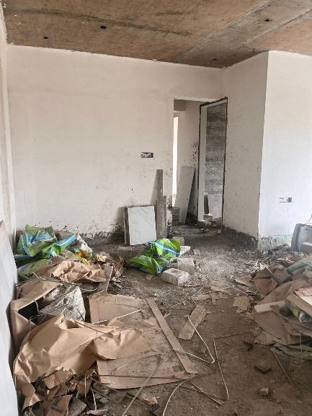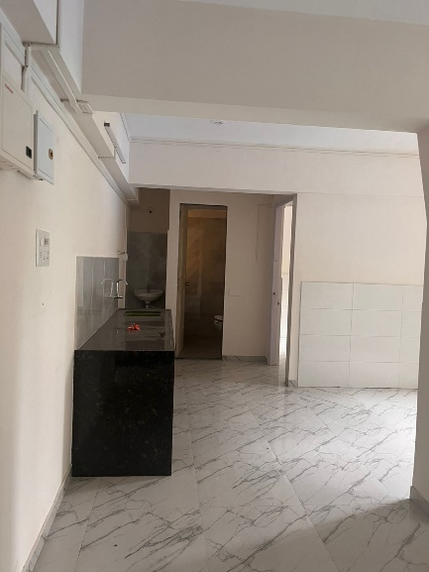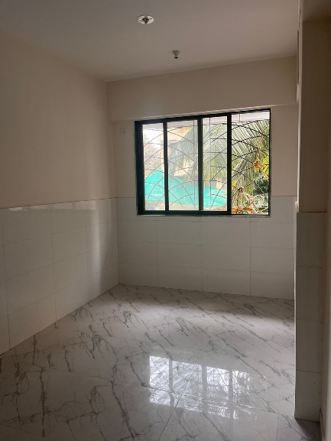

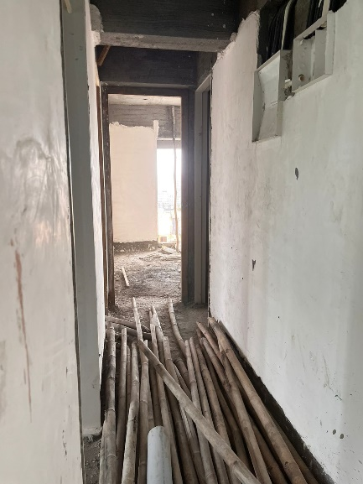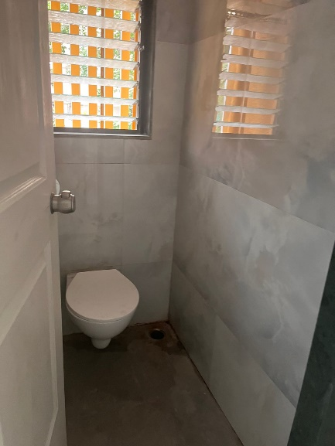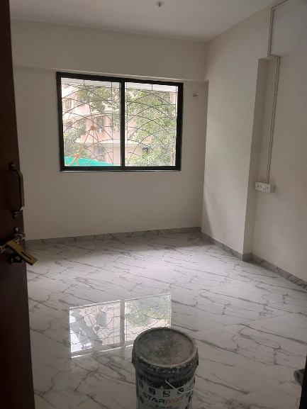

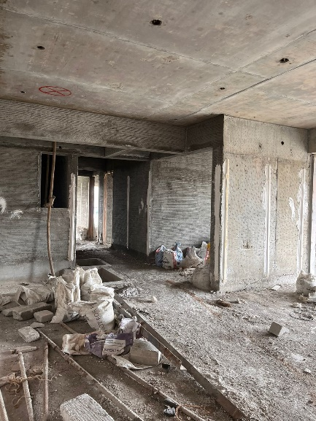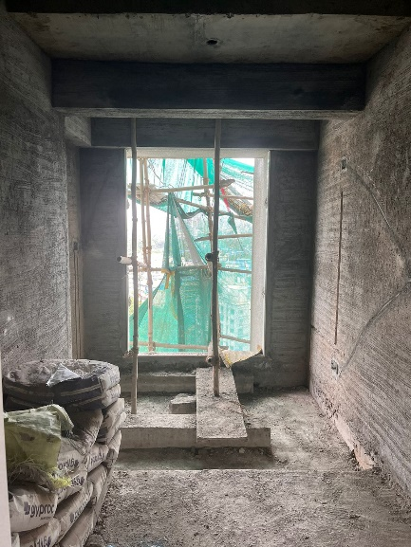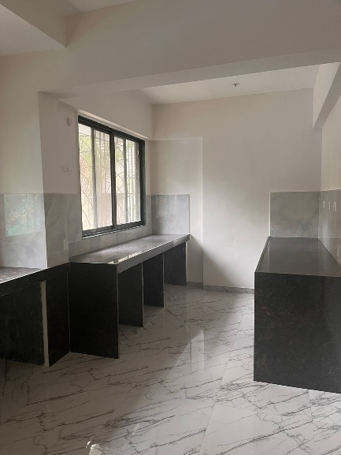**Actual Site Photographs**

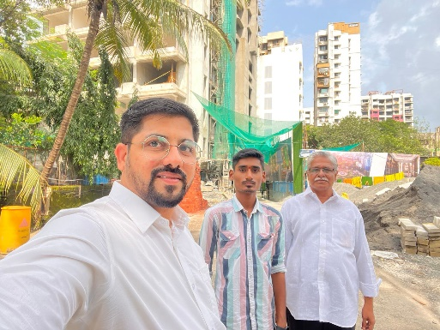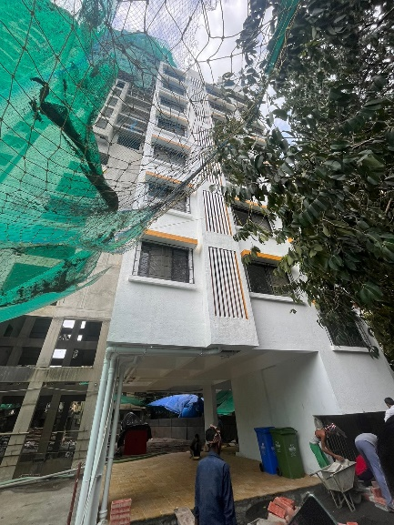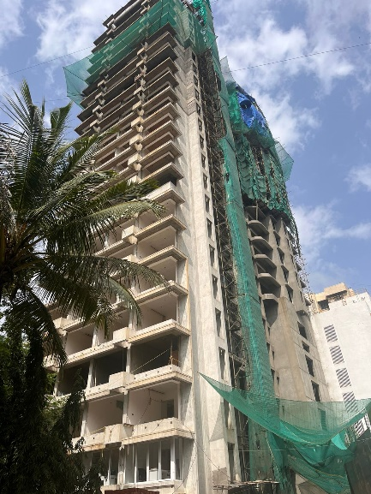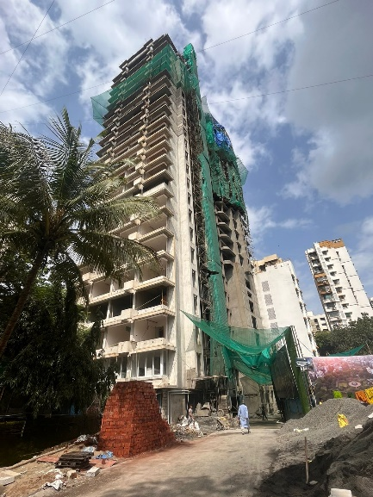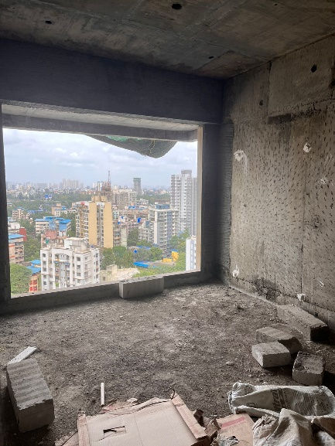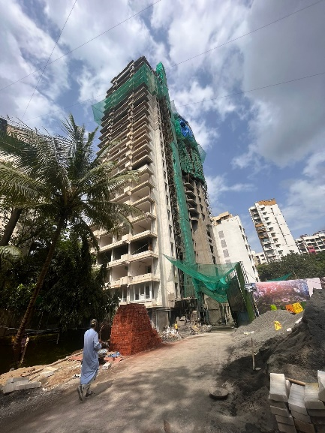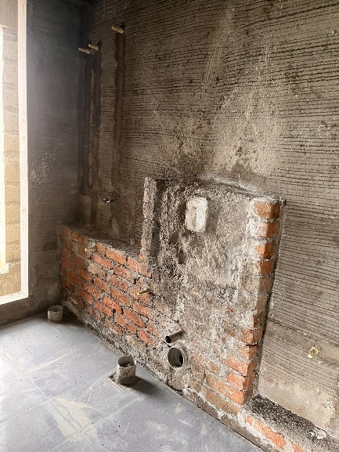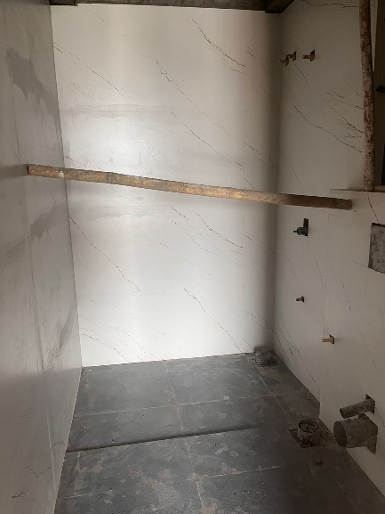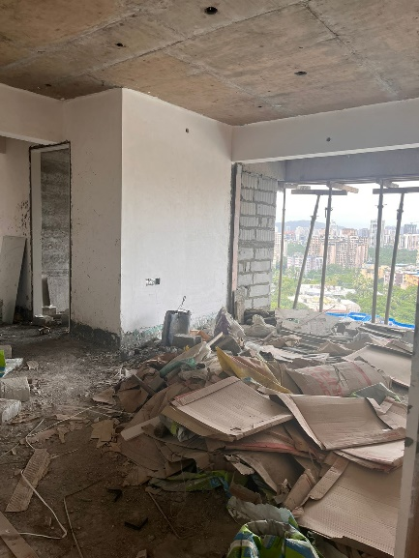**Route Map of the property**

**Site u/r**

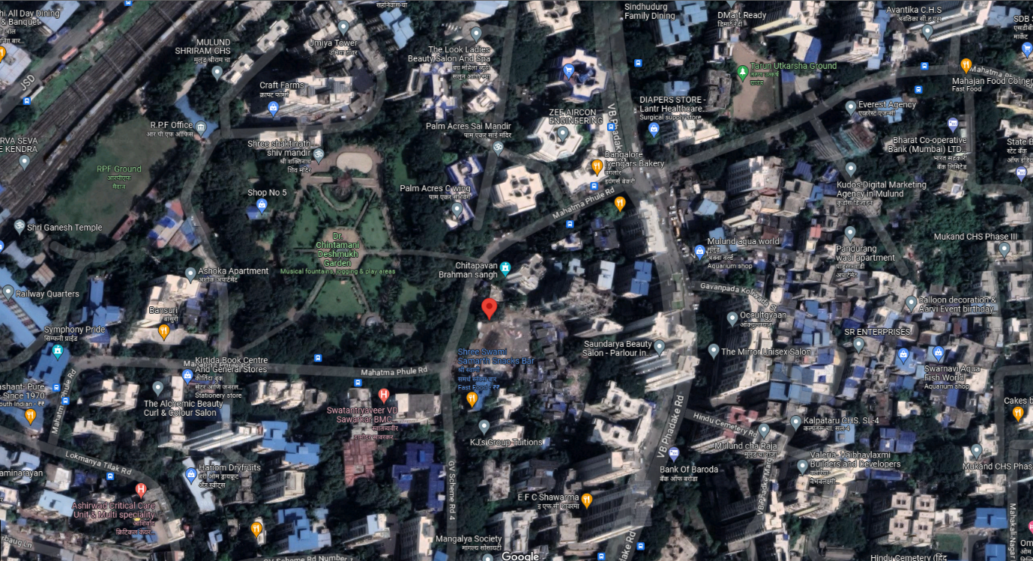

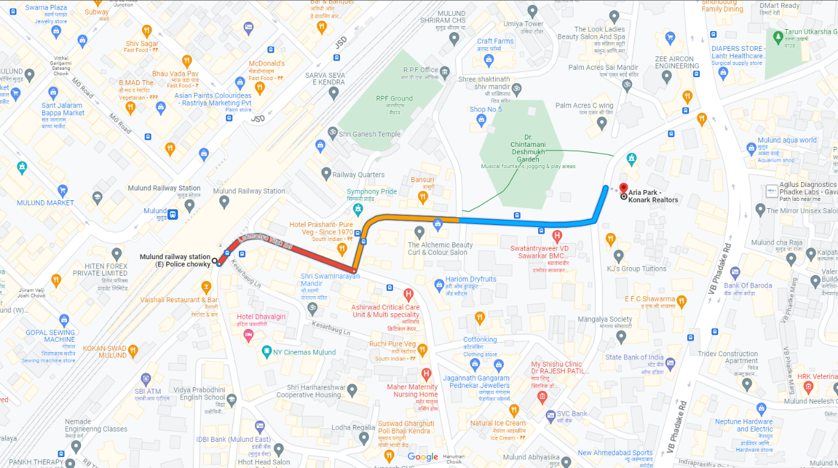

# **Latitude Longitude: 19°10'20.2"N 72°57'39.5"E**

# **Note:** The Blue line shows the route to site from nearest railway station (Mulund – 550 M.)