Valuation Report of the Immovable Property
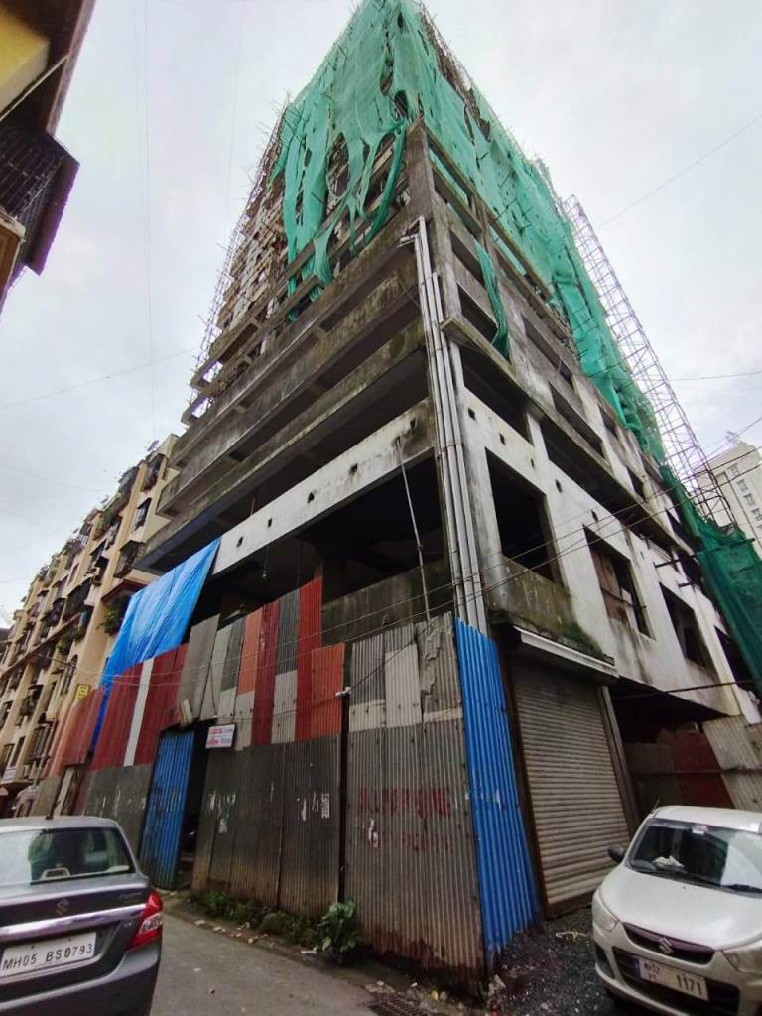

Details of the property under consideration:

Name of Owner: Mr. Mahesh Manohar Karkhanis

Residential Flat No. 801, 8th Floor, "Celestial", Final Plot No. 201, TPS IV of Mahim Division,
Gokhale Road (North), Dadar (West), Mumbai – 400 028,
State – Maharashtra, Country – India.

Latitude Longitude - 19°01'23.8"N 72°50'22.0"E

Valuation Prepared for:
Cosmos Bank

Dadar (West) Branch

Horizon Bldg.,1st Floor, Ranade Road & Gokhale Road, Dadar (West), Mumbai – 400 028,

State – Maharashtra, Country – India

Vastu/Mumbai/09/2023/3567/2302430
06/08-74-JAVS
Date: 06.09.2023

VALUATION OPINION REPORT

The property bearing Residential Flat No. 801, 8th Floor, "Celestial", Final Plot No. 201, TPS IV of Mahim Division,
Gokhale Road (North), Dadar (West), Mumbai – 400 028, State – Maharashtra, Country – India belongs to Mr. Mahesh Manohar Karkhanis.

Boundaries of the property.
North | : | Sqd. Ldr. M.P. Rane Road
South | : | Ramgiri Paradise Building
East | : | SBVN Path
West | : | Gokhale Road (North)

Considering various parameters recorded, existing economic scenario, and the information that is available with reference to the development of neighborhood and method selected for valuation, we are of the opinion that, the property premises can be assessed and valued for banking purpose for ` 2,21,10,000.00 (Rupees Two Crore Twenty One Lakh Ten Thousand Only). As per Site Inspection / Site Information, the building is under Construction as on date.

The valuation of the property is based on the documents produced by the concern. Legal aspects have not been taken into considerations while preparing this valuation report.

Hence certified

Manoj B. Chalikwar

Registered Valuer

Chartered Engineer (India)

Reg. No. CAT-I-F-1763

Cosmos Emp. No. H.O./Credit/67/2019-20
Encl. Valuation Report

Valuation Report of Residential Flat No. 801, 8th Floor, "Celestial", Final Plot No. 201, TPS IV of Mahim Division,
Gokhale Road (North), Dadar (West), Mumbai – 400 028, State – Maharashtra, Country – India.
Form 0-1
(See Rule 8 D)
REPORT OF VALUATION OF IMMOVABLE PROPERTY (OTHER THAN AGRICULTURAL LANDS, PLANTATIONS, FORESTS, MINES AND QUARRIES)
GENERAL:

1 | Purpose for which the valuation is made |  | To assess the Fair Market Value as on 06.09.2023 for Bank Loan Purpose
2 | Date of inspection |  | 05.09.2023
3 | Name of the owner/ owners |  | Mr. Mahesh Manohar Karkhanis
4 | If the property is under joint ownership / co-ownership, share of each such owner. Are the shares undivided? |  | Sole Ownership
5 | Brief description of the property |  | Address: Residential Flat No. 801, 8th Floor, "Celestial", Final Plot No. 201, TPS IV of Mahim Division, Gokhale Road (North), Dadar (West), Mumbai – 400 028, State – Maharashtra, Country – India.  Contact Person:  Mr. Mahesh Karkhanis (Owner)  Contact No.: 9820250266
6 | Location, street, ward no |  | G-4593(1), Gokhale Road (North), Dadar (West), Mumbai
7 | Survey/ Plot no. of land |  | Final Plot No. 201, TPS IV of Mahim Division, C.T.S. No. 1582
8 | Is the property situated in residential/ commercial/ mixed area/ Residential area? |  | Residential Area
9 | Classification of locality-high class/ middle class/poor class |  | Middle Class
10 | Proximity to civic amenities like schools, Hospitals, Units, market, cinemas etc. |  | All the amenities are available in the vicinity
11 | Means and proximity to surface communication by which the locality is served |  | Served by Buses, Taxies and Private cars
 | LAND
12 | Area of Unit supported by documentary proof. Shape, dimension and physical features |  | MOFA Carpet Area in Sq. Ft. = 800.00 (Including terrace area of 106.00 Sq. Ft.)  (Area as per Supplemental Agreement Cum Modification Deed)  Area as per actual site measurement:  Built Up Area in Sq. Ft. = 836.00  (Measured Carpet Area + 20%)
  Particulars | Area in Sq. Ft.
  Carpet Area | 697.00
  Pocket Terrace | 40.00  (40% of 101.00 Sq. Ft.)
13 | Roads, Streets or lanes on which the land is abutting |  | Gokhale Road, Dadar (West), Mumbai
14 | If freehold or leasehold land |  | Freehold
15 | If leasehold, the name of Lessor/lessee, nature of lease, date of commencement and termination of lease and terms of renewal of lease.  - Initial Premium  - Ground Rent payable per annum  - Unearned increased payable to the  Lessor in the event of sale or transfer |  | N. A.
16 | Is there any restriction covenant in regard to use of land? If so, attach a copy of the covenant. |  | As per documents
17 | Are there any agreements of easements? If so, attach a copy of the covenant |  | Information not available
18 | Does the land fall in an area included in any Town Planning Scheme or any Development Plan of Government or any statutory body? If so, give Particulars. |  | Information not available
19 | Has any contribution been made towards development or is any demand for such contribution still outstanding? |  | Information not available
20 | Has the whole or part of the land been notified for acquisition by government or any statutory body? Give date of the notification. |  | No
21 | Attach a dimensioned site plan |  | N.A.
 | IMPROVEMENTS
22 | Attach plans and elevations of all structures standing on the land and a lay-out plan. |  | Information not available
23 | Furnish technical details of the building on a separate sheet (The Annexure to this form may be used) |  | Attached
24 | Is the building owner occupied/ tenanted/ both? |  | Owner Occupied
 | If the property owner occupied, specify portion and extent of area under owner-occupation |  | N.A.
25 | What is the Floor Space Index permissible and Percentage actually utilized? |  | Floor Space Index permissible – As per MCGM norms  Percentage actually utilized – Details not available
26 | RENTS
 | (i) | Names of tenants/ lessees/ licensees, etc | N.A.
 | (ii) | Portions in their occupation | N.A.
 | (iii) | Monthly or annual rent /compensation/license fee, etc. paid by each | ` 52,000.00 Expected rental income per month after completion.
 | (iv) | Gross amount received for the whole property | N.A.
27 | Are any of the occupants related to, or close to business associates of the owner? |  | N.A.
28 | Is separate amount being recovered for the use of fixtures, like fans, geysers, refrigerators, cooking ranges, built-in wardrobes, etc. or for services charges? If so, give details |  | N. A.
29 | Give details of the water and electricity charges, If any, to be borne by the owner |  | N. A.
30 | Has the tenant to bear the whole or part of the cost repairs and maintenance? Give particulars |  | N. A.
31 | If a lift is installed, who is to bear the cost of maintenance and operation- owner or tenant? |  | N. A.
32 | If a pump is installed, who is to bear the cost of maintenance and operation- owner or tenant? |  | N. A.
33 | Who has to bear the cost of electricity charges for lighting of common space like entrance hall, stairs, passage, compound, etc. owner or tenant? |  | N. A.
34 | What is the amount of property tax? Who is to bear it? Give details with documentary proof |  | Information not available
35 | Is the building insured? If so, give the policy no., amount for which it is insured and the annual premium |  | Information not available
36 | Is any dispute between landlord and tenant regarding rent pending in a court of rent? |  | N. A.
37 | Has any standard rent been fixed for the premises under any law relating to the control of rent? |  | N. A.
 | SALES
38 | Give instances of sales of immovable property in the locality on a separate sheet, indicating the Name and address of the property, registration No., sale price and area of land sold. |  | As per sub registrar of assurance records
39 | Land rate adopted in this valuation |  | N. A. as the property under consideration is a Residential Flat in a building. The rate is considered as composite rate.
40 | If sale instances are not available or not relied up on, the basis of arriving at the land rate |  | N. A.
 | COST OF CONSTRUCTION
41 | Year of commencement of construction and year of completion |  | Year of Commencement of Construction – 01.02.2019  (As per Commencement Certificate)  Year of Completion – December 2023  (As per site information)
42 | What was the method of construction, by contract/By employing Labour directly/ both? |  | N. A.
43 | For items of work done on contract, produce copies of agreements |  | N. A.
44 | For items of work done by engaging Labour directly, give basic rates of materials and Labour supported by documentary proof. |  | N. A.
Remark:
- As per Site inspection, the building is under construction. But the developer has given possession of bare shell units to few tenant / owners of the old building. Internal work of their property under consideration is done by the flat owner.
- The details about the Part Occupancy Certificate & Approved Plan are not available.
- The Building is under Construction. External Development & Final finishing work is on halt since many years (Since 2017).
Note:
Property in Dadar West, Gokhale road of such specification are sold in the range of ` 50,000 to ` 55,000/-per sq. ft. rate on Carpet Area. But due to the points mentioned in the remarks, Salability of the property is very low. Hence, Lower Rate of ` 30,000.00 per Sq. Ft. on Measured Carpet Area is considered for valuation.

PART II- VALUATION
GENERAL:

Under the instruction of Cosmos Bank, Dadar (West) Branch to assess fair market value as on 06.09.2023 for Residential Flat No. 801, 8th Floor, "Celestial", Final Plot No. 201, TPS IV of Mahim Division, Gokhale Road (North), Dadar (West), Mumbai – 400 028, State – Maharashtra, Country – India belongs to Mr. Mahesh Manohar Karkhanis.

We are in receipt of the following documents:
1 | Copy of Supplemental Agreement cum Modification Deed dated 27.07.2023 between M/s. Sai Sadguru Developers (Developer / Owner) AND Mr. Mahesh Manohar Karkhanis (the Tenant / Occupant)
2 | Copy of Commencement Certificate No. EB / 798 / GN / A / FCC / 2 / Amend dated 01.02.2019 issued by Municipal Corporation of Greater Mumbai.

LOCATION:

The said building is located at bearing C. S. No. 1582, Final Plot No. 201, TPS IV of Mahim Division, G/North Ward, Gokhale Road, Dadar (West), Mumbai, PIN Code – 400 028, State – Maharashtra, Country – India. The property falls in Residential Zone. It is at a travelling distance 850 M. from Dadar railway station.

BUILDING:

The building under reference is having Ground + 5 Podiums + 6th to 13th Upper Residential Floors. It is a R.C.C. Framed Structure with 9" thick external walls and 6" thick internal brick walls. The walls are having sand faced plaster from outside. The building is used for residential purpose. 8th Floor is having 4 Residential Flat. The building is having 2 Lifts.

Residential Flat:

The residential flat under reference is situated on the 8th Floor. It consists of 2 Bedrooms + Living Room cum Dinning Area + Kitchen + 2 Toilets + Pocket Terrace + Deck Area (i.e., 2 BHK + 2 Toilets). Along with One Car Parking Space. The residential flat is ﬁnished with Vitrified tiles flooring, Teak wood door frame with flush shutters, Powdered coated Aluminum sliding windows, Concealed electrification & Concealed plumbing etc.

Valuation as on 6th September 2023
Measured Carpet Area of the Residential Flat | : | 697.00 Sq. Ft.
Pocket Terrace Area | : | 40.00 Sq. Ft. (40% of 101.00 Sq. Ft.)
Deduct Depreciation:
Year of Construction of the building | : | December 2023 Expected date of completion
Expected total life of building | : | 60 Years (After completion) Subject to proper, preventive periodic maintenance & structural repairs
Age of the building as on 2023 | : | Building Under Construction
Cost of Construction | : | 836.00 Sq. Ft. X ` 3,000.00 = ` 25,08,000.00
Depreciation | : | N.A., as the building is Under Construction
Amount of depreciation | : | Nil
Guideline rate obtained from the Registrar's office (an evidence thereof to be enclosed) | : | ` 3,44,201.00 per Sq. M.  i.e. ` 31,977.00 per Sq. Ft.
Guideline rate (after deprecation) | : | N.A.
Prevailing market rate | : | ` 30,000.00 per Sq. Ft.
Value of property as on 06.09.2023 | :
Measured Carpet Area |  | 697.00 Sq. Ft. X ` 30,000.00 = ` 2,09,10,000.00
Pocket Terrace Area (40% of 101.00 Sq. Ft.) |  | 40.00 Sq. Ft. X ` 30,000.00 = ` 12,00,000.00
(Area of property x market rate of developed land & Residential premises as on 2023 - 24 published in The Indian Valuer’s Directory and Reference Book for purpose of valuation. – Depreciation)

Total Value of the property as on  06.09.2023 | : | ` 2,21,10,000.00
The realizable value of the property | : | ` 1,98,99,000.00
Distress value of the property | : | ` 1,76,88,000.00
Insurable value of the property | : | ` 25,08,000.00
Guideline value of the property | : | ` 2,67,32,772.00

Taking into consideration above said facts, we can evaluate the value of Valuation Report of Residential Flat No. 801, 8th Floor, "Celestial", Final Plot No. 201, TPS IV of Mahim Division, Gokhale Road (North), Dadar (West), Mumbai – 400 028, State – Maharashtra, Country – India for this particular purpose at ` 2,21,10,000.00 (Rupees Two Crore Twenty One Lakh Ten Thousand Only). As per Site Inspection / Site Information, the building is under Construction as on date 6th September 2023.

NOTES

- I, Sharad Chalikwar with my experience and ability to judgment I am of the considered opinion that the fair market value of the property as on 6th September 2023 is ` 2,21,10,000.00 (Rupees Two Crore Twenty One Lakh Ten Thousand Only). As per Site Inspection / Site Information, the building is under Construction as on date. Value varies with time and purpose and hence this value should not be referred for any purpose other than mentioned in this report.

- This valuation is done on the basis of information, which the valuer has obtained by information provided by the client about the premises and location of the surrounding area and also prevailing rates in the surrounding area, and further subject to document as mentioned in valuation report.

- This valuer should not be held responsible for authentication of documents, clear title and other such related matters. For that purpose Latest Legal Opinion should be sought.

PART III- DECLARATION

I hereby declare that
    - The information furnished in part I is true and correct to the best of my knowledge and belief;
    - I have no direct or indirect interest in the property valued:

ANNEXURE TO FORM 0-1

Technical details Main Building
1. | No. of floors and height of each floor | Ground + 5 Podiums + 6th to 13th Upper Residential Floors
2. | Plinth area floor wise as per IS 3361-1966 | N.A. as the said property is a Residential Flat situated on 8th Floor
3 | Year of construction | December 2023 Expected date of completion
4 | Estimated future life | 60 Years (After completion) Subject to proper, preventive periodic maintenance & structural repairs
5 | Type of construction- load bearing walls/RCC frame/ steel frame | R.C.C. Framed Structure
6 | Type of foundations | R.C.C. Foundation
7 | Walls | All external walls are 9" thick and partition walls are 6" thick.
8 | Partitions | 6” thick brick wall
9 | Doors and Windows | Teak wood door frame with flush door, Powder Coated Aluminum sliding windows
10 | Flooring | Vitrified tiles flooring
11 | Finishing | Cement plastering
12 | Roofing and terracing | R.C.C. Slab
13 | Special architectural or decorative features, if any | No
14 |  | Concealed electrification  Concealed plumbing
  (i) | Internal wiring – surface or conduit
  (ii) | Class of fittings: Superior/ Ordinary/ Poor.
15 | Sanitary installations | As per Requirement
  (i) | No. of water closets
  (ii) | No. of lavatory basins
  (iii) | No. of urinals
  (iv) | No. of sink
16 | Class of fittings: Superior colored / superior white/ordinary. | Ordinary
17 | Compound wall  Height and length  Type of construction | Provided
18 | No. of lifts and capacity | 2 Lifts
19 | Underground sump – capacity and type of construction | R.C.C tank
20 | Over-head tank  Location, capacity  Type of construction | R.C.C tank on terrace
21 | Pumps- no. and their horse power | May be provided as per requirement
22 | Roads and paving within the compound approximate area and type of paving | Cement concrete in open spaces, etc.
23 | Sewage disposal – whereas connected to public sewers, if septic tanks provided, no. and capacity | Connected to Municipal Sewerage System
Actual site photographs
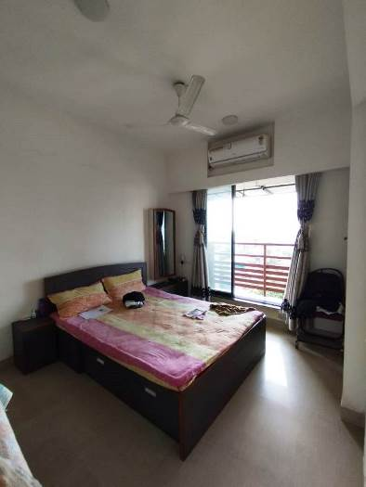
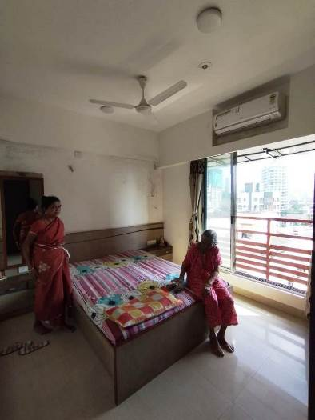
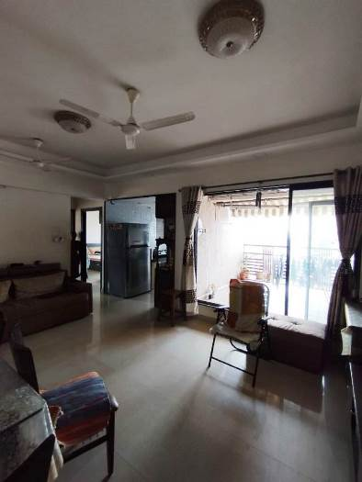

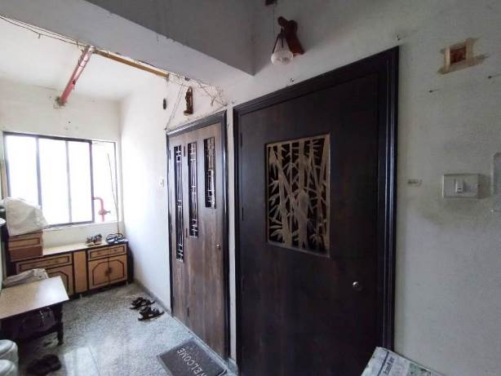
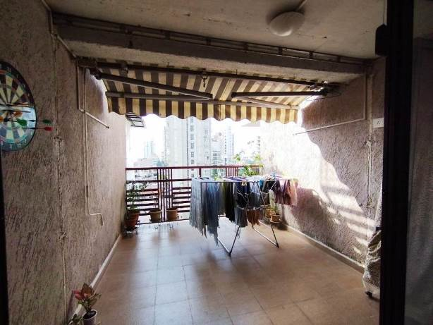

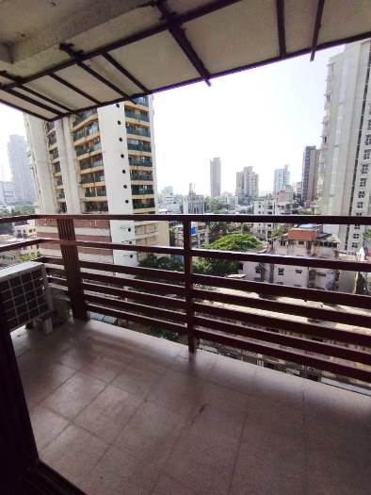
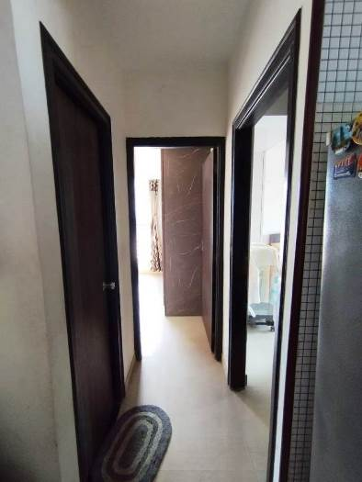
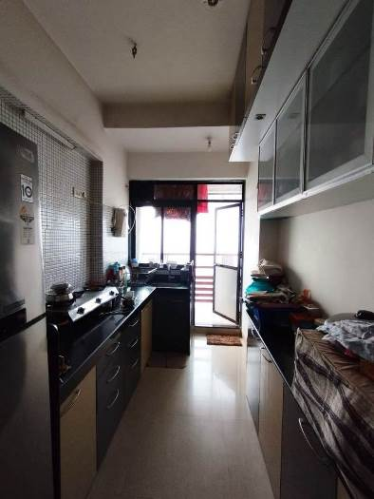
Actual site photographs
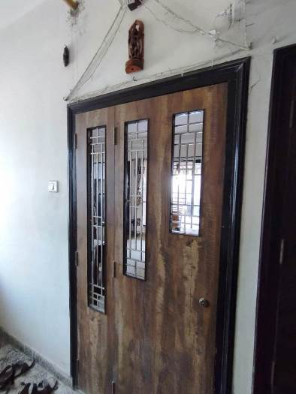
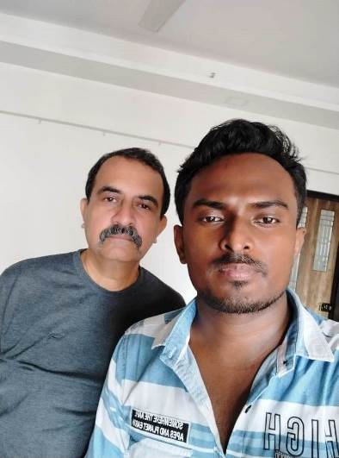
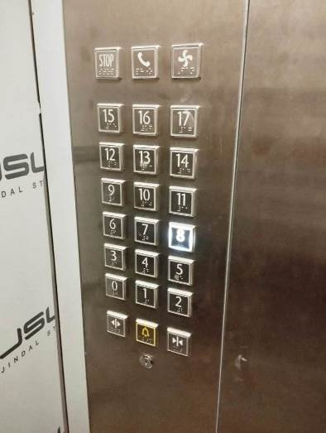
Route Map of the property
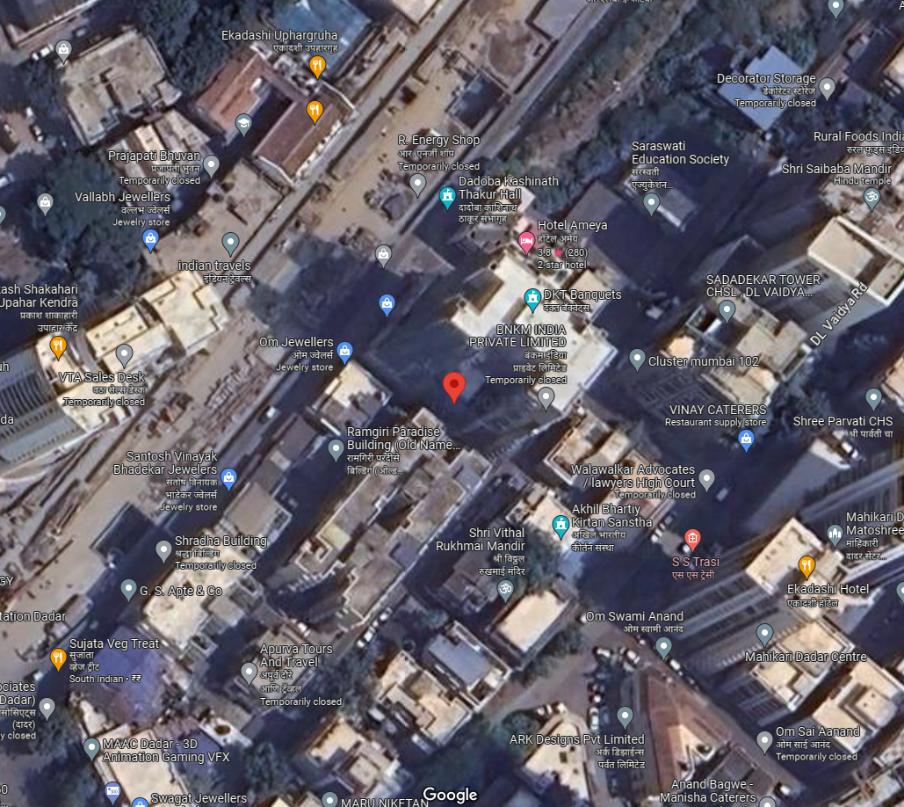
Site u/r

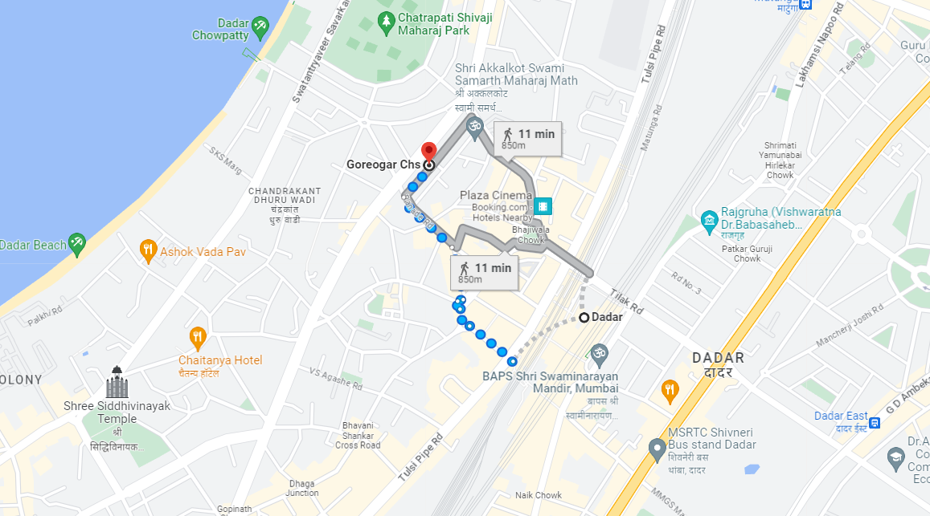

Latitude Longitude - 19°01'23.8"N 72°50'22.0"E

Note: The Blue line shows the route to site from nearest railway station (Dadar – 850 Mt.)
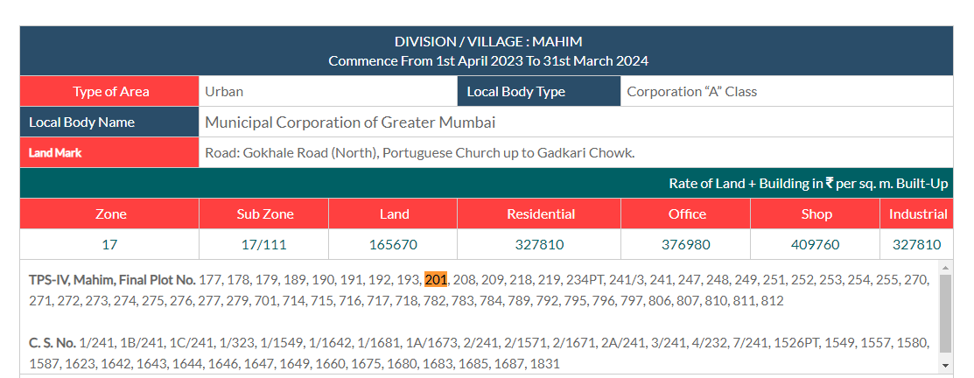
Ready Reckoner Rate

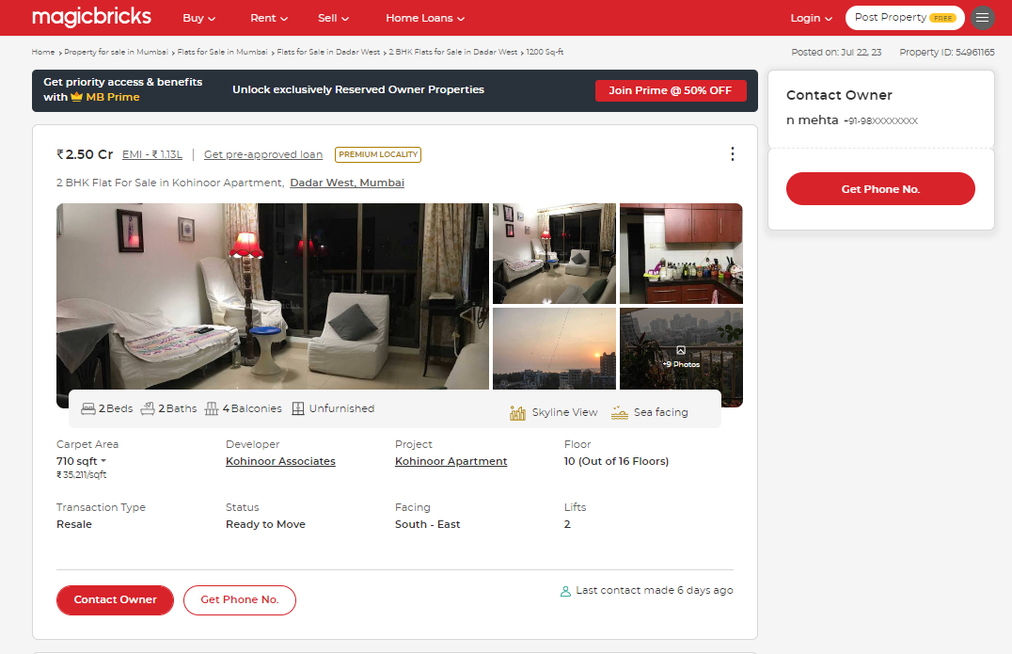
Price Indicators

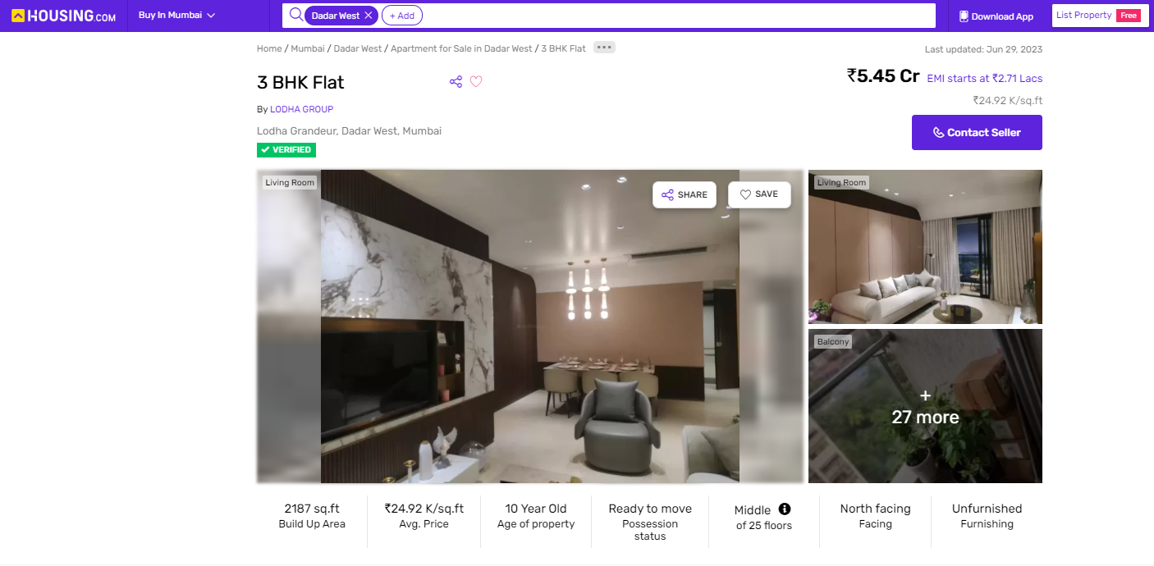

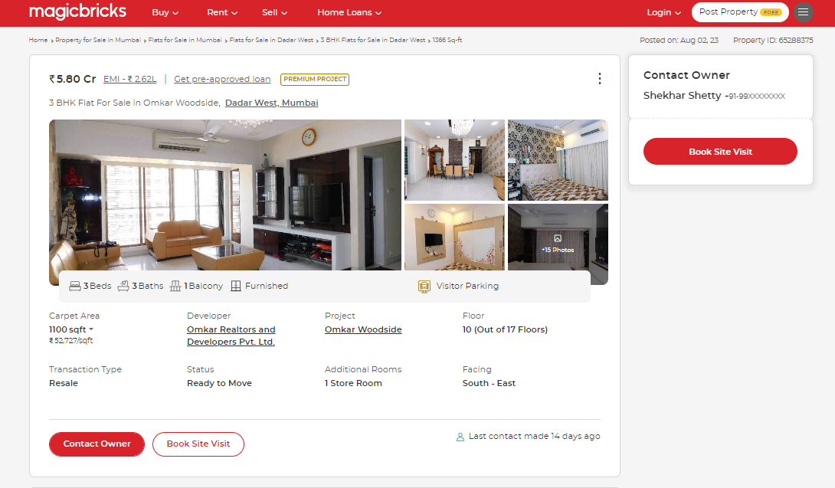
Price Indicators

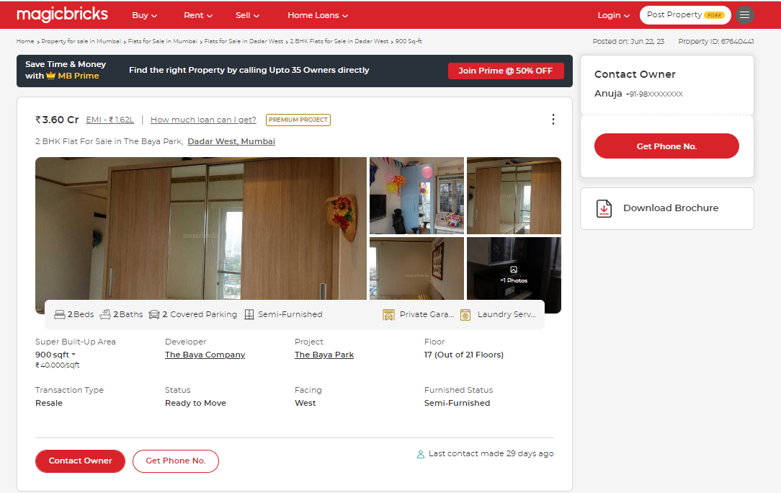

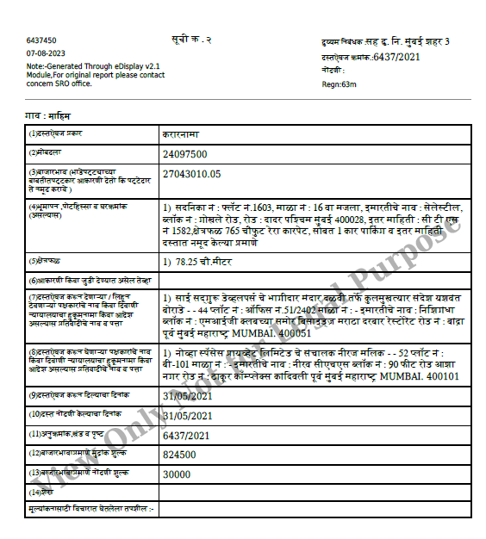
Sale Instances

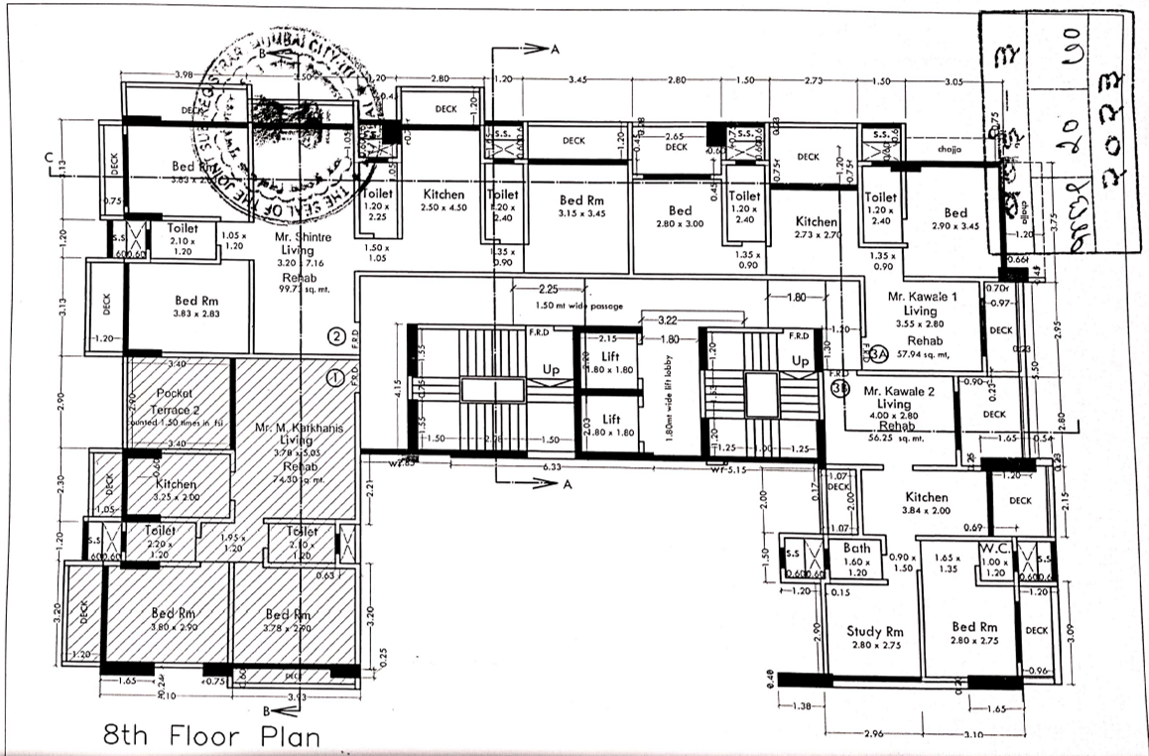
Sale Plan

DEFINITION OF VALUE FOR THIS SPECIFIC PURPOSE

This exercise is to assess Fair Market Value of the property under reference as on 6th September 2023.

The term Value is defined as

“The most probable price, as of a specified date, in cash, terms equivalent to cash, or in other precisely revealed terms for which the specified property rights would sell after reasonable exposure in a competitive market under all conditions requisite to a fair sale, with the buyer and seller each acting prudently knowledgeably and for self interest assuming that neither is under undue duress”.
Fundamental assumptions and conditions presumed in this definition are:

1. Buyer and seller are motivated by self-interest.

2. Buyer and seller are well informed and are acting prudently.

3. The property is exposed for a reasonable time on the open market.

4. Payment is made in cash or equivalent or in specified financing terms.

UNDER LYING ASSUMPTIONS
1. We assume no responsibility for matters of legal nature affecting the property appraised or the title thereto, nor do we render our opinion as to the title, which is assumed to be good and marketable.
2. The property is valued as though under responsible ownership.
3. It is assumed that the property is free of liens and encumbrances.
4. It is assumed that there are no hidden or unapparent conditions of the subsoil or structure that would render it more or less valuable. No responsibility is assumed for such conditions or for engineering that might be required to discover such factors.
5. There is no direct/ indirect interest in the property valued.
6. The rates for valuation of the property are in accordance with the Govt. approved rates and prevailing market rates.

DECLARATION OF PROFESSIONAL FEES CHARGED

We hereby declare that, our professional fees are not contingent upon the valuation findings. However, if the statute AND/OR clients demands that, the fees should be charged on the percentage of assessed value then, with the full knowledge of the AND/OR end user, it is being charged accordingly.

VALUATION OF THE PROPERTY PREMISES

Considering various parameters recorded herein above, existing economic scenario, and the information that is available with reference to the development of neighborhood and method selected for valuation, we are of the opinion that, the property premises can be assessed and valued for banking purpose as on day for ` 2,21,10,000.00 (Rupees Two Crore Twenty One Lakh Ten Thousand Only). As per Site Inspection / Site Information, the building is under Construction as on date.

Manoj B. Chalikwar

Registered Valuer

Chartered Engineer (India)

Reg. No. CAT-I-F-1763

Cosmos Emp. No. H.O./Credit/67/2019-20

