Vastu/Nashik/09/2023/3557/2302405
04/17-49-RYSH
Date: 04.09.2023

To,
The Branch Manager,
Bank of Baroda
Regional Office
BSNL Building, Datta Mandir Road, Nashik Road,
Nashik, PIN – 422 101, State - Maharashtra, Country - India.

Sub: Vetting of Cost Sheet

Sir,

With reference to above subject, we have evaluated the Cost Sheet for Residential Flat No. 101, First Floor, "Shiv Orchid Apartment", Survey No. 58/ 7/ 8, Plot No. 01 Near Mahadubaba Mandir, Siddheshwar Nagar, Jail Road, Village – Dasak, Taluka – Nashik, District - Nashik, PIN Code – 422 101, State – Maharashtra, Country – India belongs Sau. Sonali Lokesh Kamde.

We have verified the rates quoted as per current market rates. Details of Cost Sheet considered as per copy of Cost Sheet Provided by Smooth Slide Furniture received on dated 04.09.2023. The Cost Sheet amount is Rs. 10,00,000/- (Rupees Ten Lakh Only.)

Note:1) The said Cost Vetting Certificate is valid upto next 6 months Only.

Thanking you

Sincerely yours

Sharadkumar B. Chalikwar
Govt. Reg. Valuer
Chartered Engineer (India)
Reg. No. (N) CCIT/1-14/52/2008-09

Cost Sheet
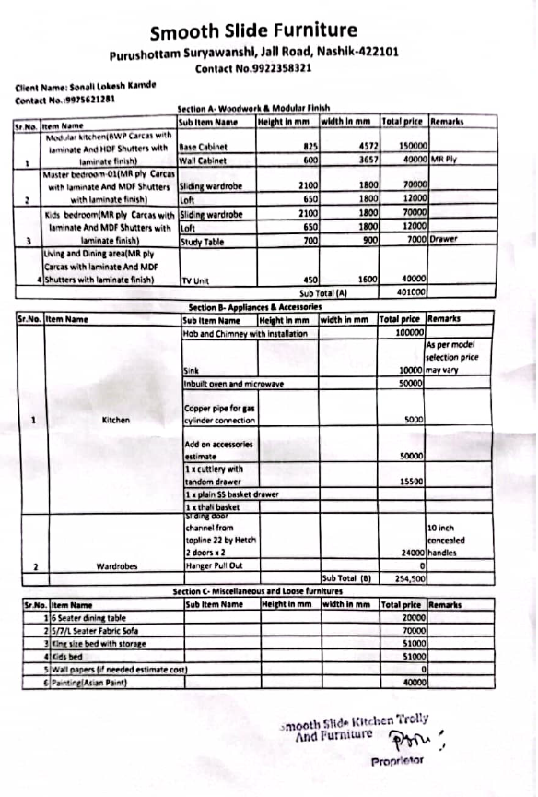

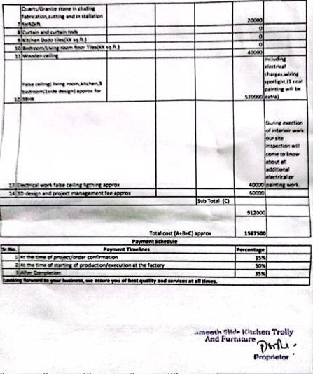

The Cost Sheet amount is Rs.10,00,000/- (Rupees Ten Lakh Only.)

