Techno-Economic Viability

Study Report On
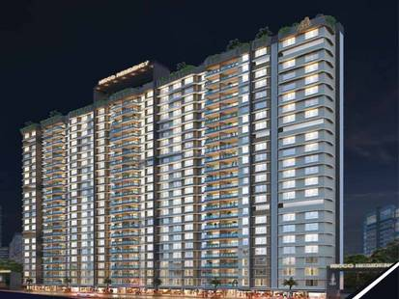
Ashtavinayak Aparmtents, Jogeshwari (East)

Name of Owner : M/s. Shiv Shruti Developers LLP
Proposed S. R. Scheme Residential building on Plot bearing C.T.S. No. 68, 68/1, to 20, 69, 70, 70/1 to 26, 71, 71/1 to 38, 72, 72/1 to 26, 73, 73/1 to 14, 74 & 74/1 to 17, Village – Majas, Jogeshwari (East), Taluka – Andheri, Mumbai – 400 060, State – Maharashtra, Country – India

TEV Report for : State Bank of India
SME Chembur Branch,
Unit No. 11, Building No. 11, Ground Floor, Corporate Park, Sion Trombay Road, Chembur, Mumbai - 400 071

Consultants : Vastukala Consultants (I) Pvt. Ltd.
B1 – 001, Upper Basement, Boomerang Building, Chandivali Farm Road, Andheri (East), Mumbai - 400 072
Table of Contents

Executive Summary 4
Scope of the Work 15
Methodology 16
Real Industry Analysis 20
Segments in the Indian Real Estate Sector 25
Market Size of the India Real Estate 26
Demand for Residential Space 27
About Jogeshwari 29
Connectivity with nearby localities 29
Civic Amenities & Infrastructure 30
Price Trends in Jogeshwari 30
PRICE TRENDS IN JOGESHWARI (EAST) 31
PRICE TRENDS IN JOGESHWARI (EAST) IN ONE YEAR 32
PRICE TRENDS IN JOGESHWARI (EAST) IN ONE YEAR 33
PRICE TRENDS IN JOGESHWARI (EAST) IN ONE YEAR 34
AVERAGE PRICE TRENDS IN JOGESHWARI (EAST) IN ONE YEAR 35
RENTAL YEILD IN JOGESHWARI (EAST) IN ONE YEAR 36
LOCALITY DEMAND IN JOGESHWARI (EAST) IN ONE YEAR 37
LOCALITY SUPPLY IN JOGESHWARI (EAST) IN ONE YEAR 38
Project Details 39
Location & Connectivity 41
Land Details 42
Project Area Statement as per Approved Building Plans 44
Project Area Statement as per Concessions Building Plans 46
Project Cost 49
Means of Finance 50
Project Approvals and their Status 50
Utilities for the Project 51
Current Status of the Project 62
Implementation Schedule 62
Economic Viability 65
Construction Area 65
Inventory 66
Profitability Projections 68
Cashflow Statement 69
Financial Analysis 69
Debt Equity Ratio 69
Loan-to-Sale Value (LTSV) 70
Debt Service Coverage Ratio (DSCR) 70
Internal Rate of Return (IRR) 70
Sensitivity Analysis 71
Swot Analysis 72
Risk Analysis and Mitigation 73
Conclusion 75
Annexure – 1 Projected Profitability Statement 76
Annexure – 2 Projected Balance Sheet 77
Annexure -3 Projected Cashflow Statement 78
Annexure - 4 Debt Service Coverage Statement 82
Annexure - 5 Repayment of Term Loan 82
Annexure – 6 Booking Details till June 30, 2023 83
Annexure - 7 Photographs 84
Disclaimer 89

Vastu/SBI/Mumbai/08/2023/3497/2302336
31/11-482-PY
Date: 28.08.2023

Executive Summary

State Bank of India, SME Chembur Branch, Chembur through Mr. Manish Jha, RMRE has appointed Vastukala Consultants (I) Private Limited (VCIPL) for undertaking the Techno-Economic Viability (TEV) study of the real estate project, namely, Ashtavinayak Apartments in Jogeshwari (East) owned by Shiv Shruti Developers LLP (SSDL).
The study would be to assess the technical, commercial and financial viability of the said real estate project through a detailed analysis of the project and evaluation of the constraints and future potential.

Shiv Shruti Developers LLP is developing S. R. Scheme Project in Jogeshwari (East) in the name of “Ashtavinayak Apartments”. It is a mixed-use project development which comprises of Residential and Commercial. The project is being developed in single Phases. Project comprises of Rehab Building No. 1 (Wing C), Sale Building No. 2 (having A & B Wings).

Ashtavinayak Apartments, consists of Commercial cum Residential building Rehab Building No. 1, & Sale Building No. 2 having 2 Wings (A & B) in Jogeshwari (East), Mumbai is mixed used development by Shiv Shruti Developers LLP.
The project offers Apartment with perfect combination of contemporary architecture and features to provide comfortable healthy living in post Covid era with best of the amenities to match the lifestyles.

Ashtavinayak Apartments, consists of Commercial cum Residential building Rehab Building No. 1 totaling 171 apartments including, & Sale Building No. 2 having 2 Wings (A & B ) totaling to 548 apartments, 10 commercial shop units for Tenant and 318 apartments for sale, 28 apartments for Land owner , 21 apartments for PAP and 171 apartments for Rehab. The Commencement certificate and MahaRERA registration is obtained for totaling about 548 apartments including commercial units. RERA registration number of Residential building is P51800049920.

Building | Proposed Completion | Levels | Present stage of Construction
Rehab Building No. 1 Wing-C | 31st March – 2025 | Proposed Rehab Building no. 1 (Wing C) of Ground Floor + 1st to 23rd Upper Residential Floor as per approved plan. | Ground + 14th Floor Slab work, Ground + 10th Floor Block work, Ground + 5th Floor Internal Plaster & Gypsum Work & Ground + 7th Floor internal plumbing work is completed
Sale Building-1 (Wing A) |  | Proposed Sale Building No. 2 (Wing A) of Ground Floor + 1st to 11th Upper Residential Floor as per approved plan. As per information from developer & architect drawing Sale Building No. 2 (Wing A) of Ground Floor + 1st to 23rd Upper Residential Floor | Ground + 11th Floor Slab work, Ground + 4th Floor Block work, Ground + 3th Floor Internal Plaster Work is completed
Sale Building-2 (Wing B) |  | Proposed Sale Building No. 2 (Wing B) of Ground Floor + 1st to 23rd Upper Residential Floor as per approved plan. As per information from developer & architect drawing Proposed Sale Building No. 2 (Wing B) of Ground Floor + 1st to 23rd Upper Residential Floor. | Ground + 8th Floor Slab work, Ground + 4th Floor Block work, is completed

Building | Proposed  Completion | Levels | Current Status
Rehab Building No. 1 Wing-C | 31st March 2025 | Proposed Rehab Building no. 1 (Wing C) of Ground Floor + 1st to 23rd Upper Residential Floor as per approved plan. | Commencement Certificate is obtained for Ground Floor + 14th Upper Floor as per approved plan dated 21.04.2022. Work is started completed till 14th floor slab work.
Sale Building-1 (Wing A) |  | Proposed Sale Building No. 2 (Wing A) of Ground Floor + 1st to 11th Upper Residential Floor as per approved plan. As per information from developer & architect drawing Sale Building No. 2 (Wing A) of Ground Floor + 1st to 23rd Upper Residential Floor | Commencement Certificate is obtained for Ground Floor + 11th Upper Floor. Work is started completed till 11th floor slab work
Sale Building-2 (Wing B) |  | Proposed Sale Building No. 2 (Wing B) of Ground Floor + 1st to 23rd Upper Residential Floor as per approved plan. As per information from developer & architect drawing Proposed Sale Building No. 2 (Wing B) of Ground Floor + 1st to 23rd Upper Residential Floor. | Commencement Certificate is obtained for Ground Floor + 12th Upper Floor. Work is started completed till 8th floor slab work

Parameter | Details
Asset Class | Residential and Part Commercial
Category | Mid Segment
Location | C.T.S. No. 68, 68/1, to 20, 69, 70, 70/1 to 26, 71, 71/1 to 38, 72, 72/1 to 26, 73, 73/1 to 14, 74 & 74/1 to 17, Village – Majas, Jogeshwari (East), Taluka – Andheri, Mumbai – 400 060, State – Maharashtra, Country – India
Land Area | Net Plot area – 3,217.80 Sq. M.
Land Purchased in | As per Agreement For sale date :29-12-2020
Land Financed by | -
Project Type | Residential cum Part Commercial
Applicable DCRs | Slum Rehabilitation Authority (SRA)
Development Potential | As per table attached
Sales begun in | 2023
Saleable Area | As per table attached
Construction Start Date | 2022
Construction End Date as per information uploaded by the Developer on the RERA Website | 31/12/2025
Architect and Planning | As per table attached
Key Project Consultants
Landscaping Consultant
Structural Consulting
Project Contractors

Project Cost
The total project cost estimated by SSDL works out to INR 148.48 Crore. The detailed acquisition cost is as tabulated below:
INR in Crore
Particulars | Total Project Cost | %tage of Total
Land & Stamp Duty | 0.44 | 0.30%
Construction Cost | 105.00 | 70.70%
Approval Cost (FSI charges) + DC + Stair case + PT + (BMC Premium) | 13.00 | 8.76%
Architect & Consultancy Expenses | 2.00 | 1.35%
Admin & Marketing Expenses | 11.50 | 7.75%
Contingency | 1.47 | 0.99%
Rent Cost | 9.45 | 6.36%
Interest to Bank Finance upto construction period | 5.63 | 3.79%
Total | 148.48 | 100.00%

Cost Incurred till June 30, 2023
The cost incurred on project the till June 30, 2023 is as tabulated below:
INR in Crore
Particulars | Cost incurred till 30/06/2023
Land & Stamp Duty | 0.44
Construction Cost | 31.54
Approval Cost (FSI charges) + DC + Stair case + PT + (BMC Premium) | 3.80
Architect & Consultancy Expenses | 1.07
Admin & Marketing Expenses | 2.16
Rent Cost | 6.27
Total | 45.28

Balance Cost to Complete the Project
The balance cost to complete the project budgeted by SSDL is as tabulated below:
INR in Crore
Particulars | Balance Cost to be Incurred
Land & Stamp Duty | -
Construction Cost | 73.45
Approval Cost (FSI charges) + DC + Stair case + PT + (BMC Premium) | 9.20
Architect & Consultancy Expenses | 0.93
Admin & Marketing Expenses | 9.34
Contingency | 1.47
Rent Cost | 3.18
Interest to Bank Finance upto construction period | 5.63
Total | 103.20

Means of Finance
The means of finance proposed for the said project cost shall be as tabulated below:
INR in Crore
Particulars | Total Funds to be Raised | %tage of Total
Promoters Contribution
Promoters Contribution | 35.75 | 24.10%
Bank Loan
Term Loan | 30.00 | 20.20%
Customer Advances | 82.73 | 55.70%
Total | 148.48 | 100.0%

Analysis on Project Sales
The analysis for project sales is as tabulated below:

Flat Inventory: -
Type | RERA Area | Total Units |  |  | Inventory as on 30th June’ 23
 | In Sq. Ft. | Wing A | Wing B | Wing C | Wing A | Wing B | Wing C
1BHK | 29.45 | 0 | 20 | 0 | 0 | 11 | 0
1BHK | 30.01 | 145 | 0 | 0 | 145 | 0 | 0
1BHK | 39.76 | 0 | 20 | 0 | 0 | 13 | 0
1BHK | 41.43 | 0 | 23 | 0 | 0 | 22 | 0
1BHK | 41.53 | 0 | 23 | 0 | 0 | 23 | 0
1BHK | 41.81 | 0 | 22 | 0 | 0 | 19 | 0
1BHK | 42.08 | 0 | 23 | 0 | 0 | 22 | 0
1BHK | 42.46 | 0 | 21 | 0 | 0 | 21 | 0
3BHK | 43.57 | 0 | 21 | 0 | 0 | 10 | 0
Total |  | 145 | 173 | 0 | 145 | 141 | 0

Profitability Statement
The project sales from receivables on sold inventory and sale of unsold inventory is as tabulated below:
INR in Crore
Particulars | FY 23-24 | FY 24-25 | FY 25-26
Revenue
Sales | - | - | 232.10
Closing WIP – Ashtavinayak Apartments | 89.10 | 140.73 | -
Total Revenue | 89.10 | 140.73 | 232.10
Expenses
Expenses incurred during the year | 43.82 | 51.63 | 7.76
Closing WIP – Ashtavinayak Apartments | 45.28 | 89.10 | 140.73
Operating Profit | - | - | 83.61
PBT | - | - | 83.61
Tax | - | - | 25.08
PAT | - | - | 58.53

Balance Sheet
The projected Balance sheet of the project is as tabulated below:
INR in Crore
Particulars | FY 23-24 | FY 24-25 | FY 25-26
Shareholder Funds | 2.35 | 2.75 | 61.28
Share capital | 2.35 | 2.75 | 2.75
Reserve & Surplus | - | - | 58.53
Noncurrent Liabilities | 50.70 | 63.00 | -
Term Loan | 17.70 | 30.00 | -
Promotors Loan | 33.00 | 33.00 | -
Current Liabilities | 58.76 | 109.26 | 46.37
Unsecured loan | 20.40 | 20.40 | 20.40
Advance received | 37.03 | 86.34 | -
Sundry Creditors | 0.61 | 0.65 | -
Provision | 0.14 | 1.24 | 25.28
Duties & Taxes | 0.57 | 0.63 | 0.69
Total Liabilities | 111.81 | 175.01 | 107.65
Asset
Non-Current Assets
Fixed Assets | 0.04 | 0.04 | 0.03
 |  | - | -
Project WIP | 89.10 | 140.73 | -
Current Assets
Advance for Plots | 19.48 | 19.48 | 74.48
Sundry Debtors | - | - | -
DSRA - FDR NICCO | 0.98 | 11.37 | -
TDS and Advance tax | 0.39 | 0.85 | 20.26
Deposit | 0.80 | 0.80 | 0.80
Loans & Advances | 0.29 | 0.29 | 0.29
Cash & Cash Equivalent | 0.72 | 1.45 | 11.79
Total Current Assets | 111.76 | 174.97 | 107.62
Total | 111.81 | 175.01 | 107.65

Debt Service Coverage Ratio
The Debt service coverage ratio of the project is tabulated below: -
INR in Crore
Particular | FY24 | FY25 | FY26
Closing Cash Balance | - | - | 95.61
Interest on Term Loan | 0.98 | 2.89 | 1.76
Repayment of Term Loan | - | - | 30.00
Coverage | 0.98 | 2.89 | 127.37
Debt Service | 0.98 | 2.89 | 31.76
DSCR | 1.00 | 1.00 | 4.01
Average DSCR | 3.68

Internal Rate of Return
The IRR for the project is worked out for the following scenarios:
INR in Crore
Particular | FY24 | FY25 | FY26
Cash Inflow
Amount Received | 37.03 | 49.31 | 145.76
Cash Outflow
Cash outflow | 89.10 | 51.63 | 7.76
Net Cashflow | -52.07 | -2.32 | 138
Internal Rate of Return | 60.59%

The IRR is comfortably greater than the weighted average cost of capital which works of to 37.66%.

Sensitivity Analysis
A sensitivity analysis was carried out to assess the impact of the following scenarios on the following major parameters.
- Average Debt Service Coverage Ratio (Average DSCR)
- Minimum Debt Service Coverage Ratio (Min. DSCR)
- Internal Rate of Return (IRR)
- Cash Break-Even Point (BEP)

Particulars | Average DSCR | Min. DSCR | IRR
Base Case | 3.68 | 1.00 | 58.98%
Sales reduce by 5% | 3.37 | 1.00 | 51.30%
Price reduces by 5% | 3.40 | 1.00 | 53.60%
Cost increase by 5% | 3.55 | 1.00 | 49.90%
Interest cost increase by 2% | 3.59 | 1.00 | 58.43%

The sensitivity analysis shows that the project IRR, average and minimum DSCR are sensitive to reduction in the Sales & Price and increase in the Operating Expenses.
In all scenarios, the IRR, average DSCR are not adversely affected by a drastic change in the scenarios.
Project Status
Building | Present stage of Construction
Rehab Building No. 1 | Commencement Certificate is obtained for Ground Floor + 14th Upper Floor as per approved plan dated 21.04.2022. Work is started completed till 14th floor slab work.
Sale Building -2 (Wing A) | Commencement Certificate is obtained for Ground Floor + 11th Upper Floor. Work is started completed till 11th floor slab work
Sale Building -2 (Wing B) | Commencement Certificate is obtained for Ground Floor + 12th Upper Floor. Work is started completed till 8th floor slab work

Approvals Status of the Project

Approval/ Consent | Approving Authority | Status
LOI Notification | SRA | Obtained
Pre-Construction / Plan Approval | SRA | Obtained
NOC (Road, Fire, Drainage, Water, Garden,  Health,) | SRA | Obtained
Sanction for construction electrical load | MCGM | Obtained
Sanction for water supply requirement | MCGM | Obtained
Environmental Clearance | SEIAA | Obtained
Pollution Consent | SEIAA | Obtained
NOC on building height and civil aviation  Clearance | Airport Authority of  India | Obtained

Conclusion

Vastukala Consulting (I) Pvt. Ltd. believes that the promoters have the financial and technical capability and have tied up with Shiv Shruti Developers LLP to construct the real estate project and to market the same successfully. In view of adequate promoter experience, fair market conditions, proper project planning and the ability of the project to service the debt within a reasonable time, the proposal for real estate project of Shiv Shruti Developers LLP is considered Technically Feasible and Economically Viable.

Scope of the Work

State Bank India has appointed Vastukala Consulting (I) Pvt. Ltd. for assessing the technical, commercial and financial viability of real estate project, namely, “Ashtavinayak Apartments” in Jogeshwari (East) being developed by the Company. The study would be to assess the techno-economic viability of the project through a detailed techno – financial analysis of the project and evaluation of the constraints and future potential.

The scope of work was finalized a under:
• Vastukala Consulting (I) Pvt. Ltd. will validate the cost of the proposed project, given the specifications on CIRP Cost and payment to Secured & Unsecured lenders.
• Vastukala Consulting (I) Pvt. Ltd. will analyse the revenue and cost estimates for the project. Various financial tools such as debt service coverage ratio (DSCR), internal rate of return (IRR), etc., will be used to arrive at a conclusion on the viability of the project.

Methodology

The techno-economic viability study assigned to Vastukala Consulting (I) Pvt. Ltd. was carried out in the following sequence:
- Verification of the documents provided by the client, identification of missing information, and requesting for the revised list of documents required from SSDL.
- Visit to the project sites.
- Assessment of the project cost reasonableness for the proposed project.
- Assessment of revenue and cost estimates of the project.
- Secondary research to understand industry specific benchmarks.
- Assessment of financial projection and to derive various financial ratios to assess viability of the financial project.
- To carry out sensitivity analysis, SWOT analysis and to identify risk & its mitigation pertaining to the project.

Shiv Shruti Developers LLP
SHIV SHRUTI DEVELOPERS LLP, a Limited Liability Partnership (LLPIN- AAN-7303) having PAN No-ADZFS2680L and GSTIN 27 ADZFS2680L1Z2 was incorporated on 12TH July,2019 through a LLP agreement with 4 partners with the prime objective to carry on the business as builder and property developers and civil contractors, etc. and other allied / or any ancillary business and may carry on any other business.

Presently there are 2 designated partners, all family members, in the LLP and the sharing of Profits and Losses between partners has been decided in the LLP Agreement as mentioned hereunder: -
Sl No. | Partners Name | Profit sharing Ratio
1 | Mr. Chirag Ashok Shah | 70.00%
2 | Mr. Hetanshu Chirag Shah | 25.00%
3 | Mr. Karan Mahesh Doshi | 2.50%
4 | Mr. Niraj Mahesh Doshi | 2.50%
 | Total | 100.00%

About the Promoters and Partners:
No. in years
Sr. No. | Name | Age | Profit Sharing Ratio | Educational Qualification | Designation | Experience
1 | Mr. Chirag Ashok Shah | 50 | 70.00% | Civil Engineering | Designated partners | 30 years
2 | Mr. Hetanshu Chirag Shah | 24 | 25.00%% | Civil Engineering | Designated partners | 4 years
3 | Mr. Karan Mahesh Doshi | 37 | 2.50% | Chemical Engineering (Degree) | Designated partners | 15 years
4 | Mr. Niraj Mahesh Doshi | 40 | 2.50% | Electronic & Telecom  Engineering (Degree) | Designated partners | 18 years

Shiv Shruti Developers LLP is subsidiary company of the NICCO Group.

ABOUT THE NICCO GROUP: -
New India Construction Company (NICCO) is one of the most trusted developers. Who believes in improving the lifestyle of its customers through better amenities and new infrastructure.
NICCO is the brainchild of Mr. Ashok Shah, since its inception in 1972, various innovative approaches have been taken since, that have resulted in a paradigm shift in construction industry. Today, NICCO has successfully completed 50 projects, while several other projects are in the pipeline. In addition to contributing towards the construction industry, the company also plays an important role in the upliftment of the socio – economic status of the society. Absit is a initiative towards the same. A technical college that helps inculcate decision making, analytical & conceptual skills along with leadership qualities into every student.

ONGOING PROJECTS: -
- Amey Heights
- Ashok Premises
- Ashok Smruti Wing B
- Shree Parshva Heights
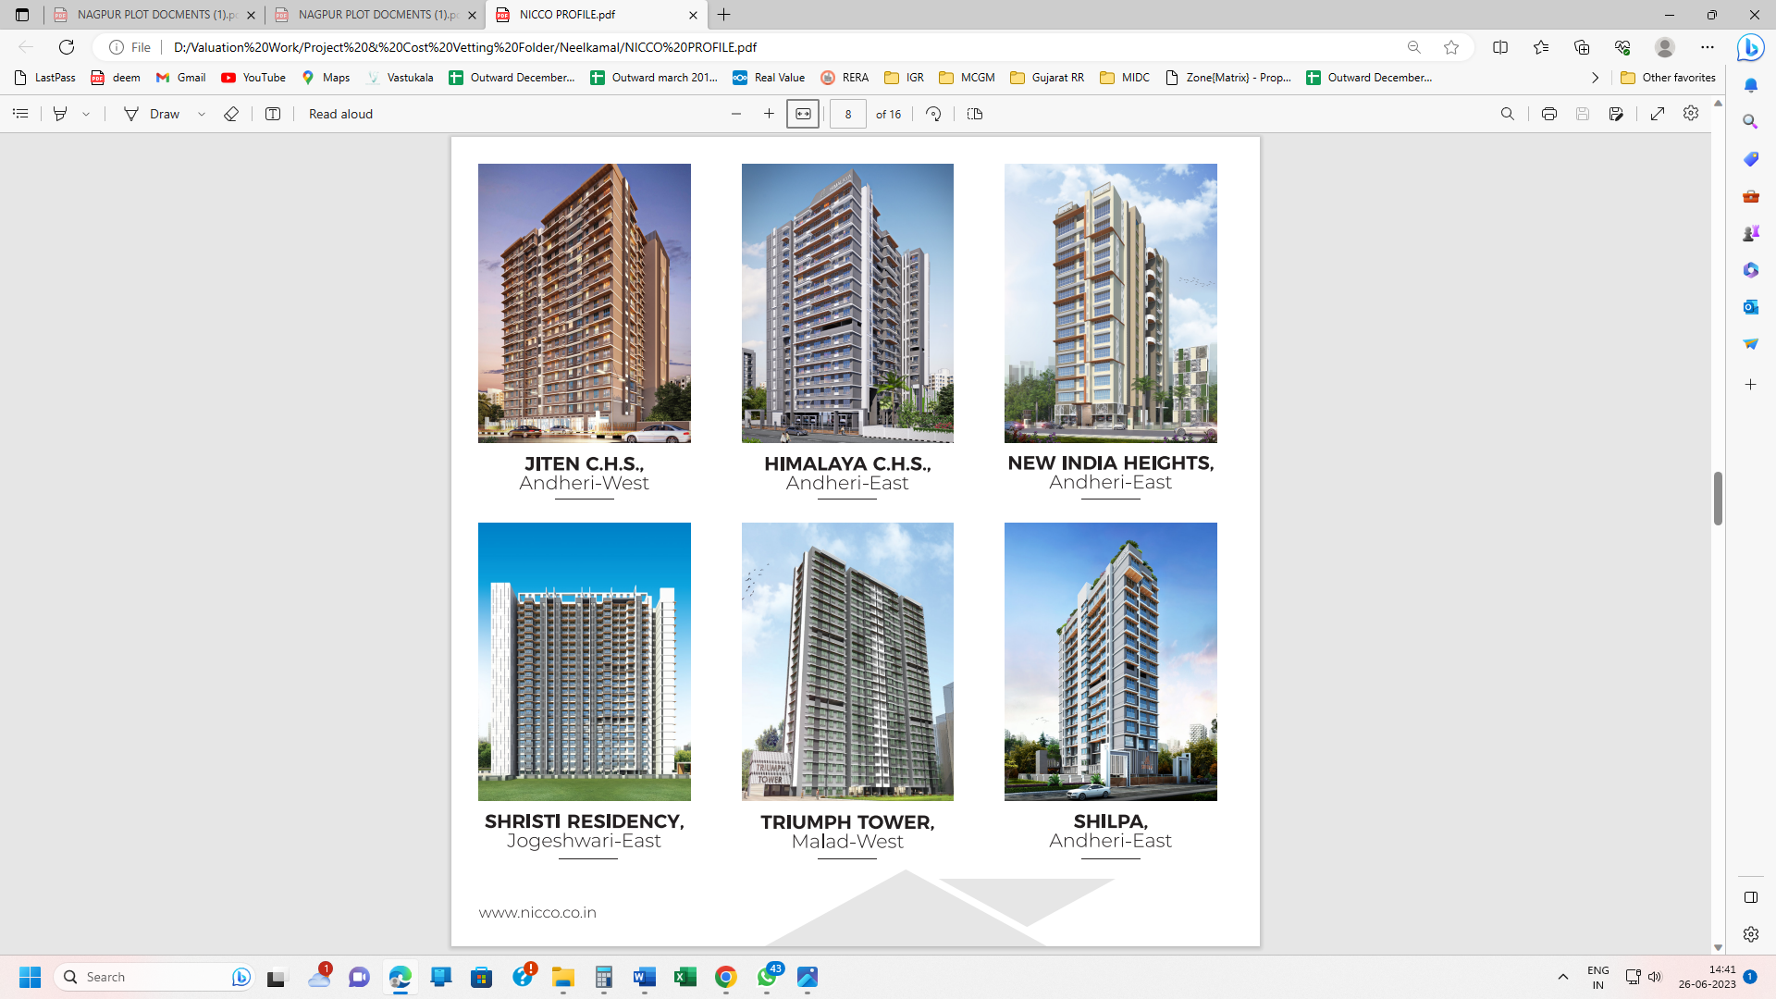
- Shristi Residency
- Key Tech Park
- Konshila
- Neelkamal Realty
- Aishwarya Heights

ONGOING REDEVELOPEMENT PROJECTS: -
- Keshav Apartments
- Jiten C.H.S.
- New India Heights
- Shilpa C.H.S.
- Vishakha Heights
- Hem Ratan Apartments
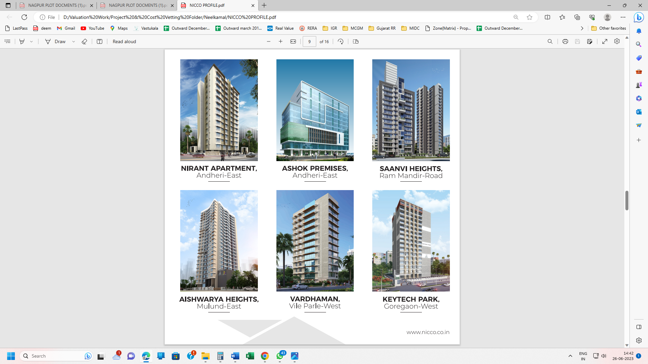
- Kamlesh Apartments
- Triumph Tower
- Triumph Swastik

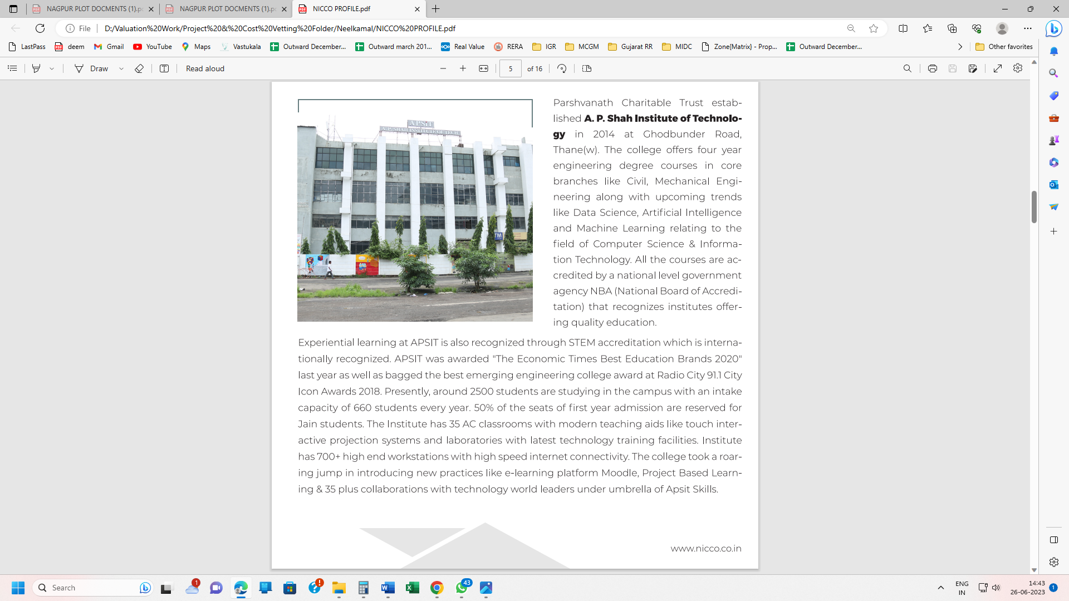

Real Industry Analysis

Introduction
In India, the real estate sector is the second-highest employment generator, after the agriculture sector. Real estate sector in India is expected to reach US$ 1 trillion in market size by 2030, up from US$ 200 billion in 2021. By 2025, it will contribute 13% to country’s GDP. Emergence of nuclear families, rapid urbanisation and rising household income are likely to remain the key drivers for growth in all spheres of real estate, including residential, commercial, and retail. Rapid urbanisation in the country is pushing the growth of real estate. >70-75% of India’s GDP will be contributed by urban areas by 2020.

Around 40 million square feet were delivered in India in 2021. It is expected that the country will have a 40% market share in the next 2-3 years. India is expected to deliver 46 million square feet in 2022.

As per ICRA estimates, Indian firms are expected to raise >Rs. 3.5 trillion (US$ 48 billion) through infrastructure and real estate investment trusts in 2022, as compared with raised funds worth US$ 29 billion to date.

India’s real estate sector saw over 1,700 acres of land deals in the top 7 cities in 1 year. Foreign investments in the commercial real estate sector were at US$ 10.3 billion between 2017-21. As of February 2022, Developers expect demand for office spaces in SEZs to shoot up after the replacement of the existing SEZs act.

Private market investor, Blackstone, which has significantly invested in the Indian real estate sector (worth Rs. 3.8 lakh crore (US$ 50 billion), is seeking to invest an additional Rs. 1.7 lakh crore (US$ 22 billion) by 2030.

India's Global Real Estate Transparency Index ranking improved by five notches from 39 to 34 since the past six years from 2014 until 2020 on the back of regulatory reforms, better market data and green initiatives, according to property consultant JLL.

According to Savills India, real estate demand for data centres is expected to increase by 15-18 million sq. ft. by 2025.

The institutional investments in the Indian real estate sector are expected to increase by 4% to reach Rs. 36,500 crore (US$ 5 billion) in 2021, driven by rising interest of investors towards capturing attractive valuations amid the pandemic. Between January 2021 and September 2021, private equity investment inflows into the real estate sector in India stood at US$ 3.3 billion. In the first quarter of 2022, the gross leasing volume of India’s top seven office markets was at 11.55 million sq. ft.

The office market in top eight cities recorded transactions of 22.2 msf from July 2020-December 2020, whereas new completions were recorded at 17.2 msf in the same period. In terms of share of sectoral occupiers, Information Technology (IT/ITeS) sector dominated with a 41% share in second half of 2020, followed by BSFI and Manufacturing sectors with 16% each, while Other Services and Co-working sectors recorded 17% and 10%, respectively. The office space leasing activity is expected to pick up in 2021 and is likely to be at par with the 10-year average, i.e., 30-31 million sq. ft. Of the total PE investments in real estate in Q4 FY21, the office segment attracted 71% share, followed by retail at 15% and residential and warehousing with 7% each.

Demand for residential real estate revived in Q4 FY21 as homebuyers took advantage of low mortgage rates and incentives rendered by developers. Residential sales in this quarter recovered to >90% volumes recorded in 2020 across the top seven cities. In the first half of 2022, office absorption in the top 7 cities stood at 27.20 million Sq. ft.

Home sales volume across seven major cities in India surged 113% YoY to reach ~62,800 units in the third quarter 2021, from 29,520 units in the same period last year, signifying healthy recovery post the strict lockdown imposed in the second quarter due to the spread of COVID-19 in the country.

According to the Economic Times Housing Finance Summit, about 3 houses are built per 1,000 people per year compared with the required construction rate of five houses per 1,000 population. The current shortage of housing in urban areas is estimated to be ~10 million units. An additional 25 million units of affordable housing are required by 2030 to meet the growth in the country’s urban population.

The Government of India has been supportive towards the real estate sector. In August 2015, the Union Cabinet approved 100 Smart City Projects in India. The Government has also raised FDI (Foreign Direct Investment) limits for townships and settlements development projects to 100%. Real estate projects within Special Economic Zones (SEZ) are also permitted for 100% FDI. Construction is the third-largest sector in terms of FDI inflow. FDI in the sector (including construction development & activities) stood at US$ 55.18 billion from April 2000-September 2022.

Exports from SEZs reached Rs. 7.96 lakh crore (US$ 113.0 billion) in FY20 and grew ~13.6% from Rs. 7.1 lakh crore (US$ 100.3 billion) in FY19. Indian real estate is expected to attract a substantial amount of FDI in the next two years with US$ 8 billion capital infusion by FY22. As of June 30, 2021, India formally approved 427 SEZs.

In the first-half of 2021, India registered investments worth US$ 2.4 billion into real estate assets, a growth of 52% YoY.

Share of the top listed developers in the Indian residential market is expected to increase to 29% in FY24, from 25% in FY21, driven by a strong pipeline for residential project launch.

Between July 2021-September 2021, a total of 55,907 new housing units were sold in the eight micro markets in India (59% YoY growth).

Between July 2021-September 2021, housing sales in the NCR surged 97% to reach 10,220 units compared with the same period last year.

In the third quarter of 2021 (between July 2021-September 2021), new housing supply stood at 65,211 units, increased by 228% YoY across the top eight cities compared with ~19,865 units launched in the third quarter of 2020.

In 2021-22, the commercial space is expected to record increasing investments. For instance, in October 2021, Chintels Group announced to invest Rs. 400 crore (US$ 53.47 million) to build a new commercial project in Gurugram, covering a 9.28 lakh square feet area.

Government of India’s Housing for All initiative is expected to bring US$ 1.3 trillion investments in the housing sector by 2025. As of December 2019, under Pradhan Mantri Awas Yojana (Urban) [PMAY (U)], 1.12 crore houses were sanctioned in urban areas, with a potential to create 1.20 crore jobs. The scheme is expected to push affordable housing and construction in the country and give a boost to the real estate sector. On July 09, 2020, Union Cabinet approved the development of Affordable Rental Housing Complexes (AHRCs) for urban migrants and poor as a sub-scheme under PMAY–U.

In October 2021, the RBI announced to keep benchmark interest rate unchanged at 4%, giving a major boost to the real estate sector in the country. The low home loan interest rates regime is expected to drive the housing demand and increase sales by 35-40% in the festive season in 2021.

Government has also released draft guidelines for investment by Real Estate Investment Trusts (REITs) in non-residential segment.

The Ministry of Housing and Urban Affairs has recommended all the states to consider reducing stamp duty of property transactions in a bid to push real estate activity, generate more revenue and aid economic growth.

In July 2021, the Securities and Exchange Board of India lowered the minimum application value for Real Estate Investment Trusts from Rs. 50,000 to Rs. 10,000-15,000 to make the market more accessible to small and retail investors.
Construction is the third-largest sector in terms of FDI inflow. FDI in the sector, including construction development and construction activities stood at US$ 42.66 billion between April 2000 and June 2020. Government of India’s ‘Housing for All’ initiative is expected to bring US$ 1.3 trillion investment in the housing sector by 2025.
Source: KPMG, World Bank, Census 2011, Credai-JLL report, United Nations World Urbanization Prospects 2018, CBRE, India’s Urban System: Sustainability and Imbalanced Growth of Cities

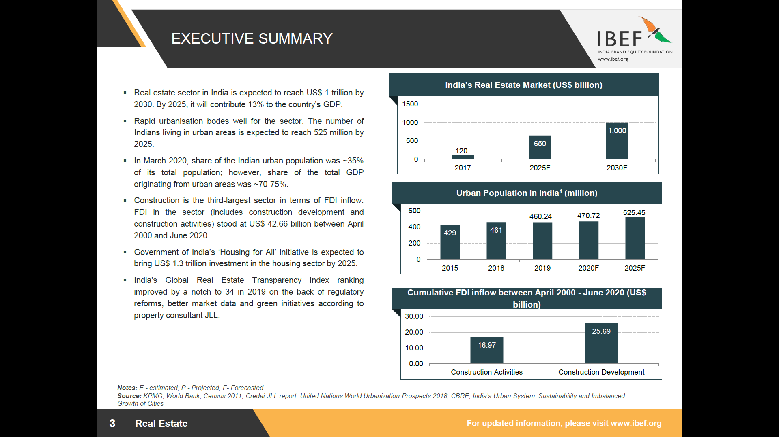
Advantage India

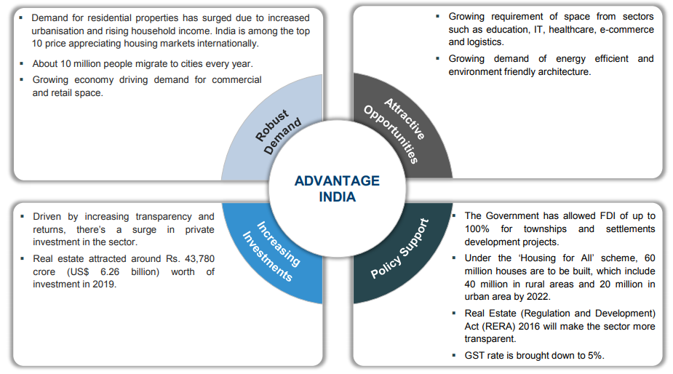

Segments in the Indian Real Estate Sector

The Real Estate Sector is divided into several market namely residential, commercial, retail space, hospitality & Special Economic Zones (SEZs). The residential segment contributes approximately 80 per cent to the real estate sector. New housing launches across top eight cities in India are expected to increase by 23 per cent year-on-year by 2019 to 2,23,325 units. As far as the commercial segment is concerned, there are only a few players with presence across India and most of the activity is in the leasing segment. FDI in multi brand retail is expected to boost demand.

In 2019, Retail segment in Indian attracted private equity (PE) investment of around US$ 1 billion and supply of around another 39 million sq. ft. is expected in 2022. In the hospitality segment, Supply of Hotel room in India has increased 5.4 per cent year-on-year in 2019, totalling to 133,359 rooms at the end of 2019. The sector is likely to attract an annual investment between US$ 0.5-0.6 billion during 2018-2022, with total investment reaching US$ 2.8 billion by 2022. As on July 31, 2020, India had formally approved 423 SEZs, of which 248 were in operation. Majority of the SEZs are in the IT/ ITeS sector. In March 2020, the Government had approved proposals from TCS and DLF to set up SEZs for IT sector in Haryana and Uttar Pradesh.

Market Size of the India Real Estate

The Real Estate sector in India is expected to reach a market size of US$ 1 trillion in market size by 2030, up from US$ 120 billion in 2017. It has been estimated that India’s real estate market will grow at a CAGR of 19.5% during 2017- 2028. Increasing share of real estate in the GDP would be supported by increasing industrial activity, improving income level and urbanization. The government also launched 10 key policies for real estate sector, namely: Real Estate Regulatory Act, Benami Transactions Act, boost to affordable housing construction, Interest subsidy to home buyers, change in arbitration norms, service tax exemption, Dividend Distribution Tax (DDT) exemption, Goods and Services Tax, Demonetization & PR for foreign investors.
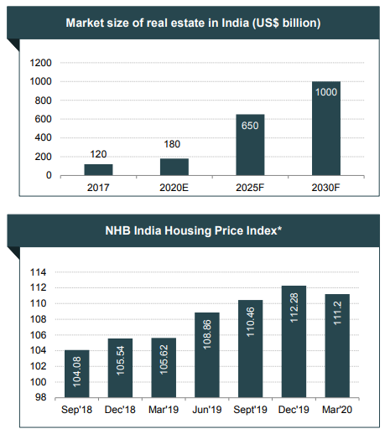
CAGR - Compounded Annual Growth Rate
*average of indices of all cities

Demand for Residential Space

A localized, fragmented market presents opportunities for consolidation with only few large, pan-India players such as DLF. More foreign players might enter the market as FDI norms have eased. Furthermore, norms on land acquisitions are expected to be relaxed. Key drivers for the increase in demand are rapid urbanization, growth in population, rise in the number of nuclear families, easy availability of finance, repatriation of NRIs and HNIs & rise in disposable income.

Housing sales reached 2.61 lakh units in 2019 across seven major cities. NCR (National Capital Region) is expected to generate maximum demand in MIG and HIG category followed by Bengaluru. Developers are now focussing on affordable and mid-range categories to meet the huge demand.
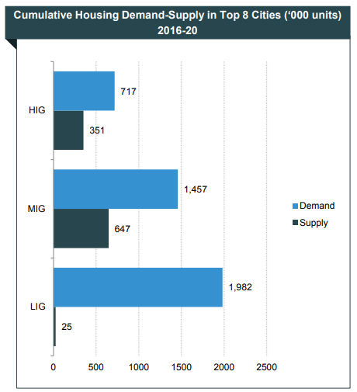
Source : Cushman and Wakefield, Anarock Property Consultants

Factors driving the Residential Demand Revival

Stress in real estate sector and the covid-19 pandemic in a way has been a blessing in disguise for the end users and disciplined Developers like Aurum. These have lead to consolidation and segregation of projects while the smaller un-organised developers without financial closures are finding it difficult to sell, there is already up surge in take up for the apartments with certainty of completion.
The factors driving the apartments demand are:
The interest rates are at 15 years low, making purchase of homes much more affordable.
The stamp duty reduction by government of Maharashtra has provided impetus for new to Apartment purchases as well as faster registration
Covid pandemic has underlined the advantages of owning a good quality apartment

Strategies Adopted

A few strategies adopted are mentioned in brief. Having a diverse portfolio of residential, commercial and township developments is vital. Companies have projects in various strategic geographic locations in order to diversify risks. There is focus on the growth of lease business. Housing finance companies and private equity companies have started focusing on affordable housing.

There has been risk management in land sourcing. Mumbai based realty firms have adopted strategies such as Joint Ventures with land owners instead of amassing land banks, while entering the National Capital Region (NCR).

The execution has been superior through outsourced support functions, focus on delivery capability, rationalizing costs and development of world class infrastructure.

About Jogeshwari

Jogeshwari is a suburb located in the western part of Mumbai, Maharashtra, India. It is notable for its caves - 'Jogeshwari Caves', particularly one containing a shrine of the Hindu Goddess Jogeshwari, Lord Shiva and the deity Hanuman. It belongs to the K/E Ward of Mumbai.[1]

On the Mumbai Suburban Railway, (which is part of the Indian Western Railway line,) that runs from Churchgate to Dahanu, Jogeshwari is north of and next to Andheri and has a train station of the same name.

The Jogeshwari - Vikhroli Link Road connects Jogeshwari a western suburb of Mumbai with Vikhroli an eastern suburb. This road typically experiences traffic jams during peak hours but has improved access and connectivity between the city's suburbs. For healthcare a public governed HBT trauma hospital is located near the Western express highway
Source: https://en.wikipedia.org/wiki/Jogeshwari

Jogeshwari East is a luxury locality situated in Mumbai. The pincode of this locality is 400060. This locality is near Majas Wadi, Shyam Nagar and Indira Nagar. This locality has 200+ properties to buy and 100+ properties to rent. The residents of Jogeshwari East rated this locality at 5/5 in terms of connectivity, whereas for safety, they rated it 4/5.

Connectivity with nearby localities

- Jogeshwari Railway Station, situated on the Western line of the Mumbai suburban railway network, is a preferred medium of connectivity for daily commuters, providing easy access to CSMT and Mumbai Central Network. The proposed Metro Station on Line 6 of Jogeshwari East Metro (Jogeshwari-Vikhroli link road) is expected to improve connectivity to the area.
- BEST buses and NMMT buses are available
- The nearest airport is the Chhatrapati Shivaji Maharaj International Airport which is located at 24.00 kilometres. Proposed Navi Mumbai airport will further improve connectivity.
- Majas Depot, Marol Depot, Jogeshwari railway station, Ram mandir railway station, Western express highway metro station, Chakala metro station are the commute options in the locality.

Civic Amenities & Infrastructure

Popular educational institutions in the area are shri Ghanshamdas podhar vidyalay Rajasthani school, Shree ram welfare high school. For any medical emergency, DNA Hospital, matoshri umabai RANE hospital, Balthakra Sahara Jogeshwari Hospital are located in proximity. Some of the popular recreational hubs near the locality are PVR Andheri, Navrang Talkies.

Price Trends in Jogeshwari
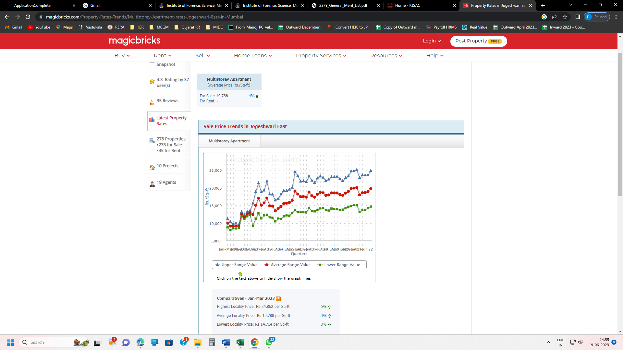

Comparatives – Jan – Mar 2023
- Highest Locality Price: Rs 24,862 per Sq-ft 5%
- Average Locality Price: Rs 19,788 per Sq-ft 4%
- Lowest Locality Price: Rs 14,714 per Sq-ft 3%

PRICE TRENDS IN JOGESHWARI (EAST)
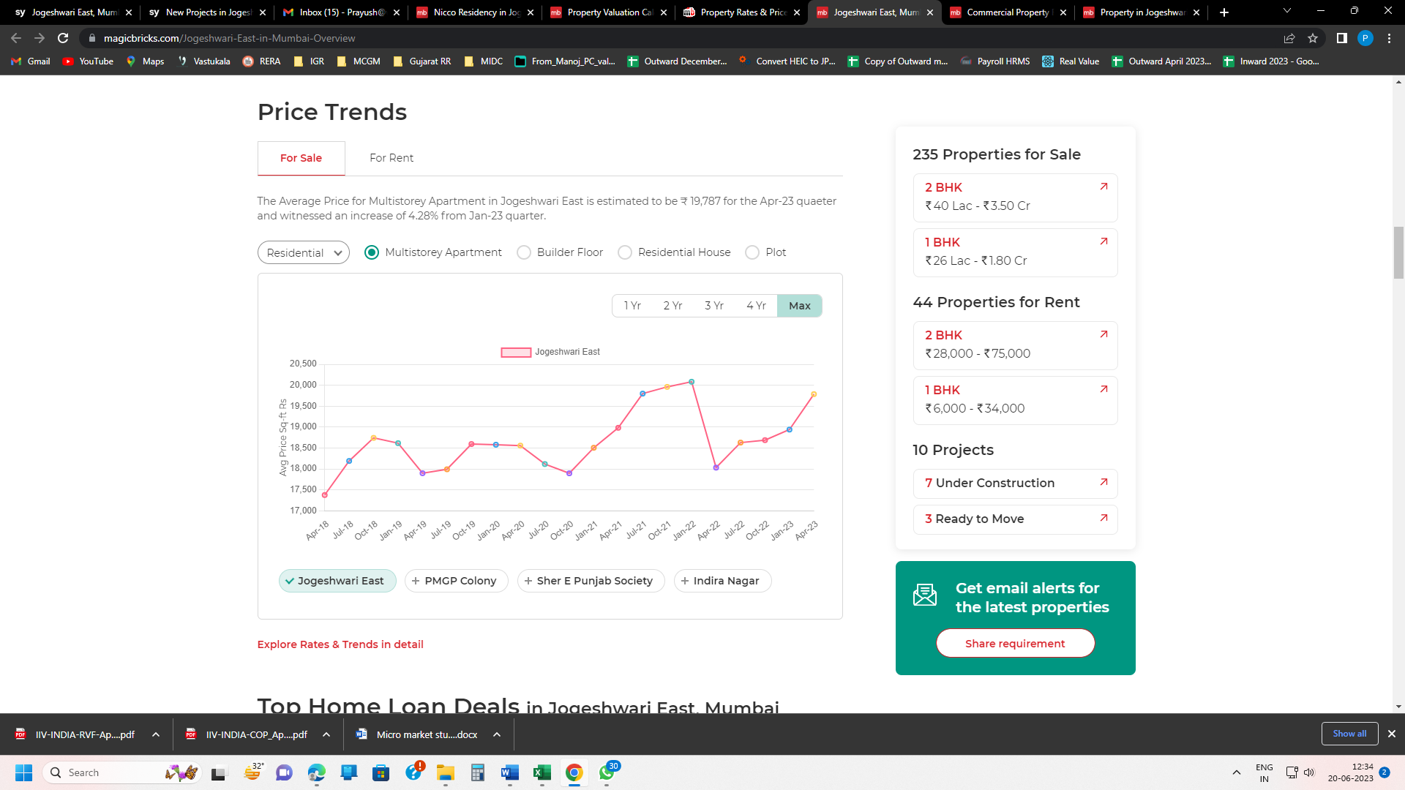

PRICE TRENDS IN JOGESHWARI (EAST) IN ONE YEAR
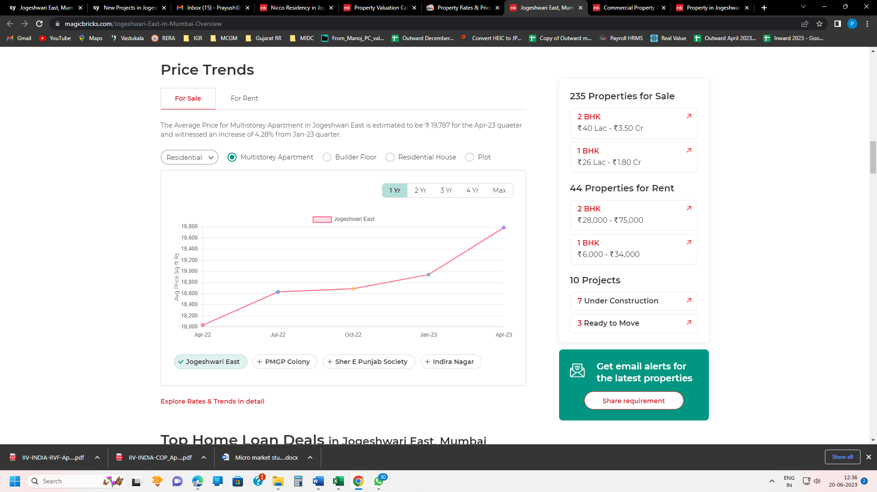

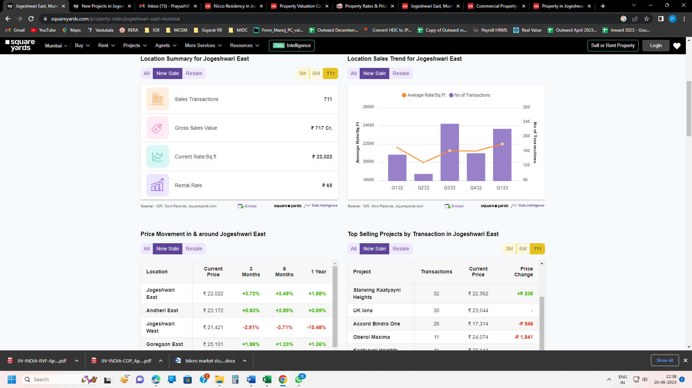

PRICE TRENDS IN JOGESHWARI (EAST) IN ONE YEAR

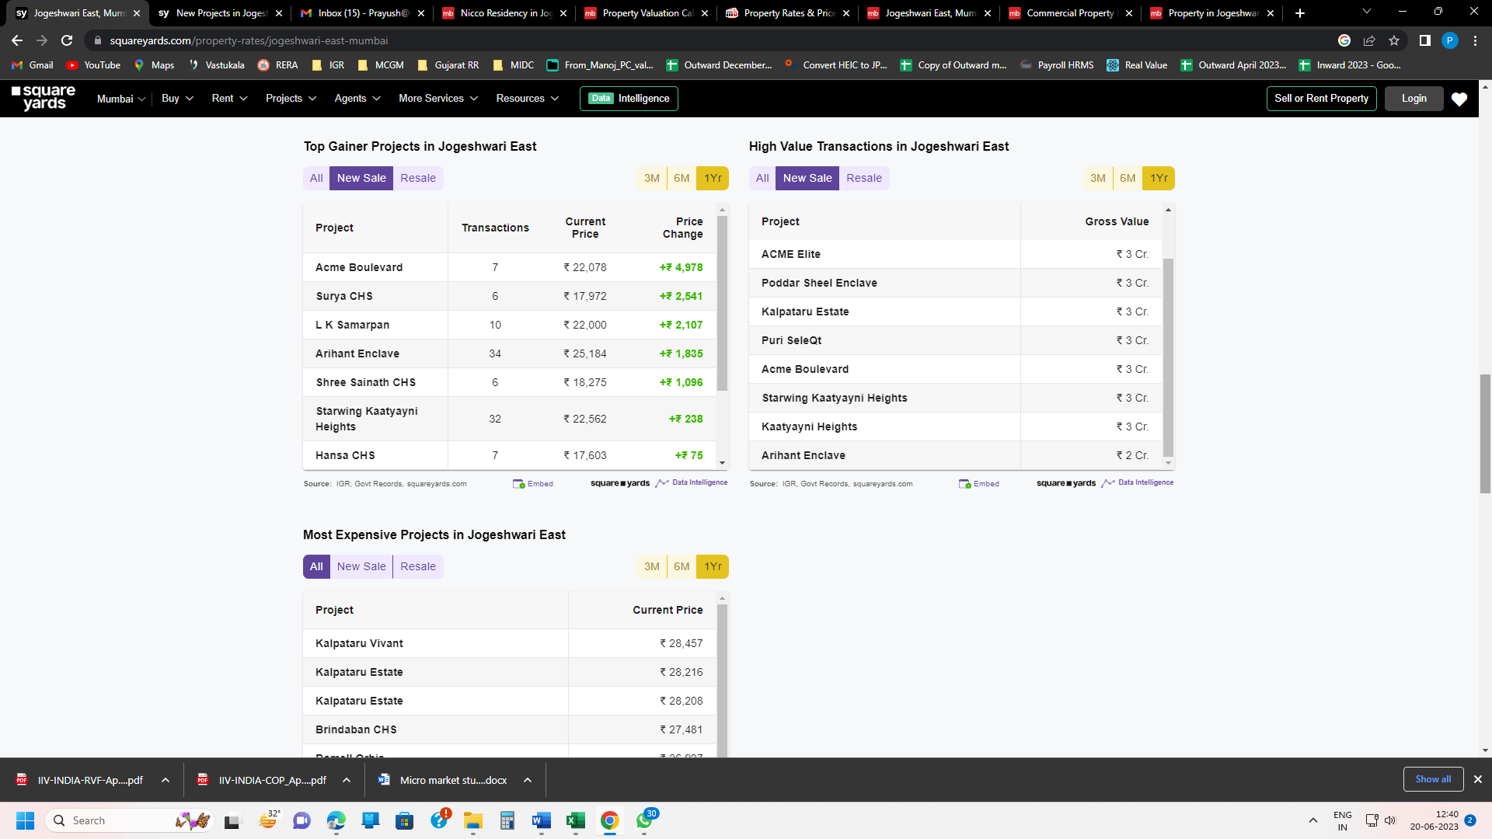
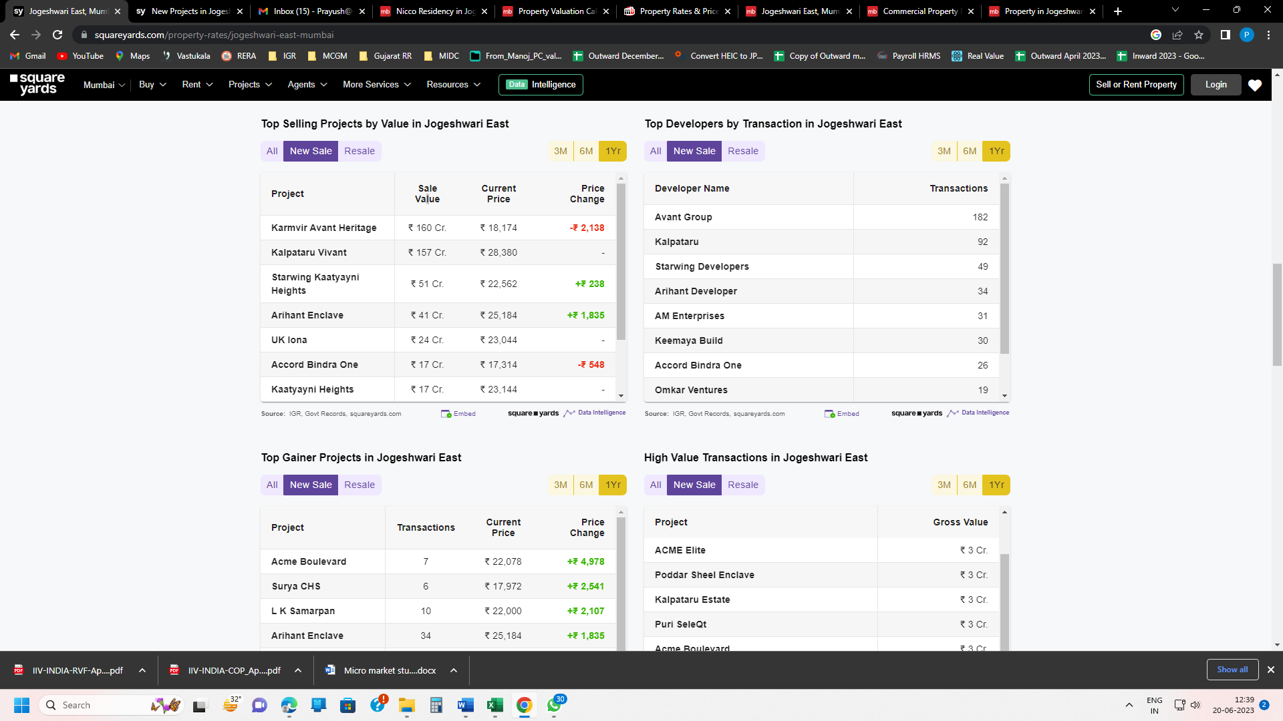
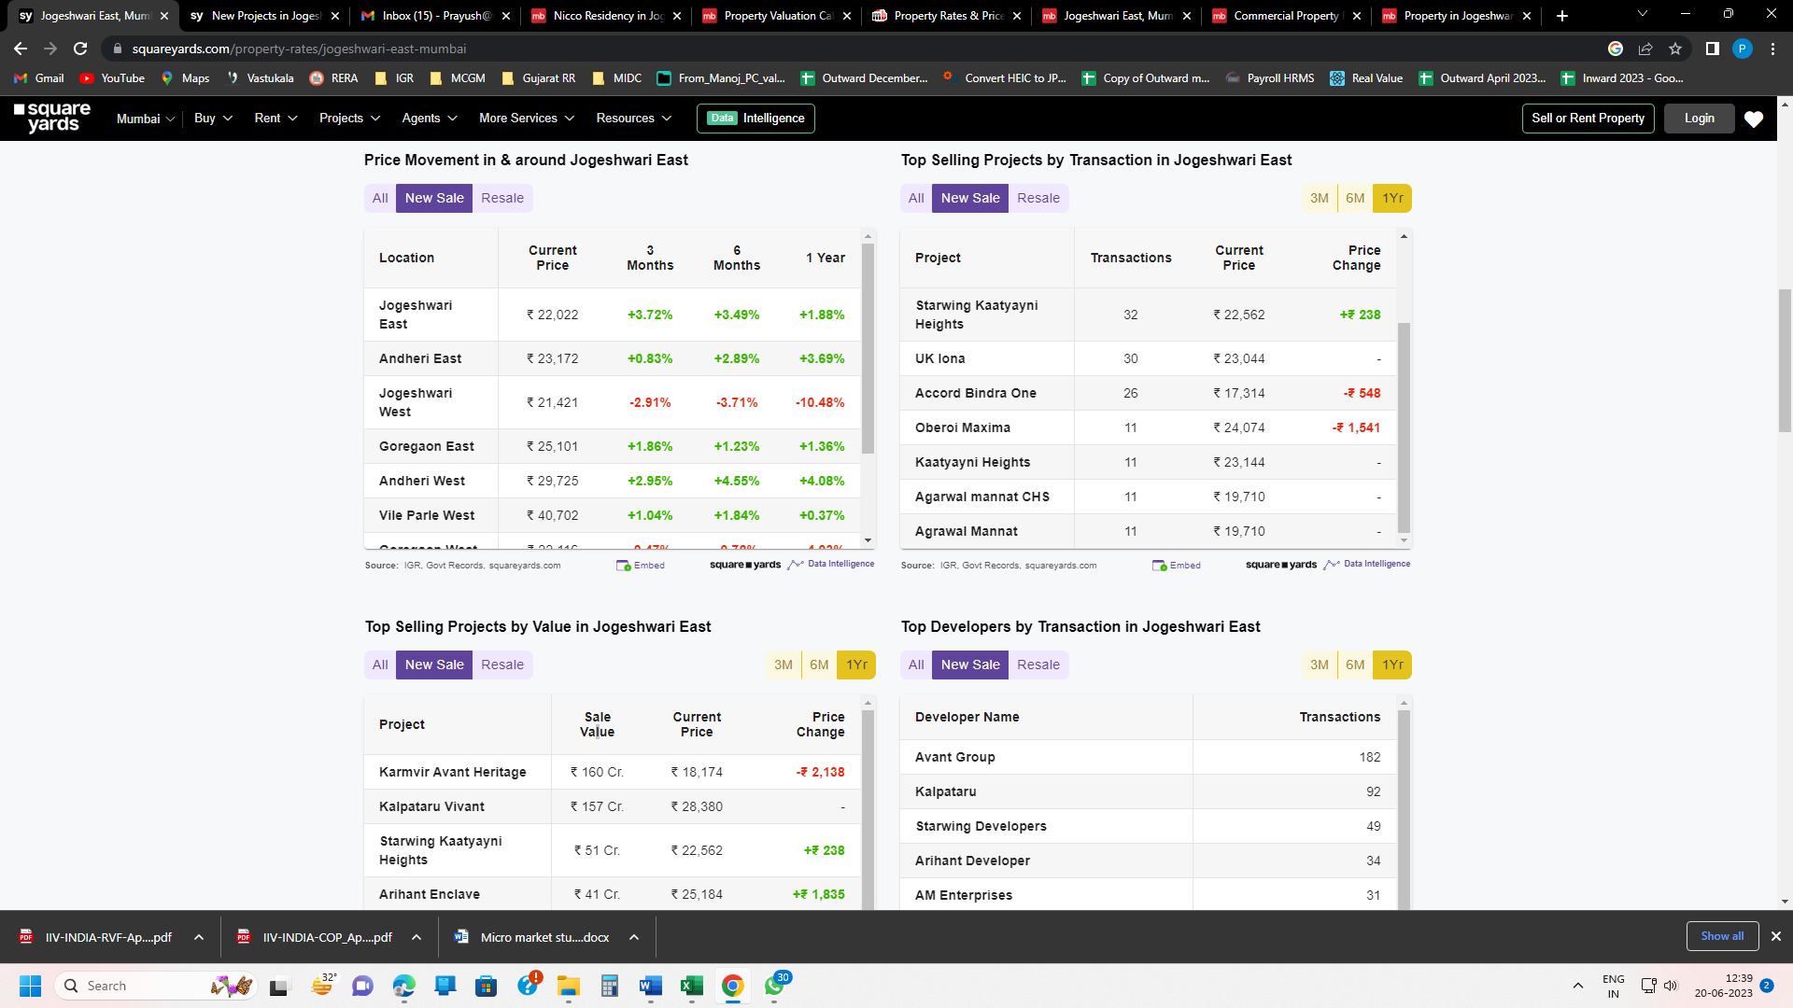

PRICE TRENDS IN JOGESHWARI (EAST) IN ONE YEAR
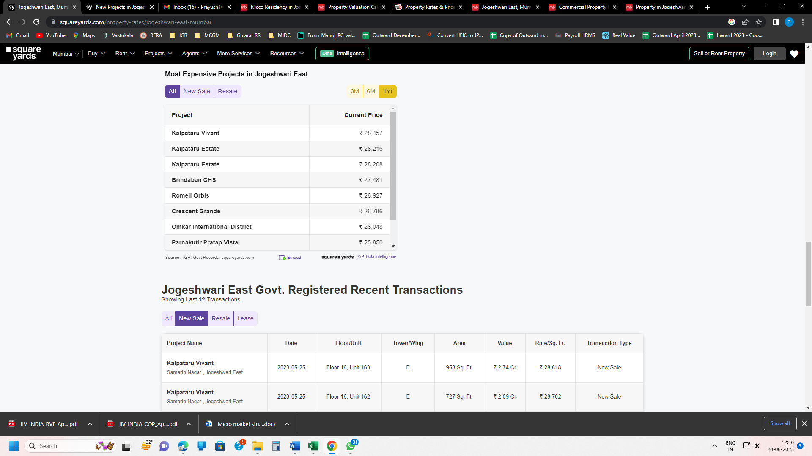
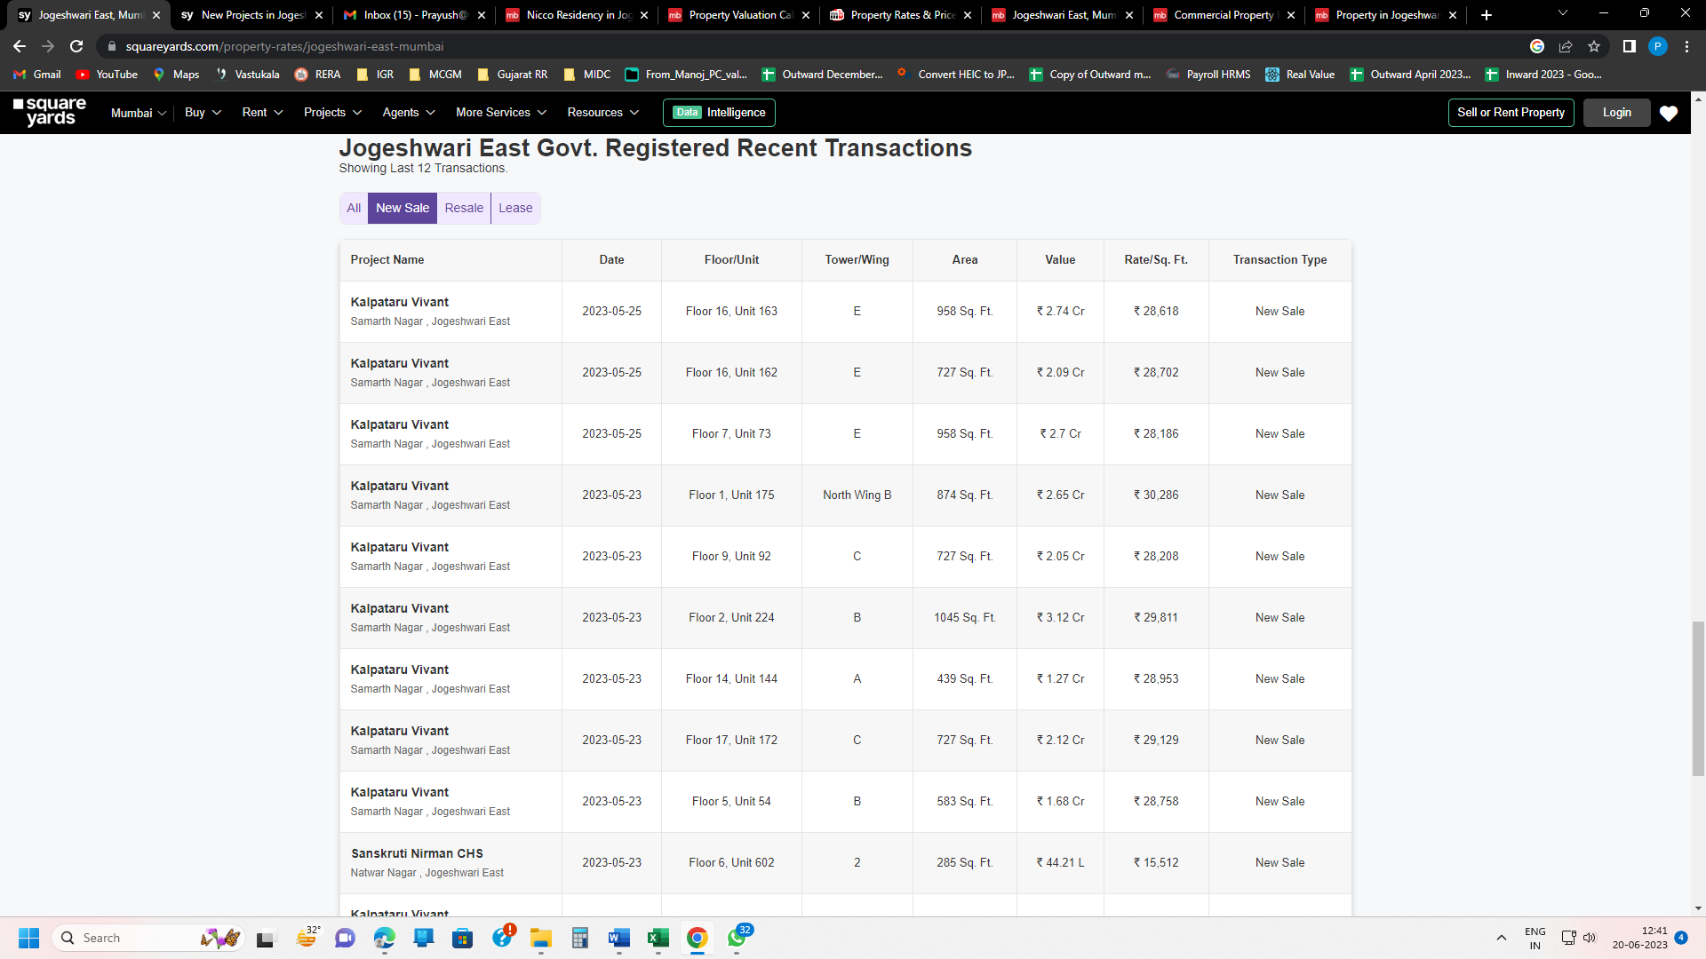

AVERAGE PRICE TRENDS IN JOGESHWARI (EAST) IN ONE YEAR

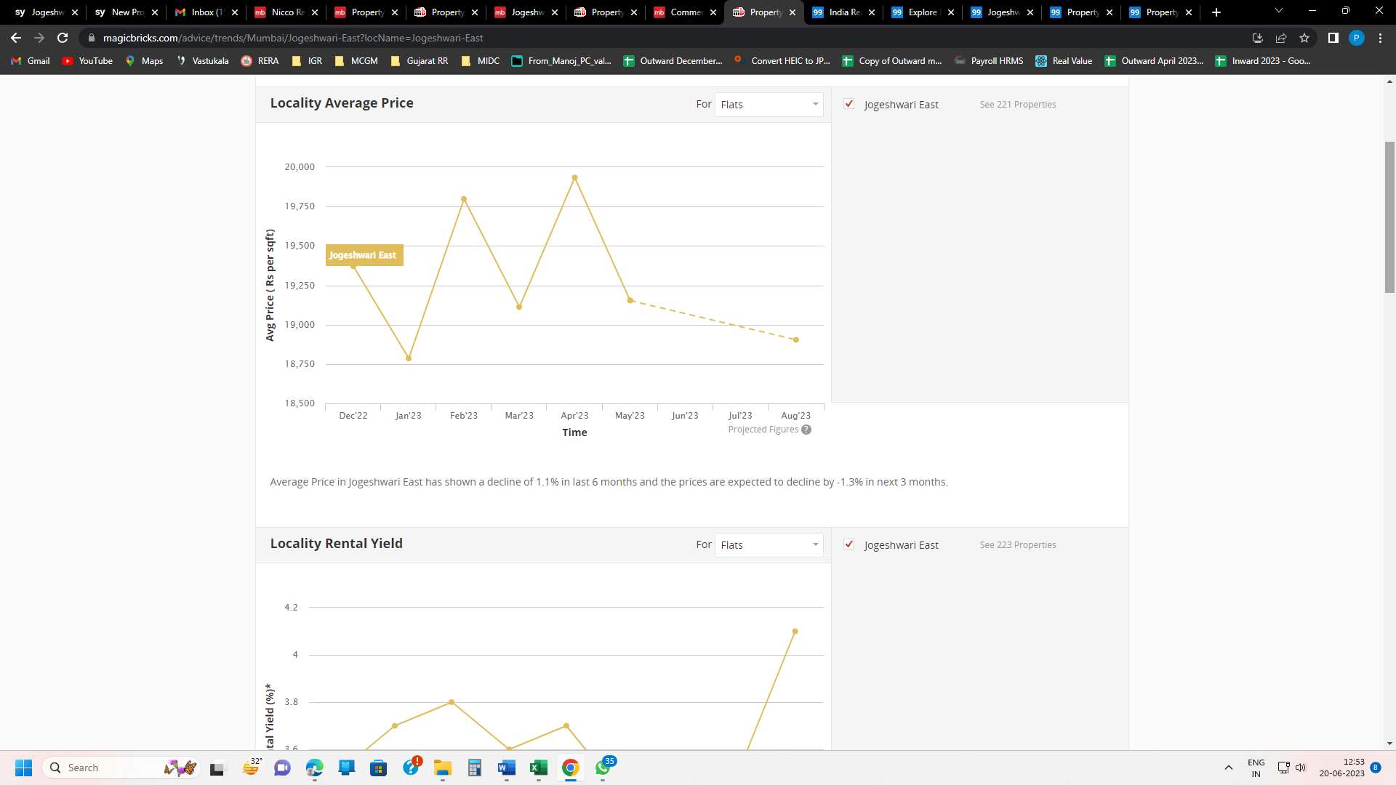

RENTAL YEILD IN JOGESHWARI (EAST) IN ONE YEAR
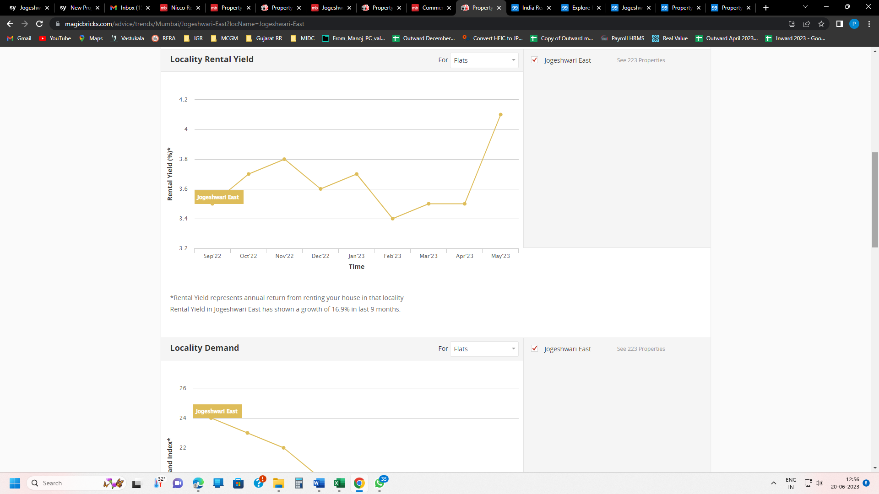

LOCALITY DEMAND IN JOGESHWARI (EAST) IN ONE YEAR

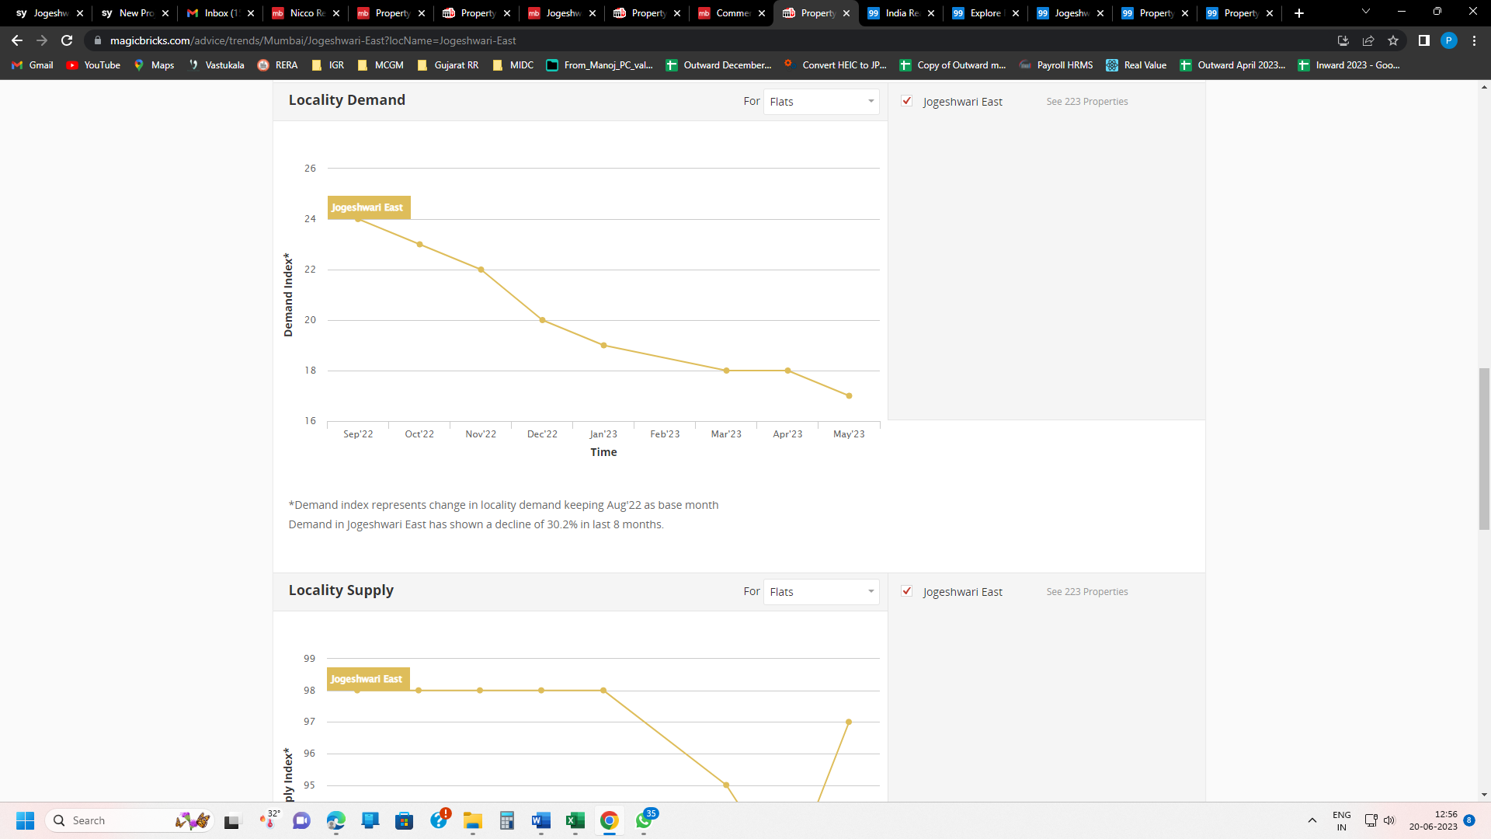

LOCALITY SUPPLY IN JOGESHWARI (EAST) IN ONE YEAR

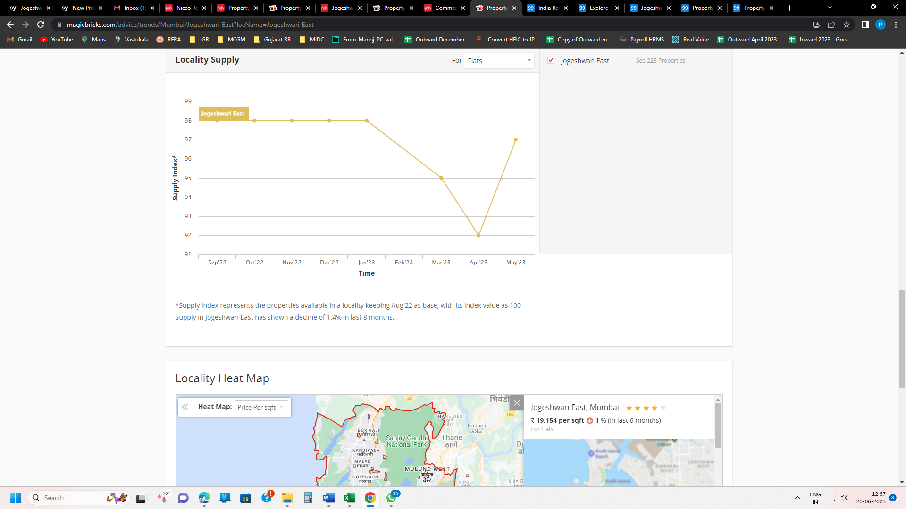

Supply of Residential Property | 1.4% Drop
Demand for Residential Property | 30.2% Drop
Rental Yield from Residential Property | 16.9% Increase
Average price may increase | 1.1 % Drop

Looking at overall inventory in the area, prices and demand, there is Neutral indication about prospective sale of the subject project.

Project Details

Shiv Shruti Developers LLP is developing S. R. Scheme Project in Jogeshwari (East) in the name of “Ashtavinayak Apartments”. It is a mixed-use project development which comprises of Residential and Retail. The project is being developed in single Phases. Project comprises of Rehab Building No. 1 & Sale Building No.1 & 2 having 2 Wings (A & B).

Ashtavinayak Apartments, consists of Commercial cum Residential building Rehab Building No. 1 & Sale Building No.1 & 2 having 2 Wings (A & B).in Jogeshwari (East), Mumbai is mixed used development by Shiv Shruti Developers LLP. The project offers Apartment with perfect combination of contemporary architecture and features to provide comfortable healthy living in post Covid era with best of the amenities to match the lifestyles.

Ashtavinayak Apartments, consists of Commercial cum Residential building Rehab Building No. 1, & Building No. 1 & 2 is Sale Building having 2 Wings (A, & B) totaling to 548 apartments, 10 commercial units for Tenant and 318 apartments for sale, 28 apartments for Land owner, 21 apartments for PAP and 171 apartments for Rehab. The Commencement certificate and MahaRERA registration is obtained for totaling about 548 apartments including commercial units. RERA registration number of Residential building is P51800049920.

About Residential Building R4 & R5
The project is a RERA registered project. RERA registration number of Commercial cum Residential building is P51800049920.
Details of the apartments are as below
Flat Inventory: -
Type | RERA Area | Total Units |  |  | Inventory as on 30th June’ 23
 | In Sq. Ft. | Wing A | Wing B | Wing C | Wing A | Wing B | Wing C
1BHK | 29.45 | 0 | 20 | 0 | 0 | 11 | 0
1BHK | 30.01 | 145 | 0 | 0 | 145 | 0 | 0
1BHK | 39.76 | 0 | 20 | 0 | 0 | 13 | 0
1BHK | 41.43 | 0 | 23 | 0 | 0 | 22 | 0
1BHK | 41.53 | 0 | 23 | 0 | 0 | 23 | 0
1BHK | 41.81 | 0 | 22 | 0 | 0 | 19 | 0
1BHK | 42.08 | 0 | 23 | 0 | 0 | 22 | 0
1BHK | 42.46 | 0 | 21 | 0 | 0 | 21 | 0
3BHK | 43.57 | 0 | 21 | 0 | 0 | 10 | 0
Total |  | 145 | 173 | 0 | 145 | 141 | 0

Amenities available for the convenience of residents are closed car parking areas, open area for fire protection system, Fire sprinklers, fire safety equipment, well-lit internal roads, regular supply of water, and other facilities are provided in the complex. All work related to solid waste management and disposal, treatment of sewage and sullage water, sewerage chamber, lines, septic tank, and STP are taken care with the best technology in the premises. Water conservation, energy management, and rainwater harvesting, recreational activities, landscaping and tree planting are under taken to make buildings sustainable, protect the environment & optimize the resources.

Location & Connectivity

Project Ashtavinayak Apartments Plot bearing CTS No. 68,69 & 72 (Old CTS nos. 68,68/1 TO 20,69,70,70/1 to 26,71, 71/ to 38,72,72/1 to 26,73,73/1 to 14,74, 74/1 to 17) of village Majas Andheri East at Jogeshwari (east) Mumbai-400060, State – Maharashtra, Country – India. The satellite location of the site is 19.13682902, 72.86163255770265 North and 72.86163255 East.
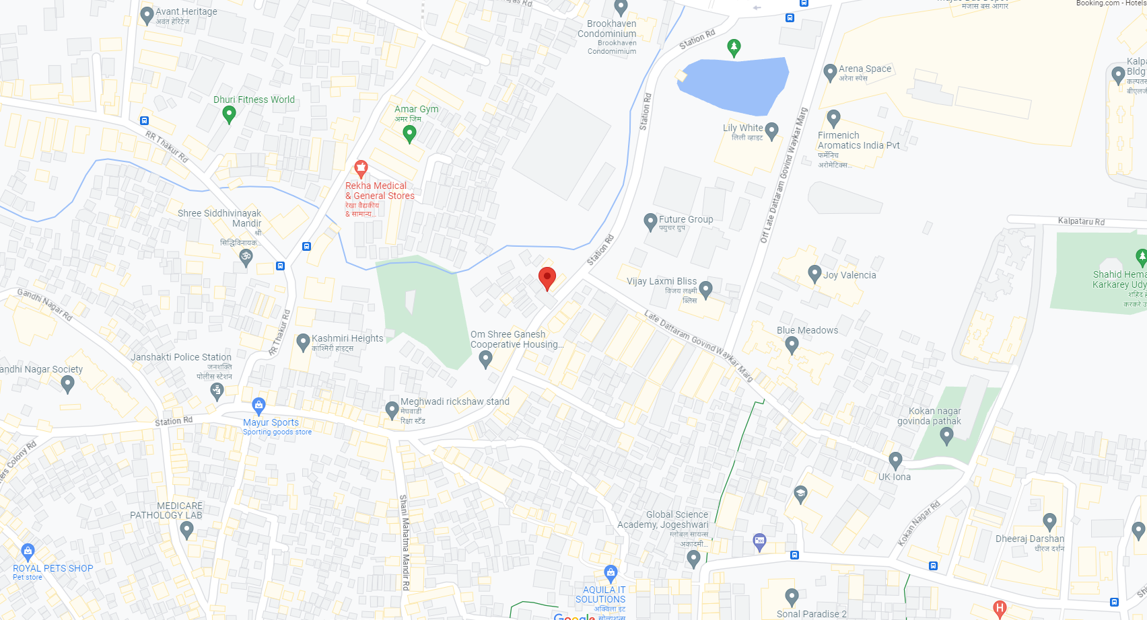

Location
The project is closely connected with railways and city roads. The Jogeshwari Railway Station is about 2.10 Km from the project site. The Chhatrapati Shivaji International Airport is located about 20 km from the said property. The said property is located in a mixed-use development area where there are residential and commercial establishments. The site is accessible by road. There are buses, taxis and richshaws available to reach the site.

Land Details

- The land is given Sale Agreement (registered agreement vide No. BDR-18-1136-2021 dated 22.01.2021) and agreement dated 29.12.2020 between M/s. Aishwarya Light Construction Company (The Vendor) and M/s. Shiv Shruti Developers LLP (The Purchasers).

- Rectification Deed (registered agreement vide No. BDR-18-8232-2021 dated 05.07.2021) and agreement dated 29.06.2021 between M/s. Aishwarya Light Construction Company (The Vendor) and M/s. Shiv Shruti Developers LLP (The Purchasers).

Project Configuration

Ashtavinayak Apartments
This Project is being constructed on Plot bearing CTS No C.T.S. No. 68, 68/1, to 20, 69, 70, 70/1 to 26, 71, 71/1 to 38, 72, 72/1 to 26, 73, 73/1 to 14, 74 & 74/1 to 17 of admeasuring net plot area of 3,217.80 Sq. M. of Village Majas III of Jogeshwari (East), Mumabi having built up area as Follows:
Particulars | Approved | Proposed | Free of FSI | Total Construction area
Rehab Building No. 1 | 6,202.55 | - | 8,222.18 | 14,424.73
Sale Building No. 2 (Wing A & B) | 11,643.19 | 2,381.22 | 13,393.44 | 27,417.85
Total | 20,226.96 | 2,381.22 | 21,615.62 | 41,842.58

Details for Rehab Building No. 1:
According to the information uploaded on the RERA website the Proposed Date of completion of this project is December 31, 2026. The RERA website further indicates that this building comprises of Ground Floor + 1st to 23rd Upper Residential Floor. Further, provision of Total 27 Stack Car Parking.
* Information culled out of from https://maharerait.mahaonline.gov.in/SearchList/Search
Details for Sale Building No. 2 (Wings A & B)
The Total cosntruction area admeasuring 27,417.85 sq. m.
According to the information uploaded on the RERA website the Proposed Date of completion of this project is December 31, 2026. The RERA website further indicates that this building comprises of Ground Floor + 1st to 23rd Upper floors of Super Structure. Further, provision of Total 78 Stack Car Parking. Considering the above the Configuration of Sale Building No. 2 is as follows:
Type | RERA Area | Total Units |  |  | Inventory as on 30th June’ 23
 | In Sq. Ft. | Wing A | Wing B | Wing C | Wing A | Wing B | Wing C
1BHK | 29.45 | 0 | 20 | 0 | 0 | 11 | 0
1BHK | 30.01 | 145 | 0 | 0 | 145 | 0 | 0
1BHK | 39.76 | 0 | 20 | 0 | 0 | 13 | 0
1BHK | 41.43 | 0 | 23 | 0 | 0 | 22 | 0
1BHK | 41.53 | 0 | 23 | 0 | 0 | 23 | 0
1BHK | 41.81 | 0 | 22 | 0 | 0 | 19 | 0
1BHK | 42.08 | 0 | 23 | 0 | 0 | 22 | 0
1BHK | 42.46 | 0 | 21 | 0 | 0 | 21 | 0
3BHK | 43.57 | 0 | 21 | 0 | 0 | 10 | 0
Total |  | 145 | 173 | 0 | 145 | 141 | 0

* Information culled out of from https://maharerait.mahaonline.gov.in/SearchList/Search

Project Area Statement as per Approved Building Plans

As per Approved Plan:
I | Area Statement |  |  |  | 33(10) | 30 (non-Slum) | Total Area in Sq. M.
1 | Gross area of plot |  |  |  | 3062.75 | 155.05 | 3217.8
a | Area of Road Set back / D.P Road
2 | Deductions for
(A) | For Reservation/ Road area
a | Road set-back area to be handed over (100%)
(B) | For Amenity area
a | Area of Amenity plot/plots to be handed over as per dcr 14(a)
b | Area of amenity plot/plots to be handed over as per dcr 14(b)
c | Area of amenity plot/plots to be handed over as per dcr 15
d | Area of amenity plot/plots to be handed over as per dcr 35
(C) | Deductions for existing built-up area to be retained if any
a | Land component of existing BUA as per regulation under which the development was allowed
3 | Total deductions: [2(A)+2(B) +2(C)]
4 | Balance area of plot (1 minus 3) |  |  |  | 3062.75 | 155.05 | 3217.8
4a | Addition For
A | For Reservation / Road Area
a | Road Set-Back Area to be Handed Over (100%)
 | Total
5 | Plot area under development (As per Sr. No. 4 above) |  |  |  | 3062.75 | 155.05 | 3217.8
6 | Zonal (basic) fsi (1 or 1.33) |  |  |  |  | 155.05 | 155.05
7 | Permissible built-up area as per zonal(basic) fsi (5*6) (in case of mill land permissible built-up area kept in abeyance)
8 | Built up area equal to area of land handed over as per 3(a) of regulation 30(a)
9 | Built up area in lieu of cost of construction of built-up amenity to be handed over
10 | Built up area due to "additional fsi on payment of premium" as per table no 12 of regulation no 30(a) subject to regulation no 30(a)3
11 | Built up area due to admissible "tdr" as per table no 12 of regulation no 30(a) subject to regulation no 30(a)3
12 | Permissible built-up area (7 + 8 + 9 + 10 + 11) |  |  |  |  | 155.05 | 155.05
13 | Proposed built up area
 | Bldgs. | Rehab Bua | Sale Comm. BUA | Sale Resi. BUA
 | Rehab Building No.1 | 6202.55 |  | 153.11
 | Sale Bldg. No. 2 | 534.72 | 22.57 | 11964.65
14 | Total Rehab BUA | 6737.27 |  |  | 6737.27 |  | 6737.27
15 | Total Rehab Component Area |  |  |  | 11134.29 |  | 11134.29
16 | Incentive Sale Area (15 x 1.10) |  |  |  | 12247.72 |  | 12966.28
16a | Sale Area Permissible in Non-slum |  |  |  |  | 155.05 | 155.05
17 | Total Area Permissible (14 + 16 + 16a) |  |  |  | 18984.99 | 155.05 | 19140.04
18 | Sanctioned FSI. |  |  |  | 6.2 | 1
19 | Total Sale BUA Permissible |  |  |  | 12247.72 | 155.05 | 12402.77
20 | Total Sale BUA Proposed |  | 22.57 | 12117.76 | 12140.33 |  | 12140.33
21 | Total Proposed BUA (Rehab + Sale) (14 + 20) |  |  |  | 18877.6 |  | 18877.6
22 | Fungible compensatory area as per regulation no 31(3)
a | i) Permissible Fungible Compensatory area for Rehab component without charging premium |  |  |  |  |  | 2358.04
 | ii) Fungible Compensatory area availed for Rehab component without charging premium |  |  |  |  |  | 325.64
b | i) Sale Commercial Area |  |  |  |  |  | 22.57
 | ii) Permissible Sale Commercial Fungible Compensatory area by charging premium
 | iii)Sale Commercial Fungible Compensatory area availed on payment of premium
c | i) Sale Residential Area |  |  |  |  |  | 12117.76
 | ii) Permissible Sale Residential Fungible Compensatory area by charging premium
 | iii) Sale Residential Fungible Compensatory area availed on payment of premium
23 | Total Sale Built up Area proposed including Fungible Compensatory Area [20 + 22(b)(iii) + 22(c)(iii)] |  |  |  |  |  | 12140.33
24 | FSI consumed on Net Plot [ 21/4] |  |  |  | 6.16
II | Other Requirements
A | Reservation/Designation
a | Name of Reservation
b | Area of Reservation affecting the plot
 | Area of Reservation land to be handed/ handed over as per Regulation No.17
 | Built up area of Amenity to be handed over as per Regulation No.17
 | Area/ Built up Area of Designation
 | Plot area/ Built up Amenity to be Handed Over as per Regulation No
 | i) 14(A)
 | ii) 14(B)
 | iii) 15
 | Requirement of Open Space in Layout/ Plot as per Regulation No. 27
 | Tenement Statement
 | (i) Proposed built up area (13 above) |  |  |  | Refer above statements
 | (ii) Less deduction of Non-residential area (Shop etc.)
 | (iii) Area available for tenements [(i) minus (ii).]
 | (iv) Tenements permissible (Density of tenements/hectare)
 | (v) Total number of Tenements proposed on the plot
 | Parking Statement
 | (i) Parking required by Regulations for.-
 | Scooter/Motor cycle
 | Outsider (Visitors)
 | (ii) Covered garage permissible
 | (iii) Covered garages proposed
 | Scooter/Motor cycle
 | Outsider (Visitors)
 | (iv) Total parking provided
 | Transport Vehicles Parking
 | (i)Spaces for transport vehicles parking required by Regulations
 | (ii) Total No. of transport vehicles parking spaces provided

Project Area Statement as per Concessions Building Plans
I | Area Statement |  |  |  | 33(10) | 30 (non-Slum) | Total Area in Sq. M.
1 | Gross area of plot |  |  |  | 3062.75 | 155.05 | 3217.8
a | Area of Road Set back / D.P Road
2 | Deductions for
(A) | For Reservation/ Road area
a | Road set-back area to be handed over (100%)
(B) | For Amenity area
a | Area of Amenity plot/plots to be handed over as per dcr 14(a)
b | Area of amenity plot/plots to be handed over as per dcr 14(b)
c | Area of amenity plot/plots to be handed over as per dcr 15
d | Area of amenity plot/plots to be handed over as per dcr 35
(C) | Deductions for existing built-up area to be retained if any
a | Land component of existing bua as per regulation under which the development was allowed
3 | Total deductions: [2(A)+2(B) +2(C)]
4 | Balance area of plot (1 minus 3) |  |  |  | 3062.75 | 155.05 | 3217.8
4a | Addition For
A | For Reservation / Road Area
a | Road Set-Back Area to be Handed Over (100%)
 | Total
5 | Plot area under development (As per Sr. No. 4 above) |  |  |  | 3062.75 | 155.05 | 3217.8
6 | Zonal (basic) fsi (1 or 1.33) |  |  |  |  | 155.05 | 155.05
7 | Permissible built-up area as per zonal(basic) fsi (5*6) (in case of mill land permissible built up area kept in abeyance)
8 | Built up area equal to area of land handed over as per 3(a) of regulation 30(a)
9 | Built up area in lieu of cost of construction of built-up amenity to be handed over
10 | Built up area due to "additional fsi on payment of premium" as per table no 12 of regulation no 30(a) subject to regulation no 30(a)3 |  |  |  |  | 77.52 | 77.52
11 | Built up area due to admissible "tdr" as per table no 12 of regulation no 30(a) subject to regulation no 30(a)3 |  |  |  |  | 139.54 | 139.54
12 | Permissible built up area (7 + 8 + 9 + 10 + 11) |  |  |  |  | 372.11 | 372.11
13 | Proposed built up area
 | Bldgs. | Rehab Bua | Sale Comm. BUA | Sale Resi. BUA
 | Rehab Building No.1 | 6202.55 |  | 153.11
 | Sale Bldg. No. 2 | 948.42 | 16.72 | 13168.56
14 | Total Rehab BUA | 7150.97 |  |  | 7150.97 |  | 7150.97
15 | Total Rehab Component Area |  |  |  | 11787.53 |  | 11787.53
16 | Incentive Sale Area (15 x 1.10) |  |  |  | 12966.28 |  | 12966.28
16a | Sale Area Permissible in Non-slum |  |  |  |  | 372.11 | 372.11
17 | Total Area Permissible (14 + 16 + 16a) |  |  |  | 20117.25 | 372.11 | 20489.36
18 | Sanctioned FSI. |  |  |  | 6.57 | 2.4
19 | Total Sale BUA Proposed |  | 16.72 | 13321.67 | 12966.28 | 372.11 | 13338.39
20 | Total Proposed BUA (Rehab + Sale)  (14 + 19) |  |  |  | 20117.25 | 372.11 | 20489.36
21 | Fungible compensatory area as per regulation no 31(3)
22 | i) Permissible Fungible Compensatory area for Rehab component without charging premium |  |  |  |  |  | 2502.84
a | ii) Fungible Compensatory area availed for Rehab component without charging premium |  |  |  |  |  | 343.76
 | i) Sale Commercial Area |  |  |  |  |  | 16.72
b | ii) Permissible Sale Commercial Fungible Compensatory area by charging premium |  |  |  |  |  | 5.85
 | iii)Sale Commercial Fungible Compensatory area availed on payment of premium |  |  |  |  |  | 5.85
 | i) Sale Residential Area |  |  |  |  |  | 13321.67
c | ii) Permissible Sale Residential Fungible Compensatory area by charging premium |  |  |  |  |  | 4662.58
 | iii) Sale Residential Fungible Compensatory area availed on payment of premium |  |  |  |  |  | 2830.49
 | Total Sale Built up Area proposed including Fungible Compensatory Area [20 + 21(b)(iii) + 21(c)(iii)] |  |  |  |  |  | 16174.73
23 | FSI consumed on Net Plot [ 20/4 ] |  |  |  | 6.57 | 2.4
24 | Other Requirements
II | Reservation/Designation
A | Name of Reservation
a | Area of Reservation affecting the plot
b | Area of Reservation land to be handed/ handed over as per Regulation No.17
 | Built up area of Amenity to be handed over as per Regulation No.17
 | Area/ Built up Area of Designation
 | Plot area/ Built up Amenity to be Handed Over as per Regulation No
 | i) 14(A)
 | ii) 14(B)
 | iii) 15
 | Requirement of Open Space in Layout/ Plot as per Regulation No. 27
 | Tenement Statement
 | (i) Proposed built up area (13 above) |  |  |  | Refer above statements
 | (ii) Less deduction of Non-residential area (Shop etc.)
 | (iii) Area available for tenements [(i) minus (ii).]
 | (iv) Tenements permissible (Density of tenements/hectare)
 | (v) Total number of Tenements proposed on the plot
 | Parking Statement
 | (i) Parking required by Regulations for.- |  |  |  | Refer above statements
 | Scooter/Motor cycle
 | Outsider (Visitors)
 | (ii) Covered garage permissible
 | (iii) Covered garages proposed
 | Scooter/Motor cycle
 | Outsider (Visitors)
 | (iv) Total parking provided
 | Transport Vehicles Parking
 | (i)Spaces for transport vehicles parking required by Regulations
 | (ii) Total No. of transport vehicles parking spaces provided

Project Cost

The total project cost estimated by SSDL works out to INR 148.49 Crore. The detailed acquisition cost is as tabulated below:
INR in Crore
Particulars | Total Project Cost | Cost incurred till 30/06/2023 | Balance Cost to be Incurred | %tage of Total
Land & Stamp Duty | 0.44 | 0.44 | 0 | 0.30%
Construction Cost | 105.00 | 31.54 | 73.45 | 70.70%
Approval Cost (FSI charges) + DC + Stair case + PT + (BMC Premium) | 13.00 | 3.80 | 9.20 | 8.76%
Architect & Consultancy Expenses | 2.00 | 1.07 | 0.93 | 1.35%
Admin & Marketing Expenses | 11.50 | 2.16 | 9.34 | 7.75%
Contingency | 1.47 | 0 | 1.47 | 0.99%
Rent Cost | 9.45 | 6.27 | 3.18 | 6.36%
Interest to Bank Finance upto construction period | 5.63 | 0 | 5.63 | 3.79%
Total | 148.49 | 45.28 | 103.20 | 100.00%
- The land cost works out to 0.30% of the total project cost incurred till June 30, 2023. This cost generally ranges from 20% to 30% for comparable projects. The total land cost on the consolidated level for the said project shall work out to about 0.30%.
- The approval cost incurred in the project till June 30, 2023 works out to about 2.56%. This cost generally ranges from 10% to 15% for comparable projects. The total approval cost on the consolidated level for the said project shall work out to about 8.76%.
- The total construction cost works out to about 70.71% of the total project cost. This cost generally ranges from 50% to 70% for comparable projects.
- The admin, marketing cost incurred in the project till June 30, 2023 works out to about 1.45%. This cost generally ranges from 5% to 10% for comparable projects. The total admin, marketing cost on the consolidated level for the said project shall work out to about 7.75%.
- The interest during construction (IDC) incurred in the project works out to about 11.75%. This cost generally ranges from 10% to 20% for comparable projects.
- Total cost incurred till June 30, 2023 is INR 45.28 Crore and balance cost to complete work out to INR 103.20 Crore
- Considering all the cost we feel that the project cost seems reasonable.

Means of Finance

The means of finance proposed for the said project cost shall be as tabulated below:
INR In Crore
Particulars | Total Funds to be Raised | %tage of Total
Promoters Contribution
Promoters Contribution | 35.75 | 24.10%
Bank Loan
Term Loan | 30.00 | 20.20%
Customer Advances | 82.74 | 55.70%
Total | 148.49 | 100.0%

The means of finance proposed to fund the balance cost of construction for the project seems justified.

Project Approvals and their Status

Approval/ Consent | Approving Authority | Status
LOI Notification | SRA | Obtained
Pre-Construction / Plan Approval | SRA | Obtained
NOC (Road, Fire, Drainage, Water, Garden,  Health,) | SRA | Obtained
Sanction for construction electrical load | MCGM | Obtained
Sanction for water supply requirement | MCGM | Obtained
Environmental Clearance | SEIAA | Obtained
Pollution Consent | SEIAA | Obtained
NOC on building height and civil aviation  Clearance | Airport Authority of  India | Obtained

Utilities for the Project
According to the Environmental Clearance Certificate dated September 13, 2022 the Project shall have the following utilities
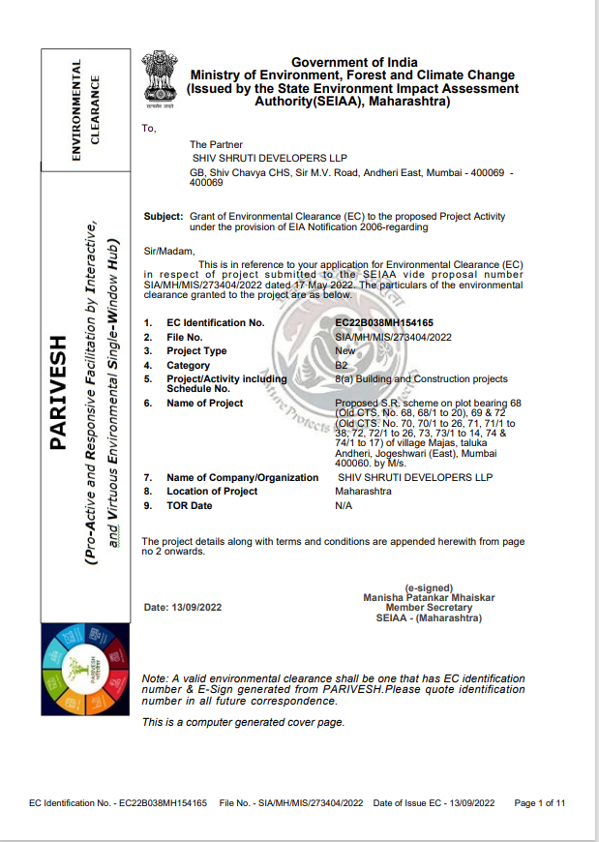

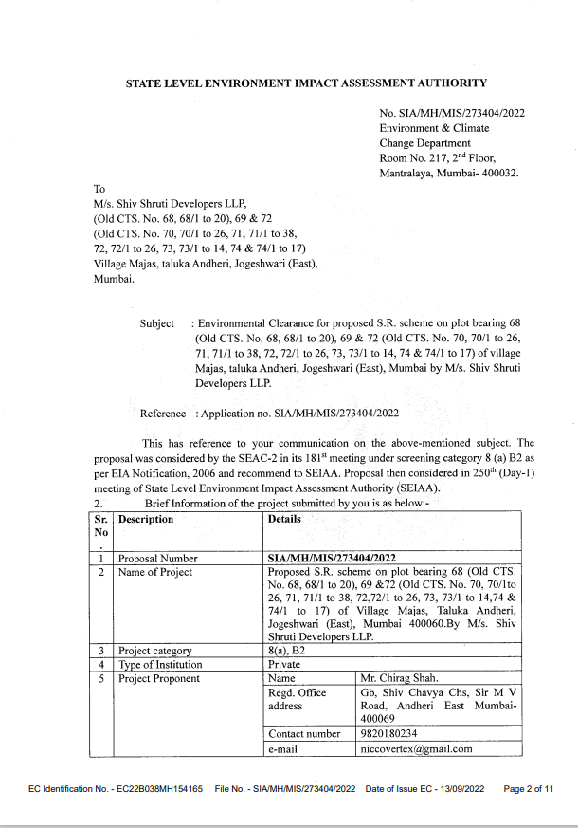
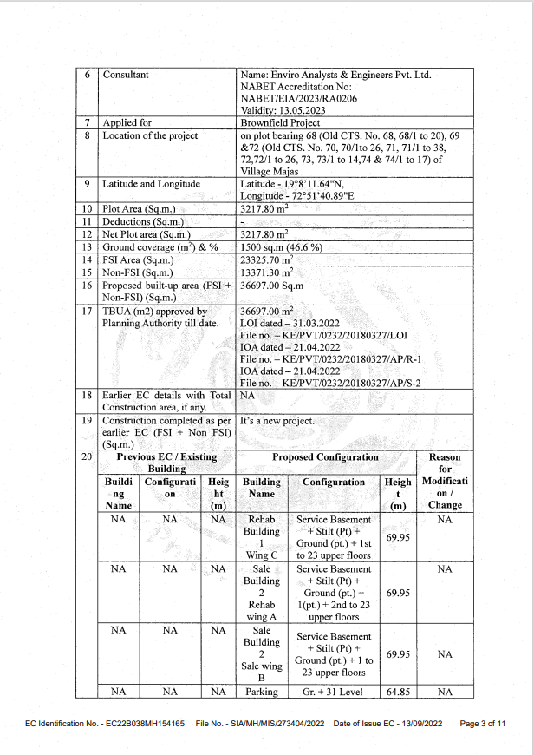
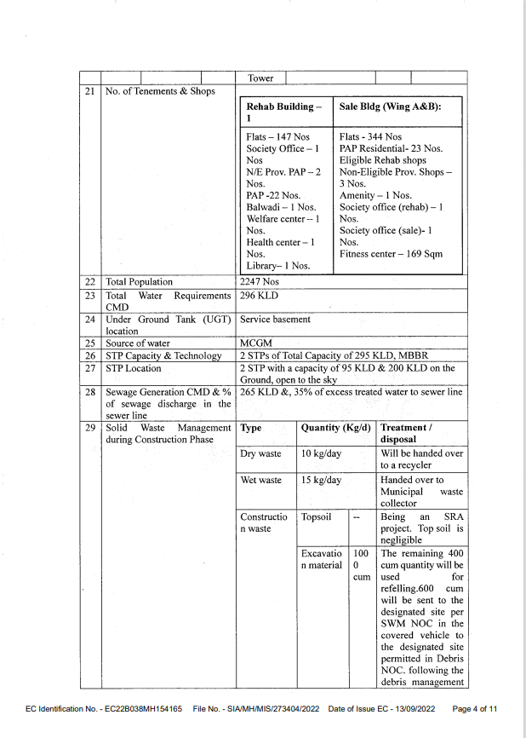
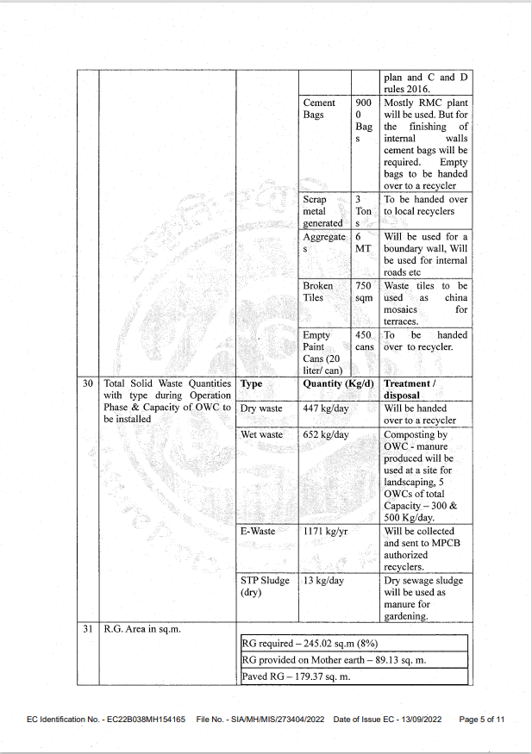
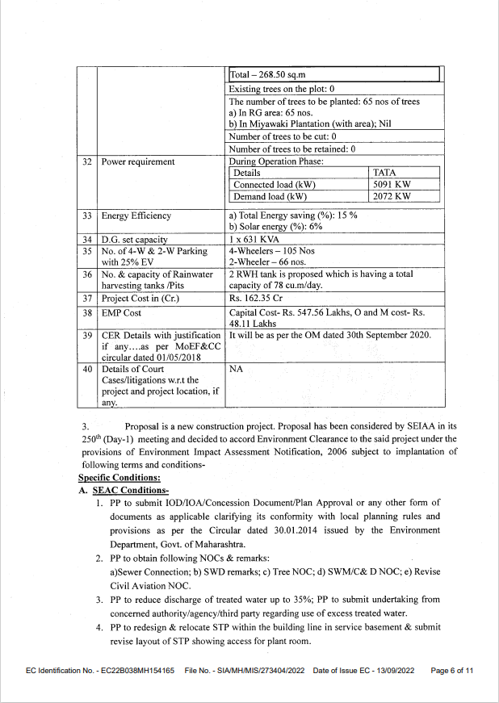
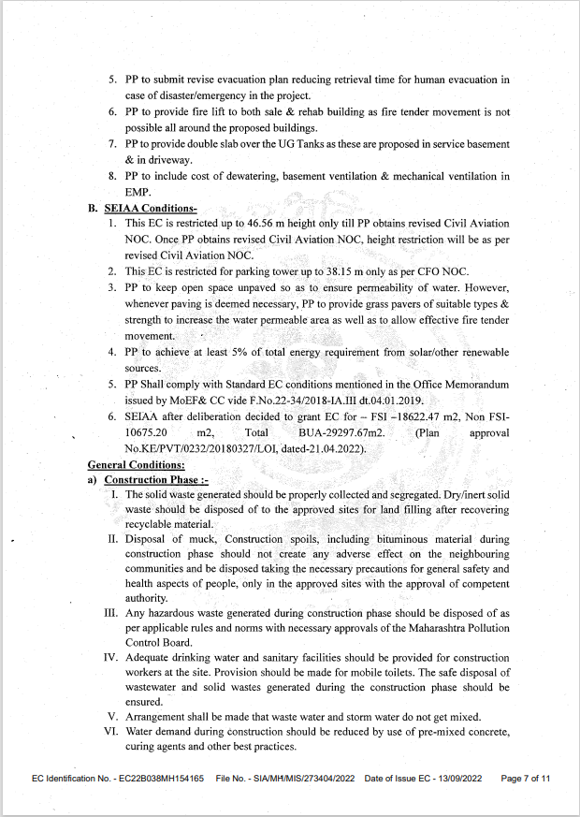
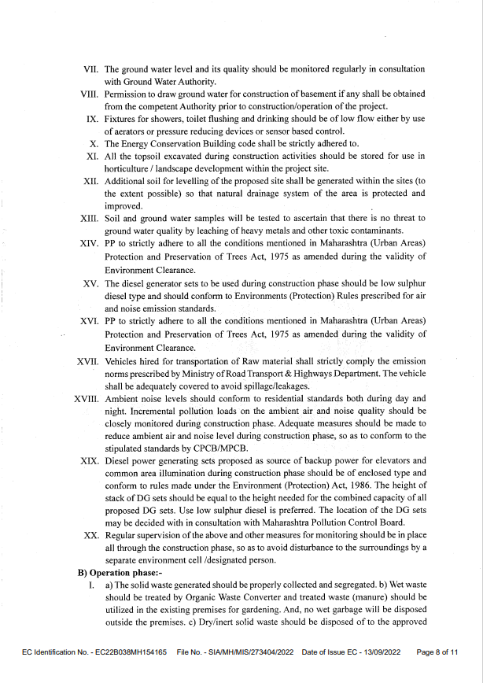
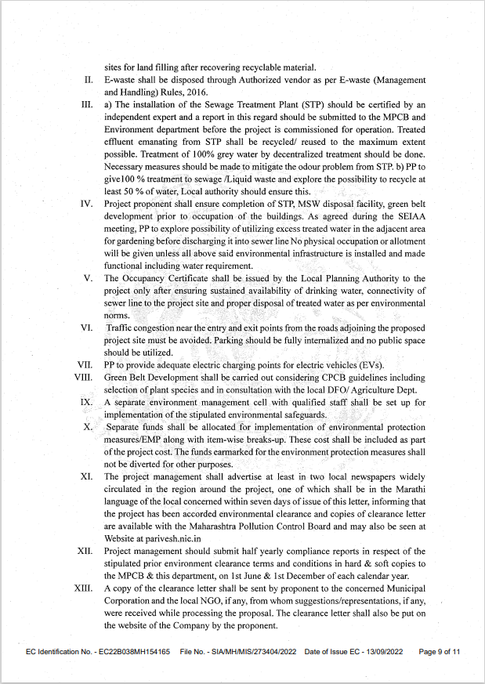
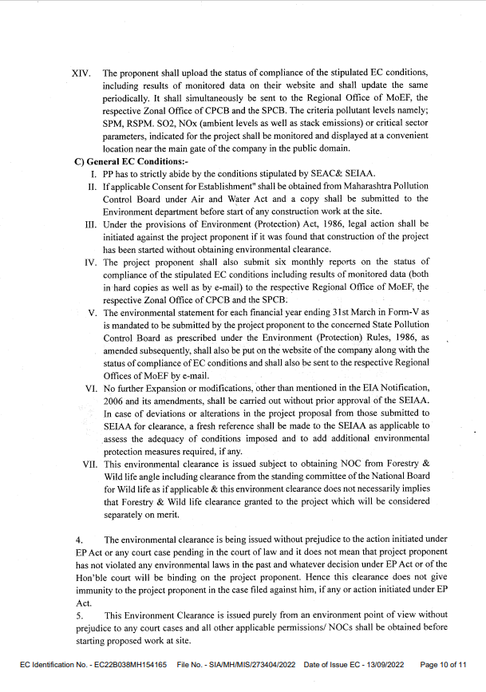
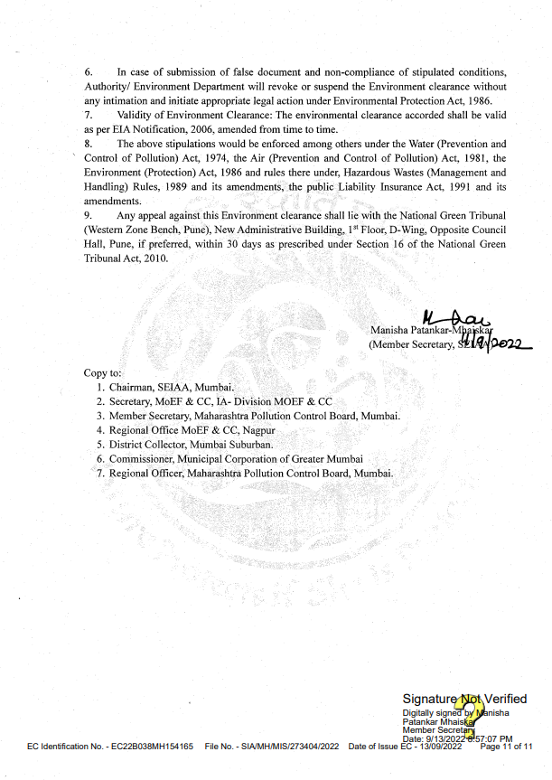

Current Status of the Project
- To have actual feel of the project we have visited the site on 18.08.2023 following person were present
Sr. | Name |  | Contact No
1 | Mona Mehta | Representative  Shiv Shruti Developers LLP | +91 - 7977952834
2 | Prayush Parekh | Senior Valuation Engineer  Vastukala Consultants (I) Pvt. Ltd. | +91 - 9767983840
3 | Bhavika Chavan | Valuation Engineer  Vastukala Consultants (I) Pvt. Ltd. | +91 - 8779527539
- The RCC slab work for Sale Building No. 2 both wing A & B was in Progress.
- Rehab Building No. 1 RCC work is going.

Implementation Schedule
Sale Building -Detailed Implementation schedule A wing
Sr. No. | Particulars | Start Date | End Date
1 | Land Acquisition | Dec-20 | Jun-21
2 | Plan Approval | Apr-22 | Apr-22
3 | Excavation, plinth to 11th slab | 01/04/2022 | 10/08/2023
4 | 12th slab | 11/08/2023 | 29/08/2023
5 | 13th slab | 30/08/2023 | 14/09/2023
6 | 14th slab | 15/09/2023 | 30/09/2023
7 | 15th slab | 01/10/2023 | 16/10/2023
8 | 16th slab | 17/10/2023 | 01/11/2023
9 | 17th slab | 02/11/2023 | 17/11/2023
10 | 18th Slab | 18/11/2023 | 03/12/2023
11 | 19th slab | 04/12/2023 | 19/12/2023
12 | 20th slab | 20/12/2023 | 04/01/2024
13 | 21St slab | 05/01/2024 | 20/01/2024
14 | 22nd slab | 21/01/2024 | 05/02/2024
15 | 23rd slab | 06/02/2024 | 21/02/2024
16 | Brick Work | 01/04/2023 | 31/03/2024
17 | Flooring, Door & Window, electrical work | 01/07/2023 | 30/06/2024
18 | Plastering Internal/ External | 01/12/2023 | 30/11/2024
19 | Satir case lift wells flooring | 01/01/2024 | 31/12/2024
20 | external plumbing | 01/01/2024 | 31/12/2024
21 | completion of terrace | 01/10/2024 | 29/01/2025
22 | Painting Internal/ External | 01/08/2024 | 28/01/2025
23 | Finishing & Completion | Mar, -2025 | Mar, -2025

Sale Building -Detailed Implementation schedule B wing
Sr. No. | Particulars | Start Date | End Date
1 | Land Acquisition | Dec-20 | Jun-21
2 | Plan Approval | Apr-22 | Apr-22
3 | Excavation, plinth to 11th slab | 01/08/2022 | 10/08/2023
4 | 8th slab | 11/08/2023 | 27/08/2023
5 | 9th slab | 28/08/2023 | 13/09/2023
6 | 10th slab | 14/09/2023 | 30/09/2023
7 | 11th slab | 01/10/2023 | 17/10/2023
8 | 12th slab | 18/10/2023 | 03/11/2023
9 | 13th slab | 04/11/2023 | 20/11/2023
10 | 14th slab | 21/11/2023 | 07/12/2023
11 | 15th slab | 08/12/2023 | 24/12/2023
12 | 16th slab | 25/12/2023 | 10/01/2024
13 | 17th slab | 11/01/2024 | 27/01/2024
14 | 18th Slab | 28/01/2024 | 13/02/2024
15 | 19th slab | 14/02/2024 | 01/03/2024
16 | 20th slab | 02/03/2024 | 18/03/2024
17 | 21St slab | 19/03/2024 | 04/04/2024
18 | 22nd slab | 05/04/2024 | 21/04/2024
19 | 23rd slab | 22/04/2024 | 08/05/2024
20 | Brick Work | 01/04/2023 | 31/03/2024
21 | Flooring, Door & Window, electrical work | 01/07/2023 | 30/06/2024
22 | Plastering Internal/ External | 01/12/2023 | 30/11/2024
23 | Satir case lift wells flooring | 01/01/2024 | 31/12/2024
24 | external plumbing | 01/01/2024 | 31/12/2024
25 | completion of terrace | 01/10/2024 | 29/01/2025
26 | Painting Internal/ External | 01/08/2024 | 28/01/2025
27 | Finishing & Completion | Mar, -2025 | Mar, -2025

Rehab Building -Detailed Implementation schedule C wing
Sr. No. | Particulars | Start Date | End Date
1 | Land Acquisition | Dec-20 | Jun-21
2 | Plan Approval | April, -22 | April,-22
3 | Excavation, plinth to 14th slab | 01/04/2022 | 10/08/2023
4 | 15th slab | 11/08/2023 | 26/08/2023
5 | 16th slab | 27/08/2023 | 11/09/2023
6 | 17th slab | 12/09/2023 | 27/09/2023
7 | 18th Slab | 28/09/2023 | 13/10/2023
8 | 19th slab | 14/10/2023 | 29/10/2023
9 | 20th slab | 30/10/2023 | 14/11/2023
10 | 21St slab | 15/11/2023 | 30/11/2023
11 | 22nd slab | 01/12/2023 | 16/12/2023
12 | 23rd slab | 17/12/2023 | 01/01/2024
13 | Brick Work | 01/04/2023 | 31/03/2024
14 | Flooring, Door & Window, electrical work | 01/07/2023 | 30/06/2024
15 | Plastering Internal/ External | 01/12/2023 | 27/08/2024
16 | Satir case lift wells flooring | 01/03/2024 | 28/08/2024
17 | external plumbing | 01/02/2024 | 29/08/2024
18 | completion of terrace | 01/07/2024 | 29/10/2024
19 | Painting Internal/ External | 01/05/2024 | 28/10/2024
20 | Finishing & Completion | Dec, -2024 | Dec, -2024

The implementation schedule is stretched over 20 months starting from July, 2023. The bottleneck of all tasks is Building Construction and Statutory approvals but enough contingency time has been allocated for each activity so that if there is any time overrun it can be taken care off. The time line allocated for each activity/ task is found to be adequate. We believe that this time frame is reasonable for completion of the project and the proposed completion date of December, 2024 for Rehab Building and March, 2025 for Residential project sale building and as per RERA completion date is December, 2026 is realistic provided the company adheres to the timelines projected in this TEV Report.

Economic Viability

Construction Area

The total construction area of the project are as follows: -
Rehab Building No. 1 (Wing C):
Sr. No. | Floor | Net Built Up Area in Sq. M. | Free FSI / Premium FSI Area in Sq. M. |  |  |  |  | Total Construction Area in Sq. M.
 |  |  | Staircase / Lift / Lobby Area | Refuge Area | Stilt Area | Duct Area | Amenities Area
1 | Ground | 1.49 | 273.85 | - | 279.71 | 30.00 | 42.87 | 627.92
2 | 1st | 110.13 | 226.68 | - | 261.11 | 30.00 | - | 627.92
3 | 2nd | 146.99 | 313.87 | - | - | 30.00 | 137.06 | 627.92
4 | 3rd | 289.99 | 264.56 | - | - | 30.00 | - | 584.55
5 | 4th | 289.99 | 264.56 | - | - | 30.00 | - | 584.55
6 | 5th | 289.99 | 264.56 | - | - | 30.00 | - | 584.55
7 | 6th | 289.99 | 264.56 | - | - | 30.00 | - | 584.55
8 | 7th | 289.99 | 264.56 | - | - | 30.00 | - | 584.55
9 | 8th | 217.22 | 243.61 | 93.83 | - | 30.00 | - | 584.66
10 | 9th | 289.99 | 264.56 | - | - | 30.00 | - | 584.55
11 | 10th | 289.99 | 264.56 | - | - | 30.00 | - | 584.55
12 | 11th | 289.99 | 264.56 | - | - | 30.00 | - | 584.55
13 | 12th | 289.99 | 264.56 | - | - | 30.00 | - | 584.55
14 | 13th | 289.99 | 264.56 | - | - | 30.00 | - | 584.55
15 | 14th | 289.99 | 264.56 | - | - | 30.00 | - | 584.55
16 | 15th | 216.91 | 228.47 | 109.92 | - | 30.00 | - | 585.30
17 | 16th | 289.99 | 264.56 | - | - | 30.00 | - | 584.55
18 | 17th | 289.99 | 264.56 | - | - | 30.00 | - | 584.55
19 | 18th | 289.99 | 264.56 | - | - | 30.00 | - | 584.55
20 | 19th | 289.99 | 264.56 | - | - | 30.00 | - | 584.55
21 | 20th | 289.99 | 264.56 | - | - | 30.00 | - | 584.55
22 | 21st | 289.99 | 264.56 | - | - | 30.00 | - | 584.55
23 | 22nd | 289.99 | 264.56 | - | - | 30.00 | - | 584.55
24 | 23rd | 289.99 | 264.56 | - | - | 30.00 | - | 584.55
25 | OHT / LMR | - | 264.56 | - | - | - | - | 264.56
Total Area in Sq. M. |  | 6,202.55 | 6,577.68 | 203.75 | 540.82 | 720.00 | 179.93 | 14,424.73
STACK PARKING Nos. |  |  |  |  |  |  |  | 27.00

Sale Building No. 2 (Wing A & B):
Sr. No. | Floor | Net Built Up Area in Sq. M. | Free FSI / Premium FSI Area in Sq. M. |  |  |  |  | Total Construction Area in Sq. M.
 |  |  | Staircase / Lift / Lobby Area | Refuge Area | Stilt Area | Duct Area | Amenities Area
1 | Ground | 148.68 | 273.85 | - | 650.42 | 65.65 | - | 1,138.60
2 | 1st | 357.82 | 259.40 | - | 347.28 | 65.65 | 108.45 | 1,138.60
3 | 2nd | 358.14 | 302.44 | - | 83.81 | 65.65 | 328.56 | 1,138.60
4 | 3rd | 679.13 | 302.44 | - | 83.81 | 65.65 | - | 1,131.03
5 | 4th | 675.02 | 302.44 | - | 83.81 | 65.65 | - | 1,126.92
6 | 5th | 675.02 | 302.44 | - | 83.81 | 65.65 | - | 1,126.92
7 | 6th | 675.02 | 302.44 | - | 83.81 | 65.65 | - | 1,126.92
8 | 7th | 675.02 | 302.44 | - | 83.81 | 65.65 | - | 1,126.92
9 | 8th | 324.57 | 292.64 | 182.17 | 83.81 | 65.65 | 190.26 | 1,139.10
10 | 9th | 675.02 | 302.44 | - | 83.81 | 65.65 | - | 1,126.92
11 | 10th | 675.02 | 302.44 | - | 83.81 | 65.65 | - | 1,126.92
12 | 11th | 675.02 | 302.44 | - | 83.81 | 65.65 | - | 1,126.92
13 | 12th | 675.02 | 302.44 | - | 83.81 | 65.65 | - | 1,126.92
14 | 13th | 675.02 | 302.44 | - | 83.81 | 65.65 | - | 1,126.92
15 | 14th | 675.02 | 302.44 | - | 83.81 | 65.65 | - | 1,126.92
16 | 15th | 324.57 | 291.50 | 233.25 | 83.81 | 65.65 | 131.03 | 1,129.81
17 | 16th | 675.02 | 302.44 | - | 83.81 | 65.65 | - | 1,126.92
18 | 17th | 675.02 | 302.44 | - | 83.81 | 65.65 | - | 1,126.92
19 | 18th | 675.02 | 302.44 | - | 83.81 | 65.65 | - | 1,126.92
20 | 19th | 675.02 | 302.44 | - | 83.81 | 65.65 | - | 1,126.92
21 | 20th | 675.02 | 302.44 | - | 83.81 | 65.65 | - | 1,126.92
22 | 21st | 675.02 | 302.44 | - | 83.81 | 65.65 | - | 1,126.92
23 | 22nd | 390.37 | 302.44 | - | 83.81 | 65.65 | 292.24 | 1,134.51
24 | 23rd | 640.81 | 302.44 | - | 83.81 | 65.65 | 41.78 | 1,134.49
25 | OHT / LMR | - | 302.44 | - | - | - | - | 302.44
Total Area in Sq. M. |  | 14,024.41 | 7,468.63 | 415.42 | 2,841.47 | 1,575.60 | 1,092.32 | 27,417.85
STACK PARKING Nos. |  |  |  |  |  |  |  | 78.00

Inventory

SSDL offers apartment with perfect combination of contemporary architecture and features to provide comfortable living. It offers Apartment in 1 BHK configurations. Details of the units are as below: -

Flat Inventory: -
Type | RERA Area | Total Units |  |  | Inventory as on 30th June’ 23
 | In Sq. Ft. | Wing A | Wing B | Wing C | Wing A | Wing B | Wing C
1BHK | 29.45 | 0 | 20 | 0 | 0 | 11 | 0
1BHK | 30.01 | 145 | 0 | 0 | 145 | 0 | 0
1BHK | 39.76 | 0 | 20 | 0 | 0 | 13 | 0
1BHK | 41.43 | 0 | 23 | 0 | 0 | 22 | 0
1BHK | 41.53 | 0 | 23 | 0 | 0 | 23 | 0
1BHK | 41.81 | 0 | 22 | 0 | 0 | 19 | 0
1BHK | 42.08 | 0 | 23 | 0 | 0 | 22 | 0
1BHK | 42.46 | 0 | 21 | 0 | 0 | 21 | 0
3BHK | 43.57 | 0 | 21 | 0 | 0 | 10 | 0
Total |  | 145 | 173 | 0 | 145 | 141 | 0

Projected Revenue

The proposed revenue from the sale of flats are as follows: -

Particulars | Units | Till june-23 | FY24 | FY25 | FY26 | Total
Sale Building | No. | 34 | 38 | 51 | 195 | 318
Rehab Building |  | 0 | 0 | 0 | 0 | 0
Shop |  | 0 | 0 | 0 | 0 | 0
Total |  | 34 | 38 | 51 | 195 | 318
Revenue
Sale Building | INR in Cr. | 10.80 | 26.23 | 49.31 | 145.76 | 232.10
Amenity Building |  | - | - | - | - | -
Rehab Building |  | - | - | - | - | -
Shop |  | - |  | - | - | -
Total Revenue |  | 10.80 | 26.23 | 49.31 | 145.76 | 2

Sales and Cost Working
INR in Crore
Particulars | Till June-23 | FY24 | FY25 | FY26 | Total
Revenue
Sale Building | 10.80 | 26.23 | 49.31 | 145.76 | 232.10
Rehab Building | - | - | - | - | -
Shop | - |  | - | - | -
Total Revenue | 10.80 | 26.23 | 49.31 | 145.76 | 232.10
Construction Cost | Till June-23 | FY24 | FY25 | FY26 | Total
Land & Stamp Duty | 0.44 | - |  |  | 0.44
Construction Cost | 31.54 | 37.86 | 35.60 | - | 105.00
Approval Cost (FSI charges) + DC + Stair case + PT + (BMC Premium) | 3.80 | 2.42 | 6.78 | - | 13.00
Architect & Consultancy Expenses | 1.07 | 0.30 | 0.63 | - | 2.00
Admin & Marketing Expenses | 2.16 | 0.51 | 2.83 | 6.00 | 11.50
Contingency | - | 0.47 | 1.00 | - | 1.47
Rent Cost | 6.27 | 1.28 | 1.90 | - | 9.45
Interest to Bank Finance upto construction period | - | 0.98 | 2.89 | 1.76 | 5.63
Total Cost Incurred | 45.28 | 43.82 | 51.63 | 7.76 | 148.49

Profitability Projections
The projected profitability statement for the said project is as follows:
INR in Crore
Particulars | FY 23-24 | FY 24-25 | FY 25-26
Revenue
Sales | - | - | 232.10
Closing WIP – Ashtavinayak Apartments | 89.10 | 140.73 | 0.00
Total Revenue | 89.10 | 140.73 | 232.10
Expenses
Expenses incurred during the year | 43.82 | 51.63 | 7.76
Closing WIP – Ashtavinayak Apartments | 45.28 | 89.10 | 140.73
Operating Profit | - | - | 83.61
PBT | - | - | 83.61
Tax |  | - | 25.08
PAT | - | - | 58.53

Cashflow Statement
The Cashflow statement of the project are as follows: -
INR in Crore
Particulars | Till June-23 | FY24 | FY25 | FY26 | Total
Revenue
Sale Building | 10.80 | 26.23 | 49.31 | 145.76 | 232.10
Rehab Building | - | - | - | - | -
Shop | - |  | - | - | -
Total Revenue | 10.80 | 26.23 | 49.31 | 145.76 | 232.10
Construction Cost | Till june 23 | FY24 | FY25 | FY26 | Total
Land & Stamp Duty | 0.44 | - |  |  | 0.44
Construction Cost | 31.54 | 37.86 | 35.60 | - | 105.00
Approval Cost (FSI charges) + DC + Stair case + PT + (BMC Premium) | 3.80 | 2.42 | 6.78 | - | 13.00
Architect & Consultancy Expenses | 1.07 | 0.30 | 0.63 | - | 2.00
Admin & Marketing Expenses | 2.16 | 0.51 | 2.83 | 6.00 | 11.50
Contingency | - | 0.47 | 1.00 | - | 1.47
Rent Cost | 6.27 | 1.28 | 1.90 | - | 9.45
Interest to Bank Finance upto construction period | - | 0.98 | 2.89 | 1.76 | 5.63
Total Cost Incurred | 45.28 | 43.82 | 51.63 | 7.76 | 148.49
Work Completed | 30.49 | 29.51% | 40% | 0.00 | 100%
Sales Completed | 4.65% | 11.30% | 21.25% | 62.80% | 100%
Cost of Sales | 42.05 | 43.01 | 48.17 | 0.0 | 133.23
Sales Recognised | 0.00 | 0.00 | 0.00 | 232.10 | 232.10
Closing WIP | 45.28 | 89.10 | 140.73 | 0.00
Cash Collection | 10.80 | 26.23 | 49.31 | 145.76 | 232.10
Debtors | 0.00 | 0.09 | 15.09 | .00

Financial Analysis

Debt Equity Ratio
As per Vastukala assessment, the debt-equity ratio of the balance project shall be 0.84times based on the promoter’s contribution of INR 35.75 crore and construction loan of INR 30.00 crore.
Vastukala believes a debt-equity ratio of 0.84 is positive for a lender, considering the size of the project the same is justified.

Loan-to-Sale Value (LTSV)
The total construction loan proposed by SSDL is to the tune of INR 30.00 crore. The sale of the total area available to the developer shall result in cash inflow of INR 232.10 crore. Thus, the LTSV works out to 12.93%. We believe, this provides the lender with a comfortable cushion in case of a severe correction in the real estate sector.

Debt Service Coverage Ratio (DSCR)
The average Cash DSCR of the projects is 3.68. The Cash debt service coverage ratio (DSCR) working of the project is as given in the table below:
INR in Crore
Particular | FY24 | FY25 | FY26
Closing Cash Balance | - | - | 95.61
Interest on Term Loan | 0.98 | 2.89 | 1.76
Repayment of Term Loan | - | - | 30.00
Coverage | 0.98 | 2.89 | 127.37
Debt Service | 0.98 | 2.89 | 31.76
DSCR | 1.00 | 1.00 | 4.01
Average DSCR |  | 3.68

We feel that the Cash DSCR for the project is in the acceptable range.

Internal Rate of Return (IRR)
The post-tax internal rate of return (IRR) for the projects works out to 60.59%.
INR in Crore
Particular | FY24 | FY25 | FY26
Cash Inflow
Amount Received | 37.03 | 49.31 | 145.76
Cash Outflow
Cash outflow | 89.10 | 51.63 | 7.76
Net Cashflow | -52.07 | -2.32 | 138.00
Internal Rate of Return |  | 60.59%

The IRR is comfortably greater than the weighted average cost of capital which works of to 60.59%.
The IRR is in line with industry standards for similar real estate projects.

Sensitivity Analysis
A sensitivity analysis was carried out to assess the impact of the following scenarios on the following major parameters.
- Internal Rate of Return (IRR).
- Average Debt Service Coverage Ratio (Average DSCR).
- Minimum Debt Service Coverage Ratio (Min DSCR).

The summary of sensitivity analysis is provided in the following exhibit.
The sensitivity analysis shows that the project IRR, average DSCR and ICR are sensitive to reduction in the selling price and increase in the construction cost. However, in all the scenarios, the IRR and average DSCR are not adversely affected by a drastic change in the scenarios.

Swot Analysis

Strengths
- The promoters have vast experience in real estate and infrastructure development and have already successfully delivered several projects in Mumbai.
- The loan-to-sale value (LTSV) of the project is only 12.93%. This covers the lenders in case of any eventuality faced in project completion.
Weakness
- The said projects are targeted for the Upper-Middle Income Group segment. Currently, the demand for this segment is tepid on account of excess supply.

Mitigation
- The Company has been consistently achieving sales for the said project by leveraging the Brand and quality construction coupled with amenities.
- The project is able to offer products across various configurations and stages of construction which helps in offering larger choice to customer and in turn achieving sales.
Opportunities
- In case the property market improves over the next 12-18 months, as is expected, the company will stand to gain from the sale of the property, thus, further boosting the profitability of the project.
- The company can leverage on this project and capture the Ghansoli micro-market which looks quite promising.
Threats
- There are number of real estate players developing residential projects in Ghansoli. There is a possibility of the supply increasing beyond the demand.

Threat Mitigation
- The developer shall deal with competition by delivering a quality product with various amenities like club house, gym, swimming pool, etc. At the same time the developer will also price the project attractively to ensure and maintain an edge over the competition.

Risk Analysis and Mitigation
Risk management strengthens the robustness of the business. Risk Analysis and management refers to the formal processes whereby risks associated with a project are managed. Risk analysis and mitigation encompasses the following sequence

- Identification of risk and risk carrier
- Evaluation of the risks as to the likelihood and consequences
- Assessment of options for mitigating the risks
- Authorization for implementation of the risk management plans
- Implementation and review of the risk management efforts
Some of the risks associated with the project and the related mitigation plans are discussed hereunder.

Key Risk |  | Risk Carrier |  | Proposed Mitigation of Risk
Experience & Capability |  | SSDL |  | The partners have experience in real estate project.  Promoters have appointed requisite technical consultants and staff with adequate knowledge of executing the said project.
Land for the project is already in the possession of SSDL. During our visit the work on the work on the projects was in progress. The project is being executed as per the implementation schedule.

TSCPL should adhere to the proposed implementation schedule so as to ensure no time overrun.
Time Overrun |  | SSDL |  | The partners have experience in real estate project.  Promoters have appointed requisite technical consultants and staff with adequate knowledge of executing the said project.
Funding Risk |  | SSDL |  | The total promoter’s contribution towards project cost shall be INR 30.00 Crore. We do not envisage any funding risk to the said project.
Cost Overrun |  | SSDL |  | We do not expect a cost overrun in the said project. We have made contingencies provision of 5%. However, we recommend the lenders to insist any cost overrun in the project to be funded by the promoters. We suggest the lenders to Appoint Lender’s Engineer to monitor the cost of the project
Key Risk | Risk Carrier |  | Proposed Mitigation of Risk
Demand Risk | SSDL |  | The company was already doing great business and APIPL has set up a professional team of marketing executives to sell the flats proposed in the said project. Promoter have great knowledge in marketing and running the business.
 | SSDL |  | We do not envisage off-take or demand risk for this project of APIPL.
Statutory Approvals | SSDL |  | We believe, APIPL has necessary approval for undertaking the construction at the site.
Pricing Level & Sustainability | SSDL |  | The selling price per sq. ft. is based on market trends. A significant drop in price below the assumed price will adversely affect the project. However, considering the demand potential of the project, Vastukala believes that the assumed prices are sustainable.
Force Majeure Risk | SSDL |  | The lender may insist the company to take adequate insurance cover for insurable Force Majeure risks.

Conclusion

The objective of the study was to assess techno – economic viability of the proposal of Residential comprising buildings Ashtavinayak Apartments, Jogeshwari in used development by Shiv Shruti Developers LLP.

Vastukala had to evaluate the capability of the company to repay the term loan which they propose in the CIRP process. Vastukala has assessed the techno – economic viability of the project based on the data provided by the company and other market information based on primary and secondary research.
While assessing the viability of the project, Vastukala considered the following major factors:
- Project specific attributes – both positive and negative.
- The promoter group companies background analysis was not identified in our scope of work
- Appropriate revenue assumptions and projections.
- Reasonable assessment of the Repayment capabilities of Secured loan and unsecured loan.
Vastukala believes that the promoters have the financial and technical capability to operate the said project and to market the same successfully. In view of adequate promoter experience, fair market conditions, proper project planning and the ability of the project to service the debt within a reasonable time, the proposal for Real estate project of Shiv Shruti Developers LLP in Jogeshwari (East), Mumbai is considered Technically Feasible and Economically Viable.
For Vastukala Consultants (I) Pvt Ltd.

Manoj B. Chalikwar
Registered Valuer
Chartered Engineer (India)
Reg. No. IBBI / RV / 07/2018/10366
Reg. No. CAT-I-F-1763
SBI TEV Empanelment No.: SME/TCC/150/5

Annexure – 1 Projected Profitability Statement
INR in Crore
Particulars | FY 23-24 | FY 24-25 | FY 25-26
Revenue | - | - | -
Sales | - | - | 232.10
Closing WIP – Ashtavinayak Apartments | 89.10 | 140.73 | -
Total Revenue | 89.10 | 140.73 | 232.10
Expenses
Expenses incurred during the year | 43.82 | 51.63 | 7.76
Closing WIP – Ashtavinayak Apartments | 45.28 | 89.10 | 140.73
Operating Profit | - | - | 83.61
PBT | - | - | 83.61
Tax | - | - | 25.08
PAT | - | - | 58.53

Annexure – 2 Projected Balance Sheet

INR in Crore
Particulars | FY 23-24 | FY 24-25 | FY 25-26
Shareholder Funds | 2.35 | 2.75 | 61.28
Share capital | 2.35 | 2.75 | 2.75
Reserve & Surplus | - | - | 58.53
Noncurrent Liabilities | 50.70 | 63.00 | -
Term Loan | 17.70 | 30.00 | -
Promotors Loan | 33.00 | 33.00 | -
Current Liabilities | 58.76 | 109.26 | 46.37
Unsecured loan | 20.40 | 20.40 | 20.40
Advance received | 37.03 | 86.34 | -
Sundry Creditors | 0.61 | 0.65 | -
Provision | 0.14 | 1.24 | 25.28
Duties & Taxes | 0.57 | 0.63 | 0.69
Total Liabilities | 111.81 | 175.01 | 107.65
Asset
Non-Current Assets
Fixed Assets | 0.04 | 0.04 | 0.03
 |  | - | -
Project WIP | 89.10 | 140.73 | -
Current Assets
Advance for Plots | 19.48 | 19.48 | 74.48
Sundry Debtors | - | - | -
DSRA - FDR NICCO | 0.98 | 11.37 | -
TDS and Advance tax | 0.39 | 0.85 | 20.26
Deposit | 0.80 | 0.80 | 0.80
Loans & Advances | 0.29 | 0.29 | 0.29
Cash & Cash Equivalent | 0.72 | 1.45 | 11.79
Total Current Assets | 111.76 | 174.97 | 107.62
Total | 111.81 | 175.01 | 107.65

Annexure -3 Projected Cashflow Statement
INR in Crore
Particulars | Till June-23 | FY24 | FY25 | FY26 | Total
Revenue
Sale Building | 10.80 | 26.23 | 49.31 | 145.76 | 232.10
Rehab Building | - | - | - | - | -
Shop | - |  | - | - | -
Total Revenue | 10.80 | 26.23 | 49.31 | 145.76 | 232.10
Construction Cost | Till june 23 | FY24 | FY25 | FY26 | Total
Land & Stamp Duty | 0.44 | - |  |  | 0.44
Construction Cost | 31.54 | 37.86 | 35.60 | - | 105.00
Approval Cost (FSI charges) + DC + Stair case + PT + (BMC Premium) | 3.80 | 2.42 | 6.78 | - | 13.00
Architect & Consultancy Expenses | 1.07 | 0.30 | 0.63 | - | 2.00
Admin & Marketing Expenses | 2.16 | 0.51 | 2.83 | 6.00 | 11.50
Contingency | - | 0.47 | 1.00 | - | 1.47
Rent Cost | 6.27 | 1.28 | 1.90 | - | 9.45
Interest to Bank Finance upto construction period | - | 0.98 | 2.89 | 1.76 | 5.63
Total Cost Incurred | 45.28 | 43.82 | 51.63 | 7.76 | 148.49
Work Completed | 30.49 | 29.51% | 40% | 0.00 | 100%
Sales Completed | 4.65% | 11.30% | 21.25% | 62.80% | 100%
Cost of Sales | 42.05 | 43.01 | 48.17 | 0.0 | 133.23
Sales Recognised | 0.00 | 0.00 | 0.00 | 232.10 | 232.10
Closing WIP | 45.28 | 89.10 | 140.73 | 0.00
Cash Collection | 10.80 | 26.23 | 49.31 | 145.76 | 232.10
Debtors | 0.00 | 0.09 | 15.09 | .00

Quarterly Cashflow
 |  | Mar-24 | Mar-24 | Mar-24 | Mar-24 | Mar-25 | Mar-25 | Mar-25 | Mar-25 | Mar-26 | Mar-26 | Mar-26 | Mar-26
 | Total | Jun-23 | Sep-23 | Dec-23 | Mar-24 | Jun-24 | Sep-24 | Dec-24 | Mar-25 | Jun-25 | Sep-25 | Dec-25 | Mar-26
Unit sale
Sale Building | 318.00 | 34.00 | 4.00 | 13 | 21 | 22 | 22 | 2 | 5 | 9 | 14 | 44 | 128
Rehab Building 1 | - | - | - | - | - | - | - | - | - | - | - | - | -
Cash inflow
Sales Receivables
Sale Building | 232.09 | 10.80 | 2.89 | 10.70 | 12.64 | 13.21 | 16.14 | 10.97 | 8.99 | 15.00 | 15.00 | 15.00 | 100.75
Rehab Building | - | - | - | - | - | - | - | - | - | - | - | - | -
Amenity Building | - | - | - | - | - | - | - | - | - | - | - | - | -
Shops | - | - | - | - | - | - | - | - | - | - | - | - | -
Total Revenue | 232.09 | 10.80 | 2.89 | 10.70 | 12.64 | 13.21 | 16.14 | 10.97 | 8.99 | 15.00 | 15.00 | 15.00 | 100.75
Cumulative Inflow |  | 10.80 | 13.69 | 24.39 | 37.03 | 50.24 | 66.38 | 77.35 | 86.34 | 101.34 | 116.34 | 131.34 | 232.09
Cash out flow
Land Cost | 0.44 | 0.44
Construction Cost
AB | - |  | - | - | - | - | - | - | - | - | - | - | -
RB | 27.93 | 8.39 | 3.35 | 3.35 | 3.35 | 3.35 | 3.35 | 1.98 | 0.81 | - | - | -
SB | 77.06 | 23.15 | 9.31 | 9.25 | 9.25 | 9.25 | 9.25 | 5.47 | 2.13 | - | - | - | -
Approval Cost (FSI charges) + DC + Stair case + PT + (BMC Premium)
SB | 13.00 | 3.80 | - | 0.47 | 1.95 | 1.95 | 1.95 | 1.56 | 1.32 | - | - | - | -
Architect & Consultancy Expenses
SB | 2.00 | 1.07 | 0.10 | 0.10 | 0.10 | 0.10 | 0.20 | 0.20 | 0.13 | - | - | -
Admin & Marketing Expenses
SB | 11.50 | 2.16 | 0.17 | 0.17 | 0.17 | 0.55 | 0.64 | 0.83 | 0.81 | 1.50 | 1.50 | 1.50 | 1.50
Contingency
SB | 1.47 | - | 0.15 | 0.21 | 0.11 | 0.10 | 0.11 | 0.10 | 0.69 | - | - | - | -
Rent Cost
SB | 9.45 | 6.27 | 0.34 | 0.47 | 0.47 | 0.47 | 0.48 | 0.47 | 0.48 | - | - | -
 | - | - | - | - | - | - | - | - | - | - | - | - | -
Total Cost | 142.85 | 45.28 | 13.42 | 14.02 | 15.40 | 15.77 | 15.98 | 10.61 | 6.37 | 15.82 | 15.10 | 15.10 | 7.97
Profit Before Interest & Tax | 89.24 | -34.48 | -10.53 | -3.32 | -2.76 | -2.56 | 0.16 | 0.36 | 2.62 | -0.31 | 0.31 | 0.69 | 6.58
Interest to Bank Finance upto construction period | 5.63 | - | 0.15 | 0.36 | 0.47 | 0.57 | 0.68 | 0.78 | 0.86 | 2.30 | 2.48 | 2.66 | 2.73
DSRA | 0.00 | - | 0.15 | 0.36 | 0.47 | 0.57 | 3.18 | 3.28 | 3.36 | 5.19 | 5.18 | 5.18 | 7.58
Income Tax | 18.00 |  | -
Total Outflow | 166.48 | 45.28 | 13.72 | 14.74 | 16.34 | 16.91 | 19.84 | 14.67 | 10.59 | 23.32 | 22.76 | 22.93 | 18.27
Cumulative Cash Flow |  | 45.28 | 59.00 | 73.74 | 90.08 | 106.99 | 126.83 | 141.50 | 152.09 | 157.36 | 163.41 | 169.24 | 166.48
Net Cash Outflow |  | 34.48 | 45.31 | 49.35 | 53.05 | 56.75 | 60.45 | 64.15 | 65.75 | 56.02 | 47.07 | 37.90 | -65.61
Owners Fund | 2.75 | 1.82 | 0.33 | 0.10 | 0.10 | 0.10 | 0.10 | 0.10 | 0.10 |  |  |  | -
Unsecured Loan | 33.00 | 32.66 | - | 0.34 | - | - | - | - | - |  |  |  | -
Total Promotor Funding | 35.75 | 34.48 | 0.33 | 0.44 | 0.10 | 0.10 | 0.10 | 0.10 | 0.10 | - | - | - | -
Cumulative Promotors Funding |  | 34.48 | 34.81 | 35.25 | 35.35 | 35.45 | 35.55 | 35.65 | 35.75 | 35.75 | 35.75 | 35.75 | 35.75
Term Loan |  | - | 10.50 | 14.10 | 17.70 | 21.30 | 24.90 | 28.50 | 30.00 | 20.27 | 11.32 | 2.15 | -101.36
Repayment |  |  | - |  |  |  |  |  |  | 7.50 | 7.50 | 7.50 | 7.50
Interest Calculation
Interest | 51.25 |  |  | 3.44 | 3.51 | 3.55 | 3.59 | 3.64 | 3.68 | 3.72 | 3.60 | 3.49 | 3.37

Annexure - 4 Debt Service Coverage Statement
INR in Crore
Particular | FY24 | FY25 | FY26
Closing Cash Balance | - | - | 95.61
Interest on Term Loan | 0.98 | 2.89 | 1.76
Repayment of Term Loan | - | - | 30.00
Coverage | 0.98 | 2.89 | 127.37
Debt Service | 0.98 | 2.89 | 31.76
DSCR | 1.00 | 1.00 | 4.01
Average DSCR |  | 3.68

Annexure - 5 Repayment of Term Loan

Particulars | INR in Crore
Secured Loan | 30.00

Disbursement & Repayment Schedule of the INR 270.00 Crore Secured Loan are as follows: -

INR in Crore
Particulars | FY 23 -24 | FY 24 - 25 | FY 25 -26
Loan Disbursement | 17.70 | 30.00 | 0.00
Interest Payment | 0.98 | 2.89 | 1.76
Loan Repayment | - | - | 30.00

Shiv Shruti Developers LLP has initially proposed a moratorium period of 22 months for the term loan from last disbursement. We have assumed that the repayment of the term loan shall start in June 2025. Although, the company is required of money for the construction, we feel the moratorium till March 2025 is reasonable.

Annexure – 6 Booking Details till June 30, 2023
Sr. No. | Floor No | Unit No. | Comp | RERA Carpet Area (In Sq. Ft.) | Built-up Area (In Sq. Ft.) | Agreement Value (in `) | Received Amount in ` | Receivable Amount in `
1 | 1st Floor | 105 | 1BHK | 450.00 | 495.00 | 82,75,000.00 | 7,81,988.00 | 74,93,012.00
2 | 1st Floor | 109 | 1BHK | 317.00 | 348.70 | 62,74,479.00 | 30,99,593.00 | 31,74,886.00
3 | 2nd Floor | 204 | 1BHK | 428.00 | 470.80 | 78,68,802.00 | 23,51,000.00 | 55,17,802.00
4 | 2nd Floor | 208 | 1BHK | 317.00 | 348.70 | 62,74,478.00 | 5,92,938.00 | 56,81,540.00
5 | 3rd Floor | 304 | 1BHK | 428.00 | 470.80 | 87,14,392.00 | 43,04,910.00 | 44,09,482.00
6 | 3rd Floor | 308 | 1BHK | 317.00 | 348.70 | 62,51,957.00 | 31,50,986.00 | 31,00,971.00
7 | 3rd Floor | 309 | 1BHK | 317.00 | 348.70 | 57,74,479.00 | 5,92,938.00 | 51,81,541.00
8 | 4th Floor | 401 | 1BHK | 446.00 | 490.60 | 87,06,911.00 | 43,88,283.00 | 43,18,628.00
9 | 4th Floor | 403 | 1BHK | 469.00 | 515.90 | 86,37,228.00 | 42,66,790.00 | 43,70,438.00
10 | 4th Floor | 404 | 1BHK | 428.00 | 470.80 | 74,36,641.00 | 37,48,067.00 | 36,88,574.00
11 | 4th Floor | 408 | 1BHK | 317.00 | 348.70 | 52,97,002.00 | 32,00,000.00 | 20,97,002.00
12 | 4th Floor | 409 | 1BHK | 317.00 | 348.70 | 62,29,434.00 | 5,88,682.00 | 56,40,752.00
13 | 5th Floor | 503 | 1BHK | 469.00 | 515.90 | 93,15,000.00 | 46,94,760.00 | 46,20,240.00
14 | 5th Floor | 508 | 1BHK | 317.00 | 348.70 | 64,54,659.00 | 6,09,965.00 | 58,44,694.00
15 | 6th Floor | 603 | 1BHK | 469.00 | 515.90 | 90,67,272.00 | 45,69,905.00 | 44,97,367.00
16 | 6th Floor | 604 | 1BHK | 428.00 | 470.80 | 85,94,299.00 | 43,31,527.00 | 42,62,772.00
17 | 6th Floor | 608 | 1BHK | 317.00 | 348.70 | 64,54,659.00 | 43,31,527.00 | 21,23,132.00
18 | 6th Floor | 609 | 1BHK | 317.00 | 348.70 | 60,09,614.00 | 31,58,052.00 | 28,51,562.00
19 | 7th Floor | 703 | 1BHK | 469.00 | 515.90 | 89,02,787.00 | 41,41,313.00 | 47,61,474.00
20 | 7th Floor | 704 | 1BHK | 428.00 | 470.80 | 76,39,396.00 | 40,14,503.00 | 36,24,893.00
21 | 7th Floor | 708 | 1BHK | 317.00 | 348.70 | 64,54,659.00 | 32,53,148.00 | 32,01,511.00
22 | 7th Floor | 709 | 1BHK | 317.00 | 348.70 | 61,33,909.00 | 32,23,369.00 | 29,10,540.00
23 | 8th Floor | 803 | 1BHK | 469.00 | 515.90 | 90,65,982.00 | 47,64,173.00 | 43,01,809.00
24 | 8th Floor | 807 | 1BHK | 453.00 | 498.30 | 93,95,588.00 | 46,41,420.00 | 47,54,168.00
25 | 9th Floor | 903 | 1BHK | 469.00 | 515.90 | 90,93,516.00 | 47,69,342.00 | 43,24,174.00
26 | 11th Floor | 1103 | 1BHK | 469.00 | 515.90 | 98,83,264.00 | 46,83,968.00 | 51,99,296.00
27 | 11th Floor | 1104 | 1BHK | 428.00 | 470.80 | 82,92,768.00 | 43,57,849.00 | 39,34,919.00
28 | 12th Floor | 1203 | 1BHK | 469.00 | 515.90 | 75,38,055.00 | 37,23,799.00 | 38,14,256.00
29 | 12th Floor | 1204 | 1BHK | 428.00 | 470.80 | 67,92,768.00 | 33,55,628.00 | 34,37,140.00
30 | 12th Floor | 1205 | 1BHK | 450.00 | 495.00 | 88,69,975.00 | 46,61,172.00 | 42,08,803.00
31 | 15th Floor | 1503 | 1BHK | 469.00 | 515.90 | 96,97,903.00 | 48,87,743.00 | 48,10,160.00
32 | 16th Floor | 1605 | 1BHK | 450.00 | 495.00 | 87,00,000.00 | 46,58,850.00 | 40,41,150.00
33 | 20th Floor | 2003 | 1BHK | 469.00 | 515.90 | 83,87,477.00 | 41,43,414.00 | 42,44,063.00
34 | 22nd Floor | 2203 | 1BHK | 469.00 | 515.90 | 97,23,505.00 | 9,18,871.00 | 88,04,634.00
TOTAL |  |  |  | 13,891.00 | 15,280.10 | 26,62,07,858.00 | 11,69,60,473.00 | 14,92,47,385.00

Annexure - 7 Photographs
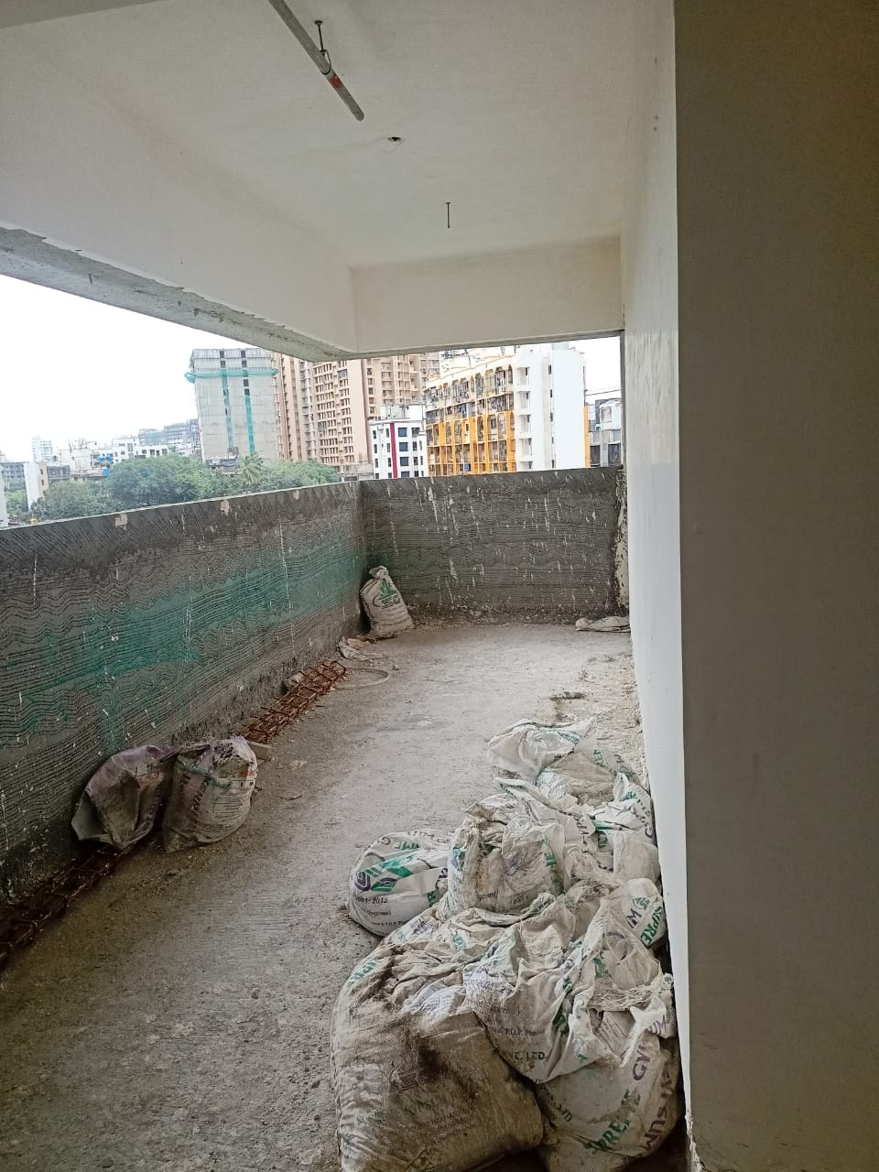
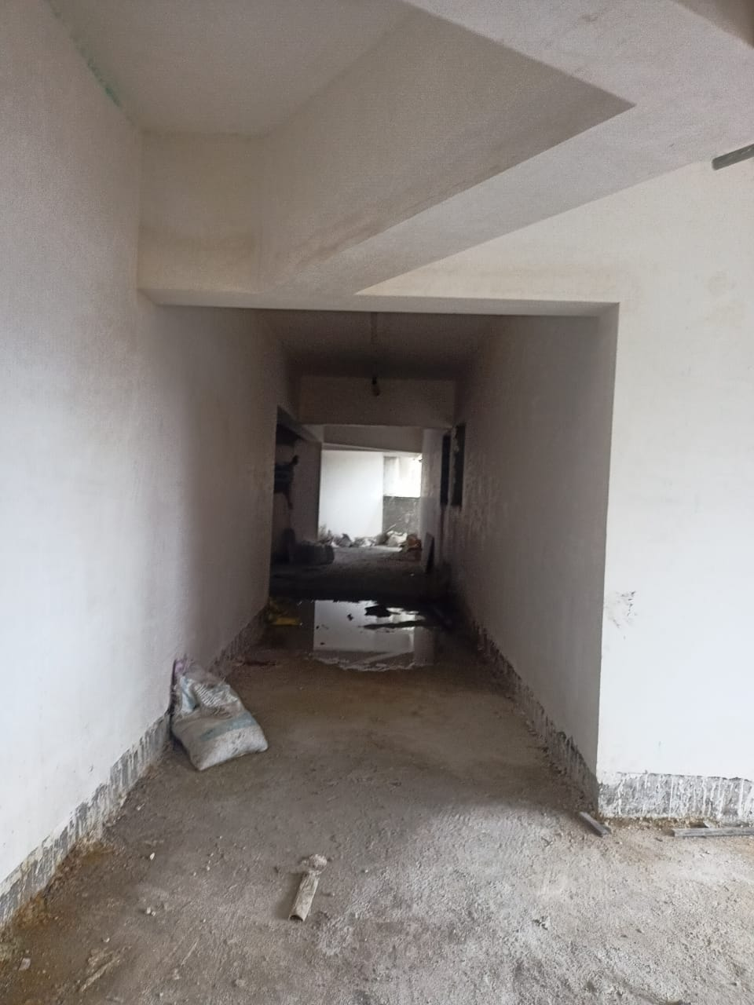
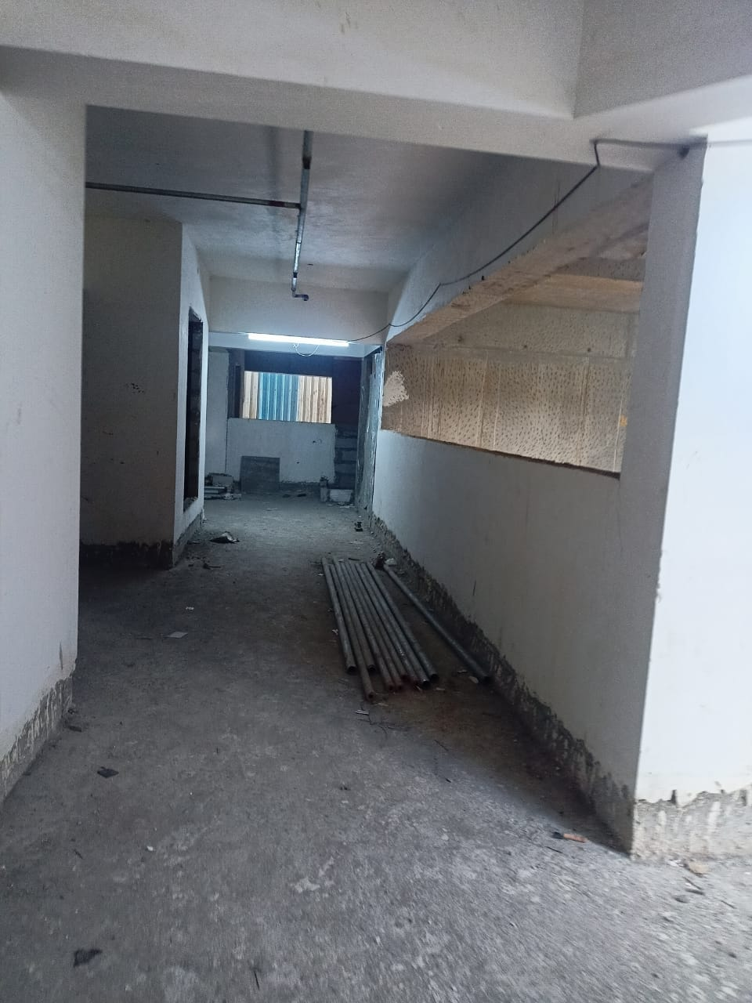
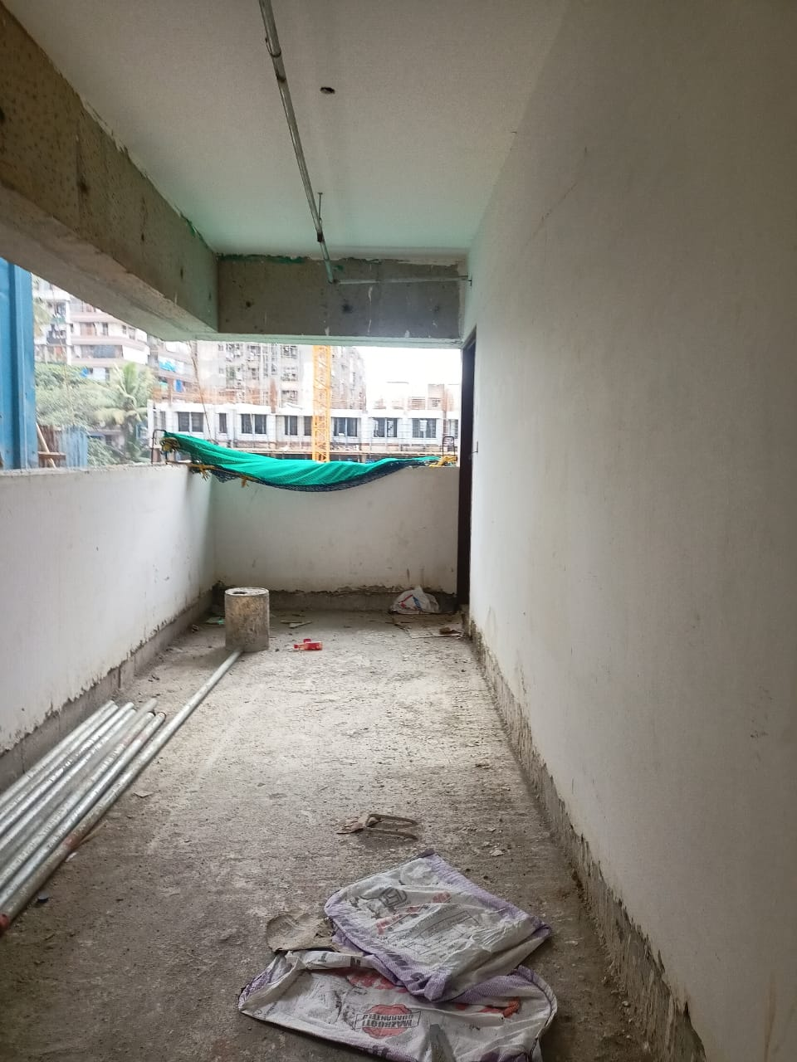
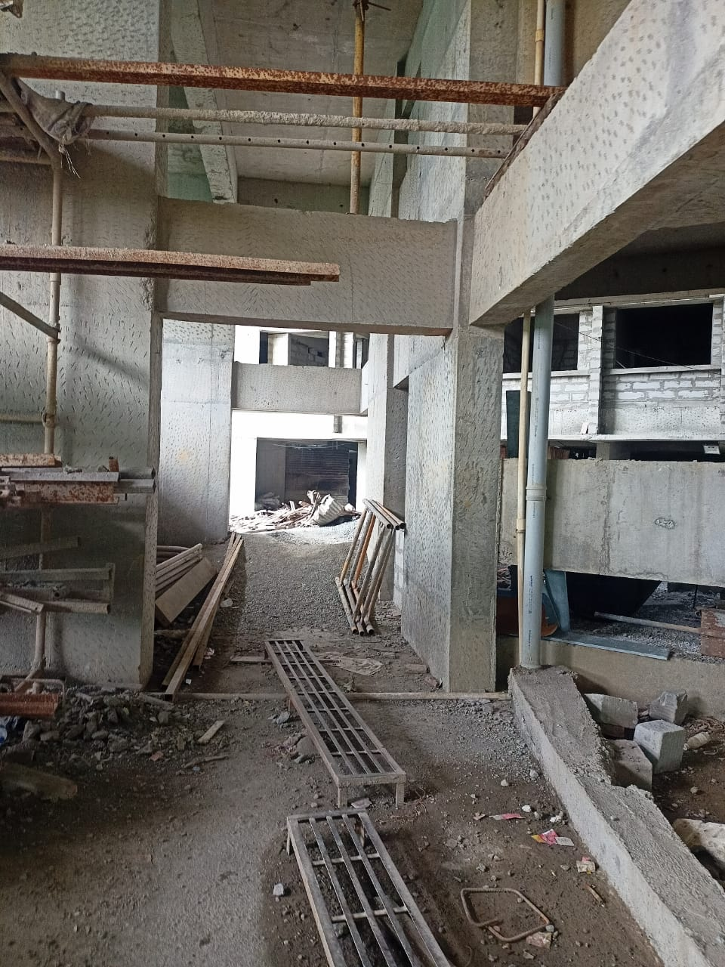
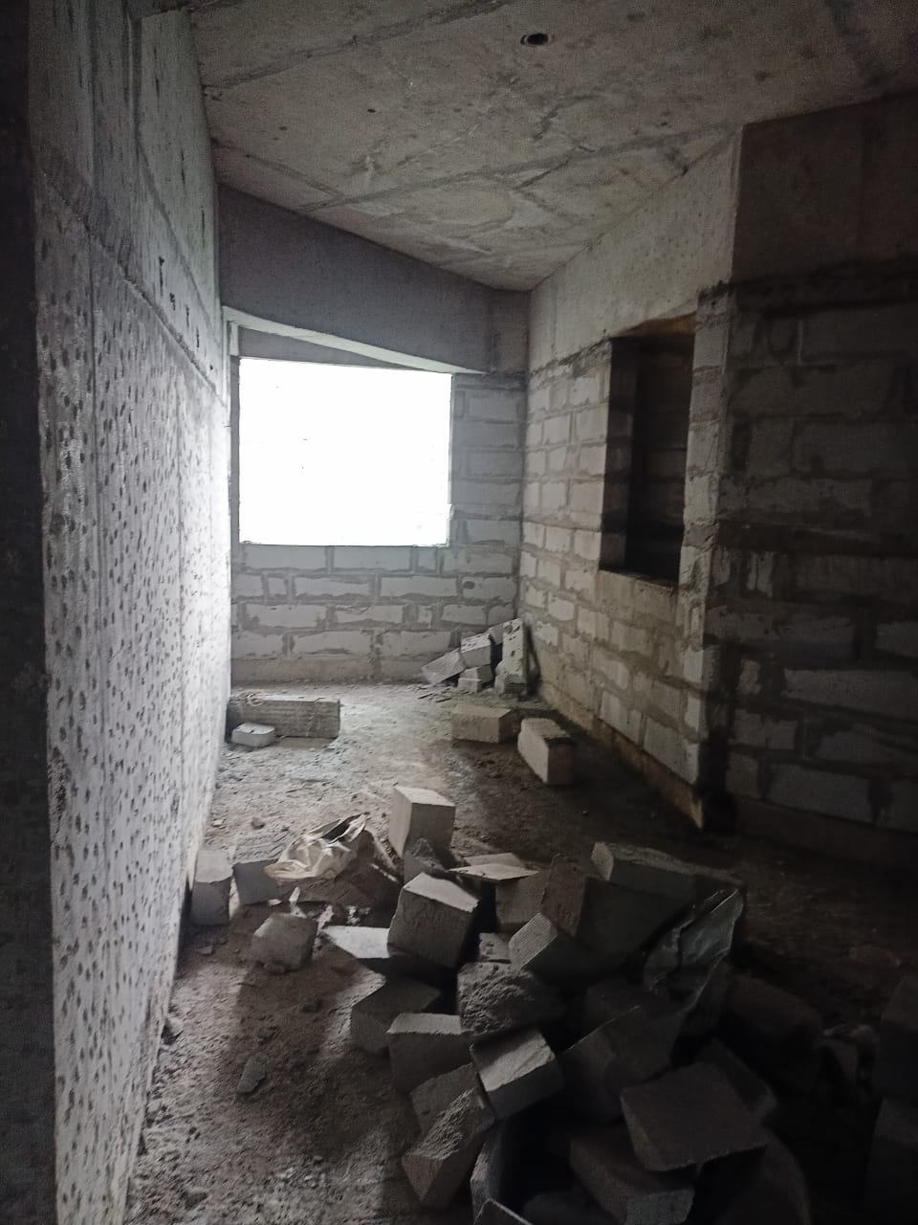
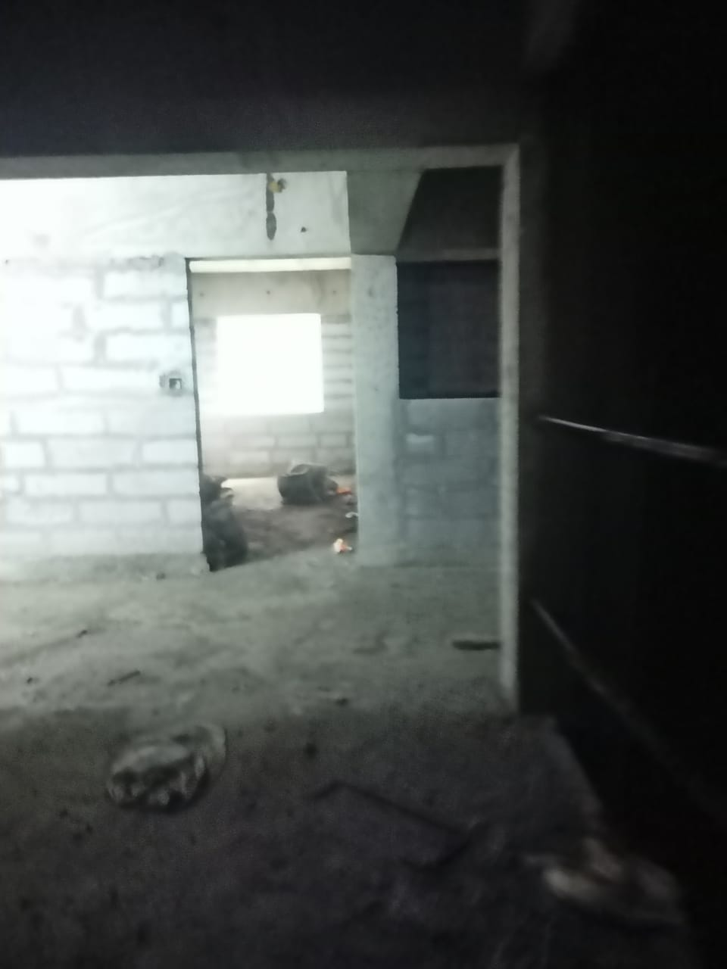
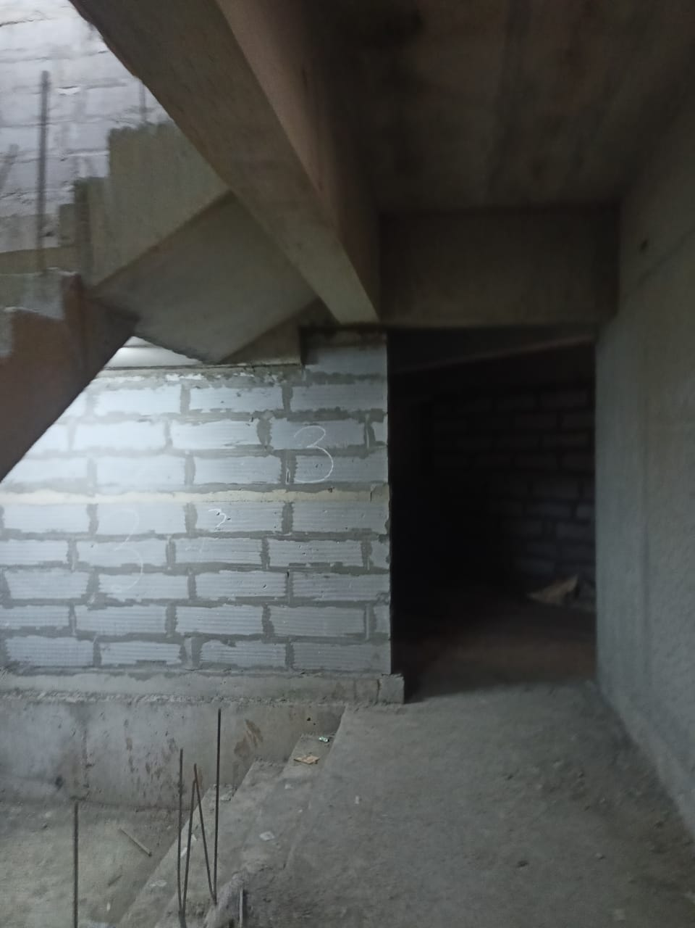
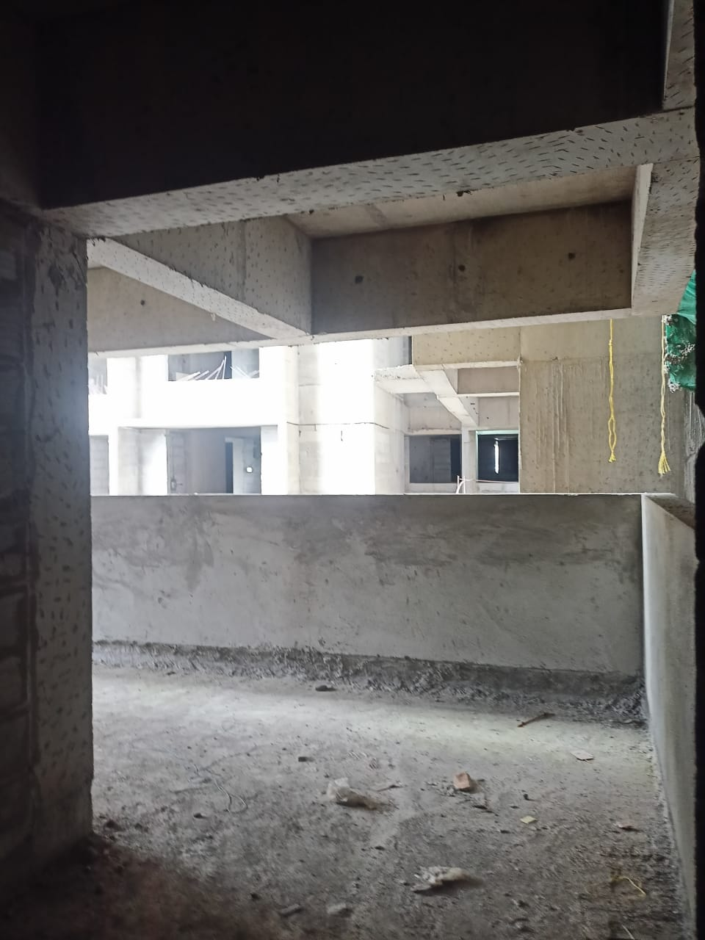
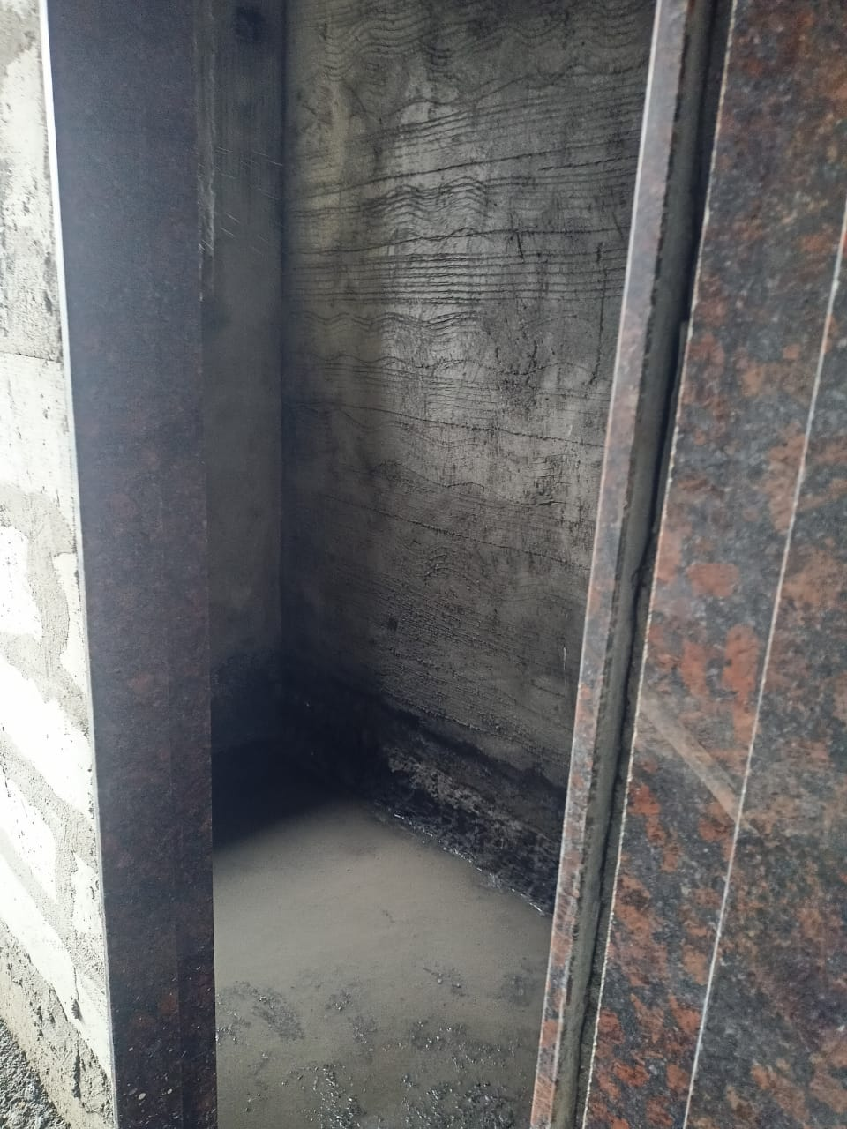
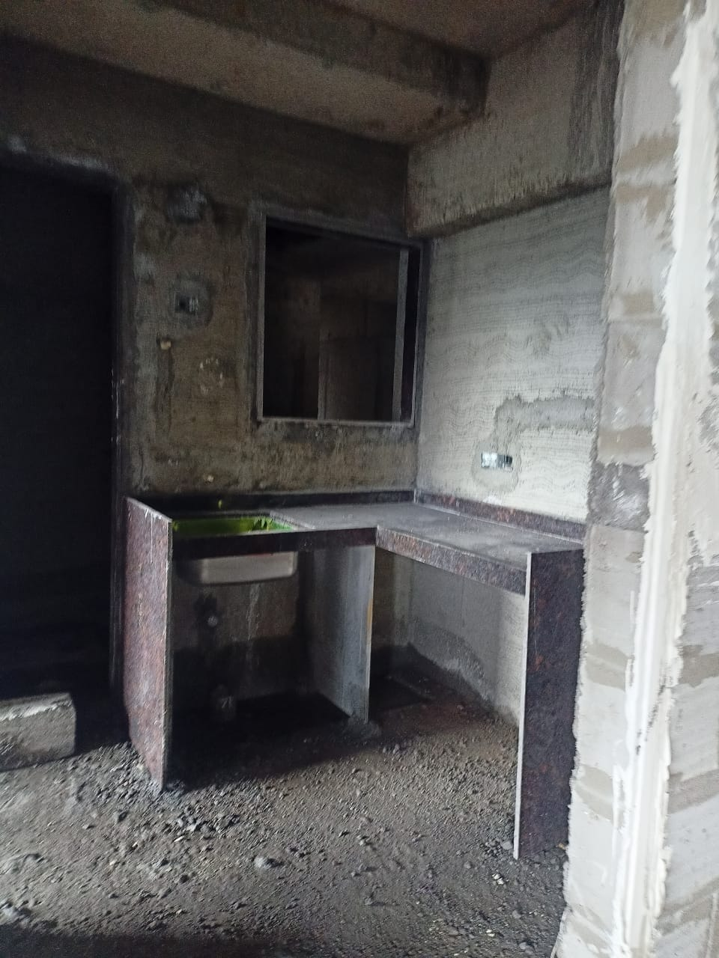
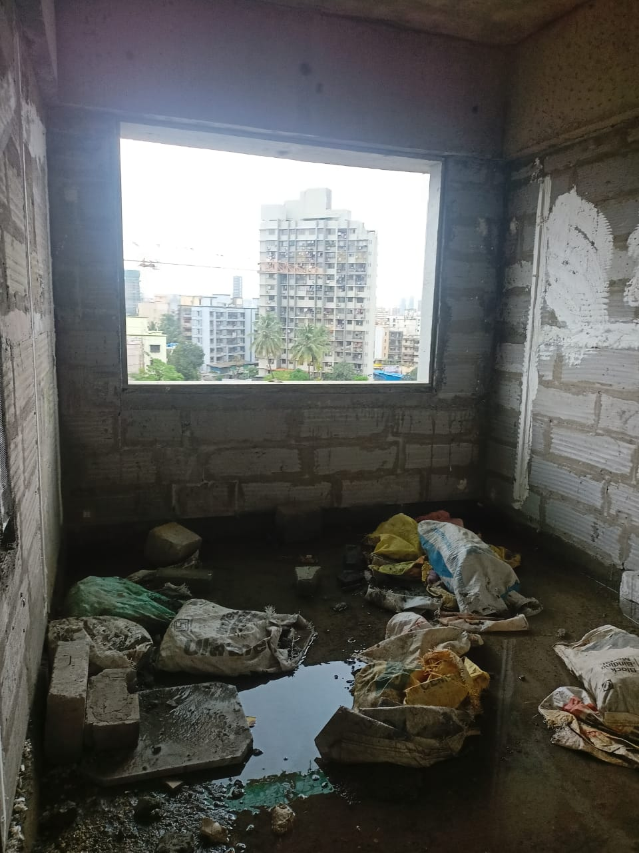
Actual Site Photographs
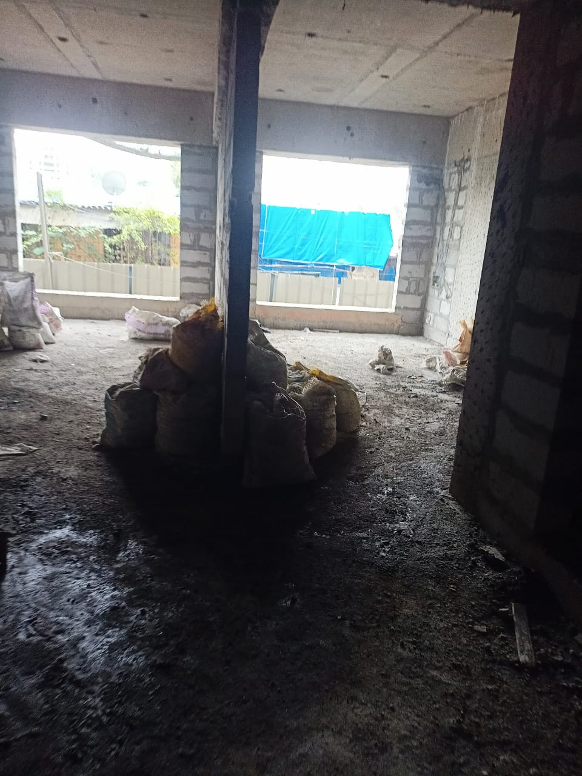
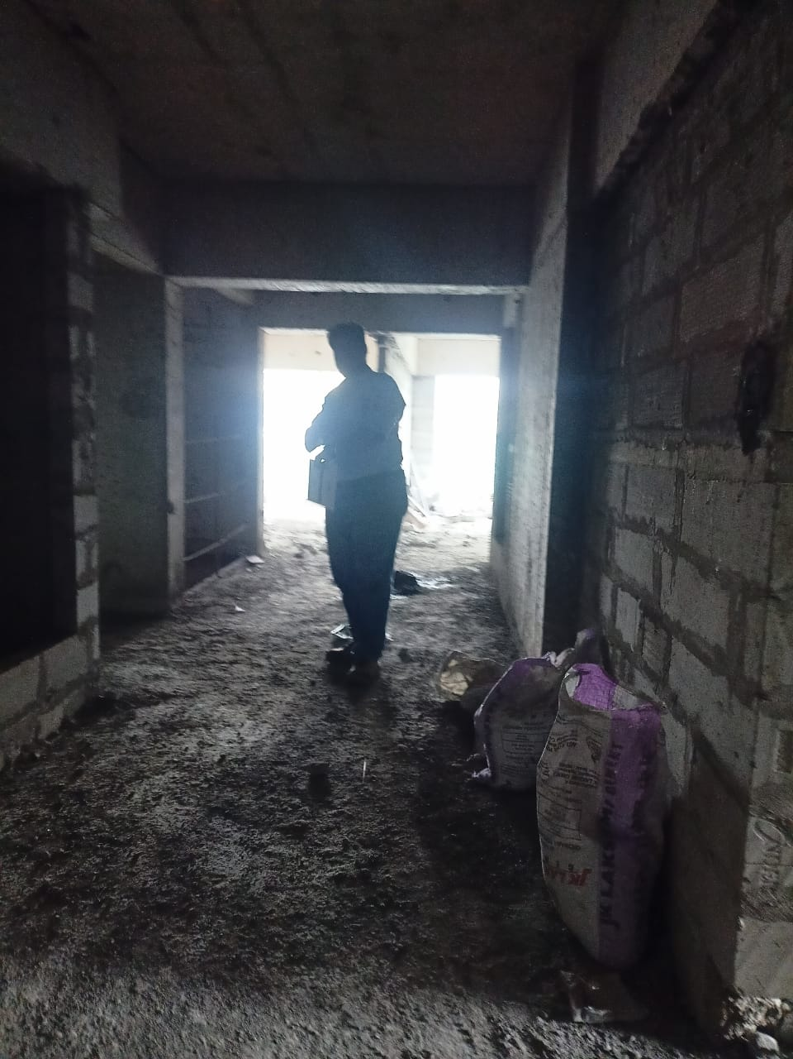
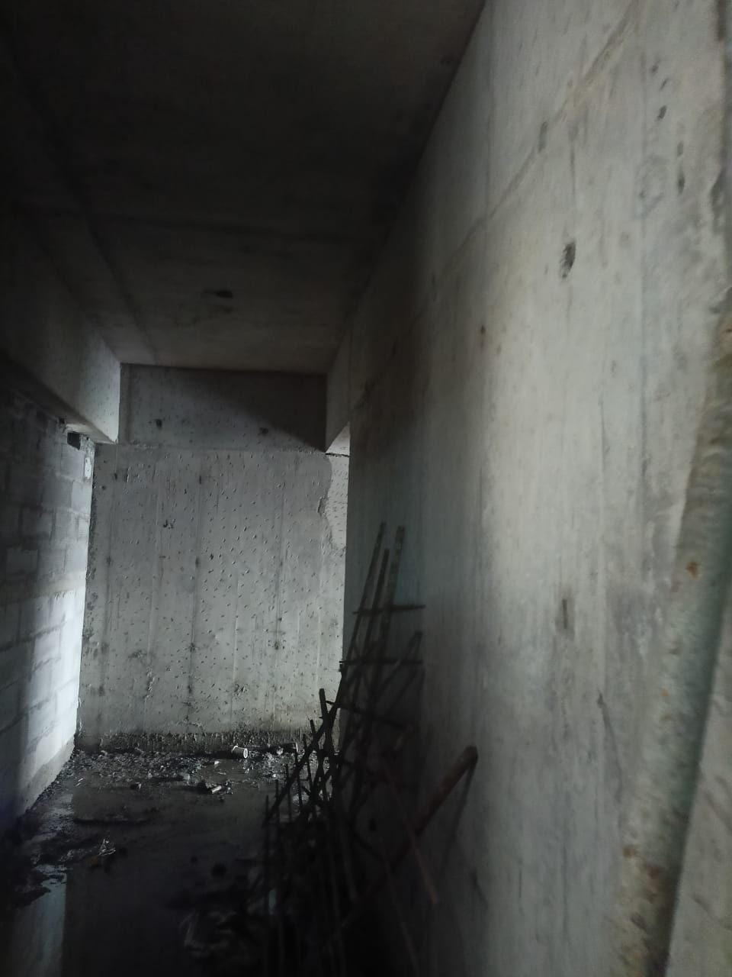
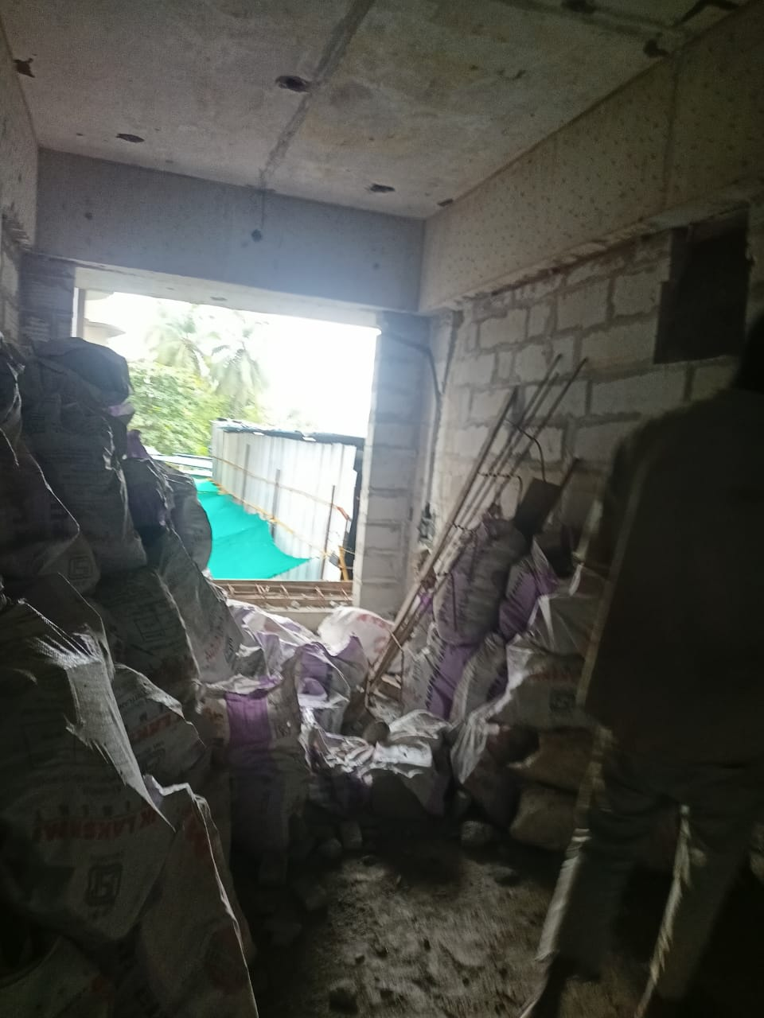
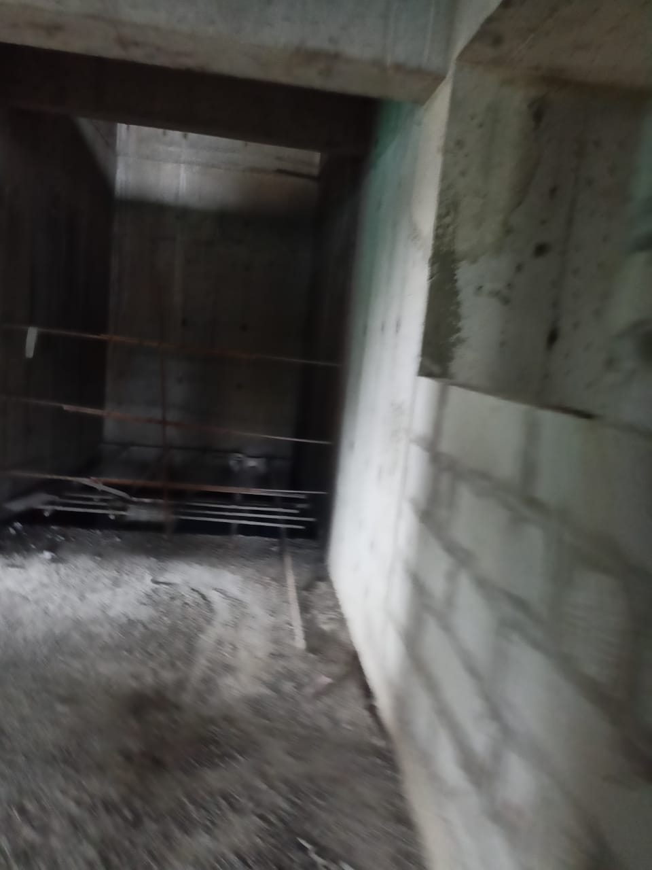
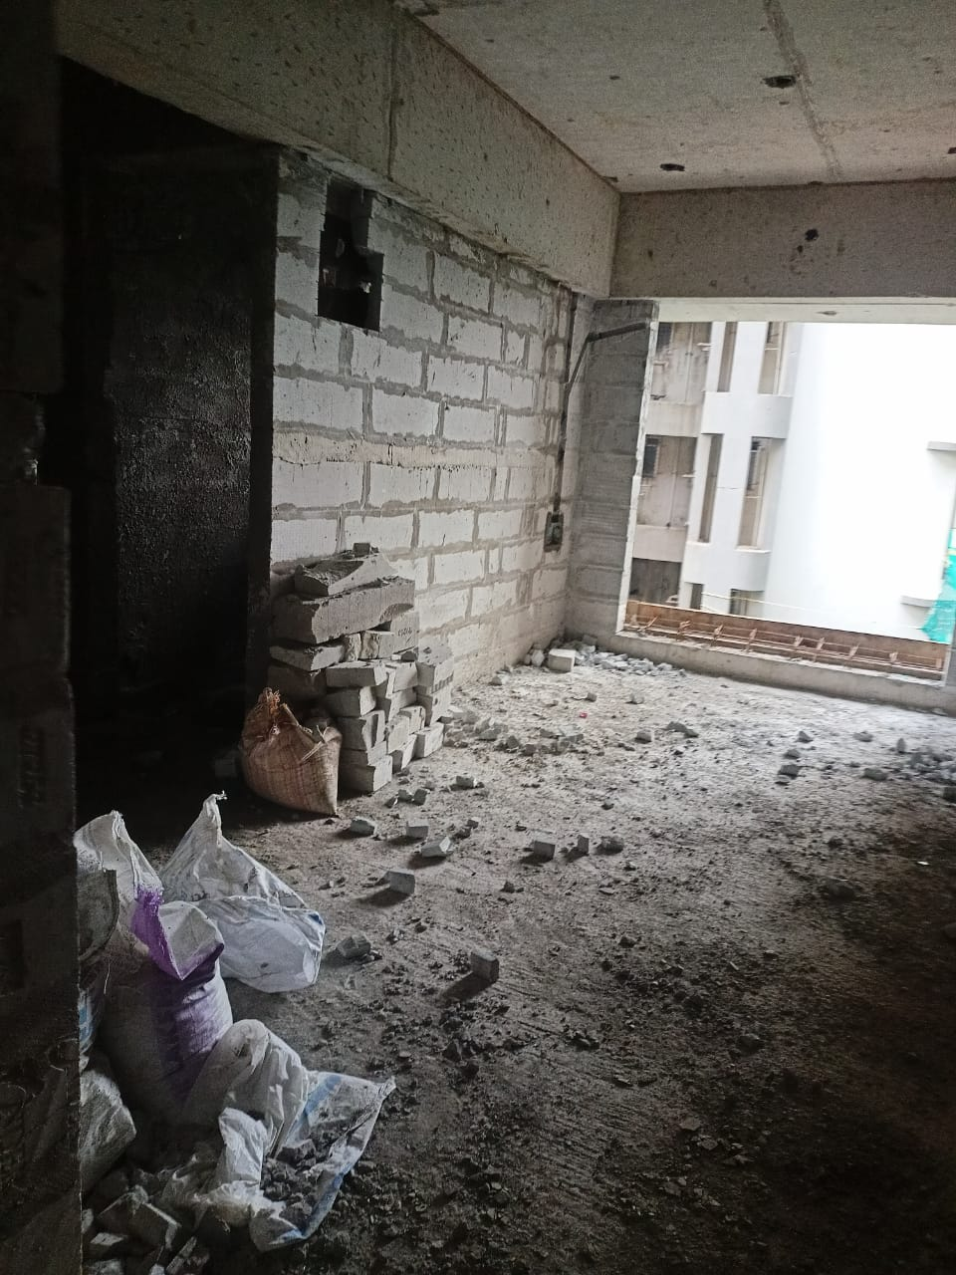
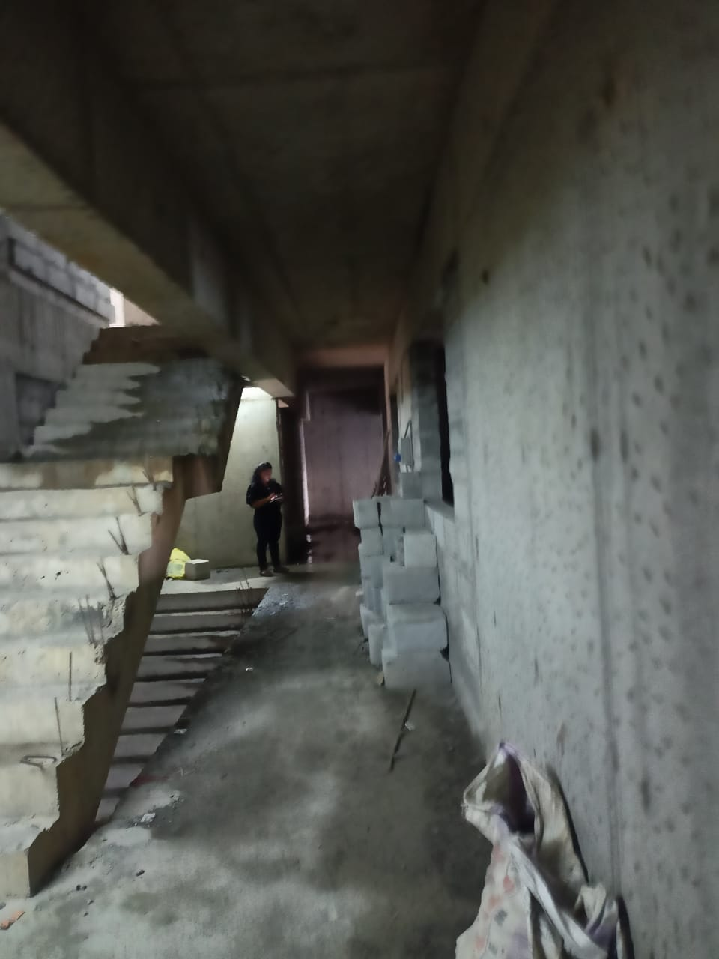
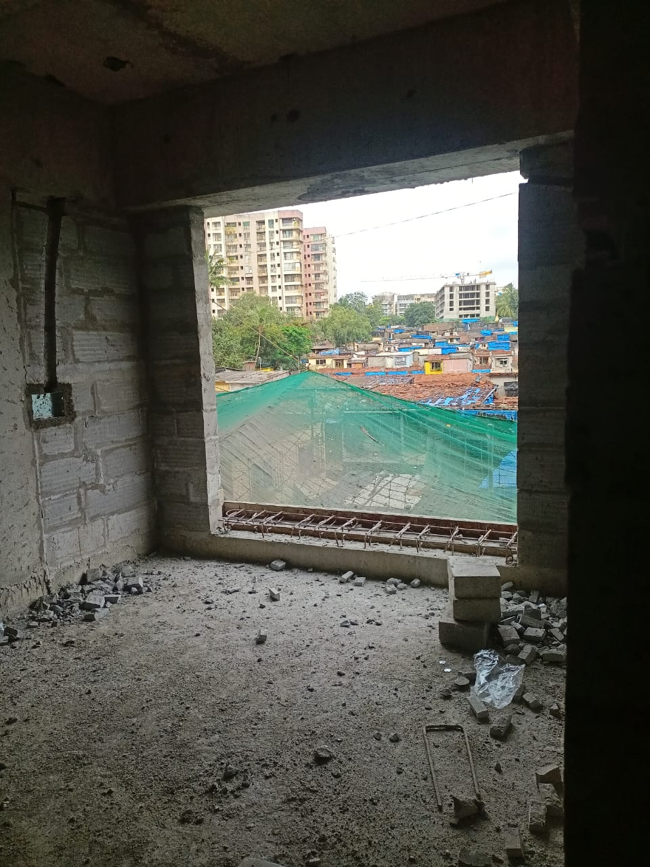
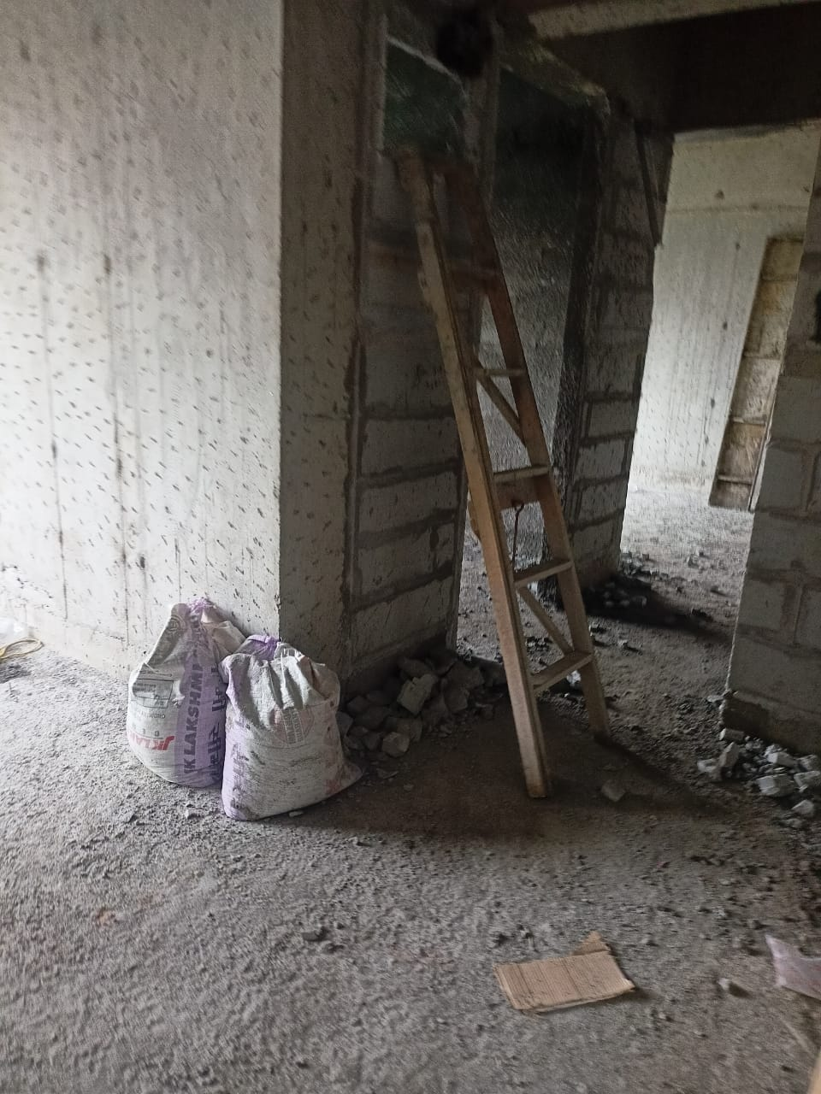
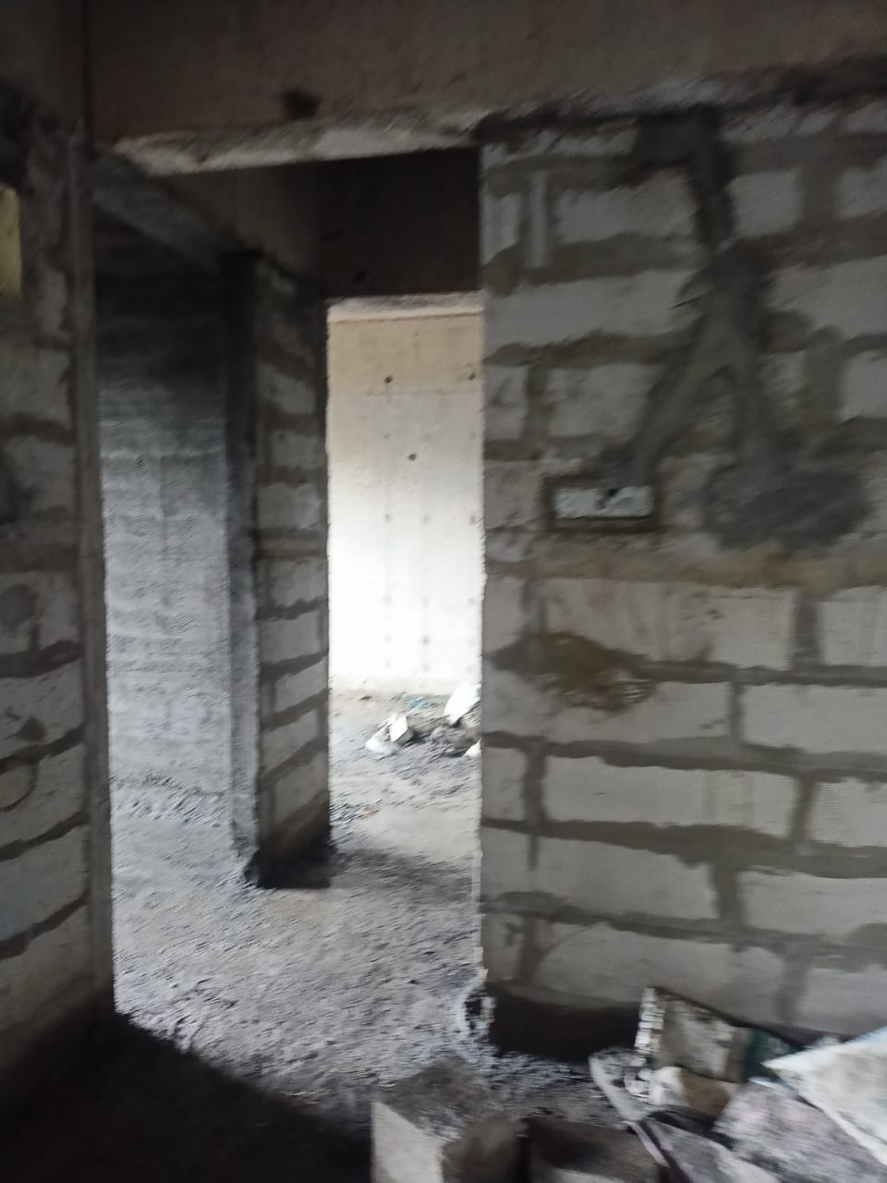
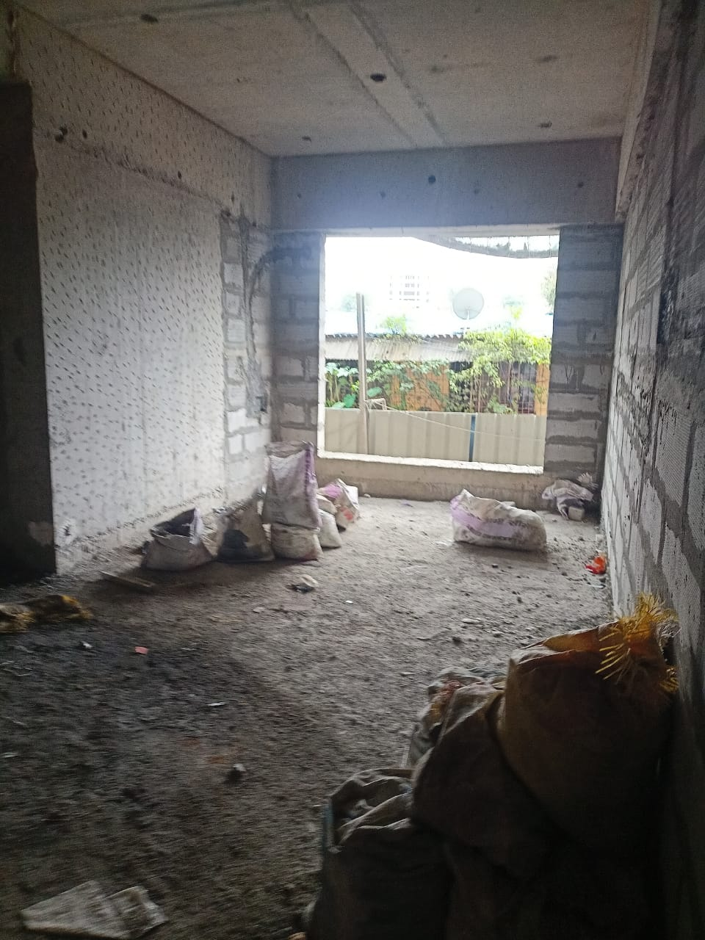
Actual Site Photographs
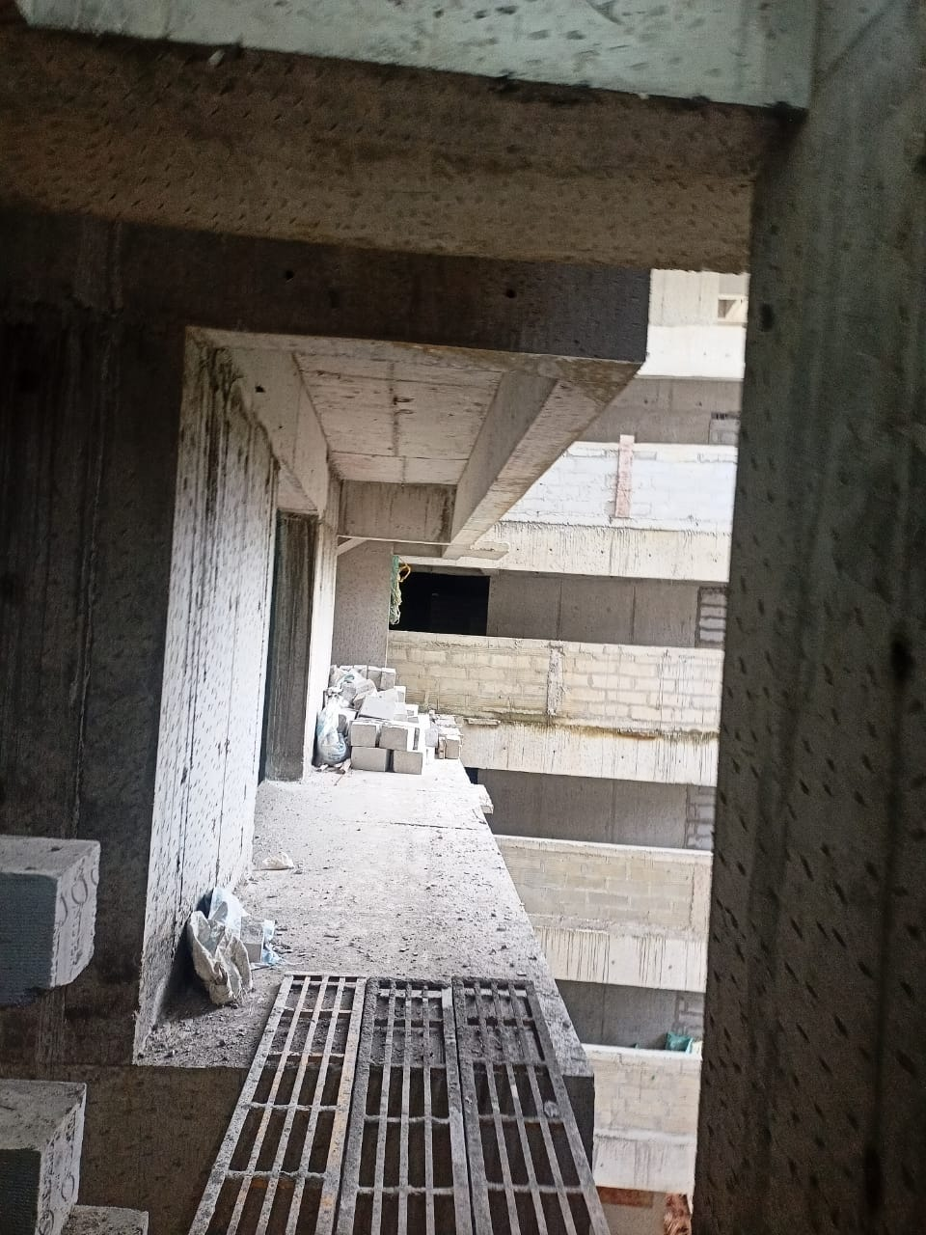
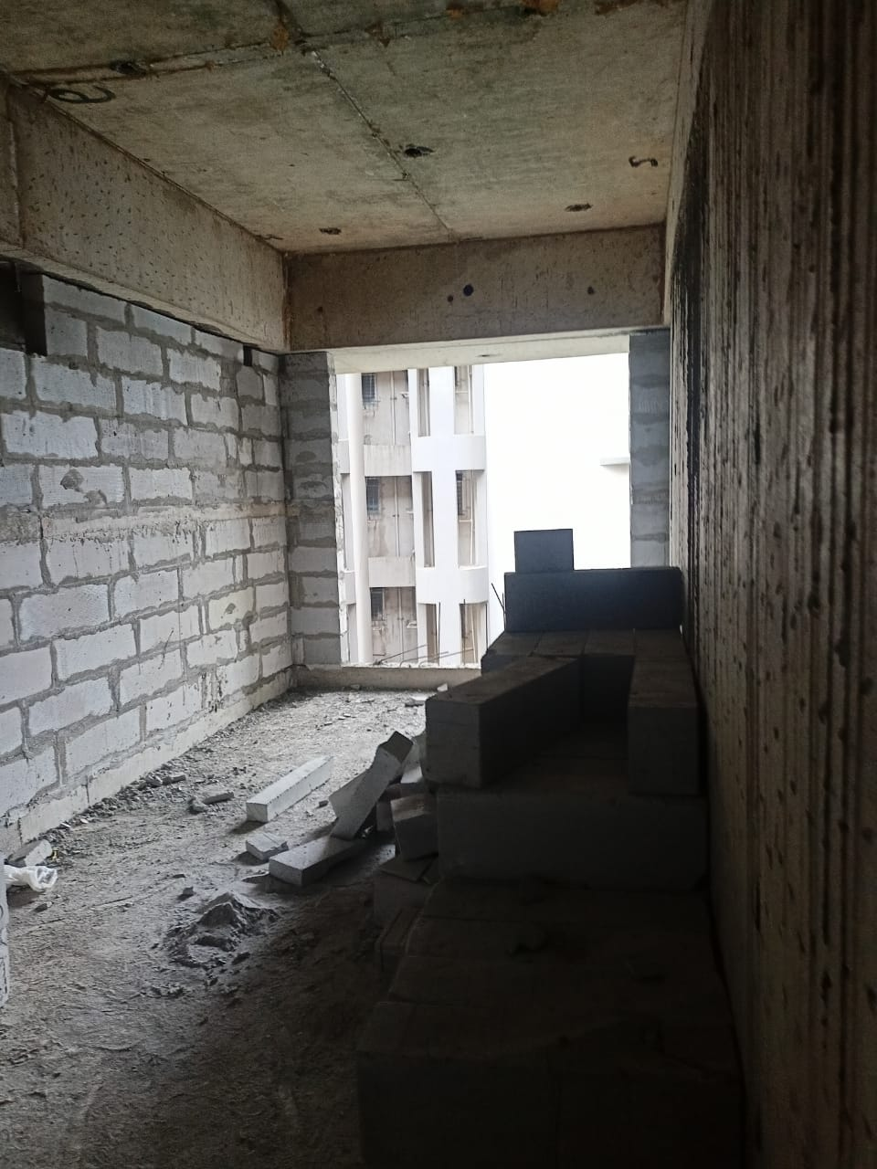
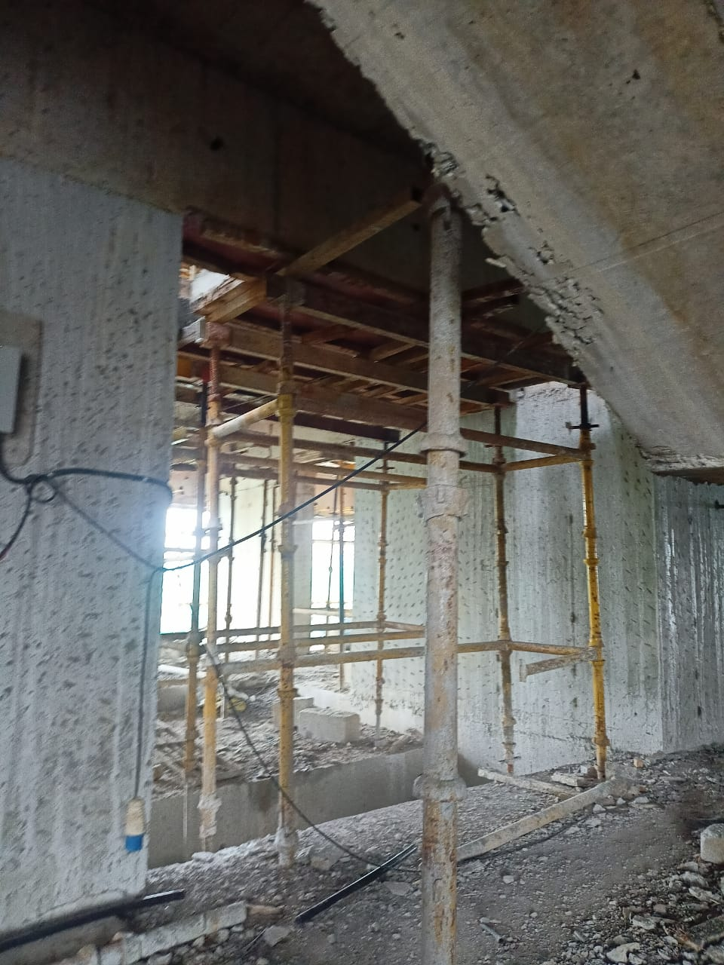
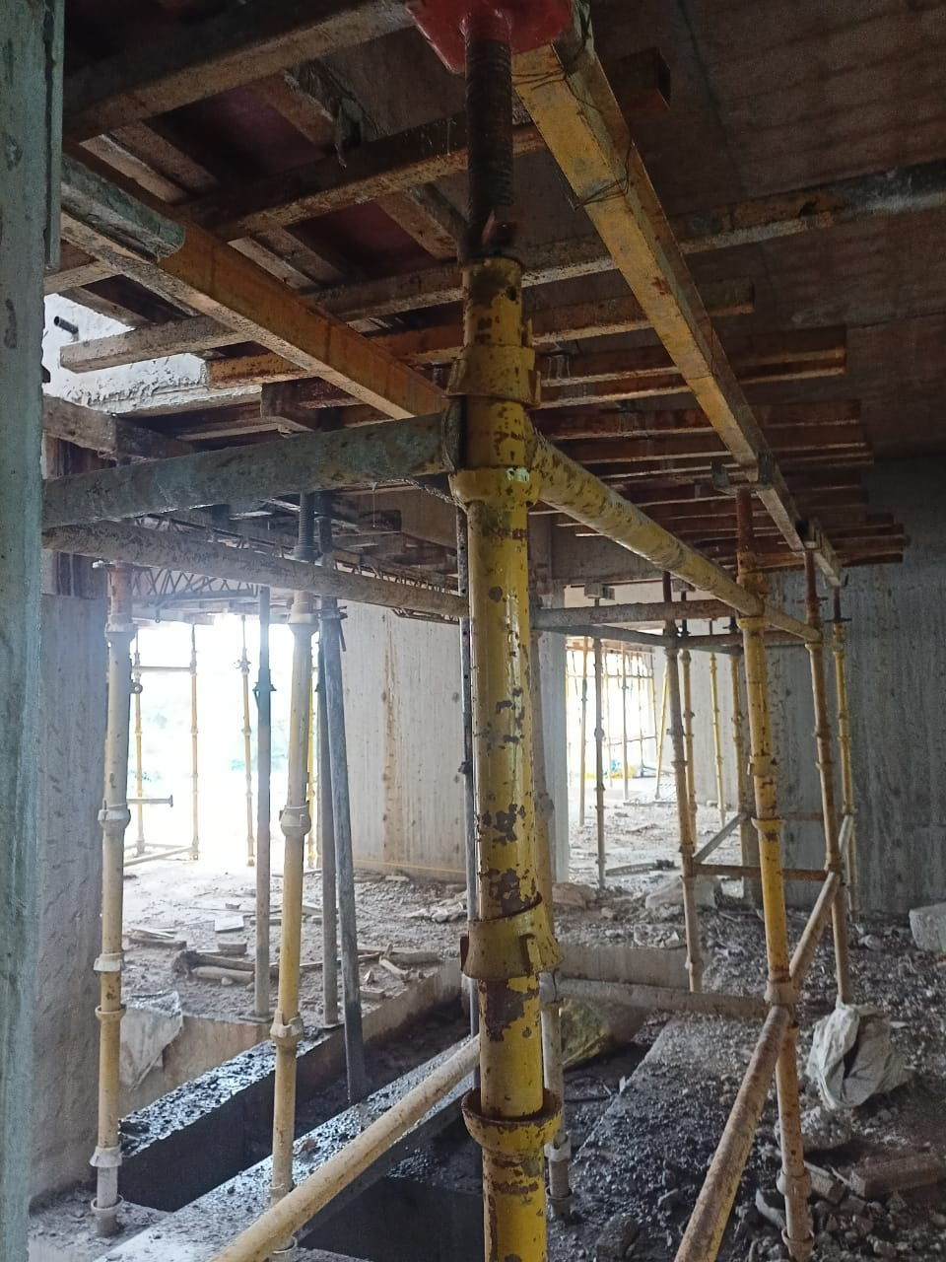
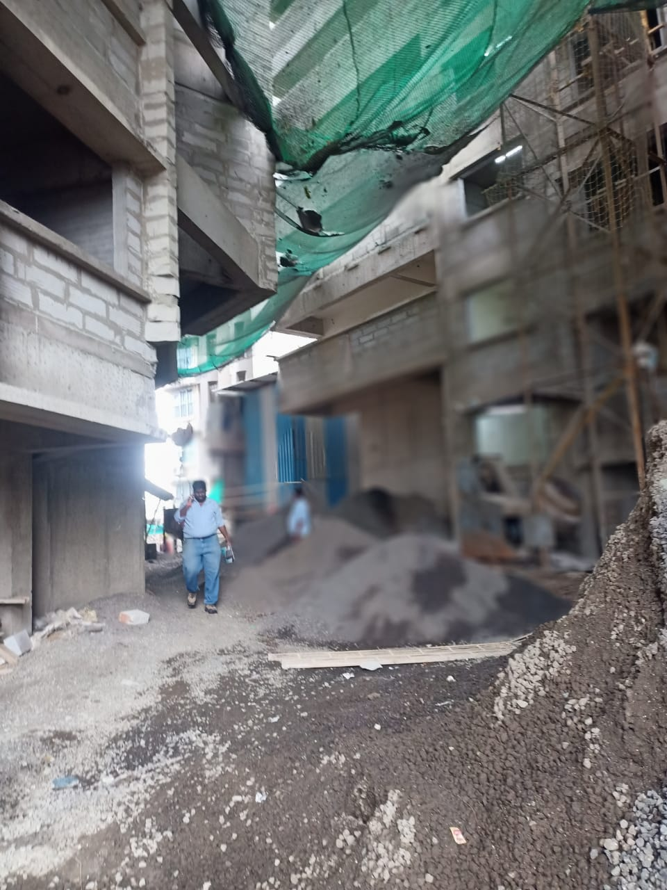
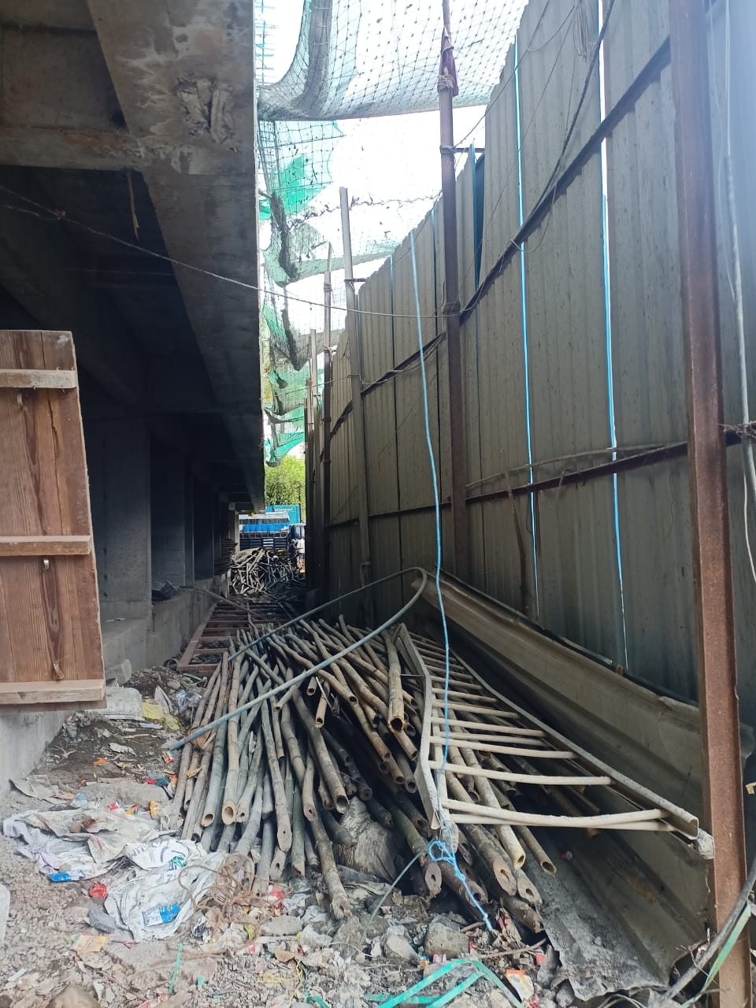
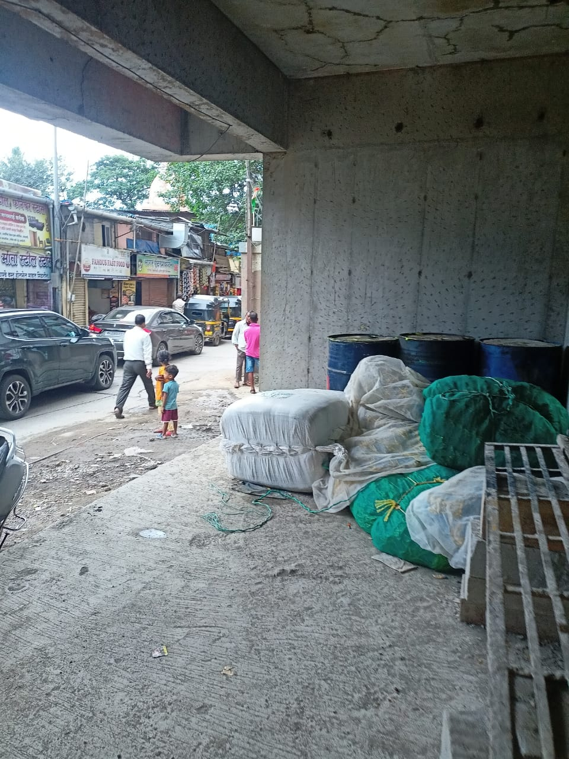
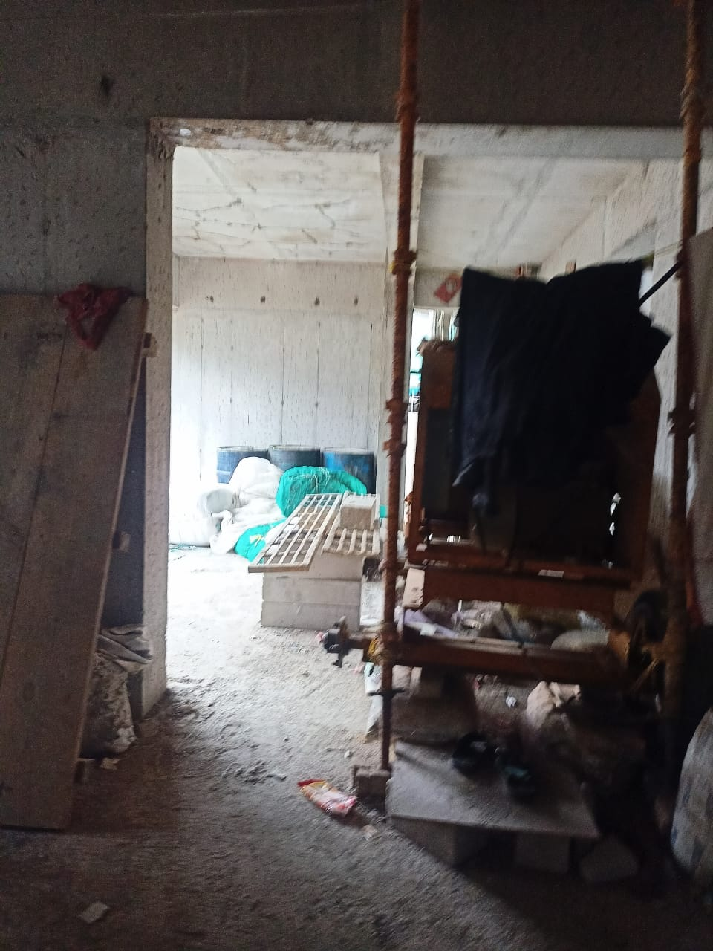
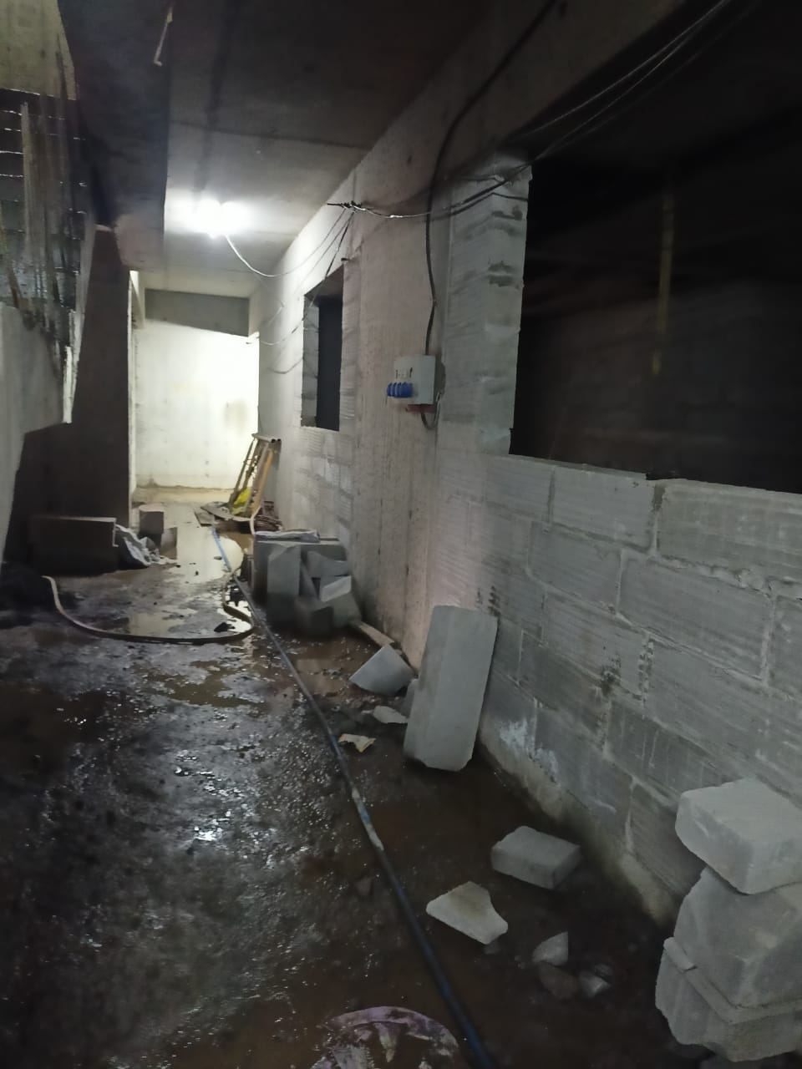
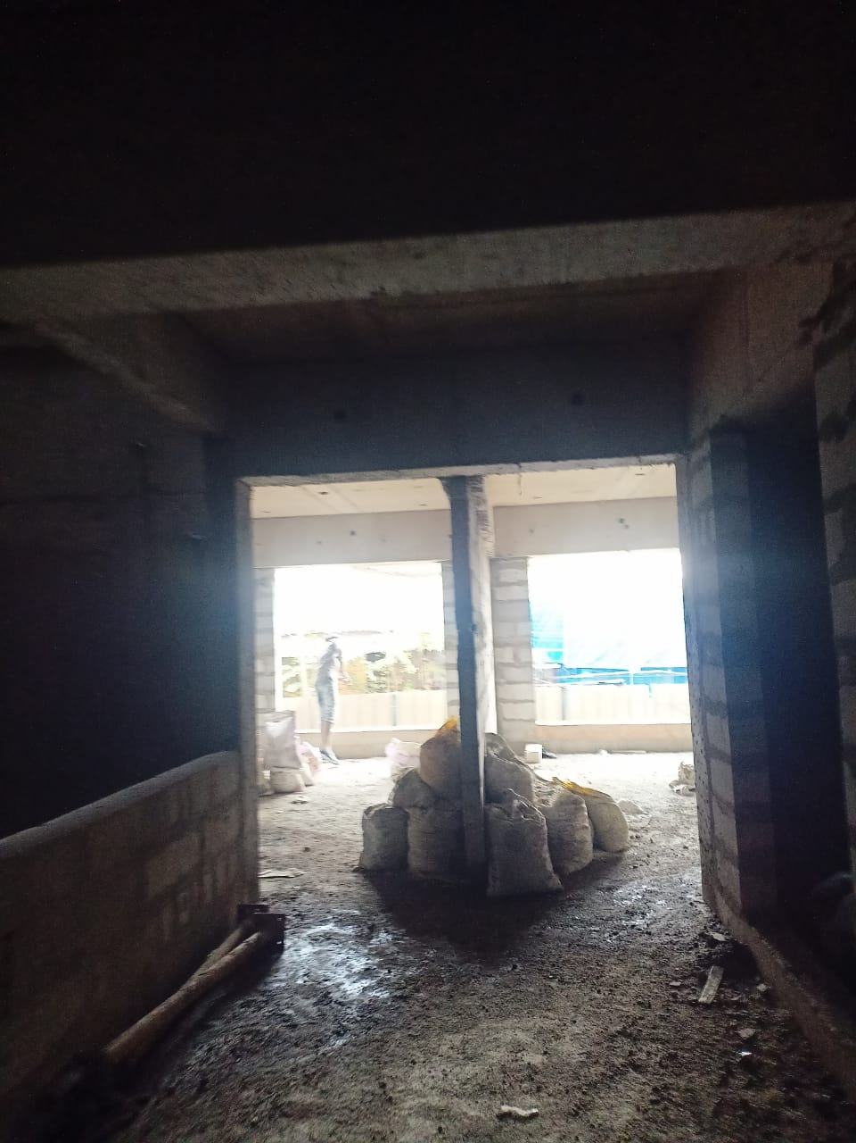
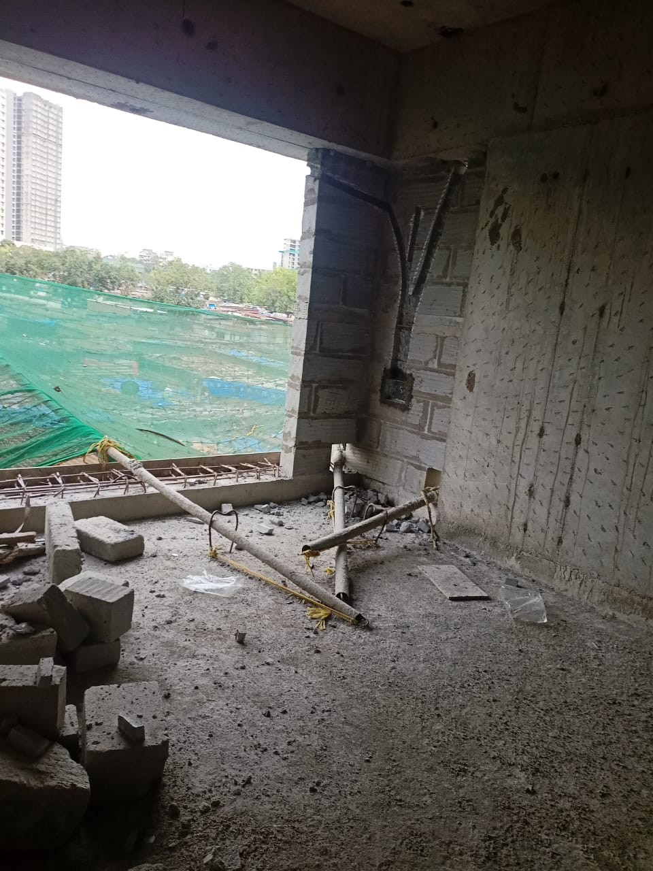
Actual Site Photographs
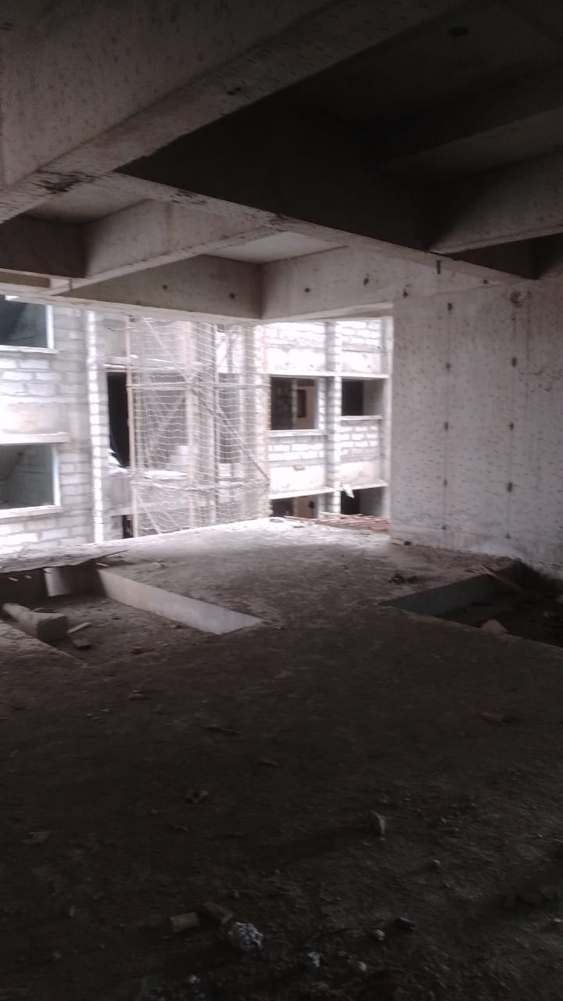
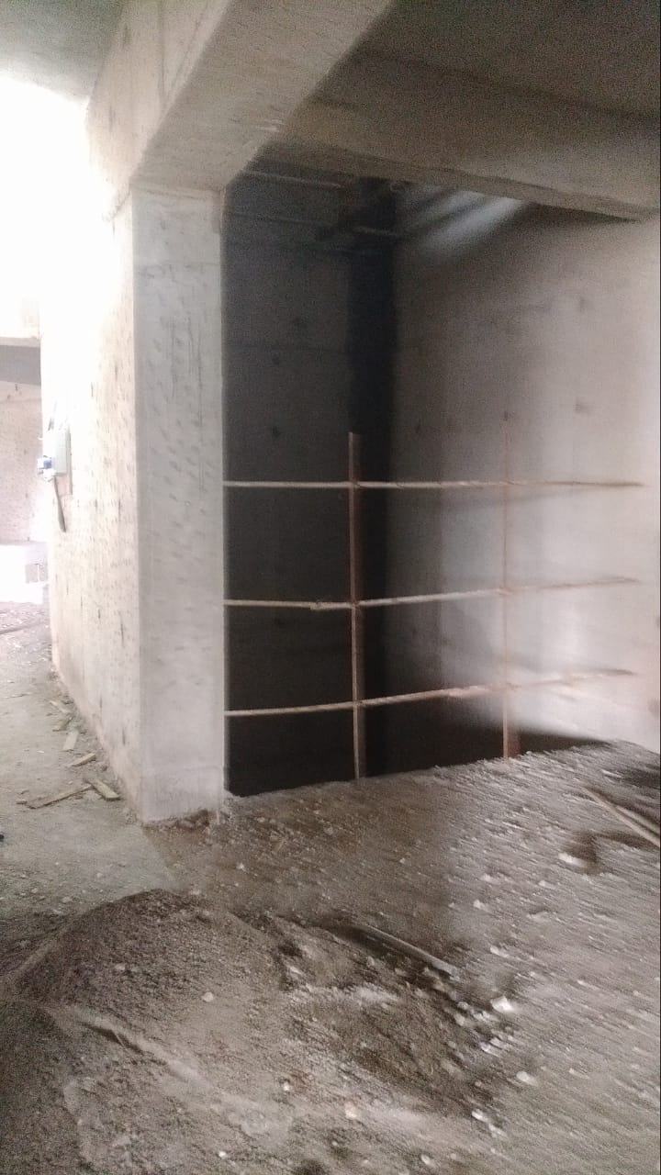
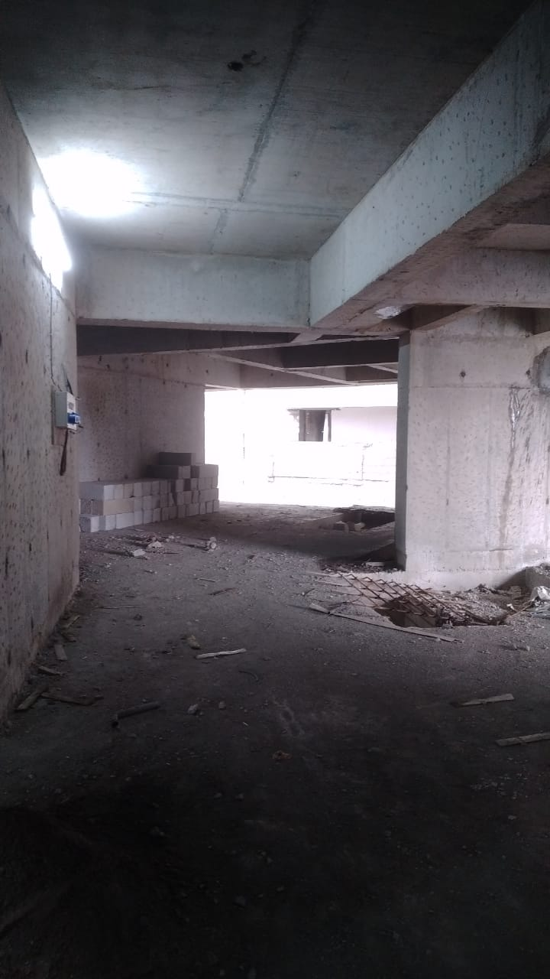
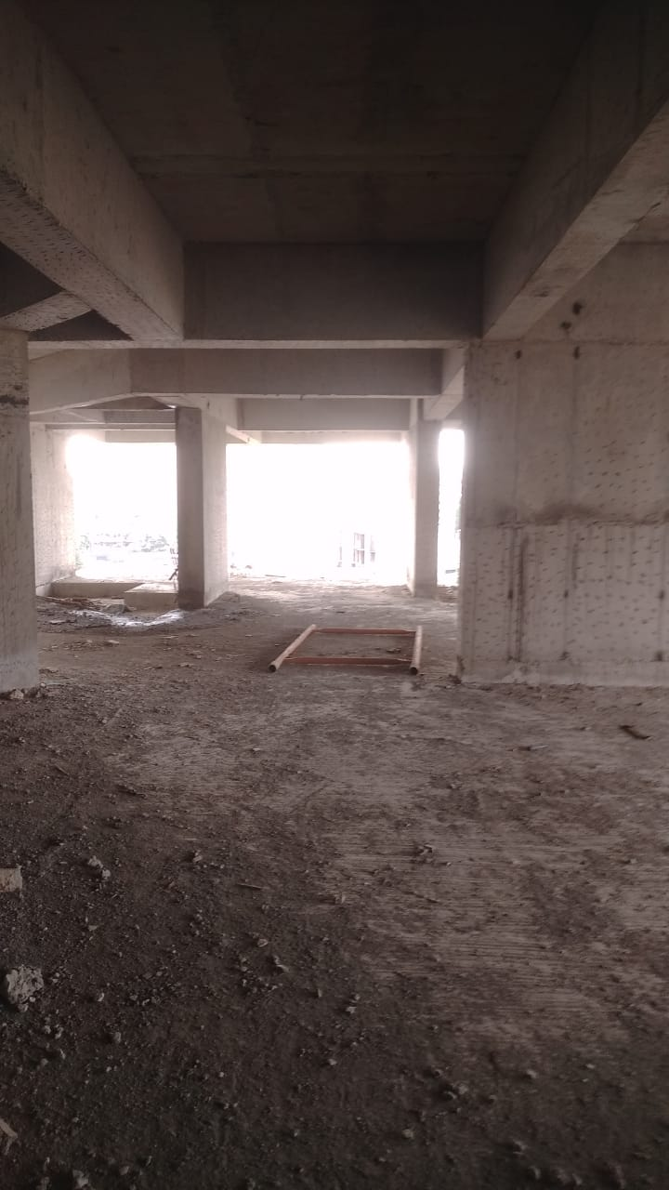
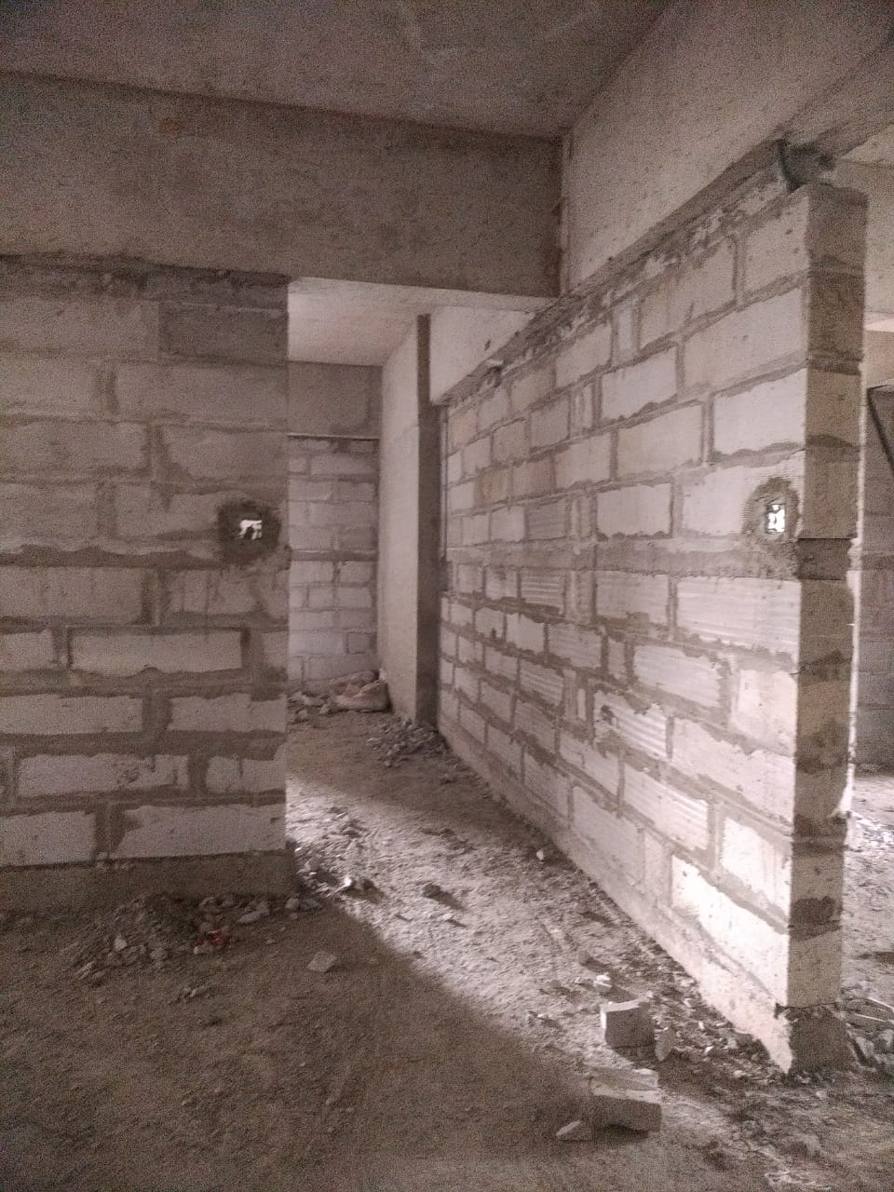
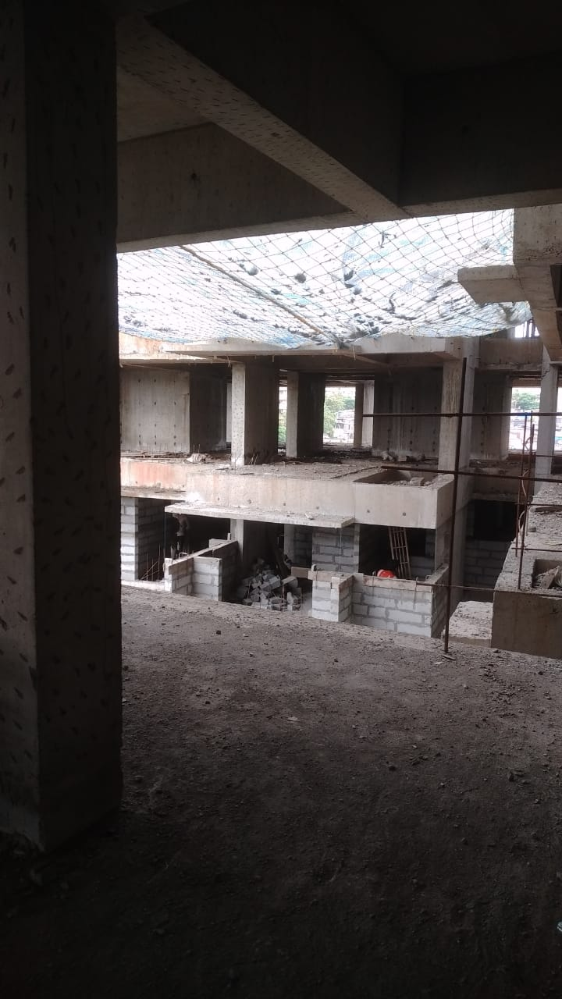
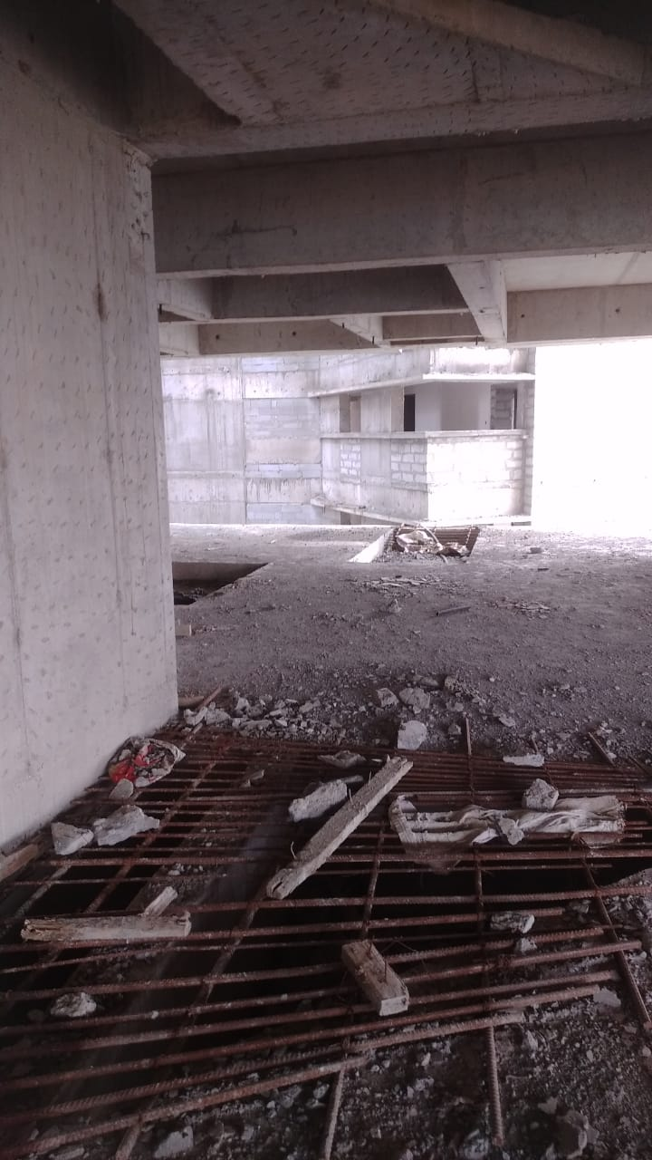
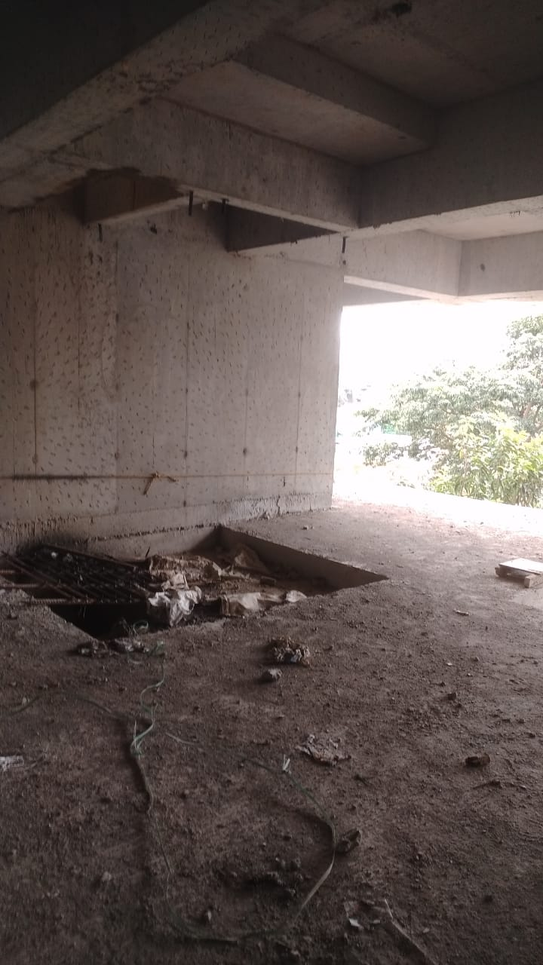
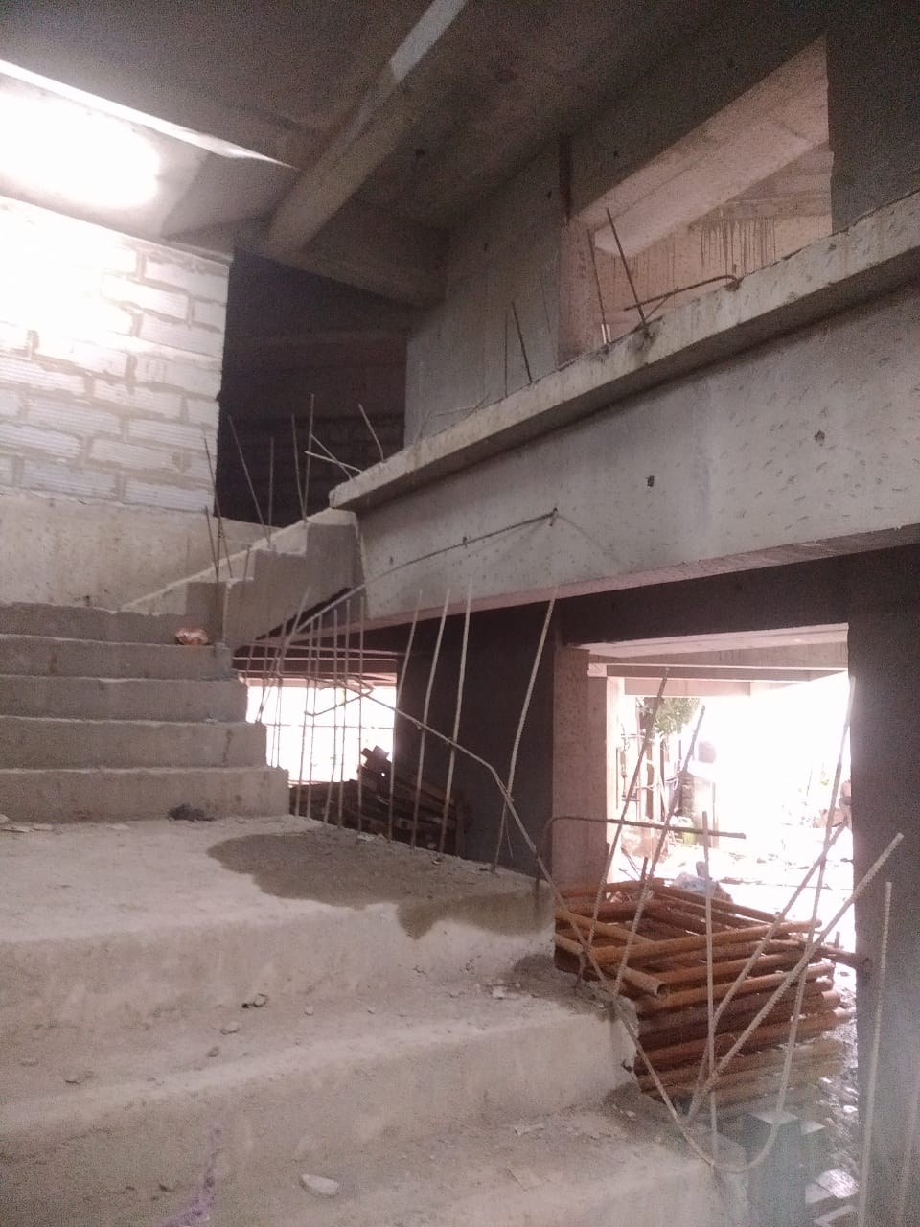
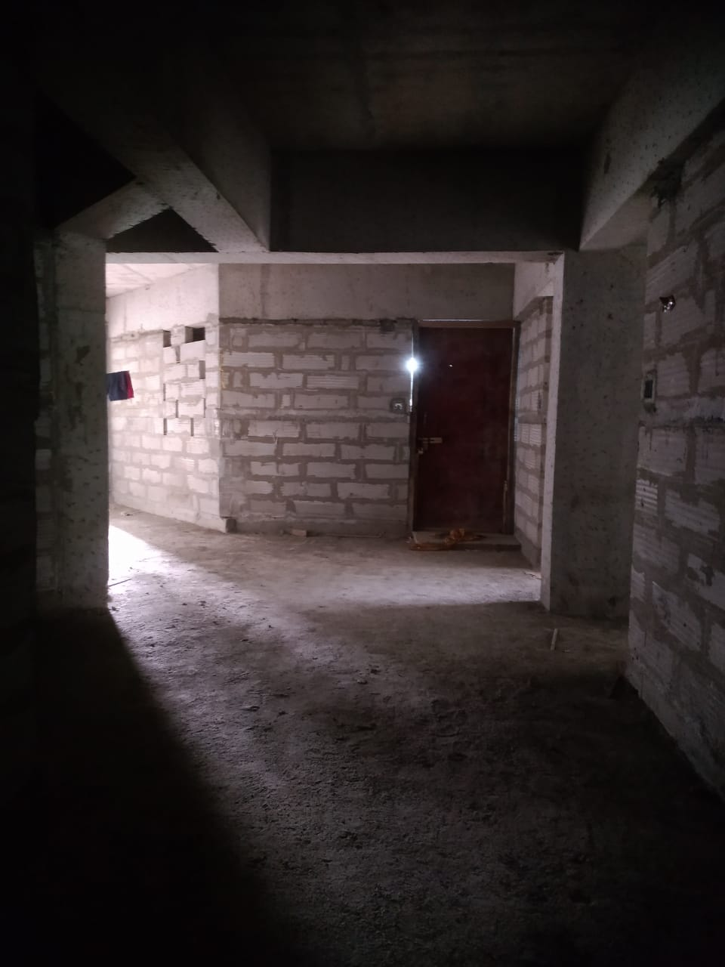
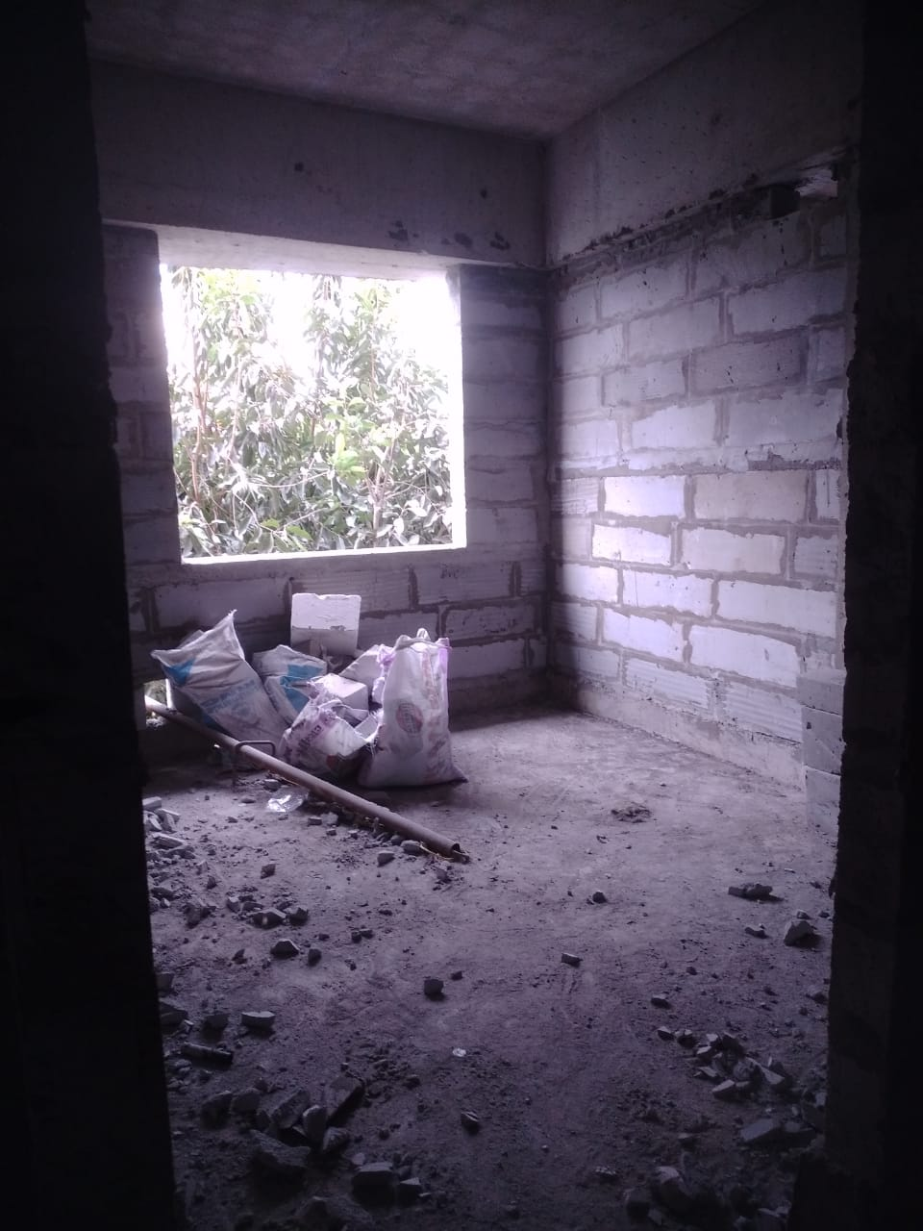
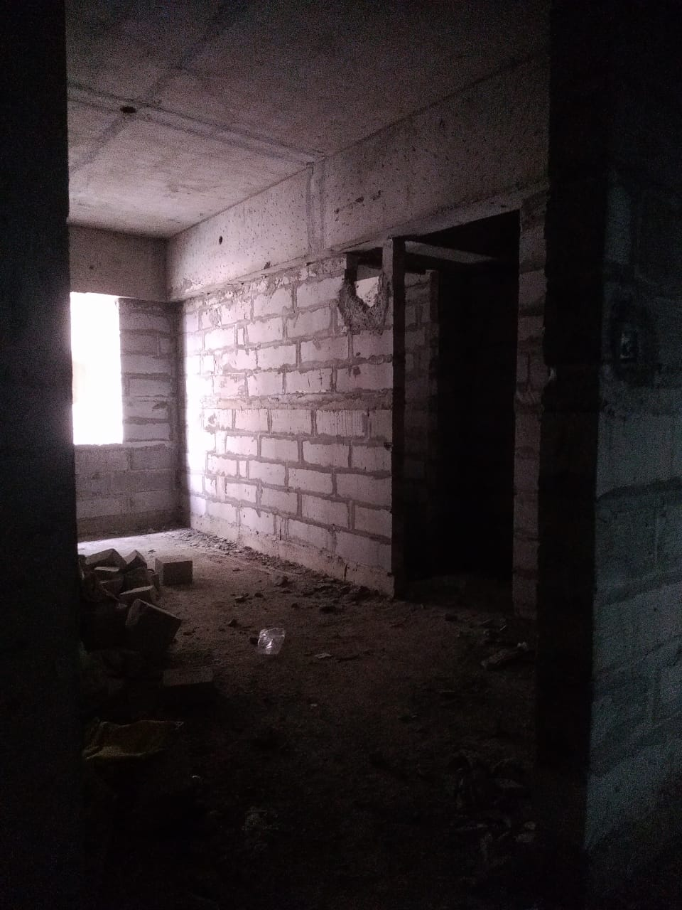
Actual Site Photographs
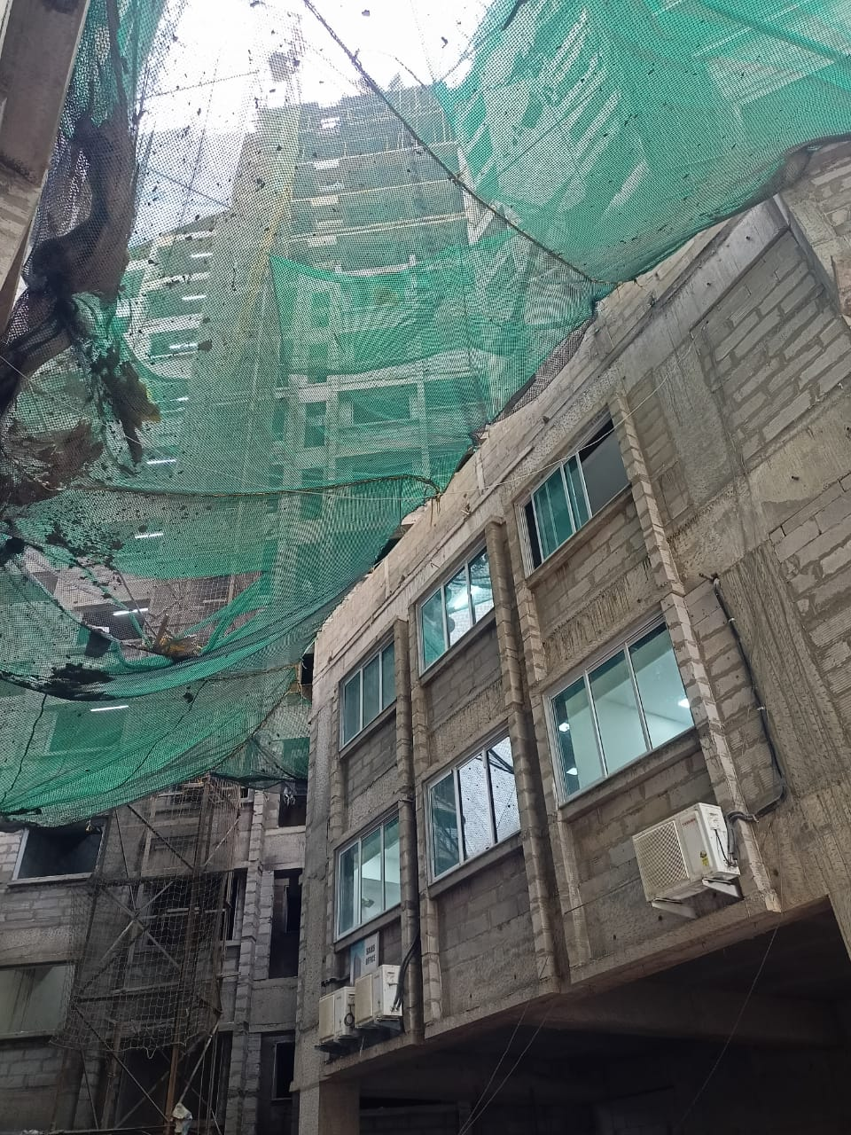
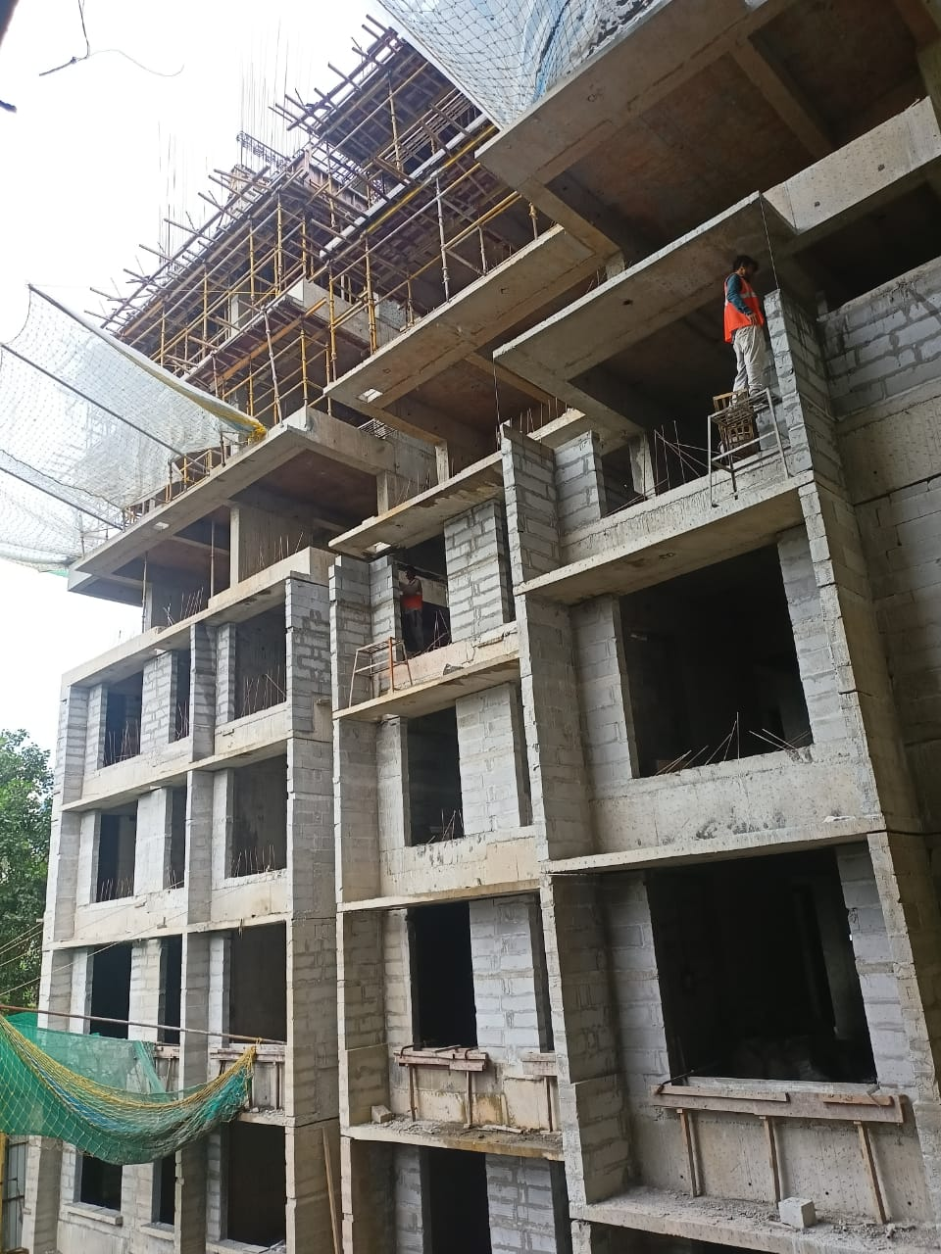
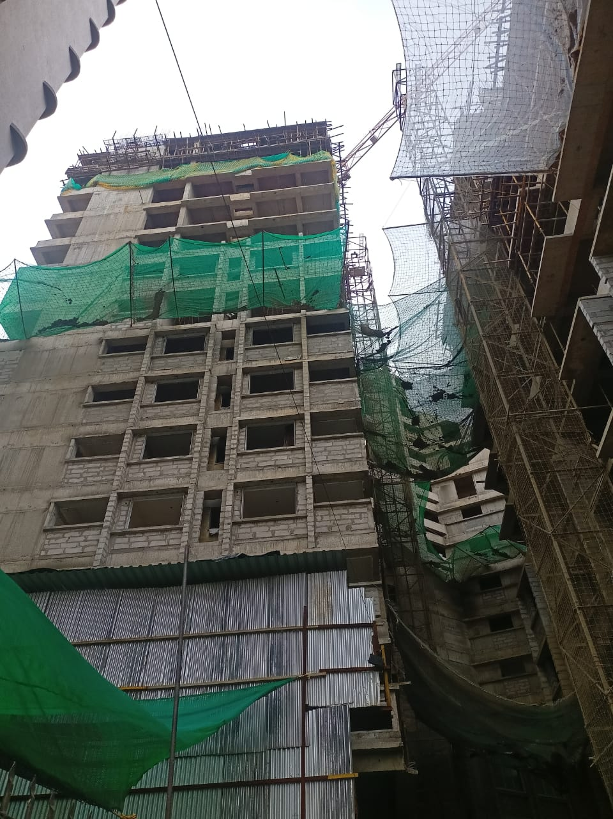
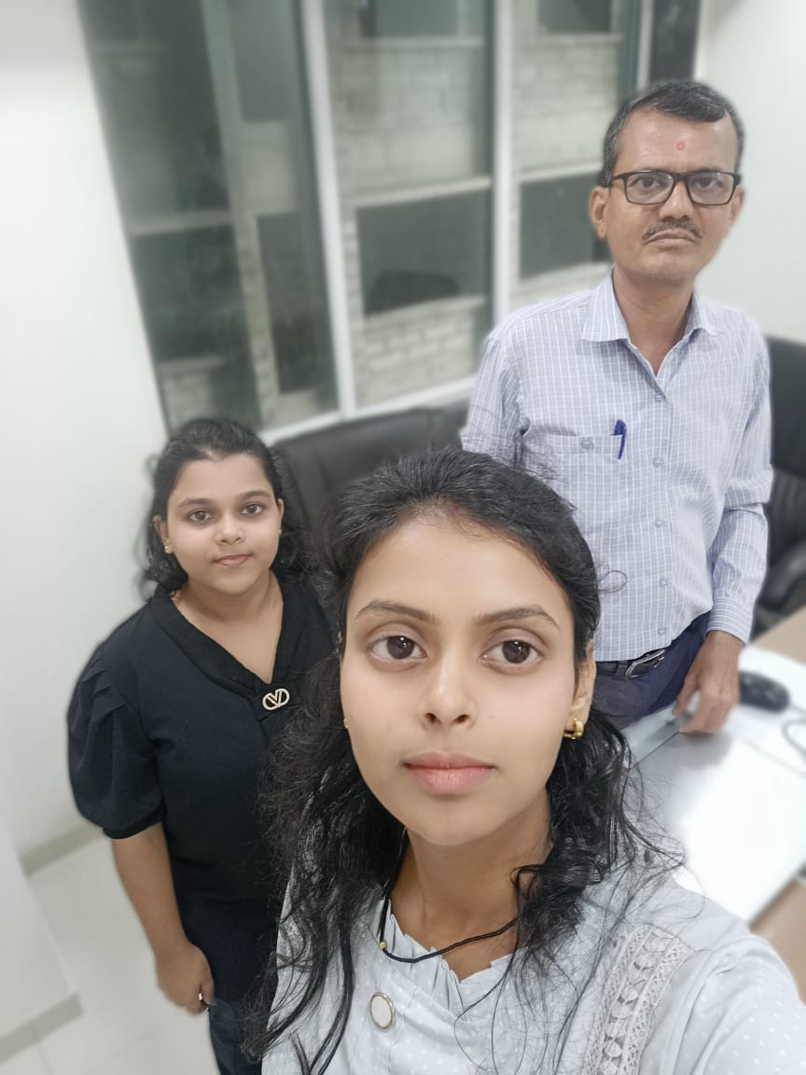
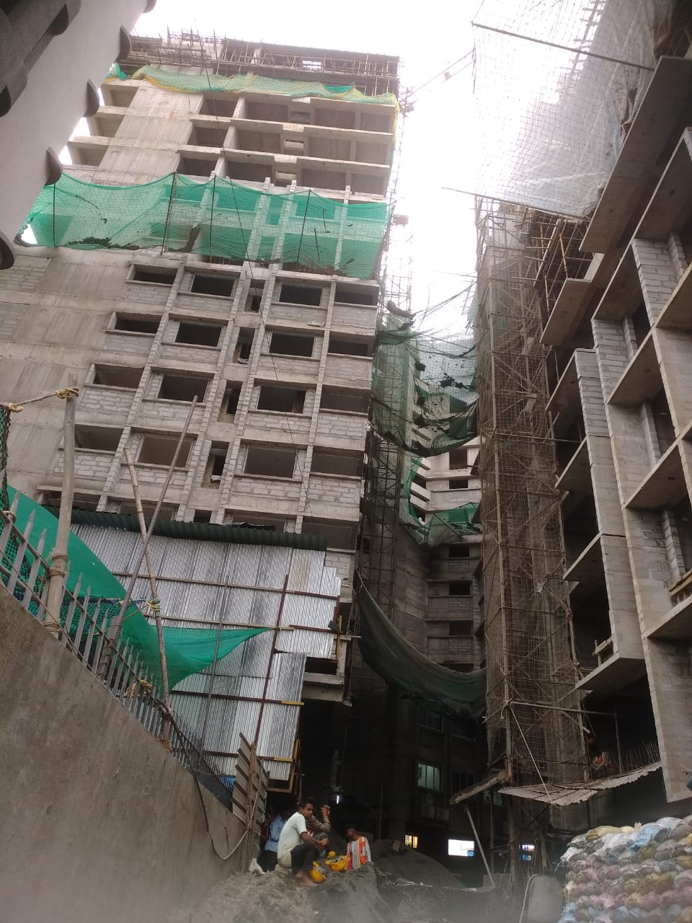
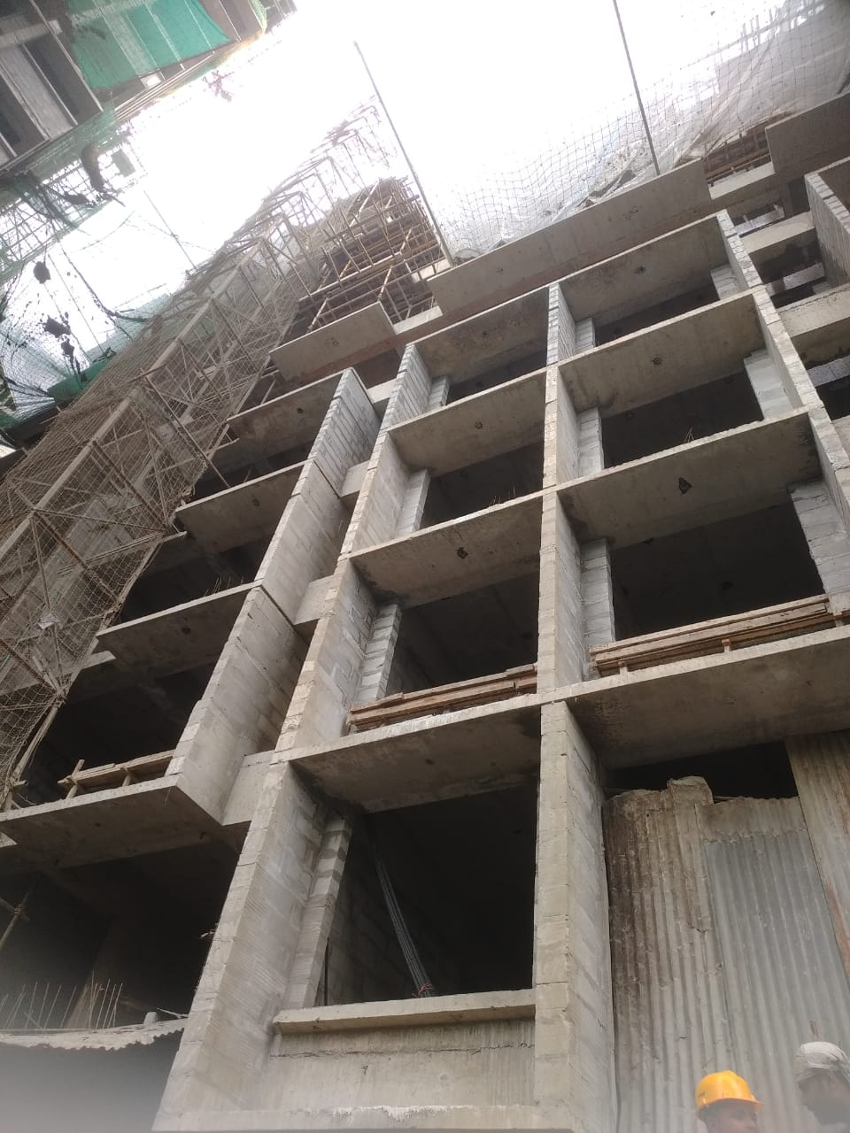
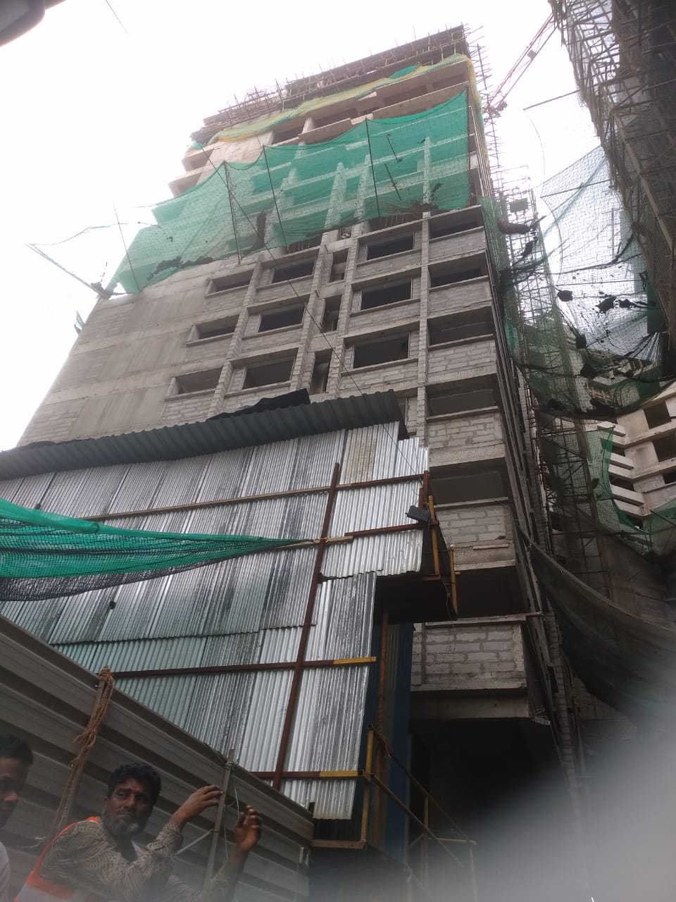
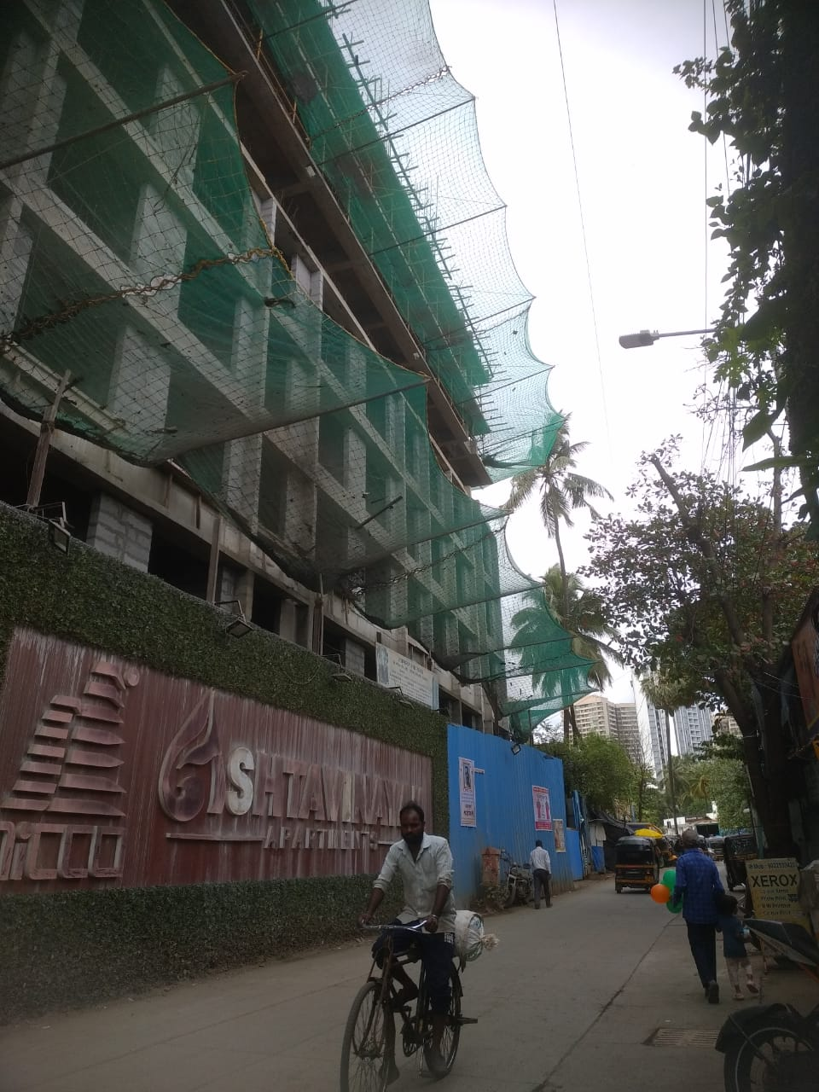
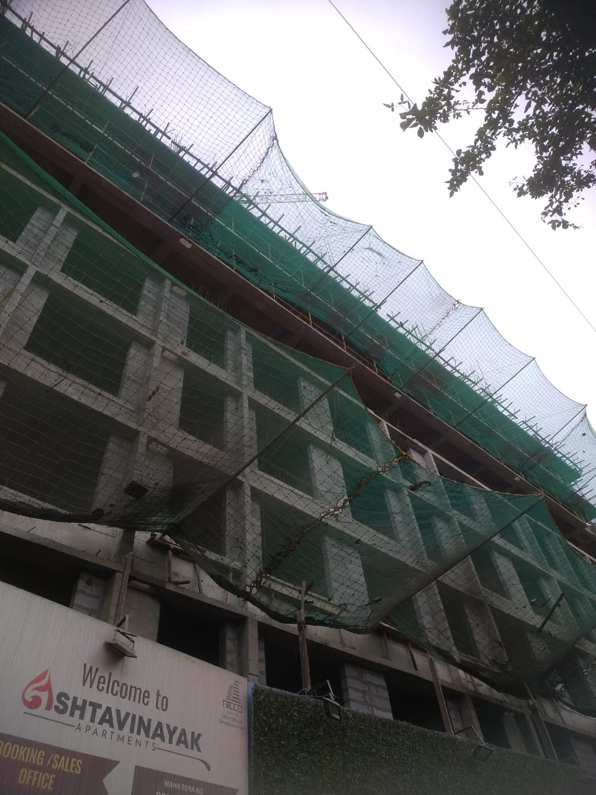
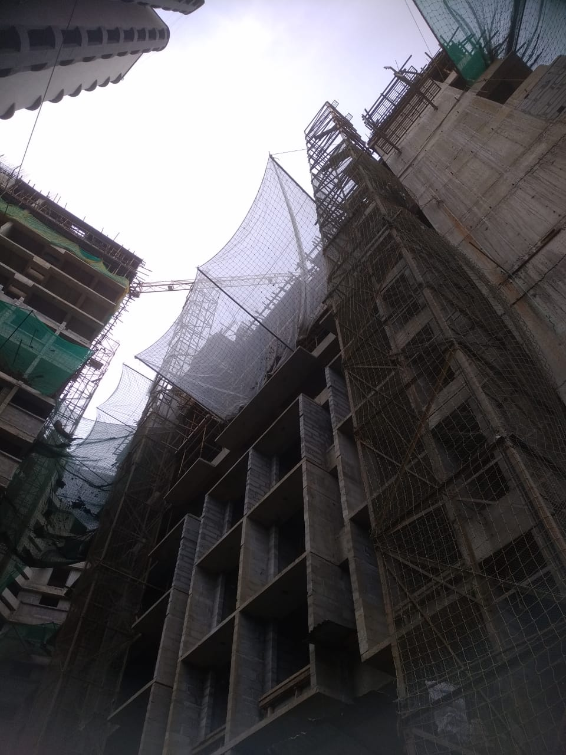
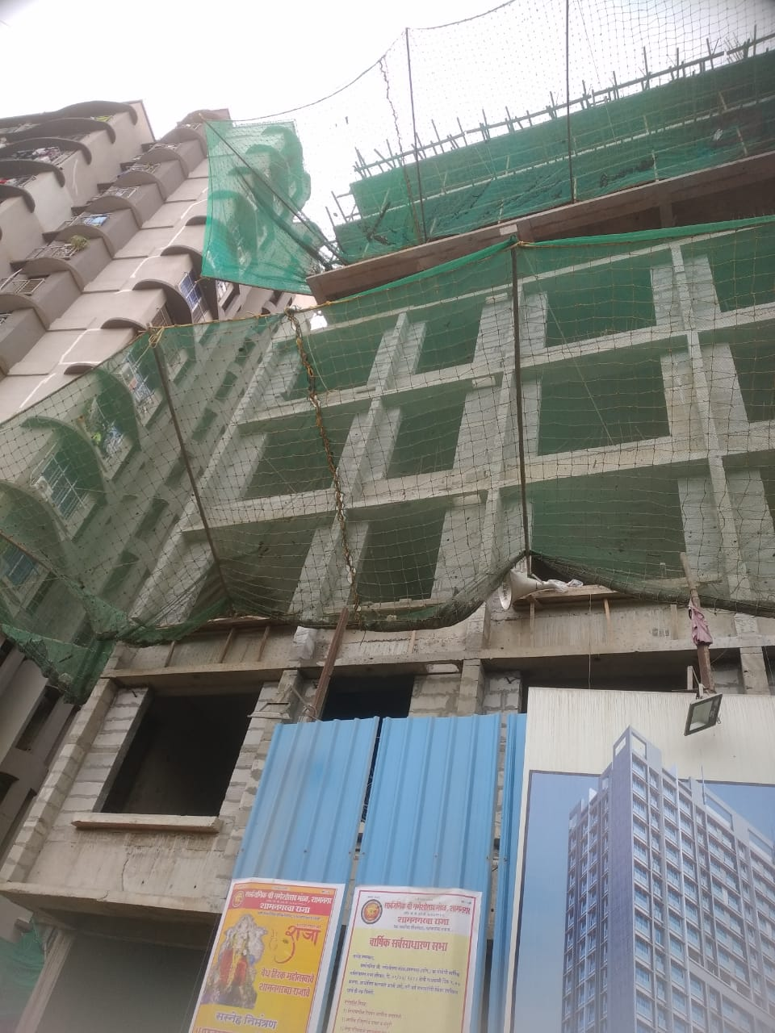
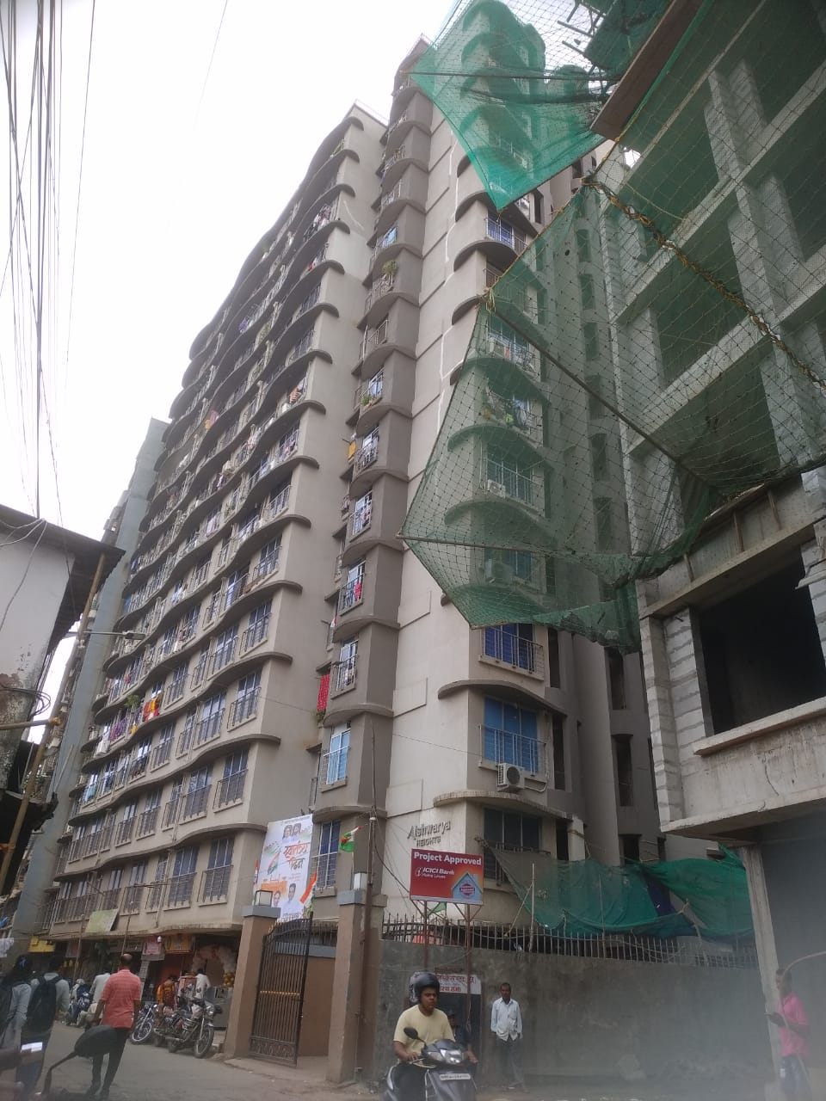

Disclaimer
This Techno Economic Viability (TEV) Report is submitted on the basis that this Report and its contents will be held in complete confidence. Accordingly, by accepting a copy of this report, the recipient agrees to keep its contents and any other information, which is disclosed to such recipient, confidential and shall not divulge, distribute or disseminate any information contained herein, in part or in full, without the prior written approval of Vastukala Consultants (India) Pvt. Ltd.

The Report has been prepared for private circulation as required by the State Bank of India (SBI) for evaluating the proposed ongoing Real estate project by Shiv Shruti Developers LLP. This report has been prepared on the basis of details provided by the company and discussions held with SSDL’s officials. The industry norms, studies and other information / documents obtained by Vastukala Consultants (India) Pvt. Ltd. from various sources available publicly, which Vastukala Consultants (India) Pvt. Ltd. believes to be reliable, were the basis of this report. Vastukala Consultants (India) Pvt. Ltd. has not carried out any independent verification for the truthfulness of the same. We have tried our best to independently verify the same. We have not checked the title clearance or the legality of the documents of the said property or the invoices / quotations of the machinery submitted by SSDL to us. The net worth of the promoters of the company has been provided to us and Vastukala Consultants (India) Pvt. Ltd. has not independently verified the same. This report is purely an opinion and has no legal or contractual obligation on our part. We have no direct or indirect interest in the company, its directors, their suppliers / vendors and / or the said project.

