Vastu/Nashik/08/2023/3462/2302316
30/01-462-RPSH
Date: 30.08.2023

To,
The Branch Manager
Union Bank of India
Deepali Nagar Branch, Nashik
Z. P. Colony, 21, Shirode Complex, Charwak Chowk,
Indira Nagar, Nashik, State – Maharashtra, Country – India.

Sub: Vetting of Extra Work

Sir,

With reference to above subject, we have evaluated the Extra Work for Residential Flat No. B-04, Second Floor, "Kamal Regency Apartment” Survey No. 10 / 4 / B [4/2], Plot No. 67 + 68, Near Sai Baba Temple, Ramkrishna Nagar, Makhamalabad - Mhasrul Link Road, Village – Makhamalabad, Taluka & District - Nashik, PIN Code – 422 003, State – Maharashtra, Country – India belongs to Name of Proposed Purchaser: Mr. Kunal Kishor Karanjkar & Mrs. Pooja Kunal Karanjkar. Name of Owner: M/S. Kamal Infrabuild Pvt. Ltd.

We have verified the rates quoted as per current market rates. Details of work and Extra Work considered as per copy of Agreement for Extra Work between Mr. Kunal Kishor Karanjkar (First Party) and Mr. Nilesh Rohitdas Mhaske (Second Party) received on dated 28.08.2023. The Extra Work amount is Rs. 3,15,000/- (Rupees Three Lakh Fifteen Thousand Only).

The said Cost Vetting Certificate is valid upto next 6 months Only.

Thanking you

Sincerely yours

Sharadkumar B. Chalikwar
Govt. Reg. Valuer
Chartered Engineer (India)
Reg. No. (N) CCIT/1-14/52/2008-09

Agreement for Extra Work
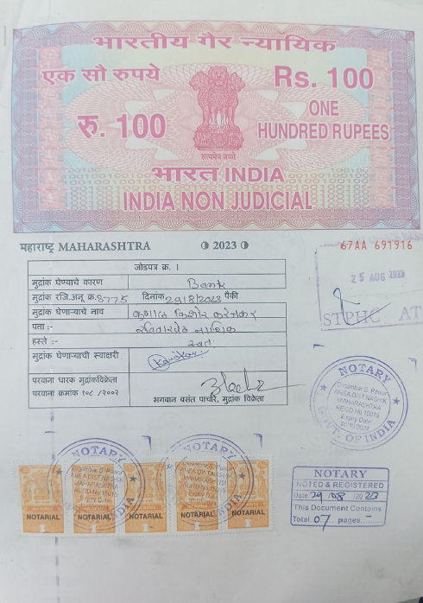
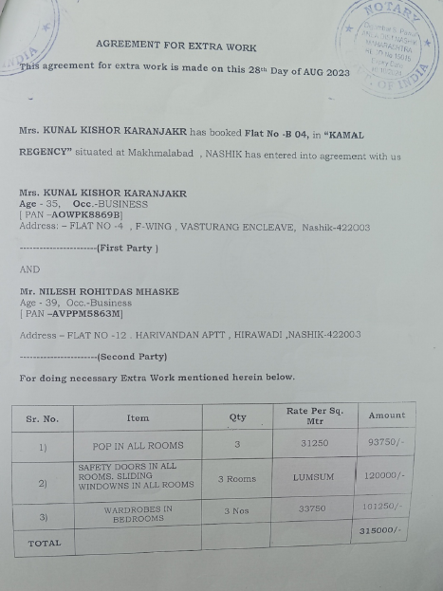

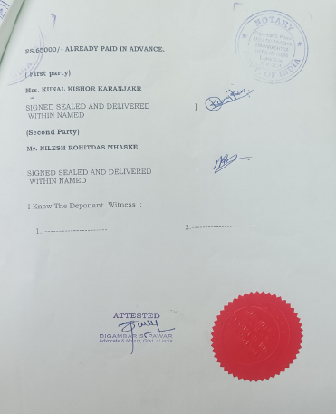

The Extra Amenities amount is Rs. 3,15,000/- (Rupees Three Lakh Fifteen Thousand Only).

