Vastu/Nashik/08/2023/3445/2302300
29/06-446-RPSH
Date: 29.08.2023

To,
The Branch Manager
Union Bank of India
Gangapur Road Branch
Shree Ganesh Avenue, Gangapur Road,
Nashik - 422 013, State – Maharashtra, Country – India

Sub: Vetting of Extra Amenities

Sir,

With reference to above subject, we have evaluated the Extra Amenities for Residential Land and Bungalow on Plot No. 14, “Dhanlaxmi Row Bungalow” Survey No. 42/5/B/ 14, Near Siddhi Vinayak Mandir, Shanti Nagar, Village – Makhmalabad-2, Taluka & District - Nashik, PIN Code – 422 003, State – Maharashtra, Country – India belongs to Name of Proposed Purchaser: Shri. Dharma Chhaju Rathod & Shri. Devidas Dharma Rathod. Name of Owner: Smt. Chandrikaben Rasikbhai Dashlani & Smt. Ranjanben Dilipbhai Vekaria.

We have verified the rates quoted as per current market rates. Details of work and Extra Amenities considered as per copy of Agreement for Extra Amenities between Shri. Dharma Chhaju Rathod & Shri. Devidas Dharma Rathod (First Party) and Shri. Dilipbhai Ravjibhai Vekaria (Second Party) received on dated 17.08.2023. The Extra Amenities amount is Rs. 3,00,000 /- (Rupees Three Lakh Only).

The said Cost Vetting Certificate is valid upto next 6 months Only.

Thanking you

Sincerely yours

Sharadkumar B. Chalikwar
Govt. Reg. Valuer
Chartered Engineer (India)
Reg. No. (N) CCIT/1-14/52/2008-09

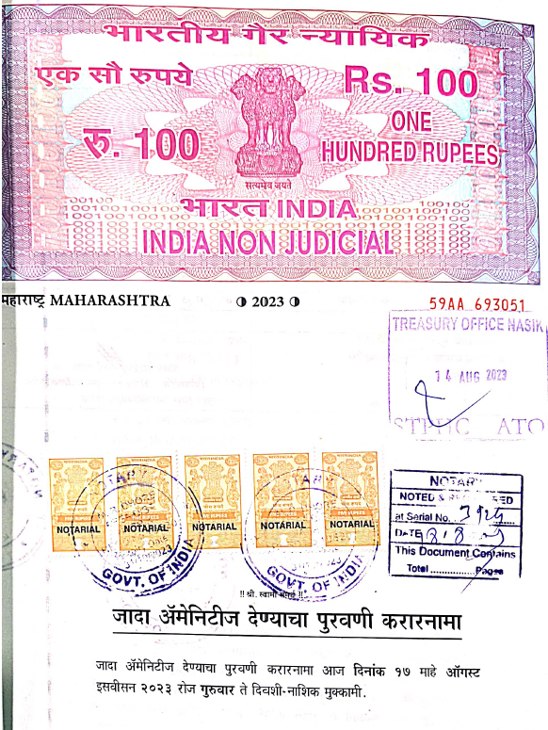
Agreement for Extra Amenities
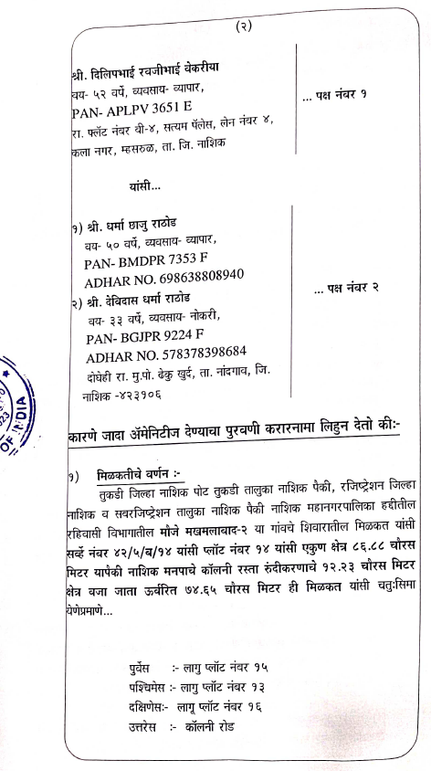

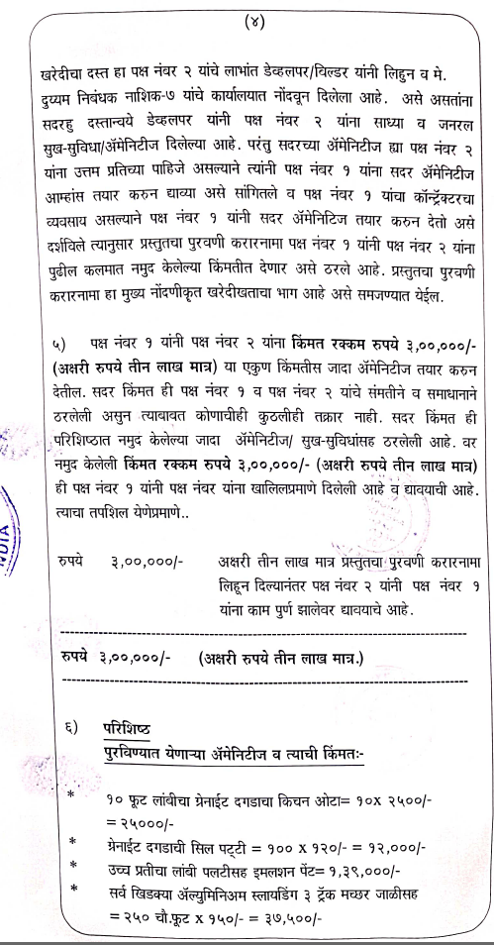
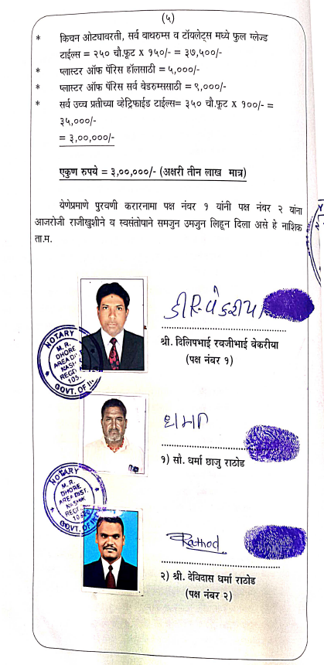

The Extra Amenities amount is Rs. 3,00,000 /- (Rupees Three Lakh Only).

