Valuation Report of the Immovable Property

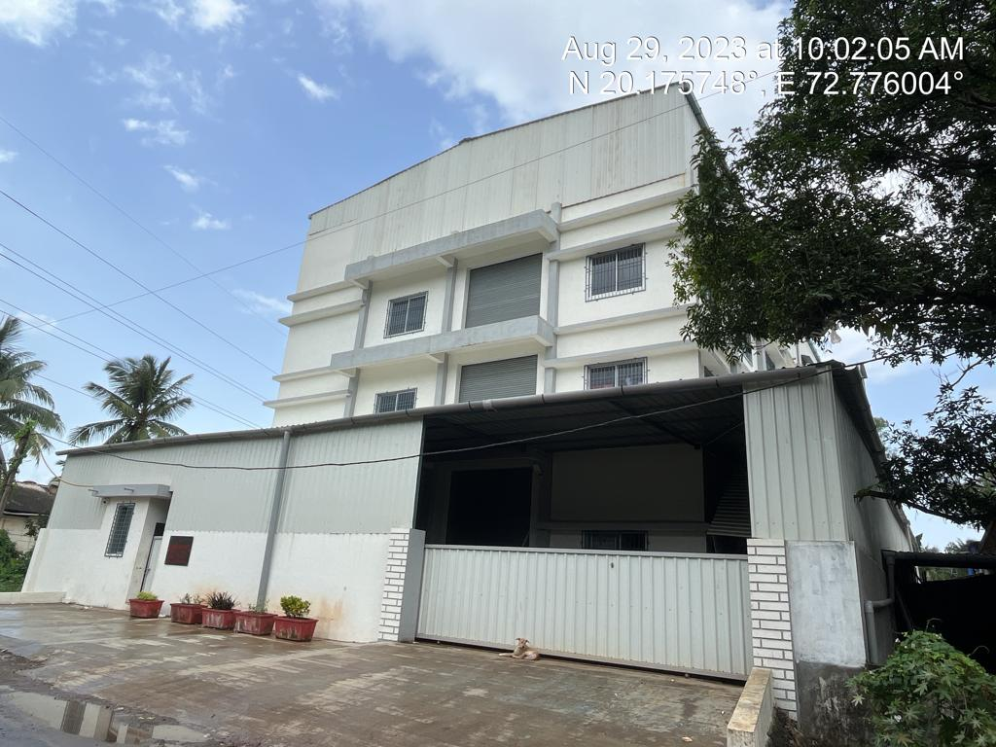

Details of the property under consideration:

Name of Owner: M/s. Punamiya Exim Pvt. Ltd.

Industrial Land & Building on Plot No. 828/A, Near Bharat Timber, "GIDC Industrial Area",
PO - Umbergaon, Taluka – Umbergaon, District – Valsad - 396171, State – Gujarat, Country – India

Latitude Longitude - 20°10'32.7"N 72°46'33.6"E

Valuation Done for:

Cosmos Bank
(Borivali MRO A-2) Branch
Shop No. 12 & 14, Mayfair, Ramdas Sutrale Marg, Opp. Chandawarkar Road, Borivali (West), Mumbai - 400 092, State – Maharashtra, Country – India

Vastu/Mumbai/08/2023/3440/2302331
31/06-477-VSU Date: 31.08.2023

VALUATION OPINION REPORT

The property bearing Industrial Land & Building on Plot No. 828/A, Near Bharat Timber, "GIDC Industrial Area", P O - Umbergaon, Taluka – Umbergaon, District – Valsad - 396171, State – Gujarat, Country – India belongs to M/s. Punamiya Exim Pvt. Ltd.

Boundaries of the property.
North | : | Internal Road
South | : | Plot No. C1 / 804
East | : | Plot No. C1 / 828
West | : | J Type shed and other units

Considering various parameters recorded, existing economic scenario, and the information that is available with reference to the development of neighborhood and method selected for valuation, we are of the opinion that, the property premises can be assessed and valued for banking purpose as below –
Particulars | Value (`)
Fair Market Value | 2,58,16,700.00
Realizable Value | 2,32,35,030.00
Distress Sale Value | 2.06,53,360.00
Insurance Value | 1,51,36,783.00

The valuation of the property is based on the documents produced by the concern. Legal aspects have not been taken into considerations while preparing this valuation report.

Hence certified

Sharadkumar B. Chalikwar
Govt. Reg. Valuer
Chartered Engineer (India)

Reg. No. (N) CCIT/1-14/52/2008-09

Encl: Valuation report in Form – 01

Industrial Land & Building on Plot No. 828/A, Near Bharat Timber, "GIDC Industrial Area", P O - Umbergaon,Taluka – Umbergaon District – Valsad - 396171, State – Gujarat, Country – India

Form 0-1

(See Rule 8 D)

REPORT OF VALUATION OF IMMOVABLE PROPERTY (OTHER THAN AGRICULTURAL LANDS, PLANTATIONS, FORESTS, MINES AND QUARRIES)

GENERAL:

1 | Purpose for which the valuation is made |  | To assess the Fair Market Value as on 31.08.2023 for Bank loan Purpose
2 | Date of inspection |  | 29.08.2023
 | Name of the owner/ owners |  | M/s. Punamiya Exim Pvt. Ltd.
4 | If the property is under joint ownership / co-ownership, share of each such owner. Are the shares undivided? |  | Pvt. Ltd. Co. Ownership
5 | Brief description of the property |  | Industrial Land & Building on Plot No. 828/A, Near Bharat Timber, "GIDC Industrial Area", P O - Umbergaon,Taluka – Umbergaon District – Valsad - 396171, State – Gujarat, Country – India
6 | Location, street, ward no |  | GIDC
7 | Survey/ Plot no. of land |  | Plot No. 828 / A
8 | Is the property situated in residential/ commercial/ mixed area/ industrial area? |  | Industrial area
9 | Classification of locality-high class/ middle class/poor class |  | Middle Class
10 | Proximity to civic amenities like schools, Hospitals, Offices, market, cinemas etc. |  | All the amenities are available in the vicinity
11 | Means and proximity to surface communication by which the locality is served |  | Served by Buses and Private cars
 | LAND
12 | Area of land supported by documentary proof. Shape, dimension and physical features |  | Plot area – 1,001.09 Sq. M.  (Area as per Lease Deed / Approved Plan)
13 | Roads, Streets or lanes on which the land is abutting |  | 16 M wide road
14 | If freehold or leasehold land |  | Leasehold
15 | If leasehold, the name of Lessor/lessee, nature of lease, date of commencement and termination of lease and terms of renewal of lease. |  | Lessor – GIDC  Lessee - M/s. Punamiya Exim Pvt. Ltd.  For the period of 99 years commencing from 31.01.1984. Balance lease period is 60 years.
 | (i) Initial premium |  | Details not available
 | (ii) Ground rent payable per annum |  | Details not available
 | (iii) Unearned increase payable to the Lessor in the event of sale or transfer |  | Details not available
16 | Is there any restriction covenant in regard to use of land? If so attach a copy of the covenant. |  | Industrial
17 | Are there any agreements of easements? If so, attach a copy of the covenant |  | Information not available
18 | Does the land fall in an area included in any Town Planning Scheme or any Development Plan of Government or any statutory body? If so, give Particulars. |  | GIDC
19 | Has any contribution been made towards development or is any demand for such contribution still outstanding? |  | Information not available
20 | Has the whole or part of the land been notified for acquisition by government or any statutory body? Give date of the notification. |  | No
21 | Attach a dimensioned site plan |  | Copy of Approve Plan dated 03.02.2022 issued by GIDC.
 | IMPROVEMENT
22 | Attach plans and elevations of all structures standing on the land and a lay-out plan. |  | Copy of Approve Plan dated 03.02.2022 issued by GIDC.
23 | Furnish technical details of the building on a separate sheet (The Annexure to this form may be used) |  | Attached
24 | Is the building owner occupied/tenanted/both? |  | Owner Occupied
 | If the property owner occupied, specify portion and extent of area under owner-occupation |  | Owner Occupied
25 | What is the Floor Space Index permissible and Percentage actually utilized? |  | As per Approved Plan  Particulars Permissible F.S.I. Consumed F.S.I.  Plot No.828/A 1396.63 Sq. M. (1396.63/1001.09) = 1.395
26 | RENTS
 | (i) | Names of tenants/ lessees/ licensees, etc. | N.A.
 | (ii) | Portions in their occupation | N.A.
 | (iii) | Monthly or annual rent/ compensation / license fee, etc. paid by each | N.A.
 | (iv) | Information not available | N.A.
27 | Are any of the occupants related to, or close to business associates of the owner? |  | N.A.
28 | Is separate amount being recovered for the use of fixtures, like fans, geysers, refrigerators, cooking ranges, built-in wardrobes, etc. or for services charges? If so, give details |  | N.A.
29 | Give details of the water and electricity charges, if any, to be borne by the owner |  | Information not available
30 | Has the tenant to bear the whole or part of the cost repairs and maintenance? Give particulars |  | N.A.
31 | If a lift is installed, who is to bear the cost of maintenance and operation- owner or tenant? |  | N.A.
32 | If a pump is installed, who is to bear the cost of maintenance and operation- owner or tenant? |  | N.A.
33 | Who has to bear the cost of electricity charges for lighting of common space like entrance hall, stairs, passage, compound, etc. owner or tenant? |  | N.A.
34 | What is the amount of property tax? Who is to bear it? Give details with documentary proof |  | Information not available
35 | Is the building insured? If so, give the policy no., amount for which it is insured and the annual premium |  | Information not available
36 | Is any dispute between landlord and tenant regarding rent pending in a court of rent? |  | N.A.
37 | Has any standard rent been fixed for the premises under any law relating to the control of rent? |  | As per G.I.D.C. norms
 | SALES
38 | Give instances of sales of immovable property in the locality on a separate sheet, indicating the Name and address of the property, registration No., sale price and area of land sold. |  | As per sub registrar of assurance
39 | Land rate adopted in this valuation |  | ` 8,000.00 Per Sq. M.
40 | If sale instances are not available or not relied up on, the basis of arriving at the land rate |  | Online Price Indicators, Location, development of surrounding area, type of land and construction, construction specifications, age of building, condition of the premises & building, facilities provided and its prevailing market rate.
 | COST OF CONSTRUCTION
41 | Year of commencement of construction and year of completion |  | Items Year Of Const.  RCC Factory Building  Ground Floor 2022  First Floor 2022  Security Cabin 2022  (As per Approved Plan)
42 | What was the method of construction, by contract / By employing Labour directly / both? |  | Information Not available
43 | For items of work done on contract, produce copies of agreements |  | Information Not available
44 | For items of work done by engaging Labour directly, give basic rates of materials and Labour supported by documentary proof. |  | Information Not available

PART II- VALUATION

GENERAL:
Under the instruction of Cosmos Bank, Borivali MRO A – 2, to assess fair market value as on 31st August 2023 for Industrial Land & Building on Plot No. 828/A, Near Bharat Timber, "GIDC Industrial Area", P O - Umbergaon, Taluka – Umbergaon District – Valsad - 396171, State – Gujarat, Country – India belongs to M/s. Punamiya Exim Pvt. Ltd.

We are in receipt of the following documents:
Copy of Final Agreement for Sale dated 21.07.2023 (Notary) between M/s. Bajj Infra (Vendor) and M/s. Punamiya Exim Pvt. Ltd. (Purchaser).
Copy of Lease Deed dated 17.08.2023 between GIDC (Lessor) and M/s. Punamiya Exim Pvt. Ltd. (Lessee).
Copy of Approve Plan dated 03.02.2022 issued by GIDC.
Copy of Approval Letter for Plan vide No. GIDC / XEN / VA / 001175 dated 16.02.2022 issued by GIDC.

Land:
The plot under valuation is leasehold industrial plot of GIDC. It is on lease for the period of 99 years commencing from 31.01.1984. Balance lease period is 60 years. It is at 1.6 KM. travel distance from Umbergaon Railway station.
As per Approved Plan & Lease Deed the Plot area is 1,001.09 Sq. M. which is considered for valuation.

Structure:
As per actual site there is RCC Ground + 2 upper floor factory building with provision for 1 lift.

Particulars | Approx. Height  In M. | Carpet area as per site measurement  (Sq. M.)
Factory building
Lift & working area |  | 5,310.00
First |  | 5,310.00
Second |  | 5,310.00
Toilet |  | 72.00
Security Cabin | 7’ | 53.55
Mezzanine at ground |  | 524.74

The factory is finished partly vitrified tiles flooring. 6" thick B. B. Masonry internal walls with cement plastering. Amenities such as Power coated sliding windows, Glass Wooden frame door with M. S. Rolling Shutter, Partly industrial and Partly Concealed type Wiring and plumbing.

As per Approved Plan, the construction area as under and considered for valuation –

Particulars | Built up Area in Sq. M.
Factory building – Ground + 2 upper floors | 1,478.79
Security cabin | 6.25

Valuation as on 31st August 2023:
- Land Valuation
Particulars | Area in Sq. M. | Rate per Sq. M. | Value in `
Plot No. 828/A | 1,001.09 | 8,000.00 | 80,08,720.00
Total |  |  | 80,08,720.00

- Valuation of Structures.
The Built-up area of the building : As per valuation table below
Deduct Depreciation:
Year of Construction of the building : As mentioned below
Expected total life of building : As mentioned below
Age of the building as on 2023 : As mentioned below
Particulars | Year of Construction | Expected total life of building | Age of the building as on 2023
Factory building – Ground + 2 upper floors | 2022 | 59 Years | 1 Year
Security cabin | 2022 | 59 Years | 1 Year

Cost of Construction : As per valuation table below
Depreciation : As per valuation table below
Amount of depreciation : As per valuation table below
Depreciated cost of construction : As per valuation table below

Particulars | Built up Area in  Sq. M. | Estimated Replacement Rate in ` | Depreciated Replacement Rate in ` | Depreciated Replacement Value in `
Factory building – Ground + 2 upper floors | 1,478.79 | 12,000.00 | Nil | 1,77,45,480.00
Security cabin | 6.25 | 10,000.00 | Nil | 62,500.00
Total |  |  | TOTAL | 1,78,07,980.00

GUIDELINE VALUE:
G.I.D.C. Circle Rate for Land per Sq. M. | ` 1,990.00

Particulars | Value (`)
Plot area | 1,001.09
Rate per Sq. M. | 1,990.00
Land Value | 19,92,169.00
Building Value (As per valuation table) | 1,78,07,980.00
TOTAL | 1,98,00,149.00

TOTAL VALUE OF THE PROPERTY:
Particulars | Value (`)
Land | 80,08,720.00
Buildings | 1,78,07,980.00
Fair Market Value | 2,58,16,700.00
Realizable Value | 2,32,35,030.00
Distress Sale Value | 2.06,53,360.00
Insurance Value | 1,51,36,783.00

Taking into consideration above said facts, we can evaluate the value of Industrial Land & Building on Plot No. 828/A, Near Bharat Timber, "GIDC Industrial Area", P O - Umbergaon, Taluka – Umbergaon District – Valsad - 396171, State – Gujarat, Country – India for this particular purpose at ` 2,58,16,700.00 (Amount in words Rupees Two Crore Fifty Eight Lakh Sixteen Thousand Seven Hundred Only) as on 31st August 2023.

NOTES

I, Sharadkumar B. Chalikwar with my experience and ability to judgment I am of the considered opinion that the fair market value of the property as on 31st August 2023 is ` 2,58,16,700.00 (Amount in words Rupees Two Crore Fifty Eight Lakh Sixteen Thousand Seven Hundred Only).

Value varies with time and purpose and hence this value should not be referred for any purpose other than mentioned in this report.

This valuation is done on the basis of information, which the valuer has obtained by information provided by the client about the premises and location of the surrounding area and also prevailing rates in the surrounding area, and further subject to document as mentioned in valuation report.

This valuer should not be held responsible for authentication of documents, clear title and other such related matters. For that purpose, Latest Legal Opinion should be sought.

PART III- DECLARATION

I hereby declare that

The information furnished in part I is true and correct to the best of my knowledge and belief;

I have no direct or indirect interest in the property valued:

ANNEXURE TO FORM 0-1

Technical details Main Building
1. | No. of floors and height of each floor | As per brief description
2. | Plinth area floor wise as per IS- 1225 | Plot Area = 1,001.09 Sq. M.  Structure - As per valuation table
3 | Year of construction | Year - 2022  (As per Approved Plan)
4 | Estimated future life | 59 Years Subject to proper, preventive periodic maintenance and structural repairs.
5 | Type of construction- load bearing walls/RCC frame/ steel frame | As per brief description
6 | Type of foundations | R.C.C. with AC sheet roofing
7 | Walls | All external walls are 9” thick and partition walls are 6” thick.
8 | Partitions | 6” thick brick wall
9 | Doors and Windows | As per brief description
10 | Flooring | As per brief description
11 | Finishing | Internal walls are finished with Neeru Finish. External walls are finished with sand faced plaster.
12 | Roofing and terracing | RCC slabs and A.C. sheet roofing on top
13 | Special architectural or decorative features, if any | No
14 | (i) Internal wiring – surface or conduit  (ii) Class of fittings: Superior/ Ordinary/ Poor. | Partly Concealed wiring and Partly Open Industrial type wiring  Ordinary
15 | Sanitary installations  (i) No. of water closets  (ii) No. of lavatory basins  (iii) No. of urinals  (iv) No. of sinks  Class of fittings: Superior colored / superior white/ordinary. | As per requirement having ordinary class of fitting
16 | Compound wall  Height and length  Type of construction | Compound wall of R.C.C. columns with Brick Masonry wall
17 | No. of lifts and capacity | Provision for 1 lift
18 | Underground sump – capacity and type of construction | R.C.C.
19 | Over-head tank Location, capacity Type of construction | R.C.C.
20 | Pumps- no. and their horse power | Information not available
21 | Roads and paving within the compound approximate area and type of paving | Concrete cement finish in open spaces, etc.
22 | Sewage disposal – whereas connected to public sewers, if septic tanks provided, no. and capacity | Connected to G.I.D.C. sewer line
23 | General Remarks
 | For the purpose of valuation, we have considered the Plot area and constructed area as per Approved Plan.

Actual site photographs

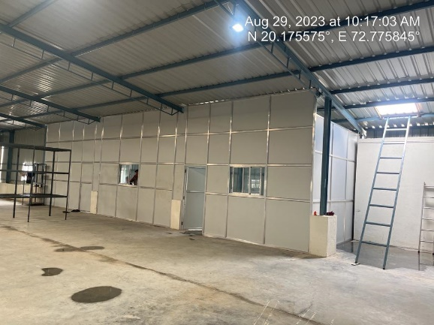
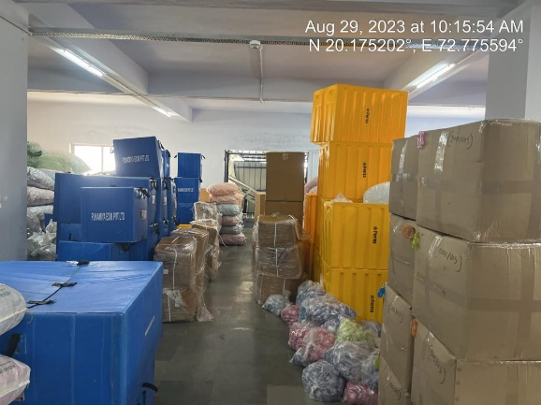

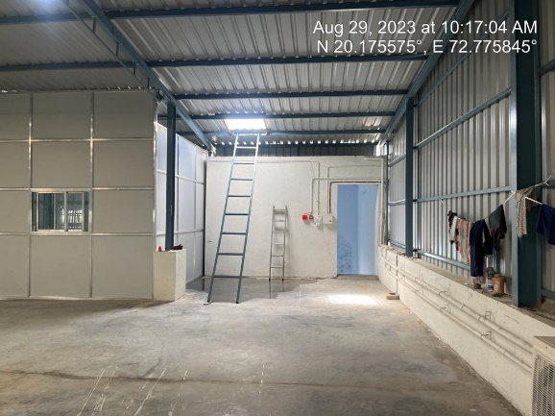
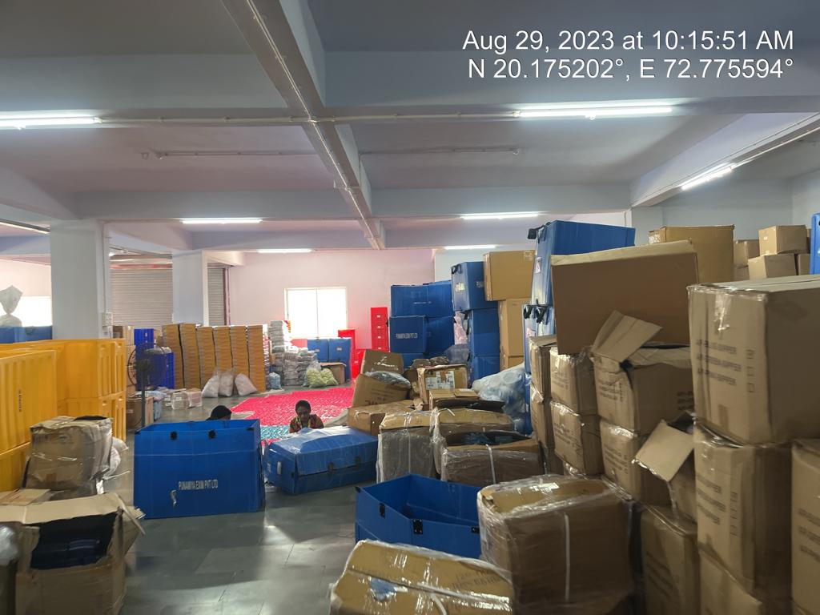

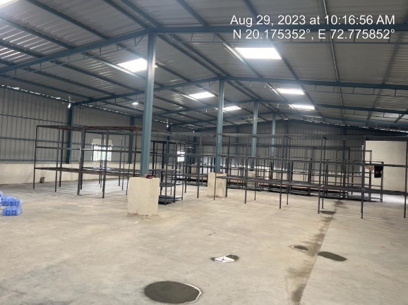
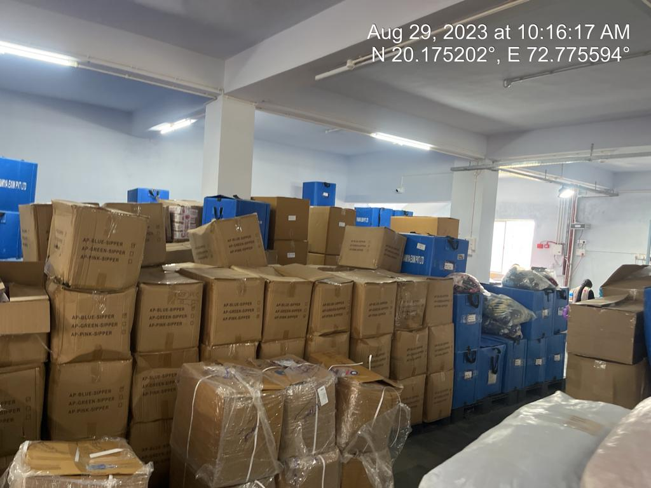

Actual site photographs

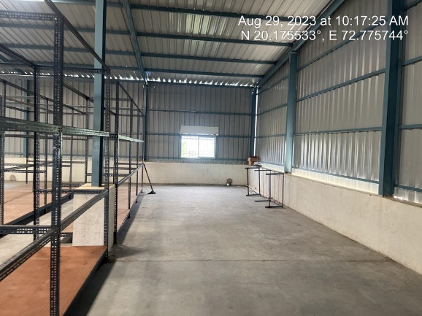
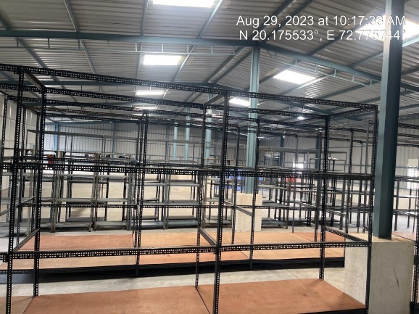
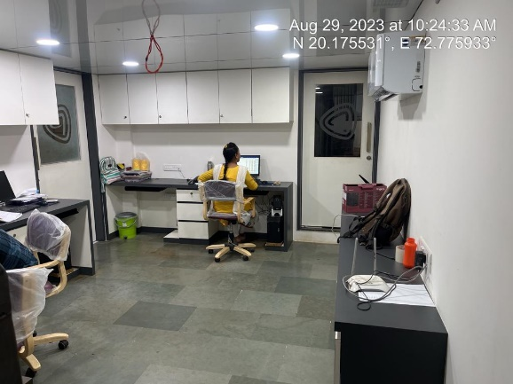
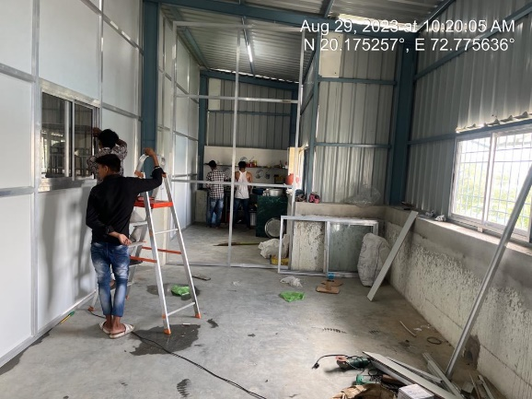
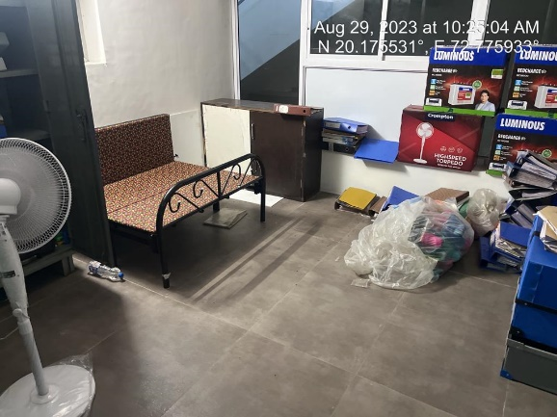
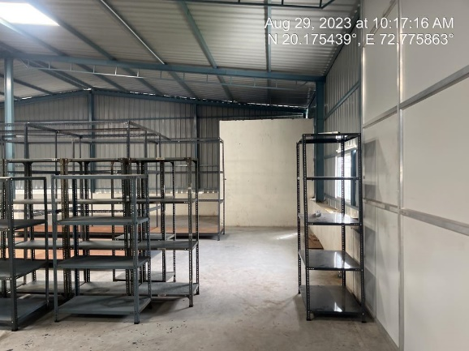
Actual site photographs

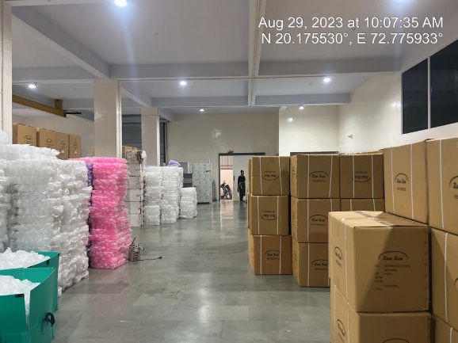
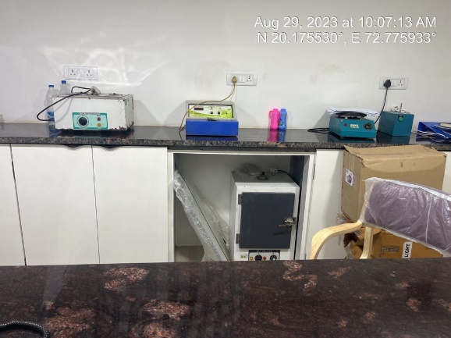
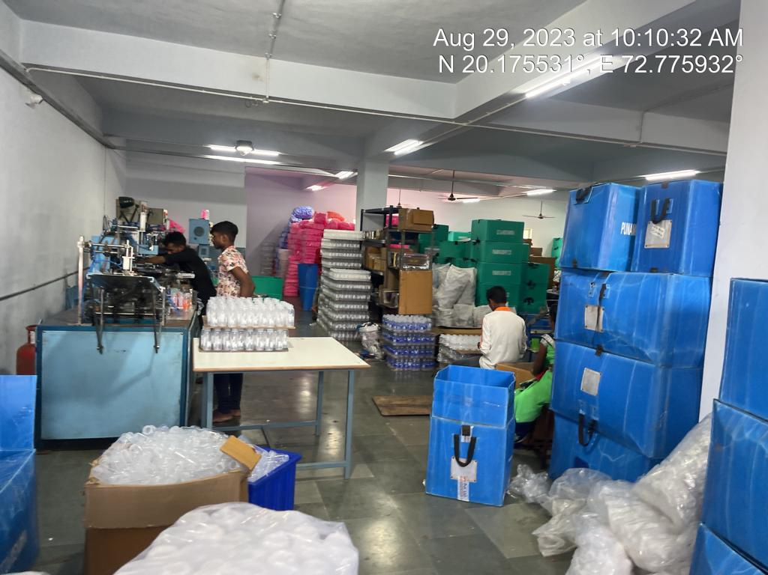
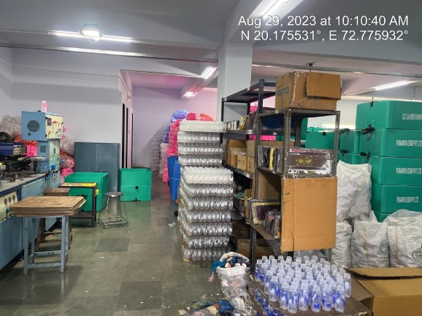
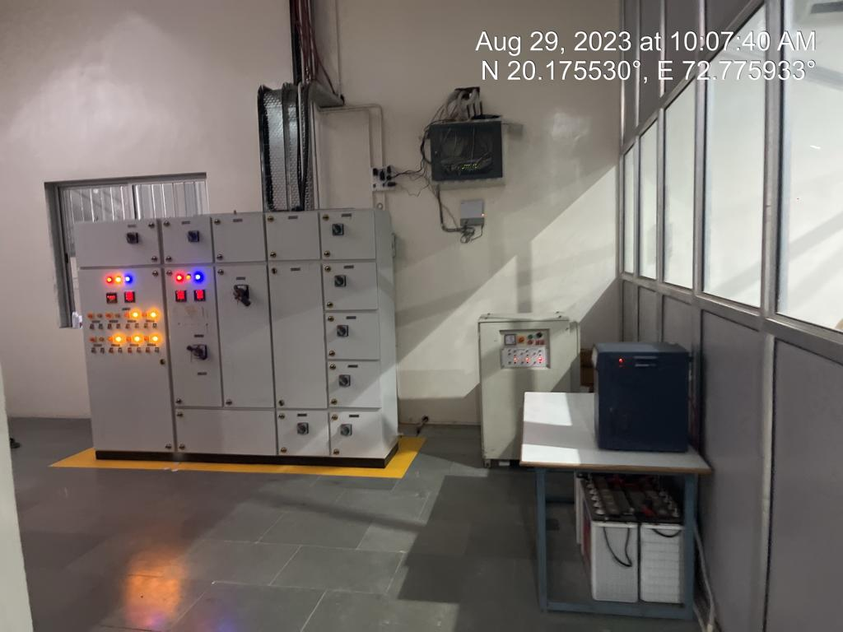
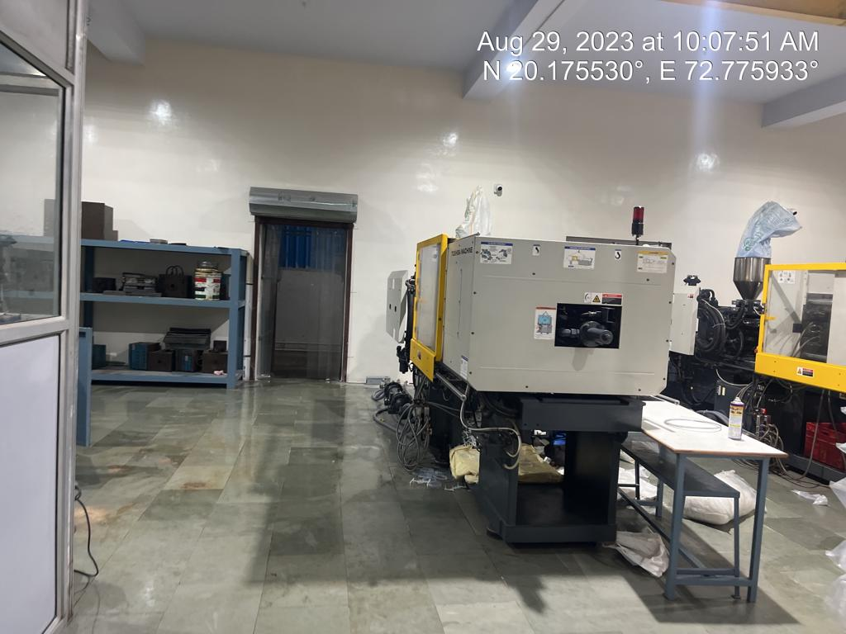
Actual site photographs

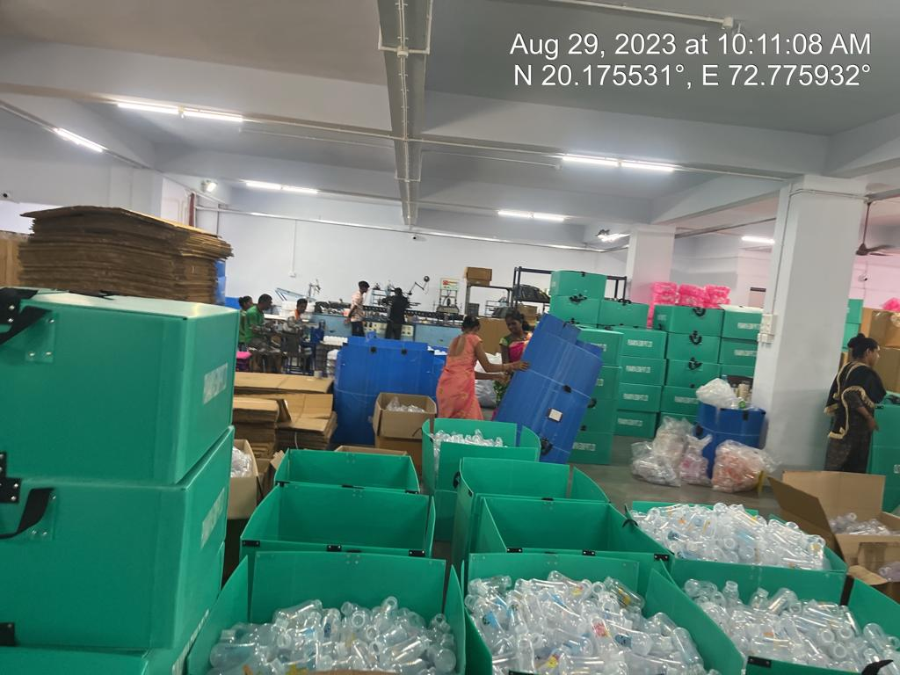
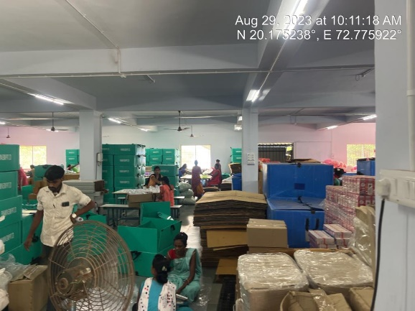
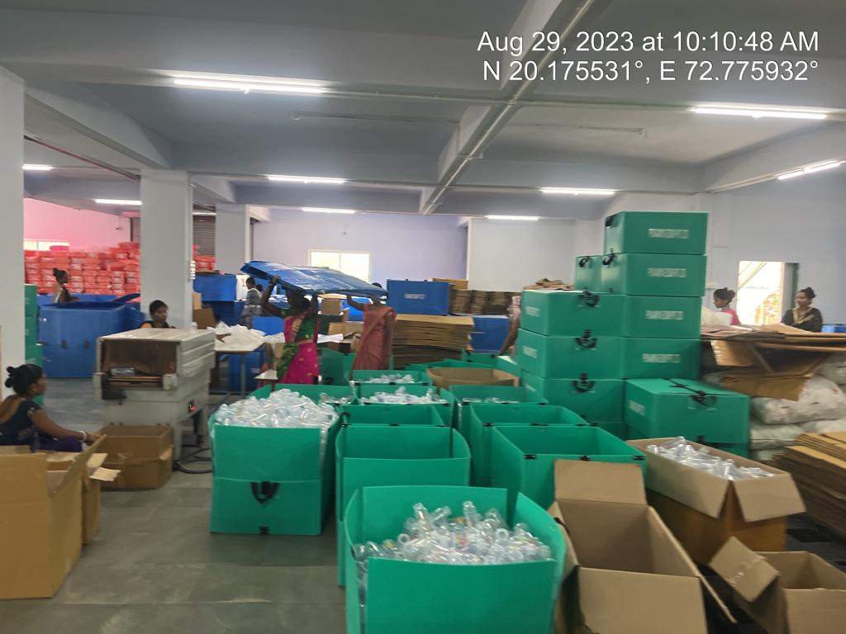
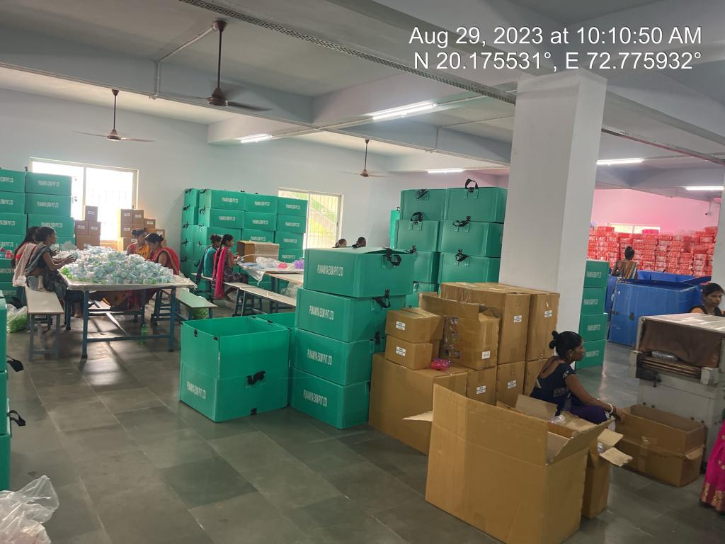
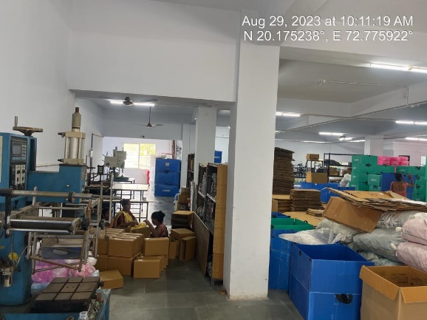
Actual site photographs

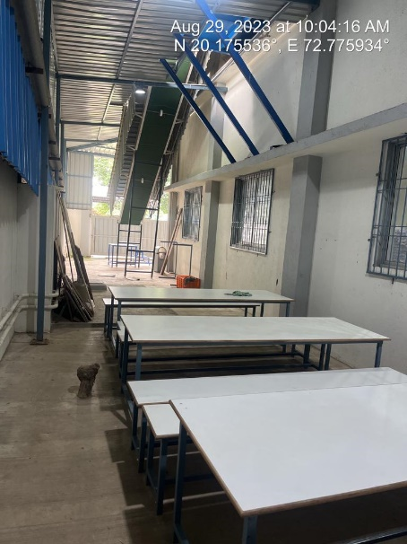
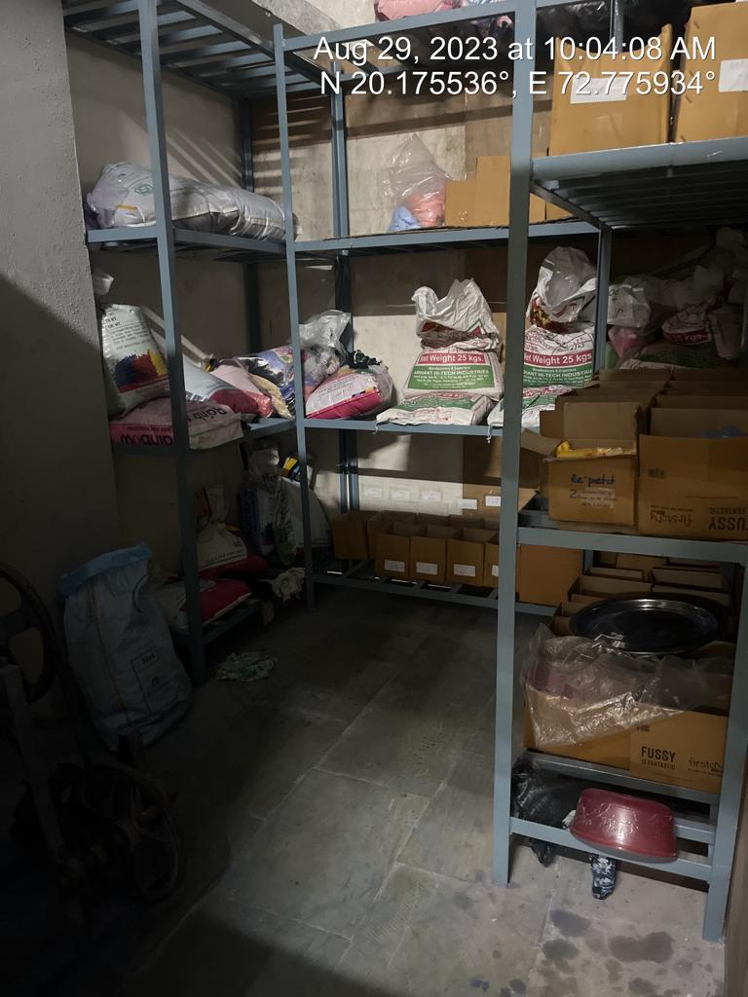
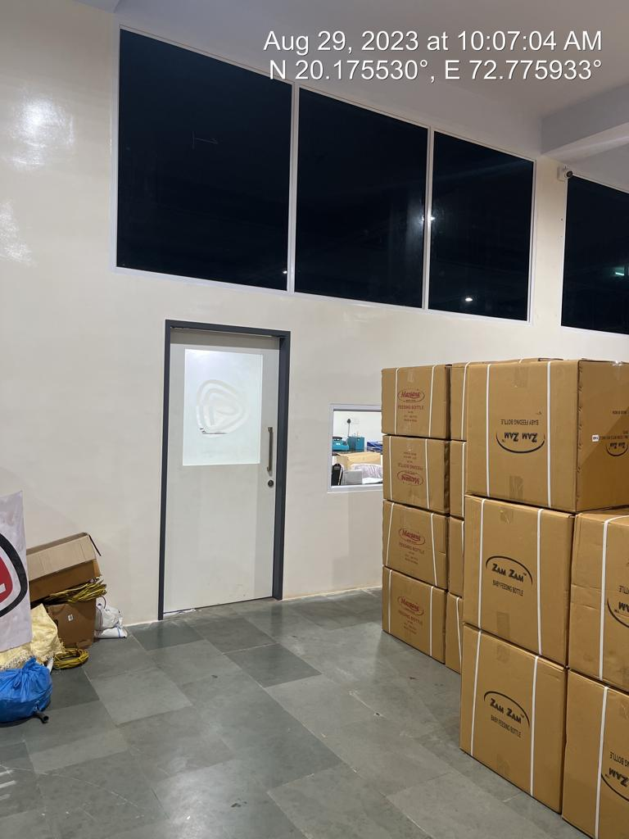
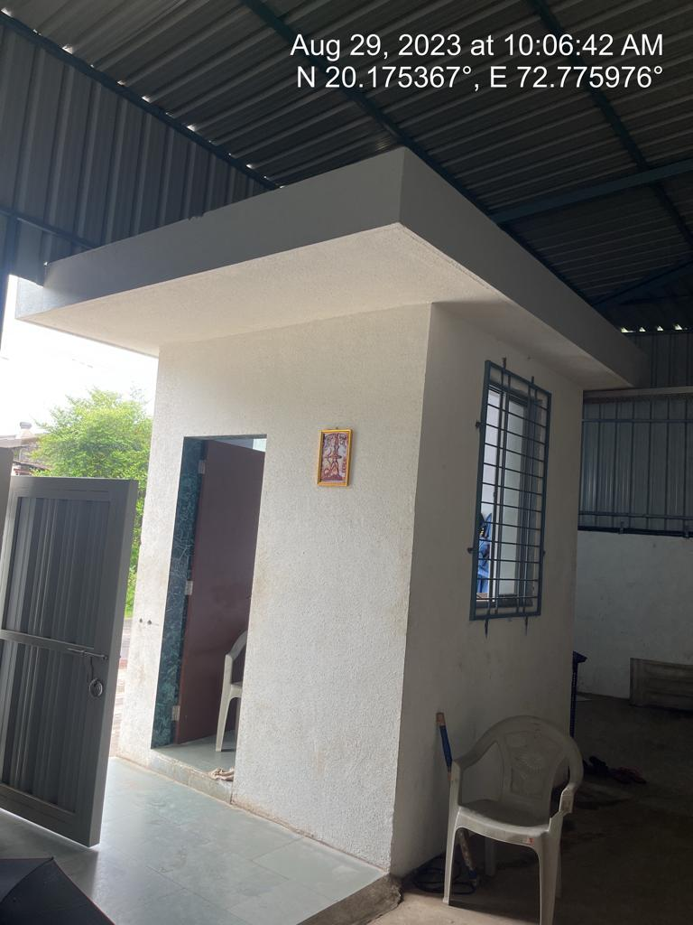
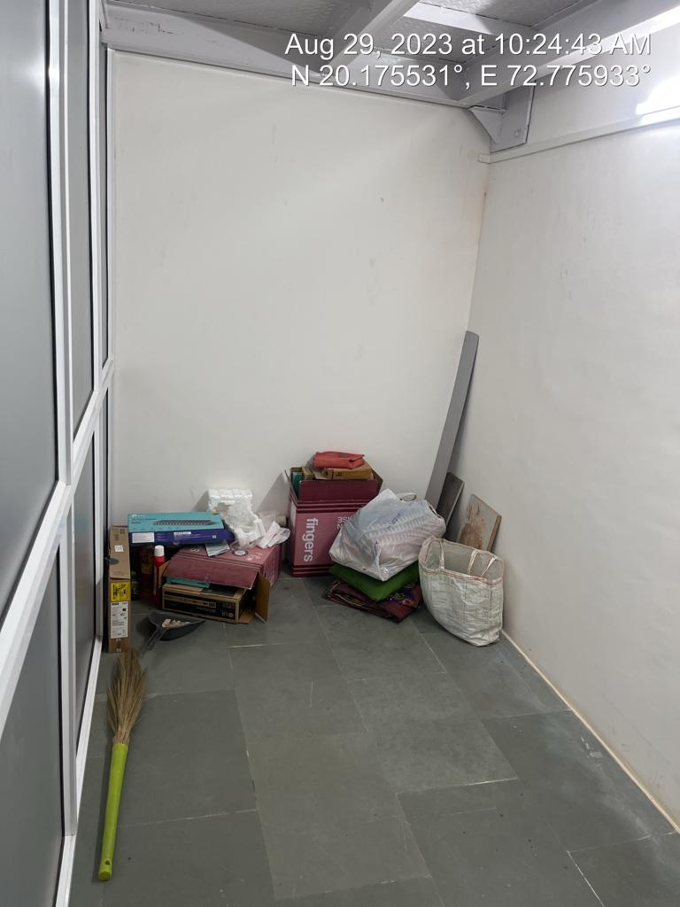
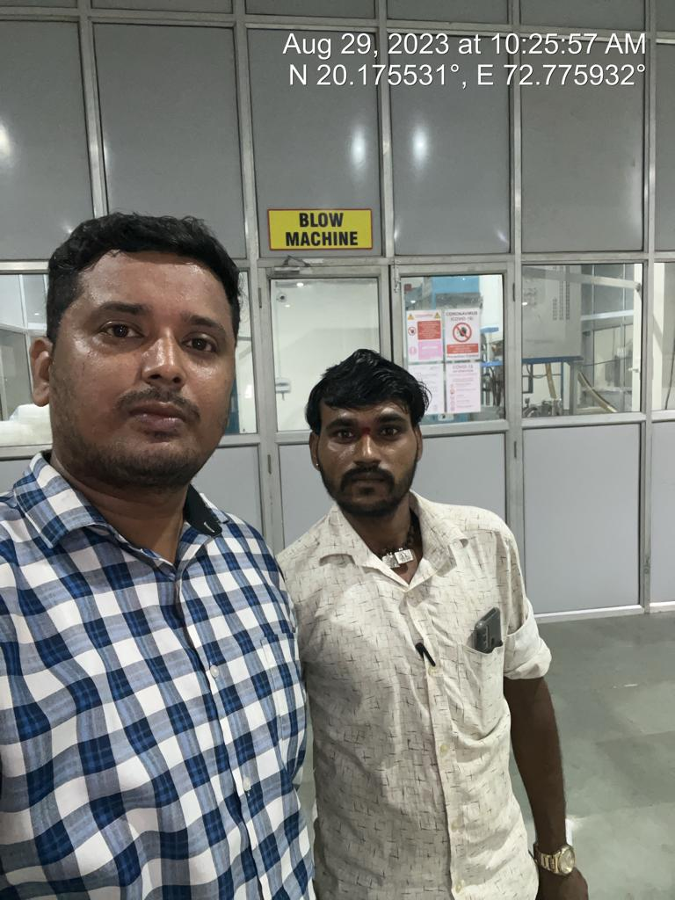
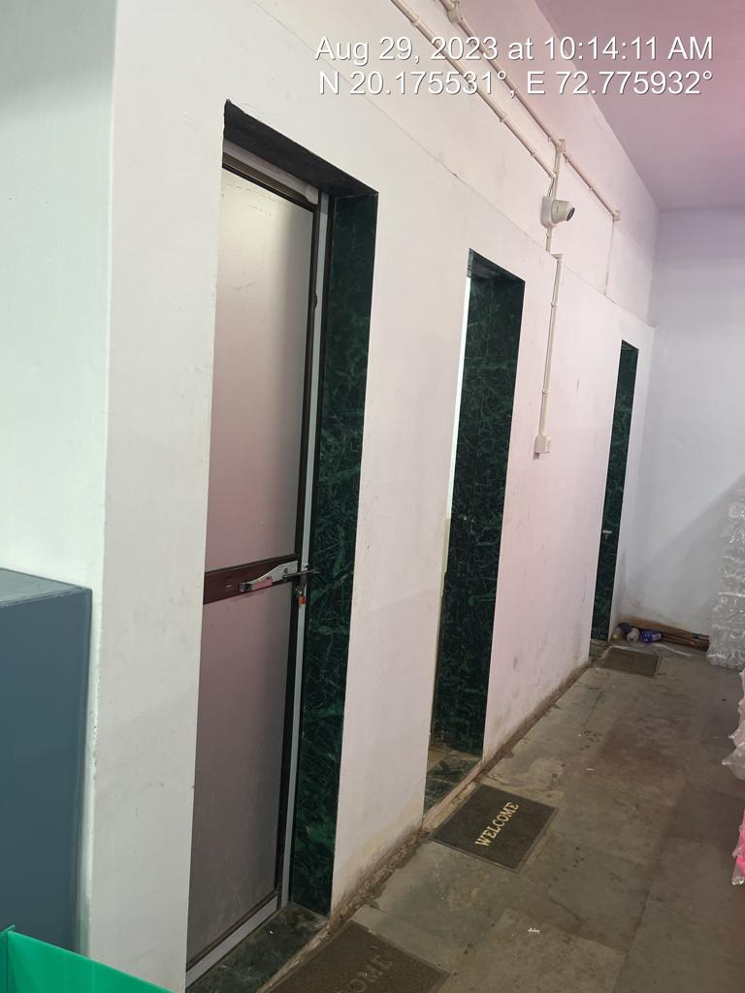
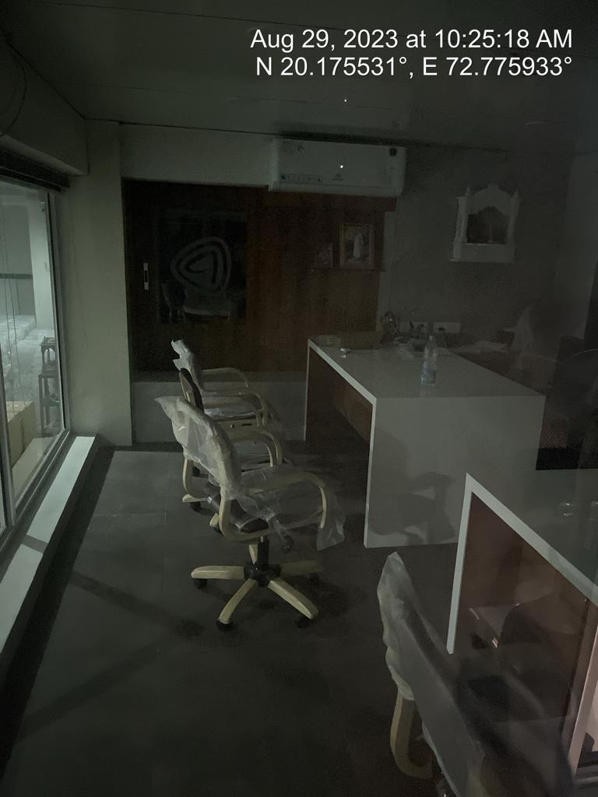
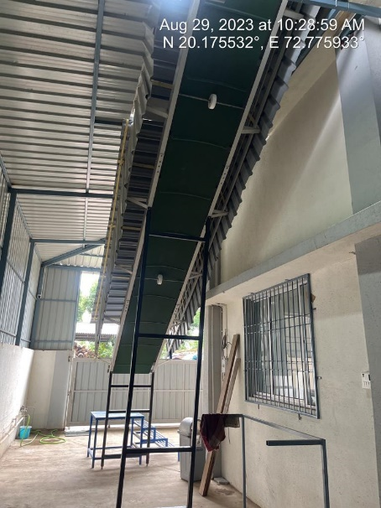
Actual site photographs
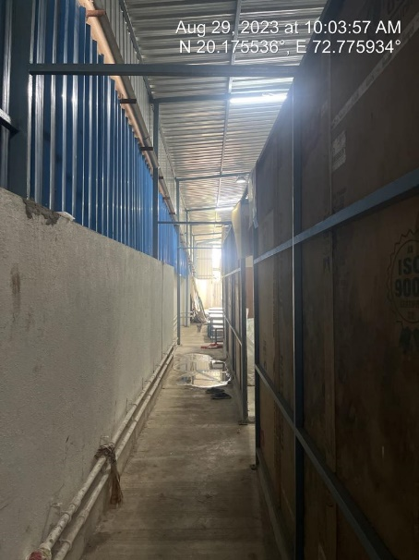
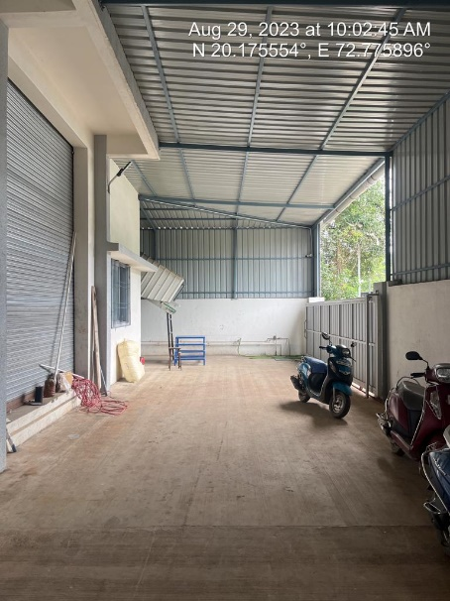
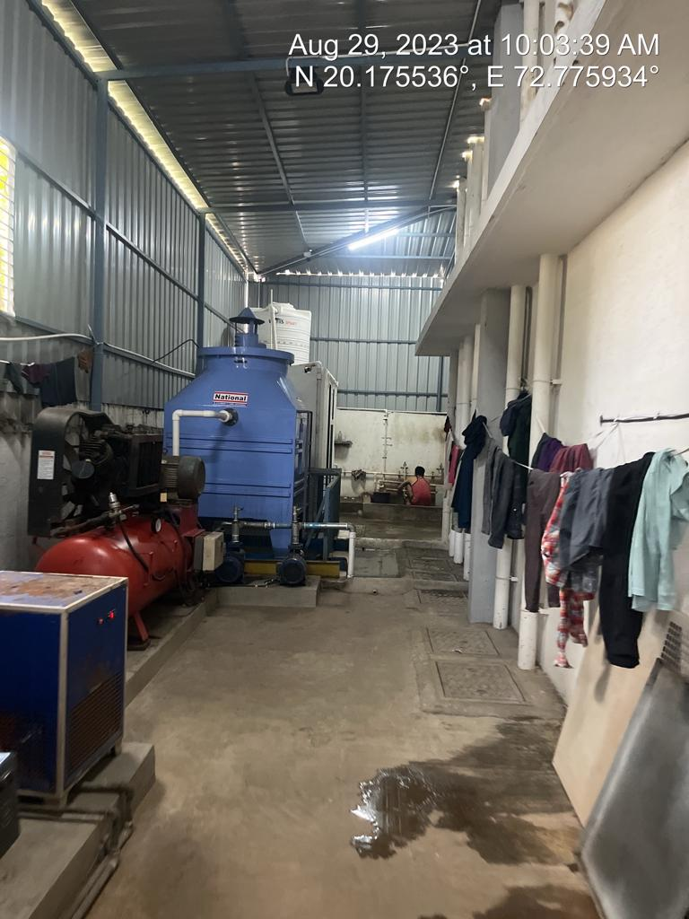

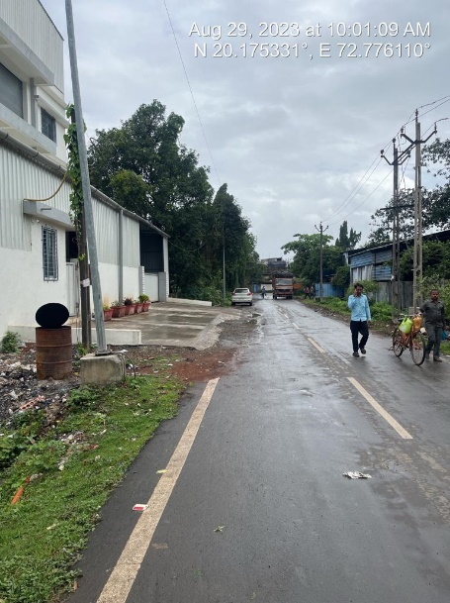
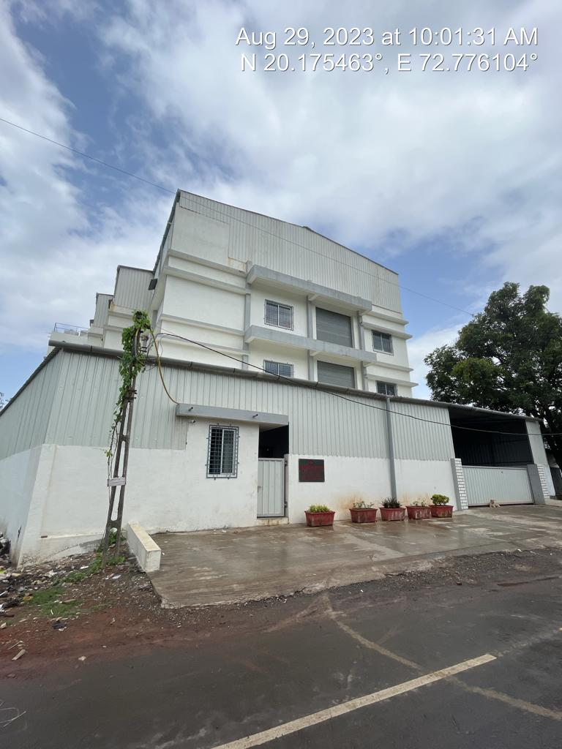
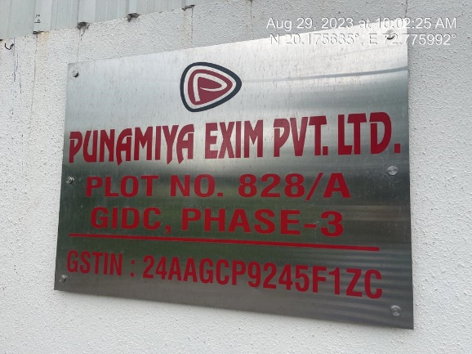
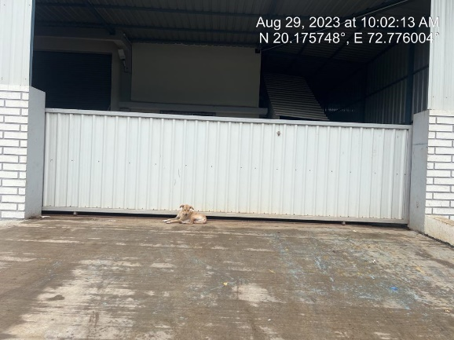
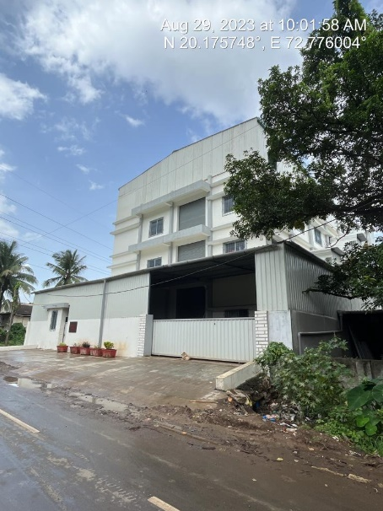
Route Map of the property
Site u/r
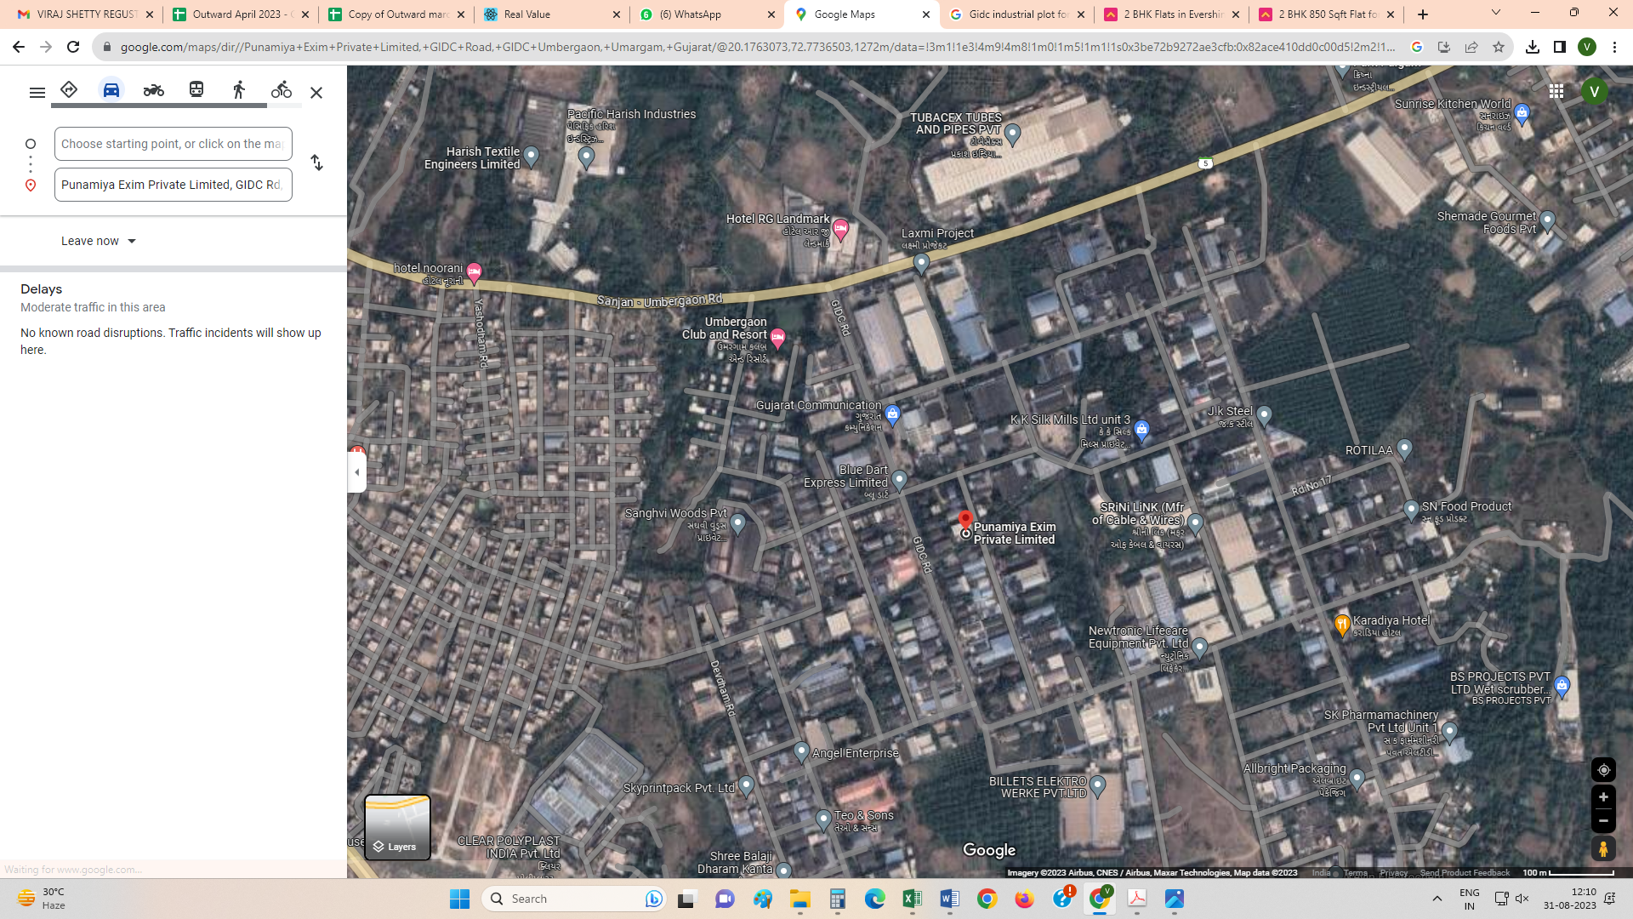

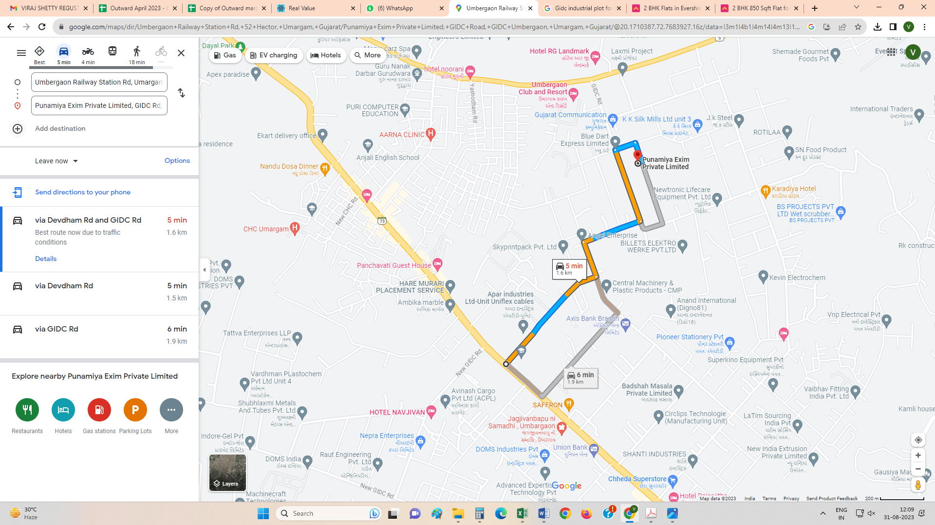

Latitude Longitude - 20°10'32.7"N 72°46'33.6"E

Note: The Blue line shows the route to site from nearest Railway Station (Umbergaon – 1.4 KM.)

G.I.D.C. CIRCLE RATE
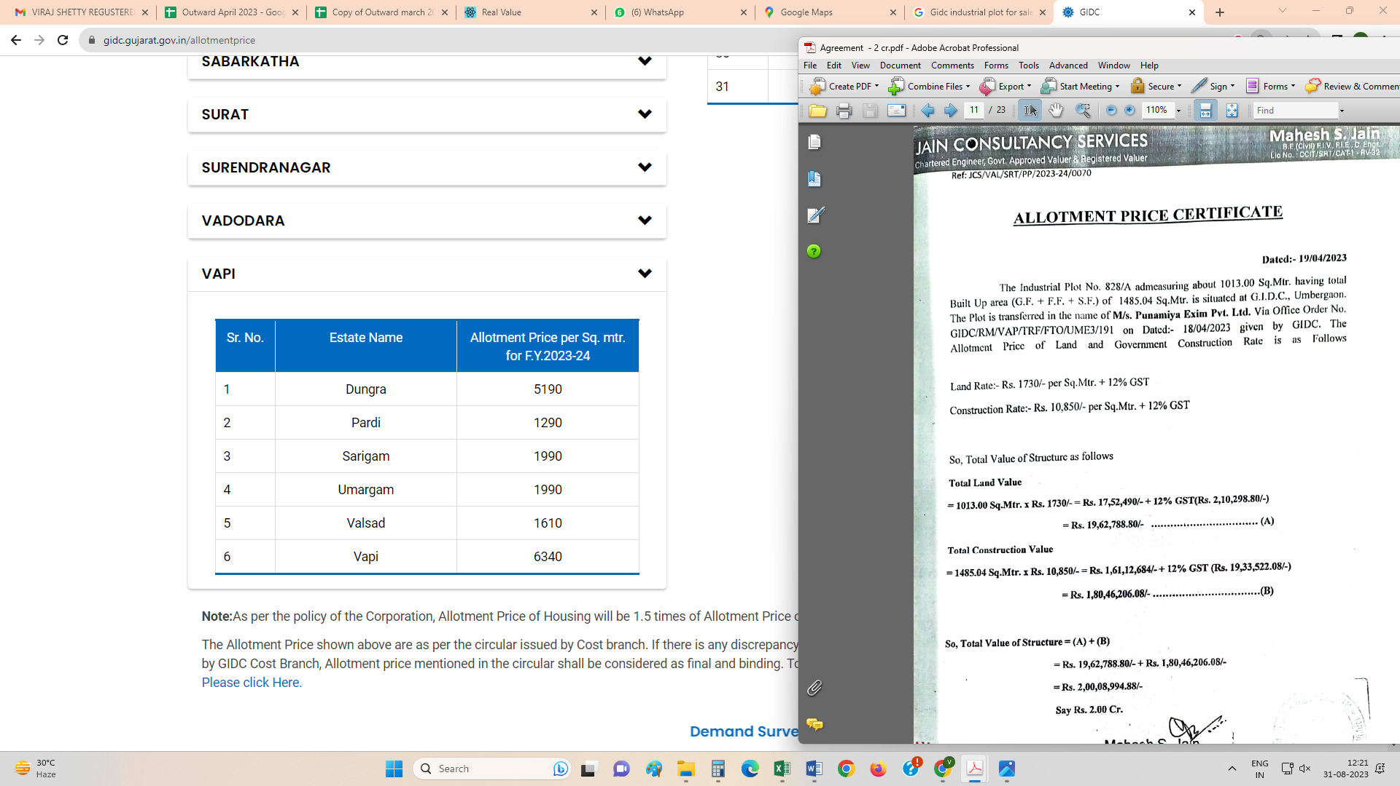

Price Indicators

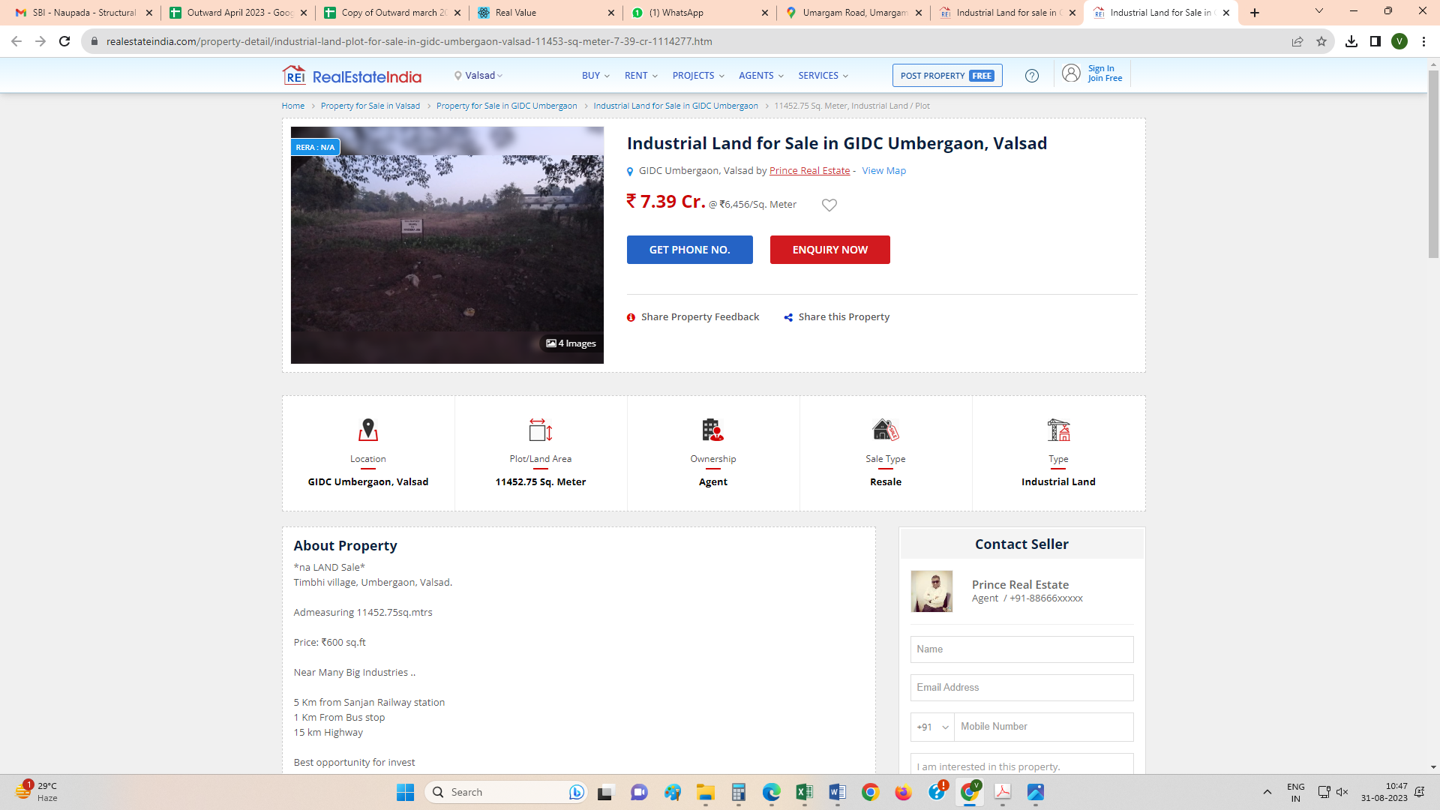
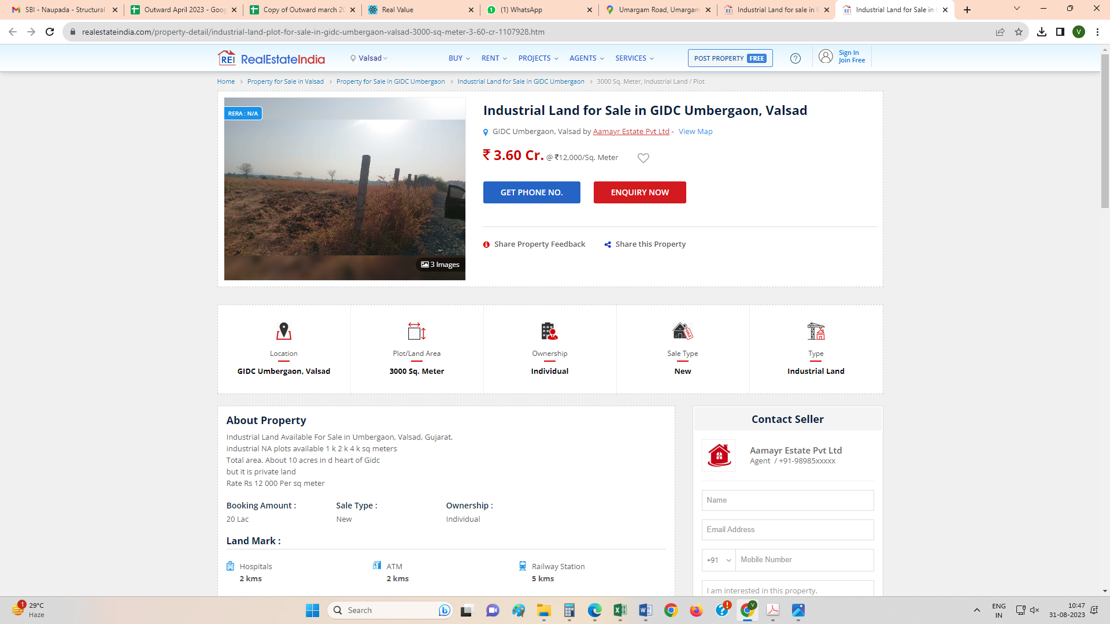
Price Indicators

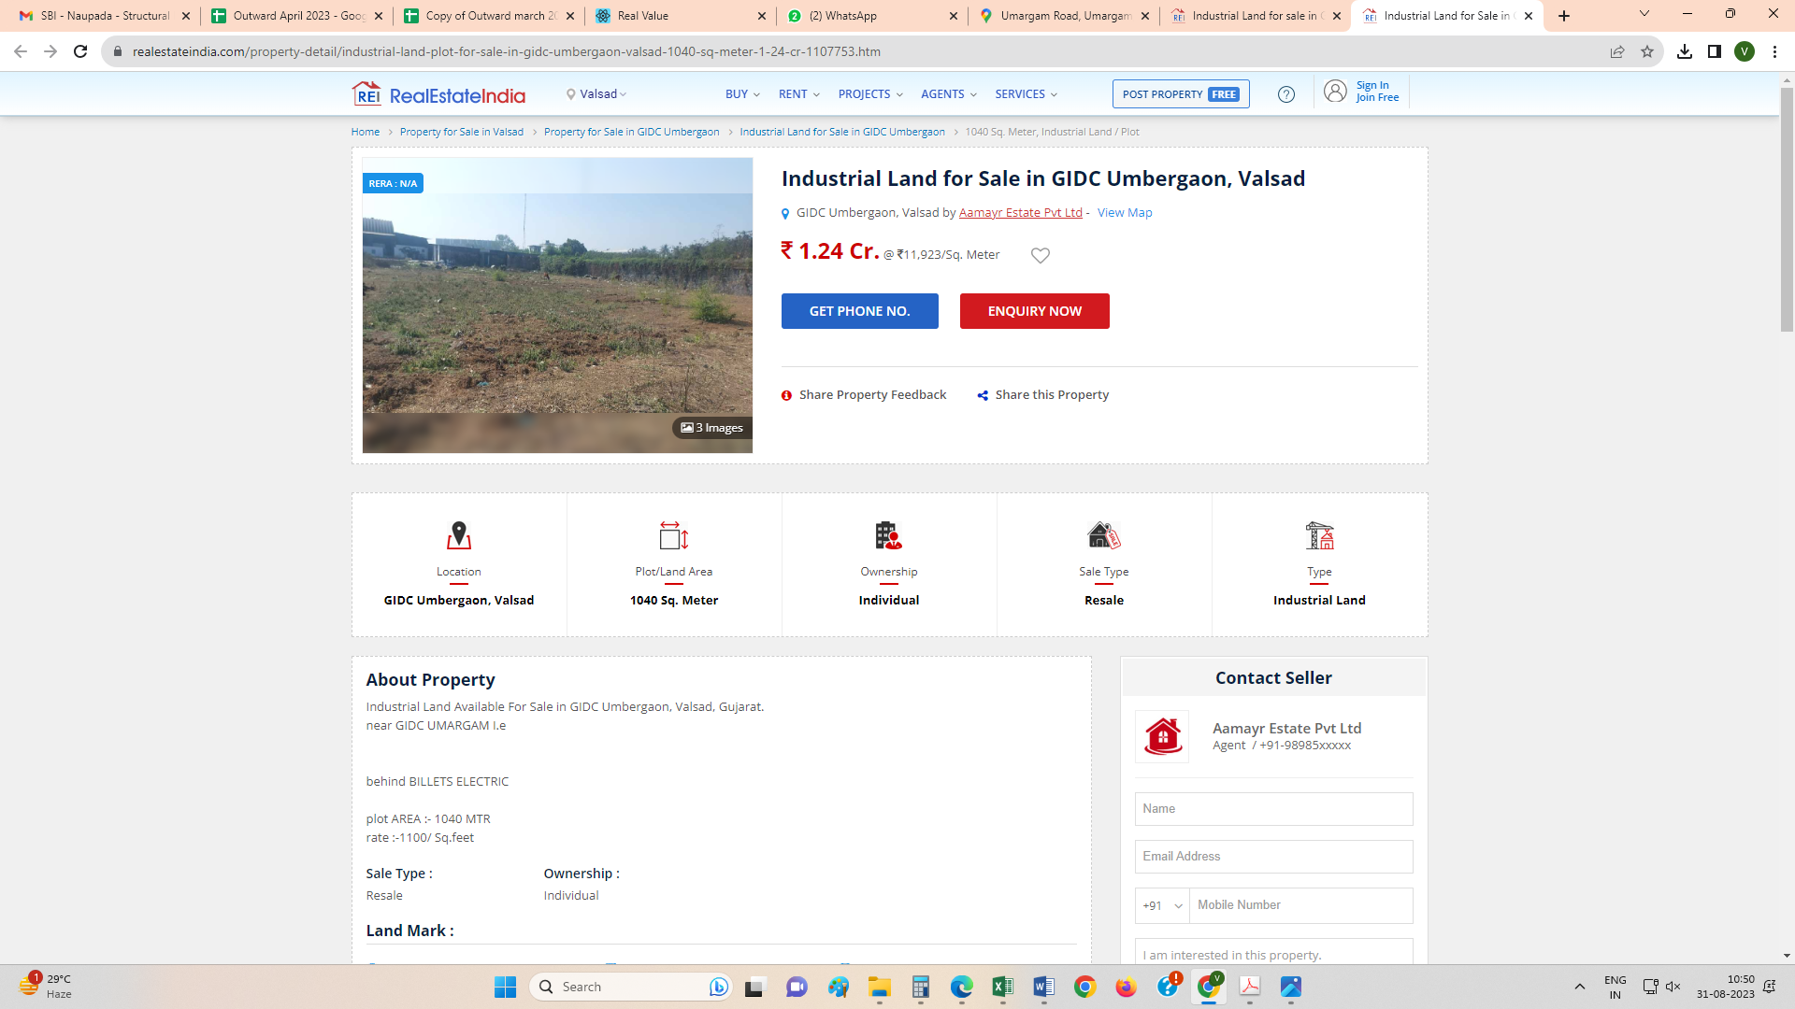
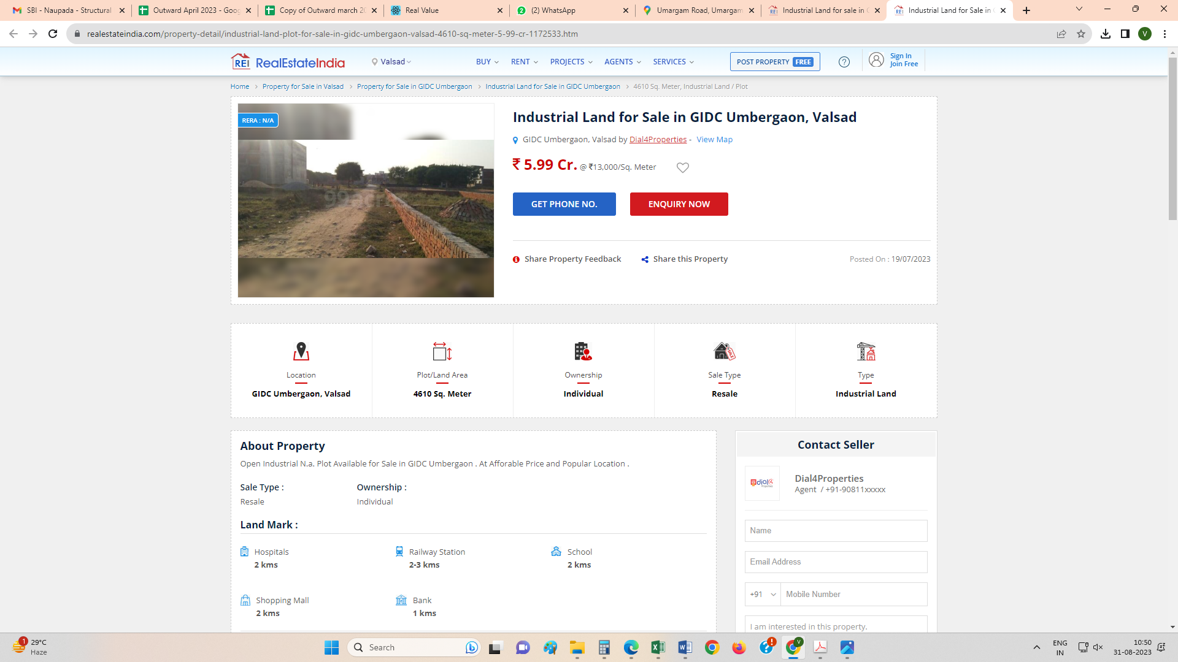

DEFINITION OF VALUE FOR THIS SPECIFIC PURPOSE
This exercise is to assess Fair Market Value of the property under reference as on 31st August 2023.

The term Fair Market Value is defined as

“The most probable price, as of a specified date, in cash, terms equivalent to cash, or in other precisely revealed terms for which the specified property rights would sell after reasonable exposure in a competitive market under all conditions requisite to a fair sale, with the buyer and seller each acting prudently knowledgeably and for self-interest assuming that neither is under undue duress”.
Fundamental assumptions and conditions presumed in this definition are:

1. Buyer and seller are motivated by self-interest.

2. Buyer and seller are well informed and are acting prudently.

3. The property is exposed for a reasonable time on the open market.

4. Payment is made in cash or equivalent or in specified financing terms.

UNDER LYING ASSUMPTIONS
1. We assume no responsibility for matters of legal nature affecting the property appraised or the title thereto, nor do we render our opinion as to the title, which is assumed to be good and marketable.
2. The property is valued as though under responsible ownership.
3. It is assumed that the property is free of liens and encumbrances.
4. It is assumed that there are no hidden or unapparent conditions of the subsoil or structure that would render it more or less valuable. No responsibility is assumed for such conditions or for engineering that might be required to discover such factors.
5. There is no direct/ indirect interest in the property valued
6. The rates for valuation of the property are in accordance with the Govt. approved rates and prevailing market rates.

Sharadkumar B. Chalikwar
Govt. Reg. Valuer
Chartered Engineer (India)
Reg. No. (N) CCIT/1-14/52/2008-09

