Vastu/Nashik/08/2023/3030/2301982
09/11-128-CHSH
Date: 28.08.2023

To,
The Branch Manager,
Bank of Baroda
Regional Office
BSNL Building, Datta Mandir Road, Nashik Road,
Nashik, PIN – 422 101, State - Maharashtra, Country - India.

Sub: Vetting of Extra Work Amenities

Sir,

With reference to above subject, we have evaluated the Extra Work Amenities for Residential Duplex Row House No. 1, Ground + First Floor ,“ Gurudatta Row Houses”, Survey No.854/1/B, ( Old Survey No.1145) Plot No.09, Property No.3536, ( Ward No.S6, Zone No.2) , Near Karpe Ground , Karpe Nagar , Mouje - Sinnar, Taluka – Sinnar, District - Nashik, PIN Code – 422 103, State – Maharashtra, Country – India belongs Shri.Sharad Tukaram Ugale & Sau.Vaishnavi Sharad Ugale

We have verified the rates quoted as per current market rates. Details of Extra Work Amenities considered as per copy of Extra Work Amenities Agreement between Shri.Sharad Tukaram Ugale & Sau.Vaishnavi Sharad Ugale ( Claiming Party and Shri.Ganesh Devram Tambe ( Executing Party ) received on dated 28.06.2023. The Extra Work Amenities Agreement amount is Rs.4,00,000/- (Rupees Four Lakh Only.)

Note:1) The said Cost Vetting Certificate is valid upto next 6 months Only.

Thanking you

Sincerely yours

Sharadkumar B. Chalikwar
Govt. Reg. Valuer
Chartered Engineer (India)
Reg. No. (N) CCIT/1-14/52/2008-09
Encl: Valuation report.
Encl: Vetting Report

Extra Amenities Work Notarized Agreement
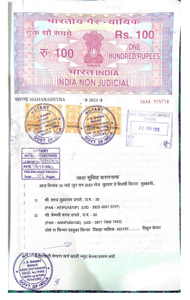
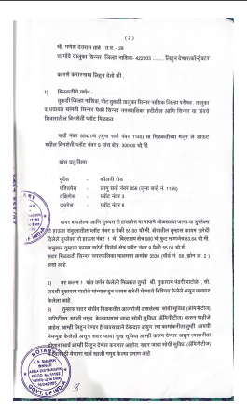

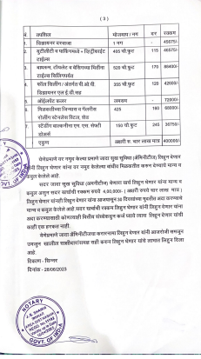
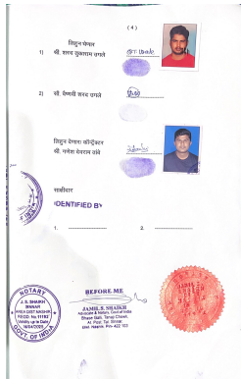

The Extra Work Amenities Agreement amount is Rs.4,00,000/- (Rupees Four Lakh Only.)

