Vastu/Nashik/08/3343/2302193
24/03-339-CHSH
Date: 24.08.2023

To,
The Branch Manager,
Union Bank of India
Gangapur Road Branch
Shree Ganesh Avenue, Chunchale Road,
Nashik - 422 013, State – Maharashtra, Country – India

Sub: Vetting of Extra Amenities

Sir,

With reference to above subject, we have evaluated the Extra Amenities for Residential Flat No. 03, First Floor, "Jyoti Classic Apartment ", Survey No. 33/ 1/ B, Plot No. 7, Behind Reliance Petrol Pump, Near Gulmohar Vihar, Satpur Colony, Kamgar Nagar, Pipeline Road, Village – Anandvalli, Taluka & District - Nashik, PIN Code – 422207, State – Maharashtra, Country – India belongs to Name of Owner: Sau. Preeti Gopalan Nair & Shri. Jaiganesh Ramdas Name of Proposed Purchaser: Shri. Aniket Anil Kankiral & Shri. Anil Purnaji Kankirad.

We have verified the rates quoted as per current market rates. Details of Extra Amenities considered as per copy of Extra Amenities Agreement between Mr. Anil Purnaji Kankirad (First Party). Mr. Yogesh Baburao Patil (Second Party) received on dated 22.08.2023. The Extra Amenities amount is Rs. 3,00,000/- (Rupees Three Lakh Only)

The said Cost Vetting Certificate is valid upto next 6 months Only.

Thanking you

Sincerely yours

Sharadkumar B. Chalikwar
Govt. Reg. Valuer
Chartered Engineer (India)
Reg. No. (N) CCIT/1-14/52/2008-09

Agreement for Extra Work
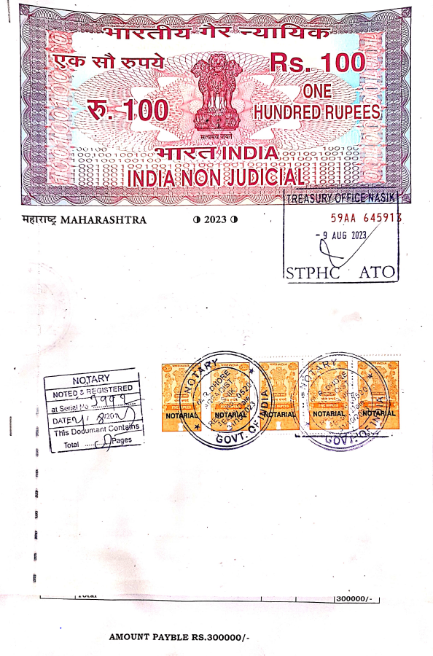
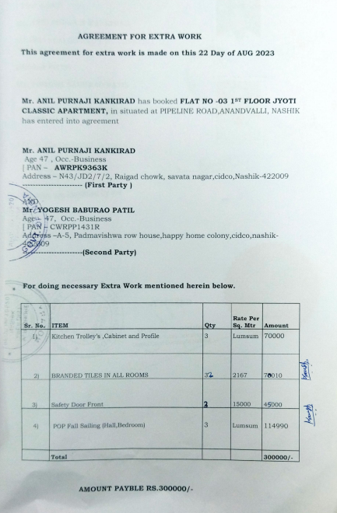

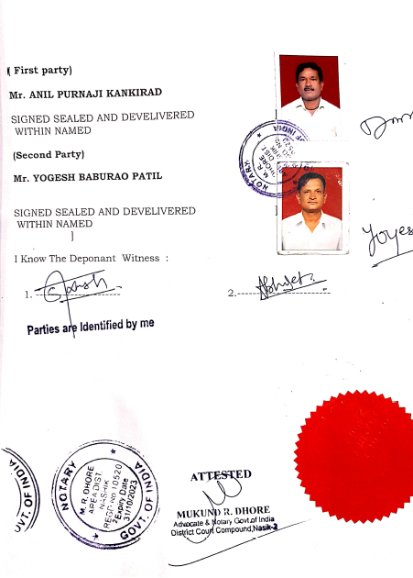

The Extra Amenities amount is Rs. 3,00,000/- (Rupees Three Lakh Only)

