Vastu/Nashik/08/3016/2301973
09/02-119-CHV
Date: 22.08.2023

To,
The Branch Manager,
Bank of Baroda
Regional Office
BSNL Building, Datta Mandir Road, Nashik Road,
Nashik, PIN – 422 101, State - Maharashtra, Country - India.

Sub: Vetting of Estimate

Sir,

With reference to above subject, we have evaluated the Estimate for Residential Land and Bungalow on Plot No. 32, Ground + First Floor, Survey No. 229/1, Near Stayville Casa Cruda Bungalow, At –Igatpuri, Taluka – Igatpuri, District – Nashik,Pin Code – 422 403, State - Maharashtra, Country – India belongs Shri. Pratik Jayendra Yagnik & Vijita Paritosh Daru.

We have verified the rates quoted as per current market rates. Details of Estimate considered as per copy of Estimate Provided by Armaq Studio received on dated 29.05.2023. The Estimate amount is Rs. 49,00,000/- (Rupees Forty Nine Lakh Only. )

Note:1) The said Cost Vetting Certificate is valid upto next 6 months Only.

Thanking you

Sincerely yours

Manoj B. Chalikwar
Registered Valuer
Chartered Engineer (India)
Reg. No. CAT-I-F-1763
Reg. No. IBBI/RV/07/2018/10366
BOB Empanelment No.: ZO:MZ:ADV:46:941
Encl: Vetting Report
.

Estimate
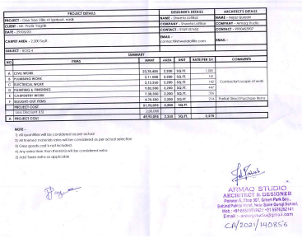
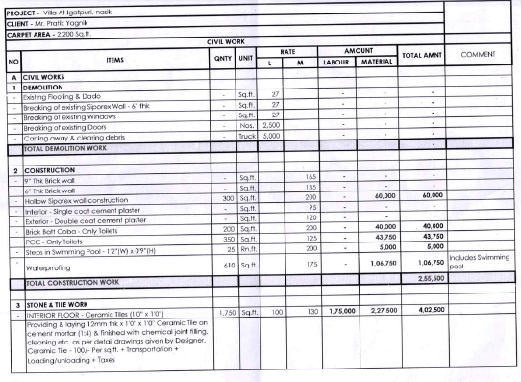

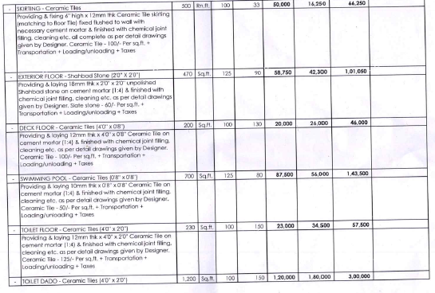
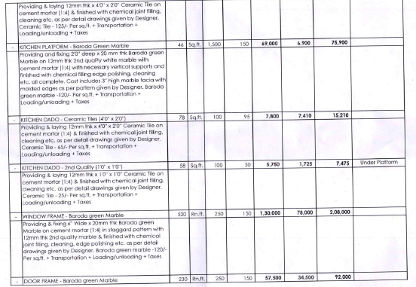

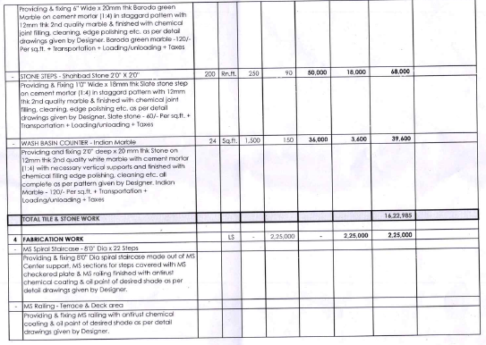
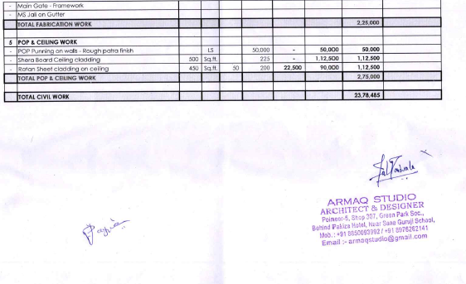

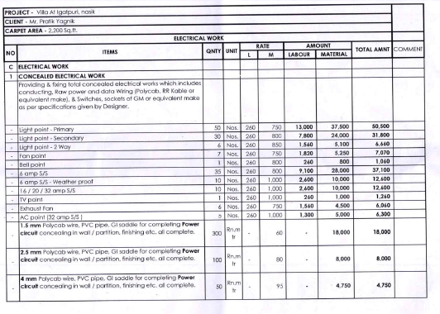
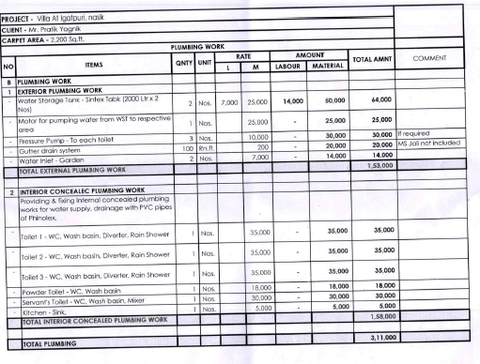

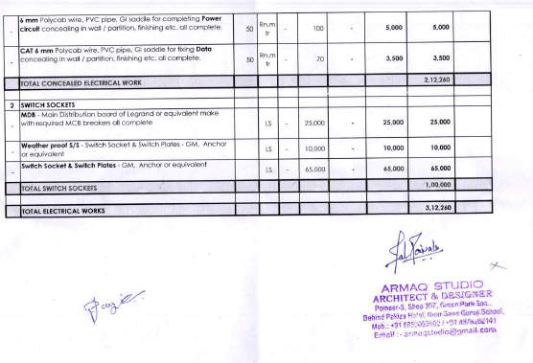
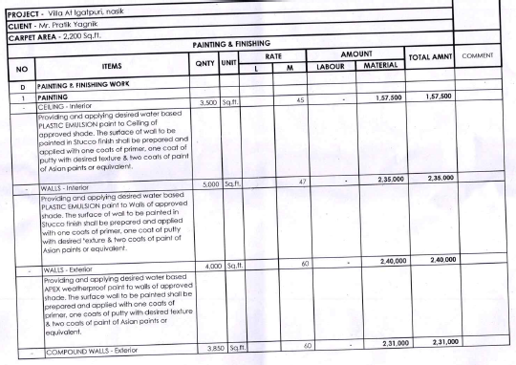

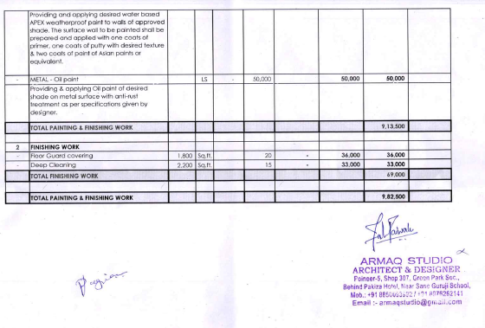
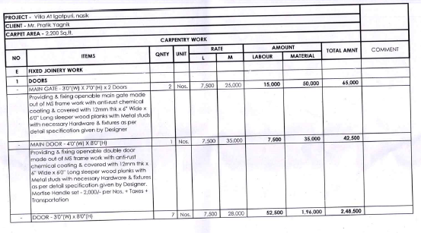

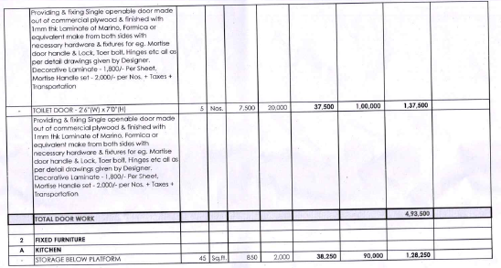
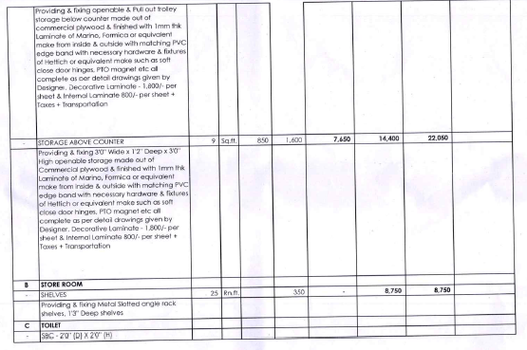

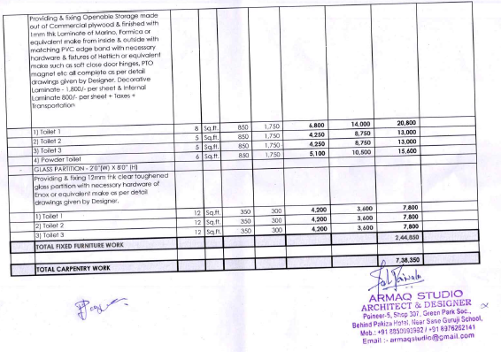
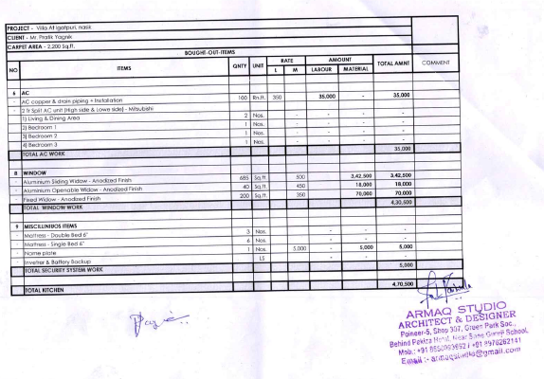

The Estimate amount is Rs. 49,00,000/- (Rupees Forty Nine Lakh Only. )

