2nd LENDERS INDEPENDENT ENGINEER REPORT

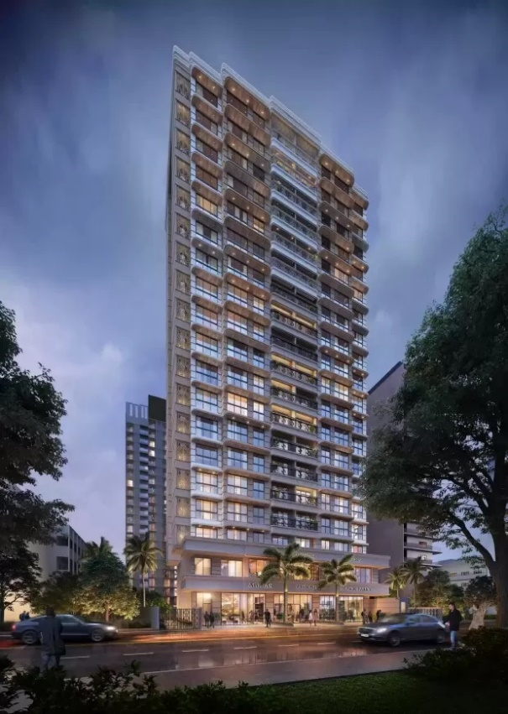

**Details of the property under consideration:**

**Name of Project: Cynthiandra**

**"Cynthiandra", Proposed Redevelopment on Plot bearing C.T.S. No. 1526, F. P. 272, TPS IV,**

**Mahim Division, G / North Ward, Gokhale Road, Dadar (West), Mumbai – 400 028,**

**State – Maharashtra, Country – India**

**Latitude Longitude: 19°01'12.8"N 72°50'13.0"E**

Valuation Prepared for:

State Bank of India

SME Chembur Branch

Unit No. 11, Building No. 11, Ground Floor, Corporate Park, Sion Trombay Road,

Chembur, Mumbai, Pin Code – 400 071, State - Maharashtra, Country – India.

Vastu/SBI/Mumbai/08/2023/3248/2302117

21/04-263-PY

Date: - 21.08.2023

SECOND LENDERS INDEPENDENT ENGINEER REPORT

**To,**

**State Bank of India**

SME Chembur Branch

Unit No. 11, Building No. 11, Ground Floor,

Corporate Park, Sion Trombay Road, Chembur,

Mumbai, Pin Code – 400 071,

State - Maharashtra, Country – India.

Subject: Construction of Proposed Redevelopment on Plot bearing C.T.S. No. 1526, F. P. 272, TPS IV, Mahim Division, G / North Ward, Gokhale Road, Dadar (West), Mumbai – 400 028, State – Maharashtra, Country – India

**Ref:** You’re Request for Lenders Independent Engineer Report of under Construction Building.

**Dear Sir,**

**The Construction work as per approved plan was in progress during the site visit on 13th July 2023. Total expenditure occurred as on 30/06/2023 on this project by M/s. Shubh Laxmi Developers is ` 18.37 Cr. & as per CA Certificate actual total expenditure occurred as on 30/06/2023 is ` 19.46 Cr.**

**DECLARATION**

1. The information furnished in the report is based on our 2nd site visit Dated 13/07/2023 & Document Provided by Client.
2. Vastukala 1st LIE Report for the period ending 31.12.2022 of the project dated 28/02/2023.
3. I have no direct and indirect interest in the property examined for report.
4. I have not been found guilty of misconduct in my professional capacity.

**Sharadkumar B. Chalikwar**

Govt. Reg. Valuer

Chartered Engineer (India)

Reg. No. (N) CCIT/1-14/52/2008-09

Encl.: LIE report

# Purpose & Methodology

• State Bank of India Banks and financial institutions require monitoring & an independent review of the progress of the sanctioned projects

**VCIPL** undertakes such study to independently review the progress of the project and put forward a comprehensive analysis

# Advantages:

* Assurance on present practices
* Identification of risk
* Analyzing the performance of third parties
* Recommendations

# The Methodology

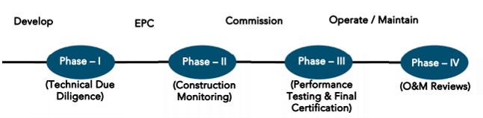

**SECOND LENDERS INDEPENDENT ENGINEER REPORT**

**OF**

**"CYNTHIANDRA"**

"**Cynthiandra**", Proposed Redevelopment on Plot bearing C.T.S. No. 1526, F. P. 272, TPS IV, Mahim Division, G / North Ward, Gokhale Road, Dadar (West), Mumbai – 400 028, State – Maharashtra, Country – India

**Latitude Longitude: 19°01'12.8"N 72°50'13.0"E**

**NAME OF DEVELOPER: M/s. Shubh Laxmi Developers**

|  |
| --- |
| Pursuant to instructions from State of India, Diamond Garden Chembur Branch, we have duly visited, inspected, surveyed & assessed the above said property on **13th July 2023** to determine the fair & reasonable market value of the said property/project as on Quarter ending **30th June 2023** for LIE purpose.  **1. Location Details:**  Proposed Redevelopment on Plot bearing C.T.S. No. 1526, F. P. 272, TPS IV, Mahim Division, G / North Ward, Gokhale Road, Dadar (West), Mumbai – 400 028. It is about 1.10 Km. walking distance from Dadar West Railway station. Surface transport to the property is by buses, taxis & private vehicles. The property is in developed locality. All the amenities like shops, banks, hotels, markets, schools, hospitals, etc. are all available in the surrounding locality. The area is higher middle class & developed. |

**2. Developer Details:**

|  |  |
| --- | --- |
| **Name of builder** | **M/s. M/s. Shubh Laxmi Developers** |
| **Project Rera Registration Number** | **P51900033836** |
| **Registered office address** | Ground Floor, Yoke Arcade, Bhavani Shankar Road, Dadar (West), Mumbai – 400 028, State - Maharashtra, Country – India |
| **Contact details** | **Contact Person:**  Mr. Ritesh Chawla  Mobile No. +91 9819544521 |
| **E – mail ID and website** |  |

**3. Boundaries of the Property:**

|  |  |
| --- | --- |
| **Direction** | **Particulars** |
| **On or towards North** | Anila Niwas |
| **On or towards South** | Louisandra Building |
| **On or towards East** | Denisandra Building |
| **On or towards West** | Gokhale Road |

# Introduction

**As per Information on site M/s. Shubh Laxmi Developers** has acquired land by Conveyance Deed Date 28.03.2019 admeasuring **area is 374.12 Sq. M.** bearing **C.T.S. No. 1526, F. P. 272, TPS IV.** For the Proposed Residential Building.

# Area Statement:

# Land:

|  |  |  |
| --- | --- | --- |
| **Date** | **Particular** | **Area in Sq. M.** |
| 31.03.2006 | C.T.S. No. 1526, F. P. 272, TPS IV | 374.12 |
| TOTAL | | 374.12 |

1. Copy of Deed of Conveyance dated 28.03.2019 between M/s. Cosmos Homes (India) Private Limited (The Owners) and M/s. Shubh Laxmi Developers (The Purchaser) registered vide No. BBE-4-3548-2019 dated 28.03.2019.
2. Copy of Permanent Alternate Accommodation Agreement dated 06.12.2021 M/s. Shubh Laxmi Developers (The Owner) and Mrs. Adelita Vasant Jadhav & Mr. Vasant Shantaram Jadhav (The Tenants) registered vide No. BBE-3-1553 dated 06.12.2021.
3. Copy of Permanent Alternate Accommodation Agreement dated 20.09.2021 M/s. Shubh Laxmi Developers (The Owner) and Dr. Terence Stephen Nazareth (The Tenants) registered vide No. BBE-3-11512 dated 20.09.2021.
4. Copy of Occupant irrevocable Consent Agreement dated 09.04.2019 from Mr. Ankit Chopra (The Tenant) to M/s. Shubh Laxmi Developers (The Owner).
5. Copy of Occupant irrevocable Consent Agreement dated 20.04.2019 from Mr. Manish Mehta (The Tenant) to M/s. Shubh Laxmi Developers (The Owner).
6. Copy of Occupant irrevocable Consent Agreement dated 09.04.2019 from Mr. Pradip B. Chopra (The Tenant) to M/s. Shubh Laxmi Developers (The Owner).
7. Copy of Occupant irrevocable Consent Agreement dated 09.04.2019 from Ms. Shraddha Mehta (The Tenant) to M/s. Shubh Laxmi Developers (The Owner).
8. Copy of Occupant irrevocable Consent Agreement dated 30.04.2019 from Mrs. Adelita Vasant Jadhav & Mr. Vasant Shantaram Jadhav (The Tenant) to M/s. Shubh Laxmi Developers (The Owner).

# Building Area As per Concession Plan:

| **Sr. No.** | **Particulars** | | **Area in Sq. M.** | |
| --- | --- | --- | --- | --- |
| **1** | Area of Plot | | 374.12 | |
| **2** | Deduction for | |  | |
|  | (a) Set Back Area | | - | |
|  | (b) Proposed Road | | - | |
|  | (c) Any Reservation | | - | |
|  | (d) % amenity space as per DCPR | | - | |
|  | (e) Other | | - | |
| **3** | Balance Area of Plot | | 374.12 | |
| **4** | Deduction for 15% Recreational Ground, 10% Amenity space (If Deductible for Ind) | | - | |
| **5** | Net Plot Area (3-4) | | 374.12 | |
| **6** | Additions for Floor Space Index | | - | |
|  | a) 100% for D. P. Road | | - | |
|  | b) 100% for Setback | | - | |
| **7** | Total Area (5+6) | | 374.12 | |
| **8** | Floor Space Index Permissible | | - | |
| **9** | 1. Floor Space Index Credit available by development right   (Restricted to -% of the balance area vide 3 above) | | - | |
|  | Addition for Floor Space Index   1. % As per DCPR 2. % As per DCPR 3. Other | | - | |
| **10** | Total FSI Available as per reg 33(7) | | 3.00 | |
| **11** | Total Permissible built-up area as per reg 33(7) (374.12 X 3 FSI) = 112.36  (33.45 X 7) = 234.15 Sq. M. Incentive on PAPA 116.33 | | 1,472.84 | |
| **12** | 5% Additional for Tenants | | 23.62 | |
| **13** | Total Permissible Area | | 1,496.46 | |
| **14** | Existing Floor Area | | - | |
| **15** | Proposed Built-up Area | | - | |
| **16** | Excess Balcony Area taken in Floor Space Index | | - | |
| **17 A** | Purely Residential Built-up Area | | 1,404.23 | |
| **17 B** | Remaining Non-Residential Built-up Area | | 92.23 | |
| **17 C** | Residential Built-up Area of | | - | |
| **18** | Total Built-up Area Proposed (11 + 12 + 13) | | 1,496.46 | |
| **19** | FSI Consumed on net holding = 14 / 3 | |  | |
| **B.** | **Details of FSI Availed As per DCPR 31 (3)** | | **Permissible** | **Proposed** |
| **1.** | Fungible Built-up Area Component permissible / proposed vide  DCPR 31 (3) for purely residential = OR (14A X 0.35) | REHAB | 133.38 | 107.13 |
| MHADA | 22.73 | 22.73 |
| SALE | 204.65 | 204.55 |
|  | PAP | 81.95 | 81.95 |
|  | Incentive on PAP | 40.71 | 40.71 |
| **2.** | Fungible Built-up Area Component permissible / proposed vide  DCPR 31 (3) for purely non - residential = OR (14B X 0.35) | NR | 40.32 | 40.32 |
| **3.** | Total Fungible Built-up Area vide DCPR 31 (3) = (B.1 + B.2) | | 523.74 | 497.49 |
| **4.** | Total Gross Built-up Area Proposed (14 + B.3) | | 2,020.20 |  |
|  | Less Deficit Area | | 25.85 |  |
|  | Net Permissible | | 1,994.35 | 1,993.95 |
| **C.** | **Tenement Statement** | |  | |
| **a** | Proposed Area Item B - 12 above | | - | |
| **b** | Less Deduction for Non Resi. Built Up Area | | - | |
| **c** | Area Available for Tenements | | - | |
| **d** | Tenement Permissible | | - | |
| **e** | Tenement Existing | | - | |
| **E.** | **Parking Statement** | |  | |
| **1** | Parking Required by regulation for | | - | |
|  | Car | | - | |
|  | Scooter / Motor Cycle | | - | |
|  | Outsiders (Visitors) | | - | |
| **2** | Covered Garage Permissible | | - | |
|  | Covered Garage Proposed | | - | |
|  | Car | | - | |
|  | Scooter / Motor Cycle | | - | |
|  | Outsiders (Visitors) | | - | |
| **F.** | **Transport Vehicles Parking** | |  | |
| **1** | Spaces for transport vehicles parking required by regulations | | - | |
| **2** | Total No. of transport vehicles parking spaces provided | | - | |

# List of Approvals:

1. Copy of Approved Plan No. P-6728/2021/(272)/G/North/FP dated 18.08.2021 issued by Municipal Corporation of Greater Mumbai

**Approved upto: Basement + Ground Floor + 1st to 18th Upper Residential Floor**

1. Copy of Commencement Certificate No. P-6728/2021/(272)/G/North/FP/CC/1/New dated 24.02.2022 issued by Municipal Corporation of Greater Mumbai

**(This CC is endorsed for the work upto Plinth Level)**

1. Copy of Concession Drawing Plan No. P-6728/2021/(272)/G/North/FP dated 30.07.2021 issued by Municipal Corporation of Greater Mumbai

**Approved upto: Basement + Ground Floor + 1st to 22nd Upper Residential Floor**

# LEVEL OF COMPLETION:

| **Sr. No.** | **Floor** | **Construction area as per plan (Sq. M.)** | **Completed area (Sq. M.)** | **Work Completion as 10.01.2023 of 1st LIE Report** | **Work Completion as 13.07.2023** |
| --- | --- | --- | --- | --- | --- |
| 1 | Excavation |  |  | Excavation Work is Completed | Foundation work is progress |
| 2 | Basement Floor | 79.43 |  |  |  |
| 3 | Ground / Stilt Floor | 144.60 |  |  |  |
| 4 | 1st Floor | 148.59 |  |  |  |
| 5 | 2nd Floor | 148.59 |  |  |  |
| 6 | 3rd Floor | 148.59 |  |  |  |
| 7 | 4th Floor | 148.59 |  |  |  |
| 8 | 5th Floor | 148.59 |  |  |  |
| 9 | 6th Floor | 148.59 |  |  |  |
| 10 | 7th Floor | 148.65 |  |  |  |
| 11 | 8th Floor | 148.59 |  |  |  |
| 12 | 9th Floor | 147.28 |  |  |  |
| 13 | 10th Floor | 166.39 |  |  |  |
| 14 | 11th Floor | 166.39 |  |  |  |
| 15 | 12th Floor | 166.39 |  |  |  |
| 16 | 13th Floor | 166.39 |  |  |  |
| 17 | 14th Floor | 166.37 |  |  |  |
| 18 | 15th Floor | 166.39 |  |  |  |
| 19 | 16th Floor | 166.39 |  |  |  |
| 20 | 17th Floor | 166.39 |  |  |  |
| 21 | 18th Floor | 166.39 |  |  |  |
| 22 | 19th Floor | 166.39 |  |  |  |
| 23 | 20th Floor | 166.39 |  |  |  |
| 24 | 21st Floor | 166.39 |  |  |  |
| 25 | 22nd Floor | 158.39 |  |  |  |
| 26 | Terrace Area | 73.58 |  |  |  |
| **TOTAL AREA in Sq. M.** | | **3,709.29** |  |  |  |
| **No. of Stack Parking** | | **32** |  |  |  |

# Details of the Project as Financed By SBI:

# Project Cost: (as per C.A. Certificate)

|  |  |  |  |  |
| --- | --- | --- | --- | --- |
| **Particulars** | **Estimated Cost (in Cr.)** | **Incurred Cost (In Cr.) 30.06.2022 by M/s JRSM & Associates** | **Incurred Cost (In Cr.) 31.12.2022 by M/s JRSM & Associates** | **Net** |
| Land Cost | 9.91 | 10.17 | 10.17 | - |
| Payment payable to Rehab Tenants for Alternative Accommodation | 1.06 | 0.51 | 0.37 | 0.14 |
| Construction Cost | 12.73 | 3.08 | 1.92 | 1.16 |
| Approval Cost of Fungible Cost & Development cess premium & Stamp Duty | 6.25 | 3.27 | 3.08 | 0.19 |
| Professional, Administrative & Marketing Cost | 2.09 | 0.70 | 0.58 | 0.12 |
| Interest Cost | 2.60 | 1.73 | 0.30 | 1.43 |
| Contingency | 0.38 | - | - | - |
| **Total** | **35.02** | **19.46** | **16.42** | **3.04** |

* **The Builder has incurred about 0.51 Cr. for rent cost, 3.08 Cr. for construction cost, 3.27 Cr. for approval of project, 0.70 Cr. for on-site expenditure & 1.73 Cr. for Interest Cost in last quarter till 30.06.2023 as per C.A. certificate issued by M/s. JRSM & Associates dated 12.07.2023**

# Project Cost: (as per Bills):

|  |  |  |  |
| --- | --- | --- | --- |
| **Particulars** | **Incurred Cost (in Cr.)** | |  |
| **30.06.2023 as per Bill (Inclusive GST)** | **31.12.2022 as per Bill (Inclusive GST)** | **Net** |
| Land Cost | 9.91 | 9.91 | - |
| Payment payable to Rehab Tenants for Alternative Accommodation | 0.85 | 0.37 | 0.48 |
| Construction cost of Building | 2.93 | 1.68 | 1.25 |
| Premium Cost / FSI / GOM Charges / fees / security Deposits | 2.80 | 2.80 | - |
| Professional, Administrative & Marketing Cost | 1.70 | 1.48 | 0.22 |
| Interest Cost | 0.18 | 0.03 | 0.14 |
| Contingency Cost | - | - | - |
| **Total** | **18.37** | **16.28** | **2.10** |

Note:

# Land Cost:

|  |  |  |  |  |
| --- | --- | --- | --- | --- |
| Sr. No. | Date | Document Name | Description | Incurred Cost in ` |
| 1 | 28.03.2019 | Conveyance Deed | Purchase Price | 9,22,27,000.00 |
| 2 | Stamp Duty | 55,34,000.00 |
| 3 | Reg. Fees | 30,000.00 |
| 4 | 1,280.00 |
| 5 | 06.12.2021 | Permanent Alternate Accommodation Agreement | Stamp Duty | 7,34,000.00 |
| 6 | Reg. Fees | 30,000.00 |
| 7 | 1,560.00 |
| 8 | 20.09.2021 | Permanent Alternate Accommodation Agreement | Stamp Duty | 5,59,500.00 |
| 9 | 17.01.2014 | Reg. Fees | 30,000.00 |
| 10 | 17.01.2014 | 1,700.00 |
| Total | | | | **9,91,49,040.00** |

As per conveyance deed & PAA Agreement.

|  |  |  |  |  |  |  |
| --- | --- | --- | --- | --- | --- | --- |
| **Summary of Bills** | | | | | | |
| **Sr. No.** | **Particulars** | **Amount in `**  **(till 30.06.2023)** | **Amount in ` (in Cr.)** | **Amount in `**  **(till 31.12.2022)** | **Amount in ` (in Cr.)** | **Net in ` (In Cr.)** |
| **1** | Rent Cost | 85,39,053.00 | 0.85 | 37,00,000.00 | 0.37 | 0.48 |
| **2** | Construction Cost | 2,92,60,943.00 | 2.93 | 1,68,04,945.00 | 1.68 | 1.25 |
| **3** | Premium Cost / FSI / GOM Charges / fees / security Deposits | 2,80,16,710.00 | 2.80 | 2,79,71,110.00 | 2.80 | - |
| **4** | Professional Cost | 1,01,14,433.00 | 1.01 | 94,12,087.00 | 0.94 | 0.07 |
| **5** | Administrative Cost | 68,62,706.00 | 0.69 | 54,04,363.00 | 0.54 | 0.15 |
| **6** | Marketing Cost | 19,202.00 | 0.00 | 19,202.00 | 0.00 | - |
| **TOTAL** | | **8,28,13,047.00** | **8.28** | **6,33,11,707.00** | **6.33** | **2.10** |

Note: Bills were provided by the client up to 30.06.2023

# Interest Cost:

|  |  |  |  |  |  |
| --- | --- | --- | --- | --- | --- |
| **Sr. No** | **Particulars** | **Estimate Amount in `** | **Incurred Amount in ` (till 30.06.2023)** | **Incurred Amount in ` (till 31.12.2022)** | **Net** |
| **1** | Interest Cost | 10,25,00,000.00 | 17,69,153.00 | 3,20,082.00 | 14,49,071.00 |
| **TOTAL** | | **10,25,00,000.00** | **17,69,153.00** | **3,20,082.00** | **14,49,071.00** |

Interest Cost is based on discussion with the client.

# Cost of Construction as on 13th July 2023:

|  |  |  |  |  |  |  |  |
| --- | --- | --- | --- | --- | --- | --- | --- |
| Plinth Area Calculation | | | | | | | |
| Sr. No | **Floor Nos.** | **Construction Area in Sq. M.** | **Completed Area in Sq. M.** | **Rate per Sq. M.** | **Full Value after completion** | **Percentage of work completed** | **Actual Expenditure till date in `** |
| 1 | Excavation & Piling Work Cost is Increase | | | | 1,05,29,444.00 | As per Bills | 2,92,60,943.00 |
| 2 | Basement | 79.43 |  | 29,375.00 | 23,33,256.25 | - | - |
| 3 | Ground | 144.60 |  | 29,375.00 | 42,47,625.00 | - | - |
| 4 | 1st | 148.59 |  | 29,375.00 | 43,64,831.25 | - | - |
| 5 | 2nd | 148.59 |  | 29,375.00 | 43,64,831.25 | - | - |
| 6 | 3rd | |  | | --- | | 148.59 | |  | 29,375.00 | 43,64,831.25 | - | - |
| 7 | 4th | 148.59 |  | 29,375.00 | 43,64,831.25 | - | - |
| 8 | 5th | 148.59 |  | 29,375.00 | 43,64,831.25 | - | - |
| 9 | 6th | 148.59 |  | 29,375.00 | 43,64,831.25 | - | - |
| 10 | 7th | 148.65 |  | 29,375.00 | 43,66,593.75 | - | - |
| 11 | 8th | 148.59 |  | 29,375.00 | 43,64,831.25 | - | - |
| 12 | 9th | 147.28 |  | 29,375.00 | 43,26,350.00 | - | - |
| 13 | 10th | 166.39 |  | 29,375.00 | 48,87,706.25 | - | - |
| 14 | 11th | 166.39 |  | 29,375.00 | 48,87,706.25 | - | - |
| 15 | 12th | 166.39 |  | 29,375.00 | 48,87,706.25 | - | - |
| 16 | 13th | 166.39 |  | 29,375.00 | 48,87,706.25 | - | - |
| 17 | 14th | 166.37 |  | 29,375.00 | 48,87,118.75 | - | - |
| 18 | 15th | 166.39 |  | 29,375.00 | 48,87,706.25 | - | - |
| 19 | 16th | 166.39 |  | 29,375.00 | 48,87,706.25 | - | - |
| 20 | 17th | 166.39 |  | 29,375.00 | 48,87,706.25 | - | - |
| 21 | 18th | 166.39 |  | 29,375.00 | 48,87,706.25 | - | - |
| 22 | 19th | 166.39 |  | 29,375.00 | 48,87,706.25 | - | - |
| 23 | 20th | 166.39 |  | 29,375.00 | 48,87,706.25 | - | - |
| 24 | 21st | 166.39 |  | 29,375.00 | 48,87,706.25 | - | - |
| 25 | 22nd | 158.39 |  | 29,375.00 | 46,52,706.25 | - | - |
| 26 | Terrace | 73.58 |  | 29,375.00 | 21,61,412.50 | - | - |
| Total | | 3,788.72 | 14,164.01 |  | 11,12,93,650.00 | - | - |
|  |  | 32.00 | 5,00,000.00 |  | 1,60,00,000.00 | - | - |
| TOTAL | | | | | **13,78,23,094.00** | **21.23%** | **2,92,60,943.00** |

##### Note: Details of work completed is as per site visit dated 13.07.2023 but report is prepared for 30th June quarter 2023.

##### Piling Cost was increase due to modification in 8 extra piling work.

|  |  |  |  |  |  |  |
| --- | --- | --- | --- | --- | --- | --- |
| **Particulars** | **Estimated Cost**  **(In Cr.)** | **Revised Estimated Cost**  **(In Cr.)** | **Incurred Cost (in Cr.)** | | | **Net** |
| **Issued dated 12.07.2023 till 30.06.2023 as per CA** | **As per Bills upto 30.06.2023** | **As per Bills upto 31.12.2022** |
| Land Cost | 9.91 | 9.91 | 10.17 | 9.91 | 9.91 | - |
| Payment payable to Rehab Tenants Alter Accommodation | 1.06 | 1.06 | 0.51 | 0.85 | 0.37 | 0.48 |
| Construction cost of Building | 12.73 | 13.78 | 3.08 | 2.93 | 1.68 | 1.25 |
| Premium Cost / FSI / GOM Charges / fees / security Deposits | 6.25 | 6.25 | 3.27 | 2.80 | 2.80 | - |
| Professional, Administrative & Marketing Cost | 2.09 | 2.09 | 0.70 | 1.70 | 1.48 | 0.22 |
| Interest Cost | 2.60 | 2.60 | 1.73 | 0.18 | 0.03 | 0.14 |
| Contingency Cost | 0.38 | 0.38 | - | - | - | - |
| **Total** | **35.02** | **36.07** | **19.46** | **18.37** | **16.28** | **2.10** |

Note:

Due to Extra Piling work cosntruction cost is increase by 1.05 Cr. and estimated cost is revised in this LIE Report.

We have considered GST Amount, Other Expenses, Printing & Stationery, Bank processing fees cost is consider in on-site expenditure cost header but CA has considered them in cost of construction header

As per plinth area, calculation the work completed is up to 21.23% of total work, which comes to ` 2.93 Cr. However, company has incurred cost of ` 2.93 Cr. till 30.06.2023 as per bill .

# Comparison of Cost incurred on dated 30.06.2023 & 31.12.2022

|  |  |  |  |  |
| --- | --- | --- | --- | --- |
| Particulars | 30.06.2023 as per Bill | 31.12.2022 as per Bill | Net | % of net amount |
| Land Cost | 9.91 | 9.91 | - | 0.00% |
| Payment payable to Rehab Tenants Alter Accommodation | 0.85 | 0.37 | 0.48 | 2.61% |
| Construction cost of Building | 2.93 | 1.68 | 1.25 | 6.80% |
| Premium Cost / FSI / GOM Charges / fees / security Deposits | 2.80 | 2.80 | - | 0.00% |
| Professional, Administrative & Marketing Cost | 1.70 | 1.48 | 0.22 | 1.20% |
| Interest Cost | 0.18 | 0.03 | 0.14 | 0.76% |
| Contingency Cost | - | - | - | 0.00% |
| Total | **18.37** | **16.28** | **2.10** | **11.43%** |

# % of Fund Utilised till 30th June 2023

|  |  |  |  |  |
| --- | --- | --- | --- | --- |
| Particulars | Revised Estimated Project Cost  (in Cr.) | Incurred cost as on 30.06.2023 | % of Incurred Cost | % of Estimated Project Cost |
| Land Cost | 9.91 | 9.91 | 100.00% | 27.49% |
| Payment payable to Rehab Tenants Alter Accommodation | 1.06 | 0.85 | 80.56% | 2.37% |
| Construction cost of Building | 13.78 | 2.93 | 21.23% | 8.11% |
| Premium Cost / FSI / GOM Charges / fees / security Deposits | 6.25 | 2.80 | 44.83% | 7.77% |
| Professional, Administrative & Marketing Cost | 2.09 | 1.70 | 81.32% | 4.71% |
| Interest Cost | 2.60 | 0.18 | 6.80% | 0.49% |
| Contingency Cost | 0.38 | - | 0.00% | 0.00% |
| Total | **36.07** | **18.37** | **50.94%** | **50.94%** |

Based on above Calculation it is found that total Project cost incurred is 50.94% of the Total Project Cost.

# Means of Finance:

|  |  |  |
| --- | --- | --- |
| **Sr. No.** | **Particulars** | **Exp. Cumulative (Cr.)** |
|  | Equity share capital / Quassi Loan from Promoter | 16.41 |
|  | Sales (Advance from customer) | 1.09 |
|  | Bank Laon Amount | 1.96 |
|  | **Total** | **19.46** |

The Details of the Means of Finance are provided by Client as on 30.06.2023

# Mandatory Arrangements:

|  |  |  |
| --- | --- | --- |
| **Sr. No.** | **Particulars** | **Status** |
|  | Rainwater Harvesting | To be executed after RCC Structure |
|  | Firefighting System | To be executed after RCC Structure |
|  | Solid Waste Management | To be executed after RCC Structure |

# Quality of Construction:

|  |  |  |
| --- | --- | --- |
| **Sr. No.** | **Particulars** | **Status** |
|  | Soundness of Structures | Executing as per approved Structural Design |
|  | Look of Structures | Good |
|  | Quality of Material Used | Good |
|  | Safety Measures for Construction/labour | Taken Care by Contractor |

# Schedule V/s. Actual Progress:

| Activity | Date of Implementation | Date of Completion | Status |
| --- | --- | --- | --- |
| Land |  |  | Completed |
| Development of Land |  |  | Completed |
| Foundation Work |  |  | Completed |
| Basement 1 |  |  |  |
| Ground Floor Slab |  |  |  |
| 1st Floor Slab |  |  |  |
| 2nd Floor Slab |  |  |  |
| 3rd Floor Slab |  |  |  |
| 4th Floor Slab |  |  |  |
| 5th Floor Slab |  |  |  |
| 6th Floor Slab |  |  |  |
| 7th Floor Slab |  |  |  |
| 8th Floor Slab |  |  |  |
| 9th Floor Slab |  |  |  |
| 10th Floor Slab |  |  |  |
| 11th Floor Slab |  |  |  |
| 12th Floor Slab |  |  |  |
| 13th Floor Slab |  |  |  |
| 14th Floor Slab |  |  |  |
| 15th Floor Slab |  |  |  |
| 16th Floor Slab |  |  |  |
| 17th Floor Slab |  |  |  |
| 18th Floor Slab |  |  |  |
| 19th Floor Slab |  |  |  |
| 20th Floor Slab |  |  |  |
| 21st Floor Slab |  |  |  |
| 22nd Floor Slab |  |  |  |
| Block work / Internal Plaster work |  |  |  |
| Terrace Parapet wall / Overhead water tank / Lift Machine room / compound wall / External Plaster work |  |  |  |
| Electric Work |  |  |  |
| Water Proofing |  |  |
| Plumbing Work |  |  |
| Tiling / Marble Flooring |  |  |
| Door Frames |  |  |
| Window Installation |  |  |
| Staircase Flooring |  |  |
| Staircase Railing |  |  |
| Refuge Area Flooring |  |  |
| Internal Painting |  |  |  |
| External Painting |  |  |
| Lift Work |  |  |  |
| Fire Fighting Installation |  |  |
| Stack Parking |  |  |
| CP Fitting & Sanitary Work |  |  |
| Final Finishing & Fitting |  |  |

Work Completion Schedule is not provided

# Action initiated to complete the project in time:

Excavation work is completed.

# Comments related to cost overrun if any:

The cost of Sales Building is ` 35.02 Cr.

# Balance investment required for completion of project:

We opinion amount of **` 18.74 Cr.** Will be required to complete the Project.

# Mandatory Approval Status:

|  |  |  |  |  |
| --- | --- | --- | --- | --- |
| **Sr. No.** | **Particulars** | **Name of Department** | **Status** | **Order Details** |
| **1** | IOD of Building | Municipal Corporation of Greater Mumbai (MCGM). | Obtained and available at site | P-6728/2021/(272)/G/North/FP dated 18.08.2021 |
| **2A** | First C.C. | Municipal Corporation of Greater Mumbai (MCGM). | Obtained and available at site | P-6728/2021/(272)/G/North/FP/CC/1/New dated 24.02.2022. This CC is endorsed for the work upto Plinth Level |
| **2B** | Second C.C. | Municipal Corporation of Greater Mumbai (MCGM). | Pending |  |
| **3B** | Occupancy | Municipal Corporation of Greater Mumbai (MCGM). | Pending (Project is not completed) |  |

# Status Insurance Coverage:

Information not available

# Assumptions & Remarks:

* The adequacy of Engineering / Structural design is beyond the scope of our assignment.
* Estimated project completion date is 31/12/2025 for Sales Building respectively. The cost is certified based on the assumptions that the project will be completed within period. Few assumptions were made regarding inflation & cost rise etc. during construction period.

**Sharadkumar B. Chalikwar**

Govt. Reg. Valuer

Chartered Engineer (India)

Reg. No. (N) CCIT/1-14/52/2008

**About the Project:**

|  |  |  |
| --- | --- | --- |
| **1. Introduction** | |  |
| a) | Project Name  (With Address & Phone Nos.) | **"Cynthiandra",** Proposed Redevelopment on Plot bearing C.T.S. No. 1526, F. P. 272, TPS IV, Mahim Division, G / North Ward, Gokhale Road, Dadar (West), Mumbai – 400 028, State – Maharashtra, Country – India  Contact Person:  Mr. Ritesh Chawla (Owner)  Mobile No. +91 9819544521 |
| b) | Purpose of Valuation | As per request from State Bank of India, SME Backbay Reclamation Branch to assess fair market value of the Project for LIE purpose. |
| c) | Date of Inspection of Property | 13.07.2023 |
| d) | Date of LIE Report | 21.08.2023 |
| e) | Name of the Developer of Property  (in case of developer built properties) | M/s. Shubh Laxmi Developers  Ground Floor, Yoke Arcade, Bhavani Shankar Road, Dadar (West), Mumbai – 400 028, State - Maharashtra, Country – India |
| **2. Physical Characteristics of the Property** | | |
| a) | Location of the Property | **"Cynthiandra",** Proposed Redevelopment on Plot bearing C.T.S. No. 1526, F. P. 272, TPS IV, Mahim Division, G / North Ward, Gokhale Road, Dadar (West), Mumbai – 400 028, State – Maharashtra, Country – India |
| Brief description of the property |  |
|  | **About Project:**  Shubh Cynthiandra is a project by Shubh Laxmi Developers Dadar in Mumbai. It is a Under Construction project. Shubh Cynthiandra offers some of the most conveniently designed Apartment. Located in Dadar West, it is a residential project. The project is spread over 0.09 Acres. It has 20 units. There is 1 building in this project. Shubh Cynthiandra offers some of the most exclusive 1 BHK, 2 BHK, 3 BHK. As per the area plan, units are in the size range of 425.0 - 801.0 sq.ft.. Launched in March 2022, Shubh Cynthiandra is slated for possession in Dec, 2025. The address of Shubh Cynthiandra is Bhavani Shankar Street, Dadar West.  Shubh Cynthiandra ensures a coveted lifestyle and offers a convenient living.  The firm has since then developed 1 projects and focuses on customer-centricity.  Dadar West is well-connected to other parts of city by road, which passes through the heart of this suburb. Prominent shopping malls, movie theatres, school, and hospitals are present in proximity of this residential project.  **TYPE OF THE BUILDING**   |  |  | | --- | --- | | **Building** | **Number of Floors** | | **"Cynthiandra”** | Proposed building of Basement + Ground Floor + 1st to 18th Residential Floors as per approved plan. As per information from builder & concessions drawing building is proposed of Basement + Ground Floor + 1st to 22nd Residential Floor. |   Sales Building work is given on contract based for RCC contract. Developer has grant to the contractor do the work of construction and completion includes Concrete work, Reinforcement work, Masonry, Internal Plaster, External Plaster and other miscellaneous work such as repairing, joints b/w concrete and masonry surface, etc. Bill must be paid on measurement of construction area exclusive of Steel, Cement & other construction material.  Lift & lift installation contract is not finalized till now.  Firefighting work contract is not finalized.  **PROPOSED DATE OF COMPLETION & FUTURE LIFE:**  Expected completion date as per RERA is 31st December 2025 | |
|  | Nearby landmark | - |
| Postal Address of the Property | **"Cynthiandra",** Proposed Redevelopment on Plot bearing C.T.S. No. 1526, F. P. 272, TPS IV, Mahim Division, G / North Ward, Gokhale Road, Dadar (West), Mumbai – 400 028, State – Maharashtra, Country – India |
|  | Area of the plot/land  (Supported by a plan) | Plot Area: 17,181.30 Sq. M. |
| Type of Land: Solid, Rocky, Marsh land, reclaimed land, Water-logged, Land locked. | Solid land |
|  | Independent access/approach to the property etc. | Yes |
| Google Map Location of the Property with a neighborhood layout map | Provided |
|  | Details of roads abutting the property | 30.00 Mt. wide Road |
| Description of adjoining property | Located in Higher Middle-class locality |
| Plot No. Survey No. | F. P. 272, TPS IV, C.T.S. No. 1526 |
| Ward/Village/Taluka | Dadar (West), Mahim Division, G / North Ward |
| Sub-Registry/Block | Mumbai Suburban |
| District | District - Mumbai Suburban |
| b) | **Boundaries of the Plot** |  |
|  | |  |  |  |  | | --- | --- | --- | --- | |  | **As per Agreement** | **As per RERA Certificate** | **Actual** | | **North** | 21 Ft. Internal Road | 21 Ft. Internal Road | Anila Niwas | | **South** | 10 Ft. Internal Road | 10 Ft. Internal Road | Louisandra Building | | **East** | Land belongs to the Settlor | Settlor | Denisandra Building | | **West** | Gokhale Road | Gokhale Road | Gokhale Road | | |

|  |  |
| --- | --- |
| **4. Document Details and Legal Aspects of Property:** | |
| a) | Ownership Documents (**Building Permission, Commencement Certificate & Status of Plan)** |
|  | Sale Deed, Gift Deed, Lease Deed |
| 1. Copy of Deed of Conveyance dated 28.03.2019 between M/s. Cosmos Homes (India) Private Limited (The Owners) and M/s. Shubh Laxmi Developers (The Purchaser) registered vide No. BBE-4-3548-2019 dated 28.03.2019. |
| 1. Copy of Permanent Alternate Accommodation Agreement dated 06.12.2021 M/s. Shubh Laxmi Developers (The Owner) and Mrs. Adelita Vasant Jadhav & Mr. Vasant Shantaram Jadhav (The Tenants) registered vide No. BBE-3-1553 dated 06.12.2021. |
| 1. Copy of Permanent Alternate Accommodation Agreement dated 20.09.2021 M/s. Shubh Laxmi Developers (The Owner) and Dr. Terence Stephen Nazareth (The Tenants) registered vide No. BBE-3-11512 dated 20.09.2021. |
| 1. Copy of Occupant irrevocable Consent Agreement dated 09.04.2019 from Mr. Ankit Chopra (The Tenant) to M/s. Shubh Laxmi Developers (The Owner). |
| 1. Copy of Occupant irrevocable Consent Agreement dated 20.04.2019 from Mr. Manish Mehta (The Tenant) to M/s. Shubh Laxmi Developers (The Owner). |
| 1. Copy of Occupant irrevocable Consent Agreement dated 09.04.2019 from Mr. Pradip B. Chopra (The Tenant) to M/s. Shubh Laxmi Developers (The Owner). |
| 1. Copy of Occupant irrevocable Consent Agreement dated 09.04.2019 from Ms. Shraddha Mehta (The Tenant) to M/s. Shubh Laxmi Developers (The Owner). |
| 1. Copy of Occupant irrevocable Consent Agreement dated 30.04.2019 from Mrs. Adelita Vasant Jadhav & Mr. Vasant Shantaram Jadhav (The Tenant) to M/s. Shubh Laxmi Developers (The Owner). |
| 1. Copy of Fire NOC No. CE/8215/WS/AK-CFO dated 15.09.2019 issued by Municipal Corporation of Greater Mumbai. |
| 1. Copy of Approved Plan No. P-6728/2021/(272)/G/North/FP dated 18.08.2021 issued by Municipal Corporation of Greater Mumbai   **Approved upto: Basement + Ground Floor + 1st to 18th Upper Residential Floor** |
| 1. Copy of Commencement Certificate No. P-6728/2021/(272)/G/North/FP/CC/1/New dated 24.02.2022 issued by Municipal Corporation of Greater Mumbai.   **(This CC is endorsed for the work upto Plinth Level)** |
| 1. Copy of Concession Drawing Plan No. P-6728/2021/(272)/G/North/FP dated 30.07.2021 issued by Municipal Corporation of Greater Mumbai   **Approved upto: Basement + Ground Floor + 1st to 22nd Upper Residential Floor** |
| 1. Copy of No Objection Certificate No. R/NOC/F-2695/1383/M.B.R&R Board – 2021 dated 05.02.2021 issued by Mumbai Building Repairs and Construction Board (MHADA)   **Area to handover to MHADA is 97.47 Sq. M.** |
| 1. Copy of Revised No Objection Certificate No. R/NOC/F-2695/10351/M.B.R&R Board – 2021 dated 14.12.2021 issued by Mumbai Building Repairs and Construction Board (MHADA)   **Area to handover to MHADA is 64.97 Sq. M. instead of 97.47 Sq. M.** |
| 1. Copy of Fire NOC Certificate dated 30.05.2021 issued by Municipal Corporation of Greater Mumbai |
| 1. Copy of CA Certificate dated 10.06.2022 for cost incurred till 31.05.2022 issued by M/s. JRSM & Associates. |
| 1. Copy of Form 3 CA Certificate dated 10.06.2022 issued by M/s. JRSM & Associates. |
| 1. Copy of RERA Certificate No. P51900033836 dated 08.03.2022 issued by Maharashtra Real Estate Regulatory Authority. |
| 1. Copy of Bill till 31.12.2022 |
|  | 1. Copy of Bill from 01.01.2023 to 31.06.2023 |
|  | 1. Copy of Form 3 CA Certificate dated 10.06.2022 issued by M/s. JRSM & Associates. |

**Actual Site Photographs As on 13.07.2023**

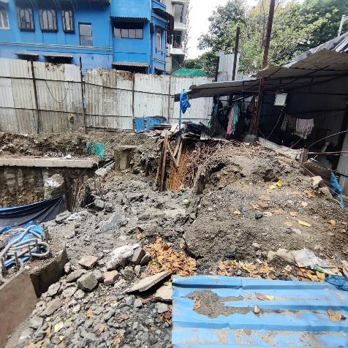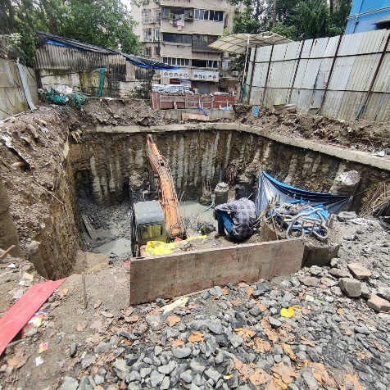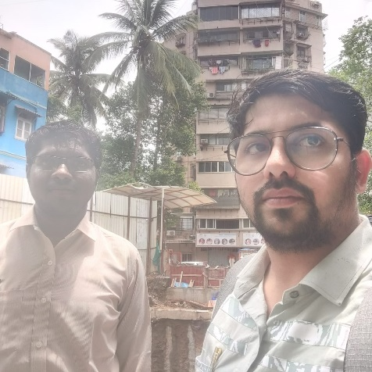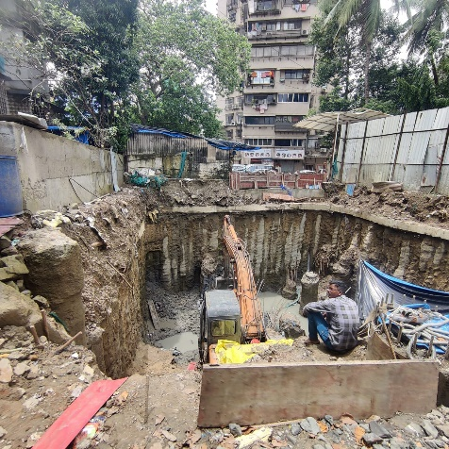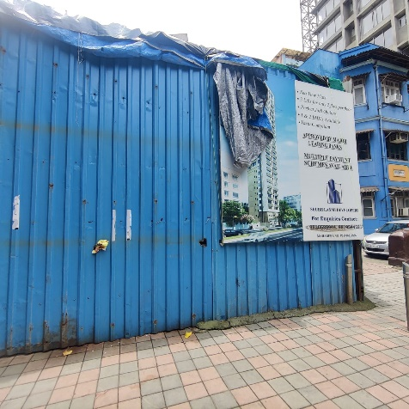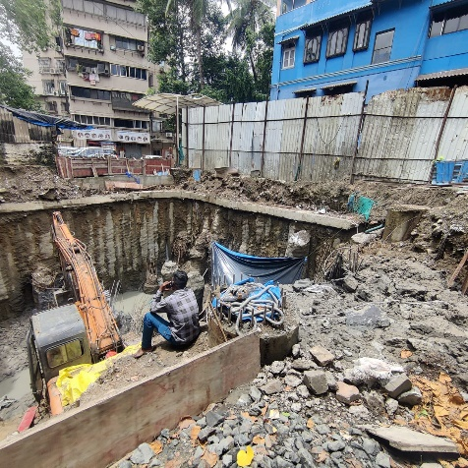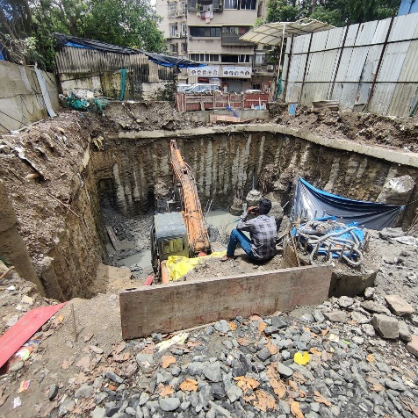

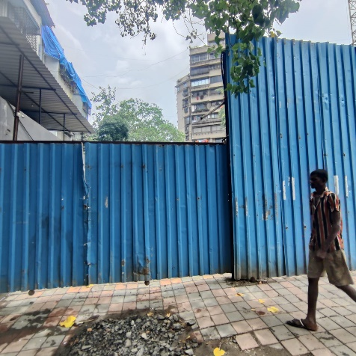

**Route Map of the property**

**Site u/r**

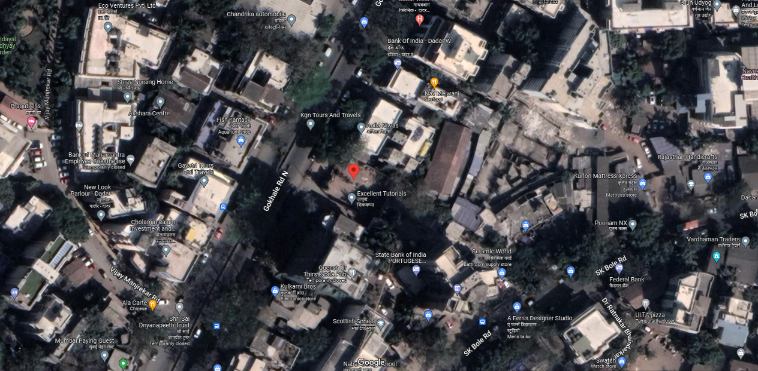

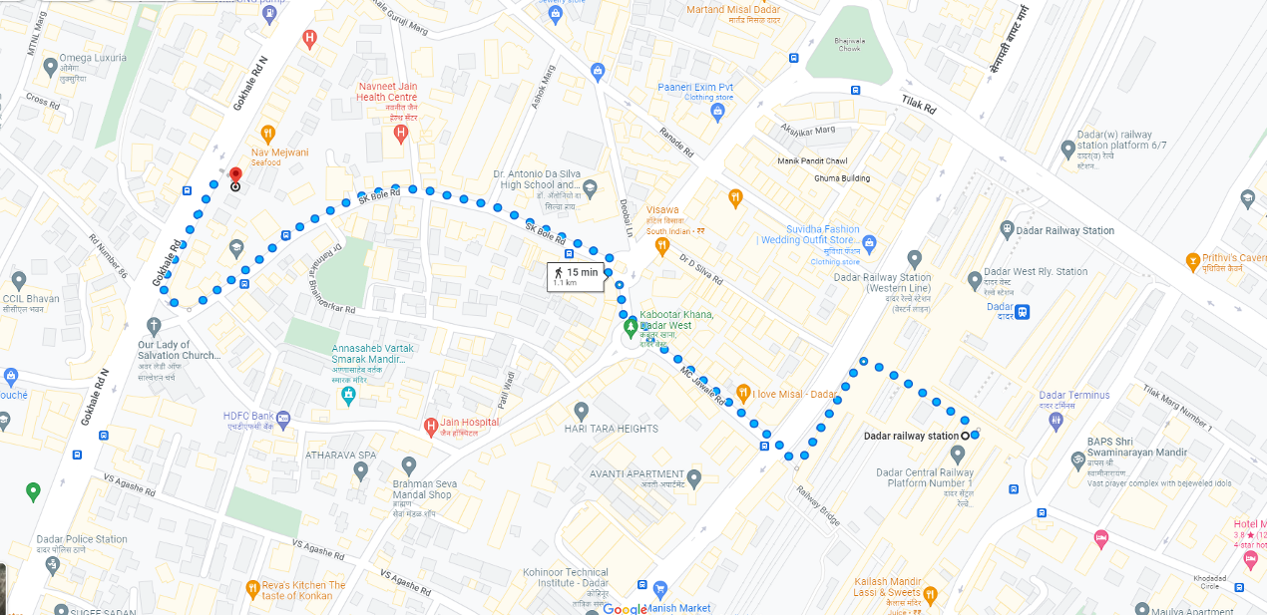

## Latitude Longitude: 19°01'12.8"N 72°50'13.0"E

Note: The Blue line shows the route to site from nearest railway station (Dadar – 1.10 Km.)

**CA Certificate Dated 12.07.2023 incurred cost till 30.06.2023**

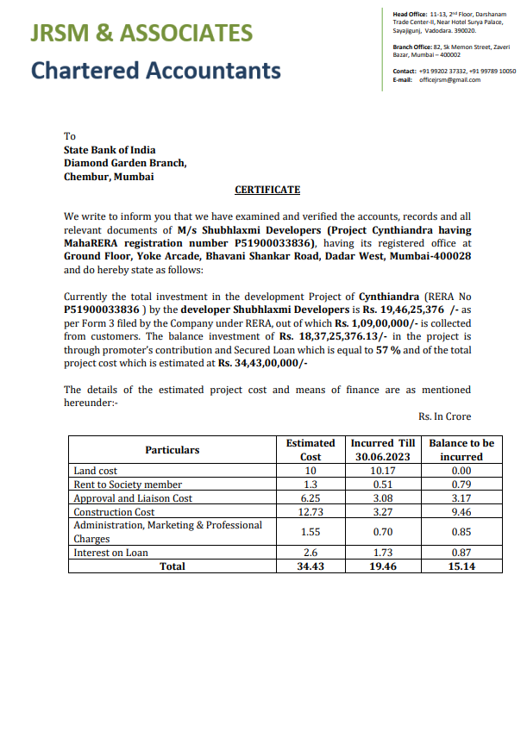

**CA Certificate Dated 12.07.2023 incurred cost till 21.08.2023**

