Vastu/Nashik/08/3242/2302130
21/17-276-RPSH
Date: 21.08.2023

To, `
The Branch Manager,
State Bank of India
Adgaon Branch
Vibhuti, Plot No. 1, Survey No.501, Nashik-Agra Road, Adgaon Shivar,
Nashik - 422003, State – Maharashtra, Country – India.

Sub: Vetting of Extra Amenities

Sir,

With reference to above subject, we have evaluated the Extra Amenities for Residential Flat No. 03, First Floor, Wing-A, "Morya Heights", Survey No. 897/ 1/ B, Plot No. 30,31 & 40,41, Near Police Headquarter Ground, Dnyaneshwar Nagar, Wasan Nagar Road, Pathardi Phata, Village – Nashik, Taluka & District - Nashik, PIN Code – 422 009, State – Maharashtra, Country – India belongs to M/s. Jaap builders. Name of Proposed Purchaser: Mr. Mukesh Prasad Gupta & Mrs. Dolly Kumari.

We have verified the rates quoted as per current market rates. Details of work and Extra Amenities considered as per copy of Agreement for Extra Amenities issued by Mr. Mukesh Prasad Gupta & Mrs. Dolly Kumari. (First Party) and Mr. Sunil Gumansingh Pardeshi (Second Party) received on dated 04.08.2023. The Extra Amenities amount is Rs. 5,58,000/- ( Rupees Five Lakh Fifty Eight Thousand Only. )

The said Cost Vetting Certificate is valid upto next 6 months Only.

Thanking you

Sincerely yours

Manoj B. Chalikwar
Registered Valuer
Chartered Engineer (India)
Reg. No. CAT-I-F-1763
Reg. No. IBBI/RV/07/2018/10366
BOB Empanelment No.: ZO:MZ:ADV:46:941
Encl: Valuation report.

Agreement for Extra Amenities
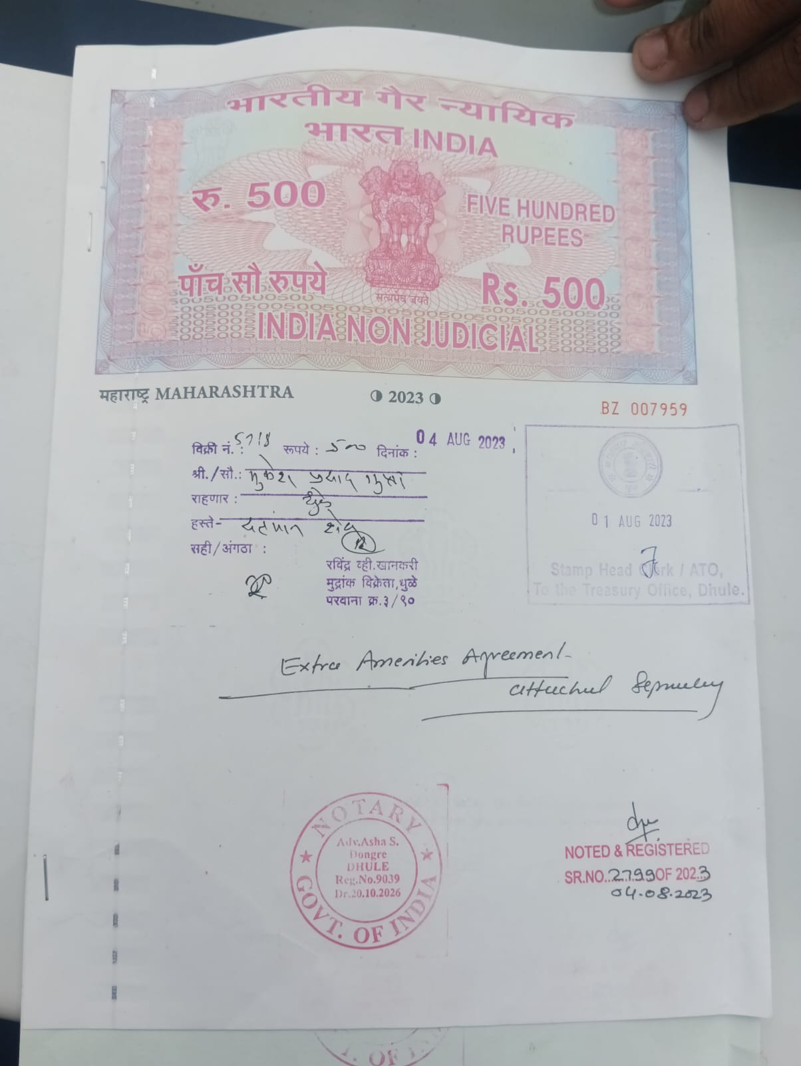

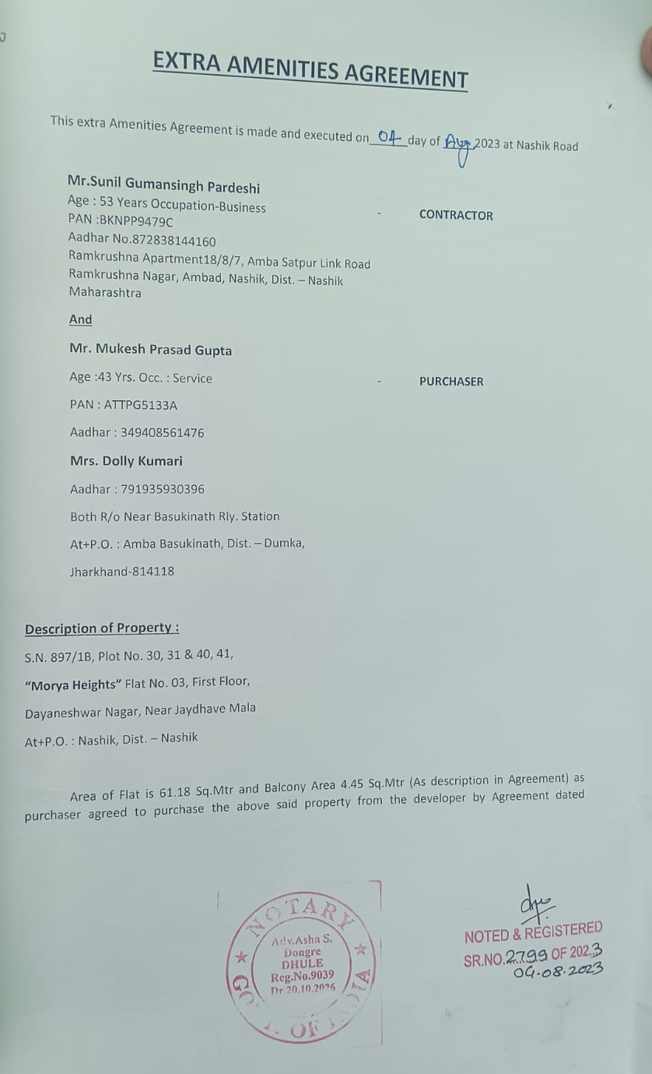

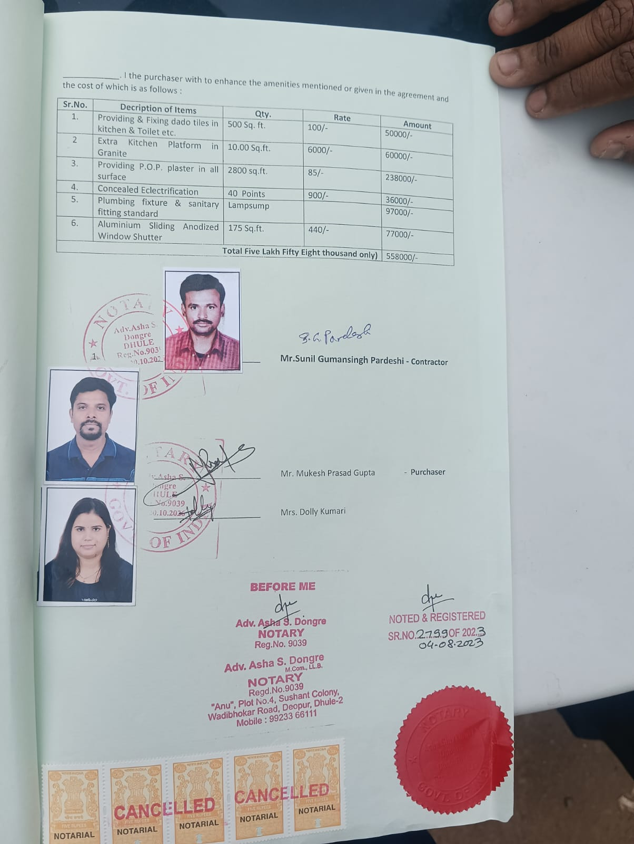

The Extra Amenities amount is Rs.5,58,000/- (Rupees Five Lakh Fifty Eight Thousand Only.)

