Valuation Report of the Immovable Property
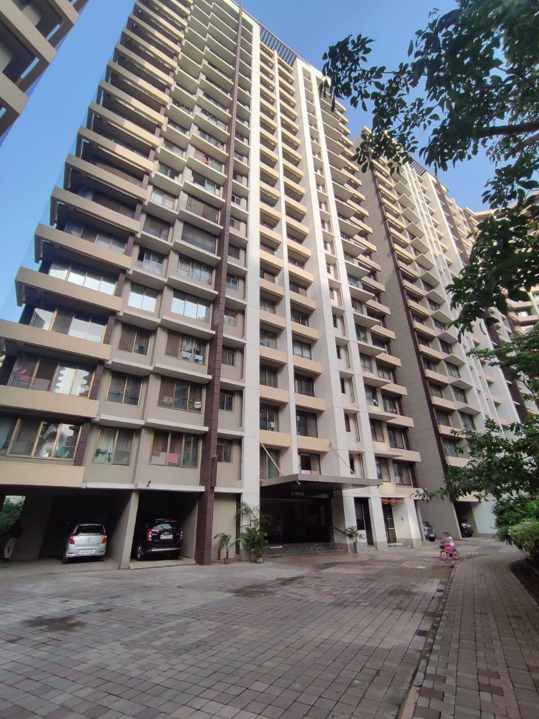

Details of the property under consideration:

Name of Owner: Mrs. Milan Ajit Rane & Mr.Ajit Tatebhaou Rane

Residential Flat No. 32, 3rd Floor, Wing – D, Building No. 1, "Indigo", "Kalpataru Aura Bldg. No. 1 A, B, C, D Co-Op. Hsg. Soc. Ltd.", L.B.S. Marg, Near R City Mall, Ghatkopar (West), Mumbai - 400 086,
State – Maharashtra, Country – India.

Longitude Latitude: 19°05'48.2"N 72°55'03.0"E

Valuation Prepared for:
Bank of India
Kalwa Branch
Sanghvi Valley A1 & A2, Parsik Nagar, Kalwa (West), Thane – 400 605,
State – Maharashtra, Country – India.

Vastu/Thane/08/2023/3207/2301022
08/20-128-PSVS
Date: 22.08.2023

VALUATION OPINION REPORT

This is to certify that the property bearing Residential Flat No. 32, 3rd Floor, Wing – D, Building No. 1, "Indigo", "Kalpataru Aura Bldg. No. 1 A, B, C, D Co-Op. Hsg. Soc. Ltd.", L.B.S. Marg, Near R City Mall, Ghatkopar (West), Mumbai - 400 086, State – Maharashtra, Country – India belongs to Mrs. Milan Ajit Rane & Mr.Ajit Tatebhaou Rane.

Boundaries of the property.
North |  | : | Kalpataru Aura Club One
South |  | : | Wing – A, Building No. 2
East |  | : | Internal Road
West |  | : | Internal Road
Considering various parameters recorded, existing economic scenario, and the information that is available with reference to the development of neighborhood and method selected for valuation, we are of the opinion that, the property premises can be assessed and valued for this particular purpose at ` 2,61,10,500.00 (Rupees Two Crore Sixty One Lakh Ten Thousand Five Hundred Only).

The valuation of the property is based on the documents produced by the concern. Legal aspects have not been taken into considerations while preparing this valuation report.

Hence certified

Manoj B. Chalikwar
Registered Valuer
Chartered Engineer (India)
Reg. No. CAT-I-F-1763
BOI Emp. No. MNZ:C&IC:VAL19-20
Encl: Valuation report.

Vastukala Consultants (I) Pvt. Ltd.
121, 1st Floor, Ackruti Star, Central Road, MIDC, Andheri (E), Mumbai – 400 093

To,
The Branch Manager,
Bank of India
Kalwa Branch
Sanghvi Valley A1 & A2, Parsik Nagar,
Kalwa (West), Thane – 400 605,
State – Maharashtra, Country – India.

VALUATION REPORT (IN RESPECT OF FLAT)
I | General
1. | Purpose for which the valuation is made |  |  | : | To assess fair market value of the property for Housing Loan Purpose
2. | a) |  | Date of inspection | : | 21.08.2023
 | b) |  | Date on which the valuation is made |  | 22.08.2023
3. | List of documents produced for perusal:  - Copy of Agreement for sale dated 26.12.2009 Between Kalpataru Limited (the Developers) and Mrs. Milan Ajit Rane & Mr. Ajit Tatebhaou Rane (the Purchaser).  - Copy of Commencement Certificate No. 6382 / BPES / AN dated 22.08.2007 issued by Municipal Corporation of Greater Mumbai.  - Copy of Society Share Certificate No. 193 dated 04.01.2013 in the name of Milan Ajit Rane J/W Ajit Tatebhaou Rane.
4. | Name of the owner(s) and his / their address (es) with Phone no. (details of share of each owner in case of joint ownership) |  |  | : | Mrs. Milan Ajit Rane & Mr. Ajit Tatebhaou Rane.  Address: Residential Flat No. 32, 3rd Floor, Wing – D, Building No. 1, "Indigo", "Kalpataru Aura Bldg. No. 1 A, B, C, D Co-Op. Hsg. Soc. Ltd.", L.B.S. Marg, Near R City Mall, Ghatkopar (West), Mumbai - 400 086, State – Maharashtra, Country – India.  Contact Person:  Mr. Ajay Modi (Tenant)  Mob No. 9820049659  Joint Ownership
5. | Brief description of the property (Including Leasehold / freehold etc.) |  |  | : | The property is a residential flat located on 3rd floor. The Composition of Flat is having 3 Bedrooms + Living Room + Dinning + Kitchen + 2 Toilets + Passage + Dry Balcony. (i.e., 2.5 BHK with 2 Toilets) The property is at 2.1 Km. travelling distance from nearest railway station Ghatkopar.
6. | Location of property |  |  | :
 | a) | Plot No. / Survey No. |  | : | -
 | b) | Door No. |  | : | Residential Flat No. 32
 | c) | C. T.S. No. / Village |  | : | C.T.S. No. 168A/A, 168A/1-28, 168A/31, 168A/33 & 168G (Part) of Village – Ghatkopar
 | d) | Ward / Taluka |  | : | Ward – N, Taluka – Kurla
 | e) | Mandal / District |  | : | District – Mumbai Suburban
 | f) | Date of issue and validity of layout of approved map / plan |  | : | Copy of Approved Building plans were not provided and not verified.
 | g) | Approved map / plan issuing authority |  | :
 | h) | Whether genuineness or authenticity of approved map/ plan is verified |  | :
 | i) | Any other comments by our empanelled valuers on authentic of approved plan |  |  | N.A.
7. | Postal address of the property |  |  | : | Residential Flat No. 32, 3rd Floor, Wing – D, Building No. 1, "Indigo", "Kalpataru Aura Bldg. No. 1 A, B, C, D Co-Op. Hsg. Soc. Ltd.", L.B.S. Marg, Near R City Mall, Ghatkopar (West), Mumbai - 400 086, State – Maharashtra, Country – India.
8. | City / Town |  |  | : | Ghatkopar (West), Mumbai
 | Residential area |  |  | : | Yes
 | Commercial area |  |  | : | No
 | Industrial area |  |  | : | No
9. | Classification of the area |  |  | :
 | i) High / Middle / Poor |  |  | : | Middle Class
 | ii) Urban / Semi Urban / Rural |  |  | : | Urban
10. | Coming under Corporation limit / Village Panchayat / Municipality |  |  | : | Village – Ghatkopar  Municipal Corporation of Greater Mumbai
11. | Whether covered under any State / Central Govt. enactments (e.g., Urban Land Ceiling Act) or notified under agency area/ scheduled area / cantonment area |  |  | : | No
12. | Boundaries of the property |  |  |  | As per Site |  | As per Documents
 | North |  |  | : | Kalpataru Aura Club One |  | Partly by the property bearing C.T.S. 167E of Village Ghatkopar, & partly by L.B.S. Marg
 | South |  |  | : | Wing – A, Building No. 2 |  | Partly by the property bearing C.T.S. 168A/B of Village Ghatkopar, & partly by boundary of Central Railway
 | East |  |  | : | Internal Road |  | Partly by boundary of the Central Railway and partly by the boundary of Village Vikhroli
 | West |  |  | : | Internal Road |  | Partly by the Lal Bahadur Shastri Marg and Partly by the properties bearing C.T.S. No. 168A/B and 168C/1 of Village - Ghatkopar
13 | Dimensions of the site |  |  |  | N. A. as property under consideration is a Residential Flat in a building.
 |  |  |  |  | A As per the Deed | B Actuals
 | North |  |  | : | Details not available | Lift
 | South |  |  | : | Details not available | Flat No. 31
 | East |  |  | : | Details not available | Passage
 | West |  |  | : | Details not available | Open Plot
14. | Extent of the site |  |  | : | Carpet Area in Sq. Ft. = 808.00  Dry Balcony in Sq. Ft. = 74.00  Total Carpet Area in Sq. Ft. = 882.00  (Area as per Actual site measurement)  Carpet Area in Sq. Ft. = 845.00  (Area as per Agreement for sale)  Built Up Area in Sq. Ft. = 1,014.00  (Area as per Index II)
14.1 | Latitude, Longitude & Co-ordinates of Flat |  |  | : | 19°05'48.2"N 72°55'03.0"E
15. | Extent of the site considered for Valuation (least of 13A& 13B) |  |  | : | Carpet Area in Sq. Ft. = 845.00  (Area as per Agreement for sale)
16 | Whether occupied by the owner / tenant? If occupied by tenant since how long? Rent received per month. |  |  | : | Tenant Occupied (Mr. Ajay Modi)  Rented Since – 4 Months  ` 49,000.00 Present rental income per month
II | APARTMENT BUILDING
 | Nature of the Apartment |  |  | : | Residential
 | Location |  |  | :
 | C. T.S. No. |  |  | : | C.T.S. No. 168A/A, 168A/1-28, 168A/31, 168A/33 & 168G (Part) of Village – Ghatkopar
 | Block No. |  |  | : | -
 | Ward No. |  |  | : | Ward - N
 | Village / Municipality / Corporation |  |  | : | Village – Ghatkopar  Municipal Corporation of Greater Mumbai
 | Door No., Street or Road (Pin Code) |  |  | : | Residential Flat No. 32, 3rd Floor, Wing – D, Building No. 1, "Indigo", "Kalpataru Aura Bldg. No. 1 A, B, C, D Co-Op. Hsg. Soc. Ltd.", L.B.S. Marg, Near R City Mall, Ghatkopar (West), Mumbai - 400 086, State – Maharashtra, Country – India.
 | Description of the locality Residential / Commercial / Mixed |  |  | : | Residential
 | Year of Construction |  |  | : | 2007 (As per Full Commencement Certificate)
 | Number of Floors |  |  | : | Podium 1 + Stilt + 1st to 19th Upper Floors
 | Type of Structure |  |  | : | R.C.C. Framed Structure
 | Number of Dwelling units in the building |  |  | : | 4 Flats on 3rd Floor
 | Quality of Construction |  |  | : | Good
 | Appearance of the Building |  |  | : | Good
 | Maintenance of the Building |  |  | : | Good
 | Facilities Available |  |  | :
 | Lift |  |  | : | 2 Lifts
 | Protected Water Supply |  |  | : | Municipal Water supply
 | Underground Sewerage |  |  | : | Connected to Municipal sewer
 | Car parking |  |  | : | Along with 1 Basement Car Parking Space
 | Is Compound wall existing? |  |  | : | Yes
 | Is pavement laid around the building |  |  | : | Yes
III | FLAT
1 | The floor in which the Flat is situated |  |  | : | 3rd Floor
2 | Door No. of the Flat |  |  | : | Residential Flat No. 32
3 | Specifications of the Flat |  |  | :
 | Roof |  |  | : | R.C.C. Slab
 | Flooring |  |  | : | Vitrified & Wooden flooring
 | Doors |  |  | : | Teak Wood door frames with solid flush Shutter door
 | Windows |  |  | : | Powder Coated Aluminum sliding windows
 | Fittings |  |  | : | Concealed & Open plumbing with C.P. fittings.  Electrical wiring with Concealed.
 | Finishing |  |  | : | Cement Plaster & POP finishing
4 | House Tax |  |  | :
 | Assessment No. |  |  | : | Details not available
 | Tax paid in the name of: |  |  | : | Details not available
 | Tax amount: |  |  | : | Details not available
5 | Electricity Service connection No.: |  |  | : | Details not available
 | Meter Card is in the name of: |  |  | : | Details not available
6 | How is the maintenance of the Flat? |  |  | : | Good
7 | Sale Deed executed in the name of |  |  | : | Mrs. Milan Ajit Rane & Mr. Ajit Tatebhaou Rane
8 | What is the undivided area of land as per Sale Deed? |  |  | : | Details not available
9 | What is the plinth area of the Flat? |  |  | : | Built Up Area in Sq. Ft. = 1,014.00  (Area as per Index II)
10 | What is the floor space index (app.) |  |  | : | As per MCGM norms
11 | What is the Carpet Area of the Flat? |  |  | : | Carpet Area in Sq. Ft. = 808.00  Dry Balcony in Sq. Ft. = 74.00  Total Carpet Area in Sq. Ft. = 882.00  (Area as per Actual site measurement)  Carpet Area in Sq. Ft. = 845.00  (Area as per Agreement for sale)
12 | Is it Posh / I Class / Medium / Ordinary? |  |  | : | Middle Class
13 | Is it being used for Residential or Commercial purpose? |  |  | : | Residential
14 | Is it Owner-occupied or let out? |  |  | : | Tenant Occupied (Mr. Ajay Modi)
15 | If rented, what is the monthly rent? |  |  | : | ` 49,000.00 Present rental income per month
IV | MARKETABILITY |  |  | :
1 | How is the marketability? |  |  | : | Good
2 | What are the factors favoring for an extra Potential Value? |  |  | : | Located in developed area
3 | Any negative factors are observed which affect the market value in general? |  |  | : | No
V | Rate |  |  | :
1 | After analyzing the comparable sale instances, what is the composite rate for a similar Flat with same specifications in the adjoining locality? - (Along with details / reference of at - least two latest deals / transactions with respect to adjacent properties in the areas) |  |  | : | ` 30,000.00 to ` 32,000.00 per Sq. Ft.
2 | Assuming it is a new construction, what is the adopted basic composite rate of the Flat under valuation after comparing with the specifications and other factors with the Flat under comparison (give details). |  |  | : | ` 31,500.00 per Sq. Ft.  ` 30,900.00 per Sq. Ft. (after deprecation)
3 | Break – up for the rate |  |  | :
 | I. Building + Services |  |  | : | ` 2,500.00 per Sq. Ft.
 | II. Land + others |  |  | : | ` 29,000.00 per Sq. Ft.
4 | Guideline rate obtained from the Registrar's office (an evidence thereof to be enclosed) |  |  | : | ` 2,18,510.00 per Sq. M. i.e.  ` 20,300.00 per Sq. Ft.
4A | Guideline rate (After depreciation) |  |  |  | ` 2,02,008.00 per Sq. M. i.e.  ` 18,767.00 per Sq. Ft.
 | In case of variation of 20% or more in the valuation proposed by the valuer and the Guideline value provided in the State Govt. notification or Income Tax Gazette justification on variation has to be given. |  |  |  | It is a foregone conclusion that market value is always more than RR prices. As the RR rates are fixed by respective state governments for computing stamp duty / Regn. Fees. Thus the rates differs from place to place and location. amenities per se as evident from the fact that even RR rates decided by Govt. differs.
VI | COMPOSITE RATE ADOPTED AFTER DEPRECIATION
a | Depreciated building rate |  |  | :
 | Replacement cost of Flat with Services (v(3)i) |  |  | : | ` 2,500.00 per Sq. Ft.
 | Age of the building |  |  | : | 16 Years
 | Life of the building estimated |  |  | : | 44 years Subject to proper, preventive periodic maintenance & structural repairs.
 | Depreciation percentage assuming the salvage value as 10% |  |  | : | 24.00%
 | Depreciated Ratio of the building |  |  | : | -
b | Total composite rate arrived for Valuation |  |  | :
 | Depreciated building rate VI (a) |  |  | : | ` 1,900.00 per Sq. Ft.
 | Rate for Land & other V (3) ii |  |  | : | ` 29,000.00 per Sq. Ft.
 | Total Composite Rate |  |  | : | ` 30,900.00 per Sq. Ft.
 | Remark:

Details of Valuation:

Sr. No. | Description | Qty. | Rate per  unit (`) | Estimated  Value (`)
1 | Present value of the Flat | 845.00 Sq. Ft. | 30,900.00 | 2,61,10,500.00
2 | Wardrobes
3 | Showcases
4 | Kitchen arrangements
5 | Superfine finish
6 | Interior Decorations
7 | Electricity deposits / electrical fittings, etc.
8 | Extra collapsible gates / grill works etc.
9 | Potential value, if any
 | Fair market value of the property |  |  | 2,61,10,500.00
 | The Realizable value of the property |  |  | 2,34,99,450.00
 | The Distress value of the property |  |  | 2,08,88,400.00
 | Insurable value of the property (1,014.00 Sq. Ft. X 2,500.00) |  |  | 25,35,000.00
 | Govt. Value of the property (1,014.00 Sq. Ft. X 18,767.00) |  |  | 1,90,29,738.00

The sales comparison approach uses the market data of sale prices to estimate the value of a real estate property. Property valuation in this method is done by comparing a property to other similar properties that have been recently sold. Comparable properties, also known as comparables, or comps, must share certain features with the property in question. Some of these include physical features such as square footage, number of rooms, condition, and age of the building; however, the most important factor is no doubt the location of the property. Adjustments are usually needed to account for differences as no two properties are exactly the same. To make proper adjustments when comparing properties, real estate appraisers must know the differences between the comparable properties and how to value these differences. The sales comparison approach is commonly used for Residential Flat, where there are typically many comparables available to analyze. As the property is a residential Flat, we have adopted Sale Comparison Approach Method for the purpose of valuation. The Price for similar type of property in the nearby vicinity is in the range of ` 30,000.00 to ` 32,000.00 per Sq. Ft. on Carpet Area Considering the rate with attached report, current market conditions, demand and supply position, Flat size, location, upswing in real estate prices, sustained demand for Residential Flat, all round development of commercial and residential application in the locality etc. We estimate ` 30,900.00 per Sq. Ft. for valuation.
Impending threat of acquisition by government for road widening / publics service purposes, sub merging & applicability of CRZ provisions (Distance from sea-cost / tidal level must be incorporated) and their effect on
- Saleability | Good
- Likely rental values in future in | ` 49,000.00 Present rental income per month
- Any likely income it may generate | Rental Income
Actual Site Photographs

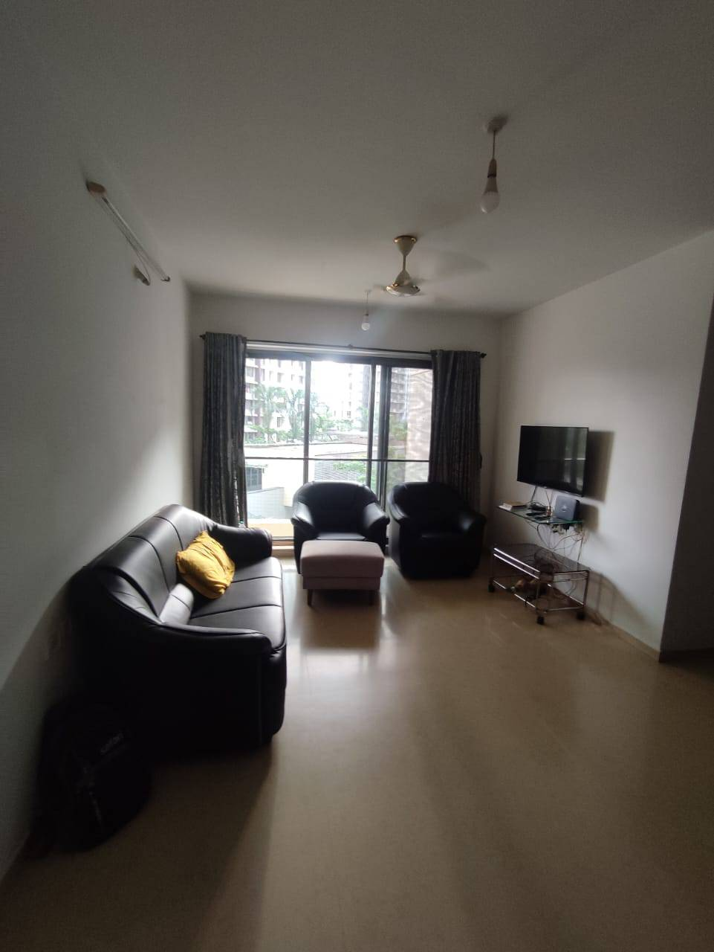
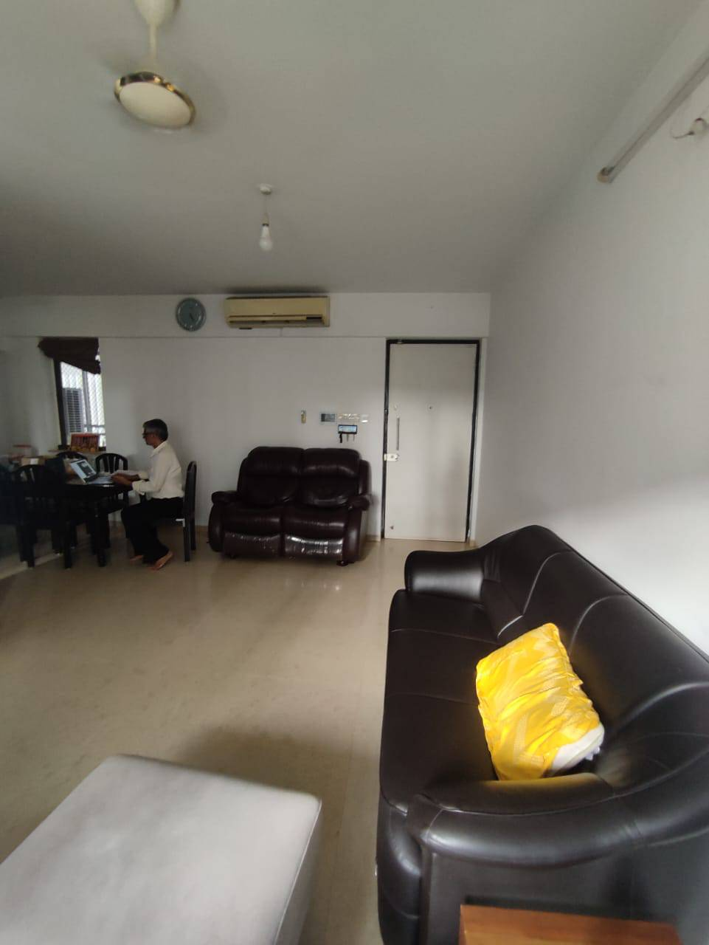
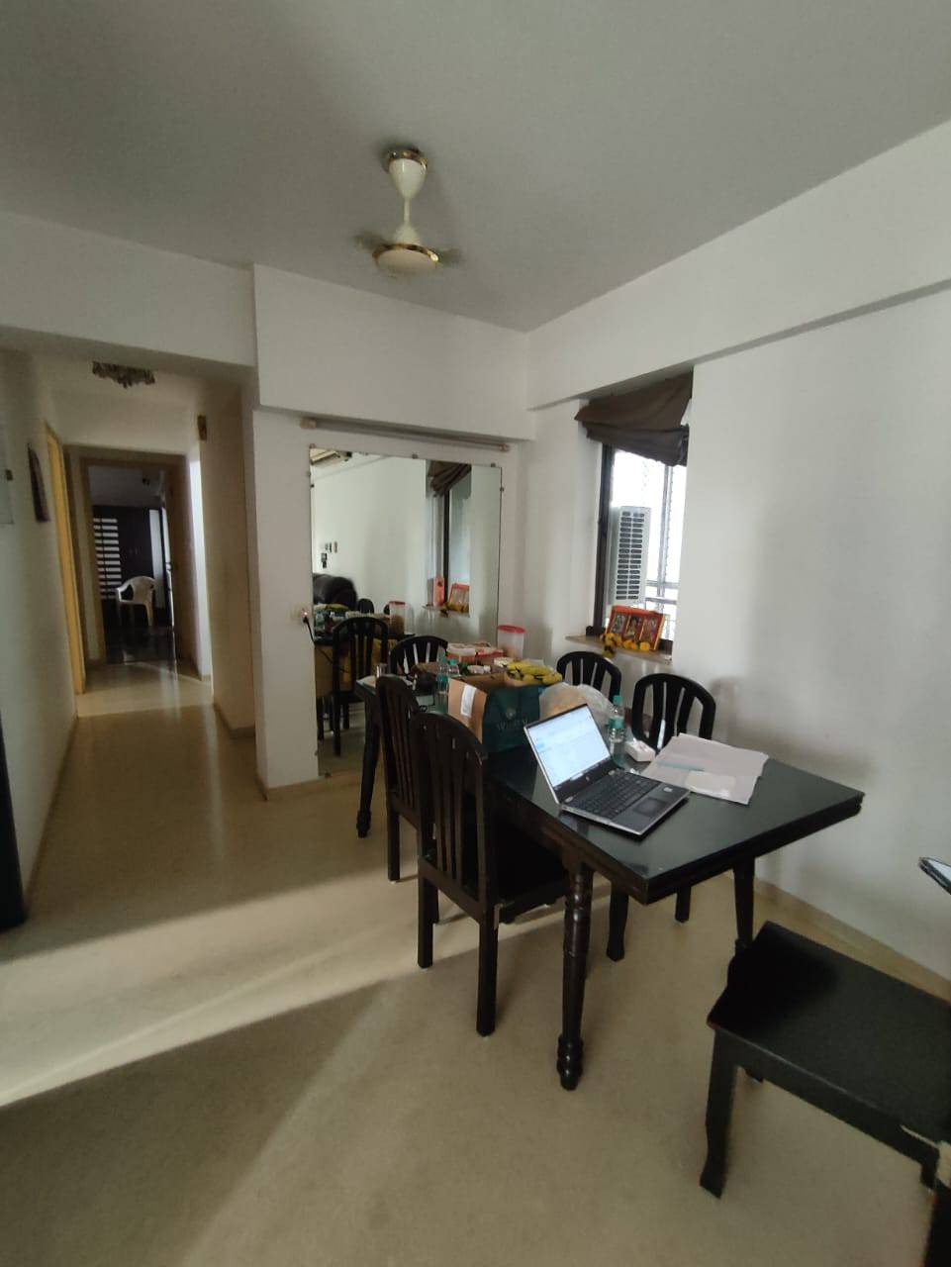

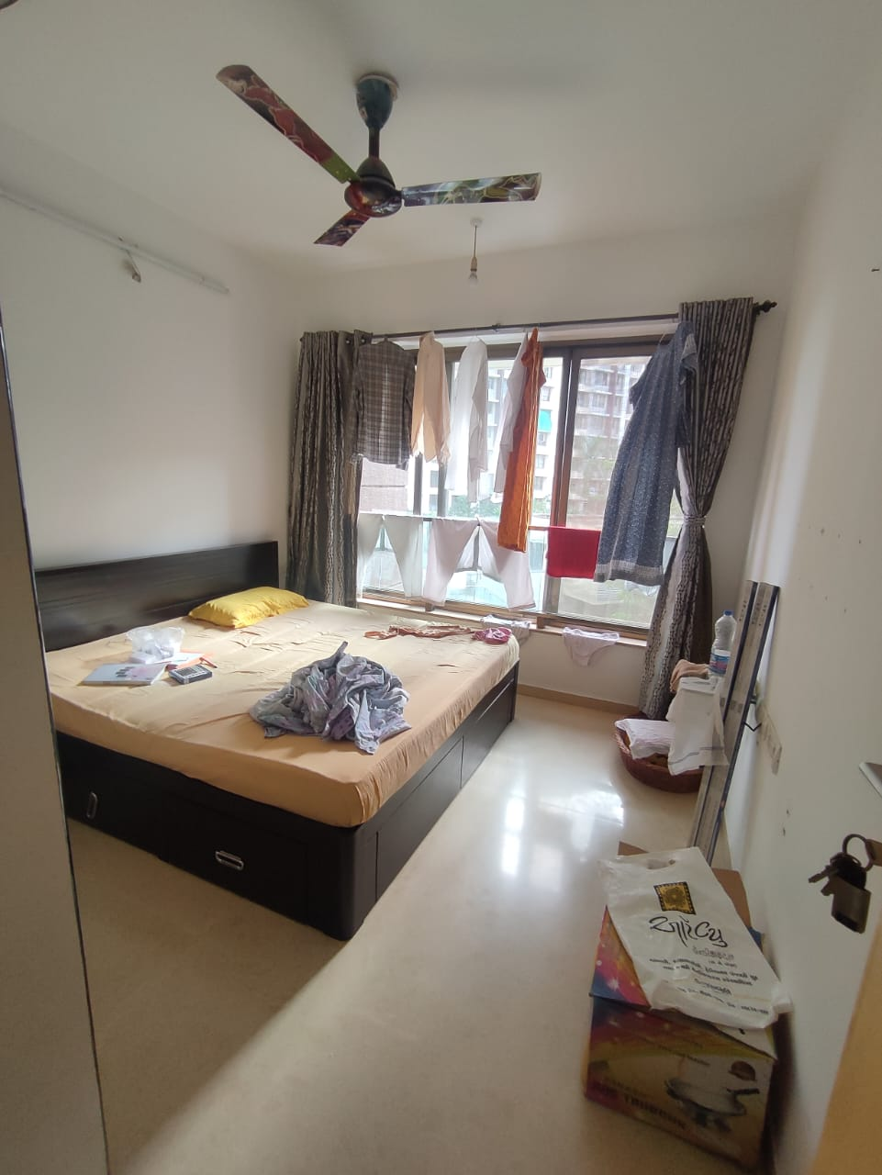
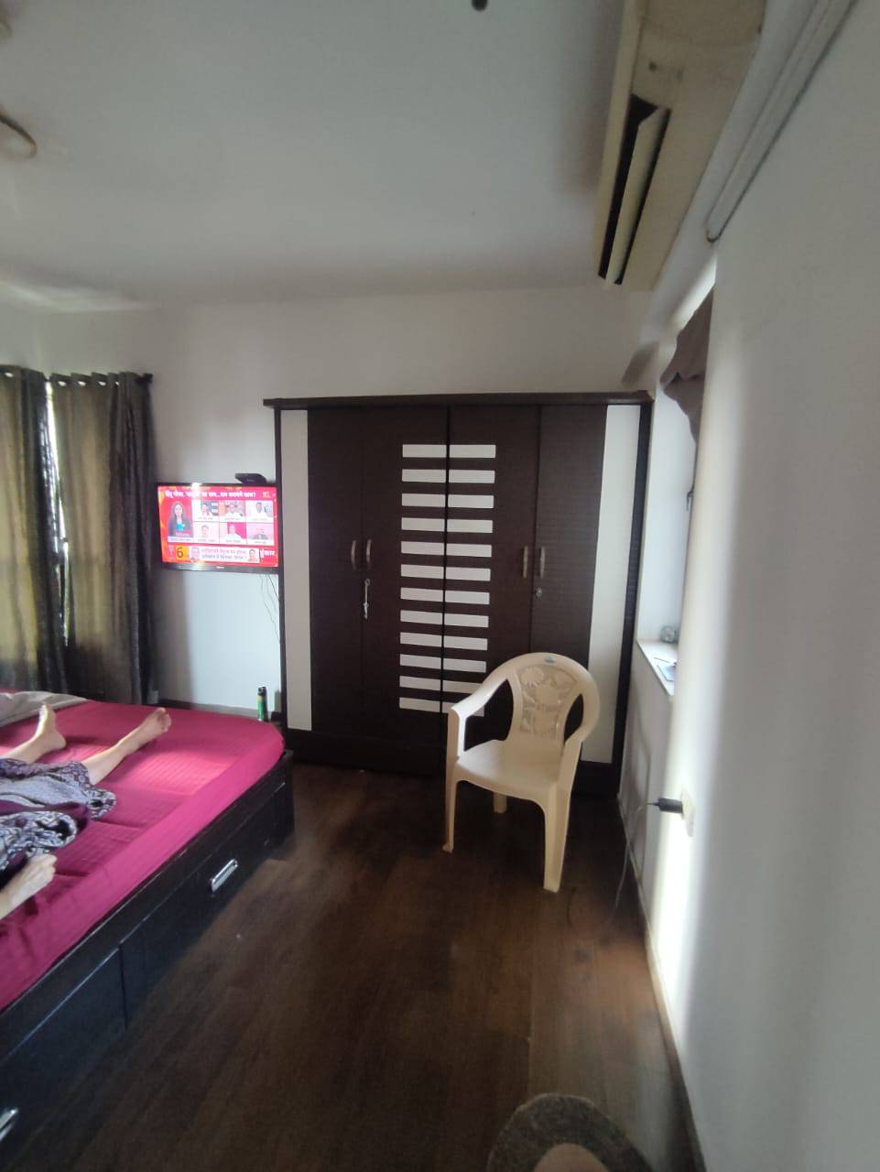
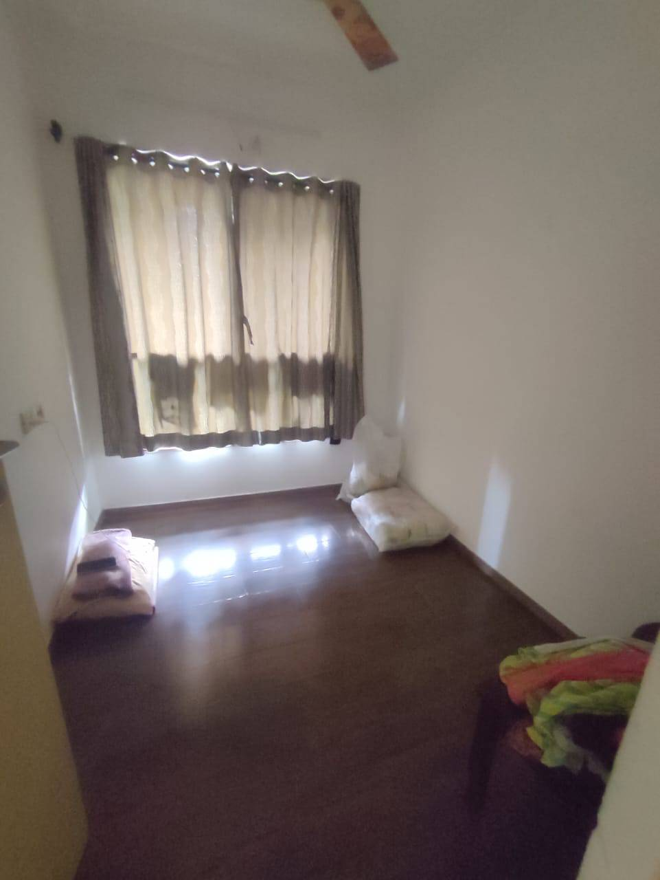

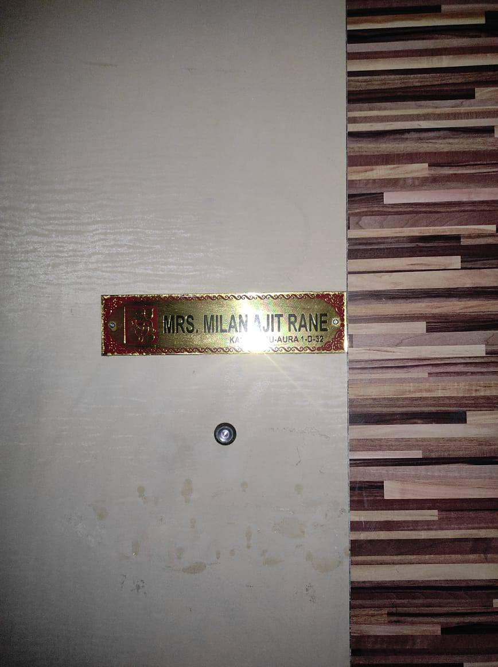
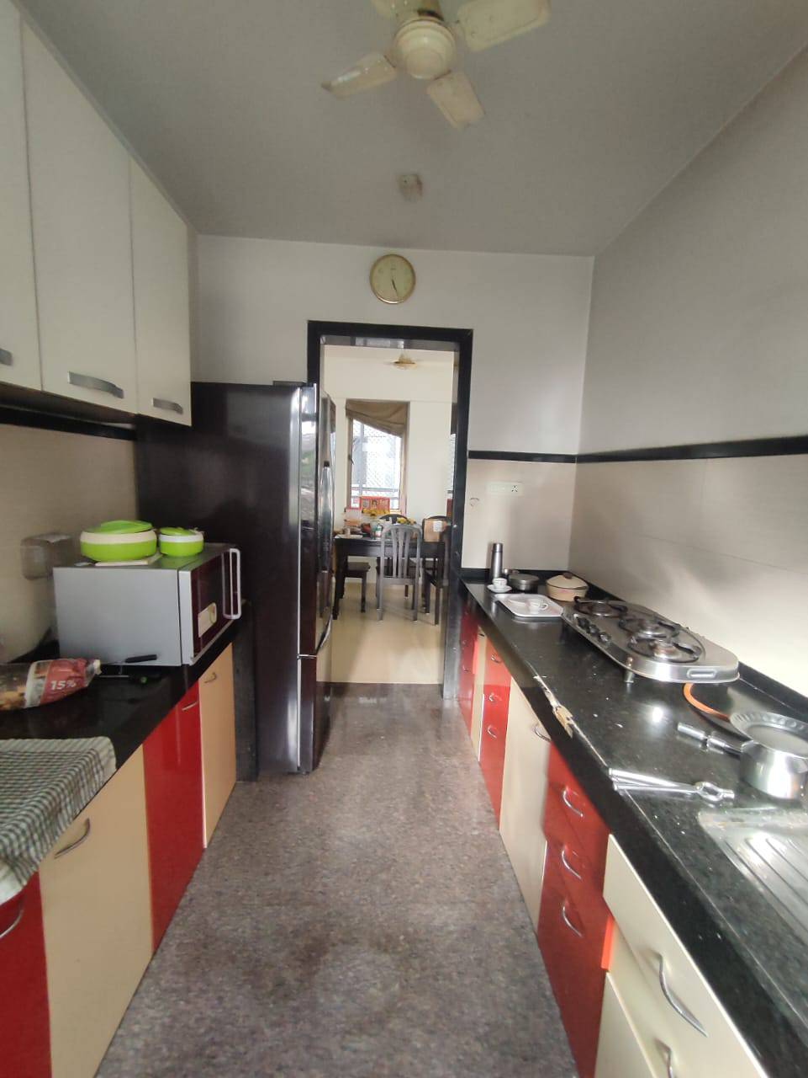
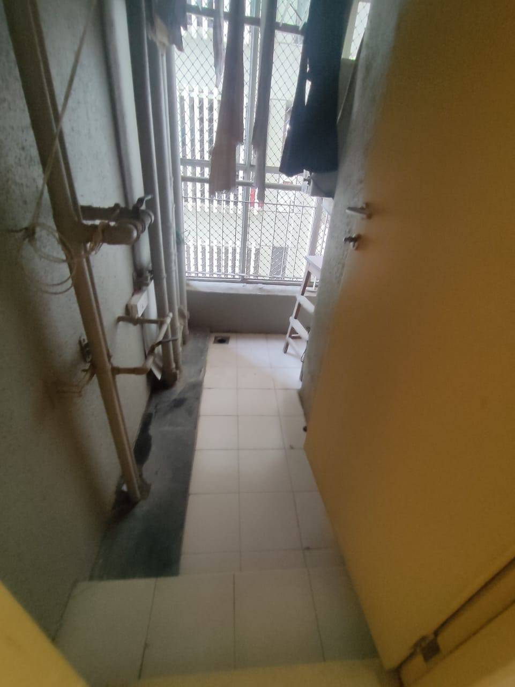

Actual Site Photographs
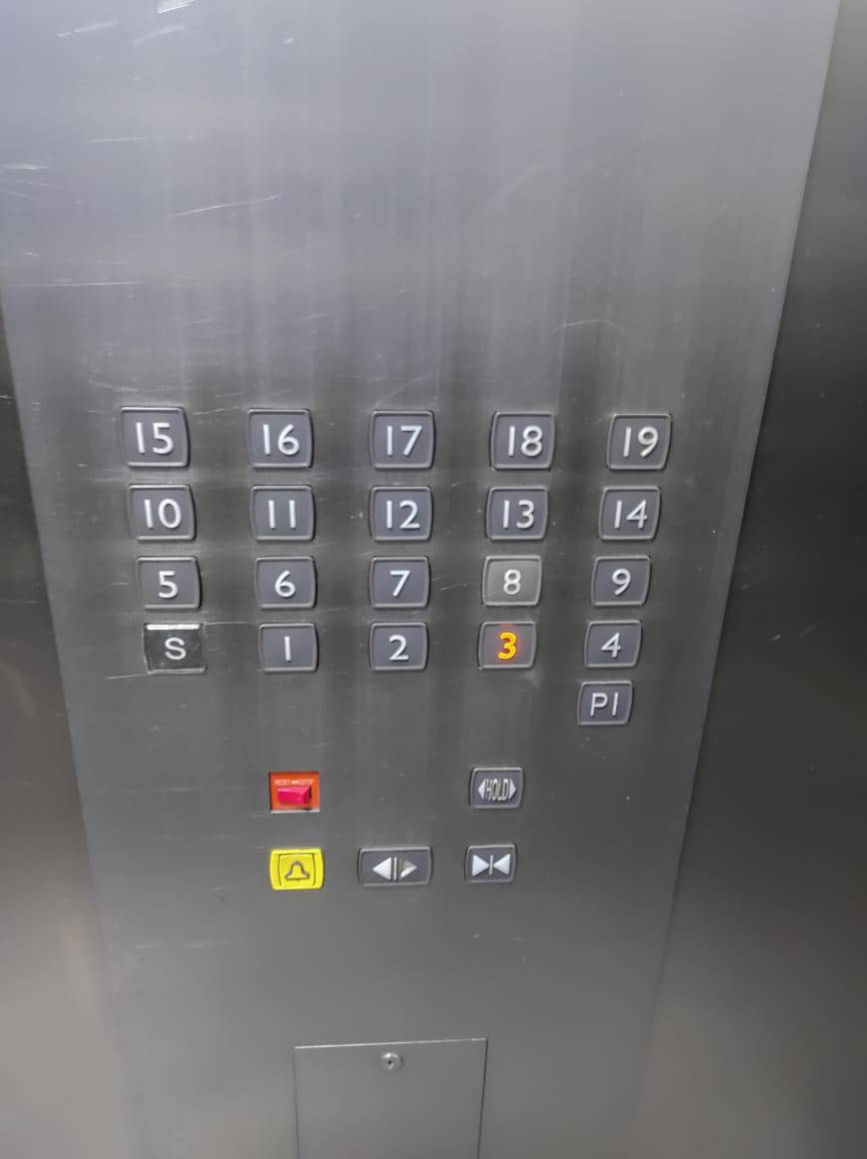
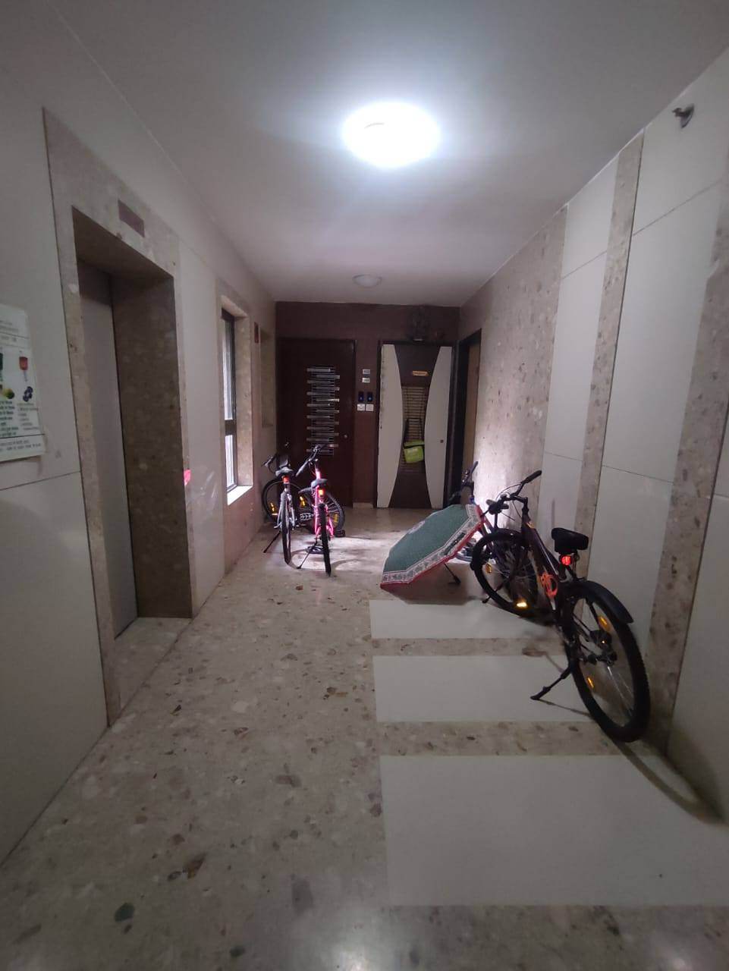

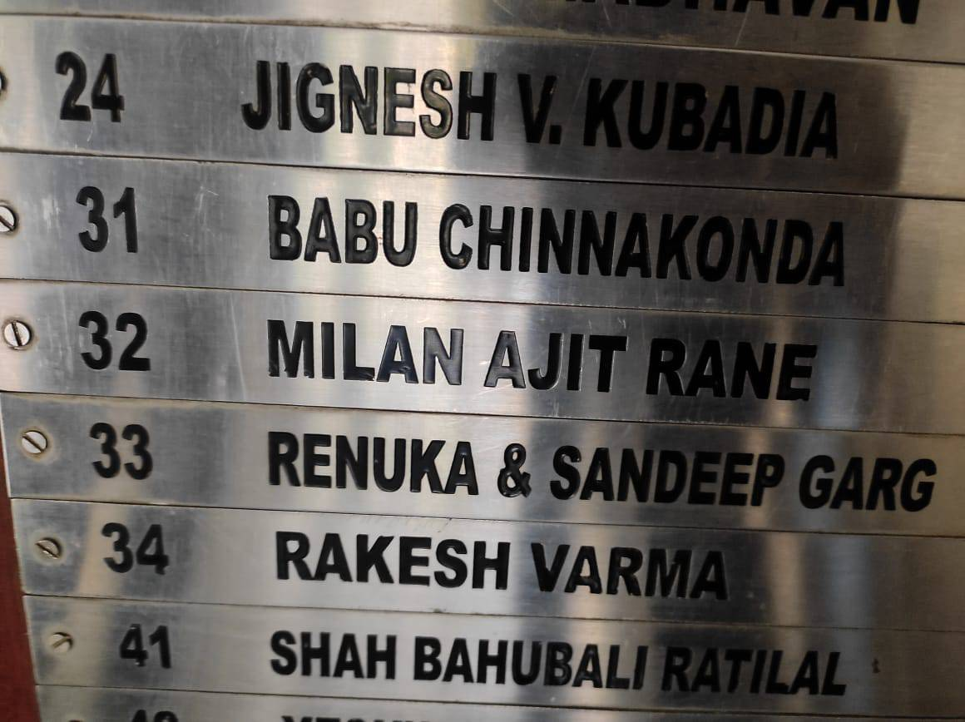

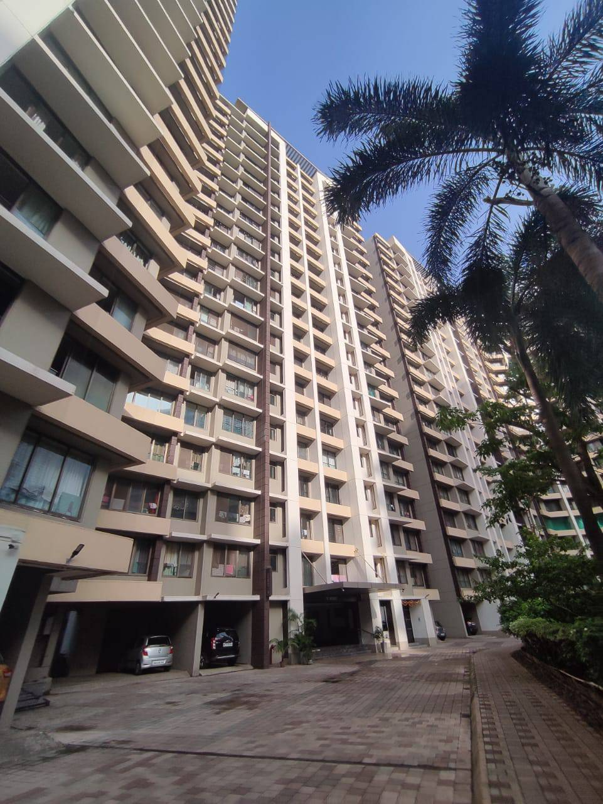
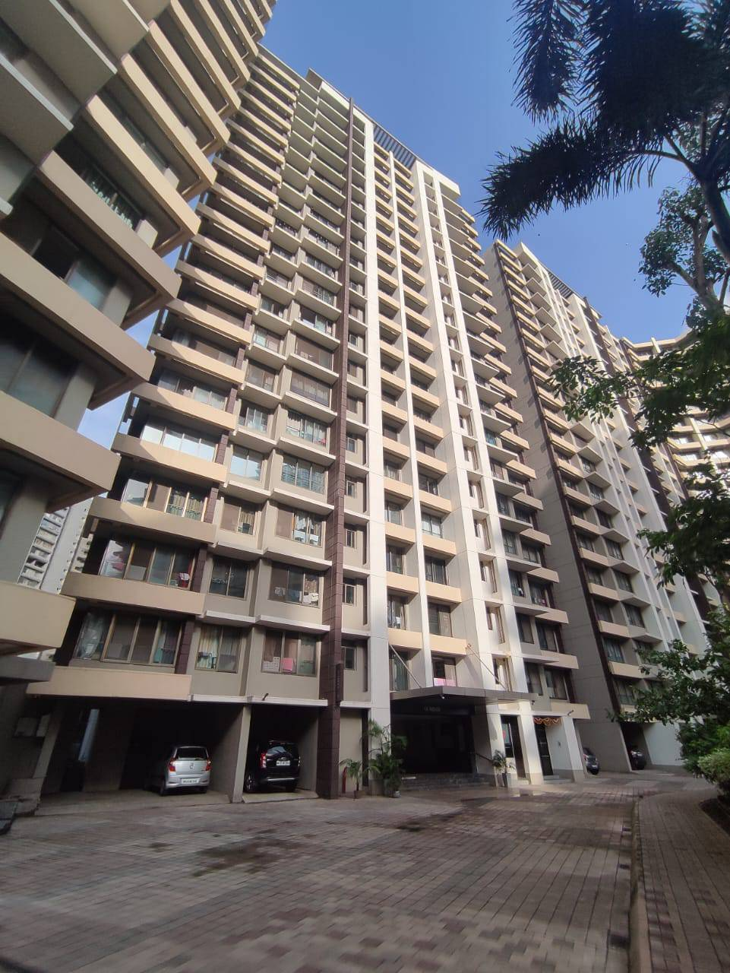

Route Map of the property
Site u/r
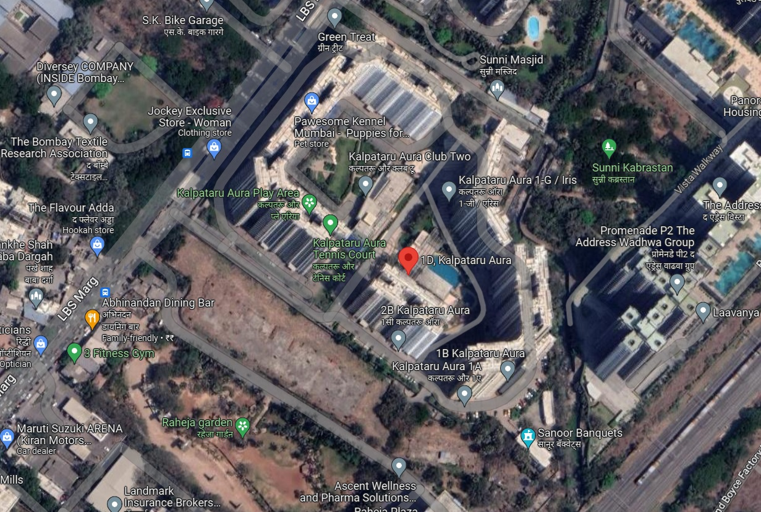

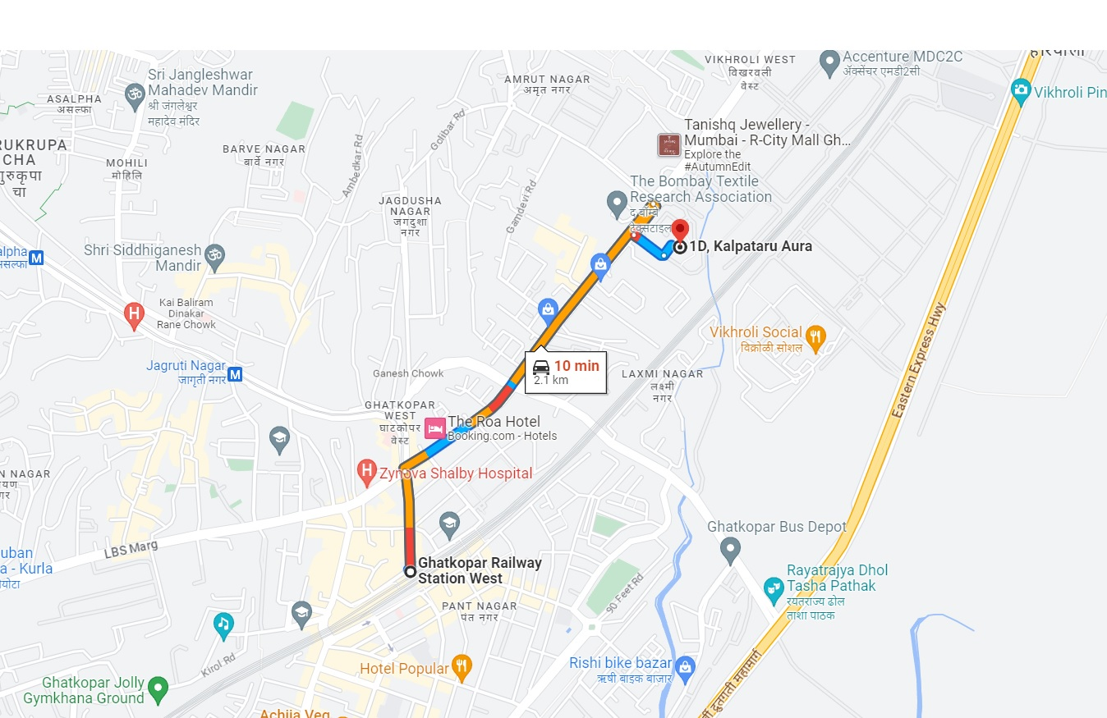

Longitude Latitude: 19°05'48.2"N 72°55'03.0"E

Note: The Blue line shows the route to site from nearest railway station (Ghatkopar – 2.1 Km.)

Ready Reckoner Rate
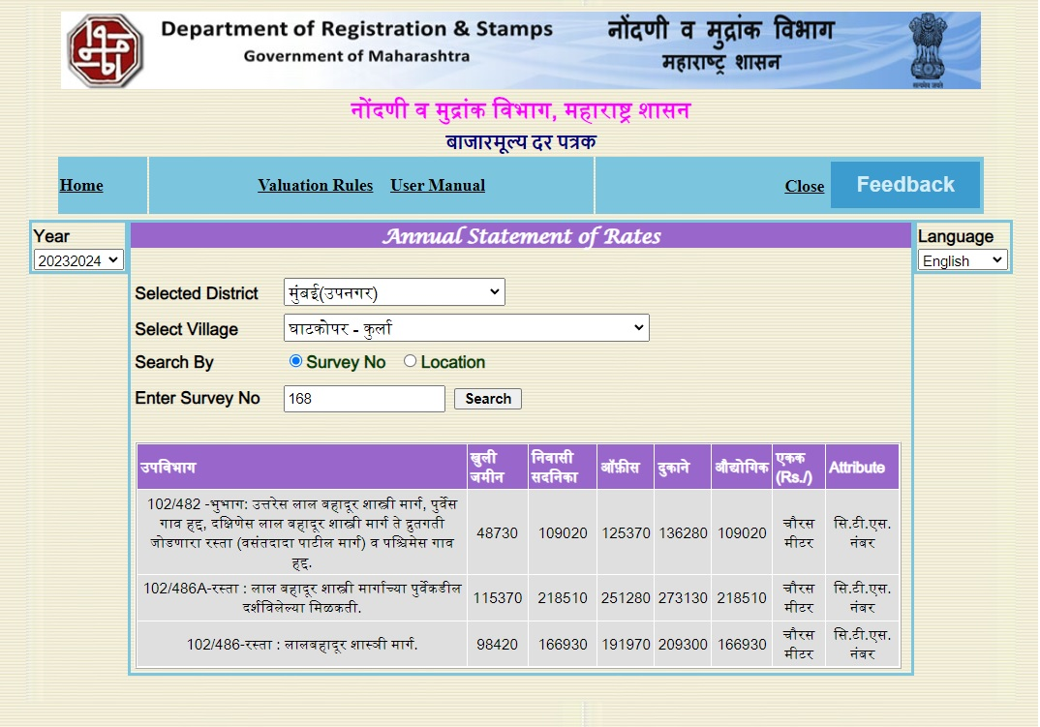

Stamp Duty Ready Reckoner Market Value Rate for Flat | 2,18,510.00
No Reduced, Flat Located on 3rd Floor | -
Stamp Duty Ready Reckoner Market Value Rate (After Reduced) (A) | 2,18,510.00 | Sq. Mt. | 20,300.00 | Sq. Ft.
Stamp Duty Ready Reckoner Market Value Rate for Land (B) | 1,15,370.00
The difference between land rate and building rate (A – B = C) | 1,03,140.00
Depreciation Percentage as per table (D) [100% - 16%]  (Age of the Building – 16 Years) | 84%
Rate to be adopted after considering depreciation [B + (C x D)] | 2,02,008.00 | Sq. Mt. | 18,767.00 | Sq. Ft.

Building not having lift
The following table gives the valuation of residential building / flat / commercial unit / office in such building on above floor where there is no lift. Depending upon the floor, ready reckoner rates will be reduced.

 | Floor on which flat is Located | Rate to be adopted
a) | Ground Floor / Stilt / Floor | 100%
b) | First Floor | 95%
c) | Second Floor | 90%
d) | Third Floor | 85%
e) | Fourth Floor and above | 80%

Table – D: Depreciation Percentage Table

Completed Age of Building in Years | Value in percent after depreciation
 | R.C.C. Structure / other Pukka Structure | Cessed Building, Half or Semi – Pukka Structure & Kaccha Structure.
0 to 2 Years | 100% | 100%
Above 2 & up to 5 Years | 95% | 95%
Above 5 Years | After initial 5 year for every year 1% depreciation is to be considered. However maximum deduction available as per this shall be 70% of Market Value rate | After initial 5 year for every year 1.5% depreciation is to be considered. However maximum deduction available as per this shall be 85% of Market Value rate

Price Indicators
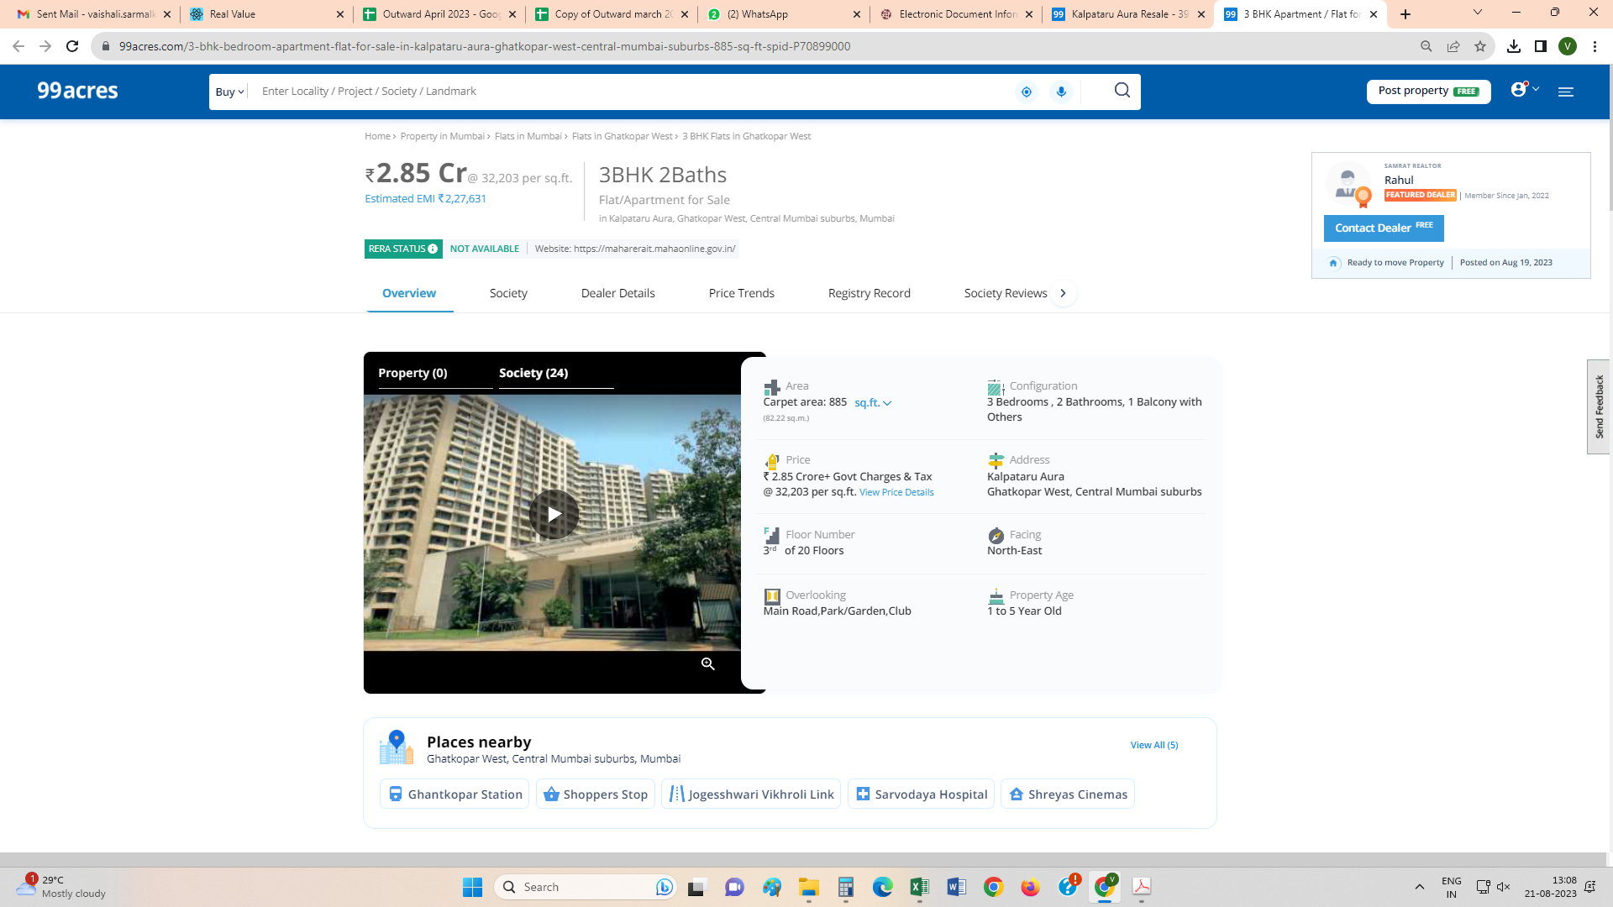

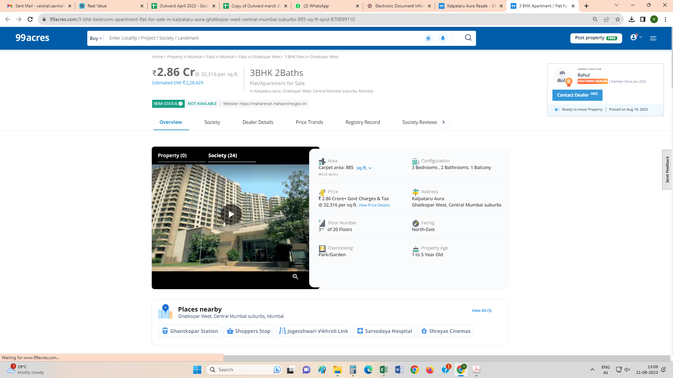

Price Indicators
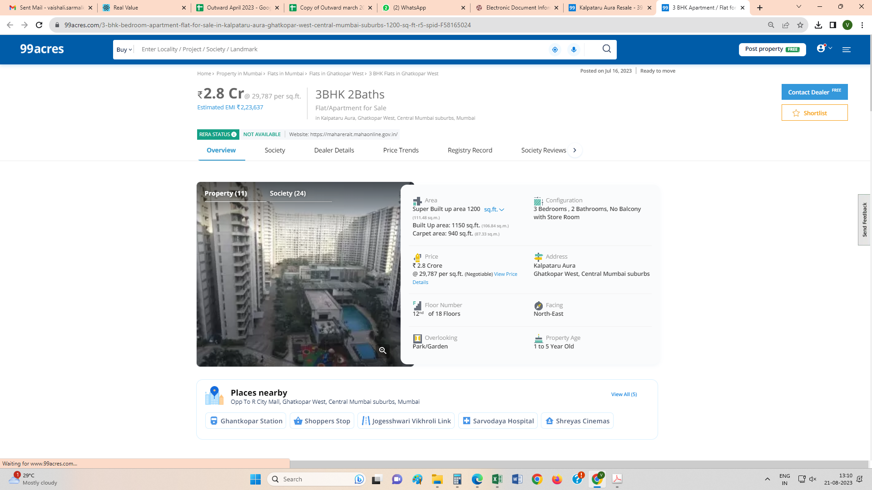
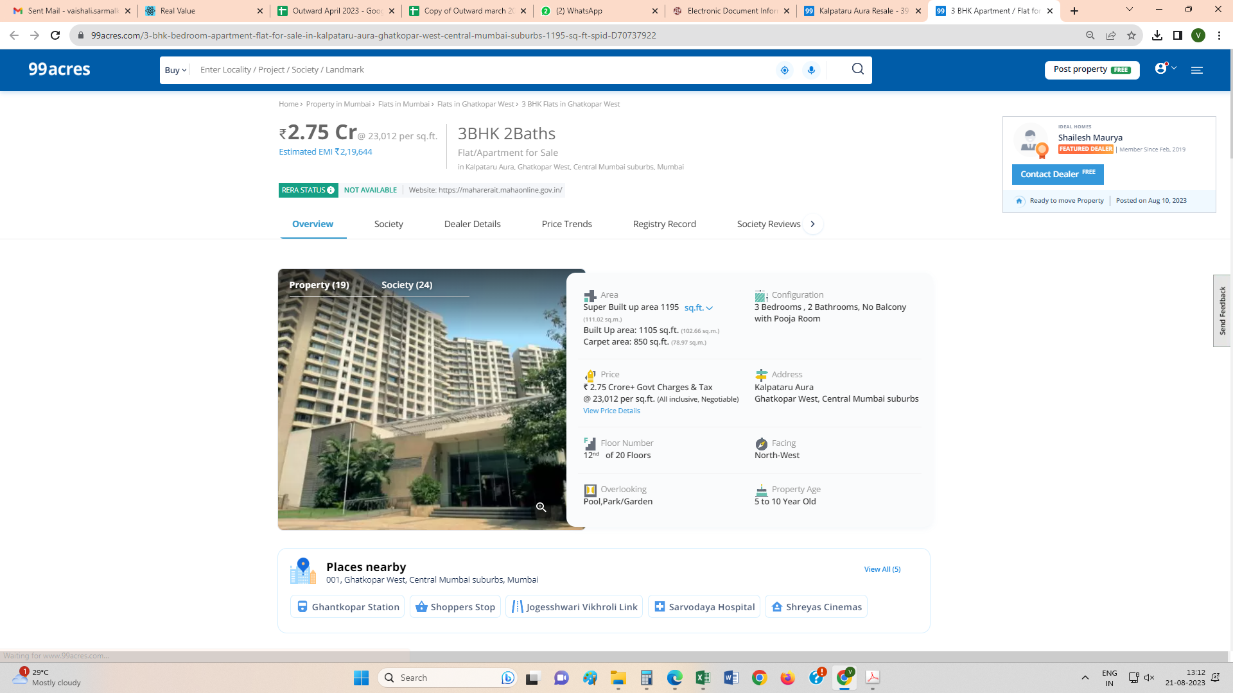
As a result of my appraisal and analysis, it is my considered opinion that the present fair market value of the above property in the prevailing condition with aforesaid specifications is ` 2,61,10,500.00 (Rupees Two Crore Sixty One Lakh Ten Thousand Five Hundred Only). The Realizable Value of the above property is ` 2,34,99,450.00 (Rupees Two Crore Thirty Four Lakh Ninety Nine Thousand Four Hundred Fifty Only). The Distress Value is ` 2,08,88,400.00 (Rupees Two Crore Eight Lakh Eighty Eight Thousand Four Hundred Only).

Place: Thane
Date: 22.08.2023

Manoj B. Chalikwar
Registered Valuer
Chartered Engineer (India)
Reg. No. CAT-I-F-1763
BOI Emp. No. MNZ:C&IC:VAL19-20

The undersigned has inspected the property detailed in the Valuation Report dated _______________________

on ____________________. We are satisfied that the fair and reasonable market value of the property is `_________________________ (Rupees ________________________________________________________

________________________________________only).

Date
Signature
(Name of the Branch Manager with office Seal)

DECLARATION FROM VALUERS

- The information furnished in my valuation report dated 22.08.2023 is true and correct to the best of my knowledge and belief and I have made and impartial and true valuation of the property. I have valued right property.
- I have no direct or indirect interest in the property valued;
- I/We have personally inspected the property on 21.08.2023 (Mr. Barkat Hodekar) the work is not sub-contracted to any other valuer and carried out by myself.
- I have not been convicted of any offence and sentenced to a term of imprisonment;
- I have not been found guilty of misconduct in my professional capacity.
- I have read the Handbook on Policy, Standard and procedure for Real Estate Valuation, 2011 of the IBA and this report is in conformity to the “Standards” enshrined for valuation in the Part-B of the above handbook to the best of my ability.
- I have read the Internal Valuation Standard (IVS) and the report submitted to the Bank for the respective asset class is in conformity to the “Standards” as enshrined for valuation in IVS in “General Standards” and “Asset Standards” as applicable.
- Past performance of Real Estate Market need not necessarily indicate the future trends. This valuation purely and estimate & has no legal or Contractual obligation on our part. Analysis & conclusions of the value of the property are based on assumptions & conditions prevailing at the time of date of valuation. The rated indicated are based on current market condition & these may vary with time.
- Encumbrances of Loan, Govt. or other dues, stamp duty, registration charges, transfer charged etc. if any, are not considered in the valuation. We have assumed that the assets are free of lien & encumbrances.
- Bank authorities are requested to contact valuers in case of any doubts or discrepancy. The opinion about valuation is true & fair to the best of our knowledge & belief. We have no direct or indirect interest in the assets valued.
- I abide by the Model Code of Conduct for empanelment of the valuer in the Bank.
- I am registered under Section 34 AB of the Wealth Tax Act, 1957.
- I am the proprietor / partner / authorized official of the firm / company, who is competent to sign this valuation report.
- VCIPL, by reason of this report, are not required to give testimony or attendance in court or to any Government Agency whit reference to the subject property unless prior arrangements and consent have been made.
- Further, I hereby provide the following information.

Sr.  No. | Particulars | Valuer comment
 | background information of the asset being valued; | The property was purchased by Mrs. Milan Ajit Rane & Mr.Ajit Tatebhaou Rane from Kalpataru Limited as per vide Agreement for sale dated 26.12.2009.
 | purpose of valuation and appointing authority | As per the request from Bank of India, Kalwa Branch, Thane to assess value of the property for Banking purpose
 | identity of the valuer and any other experts involved in the valuation; | Manoj B. Chalikwar – Regd. Valuer  Barkat Hodekar – Valuation Engineer  Vaishali Sarmalkar – Technical Manager  Pratibha Shilvanta – Technical Officer
 | disclosure of valuer interest or conflict, if any; | We have no interest, either direct or indirect, in the property valued. Further to state that we do not have relation or any connection with property owner / applicant directly or indirectly. Further to state that we are an independent Valuer and in no way related to property owner / applicant
 | date of appointment, valuation date and date of  report; | Date of Appointment – 21.08.2023  Valuation Date – 22.08.2023  Date of Report – 22.08.2023
 | inspections and/or investigations undertaken; | Physical Inspection done on 21.08.2023
 | nature and sources of the information used or relied upon; | - Market Survey at the time of site visit  - Ready Reckoner rates / Circle rates  - Online search for Registered Transactions  - Online Price Indicators on real estate portals  - Enquiries with Real estate consultants  - Existing data of Valuation assignments carried out by us
 | procedures adopted in carrying out the valuation and valuation standards followed; | Sales Comparison Method
 | restrictions on use of the report, if any; | This valuation is for the use of the party to whom it is addressed and for no other purpose. No responsibility is accepted to any third party who may use or rely on the whole or any part of this valuation. The valuer has no pecuniary interest that would conflict with the proper valuation of the property.
 | major factors that were taken into account during the valuation; | current market conditions, demand and supply position, Residential Flat size, location, upswing in real estate prices, sustained demand for Residential Flat, all round development of commercial and residential application in the locality etc.
 | Caveats, limitations and disclaimers to the extent they explain or elucidate the limitations faced by valuer, which shall not be for the purpose of limiting his responsibility for the valuation report. | Attached

Assumptions, Disclaimers, Limitations & Qualifications

Value Subject to Change
The subject appraisal exercise is based on prevailing market dynamics as on 22nd August 2023 and does not take into account any unforeseeable developments which could impact the same in the future.
Our Investigations
We are not engaged to carry out all possible investigations in relation to the subject property. Where in our report we identify certain limitations to our investigations, this is to enable the reliant party to instruct further investigations where considered appropriate or where we recommend as necessary prior to reliance. Vastukala Consultants India Pvt. Ltd. (VCIPL) is not liable for any loss occasioned by a decision not to conduct further investigations
Assumptions
Assumptions are a necessary part of undertaking valuations. VCIPL adopts assumptions for the purpose of providing valuation advise because some matters are not capable of accurate calculations or fall outside the scope of our expertise, or out instructions. The reliant party accepts that the valuation contains certain specific assumptions and acknowledge and accept the risk of that if any of the assumptions adopted in the valuation are incorrect, then this may have an effect on the valuation.
Information Supplied by Others
The appraisal is based on the information provided by the client. The same has been assumed to be correct and has been used for appraisal exercise. Where it is stated in the report that another party has supplied information to VCIPL, this information is believed to be reliable but VCIPL can accept no responsibility if this should prove not to be so.
Future Matters
To the extent that the valuation includes any statement as to a future matter, that statement is provided as an estimate and/or opinion based on the information known to VCIPL at the date of this document. VCIPL does not warrant that such statements are accurate or correct.
Map and Plans
Any sketch, plan or map in this report is included to assist the reader while visualising the property and assume no responsibility in connection with such matters.
Site Details
Based on inputs received from Client's representative and site visit conducted, we understand that the subject property is Residential Flat, admeasuring Carpet Area = 845.00 Sq. Ft. in the name of Mrs. Milan Ajit Rane & Mr. Ajit Tatebhaou Rane. Further, VCIPL has assumed that the subject property is free from any encroachment and is available as on the date of the appraisal.

Property Title
Based on our discussion with the Client's representative, we understand that the subject property is owned by Mrs. Milan Ajit Rane & Mr. Ajit Tatebhaou Rane. For the purpose of this appraisal exercise, we have assumed that the subject property has a clear title and is free from any encumbrances, disputes and claims. VCIPL has made no further enquiries with the relevant local authorities in this regard and does not certify the property as having a clear and marketable title. Further, no legal advice regarding the title and ownership of the subject property has been obtained for the purpose of this appraisal exercise. It has been assumed that the title deeds are clear and marketable.
Environmental Conditions
We have assumed that the subject property is not contaminated and is not adversely affected by any existing or proposed environmental law and any processes which are carried out on the property are regulated by environmental legislation and are properly licensed by the appropriate authorities.
Town Planning
The permissible land use, zoning, achievable FSI, area statement adopted for purpose of this valuation is based on the information provided by the Client's representative and the same has been adopted for this valuation purpose. VCIPL has assumed the same to be correct and permissible. VCIPL has not validated the same from any authority.
Area
Based on the information provided by the Client's representative, we understand that the subject property is Residential Flat, admeasuring Carpet Area = 845.00 Sq. Ft. owned by Mrs. Milan Ajit Rane & Mr.Ajit Tatebhaou Rane.

Condition & Repair
In the absence of any information to the contrary, we have assumed that there are no abnormal ground conditions, nor archaeological remains present which might adversely affect the current or future occupation, development or value of the property. The property is free from rat, infestation, structural or latent defect. No currently known deleterious or hazardous materials or suspect techniques will be used in the construction of or subsequent alteration or additions to the property and comments made in the property details do not purport to express an opinion about, or advise upon, the condition of uninspected parts and should not be taken as making an implied representation or statement about such parts
Valuation Methodology
For the purpose of this valuation exercise, the valuation methodology used is Direct Comparison Approach Method and proposed Current use / Exiting use premise is considered for this assignment.
The Direct Comparison Approach involves a comparison of the property being valued to similar properties that have actually been sold in arms - length transactions or are offered for sale. This approach demonstrates what buyers have historically been willing to pay (and sellers willing to accept) for similar properties in an open and competitive market and is particularly useful in estimating the value of the land and properties that are typically traded on a unit basis.
In case of inadequate recent transaction activity in the subject micro-market, the appraiser would collate details of older transactions. Subsequently, the appraiser would analyse rental / capital value trends in the subject micro-market in order to calculate the percentage increase / decrease in values since the date of the identified transactions. This percentage would then be adopted to project the current value of the same.
Where reliance has been placed upon external sources of information in applying the valuation methodologies, unless otherwise specifically instructed by Client and/or stated in the valuation, VCIPL has not independently verified that information and VCIPL does not advise nor accept it as reliable. The person or entity to whom the report is addressed acknowledges and accepts the risk that if any of the unverified information in the valuation is incorrect, then this may have an effect on the valuation.
Not a Structural Survey
We state that this is a valuation report and not a structural survey
Other
All measurements, areas and ages quoted in our report are approximate
Legal
We have not made any allowances with respect to any existing or proposed local legislation relating to taxation on realization of the sale value of the subject property. VCIPL is not required to give testimony or to appear in court by reason of this appraisal report, with reference to the property in question, unless arrangement has been made thereof. Further, no legal advice on any aspects has been obtained for the purpose of this appraisal exercise
Property specific assumptions
Based on inputs received from the client's representative and site visit conducted, we understand that the subject property is Residential Flat, admeasuring Carpet Area = 845.00 Sq. Ft.

DEFINITION OF VALUE FOR THIS SPECIFIC PURPOSE

This exercise is to assess Fair Market Value of the property under reference as on 22nd August 2023.

The term Fair Market Value is defined as

“The most probable price, as of a specified date, in cash, terms equivalent to cash, or in other precisely revealed terms for which the specified property rights would sell after reasonable exposure in a competitive market under all conditions requisite to a fair sale, with the buyer and seller each acting prudently knowledgeably and for self interest assuming that neither is under undue duress”.

Fundamental assumptions and conditions presumed in this definition are:

1. Buyer and seller are motivated by self-interest.
2. Buyer and seller are well informed and are acting prudently.
3. The property is exposed for a reasonable time on the open market.
4. Payment is made in cash or equivalent or in specified financing terms.

ASSUMPTIONS, CAVEATS, LIMITATION AND DISCLAIMERS
1. We assume no responsibility for matters of legal nature affecting the property appraised or the title thereto, nor do we render our opinion as to the title, which is assumed to be good and marketable.
2. The property is valued as though under responsible ownership.
3. It is assumed that the property is free of liens and encumbrances.
4. It is assumed that there are no hidden or unapparent conditions of the subsoil or structure that would render it more or less valuable. No responsibility is assumed for such conditions or for engineering that might be required to discover such factors.
5. There is no direct/ indirect interest in the property valued.
6. The rates for valuation of the property are in accordance with the Govt. approved rates and prevailing market rates.

DECLARATION OF PROFESSIONAL FEES CHARGED

We hereby declare that, our professional fees are not contingent upon the valuation findings. However, if the statute AND/OR clients demands that, the fees should be charged on the percentage of assessed value then, with the full knowledge of the AND/OR end user, it is being charged accordingly.

VALUATION OF THE PROPERTY PREMISES

Considering various parameters recorded herein above, existing economic scenario, and the information that is available with reference to the development of neighborhood and method selected for valuation, we are of the opinion that, the property premises can be assessed and valued for this particular purpose at ` 2,61,10,500.00 (Rupees Two Crore Sixty One Lakh Ten Thousand Five Hundred Only).

Manoj B. Chalikwar
Registered Valuer
Chartered Engineer (India)
Reg. No. CAT-I-F-1763
BOI Emp. No. MNZ:C&IC:VAL19-20

