Valuation Report of the Immovable Property
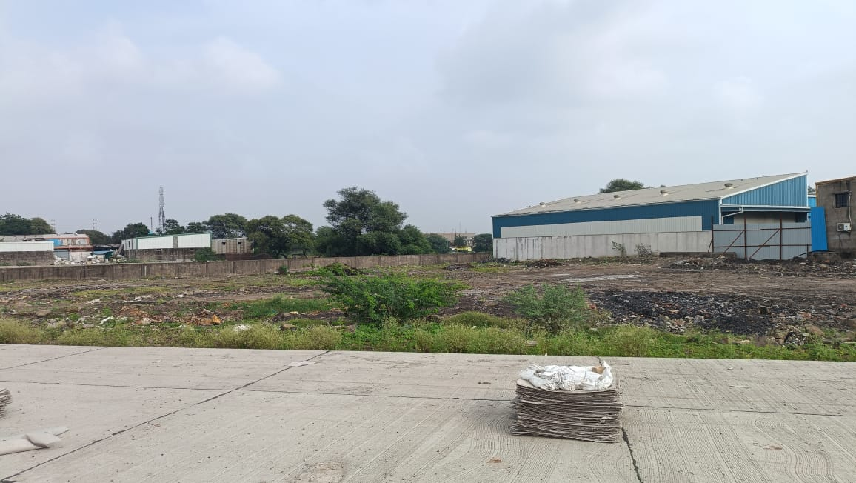

Details of the property under consideration:

Name of Owner: Shri. Mukesh Maheswari S/o Shri. Ved Prakash Maheswari

Commercial Land bearing Survey No. 103/1/1/1 & 103/1/3, Gram – Bhawrasala, Tehsil – Malhargan (Old - Sanwer), District – Indore, PIN Code – 453 555, State – Madhya Pradesh, Country – India.

Longitude Latitude: 22°47’08.1”N 75°50’28.5”E

Private Valuation Done for:

Shiva Shree Corporate Advisory Pvt. Ltd.
201- 2nd Floor, Gold Star Building, 576, M.G. Road,
Indore, Pin Code – 452 001, State – Madhya Pradesh, Country – India.

INDEX
Particulars Page No.

1. VALUATION OPINION REPORT 3
2. VALUATION REPORT (IN RESPECT OF COMMERCIAL LAND) 4
3. TOTAL ABSTRACT OF THE ENTIRE PROPERTY 8
4. ACTUAL SITE PHOTOGRAPH 10
5. ROUTE MAP OF THE PROPERTY 11
6. GUIDELINE RATE 12
7. ASSUMPTIONS, DISCLAIMERS, LIMITATIONS & QUALIFICATIONS 16
8. ASSUMPTIONS, CAVEATS, LIMITATION AND DISCLAIMERS 18

Vastu/Indore/09/2023/003182/2302596
16/19-240-AKT
Date: 16.09.2023

VALUATION OPINION REPORT

This is to certify that the Commercial Land bearing Survey No. 103/1/1/1 & 103/1/3, Gram – Bhawrasala, Tehsil – Malhargan (Old - Sanwer), District – Indore, PIN Code – 453 555, State – Madhya Pradesh, Country – India belongs to Shri. Mukesh Maheswari S/o Shri. Ved Prakash Maheswari.
Boundaries Of Property
North | : | Road
South | : | Industrial Premises
East | : | Open Land
West | : | Open Land & Road
Considering various parameters recorded, existing economic scenario, and the information that is available with reference to the development of neighborhood and method selected for valuation, we are of the opinion that, the property premises can be assessed and Fair Market Value at:
Particulars | Fair Market Value In (`) | Realizable Value In (`) | Distress Sale Value In (`)
Commercial Land | 28,09,39,500/- | 25,28,45,550/- | 22,47,51,600/-

The valuation of the property is based on the documents produced by the concern. Legal aspects have not been taken into consideration while preparing this valuation report.
Hence certified.

Manoj B. Chalikwar
Registered Valuer
Chartered Engineer (India)
Reg. No. CAT-I-F-1763
Encl.: Valuation Report

Vastukala Consultants (I) Pvt. Ltd.
106, 1st Floor, Gold Star Tower, 576, M.G. Road, Opp. Treasure Island Mall., Indore - 452 001

VALUATION REPORT (IN RESPECT OF COMMERCIAL LAND)

I | General
1. | Purpose for which the valuation is made |  |  |  | : | To assess Fair Market value of the property.
2. | a) | Date of inspection |  |  | : | 17.08.2023
 | b) | Date on which the valuation is made |  |  | : | 16.09.2023
3. | Copy of List of documents produced for perusal
- Sale Deed of Survey No. 103/1/1/1 Dated 10.06.2014, Registration No. 1849 between Shri. Hem Singh S/o Shri. Mohan Singh Ji (the Seller) AND Shri. Mukesh Maheshwari S/o Shri. Ved Prakash Maheshwari (the Purchaser).
- Sale Deed of Survey No. 103/1 Paiki (After Diversion - 103/1/3) Dated 13.06.2011, Registration No. 1865 between Shri. Hem Singh S/o Shri. Mohan Singh Ji (the Seller) AND Shri. Mukesh Maheshwari S/o Shri. Ved Prakash Maheshwari (the Purchaser).
- Diversion Letter of Survey No. 103/1/1/1 & 103/1/3 Memo No. 2206 0079 904 Dated 11.08.2023, Gram Bhawrasala, Tehsil Malharganj, District Indore.
- Online Khasra Record of Survey No.103/1/1/1 & 103/1/3.
- Approved Site Plan, Memo No. 90 dated 03.01.2015 issued by Town & Country Planning, Indore (M.P.)
4. | Name of the owner(s) and his / their address (es) with Phone no. (details of share of each owner in case of joint ownership) |  |  |  | : | Shri. Mukesh Maheswari S/o Shri. Ved Prakash Maheswari  Address: Commercial Land bearing Survey No. 103/1/1/1 & 103/1/3, Gram – Bhawrasala, Tehsil – Malhargan (Old - Sanwer), District – Indore, PIN Code – 453 555, State – Madhya Pradesh, Country – India.  Contact Person:  Mr. Narendra (Representative of owner)  Contact No. + 91- 98275 58985
5. | Brief description of the property (Including Leasehold / freehold etc.)
The immovable property comprises of freehold Commercial open land. The property is located in a developing area having good infrastructure, well connected by road and train. It is located at about – 11.5 KM. travelling distance from Indore Junction Railway Station.

Land:
As per Sale Deed, the land area is as under and considered for the purpose of valuation –
Survey No. | In Sq. M. | In Sq. Ft.
103/1/1/1 | 820.00 | 8,826.00
103/1/3 | 4,980.00 | 53,605.00
Total | 5,800.00 | 62,431.00

As per site inspection, there is water logging in part front side portion of the land.
As per TNCP approved layout plan, the plot is triangular in shape but on site, physical boundaries are not available for verification. The land is partly bounded by Pillers on north front side.
6. | Location of property |  |  |  | :
 | a) | Plot No. / Survey No. |  |  | : | Survey No. 103/1/1/1 & 103/1/3
 | b) | Door No. |  |  | : | -
 | c) | C.T.S. No. / Village |  |  | : | Gram – Bhawrasala
 | d) | Ward / Taluka |  |  | : | Tehsil – Malhargan (Old - Sanwer)
 | e) | Mandal / District |  |  | : | Mandal 2 Dharampuri, District – Indore
7. | Postal address of the property |  |  |  | : | Commercial Land bearing Survey No. 103/1/1/1 & 103/1/3, Gram – Bhawrasala, Tehsil – Malhargan (Old - Sanwer), District – Indore, PIN Code – 453 555, State – Madhya Pradesh, Country – India.
8. | City / Town |  |  |  | : | Town
 | Residential area |  |  |  | : | No
 | Commercial area |  |  |  | : | Commercial Area
 | Industrial area |  |  |  | : | Industrial Area
9. | Classification of the area |  |  |  | :
 | i) High / Middle / Poor |  |  |  | : | Middle Class
 | ii) Urban / Semi Urban / Rural |  |  |  | : | Semi - Urban
10. | Coming under Corporation limit / Village Panchayat / Municipality |  |  |  | : | Gram Panchayat Bhawrasala, Indore
11. | Whether covered under any State / Central Govt. enactments (e.g., Urban Land Ceiling Act) or notified under agency area/ scheduled area / cantonment area |  |  |  | : | No
12. | In Case it is Agricultural land, any conversion to house site plots is contemplated |  |  |  | : | N.A.
 | Land Mark |  |  |  | : | Nearby Luv Kush Square
13. | Boundaries of the property
 | Particulars |  | North | South |  |  | East |  | West
 | As per document
 | Survey No. 103/1/1/1 |  | Details not available | Details not available |  |  | Details not available |  | Details not available
 | Survey No. 103/1/3 |  | Remaining Land of Survey No. 103/1 | Land of Survey No. 103/2 |  |  | Land of Survey No. 105 |  | Remaining Land of Survey No. 103/1
 | As per Site Visit
 | Amalgamated Survey No. 103/1/1/1 & 103/1/3 |  | Road | Industrial Premises |  |  | Open Land |  | Open Land & Road
14.1 | Dimensions of the site |  |  |  | :
 |  |  |  |  |  | A As per the Deed |  | B Actuals
 | North |  |  |  | : | N.A. as the Plot is irregular in shape.
 | South |  |  |  | :
 | East |  |  |  | :
 | West |  |  |  | :
14.2 | Latitude, Longitude & Co-ordinates of property |  |  |  | : | 22°47’08.1”N 75°50’28.5”E
14. | Extent of the site |  |  |  | : | Land Area - As Per Sale Deed
  Survey No. | In Sq. M. | In Sq. Ft.
  103/1/1/1 | 820.00 | 8,826.00
  103/1/3 | 4,980.00 | 53,605.00
  Total | 5,800.00 | 62,431.00
15. | Extent of the site considered for Valuation (least of 14A& 14B) |  |  |  | :
16 | Whether occupied by the owner / tenant? If occupied by tenant since how long? Rent received per month. |  |  |  | : | Vacant land and under owner’s possession.
II | CHARACTERSTICS OF THE SITE
 | Classification of locality |  |  |  | : | Middle class
 | Development of surrounding areas |  |  |  | : | Under developing
 | Possibility of frequent flooding/ sub-merging |  |  |  | : | No
 | Feasibility to the Civic amenities like School, Hospital, Bus Stop, Market etc. |  |  |  | : | All available near by
 | Level of land with topographical conditions |  |  |  | : | Unlevelled Plain Land
 | Shape of land |  |  |  | : | Triangle
 | Type of use to which it can be put |  |  |  | : | Commercial
 | Any usage restriction |  |  |  | :
 | Is plot in town planning approved layout? |  |  |  | : | Information not available
 | Corner plot or intermittent plot? |  |  |  | : | Intermittent
 | Road facilities |  |  |  | : | Yes
 | Type of road available at present |  |  |  | : | R.C.C Road
 | Width of road – is it below 20 ft. or more than 20 ft. |  |  |  | : | More than 20 ft.
 | Is it a Land – Locked land? |  |  |  | : | No
 | Water potentiality |  |  |  | : | N.A., the property under consideration is open land only.
 | Underground sewerage system |  |  |  | : | N.A., the property under consideration is open land only.
 | Is Power supply is available in the site |  |  |  | : | No
 | Advantages of the site |  |  |  | : | Developing Locality
 | Special remarks, if any like threat of acquisition of land for publics service purposes, road widening or applicability of CRZ provisions etc. (Distance from sea-cost / tidal level must be incorporated) |  |  |  | : | No
Part – A (Valuation of land)
1 | Size of plot |  |  |  | : | Land Area = 62,431.00 Sq. Ft.  (As per Sale Deed)
 | North & South |  |  |  | : | N.A., the land is irregular in shape
 | East & West |  |  |  | :
2 | Total extent of the plot |  |  |  | : | Land Area = 62,431.00 Sq. Ft.  (As per Sale Deed)
3 | Prevailing market rate (Along with details / reference of at least two latest deals / transactions with respect to adjacent properties in the areas) |  |  |  | : | ` 4,000/- to ` 5,000/- per Sq. Ft.
4 | Guideline rate obtained from the Stamp Duty Ready Reckoner for land (evidence thereof to be enclosed) |  |  |  | : | ` 6,800/- per Sq. M. i.e.  ` 632/- per Sq. Ft.
 | In case of variation of 20% or more in the valuation proposed by the valuer and the Guideline value provided in the State Govt. notification or Income Tax Gazette justification on variation has to be given. |  |  |  | : | It is a foregone conclusion that market value is always more than RR prices. As the RR rates are fixed by respective state governments for computing stamp duty / regn. Fees. Thus, the rates differ from place to place and location. Amenities per se as evident from the fact that even RR rates decided by Govt. differ.
5 | Assessed / adopted rate of valuation |  |  |  | : | ` 4,500/- per Sq. Ft.
6 | Estimated value of land |  |  |  | : | ` 28,09,39,500/-
Part – B (Valuation of Building)
1 | Technical details of the building |  |  |  | :
 | - Type of Building (Residential / Commercial / Industrial) |  |  |  | : | N.A.
 | - Type of construction (Load bearing / RCC / Steel Framed) |  |  |  | : | N.A.
 | - Year of construction |  |  |  | : | N.A.
 | - Number of floors and height of each floor including basement, if any |  |  |  | : | N.A.
 | - Plinth area floor-wise |  |  |  | : | N.A.
 | - Condition of the building |  |  |  | : | N.A.
 | - Exterior – Excellent, Good, Normal, Poor |  |  |  | : | N.A.
 | - Interior – Excellent, Good, Normal, Poor |  |  |  | : | N.A.
 | - Date of issue and validity of layout of approved map |  |  |  | : | Copy of Approved Site Plan, Memo No. 90 dated 03.01.2015 issued by Town & Country Planning, Indore (M.P.) has been verified.
 | - Approved map / plan issuing authority |  |  |  | :
 | - Whether genuineness or authenticity of approved map / plan is verified |  |  |  | :
 | - Any other comments by our empaneled valuers on authentic of approved plan |  |  |  | : | No

Specifications of construction (floor-wise) in respect of
 | Description
 | Foundation | : | N.A.
 | Basement | : | N.A.
 | Superstructure | : | N.A.
 | Joinery / Doors & Windows (Please furnish details about size of frames, shutters, glazing, fitting etc. and specify the species of timber | : | N.A.
 | RCC Works | : | N.A.
 | Plastering | : | N.A.
 | Flooring, Skirting, dado | : | N.A.
 | Special finish as marble, granite, wooden paneling, grills etc. | : | N.A.
 | Roofing including weatherproof course | : | N.A.
 | Drainage | : | N.A.
2. | Compound Wall | :
 | Height | : | N.A.
 | Length | : | N.A.
 | Type of construction | : | N.A.
3. | Electrical installation | :
 | Type of wiring | : | N.A.
 | Class of fittings (superior / ordinary / poor) | : | N.A.
 | Number of light points | : | N.A.
 | Fan points | : | N.A.
 | Spare plug points | : | N.A.
 | Any other item | : | N.A.
4. | Plumbing installation
 | - No. of water closets and their type | : | N.A.
 | - No. of wash basins | : | N.A.
 | - No. of urinals | : | N.A.
 | - No. of bathtubs | : | N.A.
 | - Water meters, taps etc. | : | N.A.
 | - Any other fixtures | : | N.A.

Part – C (Extra Items) |  | : | Amount in `
 | Portico | : | N.A.
 | Ornamental front door | : | N.A.
 | Sit out / Verandah with steel grills | : | N.A.
 | Overhead water tank | : | N.A.
 | Extra steel / collapsible gates | : | N.A.
 | Total |  | N.A.
Part – D (Amenities) |  | : | Amount in `
 | Wardrobes | : | N.A.
 | Glazed tiles | : | N.A.
 | Extra sinks and bathtub | : | N.A.
 | Marble / ceramic tiles flooring | : | N.A.
 | Interior decorations | : | N.A.
 | Architectural elevation works |  | N.A.
 | Paneling works |  | N.A.
 | Aluminum works |  | N.A.
 | Aluminum handrails |  | N.A.
 | False ceiling |  | N.A.
 | Total |  | N.A.
Part – E (Miscellaneous) |  | : | Amount in `
 | Separate toilet room | : | N.A.
 | Separate lumber room | : | N.A.
 | Separate water tank / sump | : | N.A.
 | Trees, gardening | : | N.A.
 | Total |  | N.A.
Part – F (Services) |  | : | Amount in `
 | Water supply arrangements | : | N.A.
 | Drainage arrangements | : | N.A.
 | Compound wall | : | N.A.
 | C.B. deposits, fittings etc. | : | N.A.
 | Pavement |  | N.A.
 | Total |  | N.A.
Government Value
Particulars | Area in Sq. Ft. | Rate per Sq. Ft. (`) | Value in (`)
Commercial Land | 62,431.00 | 632/- | 3,94,56,392/-

TOTAL ABSTRACT OF THE ENTIRE PROPERTY

Part - A | Land |  | ` 28,09,39,500/-
Part - B | Buildings |  | -
Part – C | Compound Wall |  | -
Part – D | Amenities |  | -
Part - E | Pavement |  | -
Part - F | Services |  | -
 | Fair Market Value |  | ` 28,09,39,500/-
 | Realizable Value |  | ` 25,28,45,550/-
 | Distress Sale Value |  | ` 22,47,51,600/-
Remarks | - As per site inspection, there is water logging in part front side portion of the land.  - As per TNCP approved layout plan, the plot is triangular in shape but on site, physical boundaries are not available for verification. The land is partly bounded by Pillers on north front side.

Justification for price /rate
The Market Value of the property is based on facts of markets discovered by us during our enquiries, however the government rate value in this case is less than the market value arrived by us. We are of the opinion that the value arrive by us will prove to be correct if an Auction of the subject property is carried out. As far as Market Value as per property document is concerned, it is not possible to comment on same, may be government rates are fixed by sampling during same point of time in part and whereas, Market values change every month.
In most of the cases the actual deal amount or Transaction value is not reflected in the property documents because of various Market practices. As Valuer, we always try to give a value which is correct reflection of actual transaction value irrespective of any factors in market.
Method of Valuation / Approach
Land cost can be estimated using the Sales Comparison Approach by studying recent sales of land close to the subject property, and these sales should be comparable in size and location with subject property.
As the property is a Commercial land, we have adopted Comparative Sales Method for the purpose of valuation. The Price for similar type of property in the nearby vicinity is in the range of ` 4,000/- to ` 5,000/- per Sq. Ft. for land. Considering the rate with attached report, current market conditions, demand and supply position, Land size, location, sustained demand for such plot, all round development in the locality etc., We estimate ` 4,500/- per Sq. Ft. for land.

The saleability of the property is: Average
Expected rental values per month: N. A
Any likely income it may generate: N. A

ACTUAL SITE PHOTOGRAPH

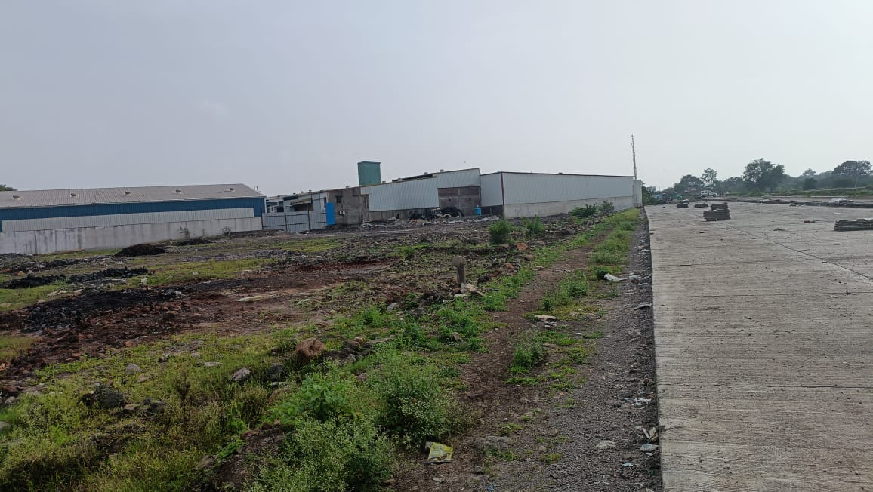
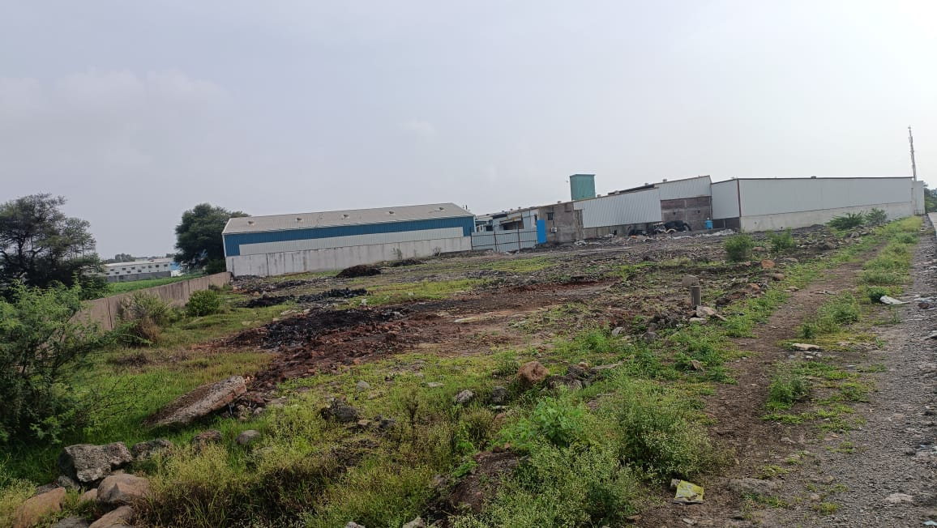
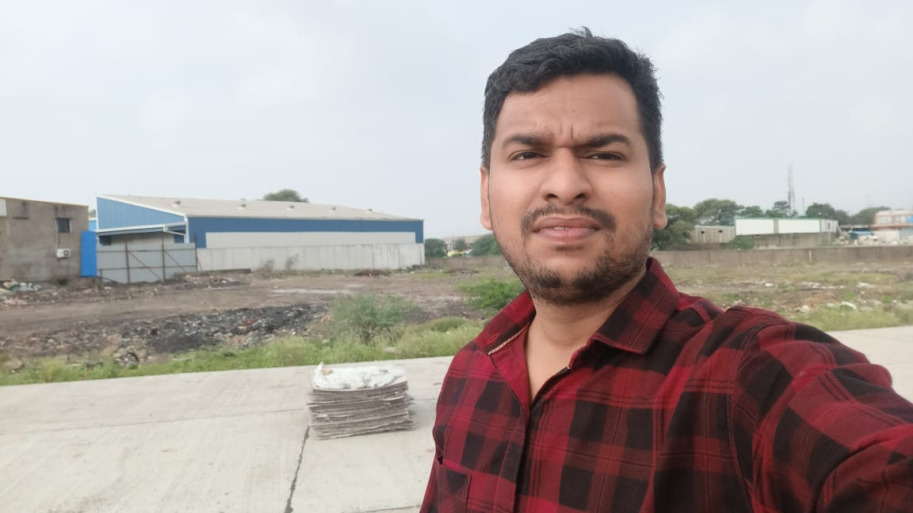
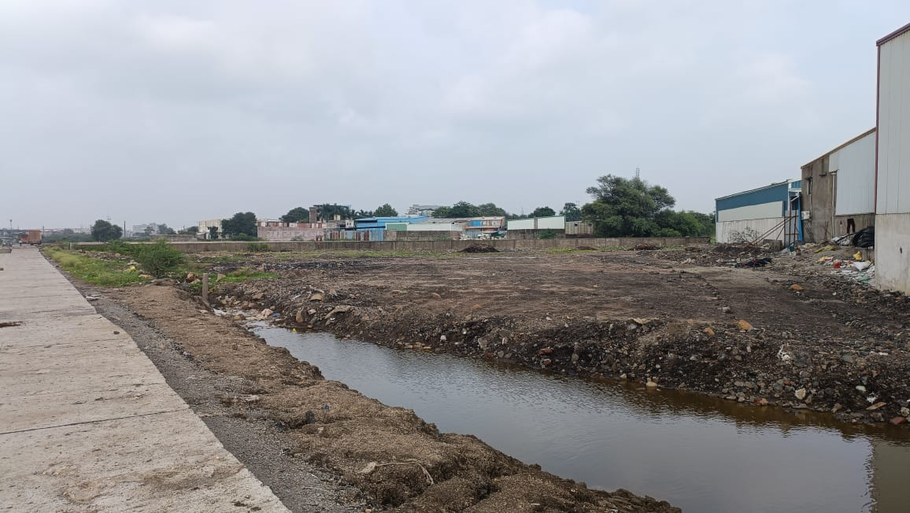

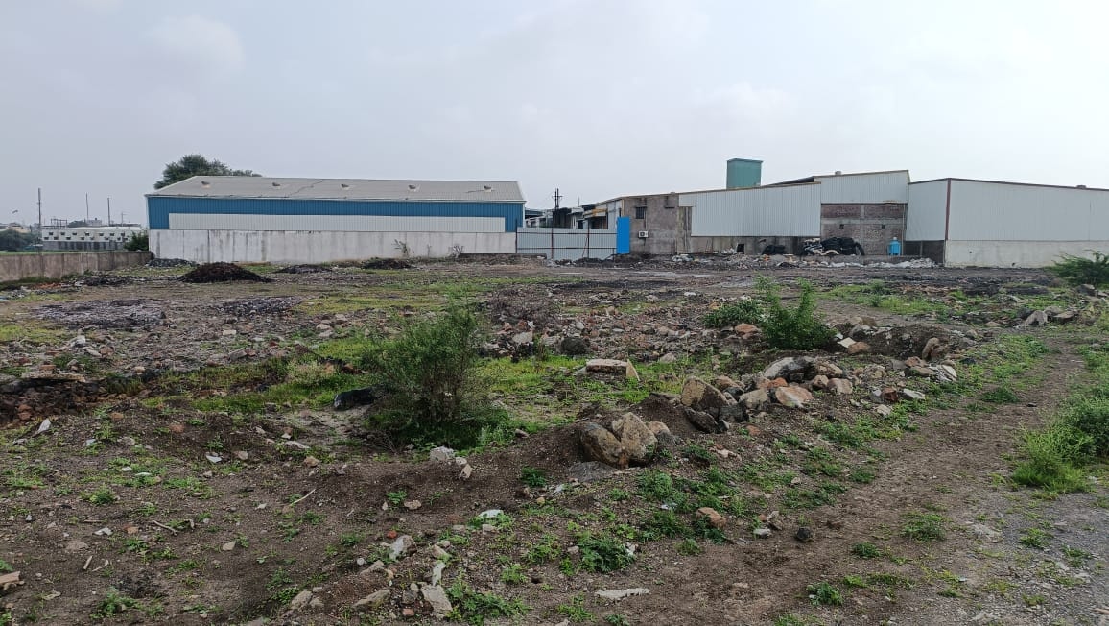

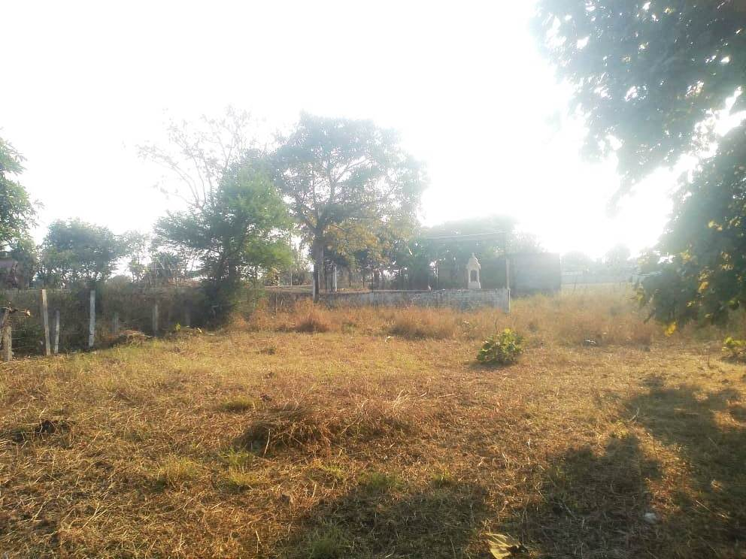

ROUTE MAP OF THE PROPERTY
Site u/r
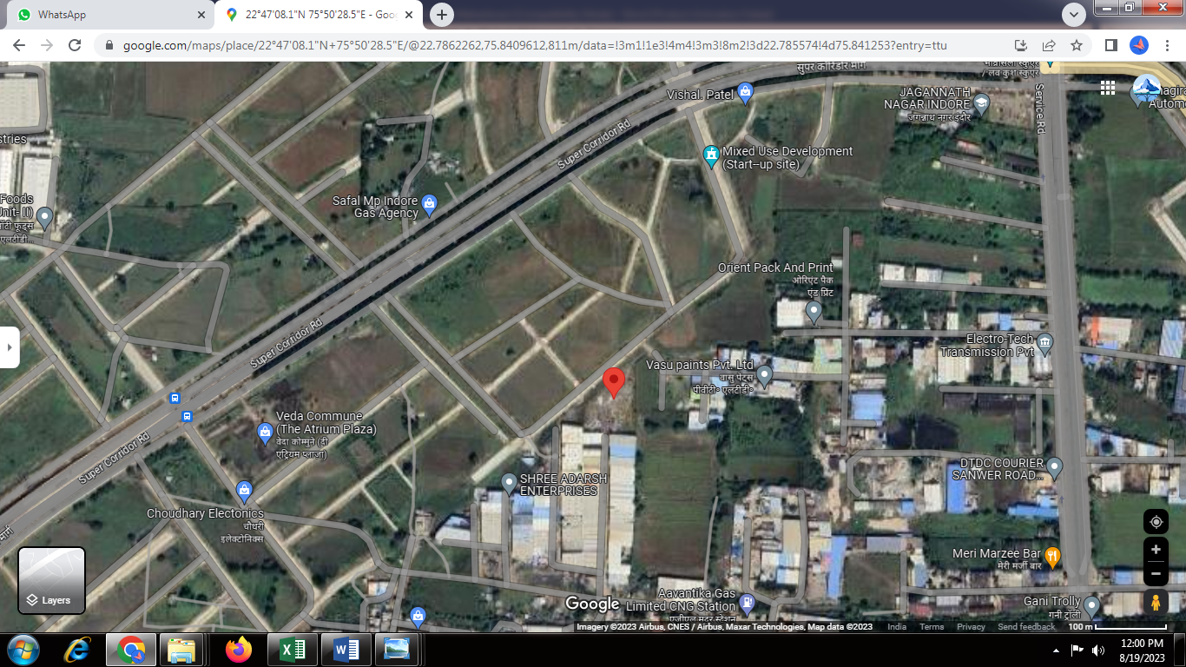

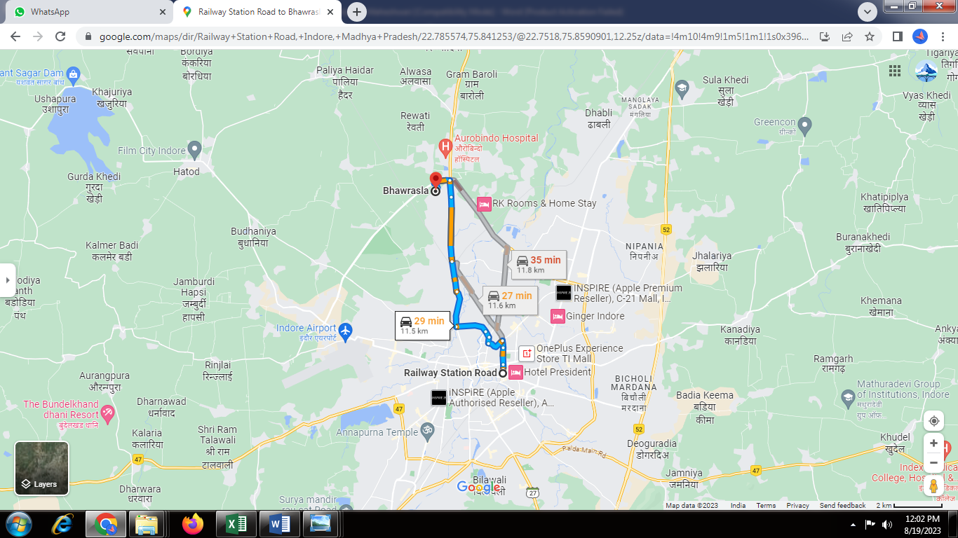

Longitude Latitude: 22°47’08.1”N 75°50’28.5”E
Note: The Blue line shows the route to site from nearest Railway Station (Indore Junction – 11.5 KM.)

GUIDELINE RATE

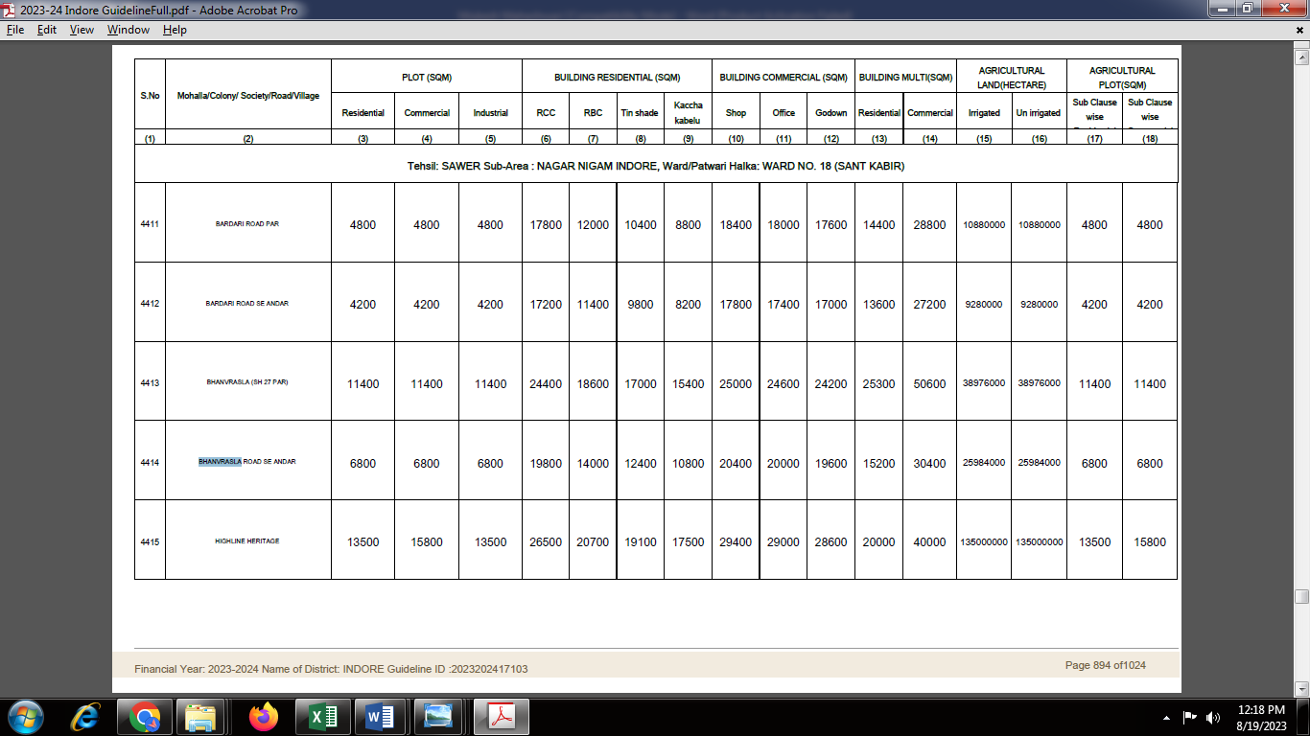

Price Indicators
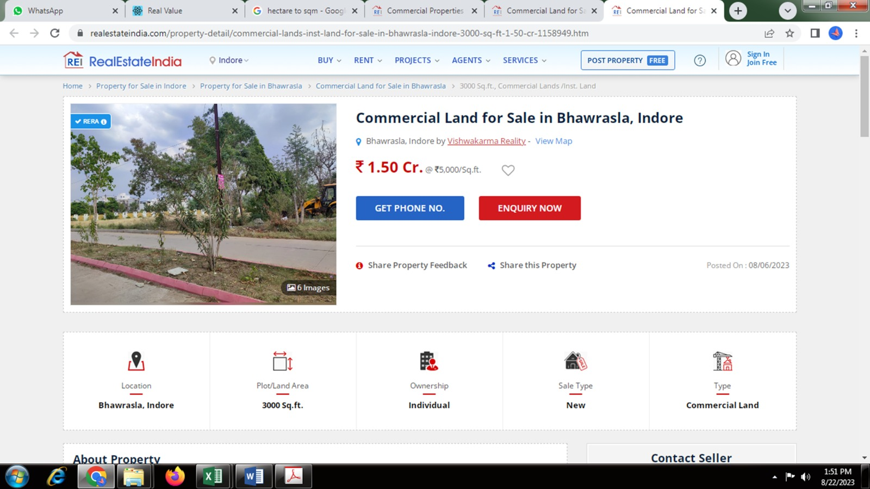

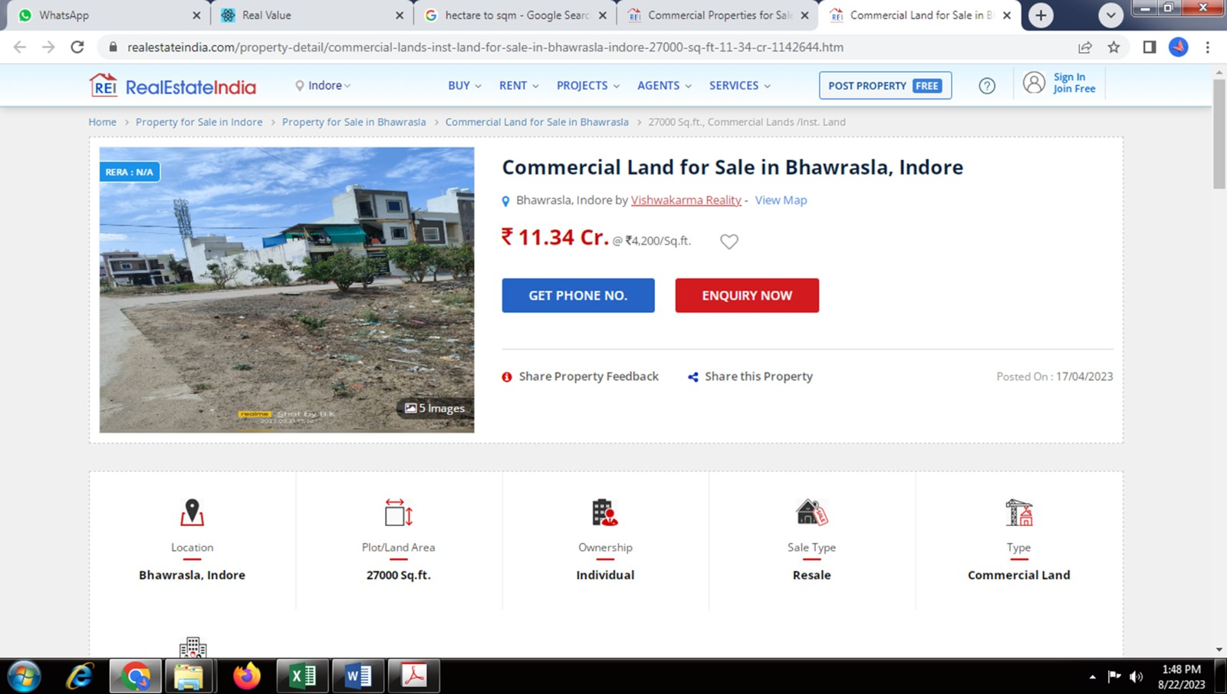

As a result of my appraisal and analysis, it is my considered opinion that the Fair Market Value for this particular above property in the prevailing condition with aforesaid specification is as below –
Particulars | Fair Market Value In (`) | Realizable Value In (`) | Distress Sale Value In (`)
Commercial Land | 28,09,39,500/- | 25,28,45,550/- | 22,47,51,600/-

Place: Indore
Date: 16.09.2023

Manoj B. Chalikwar
Registered Valuer
Chartered Engineer (India)
Reg. No. CAT-I-F-1763

Sr. No. | Particulars | Valuer comment
1 | Background information of the asset being valued; | As per the documents provided, the property is owned by Shri. Mukesh Maheswari S/o Shri. Ved Prakash Maheswari
2 | Purpose of valuation and appointing authority | As per the request from the client, to assess value of the property for Private Purpose.
3 | Identity of the Valuer and any other experts involved in the valuation; | Manoj B. Chalikwar – Regd. Valuer  Dinesh Kanere – Reginal Technical Manager  Akshay Kumar Trivedi – Valuation Engineer  Akhilesh Yadav – Technical Manager
4 | Disclosure of Valuer interest or conflict, if any; | We have no interest, either direct or indirect, in the property valued. Further to state that we do not have relation or any connection with property owner / applicant directly or indirectly. Further to state that we are an independent Valuer and in no way related to property owner / applicant
5 | Date of appointment, valuation date and date of report; | Date of Appointment – 17.08.2023  Valuation Date – 16.09.2023  Date of Report – 16.09.2023
6 | Inspections and/or investigations undertaken; | Physical Inspection done on date 17.08.2023
7 | Nature and sources of the information used or relied upon; | - Market Survey at the time of site visit  - Ready Reckoner rates / Circle rates  - Enquiries with Real estate consultants  - Existing data of Valuation assignments carried out by us
8 | Procedures adopted in carrying out the valuation and valuation standards followed; | Comparative Sales Method (For Land component)
9 | Restrictions on use of the report, if any; | This valuation is for the use of the party to whom it is addressed and for no other purpose. No responsibility is accepted to any third party who may use or rely on the whole or any part of this valuation. The valuer has no pecuniary interest that would conflict with the proper valuation of the property.
10 | Major factors that were taken into account during the valuation. | Current market conditions, demand and supply position, land size, location, sustained demand for such land, all round development in the locality etc.
 | Major factors that were not taken into account during the valuation. | Nil
11 | Caveats, limitations, and disclaimers to the extent they explain or elucidate the limitations faced by valuer, which shall not be for the purpose of limiting his responsibility for the valuation report. | Attached

ASSUMPTIONS, DISCLAIMERS, LIMITATIONS & QUALIFICATIONS

Value Subject to Change
The subject appraisal exercise is based on prevailing market dynamics as on 16th September 2023 and does not take into account any unforeseeable developments which could impact the same in the future.
Our Investigations
We are not engaged to carry out all possible investigations in relation to the subject property. Where in our report we identify certain limitations to our investigations, this is to enable the reliant party to instruct further investigations were considered appropriate or where we recommend as necessary prior to reliance. Vastukala Consultants India Pvt. Ltd. (VCIPL) is not liable for any loss occasioned by a decision not to conduct further investigations
Assumptions
Assumptions are a necessary part of undertaking valuations. VCIPL adopts assumptions for the purpose of providing valuation advise because some matters are not capable of accurate calculations or fall outside the scope of our expertise, or out instructions. The reliant party accepts that the valuation contains certain specific assumptions and acknowledge and accept the risk of that if any of the assumptions adopted in the valuation are incorrect, then this may have an effect on the valuation.
Information Supplied by Others
The appraisal is based on the information provided by the client. The same has been assumed to be correct and has been used for appraisal exercise. Where it is stated in the report that another party has supplied information to VCIPL, this information is believed to be reliable but VCIPL can accept no responsibility if this should prove not to be so.
Future Matters
To the extent that the valuation includes any statement as to a future matter, that statement is provided as an estimate and/or opinion based on the information known to VCIPL at the date of this document. VCIPL does not warrant that such statements are accurate or correct.
Map and Plans
Any sketch, plan or map in this report is included to assist the reader while visualizing the property and assume no responsibility in connection with such matters.
Site Details
Based on inputs received from Client's representative and site visit conducted, we understand that the subject property is currently a contiguous and Commercial land parcel admeasuring 5,800.00 Sq. M. i.e. 62,431.00 Sq. Ft. The property is owned by Shri. Mukesh Maheswari S/o Shri. Ved Prakash Maheswari. at present, the property is vacant and under owner’s possession. Further, VCIPL has assumed that the subject property is free from any encroachment and is available as on the date of the appraisal.
Property Title
Based on Title Search Report, we understand that the property is owned by Shri. Mukesh Maheswari S/o Shri. Ved Prakash Maheswari for the purpose of this appraisal exercise, we have assumed that the subject property has a clear title and is free from any encumbrances, disputes and claims. VCIPL has made no further enquiries with the relevant local authorities in this regard and does not certify the property as having a clear and marketable title. Further, no legal advice regarding the title and ownership of the subject property has been obtained for the purpose of this appraisal exercise. It has been assumed that the title deeds are clear and marketable.
Environmental Conditions
We have assumed that the subject property is not contaminated and is not adversely affected by any existing or proposed environmental law and any processes which are carried out on the property are regulated by environmental legislation and are properly licensed by the appropriate authorities.

Town Planning
The permissible land use, zoning, achievable FSI, area statement adopted for purpose of this valuation is based on the information provided by the Client's representative and the same has been adopted for this valuation purpose. VCIPL has assumed the same to be correct and permissible. VCIPL has not validated the same from any authority.
Area
Based on the documents, we understand that the subject property is contiguous and Commercial land parcel admeasuring 5,800.00 Sq. M. i.e. 62,431.00 Sq. Ft.
Condition & Repair
In the absence of any information to the contrary, we have assumed that there are no abnormal ground conditions, nor archaeological remains present which might adversely affect the current or future occupation, development or value of the property. The property is free from rat, infestation, structural or latent defect. No currently known deleterious or hazardous materials or suspect techniques will be used in the construction of or subsequent alteration or additions to the property and comments made in the property details do not purport to express an opinion about, or advise upon, the condition of uninspected parts and should not be taken as making an implied representation or statement about such parts.
Valuation Methodology
For the purpose of this valuation exercise, the valuation methodology used is Direct Comparison Approach Method and proposed Highest and Best Use model is used for analysing development potential.
The Direct Comparison Approach involves a comparison of the property being valued to similar properties that have actually been sold in arms - length transactions or are offered for sale. This approach demonstrates what buyers have historically been willing to pay (and sellers willing to accept) for similar properties in an open and competitive market and is particularly useful in estimating the value of the land and properties that are typically traded on a unit basis.
In case of inadequate recent transaction activity in the subject micro-market, the appraiser would collate details of older transactions. Subsequently, the appraiser would analyse rental / capital value trends in the subject micro-market in order to calculate the percentage increase / decrease in values since the date of the identified transactions. This percentage would then be adopted to project the current value of the same.
Where reliance has been placed upon external sources of information in applying the valuation methodologies, unless otherwise specifically instructed by Client and/or stated in the valuation, VCIPL has not independently verified that information and VCIPL does not advise nor accept it as reliable. The person or entity to whom the report is addressed acknowledges and accepts the risk that if any of the unverified information in the valuation is incorrect, then this may have an effect on the valuation.
Not a Structural Survey
We state that this is a valuation report and not a structural survey
Other
All measurements, areas and ages quoted in our report are approximate
Legal
We have not made any allowances with respect to any existing or proposed local legislation relating to taxation on realization of the sale value of the subject property. VCIPL is not required to give testimony or to appear in court by reason of this appraisal report, with reference to the property in question, unless arrangement has been made thereof. Further, no legal advice on any aspects has been obtained for the purpose of this appraisal exercise
Property specific assumptions
Based on inputs received from the client and site visit conducted, we understand that the subject property is currently vacant, contiguous and Commercial land parcel admeasuring 5,800.00 Sq. M. i.e. 62,431.00 Sq. Ft.

ASSUMPTIONS, CAVEATS, LIMITATION AND DISCLAIMERS
- We assume no responsibility for matters of legal nature affecting the property appraised or the title thereto, nor do we render our opinion as to the title, which is assumed to be good and marketable.
- The property is valued as though under responsible ownership.
- It is assumed that the property is free of liens and encumbrances.
- It is assumed that there are no hidden or unapparent conditions of the subsoil or structure that would render it more or less valuable. No responsibility is assumed for such conditions or for engineering that might be required to discover such factors.
- There is no direct/ indirect interest in the property valued.
- The rates for valuation of the property are in accordance with the Govt. approved rates and prevailing market rates

Manoj B. Chalikwar
Registered Valuer
Chartered Engineer (India)
Reg. No. CAT-I-F-1763

