Valuation Report of the Immovable Property
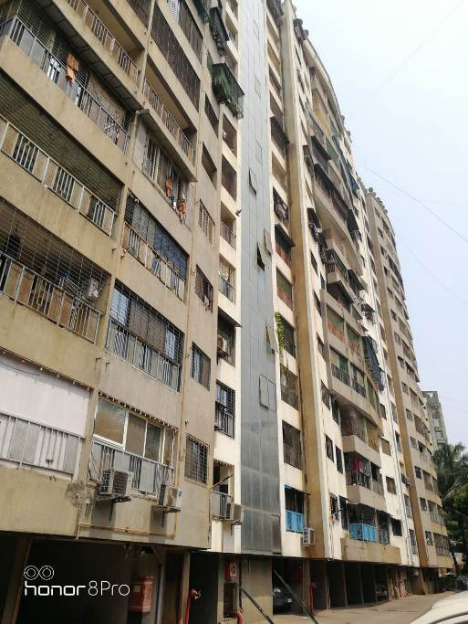

Details of the property under consideration:

Name of Owner: Mr. Rajesh Ramprasanna Upadhyay

Residential Flat No. A/601, 6th Floor, Wing – A, Building No. 4, "Raviraj Palm", Raviraj Palms Co-op. Hsg. Soc. Ltd., Prince City, Near Poonam Garden, Opp. S. K. Stone, Mira Bhayander Road, Mira Road (East),
Thane – 401 107, State – Maharashtra, Country – India.

Longitude Latitude: 19°17'14.1"N 72°52'19.4"E

Valuation Done for:
State Bank of India
SME Backbay Reclamation Branch
Mittal Court, 'B' Wing, Ground Floor, Nariman Point,
Mumbai - 400 021, State - Maharashtra, Country - India.

Vastukala Consultants (I) Pvt. Ltd.
Mumbai • Delhi NCR • Aurangabad • Nanded

Vastu/Mumbai/04/2021/19811/35187
16/01-65-SBVS
Date: 16.04.2021

VALUATION OPINION REPORT

This is to certify that the property bearing Residential Flat No. A/601, 6th Floor, Wing – A, Building No. 4, "Raviraj Palm", Raviraj Palms Co-op. Hsg. Soc. Ltd., Prince City, Near Poonam Garden, Opp. S. K. Stone, Mira Bhayander Road, Mira Road (East), Thane – 401 107, State – Maharashtra, Country – India belongs to Mr. Rajesh Ramprasanna Upadhyay.

Considering various parameters recorded, existing economic scenario, and the information that is available with reference to the development of neighborhood and method selected for valuation, we are of the opinion that, the property premises can be assessed and Valued for this particular purpose at ` 1,14,90,765.00 (Rupees One Crore Fourteen Lakh Ninety Thousand Seven Hundred Sixty Five Only).
Boundaries of the property.

North | : | Diamond Prince City Apartment
South | : | Arena Apartment II
East | : | Open Plot
West | : | Internal Road / Arena I

The valuation of the property is based on the documents produced by the concern. Legal aspects have not been taken into considerations while preparing this valuation report.

Hence certified

Sharadkumar B. Chalikwar
Govt. Reg. Valuer
Chartered Engineer (India)
Reg. No. (N) CCIT/1-14/52/2008-09
SBI Empanelment No.: SME/TCC/2017-18/942/178
Encl: Valuation report.

Vastukala Consultants (I) Pvt. Ltd.
121, 1st Floor, Ackruti Star, Central Road, MIDC, Andheri (E), Mumbai - 400 093

To,
The Branch Manager,
State Bank of India
SME Backbay Reclamation Branch
Mittal Court, 'B' Wing, Ground Floor, Nariman Point,
Mumbai - 400 021, State - Maharashtra, Country - India.

VALUATION REPORT (IN RESPECT OF FLAT)
I | General
1. | Purpose for which the valuation is made |  |  | : | As per request from State Bank of India, SME Backbay Reclamation Branch, to assess fair market value of the property for bank loan purpose.
2. | a) |  | Date of inspection | : | 13.04.2021
 | b) |  | Date on which the valuation is made | : | 16.04.2021
3. | List of documents produced for perusal |  |  | : | - Copy of Agreement for sale dated 26.04.2018.  - Copy of Commencement Certificate No. MB / MNP / NR / 4306 / 2006-2007 dated 30.03.2007 issued by Mira Bhayandar Municipal Corporation.  - Copy of Building Completion Certificate No. MB / MNP / NR / 4323 / 2009-2010 dated 25.03.2010 issued by Mira Bhayandar Municipal Corporation.  - Copy of previous valuation report dated 19.03.2019 issued by Archinova Design Inc.
4. | Name of the owner(s) and his / their address (es) with Phone no. (details of share of each owner in case of joint ownership) |  |  | : | Mr. Rajesh Ramprasanna Upadhyay  Address: Residential Flat No. A/601, 6th Floor, Wing – A, Building No. 4, "Raviraj Palm", Raviraj Palms Co-op. Hsg. Soc. Ltd., Prince City, Near Poonam Garden, Opp. S. K. Stone, Mira Bhayander Road, Mira Road (East), Thane – 401 107, State – Maharashtra, Country – India.  Contact Person:  Mr. Dawood Ansari – (Broker)  Contact No. 9892953123  Sole Ownership
5. | Brief description of the property (Including Leasehold / freehold etc.) |  |  | : | The property is a residential flat located on 6th floor. The composition of flat is 2 Bedrooms + Living Room + Kitchen + 2 Toilets. The property is at 2.3 Km. distance from nearest railway station Mira Road.
6. | Location of property |  |  | :
 | a) | Plot No. / Survey No. |  | : | Old Survey No. 452 (Pt), New Survey No. 152 (Pt)
 | b) | Door No. |  | : | Residential Flat No. A/601
 | c) | C.T.S. No. / Village |  | : | Village – Navghar
 | d) | Ward / Taluka |  | : | Taluka – Thane
 | e) | Mandal / District |  | : | District – Thane
 | f) | Date of issue and validity of layout of approved map / plan |  | : | Approved Building Plan were not provided and not verified
 | g) | Approved map / plan issuing authority |  | :
 | h) | Whether genuineness or authenticity of approved map/ plan is verified |  | : | N.A.
 | i) | Any other comments by our empanelled valuers on authentic of approved plan |  | : | N.A.
7. | Postal address of the property |  |  | : | Residential Flat No. A/601, 6th Floor, Wing – A, Building No. 4, "Raviraj Palm", Raviraj Palms Co-op. Hsg. Soc. Ltd., Prince City, Near Poonam Garden, Opp. S. K. Stone, Mira Bhayander Road, Mira Road (East), Thane – 401 107, State – Maharashtra, Country – India.
8. | City / Town |  |  | : | Mira Road
 | Residential area |  |  | : | Yes
 | Commercial area |  |  | : | No
 | Industrial area |  |  | : | No
9. | Classification of the area |  |  | :
 | i) High / Middle / Poor |  |  | : | Middle Class
 | ii) Urban / Semi Urban / Rural |  |  | : | Urban
10. | Coming under Corporation limit / Village Panchayat / Municipality |  |  | : | Village – Navghar  Mira Bhayandar Municipal Corporation
11. | Whether covered under any State / Central Govt. enactments (e.g., Urban Land Ceiling Act) or notified under agency area/ scheduled area / cantonment area |  |  | : | No
12. | Boundaries of the property |  |  |  | As per Documents | As per Site
 | North |  |  | : | Details not available | Diamond Prince City Apartment
 | South |  |  | : | Details not available | Arena Apartment II
 | East |  |  | : | Details not available | Open Plot
 | West |  |  | : | Details not available | Internal Road / Arena I
13 | Dimensions of the site |  |  |  | N. A. as property under consideration is a flat in an apartment building.
 |  |  |  |  | A As per the Deed |  | B Actuals
 | North |  |  | : | - |  | -
 | South |  |  | : | - |  | -
 | East |  |  | : | - |  | -
 | West |  |  | : | - |  | -
14. | Extent of the site |  |  | : | Carpet Area = 710.00 Sq. Ft.  Balcony Area = 208.00 Sq. Ft.  (Area as per actual site measurement)  Carpet Area = 715.00 Sq. Ft.  (Area as per Agreement for sale)  Built up Area = 858.00 Sq. Ft.  (Agreement Carpet + 20%)
14.1 | Latitude, Longitude & Co-ordinates of flat |  |  | : | 19°17'14.1"N 72°52'19.4"E
15. | Extent of the site considered for Valuation (least of 13A& 13B) |  |  | : | Carpet Area = 715.00 Sq. Ft.  (Area as per Agreement for sale)
16 | Whether occupied by the owner / tenant? If occupied by tenant since how long? Rent received per month. |  |  | : | Vacant at the time of visit
II | APARTMENT BUILDING
 | Nature of the Apartment |  |  | : | Residential
 | Location |  |  | :
 | C.T.S. No. |  |  | : | Old Survey No. 452 (Pt), New Survey No. 152 (Pt)
 | Block No. |  |  | : | -
 | Ward No. |  |  | : | -
 | Village / Municipality / Corporation |  |  | : | Village – Navghar  Mira Bhayandar Municipal Corporation
 | Door No., Street or Road (Pin Code) |  |  | : | Residential Flat No. A/601, 6th Floor, Wing – A, Building No. 4, "Raviraj Palm", Raviraj Palms Co-op. Hsg. Soc. Ltd., Prince City, Near Poonam Garden, Opp. S. K. Stone, Mira Bhayander Road, Mira Road (East), Thane – 401 107, State – Maharashtra, Country – India.
 | Description of the locality Residential / Commercial / Mixed |  |  | : | Residential
 | Year of Construction |  |  | : | 2010 Years (As per Building Completion Certificate)
 | Number of Floors |  |  | : | Ground (Part) + Stilt (Part) + 14 Upper Floors
 | Type of Structure |  |  | : | R.C.C. Framed Structure
 | Number of Dwelling units in the building |  |  | : | 04 flats on 6th Floor
 | Quality of Construction |  |  | : | Good
 | Appearance of the Building |  |  | : | Good
 | Maintenance of the Building |  |  | : | Good
 | Facilities Available |  |  | :
 | Lift |  |  | : | 02 Lifts
 | Protected Water Supply |  |  | : | Municipal Water supply
 | Underground Sewerage |  |  | : | Connected to Municipal Sewerage System
 | Car parking - Open / Covered |  |  | : | Stilt Parking
 | Is Compound wall existing? |  |  | : | Yes
 | Is pavement laid around the Building |  |  | : | Yes

III | FLAT
1 | The floor in which the flat is situated | : | 6th floor
2 | Door No. of the flat | : | Residential Flat No. A/601
3 | Specifications of the flat | :
 | Roof | : | R.C.C. Slab
 | Flooring | : | Vitrified tile flooring
 | Doors | : | Teak Wood door frame with flush doors with safety door
 | Windows | : | Powder coated aluminum sliding windows with M.S. Grills
 | Fittings | : | Concealed plumbing with C.P. fittings. Electrical wiring with concealed.
 | Finishing | : | Cement Plastering + POP finish
4 | House Tax | :
 | Assessment No. | : | Details not available
 | Tax paid in the name of : | : | Details not available
 | Tax amount: | : | Details not available
5 | Electricity Service connection No. : | : | Details not available
 | Meter Card is in the name of : | : | Details not available
6 | How is the maintenance of the flat? | : | Good
7 | Sale Deed executed in the name of | : | Mr. Rajesh Ramprasanna Upadhyay
8 | What is the undivided area of land as per Sale Deed? | : | Details not available
9 | What is the plinth area of the flat? | : | Built up Area = 858.00 Sq. Ft.  (Agreement Carpet + 20%)
10 | What is the floor space index (app.) | : | As per local norms
11 | What is the Carpet Area of the flat? | : | Carpet Area = 710.00 Sq. Ft.  Balcony Area = 208.00 Sq. Ft.  (Area as per actual site measurement)  Carpet Area = 715.00 Sq. Ft.  (Area as per Agreement for sale)
12 | Is it Posh / I Class / Medium / Ordinary? | : | Medium
13 | Is it being used for Residential or Commercial purpose? | : | Residential purpose
14 | Is it Owner-occupied or let out? | : | Vacant
15 | If rented, what is the monthly rent? | : | ` 24,000.00 Expected rental income from the property per month
IV | MARKETABILITY | :
1 | How is the marketability? | : | Good
2 | What are the factors favouring for an extra Potential Value? | : | Located in developed area
3 | Any negative factors are observed which affect the market value in general? | : | No
V | Rate | :
1 | After analyzing the comparable sale instances, what is the composite rate for a similar flat with same specifications in the adjoining locality? - (Along with details / reference of at - least two latest deals / transactions with respect to adjacent properties in the areas) | : | ` 15,500.00 to ` 16,500.00 per Sq. Ft. on Carpet Area
2 | Assuming it is a new construction, what is the adopted basic composite rate of the flat under valuation after comparing with the specifications and other factors with the flat under comparison (give details). | : | ` 16,500.00 per Sq. Ft. on Carpet Area
3 | Break – up for the rate | :
 | I. Building + Services | : | ` 2,600.00 per Sq. Ft.
 | II. Land + others | : | ` 13,900.00 per Sq. Ft.
4 | Guideline rate obtained from the Registrar's office (an evidence thereof to be enclosed) | : | ` 89,775.00 per Sq. M. i.e.  ` 8,340.00 per Sq. Ft.
 | Guideline rate after depreciation | : | ` 84,178.00 per Sq. M. i.e.  ` 7,820.00 per Sq. Ft.
5 | In case of variation of 20% or more in the valuation proposed by the valuer and the Guideline value provided in the State Govt. notification or Income Tax Gazette justification on variation has to be given. |  | It is a foregone conclusion that market value is always more than RR prices. As the RR rates are fixed by respective state governments for computing stamp duty/Rgstn. Fees. Thus the rates differs from place to place and location. amenities per se as evident from the fact that even RR rates decided by Govt. differs.
6 | Details of last two transactions in the locality/area to be provided, if available. |  | -
VI | COMPOSITE RATE ADOPTED AFTER DEPRECIATION
a | Depreciated building rate | : | -
 | Replacement cost of flat with Services (v(3)i) | : | ` 2,600.00 per Sq. Ft.
 | Age of the building | : | 11 Years
 | Life of the building estimated | : | 49 years Subject to proper, preventive periodic maintenance & structural repairs
 | Depreciation percentage assuming the salvage value as 10% | : | 16.50%
 | Depreciated Ratio of the building | :
b | Total composite rate arrived for Valuation | :
 | Depreciated building rate VI (a) | : | ` 2,171.00 per Sq. Ft.
 | Rate for Land & other V (3) ii | : | ` 13,900.00 per Sq. Ft.
 | Total Composite Rate | : | ` 16,071.00 per Sq. Ft.
 | Remark: As per measurement Carpet area is 918 Sq. Ft. (including Flowerbed area of 208 Sq. ft.) which is more than Carpet area of 715 Sq. Ft. mentioned in the Agreement for sale provided to us. We have considered area mentioned in the documents. Hence, to give proper weightage to the value of the property, higher rate is considered.

Details of Valuation:

Sr. No. | Description | Qty. | Rate per  unit (`) | Estimated  Value (`)
1 | Present value of the flat (incl. car parking, if provided) | 715.00  Sq. Ft. | 16,071.00 | 1,14,90,765.00
2 | Wardrobes
3 | Showcases /
4 | Kitchen arrangements
5 | Superfine finish
6 | Interior Decorations
7 | Electricity deposits / electrical fittings, etc.
8 | Extra collapsible gates / grill works etc.
9 | Potential value, if any
10 | Others
 | Total Value of the property |  |  | 1,14,90,765.00
 | The realizable Value of property |  |  | 1,03,41,689.00
 | The Distress value of property |  |  | 91,92,612.00
 | Insurable value of the property |  |  | 22,30,800.00
 | Guideline Value of the Property |  |  | 67,09,560.00

The sales comparison approach uses the market data of sale prices to estimate the value of a real estate property. Property valuation in this method is done by comparing a property to other similar properties that have been recently sold. Comparable properties, also known as comparable, or comps, must share certain features with the property in question. Some of these include physical features such as square footage, number of rooms, condition, and age of the building; however, the most important factor is no doubt the location of the property. Adjustments are usually needed to account for differences as no two properties are exactly the same. To make proper adjustments when comparing properties, real estate appraisers must know the differences between the comparable properties and how to value these differences. The sales comparison approach is commonly used for Residential Flat, where there are typically many comparables available to analyze. As the property is a residential flat, we have adopted Sale Comparison Approach Method for the purpose of valuation .The Price for similar type of property in the nearby vicinity is in the range of ` 15,500.00 to ` 16,500.00 per Sq. Ft. on Carpet Area Considering the rate with attached report, current market conditions, demand and supply position, Flat size, location, upswing in real estate prices, sustained demand for Residential Flat, all round development of commercial and residential application in the locality etc. We estimate ` 16,071.00 per Sq. Ft. on Carpet Area for valuation.

Impending threat of acquisition by government for road widening / publics service purposes, sub merging & applicability of CRZ provisions (Distance from sea-cost / tidal level must be incorporated) and their effect on
- Salability | Good
- Likely rental values in future | ` 24,000.00 Expected rental income from the property per month
- Any likely income it may generate | Rental Income

Sharadkumar B. Chalikwar
Govt. Reg. Valuer
Chartered Engineer (India)
Reg. No. (N) CCIT/1-14/52/2008-09
SBI Empanelment No.: SME/TCC/2017-18/942/178

Place: Mumbai
Date: 16.04.2021

Actual Site Photographs
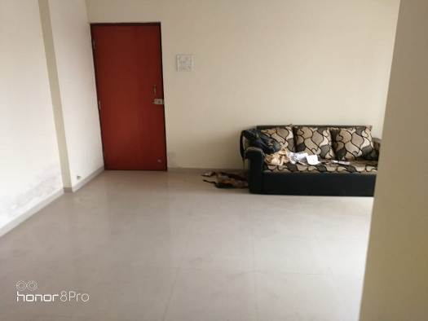
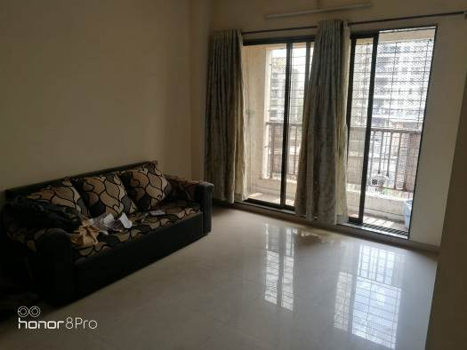

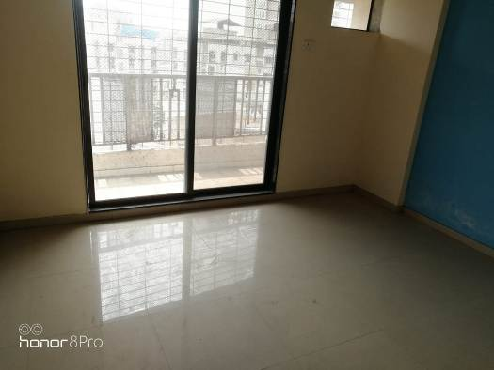
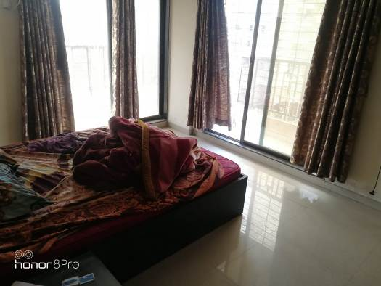

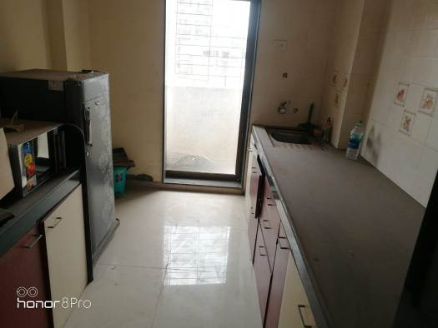
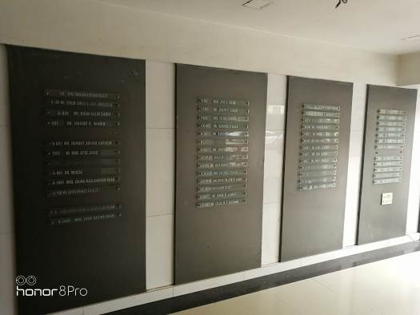

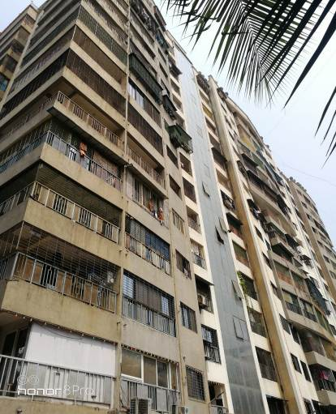
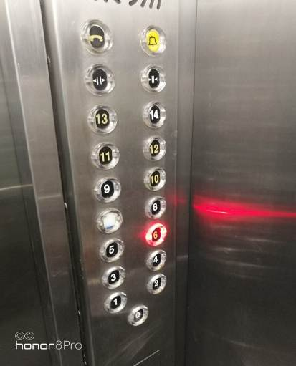
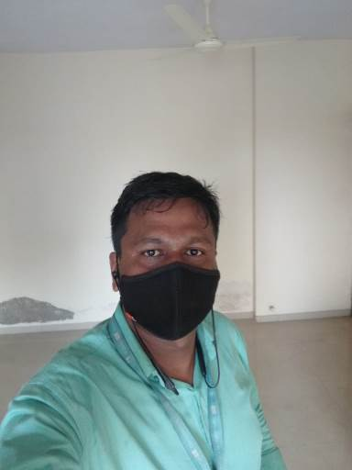

Route Map of the property
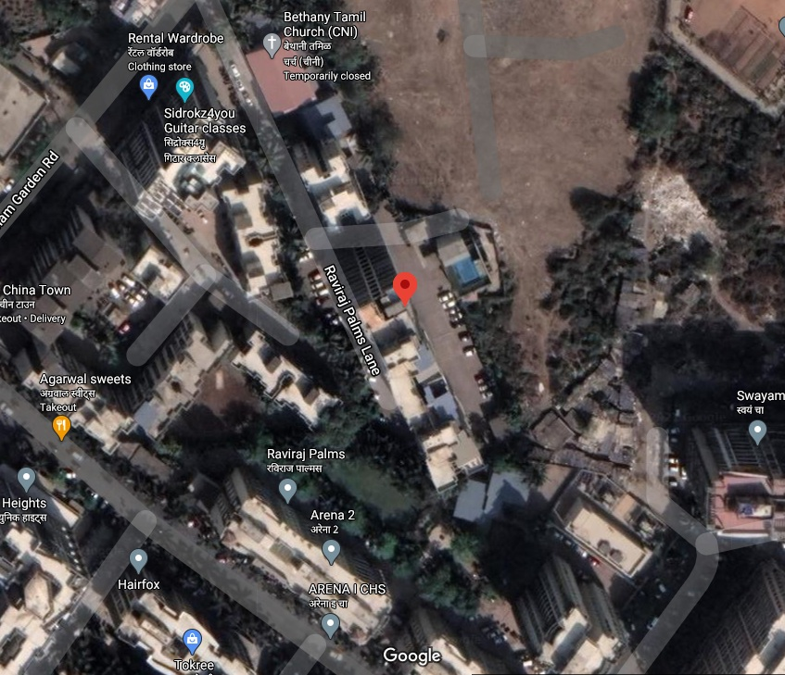

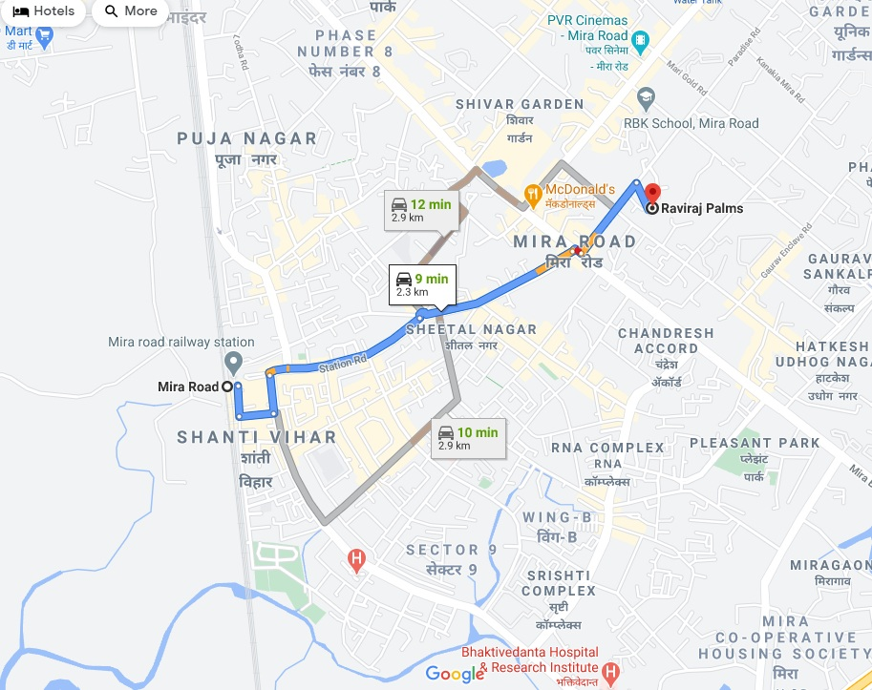

Longitude Latitude: 19°17'14.1"N 72°52'19.4"E

Note: The Blue line shows the route to site from nearest railway station (Mira Road – 2.3 Kmtr.)

Ready Reckoner Rate
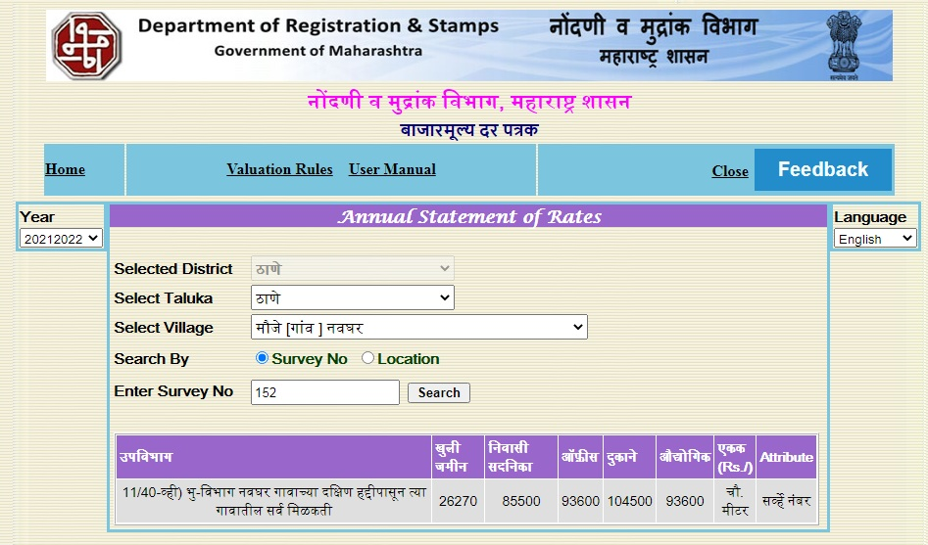
Price Indicator
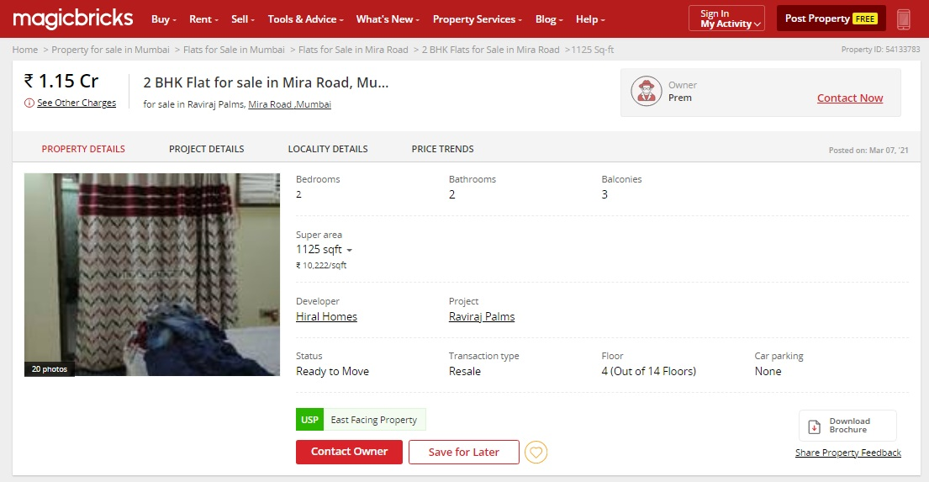

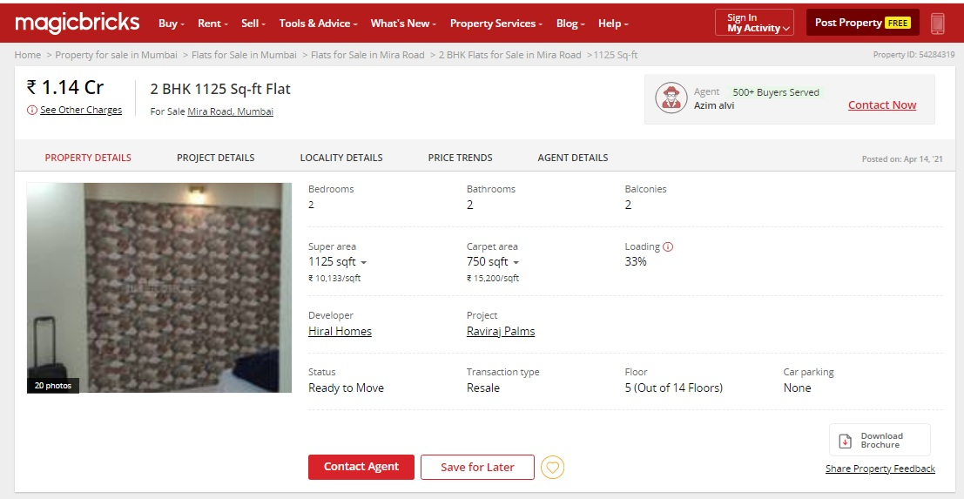

Sales Instance
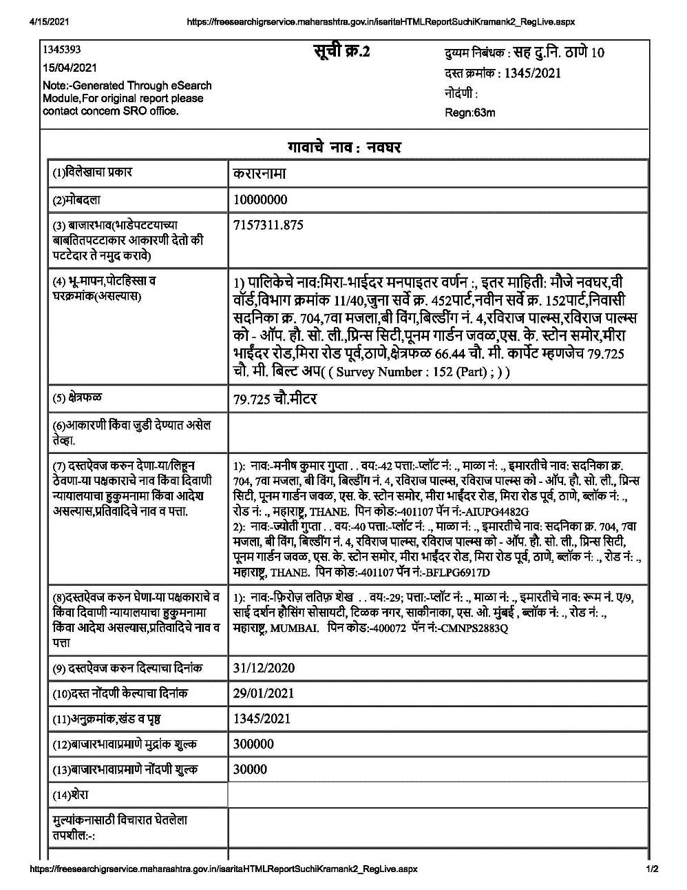

As a result of my appraisal and analysis, it is my considered opinion that the above property in the prevailing condition with aforesaid specifications is ` 1,14,90,765.00 (Rupees One Crore Fourteen Lakh Ninety Thousand Seven Hundred Sixty Five Only). The Realizable Value of the above property is ` 1,03,41,689.00 (Rupees One Crore Three Lakh Forty One Thousand Six Hundred Eighty Nine Only). The book value (purchase price) of the above property as of 26.04.2018 is ` 90,40,000.00 (Rupees Ninety Lakh Forty Thousand Only) and The Distress Value of the above property is ` 91,92,612.00 (Rupees Ninety One Lakh Ninety Two Thousand Six Hundred Twelve Only).

Place: Mumbai
Date: 16.04.2021

Sharadkumar B. Chalikwar
Govt. Reg. Valuer
Chartered Engineer (India)
Reg. No. (N) CCIT/1-14/52/2008-09
SBI Empanelment No.: SME/TCC/2017-18/942/178

The undersigned has inspected the property detailed in the Valuation Report dated _______________________

on ____________________. We are satisfied that the fair and reasonable market value of the property is `_________________________ (Rupees ________________________________________________________

________________________________________only).

Date : 21.10.2020
Signature
(Name & Designation of the Inspecting Official/s)

Countersigned
(BRANCH MANAGER)

Enclosures
 | Declaration-cum-undertaking from the valuer (Annexure- I) | Attached

(Annexure-I)

DECLARATION-CUM-UNDERTAKING

I, Sharadkumar Chalikwar son of Shri. Baburao Chalikwar do hereby solemnly affirm and state that:

- I am a citizen of India.

- I will not undertake valuation of any assets in which I have a direct or indirect interest or become so interested at any time during a period of three years prior to my appointment as valuer or three years after the valuation of assets was conducted by me.

- The information furnished in my valuation report dated 16.04.2021 is true and correct to the best of my knowledge and belief and I have made an impartial and true valuation of the property.

- I/ my authorized representative have personally inspected the property on 13.04.2021 The work is not sub - contracted to any other valuer and carried out by myself.

- Valuation report is submitted in the format as prescribed by the bank.

- I have not been depanelled / delisted by any other bank and in case any such depanelment by other banks during my empanelment with you, I will inform you within 3 days of such depanelment.

- I have not been removed / dismissed from service / employment earlier.

- I have not been convicted of any offence and sentenced to a term of imprisonment

- I have not been found guilty of misconduct in my professional capacity.

- I have not been declared to be unsound mind

- I am not an undischarged bankrupt, or has not applied to be adjudicated as a bankrupt;

- I am not an undischarged insolvent.

- I have not been levied a penalty under section 271J of Income-tax Act, 1961 (43 of 1961) and time limit for filing appeal before Commissioner of Income-tax (Appeals) or Income-tax Appellate Tribunal, as the case may be has expired, or such penalty has been confirmed by Income-tax Appellate Tribunal, and five years have not elapsed after levy of such penalty

- I have not been convicted of an offence connected with any proceeding under the Income Tax Act 1961, Wealth Tax Act 1957 or Gift Tax Act 1958 and

- My PAN Card number as applicable is AEAPC0117Q

- I undertake to keep you informed of any events or happenings which would make me ineligible for empanelment as a valuer

- I have not concealed or suppressed any material information, facts and records and I have made a complete and full disclosure

- I have read the Handbook on Policy, Standards and procedure for Real Estate Valuation, 2011 of the IBA and this report is in conformity to the "Standards" enshrined for valuation in the Part - B of the above handbook to the best of my ability.

- I have read the International Valuation Standards (IVS) and the report submitted to the Bank for the respective asset class is in conformity to the "Standards" as enshrined for valuation in the IVS in "General Standards" and "Asset Standards" as applicable. The valuation report is submitted in the prescribed format of the bank.

- I abide by the Model Code of Conduct for empanelment of valuer in the Bank. (Annexure V - A signed copy of same to be taken and kept along with this declaration)

- I am registered under Section 34 AB of the Wealth Tax Act, 1957.

- I am valuer registered with Insolvency & Bankruptcy Board of India (IBBI)

- My CIBIL Score and credit worthiness is as per Bank's guidelines.

- I am Chairman & Managing Director of the company, who is competent to sign this valuation report.

- I will undertake the valuation work on receipt of Letter of Engagement generated from the system (i.e. LLMS / LOS) only.

- Further, I hereby provide the following information.

Sl No. | Particulars | Valuer comment
 | background information of the asset being valued; | The property under consideration is purchased by Mr. Rajesh Ramprasanna Upadhyay from Shri. Hemant Arvind Kapadia vide agreement for the sale dated 26.04.2018.
 | purpose of valuation and appointing authority | As per request from State Bank of India, SME Backbay Reclamation Branch, to assess fair market value of the property for bank loan purpose.
 | Identity of the valuer and any other experts involved in the valuation; | Sharadkumar B. Chalikwar – Regd. Valuer  Manoj B. Chalikwar – Regd. Valuer  Mahesh Shinde – Valuation Engineer  Shamal Bodke – Processing Officer
 | disclosure of valuer interest or conflict, if any; | We have no interest, either direct or indirect, in the property valued. Further to state that we do not have relation or any connection with property owner / applicant directly or indirectly. Further to state that we are an independent Valuer and in no way related to property owner / applicant
 | date of appointment, valuation date and date of  report; | Date of Appointment - 13.04.2021  Valuation Date – 16.04.2021  Date of Report - 16.04.2021
 | inspections and/or investigations undertaken; | Physical Inspection done on 13.04.2021
 | nature and sources of the information used or relied upon; | - Market Survey at the time of site visit  - Ready Reckoner rates / Circle rates  - Online search for Registered Transactions  - Online Price Indicators on real estate portals  - Enquiries with Real estate consultants  - Existing data of Valuation assignments carried out by us
 | procedures adopted in carrying out the valuation and valuation standards followed; | Sales Comparison Method
 | restrictions on use of the report, if any; | This valuation is for the use of the party to whom it is addressed and for no other purpose. No responsibility is accepted to any third party who may use or rely on the whole or any part of this valuation. The valuer has no pecuniary interest that would conflict with the proper valuation of the property.
 | major factors that were taken into account during the valuation; | current market conditions, demand and supply position, Residential Flat size, location, upswing in real estate prices, sustained demand for Residential Flat, all round development of commercial and residential application in the locality etc.
 | Caveats, limitations and disclaimers to the extent they explain or elucidate the limitations faced by valuer, which shall not be for the purpose of limiting his responsibility for the valuation report. | Attached

Date: 16.04.2021
Place: Mumbai

Sharadkumar B. Chalikwar
Govt. Reg. Valuer
Chartered Engineer (India)
Reg. No. (N) CCIT/1-14/52/2008-09
SBI Empanelment No.: SME/TCC/2017-18/942/178

Assumptions, Disclaimers, Limitations & Qualifications

Value Subject to Change
The subject appraisal exercise is based on prevailing market dynamics as on 16th April 2021 and does not take into account any unforeseeable developments which could impact the same in the future.
Our Investigations
We are not engaged to carry out all possible investigations in relation to the subject property. Where in our report we identify certain limitations to our investigations, this is to enable the reliant party to instruct further investigations where considered appropriate or where we recommend as necessary prior to reliance. Vastukala Consultants India Pvt. Ltd. (VCIPL) is not liable for any loss occasioned by a decision not to conduct further investigations
Assumptions
Assumptions are a necessary part of undertaking valuations. VCIPL adopts assumptions for the purpose of providing valuation advise because some matters are not capable of accurate calculations or fall outside the scope of our expertise, or out instructions. The reliant party accepts that the valuation contains certain specific assumptions and acknowledge and accept the risk of that if any of the assumptions adopted in the valuation are incorrect, then this may have an effect on the valuation.

Information Supplied by Others
The appraisal is based on the information provided by the client. The same has been assumed to be correct and has been used for appraisal exercise. Where it is stated in the report that another party has supplied information to VCIPL, this information is believed to be reliable but VCIPL can accept no responsibility if this should prove not to be so.

Future Matters
To the extent that the valuation includes any statement as to a future matter, that statement is provided as an estimate and/or opinion based on the information known to VCIPL at the date of this document. VCIPL does not warrant that such statements are accurate or correct.

Map and Plans
Any sketch, plan or map in this report is included to assist the reader while visualising the property and assume no responsibility in connection with such matters.

Site Details
Based on inputs received from Sales Executive representative and site visit conducted, we understand that the subject property is Residential Flat having Carpet Area = 715.00 Sq. Ft. in the name of Mr. Rajesh Ramprasanna Upadhyay. Further, VCIPL has assumed that the subject property is free from any encroachment and is available as on the date of the appraisal.
Property Title
Based on inputs received from Sales Executive representative and site visit conducted, we understand that the subject property is owned by Mr. Rajesh Ramprasanna Upadhyay. For the purpose of this appraisal exercise, we have assumed that the subject property has a clear title and is free from any encumbrances, disputes and claims. VCIPL has made no further enquiries with the relevant local authorities in this regard and does not certify the property as having a clear and marketable title. Further, no legal advice regarding the title and ownership of the subject property has been obtained for the purpose of this appraisal exercise. It has been assumed that the title deeds are clear and marketable.

Environmental Conditions
We have assumed that the subject property is not contaminated and is not adversely affected by any existing or proposed environmental law and any processes which are carried out on the property are regulated by environmental legislation and are properly licensed by the appropriate authorities.

Area
Based on the information provided by the Sales Executive representative, we understand that the Residential Flat having Carpet Area = 715.00 Sq. Ft.

Condition & Repair
In the absence of any information to the contrary, we have assumed that there are no abnormal ground conditions, nor archaeological remains present which might adversely affect the current or future occupation, development or value of the property. The property is free from rat, infestation, structural or latent defect. No currently known deleterious or hazardous materials or suspect techniques will be used in the construction of or subsequent alteration or additions to the property and comments made in the property details do not purport to express an opinion about, or advise upon, the condition of uninspected parts and should not be taken as making an implied representation or statement about such parts.

Valuation Methodology
For the purpose of this valuation exercise, the valuation methodology used is Direct Comparison Approach Method and proposed Current use / Exiting use premise is considered for this assignment.
The Direct Comparison Approach involves a comparison of the property being valued to similar properties that have actually been sold in arms - length transactions or are offered for sale. This approach demonstrates what buyers have historically been willing to pay (and sellers willing to accept) for similar properties in an open and competitive market and is particularly useful in estimating the value of the flat and properties that are typically traded on a unit basis.
In case of inadequate recent transaction activity in the subject micro-market, the appraiser would collate details of older transactions. Subsequently, the appraiser would analyse rental / capital value trends in the subject micro-market in order to calculate the percentage increase / decrease in values since the date of the identified transactions. This percentage would then be adopted to project the current value of the same.
Where reliance has been placed upon external sources of information in applying the valuation methodologies, unless otherwise specifically instructed by Client and/or stated in the valuation, VCIPL has not independently verified that information and VCIPL does not advise nor accept it as reliable. The person or entity to whom the report is addressed acknowledges and accepts the risk that if any of the unverified information in the valuation is incorrect, then this may have an effect on the valuation.
Not a Structural Survey
We state that this is a valuation report and not a structural survey
Other
All measurements, areas and ages quoted in our report are approximate
Legal
We have not made any allowances with respect to any existing or proposed local legislation relating to taxation on realization of the sale value of the subject property. VCIPL is not required to give testimony or to appear in court by reason of this appraisal report, with reference to the property in question, unless arrangement has been made thereof. Further, no legal advice on any aspects has been obtained for the purpose of this appraisal exercise
Property specific assumptions

Based on inputs received from Sales Executive representative and site visit conducted, we understand that the subject property is Residential Flat having Carpet Area = 715.00 Sq. Ft.

ASSUMPTIONS, CAVEATS, LIMITATION AND DISCLAIMERS
- We assume no responsibility for matters of legal nature affecting the property appraised or the title thereto, nor do we render our opinion as to the title, which is assumed to be good and marketable.
- The property is valued as though under responsible ownership.
- It is assumed that the property is free of liens and encumbrances.
- It is assumed that there are no hidden or unapparent conditions of the subsoil or structure that would render it more or less valuable. No responsibility is assumed for such conditions or for engineering that might be required to discover such factors.
- There is no direct/ indirect interest in the property valued.
- The rates for valuation of the property are in accordance with the Govt. approved rates and prevailing market rates.

DEFINITION OF VALUE FOR THIS SPECIFIC PURPOSE

This exercise is to assess the Realizable Value property under reference as on 16th April 2021

The term Fair Market Value is defined as

“The most probable price, as of a specified date, in cash, terms equivalent to cash, or in other precisely revealed terms for which the specified property rights would sell after reasonable exposure in a competitive market under all conditions requisite to a fair sale, with the buyer and seller each acting prudently knowledgeably and for self interest assuming that neither is under undue duress”.

Fundamental assumptions and conditions presumed in this definition are:

1. Buyer and seller are motivated by self-interest.
2. Buyer and seller are well informed and are acting prudently.
3. The property is exposed for a reasonable time on the open market.
4. Payment is made in cash or equivalent or in specified financing terms.

DECLARATION OF PROFESSIONAL FEES CHARGED

We hereby declare that, our professional fees are not contingent upon the valuation findings. However, if the statute AND/OR clients demands that, the fees should be charged on the percentage of assessed value then, with the full knowledge of the AND/OR end user, it is being charged accordingly.

VALUATION OF THE PROPERTY PREMISES

Considering various parameters recorded herein above, existing economic scenario, and the information that is available with reference to the development of neighborhood and method selected for valuation, we are of the opinion that, the property premises can be assessed and Fair Market Value for this particular purpose at ` 1,14,90,765.00 (Rupees One Crore Fourteen Lakh Ninety Thousand Seven Hundred Sixty Five Only).

Sharadkumar B. Chalikwar
Govt. Reg. Valuer
Chartered Engineer (India)
Reg. No. (N) CCIT/1-14/52/2008-09
SBI Empanelment No.: SME/TCC/2017-18/942/178

