Vastu/Nashik/01/2023/28773/44599 03/05-13-RPV Date: 11.08.2023

**Structural Stability Report**

Residential Flat No. F-3, Building No. F-8, Ground Floor, **"Kailasji Co. Op. Hsg. Soc. Ltd. Nashikroad "**,Survey No.125/1B, Front of Central Jail, Bhim Nagar, Jail Road, Nashik Road, Village - Deolali, Taluka & District - Nashik, PIN Code – 422 401, State – Maharashtra, Country – India belongs to **Kailasji Co. Op. Hsg. Soc. Ltd. Nashikroad, Through Member Smt. Vimalbai Bhaidas Wadile** Name of Proposed Purchaser: **Shri. Yuvraj Bhimrao Shriwant & Sau. Maya Yuvraj Shriwant.**

This is to certify that on visual inspection, it appears that the structure of **" Kailasji Co. Op. Hsg. Soc. Ltd. Nashikroad "** is in Average condition and the future life can be reasonably takes under Average condition and with proper periodic repairs & maintenance is about 38 years.

**General Information**:

|  |  |  |
| --- | --- | --- |
| **A.** | **Introduction** | |
| 1 | Name of Building | **" Kailasji Co. Op. Hsg. Soc. Ltd. Nashikroad "** |
| 2 | Property Address | Residential Flat No. F-3, Building No. F-8, Ground Floor, **" Kailasji Co. Op. Hsg. Soc. Ltd. Nashikroad"**, Survey No.125/1B, Front of Central Jail, Bhim Nagar, Jail Road, Nashik Road, Village - Deolali, Taluka & District - Nashik, PIN Code – 422 401, State – Maharashtra, Country – India |
| 3 | Type of Building | Flat No.F-3 |
| 4 | No. of Floors | Ground + 3 Upper Floors |
| 5 | Whether stilt / podium / open parking provided | Open Car Parking |
| 6 | Type of Construction | R.C.C. Framed Structure |
| 7 | Type of Foundation | R.C.C. Footing |
| 8 | Thickness of the External Walls | 6’ thick brick walls both sides plastered |
| 9 | Type of Compound | Brick Masonry Walls |
| 10 | Year of Construction | 2001 (As per Part Occupancy Certificate) |
| 11 | Present age of building | 22 years |
| 12 | Residual age of the building | 38 years Subject to proper, preventive periodic maintenance & structural repairs. |
| 13 | No. of Flats | 4 Flats on Ground Floor |
| 14 | Methodology adopted | As per visual site inspection |

|  |  |  |
| --- | --- | --- |
| **B.** | **External Observation of the Building** | |
| 1 | Plaster | Average |
| 2 | Chajjas | Average |
| 3 | Plumbing | Average |
| 4 | Cracks on the external walls | Not Found |
| 5 | Filling cracks on the external walls | Not Found |
| 6 | Cracks on columns & beams | Not Found |
| 7 | Vegetation | Not Found |
| 8 | Leakages of water in the drainage pipes or water pipes | Not Found |
| 9 | Dampness external in the wall due to leakages | Not Found |
| 10 | Any other observation about the condition of external side of the building | The external condition of the structure is in Average condition |
| **C** | **Internal Observation of the common areas of the building and captioned premises** | |
| 1 | Beams (Cracks & Leakages) | Not found |
| 2 | Columns (Cracks & Leakages) | Not found |
| 3 | Ceiling (Cracks & Leakages) | Not found |
| 4 | Leakages inside the property | Not Found |
| 5 | Painting inside the property | External Wall Plaster and Painting Condition is Average. |
| 6 | Maintenance of staircase & cracks | Average |

|  |  |  |
| --- | --- | --- |
| **D** | **Common Observation** | |
| 1 | Structural Audit of the Building Under Bye – Laws No. 77 of the Model Bye Laws (Co-Operative Societies Act / Rules) | As per bye Laws No. 77 of Co-Op. Societies bye Laws under the Act the society shall conduct a Structural Audit of the building of the society as follows |
| 2 | Remark | - |

|  |  |
| --- | --- |
| **E** | **Conclusion** |
| The captioned Flat is having Ground Floor which are constructed in year 2001 (As per Part Occupancy Certificate). Estimated future life under present circumstances is about 38 years’ subject to proper, preventive periodic maintenance & structural repairs.  The inspection dated 02.08.2023 reveals no structural damage or deterioration to the building. The building as well as the property is maintained in Average condition & will stand future life subject to proper, preventive periodic maintenance & Average structural repairs.  Our Observations about the structure are given above.  The above assessment is based on visual inspection only. | |
|  | |

**Sharadkumar B. Chalikwar**

Govt. Reg. Valuer

Chartered Engineer (India)

Reg. No. (N) CCIT/1-14/52/2008-09

Encl: Valuation report.

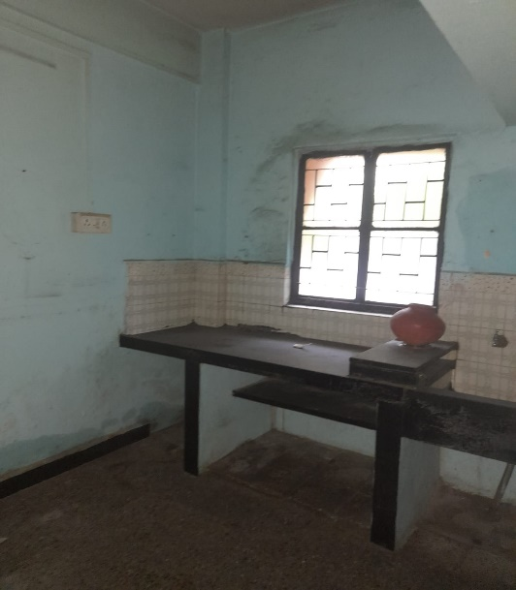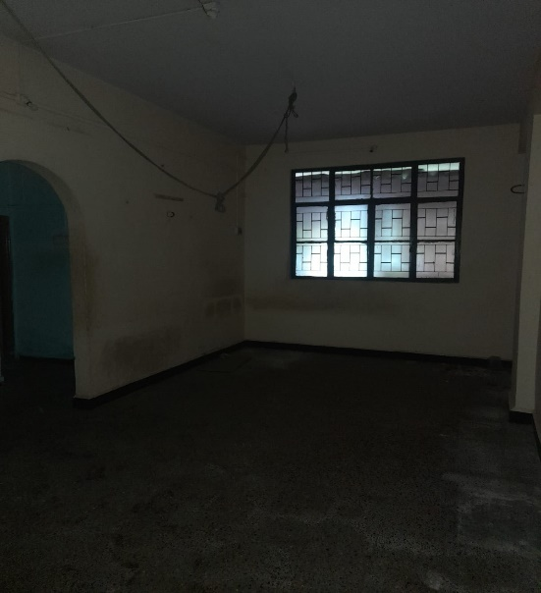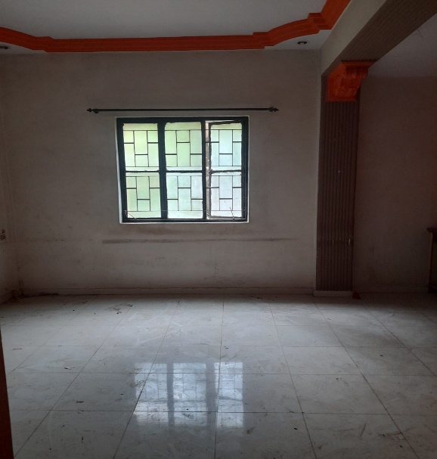**Actual site photographs**

