Vastu/Mumbai/082023/3092/2302043

14/02-189-NISH

Date: 14.08.2023

**Structural Stability Report**

Structural Observation Report of Residential Flat No. 304, 3rd Floor, Wing – D, **"Shree Sai Park D Wing Co-op. Hsg. Soc. Ltd."**, Azad Nagar No. 2, Near Castle Mill, Village – Panchpakhadi, Thane (West), PIN Code – 400 601, State – Maharashtra, Country – India.

**Name of Owner**: **Mr. Jamaluddin Usman Shaikh, Mr. Firoz Usman Shaikh, Shaikh Usman Mohammad Ibrahim & Mrs. Zulekhabi Usman Shaikh**

This is to certify that on visual inspection, it appears that the structure of the building **"Shree Sai Park D Wing Co-op. Hsg. Soc. Ltd."** is in normal condition and the future life can be reasonably takes under good working condition and with proper periodic repairs & maintenance is about 45 years.

**General Information**:

|  |  |  |
| --- | --- | --- |
| **A.** | **Introduction** | |
| 1 | Name of Building | **"Shree Sai Park D Wing Co-op. Hsg. Soc. Ltd."** |
| 2 | Property Address | Residential Flat No. 304, 3rd Floor, Wing – D, **"Shree Sai Park D Wing Co-op. Hsg. Soc. Ltd."**, Azad Nagar No. 2, Near Castle Mill, Village – Panchpakhadi, Thane (West), PIN Code – 400 601, State – Maharashtra, Country – India |
| 3 | Type of Building | Residential use |
| 4 | No. of Floors | Ground + 8 Upper Floors |
| 5 | Whether stilt / podium / open parking provided | Open Car Parking Space |
| 6 | Type of Construction | R.C.C. Framed Structure |
| 7 | Type of Foundation | R.C.C. Footing |
| 8 | Thickness of the External Walls | 9” thick brick walls both side plastered |
| 9 | Type of Compound | Brick Masonry Walls |
| 10 | Year of Construction | 2008 (Approx.) |
| 11 | Present age of building | 15 Years |
| 12 | Residual age of the building | 45 years Subject to proper, preventive periodic maintenance & structural repairs. |
| 13 | No. of flats (Per Floor) | 4 Flats |
| 14 | Methodology adopted | As per visual site inspection |

|  |  |  |
| --- | --- | --- |
| **B.** | **External Observation of the Building** | |
| 1 | Plaster | Normal Condition |
| 2 | Chajjas | Normal Condition |
| 3 | Plumbing | Normal Condition |
| 4 | Cracks on the external walls | Found |
| 5 | Filling cracks on the external walls | Found |
| 6 | Cracks on columns & beams | Not Found |
| 7 | Vegetation | Found |
| 8 | Leakages of water in the drainage pipes or water pipes | Not Found |
| 9 | Dampness external in the wall due to leakages | Found |
| 10 | Any other observation about the condition of external side of the building | The external condition is Normal |
| **C** | **Internal Observation of the common areas of the building and captioned premises** | |
| 1 | Beams (Cracks & Leakages) | Good Condition |
| 2 | Columns (Cracks & Leakages) | Good Condition |
| 3 | Ceiling (Cracks & Leakages) | Normal Condition |
| 4 | Leakages inside the property | Not Found |
| 5 | Painting inside the property | Good |
| 6 | Maintenance of staircase & cracks | Normal |

|  |  |  |
| --- | --- | --- |
| **D** | **Common Observation** | |
| 1 | Structural Audit of the Building Under Bye – Laws No. 77 of the Model Bye Laws (Co-Operative Societies Act / Rules) | As per Bye Laws No. 77 of Co-Op. Societies Bye Laws under the Act the society shall conduct a Structural Audit of the building of the society as follows |
| 2 | Remark | No Structural Audit Report is furnished for the perusal |

|  |  |
| --- | --- |
| **E** | **Conclusion** |
| The captioned building is having Ground + 8 upper ﬂoors which is constructed in year 2008 (Approx.). Estimated future life under present circumstances is about 45 years subject to proper, preventive periodic maintenance & structural repairs.  The inspection dated 24.07.2023 reveals no structural damage to the building. The building as well as the property is maintained normally and will stand future life subject to proper, preventive periodic maintenance & structural repairs.  Our Observations about the structure are given as above.  `  The above assessment is based on visual inspection only. | |

## Sharadkumar B. Chalikwar

Govt. Reg. Valuer

Chartered Engineer (India)

Reg. No. (N) CCIT/1-14/52/2008-09

SBI Empanelment No.: SME / TCC / 2016-17 / 156 / Sr. No. - 193

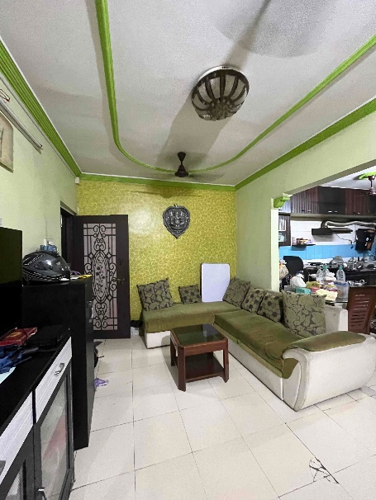**Actual Site Photographs**

