Vastu/Nashik/08/3016/2301973
09/02-119-CHV
Date: 08.09.2023

To,
State Bank of India
RACC Nashik Branch
RBO.2, The Wave Building, 1st Floor, Opposite Shell Petrol Pump,
Pathardi Road,Nashik – 422 010, State – Maharashtra, Country – India.

Sub: Vetting of Estimate

Sir,

With reference to above subject, we have evaluated the Estimate for Residential Land and Proposed Bungalow on CTS No. 760/1, Ground + First Floor Near Shiv Mandir, Adgaon Road, At - Adgoan Gaothan, Pin Code – 422 003, Taluka & District – Nashik, State – Maharashtra, Country – India belongs Mr. Santosh Yashwant Borade.

We have verified the rates quoted as per current market rates. Details of Estimate considered as per copy of Estimate Provided by Mr.Gaurav .S Dhatrak received on dated 08.09.2023. The Estimate amount is Rs.15,00,000/- (Rupees Fifteen Lakh Only. )

Note:1) The said Cost Vetting Certificate is valid upto next 6 months Only.
2) Estimate Submitted For Verification is Much More In Cost With Respective prevailing Market Rate.
3) The Value Of Construction Given In The Report Is As Per The Specification To Be Provided And With Respect To Prevailing Market Rate

Thanking you

Sincerely yours

Manoj B. Chalikwar
Registered Valuer
Chartered Engineer (India)
Reg. No. CAT-I-F-1763
SBI Empanelment No.: SME/TCC/2021-22/86/3

Estimate
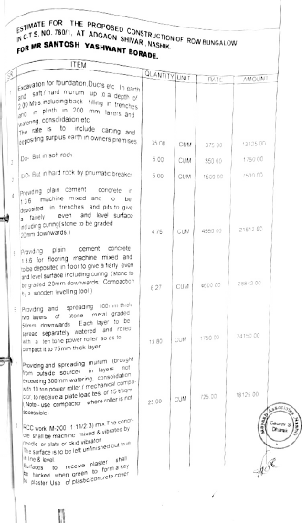
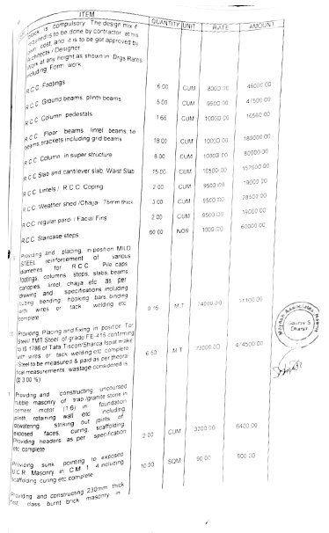

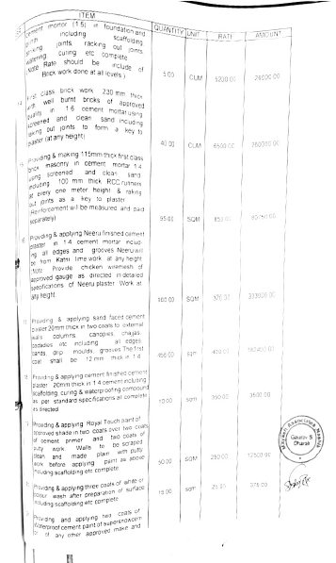
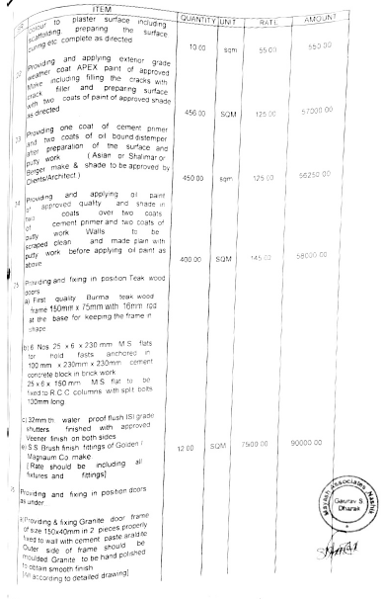

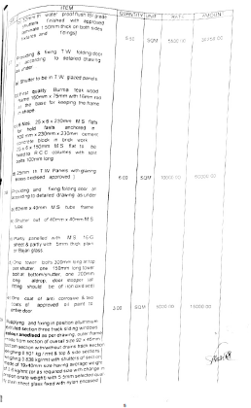
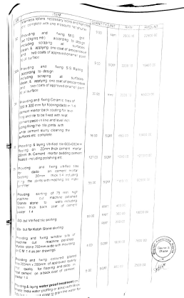

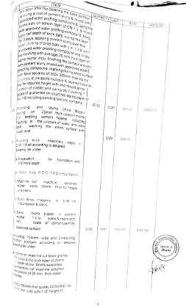
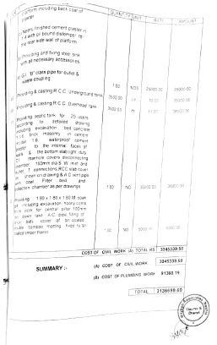

The Estimate amount is Rs.15,00,000/- (Rupees Fifteen Lakh Only. )

