Vastu/Nashik/08/2023/3030/2301982
09/11-128-CHSH
Date: 09.08.2023

To,
The Branch Manager,
Bank of Baroda
Regional Office
BSNL Building, Datta Mandir Road, Nashik Road,
Nashik, PIN – 422 101, State - Maharashtra, Country - India.

Sub: Vetting of Extra Work

Sir,

With reference to above subject, we have evaluated the Extra Work Cost Sheet for Residential Flat No. 401, Fourth Floor, C-Wing, "Sahajanand Park Phase-2 ", Survey No.148/7, Near Jain Mandir, Rathi Chawl, Seva Kunj, Panchavati, Village – Nashik, Taluka & District - Nashik, PIN Code – 422 003, State – Maharashtra, Country – India belongs M/s. Shree Harikrushna Developers Name of Proposed Purchaser Shri. Mayur Sunil Nirbhavane & Sau. Sonal Mayur Nirbhavane.

We have verified the rates quoted as per current market rates. Details of Extra Work Cost Sheet considered as per copy of Extra Work Cost Sheet by M/s. Shree Harikrushna Developers received on dated 09.08.2023. The Extra Work Cost Sheet amount is Rs.3,00,000/- (Rupees Three Lakh Only.)

Note:1) The said Cost Vetting Certificate is valid upto next 6 months Only.

Thanking you

Sincerely yours

Manoj B. Chalikwar
Registered Valuer
Chartered Engineer (India)
Reg. No. CAT-I-F-1763
Reg. No. IBBI/RV/07/2018/10366
BOB Empanelment No.: ZO:MZ:ADV:46:941
Encl: Vetting Report
.
Extra Work Cost Sheet
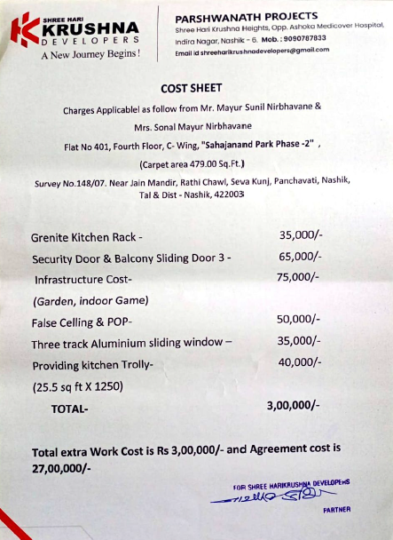

The Extra Work Cost Sheet amount is Rs.3,00,000/- ( Rupees Three Lakh Only.)

