Vastu/Nashik/09/3012/2301974
09/03-120-CHV
Date: 09.08.2023

To,
The Branch Manager,
Bank of Baroda
Regional Office
BSNL Building, Datta Mandir Road, Nashik Road,
Nashik, PIN – 422 101, State - Maharashtra, Country - India.

Sub: Vetting of Estimate

Sir,

With reference to above subject, we have evaluated the Estimate for Residential Flat No. 2, Second Floor, "Hemka Apartment", Survey No.13/3 & 13/4, Plot No.3+4, Opp. Borade Hospital, Agriculture Collage Farm Area, Loknete Vyankatrao Hire Marg, At – Malegaon Camp, Taluka- Malegaon, District - Nashik, PIN Code – 423 105, State – Maharashtra, Country – India belongs Shri. Lalit Mohanlal Kankariya.

We have verified the rates quoted as per current market rates. Details of Estimate considered as per copy of Estimate Provided by Vardhaman Infrastructure Services received on dated 18.06.2023. The Estimate amount is Rs. 51,00,000/- (Rupees Fifty One Lakh Only)

Note:1) The said Cost Vetting Certificate is valid upto next 6 months Only.

Thanking you

Sincerely yours

Manoj B. Chalikwar
Registered Valuer
Chartered Engineer (India)
Reg. No. CAT-I-F-1763
Reg. No. IBBI/RV/07/2018/10366
BOB Empanelment No.: ZO:MZ:ADV:46:941
Encl: Vetting Report
.
Estimate
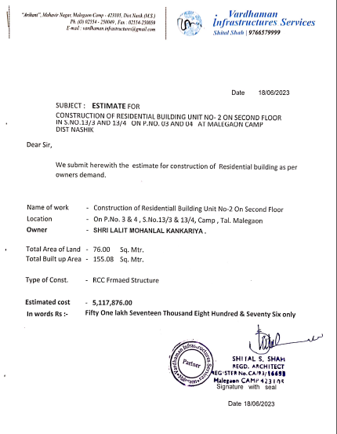
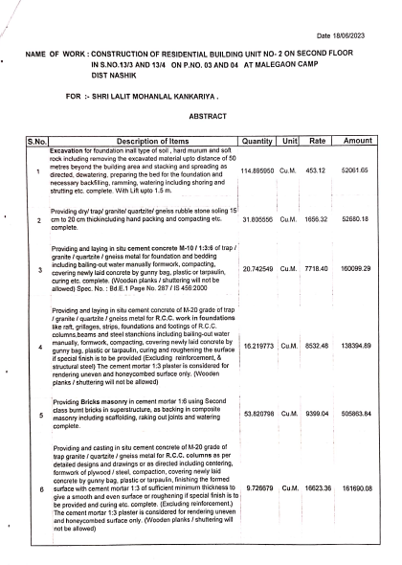

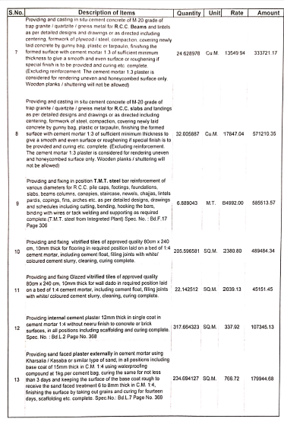
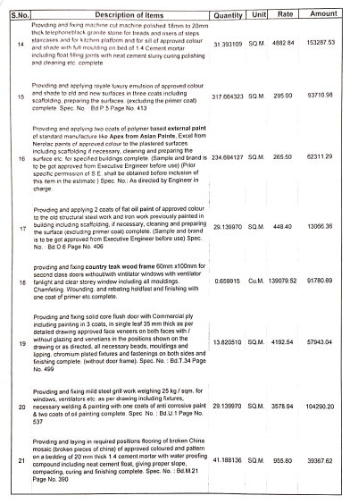

Estimate
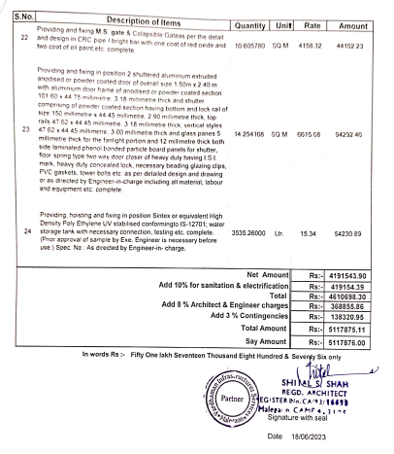

The Estimate amount is Rs.51,00,000/- (Rupees Fifty One Lakh Only)

