Vastu/Nashik/08/2023/3011/2301966
08/18-112
Date: 08.08.2023

To, `
The Branch Manager,
Bank of Baroda
Regional Office Nashik Road Branch
BSNL Building, Datta Mandir Road, Nashik Road,
Nashik -422 101, State - Maharashtra, Country - India.

Sub: Vetting of Extra Amenities

Sir,

With reference to above subject, we have evaluated the Extra Amenities for Residential Row House No. 02, Ground + 1 upper floor, "Gauri Row Houses", Gat No. 561/ 2/ 1, Plot No.79, Near Nishant Garden, Dhatark Phata, Village – Adgaon-2, Taluka & District - Nashik, PIN Code – 422 207, State – Maharashtra, Country – India belongs to Name of Owner: Shri. Tatyabhau Uttamrao Ahire & Shri. Piyush Rashikbhai Borsaniya. Name of Proposed Purchaser: Nitu Ramprakash Tyagi (Alias) Sau. Nitu Swapnil Suryawanshi.

We have verified the rates quoted as per current market rates. Details of work and Extra Amenities considered as per copy of Agreement for Extra Amenities issued by Nitu Ramprakash Tyagi (Alias) Sau. Nitu Swapnil Suryawanshi (First Party) and Shri. Pravin Pandit Suryawanshi (Second Party) received on dated August 2023. The Extra Amenities amount is Rs.7,00,000/- (Rupees Seven Lakh Only.)

The said Cost Vetting Certificate is valid upto next 6 months Only.

Thanking you

Sincerely yours

Manoj B. Chalikwar
Registered Valuer
Chartered Engineer (India)
Reg. No. CAT-I-F-1763
Reg. No. IBBI/RV/07/2018/10366
BOB Empanelment No.: ZO:MZ:ADV:46:941
Encl: Valuation report.

Agreement for Extra Amenities
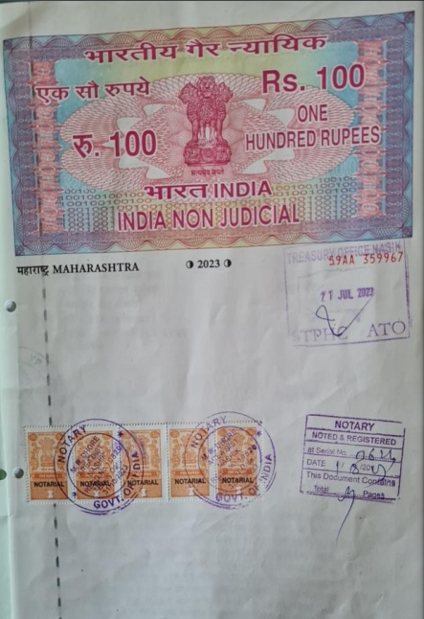
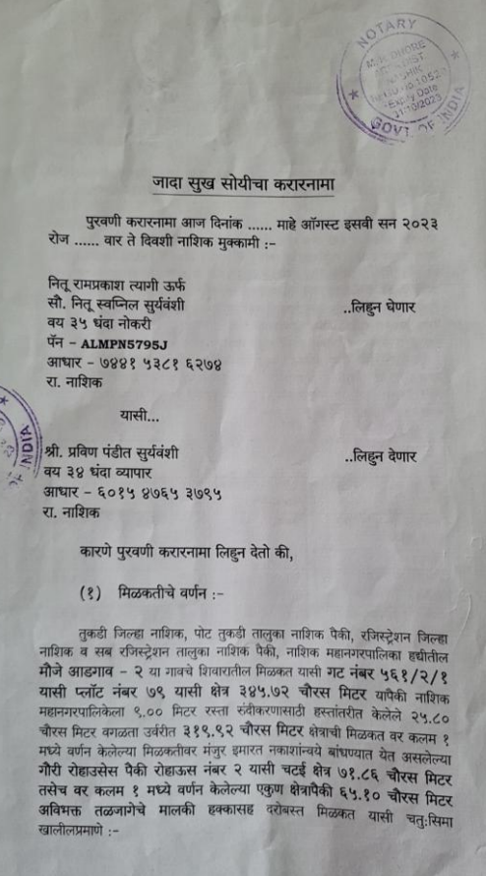

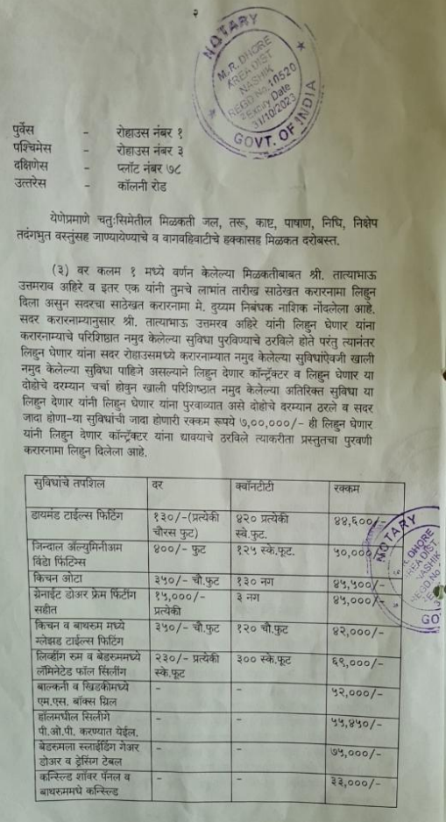
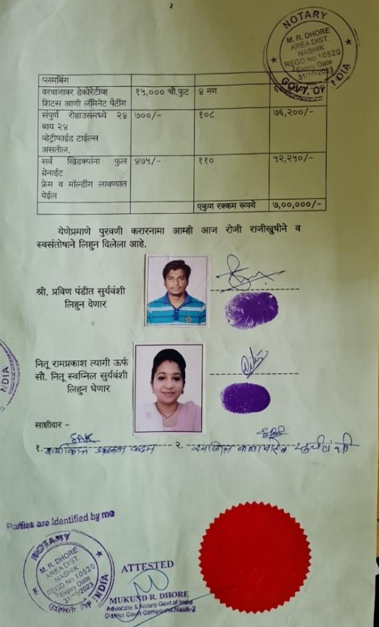

The Extra Amenities amount is Rs.7,00,000/- (Rupees Seven Lakh Only.)

