Valuation Report of the Immovable Property
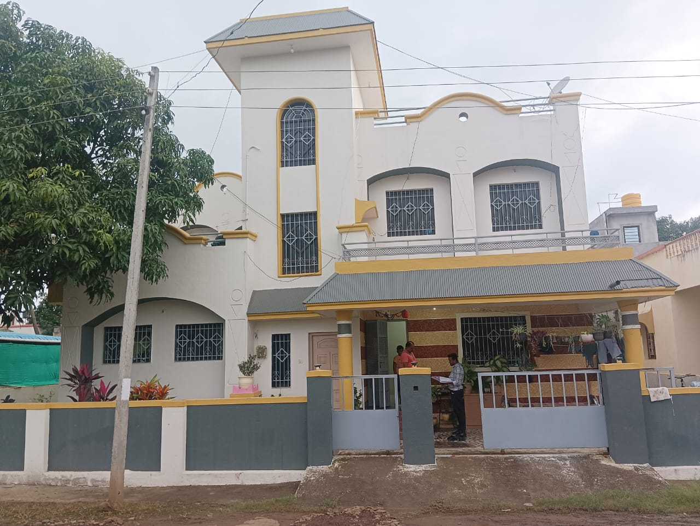

Details of the property under consideration:

Name of Owner: Shri.Nimnath Kisan Chaudhari

Residential Land and Bungalow on Survey No.5/120, Near Nirmiti Diary ,Dhumalwadi Road,
Mouje – Nawalewadi, PIN Code – 422 601,Taluka-Akole, District – Ahemednagar,
State – Maharashtra, Country – India

Latitude Longitude: 19°32'02.6"N 73°59'41.7"E

Valuation Done for:
Bank of India
Ghoti Branch
Post Box No.6,Old Agra Road,Ghoti Pincode-422 402,
Tal- Igatpuri, Dist-Nashik, State - Maharashtra,Country - India

‘

Vastukala Consultants (I) Pvt. Ltd.
Mumbai • Delhi NCR • Aurangabad • Nanded • Indore • Pune Raipur • Jaipur • Ahmedabad • Rajkot • Thane • Nashik
Vastu/Nashik/06/2023/31977/2301154
19/17-258-CHV
Date: 08.08.2023

VALUATION OPINION REPORT

This is to certify that the property bearing Residential Land and Bungalow on Survey No.5/120, Near Nirmiti Diary,Dhumalwadi Road, Mouje – Nawalewadi, PIN Code – 422 601,Taluka-Akole, District – Ahemednagar,
State – Maharashtra, Country – India belongs to Shri.Nimnath Kisan Chaudhari.

Boundaries of the property.

North | : | Bungalow
South | : | Road
East | : | Road
West | : | Open Plot
Considering various parameters recorded, existing economic scenario, and the information that is available with reference to the development of neighborhood and method selected for valuation, we are of the opinion that, the property premises can be assessed and valued for this particular purpose at ` 35,55,000.00 (Rupees Thirty Five Lakh Fifty Five Thousand Only)

The valuation of the property is based on the documents produced by the concern. Legal aspects have not been taken into considerations while preparing this valuation report.

Hence certified

Manoj B. Chalikwar
Registered Valuer
Chartered Engineer (India)
Reg. No. CAT-I-F-1763
BOI Empanelment No.: MNZ:C&IC:VAL19-20
Encl: Valuation report.

Vastukala Consultants (I) Pvt. Ltd.
B1-001, U/B Floor, Boomerang, Chandivali Farm Road, Powai, Andheri (East), Mumbai – 400 072

To,
The Branch Manager,
Bank of India
Ghoti Branch
Post Box No.6,Old Agra Road,Ghoti Pincode-422 402,
Tal- Igatpuri, Dist-Nashik, State - Maharashtra,Country - India

VALUATION REPORT (IN RESPECT OF RESIDENTIAL LAND )
I | General
1. | Purpose for which the valuation is made |  |  | : | To assess fair market value of the property for Banking Purpose.
2. | a) | Date of inspection |  | : | 02.08.2023
 | b) | Date on which the valuation is made |  | : | 08.08.2023
3. | List of documents produced for perusal |  |  | :
- Copy of Saledeed Vide No.915/2018 Dated.16.04.2017
- Copy Grampanchayat 8A Extract
- Copy of 7/12 Extract
4. | Name of the owner(s) and his / their address (es) with Phone no. (details of share of each owner in case of joint ownership) |  |  | : | Shri.Nimnath Kisan Chaudhari  Address – Residential Land and Bungalow on Survey No.5/120, Near Nirmiti Diary,Dhumalwadi Road, Mouje – Nawalewadi, PIN Code – 422 601,Taluka-Akole, District – Ahemednagar, State – Maharashtra, Country – India  Contact Person –  Shri.Nimnath Kisan Chaudhari (Owner)  Contact No. – +91 9421982163  Sole Ownership
5. | Brief description of the property (Including Leasehold / freehold etc.) |  |  | :
The property is located in a developed area well connected by road. The immovable property comprises of freehold N.A. land. It is located at about 66.4 Km. distance from Nashik Road Railway Station.
Land:
The Land under valuation is Freehold Residential Land. As per Saledeed & 7/12 Extract Land area is 237.00 Sq. M, which is considered for valuation.
6. | Location of property |  |  | :
 | a) |  | Survey No | : | Survey No.5/120
 | b) |  | Door No. | : | ---
 | c) |  | T.S. No. / Village | : | Mouje – Nawalewadi
 | d) |  | Ward / Taluka | : | Taluka-Akole
 | e) |  | Mandal / District | : | District – Ahemednagar
7. | Postal address of the property |  |  | : | Residential Land and Bungalow on Survey No.5/120, Near Nirmiti Diary,Dhumalwadi Road, Mouje – Nawalewadi, PIN Code – 422 601,Taluka-Akole, District – Ahemednagar, State – Maharashtra, Country – India
8. | City / Town |  |  | : | Mouje – Nawalewadi
 | Residential area |  |  | : | Yes
 | Commercial area |  |  | : | No
 | Industrial area |  |  | : | No
9. | Classification of the area |  |  | :
 | i) High / Middle / Poor |  |  | : | Middle Class
 | ii) Urban / Semi Urban / Rural |  |  | : | Semi Urban
10. | Coming under Corporation limit / Village Panchayat / Municipality |  |  | : | Nawalewadi Grampanchayat
11. | Whether covered under any State / Central Govt. enactments (e.g., Urban Land Ceiling Act) or notified under agency area/ scheduled area / cantonment area |  |  | : | No
12. | In Case it is Agricultural land, any conversion to house site Lands is contemplated |  |  | : | N.A.
13. | Boundaries of the property |  |  |  | As per site |  | As per Document
 | North |  |  | : | Bungalow |  | Property of Shri.Tukaram Chaudhari
 | South |  |  | : | Road |  | 3.65 Meter wide Road
 | East |  |  | : | Road |  | 6 Meter Common Road
 | West |  |  | : | Open Plot |  | Survey No.5/3/2
14.1 | Dimensions of the site |  |  |  | N. A. as the land is irregular in shape
 |  |  |  |  | A As per the Deed | B Actuals
 | North |  |  | : | - | -
 | South |  |  | : | - | -
 | East |  |  | : | - | -
 | West |  |  | : | - | -
14.2 | Latitude, Longitude & Co-ordinates of Land |  |  | : | 19°32'02.6"N 73°59'41.7"E
15. | Extent of the site |  |  | : | Land area - 237.00 Sq. M.  (Area as per Saledeed & 7/12 Extract)
16. | Extent of the site considered for Valuation (least of 14A& 14B) |  |  | : | Land area - 237.00 Sq. M.  (Area as per Saledeed & 7/12 Extract)
17. | Whether occupied by the owner / tenant? If occupied by tenant since how long? Rent received per month. |  |  | : | Owner Occupied
II | CHARACTERSTICS OF THE SITE
 | Classification of locality |  |  | : | Located in Middle class locality
 | Development of surrounding areas |  |  | : | Underdevelopment
 | Possibility of frequent flooding/ sub-merging |  |  | : | No
 | Feasibility to the Civic amenities like School, Hospital, Bus Stop, Market etc. |  |  | : | All available near by
 | Level of land with topographical conditions |  |  | : | Plain
 | Shape of land |  |  | : | Square
 | Type of use to which it can be put |  |  | : | Currently the land is used for Residential Purpose
 | Any usage restriction |  |  | : | Residential
 | Is Land in town planning approved layout? |  |  | : | Not Provided
 | Corner Land or intermittent Land? |  |  | : | Intermittent
 | Road facilities |  |  | : | Yes
 | Type of road available at present |  |  | : | B. T. Road
 | Width of road – is it below 20 ft. or more than 20 ft. |  |  | : | Below 20 ft.
 | Is it a Land – Locked land? |  |  | : | No
 | Water potentiality |  |  | : | Available
 | Underground sewerage system |  |  | : | Available
 | Is Power supply is available in the site |  |  | : | Available
 | Advantages of the site |  |  | : | Located in developed Residential area
 | Special remarks, if any like threat of acquisition of land for publics service purposes, road widening or applicability of CRZ provisions etc.(Distance from sea-cost / tidal level must be incorporated) |  |  | : | No
Part – A (Valuation of land)
1 | Size of Land |  |  | : | Land area - 237.00 Sq. M.  (Area as per Saledeed & 7/12 Extract)
 | North & South |  |  | : | -
 | East & West |  |  | : | -
2 | Total extent of the Land |  |  | : | Land area - 237.00 Sq. M.  (Area as per Saledeed & 7/12 Extract)
3 | Prevailing market rate ( Along With details / reference of at least two latest deals / transactions with respect to adjacent properties in the areas) |  |  | : | ` 12,000.00 to ` 18,000.00 per Sq. M. for land  Last Two Transactions: Not Available  Last two transaction are not available; we have made the online search but could not find out any ready reference for the surrounding locality.  Value derived and adopted above is the outcome of local inquiry, searching on Internet, application of personal experience, keeping in mind, the area on which property is falling, its size, shape, surrounding development, nature of surrounding locality, nature of holding of plot, facilities available, civic amenities for communication, permissible and restriction in development, future potentiality etc.  Details of online listings are attached with the report.
4 | Guideline rate obtained from the Register’s Office ( an evidence thereof to be enclosed) |  |  | : | ` 1830.00 per Sq. M.
 | Guideline Value |  |  | : | ` 4,33,710.00
5 | Assessed / adopted rate of valuation |  |  | : | ` 15,000.00 per Sq. M.
6 | Estimated value of land |  |  | : | ` 35,55,000.00
Part – B (Valuation of Building)
1 | Technical details of the building |  |  | :
 | - Type of Building (Residential / Residential / Industrial) |  |  | : | Residential
 | - Type of construction (Load bearing / RCC / Steel Framed) |  |  | : | Not Applicable
 | - Year of construction |  |  | : | Not Applicable
 | - Number of floors and height of each floor including basement, if any |  |  | : | Not Applicable
 | - Plinth area floor-wise |  |  | : | Not Applicable
 | - Condition of the building |  |  | : | Not Applicable
 | - Exterior – Excellent, Good, Normal, Poor |  |  | : | Not Applicable
 | - Interior – Excellent, Good, Normal, Poor |  |  | : | Not Applicable
 | - Date of issue and validity of layout of approved map |  |  | : | Not Provided
 | - Approved map / plan issuing authority |  |  | : | Building Plan is Not Provided
 | - Whether genuineness or authenticity of approved map / plan is verified |  |  | : | Building Plan is Not Provided
 | - Any other comments by our empanelled valuers on authentic of approved plan |  |  | : | Yes- Subject Property is Residential Land and Bungalow, Currently the Land us used for Residential Purpose ,but Construction Related Building Plan is not Provided, hence Construction area is not Consider for this Valuation, the Above mention Valuation is Consider only for Land.

Specifications of construction (floor-wise) in respect of

Sr.  No. | Description
 | Foundation | : | Not Applicable
 | Basement | : | Not Applicable
 | Superstructure | : | Not Applicable
 | Joinery / Doors & Windows (Please furnish details about size of frames, shutters, glazing, fitting etc. and specify the species of timber | : | Not Applicable
 | RCC Works | : | Not Applicable
 | Plastering | : | Not Applicable
 | Flooring, Skirting, dado | : | Not Applicable
 | Special finish as marble, granite, wooden paneling, grills etc. | : | Not Applicable
 | Roofing including weather proof course | : | Not Applicable
 | Drainage | : | Not Applicable

2. | Compound Wall | :
 | Height | : | 5’ BBM Masonry
 | Length | : | 5’ BBM Masonry
 | Type of construction | : | 5’ BBM Masonry
3. | Electrical installation | :
 | Type of wiring | : | N.A. as the property is an Land
 | Class of fittings (superior / ordinary / poor) | : | Not Applicable
 | Number of light points | : | Not Applicable
 | Fan points | : | Not Applicable
 | Spare plug points | : | Not Applicable
 | Any other item | : | Not Applicable
4. | Plumbing installation
 | - No. of water closets and their type | : | Not Applicable
 | - No. of wash basins | : | Not Applicable
 | - No. of urinals | : | Not Applicable
 | - No. of bath tubs | : | Not Applicable
 | - Water meters, taps etc. | : | Not Applicable
 | - Any other fixtures | : | Not Applicable

Part – C (Extra Items) |  | : | Amount in `
 | Portico | : | Not Applicable
 | Ornamental front door | : | Not Applicable
 | Sit out / Verandah with steel grills | : | Not Applicable
 | Overhead water tank | : | Not Applicable
 | Extra steel / collapsible gates | : | Not Applicable
 | Total |  | Not Applicable

Part – D (Amenities) |  | : | Amount in `
 | Wardrobes | : | Not Applicable
 | Glazed tiles | : | Not Applicable
 | Extra sinks and bath tub | : | Not Applicable
 | Marble / ceramic tiles flooring | : | Not Applicable
 | Interior decorations | : | Not Applicable
 | Architectural elevation works |  | Not Applicable
 | Paneling works |  | Not Applicable
 | Aluminum works |  | Not Applicable
 | Aluminum hand rails |  | Not Applicable
 | False ceiling |  | Not Applicable
 | Total

Part – E (Miscellaneous) |  | : | Amount in `
 | Separate toilet room | : | Not Applicable
 | Separate lumber room | : | Not Applicable
 | Separate water tank / sump | : | Not Applicable
 | Trees, gardening | : | Not Applicable
 | Total

Part – F (Services) |  | : | Amount in `
 | Water supply arrangements | : | Not Applicable
 | Drainage arrangements | : | Not Applicable
 | Compound wall | : | Not Applicable
 | C.B. deposits, fittings etc. | : | Not Applicable
 | Pavement |  | Not Applicable
 | Total
Government Value
Particulars | Area in Sq. M. | Rate in ` | Value in `
Land | 237.00 | 1830.00 | 4,33,710.00
Total |  |  | 4,33,710.00
Total abstract of the entire property
Part – A | Land | : | ` 35,55,000.00
Part – B | Building | : | ---
Part – C | Compound wall | :
Part - D | Amenities | :
Part – E | Pavement | :
Part – F | Services | :
 | Fair Market Value | : | ` 35,55,000.00
 | Realizable Value | : | ` 33,77,250.00
 | Distress Sale Value |  | ` 28,44,000.00
 | Value as per Circle Rate |  | ` 4,33,710.00
 | Insurable value (Full Replacement Cost – Subsoil Structure cost (15%) |  | ---
 | Remark:1) Subject Property is Residential Land and Bungalow, Currently the Land us used for Residential Purpose ,but Construction Related Building Plan is not Provided, hence Construction area is not Consider for this Valuation, the Above mention Valuation is Consider only for Land.

The cost approach is a Real Property Valuation method which considers the value of a property as the cost of the land plus the replacement cost of the building (construction costs) minus the physical and functional depreciation.

The cost approach is a Real Property Valuation method which considers the value of a property as the cost of the land plus the replacement cost of the building (construction costs) minus the physical and functional depreciation.

This approach is most commonly used for real estate properties that are not easily sold like schools, hospitals, government buildings and above type of property. Land cost can be estimated using the Sales Comparison Approach by studying recent sales of land close to the subject property, and these sales should be comparable in size and location with subject property. There are different ways to estimate replacement costs, the most common being finding out the cost to build a square foot of comparable properties multiplied by the total square footage of the building. The cost approach is commonly used for Residential Bungalow, Residential Building and properties mentioned above. As the property is an Residential land and building thereof, we have adopted Cost approach / Land and Building Method for the purpose of valuation. The Price for similar type of property in the nearby vicinity is in the range of ` 12,000/- to ` 18,000/- per Sq. M. for land Considering the rate with attached report, current market conditions, demand and supply position, Land size, location, sustained demand for Residential building / Land, all round development of Residential and Residential application in the locality etc.

We estimate ` 15,000/- per Sq. M. for Land with appropriate cost of construction for valuation.

The salability of the property is: Good
Likely rental values in future in: N.A.
Any likely income it may generate: Nil

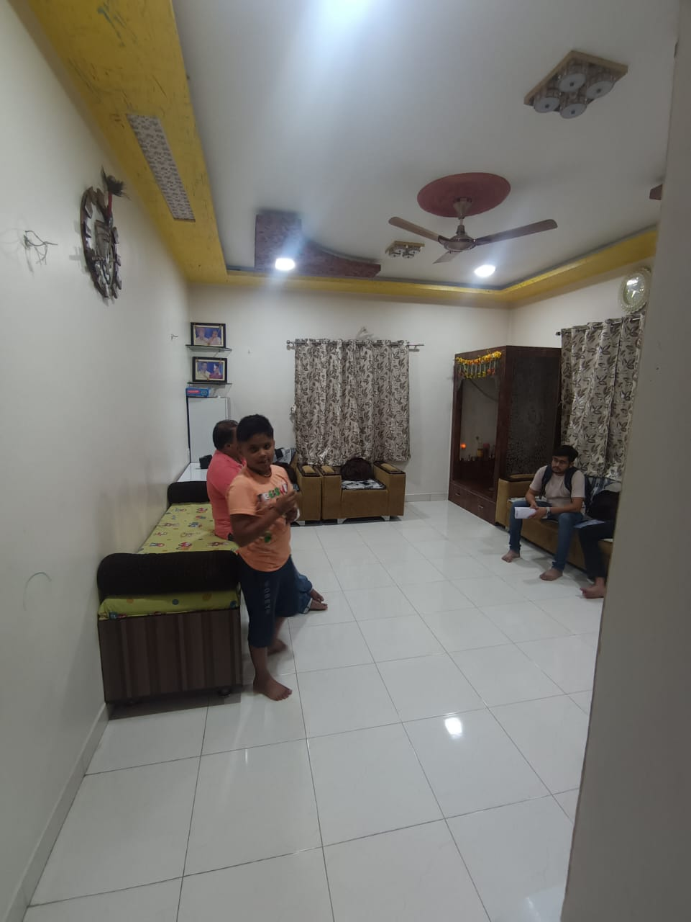
Actual Site Photographs
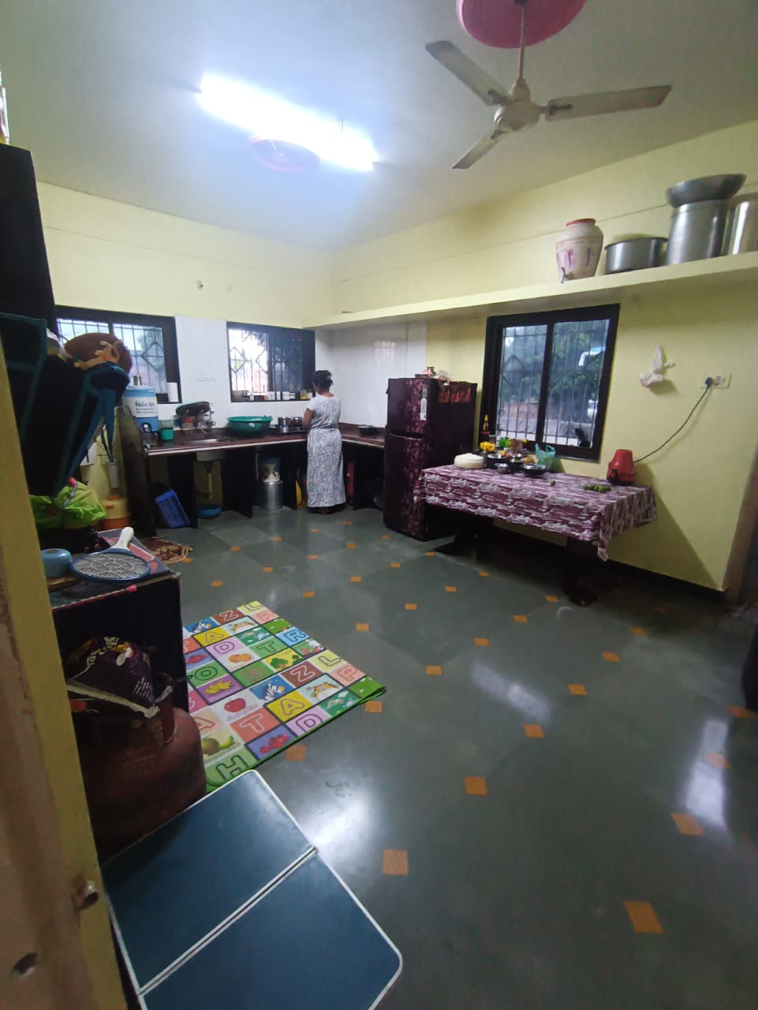
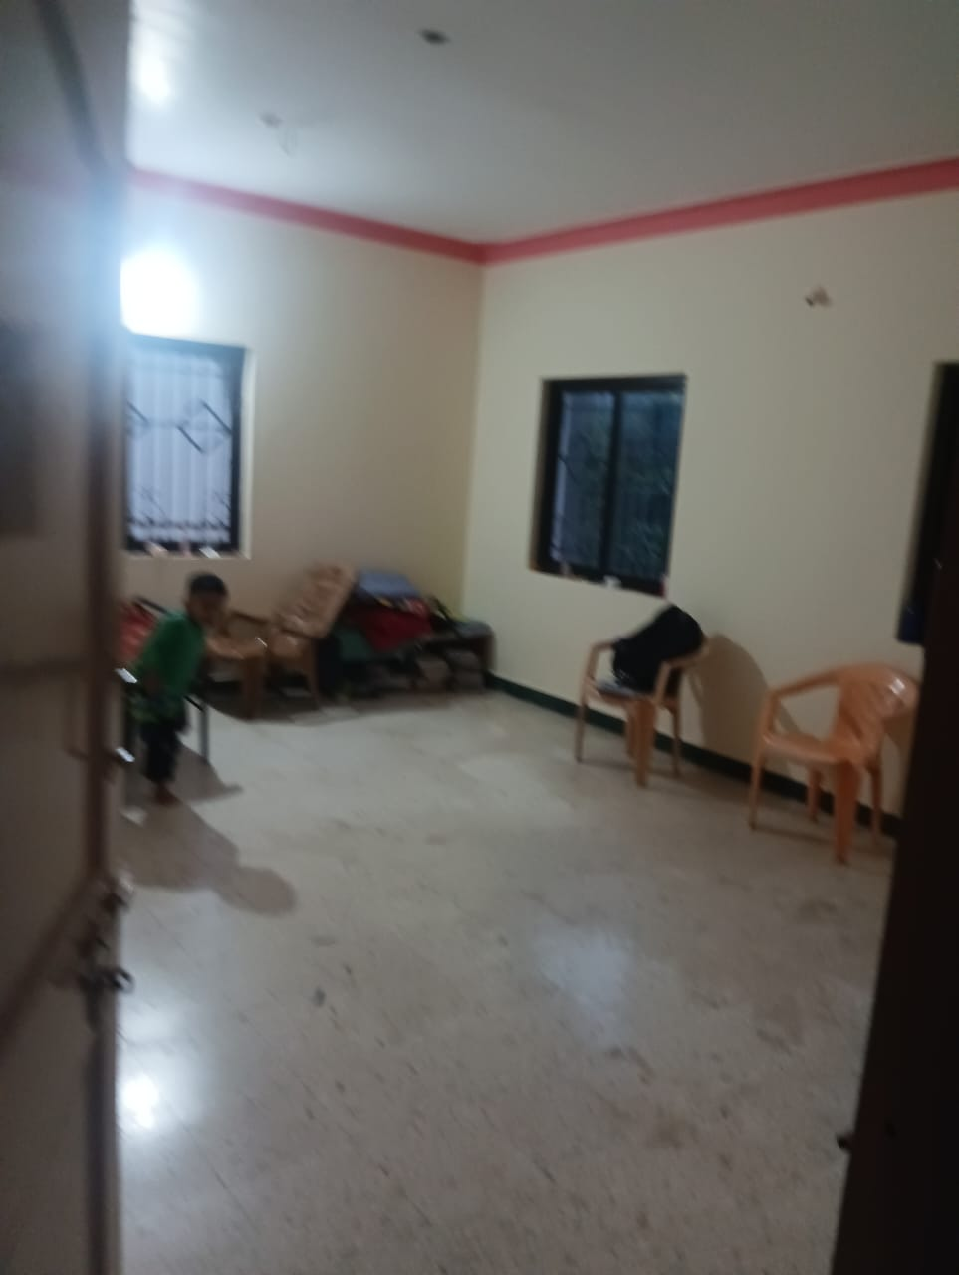

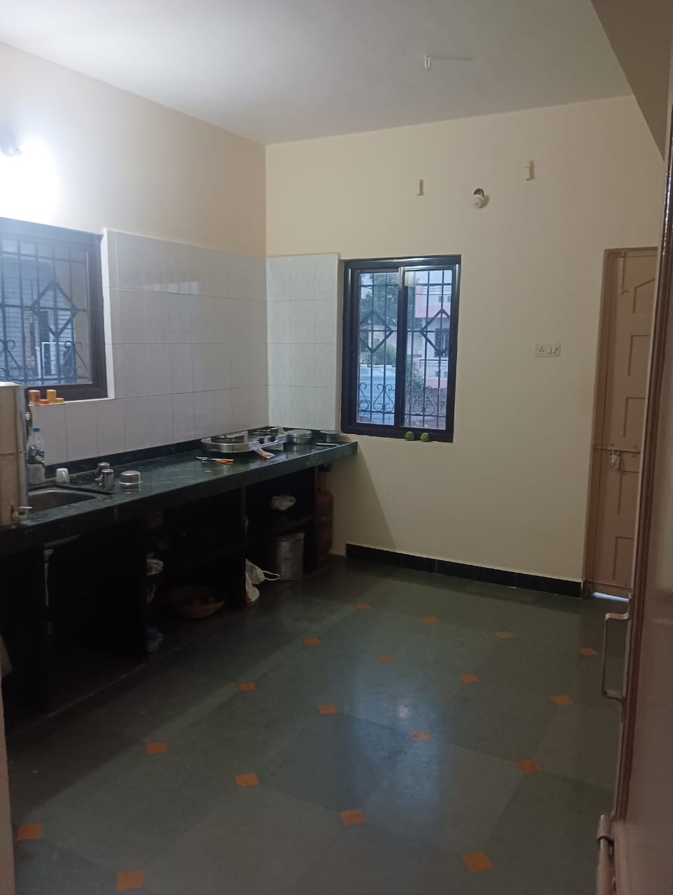
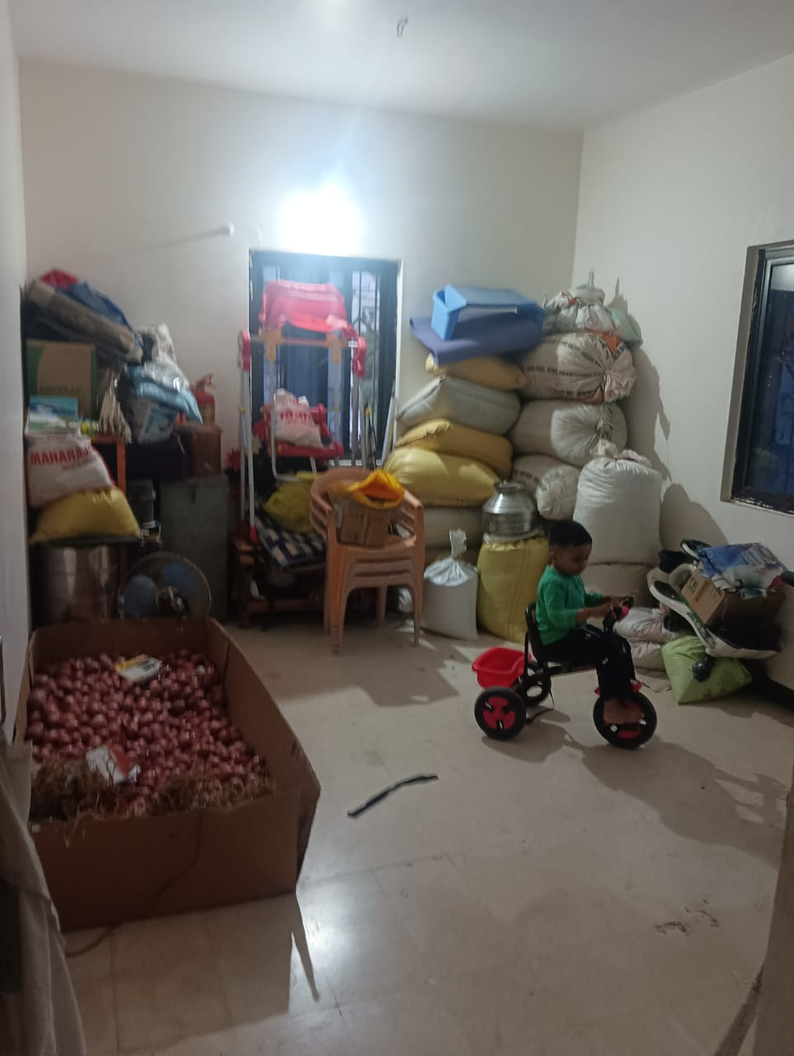
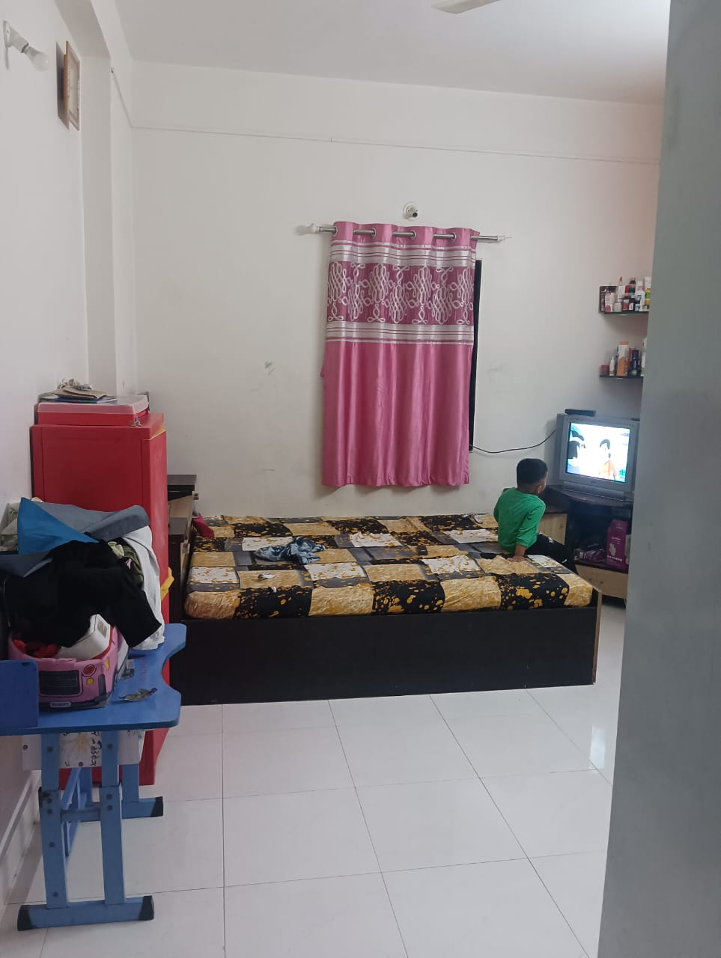

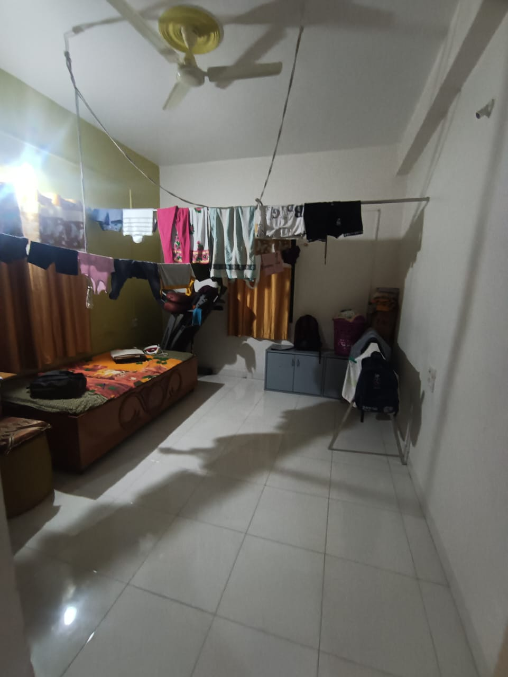
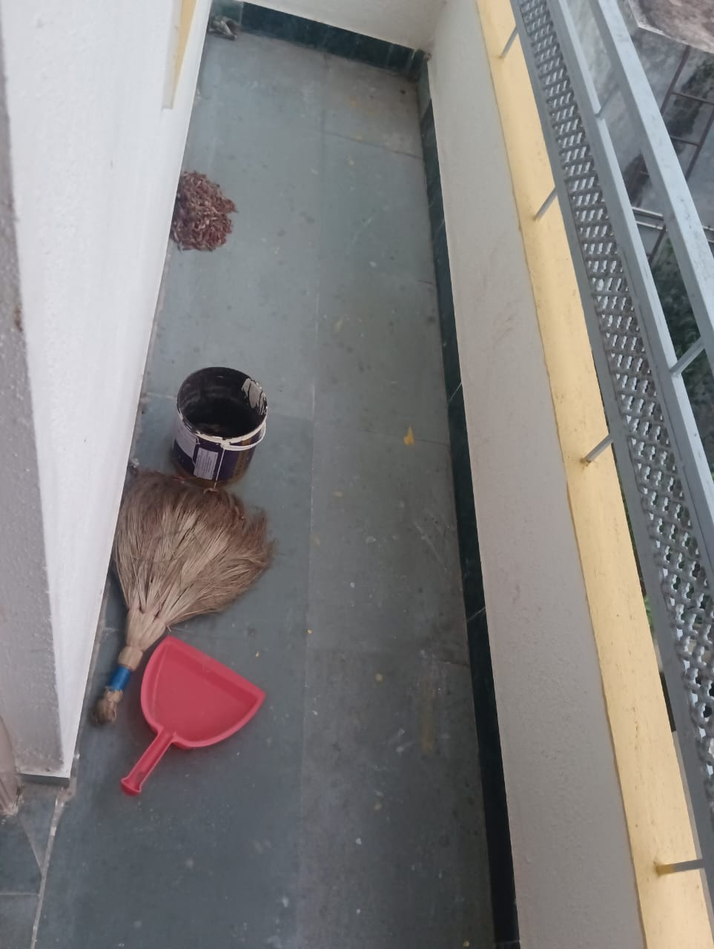
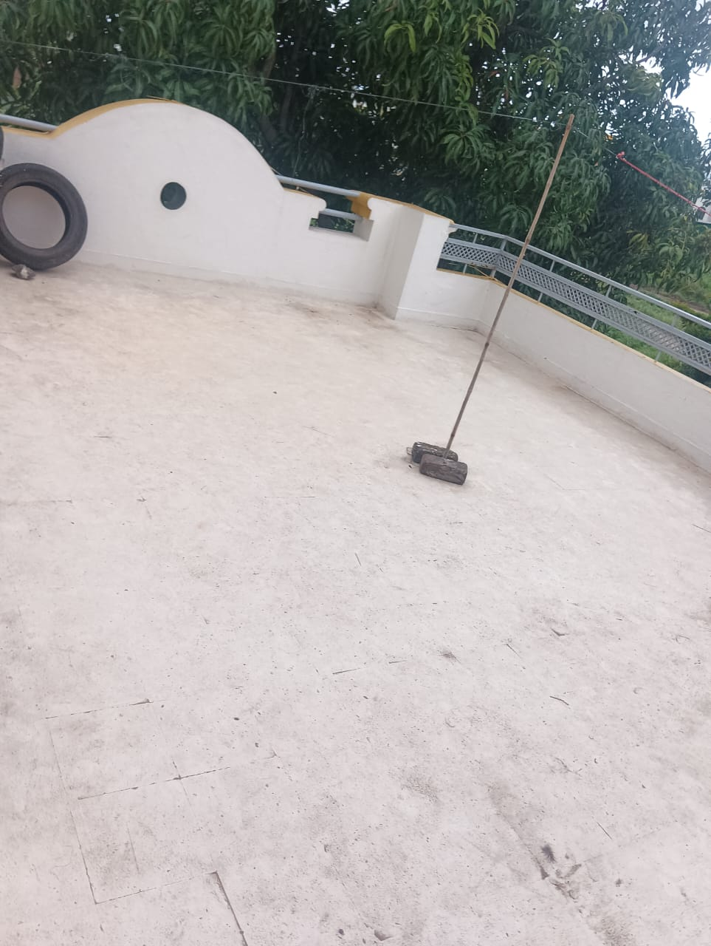

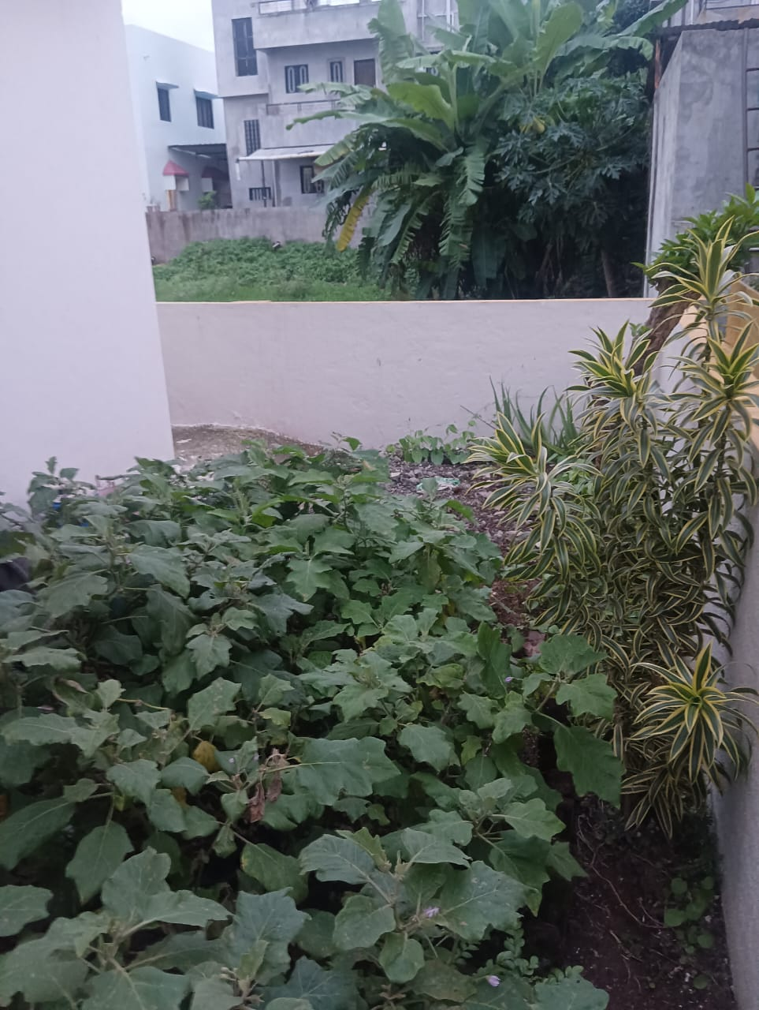
Actual Site Photographs
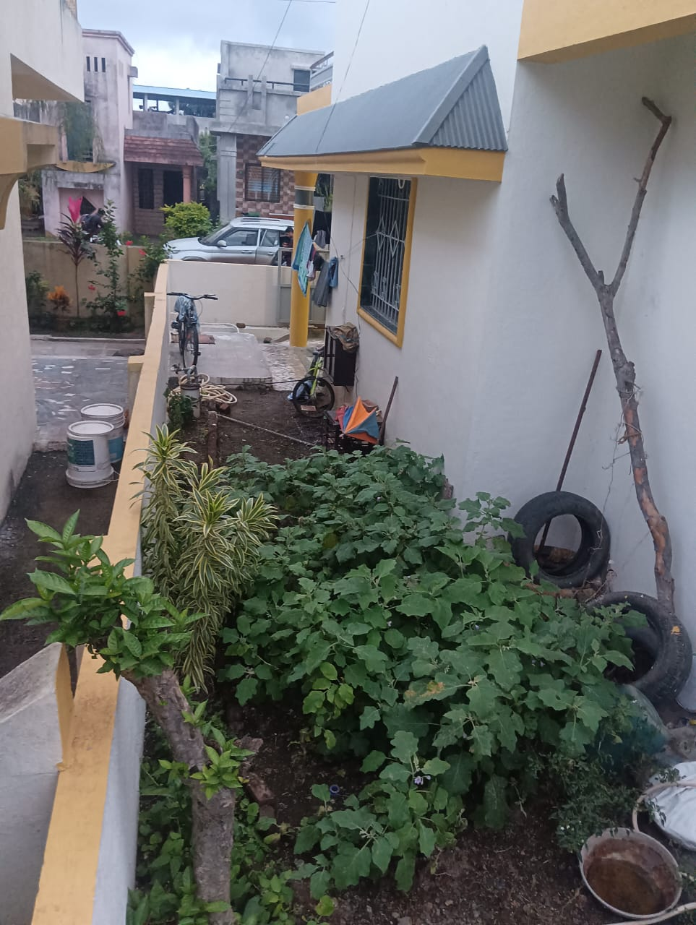
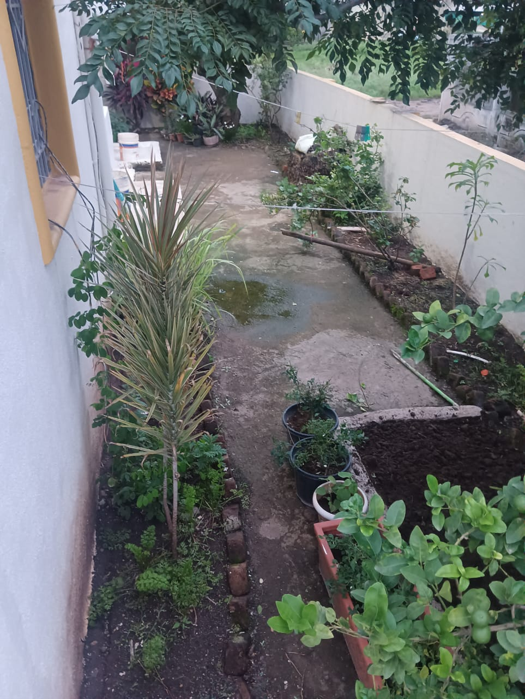

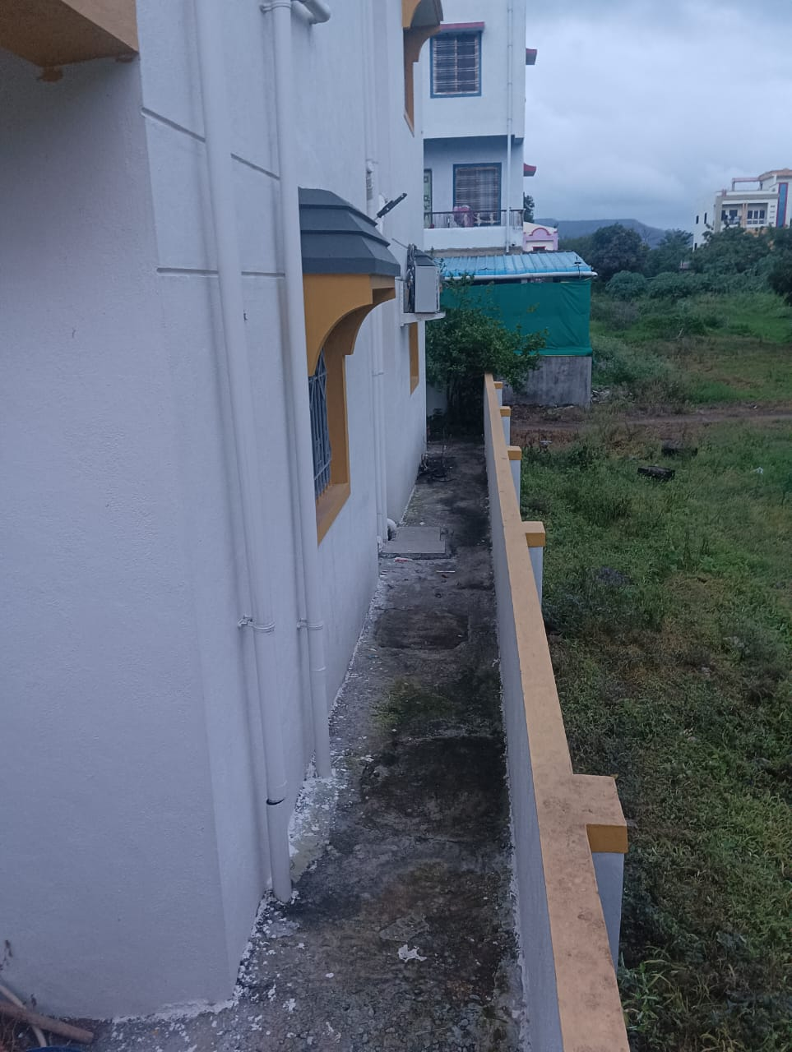
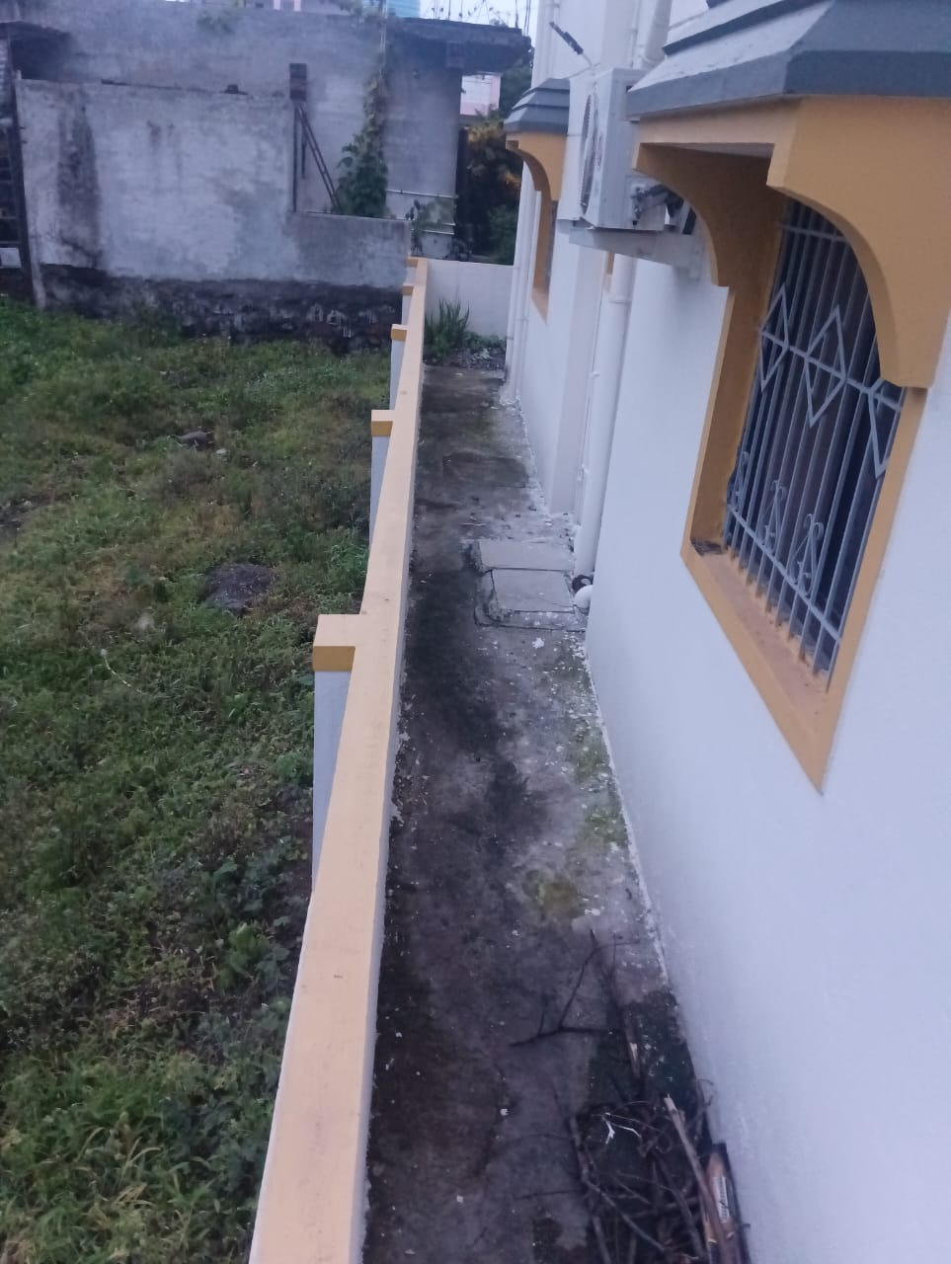
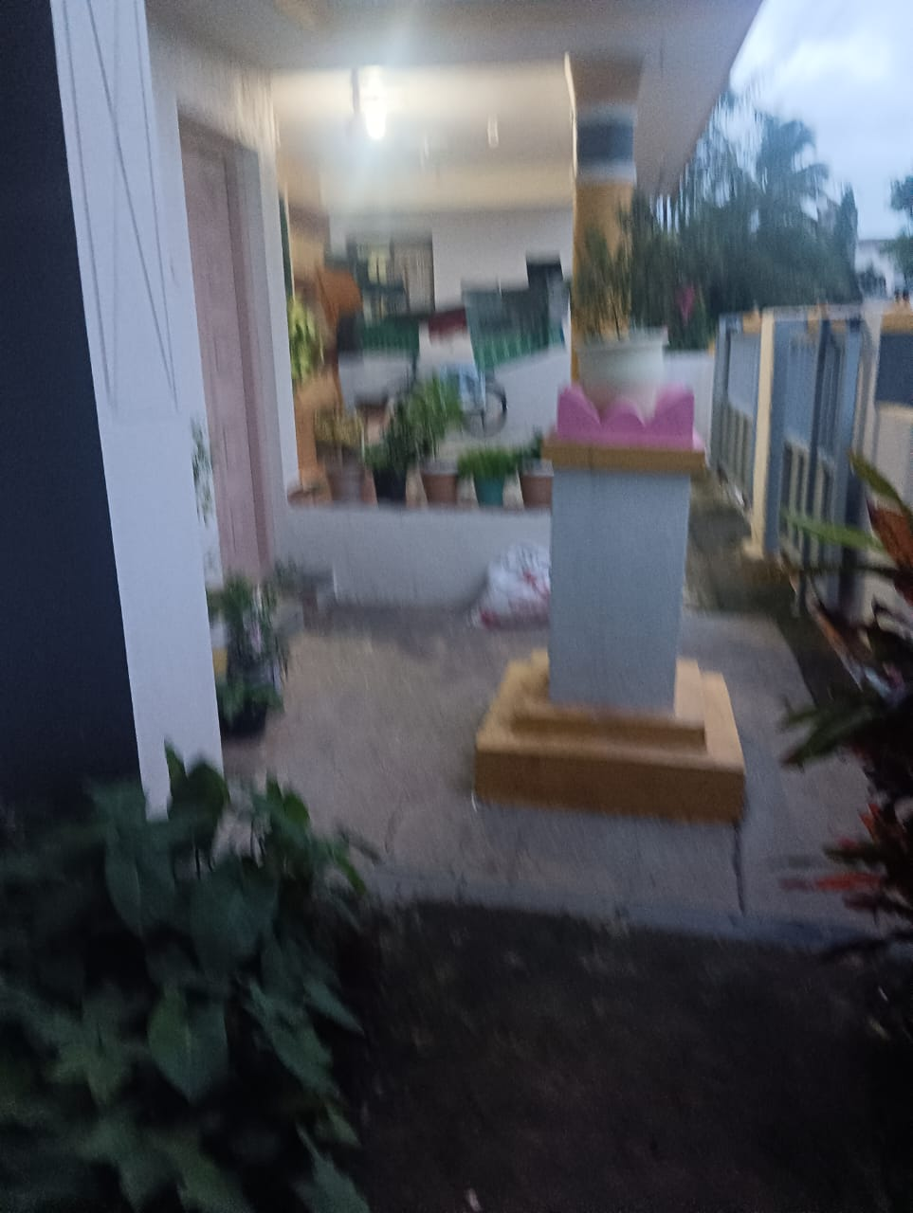

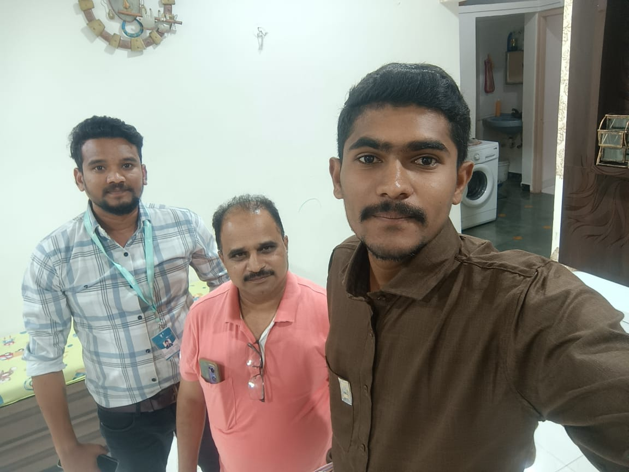

Route Map of the property
Site u/r
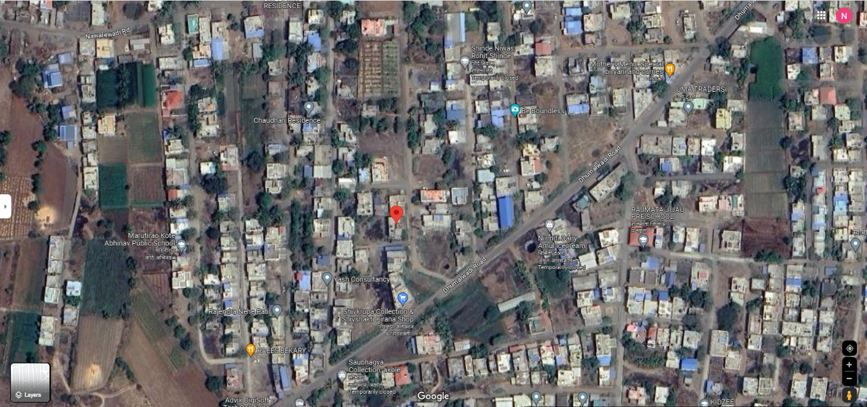

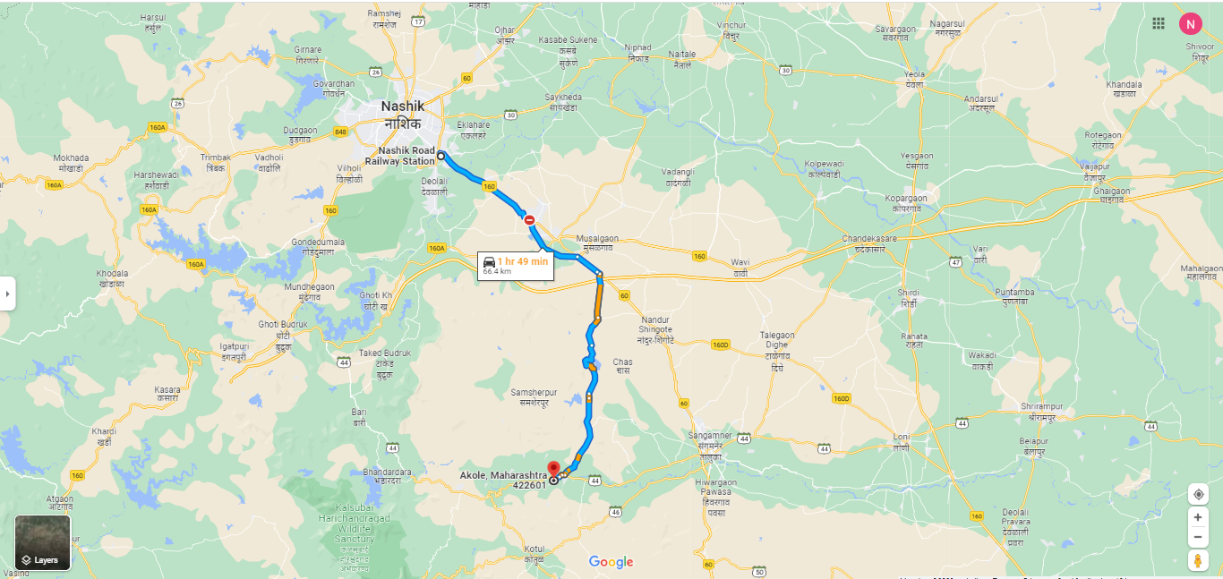

Latitude Longitude: 19°32'02.6"N 73°59'41.7"E
Note: The Blue line shows the route to site from nearest railway station (Nashik – 66.4 Km.)
Ready Reckoner Rate

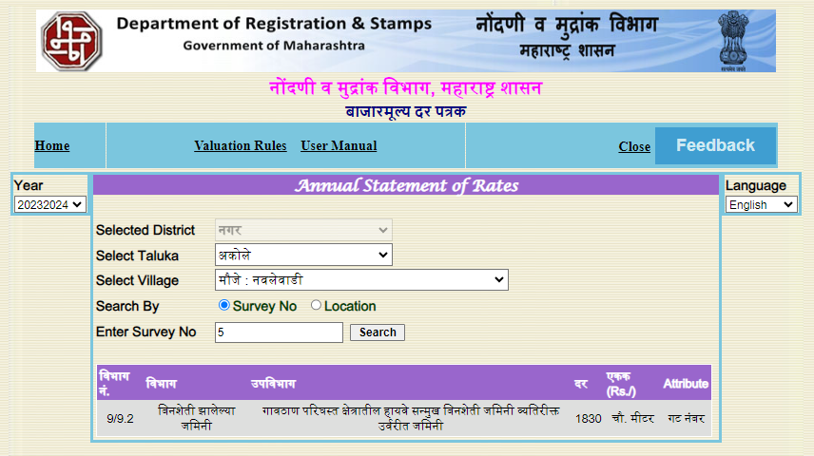

Price Indicators
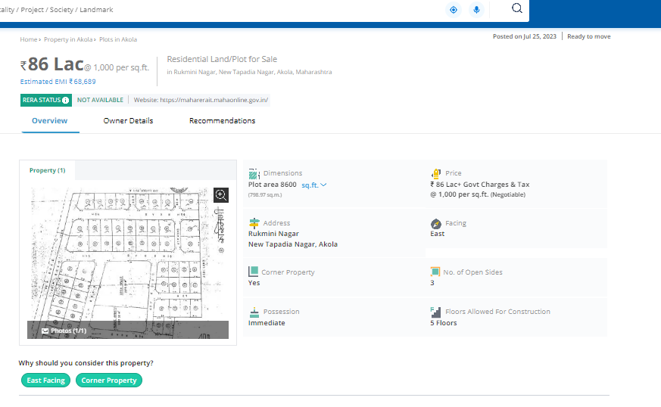
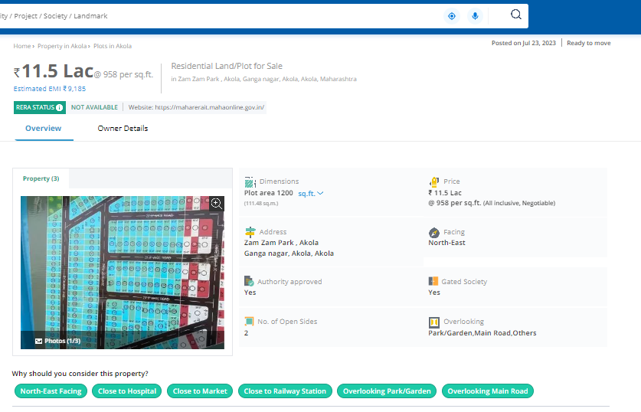

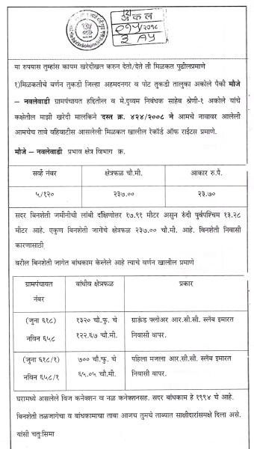
Plot Area

As a result of my appraisal and analysis, it is my considered opinion that the present fair market value of the above property in the prevailing condition with aforesaid specifications is ` 35,55,000.00 (Rupees Thirty Five Lakh Fifty Five Thousand Only). The Realizable Value of the above property is ` 33,77,250.00 (Rupees Thirty Three Lakh Seventy Seven Thousand Two Hundred Fifty Only). The Distress Value is ` 28,44,000.00 (Rupees Twenty Eight Lakh Forty Four Thousand only).

Place : Nashik
Date : 08.08.2023

Manoj B. Chalikwar
Registered Valuer
Chartered Engineer (India)
Reg. No. CAT-I-F-1763
BOI Empanelment No.: MNZ:C&IC:VAL19-20

The undersigned has inspected the property detailed in the Valuation Report dated _______________________

on ____________________. We are satisfied that the fair and reasonable market value of the property is

`_________________________ (Rupees ________________________________________________________

________________________________________only).

Date
Signature
(Name of the Branch Manager with Official seal)

DECLARATION FROM VALUERS

- The information furnished in my valuation report dated 08.08.2023 is true and correct to the best of my knowledge and belief and I have made and impartial and true valuation of the property. I have valued right property.
- I have no direct or indirect interest in the property valued;
- I/We have personally inspected the property on 02.08.2023 the work is not sub-contracted to any other valuer and carried out by myself.
- I have not been convicted of any offence and sentenced to a term of imprisonment;
- I have not been found guilty of misconduct in my professional capacity.
- I have read the Handbook on Policy, Standard and procedure for Real Estate Valuation, 2011 of the IBA and this report is in conformity to the “Standards” enshrined for valuation in the Part-B of the above handbook to the best of my ability.
- I have read the Internal Valuation Standard (IVS) and the report submitted to the Bank for the respective asset class is in conformity to the “Standards” as enshrined for valuation in IVS in “General Standards” and “Asset Standards” as applicable.
- Past performance of Real Estate Market need not necessarily indicate the future trends. This valuation purely and estimate & has no legal or Contractual obligation on our part. Analysis & conclusions of the value of the property are based on assumptions & conditions prevailing at the time of date of valuation. The rated indicated are based on current market condition & these may vary with time.
- Encumbrances of Loan, Govt. or other dues, stamp duty, registration charges, transfer charged etc. if any, are not considered in the valuation. We have assumed that the assets are free of lien & encumbrances.
- Bank authorities are requested to contact valuers in case of any doubts or discrepancy. The opinion about valuation is true & fair to the best of our knowledge & belief. We have no direct or indirect interest in the assets valued.
- I abide by the Model Code of Conduct for empanelment of the valuer in the Bank.
- I am the proprietor / partner / authorized official of the firm / company, who is competent to sign this valuation report.
- VCIPL, by reason of this report, are not required to give testimony or attendance in court or to any Government Agency whit reference to the subject property unless prior arrangements and consent have been made.
- Further, I hereby provide the following information.

Sr.  No. | Particulars | Valuer comment
 | background information of the asset being valued; | The property under consideration was purchased by Shri.Nimnath Kisan Chaudhari from Shri.Tulshiram Kisan Chaudhari Vide Sale Deed Dated 16.04.2017.
 | purpose of valuation and appointing authority | As per the request from Bank of India, Ghoti Branch, Nashik to assess value of the property for Banking purpose
 | identity of the valuer and any other experts involved in the valuation; | Manoj B. Chalikwar – Regd. Valuer  Sanjay Phadol - Regional Technical Manager  Sachin Raundal - Valuation Engineer  Vinita Surve– Technical Manager  Chintamani Chaudhari – Technical Officer
 | disclosure of valuer interest or conflict, if any; | We have no interest, either direct or indirect, in the property valued. Further to state that we do not have relation or any connection with property owner / applicant directly or indirectly. Further to state that we are an independent Valuer and in no way related to property owner / applicant
 | date of appointment, valuation date and date of  report; | Date of Appointment – 02.08.2023  Valuation Date – 08.08.2023  Date of Report - 08.08.2023
 | inspections and/or investigations undertaken; | Physical Inspection done on 02.08.2023
 | nature and sources of the information used or relied upon; | - Market Survey at the time of site visit  - Ready Reckoner rates / Circle rates  - Online search for Registered Transactions  - Online Price Indicators on real estate portals  - Enquiries with Real estate consultants  - Existing data of Valuation assignments carried out by us
 | procedures adopted in carrying out the valuation and valuation standards followed; | Sales Comparison Method
 | restrictions on use of the report, if any; | This valuation is for the use of the party to whom it is addressed and for no other purpose. No responsibility is accepted to any third party who may use or rely on the whole or any part of this valuation. The valuer has no pecuniary interest that would conflict with the proper valuation of the property.
 | major factors that were taken into account during the valuation; | current market conditions, demand and supply position, Residential Office size, location, upswing in real estate prices, sustained demand for Residential Office, all round development of Residential and Residential application in the locality etc.
 | Caveats, limitations and disclaimers to the extent they explain or elucidate the limitations faced by valuer, which shall not be for the purpose of limiting his responsibility for the valuation report. | Attached
Assumptions, Disclaimers, Limitations & Qualifications
Value Subject to Change
The subject appraisal exercise is based on prevailing market dynamics as on 08th Aug 2023 and does not take into account any unforeseeable developments which could impact the same in the future.
Our Investigations
We are not engaged to carry out all possible investigations in relation to the subject property. Where in our report we identify certain limitations to our investigations, this is to enable the reliant party to instruct further investigations where considered appropriate or where we recommend as necessary prior to reliance. Vastukala Consultants India Pvt. Ltd. (VCIPL) is not liable for any loss occasioned by a decision not to conduct further investigations
Assumptions
Assumptions are a necessary part of undertaking valuations. VCIPL adopts assumptions for the purpose of providing valuation advise because some matters are not capable of accurate calculations or fall outside the scope of our expertise, or out instructions. The reliant party accepts that the valuation contains certain specific assumptions and acknowledge and accept the risk of that if any of the assumptions adopted in the valuation are incorrect, then this may have an effect on the valuation.
Information Supplied by Others
The appraisal is based on the information provided by the client. The same has been assumed to be correct and has been used for appraisal exercise. Where it is stated in the report that another party has supplied information to VCIPL, this information is believed to be reliable but VCIPL can accept no responsibility if this should prove not to be so.
Future Matters
To the extent that the valuation includes any statement as to a future matter, that statement is provided as an estimate and/or opinion based on the information known to VCIPL at the date of this document. VCIPL does not warrant that such statements are accurate or correct.
Map and Plans
Any sketch, plan or map in this report is included to assist the reader while visualising the property and assume no responsibility in connection with such matters.
Site Details
Based on inputs received from Client's representative and site visit conducted, we understand that the subject property is contiguous and non-agricultural land parcel admeasuring 237.00 Sq. M. structures thereof. The property is owned by Shri.Nimnath Kisan Chaudhari. Further, VCIPL has assumed that the subject property is free from any encroachment and is available as on the date of the appraisal.

Property Title
Based on our discussion with the Client, we understand that the subject property is owned by Shri.Nimnath Kisan Chaudhari. For the purpose of this appraisal exercise, we have assumed that the subject property has a clear title and is free from any encumbrances, disputes and claims. VCIPL has made no further enquiries with the relevant local authorities in this regard and does not certify the property as having a clear and marketable title. Further, no legal advice regarding the title and ownership of the subject property has been obtained for the purpose of this appraisal exercise. It has been assumed that the title deeds are clear and marketable.
Environmental Conditions
We have assumed that the subject property is not contaminated and is not adversely affected by any existing or proposed environmental law and any processes which are carried out on the property are regulated by environmental legislation and are properly licensed by the appropriate authorities.
Town Planning
The permissible land use, zoning, achievable FSI, area statement adopted for purpose of this valuation is based on the information provided by the Client's representative and the same has been adopted for this valuation purpose. VCIPL has assumed the same to be correct and permissible. VCIPL has not validated the same from any authority.
Area
Based on the information provided by the Client's representative, we understand that the subject property, contiguous and non-agricultural land parcel admeasuring 237.00 Sq. M. and structure thereof
Condition & Repair
In the absence of any information to the contrary, we have assumed that there are no abnormal ground conditions, nor archaeological remains present which might adversely affect the current or future occupation, development or value of the property. The property is free from rat, infestation, structural or latent defect. No currently known deleterious or hazardous materials or suspect techniques will be used in the construction of or subsequent alteration or additions to the property and comments made in the property details do not purport to express an opinion about, or advise upon, the condition of uninspected parts and should not be taken as making an implied representation or statement about such parts
Valuation Methodology
For the purpose of this valuation exercise, the valuation methodology used is Direct Comparison Approach Method and proposed Highest and Best Use model is used for analysing development potential.
The Direct Comparison Approach involves a comparison of the property being valued to similar properties that have actually been sold in arms - length transactions or are offered for sale. This approach demonstrates what buyers have historically been willing to pay (and sellers willing to accept) for similar properties in an open and competitive market and is particularly useful in estimating the value of the land and properties that are typically traded on a unit basis.
In case of inadequate recent transaction activity in the subject micro-market, the appraiser would collate details of older transactions. Subsequently, the appraiser would analyse rental / capital value trends in the subject micro-market in order to calculate the percentage increase / decrease in values since the date of the identified transactions. This percentage would then be adopted to project the current value of the same.
Where reliance has been placed upon external sources of information in applying the valuation methodologies, unless otherwise specifically instructed by Client and/or stated in the valuation, VCIPL has not independently verified that information and VCIPL does not advise nor accept it as reliable. The person or entity to whom the report is addressed acknowledges and accepts the risk that if any of the unverified information in the valuation is incorrect, then this may have an effect on the valuation.
Not a Structural Survey
We state that this is a valuation report and not a structural survey
Other
All measurements, areas and ages quoted in our report are approximate
Legal
We have not made any allowances with respect to any existing or proposed local legislation relating to taxation on realization of the sale value of the subject property. VCIPL is not required to give testimony or to appear in court by reason of this appraisal report, with reference to the property in question, unless arrangement has been made thereof. Further, no legal advice on any aspects has been obtained for the purpose of this appraisal exercise
Property specific assumptions
Based on inputs received from the client and site visit conducted, we understand that the subject property is contiguous and non-agricultural land parcel admeasuring 237.00 Sq. M

ASSUMPTIONS, CAVEATS, LIMITATION AND DISCLAIMERS
- We assume no responsibility for matters of legal nature affecting the property appraised or the title thereto, nor do we render our opinion as to the title, which is assumed to be good and marketable.
- The property is valued as though under responsible ownership.
- It is assumed that the property is free of liens and encumbrances.
- It is assumed that there are no hidden or unapparent conditions of the subsoil or structure that would render it more or less valuable. No responsibility is assumed for such conditions or for engineering that might be required to discover such factors.
- There is no direct/ indirect interest in the property valued.
- The rates for valuation of the property are in accordance with the Govt. approved rates and prevailing market rates

DEFINITION OF VALUE FOR THIS SPECIFIC PURPOSE

This exercise is to assess Fair Market Value of the property under reference as on 08th Aug 2023.

The term Fair Market Value is defined as

“The most probable price, as of a specified date, in cash, terms equivalent to cash, or in other precisely revealed terms for which the specified property rights would sell after reasonable exposure in a competitive market under all conditions requisite to a fair sale, with the buyer and seller each acting prudently knowledgeably and for self interest assuming that neither is under undue duress”.

Fundamental assumptions and conditions presumed in this definition are:

1. Buyer and seller are motivated by self-interest.
2. Buyer and seller are well informed and are acting prudently.
3. The property is exposed for a reasonable time on the open market.
4. Payment is made in cash or equivalent or in specified financing terms.
DECLARATION OF PROFESSIONAL FEES CHARGED

We hereby declare that, our professional fees are not contingent upon the valuation findings. However, if the statute AND/OR clients demands that, the fees should be charged on the percentage of assessed value then, with the full knowledge of the AND/OR end user, it is being charged accordingly.

VALUATION OF THE PROPERTY PREMISES

Considering various parameters recorded, existing economic scenario, and the information that is available with reference to the development of neighborhood and method selected for valuation, we are of the opinion that, the property premises can be assessed and Fair Market Value for this particular purpose ` 35,55,000.00 (Rupees Thirty Five Lakh Fifty Five Thousand Only).

Manoj B. Chalikwar
Registered Valuer
Chartered Engineer (India)
Reg. No. CAT-I-F-1763
BOI Empanelment No.: MNZ:C&IC:VAL19-20

