Vastu/Nashik/08/2959/2301917
05/07-63-RPSH
Date: 05.08.2023

To, `
The Branch Manager,
Bank of Baroda
Regional Office Nashik Road Branch
BSNL Building, Datta Mandir Road, Nashik Road,
Nashik -422 101, State - Maharashtra, Country - India.

Sub: Vetting of Extra Amenities

Sir,

With reference to above subject, we have evaluated the Extra Amenities for Residential Row Bungalow No. 2, Ground + First Floor, “New Sai Samruddhi Row Bungalows”, Survey No. 925/3/2 (Old 1157), Plot No. 17, Behind Sai Hotel, Deshmukh Nagar, At - Sinnar, Taluka- Sinnar, District - Nashik, PIN Code – 422 113, State – Maharashtra, Country – India belongs to Mrs. Sunanda Balu Sonawane & Mrs. Suman Keshav Dholi. Name of Proposed Purchaser: Shri. Sudhir Barku Bhadane.

We have verified the rates quoted as per current market rates. Details of work and Extra Amenities considered as per copy of Agreement for Extra Amenities issued by Shri. Sudhir Barku Bhadane (First Party) and Smt. Sunanda Balu Sonawane & Smt. Suman Keshav Dholi (Second Party) received on dated 21.07.2023. The Extra Amenities amount is Rs.6,00,000/- (Rupees Six Lakh Only.)

The said Cost Vetting Certificate is valid upto next 6 months Only.

Thanking you

Sincerely yours

Manoj B. Chalikwar
Registered Valuer
Chartered Engineer (India)
Reg. No. CAT-I-F-1763
Reg. No. IBBI/RV/07/2018/10366
BOB Empanelment No.: ZO:MZ:ADV:46:941
Encl: Valuation report.

Agreement for Extra Amenities
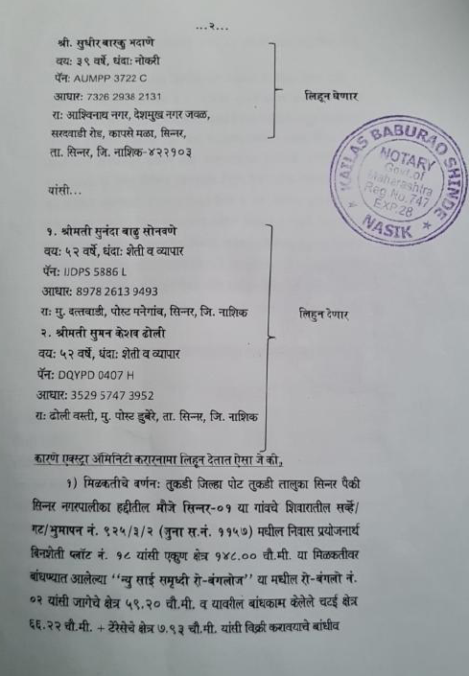
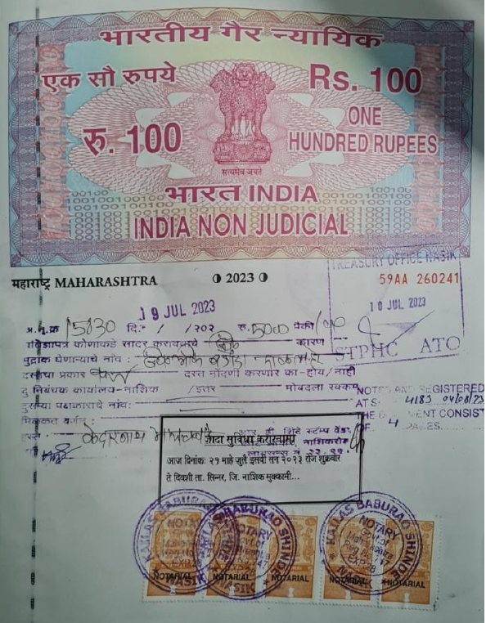

Agreement for Extra Amenities
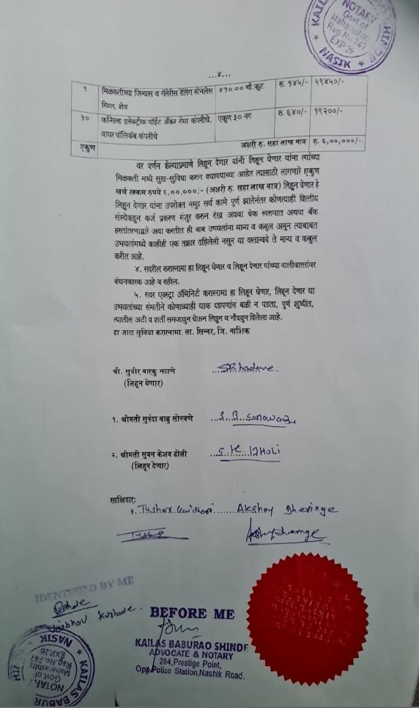

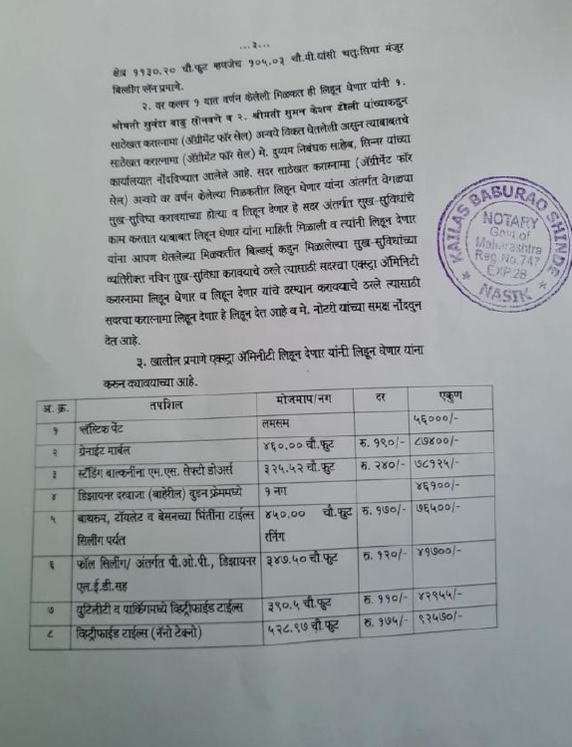

The Extra Amenities amount is Rs.6,00,000/- ( Rupees Six Lakh Only. )

