Valuation Report of the Immovable Property

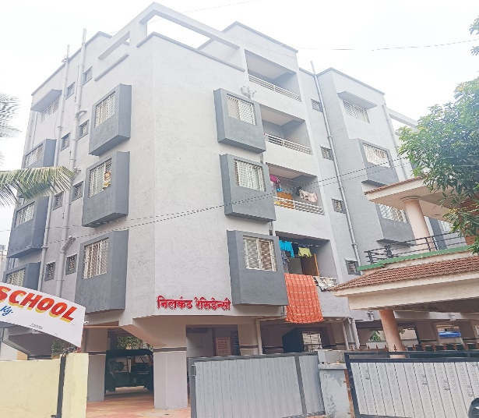

**Details of the property under consideration:**

Name of Owner:**Shri.Rahul Pratap Mahale**

Residential Flat No.10,Fourth Floor "**Nilkanth Residency** ",Survey No.320/3/1,

Plot No.8, Near Strawberry English Medium School, Murlidhar Vyas Colony, Pathardi Phata

Village- Pathardi,Taluka & District - Nashik, PIN Code - 422 010, State - Maharashtra, Country - India

# **Longitude Latitude: 19°57'04.2"N 73°45'52.4"E**

**Valuation Done for:**

**Bank of India**

**Indira Nagar Branch**

Bungalow No 23, Shree Samartha Kripa, Gurukrinear Rathachakara Chowk,

Indira Nagar, Nashik-422 009, State - Maharashtra,Country - India

Vastu/Mumbai/01/2020/16759/32210

20/06-210-NIA

Date:31 .07.2023

# **VALUATION OPINION REPORT**

This is to certify that the property bearing Residential Flat No.10, Fourth Floor "**Nilkanth Residency** ",Survey No.320/3/1, Plot No.8, Near Strawberry English Medium School, Murlidhar Vyas Colony, Pathardi Phata, Village- Pathardi,Taluka & District - Nashik, PIN Code - 422 010, State - Maharashtra, Country - India. belongs to **Shri.Rahul Pratap Mahale.**

|  |  |  |
| --- | --- | --- |
| Boundaries of the property. | | |
| North | : | Row House | |
| South | : | Building and Road | |
| East | : | Building | |
| West | : | Bungalow | |
|  |  |  | |

Considering various parameters recorded, existing economic scenario, and the information that is available with reference to the development of neighborhood and method selected for valuation, we are of the opinion that, the property premises can be assessed and valued for this particular purpose at **` 18,17,600.00 (Rupees Eighteen Lakh Seventeen Thousand Six Hundred Only)**

The valuation of the property is based on the documents produced by the concern. Legal aspects have not been taken into considerations while preparing this valuation report.

Hence certified

## Sharadkumar B. Chalikwar

Govt. Reg. Valuer

Chartered Engineer (India)

Reg. No. (N) CCIT/1-14/52/2008-09

Encl: Valuation report.

|  |  |  |  |
| --- | --- | --- | --- |
|  |  |  |  |

|  |  |  |  |  |  |  |  |  |  |  |  |  |  |  |  |  |  |  |  |  |  |  |  |  |  |  |  |  |  |  |  |  |  |  |  |  |  |  |  |  |  |  |  |  |  |  |  |  |  |  |  |  |  |  |  |  |  |  |  |  |  |  |  |  |  |  |  |  |  |  |  |  |  |  |  |  |  |  |  |  |  |  |  |  |  |  |  |  |  |  |  |  |  |  |  |  |  |  |  |  |  |  |  |  |  |  |  |  |  |  |  |  |  |  |  |  |  |  |  |  |  |  |  |  |  |  |  |  |  |  |  |  |  |  |  |  |  |  |  |  |  |  |  |  |  |  |  |  |  |  |  |  |  |  |  |  |  |  |  |  |  |  |  |  |  |  |  |  |  |  |  |  |  |  |  |  |  |  |  |  |  |  |  |  |  |  |  |  |  |  |  |  |  |  |  |  |  |  |  |  |  |  |  |  |  |  |  |  |  |  |  |  |  |  |  |  |  |  |  |  |  |  |  |  |  |  |  |  |  |  |  |  |  |  |  |  |  |  |  |  |  |  |  |  |  |  |  |  |  |  |  |  |  |  |  |  |  |  |  |  |  |  |  |  |  |  |  |  |  |  |  |  |  |  |  |  |  |  |  |  |  |  |  |  |  |  |  |  |  |  |  |  |  |  |  |  |  |  |  |  |  |  |  |  |  |  |  |  |  |  |  |  |  |  |  |  |  |  |  |  |  |  |  |  |  |  |  |  |  |  |  |  |  |  |  |  |  |  |  |  |  |  |  |  |  |  |  |  |  |  |  |  |  |  |  |  |  |  |  |  |  |  |  |  |  |  |  |  |  |  |  |  |  |  |  |  |  |  |  |  |  |  |  |  |  |  |  |  |  |  |  |  |  |  |  |  |  |  |  |  |  |  |  |  |  |  |  |  |  |  |  |  |  |  |  |  |  |  |  |  |  |  |  |  |  |  |  |  |  |  |  |  |  |  |  |  |  |  |  |  |  |  |  |  |  |  |  |  |  |  |  |  |  |  |  |  |  |  |  |  |  |  |  |  |  |  |  |  |  |  |  |  |  |  |  |  |  |  |  |  |  |  |  |  |  |  |  |  |  |  |  |  |  |  |  |  |  |  |  |  |  |  |  |  |  |  |  |  |  |  |  |  |  |  |  |  |  |  |  |  |  |  |  |  |  |  |  |  |  |  |  |  |  |  |  |  |  |  |  |  |  |  |  |  |  |  |  |  |  |  |  |  |  |  |  |  |  |  |  |  |  |  |  |  |  |  |  |  |  |  |  |  |  |  |  |  |  |  |  |  |  |  |  |  |  |  |  |  |  |  |  |  |  |  |  |  |  |  |  |  |  |  |  |  |  |  |  |  |  |  |  |  |  |  |  |  |  |  |  |  |  |  |  |  |  |  |  |  |  |  |  |  |  |  |  |  |  |  |  |  |  |  |  |  |  |  |  |  |  |  |  |  |  |  |  |  |  |  |  |  |  |  |  |  |  |  |  |  |  |  |  |  |  |  |  |  |  |  |  |  |  |  |  |  |  |  |  |  |  |  |  |  |  |  |  |  |  |  |  |  |  |  |  |  |  |  |  |  |  |  |  |  |  |  |  |  |  |  |  |  |  |  |  |  |  |  |  |  |  |  |  |  |  |  |  |  |  |  |  |  |  |  |  |  |  |  |  |  |  |  |  |  |  |  |  |  |  |  |  |  |  |  |  |  |  |  |  |  |  |  |  |  |  |  |  |  |  |  |  |  |  |  |  |  |  |  |  |  |  |  |  |  |  |  |  |  |  |  |  |  |  |  |  |  |  |  |  |  |  |  |  |  |  |  |  |  |
| --- | --- | --- | --- | --- | --- | --- | --- | --- | --- | --- | --- | --- | --- | --- | --- | --- | --- | --- | --- | --- | --- | --- | --- | --- | --- | --- | --- | --- | --- | --- | --- | --- | --- | --- | --- | --- | --- | --- | --- | --- | --- | --- | --- | --- | --- | --- | --- | --- | --- | --- | --- | --- | --- | --- | --- | --- | --- | --- | --- | --- | --- | --- | --- | --- | --- | --- | --- | --- | --- | --- | --- | --- | --- | --- | --- | --- | --- | --- | --- | --- | --- | --- | --- | --- | --- | --- | --- | --- | --- | --- | --- | --- | --- | --- | --- | --- | --- | --- | --- | --- | --- | --- | --- | --- | --- | --- | --- | --- | --- | --- | --- | --- | --- | --- | --- | --- | --- | --- | --- | --- | --- | --- | --- | --- | --- | --- | --- | --- | --- | --- | --- | --- | --- | --- | --- | --- | --- | --- | --- | --- | --- | --- | --- | --- | --- | --- | --- | --- | --- | --- | --- | --- | --- | --- | --- | --- | --- | --- | --- | --- | --- | --- | --- | --- | --- | --- | --- | --- | --- | --- | --- | --- | --- | --- | --- | --- | --- | --- | --- | --- | --- | --- | --- | --- | --- | --- | --- | --- | --- | --- | --- | --- | --- | --- | --- | --- | --- | --- | --- | --- | --- | --- | --- | --- | --- | --- | --- | --- | --- | --- | --- | --- | --- | --- | --- | --- | --- | --- | --- | --- | --- | --- | --- | --- | --- | --- | --- | --- | --- | --- | --- | --- | --- | --- | --- | --- | --- | --- | --- | --- | --- | --- | --- | --- | --- | --- | --- | --- | --- | --- | --- | --- | --- | --- | --- | --- | --- | --- | --- | --- | --- | --- | --- | --- | --- | --- | --- | --- | --- | --- | --- | --- | --- | --- | --- | --- | --- | --- | --- | --- | --- | --- | --- | --- | --- | --- | --- | --- | --- | --- | --- | --- | --- | --- | --- | --- | --- | --- | --- | --- | --- | --- | --- | --- | --- | --- | --- | --- | --- | --- | --- | --- | --- | --- | --- | --- | --- | --- | --- | --- | --- | --- | --- | --- | --- | --- | --- | --- | --- | --- | --- | --- | --- | --- | --- | --- | --- | --- | --- | --- | --- | --- | --- | --- | --- | --- | --- | --- | --- | --- | --- | --- | --- | --- | --- | --- | --- | --- | --- | --- | --- | --- | --- | --- | --- | --- | --- | --- | --- | --- | --- | --- | --- | --- | --- | --- | --- | --- | --- | --- | --- | --- | --- | --- | --- | --- | --- | --- | --- | --- | --- | --- | --- | --- | --- | --- | --- | --- | --- | --- | --- | --- | --- | --- | --- | --- | --- | --- | --- | --- | --- | --- | --- | --- | --- | --- | --- | --- | --- | --- | --- | --- | --- | --- | --- | --- | --- | --- | --- | --- | --- | --- | --- | --- | --- | --- | --- | --- | --- | --- | --- | --- | --- | --- | --- | --- | --- | --- | --- | --- | --- | --- | --- | --- | --- | --- | --- | --- | --- | --- | --- | --- | --- | --- | --- | --- | --- | --- | --- | --- | --- | --- | --- | --- | --- | --- | --- | --- | --- | --- | --- | --- | --- | --- | --- | --- | --- | --- | --- | --- | --- | --- | --- | --- | --- | --- | --- | --- | --- | --- | --- | --- | --- | --- | --- | --- | --- | --- | --- | --- | --- | --- | --- | --- | --- | --- | --- | --- | --- | --- | --- | --- | --- | --- | --- | --- | --- | --- | --- | --- | --- | --- | --- | --- | --- | --- | --- | --- | --- | --- | --- | --- | --- | --- | --- | --- | --- | --- | --- | --- | --- | --- | --- | --- | --- | --- | --- | --- | --- | --- | --- | --- | --- | --- | --- | --- | --- | --- | --- | --- | --- | --- | --- | --- | --- | --- | --- | --- | --- | --- | --- | --- | --- | --- | --- | --- | --- | --- | --- | --- | --- | --- | --- | --- | --- | --- | --- | --- | --- | --- | --- | --- | --- | --- | --- | --- | --- | --- | --- | --- | --- | --- | --- | --- | --- | --- | --- | --- | --- | --- | --- | --- | --- | --- | --- | --- | --- | --- | --- | --- | --- | --- | --- | --- | --- | --- | --- | --- | --- | --- | --- | --- | --- | --- | --- | --- | --- | --- | --- | --- | --- | --- | --- | --- | --- | --- | --- | --- | --- | --- | --- | --- | --- | --- | --- | --- | --- | --- | --- | --- | --- | --- | --- | --- | --- | --- | --- | --- | --- | --- | --- | --- | --- | --- | --- | --- | --- | --- | --- | --- | --- | --- | --- | --- | --- | --- | --- | --- | --- | --- | --- | --- | --- | --- | --- | --- | --- | --- | --- | --- | --- | --- | --- | --- | --- | --- | --- | --- | --- | --- | --- | --- | --- | --- | --- | --- | --- | --- | --- | --- | --- | --- | --- | --- | --- | --- | --- | --- | --- | --- | --- | --- | --- | --- | --- | --- | --- | --- | --- | --- | --- | --- | --- | --- | --- | --- | --- | --- | --- | --- | --- | --- | --- | --- | --- | --- | --- | --- | --- | --- | --- | --- | --- | --- | --- | --- | --- | --- | --- | --- | --- | --- | --- | --- | --- | --- | --- | --- | --- | --- | --- | --- | --- | --- | --- | --- | --- | --- | --- | --- | --- | --- | --- | --- | --- | --- | --- | --- | --- | --- | --- | --- | --- | --- | --- | --- |
| **Vastukala Consultants (I) Pvt. Ltd.**  B1-001, U/B Floor, **Boomerang**, Chandivali Farm Road, Powai, Andheri (East), Mumbai – 400 072  To,  **The Branch Manager,**  **Bank of India**  **Indira Nagar Branch**  Bungalow No 23, Shree Samartha Kripa, Gurukrinear  Rathachakara Chowk, Indira Nagar, Nashik-422 009,  State - Maharashtra,Country - India  **VALUATION REPORT (IN RESPECT OF FLAT)**   |  |  |  |  |  |  |  |  | | --- | --- | --- | --- | --- | --- | --- | --- | | I | **General** | | | | | | | | 1. | Purpose for which the valuation is made | | | : | To assess fair market value of the property for Housing Loan Purpose. | | | | 2. | a) | | Date of inspection | : | 10.07.2023 | | | |  | b) | | Date on which the valuation is  Made |  | 31.07.2023 | | | |  | List of documents produced for perusal | | | : | 1. Copy of Deed of Apartment Vide No.5090/2023 Dated.04.05.2023 2. Copy of Approved Building Plan Accompaining Commencement Certificate No. CD / 149 dated 26.03.2021 issued by Executive Engineer Town Planning Nashik Municipal Corporation, Nashik. 3. Copy of Full Occupancy Certificate Building Proposal Number -123875 Dated.21.09.2022 issued by Nashik Municipal Corporation, Nashik. | | | | 4. | Name of the owner(s) and his / their address (es) with Phone no. (details of share of each owner in case of joint ownership) | | | : | **Shri.Rahul Pratap Mahale**  **Address** - Residential Flat No.10, Fourth Floor "**Nilkanth Residency** ",Survey No.320/3/1, Plot No.8, Near Strawberry English Medium School, Murlidhar Vyas Colony, Pathardi Phata, Village- Pathardi,Taluka & District - Nashik, PIN Code - 422 010, State - Maharashtra, Country - India  **Contact Person :**  Mr.Vijaybhai Meshiya (Mob No. +91 8983504211)  Sole Ownership | | | | 5. | Brief description of the property (Including Leasehold / freehold etc.) | | | : | The property is a residential flat located on 4th Floor. As per Approved Plan The composition of flat No.10 is Living, Kitchen , WC, Bath, Passage + Balcony.  **( i.e.1RK)** but as per Site Inspection is flat is Converted in to Living, Kitchen , WC, Bath, Passage + Balcony+ Open Terrace **( i.e.1RK+ Open Terrace)**  The property is at 10.7 Mtr. distances from nearest railway station Nashik.  **Landmark:** Near Strawberry English Medium School | | | | 6. | Location of property | | | : |  | | | |  | a) | Plot No. / Survey No. | | : | Survey No.320/3/1, Plot No.8 | | | |  | b) | Door No. | | : | Residential Flat No.10 | | | |  | c) | T.S. No. / Village | | : | Village- Pathardi | | | |  | d) | Ward / Taluka | | : | Taluka – Nashik | | | |  | e) | Mandal / District | | : | District - Nashik | | | |  | f) | Date of issue and validity of layout of approved map / plan | | : | Copy of Approved Building Plan Accompaining Commencement Certificate No. CD / 149 dated 26.03.2021 issued by Executive Engineer Town Planning Nashik Municipal Corporation, Nashik | | | |  | g) | Approved map / plan issuing authority | |  | Nashik Municipal Corporation, Nashik | | | |  | h) | Whether genuineness or authenticity of approved map/ plan is verified | | : | Yes | | | |  | i) | Any other comments by our empanelled valuers on authentic of approved plan | | : | Yes- As per Approved Plan The composition of flat No.10 is Living, Kitchen , WC, Bath, Passage + Balcony.  **( i.e.1RK)** but as per Site Inspection is flat is Converted in to Living, Kitchen , WC, Bath, Passage + Balcony+ Open Terrace **( i.e.1RK+ Open Terrace)** | | | | 7. | Postal address of the property | | | : | Residential Flat No.10, Fourth Floor "**Nilkanth Residency** ",Survey No.320/3/1, Plot No.8, Near Strawberry English Medium School, Murlidhar Vyas Colony, Pathardi Phata, Village- Pathardi,Taluka & District - Nashik, PIN Code - 422 010, State - Maharashtra, Country - India | | | | 8. | City / Town | | | : | Nashik | | | |  | Residential area | | | : | Yes | | | |  | Commercial area | | | : | No | | | |  | Industrial area | | | : | No | | | | 9. | Classification of the area | | | : |  | | | |  | i) High / Middle / Poor | | | : | Middle Class | | | |  | ii) Urban / Semi Urban / Rural | | | : | Urban | | | | 10. | Coming under Corporation limit / Village Panchayat / Municipality | | | : | Village- Nashik  Nashik Municipal Corporation, Nashik | | | | 11. | Whether covered under any State / Central Govt. enactments (e.g., Urban Land Ceiling Act) or notified under agency area/ scheduled area / cantonment area | | | : | No | | | | 12. | Boundaries of the property ( Building ) | | |  | As per Site | | As per Deed | |  | North | | | : | Row House | | Adj.Survey No.320/3/1 Part | |  | South | | | : | Building and Road | Plot No.9 and Colony Road | | |  | East | | | : | Building | Plot No.15 | | |  | West | | | : | Bungalow | Plot No.7 | | | 13 | Boundaries of the property ( Flat No.10 ) | | |  |  |  | | |  |  | | |  | As per Site | As per Deed | | |  | North | | | : | Staircase and Terrace | Staircase and Terrace | | |  | South | | | : | Marginal Space | Marginal Space | | |  | East | | | : | Marginal Space | Marginal Space | | |  | West | | | : | Flat No.11 and Staircase | Flat No.11 and Staircase | | |  |  | | |  |  |  | | | 14. | Extent of the site | | | : | Carpet Area in Sq. Ft. = 265.00  Balcony Area in Sq.Ft =24  Open Terrace Area in Sq.Ft =118.00  (Area as per actual site measurement)  **Carpet Area in Sq. Ft. = 284.00**  **(Area as per Deed of Apartment)**  Built Up Area in Sq. Ft. = 341.00  (As per as per Deed of Apartment + 20%) | | | | 14.1 | Latitude, Longitude & Co-ordinates of flat | | | : | 19°57'04.2"N 73°45'52.4"E | | | | 15. | Extent of the site considered for Valuation (least of 13A& 13B) | | | : | **Carpet Area in Sq. Ft. = 284.00**  **(Area as per Deed of Apartment)** | | | | 16 | Whether occupied by the owner / tenant? If occupied by tenant since how long? Rent received per month. | | | : | Vacant | | | | **II** | **APARTMENT BUILDING** | | |  |  | | | |  | Nature of the Apartment | | | : | Residential | | | |  | Location | | | : |  | | | |  | S. No. / Plot No | | | : | Survey No.320/3/1, Plot No.8 | | | |  | Block No. | | | : | - | | | |  | Ward No. | | | : | - | | | |  | Village / Municipality / Corporation | | | : | Village- Nashik  Nashik Municipal Corporation, Nashik | | | |  | Door No., Street or Road (Pin Code) | | | : | Residential Flat No.10 Fourth Floor "**Nilkanth Residency** ",Survey No.320/3/1, Plot No.8, Near Strawberry English Medium School, Murlidhar Vyas Colony, Pathardi Phata, Village- Pathardi,Taluka & District - Nashik, PIN Code - 422 010, State - Maharashtra, Country - India | | | |  | Description of the locality Residential / Commercial / Mixed | | | : | Residential | | | |  | Year of Construction | | | : | 2022 (As per Full Occupancy Certificate) | | | |  | Number of Floors | | | : | Ground ( Parking) + 4 Upper Floors | | | |  | Type of Structure | | | : | R.C.C. Framed Structure | | | |  | Number of Dwelling units in the building | | | : | 2 Flats on 4th Floor | | | |  | Quality of Construction | | | : | Good | | | |  | Appearance of the Building | | | : | Good | | | |  | Maintenance of the Building | | | : | Good | | | |  | Facilities Available | | | : |  | | | |  | Lift | | | : | No Lift | | | |  | Protected Water Supply | | | : | Municipal Water supply | | | |  | Underground Sewerage | | | : | Connected to Municipal sewer | | | |  | Car parking - Open / Covered | | | : | Covered Parking | | | |  | Is Compound wall existing? | | | : | Yes | | | |  | Is pavement laid around the Building | | | : | Yes | | |  |  |  |  |  | | --- | --- | --- | --- | | **III** | **FLAT** |  |  | | 1 | The floor in which the flat is situated | : | 4th Floor | | 2 | Door No. of the flat | : | Residential Flat No.10 | | 3 | Specifications of the flat | : |  | |  | Roof | : | R.C.C. Slab | |  | Flooring | : | Vitrified tiles flooring | |  | Doors | : | Teak Wood door frame, Flush doors, Rolling Shutter | |  | Windows | : | Powder coated Aluminum sliding windows with M. S. Grills | |  | Fittings | : | Concealed plumbing with C.P. fittings. Electrical wiring with Concealed. | |  | Finishing | : | Good | | 4 | House Tax | : |  | |  | Assessment No. | : | Details Not Available | |  | Tax paid in the name of : | : | Details Not Available | |  | Tax amount : | : | Details Not Available | | 5 | Electricity Service connection No. : | : | Details Not Available | |  | Meter Card is in the name of : | : | Details Not Available | | 6 | How is the maintenance of the flat? | : | Good | | 7 | Sale Deed executed in the name of | : | Shri.Rahul Pratap Mahale | | 8 | What is the undivided area of land as per Sale Deed? | : | Details not available | | 9 | What is the plinth area of the flat? | : | Built Up Area in Sq. Ft. = 341.00  (As per as per Deed of Apartment + 20%) | | 10 | What is the floor space index (app.) | : | As per NMC norms | | 11 | What is the Carpet Area of the flat? | : | Carpet Area in Sq. Ft. = 265.00  Balcony Area in Sq.Ft =24  Open Terrace Area in Sq.Ft =118.00  (Area as per actual site measurement)  **Carpet Area in Sq. Ft. = 284.00**  **(Area as per Deed of Apartment)** | | 12 | Is it Posh / I Class / Medium / Ordinary? | : | Medium Class | | 13 | Is it being used for Residential or Commercial purpose? | : | Residential purpose | | 14 | Is it Owner-occupied or let out? | : | Vacant | | 15 | If rented, what is the monthly rent? | : | ` 3,500.00 expected rent per month | | **IV** | **MARKETABILITY** | : |  | | 1 | How is the marketability? | : | Good | | 2 | What are the factors favoring for an extra Potential Value? | : | Located in developed area | | 3 | Any negative factors are observed which affect the market value in general? | : | No | | **V** | **Rate** | : |  | | 1 | After analyzing the comparable sale instances, what is the composite rate for a similar flat with same specifications in the adjoining locality? - (Along with details / reference of at - least two latest deals / transactions with respect to adjacent properties in the areas) | : | ` 6,000.00 to ` 7,000.00 per Sq. Ft. on Carpet area | | 2 | Assuming it is a new construction, what is the adopted basic composite rate of the flat under valuation after comparing with the specifications and other factors with the flat under comparison (give details). | : | ` 6,400.00 per Sq. Ft. on Carpet area | | 3 | Break – up for the rate | : |  | |  | I. Building + Services | : | ` 2,000.00 per Sq. Ft. | |  | II. Land + others | : | ` 4,400.00 per Sq. Ft. | | 4 | Guideline rate obtained from the Registrar's office(an evidence thereof to be enclosed) | : | ` 36,000.00 per Sq. M. i.e.  ` 3,344.00 per Sq. Ft. | |  | Guideline rate obtained from the Registrar’s  office (After Depreciation) |  | N.A. as the age of the property is below 5 years | | **VI** | **COMPOSITE RATE ADOPTED AFTER DEPRECIATION** |  |  | | **a** | Depreciated building rate | : | ` 2,000.00 per Sq. Ft. | |  | Replacement cost of flat with Services (v(3)i) | : | ` 2,000.00 per Sq. Ft. | |  | Age of the building | : | 01 Year | |  | Life of the building estimated | : | 59 years Subject to proper, preventive periodic maintenance & structural repairs. | |  | Depreciation percentage assuming the salvage value as 10% | : | N.A. as the age of the property is below 5 years | |  | Depreciated Ratio of the building | : | N.A. as the age of the property is below 5 years | | **b** | Total composite rate arrived for Valuation | : |  | |  | Depreciated building rate VI (a) | : | ` 2,000.00 per Sq. Ft. | |  | Rate for Land & other V (3) ii | : | ` 4,400.00 per Sq. Ft. | |  | **Total Composite Rate** | : | **` 6,400.00 per Sq. Ft.** | |  | **Remarks:**1) *As per Approved Plan The composition of flat No.10 is Living, Kitchen , WC, Bath, Passage + Balcony****.( i.e.1RK)*** *but as per Site Inspection is flat is Converted in to Living, Kitchen , WC, Bath, Passage + Balcony+ Open Terrace* ***( i.e.1RK+ Open Terrace)*** | | |   **Details of Valuation:**   |  |  |  |  |  | | --- | --- | --- | --- | --- | | **Sr. No.** | **Description** | **Qty.** | **Rate per  unit (`)** | **Estimated**  **Value (`)** | | 1 | Present value of the flat | 284.00  Sq. Ft. | 6,400.00 | **18,17,600.00** | | 2 | Wardrobes |  |  |  | | 3 | Showcases / |  |  |  | | 4 | Kitchen arrangements |  |  |  | | 5 | Superfine finish |  |  |  | | 6 | Interior Decorations |  |  |  | | 7 | Electricity deposits / electrical fittings, etc. |  |  |  | | 8 | Extra collapsible gates / grill works etc. |  |  |  | | 9 | Potential value, if any |  |  |  | | 10 | Others |  |  |  | |  | **Present Market value of the property** | | | **18,17,600.00** | |  | **The realizable value of the property** | | | **17,26,720.00** | |  | **The distress value of the property** | | | **14,54,080.00** | |  | **Insurable value of the property (341.00 Sq. Ft. X** ` **2,000.00)** | | | **6,82,000.00** | |  | **Guideline value of the property(341.00 Sq. Ft. X** ` **3,344.00)** | | | **11,40,304.00** |   The sales comparison approach uses the market data of sale prices to estimate the value of a real estate property. Property valuation in this method is done by comparing a property to other similar properties that have been recently sold. Comparable properties, also known as comparables, or comps, must share certain features with the property in question. Some of these include physical features such as square footage, number of rooms, condition, and age of the building; however, the most important factor is no doubt the location of the property. Adjustments are usually needed to account for differences as no two properties are exactly the same. To make proper adjustments when comparing properties, real estate appraisers must know the differences between the comparable properties and how to value these differences. The sales comparison approach is commonly used for Residential Flat, where there are typically many comparables available to analyze. As the property is a residential flat, we have adopted Sale Comparison Approach Method for the purpose of valuation .The Price for similar type of property in the nearby vicinity is in the range of ` 6,000.00 to ` 7,000.00 per Sq. Ft. Considering the rate with attached report , current market conditions , demand and supply position, Flat size, location, upswing in real estate prices , sustained demand for Residential Flat , all round development of commercial and residential application in the locality etc. We estimate ` 6,400.00 per Sq. Ft. for valuation.   |  |  | | --- | --- | | Impending threat of acquisition by government for road widening / publics service purposes, sub merging & applicability of CRZ provisions (Distance from sea-cost / tidal level must be incorporated) and their effect on |  | | 1. Saleability | Good | | 1. Likely rental values in future in | ` 3,500.00 expected rent per month | | 1. Any likely income it may generate | Rental Income |   **Sharadkumar B. Chalikwar**  Govt. Reg. Valuer  Chartered Engineer (India)  Reg. No. (N) CCIT/1-14/52/2008-09  Place : Nashik  Date : 31.07.2023 |

**Actual Site Photographs**

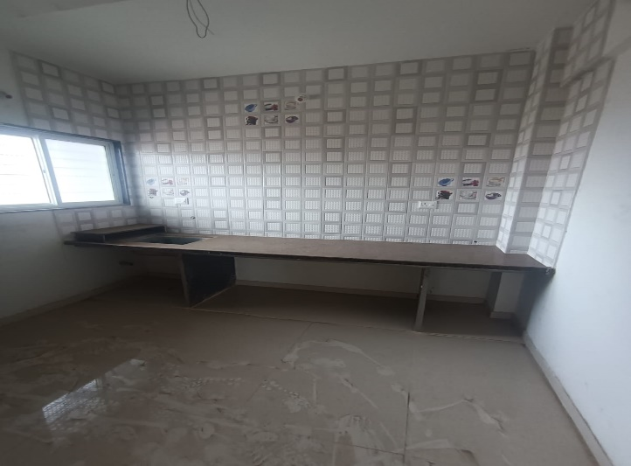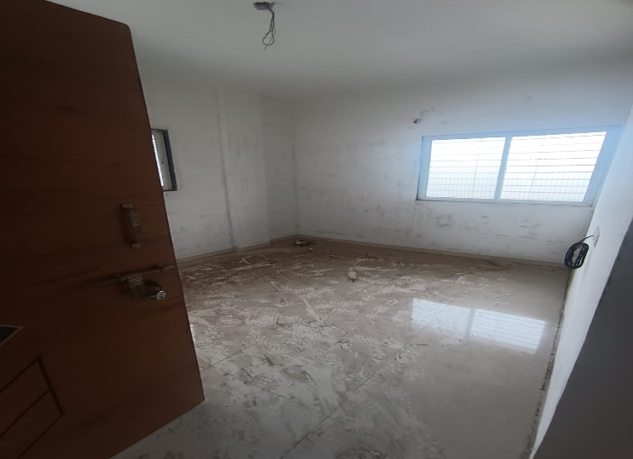

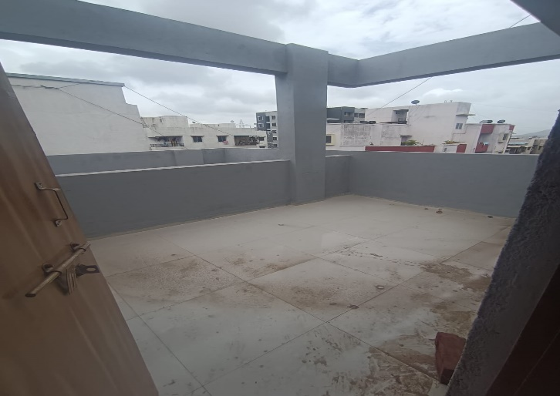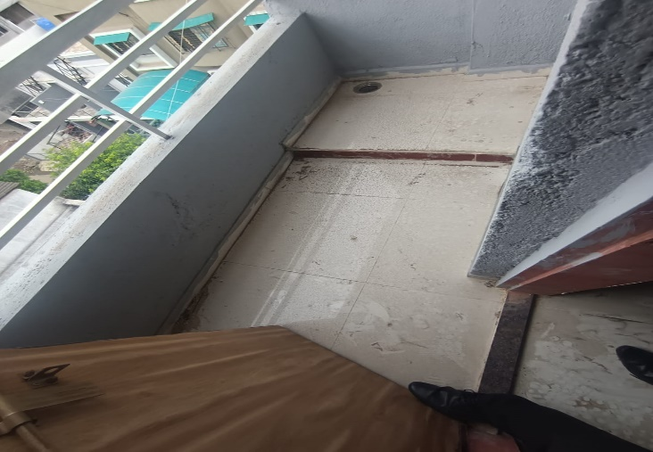

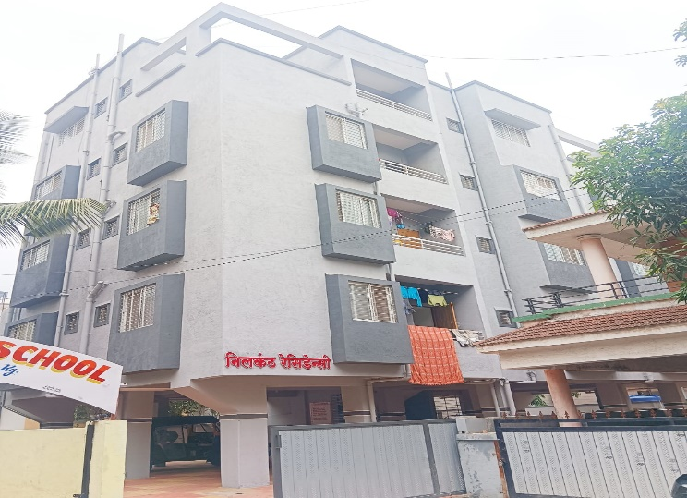

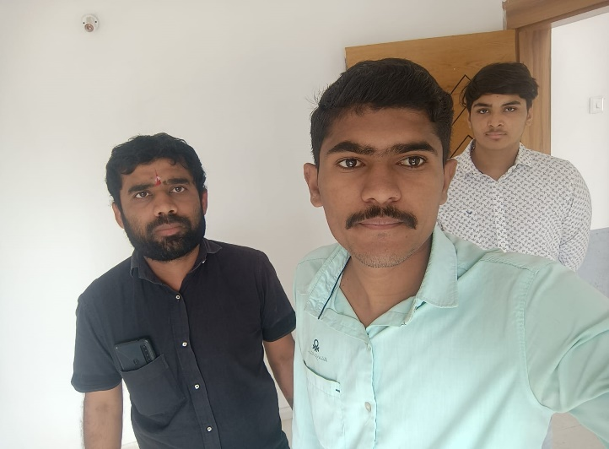

Route Map of the property

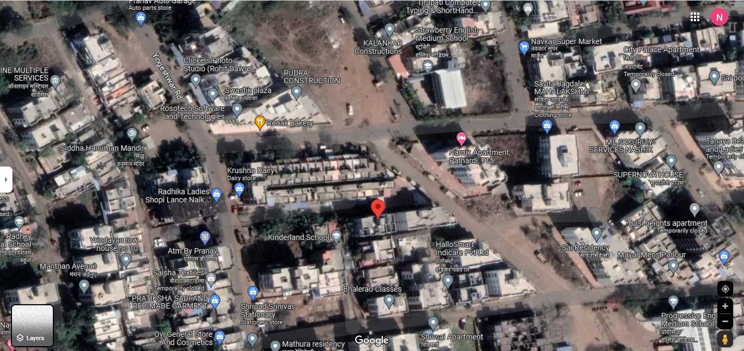

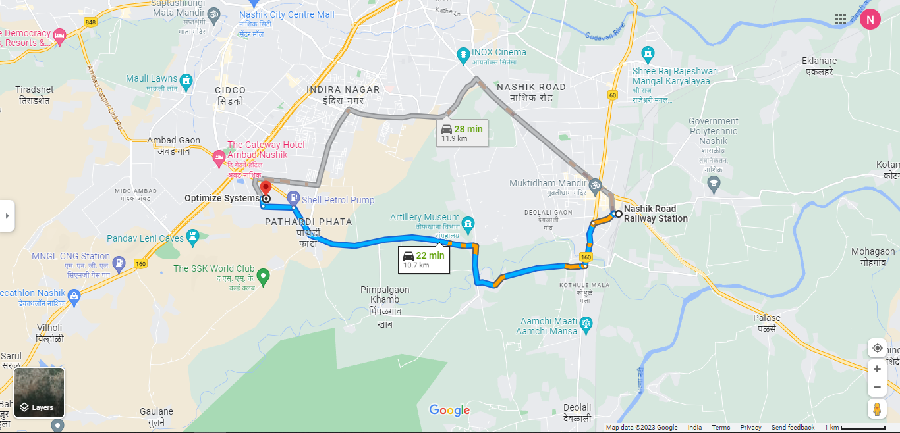

# **Longitude Latitude: 19°57'04.2"N 73°45'52.4"E**

**Note:** The Blue line shows the route to site from nearest railway station (Nashik –10.7 Km.)

**Ready Reckoner Rate**

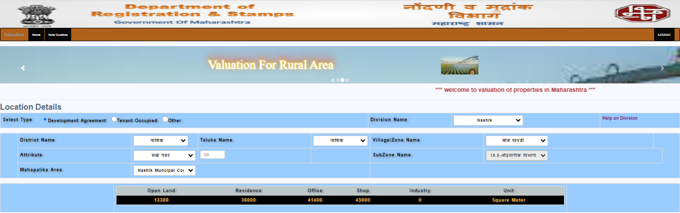

**Price Indicators**

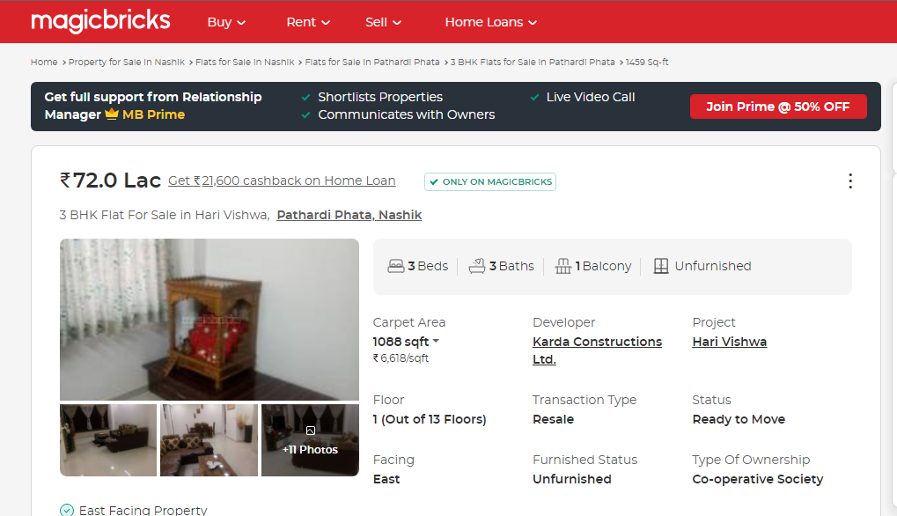

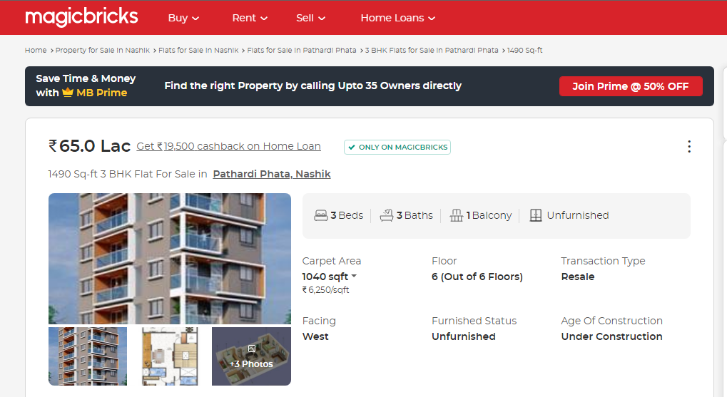

**Price Indicators**

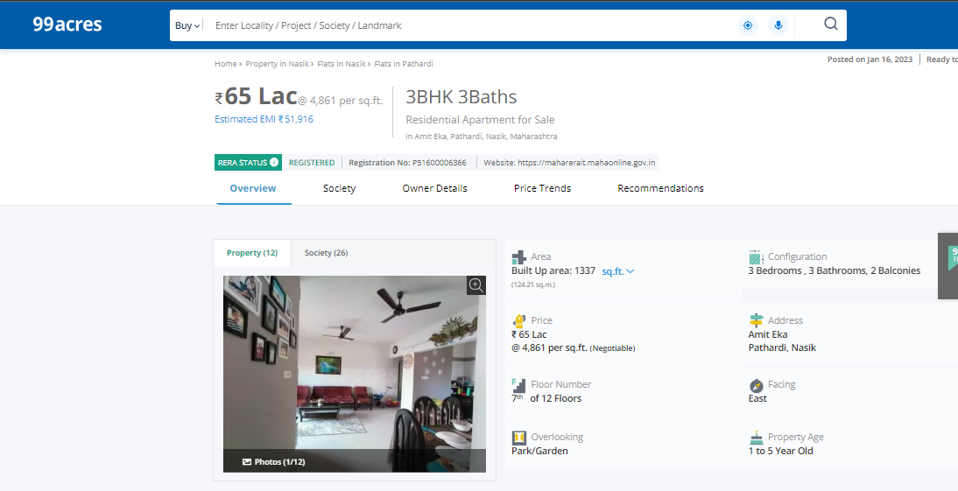 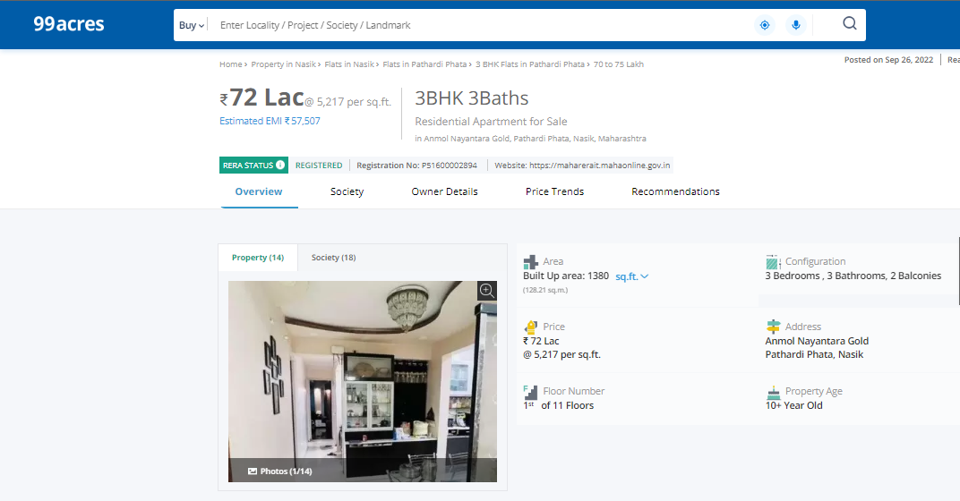

As a result of my appraisal and analysis, it is my considered opinion that the present fair market value of the above property in the prevailing condition with aforesaid specifications is **` 18,17,600.00 (Rupees Eighteen Lakh Seventeen Thousand Six Hundred Only).** The Realizable Value of the above property is **` 17,26,720.00 (Rupees Seventeen Lakh Twenty Six Thousand Seven Hundred Twenty Only).** And the distress value **` 14,54,080.00 (Rupees Fourteen Lakh Fifty Four Thousand Eighty Only).**

Place :Nashik

Date :31.07.2023

**Sharadkumar B. Chalikwar**

Govt. Reg. Valuer

Chartered Engineer (India)

Reg. No. (N) CCIT/1-14/52/2008-09

The undersigned has inspected the property detailed in the Valuation Report dated _______________________

on ____________________. We are satisfied that the fair and reasonable market value of the property is `_________________________ (Rupees ________________________________________________________

________________________________________only).

Date

Signature

(Name & Designation of the Inspecting Official/s)

Countersigned

(BRANCH MANAGER)

**Assumptions, Disclaimers, Limitations & Qualifications**

**Value Subject to Change**

The subject appraisal exercise is based on prevailing market dynamics as on **31st July 2023** and does not take into account any unforeseeable developments which could impact the same in the future.

**Our Investigations**

We are not engaged to carry out all possible investigations in relation to the subject property. Where in our report we identify certain limitations to our investigations, this is to enable the reliant party to instruct further investigations where considered appropriate or where we recommend as necessary prior to reliance. Vastukala Consultants India Pvt. Ltd. (VCIPL) is not liable for any loss occasioned by a decision not to conduct further investigations

**Assumptions**

Assumptions are a necessary part of undertaking valuations. VCIPL adopts assumptions for the purpose of providing valuation advise because some matters are not capable of accurate calculations or fall outside the scope of our expertise, or out instructions. The reliant party accepts that the valuation contains certain specific assumptions and acknowledge and accept the risk of that if any of the assumptions adopted in the valuation are incorrect, then this may have an effect on the valuation.

**Information Supplied by Others**

The appraisal is based on the information provided by the client. The same has been assumed to be correct and has been used for appraisal exercise. Where it is stated in the report that another party has supplied information to VCIPL, this information is believed to be reliable but VCIPL can accept no responsibility if this should prove not to be so.

**Future Matters**

To the extent that the valuation includes any statement as to a future matter, that statement is provided as an estimate and/or opinion based on the information known to VCIPL at the date of this document. VCIPL does not warrant that such statements are accurate or correct.

**Map and Plans**

Any sketch, plan or map in this report is included to assist the reader while visualising the property and assume no responsibility in connection with such matters.

**Site Details**

Based on inputs received from Client's representative and site visit conducted, we understand that the subject property is currently Vacant admeasuring **284.00 Sq. ft. Carpet Area** in the name of **Shri.Rahul Pratap Mahale.** Further, VCIPL has assumed that the subject property is free from any encroachment and is available as on the date of the appraisal.

**Property Title**

Based on our discussion with the Client, we understand that the subject property is owned by **Shri.Rahul Pratap Mahale.** For the purpose of this appraisal exercise, we have assumed that the subject property has a clear title and is free from any encumbrances, disputes and claims. VCIPL has made no further enquiries with the relevant local authorities in this regard and does not certify the property as having a clear and marketable title. Further, no legal advice regarding the title and ownership of the subject property has been obtained for the purpose of this appraisal exercise. It has been assumed that the title deeds are clear and marketable.

**Environmental Conditions**

We have assumed that the subject property is not contaminated and is not adversely affected by any existing or proposed environmental law and any processes which are carried out on the property are regulated by environmental legislation and are properly licensed by the appropriate authorities.

**Town Planning**

The permissible land use, zoning, achievable FSI, area statement adopted for purpose of this valuation is based on the information provided by the Client's representative and the same has been adopted for this valuation purpose. VCIPL has assumed the same to be correct and permissible. VCIPL has not validated the same from any authority.

**Area**

Based on the information provided by the Client's representative, we understand that the subject property is Vacant and Super Built up area is **284.00 Sq. ft. Carpet Area**.

**Condition & Repair**

In the absence of any information to the contrary, we have assumed that there are no abnormal ground conditions, nor archaeological remains present which might adversely affect the current or future occupation, development or value of the property. The property is free from rat, infestation, structural or latent defect. No currently known deleterious or hazardous materials or suspect techniques will be used in the construction of or subsequent alteration or additions to the property and comments made in the property details do not purport to express an opinion about, or advise upon, the condition of uninspected parts and should not be taken as making an implied representation or statement about such parts

**Valuation Methodology**

For the purpose of this valuation exercise, the valuation methodology used is Direct Comparison Approach Method and proposed Highest and Best Use model is used for analysing development potential.

The Direct Comparison Approach involves a comparison of the property being valued to similar properties that have actually been sold in arms - length transactions or are offered for sale. This approach demonstrates what buyers have historically been willing to pay (and sellers willing to accept) for similar properties in an open and competitive market and is particularly useful in estimating the value of the land and properties that are typically traded on a unit basis.

In case of inadequate recent transaction activity in the subject micro-market, the appraiser would collate details of older transactions. Subsequently, the appraiser would analysed rental / capital value trends in the subject micro-market in order to calculate the percentage increase / decrease in values since the date of the identified transactions. This percentage would then be adopted to project the current value of the same.

Where reliance has been placed upon external sources of information in applying the valuation methodologies, unless otherwise specifically instructed by Client and/or stated in the valuation, VCIPL has not independently verified that information and VCIPL does not advise nor accept it as reliable. The person or entity to whom the report is addressed acknowledges and accepts the risk that if any of the unverified information in the valuation is incorrect, then this may have an effect on the valuation.

**Not a Structural Survey**

We state that this is a valuation report and not a structural survey

**Other**

All measurements, areas and ages quoted in our report are approximate

**Legal**

We have not made any allowances with respect to any existing or proposed local legislation relating to taxation on realization of the sale value of the subject property. VCIPL is not required to give testimony or to appear in court by reason of this appraisal report, with reference to the property in question, unless arrangement has been made thereof. Further, no legal advice on any aspects has been obtained for the purpose of this appraisal exercise

Property specific assumptions

Based on inputs received from the client and site visit conducted, we understand that the subject property is currently Vacant and Super Built up area is **284.00 Sq. ft. Carpet Area**.

**Sharadkumar B. Chalikwar**

Govt. Reg. Valuer

Chartered Engineer (India)

Reg. No. (N) CCIT/1-14/52/2008-09

SBI Empanelment No.: SME/TCC/2017-18/942/178

**Vastukala Consultants (I) Pvt. Ltd.**

B1-001, U/B Floor, **Boomerang**, Chandivali Farm Road, Powai,

Andheri (East), Mumbai – 400 072

Date: 31.07.2023

Place: Nashik

**DEFINITION OF VALUE FOR THIS SPECIFIC PURPOSE**

This exercise is to assess **Fair Market Value** of the property under reference as on **31st July 2023.**

The term **Fair Market Value** is defined as

*“The most probable price, as of a specified date, in cash, terms equivalent to cash, or in other precisely revealed terms for which the specified property rights would sell after reasonable exposure in a competitive market under all conditions requisite to a fair sale, with the buyer and seller each acting prudently knowledgeably and for self interest assuming that neither is under undue duress”.*

Fundamental assumptions and conditions presumed in this definition are:

1. Buyer and seller are motivated by self-interest.

2. Buyer and seller are well informed and are acting prudently.

3. The property is exposed for a reasonable time on the open market.

4. Payment is made in cash or equivalent or in specified financing terms.

#### UNDER LYING ASSUMPTIONS

1. We assume no responsibility for matters of legal nature affecting the property appraised or the title thereto, nor do we render our opinion as to the title, which is assumed to be good and marketable.

2. The property is valued as though under responsible ownership.

3. It is assumed that the property is free of liens and encumbrances.

4. It is assumed that there are no hidden or unapparent conditions of the subsoil or structure that would render it more or less valuable. No responsibility is assumed for such conditions or for engineering that might be required to discover such factors.

## Sharadkumar B. Chalikwar

Govt. Reg. Valuer

Chartered Engineer (India)

Reg. No. (N) CCIT/1-14/52/2008-09

**DECLARATION OF PROFESSIONAL FEES CHARGED**

We hereby declare that, our professional fees are not contingent upon the valuation findings. However, if the statute AND/OR clients demands that, the fees should be charged on the percentage of assessed value then, with the full knowledge of the AND/OR end user, it is being charged accordingly.

# **VALUATION OF THE PROPERTY PREMISES**

Considering various parameters recorded herein above, existing economic scenario, and the information that is available with reference to the development of neighborhood and method selected for valuation, we are of the opinion that, the property premises can be assessed and valued for this particular purpose at **` 18,17,600.00 (Rupees Eighteen Lakh Seventeen Thousand Six Hundred Only)**

## Sharadkumar B. Chalikwar

Govt. Reg. Valuer

Chartered Engineer (India)

Reg. No. (N) CCIT/1-14/52/2008-09