Valuation Report of the Immovable Property
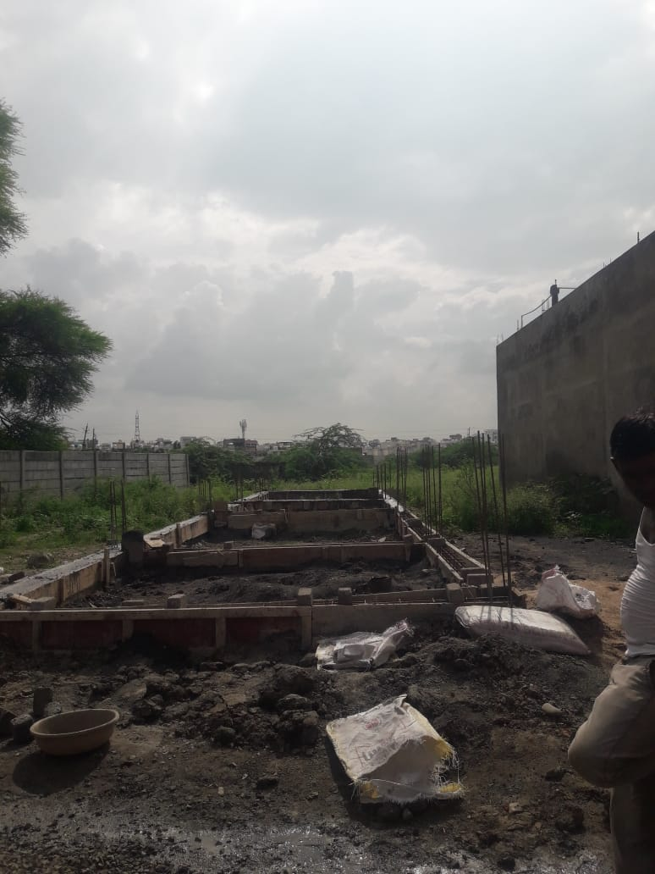

Details of the property under consideration:

Name of Owner: Mr. Rohit Shakyvar S/o. Shyamlal Shakyvar &
Mrs. Chandni Shakyvar W/o. Rohit Shakyvar

Residential Open Plot No. UE - 10, “Gyansheela City Dhabli”, Patwari Halka No. 70,
Village Dhabli, Tehsil - Sanwer, District - Indore, PIN – 453 771,
State – Madhya Pradesh, Country – India

Latitude Longitude - 22°48’28.6”N 75°54’28.7”E

Valuation Done for:
Bank of Maharashtra
South Tukoganj Branch
Indraprasth Tower, 6, M. G. Road, Indore, PIN – 452 001,
State – Madhya Pradesh, Country – India

Vastu/Indore/07/2023/002829/2301844
31/5-469-BSA
Date: 31.07.2023

VALUATION OPINION REPORT

The property of Residential Open Plot No. UE - 10, “Gyansheela City Dhabli”, Patwari Halka No. 70, Village Dhabli, Tehsil - Sanwer, District - Indore, PIN – 453 771, State – Madhya Pradesh, Country - India belongs to Mr. Rohit Shakyvar S/o. Shyamlal Shakyvar & Mrs. Chandni Shakyvar W/o. Rohit Shakyvar.

Boundaries of the property.

North | : | Plot No. UE-11
South | : | Plot No. UE-09
East | : | Road
West | : | Plot No. TE-12

Considering various parameters recorded, existing economic scenario, and the information that is available with reference to the development of neighborhood and method selected for valuation, we are of the opinion that, the property premises can be assessed and valued for banking purpose at ` 15,00,000/- (Rupees Fifteen Lakh Only).

The valuation of the property is based on the documents produced by the concern. Legal aspects have not been taken into considerations while preparing this valuation report.

Hence certified

Manoj B. Chalikwar
Registered Valuer
Chartered Engineer (India)
Reg. No. CAT-I-F-1763
BOM Emp. No. AX40/Empanelment: Valuer/VCPL/2021-22

VALUATION REPORT IN RESPECT OF IMMOVABLE PROPERTY

1. | Date of Inspection | : | 26.07.2023
2. | Purpose of valuation | : | As per request from Bank of Maharashtra, South Tukoganj Branch, Indore to assess Fair Market Value of the property under reference for Banking purpose.
3. | Name and address of the Valuer. | : | Manoj B. Chalikwar  Vastukala Consultants (I) Pvt. Ltd.  106, 1st Floor, Gold Star Tower, Opp. Treasure Island Mall, M.G. Road, Indore – 452 001
4. | Copy Of Documents Handed Over to The Valuer by The Bank |  | - Sale Deed, Registration No. MP179092018A1278302 dated 26.04.2018 between Gyansheela Developers Limited Authorized person Shri. Vidhyut Mittal (the Seller) AND Mr. Rohit Shakyvar S/o. Shyamlal Shakyvar & Mrs. Chandni Shakyvar W/o. Rohit Shakyvar (the Purchaser)  - Commencement Certificate No. 128 dated 15.11.2021 issued by Gram Panchayat Dhabli, Tehsil Sanwer, District Indore.  - Layout Plan Approval No. 5316 / Nagrani / 2012 dated 07.09.2012 for Land bearing Survey No. 69, 70 Paiki, 71, 72/1, 72/2, 73, 74, 75/2, 76/2 at Village Dhabli, Tehsil Sanwer, District Indore, issued by Joint Director, Town and Country Planning, Indore (M.P.).  - Layout Plan approved vide Memo No. 5316 to 5321 dated 07.09.2012 passed by Joint Director, Town and Country Planning, Indore (M.P.)
- 5. | Details of enquiries made/ visited to govt. Offices for arriving fair market value. | : | Market analysis and as per sub-registrar value.
- 6. | Factors for determining its market value. | : | Location, development of surrounding area, facilities provided and its prevailing market rate.
- 7. | Any Critical Aspects Associated with Property | : | No
- 8. | Present/Expected Income from the property | : | N.A., as the property is open plot
 | Property Details: | :
- 9. | Name(s) of the Owner and Postal address of the property under consideration. | : | Mr. Rohit Shakyvar S/o. Shyamlal Shakyvar &  Mrs. Chandni Shakyvar W/o. Rohit Shakyvar
 |  | : | Residential Open Plot No. UE - 10, “Gyansheela City Dhabli”, Patwari Halka No. 70, Village Dhabli, Tehsil - Sanwer, District - Indore, PIN – 453 771, State – Madhya Pradesh, Country – India.  Contact Person:  Rohit Shakyvar (Co-Owner)  Contact No.: +91 9179261475
- 10. | If the property is under joint ownership/ co-ownership share of each such owner/ are the share is undivided. | : | Joint Ownership  Details of Ownership share is not available.
- 11. | Brief description of the property. | :
The immovable property comprising of freehold residential land. The property is located in a developing area having basic infrastructure, well connected by road and train. It is located at 12.8 KM. travelling distance from Indore Junction Railway station.

Land:
As per Sale Deed, the land area is 69.67 Sq. M. i.e. 750.00 Sq. Ft., which is considered for valuation.

As per site inspection, plinth work of proposed structure is in progress on the plot, approved building plan for the same is not provided hence only open land is considered for valuation.
- 12. | Location of the property.  (C.T.S. No., Survey No., Hissa No., Plot No., etc.). | : | Plot No. UE - 10, Patwari No. 01
- 13. | Boundaries of the property | :
- 13. |  |  | As per Actual |  | As per Sale Deed
- 13. | North | : | Plot No. UE-11 |  | Plot No. UE-11
- 13. | South | : | Plot No. UE-09 |  | Plot No. UE-09
- 13. | East | : | Road |  | Colony Road
- 13. | West | : | Plot No. TE-12 |  | Plot No. TE-12
- 14. | Route map | : | Enclosed
- 15. | Any specific identification marks | : | Colony Water Tank
- 16. | Whether covered under Corporation/ Panchayat/ Municipality. | : | Gram Panchayat Dhabli, Tehsil Sanwer, District Indore.
- 17. | Whether covered under any land ceiling of State/ Central Government. | : | No
- 18. | Is the land freehold/ leasehold. | : | Freehold
- 19. | Are there any restrictive covenants in regard to use of Land? If so attach a copy of the covenant. | : | As per Sale Deed
- 20. | Type of the property- Whether | :
 | Residential | : | Yes
 | Industrial | : | No
 | Commercial | : | No
 | Institutional | : | No
 | Government | : | No
 | Non – Government | : | No
 | Other (Specify) | : | N.A.
- 21. | In case of Agricultural land
 | Any conversion to House site is obtained | : | N.A.
 | Whether the land is dry or wet. | : | N.A.
 | Availability of irrigation facilities | : | N.A.
 | Type of crops grown | : | N.A.
 | Annual yield or income. | : | N.A.
- 22. | Year of acquisition/ purchase. | : | Sale Deed, E-Registration No. MP179092018A1278302 dated 26.04.2018
- 23. | Whether the property is occupied by owner or tenant. If occupied by tenant since how long he is staying, and the amount of rent being paid. | : | Open plot of land and under Owner’s possession.
- 24. | Classification of the site. | :
 | a. Population group. | : | Semi Urban
 | b. High/ Middle/ Poor class | : | Middle class
 | c. Residential/ nonresidential. | : | Residential
 | d. Development of surrounding area. | : | Developing
 | e. Possibility of any threat to the property. (Floods, calamities etc.). | : | No
- 25. | Proximity of civic amenities.  (Like school, hospital, bus stop, market etc.). | : | All available near by
- 26. | Level of the land (Plain, rock etc.) | : | Plain
- 27. | Terrain of the Land. | : | Leveled
- 28. | Shape of the land (Square/ rectangle etc.). | : | Rectangular
- 29. | Type of use to which it can be put (for construction of house, factory etc.). | : | Residential Purpose
- 30. | Any usage restrictions on the property. | : | Residential
- 31. | Whether the plot is under town planning approved layout? | : | Yes
- 32. | Whether the building is intermittent or corner? | : | Intermittent
- 33. | Whether any road facility is available? | : | Yes
- 34. | Type of road available (B.T. / Cement Road etc.). | : | Cement Concrete Road
- 35. | Front Width of the Road? | : | More than 20 ft.
- 36. | Source of water & water potentiality. | : | At present not available at site
- 37. | Type of Sewerage System. | : | At present not available at site
- 38. | Availability of power supply. | : | At present not available at site
- 39. | Advantages of the site. | : | Located in developing residential area
- 40. | Disadvantages of the site. | : | No
- 41. | Give instances of sales of immovable property in the locality on a separate sheet, indicating the name & address of the property, registration No. sale price and area of land sold. | : | As per Sub-Registrar of Assurance records
 | Valuation of the property:
42. | 1) Dimensions of the plot | : | 4.57 M. x 15.24 M.  (As per TNCP approved plan)
43. | 2) Total area of the plot | : | 750.00 Sq. Ft.  (As per Sale Deed)
44. | 3) Prevailing Market Rate/Price trend of the Property in the locality/city from property search sites viz magickbricks.com, 99acres.com, makaan.com etc. if available | : | ` 1,500/- to ` 2,500/- per Sq. Ft. for Residential Plot  Last Two Transactions: Not Available  Last two transactions are not available; we have made the online search but could not find out any ready reference for the surrounding locality.  Value derived and adopted above is the outcome of local inquiry, searching on Internet, application of personal experience, keeping in mind, the area on which property is falling, its size, shape, surrounding development, nature of surrounding locality, nature of holding of plot, facilities available, civic amenities for communication, permissible and restriction in development, future potentiality etc.  Details of online listings are attached with the report.
45. | 4) Government Rate obtained from the online government records of Land | : | ` 9,200/- per Sq. M.  i.e. ` 855/- per Sq. Ft.
46. | Building |  | N.A., as the property is open plot of land only
47. | - Government Value
 | Particulars | : | Area in Sq. Ft. | Rate in ` | Value in `
 | Land | : | 750.00 | 855/- | 6,41,250/-
 | Building | : | N.A., as the property is open plot of land only
 | Total |  |  |  | 6,41,250/-
 | 5) Assessed/ adopted rate of valuation. |  | ` 2,000/- per Sq. Ft. for Residential Open Plot
48. | - Fair Market Value
 | Particulars | : | Area in Sq. Ft. | Rate in ` | Value in `
 | A) Land |  | 750.00 | 2,000/- | 15,00,000/-
 | B) Building |  | N.A., as the property is open plot of land only
 | 6) Estimated value of the land. | : | ` 15,00,000/-
 | a. Technical details of the Building:
- 49. | Type of Building (Residential/ Commercial/ Industrial). | : | N.A., as the property is open plot of land only
- 50. | Year of construction. | : | N.A.
- 51. | Future life of the property. | : | N.A.
- 52. | No. of floors and height of each floor including basement. | : | N.A.
- 53. | Plinth area of each floor | : | N.A.
- 54. | Type of construction.  (Load bearing/ R.C.C. / Steel framed). |  | N.A.
 | Condition of the building. | :
- 55. | External (excellent/ good/ normal/ poor). | : | N.A.
- 56. | Internal (excellent/ good/ normal/ poor). | : | N.A.
 | Remarks | :
- 57. | b. Specifications of Construction:
 | Foundation. | : | N.A.
 | Basement. | : | N.A.
 | Superstructure. | : | N.A.
 | Joinery/ Doors & Windows. | : | N.A.
 | RCC work. | : | N.A.
 | Plastering. | : | N.A.
 | Flooring, Skirting. | : | N.A.
 | Kitchen Pantry Platform | : | N.A.
 | Whether any weather proof course is provided. | : | N.A.
 | Drainage. | : | N.A.
 | Compound wall (Height, length and type of construction). | : | N.A.
 | Electric installation (Type of wire, Class of fittings) | : | N.A.
 | Plumbing installation (No. of water closets & wash basins etc.) | : | N.A.
 | Bore well. | : | N.A.
 | Wardrobes, if any. | : | N.A.
 | Development of open area | : | N.A.

1,

 | Summary of Valuation
 | Total Value of the Property | ` 15,00,000/-
 | Realizable Value | ` 13,50,000/-
 | Forced/ Distress Sale value. | ` 12,00,000/-
 | Insurable value of the property | N.A. as the property is open plot of land only.
e) | Remarks | As per site inspection, plinth work of proposed structure is in progress on the plot, approved building plan for the same is not provided hence only open land is considered for valuation.

Justification for price /rate
The Market Value of the property is based on facts of markets discovered by us during our enquiries, however the government rate value in this case is less than the market value arrived by us. We are of the opinion that the value arrive by us will prove to be correct if an Auction of the subject property is carried out. As far as Market Value in Index II is concerned, it is not possible to comment on same, may be government rates are fixed by sampling during same point of time in part and whereas, Market values change every month.
In most of the cases the actual deal amount or Transaction value is not reflected in Index II because of various Market practices. As Valuer, we always try to give a value which is correct reflection of actual transaction value irrespective of any factors in market.

Actual site photographs
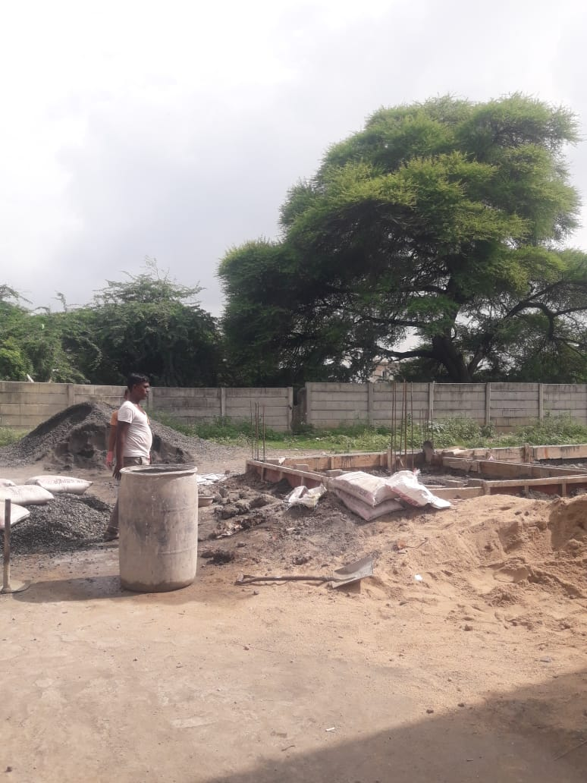
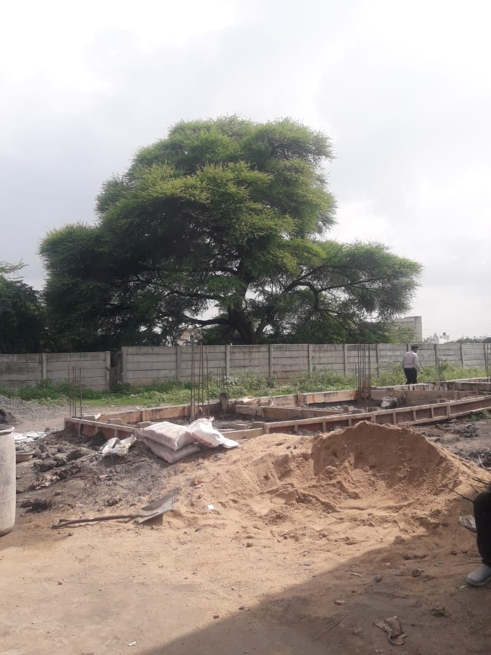

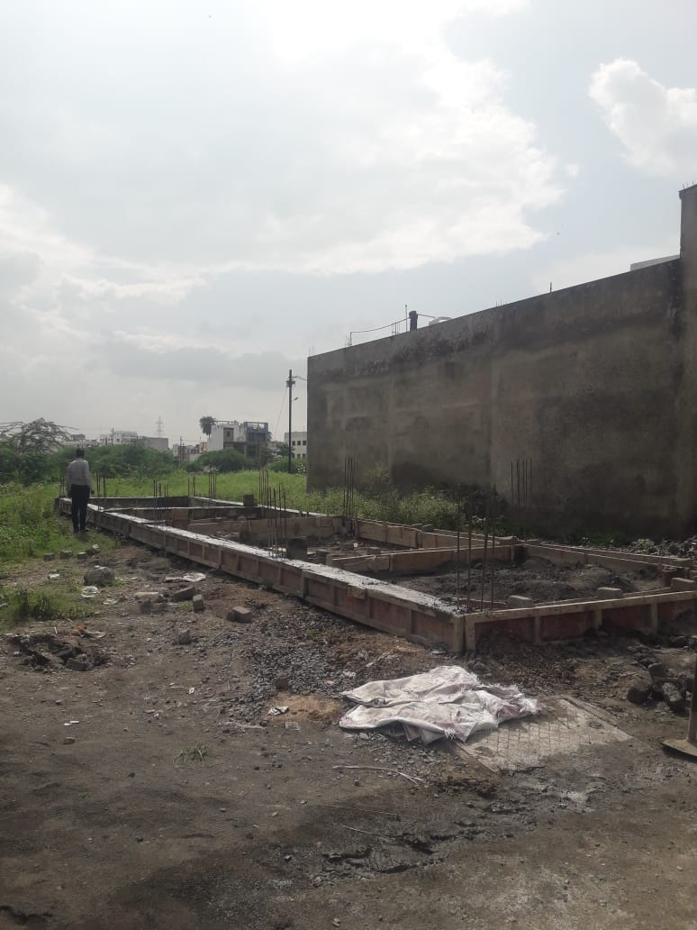
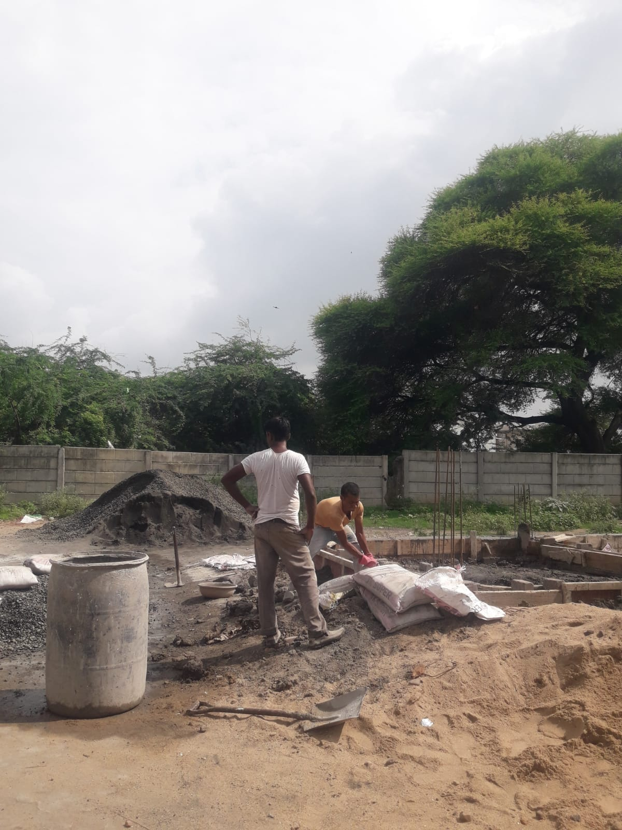
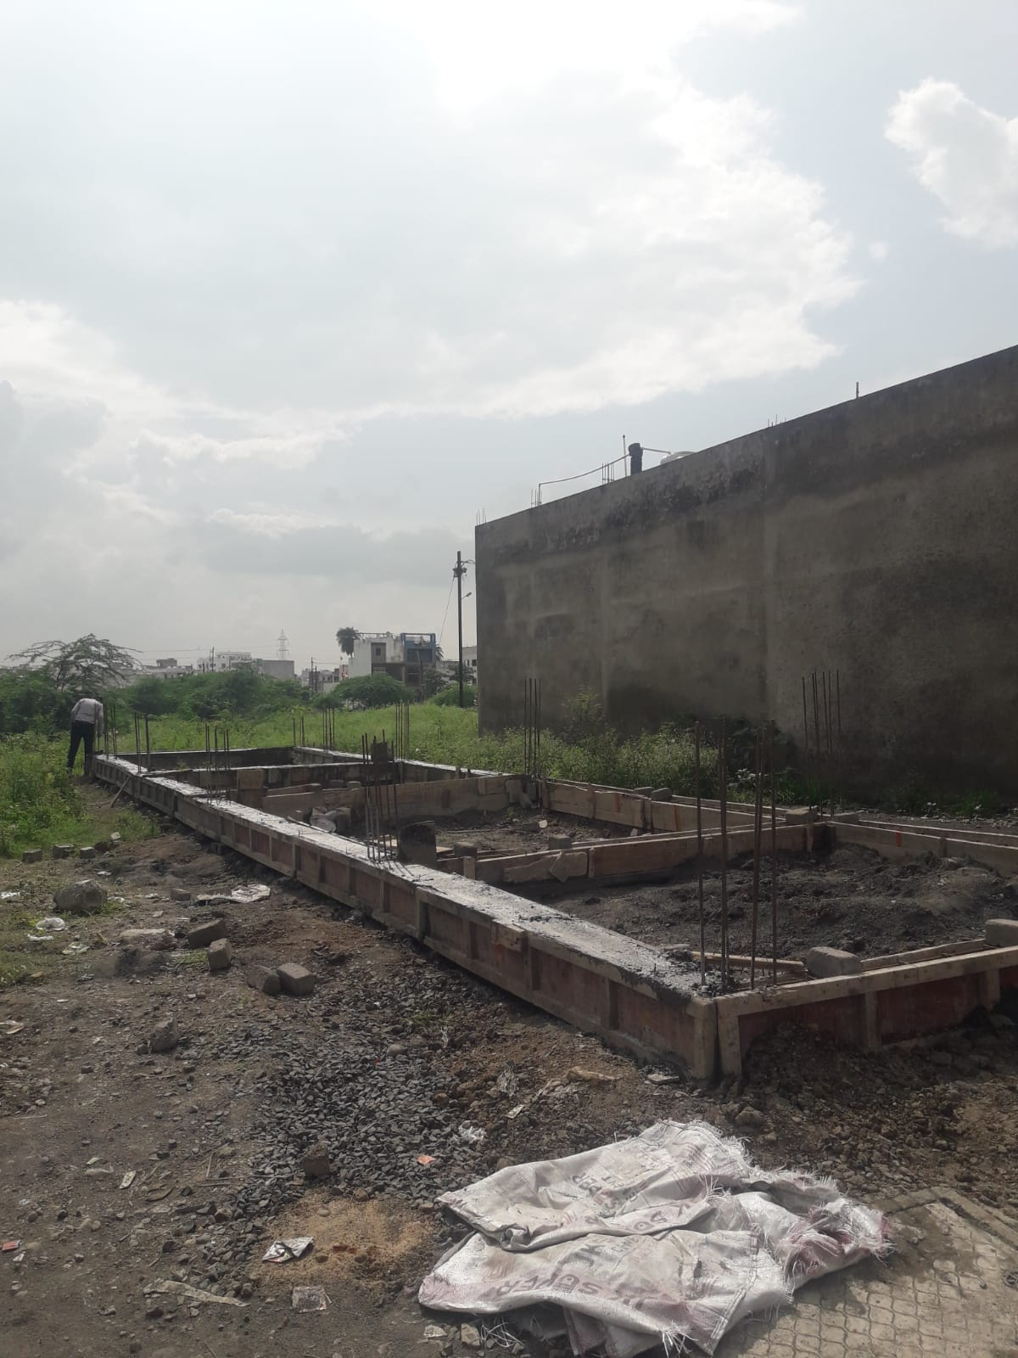

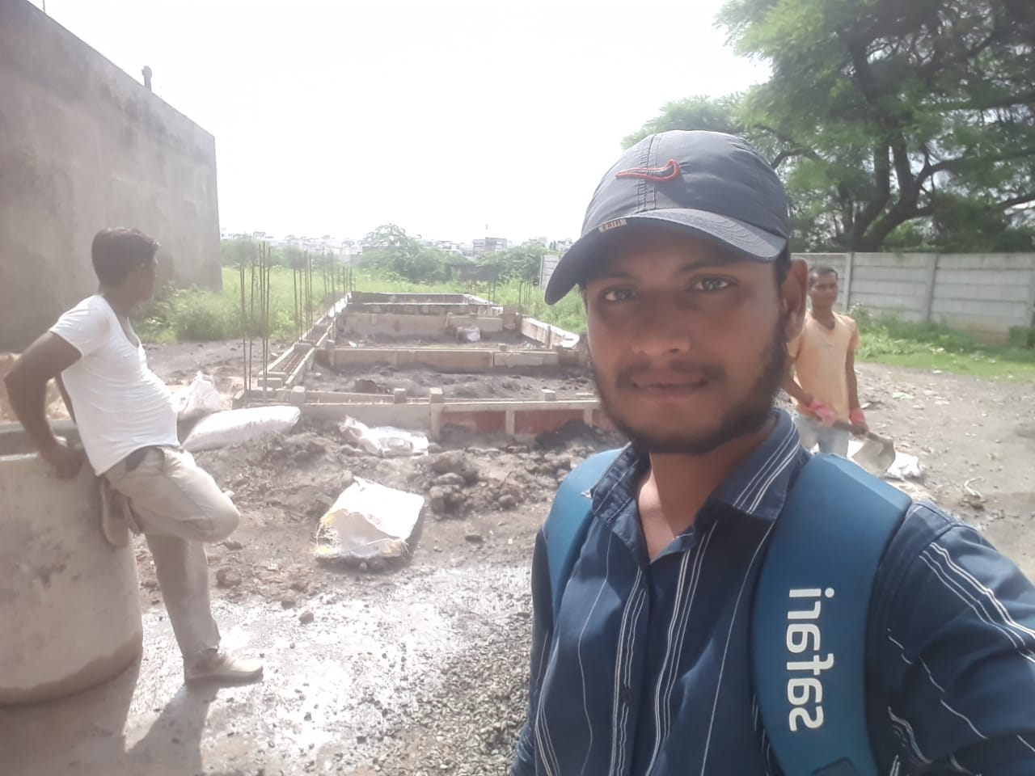
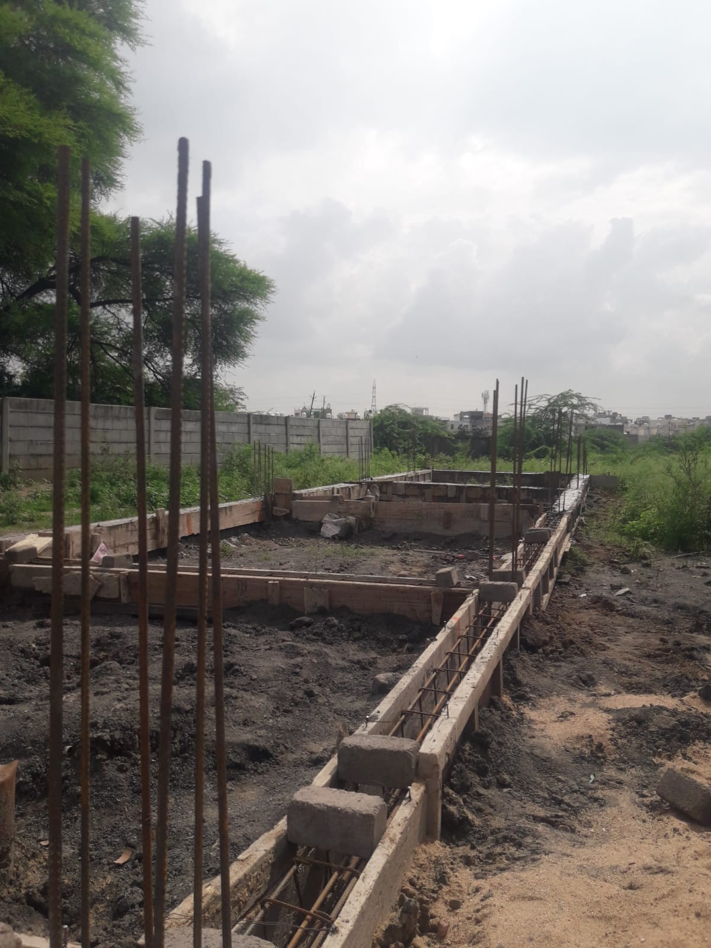
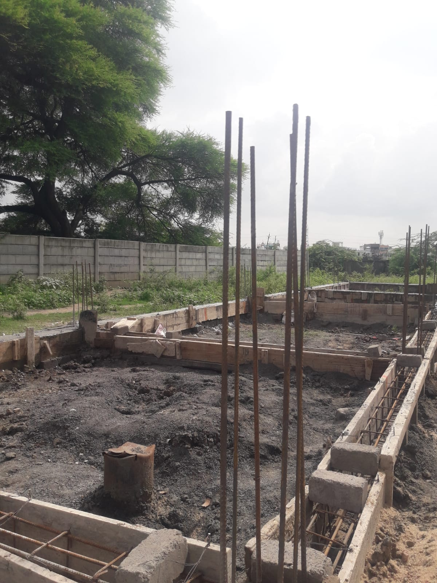

Route Map of the property
Site u/r
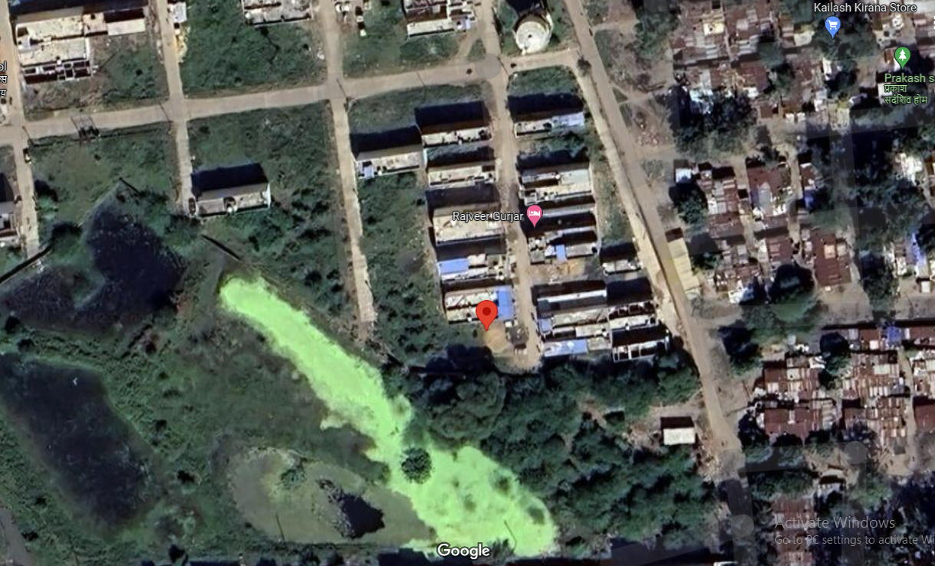

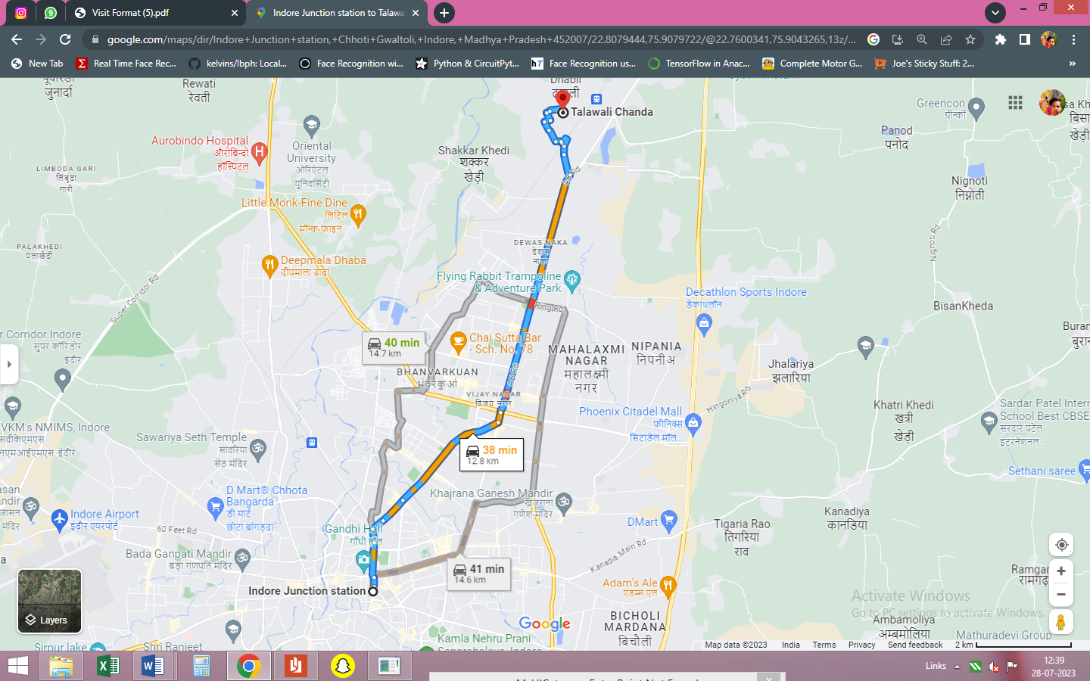

Latitude Longitude - 22°48’28.6”N 75°54’28.7”E
Note: The Blue line shows the route to site from nearest Railway Station (Mhow Railway Station – 12.8 KM.)
Government Guideline Rate
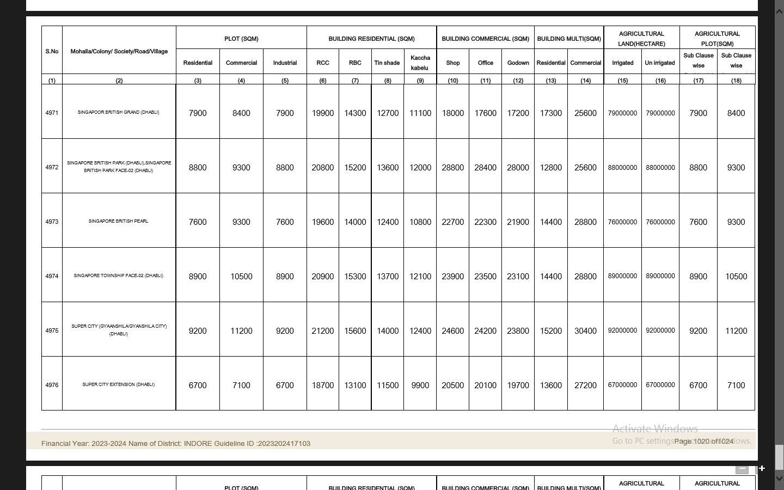

Price Indicators
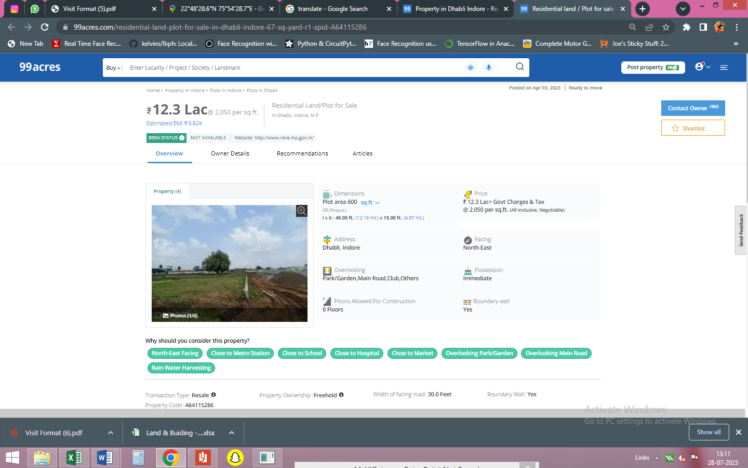

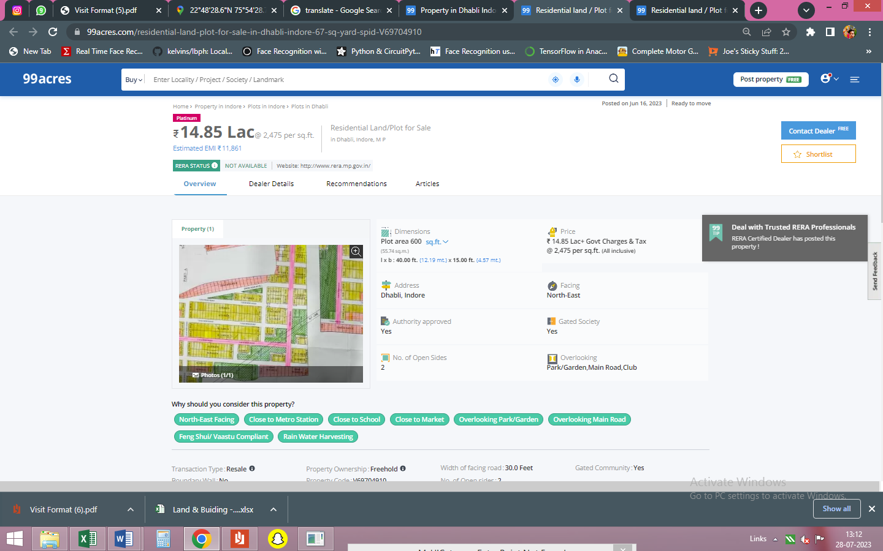

DEFINITION OF VALUE FOR THIS SPECIFIC PURPOSE

This exercise is to assess Fair Market Value of the property under reference for purpose as on 31st July 2023.

The term Fair Market Value is defined as

"The most probable price, as of a specified date, in cash, terms equivalent to cash, or in other precisely revealed terms for which the specified property rights would sell after reasonable exposure in a competitive market under all conditions requisite to a fair sale, with the buyer and seller each acting prudently knowledgeably and for self-interest assuming that neither is under undue duress"

Fundamental assumptions and conditions presumed in this definition are:

- Buyer and seller are motivated by self-interest.

- Buyer and seller are well informed and are acting prudently.

- The property is exposed for a reasonable time on the open market.

- Payment is made in cash or equivalent or in specified financing terms.

ASSUMPTIONS, CAVEATS, LIMITATION AND DISCLAIMERS
- We assume no responsibility for matters of legal nature affecting the property appraised or the title thereto, nor do we render our opinion as to the title, which is assumed to be good and marketable.
- The property is valued as though under responsible ownership.
- It is assumed that there are no hidden or unapparent conditions of the subsoil or structure that would render it more or less valuable. No responsibility is assumed for such conditions or for engineering that might be required to discover such factors.
- There is no direct/ indirect interest in the property valued.
- The rates for valuation of the property are in accordance with the Govt. approved rates and prevailing market rates.

Manoj B. Chalikwar
Registered Valuer
Chartered Engineer (India)
Reg. No. CAT-I-F-1763
BOM Emp. No. AX40/Empanelment: Valuer/VCPL/2021-22

