Vastu/Mumbai/06/2023/2223/2301356

29/11-457-PRDVS

Date: 10.07.2023

**Structural Stability Report**

Structural Observation Report of Residential Amalgamated Flat No. 1404/A, 1404/B, 1404/C, 14th Floor, **"Odyssey – II Co-op. Hsg. Soc. Ltd.",** Orchid Avenue, Hiranandani Gardens, Powai, Mumbai – 400 076, State – Maharashtra, Country – India.

Name of Owners: **Mr. Kanwar Bir Singh & Mrs. Gurpreet Kaur.**

This is to certify that on visual inspection, it appears that the structure at **"Odyssey – II Co-op. Hsg. Soc. Ltd."** is in good condition and the future life can be reasonably takes under normal condition and with proper periodic repairs & maintenance is about 39 years.

**General Information**:

|  |  |  |
| --- | --- | --- |
| **A.** | **Introduction** | |
| 1 | Name of Building | **"Odyssey – II Co-op. Hsg. Soc. Ltd."** |
| 2 | Property Address | Residential Amalgamated Flat No. 1404/A, 1404/B, 1404/C, 14th Floor, **"Odyssey – II Co-op. Hsg. Soc. Ltd."**, Orchid Avenue, Hiranandani Gardens, Powai, Mumbai – 400 076, State – Maharashtra, Country – India. |
| 3 | Type of Building | Residential |
| 4 | No. of Floors | Stilt + 1st to 29th Upper Floors |
| 5 | Whether stilt / podium / open parking provided | Along with One Stilt Car parking No. 4 & Open Car Parking No. 4A |
| 6 | Type of Construction | R.C.C. Framed Structure |
| 7 | Type of Foundation | R.C.C. Footing |
| 8 | Thickness of the External Walls | 9” thick brick walls both sides plastered |
| 9 | Type of Compound | Brick Masonry Walls |
| 10 | Year of Construction | 2002 (As per Occupancy Certificate) |
| 11 | Present age of building | 21 years |
| 12 | Residual age of the building | 39 years Subject to proper, preventive periodic maintenance & structural repairs. |
| 13 | No. of flats (Per Floor) | 4 Flats on 14th Floor |
| 14 | Methodology adopted | As per visual site inspection |

|  |  |  |
| --- | --- | --- |
| **B.** | **External Observation of the Building** | |
| 1 | Plaster | Normal Condition |
| 2 | Chajjas | Normal Condition |
| 3 | Plumbing | Normal Condition |
| 4 | Cracks on the external walls | Not found |
| 5 | Filling cracks on the external walls | Not found |
| 6 | Cracks on columns & beams | Not found |
| 7 | Vegetation | Not found |
| 8 | Leakages of water in the drainage pipes or water pipes | Not found |
| 9 | Dampness external in the wall due to leakages | Not found |
| 10 | Any other observation about the condition of external side of the building | The external condition of the building is Good. |
| **C** | **Internal Observation of the common areas of the building and captioned premises** | |
| 1 | Beams (Cracks & Leakages) | Not Found |
| 2 | Columns (Cracks & Leakages) | Not Found |
| 3 | Ceiling (Cracks & Leakages) | Not Found |
| 4 | Leakages inside the property | Not Found |
| 5 | Painting inside the property | Normal |
| 6 | Maintenance of staircase & cracks | Normal |

|  |  |  |
| --- | --- | --- |
| **D** | **Common Observation** | |
| 1 | Structural Audit of the Building Under Bye – Laws No. 77 of the Model Bye Laws (Co-Operative Societies Act / Rules) | As per bye Laws No. 77 of Co-Op. Societies bye Laws under the Act the society shall conduct a Structural Audit of the building of the society as follows |
| 2 | Remark | No Structural Audit Report is furnished for the perusal |

|  |  |
| --- | --- |
| **E** | **Conclusion** |
| The captioned building is having Stilt + 1st to 29th Upper Floors Upper Floors which are constructed in year 2002 as per Occupancy Certificate. Estimated future life under present circumstances is about 39 years subject to proper, preventive periodic maintenance & structural repairs.  The inspection dated 29.06.2023 reveals no structural damage or deterioration to the building. The building as well as the property is maintained in good condition & will stand future life subject to proper, preventive periodic maintenance & Good structural repairs.  Our Observations about the structure are given above.  The above assessment is based on visual inspection only. | |

## Sharadkumar B. Chalikwar

Govt. Reg. Valuer

Chartered Engineer (India)

Reg. No. IBBI/RV/07/2019/11744

Reg. No. (N) CCIT/1-14/52/2008-09

SBI Empanelment No.: SME/TCC/2021-22/85/13

**Actual site photographs**

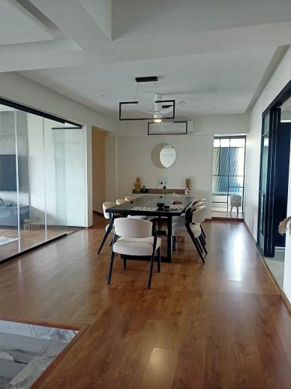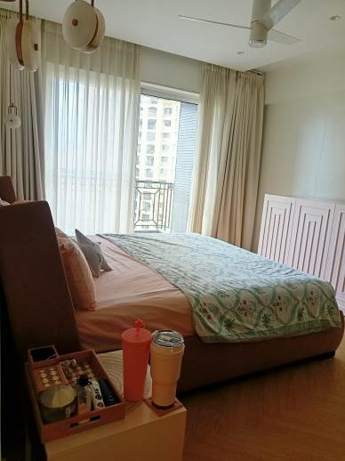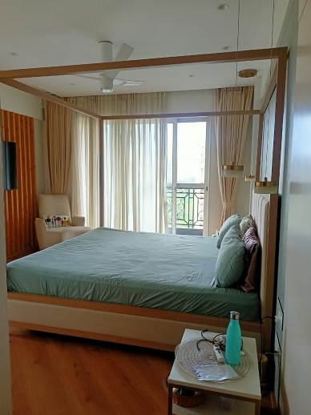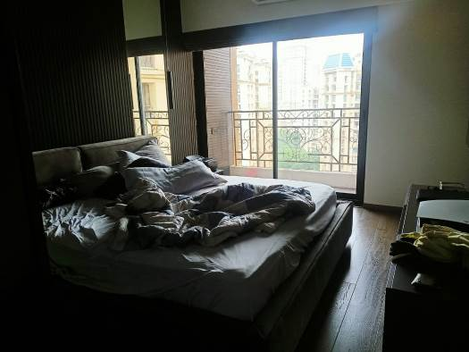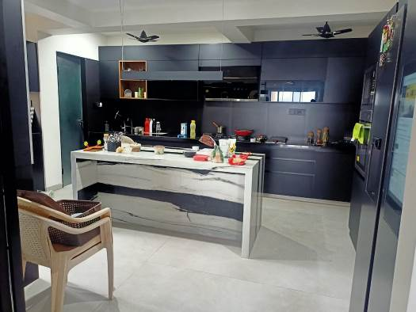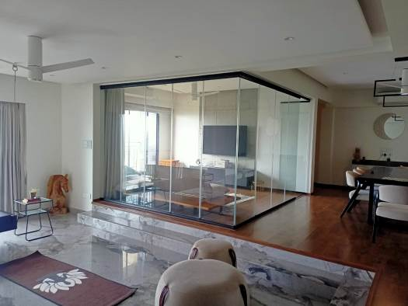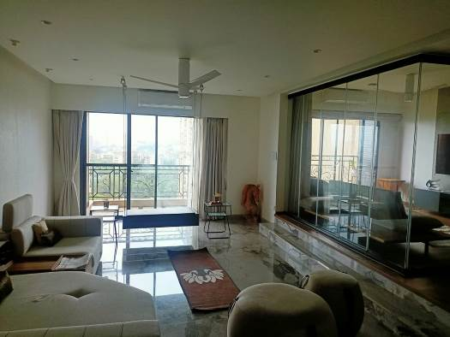

**Actual site photographs**

