LENDERS INDEPENDENT ENGINEER REPORT
(5th Report)
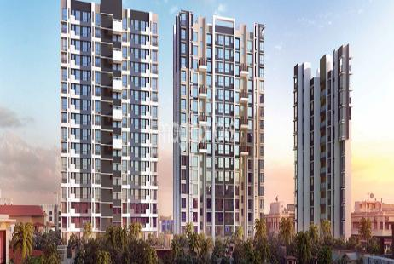

Details of the property under consideration:

Name of Project: Poddar Spraha Diamond (Sanjay Nagar SRA CHS Ltd.)

Residential project on Plot Bearing CTS No. 828 (Part) and 1504A (Part) of Village - Chembur,
Subhash Nagar Road, Chembur (East), Mumbai, Pin Code – 400 071, State - Maharashtra, Country – India

Latitude Longitude: 19°03'30.5"N 72°54'16.3"E

Valuation Prepared for:

STCI FINANCE LIMITED
A/B 1-802, A Wing, 8th Floor, Marathon Innova, Marathon Nextgen Compound,
Off. Ganpatrao Kadam Marg, Lower Parel (West), Mumbai – 400 013,
State – Maharashtra, Country – India

Vastu/STCI/ Mumbai/07/2023/2780/2301774
26/1-399-PY
Date: - 26.07.2023

FIFTH LENDERS INDEPENDENT ENGINEER REPORT

To,
STCI FINANCE LIMITED
A/B 1-802, A Wing, 8th Floor,
Marathon Innova, Marathon Nextgen Compound,
Off. Ganpatrao Kadam Marg,
Lower Parel (West), Mumbai – 400 013,
State – Maharashtra, Country – India

Subject: Construction of Residential project on Plot Bearing CTS No. 828 (Part) and 1504A (Part) of Village - Chembur, Subhash Nagar Road, Chembur (East), Mumbai, Pin Code – 400 071, State - Maharashtra, Country – India.

Ref: You’re Request for Lenders Independent Engineer Report of under Construction Building.
Dear Sir,
The Construction work as per approved plan was in progress during the site visit on 06th March 2023. Total expenditure occurred as on 31/12/2022 on this project by M/s. Poddar Housing and Development Ltd. is ` 132.13 Cr. & as per CA Certificate actual total expenditure occurred as on 31/12/2022 is ` 132.13 Cr. Hence, release of Balance Amount as requested by M/s. Poddar Housing and Development Ltd. if any is hereby recommended. As per plinth area calculation construction work completed of 90.28% and cost incurred till 31.12.2022 is 96.33%

DECLARATION
- The information furnished in the report is based on our 5th site visit Dated 06/03/2023 & Document Provided by Client.
- I have no direct and indirect interest in the property examined for report.
- I have not been found guilty of misconduct in my professional capacity.

Manoj B. Chalikwar
Registered Valuer
Chartered Engineer (India)
Reg. No. IBBI/RV/07/2018/10366
Encl.: LIE report

Purpose & Methodology
• STCI Finance Limited and financial institutions require monitoring & an independent review of the progress of the sanctioned projects
VCIPL undertakes such study to independently review the progress of the project and put forward a comprehensive analysis

Advantages:
- Assurance on present practices
- Identification of risk
- Analyzing the performance of third parties
- Recommendations

The Methodology
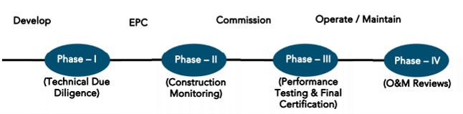
FIFTH LENDERS INDEPENDENT ENGINEER REPORT
OF
" Poddar Spraha Diamond (Sanjay Nagar SRA CHS Ltd.)"
Residential project on Plot Bearing CTS No. 828 (Part) and 1504A (Part) of Village - Chembur,
Subhash Nagar Road, Chembur (East), Mumbai, Pin Code – 400 071, State - Maharashtra, Country - India

Latitude Longitude: 19°03'30.5"N 72°54'16.3"E

NAME OF DEVELOPER: M/s. Poddar Housing and Development Ltd.
Pursuant to instructions from STCI Finance Limited, Lower Parel Branch, Mumbai we have duly visited, inspected, surveyed & assessed the above said property on 06th March 2023 to determine the work progress report of the said property/project as on Quarter ending 31st December 2022 for LIE purpose.

1. Location Details:
The property is situated on Plot Bearing CTS No. 828 (Part) and 1504A (Part) of Village - Chembur, Subhash Nagar Road, Chembur (East), Mumbai, Pin Code – 400 071. It is about 1.0 Km distance from Chembur railway station of Harbour railway line. Surface transport to the property is by buses, Auto, taxis & private vehicles. The property is in developed locality. All the amenities like shops, banks, hotels, markets, schools, hospitals, etc. are all available in the nearby locality. The locality is higher middle class & developed.

- Developer Details:
Name of builder | M/s. Poddar Housing and Development Ltd.
Project Rera Registration Number | P51900002986
Registered office address | Unit No. 3-6, Neeru Silk Mill, Mathuradas Mill compound, 126, N. M. Joshi Marg, Lower Parel (West), Mumbai - 400 013, State - Maharashtra, Country - India
Contact details | Contact Person:  Umesh Sawant - (Company staff - Mobile No. 9167399723)
E – mail ID and website
2. Boundaries of the Property:
Direction | Particulars
On or towards North | Subhash Road
On or towards South | CTS No. 1504A (Part)
On or towards East | Nallah
On or towards West | Mhada Building No. 44 & 45

Introduction
As per Information on site M/s. Poddar Housing and Development Ltd. has acquired land by developer agreement Date 04.05.2016 admeasuring area is 3,250.00 Sq. M. bearing on Plot Bearing CTS No. 828 (Part) and 1504A (Part) of Village - Chembur, For the Redevelopment of residential Building.

Area Statement:

Land:
Date | Particular | Area in Sq. M.
04.05.2016 | C. T. S. No. 828 (Part) | 2,114.80
04.05.2016 | C. T. S. No. 1504A (Part) | 1,135.20
TOTAL LAND AREA IN SQ. M. |  | 3,250.00

- Above area has been taken from copy of Development Agreement dated 04.05.2016 between Sanjay Nagar SRA CHS Ltd., M/s. Satre Infrastructure Pvt. Ltd. and M/s. Poddar Housing and Development Ltd.

Building Area:
Sr. No | AREA STATEMENT | Sq. M.
1 | Area of the plot | 3250.00
2 | Deduction for | -
a | Road set back area | -
b | Proposed Road | -
c | Any Reservation | -
d | Nalla Widening | 230.21
 | Total (a + b + c + d) | 230.21
3 | Balance Area of the plot | 3019.79
4 | Deduction for Recreation Ground 15% | -
5 | Net Area of the Plot | -
6 | Addition for F. S. I. | 907.50
 | 2 (a) 100% Road Setback | -
 | 2 (b) 100% Proposed Road | -
 | 2 (c) 100% Reservation (Buildable) | -
 | 2 (d) 100% Nalla Widening | 230.21
7 | Total Area of Plot | 3250.00
8 | F. S. I. Permissible | 3.00
9 | Total Permissible Built up Area in Situ | 9750.00
10 | Approved Rehab Building No. 1 | 4018.33
11 | Proposed Sale Building No. 2 (U/R) | 4715.20
12 | Approved Composite Building No. 3 | 596.88
13 | Total Built – up Area Proposed | 9330.41
14 | F. S. I. Consumed | 2.87
B | Balcony Area Statement | As per Statement

List of Approvals:
- Copy of IOD No. SRA / ENG / 3127 / MW / MHL & STGL / AP dated 24.04.2021 issued by Slum Rehabilitation Authority, Mumbai.
- Copy of Approved Plan No. SRA /ENG / 3127 / MW / MHL & STGL / AP dated 26.04.2021 issued by Slum Rehabilitation Authority, Mumbai.
- Copy of Commencement Certificate No. SRA / ENG / 3127 / MW MHL & STGL / AP dated 29.10.2021 issued by Slum Rehabilitation Authority, Mumbai.

LEVEL OF COMPLETION:

Rehab Building
Sr. No. | Floor | Work Completion as on 26.11.2021
1 | Basement | Building work is completed & occupied by the tenants
2 | Ground Floor
3 | 1st Floor
3 | 2nd Floor
4 | 3rd Floor
5 | 4th Floor
6 | 5th Floor
7 | 6th Floor
8 | 7th Floor
9 | 8th Floor
10 | 9th Floor
11 | 10th Floor
12 | 11th Floor
13 | 12th Floor
14 | 13th Floor
15 | 14th Floor
16 | 15th Floor
17 | Terrace

Sale Building
Sr. No. | Floor | Construction Area in Sq. M. | Completed Area in Sq. M. | Work Completion as per 4th LIE Report | Work Completion as on 06.03.2023
1 | Basement 1 | 12,392.59 | 12,392.59 | Wing A & B: - Slab work, Blockwork, Plaster work, waterproofing, Firefighting work are completed | Wing A & B: - Slab work, Blockwork, Plaster work, waterproofing, Firefighting work are completed
2 | Basement 2 | 12,392.59 | 12,392.59 | Wing A & B: - Slab work, Blockwork, Plaster work, waterproofing, Firefighting work are completed | Wing A & B: - Slab work, Blockwork, Plaster work, waterproofing, Firefighting work are completed
3 | Ground Floor | 12,392.59 | 12,392.59 | Wing B: - 100% work is completed  Wing A: - Slab work, Blockwork, Plaster work, waterproofing, Firefighting work, wiring, door & window, flooring and tiling works are completed, One lift is installed and other lift work is in progress | Wing B: - 100% work is completed  Wing A: - Slab work, Blockwork, Plaster work, waterproofing, flooring, Gypsum work, Kitchen platform work, Firefighting work, wiring, door & window, electrical & plumbing works and lift works are completed, final finishing work is in progress
3 | 1st Floor | 5,395.67 | 5,395.67 | Wing B: - 100% work is completed  Wing A: - Slab work, Blockwork, Plaster work, waterproofing, flooring, Gypsum work, Kitchen platform work, Firefighting work, wiring, door & window, internal painting, electrical & sanitary works are completed, final finishing work is in progress, One lift is installed and other lift work is in progress | Wing B: - 100% work is completed  Wing A: - Slab work, Blockwork, Plaster work, waterproofing, flooring, Gypsum work, Kitchen platform work, Firefighting work, wiring, door & window, electrical & plumbing works and lift works are completed, final finishing work is in progress
4 | 2nd Floor | 5,395.67 | 5,395.67 | Wing B: - 100% work is completed  Wing A: - Slab work, Blockwork, Plaster work, waterproofing, flooring, Gypsum work, Kitchen platform work, Firefighting work, wiring, door & window, internal painting, electrical & sanitary works are completed, final finishing work is in progress, One lift is installed and other lift work is in progress | Wing B: - 100% work is completed  Wing A: - Slab work, Blockwork, Plaster work, waterproofing, flooring, Gypsum work, Kitchen platform work, Firefighting work, wiring, door & window, electrical & plumbing works and lift works are completed, final finishing work is in progress
5 | 3rd Floor | 5,395.67 | 5,395.67 | Wing B: - 100% work is completed  Wing A: - Slab work, Blockwork, Plaster work, waterproofing, flooring, Gypsum work, Kitchen platform work, Firefighting work, wiring, door & window, internal painting, electrical & sanitary works are completed, final finishing work is in progress, One lift is installed and other lift work is in progress | Wing B: - 100% work is completed  Wing A: - Slab work, Blockwork, Plaster work, waterproofing, flooring, Gypsum work, Kitchen platform work, Firefighting work, wiring, door & window, electrical & plumbing works and lift works are completed, final finishing work is in progress
6 | 4th Floor | 5,395.67 | 5,395.67 | Wing B: - 100% work is completed  Wing A: - Slab work, Blockwork, Plaster work, waterproofing, flooring, Gypsum work, Kitchen platform work, Firefighting work, wiring, door & window, internal painting, electrical & sanitary works are completed, final finishing work is in progress, One lift is installed and other lift work is in progress | Wing B: - 100% work is completed  Wing A: - Slab work, Blockwork, Plaster work, waterproofing, flooring, Gypsum work, Kitchen platform work, Firefighting work, wiring, door & window, electrical & plumbing works and lift works are completed, final finishing work is in progress
7 | 5th Floor | 5,395.67 | 5,395.67 | Wing B: - 100% work is completed  Wing A: - Slab work, Blockwork, Plaster work, waterproofing, flooring, Gypsum work, Kitchen platform work, Firefighting work, wiring, door & window, internal painting, electrical & sanitary works are completed, final finishing work is in progress, One lift is installed and other lift work is in progress | Wing B: - 100% work is completed  Wing A: - Slab work, Blockwork, Plaster work, waterproofing, flooring, Gypsum work, Kitchen platform work, Firefighting work, wiring, door & window, electrical & plumbing works and lift works are completed, final finishing work is in progress
8 | 6th Floor | 5,395.67 | 5,395.67 | Wing B: - 100% work is completed  Wing A: - Slab work, Blockwork, Plaster work, waterproofing, flooring, Gypsum work, Kitchen platform work, Firefighting work, wiring, door & window, internal painting, electrical & sanitary works are completed, final finishing work is in progress, One lift is installed and other lift work is in progress | Wing B: - 100% work is completed  Wing A: - Slab work, Blockwork, Plaster work, waterproofing, flooring, Gypsum work, Kitchen platform work, Firefighting work, wiring, door & window, electrical & plumbing works and lift works are completed, final finishing work is in progress
9 | 7th Floor | 5,395.67 | 5,395.67 | Wing B: - 100% work is completed  Wing A: - Slab work, Blockwork, Plaster work, waterproofing, flooring, Gypsum work, Kitchen platform work, Firefighting work, wiring, door & window, internal painting, electrical & sanitary works are completed, final finishing work is in progress, One lift is installed and other lift work is in progress | Wing B: - 100% work is completed  Wing A: - Slab work, Blockwork, Plaster work, waterproofing, flooring, Gypsum work, Kitchen platform work, Firefighting work, wiring, door & window, electrical & plumbing works and lift works are completed, final finishing work is in progress
10 | 8th Floor | 5,395.67 | 5,395.67 | Wing B: - 100% work is completed  Wing A: - Slab work, Blockwork, Plaster work, waterproofing, flooring, Gypsum work, Kitchen platform work, Firefighting work, wiring, door & window, internal painting, electrical & sanitary works are completed, final finishing work is in progress, One lift is installed and other lift work is in progress | Wing B: - 100% work is completed  Wing A: - Slab work, Blockwork, Plaster work, waterproofing, flooring, Gypsum work, Kitchen platform work, Firefighting work, wiring, door & window, electrical & plumbing works and lift works are completed, final finishing work is in progress
11 | 9th Floor | 5,395.67 | 5,395.67 | Wing B: - 100% work is completed  Wing A: - Slab work, Blockwork, Plaster work, waterproofing, flooring, Gypsum work, Kitchen platform work, Firefighting work, wiring, door & window, internal painting, electrical & sanitary works are completed, final finishing work is in progress, One lift is installed and other lift work is in progress | Wing B: - 100% work is completed  Wing A: - Slab work, Blockwork, Plaster work, waterproofing, flooring, Gypsum work, Kitchen platform work, Firefighting work, wiring, door & window, electrical & plumbing works and lift works are completed, final finishing work is in progress
12 | 10th Floor | 5,395.67 | 5,395.67 | Wing B: - 100% work is completed  Wing A: - Slab work, Blockwork, Plaster work, waterproofing, flooring, Gypsum work, Kitchen platform work, Firefighting work, wiring, door & window, internal painting, electrical & sanitary works are completed, final finishing work is in progress, One lift is installed and other lift work is in progress | Wing B: - 100% work is completed  Wing A: - Slab work, Blockwork, Plaster work, waterproofing, flooring, Gypsum work, Kitchen platform work, Firefighting work, wiring, door & window, electrical & plumbing works and lift works are completed, final finishing work is in progress
13 | 11th Floor | 5,395.67 | 5,395.67 | Wing B: - 100% work is completed  Wing A: - Slab work, Blockwork, Plaster work, waterproofing, flooring, Gypsum work, Kitchen platform work, Firefighting work, wiring, door & window, internal painting, electrical & sanitary works are completed, final finishing work is in progress, One lift is installed and other lift work is in progress | Wing B: - 100% work is completed  Wing A: - Slab work, Blockwork, Plaster work, waterproofing, flooring, Gypsum work, Kitchen platform work, Firefighting work, wiring, door & window, internal painting, electrical & sanitary works are completed, final finishing work is in progress, One lift is installed and other lift work is in progress
14 | 12th Floor | 5,395.67 | 5,395.67 | Wing B: - 100% work is completed  Wing A: - Slab work, Blockwork, Plaster work, waterproofing, flooring, Gypsum work, Kitchen platform work, Firefighting work, wiring, door & window, internal painting, electrical & sanitary works are completed, final finishing work is in progress, One lift is installed and other lift work is in progress | Wing B: - 100% work is completed  Wing A: - Slab work, Blockwork, Plaster work, waterproofing, flooring, Gypsum work, Kitchen platform work, Firefighting work, wiring, door & window, electrical & plumbing works and lift works are completed, final finishing work is in progress
15 | 13th Floor | 5,395.67 | 5,395.67 | Wing B: - 100% work is completed  Wing A: - Slab work, Blockwork, Plaster work, waterproofing, flooring, Gypsum work, Kitchen platform work, Firefighting work, wiring, door & window, internal painting, electrical & sanitary works are completed, final finishing work is in progress, One lift is installed and other lift work is in progress | Wing B: - 100% work is completed  Wing A: - Slab work, Blockwork, Plaster work, waterproofing, flooring, Gypsum work, Kitchen platform work, Firefighting work, wiring, door & window, electrical & plumbing works and lift works are completed, final finishing work is in progress
16 | 14th Floor | 5,395.67 | 5,395.67 | Wing B: - 100% work is completed  Wing A: - Slab work, Blockwork, Plaster work, waterproofing, flooring, Gypsum work, Kitchen platform work, Firefighting work, wiring, door & window, electrical & part sanitary works are completed, one lift is installed and other lift work is in progress | Wing B: - 100% work is completed  Wing A: - Slab work, Blockwork, Plaster work, waterproofing, flooring, Gypsum work, Kitchen platform work, Firefighting work, wiring, door & window, electrical & plumbing works and lift works are completed, final finishing work is in progress
17 | 15th Floor | 5,395.67 | 5,395.67 | Wing B: - Wing B: - 100% work is completed, Amenity space work is in progress.  Wing A: - Slab work, Blockwork, Plaster work, waterproofing, flooring, Gypsum work, Kitchen platform work, Firefighting work, wiring, door & window, electrical & plumbing works are completed, One lift is installed and other lift work is in progress | Wing B: - Wing B: - 100% work is completed, Amenity space work is in progress.  Wing A: - Slab work, Blockwork, Plaster work, waterproofing, flooring, Gypsum work, Kitchen platform work, Firefighting work, wiring, door & window, electrical & plumbing works and lift works are completed, final finishing work is in progress
18 | Terrace | 792.23 | 792.23 | Wing A & B: Slab work is completed, parapet wall work, plaster work & OHT work is completed, swimming pool work is in progress. | Wing A & B: Slab work is completed, parapet wall work, plaster work & OHT work is completed, swimming pool work is in progress.
 | TOTAL | 1,18,905.05 | 1,18,905.05

Details of the Project as Financed By STCI:

Project Cost: (as per C.A. Certificate)
Particulars | Incurred Cost in Cr. 31.12.2022 by M/s. M. S. Bajaj & Co. | Incurred Cost in Cr. 30.09.2022 by M/s. M. S. Bajaj & Co. | Net
Land Cost & Brokeage | 24.00 | 24.00 | -
Rent to Tenants/ Security Deposit / Tenants Other charges | 9.61 | 9.61 | -
Approval Cost | 16.21 | 16.21 | -
Professional fees | 1.94 | 1.94 | -
Construction cost – Sale Building | 34.18 | 33.93 | 0.25
Construction cost – Rehab Building | 17.80 | 17.80 | -
Marketing and brokerage | 7.97 | 7.97 | -
Admin cost | 6.93 | 6.92 | 0.01
Interest Cost | 13.50 | 13.15 | 0.35
TOTAL | 132.14 | 131.53 | 0.61

Project Cost: (as per Bills):
Particulars | Incurred Cost (in Cr.)
 | 31.12.2022 as per Bill (Inclusive GST) | 30.09.2022 as per Bill (Inclusive GST) | Net
Land Cost | 23.84 | 23.84 | -
Rent, Shifting and Corpus Cost | 9.61 | 9.61 | -
Approval Cost | 15.03 | 15.03 | -
Construction cost – Sale Building | 32.27 | 32.10 | 0.17
Construction – Rehab Building | 17.80 | 17.80 | -
On- site expenditure for development / Professional / Marketing / Advance for Project/ Administrative Cost/ Fixed Assets | 20.07 | 19.98 | 0.09
Interest Cost | 13.50 | 13.16 | 0.34
Total | 132.13 | 131.52 | 0.60

Estimated Cost of Construction as on 31st December 2022:
Plinth Area Calculation
Sr. No. | Floor No. | Construction Area in Sq. Ft. | Completed area (Sq. Ft) | Rate per Sq. Ft. | Full Value after completion | Percentage of work completed | Actual Expenditure till date in `
1 | Basement 1 | 12,392.59 | 12,392.59 | 3,000.00 | 3,71,77,780.00 | 80.00% | 2,97,42,224.00
2 | Basement 2 | 12,392.59 | 12,392.59 | 3,000.00 | 3,71,77,780.00 | 80.00% | 2,97,42,224.00
3 | Ground Floor | 12,392.59 | 12,392.59 | 3,000.00 | 3,71,77,780.00 | 80.00% | 2,97,42,224.00
4 | 1st Floor | 5,395.67 | 5,395.67 | 3,000.00 | 1,61,87,011.00 | 95.00% | 1,53,77,660.00
5 | 2nd Floor | 5,395.67 | 5,395.67 | 3,000.00 | 1,61,87,011.00 | 95.00% | 1,53,77,660.00
6 | 3rd Floor | 5,395.67 | 5,395.67 | 3,000.00 | 1,61,87,011.00 | 95.00% | 1,53,77,660.00
7 | 4th Floor | 5,395.67 | 5,395.67 | 3,000.00 | 1,61,87,011.00 | 95.00% | 1,53,77,660.00
8 | 5th Floor | 5,395.67 | 5,395.67 | 3,000.00 | 1,61,87,011.00 | 95.00% | 1,53,77,660.00
9 | 6th Floor | 5,395.67 | 5,395.67 | 3,000.00 | 1,61,87,011.00 | 95.00% | 1,53,77,660.00
10 | 7th Floor | 5,395.67 | 5,395.67 | 3,000.00 | 1,61,87,011.00 | 95.00% | 1,53,77,660.00
11 | 8th Floor | 5,395.67 | 5,395.67 | 3,000.00 | 1,61,87,011.00 | 95.00% | 1,53,77,660.00
12 | 9th Floor | 5,395.67 | 5,395.67 | 3,000.00 | 1,61,87,011.00 | 95.00% | 1,53,77,660.00
13 | 10th Floor | 5,395.67 | 5,395.67 | 3,000.00 | 1,61,87,011.00 | 95.00% | 1,53,77,660.00
14 | 11th Floor | 5,395.67 | 5,395.67 | 3,000.00 | 1,61,87,011.00 | 95.00% | 1,53,77,660.00
15 | 12th Floor | 5,395.67 | 5,395.67 | 3,000.00 | 1,61,87,011.00 | 95.00% | 1,53,77,660.00
16 | 13th Floor | 5,395.67 | 5,395.67 | 3,000.00 | 1,61,87,011.00 | 95.00% | 1,53,77,660.00
17 | 14th Floor | 5,395.67 | 5,395.67 | 3,000.00 | 1,61,87,011.00 | 95.00% | 1,53,77,660.00
18 | 15th Floor | 5,395.67 | 5,395.67 | 3,000.00 | 1,61,87,011.00 | 95.00% | 1,53,77,660.00
19 | Terrace | 792.23 | 792.23 | 3,000.00 | 23,76,691.00 | 90.00% | 21,39,022.00
Total |  | 1,18,905.06 | 1,18,905.06 |  | 35,67,15,196.00 | 90.28% | 32,20,30,594.00
As per 3rd LIE Report |  | 1,18,905.06 | 1,18,905.06 |  | 35,67,15,196.00 | 87.85% | 31,33,90,647.00
Difference |  | - | - |  | - | 2.42% | 86,39,947.00

Note: Details of work completed is as per site visit dated 06.03.2023 but report is prepared for 31st December 2022.

As per plinth area, calculation the work completed is up to 90.28% of total work, which comes to ` 32.20 Cr. However, company has incurred cost of ` 32.27 Cr. till 31.12.2022, which is inclusive of material on site.

Particulars | Estimated Cost (In Cr.) as per Developer | Estimated Cost (In Cr.) as per VCIPL | Incurred Cost (in Cr.) |  |  | Net of both bills
 |  |  | Incurred till dated 31.12.2022 as per CA | As per Bills upto 31.12.2022 | As per Bills upto 30.09.2022
Land Cost | 24.00 | 24.00 | 24.00 | 23.84 | 23.84 | -
Rent, Shifting and Corpus Cost | 9.61 | 9.61 | 9.61 | 9.61 | 9.61 | -
Approval Cost | 17.68 | 17.68 | 16.21 | 15.03 | 15.03 | -
Construction cost – Sale Building | 33.50 | 35.67 | 34.18 | 32.27 | 32.10 | 0.17
Construction cost – Rehab Building | 17.88 | 18.15 | 17.80 | 17.80 | 17.80 | -
On- site expenditure for development / Professional / Marketing / Advance for Project/ Administrative Cost/ Fixed Assets | 18.20 | 18.65 | 16.84 | 20.07 | 19.98 | 0.09
Interest Cost | 16.50 | 13.99 | 13.50 | 13.50 | 13.16 | 0.34
Total | 137.37 | 137.75 | 132.14 | 132.13 | 131.52 | 0.60

Comparison of Cost incurred on dated 31.12.2022 & 30.09.2022
Particulars | 31.12.2022 as per Bill | 30.09.2022 as per Bill | Net | % of net amount
Land Cost | 23.84 | 23.84 | - | 0.00%
Rent, Shifting and Corpus Cost | 9.61 | 9.61 | - | 0.00%
Approval Cost | 15.03 | 15.03 | - | 0.00%
Construction cost – Sale Building | 32.27 | 32.10 | 0.17 | 28.33%
Construction cost – Rehab Building | 17.80 | 17.80 | - | 0.00%
On- site expenditure for development / Professional / Marketing / Advance for Project/ Administrative Cost/ Fixed Assets | 20.07 | 19.98 | 0.09 | 15.00%
Interest Cost | 13.50 | 13.16 | 0.34 | 56.67%
Total | 132.13 | 131.52 | 0.60 | 100.00%

% of Fund Utilised till 31st December 2022
Particulars | Estimated Project Cost  (in Cr.) | Incurred cost as on 31.12.2022 | % of Incurred Cost | % of Estimated Project Cost
Land Cost | 24.00 | 23.84 | 99.34% | 17.36%
Rent, Shifting and Corpus Cost | 9.61 | 9.61 | 100.00% | 7.00%
Approval Cost | 17.68 | 15.03 | 85.00% | 10.94%
Construction cost – Sale Building | 33.50 | 32.27 | 96.33% | 23.49%
Construction cost – Rehab Building | 17.88 | 17.80 | 99.55% | 12.96%
On- site expenditure for development / Professional / Marketing / Advance for Project/ Admin Cost / Fixed Assets | 18.20 | 20.07 | 110.27% | 14.61%
Interest Cost | 16.50 | 13.50 | 81.85% | 9.83%
Total | 137.37 | 132.13 | 96.19% | 96.19%
Based on above Calculation it is found that till date Project Cost is Completed upto 96.19 % of the Total Project Cost.

Means of Finance:
Sr. No. | Particulars | Exp. Cumulative (Cr.)
 | Promoter Contribution / Unsecured Loan | 5.79
 | Sales (Advance from customer) | 119.78
 | Loan Amount | 10.44
 | Total | 136.88
The Details of the Means of Finance are provided by Client as on 31.12.2022.

Mandatory Arrangements:
Sr. No. | Particulars | Status
 | Rainwater Harvesting | To be executed after RCC Structure
 | Firefighting System | To be executed after RCC Structure
 | Solid Waste Management | To be executed after RCC Structure

Quality of Construction:
Sr. No. | Particulars | Status
 | Soundness of Structures | Executing as per approved Structural Design
 | Look of Structures | Good
 | Quality of Material Used | Good
 | Safety Measures for Construction/labour | Taken Care by Contractor

Schedule V/s. Actual Progress:
Activity | Date of Implementation | Date of Completion | Status
Land | 25.09.2016 | 24.01.2022 | Completed
Development of Land |  |  | Completed
Foundation Work |  |  | Completed
Basement 1 & 2 |  |  | Slab work is completed
Ground Floor Slab |  |  | Slab work is completed
1st Floor Slab |  |  | Slab work is completed
2nd Floor Slab |  |  | Slab work is completed
3rd Floor Slab |  |  | Slab work is completed
4th Floor Slab |  |  | Slab work is completed
5th Floor Slab |  |  | Slab work is completed
6th Floor Slab |  |  | Slab work is completed
7th Floor Slab |  |  | Slab work is completed
8th Floor Slab |  |  | Slab work is completed
9th Floor Slab |  |  | Slab work is completed
10th Floor Slab |  |  | Slab work is completed
11th Floor Slab |  |  | Slab work is completed
12th Floor Slab |  |  | Slab work is completed
13th Floor Slab |  |  | Slab work is completed
14th Floor Slab |  |  | Slab work is completed
15th Floor Slab |  |  | Slab work is completed
Block work / Internal Plaster work |  |  | Wing A & B work is completed.
Terrace Parapet wall / Overhead water tank / Lift Machine room / compound wall / External Plaster work |  |  | Work is completed
Electric Work | 03.09.2021 | 30.09.2022 | Wing A & B work is completed
Water Proofing | 15.05.2019 | 26.09.2022
Plumbing Work | 06.11.2011 | 30.09.2022 | Wing A & B work is completed
Tiling / Marble Flooring | 10.05.2019 | 01.09.2022 | Wing A & B work is completed
Door Frames | 29.06.2019 | 19.09.2022 | Wing A & B work is completed
Window Installation | 31.12.2020 | 24.08.2022 | Wing A & B work is completed
Staircase Flooring | 10.08.2019 | 30.09.2022 | Wing B work is completed
Staircase Railing |  |  | Wing B work is completed
Refuge Area Flooring |  |  | Wing B work is completed
Internal Painting | 19.11.2020 | 29.09.2022 | Wing A & B work is completed
External Painting | 29.10.2021 | 28.09.2022 | Wing A & B work is completed
Lift Work | 15.10.2021 | 28.09.2022 | Wing A & B both lifts are installed
Fire Fighting Installation | 04.02.2021 | 28.09.2022 | Wing A & B work is completed
Stack Parking | 08.11.2021 | 30.09.2022 | Work is completed
CP Fitting & Sanitary Work | 06.11.2011 | 30.09.2022 | Wing A & B work is completed
Final Finishing & Fitting | 09.10.2021 | 20.06.2024 | Wing A work is in progress

Action initiated to complete the project in time:
Status as on date:
For Rehab Building: Work is completed and possession given to the tenants without receipt of Occupancy Certificate from the authority.
For Sale Buildings:
- For A – wing: final finishing work is in progress
- For B – wing: 100% work is completed
Actionable:
Multiple construction activities need to be performed simultaneously for achieving the timely completion.
Project completion dated as per RERA Certificate is 30.09.2022, hence project is not completed in timeline, so revised RERA Certificate is mandatory for the further work.

Comments related to cost overrun if any:
The cost of Rehab cum Sales Building is ` 137.75 Cr. The cost incurred till date is ` 132.13 Cr. There is no cost overrun observed till date.

Balance investment required for completion of project:
As per our opinion the amount of ` 5.24 Cr. will be required to complete the Project.

Mandatory Approval Status:
Sr. No. | Particulars | Name of Department | Status | Order Details
1 | IOD of Building | Slum Rehabilitation Authority, Mumbai. | Obtained and available at site | No. SRA / ENG / 3127 / MW / MHL & STGL / AP dated 24.04.2021
2 | Approved Plan | Slum Rehabilitation Authority, Mumbai. | Obtained and available at site | No. SRA /ENG / 3127 / MW / MHL & STGL / AP dated 26.04.2021
3 | C.C. | Slum Rehabilitation Authority, Mumbai. | Obtained and available at site | No. SRA / ENG / 3127 / MW MHL & STGL / AP dated 29.10.2021
4A | Rehab Building Occupancy | Slum Rehabilitation Authority, Mumbai. | Pending (Project is completed but occupancy is not received till now)
4B | Sale Building Occupancy | Slum Rehabilitation Authority, Mumbai. | Pending (Project is not completed)

Note:-

For receiving Sale Building occupancy certificate it is compulsory to get occupancy certiifcate of REHAB Building.

Proposed Composite building construction in the same layout is not part of the present Commencement certificate, hence it will not affect the criterion for recept of OC for Rehab & Sale building under reference.

Assumptions & Remarks:
- The adequacy of Engineering / Structural design is beyond the scope of our assignment.
- Estimated project completion date as per RERA Certificate is 30/09/2022.
- As per Architect Letter estimated project completion date will be 31/12/2022.
- The cost is certified based on the assumptions that the project will be completed within stipulated period.
- Few assumptions were made considering expected inflation & cost rise etc. during construction period.

About the Project:
1. Introduction
a) | Project Name  (With Address & Phone Nos.) | "Poddar Spraha Diamond" (Sanjay Nagar SRA CHS Ltd.), Plot Bearing CTS No. 828 (Part) and 1504A (Part) of Village - Chembur, Subhash Nagar Road, Chembur (East), Mumbai, Pin Code – 400 071, State - Maharashtra, Country – India.  Contact Person:  Umesh Sawant - (Company staff - Mobile No. 91673 99723)
b) | Purpose of Valuation | As per request from STCI Finance Limited, Lower Parel Branch to assess fair market value of the Project for LIE purpose.
c) | Date of Inspection of Property | 06.03.2023
d) | Date of LIE Report | 26.07.2023
e) | Name of the Developer of Property  (in case of developer built properties) | M/s. Poddar Housing and Development Ltd.  Address:  Unit No. 3-6, Neeru Silk Mill, Mathuradas Mill compound, 126, N. M. Joshi Marg, Lower Parel (West), Mumbai - 400 013, State - Maharashtra, Country - India
2. Physical Characteristics of the Property
a) | Location of the Property | "Poddar Spraha Diamond" (Sanjay Nagar SRA CHS Ltd.), Plot Bearing CTS No. 828 (Part) and 1504A (Part) of Village - Chembur, Subhash Nagar Road, Chembur (East), Mumbai, Pin Code – 400 071, State - Maharashtra, Country – India.
 | Brief description of the property
TYPE OF THE BUILDING
- Rehab Building
No. of Floors | Basement + Ground / Stilt Floor + 1st to 15th upper floors
Building type | Residential rehab building

- Sales Building
No. of Floors | 2 Basement + Ground / Stilt Floor + 1st to 15th upper floors
Building type | Residential sale building

Rehab building work is completed and given the possession & Sales Building work is given on contract based for labour contract. Developer has grant to the labour contractor do the work of construction and completion includes Concrete work, Reinforcement work, Masonry, Internal Plaster, External Plaster and other miscellaneous work such as repairing, joints b/w concrete and masonry surface, etc. Bill must be paid on measurement of construction area. All the material requires for construction are provided by the Developer.
Lift & lift installation contract is not finalized till now.

PROPOSED DATE OF COMPLETION & FUTURE LIFE:
Expected completion date as per RERA is 30th September 2022.

About Spraha Diamond Project:
Poddar Spraha Diamond is a residential development project of M/s. Poddar Housing and Development Ltd., located at Subhash Nagar, Chembur. It is conveniently centrally located of Western & Central Suburbs and close to Domestic & International Airport. It has a thoughtful design and is well equipped with all basic facilities. The project is well equipped with modern amenities and has excellent connectivity by public and private transport. There are restaurants and hotels close by to the project. Chembur, being one of the prominent suburbs of Mumbai is well-connected to other parts of the city through road and rail public transports.
The amenities available in the project include a modern gymnasium along with all the basic facilities to assist the daily requirements of the residents. The interiors of Spraha Diamond are designed using vitrified tile flooring, large sliding windows, designer doors and branded hardware fittings.
 | Postal Address of the Property | "Poddar Spraha Diamond" (Sanjay Nagar SRA CHS Ltd.), Plot Bearing CTS No. 828 (Part) and 1504A (Part) of Village - Chembur, Subhash Nagar Road, Chembur (East), Mumbai, Pin Code – 400 071, State - Maharashtra, Country – India.
 | Area of the plot/land | Plot Area: 3,250.00 Sq. M.
 | Type of Land: Solid, Rocky, Marsh land, reclaimed land, Water-logged, Land locked. | Solid land
 | Independent access/approach to the property etc. | Yes
 | Google Map Location of the Property with a neighborhood layout map | Provided
 | Details of roads abutting the property | 12.00 Mt. wide Road
 | Description of adjoining property | Located in Higher Middle-class locality
 | Plot No. Survey No. | CTS No. 828 (Part) and 1504A (Part)
 | Ward/Village/Taluka | M Ward, Taluka - Kurla
 | Sub-Registry/Block | Mumbai – 3
 | District | Mumbai Suburban
b) | Boundaries of the Plot
 | As per Agreement | As per RERA Certificate | Actual
North | Subhash Road | Mhada Building No 46 | SRA Tower & Subhash Nagar Main Road
South | CTS No. 1504A (Part) | Cts No 1504 A Part | Road
East | Nallah | Nallah | Saajan NX Jewellers & Road
West | Mhada Building No. 44 & 45 | Mhada Building No 44 And 45 | Residential Building & Principal Mandalecha St. Road

4. Document Details and Legal Aspects of Property:
a) | Ownership Documents (Building Permission, Commencement Certificate & Status of Plan)
 | Sale Deed, Gift Deed, Lease Deed
 | - IOD No. SRA / ENG / 3127 / MW / MHL & STGL / AP dated 24.04.2021 issued by Slum Rehabilitation Authority, Mumbai.
 | - Joint Venture agreement dated 26.04.2016 between M/s. Satre Infrastructure Pvt. Ltd. and M/s. Poddar Housing and Development Ltd.
 | - Commencement Certificate No. SRA / ENG / 3127 / MW MHL & STGL / AP dated 08.05.2017 issued by Slum Rehabilitation Authority, Mumbai.
 | - Development Agreement dated 04.05.2016 between Sanjay Nagar SRA CHS Ltd., M/s. Satre Infrastructure Pvt. Ltd. and M/s. Poddar Housing and Development Ltd.
 | - GAA Advisory progress LIE report on development of SRA project by Poddar Housing and Development Ltd. dated 15.07.2021.
 | - Bills
 | - Bills from 01.12.2021 to 31.03.2022
 | - CA Certificate dated 20.05.2022 issued by M/s. M. S. Bajaj & Co.
 | - Copy of Bills from 01.04.2022 to 30.06.2022
 | - Copy of CA Certificate dated 11.08.2022 issued by M/s. M. S. Bajaj & Co.
 | - Copy of Bills from 01.07.2022 to 30.09.2022
 | - Copy of CA Certificate dated 28.10.2022 issued by M/s. M. S. Bajaj & Co.

b) | Documents verified for present LIE report
 | - Copy of Bills from 01.10.2022 to 31.12.2022
 | - Copy of CA Certificate incurred till 31.12.2022 dated 27.06.2023 issued by M/s. M. S. Bajaj & Co.

Manoj B. Chalikwar
Registered Valuer
Chartered Engineer (India)
Reg. No. IBBI/RV/07/2018/10366

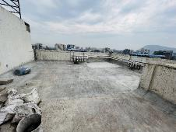
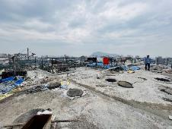
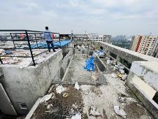
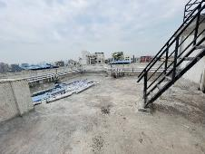
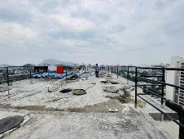
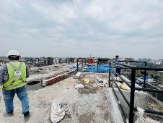
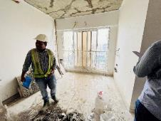
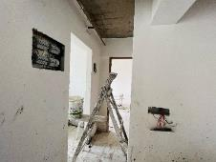
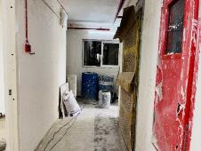
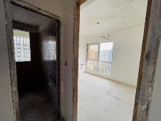
Actual Site Photographs – A wing
Actual Site Photographs – A wing
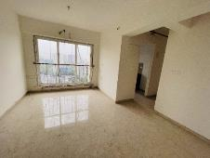
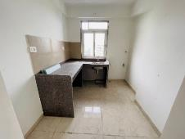
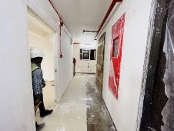
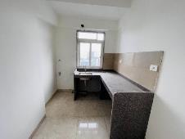
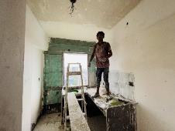
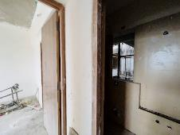
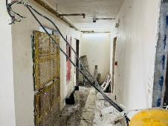
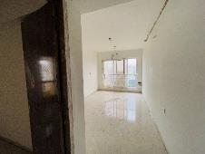
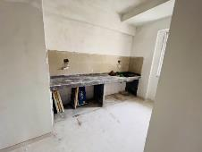
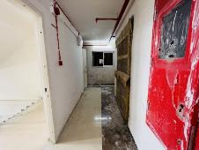

Actual Site Photographs – A wing
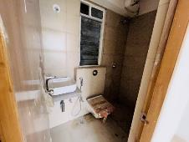
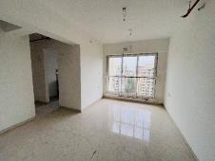
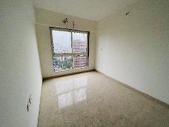
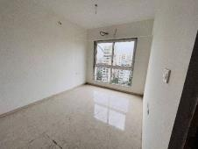
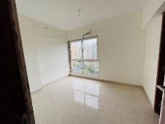
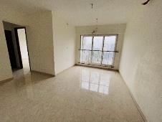
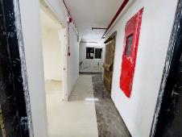
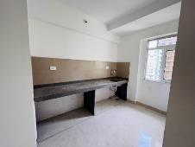
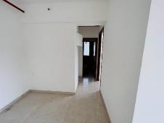
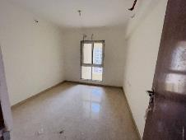
Actual Site Photographs – A wing
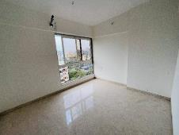
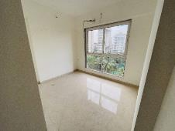
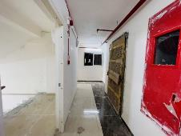
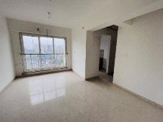
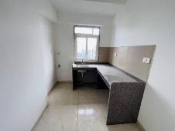
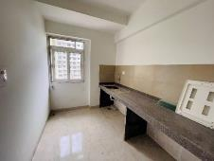
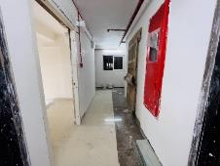
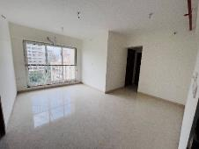
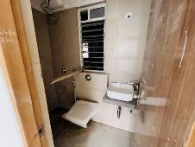
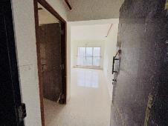
Actual Site Photographs – A wing
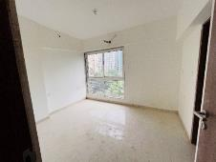
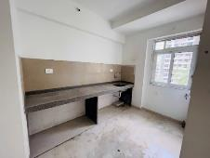
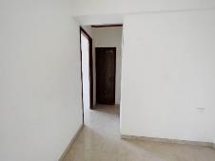
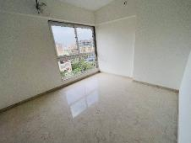
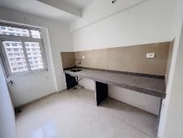
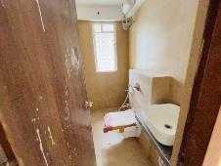
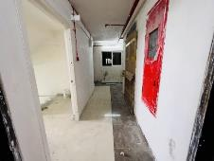
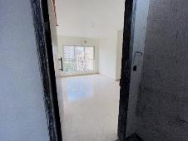
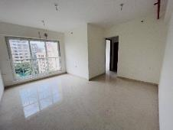
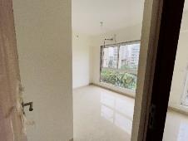
Actual Site Photographs – A wing
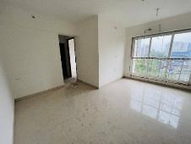
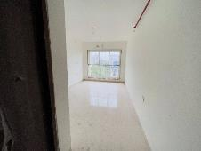
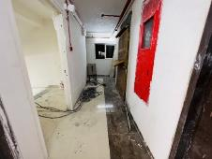
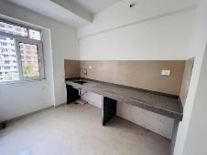
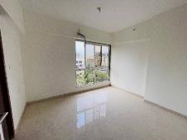
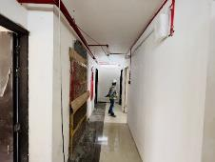
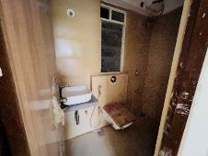
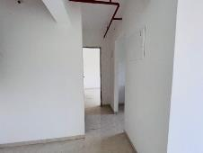
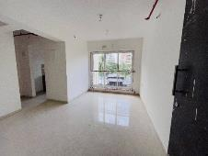
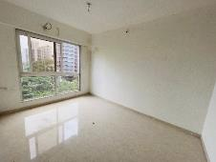
Actual Site Photographs – A wing
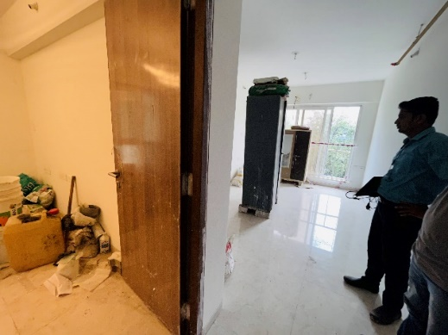
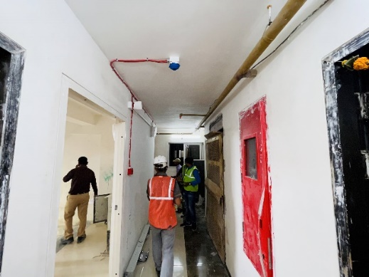
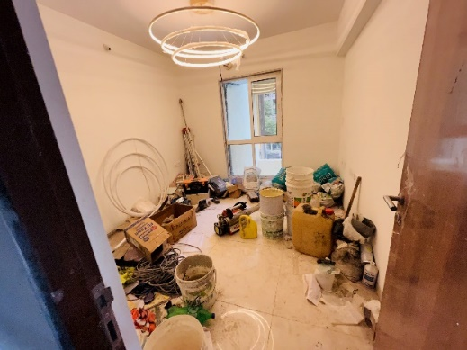
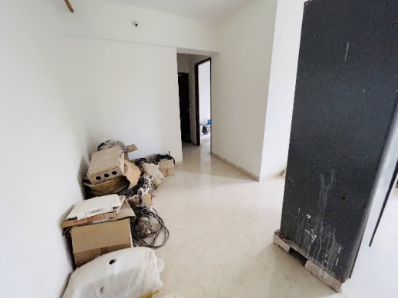
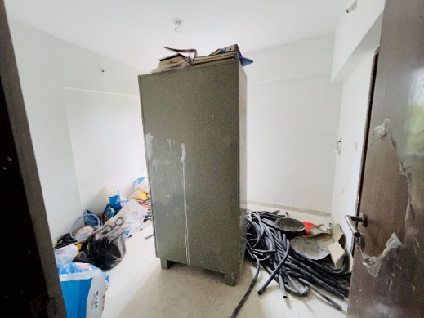
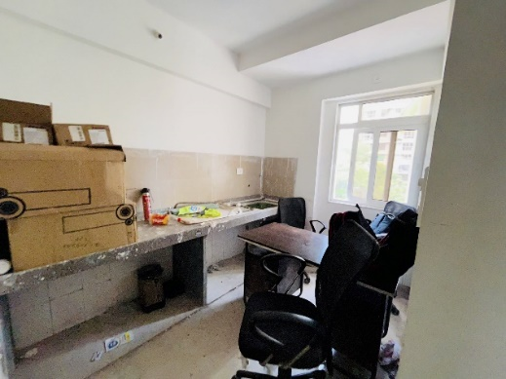
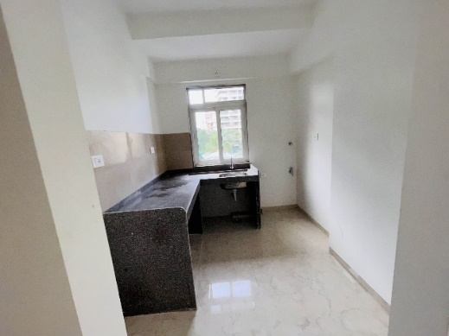
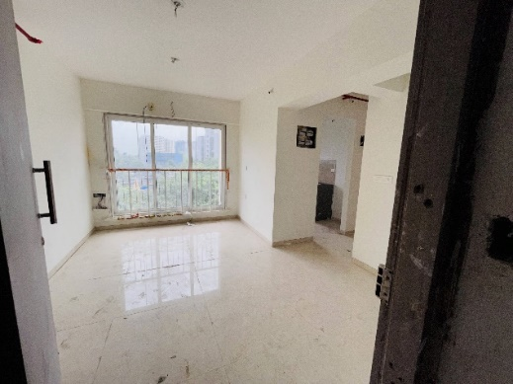
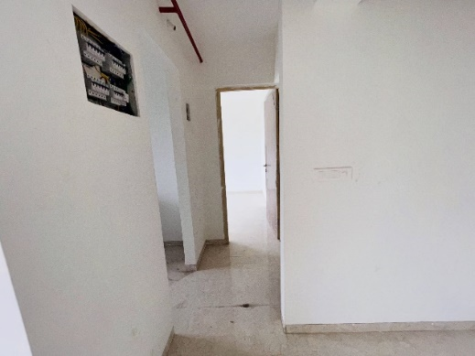
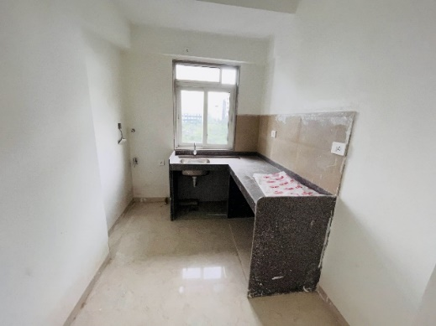
Actual Site Photographs – A wing
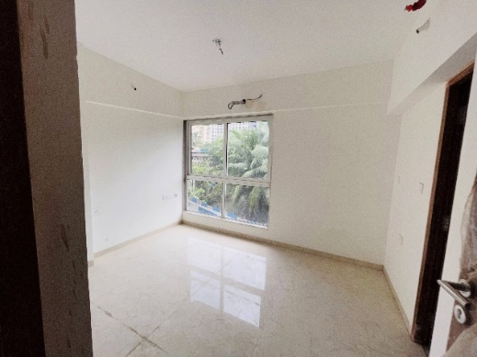
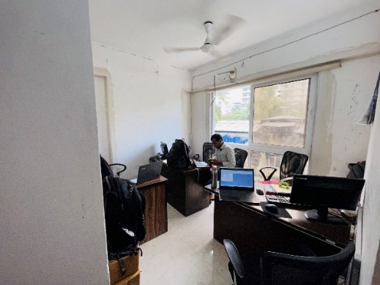
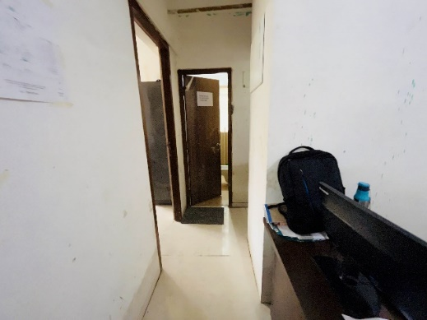
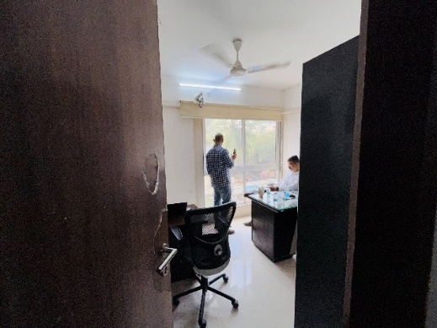
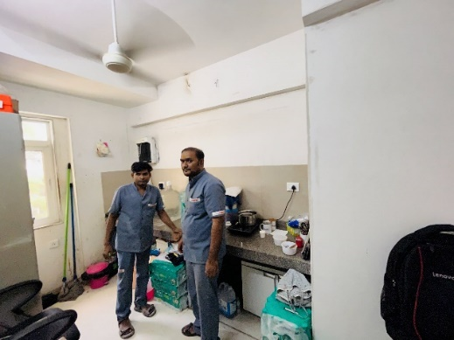
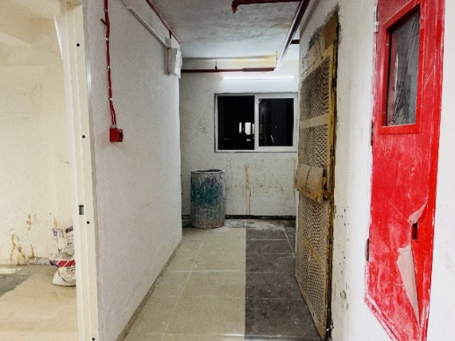
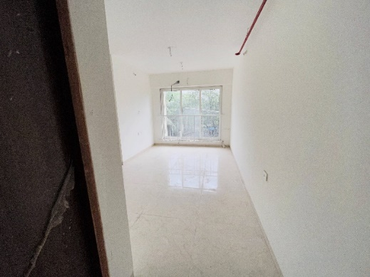
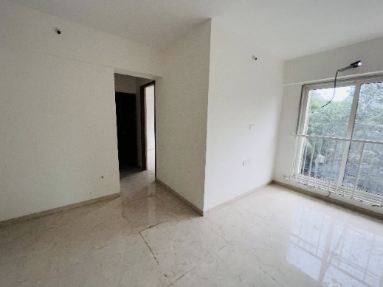
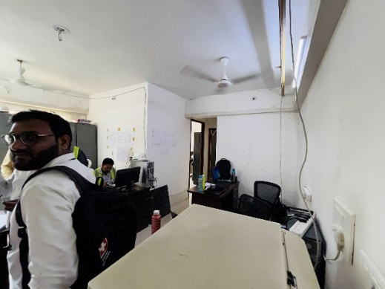
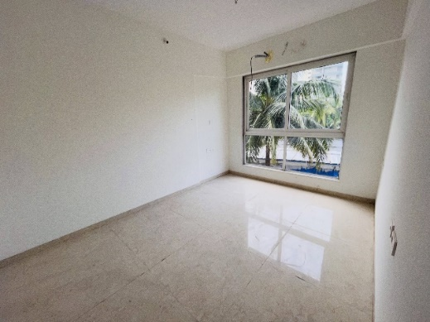
Actual Site Photographs – A wing
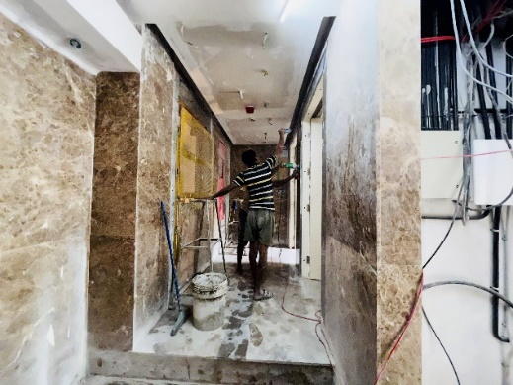
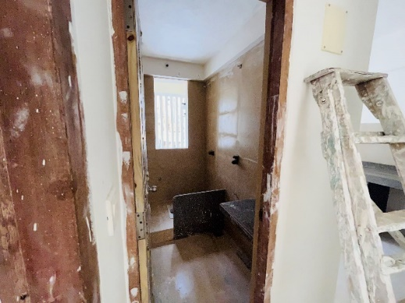
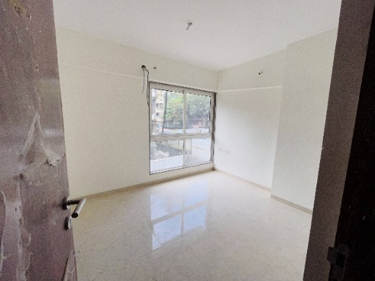
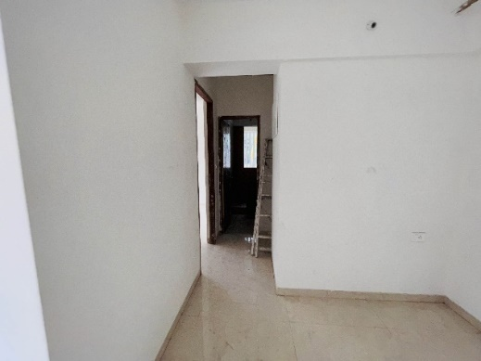
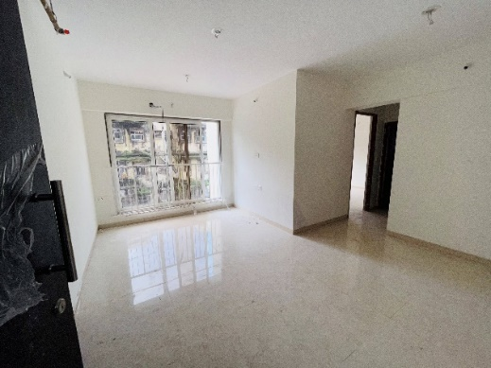
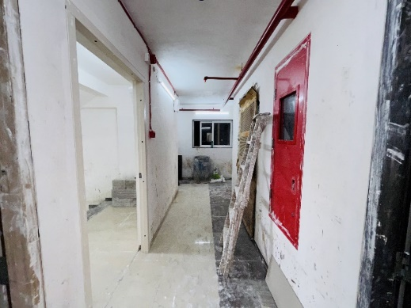
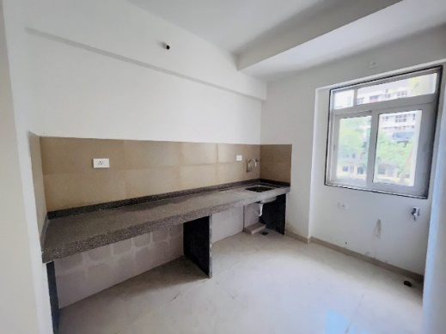
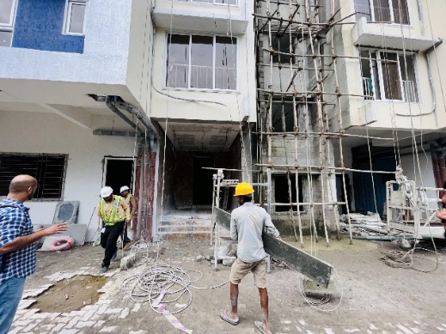
Actual Site Photographs – A wing
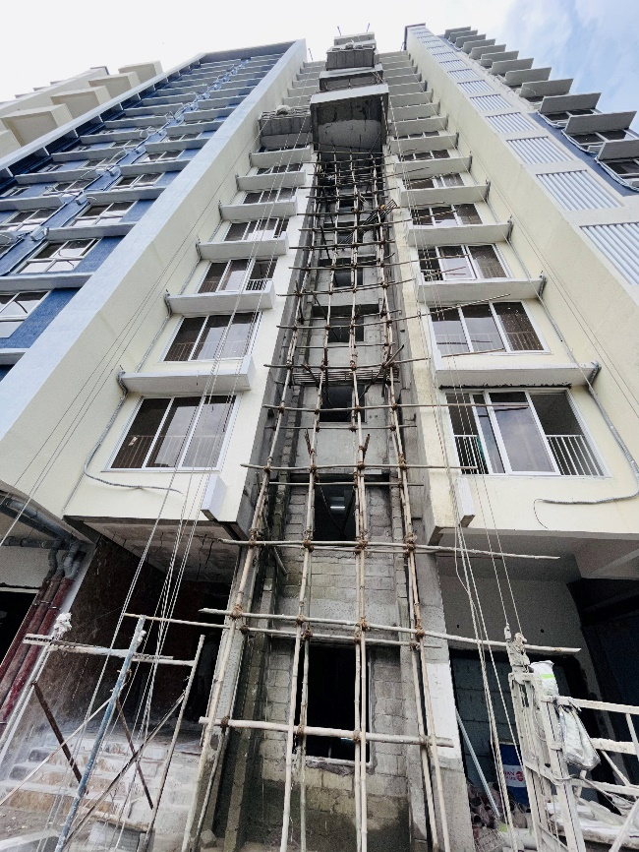
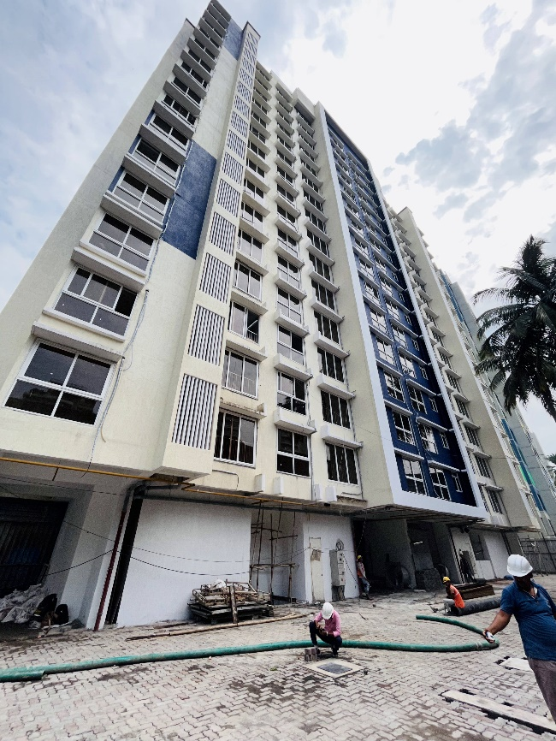
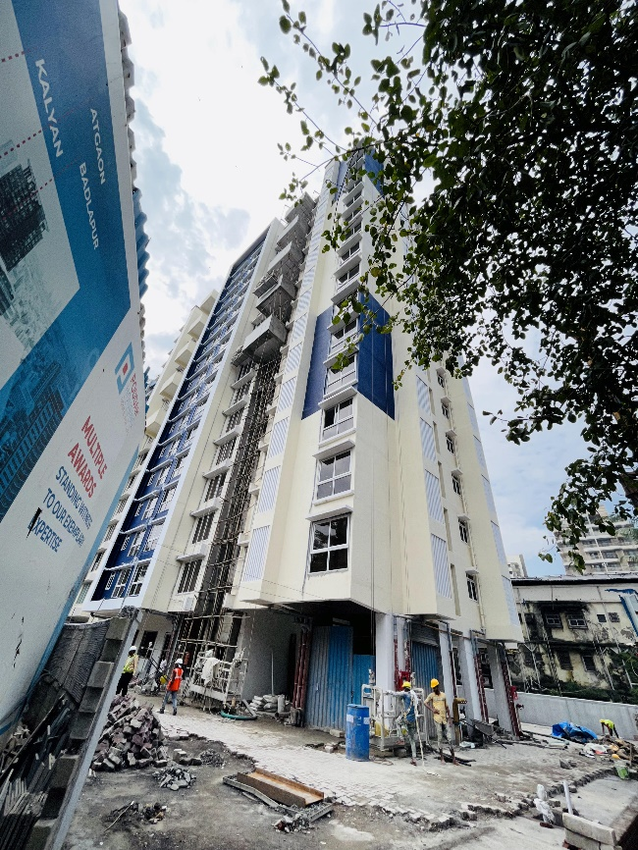
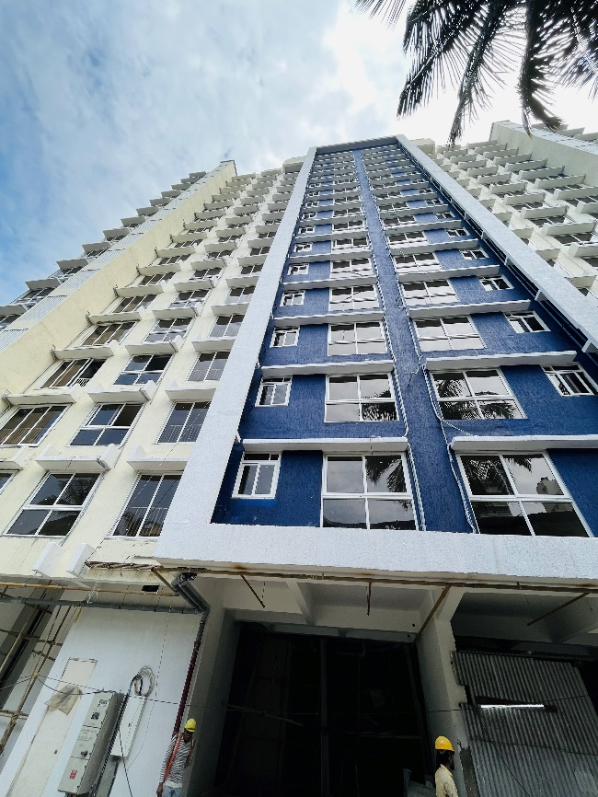

Actual Site Photographs – B wing
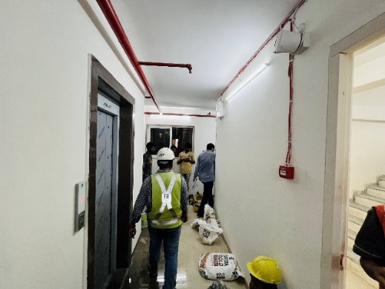
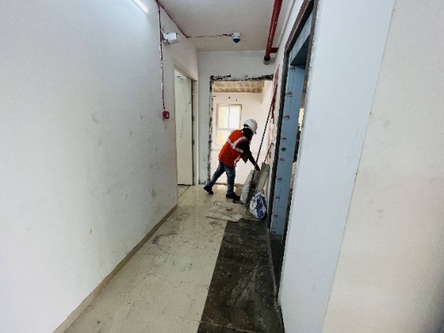
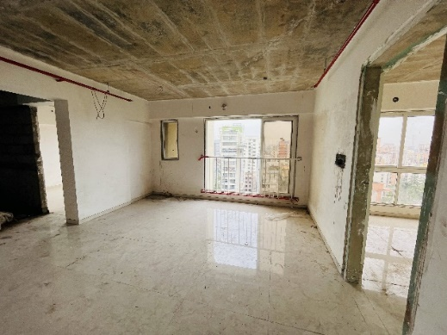
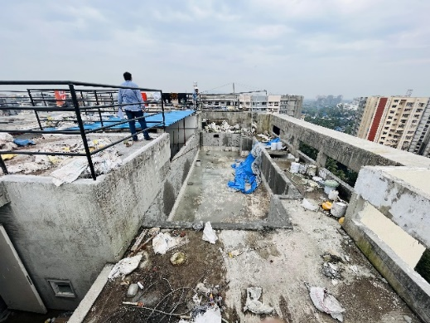
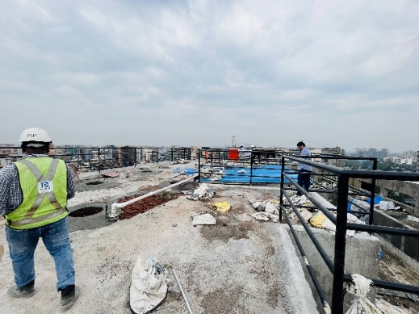
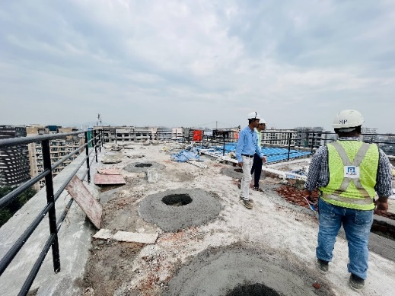
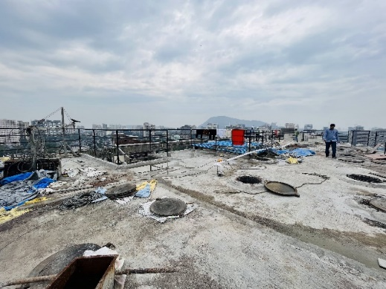
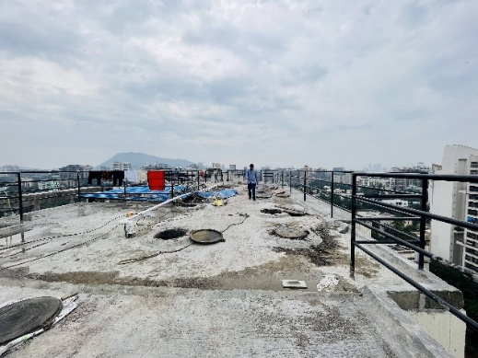
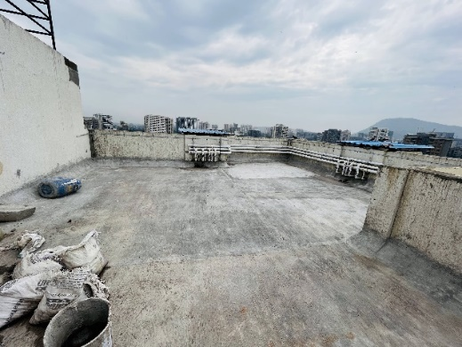
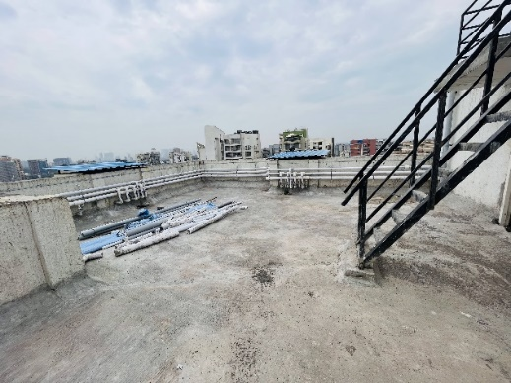
Actual Site Photographs – B wing
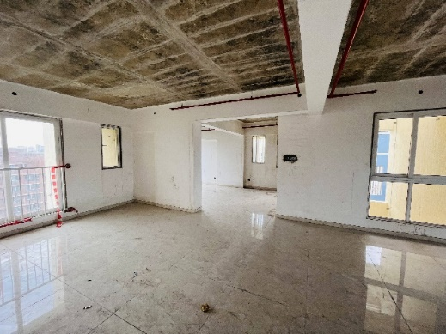
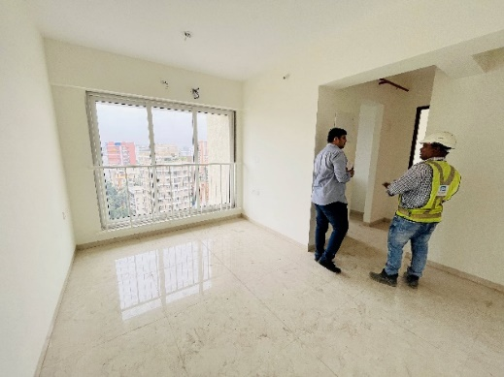
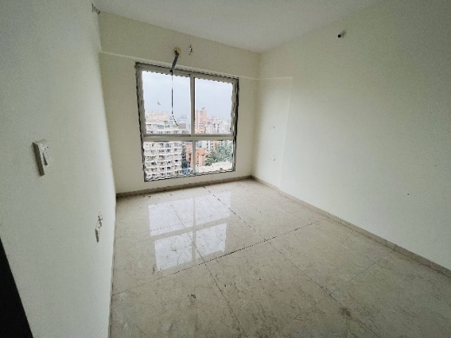
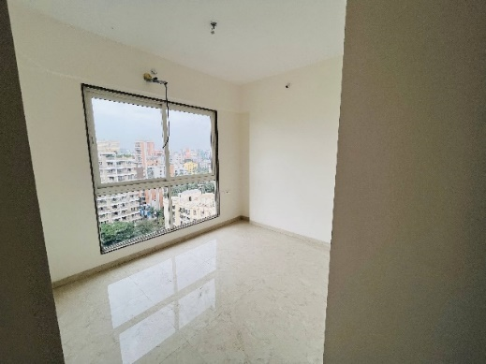
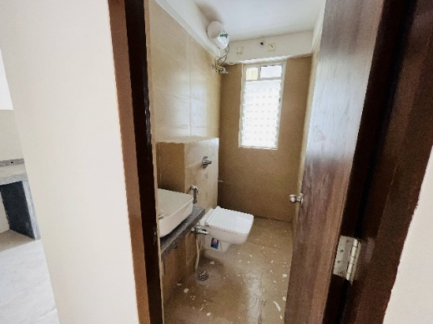
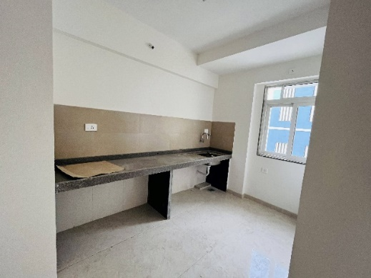
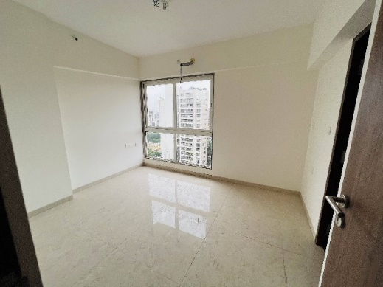
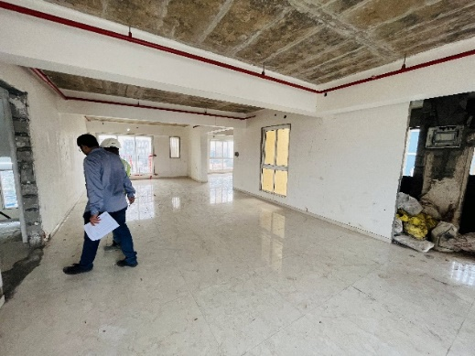
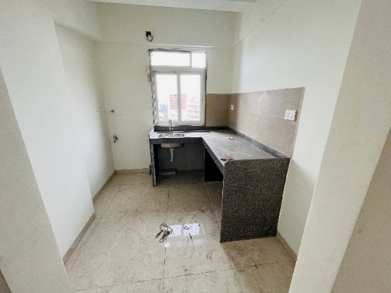
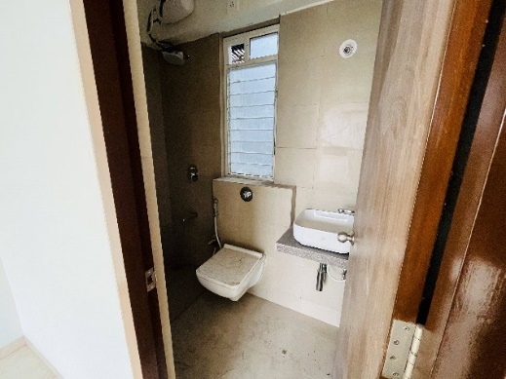

Actual Site Photographs – B wing
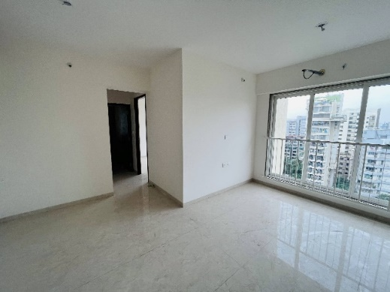
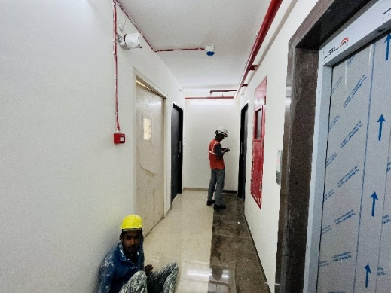
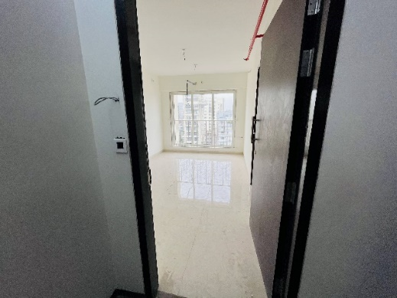
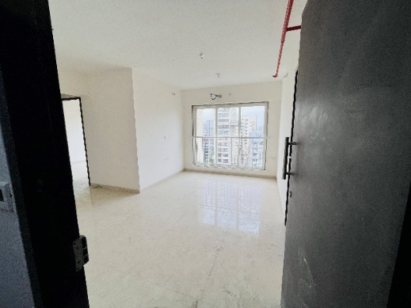
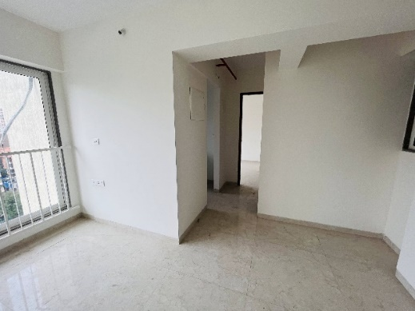
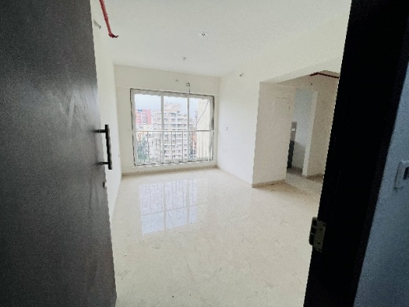
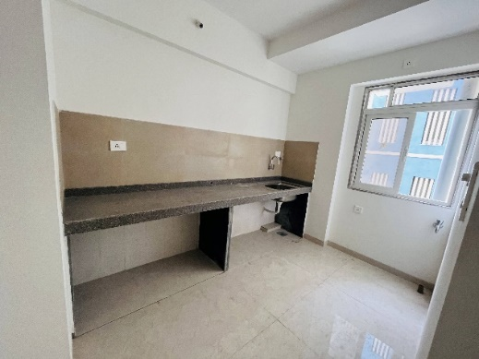
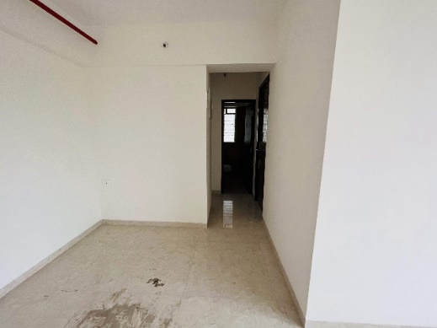
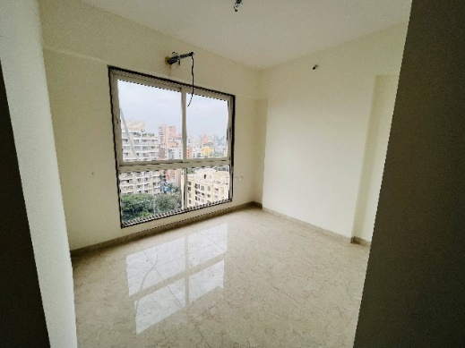
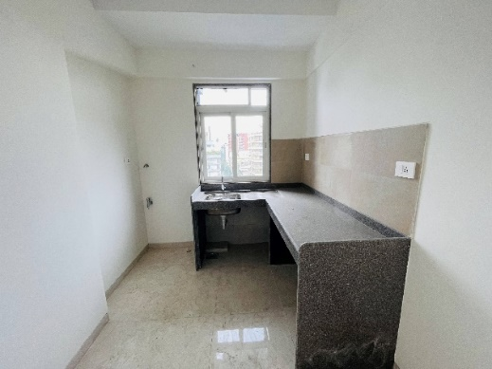
Actual Site Photographs – B wing
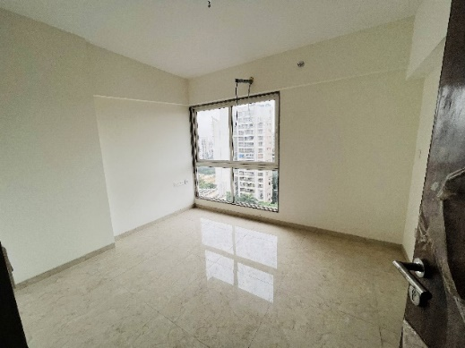
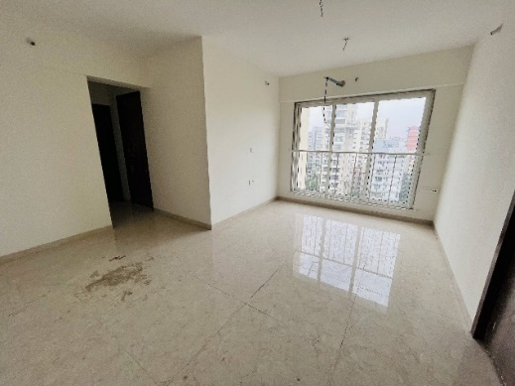
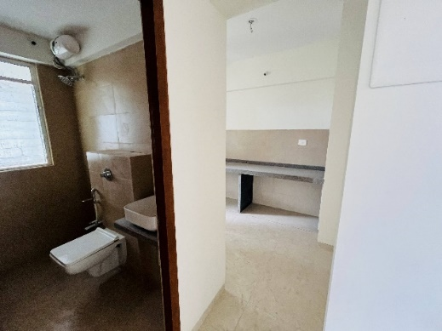
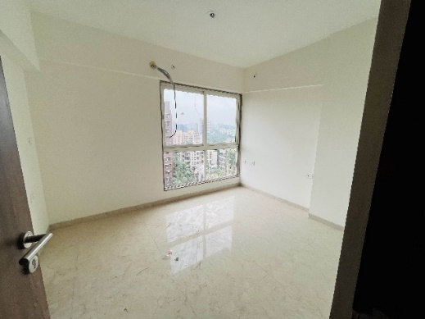
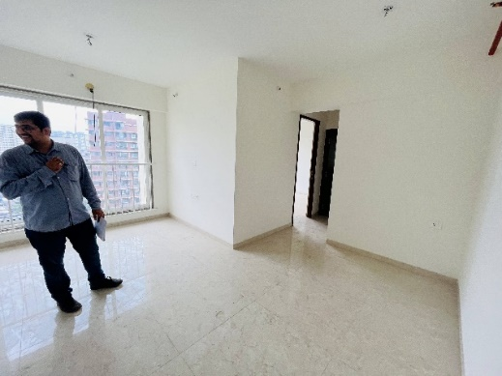
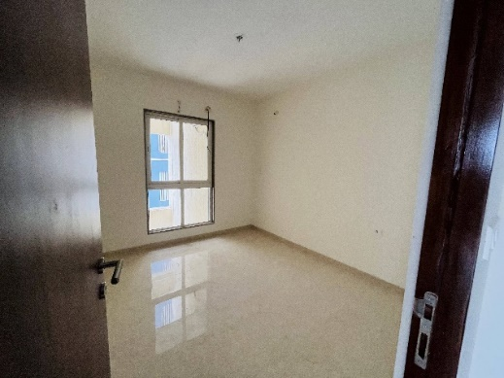
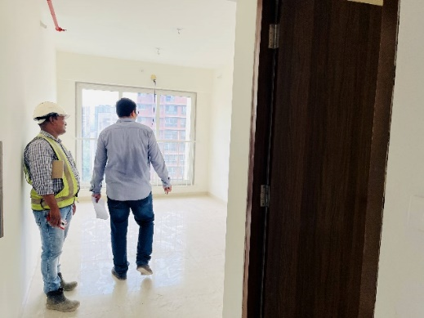
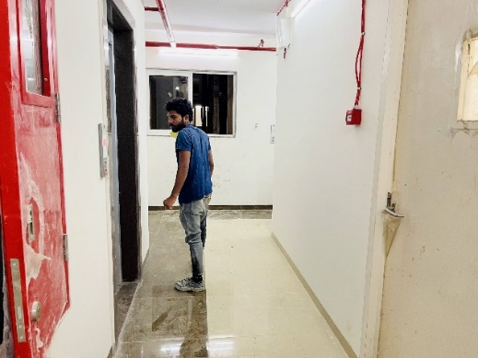
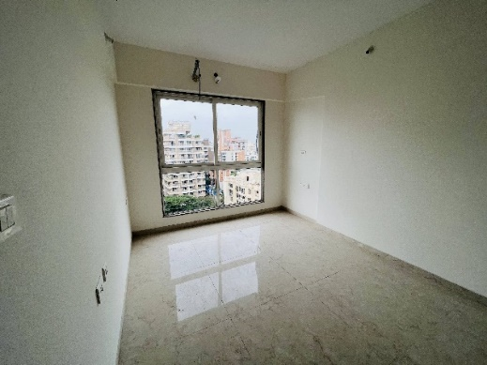
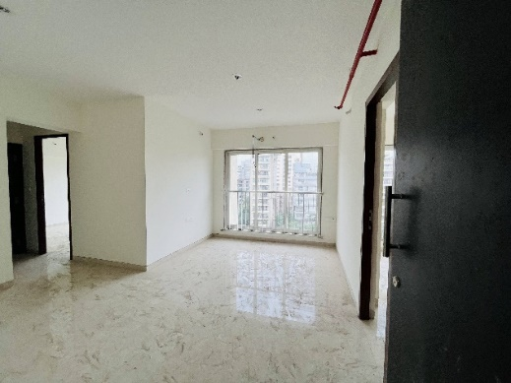
Actual Site Photographs – B wing
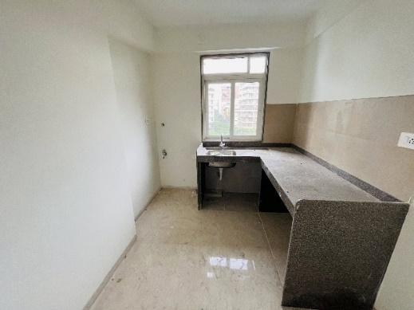
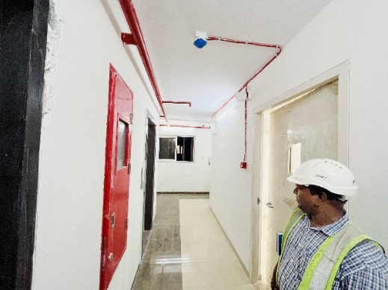
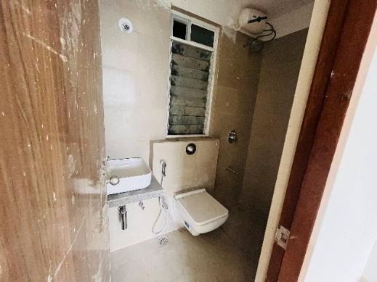
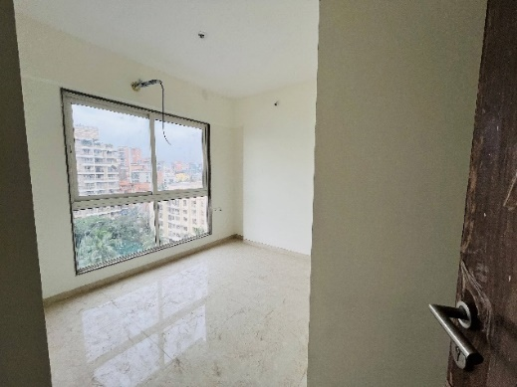
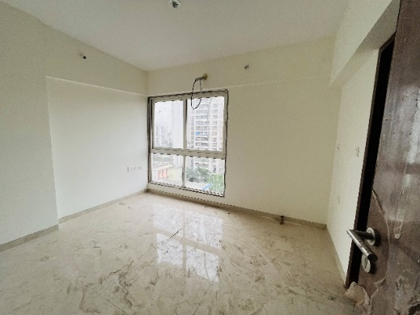
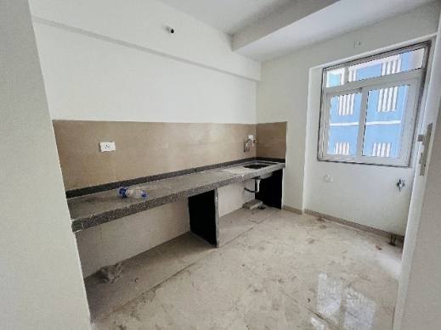
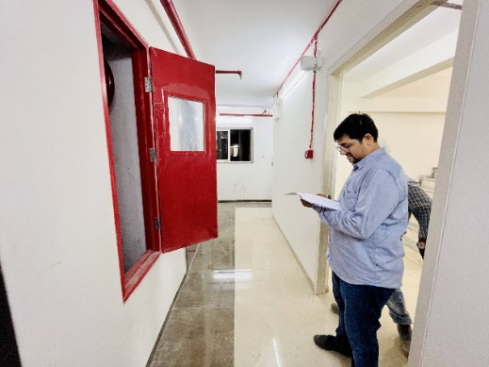
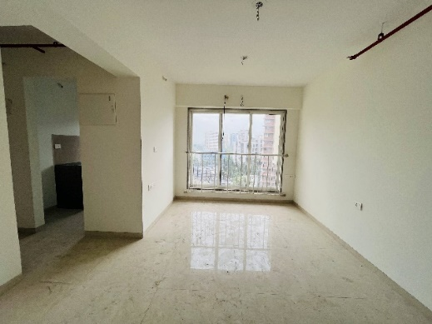
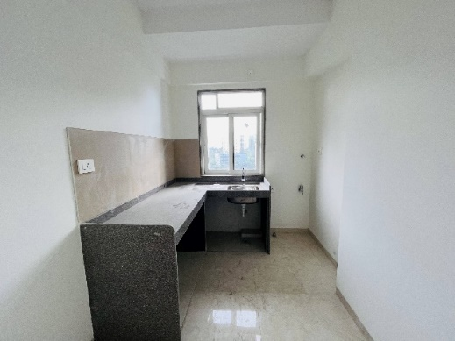
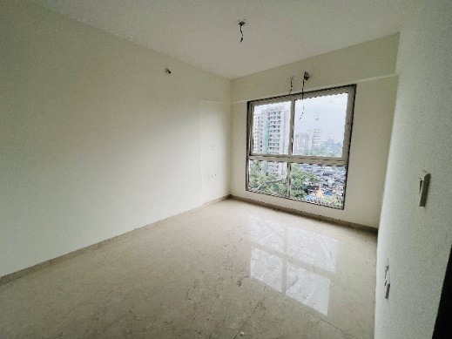
Actual Site Photographs – B wing
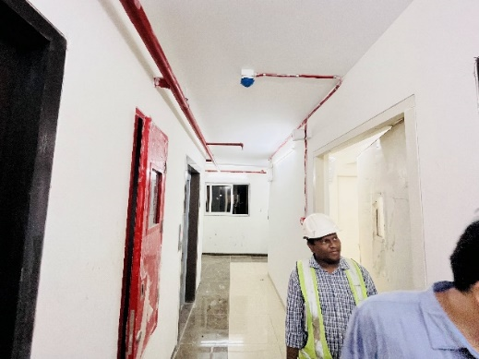
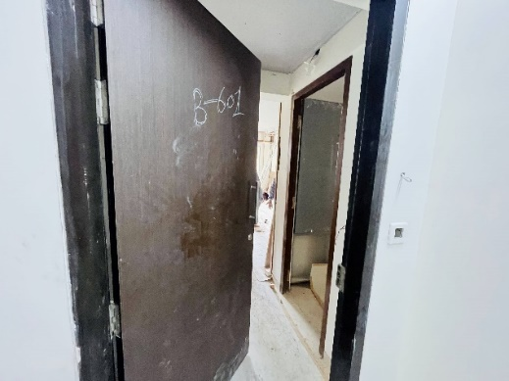
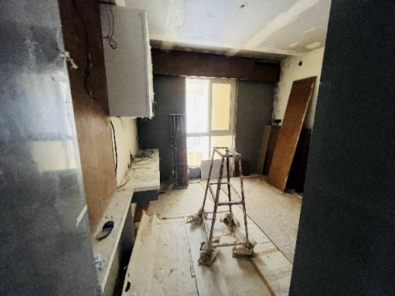
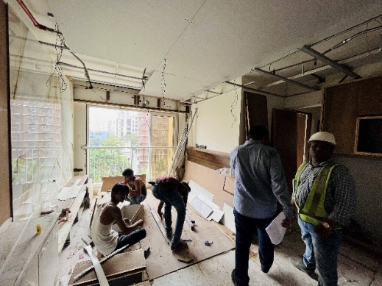
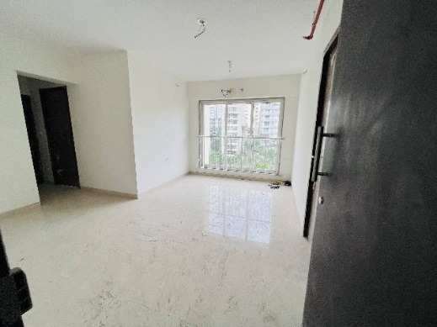
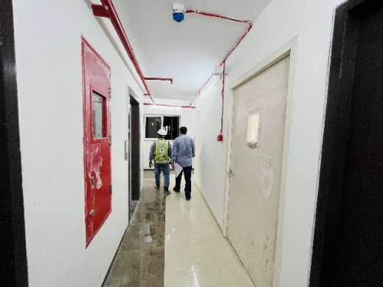
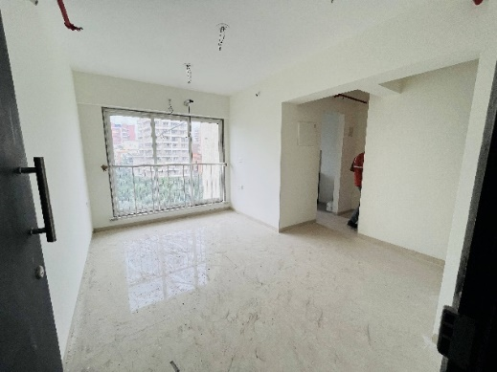
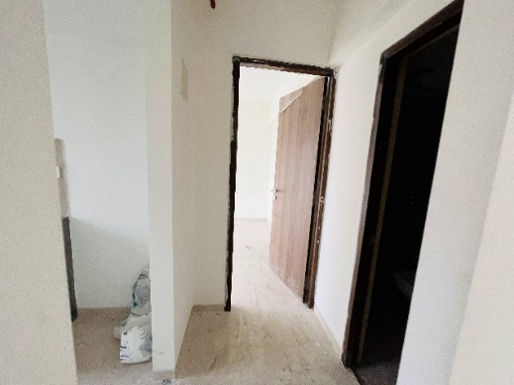
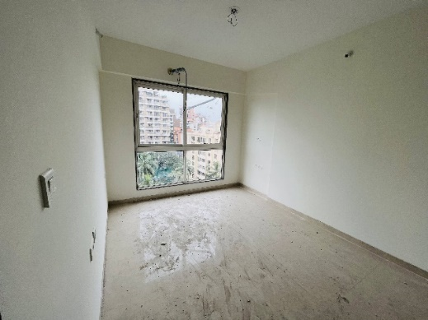
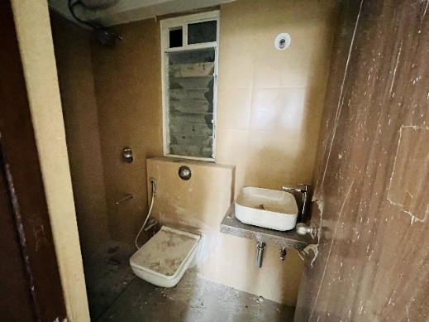
Actual Site Photographs – B wing
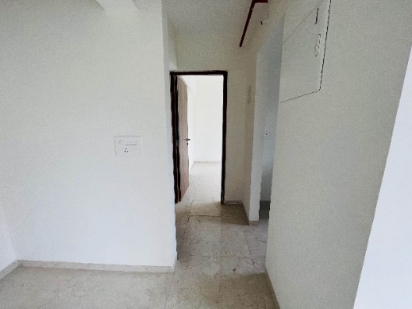
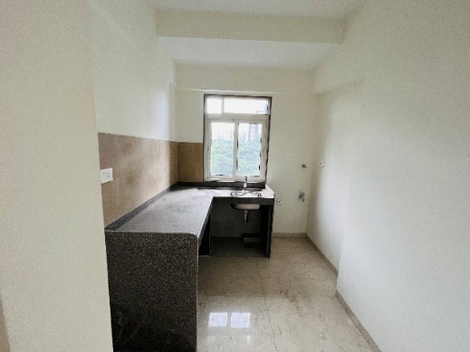
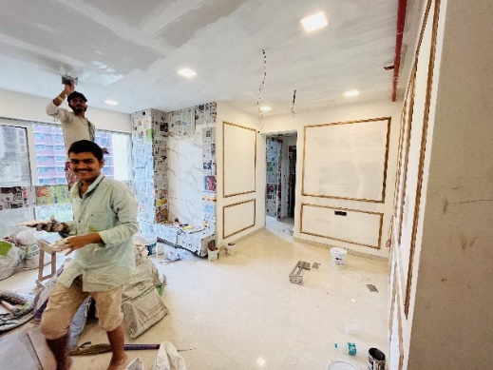
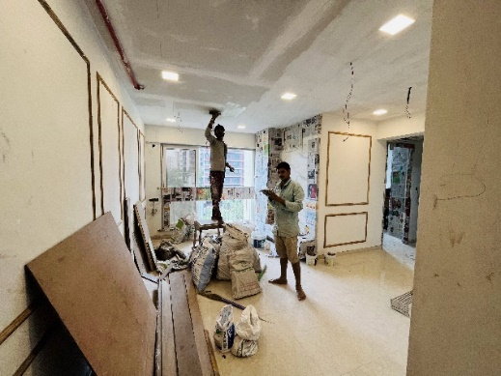
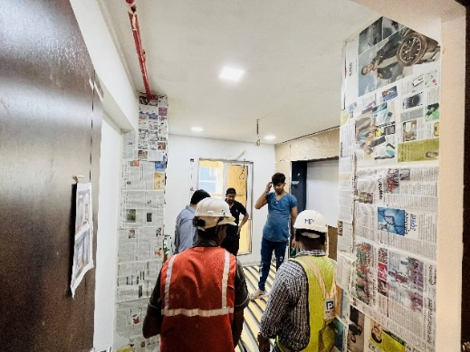
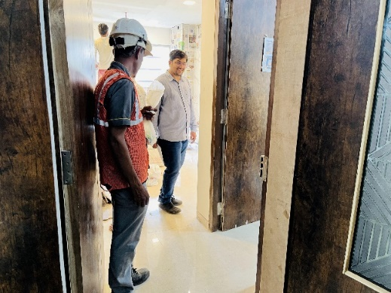
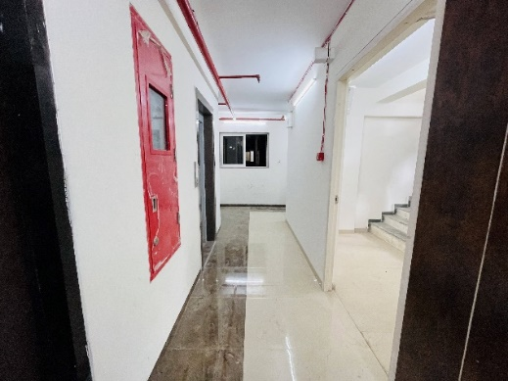
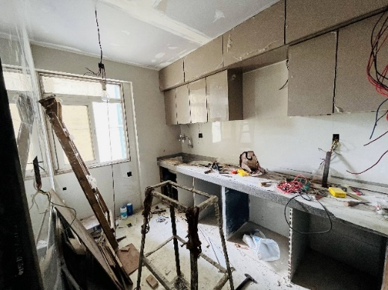
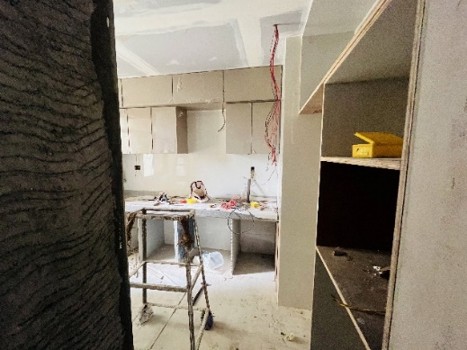
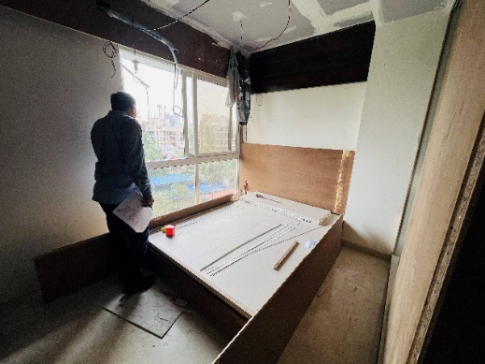
Actual Site Photographs – B wing
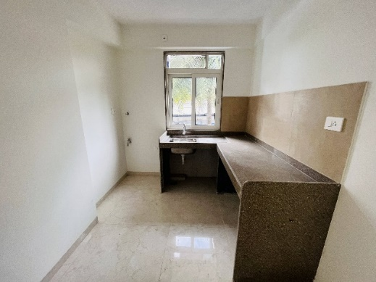
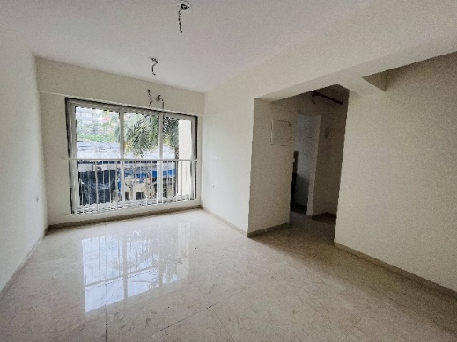
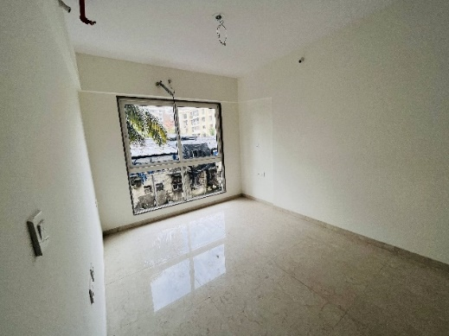
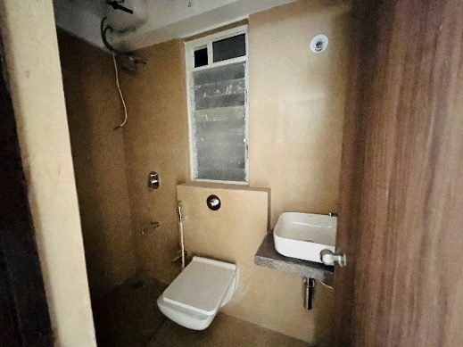
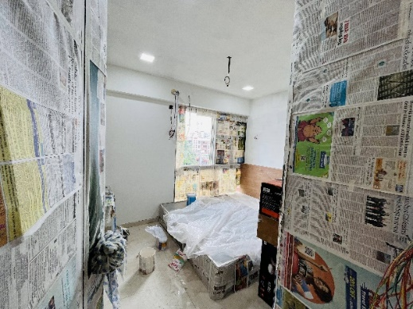
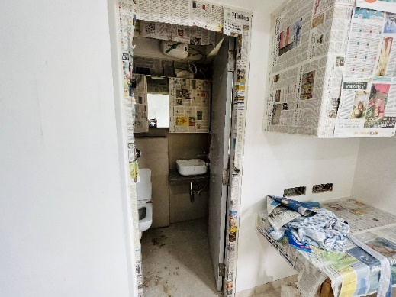
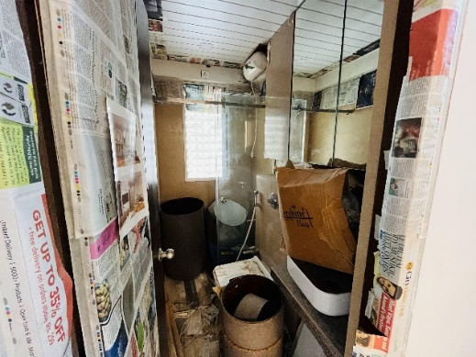
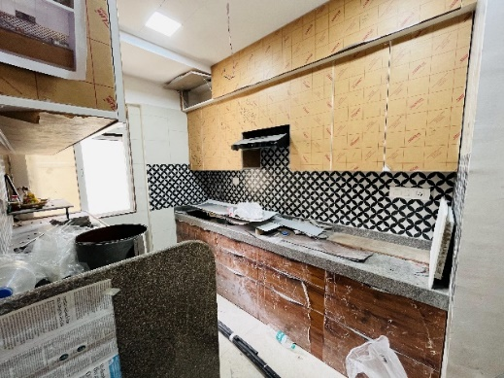
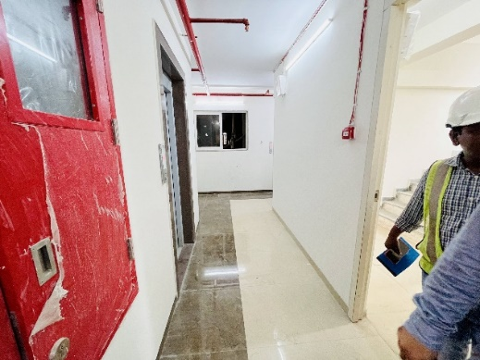
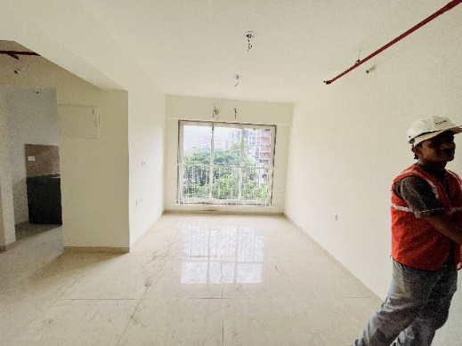
Actual Site Photographs – B wing
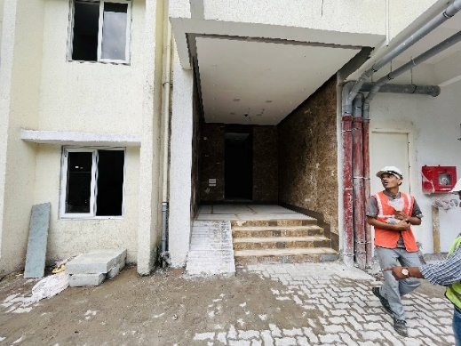
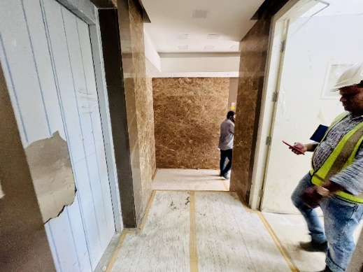
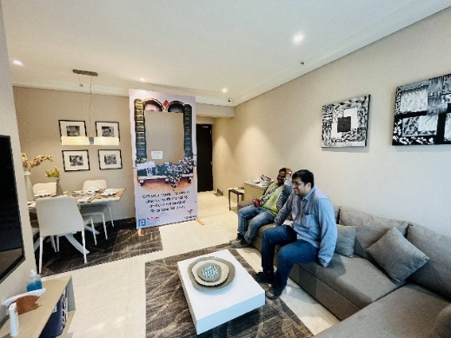
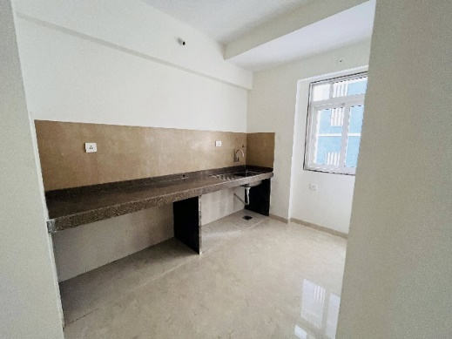
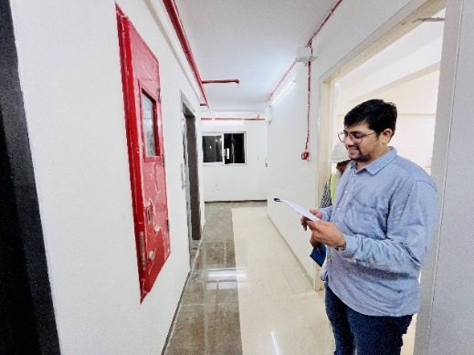
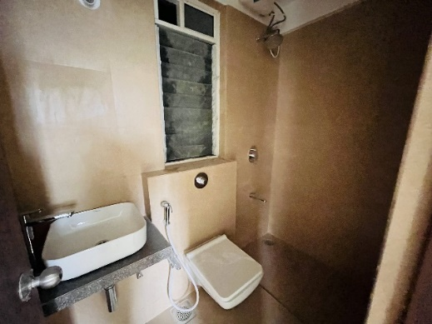
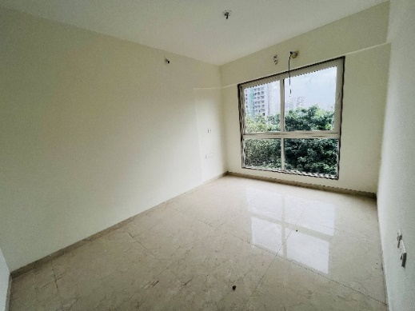
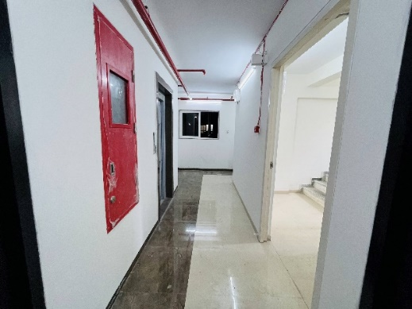
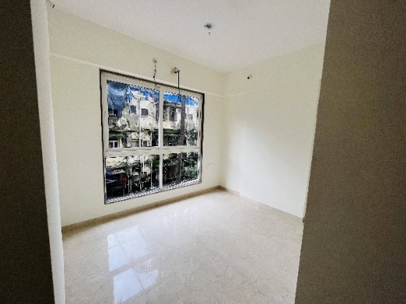
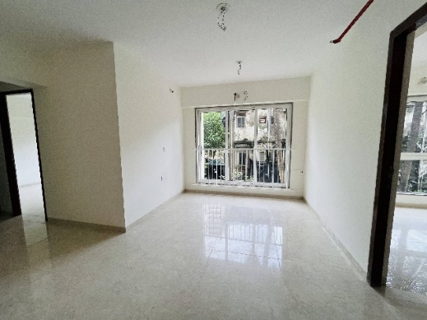
Actual Site Photographs – B wing
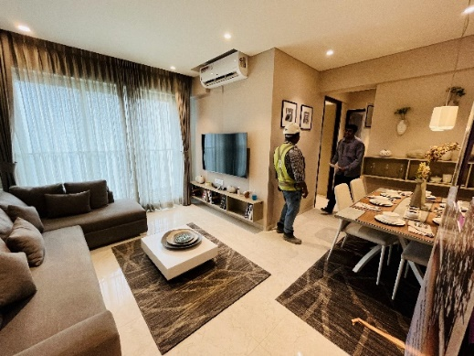
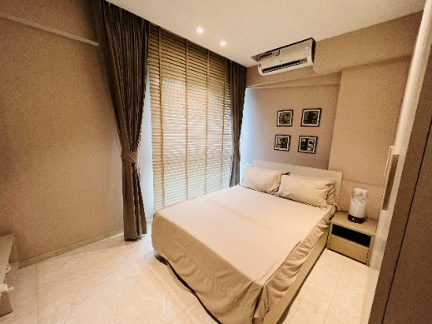
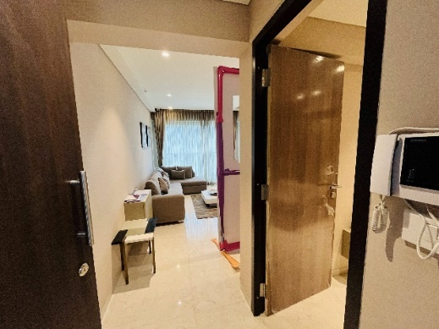
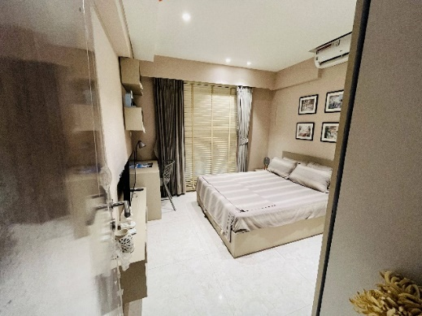
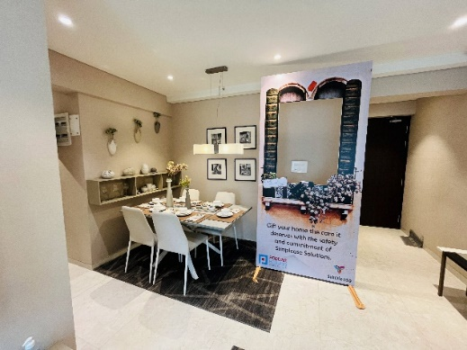
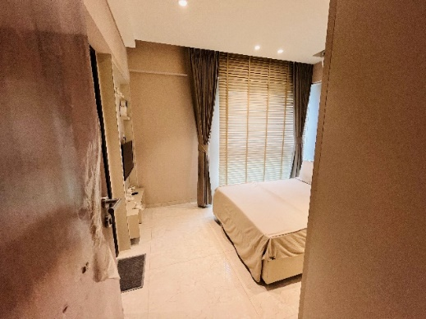
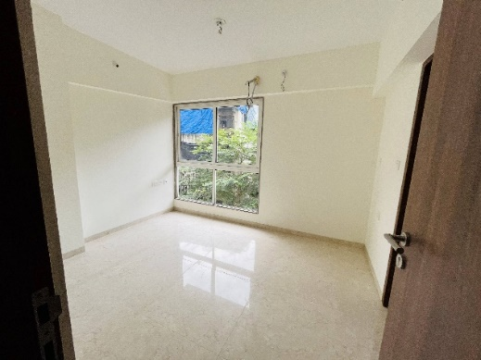
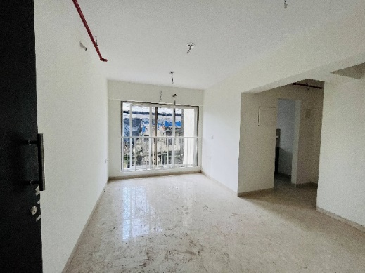
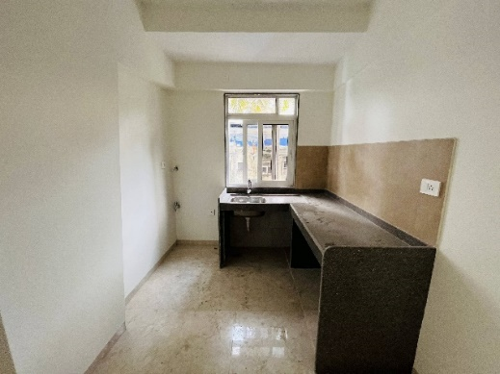
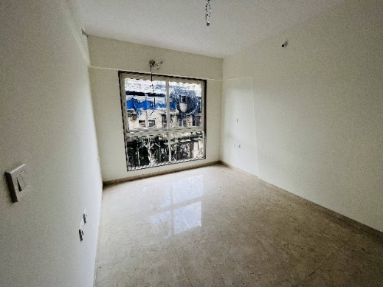
Actual Site Photographs – B wing
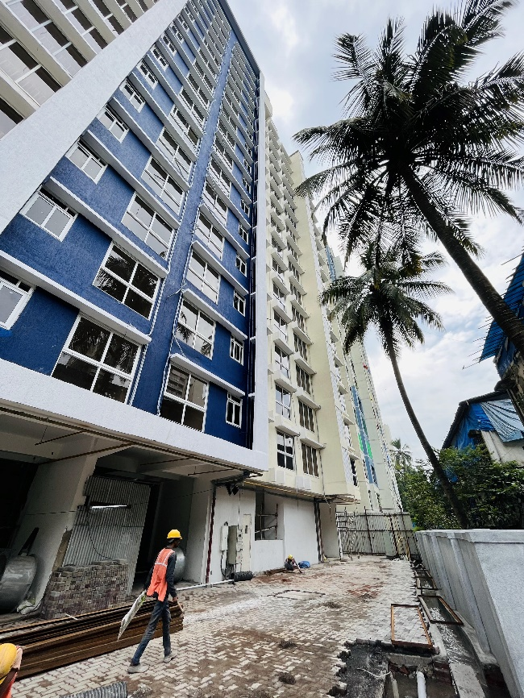
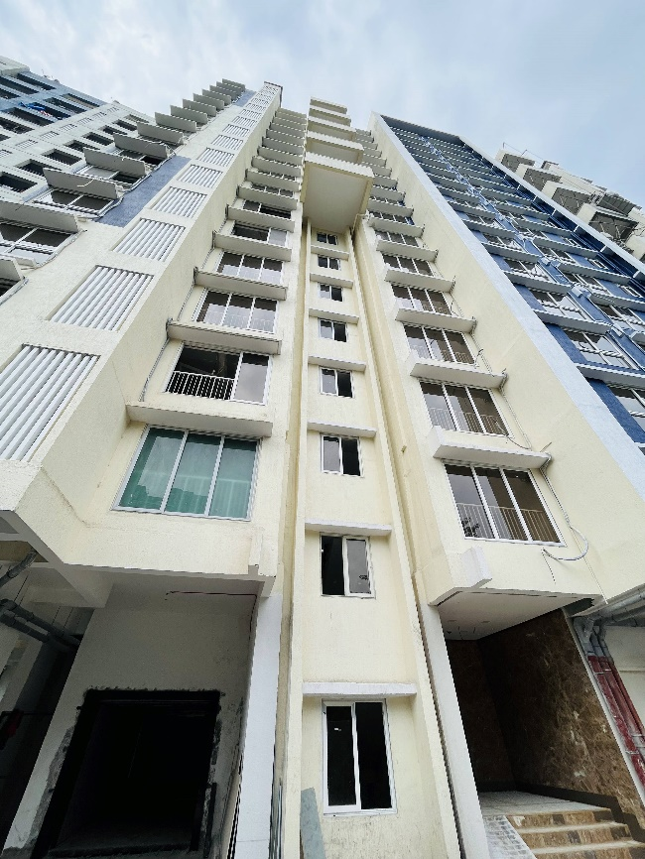
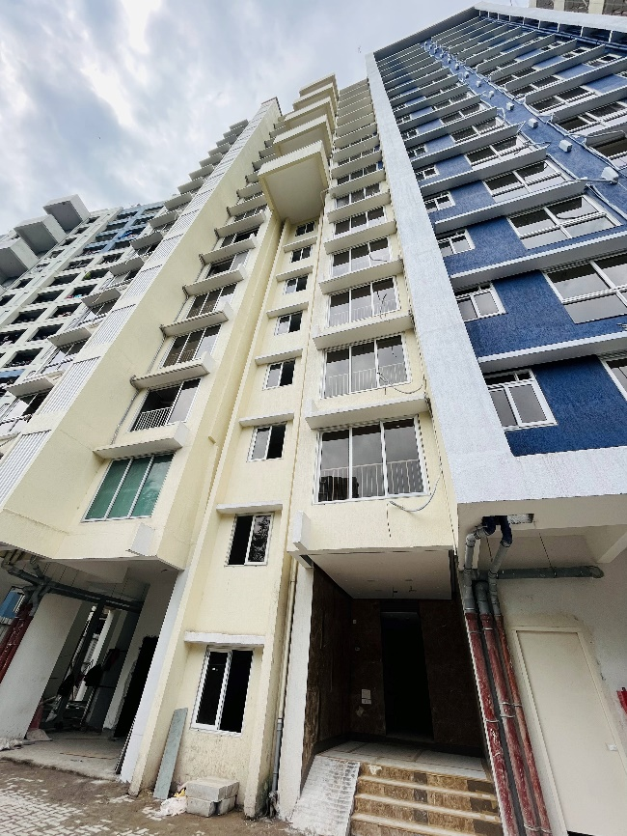
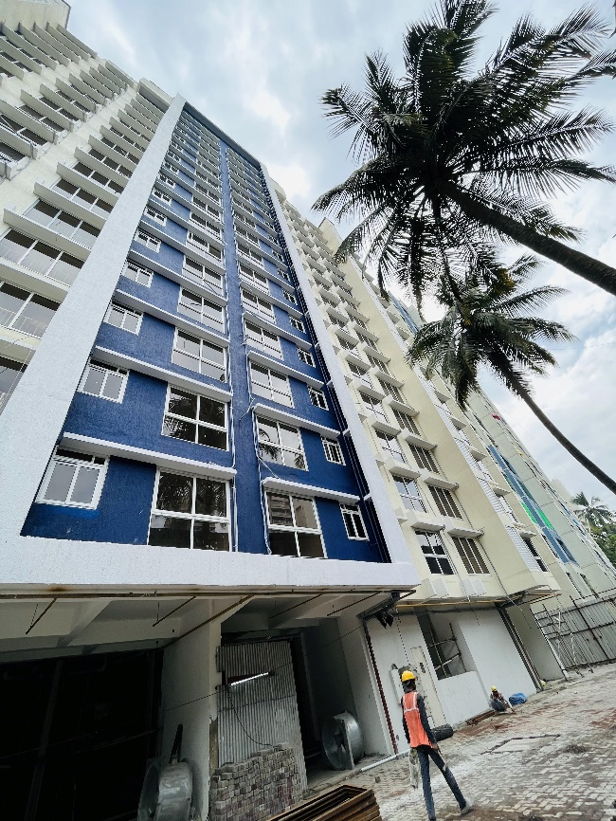

Route Map of the property
Site u/r
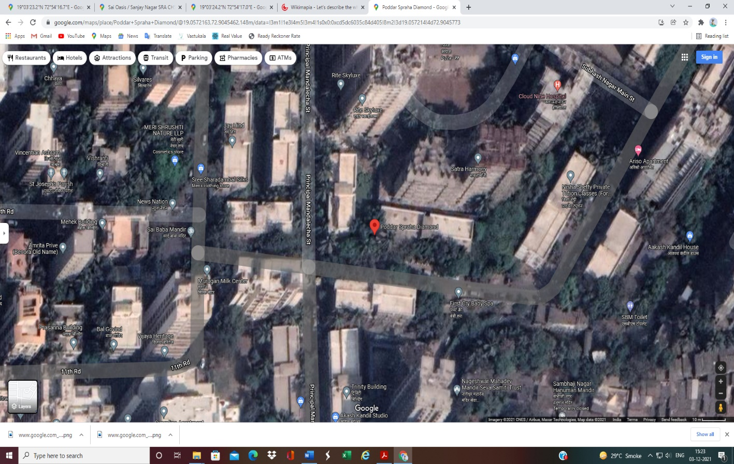

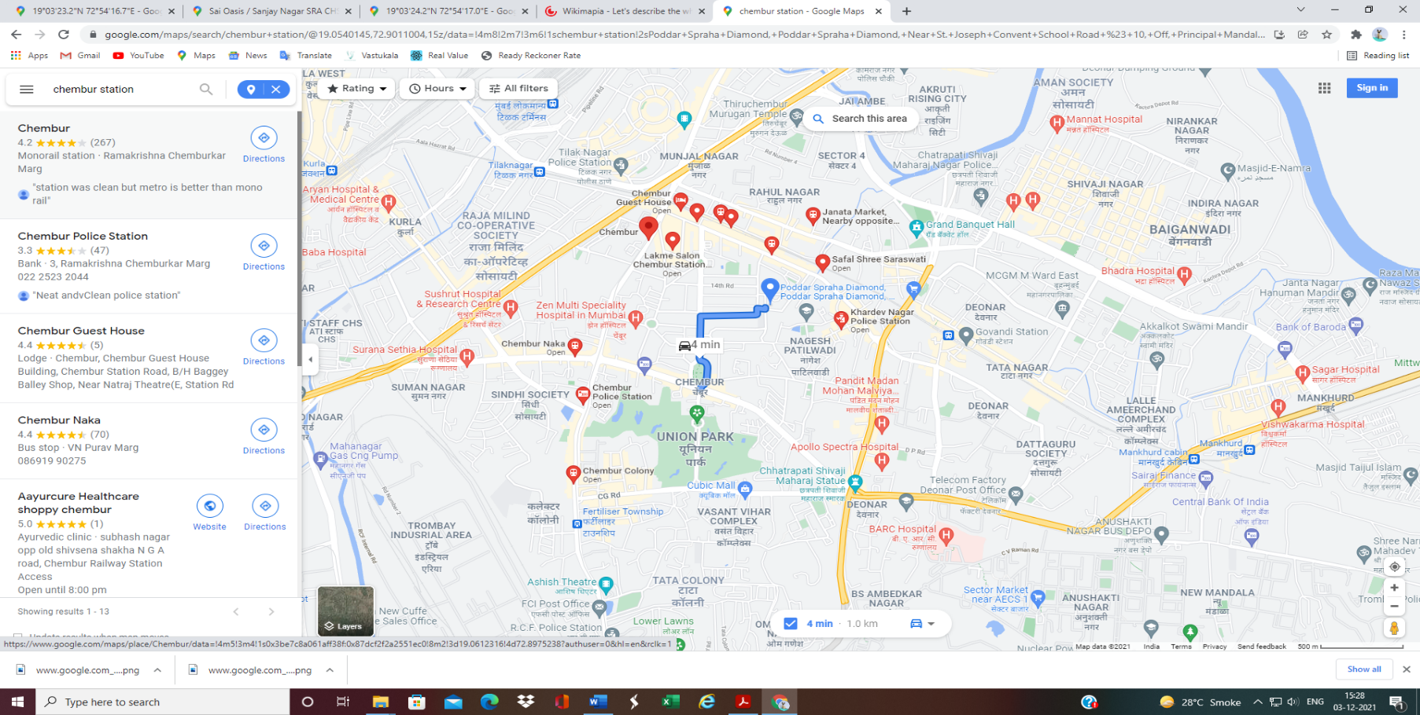

Latitude Longitude: 19°03'30.5"N 72°54'16.3"E

Note: The Blue line shows the route to site from nearest railway station (Chembur Station –1.0 KM.)

CA Certificate dated 27.06.2023 till 31.12.2022
