Visit Report of Immovable Property

Sr. No. | Particulars | Content
 | Introduction
 | Name of Valuer | Manoj B. Chalikwar  Vastukala Consultants (I) Pvt. Ltd.  106, 1st Floor, Gold Star Tower, Opp. Treasure Island Mall, M.G. Road, Indore – 452 001.
 | Date of Inspection | 19.06.2023
 | Sale Deed Number and Date | Sale Deed, E-Registration No. MP179092023A11925776 dated 01.06.2023.
 | Date of Report | 21.07.2023
 | Purpose of Visit | As per request from Punjab National Bank, MID Corporate Centre to submit the visit report.
 | Name of Property Owner/s  (Details of share of each owner in case of joint & Co-ownership) | M/s. Kamco Chew Food Pvt. Ltd.
 | Name of Bank/FI as applicable | Punjab National Bank
 | Name of Developer of the Property  (in case of developer built properties) | N.A. as the property is residential open land.
 | Whether occupied by the owner / tenant? If occupied by tenant, since how long? | Vacant Land under owner’s possession.
 | Physical Characteristics of the Property
 | Location of the Property
 | Plot No. / Survey No. | Survey No. 241/1/1, 241/1/2, 241/1/3, 241/2, 242/1, 242/2, 247/1/1/1, 247/1/2, 247/2/1, 247/2/3.
 | Door No. | -
 | T. S. No. / Village | P. H. No. - 31, Gram – Rajoda
 | Ward / Tehsil | P. H. No. 31, Tehsil – Sanwer
 | Mandal / District | District – Indore
 | Brief description of the property:
As per site inspection, the immovable property comprises of Diverted Residential Open Land owned by M/s. Kamco Chew Food Pvt. Ltd. The property is located in a developing area having basic infrastructure, well connected by road. It is located at 22.6 KM. travelling distance from Indore Junction railway station.

Nearby Landmark: Palm Corridor

Land:
As per Sale Deed, the land area is as below –
Survey No. | Area in Hectare | Area in Sq. M. | Area in Sq. Ft.
241/1/1 | 0.076 | 760.00 | 8,181.00
241/1/2 | 0.250 | 2,500.00 | 26,910.00
241/1/3 | 0.250 | 2,500.00 | 26,910.00
241/2 | 0.577 | 5,770.00 | 62,108.00
242/1 | 0.641 | 6,410.00 | 68,997.00
242/2 | 0.642 | 6,420.00 | 69,105.00
247/1/1/1 | 0.253 | 2,530.00 | 27,233.00
247/1/2 | 2.011 | 20,110.00 | 2,16,464.00
247/2/1 | 2.706 | 27,060.00 | 2,91,274.00
247/2/3 | 0.506 | 5,060.00 | 54,466.00
Total | 7.912 | 79,120.00 | 8,51,648.00

As per Sale Deed, total land area of all 10 Survey Nos. is 7.912 Hectare i.e. is 79,120 Sq. M.

As per Site Inspection, all Survey Nos. 241/1/1, 241/1/2, 241/1/3, 241/2, 242/1, 242/2, 247/1/1/1, 247/1/2, 247/2/1, 247/2/3 are merged. The Overall Land is demarcated by R.C.C Polls. The land is accessible from south side.
 | Municipal Ward No. | P.H. No. 31 (Sanwer)
 | City / Town | Rajoda, Indore
 | Residential Area / Commercial Area / Industrial Area | Residential Area
 | Classification of the area:
 | High / Middle / Poor | Middle
 | Metro / Urban / Semi Urban / Rural | Semi Urban
 | Coming under Corporation limit/ Village Panchayat/ Municipality | Gram Panchayat Rajoda
 | Postal Address of the Property | Residential Open Land Bearing Survey No. 241/1/1, 241/1/2, 241/1/3, 241/2, 242/1, 242/2, 247/1/1/1, 247/1/2, 247/2/1, 247/2/3, P.H.N - 31, Gram - Rajoda, Tehsil - Sanwer, District - Indore, PIN – 453 551, State – Madhya Pradesh, Country – India.
 | Latitude, Longitude and Coordinates of the site | 22°53’38.8”N 75°50’29.8”E
 | Area of the plot/land  (Supported by a plan) | Plot of land area = 79,120 Sq. M.  (Area as per Sale Deed)
 | Layout plan of the area in which the property is located | N.A. as the property is residential open land.
 | Development of surrounding areas | Developing
 | Details of Roads abutting the property | Rajoda Road
 | Whether covered under any State / Central Govt. enactments (e.g., Urban Land Ceiling Act) or notified under agency area / scheduled area /cantonment area | N.A.
 | In case it is an agricultural land, any conversion to house site plots is contemplated | No
 | Boundaries of the property | As per actual at site | As per Sale deed
 | North | Land of Survey No. 240/1, 240/2/1, 240/2/2, 240/2/3 & 247/1/1/2 | Land of Survey No. 240/1, 240/2/1, 240/2/2, 240/2/3 & 247/1/1/2
 | South | Govt. Kankad / Road | Govt. Kankad
 | East | Land of Survey No. 247/2/2, 279/3 & 279/4 | Land of Survey No. 247/2/2, 279/3 & 279/4
 | West | Land of Survey No. 238, 243, 246/2 & 247/1/1/2 | Land of Survey No. 238, 243, 246/2 & 247/1/1/2
 | Extent of the site considered for visit (least of 14 A & 14 B) | Plot of land area = 79,120 Sq. M.  (Area as per Sale Deed)
 | Survey no. if any | Survey No. 247/2/1, 241/1/1, 241/1/3, 247/1/2, 241/1/2, 242/1, 241/2, 247/2/3, 247/1/1/1 & 242/2
 | Type of Building (Residential/ Commercial/ Industrial) | N.A. as the property is residential open land.
 | Details of the building / buildings and other improvements in terms of area, height, no. of floors, plinth area floor wise, year of construction, year of making alterations / additional constructions with details, full details of specifications to be appended along with building plans and elevations | N.A. as the property is residential open land.
 | Plinth area, Carpet area and Saleable area to be mentioned separately and clarified | N.A. as the property is residential open land.
 | Any other aspect. | No
 | Town Planning parameters
 | Master Plan provisions related to property in terms of land use | Residential
 | Date of issue and validity of layout of approved map / plan | N.A. as the property is residential open land.
 | Approved map / plan issuing authority | N.A. as the property is residential open land.
 | Whether genuineness or authenticity of approved map / plan is verified | N.A. as the property is residential open land.
 | Any other comments by our empaneled valuers on authenticity of approved plan | No
 | Planning area/zone | Gram Panchayat Rajoda, Sanwer
 | Development controls | Gram Panchayat Rajoda, Sanwer
 | Zoning regulations | Gram Panchayat Rajoda, Sanwer
 | FAR/FSI permitted and consumed | N.A. as the property is residential open land.
 | Ground coverage | N.A. as the property is residential open land.
 | Transferability of developmental rights if any, Building by-laws provision as applicable to the property viz. setbacks, height restriction etc. | As per Gram Panchayat Rajoda, Sanwer
 | Comment on the surrounding land uses and adjoining properties in terms of usage. | Residential
 | Comment on unauthorized constructions if any | N.A. as the property is residential open land.
 | Comment on demolition proceedings if any | N.A. as the property is residential open land.
 | Comment on compounding / regularization proceedings | N.A. as the property is residential open land.
 | Comment on whether OC has been issued or not | N.A. as the property is residential open land.
 | Any other Aspect | No
 | Legal Aspects
 | Copy of Ownership Documents
- Sale Deed, Registration No. MP179092023A11925776 dated 01.06.2023. between M/s Amrit Papers Pvt. Ltd. (the Seller) AND M/s. Kamco Chew Food Pvt. Ltd. (the Purchasers).
- No Objection Certificate Latter No. NOC2020101900970382 dated 19.10.2023, Issued by Town and Country Planning Indore.
- Online Copy, Diversion of all (Ten) 10 Survey Numbers.
 | Names of Owner/s  (In case of Joint or Co-ownership, whether the shares are undivided or not?) | M/s. Kamco Chew Food Pvt. Ltd.
 | Comment on dispute / issues of landlord with tenant / statutory body / any other agencies, if any in regard to immovable property. | Information not available
 | Comment on whether the IP is independently accessible? | Yes
 | Title verification, | N.A.
 | Details of leases if any | N.A.
 | Ordinary status of freehold or leasehold including restriction on transfer, | Freehold
 | Agreements of easements if any, | Not apparent from the documents provided
 | Notification for acquisition if any, | N.A.
 | Notification for road widening if any, | Not apparent from the documents provided
 | Possibility of frequent flooding / sub-merging | No
 | Special remarks, if any, like threat of acquisition of land for public service purposes, road widening or Applicability of CRZ provisions etc. (Distance from sea-coast / tidal level must be incorporated) | N.A.
 | Heritage restrictions if any, | No
 | All legal documents, receipts related to electricity, water tax, property tax and any other building taxes to be verified and copies as applicable to be enclosed with the report. | All the provided documents are enclosed with the visit report.
 | Comment on transferability of the property ownership | Easily transferable as per norms
 | Comment on existing mortgages/ charges / encumbrances on the property if any | Details not available. The bank is requested to  independently verify the same.
 | Comment on whether the owners of the property have issued any guarantee (personal/corporate) as the case may be | Details not available. The bank is requested to  independently verify the same.
 | Building plan sanction, illegal constructions if any done without plan sanction / violations. | N.A. as the property is a residential land only.
 | Any other aspect | No
 | Economic Aspects
 | Details of ground rent payable | Information not available
 | Details of monthly rents being received if any | N.A. as the property is residential open land.
 | Taxes and other outgoings | Information not available
 | Property insurance | N.A. as the property is residential open land.
 | Monthly maintenance charges | N.A. as the property is residential open land.
 | Security charges, etc. | N.A. as the property is residential open land.
 | Any other aspect | No
 | Socio-cultural Aspects
 | Descriptive account of the location of the property in terms of social structure of the area, population, social stratification, regional origin, economic level, location of slums, squatter settlements nearby, etc. | Not applicable
 | Functional and Utilitarian Aspects
 | Description of the functionality and utility of the property in terms of:
 | - Space allocation | N.A. as the property is residential open land.
 | - Storage Spaces | N.A. as the property is residential open land.
 | - Utility spaces provided within the building | N.A. as the property is residential open land.
 | - Any other aspect | No
 | Infrastructure Availability
 | - Description of aqua infrastructure availability in terms of
 | - Water supply | N.A. as the property is residential open land.
 | - Sewerage/sanitation System | N.A. as the property is residential open land.
 | - Storm water drainage | N.A. as the property is residential open land.
 | - Description of other physical infrastructure facilities viz.
 | - Solid waste management | N.A. as the property is residential open land.
 | - Electricity | N.A. as the property is residential open land.
 | - Road and public transport connectivity | All well connected with public transport like bus, taxi and private vehicles.
 | - Availability of other public utilities nearby | All available nearby
 | - Social infrastructure in terms of  - School  - Medical facilities  - Recreational facility in terms of parks and open space | All available nearby
 | Marketability of the Property
 | Analysis of the market for the property in terms of
 | - Locational attributes | Located in developing area.
 | - Scarcity | Good
 | - Demand and supply of the kind of subject property | Good
 | - Comparable sale prices in the locality | Price Indicators from online property portals attached.  Attached Online Price indicator that we found is of smaller plot size of a developed colony.  However, property that we visited is very large in size.
 | Engineering and Technology Aspects
 | Type of construction | N.A. as the property is residential open land.
 | Material & technology used | N.A. as the property is residential open land.
 | Specifications, | N.A. as the property is residential open land.
 | Maintenance issues | N.A. as the property is residential open land.
 | Age of the building | N.A. as the property is residential open land.
 | Total life of the building | N.A. as the property is residential open land.
 | Extent of deterioration | N.A. as the property is residential open land.
 | Structural safety | N.A. as the property is residential open land.
 | Protection against natural disaster viz. earthquakes, | N.A. as the property is residential open land.
 | Visible damage in the building | N.A. as the property is residential open land.
 | Common facilities viz. lift, water pump, lights, security systems, etc., | N.A. as the property is residential open land.
 | System of air-conditioning | N.A. as the property is residential open land.
 | Provision of firefighting | N.A. as the property is residential open land.
 | Copies of the plan and elevation of the building to be included | N.A. as the property is residential open land.
 | Environmental Factors | N.A. as the property is residential open land.
 | Use of environment friendly building materials, Green Building techniques if any | N.A. as the property is residential open land.
 | Provision of rain water harvesting | N.A. as the property is residential open land.
 | Use of solar heating and lightening systems, etc., | N.A. as the property is residential open land.
 | Presence of environmental pollution in the vicinity of the property in terms of industry, heavy traffic etc. | No
 | Architectural and aesthetic quality
 | Descriptive account on whether the building is modern, old fashioned, plain looking or decorative, heritage value, presence of landscape elements etc. | N.A. as the property is residential open land.
XIII. | In case of visit of industrial property
 | 1) Proximity to residential areas | N.A.
 | 2) Availability of public transport facilities | Private Vehicles, Bus, Auto etc.
XIV. | Construction Value for the purpose of obtaining Insurance | N.A. as the property is open land.

Place: Indore
Date: 21.07.2023

For Vastukala Consultants (I) Pvt. Ltd.

Manoj B. Chalikwar
Registered Valuer
Chartered Engineer (India)
Reg. No. IBBI / RV / 07/2018/10366
Reg. No. CAT-I-F-1763

Enclosures
 | Declaration from the valuer - appendix iv | Attached
 | Model code of conduct for valuer - appendix v | Attached
 | Photograph of owner with the property in the background | Site Photographs Attached
 | Screenshot (in hard copy) of Global Positioning System (GPS)/Various Applications (Apps)/Internet sites (e.g., Google earth)/etc | Provided
 | Layout plan of the area in which the property is located | Latitude and longitude provided along with satellite image of the land
 | Building plan | N.A. as the property is residential open land.
 | Floor plan | N.A. as the property is residential open land.
 | Any other relevant documents/extracts | No

Actual Site Photographs
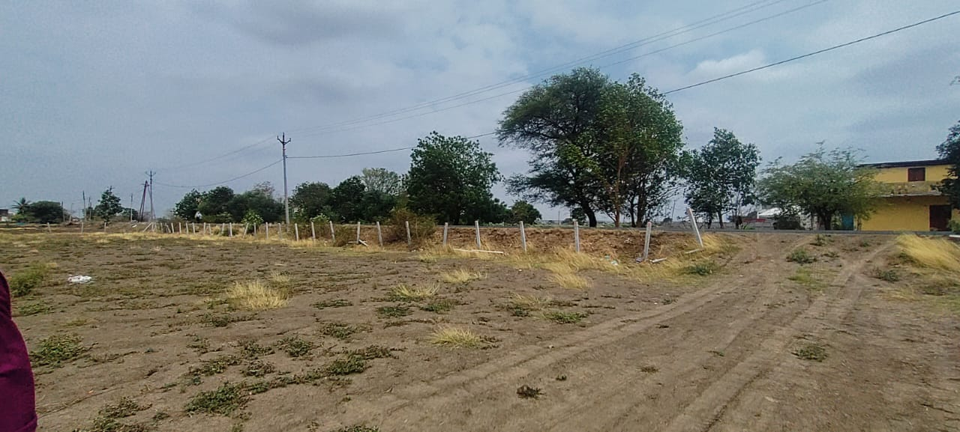
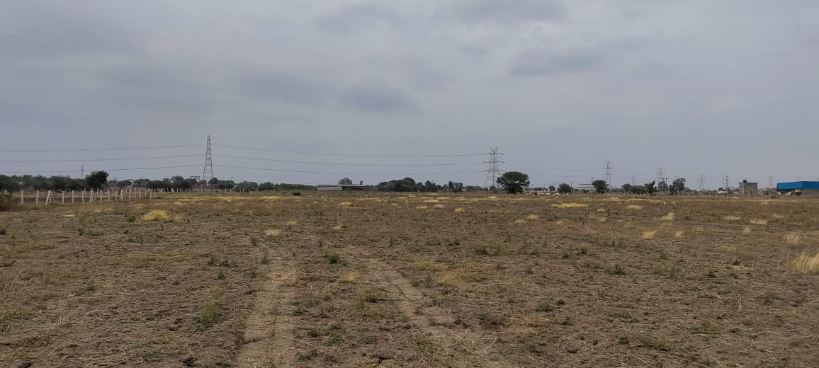
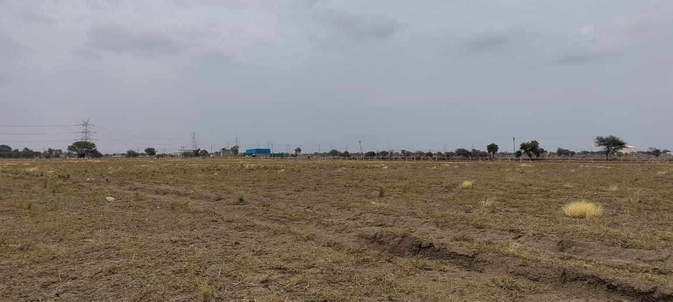

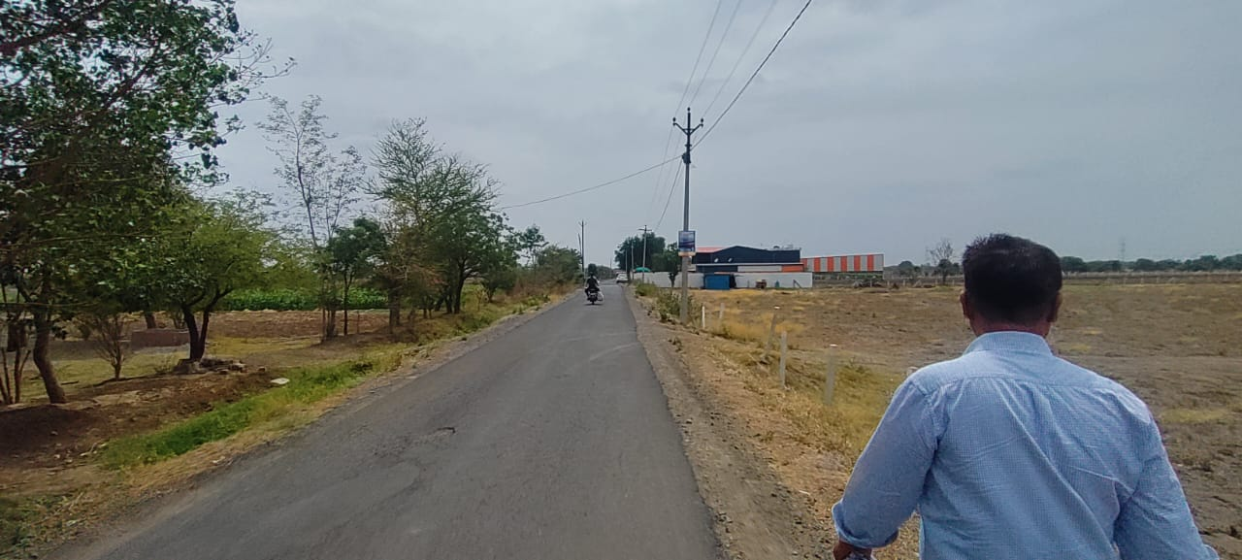
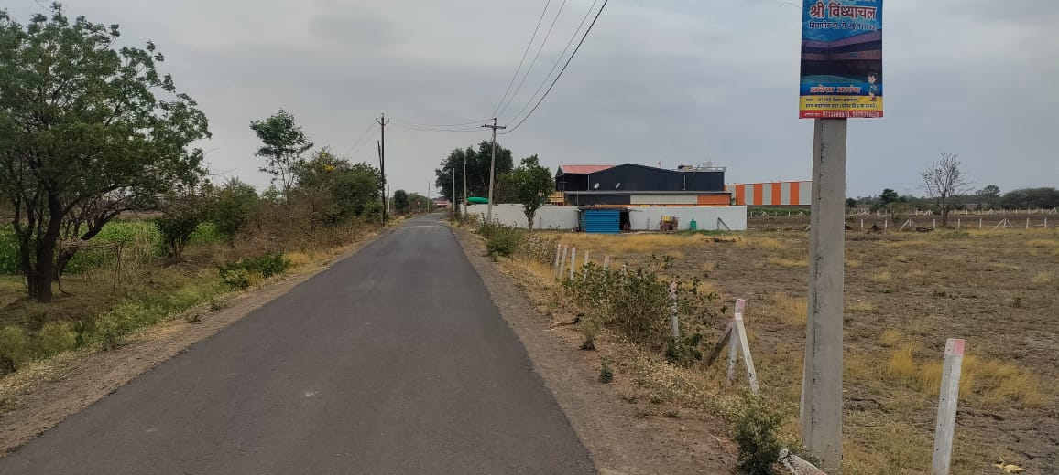
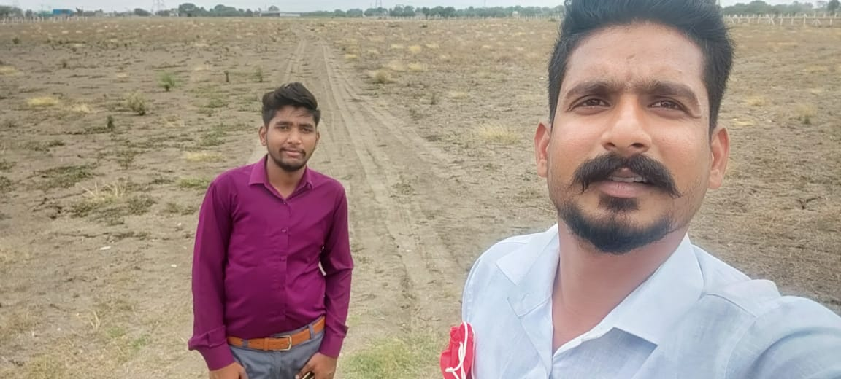

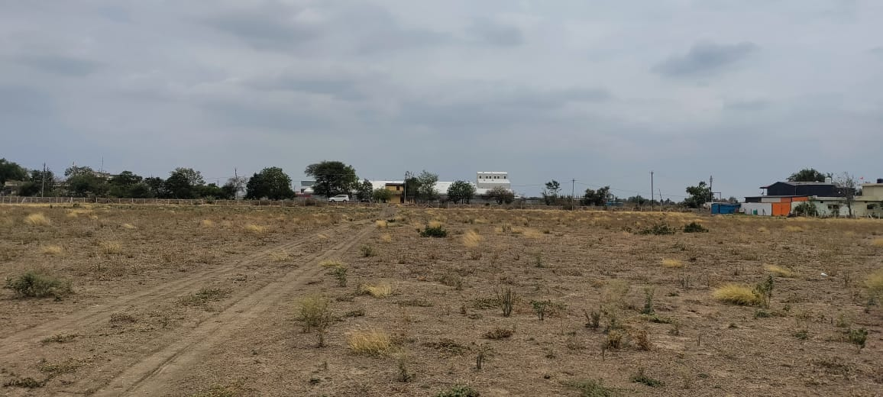
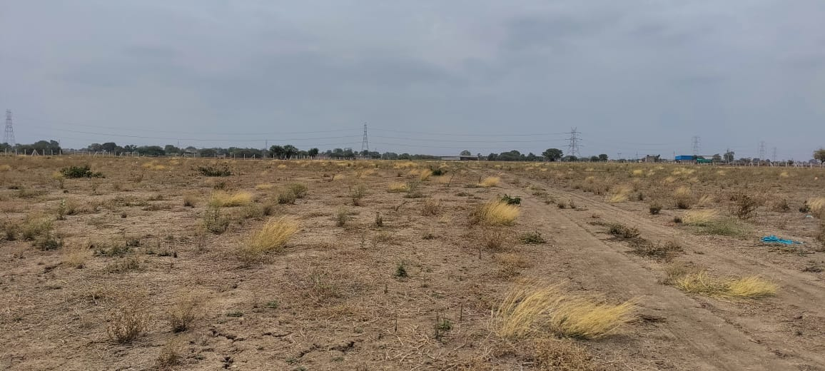
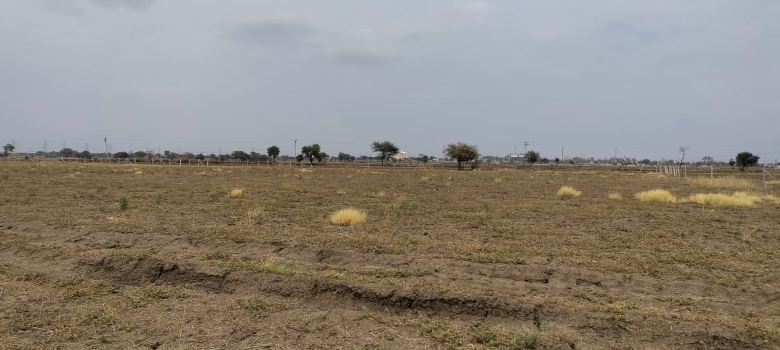
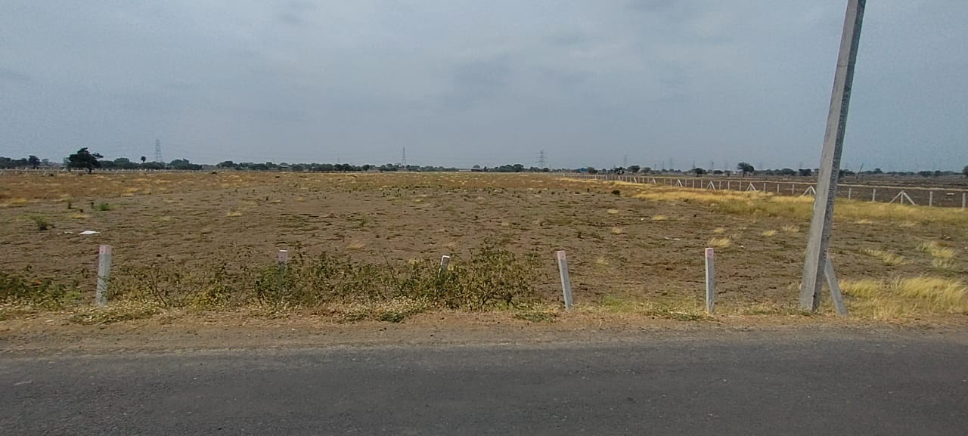
Route Map of the property

Site u/r
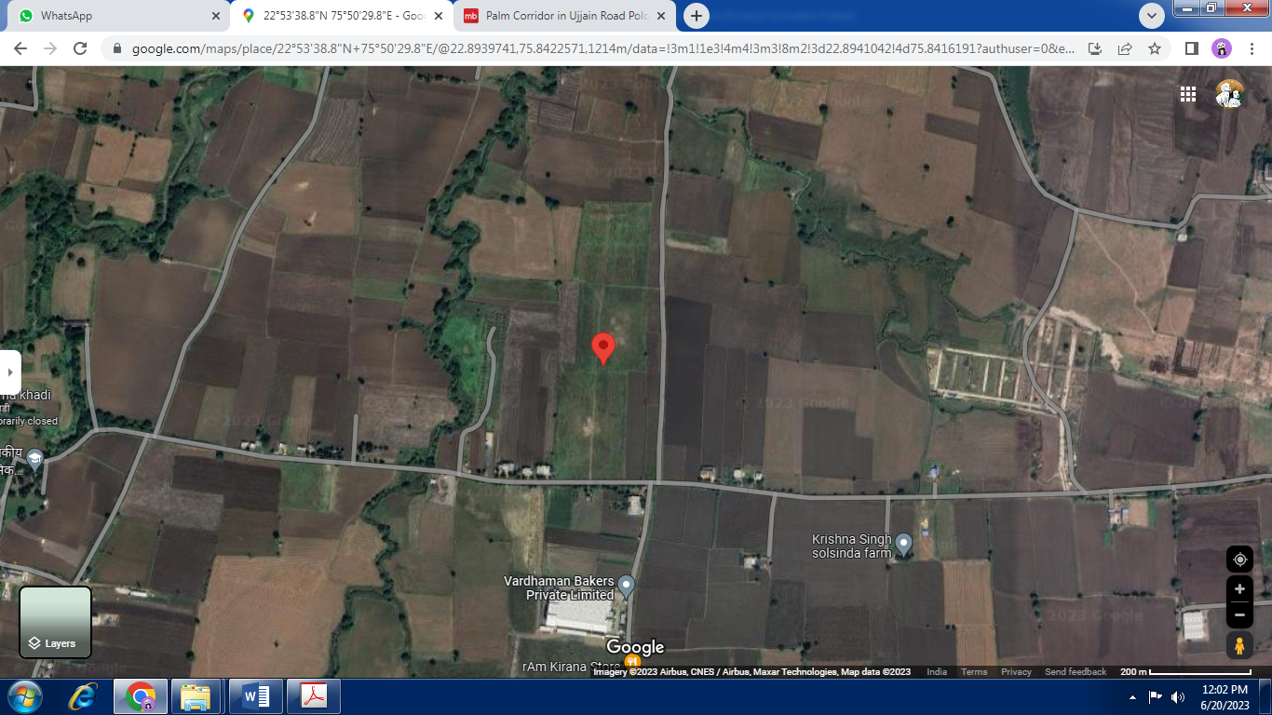

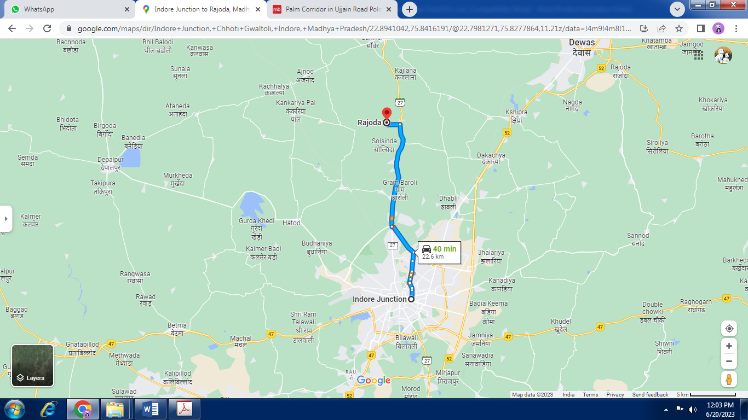

Longitude Latitude - 22°53’38.8”N 75°50’29.8”E
Note: The Blue line shows the route to site from nearest Railway Station (Indore Junction – 22.6 KM.)

Price Indicators
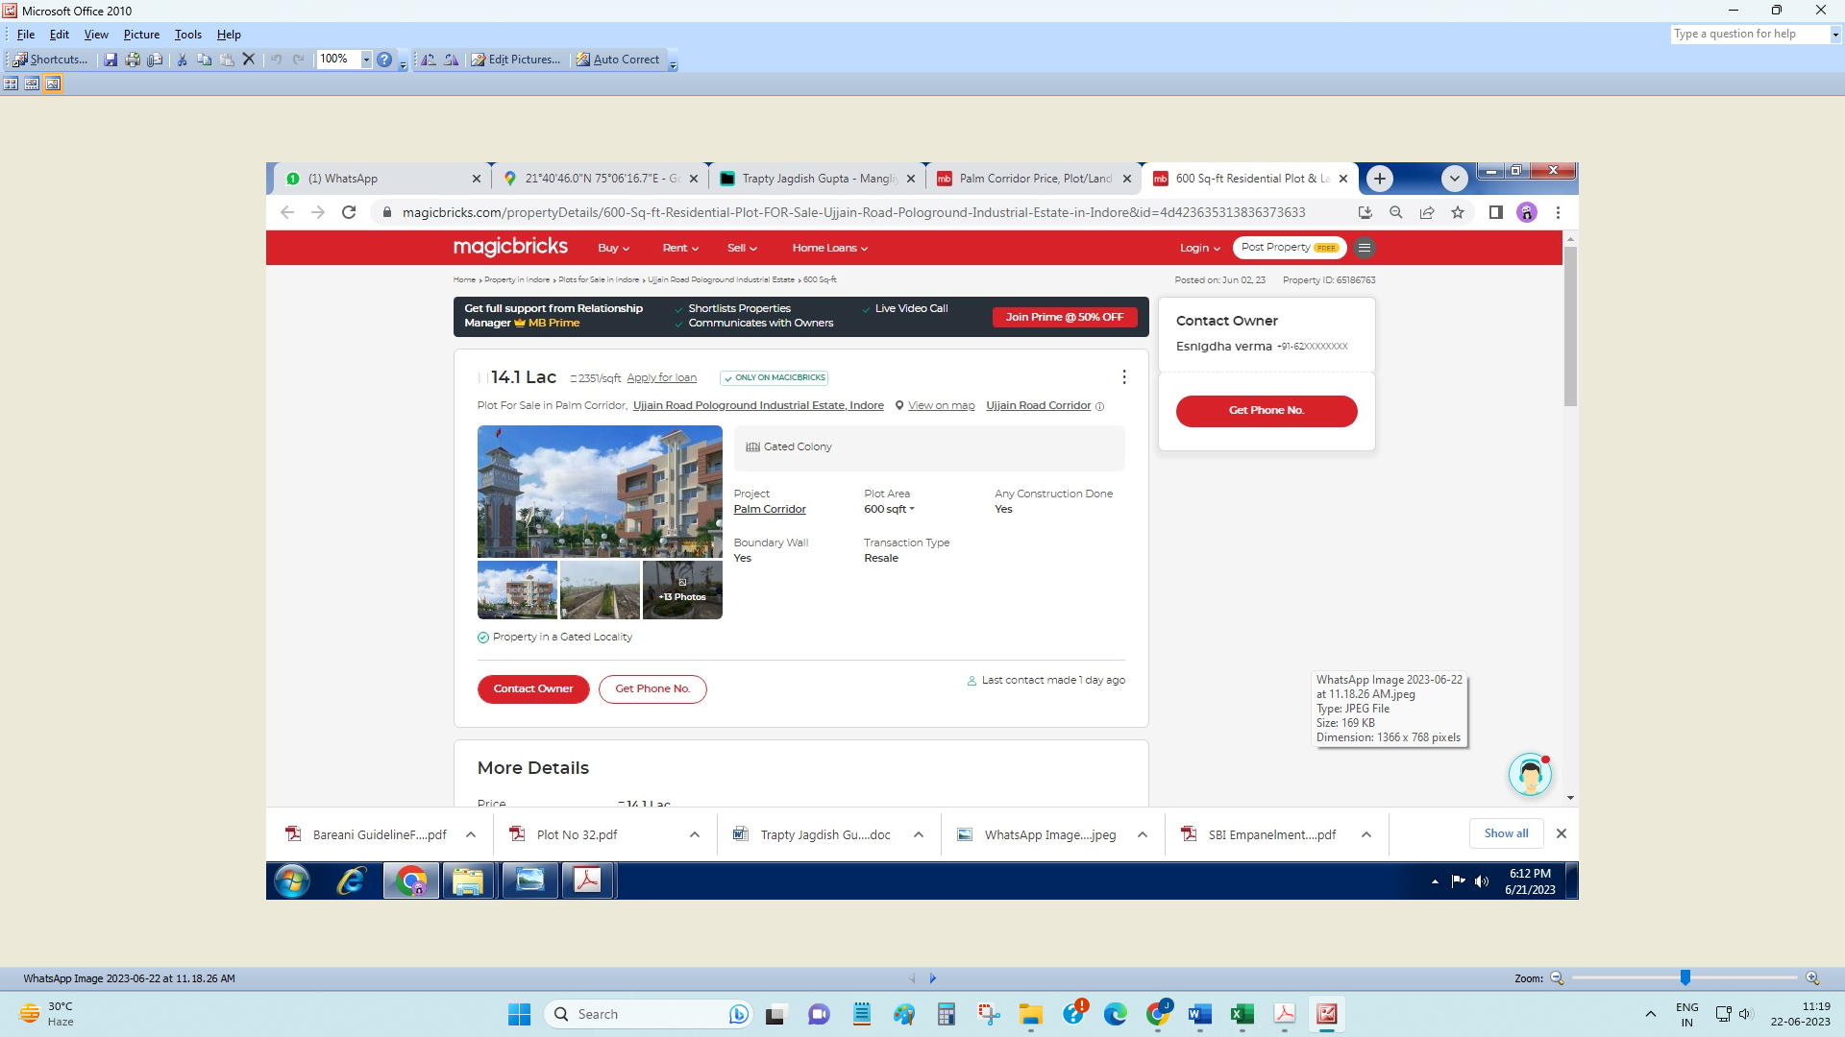

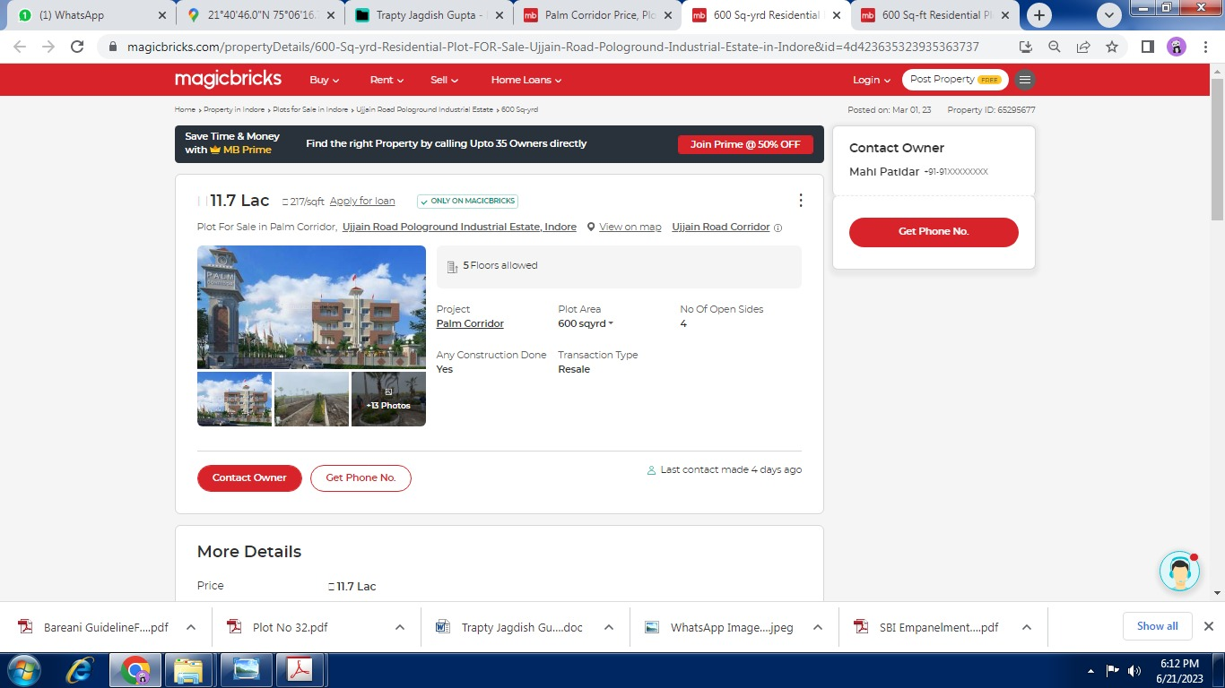

APPENDIX IV

DECLARATION FROM VALUERS

I, Manoj B. Chalikwar son of Shri. Baburao Chalikwar do hereby solemnly affirm and state that:

- The information furnished in my visit report dated 21.07.2023 is true and correct to the best of my knowledge and belief.

- I have no direct or indirect interest in the property visited;

- I/ my authorized representative has personally inspected the property on 19.06.2023 the work is not sub - contracted to any other valuer and carried out by myself.

- I have not been convicted of any offence and sentenced to a term of imprisonment.

- I have not been found guilty of misconduct in my professional capacity.

- I have read the Handbook on Policy, Standards and procedure for Real Estate Valuation, 2011 of the IBA.

- I have read the International Valuation Standards (IVS) and the report submitted to the Bank for the respective asset class is in conformity to the "Standards" as enshrined for valuation in the IVS in "General Standards" and "Asset Standards" as applicable.

- I abide by the Model Code of Conduct for empanelment of valuer in the Bank. (Annexure III - A signed copy of same to be taken and kept along with this declaration).

- My PAN Card number as applicable is AERPC9086P

- I am valuer registered with Insolvency & Bankruptcy Board of India (IBBI)

- I am the Director of the company, who is competent to sign this visit report.

- Valuer/authorized representative have visited the right property.

- Further, I hereby provide the following information.

Sr No. | Particulars | Valuer comment
 | background information of the asset being valued; | The Residential Land owned by M/s. Kamco Chew Food Pvt. Ltd as per Sale deed, Registration No. MP179092023A11925776 dated 01.06.2023.
 | purpose of visit and appointing authority | As per request from Punjab National Bank, MID Corporate Centre to submit the visit report.
 | identity of the valuer and any other experts involved in the visit report; | Manoj B. Chalikwar – Regd. Valuer  Umang Patel - Regd. Valuer  Somesh Nahar – Site Engineer  Akhilesh Yadav – Technical Manager  Akshay Trivedi – Site Engineer
 | disclosure of valuer interest or conflict, if any; | We have no interest, either direct or indirect, in the property visited. Further to state that we do not have relation or any connection with property owner / applicant directly or indirectly. Further to state that we are an independent Valuer and in no way related to property owner / applicant
 | date of appointment, visit date and date of  report; | Date of Appointment - 19.06.2023  Visit Date – 19.06.2023  Date of Report - 21.07.2023
 | inspections and/or investigations undertaken; | Physical Inspection done - 19.06.2023
 | nature and sources of the information used or relied upon; | Physical Inspection
 | procedures adopted in carrying out the valuation and valuation standards followed; | Not Applicable
 | restrictions on use of the report, if any; | This site visit report is for the use of the party to whom it is addressed and for no other purpose. No responsibility is accepted to any third party who may use or rely on the whole or any part of this visit report.
 | Major factors that were taken into account during the valuation; | Not Applicable
 | Major factors that were not taken into account during the valuation; | Not Applicable
 | Caveats, limitations and disclaimers to the extent they explain or elucidate the limitations faced by valuer, which shall not be for the purpose of limiting his responsibility for the valuation report. | Attached

Assumptions, Disclaimers, Limitations & Qualifications
Value Subject to Change
The subject appraisal exercise is based on prevailing market dynamics as on 21st July 2023 and does not take into account any unforeseeable developments which could impact the same in the future.
Our Investigations
We are not engaged to carry out all possible investigations in relation to the subject property. Where in our report we identify certain limitations to our investigations, this is to enable the reliant party to instruct further investigations where considered appropriate or where we recommend as necessary prior to reliance. Vastukala Consultants India Pvt. Ltd. (VCIPL) is not liable for any loss occasioned by a decision not to conduct further investigations
Information Supplied by Others
The appraisal is based on the information provided by the client. The same has been assumed to be correct and has been used for appraisal exercise. Where it is stated in the report that another party has supplied information to VCIPL, this information is believed to be reliable but VCIPL can accept no responsibility if this should prove not to be so.
Map and Plans
Any sketch, plan or map in this report is included to assist the reader while visualising the property and assume no responsibility in connection with such matters.
Site Details
Based on inputs received from Client's representative and site visit conducted, we understand that the subject property is currently a contiguous land parcel admeasuring 79,120 Sq. M. and is a freehold plot of land in the name of M/s. Kamco Chew Food Pvt. Ltd. Further, VCIPL has assumed that the subject property is free from any encroachment and is available as on the date of the appraisal.

Property Title
Based on our discussion with the Client, we understand that the subject property is a Freehold plot of land in the name of M/s. Kamco Chew Food Pvt. Ltd. For the purpose of this appraisal exercise, we have assumed that the subject property has a clear title and is free from any encumbrances, disputes and claims. VCIPL has made no further enquiries with the relevant local authorities in this regard and does not certify the property as having a clear and marketable title. Further, no legal advice regarding the title and ownership of the subject property has been obtained for the purpose of this appraisal exercise. It has been assumed that the title deeds are clear and marketable.

Environmental Conditions
We have assumed that the subject property is not contaminated and is not adversely affected by any existing or proposed environmental law and any processes which are carried out on the property are regulated by environmental legislation and are properly licensed by the appropriate authorities.

Area
Based on the information provided by the Client, we understand that the subject property is a contiguous land parcel admeasuring 79,120 Sq. M.

Condition & Repair
In the absence of any information to the contrary, we have assumed that there are no abnormal ground conditions, nor archaeological remains present which might adversely affect the current or future occupation, development or value of the property. The property is free from rat, infestation, structural or latent defect. No currently known deleterious or hazardous materials or suspect techniques will be used in the construction of or subsequent alteration or additions to the property and comments made in the property details do not purport to express an opinion about, or advise upon, the condition of uninspected parts and should not be taken as making an implied representation or statement about such parts
Not a Structural Survey
We state that this is a visit report and not a structural survey
Other
All measurements, areas and ages quoted in our report are approximate
Legal
We have not made any allowances with respect to any existing or proposed local legislation relating to taxation on realization of the sale value of the subject property. VCIPL is not required to give testimony or to appear in court by reason of this appraisal report, with reference to the property in question, unless arrangement has been made thereof. Further, no legal advice on any aspects has been obtained for the purpose of this appraisal exercise

Property specific assumptions
Based on inputs received from the client and site visit conducted, we understand that the subject property is currently contiguous land parcel admeasuring 79,120 Sq. M.

ASSUMPTIONS, CAVEATS, LIMITATION AND DISCLAIMERS
1. We assume no responsibility for matters of legal nature affecting the property appraised or the title thereto, nor do we render our opinion as to the title, which is assumed to be good and marketable.
2. The property is visited as though under responsible ownership.
3. It is assumed that the property is free of liens and encumbrances.
4. There is no direct/ indirect interest in the property visited.

APPENDIX V

MODEL CODE OF CONDUCT FOR VALUERS

{Adopted in line with Companies (Registered Valuers and Valuation Rules, 2017)}

All valuers empanelled with bank shall strictly adhere to the following code of conduct:

Integrity and Fairness
- A valuer shall, in the conduct of his/its business, follow high standards of integrity and fairness in all his/its dealings with his/its clients and other valuers.
- A valuer shall maintain integrity by being honest, straightforward, and forthright in all professional relationships.
- A valuer shall endeavour to ensure that he/it provides true and adequate information and shall not misrepresent any facts or situations.
- A valuer shall refrain from being involved in any action that would bring disrepute to the profession.
- A valuer shall keep public interest foremost while delivering his services.

Professional Competence and Due Care
- A valuer shall render at all times high standards of service, exercise due diligence, ensure proper care and exercise independent professional judgment.
- A valuer shall carry out professional services in accordance with the relevant technical and professional standards that may be specified from time to time.
- A valuer shall continuously maintain professional knowledge and skill to provide competent professional service based on up-to-date developments in practice, prevailing regulations / guidelines and techniques.
- In the preparation of a visit report, the valuer shall not disclaim liability for his/its expertise or deny his/its duty of care, except to the extent that the assumptions are based on statements of fact provided by the company or its auditors or consultants or information available in public domain and not generated by the valuer.
- A valuer shall not carry out any instruction of the client insofar as they are in compatible with the requirements of integrity, objectivity and independence.
- A valuer shall clearly state to his client the services that he would be competent to provide and the services for which he would be relying on other valuers or professionals or for which the client can have a separate arrangement with other valuers.
Independence and Disclosure of Interest
- A valuer shall act with objectivity in his/its professional dealings by ensuring that his/its decisions are made without the presence of any bias, conflict of interest, coercion, or undue influence of any party, whether directly connected to the visit assignment or not.
- A valuer shall not take up an assignment if he/it or any of his/its relatives or associates is not independent in terms of association to the company.
- A valuer shall maintain complete independence in his/its professional relationships and shall conduct the visit independent of external influences.
- A valuer shall wherever necessary disclose to the clients, possible sources of conflicts of duties and interests, while providing unbiased services.
- A valuer shall not deal in securities of any subject company after any time when he/it first becomes aware of the possibility of his / its association with the valuation, and in accordance with the Securities and Exchange Board of India (Prohibition of Insider Trading)Regulations,2015 or till the time the valuation report becomes public, whichever is earlier.
- A valuer shall not indulge in "mandate snatching" or offering "convenience valuations" in order to cater to a company or client's needs.
- As an independent valuer, the valuer shall not charge success fee (Success fees may be defined as a compensation / incentive paid to any third party for successful closure of transaction. In this case, approval of credit proposals).
- In any fairness opinion or independent expert opinion submitted by a valuer, if there has been a prior engagement in an unconnected transaction, the valuer shall declare the association with the company during the last five years.
Confidentiality
- A valuer shall not use or divulge to other clients or any other party any confidential information about the subject company, which has come to his / its knowledge without proper and specific authority or unless there is a legal or professional right or duty to disclose.
Information Management
- A valuer shall ensure that he/ it maintains written contemporaneous records for any decision taken, the reasons for taking the decision, and the information and evidence in support of such decision. This shall be maintained so as to sufficiently enable a reasonable person to take a view on the appropriateness of his /its decisions and actions.
- A valuer shall appear, co-operate and be available for inspections and investigations carried out by the authority, any person authorised by the authority, the registered valuers organisation with which he/it is registered or any other statutory regulatory body.
- A valuer shall provide all information and records as may be required by the authority, the Tribunal, Appellate Tribunal, the registered valuers organisation with which he/it is registered, or any other statutory regulatory body.
- A valuer while respecting the confidentiality of information acquired during the course of performing professional services, shall maintain proper working papers for a period of three years or such longer period as required in its contract for a specific valuation, for production before a regulatory authority or for a peer review. In the event of a pending case before the Tribunal or Appellate Tribunal, the record shall be maintained till the disposal of the case.
Gifts and hospitality:
- A valuer or his / its relative shall not accept gifts or hospitality which undermines or affects his independence as a valuer.
Explanation, - For the purposes of this code the term 'relative' shall have the same meaning as defined in clause (77) of Section 2 of the Companies Act, 2013 (18 of 2013).
- A valuer shall not offer gifts or hospitality or a financial or any other advantage to a public servant or any other person with a view to obtain or retain work for himself / itself, or to obtain or retain an advantage in the conduct of profession for himself / itself.
Remuneration and Costs.
- A valuer shall provide services for remuneration which is charged in a transparent manner, is a reasonable reflection of the work necessarily and properly undertaken, and is not inconsistent with the applicable rules.
- A valuer shall not accept any fees or charges other than those which are disclosed in a written contract with the person to whom he would be rendering service.
Occupation, employability and restrictions.
- A valuer shall refrain from accepting too many assignments, if he/it is unlikely to be able to devote adequate time to each of his/ its assignments.
- A valuer shall not conduct business which in the opinion of the authority or the registered valuer organisation discredits the profession.

Manoj B. Chalikwar
Registered Valuer
Chartered Engineer (India)
Reg. No. IBBI / RV / 07/2018/10366

Reg. No. CAT-I-F-1763

