Vastu/Nashik/06/32014/2301224
22/20-325-CHV
Date: 18.07.2023

To,
The Branch Manager,
Union Bank of India
Gangapur Road Branch
Shree Ganesh Avenue, Chunchale Road,
Nashik - 422 013, State – Maharashtra, Country – India

Sub: Vetting of Extra Amenities

Sir,

With reference to above subject, we have evaluated the Extra Amenities for Residential Row Bungalow No. 02, Ground + 2nd Floor, "Bodke Row - Bungalow", Survey No. 485/ 1/ 22, Plot No. 22, Near Shree Siddhivinayak Ganesh Mandir, Sant Janardan Swami Road, Papaya's Nursery, Trambakeshwar Road, Satpur Colony, Village – Satpur, Taluka& District - Nashik, PIN Code – 422 007, State – Maharashtra, Country – India belongs to Shri. Jaypal Chandrasingh Salunke & Sau. Poonam Jaypal Salunke. Name of Owner: Shri. Gaurav Ramchandra Bodke & Sau. Jijabai Ramchandra Bodke.

We have verified the rates quoted as per current market rates. Details of Extra Amenities considered as per copy of Extra Amenities Agreement between Mr. Jaypal Chandrasingh Salunke (First Party). Mr. Raju Mukesh Vitkar (Second Party) received on dated 24.05.2023. The Extra Amenities amount is Rs. 7,00,000/- (Rupees Seven Lakh Only)

The said Cost Vetting Certificate is valid upto next 6 months Only.

Thanking you

Sincerely yours

Sharadkumar B. Chalikwar
Govt. Reg. Valuer
Chartered Engineer (India)
Reg. No. (N) CCIT/1-14/52/2008-09

Agreement for Extra Work
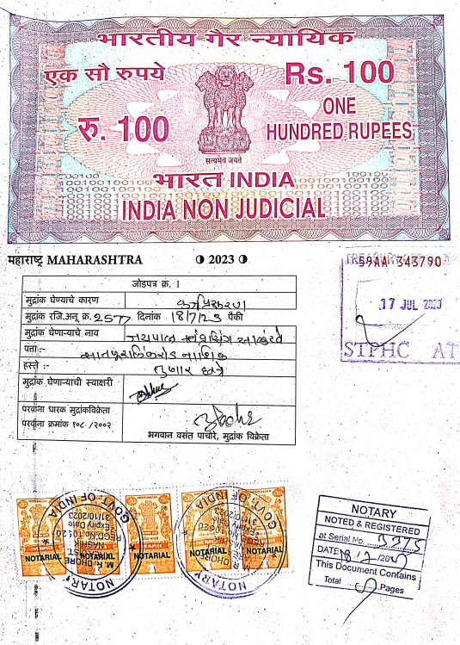
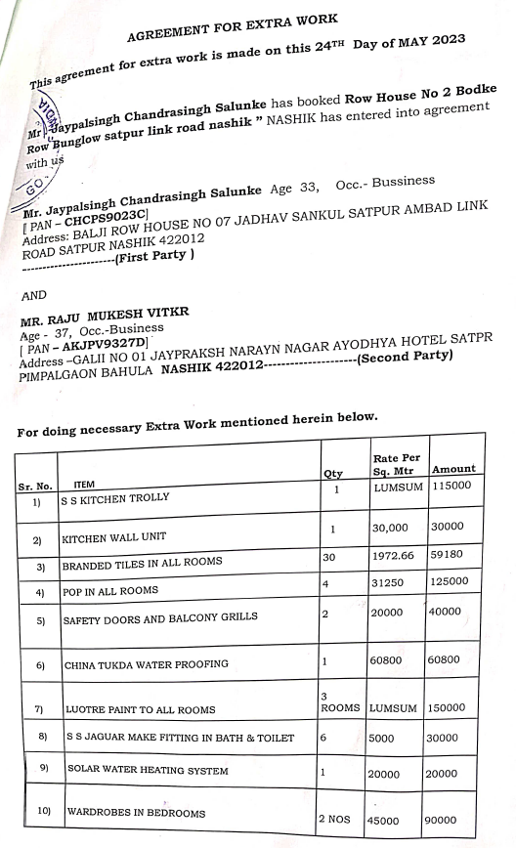

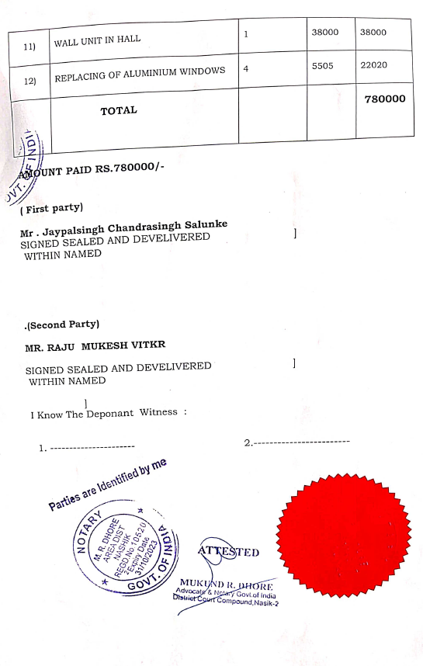

The Extra Amenities amount is Rs. 7,00,000/- (Rupees Seven Lakh Only)

