Vastu/Nashik/03/2023833/30490/46262
22/24-455-RPV
Date: 15.07.2023

To, `
The Branch Manager,
Bank of Baroda
Regional Office Nashik Road Branch
BSNL Building, Datta Mandir Road, Nashik Road,
Nashik -422 101, State - Maharashtra, Country - India.

Sub: Vetting of Extra Amenities

Sir,

With reference to above subject, we have evaluated the Extra Amenities for Residential Flat No. 904, 9th Floor, B - Wing, "Shivalik Sky Green", Survey No. 328/ 1/ 3, CTS Survey No. 7379, Near Aai Tulja Bhavani Mandir, Dnyaneshwar Nagar, Pathardi Road, Village – Pathardi - 1, Taluka & District - Nashik, PIN Code – 422 009, State – Maharashtra, Country – India, State – Maharashtra, Country – India belongs to Sau. Vandana Anil Chavhan & Shri. Anil Prakash Chavan.

We have verified the rates quoted as per current market rates. Details of work and Extra Amenities considered as per copy of Agreement for Extra Amenities issued by Sau. Vandana Anil Chavhan & Shri. Anil Prakash Chavan (First Party) and Shri. Nareshbhai Vitthalbhai Pansuriya (Second Party) received on dated 05.06.2023. The Extra Amenities amount is Rs. 3,00,000/- (Rupees Three Lakh Only)

The said Cost Vetting Certificate is valid upto next 6 months Only.

Thanking you

Sincerely yours

Manoj B. Chalikwar
Registered Valuer
Chartered Engineer (India)
Reg. No. CAT-I-F-1763
Reg. No. IBBI/RV/07/2018/10366
BOB Empanelment No.: ZO:MZ:ADV:46:941
Encl: Valuation report.

Agreement for Extra Amenities
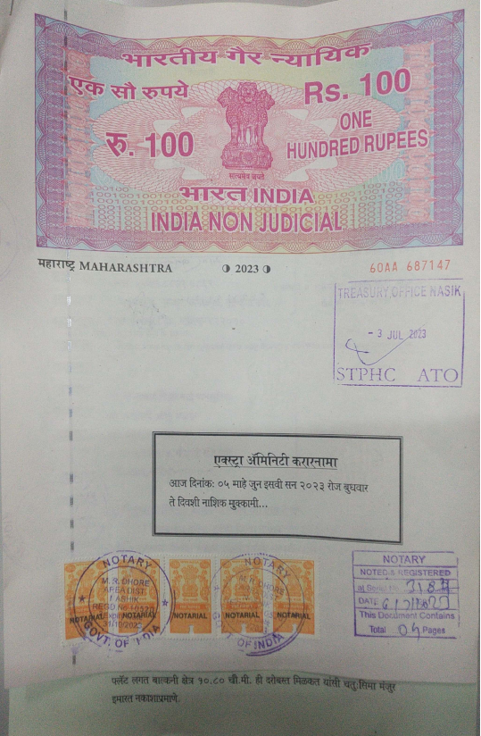
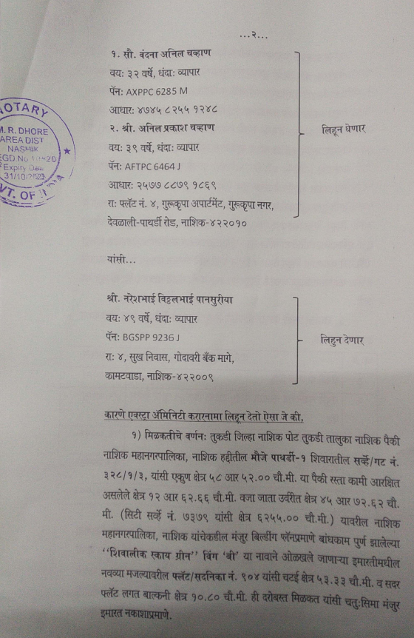

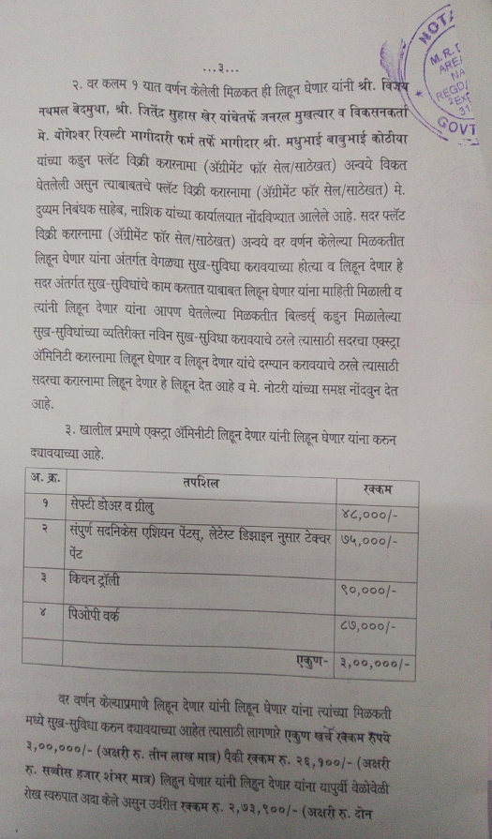

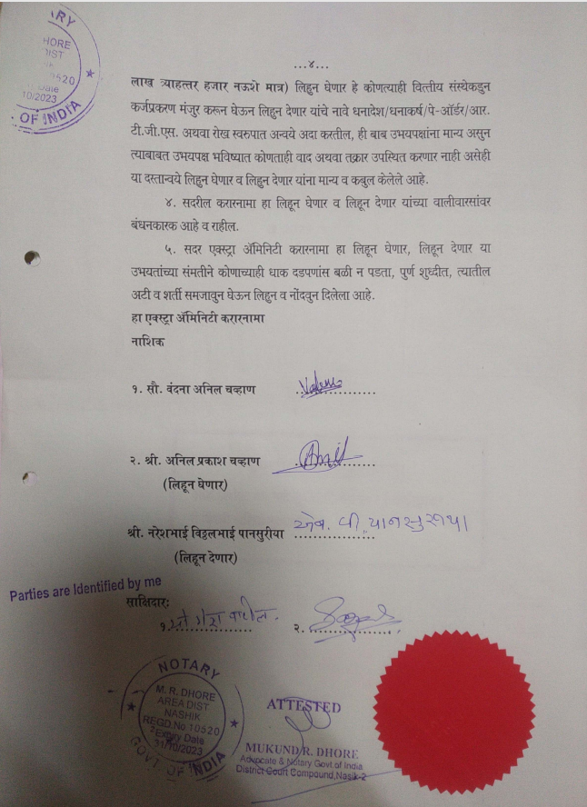

The Extra Amenities amount is Rs.3,00,000/- ( Rupees Three Lakh Only. )

