Vastu/Nashik/07/2023/2430/2301482
10/18-107-RYV
Date: 10.07.2023

To,
The Branch Manager,
Bank of Baroda
Takali (Lasalgaon)
Near Railway station, station Road Takali,
Tal:Niphad, Dist: Nashik.

Sub: Vetting of Estimate
Sir,

With reference to above subject, we have evaluated the Extra Amenities for Residential Land and Proposed Bungalow on Plot No. 53, Ground + First Floor, Survey No. 293/ 294, Near Telephone Ex-Change Tower, Lasalgaon Road, Takali, At – Lasalgaon, Taluka – Niiphad, District – Nashik, Pin Code – 422306, State - Maharashtra, Country – India belongs to Shri. Pankaj Uttam Thombare & Miss. Anita Sahebrao Shinde (after Marriage) Sau. Anita Pankaj Thombare.

We have verified the rates quoted as per current market rates. Details of Estimates considered as per copy of Estimate Provided by Sanjay M. Patil & Sunil B. Thombare received on dated 07.10.2023. The Estimate amount is Rs. 25,00,000/- (Twenty Five Lakh Only)

The said Cost Vetting Certificate is valid upto next 6 months Only.

Thanking you

Sincerely yours

Manoj B. Chalikwar
Registered Valuer
Chartered Engineer (India)
Reg. No. CAT-I-F-1763
Reg. No. IBBI/RV/07/2018/10366
BOB Empanelment No.: ZO:MZ:ADV:46:941
Encl: Valuation Report.

Estimate

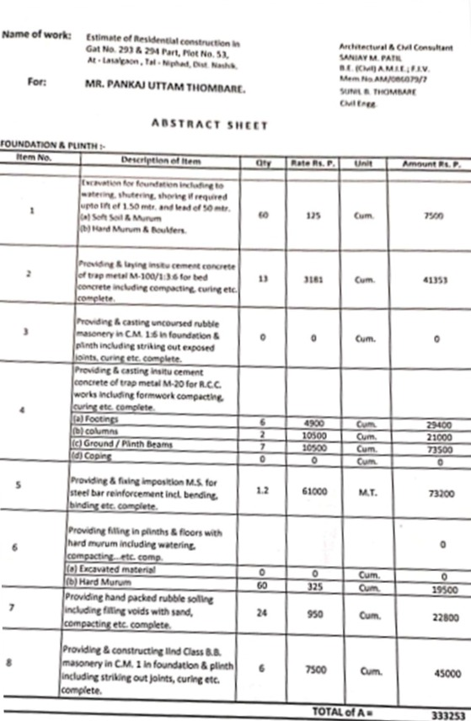
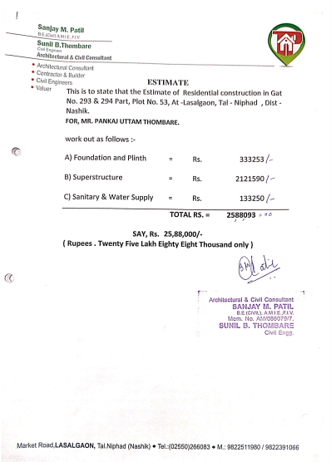

Estimate

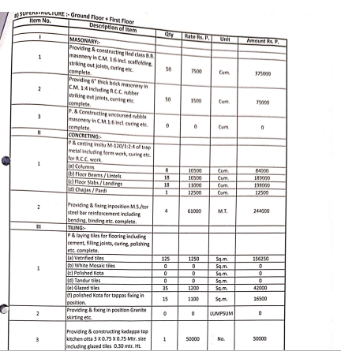
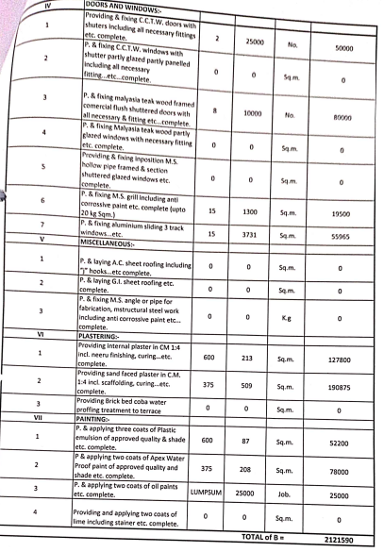

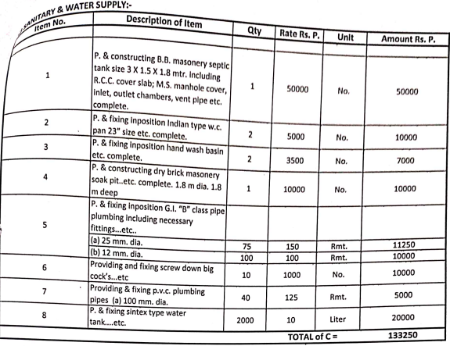

The Estimate amount is Rs.25,00,000/- (Rupees Twenty Five Lakh Only)

