Vastu/Nashik/07/2023/2425/2301477
10/13-102-CHV
Date: 10.07.2023

To,
The Branch Manager,
State Bank of India
Panchavati Branch
Manilal Chambers, Ground floor, Peth Phata, Panchavati
Nashik – 422 003, State – Maharashtra, Country – India.

Sub: Vetting of Extra Amenities

Sir,

With reference to above subject, we have evaluated the Extra Amenities for Residential Flat No. 102, 1st Floor, Wing – A, "Morya Emerald Apartment", Plot No. 29 + 30 + 31 + 32, Survey / Gat No. 338 / 340 / 341, Chandashi Shivar, Near Madhuban Hotel, Village - Jalalpur, Taluka – Nashik, District - Nashik, PIN Code – 422 222, State – Maharashtra, Country – India belongs to M/s. Omkar Builders & Developers. Name of Proposed Purchaser: Shri. Ashish Lalchand Pardeshi & Sau. Dipika Ashish Pardeshi.

We have verified the rates quoted as per current market rates. Details of Extra Amenities considered as per copy of Extra Amenities Agreement between Mr. Ashish Lalchand Pardeshi & Mrs. Deepika Aashish Pardeshi (First Part) and Mr. Rajendra Prasad Saini (Second Part) received on dated 04.06.2023. The Extra Amenities amount is Rs.3,00,000/- (Rupees Three Lakh Only)

The said Cost Vetting Certificate is valid upto next 6 months Only.

Thanking you

Sincerely yours

Sharadkumar B. Chalikwar
Govt. Reg. Valuer
Chartered Engineer (India)
Reg. No. (N) CCIT/1-14/52/2008-09
Encl: Valuation report.

Extra Amenities Agreement
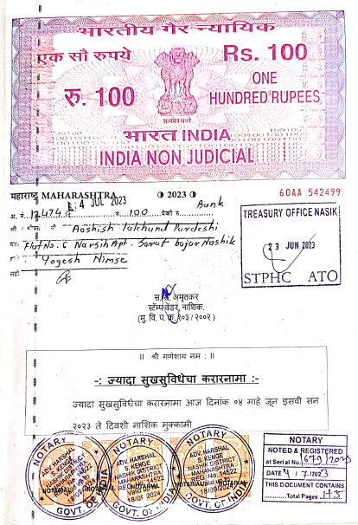
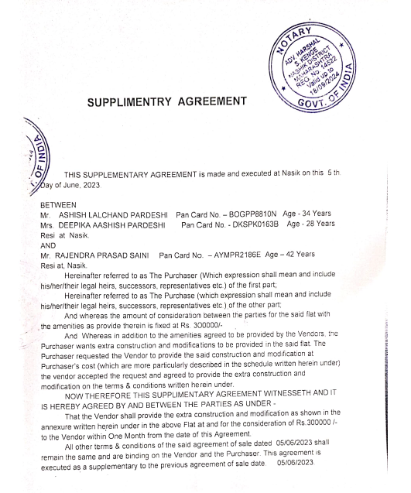

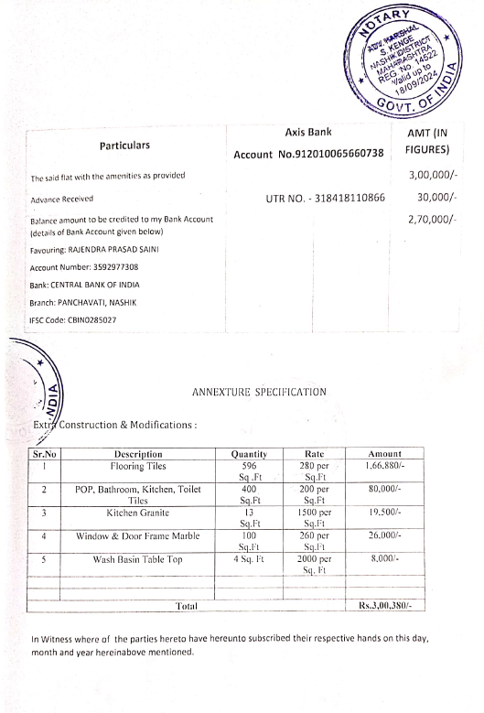
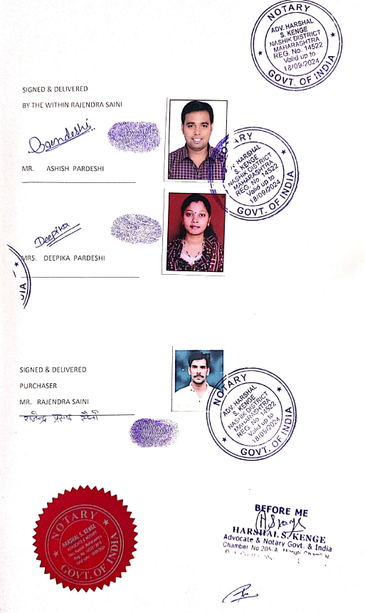

The Extra Amenities amount is Rs. 3,00,000/- (Rupees Three Lakh Only)

