Valuation Report of the Immovable Property

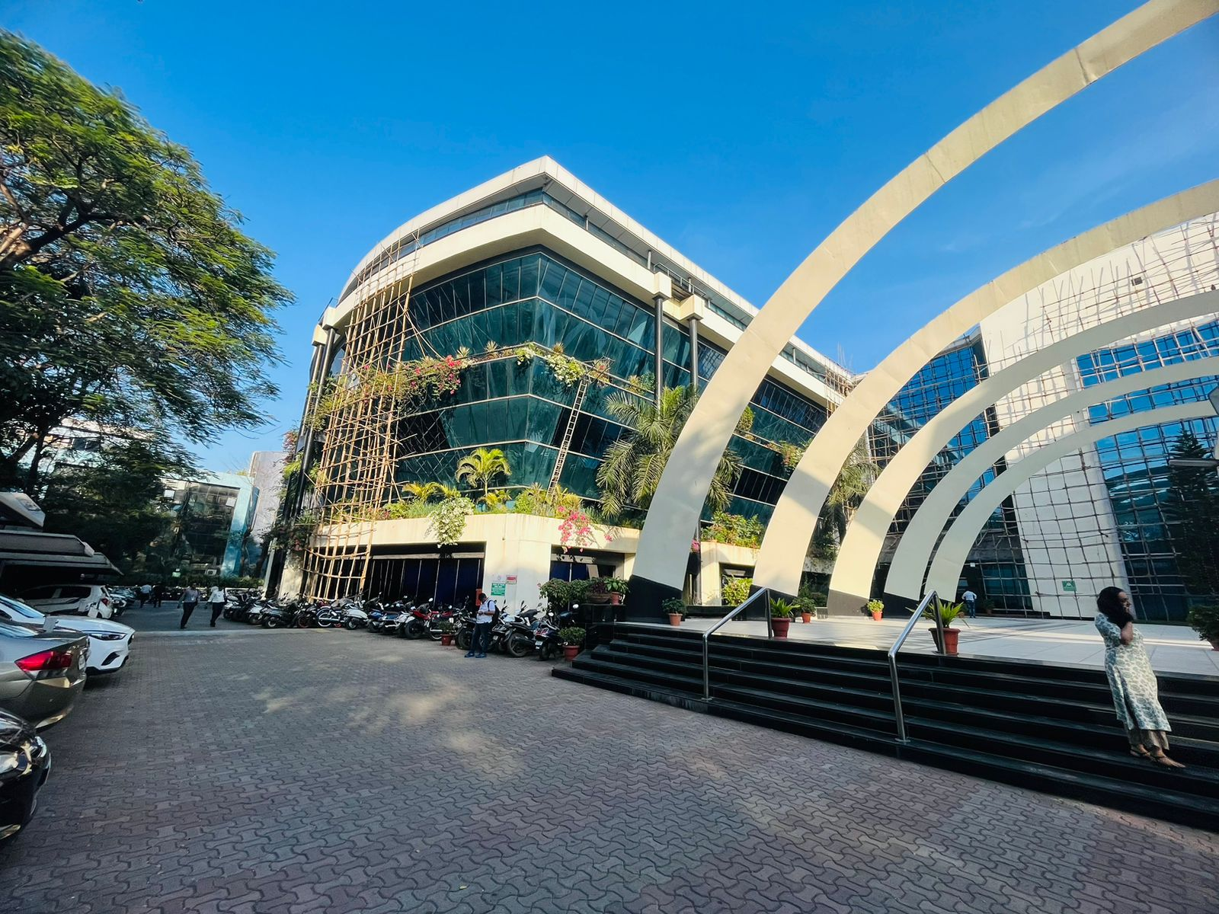

Details of the property under consideration:

Name of Owner: M/s. Dockendale Ship Management (India) Private Limited

Commercial Unit No. 5, Ground Floor, Wing - A, "Technopolis Knowledge Park", Technopolis Premises Co-Op. Soc. Ltd., Mahakali Caves Road, Hanuman Nagar, Andheri (East), Mumbai - 400093, State - Maharashtra, Country - India.

Latitude Longitude: 19°06'59.1"N 72°51'46.6"E

Vastu/Mumbai/07/2023/2419/2301480
10/16-105-VSU
Date: 10.07.2023

VALUATION OPINION REPORT

The property bearing Commercial Unit No. 5, Ground Floor, Wing - A, "Technopolis Knowledge Park", Technopolis Premises Co-Op. Soc. Ltd., Mahakali Caves Road, Hanuman Nagar, Andheri (East), Mumbai - 400093, State - Maharashtra, Country - India belongs to M/s. Dockendale Ship Management (India) Private Limited.

Boundaries of the property.

North | : | MIDC
South | : | Internal Road
East | : | Mistry Industrial Complex
West | : | Mahakali Caves Road
Considering various parameters recorded, existing economic scenario, and the information that is available with reference to the development of neighbourhood and method selected for valuation, we are of the opinion that, the property premises can be assessed and valued as on 31.03.2023 for accounting purpose at ` 6,06,10,000.00 (Rupees Six Crore Six Lakh Ten Thousand Only).

The valuation of the property is based on the documents produced by the concern. Legal aspects have not been taken into considerations while preparing this valuation report.

Hence certified

Manoj B. Chalikwar
Approved Valuer
Chartered Engineer (India)
Reg. No. CAT-I-F-1763
Encl.: Valuation report

VALUATION REPORT (IN RESPECT OF COMMERCIAL UNIT)
I | General
1. | Purpose for which the valuation is made |  |  | : | As per request from Client, to assess Market Value of the property under reference for accounting purpose as on 31.03.2023.
2. | a) |  | Date of inspection | : | 09.12.2022
 | b) |  | Date on which the valuation is made | : | 10.07.2023
3. | List of documents produced for perusal |  |  | : | - Copy of Leave And License Agreement dated 05.12.2019  - Copy of Affidavit and Indemnity Bond dated 21.04.2011  - Copy of Sale Deed dated 30.12.2010  - Copy of Commencement Certificate vide No. CE / 7078/ BSII / AK dated 15.07.1997 issued by Municipal Corporation of Greater Mumbai.  - Copy of Occupancy Certificate vide No. CE / 7078/ BSII / AK dated 24.12.2001 issued by Municipal Corporation of Greater Mumbai.  - Copy of Approved Plan vide No. CE / 7078 / BSII / WS / AK dated 23.08.2002 issued by Municipal Corporation of Greater Mumbai.
4. | Name of the owner(s) and his / their address (es) with Phone no. (details of share of each owner in case of joint ownership) |  |  | : | M/s. Dockendale Ship Management (India) Private Limited  Address: Commercial Unit No. 5, Ground Floor, Wing - A, "Technopolis Knowledge Park", Technopolis Premises Co-Op. Soc. Ltd., Mahakali Caves Road, Hanuman Nagar, Andheri (East), Mumbai - 400093, State - Maharashtra, Country - India.  Contact Person :  Mr. Mahesh Patwal  Contact No. – 9594874807  Private Limited Company Ownership
5. | Brief description of the property (Including Leasehold / freehold etc.) |  |  | : | The property is a commercial unit located on Ground Floor. The composition of unit is Reception + Working Area + Cabins + Conference Room. Common Toilet on the said floor.  The property is at 1.1 Km. distance from nearest Metro station Chakala (J B Nagar).
6. | Location of property |  |  | :
 | a) | Plot No. / Survey No. |  | : | -
 | b) | Door No. |  | : | Commercial Unit No. 5
 | c) | C. T.S. No. / Village |  | : | C.T.S. No. 238/A of Village Mulgaon & C.T.S. No. 8A, 8B of village Chakala.
 | d) | Ward / Taluka |  | : | Taluka Andheri
 | e) | Mandal / District |  | : | District - Mumbai
 | f) | Date of issue and validity of layout of approved map / plan |  | : | Copy of Approved Plan vide No. CE / 7078 / BSII / WS / AK dated 23.08.2002.
 | g) | Approved map / plan issuing authority |  | : | Municipal Corporation of Greater Mumbai.
 | h) | Whether genuineness or authenticity of approved map/ plan is verified |  | : | N.A.
 | i) | Any other comments by our empanelled valuers on authentic of approved plan |  |  | N.A.
7. | Postal address of the property |  |  | : | Commercial Unit No. 5, Ground Floor, Wing - A, "Technopolis Knowledge Park", Technopolis Premises Co-Op. Soc. Ltd., Mahakali Caves Road, Hanuman Nagar, Andheri (East), Mumbai - 400093, State - Maharashtra, Country - India.
8. | City / Town |  |  | : | Mumbai
 | Residential area |  |  | : | Yes
 | Commercial area |  |  | : | Yes
 | Industrial area |  |  | : | No
9. | Classification of the area |  |  | :
 | i) High / Middle / Poor |  |  | : | Middle Class
 | ii) Urban / Semi Urban / Rural |  |  | : | Urban
10. | Coming under Corporation limit / Village Panchayat / Municipality |  |  | : | Municipal Corporation of Greater Mumbai
11. | Whether covered under any State / Central Govt. enactments (e.g., Urban Land Ceiling Act) or notified under agency area/ scheduled area / cantonment area |  |  | : | No
12. | Boundaries of the property
 | North |  |  | : | MIDC
 | South |  |  | : | Internal Road
 | East |  |  | : | Mistry Industrial Complex
 | West |  |  | : | Mahakali Caves Road
13 | Dimensions of the site |  |  |  | N. A. as property under consideration is a commercial unit in a apartment building.
 |  |  |  |  | A As per the Deed | B Actuals
 | North |  |  | : | - | -
 | South |  |  | : | - | -
 | East |  |  | : | - | -
 | West |  |  | : | - | -
14. | Extent of the site |  |  | : | Carpet Area = 2,295.00 Sq. Ft.  (Area as per Physical Measurement)  Carpet Area = 194.21 Sq. M. i.e. 2,090.00 Sq. Ft.  (Area as per Sale Deed)  Built Up Area = 233.05. Sq. M. i.e. 2,509.00 Sq. Ft.  (Area as per Index II)
14.1 | Latitude, Longitude & Co-ordinates of Commercial Unit |  |  | : | 19°06'59.1"N 72°51'46.6"E
15. | Extent of the site considered for Valuation (least of 13A& 13B) |  |  | : | Carpet Area = 194.21 Sq. M. i.e. 2,090.00 Sq. Ft.  (Area as per Sale Deed)
16 | Whether occupied by the owner / tenant? If occupied by tenant since how long? Rent received per month. |  |  | : | Tenant occupied - Medikabazaar
II | APARTMENT BUILDING
 | Nature of the Apartment |  |  | : | Commercial
 | Location |  |  | :
 | C.T.S. No. |  |  | : | C.T.S. No. 238/A of Village Mulgaon & C.T.S. No. 8A, 8B of village Chakala.
 | Block No. |  |  | : | -
 | Ward No. |  |  | : | 'K East' Ward
 | Village / Municipality / Corporation |  |  | : | Village Mulgaon and Chakala, MCGM
 | Door No., Street or Road (Pin Code) |  |  | : | Commercial Unit No. 5, Mahakali Caves Road, Pin - 400093.
 | Description of the locality Residential / Commercial / Mixed |  |  | : | Mixed.
 | Year of Construction |  |  | : | 2001 (As per Occupancy Certificate)
 | Number of Floors |  |  | : | Basement + Ground + 5 Upper floors
 | Type of Structure |  |  | : | R.C.C. Framed Structure
 | Number of Dwelling units in the building |  |  | : | 7 units on ground floor
 | Quality of Construction |  |  | : | Good
 | Appearance of the Building |  |  | : | Good
 | Maintenance of the Building |  |  | : | Good
 | Facilities Available |  |  | :
 | Lift |  |  | : | 6 lifts
 | Protected Water Supply |  |  | : | Municipal Water supply
 | Underground Sewerage |  |  | : | Connected to Municipal Sewerage System
 | Car parking - Open / Covered |  |  | : | Basement parking
 | Is Compound wall existing? |  |  | : | Yes
 | Is pavement laid around the Building |  |  | : | Yes

III | COMMERCIAL UNIT
1 | The floor in which the Commercial Unit is situated | : | Ground Floor
2 | Door No. of the Commercial Unit | : | Commercial Unit No. 5
3 | Specifications of the Commercial Unit | :
 | Roof | : | R.C.C. Slab
 | Flooring | : | Vitrified flooring
 | Doors | : | Teak wood flush doors and Glass doors.
 | Windows | : | Not available.
 | Fittings | : | Electrical wiring with Concealed.
 | Finishing | : | Cement Plastering and POP false ceiling.
4 | House Tax | :
 | Assessment No. | : | Details not available
 | Tax paid in the name of : | : | Details not available
 | Tax amount : | : | Details not available
5 | Electricity Service connection No. : | : | Details not available
 | Meter Card is in the name of : | : | Details not available
6 | How is the maintenance of the Commercial Unit? | : | Good
7 | Sale Deed executed in the name of | : | M/s. Dockendale Ship Management (India) Private Limited
8 | What is the undivided area of land as per Sale Deed? | : | Details not available
9 | What is the plinth area of the Commercial Unit? | : | Built Up Area = 233.05. Sq. M. i.e. 2,509.00 Sq. Ft.  (Area as per Index II)
10 | What is the floor space index (app.) | : | As per local norms
11 | What is the Carpet Area of the Commercial Unit? | : | Carpet Area = 2,295.00 Sq. Ft.  (Area as per Physical Measurement)  Carpet Area = 194.21 Sq. M. i.e. 2,090.00 Sq. Ft.  (Area as per Sale Deed)
12 | Is it Posh / I Class / Medium / Ordinary? | : | Middle Class
13 | Is it being used for Residential or Commercial purpose? | : | Commercial purpose
14 | Is it Owner-occupied or let out? | : | Tenant occupied - Medikabazaar
15 | If rented, what is the monthly rent? | : | ` 3,70,230.00 present rental income per month
IV | MARKETABILITY | :
1 | How is the marketability? | : | Good
2 | What are the factors favouring for an extra Potential Value? | : | Located in developed area
3 | Any negative factors are observed which affect the market value in general? | : | No
V | Rate | :
1 | After analyzing the comparable sale instances, what is the composite rate for a similar Commercial Unit with same specifications in the adjoining locality? - (Along with details / reference of at - least two latest deals / transactions with respect to adjacent properties in the areas) | : | ` 27,500.00 to ` 29,500.00 per Sq. Ft. on Carpet area
2 | Assuming it is a new construction, what is the adopted basic composite rate of the Commercial Unit under valuation after comparing with the specifications and other factors with the Commercial Unit under comparison (give details). | : | ` 29,000.00 per Sq. Ft.
3 | Break – up for the rate | :
 | I. Building + Services | : | ` 3,000.00 per Sq. Ft.
 | II. Land + others | : | ` 26,000.00 per Sq. Ft.
4 | Guideline rate obtained from the Registrar's office (an evidence thereof to be enclosed) | : | ` 1,99,000.00 per Sq. M. i.e. ` 18,488.00 per Sq. Ft.
 | Guideline rate obtained from the Registrar's office (an evidence thereof to be enclosed) after depreciation | : | ` 1,72,597.00 per Sq. M. i.e. ` 16,035.00 per Sq. Ft.
VI | COMPOSITE RATE ADOPTED AFTER DEPRECIATION
a | Depreciated building rate | :
 | Replacement cost of Commercial Unit with Services (v(3)i) | : | -
 | Age of the building | : | 22 years.
 | Life of the building estimated | : | 38 years (Subject to proper, preventive periodic maintenance & structural repairs.)

Details of Valuation:

Sr. No. | Description | Qty. | Rate per  unit (`) | Estimated  Value (`)
1 | Value of the Commercial Unit | 2,090.00 Sq. Ft. Carpet Area | 29,000.00 | 6,06,10,000.00
 | The realizable value of the property |  |  | 5,45,49,000.00
 | Distress value of the property |  |  | 4,84,88,000.00
 | Insurable value of the property (2,509.00 Sq. Ft. Built up area x ` 3,000.00) |  |  | 75,27,000.00

The sales comparison approach uses the market data of sale prices to estimate the value of a real estate property . Property valuation in this method is done by comparing a property to other similar properties that have been recently sold. Comparable properties , also known as comparables, or comps , must share certain features with the property in question . Some of these include physical features such as square footage, number of rooms, condition, and age of the building; however, the most important factor is no doubt the location of the property. Adjustments are usually needed to account for differences as no two properties are exactly the same. To make proper adjustments when comparing properties, real estate appraisers must know the differences between the comparable properties and how to value these differences. The sales comparison approach is commonly used for Commercial Unit, where there are typically many comparables available to analyze. As the property is a Commercial Unit, we have adopted Sale Comparison Approach Method for the purpose of valuation .The Price for similar type of property in the nearby vicinity is in the range of ` 27,500.00 to ` 29,500.00 per Sq. Ft. Considering the rate with attached report , current market conditions , demand and supply position, Commercial Unit size, location, upswing in real estate prices , sustained demand for Commercial Unit , all round development of commercial and residential and commercial application in the locality etc. We estimate ` 29,000.00 per Sq. Ft. for valuation.

Manoj B. Chalikwar
Approved Valuer
Chartered Engineer (India)
Reg. No. CAT-I-F-1763

Place : Mumbai
Date : 21.03.2023
Actual site photographs
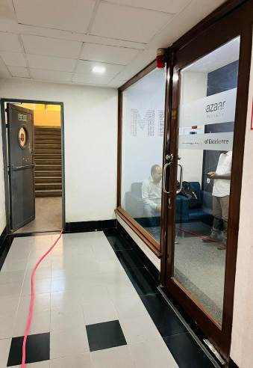
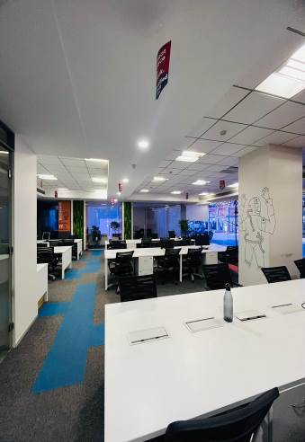
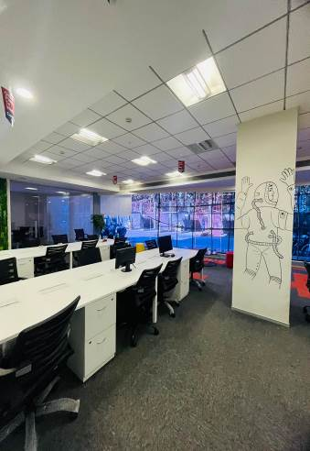

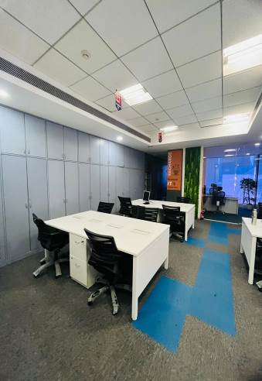
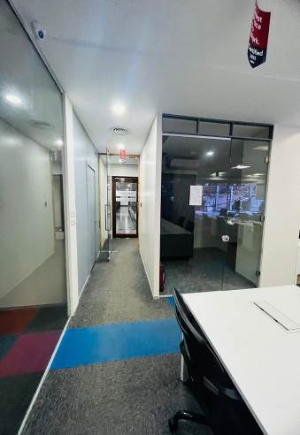
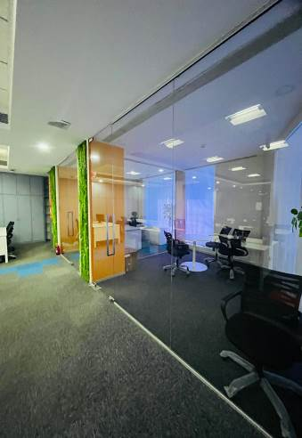

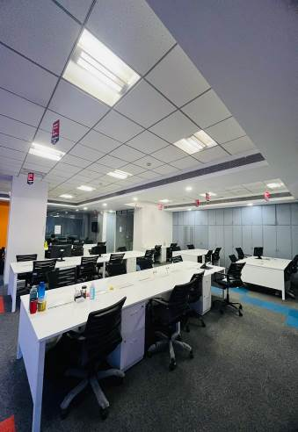
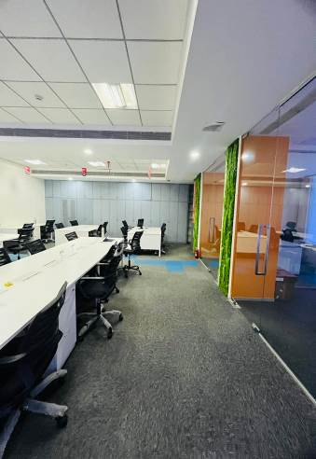
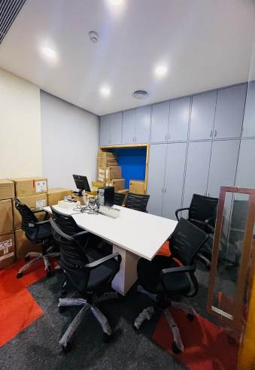

Actual site photographs
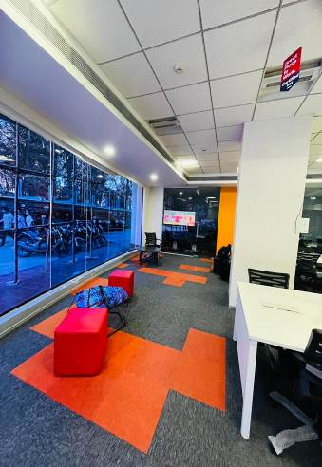
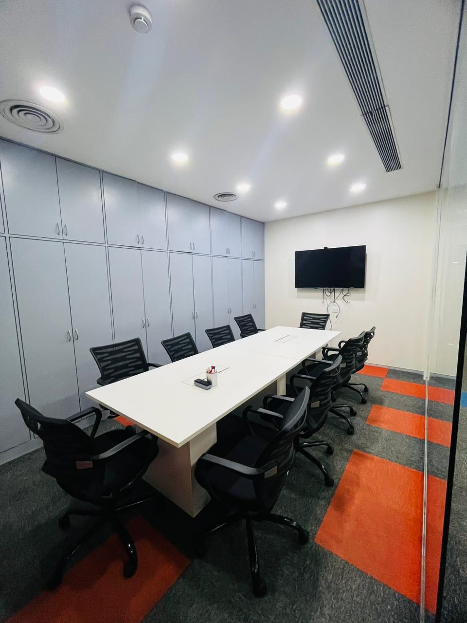

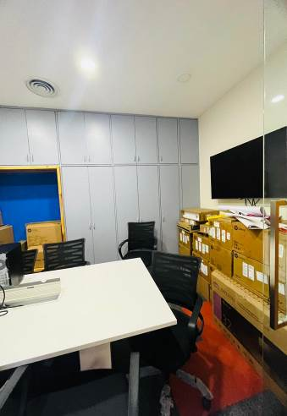
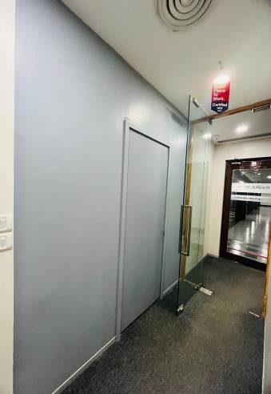

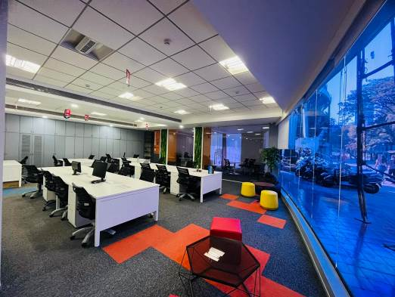
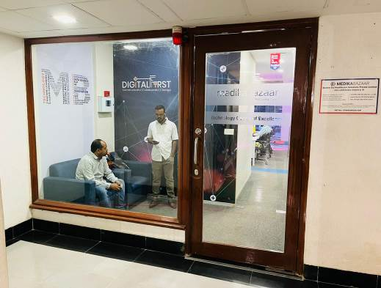
Actual site photographs

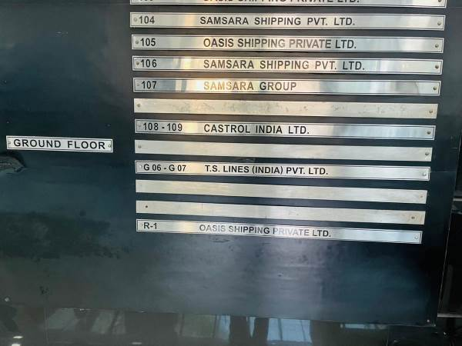

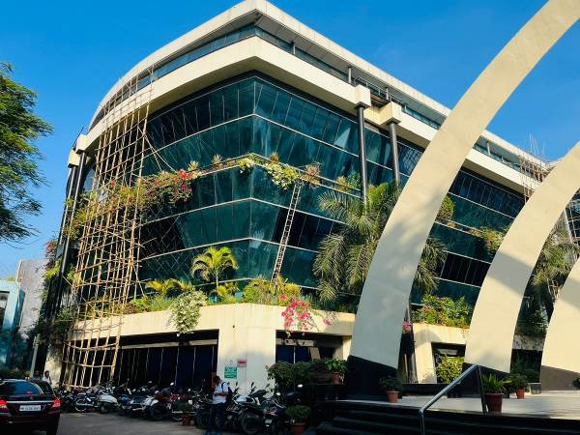
Route Map of the property
Site u/r
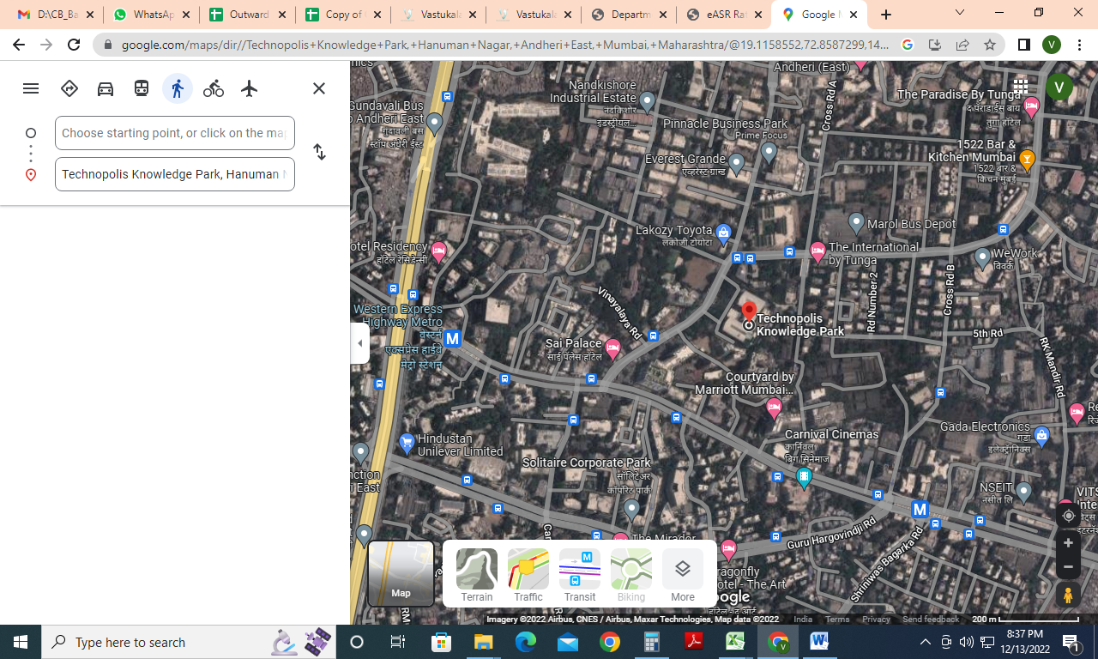

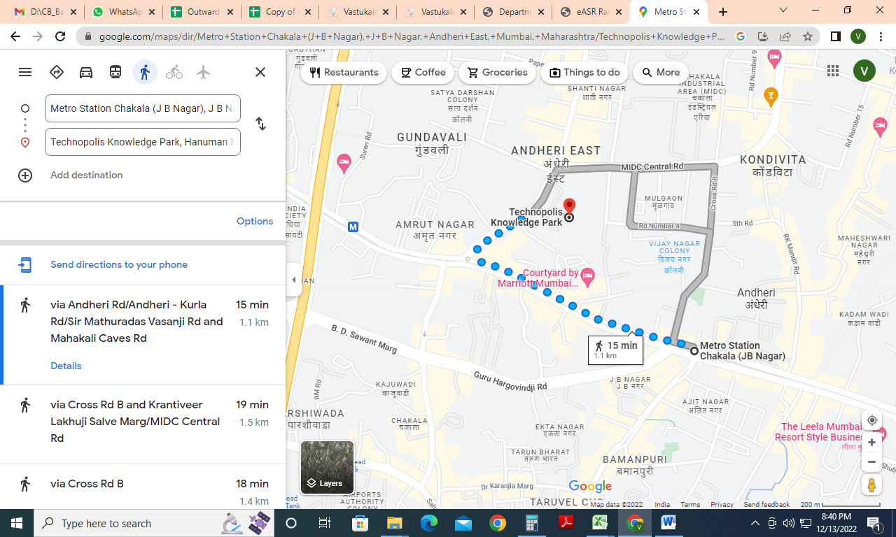



Latitude Longitude: 19°06'59.1"N 72°51'46.6"E
Note: The Blue line shows the route to site from nearest Metro station (Chakala (J B Nagar) 1.1 Km.)

Ready Reckoner Rate
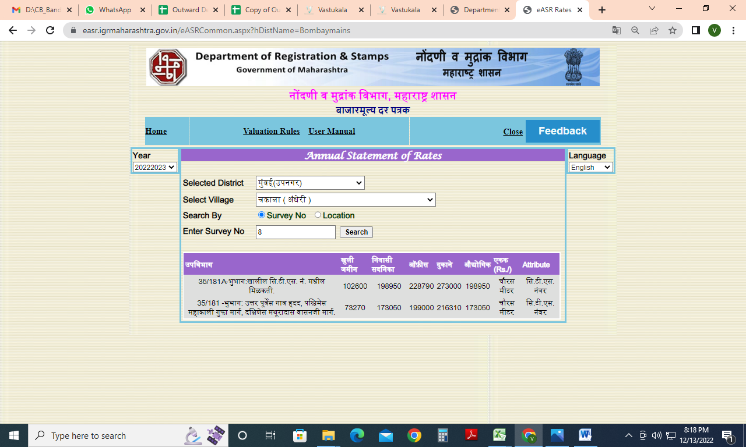
Price Indicators
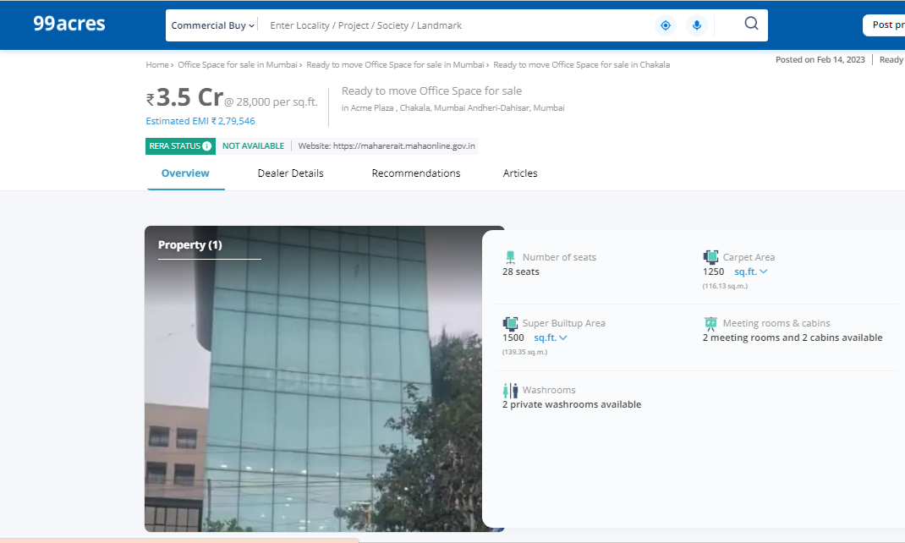

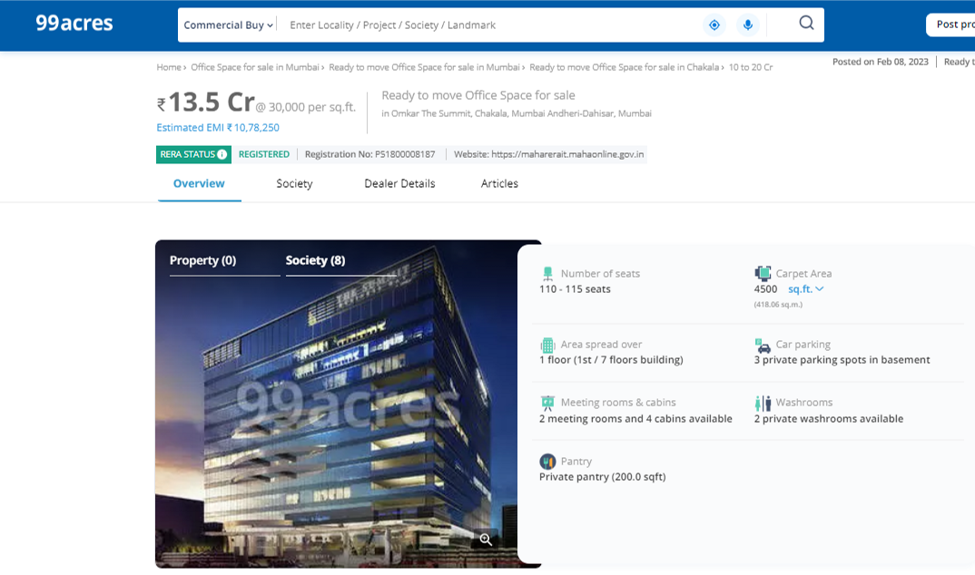

Price Indicators
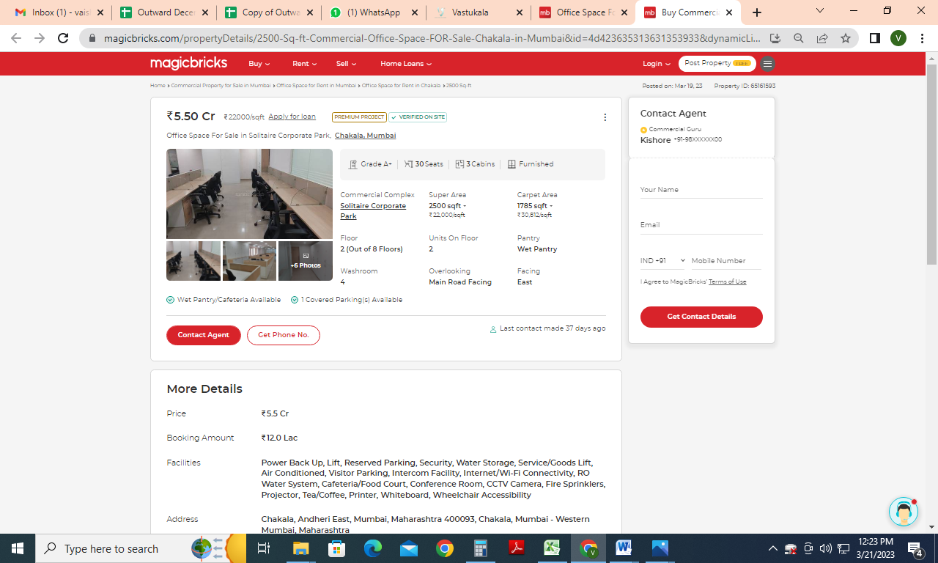
Sale Instance
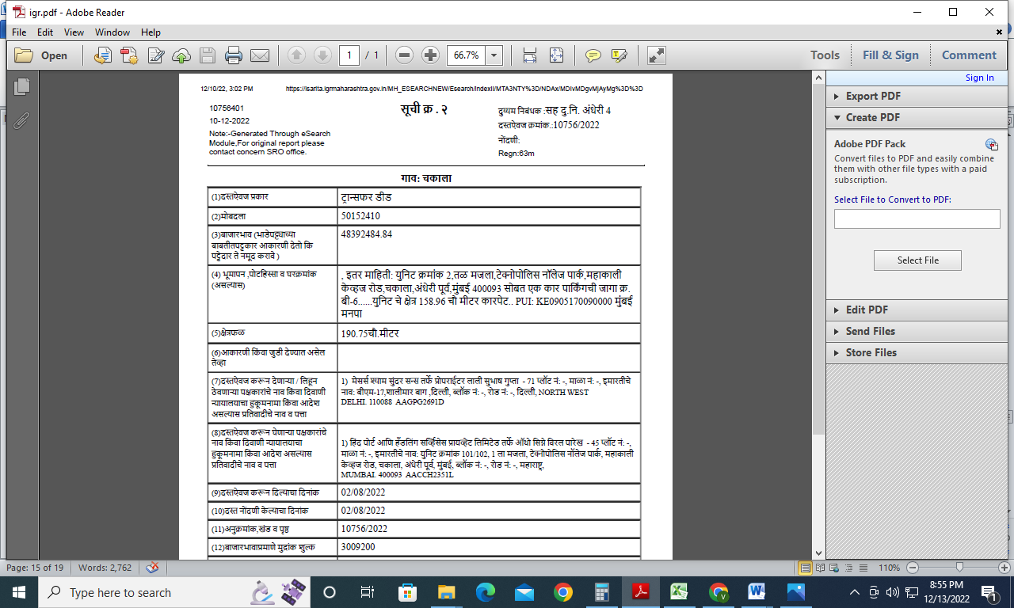
Sale Instance
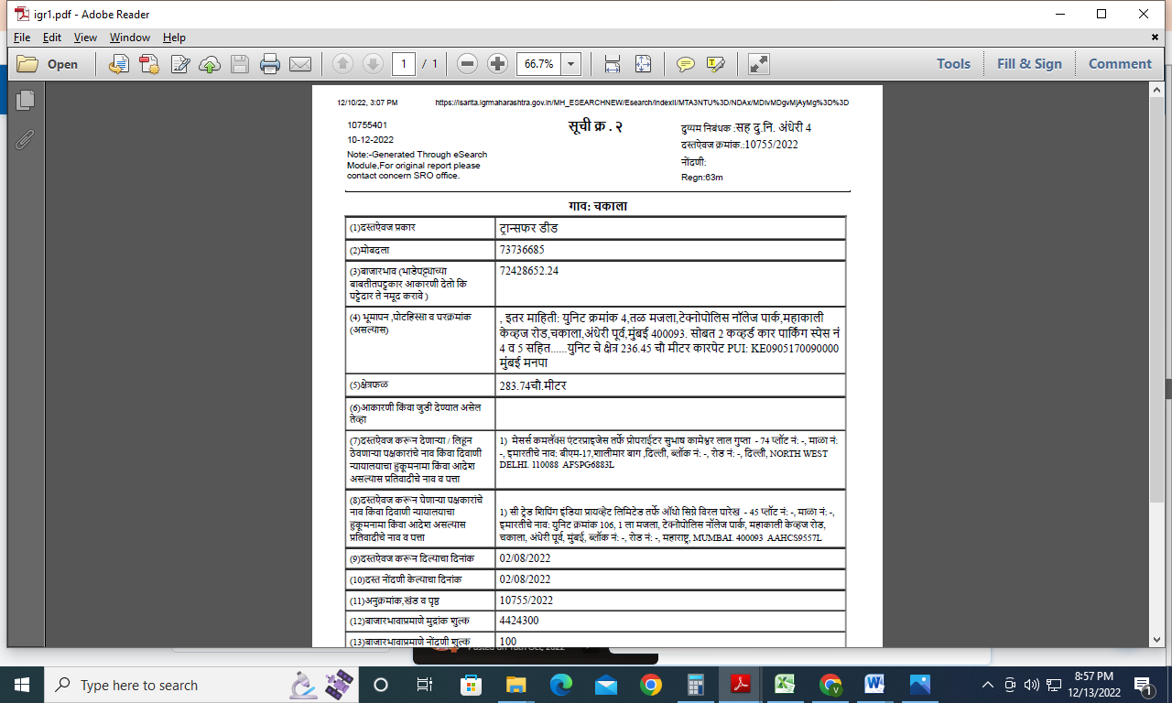
Justification for price /rate

The Market Value of the property is based on facts of markets discovered by us during our enquiries, however the government rate value in this case is less than the market value arrived by us. We are of the opinion that the value arrive by us will prove to be correct if an Auction of the subject property is carried out. As far as Market Value in Index II is concerned, it is not possible to comment on same, may be government rates are fixed by sampling during same point of time in part and whereas, Market values change every month.

In most of the cases the actual deal amount or Transaction value is not reflected in Index II because of various Market practices. As Valuer, we always try to give a value which is correct reflection of actual transaction value irrespective of any factors in market.

As a result of my appraisal and analysis, it is my considered opinion that the Market Value as on 31.03.2023 for accounting purpose of the above property in the prevailing condition with aforesaid specifications is ` 6,06,10,000.00 (Rupees Six Crore Six Lakh Ten Thousand Only).

Place : Mumbai
Date : 21.03.2023

Manoj B. Chalikwar
Approved Valuer
Chartered Engineer (India)
Reg. No. CAT-I-F-1763

DEFINITION OF VALUE FOR THIS SPECIFIC PURPOSE

This exercise is to assess Market Value of the property under reference as on 31.03.2023 for Accounting Purpose.

The term Fair Market Value is defined as

“The most probable price, as of a specified date, in cash, terms equivalent to cash, or in other precisely revealed terms for which the specified property rights would sell after reasonable exposure in a competitive market under all conditions requisite to a fair sale, with the buyer and seller each acting prudently knowledgeably and for self interest assuming that neither is under undue duress”.

Fundamental assumptions and conditions presumed in this definition are:

1. Buyer and seller are motivated by self-interest.
2. Buyer and seller are well informed and are acting prudently.
3. The property is exposed for a reasonable time on the open market.
4. Payment is made in cash or equivalent or in specified financing terms.

ASSUMPTIONS, CAVEATS, LIMITATION AND DISCLAIMERS
1. We assume no responsibility for matters of legal nature affecting the property appraised or the title thereto, nor do we render our opinion as to the title, which is assumed to be good and marketable.
2. The property is valued as though under responsible ownership.
3. It is assumed that the property is free of liens and encumbrances.
4. It is assumed that there are no hidden or unapparent conditions of the subsoil or structure that would render it more or less valuable. No responsibility is assumed for such conditions or for engineering that might be required to discover such factors.
5. There is no direct/ indirect interest in the property valued.
6. The rates for valuation of the property are in accordance with the Govt. approved rates and prevailing market rates.

Manoj B. Chalikwar
Approved Valuer
Chartered Engineer (India)
Reg. No. CAT-I-F-1763
DECLARATION OF PROFESSIONAL FEES CHARGED

We hereby declare that, our professional fees are not contingent upon the valuation findings. However, if the statute AND/OR clients demands that, the fees should be charged on the percentage of assessed value then, with the full knowledge of the AND/OR end user, it is being charged accordingly.

VALUATION OF THE PROPERTY PREMISES

Considering various parameters recorded herein above, existing economic scenario, and the information that is available with reference to the development of neighborhood and method selected for valuation, we are of the opinion that, the property premises can be assessed and Market value as on 31.03.2023 for accounting purpose for this particular purpose at ` 6,06,10,000.00 (Rupees Six Crore Six Lakh Ten Thousand Only).

Manoj B. Chalikwar
Approved Valuer
Chartered Engineer (India)
Reg. No. CAT-I-F-1763

