Valuation Report of the Immovable Property

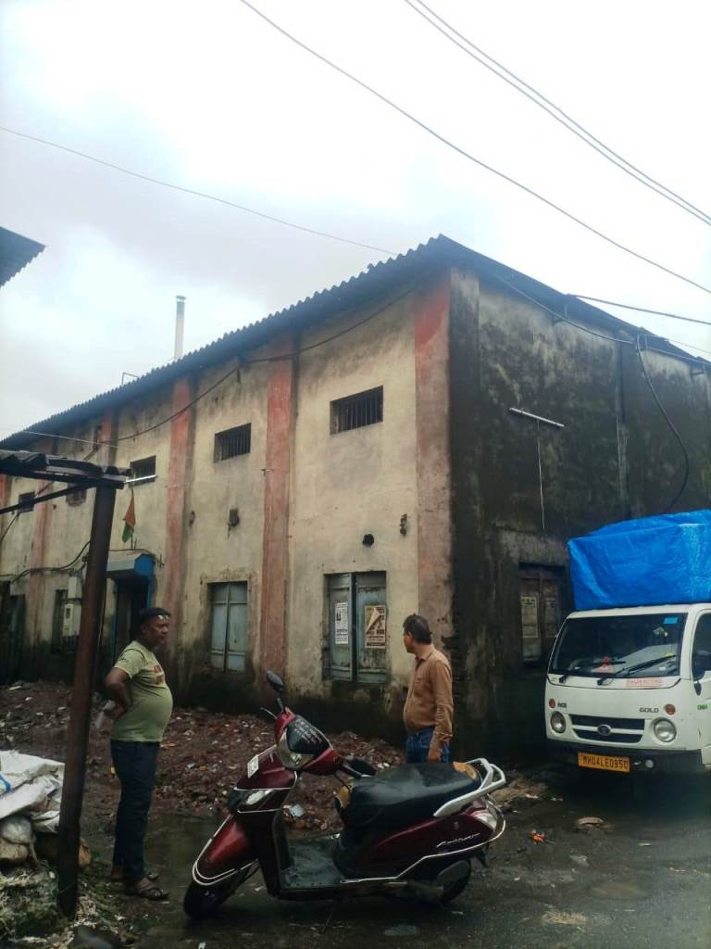

Details of the property under consideration:

Name of Owner: Smt. Nirmala Vipul Khandelwal &
Shri. Rahul Vipul Khandelwal

N.A. Land with AC Sheet House / Gala at M. H. No. 1597, New Survey No. 56/1/E, Nagaon-1,
Village Temghar, Taluka Bhiwandi, District Thane, PIN – 421 302,
State - Maharashtra, Country – India

Latitude Longitude - 19°17'19.4"N 73°04'38.4"E

Valuation Done for:

Cosmos Bank

Zaveri Bazar Branch

19/21, Cosmos Bank Bldg., Vithalwadi, Zaveri Bazar, Mumbai - 400 002,

State – Maharashtra, Country – India

Vastu/Mumbai/07/2023/2350/2301707
21/3-332-JAA Date: 21.07.2023

VALUATION OPINION REPORT

The property bearing N.A. Land with AC Sheet House / Gala at M. H. No. 1597, New Survey No. 56/1/E, Nagaon-1, Village Temghar, Taluka Bhiwandi, District Thane, PIN – 421 302, State - Maharashtra, Country – India belongs to Smt. Nirmala Vipul Khandelwal & Shri. Rahul Vipul Khandelwal.

Boundaries of the property.
Building | : | As per actual site | As per document
North | : | Godown | Internal Road
South | : | Godown | Land Bearing Survey No. 49/4
East | : | Godown | 8 Feet Galli
West | : | Internal Road | M. H. No. 1956

Considering various parameters recorded, existing economic scenario, and the information that is available with reference to the development of neighborhood and method selected for valuation, we are of the opinion that, the property premises can be assessed and valued for banking purpose as below –

Particulars | Fair Market Value In (₹) | Realizable Value In (₹) | Distress Sale Value In (₹) | Insurable Value In  (₹)
N.A. Land with AC Sheet House / Gala | 38,33,500.00 | 34,50,150.00 | 30,66,800.00 | 15,24,475.00

The valuation of the property is based on the documents produced by the concern. Legal aspects have not been taken into considerations while preparing this valuation report.

Hence certified

Manoj B. Chalikwar

Registered Valuer

Chartered Engineer (India)

Reg. No. CAT-I-F-1763

Cosmos Emp. No. H.O./Credit/67/2019-20

Encl: Valuation report in Form – 01

Valuation Report of N.A. Land with AC Sheet House / Gala at M. H. No. 1597, New Survey No. 56/1/E, Nagaon-1, Village Temghar, Taluka Bhiwandi, District Thane, PIN – 421 302,
State – Maharashtra, Country – India.

Form 0-1

(See Rule 8 D)

REPORT OF VALUATION OF IMMOVABLE PROPERTY (OTHER THAN AGRICULTURAL LANDS, PLANTATIONS, FORESTS, MINES AND QUARRIES)

GENERAL:

1 | Purpose for which the valuation is made |  | To assess the Fair Market Value as on 21.07.2023 for Banking Purpose
2 | Date of inspection |  | 07.07.2023
 | Name of the owner/ owners |  | Smt. Nirmala Vipul Khandelwal &  Shri. Rahul Vipul Khandelwal
4 | If the property is under joint ownership / co-ownership, share of each such owner. Are the shares undivided? |  | Joint Ownership  Details of ownership share is not available
5 | Brief description of the property |  | Address: N.A. Land with AC Sheet House / Gala at M. H. No. 1597, New Survey No. 56/1/E, Nagaon-1, Village Temghar, Taluka Bhiwandi, District Thane, PIN – 421 302, State – Maharashtra, Country – India.  Contact Person:  Mr. Vipul Khandelwal (Husband of Co-owner)  Contact No. 9673837490
6 | Location, street, ward no |  | Subhash Nagar, Ward No. 12/2 Temghar
7 | Survey/ Plot no. of land |  | N.A. Land Bearing Survey No. 56/1 Paiki (New Survey No. 56/1/E)
8 | Is the property situated in residential/ commercial/ mixed area/ industrial area? |  | Industrial Area
9 | Classification of locality-high class/ middle class/poor class |  | Middle Class
10 | Proximity to civic amenities like schools, Hospitals, Offices, market, cinemas etc. |  | All the amenities are available in the vicinity
11 | Means and proximity to surface communication by which the locality is served |  | Served by Buses, Taxies, Auto and Private cars
 | LAND
12 | Area of land supported by documentary proof. Shape, dimension and physical features |  | Plot area is 1,700.00 Sq. Ft  (Area as per 7/12 Revenue Extract / Gaon Namuna 6)
13 | Roads, Streets or lanes on which the land is abutting |  | Subhash Nagar, Pipe Line Road
14 | If freehold or leasehold land |  | Free hold
15 | If leasehold, the name of Lessor/lessee, nature of lease, date of commencement and termination of lease and terms of renewal of lease. |  | N. A.
 | (i) Initial premium
 | (ii) Ground rent payable per annum
 | (iii) Unearned increase payable to the Lessor in the event of sale or transfer
16 | Is there any restriction covenant in regard to use of land? If so attach a copy of the covenant. |  | Industrial
17 | Are there any agreements of easements? If so, attach a copy of the covenant |  | Information not available
18 | Does the land fall in an area included in any Town Planning Scheme or any Development Plan of Government or any statutory body? If so, give Particulars. |  | Information not available
19 | Has any contribution been made towards development or is any demand for such contribution still outstanding? |  | Information not available
20 | Has the whole or part of the land been notified for acquisition by government or any statutory body? Give date of the notification. |  | No
21 | Attach a dimensioned site plan |  | Copy of Approved Site Plan not available for our verification.
 | IMPROVEMENT
22 | Attach plans and elevations of all structures standing on the land and a lay-out plan. |  | Information not available
23 | Furnish technical details of the building on a separate sheet (The Annexure to this form may be used) |  | Attached
24 | Is the building owner occupied/tenanted/both? |  | Owner Occupied
 | If the property owner occupied, specify portion and extent of area under owner-occupation |  | N.A.
25 | What is the Floor Space Index permissible and Percentage actually utilized? |  | Floor Space Index permissible - As per BNCMC norms  Percentage actually utilized – Details not available
26 | RENTS
 | (i) | Names of tenants/ lessees/ licensees, etc. | Owner Occupied
 | (ii) | Portions in their occupation | Entire Building
 | (iii) | Monthly or annual rent/ compensation / license fee, etc. paid by each | ` 11,000.00 Expected rental income per month
 | (iv) | Gross amount received for the whole property | N.A.
27 | Are any of the occupants related to, or close to business associates of the owner? |  | N. A.
28 | Is separate amount being recovered for the use of fixtures, like fans, geysers, refrigerators, cooking ranges, built-in wardrobes, etc. or for services charges? If so, give details |  | N. A.
29 | Give details of the water and electricity charges, if any, to be borne by the owner |  | N. A.
30 | Has the tenant to bear the whole or part of the cost repairs and maintenance? Give particulars |  | N. A.
31 | If a lift is installed, who is to bear the cost of maintenance and operation- owner or tenant? |  | N. A.
32 | If a pump is installed, who is to bear the cost of maintenance and operation- owner or tenant? |  | N. A.
33 | Who has to bear the cost of electricity charges for lighting of common space like entrance hall, stairs, passage, compound, etc. owner or tenant? |  | N. A.
34 | What is the amount of property tax? Who is to bear it? Give details with documentary proof |  | Information not available
35 | Is the building insured? If so, give the policy no., amount for which it is insured and the annual premium |  | Information not available
36 | Is any dispute between landlord and tenant regarding rent pending in a court of rent? |  | N. A.
37 | Has any standard rent been fixed for the premises under any law relating to the control of rent? |  | N. A.
 | SALES
38 | Give instances of sales of immovable property in the locality on a separate sheet, indicating the Name and address of the property, registration No., sale price and area of land sold. |  | As per sub registrar of assurance records
39 | Land rate adopted in this valuation |  | ` 1,200.00 per Sq. Ft.
40 | If sale instances are not available or not relied up on, the basis of arriving at the land rate |  | Online Price Indicators, Location, development of surrounding area, type of land and construction, construction specifications, age of building, condition of the premises & building, facilities provided and its prevailing market rate.
 | COST OF CONSTRUCTION
41 | Year of commencement of construction and year of completion |  | Year of Construction (Approx.) – 2000
42 | What was the method of construction, by contract / By employing Labour directly / both? |  | Information not available
43 | For items of work done on contract, produce copies of agreements |  | Information not available
44 | For items of work done by engaging Labour directly, give basic rates of materials and Labour supported by documentary proof. |  | Information not available
Remark: As per site inspection, AC Sheet House / Gala No. 1596 & 1597 are internally merged with separate entrances. For the purpose of valuation, we have considered Area of AC Sheet House / Gala No. 1596 as per Agreement for Sale.
The property is Industrial Shed with rights to used land beneath which is generally transected in composite method but as per bank request we have given separate rate for land & Structure.

PART II- VALUATION

GENERAL:
Under the instruction of Cosmos Bank, Zaveri Bazar Branch to assess fair market value as on 21.07.2023 for N.A. Land with AC Sheet House / Gala at M. H. No. 1597, New Survey No. 56/1/E, Nagaon-1, Village Temghar, Taluka Bhiwandi, District Thane, PIN – 421 302, State – Maharashtra, Country – India belongs to Smt. Nirmala Vipul Khandelwal & Shri. Rahul Vipul Khandelwal.

We are in receipt of the following documents:
1 | Copy of Agreement for Slae dated 31.03.2022 between Shri. Harsh Paresh Mehta (the Vendor) AND Smt. Nirmala Vipul Khandelwal & Shri. Rahul Vipul Khandelwal (the Purchasers)
2 | Copy of 7/12 Revenue Extract (Gaon Namuna 7)
3 | Copy of Gaon Namuna 6
4 | Copy of Search Report dated 18.05.2022 issued by Archana Khandu Thakare.
5 | Copy of Electricity Bill, Service / Consumer Number 13012531782 for the month of May 2023 dated 13.06.2023

LOCATION:
The said building is located at N.A. Land bearing Survey No. 56, Hissa No. 1 Paiki, New Survey No. 56/1/E of Mauje Temghar, Talathi Saja Temghar, within the limits of Bhiwandi Nizampur City Municipal Corporation Bhiwandi, District Thane and Sub Division and Sub Registration Office Bhiwandi and Division & District Thane. The property falls in Industrial Zone. It is at a travelling distance of 4.9 KM. from Bhiwandi Road railway station.

BUILDING:

The building under reference is having ground floor with AC sheet roof structure only. It is a R.C.C. Framed Structure with 9" thick external walls and 6" thick internal brick walls. The walls are having sand faced plaster from outside. The building external condition is normal. The building is used for Industrial purpose.

Commercial Unit:

The N.A. Land with AC Sheet House / Gala under reference is situated on ground floor. It consists of working area with Machinery. It is ﬁnished with PCC flooring, M.S. rolling shutter to main entrance, M.S. framed windows & casing capping electrical wiring etc.

As per Agreement for Sale, the constructed built-up area is as 1,700.00 Sq. Ft., which is considered for valuation.

Valuation as on 21st July 2023:
- Land Valuation:
Fair Market Value
A) Land | Area in Sq. Ft. | Rate in ` | Fair Market Value in `
 | 1,700.00 | 1,200/- | 20,40,000/-

- Valuation of Structures.
The Built-up area of the building : As per valuation table below
Deduct Depreciation:
Year of Construction of the building : Approx. 2000 (As per site information)
Expected total life of building : 50 Years
Age of the building as on 2023 : 23 Years
Cost of Construction : As per valuation table below
Depreciation : As per valuation table below
Amount of depreciation : As per valuation table below
Depreciated cost of construction : As per valuation table below

Government Value:

Particulars | Area in Sq. Ft. | Rate in ` | Value in `
Land | 1,700.00 | 650/- | 11,05,000/-
Structure | As per valuation table |  | 17,93,500/-
Total |  |  | 28,98,500/-

B) Structure
Particulars | Built up Area in  Sq. Ft. | Year of Const. | Total Life of Structure | Replacement Rate (`) | Age Of Build. | Depreciated Rate (`) | Depreciated Value (`) | Full Value (`)
Ground Floor | 1,700.00 | 2000 | 50 | 1,800/- | 23 Years | 1,055/- | 17,93,500/- | 30,60,000/-
Total |  |  |  |  |  |  | 17,93,500/- | 30,60,000/-

TOTAL VALUE OF THE PROPERTY:
Particulars | Value (`)
Land | 20,40,000.00
Building | 17,93,500.00
Fair Market Value | 38,33,500.00
Realizable Value | 34,50,150.00
Distress Sale Value | 30,66,800.00
Insurable value  (Depreciated Cost of Construction (17,93,500/-) – Subsoil structure cost (15%) | 15,24,475.00

Taking into consideration above said facts, we can evaluate the value of Industrial Land & Building on N.A. Land with AC Sheet House / Gala at M. H. No. 1597, New Survey No. 56/1/E, Nagaon-1, Village Temghar, Taluka Bhiwandi, District Thane, PIN – 421 302, State - Maharashtra, Country – India for this particular purpose at ` 38,33,500.00 (Rupees Thirty Eight Lakhs Thirty Three Thousand Five Hundred Only) as on 21st July 2023.

NOTES

I, Manoj B. Chalikwar with my experience and ability to judgment I am of the considered opinion that the fair market value of the property as on 21st July 2023 is ` 38,33,500.00 (Rupees Thirty Eight Lakhs Thirty Three Thousand Five Hundred Only). Value varies with time and purpose and hence this value should not be referred for any purpose other than mentioned in this report.

This valuation is done on the basis of information, which the valuer has obtained by information provided by the client about the premises and location of the surrounding area and also prevailing rates in the surrounding area, and further subject to document as mentioned in valuation report.

This valuer should not be held responsible for authentication of documents, clear title and other such related matters. For that purpose, Latest Legal Opinion should be sought.

PART III- DECLARATION

I hereby declare that

The information furnished in part I is true and correct to the best of my knowledge and belief;

I have no direct or indirect interest in the property valued:

ANNEXURE TO FORM 0-1

Technical details Building
1. | No. of floors and height of each floor | Ground floor with AC sheet slopping roof structure only
2. | Plinth area floor wise as per IS- 1225 | N.A. as the said property is a N.A. Land with AC Sheet House / Gala
3 | Year of construction | Approx. 2000 (As per site information)
4 | Estimated future life | 27 Years Subject to proper, preventive periodic maintenance & structural repairs
5 | Type of construction- load bearing walls/RCC frame/ steel frame | R.C.C. framed structure
6 | Type of foundations | R.C.C. foundation
7 | Walls | All external walls are 9” thick and partition walls are 6” thick.
8 | Partitions | 6” thick brick wall
9 | Doors and Windows | M.S. rolling shutter to main entrance, M.S. framed windows
10 | Flooring | P.C.C. flooring
11 | Finishing | Cement plastering
12 | Roofing and terracing | Partly R.C.C. Slab and AC sheet slopping roof
13 | Special architectural or decorative features, if any | N.A.
14 | (i) Internal wiring – surface or conduit  (ii) Class of fittings: Superior/ Ordinary/ Poor. | Casing capping electrification
15 | Sanitary installations  (i) No. of water closets  (ii) No. of lavatory basins  (iii) No. of urinals  (iv) No. of sinks  Class of fittings: Superior colored / superior white/ordinary. | N.A.
16 | Compound wall  Height and length  Type of construction | Not existing
17 | No. of lifts and capacity | No lift
18 | Underground sump – capacity and type of construction | Not existing
19 | Over-head tank Location, capacity Type of construction | Not existing
20 | Pumps- no. and their horse power | Not existing
21 | Roads and paving within the compound approximate area and type of paving | Tar Road
22 | Sewage disposal – whereas connected to public sewers, if septic tanks provided, no. and capacity | Connected to Municipal Sewerage System
23 | General Remarks
 | For the purpose of valuation, we have considered the constructed area as per sale deed and land area as per 7/12 revenue extract.

Actual site photographs
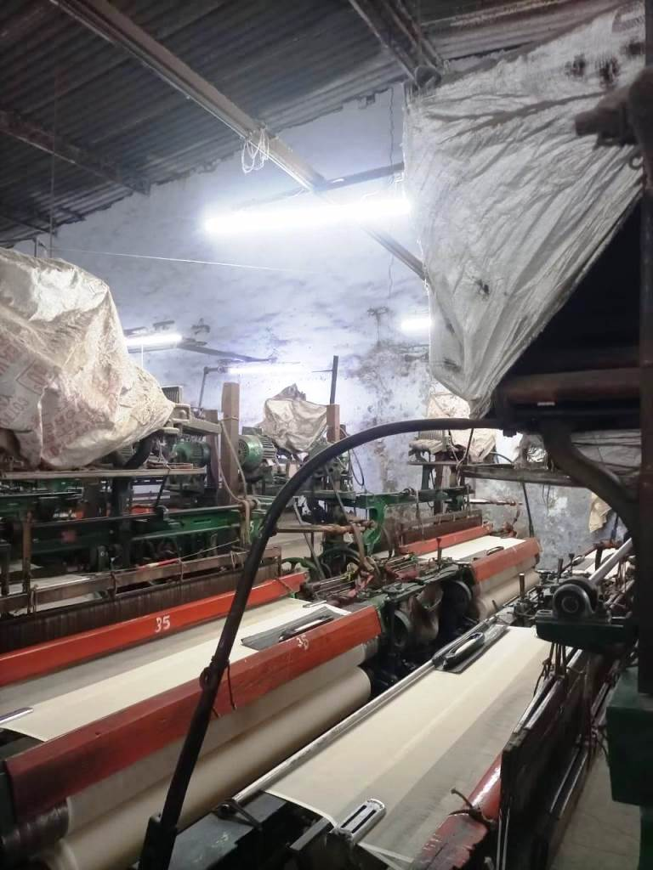
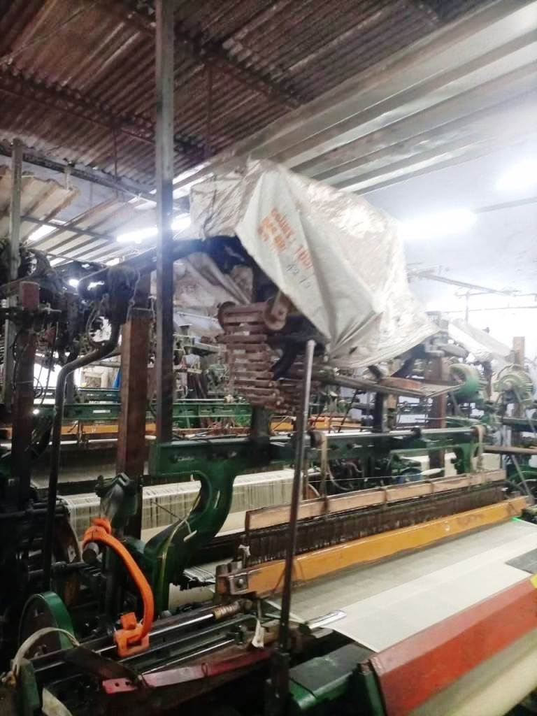
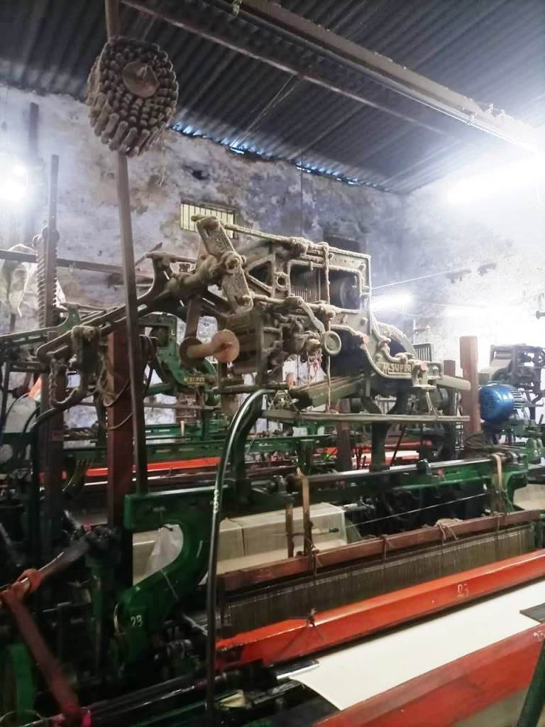
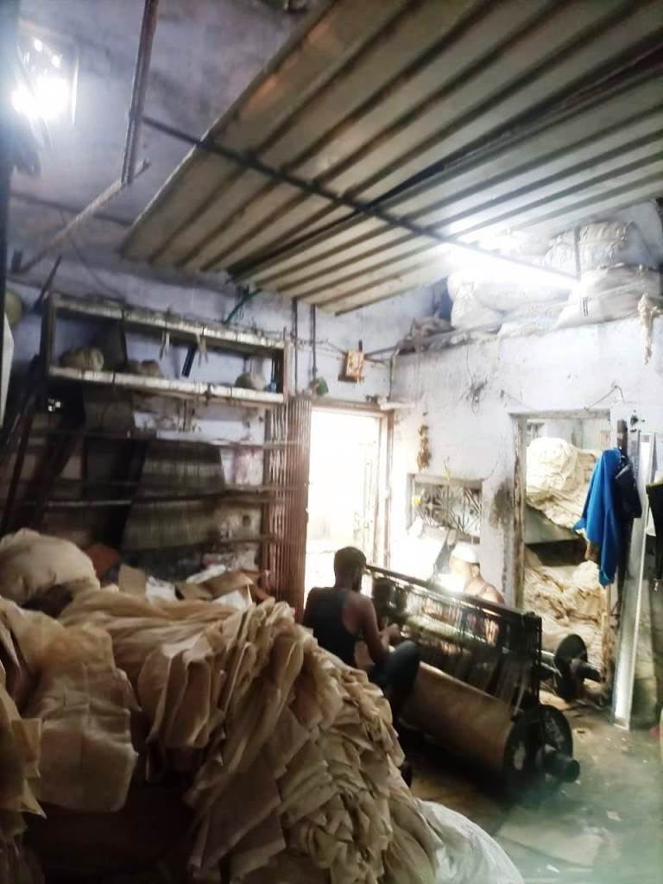
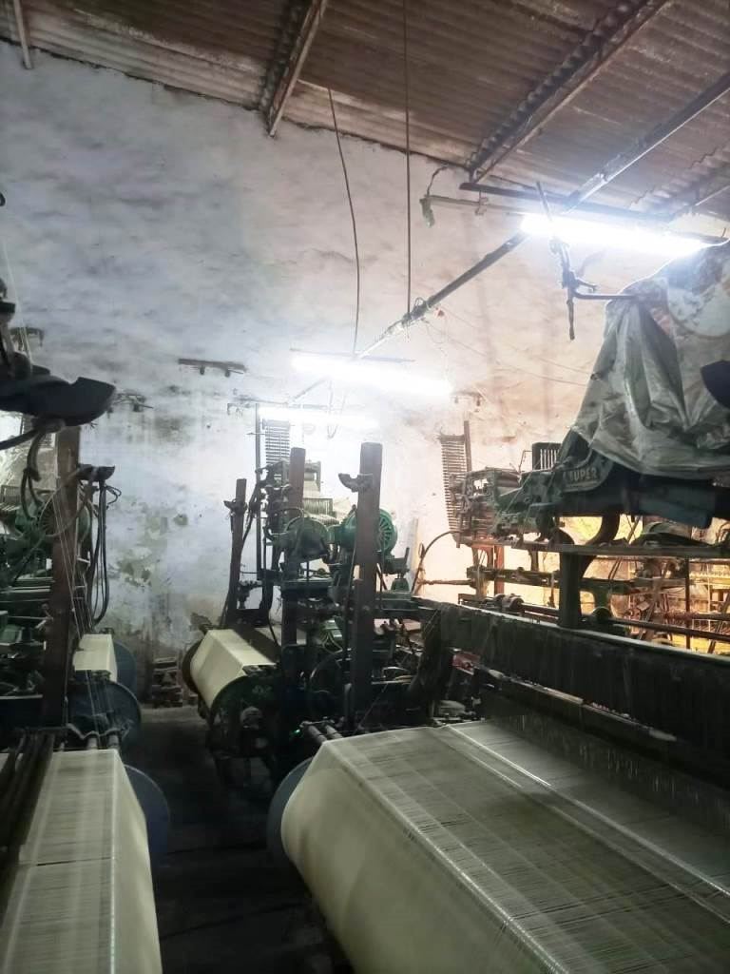
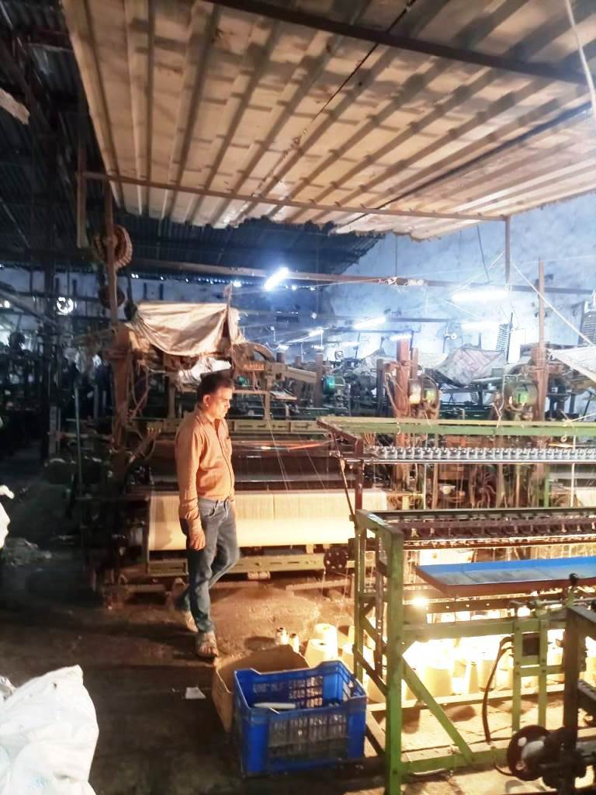
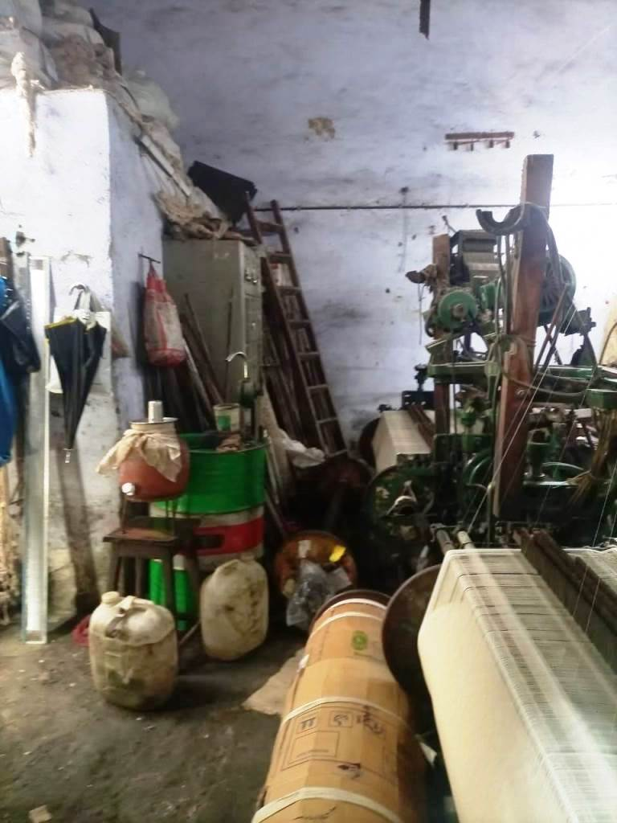
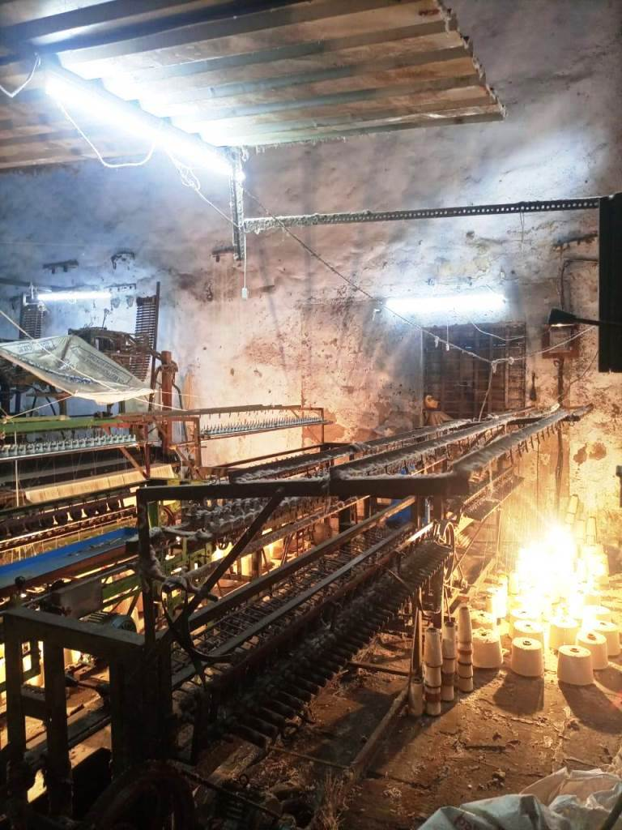
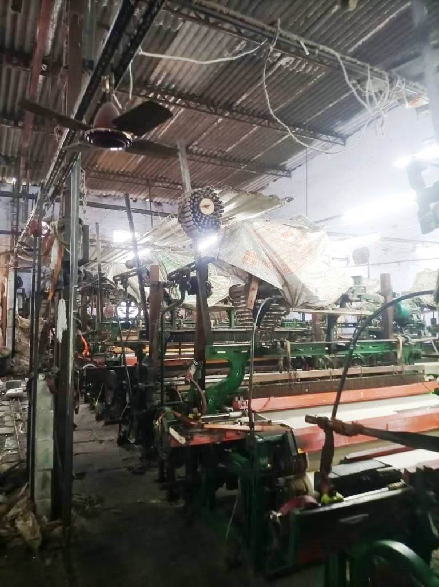
Actual site photographs
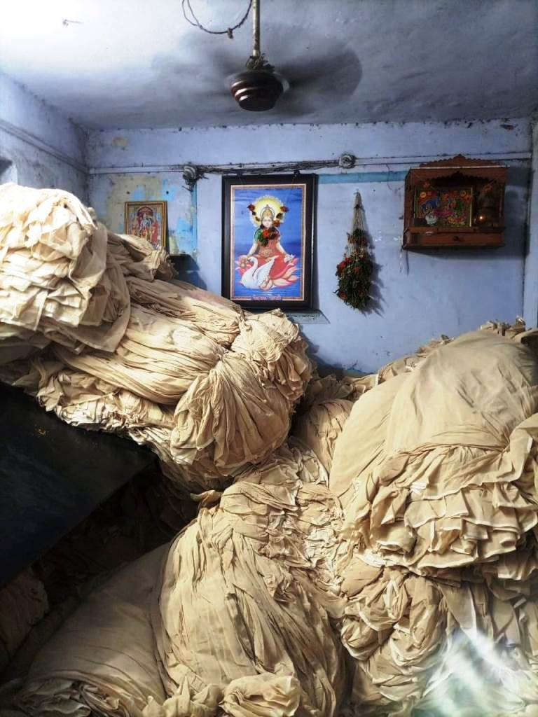
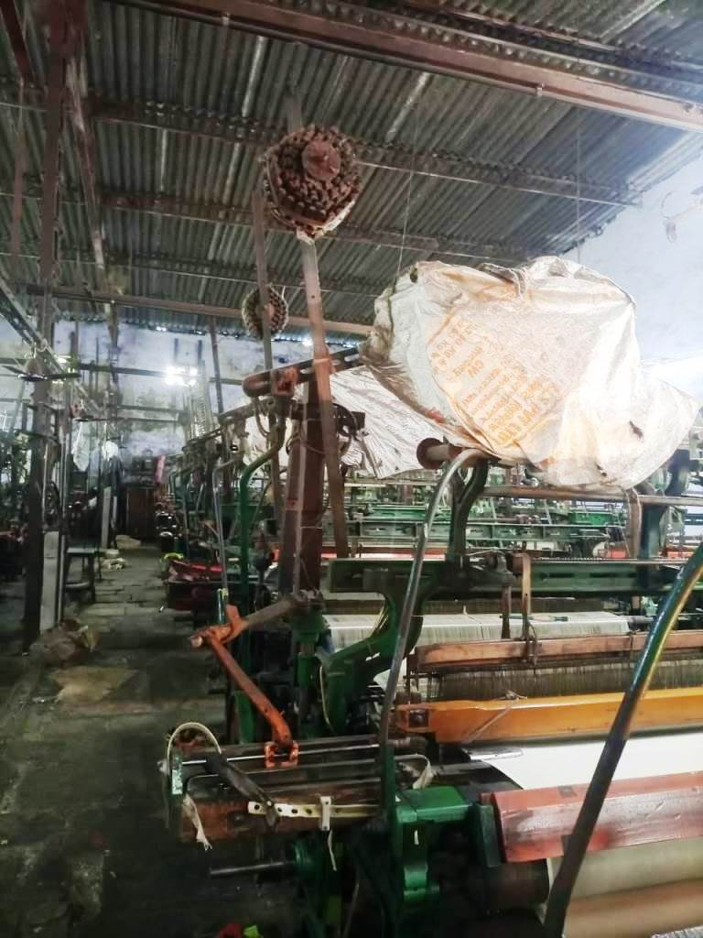
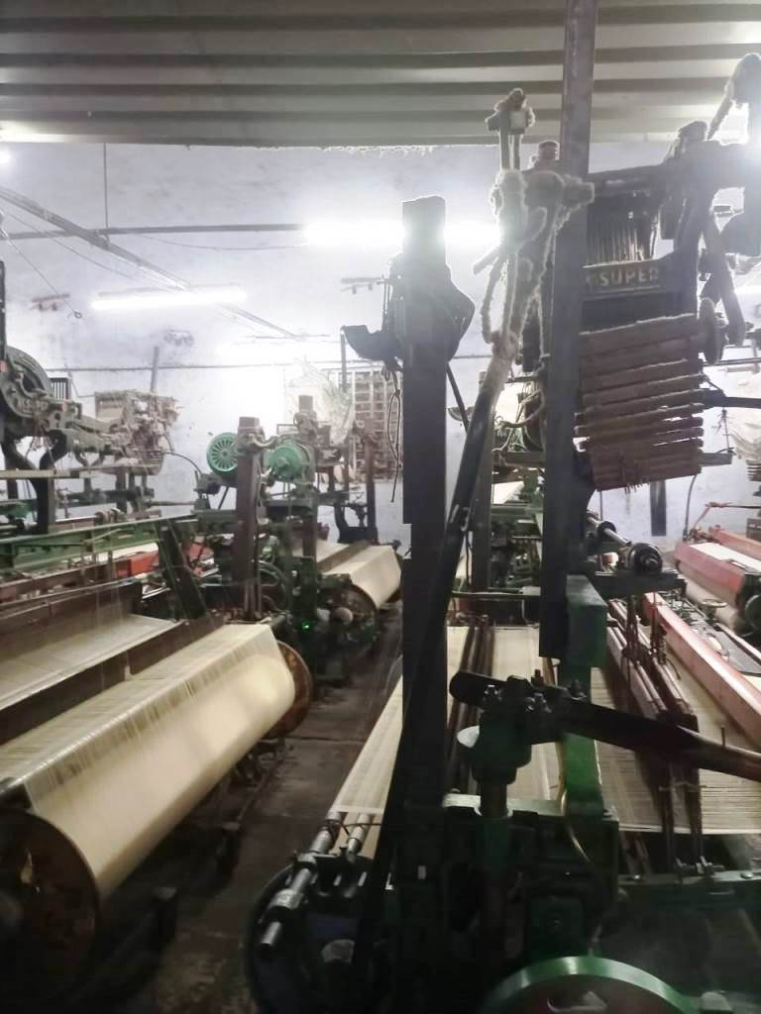

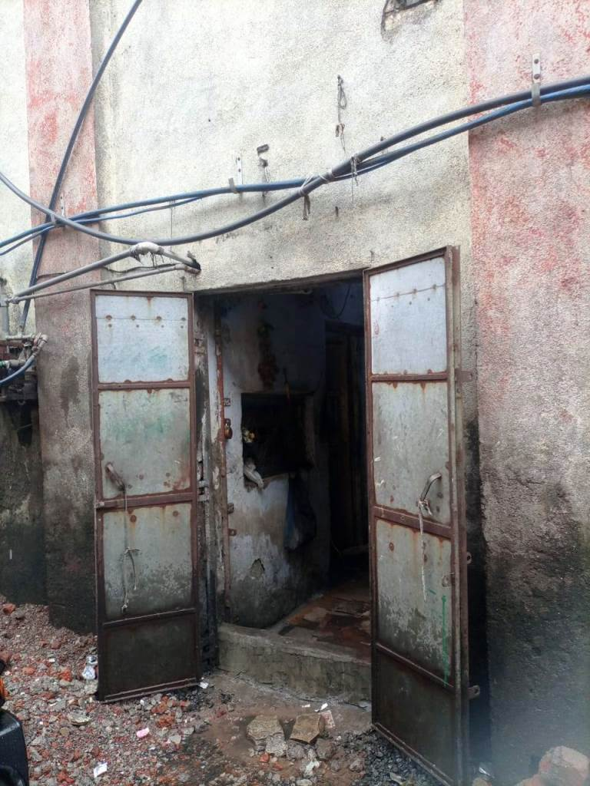
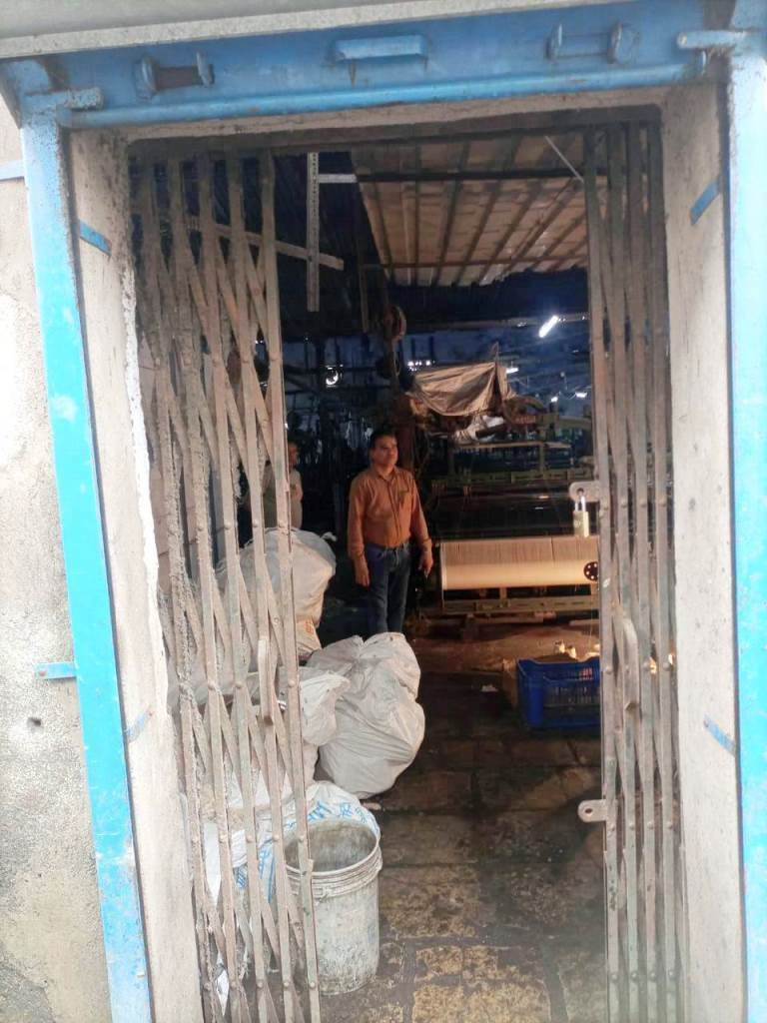
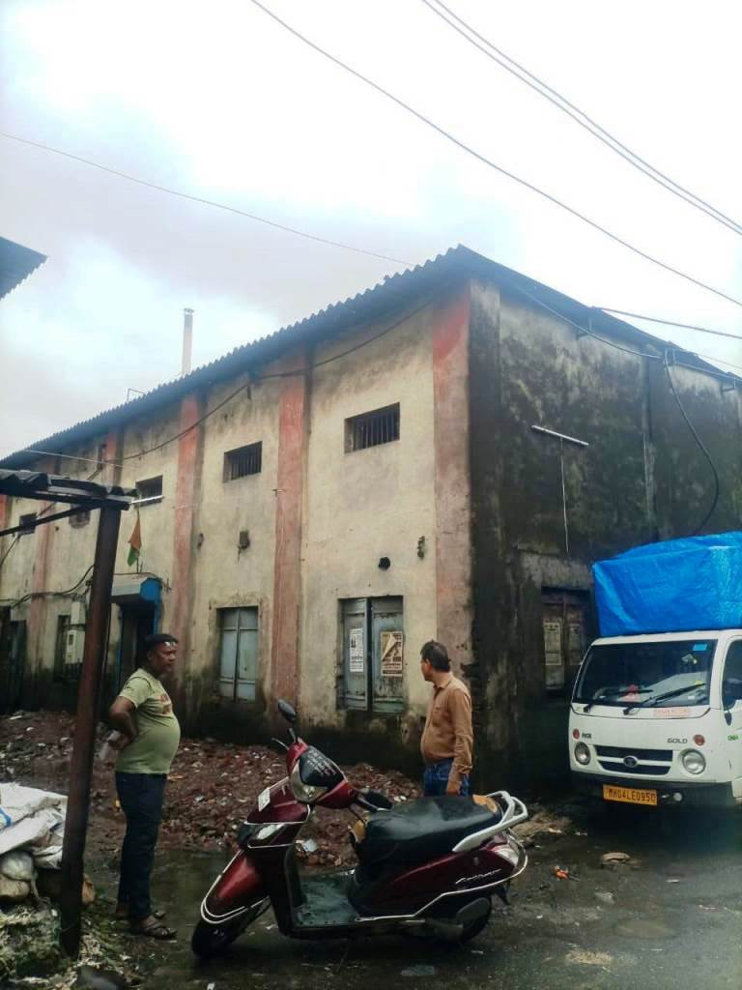


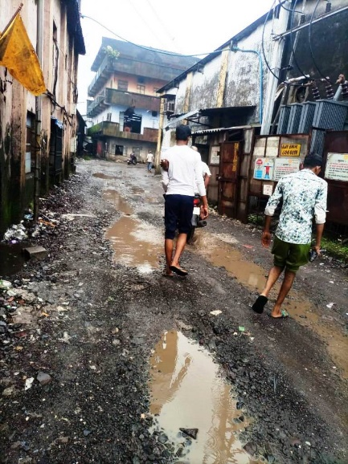
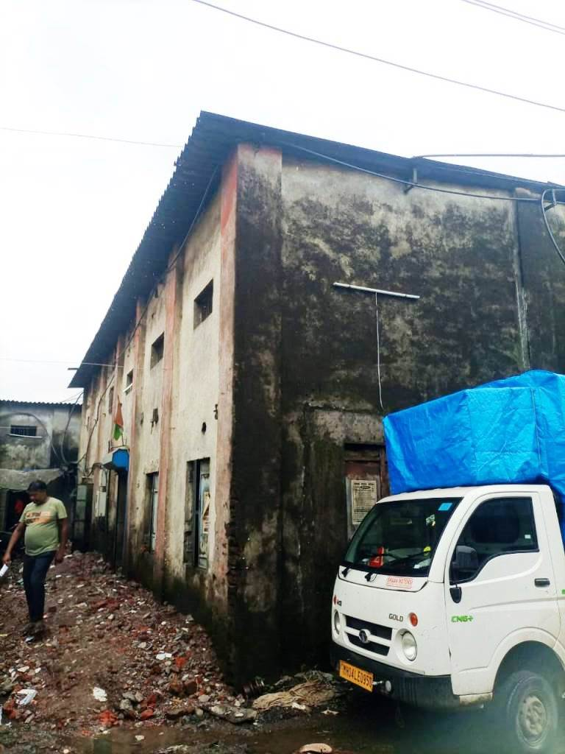

Route Map of the property
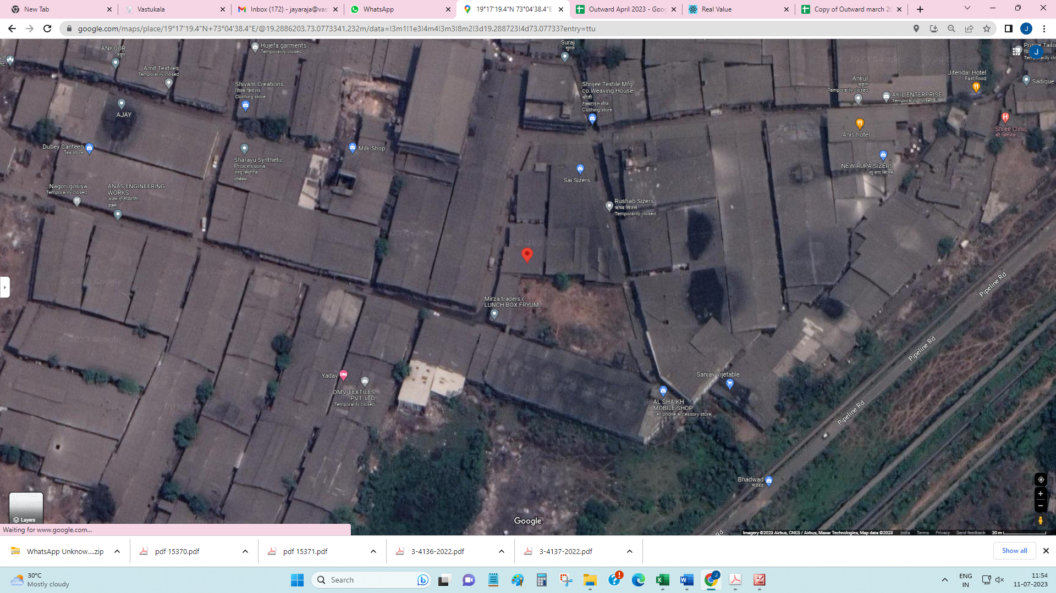
Site u/r

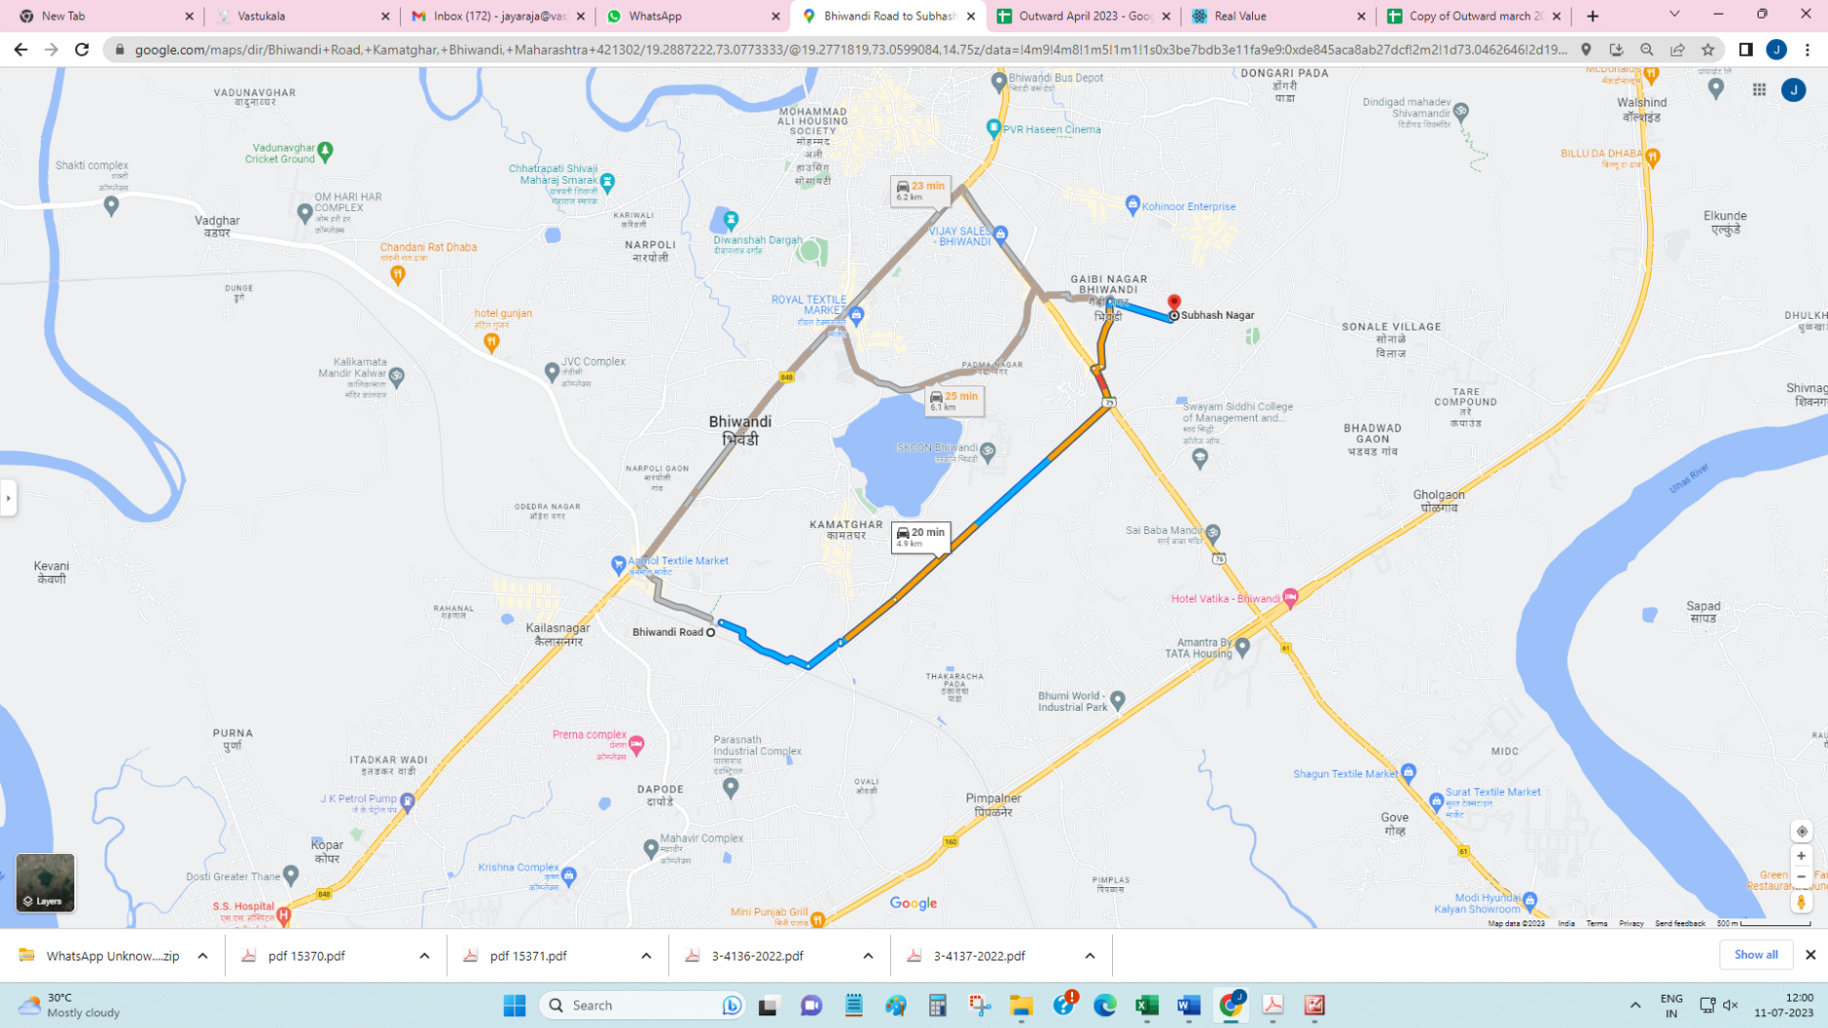

Latitude Longitude - 19°17'19.4"N 73°04'38.4"E
Note: The Blue line shows the route to site from nearest railway station (Bhiwandi Road – 4.9 KM)

READY RECKONER RATE
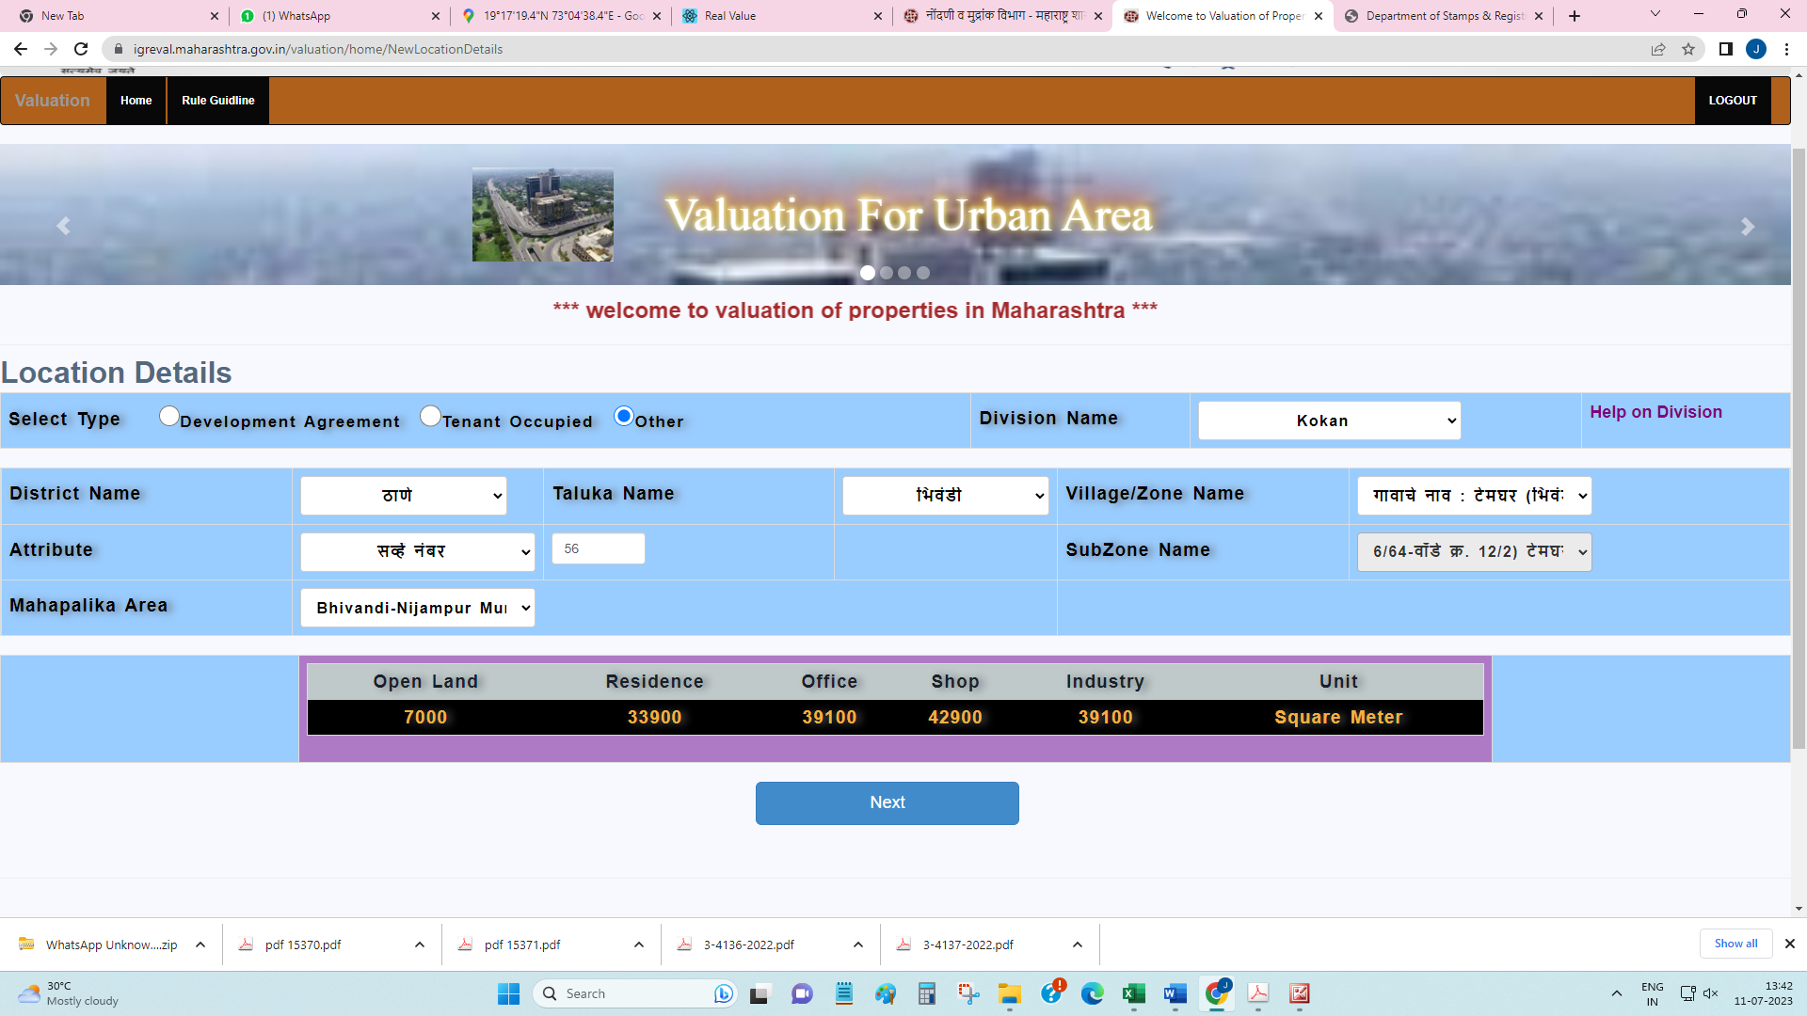

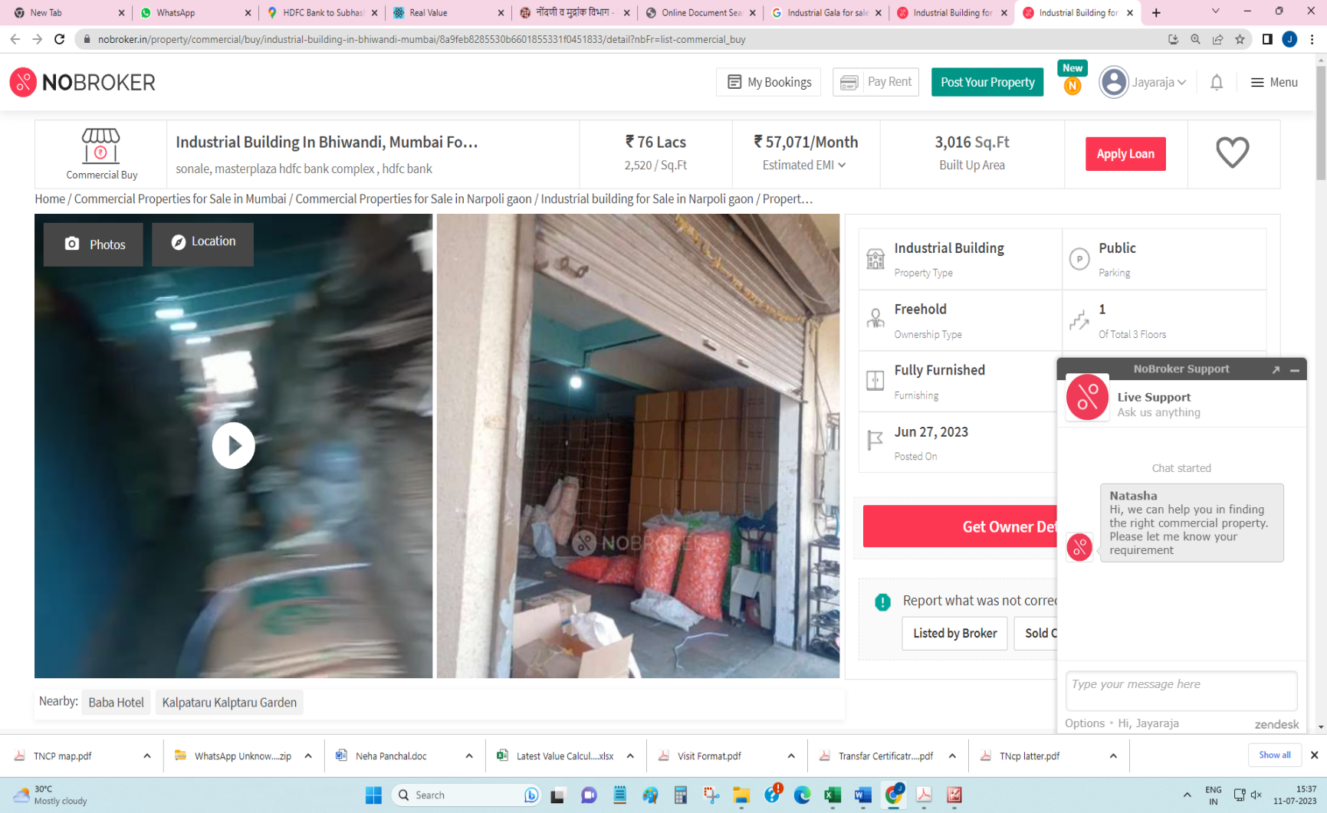
Price Indicators

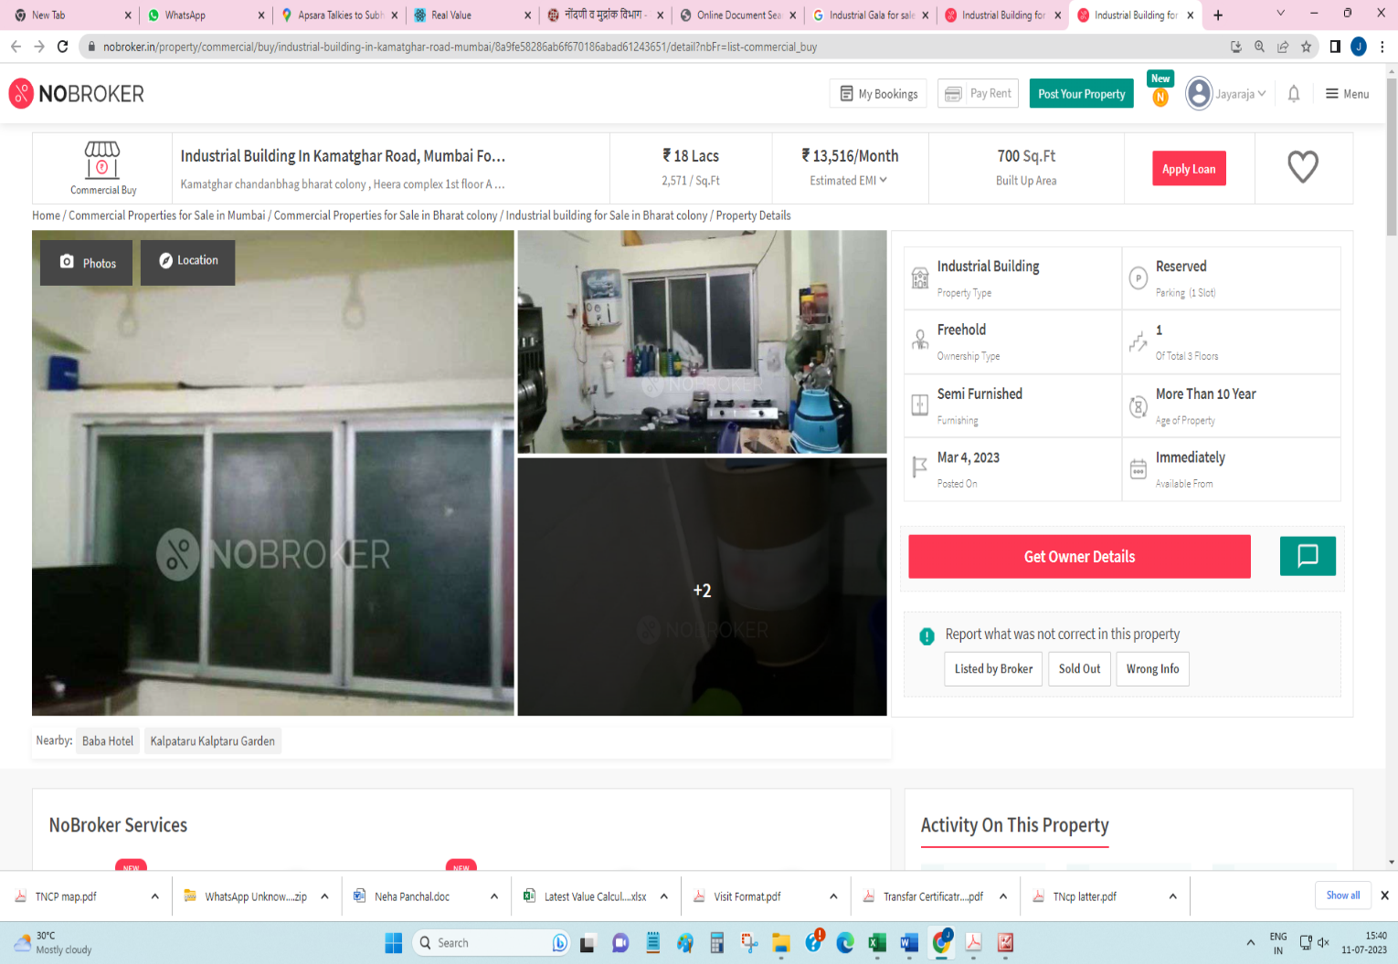

DEFINITION OF VALUE FOR THIS SPECIFIC PURPOSE
This exercise is to assess Fair Market Value of the property under reference as on 21st July 2023.

The term Fair Market Value is defined as

“The most probable price, as of a specified date, in cash, terms equivalent to cash, or in other precisely revealed terms for which the specified property rights would sell after reasonable exposure in a competitive market under all conditions requisite to a fair sale, with the buyer and seller each acting prudently knowledgeably and for self-interest assuming that neither is under undue duress”.
Fundamental assumptions and conditions presumed in this definition are:

1. Buyer and seller are motivated by self-interest.

2. Buyer and seller are well informed and are acting prudently.

3. The property is exposed for a reasonable time on the open market.

4. Payment is made in cash or equivalent or in specified financing terms.

UNDER LYING ASSUMPTIONS
1. We assume no responsibility for matters of legal nature affecting the property appraised or the title thereto, nor do we render our opinion as to the title, which is assumed to be good and marketable.
2. The property is valued as though under responsible ownership.
3. It is assumed that the property is free of liens and encumbrances.
4. It is assumed that there are no hidden or unapparent conditions of the subsoil or structure that would render it more or less valuable. No responsibility is assumed for such conditions or for engineering that might be required to discover such factors.
5. There is no direct/ indirect interest in the property valued
6. The rates for valuation of the property are in accordance with the Govt. approved rates and prevailing market rates.

DECLARATION OF PROFESSIONAL FEES CHARGED

We hereby declare that, our professional fees are not contingent upon the valuation findings. However, if the statute AND/OR clients demands that, the fees should be charged on the percentage of assessed value then, with the full knowledge of the AND/OR end user, it is being charged accordingly.

VALUATION OF THE PROPERTY PREMISES

Considering various parameters recorded herein above, existing economic scenario, and the information that is available with reference to the development of neighborhood and method selected for valuation, we are of the opinion that, the property premises can be assessed and valued for banking purpose as on day for ` 38,33,500.00 (Rupees Thirty Eight Lakhs Thirty Three Thousand Five Hundred Only).

Manoj B. Chalikwar

Registered Valuer

Chartered Engineer (India)

Reg. No. CAT-I-F-1763

Cosmos Emp. No. H.O./Credit/67/2019-20

