Valuation Report of the Immovable Property
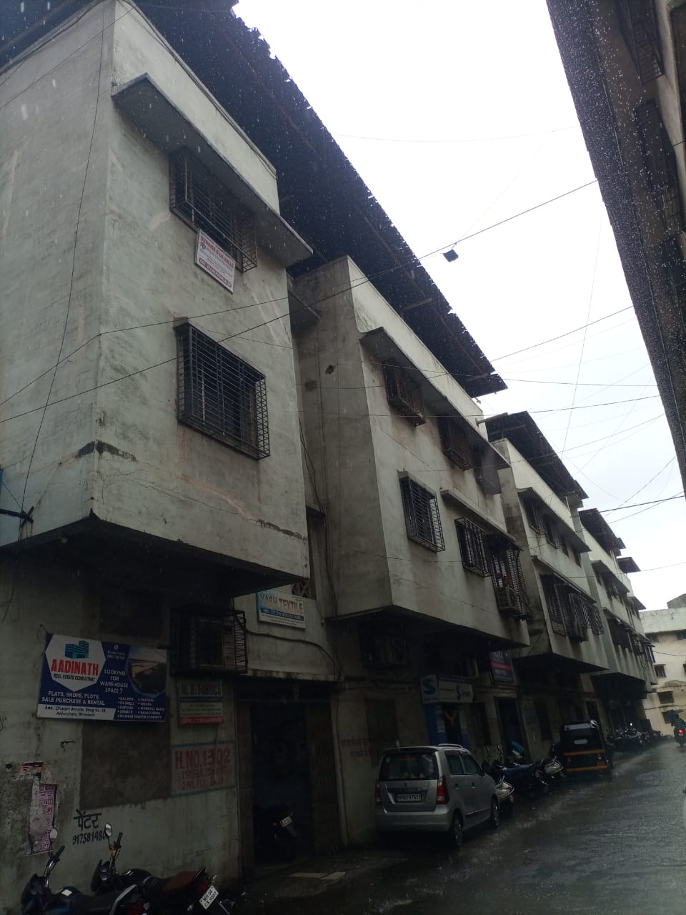

Details of the property under consideration:

Name of Owner: M/s. Swastik Power Electronic India Pvt. Ltd.

Commercial Galas / Godown No. 1, 2 & 3, Ground Floor, "Dharani Arcade", Near Anmol Market, Anjurphata, Kamatghar – Anjurphata Road, Village - Rahnal, Taluka – Bhiwandi, District – Thane, PIN Code - 421 302,
State - Maharashtra, Country – India.

Latitude Longitude: 19°16'21.2"N 73°02'29.8"E

Valuation Done for:
SVC Co-Operative Bank Ltd.
Thane Branch
Shop No. 11 & 12, Sita Vihar Society, Damani Estate, Thane, PIN Code – 400 602,
State – Maharashtra, Country – India

Vastu/Thane/07/2023/2225/2301395
03/12-20- PSVS
Date: 03.07.2023

VALUATION OPINION REPORT

This is to certify that the property bearing Commercial Galas / Godown No. 1, 2 & 3, Ground Floor, "Dharani Arcade", Near Anmol Market, Anjurphata, Kamatghar – Anjurphata Road, Village - Rahnal, Taluka – Bhiwandi, District – Thane, PIN Code - 421 302, State - Maharashtra, Country - India belongs to M/s Swastik Power Electronic India Pvt. Ltd.

Boundaries of the Property
North | : | Kamatghar – Anjurphata Road
South | : | Mukund Plaza
East | : | Internal Road
West | : | Shivkripa Building

Considering various parameters recorded, existing economic scenario, and the information that is available with reference to the development of neighborhood and method selected for valuation, we are of the opinion that, the property premises can be assessed for this particular purpose at ` 1,42,27,650.00 (Rupees One Crore Forty Two Lakh Twenty Seven Thousand Six Hundred Fifty Only).

The valuation of the property is based on the documents produced by the concern. Legal aspects have not been taken into considerations while preparing this valuation report.

Manoj B. Chalikwar
Registered Valuer
Chartered Engineer (India)
Reg. No. CAT-I-F-1763
SVC Emp. No. Ref.: CO/Tec/BUS/526/20-21
Encl: Valuation report.

Vastukala Consultants (I) Pvt. Ltd.
121, 1st Floor, Ackruti Star, Central Road, MIDC, Andheri (E), Mumbai – 400 093.

To,
The Branch Manager,
SVC Co-Operative Bank Ltd.
Thane Branch
Shop No. 11 & 12, Sita Vihar Society,
Damani Estate, Thane, PIN Code – 400 602,
State – Maharashtra, Country – India.
VALUATION REPORT (IN RESPECT OF GALA)
I | General
1. | Purpose for which the valuation is made |  |  | : | To assess value of the property for Bank Loan Purpose.
2. | a) | Date of inspection |  | : | 29.06.2023
 | b) | Date on which the valuation is made |  | : | 03.07.2023
3. | List of documents produced for perusal:  - Copy of Agreement for Sale dated 31.01.2004 Between M/s. Dharani Developers (The Developers) and M/s Swastik Power Electronic India Pvt. Ltd., (The Purchaser/s).  - Copy of Occupancy Certificate dated 07.06.2008 issued by Gram Panchayat Rahnal.  - Copy of Commencement Certificate dated 07.10.2002 issued by Gram Panchayat Rahnal.  - Copy of Approved Plan dated 07.10.2002 issued by Sarpanch, Gram Panchayat Rahnal.
4. | Name of the owner(s) and his / their address (es) with Phone no. (details of share of each owner in case of joint ownership) |  |  | : | M/s Swastik Power Electronic India Pvt. Ltd.  Address: Commercial Galas / Godown No. 1, 2 & 3, Ground Floor, "Dharani Arcade", Near Anmol Market, Anjurphata, Kamatghar – Anjurphata Road, Village - Rahnal, Taluka – Bhiwandi, District – Thane, PIN Code - 421 302, State - Maharashtra, Country - India.  Contact Person:  Mr. C Shyam Amare - (Director)  Contact No. – 98225 57583  Pvt. Ltd. Company Ownership
5. | Brief description of the property (Including Leasehold / freehold etc.) |  |  | : | The property is a Commercial unit is located on Ground Floor. As per site inspection. The Gala No. 1, 2 & 3 area internally amalgamated with Separate entrance door but demarcated individually. 1st  Gala is used as office. 2nd & 3rd Gala used as Godown. The composition of unit is Working Area + 3 Cabins + Passage + Pantry + 2 Toilets + 2 God owns + Loft Area, Height of loft is 6.1 Ft. Total Height of the Gala is 12.13 ft. The property is at 700 M. walkable distance from nearest railway station Bhiwandi.
6. | Location of property |  |  | :
 | a) |  | Plot No. / Survey No. | : | Survey No. 131 (Pt.)
 | b) |  | Door No. | : | Commercial Galas / Godown No. 1, 2 & 3
 | c) |  | T.S. No. / Village | : | Village – Rahnal
 | d) |  | Ward / Taluka | : | Taluka – Bhiwandi
 | e) |  | Mandal / District | : | District – Thane
 | f) |  | Date of issue and validity of layout of approved map / plan | : | Copy of Approved Plan dated 07.10.2002 issued by Sarpanch, Gram Panchayat Rahnal.
 | g) |  | Approved map / plan issuing authority | :
 | h) |  | Whether genuineness or authenticity of approved map/ plan is verified | :
 | i) |  | Any other comments by our empanelled valuers on authentic of approved plan |  | No
7. | Postal address of the property |  |  | : | Commercial Galas / Godown No. 1, 2 & 3, Ground Floor, "Dharani Arcade", Near Anmol Market, Anjurphata, Kamatghar – Anjurphata Road, Village - Rahnal, Taluka – Bhiwandi, District – Thane, PIN Code - 421 302, State - Maharashtra, Country – India.
8. | City / Town |  |  | : | Village – Rahnal, Bhiwandi
 | Residential area |  |  | : | No
 | Commercial area |  |  | : | Yes
 | Industrial area |  |  | : | No
9. | Classification of the area |  |  | :
 | i) High / Middle / Poor |  |  | : | Middle Class
 | ii) Urban / Semi Urban / Rural |  |  | : | Urban
10. | Coming under Corporation limit / Village Panchayat / Municipality |  |  | : | Village – Rahnal  Gram Panchayat Rahnal
11. | Whether covered under any State / Central Govt. enactments (e.g., Urban Land Ceiling Act) or notified under agency area/ scheduled area / cantonment area |  |  | : | No
12. | Boundaries
 | Building |  |  |  | As per actual site | As per document
 | North |  |  | : | Kamatghar – Anjurphata Road | Balance Land of S. No. 131 (1) Paiki
 | South |  |  | : | Mukund Plaza | Land of Mr. Kaiser Lokhandwala bearing S. No. 131 (1) Paiki
 | East |  |  | : | Internal Road | S. No. 131 (1) Paiki – Dharani Arcade – old building
 | West |  |  | : | Shivkripa Building | Land of Mr. Kaiser Lokhandwala bearing S. No. 131 (1) Paiki
13 | Dimensions of the site |  |  |  | N.A., As the property under consideration is Commercial Gala in an Apartment / Building
14. | Extent of the site:
  Particular | Gala No. 1 | Gala No. 2 | Gala No. 3 | Loft | Total
  Carpet Area in Sq. Ft.  (As per actual Measurement) | 918.00 | 1,388.00 | 1,083.00 | 1,449.00 | 3,389.00 (Excluding loft)
  Built up Area in Sq. Ft.  (As per Agreement for Sale) | 1,350.00 | 1,350.00 | 1,350.00 | - | 4,050.00
14. | Latitude, Longitude & Co-ordinates of Gala |  |  | : | 19°16'21.2"N 73°02'29.8"E
15. | Extent of the site considered for Valuation (least of 13A& 13B) |  |  | : | Built up Area in Sq. Ft. = 4,050.00  (Area as per Agreement for sale)
II | APARTMENT BUILDING
 | Nature of the Apartment |  |  | : | Commercial
 | Location |  |  | :
 | C.T.S. No. |  |  | : | S. No. 131/1 (pt)
 | Block No. |  |  | : | -
 | Ward No. |  |  | : | -
 | Village / Municipality / Corporation |  |  | : | Village – Rahnal  Gram Panchayat Rahnal
 | Door No., Street or Road |  |  | : | Commercial Galas / Godown No. 1, 2 & 3, Ground Floor, "Dharani Arcade", Near Anmol Market, Anjurphata, Kamatghar – Anjurphata Road, Village - Rahnal, Taluka – Bhiwandi, District – Thane, PIN Code - 421 302, State - Maharashtra, Country – India.
 | Description of the locality Residential / Commercial / Mixed |  |  | : | Commercial
 | Year of Construction |  |  | : | 2002 (As per Occupancy Certificate)
 | Number of Floors |  |  | : | Ground + 2 Upper Floors
 | Type of Structure |  |  | : | R.C.C. Framed Structure
 | Number of Dwelling Galas in the building |  |  | : | 8 Gala on Ground Floor
 | Quality of Construction |  |  | : | Normal
 | Appearance of the Building |  |  | : | Normal
 | Maintenance of the Building |  |  | : | Normal
 | Facilities Available |  |  | :
 | Lift |  |  | : | No Lift
 | Protected Water Supply |  |  | : | Municipal Water supply
 | Underground Sewerage |  |  | : | Connected to Municipal Sewerage System
 | Car parking - Open / Covered |  |  | : | Open Car Parking space
 | Is Compound wall existing? |  |  | : | Yes
 | Is pavement laid around the building |  |  | : | Yes
III | Commercial Gala
1 | The floor in which the Gala is situated |  |  | : | Ground Floor
2 | Door No. of the Gala |  |  | : | Commercial Gala No. 1,2,3
3 | Specifications of the Gala |  |  | :
 | Roof |  |  | : | R.C.C. Slab
 | Flooring |  |  | : | Vitrified, Kotta & Carpet flooring
 | Doors |  |  | : | M.S. Rolling Shutter, Glass Door
 | Windows |  |  | : | Aluminum Sliding Windows
 | Fittings |  |  | : | Casing Capping Electrical wiring
 | Finishing |  |  | : | Cement Plastering with POP finishing
 | Assessment No. |  |  | : | Details not available
 | Tax paid in the name of: |  |  | : | Details not available
 | Tax amount: |  |  | : | Details not available
5 | Electricity Service connection No.: |  |  | : | Details not available
 | Meter Card is in the name of: |  |  | : | Details not available
6 | How is the maintenance of the Gala? |  |  | : | Normal
7 | Sale Deed executed in the name of |  |  | : | M/s Swastik Power Electronic India Pvt. Ltd.
8 | What is the undivided area of land as per Sale Deed? |  |  | : | Details not available
9 | What is the plinth area of the Gala? |  |  | : | Built up Area in Sq. Ft. = 4050.00  (Area as per Agreement for sale)
10 | What is the floor space index (app.) |  |  | : | As per Local norms
11 | What is the Carpet Area of the Gala?
  Sr. No. | Gala No. 1 | Gala No. 2 | Gala No. 3 | Loft | Total
  Carpet Area in Sq. Ft.  (As per actual Measurement) | 918.00 | 1,388.00 | 1,083.00 | 1,449.00 | 3,389.00 (Excluding loft)
  Built up Area in Sq. Ft.  (As per Agreement for Sale) | 1,350.00 | 1,350.00 | 1,350.00 | - | 4,050.00
12 | Is it Posh / I Class / Medium / Ordinary? |  |  | : | Middle Class
13 | Is it being used for Residential or Commercial purpose? |  |  | : | Commercial purpose
14 | Is it Owner-occupied or let out? |  |  | : | Owner Occupied
15 | If rented, what is the monthly rent? |  |  | : | ` 47,500.00 Expected rental income per month
IV | MARKETABILITY |  |  | :
1 | How is the marketability? |  |  | : | Good
2 | What are the factors favouring for an extra Potential Value? |  |  | : | Located in developed area
3 | Any negative factors are observed which affect the market value in general? |  |  | : | No
V | Rate |  |  | :
1 | After analyzing the comparable sale instances, what is the composite rate for a similar Gala with same specifications in the adjoining locality? - (Along with details / reference of at - least two latest deals / transactions with respect to adjacent properties in the areas) |  |  | : | ` 3,000.00 to ` 4,500.00 per Sq. Ft. on Built up Area
2 | Assuming it is a new construction, what is the adopted basic composite rate of the Gala under valuation after comparing with the specifications and other factors with the Gala under comparison (give details). |  |  | : | ` 4,300.00 per Sq. Ft.
3 | Break – up for the rate |  |  | :
 | I. Building + Services |  |  | : | ` 2,500.00 per Sq. Ft.
 | II. Land + others |  |  | : | ` 1,800.00 per Sq. Ft.
4 | Guideline rate obtained from the Government Portal (an evidence thereof to be enclosed) |  |  | : | ` 32,100.00 per Sq. M. i.e. ` 2,982.00 per Sq. Ft.
4A | Guideline rate (After deprecation) |  |  |  | ` 26,157.00 per Sq. M. i.e. ` 2,430.00 per Sq. Ft.
VI | COMPOSITE RATE ADOPTED AFTER DEPRECIATION
a | Depreciated building rate |  |  | :
 | Replacement cost of Gala with Services (v(3)i) |  |  | : | ` 2,500.00 per Sq. Ft.
 | Age of the building |  |  | : | 21 Years
 | Life of the building estimated |  |  | : | 39 Years Subject to proper, preventive periodic maintenance & structural repairs.
 | Depreciation percentage assuming the salvage value as 10% |  |  | : | 31.50%
 | Depreciated Ratio of the building |  |  | : | -
b | Total composite rate arrived for Valuation |  |  | :
 | Depreciated building rate VI (a) |  |  | : | ` 1,713.00 per Sq. Ft.
 | Rate for Land & other V (3) ii |  |  | : | ` 1,800.00 per Sq. Ft.
 | Total Composite Rate |  |  |  | ` 3,513.00 per Sq. Ft.
Remarks:
- As per site inspection, The Gala No. 1,2,3 are internally amalgamated with separate entrance but can be demarcated individually.
- Legal document of loft is not provided for our verification. For the purpose of valuation we have considered the area as per Agreement.

Details of Valuation:

Sr. No. | Description | Area in  Sq. Ft. | Rate per  Gala (`) | Estimated  Value (`)
1 | Present value of the Gala | 4,050.00 | 3,513.00 | 1,42,27,650.00
2 | Wardrobes
3 | Showcases
4 | Kitchen arrangements
5 | Superfine finish
6 | Interior Decorations
7 | Electricity deposits / electrical fittings, etc.
8 | Extra collapsible gates / grill works etc.
9 | Potential value, if any
10 | Others
 | Fair Market value of the property |  |  | 1,42,27,650.00
 | Realizable value of the property |  |  | 1,28,04,885.00
 | Distress Value of the property |  |  | 1,13,82,120.00
 | Insurable value of the property (4,050 X 2,500.00) |  |  | 1,01,25,000.00
 | Guideline value of the property (4,050 X 2,430.00) |  |  | 98,41,500.00

Approach adopted for valuation: Sales Comparison Approach
- The sales comparison approach uses the market data of sale prices to estimate the value of a real estate property. Property valuation in this method is done by comparing a property to other similar properties that have been recently sold. Comparable properties, also known as comparable, or comps, must share certain features with the property in question. Some of these include physical features such as square footage, number of rooms, condition, and age of the building; however, the most important factor is no doubt the location of the property.
- Adjustments are usually needed to account for differences as no two properties are exactly the same. To make proper adjustments when comparing properties, real estate appraisers must know the differences between the comparable properties and how to value these differences.
- The sales comparison approach is commonly used for Commercial Gala, where there are typically many comparable available to analyze.
- As the property is a Commercial Gala, we have adopted Sale Comparison Approach Method for the purpose of valuation.
- The Price for similar type of property in the nearby vicinity is in the range of ` 3,000.00 to ` 4,500.00 per Sq. Ft. on Built up Area. Considering the rate with attached report, current market conditions, demand and supply position, Gala size, location, upswing in real estate prices, sustained demand for Commercial Gala, all round development of residential application in the locality etc. We estimate ` 3,513.00 per Sq. Ft. depreciated rate on Built up Area for valuation.
Actual site photographs

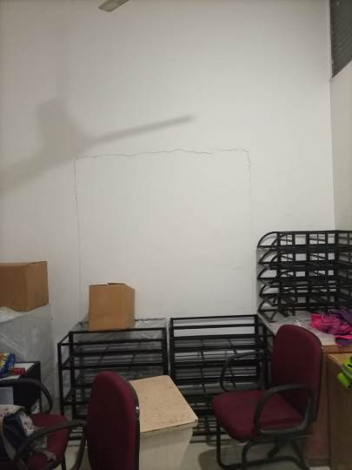
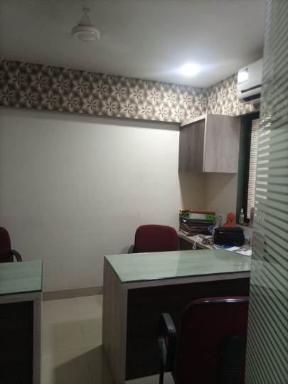
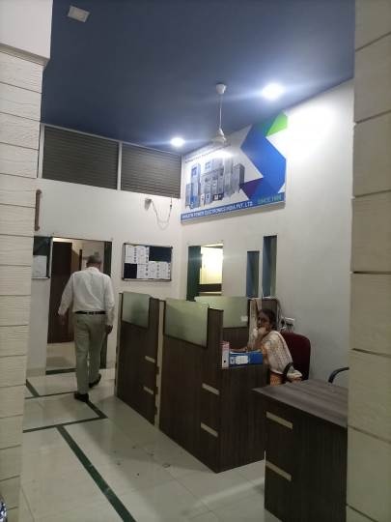

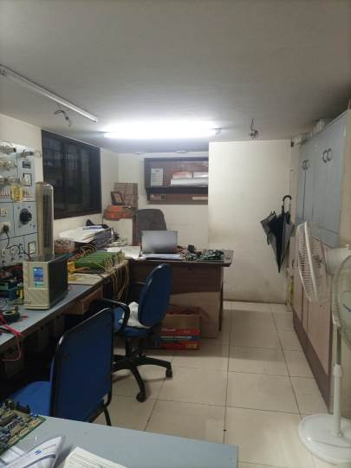
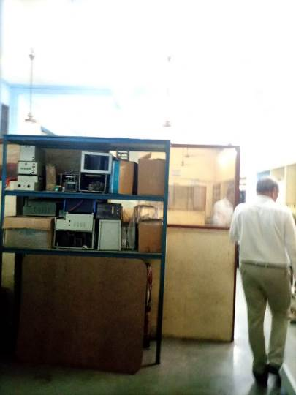
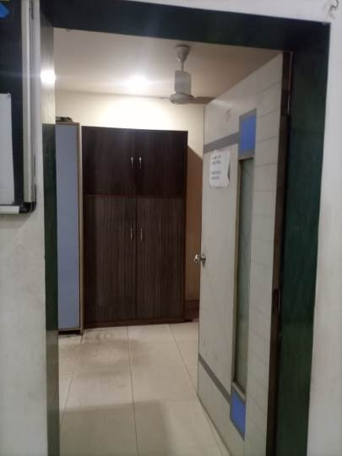

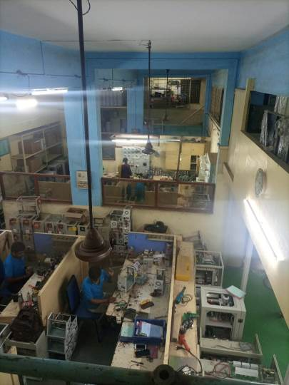
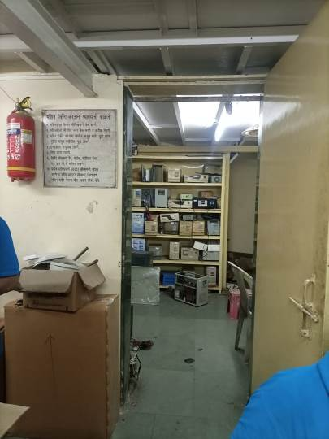
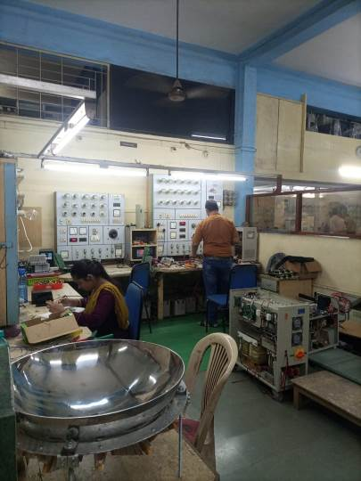

Actual site photographs
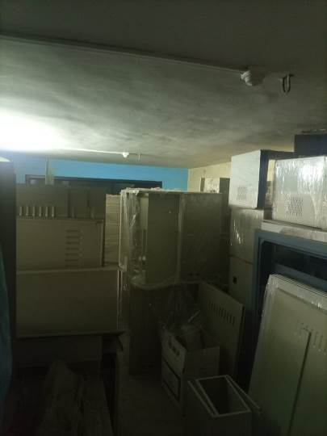
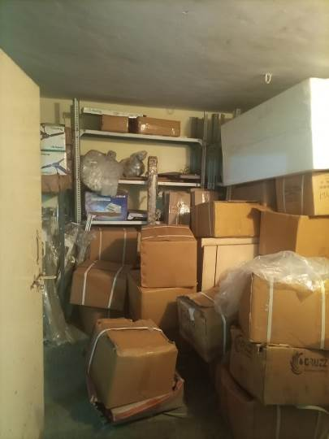
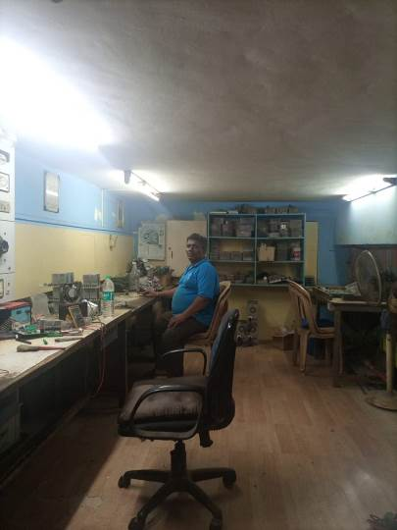

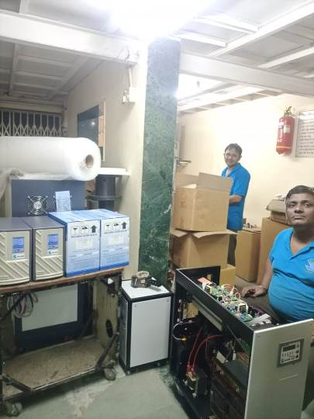
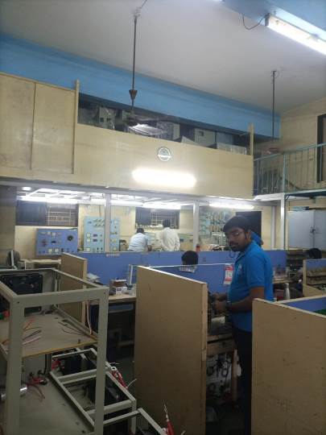
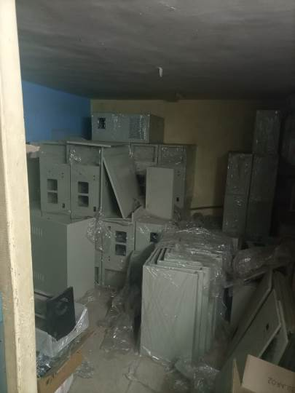

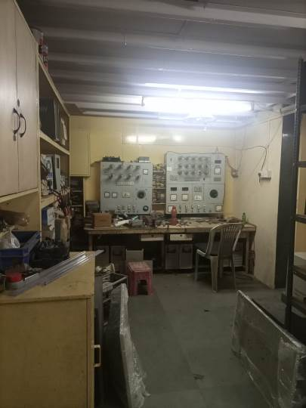
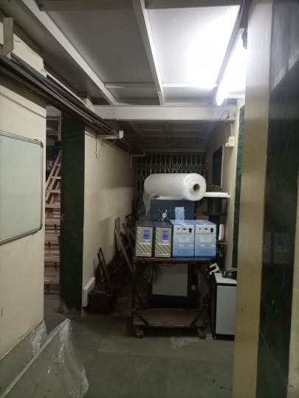
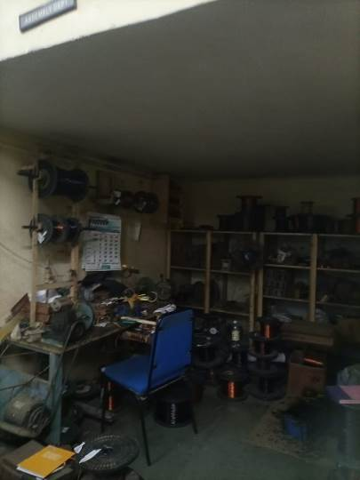

Actual site photographs
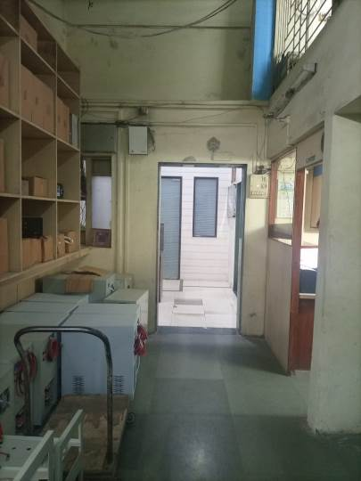
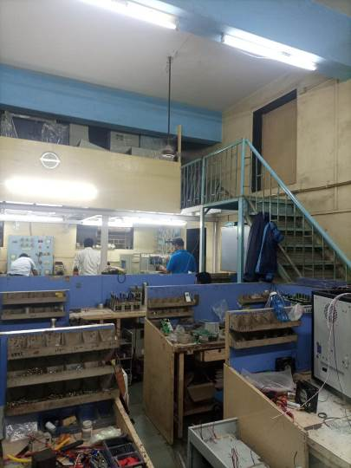
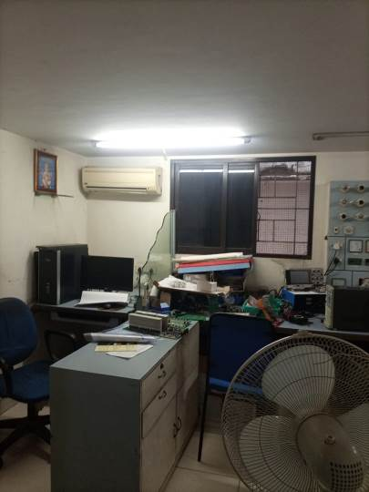

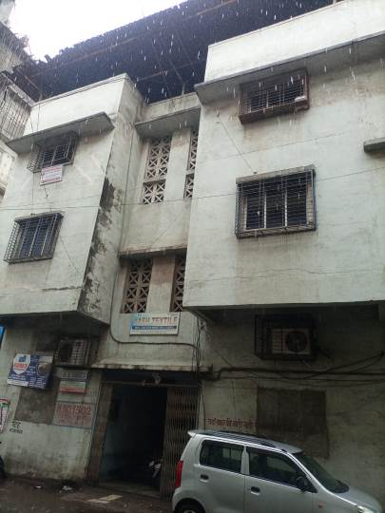

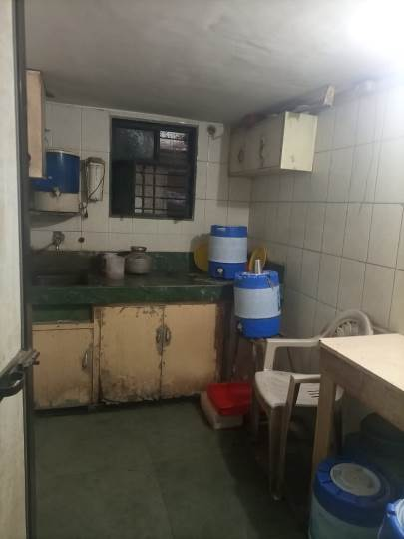
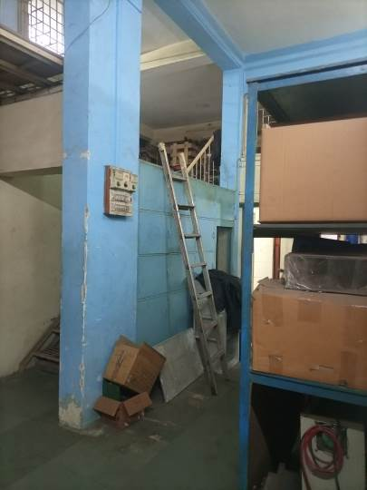
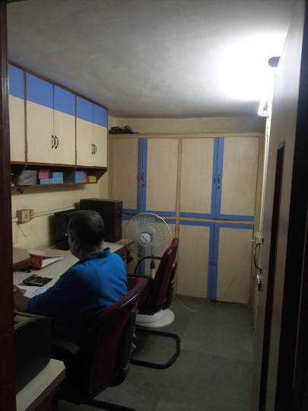

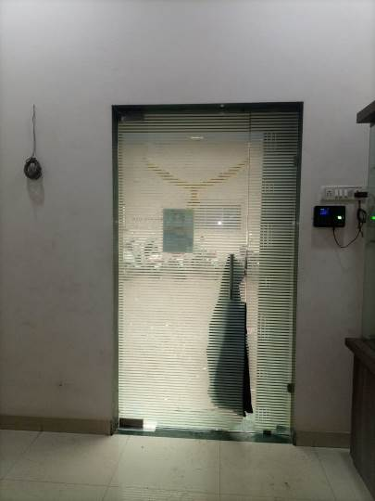
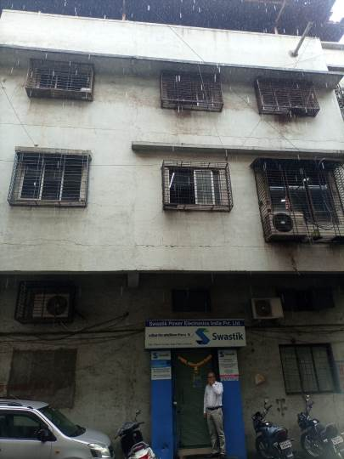

Route Map of the property
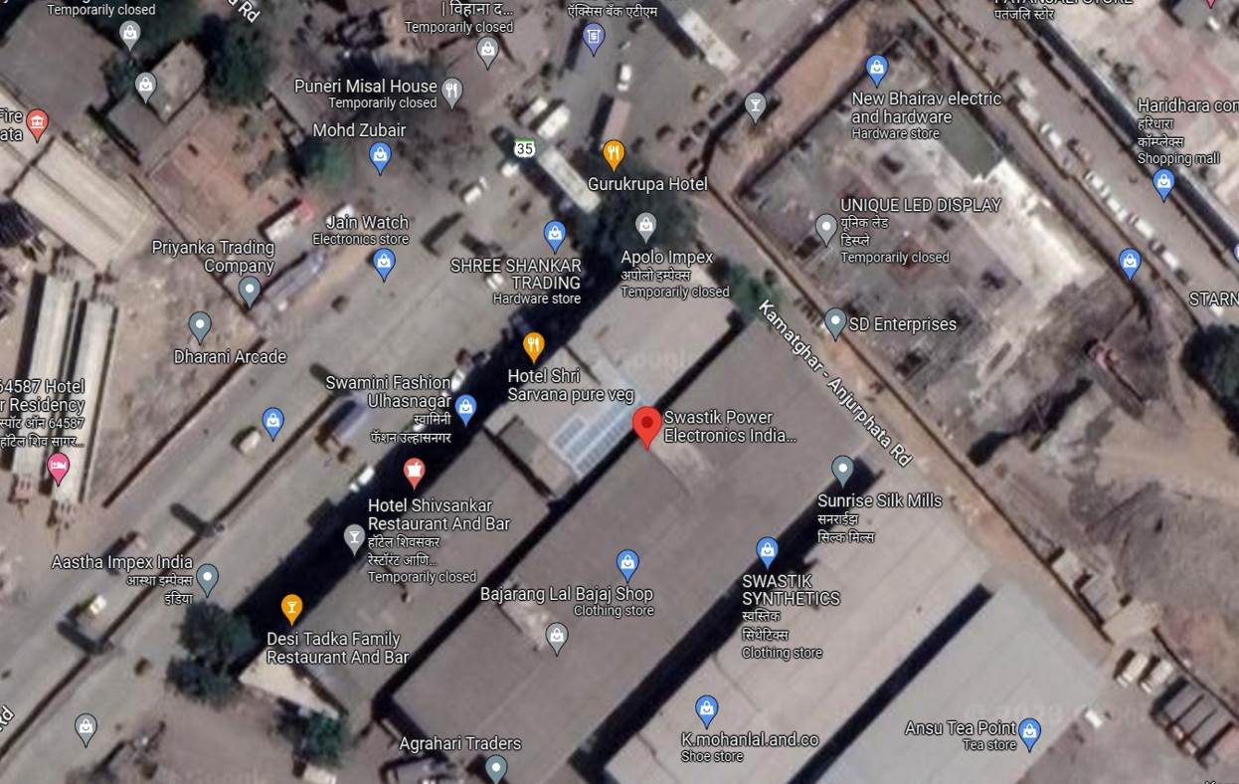

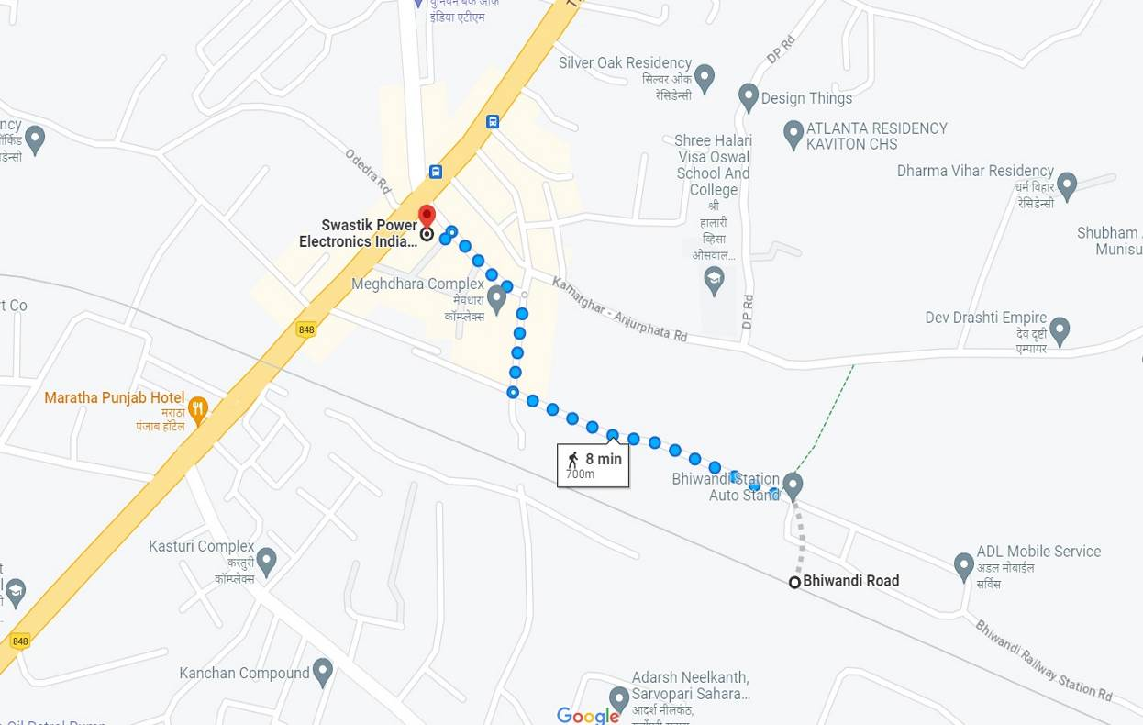


Latitude Longitude: 19°16'21.2"N 73°02'29.8"E
Note: The Blue line shows the route to site from nearest railway station (Bhiwandi – 700M.)

Ready Reckoner Rate
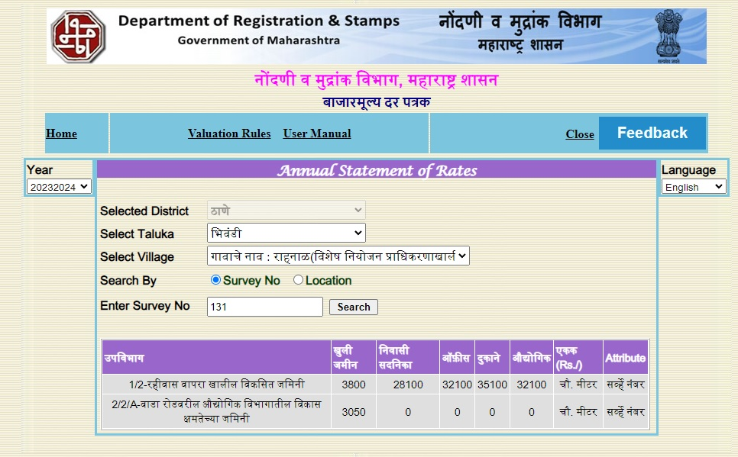

Stamp Duty Ready Reckoner Market Value Rate for Gala | 32,100.00
No Reduced, Gala Located on Ground Floor | 00.00
Stamp Duty Ready Reckoner Market Value Rate (After Reduced) (A) | 32,100.00 | Sq. Mtr. | 2,982.00 | Sq. Ft.
Stamp Duty Ready Reckoner Market Value Rate for Land (B) | 3,800.00
The difference between land rate and building rate (A – B = C) | 28,300.00
Depreciation Percentage as per table (D) [100% - 21%]  (Age of the Building – 21 Years) | 79%
Rate to be adopted after considering depreciation [B + (C x D)] | 26,157.00 | Sq. Mtr. | 2,430.00 | Sq. Ft.

Building not having lift
The following table gives the valuation of residential building / flat / commercial unit / office in such building on above floor where there is no lift. Depending upon the floor, ready reckoner rates will be reduced.

 | Floor on which flat is Located | Rate to be adopted
a) | Ground Floor / Stilt / Floor | 100%
b) | First Floor | 95%
c) | Second Floor | 90%
d) | Third Floor | 85%
e) | Fourth Floor and above | 80%

Table – D: Depreciation Percentage Table

Completed Age of Building in Years | Value in percent after depreciation
 | R.C.C. Structure / other Pukka Structure | Cessed Building, Half or Semi – Pukka Structure & Kaccha Structure.
0 to 2 Years | 100% | 100%
Above 2 & up to 5 Years | 95% | 95%
Above 5 Years | After initial 5 year for every year 1% depreciation is to be considered. However maximum deduction available as per this shall be 70% of Market Value rate | After initial 5 year for every year 1.5% depreciation is to be considered. However maximum deduction available as per this shall be 85% of Market Value rate

Price Indicators
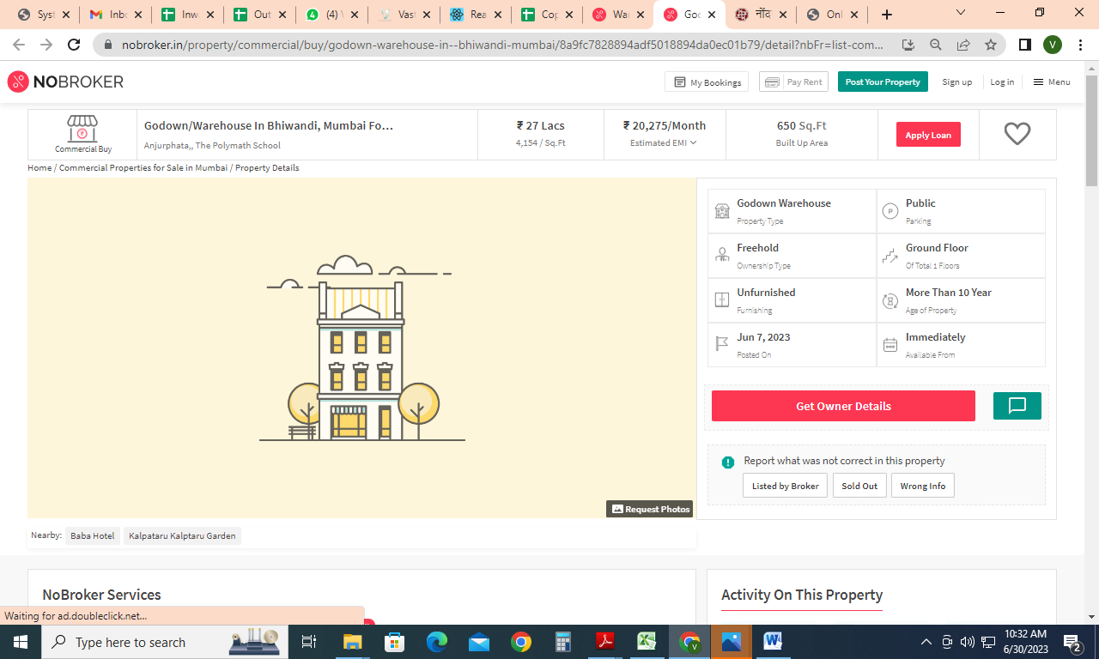

Sales Instance
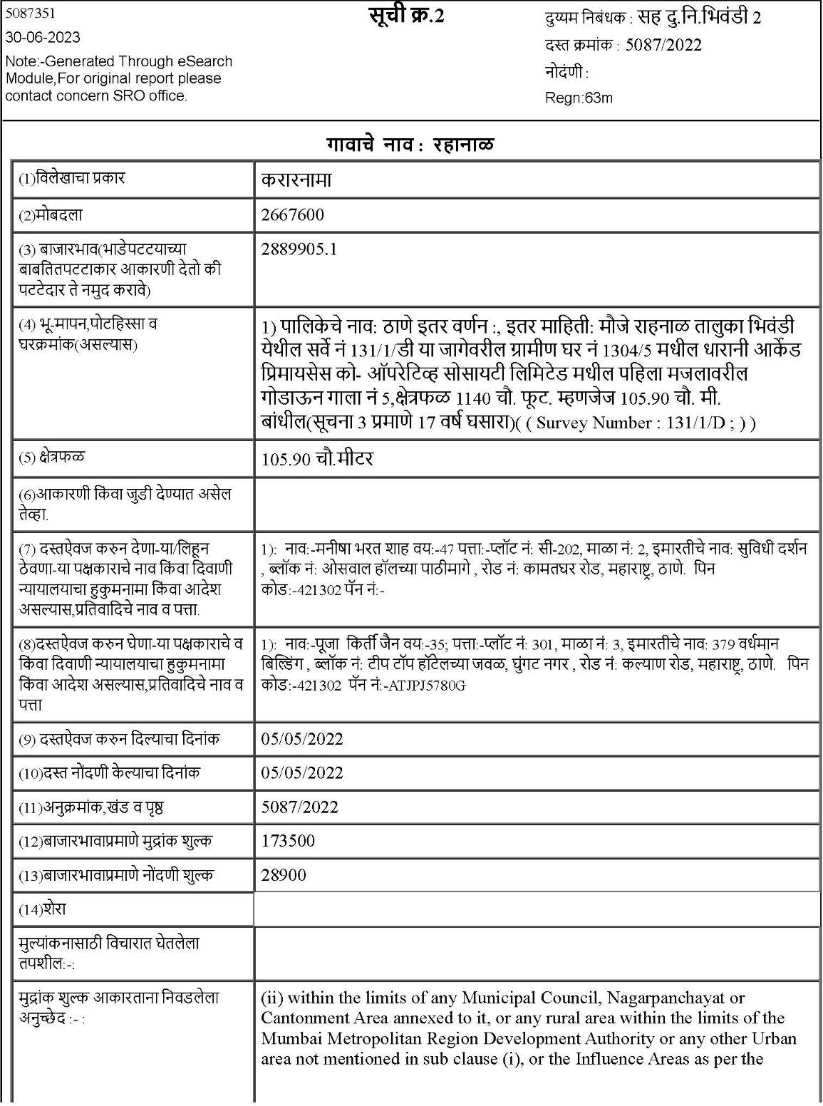

Sales Instance
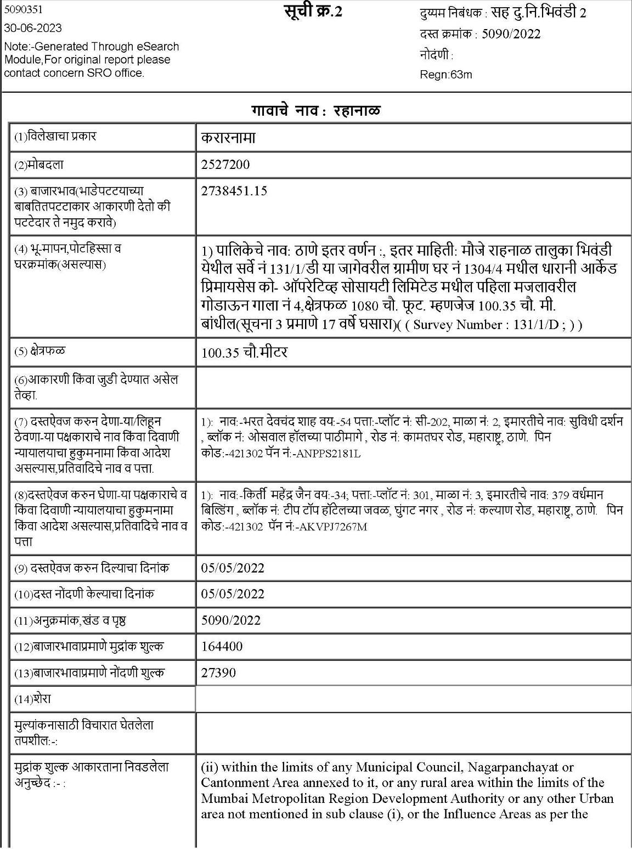

Sales Instance
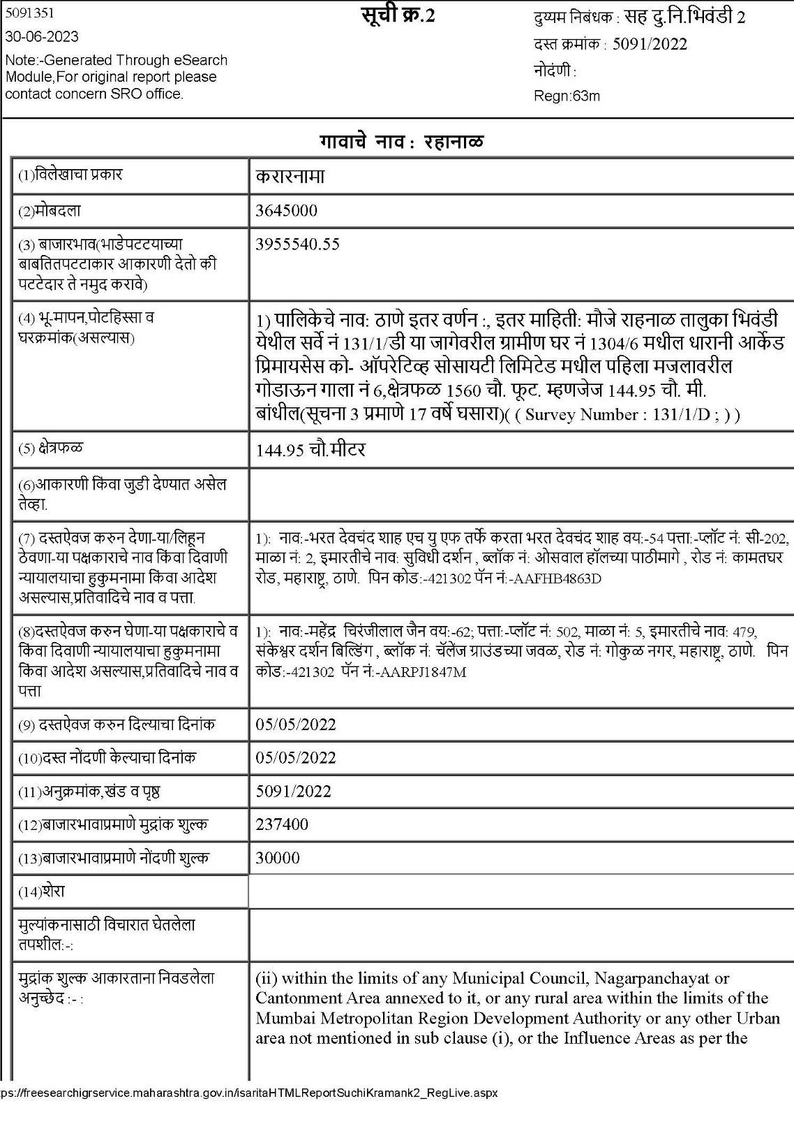

As a result of my appraisal and analysis, it is my considered opinion that Value of the above property in the prevailing condition with aforesaid specifications is ` 1,42,27,650.00 (Rupees One Crore Forty Two Lakh Twenty Seven Thousand Six Hundred Fifty Only).

Place: Thane
Date: 03.07.2023

Manoj B. Chalikwar
Registered Valuer
Chartered Engineer (India)
Reg. No. CAT-I-F-1763
SVC Emp. No. Ref.: CO/Tec/BUS/526/20-21

The undersigned has inspected the property detailed in the Valuation Report dated _______________________

on ____________________. We are satisfied that the fair and reasonable market value of the property is `_________________________ (Rupees ________________________________________________________

________________________________________only).

Date
Signature
(Name & Designation of the Inspecting Official/s)

Countersigned
(BRANCH MANAGER)

Enclosures
 | Declaration-cum-undertaking from the valuer (Annexure – I) | Attached
 | Model code of conduct for valuer (Annexure – II) | Attached

(Annexure – I)

DECLARATION-CUM-UNDERTAKING

I, Manoj Chalikwar son of Shri. Baburao Chalikwar do hereby solemnly affirm and state that:

- I am a citizen of India.

- I will not undertake valuation of any assets in which I have a direct or indirect interest or become so interested at any time during a period of three years prior to my appointment as valuer or three years after the valuation of assets was conducted by me.

- The information furnished in my valuation report dated 29.06.2023 is true and correct to the best of my knowledge and belief and I have made an impartial and true valuation of the property.

- I/ my authorized representative has personally inspected the property 03.07.2023. The work is not sub - contracted to any other valuer and carried out by myself.

- Valuation report is submitted in the format as prescribed by the bank.

- I have not been depanelled / delisted by any other bank and in case any such depanelment by other banks during my empanelment with you, I will inform you within 3 days of such depanelment.

- I have not been removed / dismissed from service / employment earlier.

- I have not been convicted of any offence and sentenced to a term of imprisonment

- I have not been found guilty of misconduct in my professional capacity.

- I have not been declared to be unsound mind

- I am not an undischarged bankrupt, or has not applied to be adjudicated as a bankrupt;

- I am not an undischarged insolvent.

- I have not been levied a penalty under section 271J of Income-tax Act, 1961 (43 of 1961) and time limit for filing appeal before Commissioner of Income-tax (Appeals) or Income-tax Appellate Tribunal, as the case may be has expired, or such penalty has been confirmed by Income-tax Appellate Tribunal, and five years have not elapsed after levy of such penalty

- I have not been convicted of an offence connected with any proceeding under the Income Tax Act 1961, Wealth Tax Act 1957 or Gift Tax Act 1958 and

- My PAN Card number as applicable is AERPC9086P

- I undertake to keep you informed of any events or happenings which would make me ineligible for empanelment as a valuer

- I have not concealed or suppressed any material information, facts and records and I have made a complete and full disclosure

- I have read the Handbook on Policy, Standards and procedure for Real Estate Valuation, 2011 of the IBA and this report is in conformity to the "Standards" enshrined for valuation in the Part - B of the above handbook to the best of my ability.

- I have read the International Valuation Standards (IVS) and the report submitted to the Bank for the respective asset class is in conformity to the "Standards" as enshrined for valuation in the IVS in "General Standards" and "Asset Standards" as applicable. The valuation report is submitted in the prescribed format of the bank.

- I abide by the Model Code of Conduct for empanelment of valuer in the Bank. (Annexure V - A signed copy of same to be taken and kept along with this declaration)

- My CIBIL Score and credit worthiness is as per Bank's guidelines.

- I am the Director of the company, who is competent to sign this valuation report.

- I will undertake the valuation work on receipt of Letter of Engagement generated from the system (i.e., LLMS / LOS) only.

- Further, I hereby provide the following information.

Sr.  No. | Particulars | Valuer comment
 | background information of the asset being valued; | The property under consideration was owned by M/s. Swastik Power Electronic India Pvt. Ltd.
 | purpose of valuation and appointing authority | As per the request from SVC Co-Operative Bank Ltd., Thane Branch to assess fair market value of the property for Bank Loan Purpose.
 | identity of the valuer and any other experts involved in the valuation; | Manoj B. Chalikwar – Regd. Valuer  Suraj Zore – Valuation Engineer  Vaishali Sarmalkar – Technical Manager  Pratibha Shilvanta – Technical Officer
 | disclosure of valuer interest or conflict, if any; | We have no interest, either direct or indirect, in the property valued. Further to state that we do not have relation or any connection with property owner / applicant directly or indirectly. Further to state that we are an independent Valuer and in no way related to property owner / applicant
 | date of appointment, valuation date and date of  report; | Date of Appointment – 29.06.2023  Valuation Date – 03.07.2023  Date of Report – 03.07.2023
 | inspections and/or investigations undertaken; | Physical Inspection done on 29.06.2023
 | nature and sources of the information used or relied upon; | - Market Survey at the time of site visit  - Ready Reckoner rates / Circle rates  - Online search for Registered Transactions  - Online Price Indicators on real estate portals  - Enquiries with Real estate consultants
 | procedures adopted in carrying out the valuation and valuation standards followed; | Comparative Sales Method / Market Approach
 | restrictions on use of the report, if any; | This valuation is for the use of the party to whom it is addressed and for no other purpose. No responsibility is accepted to any third party who may use or rely on the whole or any part of this valuation. The valuer has no pecuniary interest that would conflict with the proper valuation of the property.
 | major factors that were taken into account during the valuation; | current market conditions, demand and supply position, Commercial Gala size, location, upswing in real estate prices, sustained demand for Commercial Gala, all-round development of commercial and residential application in the locality etc.
 | Caveats, limitations and disclaimers to the extent they explain or elucidate the limitations faced by valuer, which shall not be for the purpose of limiting his responsibility for the valuation report. | Attached

Assumptions, Disclaimers, Limitations & Qualifications

Value Subject to Change
The subject appraisal exercise is based on prevailing market dynamics as on 03rd July 2023 and does not take into account any unforeseeable developments which could impact the same in the future.

Our Investigations
We are not engaged to carry out all possible investigations in relation to the subject property. Where in our report we identify certain limitations to our investigations, this is to enable the reliant party to instruct further investigations where considered appropriate or where we recommend as necessary prior to reliance. Vastukala Consultants India Pvt. Ltd. (VCIPL) is not liable for any loss occasioned by a decision not to conduct further investigations

Assumptions
Assumptions are a necessary part of undertaking valuations. VCIPL adopts assumptions for the purpose of providing valuation advise because some matters are not capable of accurate calculations or fall outside the scope of our expertise, or out instructions. The reliant party accepts that the valuation contains certain specific assumptions and acknowledge and accept the risk of that if any of the assumptions adopted in the valuation are incorrect, then this may have an effect on the valuation.

Information Supplied by Others
The appraisal is based on the information provided by the client. The same has been assumed to be correct and has been used for appraisal exercise. Where it is stated in the report that another party has supplied information to VCIPL, this information is believed to be reliable but VCIPL can accept no responsibility if this should prove not to be so.

Future Matters
To the extent that the valuation includes any statement as to a future matter, that statement is provided as an estimate and/or opinion based on the information known to VCIPL at the date of this document. VCIPL does not warrant that such statements are accurate or correct.

Map and Plans
Any sketch, plan or map in this report is included to assist the reader while visualising the property and assume no responsibility in connection with such matters.

Site Details
Based on inputs received from Client and site visit conducted, we understand that the subject property is Amalgamated Commercial Gala, admeasuring Total Built up Area - 4,050.00 Sq. Ft. in the name of M/s. Swastik Power Electronic India Pvt. Ltd. At present, the property is Owner Occupied. Further, VCIPL has assumed that the subject property is free from any encroachment and is available as on the date of the appraisal.

Property Title
Based on our discussion with the Client, we understand that the subject property is owned by M/s. Swastik Power Electronic India Pvt. Ltd. For the purpose of this appraisal exercise, we have assumed that the subject property has a clear title and is free from any encumbrances, disputes and claims. VCIPL has made no further enquiries with the relevant local authorities in this regard and does not certify the property as having a clear and marketable title. Further, no legal advice regarding the title and ownership of the subject property has been obtained for the purpose of this appraisal exercise. It has been assumed that the title deeds are clear and marketable
Environmental Conditions
We have assumed that the subject property is not contaminated and is not adversely affected by any existing or proposed environmental law and any processes which are carried out on the property are regulated by environmental legislation and are properly licensed by the appropriate authorities.

Area
Based on the information provided by the Client, we understand that subject property is Amalgamated Commercial Gala, admeasuring Total Built up Area - 4,050.00 Sq. Ft.

Condition & Repair
In the absence of any information to the contrary, we have assumed that there are no abnormal ground conditions, nor archaeological remains present which might adversely affect the current or future occupation, development or value of the property. The property is free from rat, infestation, structural or latent defect. No currently known deleterious or hazardous materials or suspect techniques will be used in the construction of or subsequent alteration or additions to the property and comments made in the property details do not purport to express an opinion about, or advise upon, the condition of uninspected parts and should not be taken as making an implied representation or statement about such parts
Valuation Methodology
The sales comparison approach uses the market data of sale prices to estimate the value of a real estate property. Property valuation in this method is done by comparing a property to other similar properties that have been recently sold. Comparable properties, also known as comparable, or comps, must share certain features with the property in question. Some of these include physical features such as square footage, number of rooms, condition, and age of the building; however, the most important factor is no doubt the location of the property.
Adjustments are usually needed to account for differences as no two properties are exactly the same. To make proper adjustments when comparing properties, real estate appraisers must know the differences between the comparable properties and how to value these differences.
The sales comparison approach is commonly used for Commercial Gala, where there are typically many comparable available to analyze. As the property is a Commercial Gala, we have adopted Sale Comparison Approach Method for the purpose of valuation.
In case of inadequate recent transaction activity in the subject micro-market, the appraiser would collate details of older transactions. Subsequently, the appraiser would analyse rental / capital value trends in the subject micro-market in order to calculate the percentage increase / decrease in values since the date of the identified transactions. This percentage would then be adopted to project the current value of the same.
Where reliance has been placed upon external sources of information in applying the valuation methodologies, unless otherwise specifically instructed by Client and/or stated in the valuation, VCIPL has not independently verified that information and VCIPL does not advise nor accept it as reliable. The person or entity to whom the report is addressed acknowledges and accepts the risk that if any of the unverified information in the valuation is incorrect, then this may have an effect on the valuation.
Not a Structural Survey
We state that this is a valuation report and not a structural survey
Other
All measurements, areas and ages quoted in our report are approximate
Legal
We have not made any allowances with respect to any existing or proposed local legislation relating to taxation on realization of the sale value of the subject property. VCIPL is not required to give testimony or to appear in court by reason of this appraisal report, with reference to the property in question, unless arrangement has been made thereof. Further, no legal advice on any aspects has been obtained for the purpose of this appraisal exercise
Property specific assumptions
Based on inputs received from the client and site visit conducted, we understand that the subject property is Amalgamated Commercial Gala, Admeasuring Total Built up Area - 4,050.00 Sq. Ft.

ASSUMPTIONS, CAVEATS, LIMITATION AND DISCLAIMERS
1. We assume no responsibility for matters of legal nature affecting the property appraised or the title thereto, nor do we render our opinion as to the title, which is assumed to be good and marketable.
2. The property is valued as though under responsible ownership.
3. It is assumed that the property is free of liens and encumbrances.
4. It is assumed that there are no hidden or unapparent conditions of the subsoil or structure that would render it more or less valuable. No responsibility is assumed for such conditions or for engineering that might be required to discover such factors.
5. There is no direct/ indirect interest in the property valued.
6. The rates for valuation of the property are in accordance with the Govt. approved rates and prevailing market rates.

(Annexure – II)

MODEL CODE OF CONDUCT FOR VALUERS

Integrity and Fairness
- A valuer shall, in the conduct of his/its business, follow high standards of integrity and fairness in all his/its dealings with his/its clients and other valuers.
- A valuer shall maintain integrity by being honest, straightforward, and forthright in all professional relationships.
- A valuer shall endeavour to ensure that he/it provides true and adequate information and shall not misrepresent any facts or situations.
- A valuer shall refrain from being involved in any action that would bring disrepute to the profession.
- A valuer shall keep public interest foremost while delivering his services.

Professional Competence and Due Care
- A valuer shall render at all times high standards of service, exercise due diligence, ensure proper care and exercise independent professional judgment.
- A valuer shall carry out professional services in accordance with the relevant technical and professional standards that may be specified from time to time.
- A valuer shall continuously maintain professional knowledge and skill to provide competent professional service based on up-to-date developments in practice, prevailing regulations / guidelines and techniques.
- In the preparation of a valuation report, the valuer shall not disclaim liability for his/its expertise or deny his/its duty of care, except to the extent that the assumptions are based on statements of fact provided by the company or its auditors or consultants or information available in public domain and not generated by the valuer.
- A valuer shall not carry out any instruction of the client insofar as they are incompatible with the requirements of integrity, objectivity and independence.
- A valuer shall clearly state to his client the services that he would be competent to provide and the services for which he would be relying on other valuers or professionals or for which the client can have a separate arrangement with other valuers.

Independence and Disclosure of Interest
- A valuer shall act with objectivity in his/its professional dealings by ensuring that his/its decisions are made without the presence of any bias, conflict of interest, coercion, or undue influence of any party, whether directly connected to the valuation assignment or not.
- A valuer shall not take up an assignment if he/it or any of his/its relatives or associates is not independent in terms of association to the company.
- A valuer shall maintain complete independence in his/its professional relationships and shall conduct the valuation independent of external influences.
- A valuer shall wherever necessary disclose to the clients, possible sources of conflicts of duties and interests, while providing unbiased services.
- A valuer shall not deal in securities of any subject company after any time when he/it first becomes aware of the possibility of his / its association with the valuation, and in accordance with the Securities and Exchange Board of India (Prohibition of Insider Trading)Regulations,2015 or till the time the valuation report becomes public, whichever is earlier.
- A valuer shall not indulge in "mandate snatching" or offering "convenience valuations" in order to cater to a company or client's needs.
- As an independent valuer, the valuer shall not charge success fee.
- In any fairness opinion or independent expert opinion submitted by a valuer, if there has been a prior engagement in an unconnected transaction, the valuer shall declare the association with the company during the last five years.
Confidentiality
- A valuer shall not use or divulge to other clients or any other party any confidential information about the subject company, which has come to his / its knowledge without proper and specific authority or unless there is a legal or professional right or duty to disclose.

Information Management

- A valuer shall ensure that he/ it maintains written contemporaneous records for any decision taken, the reasons for taking the decision, and the information and evidence in support of such decision. This shall be maintained so as to sufficiently enable a reasonable person to take a view on the appropriateness of his /its decisions and actions.
- A valuer shall appear, co-operate and be available for inspections and investigations carried out by the authority, any person authorised by the authority, the registered valuers organisation with which he/it is registered or any other statutory regulatory body.
- A valuer shall provide all information and records as may be required by the authority, the Tribunal, Appellate Tribunal, the registered valuers organisation with which he/it is registered, or any other statutory regulatory body.
- A valuer while respecting the confidentiality of information acquired during the course of performing professional services, shall maintain proper working papers for a period of three years or such longer period as required in its contract for a specific valuation, for production before a regulatory authority or for a peer review. In the event of a pending case before the Tribunal or Appellate Tribunal, the record shall be maintained till the disposal of the case.

Gifts and hospitality:
- A valuer or his / its relative shall not accept gifts or hospitality which undermines or affects his independence as a valuer.
Explanation: For the purposes of this code the term 'relative' shall have the same meaning as defined in clause (77) of Section 2 of the Companies Act, 2013 (18 of 2013).
- A valuer shall not offer gifts or hospitality or a financial or any other advantage to a public servant or any other person with a view to obtain or retain work for himself / itself, or to obtain or retain an advantage in the conduct of profession for himself / itself.

Remuneration and Costs.
- A valuer shall provide services for remuneration which is charged in a transparent manner, is a reasonable reflection of the work necessarily and properly undertaken, and is not inconsistent with the applicable rules.
- A valuer shall not accept any fees or charges other than those which are disclosed in a written contract with the person to whom he would be rendering service.

Occupation, employability and restrictions.
- A valuer shall refrain from accepting too many assignments, if he/it is unlikely to be able to devote adequate time to each of his/ its assignments.
- A valuer shall not conduct business which in the opinion of the authority or the registered valuer organisation discredits the profession.
Miscellaneous
- A valuer shall refrain from undertaking to review the work of another valuer of the same client except under written orders from the bank or housing finance institutions and with knowledge of the concerned valuer.
- A valuer shall follow this code as amended or revised from time to time.

DEFINITION OF VALUE FOR THIS SPECIFIC PURPOSE

This exercise is to assess of the property under reference as on 03rd July 2023.

The term Fair Market Value is defined as

“The most probable price, as of a specified date, in cash, terms equivalent to cash, or in other precisely revealed terms for which the specified property rights would sell after reasonable exposure in a competitive market under all conditions requisite to a fair sale, with the buyer and seller each acting prudently knowledgeably and for self interest assuming that neither is under undue duress”.

Fundamental assumptions and conditions presumed in this definition are:

1. Buyer and seller are motivated by self-interest.
2. Buyer and seller are well informed and are acting prudently.
3. The property is exposed for a reasonable time on the open market.
4. Payment is made in cash or equivalent or in specified financing terms.
DECLARATION OF PROFESSIONAL FEES CHARGED

We hereby declare that, our professional fees are not contingent upon the valuation findings. However, if the statute AND/OR clients demands that, the fees should be charged on the percentage of assessed value then, with the full knowledge of the AND/OR end user, it is being charged accordingly.

VALUATION OF THE PROPERTY PREMISES

Considering various parameters recorded herein above, existing economic scenario, and the information that is available with reference to the development of neighborhood and method selected for valuation, we are of the opinion that, the property premises can be assessed for this particular purpose at ` 1,42,27,650.00 (Rupees One Crore Forty Two Lakh Twenty Seven Thousand Six Hundred Fifty Only).

Manoj B. Chalikwar
Registered Valuer
Chartered Engineer (India)
Reg. No. CAT-I-F-1763
SVC Emp. No. Ref.: CO/Tec/BUS/526/20-21

