Vastu/Nashik/06/2170/2301273
26/15-374-CHV
Date: 26.06.2023

To,
The Branch Manager,
Union Bank of India
Gangapur Road Branch
Shree Ganesh Avenue, Chunchale Road,
Nashik - 422 013, State – Maharashtra, Country – India

Sub: Vetting of Extra Amenities

Sir,

With reference to above subject, we have evaluated the Extra Amenities for Residential Flat No. A/1, Ground Floor, A-Wing, "Shree Balaji Vihar Apartment", Survey No. 3/ 1/ 2/ 2/ 3/ 1, Plot No.30 to 32, Near Shree Tirumala Glumohar, Gamane Mala, Ramkrishna Nagar, Village – Makhmalabad-2, Taluka & District - Nashik, PIN Code – 422 003, State – Maharashtra, Country – India belongs Sau. Jyoti Pravin Sangale & Shri. Pravin Shankar Sangale.

We have verified the rates quoted as per current market rates. Details of Extra Amenities considered as per copy of Extra Amenities Agreement between Mrs. Jyoti Pravin Sangale (First Party). Mr. Gajesham Namdev Bhagwat (Second Party) received on dated 23.06.2023. The Extra Amenities amount is Rs. 5,50,000/- (Rupees Five Lakh Fifty Thousand Only)

The said Cost Vetting Certificate is valid upto next 6 months Only.

Thanking you

Sincerely yours

Sharadkumar B. Chalikwar
Govt. Reg. Valuer
Chartered Engineer (India)
Reg. No. (N) CCIT/1-14/52/2008-09

Agreement of Repairs & Renovation
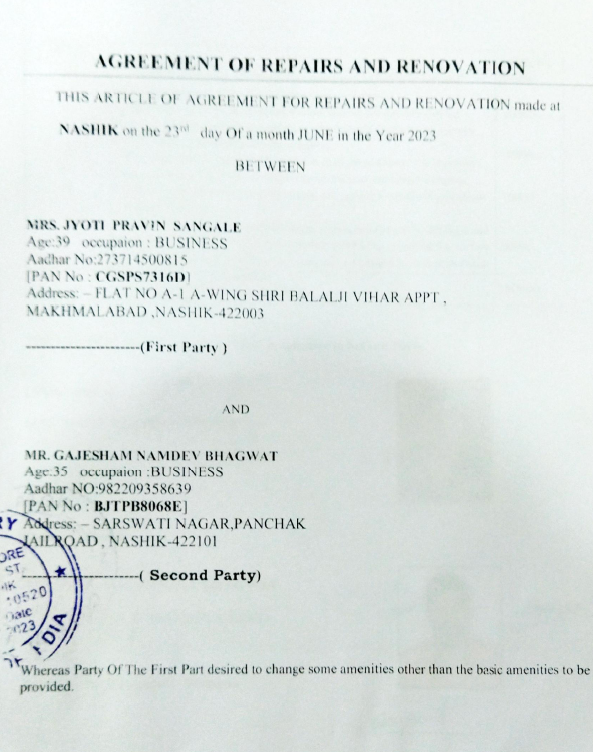

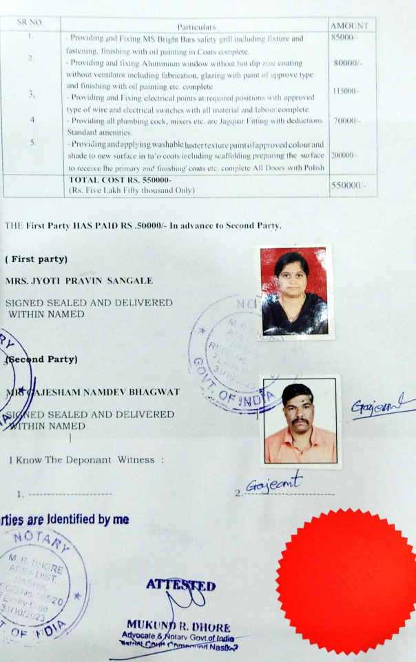

The Extra Amenities amount is Rs. 5,50,000/- (Rupees Five Lakh Fifty Thousand Only)

