|  |  |  |  |  |  |  |  |  |  |  |  |  |  |  |  |  |  |  |  |  |  |  |  |  |  |  |  |  |  |  |  |  |  |  |  |  |  |  |  |  |  |  |  |  |  |  |  |  |  |  |  |  |  |  |  |  |  |  |  |  |  |  |  |  |  |  |  |  |  |  |  |  |  |  |  |  |  |  |  |  |  |  |  |  |  |  |  |  |  |  |  |  |  |  |  |  |  |  |  |  |  |  |  |  |  |  |  |  |  |  |  |  |  |  |  |  |  |  |  |  |  |  |  |  |  |  |  |  |  |  |  |  |  |  |  |  |  |  |  |  |  |  |  |  |  |  |  |  |  |  |  |  |  |  |  |  |  |  |  |  |  |  |  |  |  |  |  |  |  |  |  |  |  |  |  |  |  |  |  |  |  |  |  |  |  |  |  |  |  |  |  |  |  |  |  |  |  |  |  |  |  |  |  |  |  |  |  |  |  |  |  |  |  |  |  |  |  |  |  |  |  |  |  |  |  |  |  |  |  |  |  |  |  |  |  |  |  |  |  |  |  |  |  |  |  |  |  |  |  |  |  |  |  |  |  |  |  |  |  |  |  |  |  |  |  |  |  |  |  |  |  |  |  |  |  |  |  |  |  |  |  |  |  |  |  |  |  |  |  |  |  |  |  |  |  |  |  |  |  |  |  |  |  |  |  |  |  |  |  |  |  |  |  |  |  |  |  |  |  |  |  |  |  |  |  |  |  |  |  |  |  |  |  |  |  |  |  |  |  |  |  |  |  |  |  |  |  |  |  |  |  |  |  |  |  |  |  |  |  |  |  |  |  |  |  |  |  |  |  |  |  |  |  |  |  |  |  |  |  |  |  |  |  |  |  |  |  |  |  |  |  |  |  |  |  |  |  |  |  |  |  |  |  |  |  |  |  |  |  |  |  |  |  |  |  |  |  |  |  |  |  |  |  |  |  |  |  |  |  |  |  |  |  |  |  |  |  |  |  |  |  |  |  |  |  |  |  |  |  |  |  |  |  |  |  |  |  |  |  |  |  |  |  |  |  |  |  |  |  |  |  |  |  |  |  |  |  |  |  |  |  |  |  |  |  |  |  |  |  |  |  |  |  |  |  |  |  |  |  |  |  |  |  |  |  |  |  |  |  |  |  |  |  |  |  |  |  |  |  |  |  |  |  |  |  |  |  |  |  |  |  |  |  |  |  |  |  |  |  |  |  |  |  |  |  |  |  |  |  |  |  |  |  |  |  |  |  |  |  |  |  |  |  |  |  |  |  |  |  |  |  |  |  |  |  |  |  |  |  |  |  |  |  |  |  |  |  |  |  |  |  |  |  |  |  |  |  |  |  |  |  |  |  |  |  |  |  |  |  |  |  |  |  |  |  |  |  |  |  |  |  |  |  |  |  |  |  |  |  |  |  |  |  |  |  |  |  |  |  |  |  |  |  |  |  |  |  |  |  |  |  |  |  |  |  |  |  |  |  |  |  |  |  |  |  |  |  |  |  |  |  |  |  |  |  |  |  |  |  |  |  |  |  |  |  |  |  |  |  |  |  |  |  |  |  |  |  |  |  |  |  |  |  |  |  |  |  |  |  |  |  |  |  |  |  |  |  |  |  |  |  |  |  |  |  |  |  |  |  |  |  |  |  |  |  |  |  |  |  |  |  |  |  |  |  |  |  |  |  |  |  |  |  |  |  |  |  |  |  |  |  |  |  |  |  |  |  |  |  |  |  |  |  |  |  |  |  |  |  |  |  |  |  |  |  |  |  |  |  |  |  |  |  |  |  |  |  |  |  |  |  |  |  |  |  |  |  |  |  |  |  |  |  |  |  |  |  |  |  |  |  |  |  |  |  |  |  |  |  |  |  |  |  |  |  |  |  |  |  |  |  |  |  |  |  |  |  |  |  |  |  |  |  |  |  |  |  |  |  |  |  |  |  |  |  |  |  |  |  |  |  |  |  |  |  |  |  |  |  |  |  |  |  |  |  |  |  |  |  |  |  |  |  |  |  |  |  |  |  |  |  |  |  |  |  |  |  |  |  |  |  |  |  |  |  |  |  |  |  |  |  |  |  |  |  |  |  |  |  |  |  |  |  |  |  |  |  |  |  |  |  |  |  |  |  |  |  |  |  |  |  |  |  |  |  |  |  |  |  |  |  |  |  |  |  |  |  |  |  |  |  |  |  |  |  |  |  |  |  |  |  |  |  |  |  |  |  |  |  |  |  |  |  |  |  |  |  |  |  |  |  |  |  |  |  |  |  |  |  |  |  |  |  |  |  |  |  |  |  |  |  |  |  |  |  |  |  |  |  |  |  |  |  |  |  |  |  |  |  |  |  |  |  |  |  |  |  |  |  |  |  |  |  |  |  |  |  |  |  |  |  |  |  |  |  |  |  |  |  |  |  |  |  |  |  |  |  |  |  |  |  |  |  |
| --- | --- | --- | --- | --- | --- | --- | --- | --- | --- | --- | --- | --- | --- | --- | --- | --- | --- | --- | --- | --- | --- | --- | --- | --- | --- | --- | --- | --- | --- | --- | --- | --- | --- | --- | --- | --- | --- | --- | --- | --- | --- | --- | --- | --- | --- | --- | --- | --- | --- | --- | --- | --- | --- | --- | --- | --- | --- | --- | --- | --- | --- | --- | --- | --- | --- | --- | --- | --- | --- | --- | --- | --- | --- | --- | --- | --- | --- | --- | --- | --- | --- | --- | --- | --- | --- | --- | --- | --- | --- | --- | --- | --- | --- | --- | --- | --- | --- | --- | --- | --- | --- | --- | --- | --- | --- | --- | --- | --- | --- | --- | --- | --- | --- | --- | --- | --- | --- | --- | --- | --- | --- | --- | --- | --- | --- | --- | --- | --- | --- | --- | --- | --- | --- | --- | --- | --- | --- | --- | --- | --- | --- | --- | --- | --- | --- | --- | --- | --- | --- | --- | --- | --- | --- | --- | --- | --- | --- | --- | --- | --- | --- | --- | --- | --- | --- | --- | --- | --- | --- | --- | --- | --- | --- | --- | --- | --- | --- | --- | --- | --- | --- | --- | --- | --- | --- | --- | --- | --- | --- | --- | --- | --- | --- | --- | --- | --- | --- | --- | --- | --- | --- | --- | --- | --- | --- | --- | --- | --- | --- | --- | --- | --- | --- | --- | --- | --- | --- | --- | --- | --- | --- | --- | --- | --- | --- | --- | --- | --- | --- | --- | --- | --- | --- | --- | --- | --- | --- | --- | --- | --- | --- | --- | --- | --- | --- | --- | --- | --- | --- | --- | --- | --- | --- | --- | --- | --- | --- | --- | --- | --- | --- | --- | --- | --- | --- | --- | --- | --- | --- | --- | --- | --- | --- | --- | --- | --- | --- | --- | --- | --- | --- | --- | --- | --- | --- | --- | --- | --- | --- | --- | --- | --- | --- | --- | --- | --- | --- | --- | --- | --- | --- | --- | --- | --- | --- | --- | --- | --- | --- | --- | --- | --- | --- | --- | --- | --- | --- | --- | --- | --- | --- | --- | --- | --- | --- | --- | --- | --- | --- | --- | --- | --- | --- | --- | --- | --- | --- | --- | --- | --- | --- | --- | --- | --- | --- | --- | --- | --- | --- | --- | --- | --- | --- | --- | --- | --- | --- | --- | --- | --- | --- | --- | --- | --- | --- | --- | --- | --- | --- | --- | --- | --- | --- | --- | --- | --- | --- | --- | --- | --- | --- | --- | --- | --- | --- | --- | --- | --- | --- | --- | --- | --- | --- | --- | --- | --- | --- | --- | --- | --- | --- | --- | --- | --- | --- | --- | --- | --- | --- | --- | --- | --- | --- | --- | --- | --- | --- | --- | --- | --- | --- | --- | --- | --- | --- | --- | --- | --- | --- | --- | --- | --- | --- | --- | --- | --- | --- | --- | --- | --- | --- | --- | --- | --- | --- | --- | --- | --- | --- | --- | --- | --- | --- | --- | --- | --- | --- | --- | --- | --- | --- | --- | --- | --- | --- | --- | --- | --- | --- | --- | --- | --- | --- | --- | --- | --- | --- | --- | --- | --- | --- | --- | --- | --- | --- | --- | --- | --- | --- | --- | --- | --- | --- | --- | --- | --- | --- | --- | --- | --- | --- | --- | --- | --- | --- | --- | --- | --- | --- | --- | --- | --- | --- | --- | --- | --- | --- | --- | --- | --- | --- | --- | --- | --- | --- | --- | --- | --- | --- | --- | --- | --- | --- | --- | --- | --- | --- | --- | --- | --- | --- | --- | --- | --- | --- | --- | --- | --- | --- | --- | --- | --- | --- | --- | --- | --- | --- | --- | --- | --- | --- | --- | --- | --- | --- | --- | --- | --- | --- | --- | --- | --- | --- | --- | --- | --- | --- | --- | --- | --- | --- | --- | --- | --- | --- | --- | --- | --- | --- | --- | --- | --- | --- | --- | --- | --- | --- | --- | --- | --- | --- | --- | --- | --- | --- | --- | --- | --- | --- | --- | --- | --- | --- | --- | --- | --- | --- | --- | --- | --- | --- | --- | --- | --- | --- | --- | --- | --- | --- | --- | --- | --- | --- | --- | --- | --- | --- | --- | --- | --- | --- | --- | --- | --- | --- | --- | --- | --- | --- | --- | --- | --- | --- | --- | --- | --- | --- | --- | --- | --- | --- | --- | --- | --- | --- | --- | --- | --- | --- | --- | --- | --- | --- | --- | --- | --- | --- | --- | --- | --- | --- | --- | --- | --- | --- | --- | --- | --- | --- | --- | --- | --- | --- | --- | --- | --- | --- | --- | --- | --- | --- | --- | --- | --- | --- | --- | --- | --- | --- | --- | --- | --- | --- | --- | --- | --- | --- | --- | --- | --- | --- | --- | --- | --- | --- | --- | --- | --- | --- | --- | --- | --- | --- | --- | --- | --- | --- | --- | --- | --- | --- | --- | --- | --- | --- | --- | --- | --- | --- | --- | --- | --- | --- | --- | --- | --- | --- | --- | --- | --- | --- | --- | --- | --- | --- | --- | --- | --- | --- | --- | --- | --- | --- | --- | --- | --- | --- | --- | --- | --- | --- | --- | --- | --- | --- | --- | --- | --- | --- | --- | --- | --- | --- | --- | --- | --- | --- | --- | --- | --- | --- | --- | --- | --- | --- | --- | --- | --- | --- | --- | --- | --- | --- | --- | --- | --- | --- | --- | --- | --- | --- | --- | --- | --- | --- | --- | --- | --- | --- | --- | --- | --- | --- | --- | --- | --- | --- | --- | --- | --- | --- | --- | --- | --- | --- | --- | --- | --- | --- | --- | --- | --- | --- | --- | --- | --- | --- | --- | --- | --- | --- | --- | --- | --- | --- | --- | --- | --- | --- | --- | --- | --- | --- | --- | --- | --- | --- | --- | --- | --- | --- | --- | --- | --- | --- | --- | --- | --- | --- | --- | --- | --- | --- | --- | --- | --- | --- | --- | --- | --- | --- | --- | --- | --- | --- | --- | --- | --- | --- | --- | --- | --- | --- | --- | --- | --- | --- | --- | --- | --- | --- | --- | --- | --- | --- | --- | --- | --- | --- | --- | --- | --- | --- | --- | --- | --- | --- | --- | --- | --- | --- | --- | --- | --- | --- | --- | --- | --- | --- | --- | --- | --- | --- | --- | --- | --- | --- | --- | --- | --- | --- | --- | --- | --- | --- | --- | --- | --- | --- | --- | --- | --- | --- | --- | --- | --- | --- | --- | --- | --- | --- | --- | --- | --- | --- | --- | --- | --- | --- | --- | --- | --- | --- | --- | --- | --- | --- | --- | --- | --- | --- | --- | --- | --- | --- | --- | --- | --- | --- | --- | --- | --- | --- | --- | --- | --- | --- | --- | --- | --- | --- | --- | --- | --- | --- | --- | --- | --- | --- | --- | --- | --- | --- | --- | --- | --- | --- | --- | --- | --- | --- | --- | --- | --- | --- | --- | --- | --- | --- | --- | --- | --- | --- | --- | --- | --- | --- | --- | --- | --- | --- | --- | --- | --- | --- | --- | --- | --- | --- | --- | --- | --- | --- | --- | --- | --- | --- | --- | --- | --- | --- | --- | --- |
| SBI/Commercial-Vile Parle/2023/133  Date: 30.06.2023  To,  **The Branch Manager,**  **State Bank of India**  **Commercial Branch (Vile Parle)**  Parle Square Building, 3rd Floor,  B.N. Agarwal Commercial Complex, Monghibai Road,  Vile Parle (East), Mumbai - 400 057,  State - Maharashtra, Country - India **VALUATION REPORT (IN RESPECT OF LAND AND BUILDING)**  |  |  |  |  |  |  |  | | --- | --- | --- | --- | --- | --- | --- | | I | **General** | | | | | | | 1. | Purpose for which the valuation is made | | : | To assess value of the property for Bank Loan Purpose. | | | | 2. | a) | Date of inspection | : | 22.06.2023 | | | |  | b) | Date on which the valuation is made | : | 30.06.2023 | | | | 3. | List of documents produced for perusal | |  |  | | | |  | 1. Lease Deed dated 03.03.1990 2. Sale Deed dated 01.08.2005 3. Transfer Order vide No. GIDC / DM / VPI / PLT / FTO / UMG / 5660 dtd. 04/08/2005 by Office of the Divisional Manger, GIDC, Vapi. 4. Approved Plan vide No. GIDC / XEN / VPI / ADM / 2249 dtd. 16/10/218 issued by Executive Engineer, G.I.D.C., Vapi. | | | | | | | 4. | Name of the owner(s) and his / their address (es) with Phone no. (details of share of each owner in case of joint ownership) | | : | **M/s. Fable Food Products Private Limited**  **Address**: Industrial Land and Building, Plot No. 220, Umbergaon Industrial Estate, Revenue S. Nos. 199 & 200 (part), G.I.D.C., Umbergaon, District Valsad - 396171, State - Gujarat, Country - India    Contact Person – Mr. Binu (Staff of factory)  Contact No.: 95120 40699  Private Limited Co. Ownership | | | | 5. | Brief description of the property (Including Leasehold / freehold etc.): | | | | | | |  | The leasehold Industrial land and structures thereof located at Plot No. 220, Umbergaon Industrial Estate .  Leasehold period for plot is 99 years commencing from 03.03.1990. We have considered plot area of 5,016.72 Sq. Mtrs. as per Plan.  Following structures are found at site at the time of inspection.  **Office building** - Ground + 1 upper floor RCC framed structure. Constructed in the year 2005.  Ground floor - It consists of Reception , Director’s room, rest room, WC, Work station, Manager’s cabin, common WC  First floor - It consists of Guest room, Worker’s room, lobby, WC  **Factory building** - Ground + Mezzanine + 1 upper floor of RCC framed structure. Constructed in the year 2005.  Ground floor - It consists of Packing department, Laboratory, Plant office, storage rooms.  First floor - It consists of Worker’s room, storage, toilet block.  Terrace floor  **Ghee Production Plant –**  RCC framed structure with RCC roof. cold storage, dry storage. Amenities provided such as MS rolling shutter, aluminum sliding windows, air ventilation cement window, Kota flooring, casing capping wiring. Constructed in the year 2005.  **Watchman cabin** –  Ground floor RCC framed structure with RCC slab. Constructed in the year 2005.  **Non – Violative Building –** Constructed in the year 2021  Ground + 1 Upper Floor - Ghee & Milk Production  Second floor – Storage  Covered terrace - Canteen & kitchen  **As per Approved Plan Total Built up area are as under:**   |  |  |  |  | | --- | --- | --- | --- | | **Floor** | **Approved Area**  **(Sq. Mtrs.)** | **Non – Violative Area (Sq. Mtrs.)** | **Total Area**  **(Sq. Mtrs.)** | | Ground floor | 1,616.20 | 343.37 | 1,959.57 | | First floor | 232.10 | 244.00 | 476.10 | | Second floor | 0 | 244.00 | 244.00 | | **Total** | **1,848.30** | **831.37** | **2,679.67** |   **As per Approved Plan Built up area are as under and considered for valuation :**   |  |  |  | | --- | --- | --- | | **Particular** | **Built up area (Sq. Mtrs.)** | **Height** | | **Office building** |  |  | | Ground floor | 112.19 | 10’ | | First floor | 112.19 | 11’ | | **Factory Building** |  |  | | Ground floor | 1,073.28 | 12’ | | First floor | 119.91 | 8’ | | Terrace floor | - | - | | **Ghee Production Plant** | 421.59 | 12’ | | **Watchman cabin** | 9.14 | 8’ | | **Non – Violative Building** |  |  | | Ground Floor | 343.37 | 12’ | | First Floor | 244.00 | 12’ | | Second floor | 244.00 | 12’ | | | | | | | | 6. | Location of property | | : |  | | | |  | a) | Plot No. / Survey No. | : | Plot No. 220  Revenue S. Nos. 199 & 200 (part) | | | |  | b) | Door No. | : | Not applicable | | | |  | c) | C.T.S. No. / Village | : | Not applicable | | | |  | d) | Ward / Taluka | : | Village Umbergaon | | | |  | e) | Mandal / District | : | Taluka Valsad | | | | 7. | Postal address of the property | | : | Industrial Land and Building, Plot No. 220, Umbergaon Industrial Estate, Revenue S. Nos. 199 & 200 (part), G.I.D.C., Umbergaon, District Valsad - 396171, State - Gujarat, Country – India | | | | 8. | City / Town | | : | Umbergaon | | | |  | Residential area | | : | No | | | |  | Commercial area | | : | No | | | |  | Industrial area | | : | Yes | | | | 9. | Classification of the area | | : |  | | | |  | i) High / Middle / Poor | | : | Middle Class | | | |  | ii) Urban / Semi Urban / Rural | | : | Urban | | | | 10. | Coming under Corporation limit / Village Panchayat / Municipality | | : | G.I.D.C. | | | | 11. | Whether covered under any State / Central Govt. enactments (e.g., Urban Land Ceiling Act) or notified under agency area/ scheduled area / cantonment area | | : | No | | | | 12. | In Case it is Agricultural land, any conversion to house site plots is contemplated | | : | N.A. | | | | 13. | Boundaries of the property | |  | **A As per the Deed** | **B Actuals** | | |  | North | |  | Plot No. 219 | Doms India Pvt. Ltd. Company and Road | | |  | South | |  | 60 mtrs. wide common road | Leena Denim | | |  | East | |  | Plot No. 221 | Navkar Casting LLP | | |  | West | |  | Plot No. 225 | Klenzaids Co. and Road | | | 14.1 | Dimensions of the site | |  | N. A. as the plot under consideration is irregular in shape. | | | |  |  | |  | A As per the Deed | | B Actuals | |  | North | | : | - | | - | |  | South | | : | - | | - | |  | East | | : | - | | - | |  | West | | : | - | | - | | 14.2 | Latitude, Longitude & Co-ordinates of property | | : | 20°09'54.0"N 72°46'29.9"E | | | | 14. | Extent of the site | | : | Plot area – 5,016.72 Sq. Mtrs. (Area as per Approved Plan)  Total Built up area – (Area as per Approved Plan) | | | | 15. | Extent of the site considered for Valuation (least of 14A& 14B) | | : | | 16 | Whether occupied by the owner / tenant? If occupied by tenant since how long? Rent received per month. | | : | Occupied by owner | | | | **II** | **CHARACTERSTICS OF THE SITE** | |  |  | | | |  | Classification of locality | | : | Middle class | | | |  | Development of surrounding areas | | : | Developed area | | | |  | Possibility of frequent flooding/ sub-merging | | : | No | | | |  | Feasibility to the Civic amenities like School, Hospital, Bus Stop, Market etc. | | : | All available in the vicinity | | | |  | Level of land with topographical conditions | | : | Plain | | | |  | Shape of land | | : | Irregular | | | |  | Type of use to which it can be put | | : | Industrial | | | |  | Any usage restriction | | : | Industrial | | | |  | Is plot in town planning approved layout? | | : | Yes. Approved as per GIDC / XEN / VPI / ADM / 2249 dtd. 16/10/218 issued by Executive Engineer, G.I.D.C., Vapi | | | |  | Corner plot or intermittent plot? | | : | Intermittent | | | |  | Road facilities | | : | Yes | | | |  | Type of road available at present | | : | B.T. Road | | | |  | Width of road – is it below 20 ft. or more than 20 ft. | | : | 16.00 M. wide road | | | |  | Is it a Land – Locked land? | | : | No | | | |  | Water potentiality | | : | Municipal Water supply | | | |  | Underground sewerage system | | : | Connected to Municipal sewer | | | |  | Is Power supply is available in the site | | : | Yes | | | |  | Advantages of the site | | : | Located in developed area | | | |  | **Special remarks, if any like threat of acquisition of land for publics service purposes, road widening or applicability of CRZ provisions etc. (Distance from sea-cost / tidal level must be incorporated)** | | : | No | | | | **Part – A (Valuation of land)** | | |  |  | | | | 1 | Size of plot | | : | Plot area – 5,016.72 Sq. Mtrs. (Area as per Approved Plan) | | | |  | North & South | | : | - | | | |  | East & West | | : | - | | | | 2 | Total extent of the plot | | : | Plot area – 5,016.72 Sq. Mtrs. (Area as per Approved Plan) | | | | 3 | Prevailing market rate (Along With details / reference of at least two latest deals / transactions with respect to adjacent properties in the areas) | | : | ` 15,000.00 to ` 17,000.00 per Sq. Mtrs.  Recent sale purchase instances not found in nearby area. For the purpose of valuation we have mentioned the rates which are available on internet site. | | | | 4 | Guideline rate obtained from the Circle Rate for Land | | : | ` 1,990.00 per Sq. Mtrs. | | | |  | In case of variation of 20% or more in the valuation proposed by the valuer and the Guideline value provided in the State Govt. notification or Income Tax Gazette justification on variation has to be given. | | : | It is a foregone conclusion that market value is always more than RR prices. As the RR rates are fixed by respective state governments for computing stamp duty / regn. Fees. Thus, the rates differ from place to place and location. Amenities per se as evident from the fact that even RR rates decided by Govt. differ. | | | | 5 | Assessed / adopted rate of valuation | | : | ` 15,800.00 per Sq. Mtrs. Including land development such as compound wall, M.S. gate, shed etc. | | | | 6 | **Estimated value of land** | | **:** | **` 7,92,64,176.00** | | | | **Part – B (Valuation of Building)** | | |  |  | | | | 1 | Technical details of the building | | : |  | | | |  | 1. Type of Building (Residential / Commercial / Industrial) | | : | Industrial | | | |  | 1. Type of construction (Load bearing / RCC / Steel Framed) | | : | Industrial | | | |  | 1. Year of construction | | : | As per Brief Description | | | |  | 1. Number of floors and height of each floor including basement, if any | | : | As per Brief Description | | | |  | 1. Plinth area floor-wise | | : |  | | | |  | |  |  | | --- | --- | | **Particular** | **Built up area (Sq. Mtrs.)** | | **Office building** |  | | Ground floor | 112.19 | | First floor | 112.19 | | **Factory Building** |  | | Ground floor | 1073.28 | | First floor | 119.91 | | Terrace floor | - | | **Ghee Production Plant** | 421.59 | | **Watchman cabin** | 9.14 | | **Non – Violative Building** |  | | Ground Floor | 343.37 | | First Floor | 244.00 | | Second floor | 244.00 | | | | | | | |  | 1. Condition of the building | | : | Good | | | |  | 1. Exterior – Excellent, Good, Normal, Poor | | : | Normal | | | |  | 1. Interior – Excellent, Good, Normal, Poor | | : | Normal | | | |  | 1. Date of issue and validity of layout of approved map | | : | Approved as per Copy of Approved Plan No. GIDC / XEN / VPI / ADM / 2249 dated 16.10.2018 | | | |  | 1. Approved map / plan issuing authority | | : | Executive Engineer, G.I.D.C., Vapi. | | | |  | 1. Whether genuineness or authenticity of approved map / plan is verified | | : | Yes | | | |  | 1. Any other comments by our empanelled valuers on authentic of approved plan | | : | No | | |   **Specifications of construction (floor-wise) in respect of**   |  |  |  |  | | --- | --- | --- | --- | | **Sr.**  **No.** | **Description** |  |  | |  | Foundation | : | RCC | |  | Basement | : | No | |  | Superstructure | : | RCC framed structure | |  | Joinery / Doors & Windows (Please furnish details about size of frames, shutters, glazing, fitting etc. and specify the species of timber | : | Teak wood flush doors, Glass Doors, MS Gate | |  | RCC Works | : | RCC slab and AC sheet roof | |  | Plastering | : | Cement | |  | Flooring, Skirting, dado | : | Vitrified, cement | |  | Special finish as marble, granite, wooden paneling, grills etc. | : | No | |  | Roofing including weatherproof course | : | No | |  | Drainage | : | Connected to local sewer | | **2.** | **Compound Wall** | : |  | |  | Height | : | Brick masonry wall with 5’ height | |  | Length | : | |  | Type of construction | : | | **3.** | **Electrical installation** | : |  | |  | Type of wiring | : | Concealed and industrial | |  | Class of fittings (superior / ordinary / poor) | : | Ordinary | |  | Number of light points | : | As per requirement | |  | Fan points | : | As per requirement | |  | Spare plug points | : | As per requirement | |  | Any other item | : | - | | **4.** | **Plumbing installation** |  |  | |  | 1. No. of water closets and their type | : | As per requirement | |  | 1. No. of wash basins | : | As per requirement | |  | 1. No. of urinals | : | As per requirement | |  | 1. No. of bath tubs | : | Not applicable | |  | 1. Water meters, taps etc. | : | As per requirement | |  | 1. Any other fixtures | : | No |   **Structure: -**   |  |  |  |  |  |  | | --- | --- | --- | --- | --- | --- | | **Sr. No.** | **Name of Bldg.** | **Built-up Area**  **(Sq. Mtrs.)** | **Replacement Rate** | **Depreciated Rate to be considered** | **Fair Market Value**  **(**`) | | 1. | **Office building** |  |  |  |  | |  | Ground floor | 112.19 | 17,500.00 | 12,775.00 | 14,33,227.00 | |  | First floor | 112.19 | 17,500.00 | 12,775.00 | 14,33,227.00 | | 2. | **Factory Building** |  |  |  |  | |  | Ground floor | 1,073.28 | 17,500.00 | 12,775.00 | 1,37,11,152.00 | |  | First floor | 119.91 | 10,000.00 | 7,300.00 | 8,75,343.00 | | 3. | Ghee Production Plant | 421.59 | 16,000.00 | 11,680.00 | 49,24,171.00 | | 4. | Watchman cabin | 9.14 | 10,000.00 | 7,300.00 | 66,722.00 | | 5. | **Non – Violative Area** |  |  |  |  | |  | Ground Floor | 343.37 | 17,500.00 | 17,500.00 | 60,08,975.00 | |  | First Floor | 244.00 | 17,500.00 | 17,500.00 | 42,70,000.00 | |  | Second Floor | 244.00 | 17,500.00 | 17,500.00 | 42,70,000.00 | |  |  |  |  | **TOTAL** | **3,69,92,817.00** |  |  |  |  |  | | --- | --- | --- | --- | | Part – C (Extra Items) | | : | Amount in ` | |  | Portico | : | Included in the Cost of Construction | |  | Ornamental front door | : |  | |  | Sit out / Verandah with steel grills | : |  | |  | Overhead water tank | : |  | |  | Extra steel / collapsible gates | : |  | |  | Total |  |  | | Part – D (Amenities) | | : | Amount in ` | |  | Wardrobes | : | Included in the Cost of Construction | |  | Glazed tiles | : |  | |  | Extra sinks and bathtub | : |  | |  | Marble / ceramic tiles flooring | : |  | |  | Interior decorations | : |  | |  | Architectural elevation works |  |  | |  | Paneling works |  |  | |  | Aluminum works |  |  | |  | Aluminum handrails |  |  | |  | False ceiling |  |  | |  | Total |  |  | | Part – E (Miscellaneous) | | : | Amount in ` | |  | Separate toilet room | : | Included in the Cost of Construction | |  | Separate lumber room | : |  | |  | Separate water tank / sump | : |  | |  | Trees, gardening | : |  | |  | Total |  |  | | Part – F (Services) | | : | Amount in ` | |  | Water supply arrangements | : | Included in the Cost of Construction | |  | Drainage arrangements | : |  | |  | Compound wall | : |  | |  | C.B. deposits, fittings etc. | : |  | |  | Pavement |  |  | |  | **Total** |  |  |   **Government Value**   |  |  |  |  | | --- | --- | --- | --- | | **Particulars** | **Area in Sq. Mtrs.** | **Rate in `** | **Value in `** | | Land | 5,016.72 | 1,990.00 | 99,83,273.00 | | Structure | As per valuation table | | 3,69,92,817.00 | | **Total** |  | | **4,69,76,090.00** |  **TOTAL ABSTRACT OF THE ENTIRE PROPERTY**  |  |  |  |  | | --- | --- | --- | --- | | **Part – A** | Land | : | **` 7,92,64,176.00** | | **Part – B** | Building | : | **` 3,69,92,817.00** | |  | Land Development | : |  | | **Part – C** | Compound wall | : |  | | **Part – D** | Amenities | : |  | | **Part – E** | Pavement | : |  | | **Part – F** | Services | : |  | |  | **Fair Market Value** | **:** | **` 11,62,56,993.00** | |  | **Realizable value** | **:** | **` 10,46,31,294.00** | |  | **Distress value** | **:** | **` 9,30,05,594.00** | |  | **Value as per Circle Rate** | **:** | **` 4,69,76,090.00** | |  | **Insurable value** | **:** | **` 3,14,43,894.00** | | **Remarks** | - | | |   **Justification for price /rate**  The Market Value of the property is based on facts of markets discovered by us during our enquiries, however the government rate value in this case is less than the market value arrived by us. We are of the opinion that the value arrive by us will prove to be correct if an Auction of the subject property is carried out. As far as Market Value in Index II is concerned, it is not possible to comment on same, may be government rates are fixed by sampling during same point of time in part and whereas, Market values change every month.  In most of the cases the actual deal amount or Transaction value is not reflected in Index II because of various Market practices. As Valuer, we always try to give a value which is correct reflection of actual transaction value irrespective of any factors in market.  **Method of Valuation / Approach**  The cost approach is a Real Property Valuation method which considers the value of a property as the cost of the land plus the replacement cost of the building (construction costs) minus the physical and functional depreciation. This approach is most commonly used for real estate properties that are not easily sold like schools, hospitals, government buildings and above type of property.  Land cost can be estimated using the Sales Comparison Approach by studying recent sales of land close to the subject property, and these sales should be comparable in size and location with subject property.  There are different ways to estimate replacement costs, the most common being finding out the cost to build a square foot of comparable properties multiplied by the total square footage of the building. The cost approach is commonly used for Residential Bungalow, Industrial Building and properties mentioned above.  As the property is an industrial land and building thereof, we have adopted Cost approach / Land and Building Method for the purpose of valuation. The Price for similar type of property in the nearby vicinity is in the range of ` 15,000.00 to ` 17,000.00 per Sq. Mtrs. for land and Structure thereof Considering the rate with attached report, current market conditions, demand and supply position, Land size, location, sustained demand for industrial building / Plot, all round development of commercial and industrial application in the locality etc.  We estimate ` 15,800.00 per Sq. Mtrs. for Land with appropriate cost of construction for valuation. |

Actual Photographs

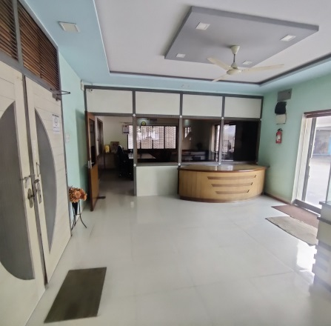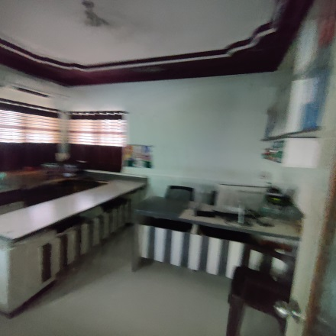

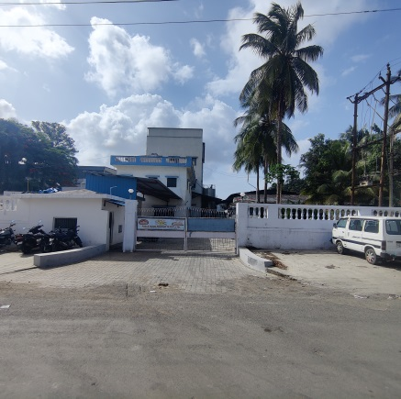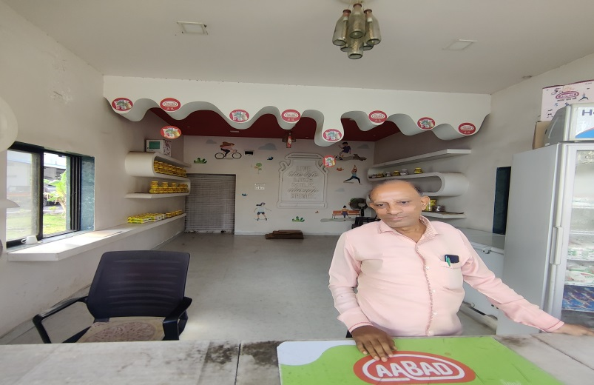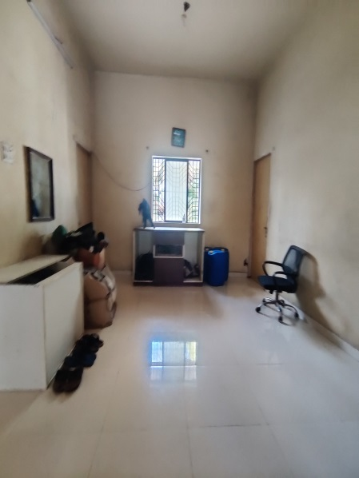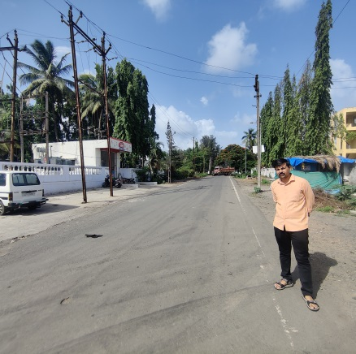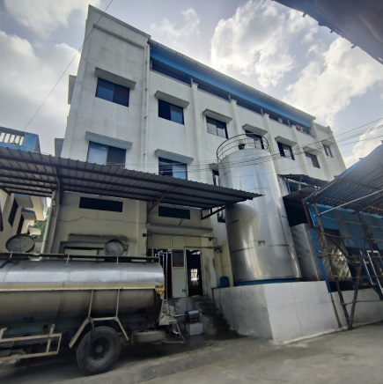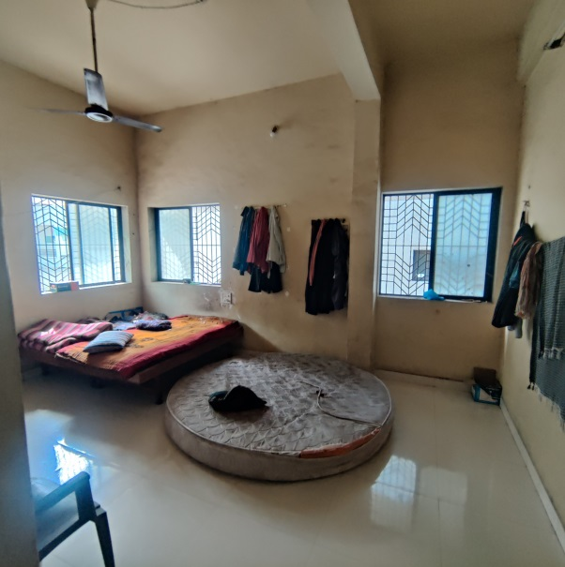

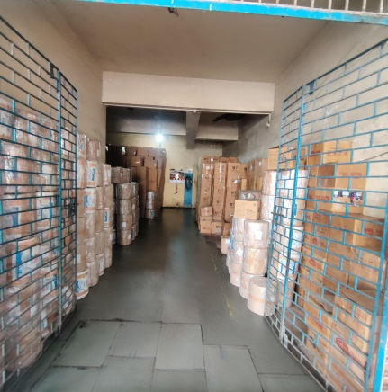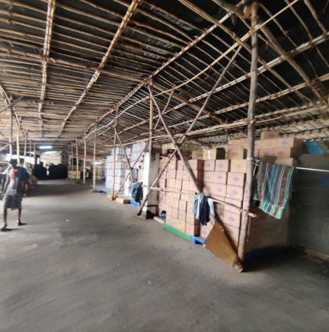Act ual Photographs

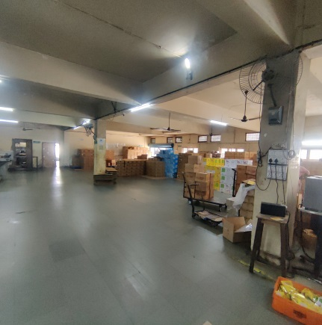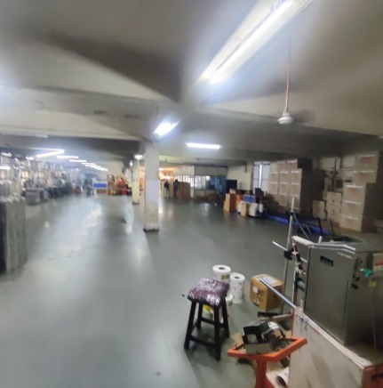

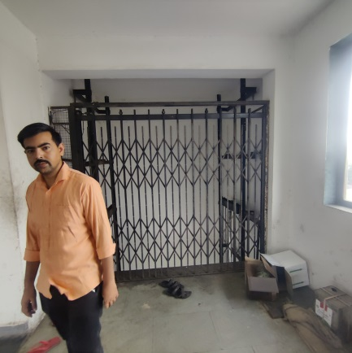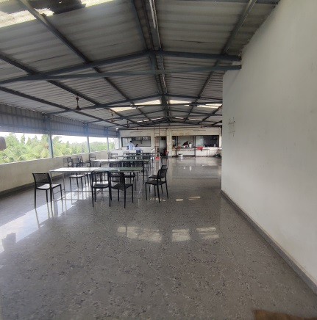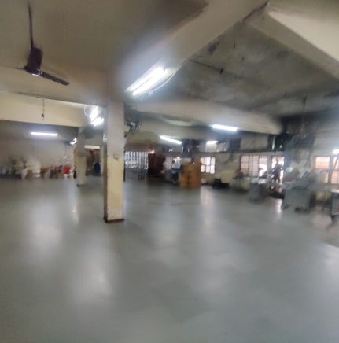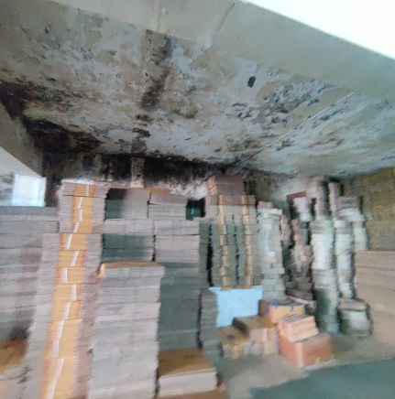 Actual Photographs

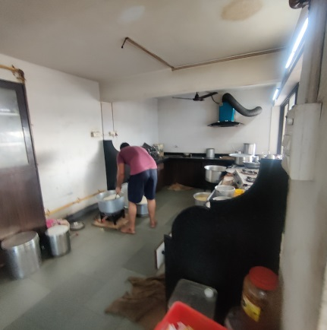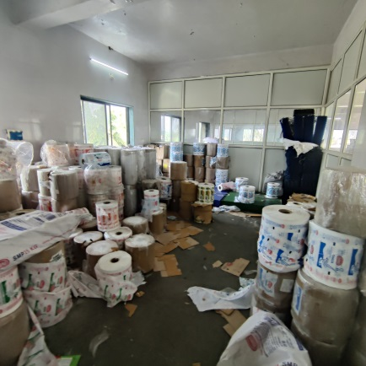

# C:\Users\Vaishali\Desktop\vastukala\SBI\Commercial Vile Parle\Fable Food-sbi - commercial vile parle-LB\Land bldg\30.06.2023\Photo\IMG_20230622_091715.jpgC:\Users\Vaishali\Desktop\vastukala\SBI\Commercial Vile Parle\Fable Food-sbi - commercial vile parle-LB\Land bldg\30.06.2023\Photo\IMG_20230622_091648.jpgC:\Users\Vaishali\Desktop\vastukala\SBI\Commercial Vile Parle\Fable Food-sbi - commercial vile parle-LB\Land bldg\30.06.2023\Photo\IMG_20230622_091512.jpgC:\Users\Vaishali\Desktop\vastukala\SBI\Commercial Vile Parle\Fable Food-sbi - commercial vile parle-LB\Land bldg\30.06.2023\Photo\IMG_20230622_091441.jpgC:\Users\Vaishali\Desktop\vastukala\SBI\Commercial Vile Parle\Fable Food-sbi - commercial vile parle-LB\Land bldg\30.06.2023\Photo\IMG_20230622_091348.jpgC:\Users\Vaishali\Desktop\vastukala\SBI\Commercial Vile Parle\Fable Food-sbi - commercial vile parle-LB\Land bldg\30.06.2023\Photo\IMG_20230622_091258.jpg

Actual Photographs

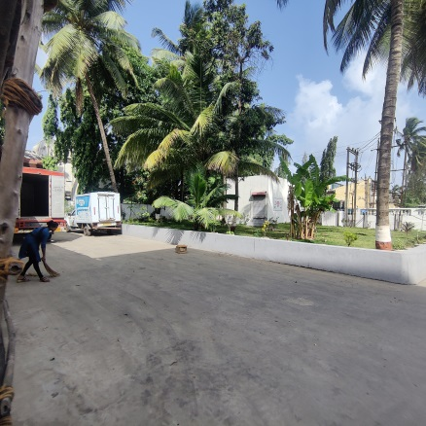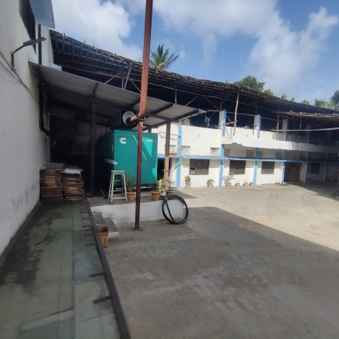

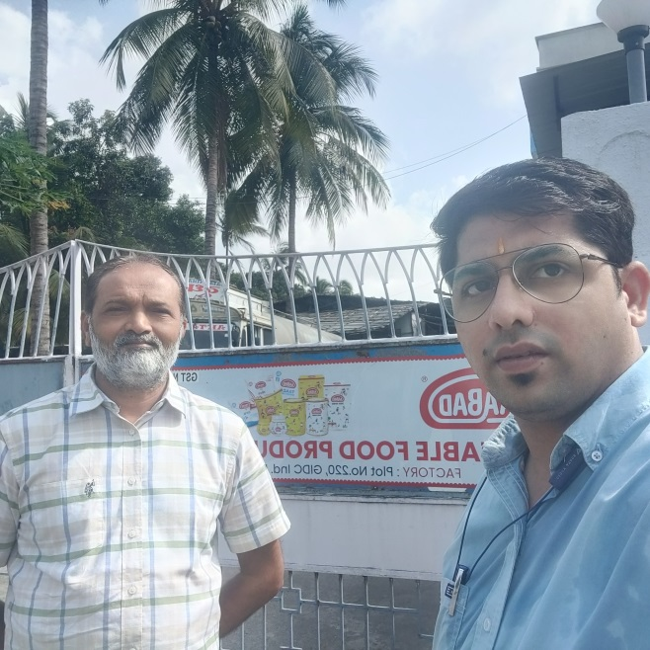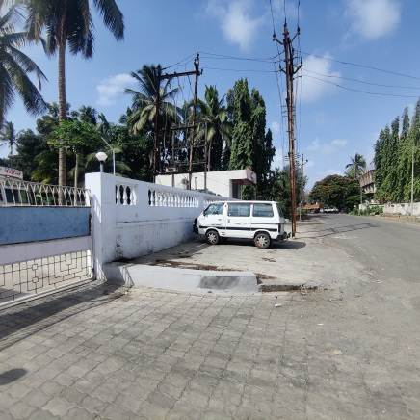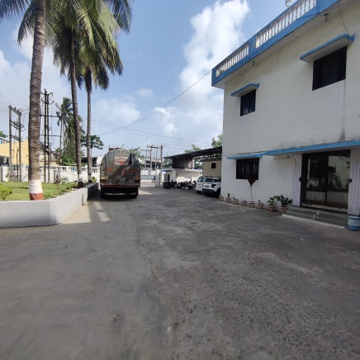

Route Map of the property

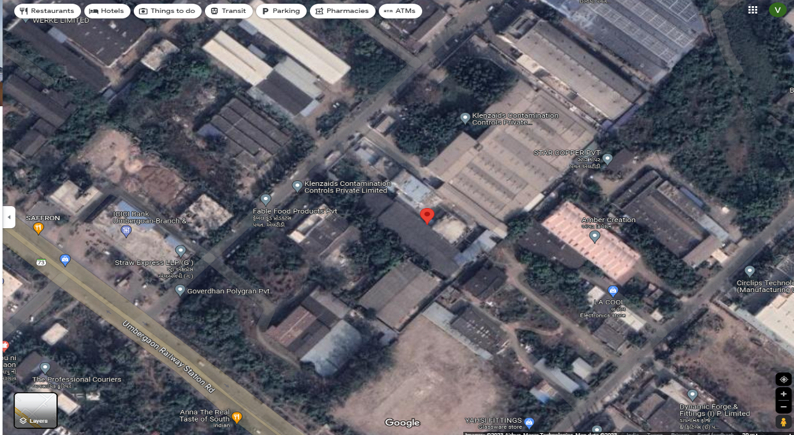

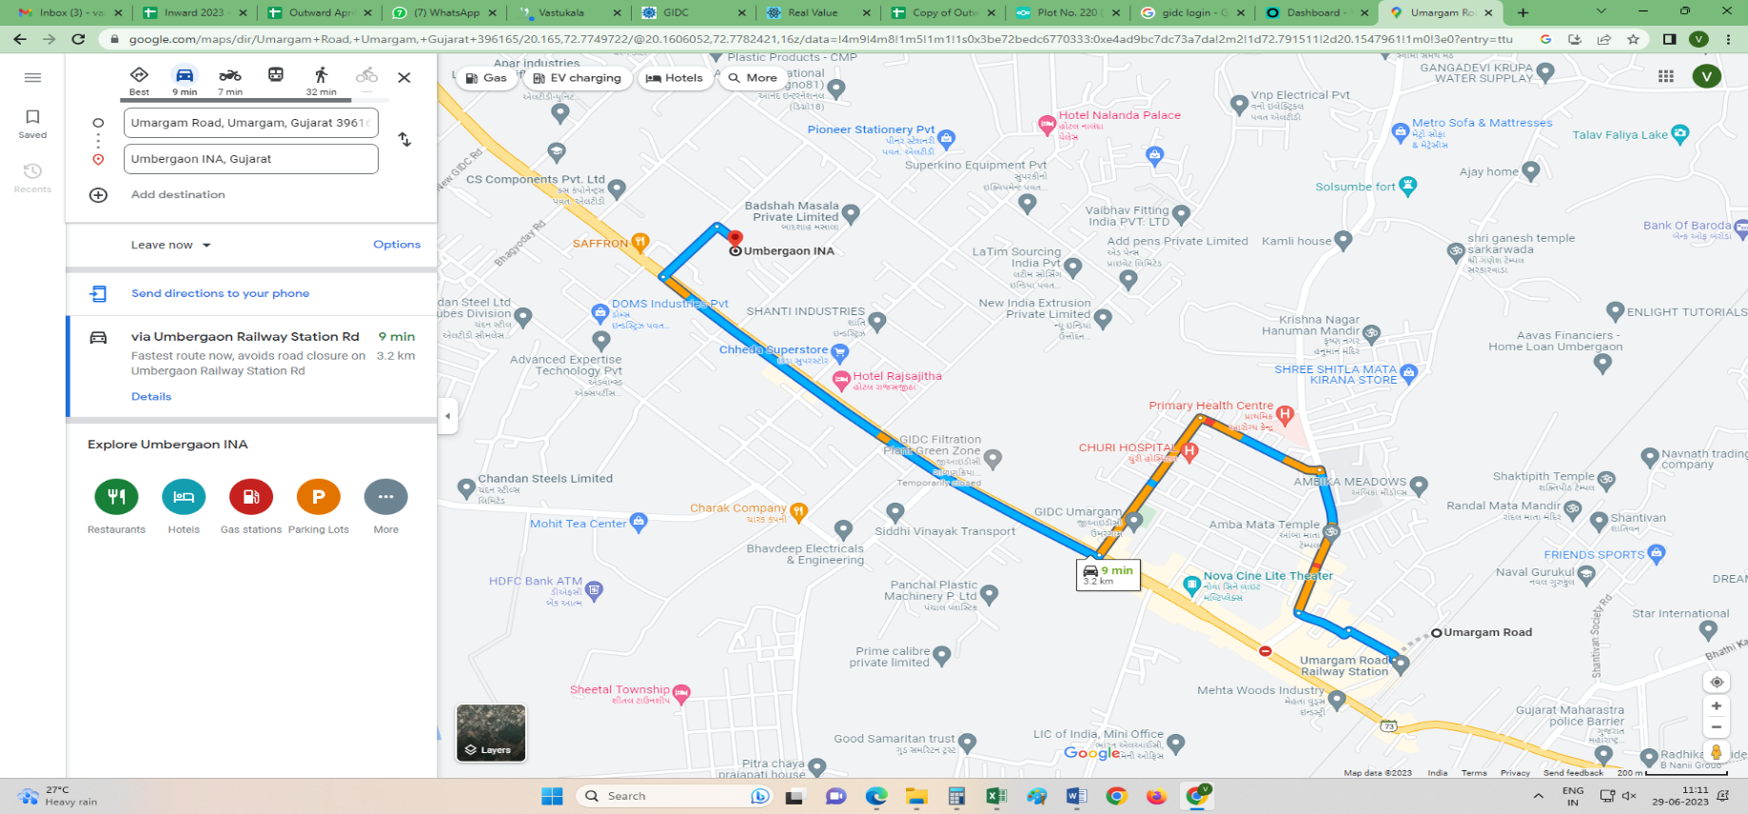

### Latitude Longitude: 20°09'54.0"N 72°46'29.9"E

**Note:** The Blue line shows the route to site from nearest railway station (Umbergaon – 3.2 KM.)

**GIDC RATE**

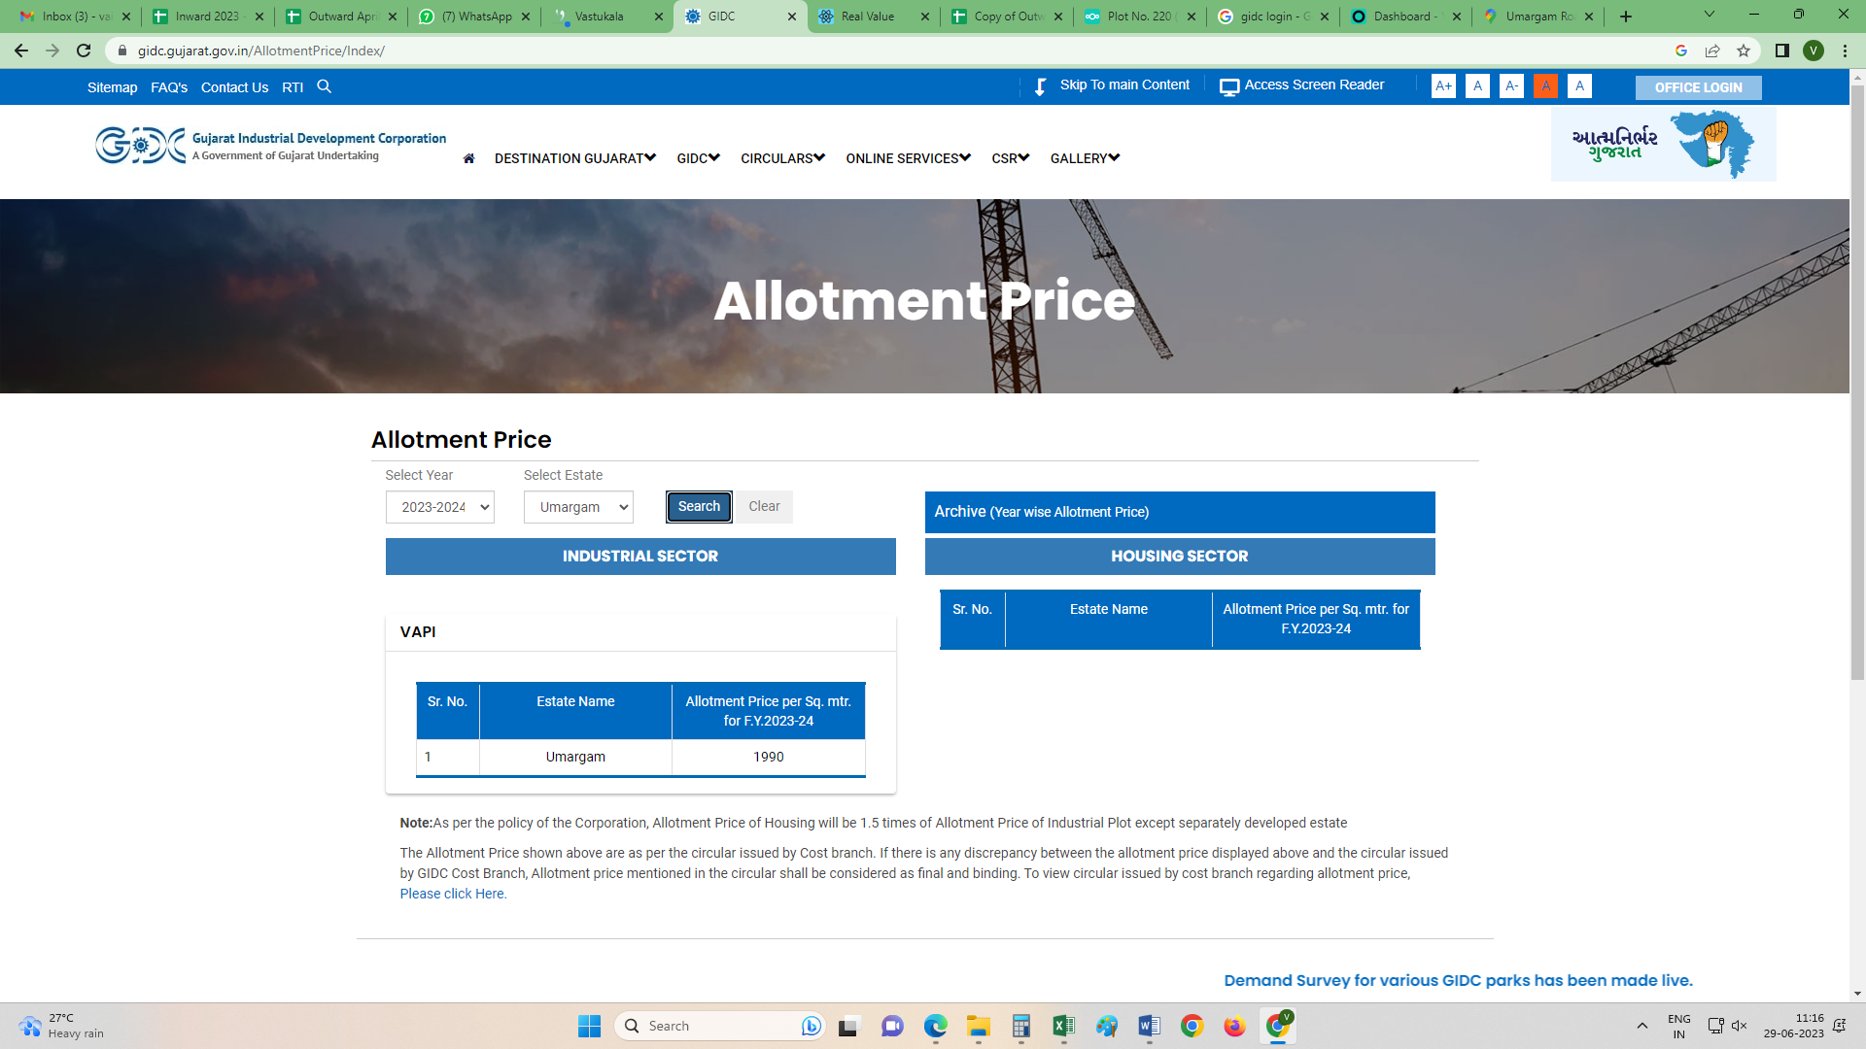

**Price Indicators**

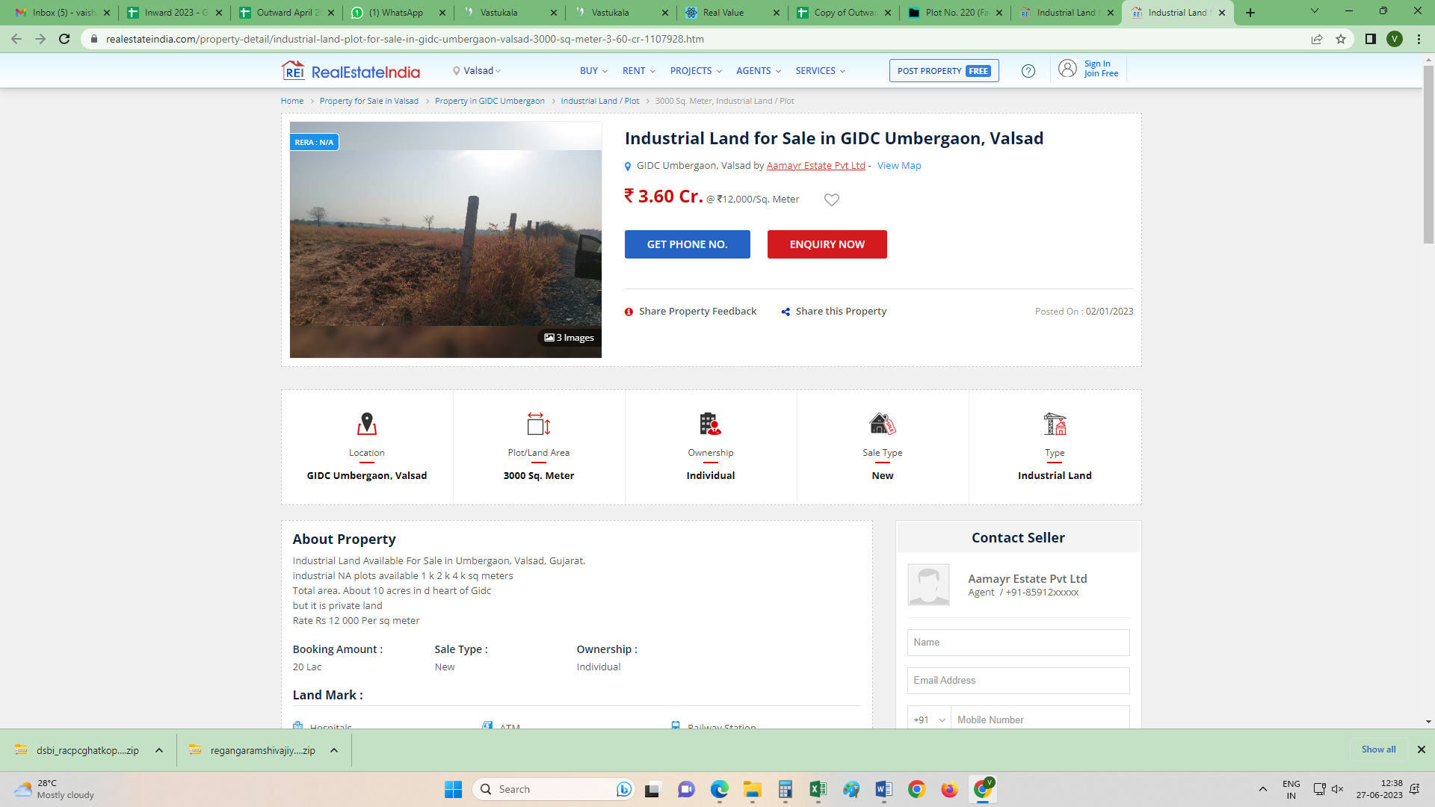

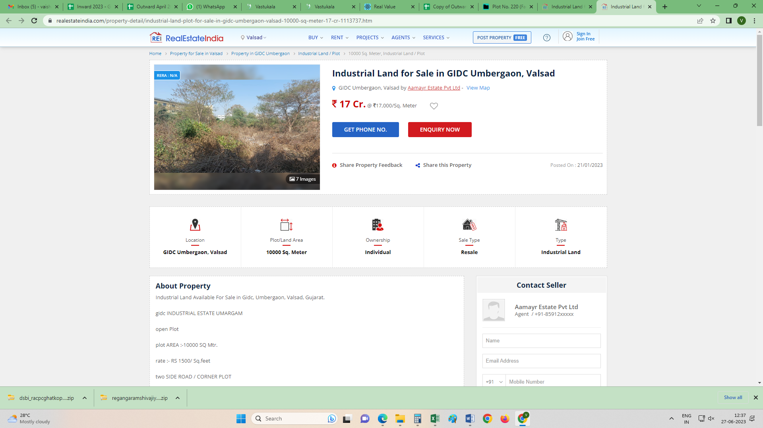

**Justification for price /rate**

It is foregone conclusion that market value is always more than Government Rate. As the Government Rates are fixed by respective State Governments for computing Stamp Duty / Registration Fees. Thus the rates differs from place to place and location, amenities as evident from the fact that even Government Rates decided by Government Differs

As a result of my appraisal and analysis, it is my considered opinion that the **Fair Market Value** for this particulars above property in the prevailing condition with aforesaid specification is **` 11,62,56,993.00 (Rupees Eleven Crore Sixty Two Lakh Fifty Six Thousand Nine Hundred Ninety Three Only).**

Place: Mumbai

Date: 30.06.2023

**Yogesh R. Vankar**

Govt. Reg. Valuer

Building Planner & Chartered Engineer (India)

The undersigned has inspected the property detailed in the Valuation Report dated \_\_\_\_\_\_\_\_\_\_\_\_\_\_\_\_\_\_\_\_\_\_\_ on \_\_\_\_\_\_\_\_\_\_\_\_\_\_\_\_\_\_\_\_. We are satisfied that the fair and reasonable market value of the property is `\_\_\_\_\_\_\_\_\_\_\_\_\_\_\_\_\_\_\_\_\_\_\_\_\_ (Rupees \_\_\_\_\_\_\_\_\_\_\_\_\_\_\_\_\_\_\_\_\_\_\_\_\_\_\_\_\_\_\_\_\_\_\_\_\_\_\_\_\_\_\_\_\_\_\_\_\_\_\_\_\_\_\_\_\_\_\_\_\_\_\_\_\_\_\_\_\_\_\_\_\_\_\_\_\_\_\_\_\_\_\_\_\_\_\_\_\_\_\_\_\_\_\_\_only).

Date

Signature

(Name & Designation of the Inspecting Official/s)

Countersigned

(BRANCH MANAGER)

|  |  |  |
| --- | --- | --- |
| **Enclosures** | | |
|  | Declaration-cum-undertaking from the valuer (Annexure- I) | Attached |
|  | Model code of conduct for valuer - (Annexure - II) | Attached |

**DECLARATION-CUM-UNDERTAKING**

I, Yogesh R. Vankar do hereby solemnly affirm and state that:

1. I am a citizen of India.
2. I will not undertake valuation of any assets in which I have a direct or indirect interest or become so interested at any time during a period of three years prior to my appointment as valuer or three years after the valuation of assets was conducted by me.
3. The information furnished in my valuation report dated 22.06.2023 is true and correct to the best of my knowledge and belief and I have made an impartial and true valuation of the property.
4. I/ my authorized representative have personally inspected the property on 30.06.2023 The work is not sub - contracted to any other valuer and carried out by myself.
5. Valuation report is submitted in the format as prescribed by the bank.
6. I have not been depanelled / delisted by any other bank and in case any such depanelment by other banks during my empanelment with you, I will inform you within 3 days of such depanelment.
7. I have not been removed / dismissed from service / employment earlier.
8. I have not been convicted of any offence and sentenced to a term of imprisonment
9. I have not been found guilty of misconduct in my professional capacity.
10. I have not been declared to be unsound mind
11. I am not an un-discharged bankrupt, or has not applied to be adjudicated as a bankrupt;
12. I am not an un-discharged insolvent.
13. I have not been levied a penalty under section 271J of Income-tax Act, 1961 (43 of 1961) and time limit for filing appeal before Commissioner of Income-tax (Appeals) or Income-tax Appellate Tribunal, as the case may be has expired, or such penalty has been confirmed by Income-tax Appellate Tribunal, and five years have not elapsed after levy of such penalty
14. I have not been convicted of an offence connected with any proceeding under the Income Tax Act 1961, Wealth Tax Act 1957 or Gift Tax Act 1958 and
15. My PAN Card number as applicable is ACUPV9792L
16. I undertake to keep you informed of any events or happenings which would make me ineligible for empanelment as a valuer
17. I have not concealed or suppressed any material information, facts and records and I have made a complete and full disclosure
18. I have read the Handbook on Policy, Standards and procedure for Real Estate Valuation, 2011 of the IBA and this report is in conformity to the "Standards" enshrined for valuation in the Part - B of the above handbook to the best of my ability.
19. I have read the International Valuation Standards (IVS) and the report submitted to the Bank for the respective asset class is in conformity to the "Standards" as enshrined for valuation in the IVS in "General Standards" and "Asset Standards" as applicable. The valuation report is submitted in the prescribed format of the bank.
20. I abide by the Model Code of Conduct for empanelment of valuer in the Bank. (Annexure V - A signed copy of same to be taken and kept along with this declaration)
21. I am registered under Section 34 AB of the Wealth Tax Act, 1957.
22. I am valuer registered with Insolvency & Bankruptcy Board of India (IBBI)
23. My CIBIL Score and credit worthiness is as per Bank's guidelines.
24. I am Chairman & Managing Director of the company, who is competent to sign this valuation report.
25. I will undertake the valuation work on receipt of Letter of Engagement generated from the system (i.e. LLMS / LOS) only.

Further, I hereby provide the following information

|  |  |  |
| --- | --- | --- |
|  | **Particulars** | **Valuer comment** |
|  | Background information of the asset being valued; | The property under consideration was purchased by M/s. Fable Food Products Private Limited from Meghraj Silk And Reyon Industries Private Limited vide Sale Deed for sale dated 01.08.2005 |
|  | Purpose of valuation and appointing authority | As per the request from State Bank of India, Commercial Branch (Vile Parle) to assess Realizable value of the property for Banking purpose. |
|  | Identity of the Valuer and any other experts involved in the valuation; | Yogesh R. Vankar – Regd. Valuer |
|  | Disclosure of Valuer interest or conflict, if any; | We have no interest, either direct or indirect, in the property valued. Further to state that we do not have relation or any connection with property owner / applicant directly or indirectly. Further to state that we are an independent Valuer and in no way related to property owner / applicant |
|  | Date of appointment, valuation date and date of report; | Date of Appointment – 30.06.2023  Valuation Date – 22.06.2023  Date of Report – 22.06.2023 |
|  | Inspections and/or investigations undertaken; | Physical Inspection done on date 22.06.2023 |
|  | Nature and sources of the information used or relied upon; | Market Survey at the time of site visit  Ready Reckoner rates / Circle rates  Online search for Registered Transactions  Online Price Indicators on real estate portals  Enquiries with Real estate consultants  Existing data of Valuation assignments carried out by us |
|  | Procedures adopted in carrying out the valuation and valuation standards followed; | Cost Approach (For building construction)  Comparative Sales Method (For Land component) |
|  | Restrictions on use of the report, if any; | This valuation is for the use of the party to whom it is addressed and for no other purpose. No responsibility is accepted to any third party who may use or rely on the whole or any part of this valuation. The valuer has no pecuniary interest that would conflict with the proper valuation of the property. |
| 1. . | Major factors that were taken into account during the valuation; | Current market conditions, demand and supply position, industrial land size, location, sustained demand for industrial land, all round development of commercial and industrial application in the locality etc. |
|  | Caveats, limitations and disclaimers to the extent they explain or elucidate the limitations faced by valuer, which shall not be for the purpose of limiting his responsibility for the valuation report. | Attached |

Date: 30.06.2023

Place: Mumbai

**Yogesh R. Vankar**

Govt. Reg. Valuer

Building Planner & Chartered Engineer (India)