Valuation Report of the Immovable Property
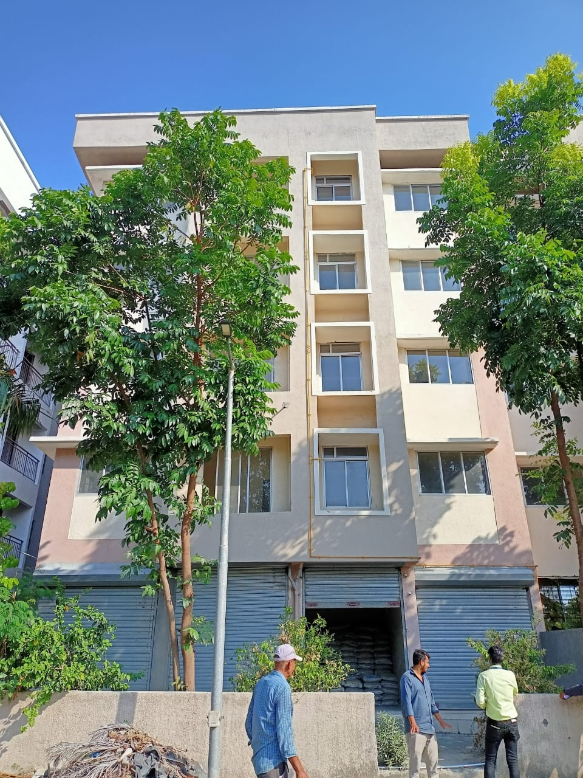

Details of the property under consideration:

Name of Client: M/s. Haware Infotech Ltd.

Property bearing Township layout having Residential Cum Commercial Buildings, "Haware Nakshatra", Kharekuran Road, opp. Dandekar College, Village – Tembhode, Palghar – 401 404,
State – Maharashtra, Country – India.

Latitude Longitude - 19°42'48.5"N 72°44'60.0"E

Valuation Prepared for:

Cosmos Bank

Naupada Thane Branch

Kusumanjali, Opposite Deodhar Hospital, Naupada, Thane (West),

State - Maharashtra, Country – India.

Vastu/Mumbai/06/2023/31957/2301134
17/25-238-BHVSU
Date: 17.06.2023

VALUATION OPINION REPORT

The property bearing Township layout having Residential Cum Commercial Buildings, "Haware Nakshatra", Kharekuran Road, opp. Dandekar College, Village – Tembhode, Palghar – 401 404, State – Maharashtra, Country – India. Unsold units belong to M/s. Haware Infotech Ltd.
List of Unsold Inventory to be Valued:
Sr. No | Building No. | Floor | Flat No. | Sale Area (Sq. Ft.) | Type
1 | 4 | Ground | 03 | 603 | 1 BHK
2 | 4 | 4th | 24 | 920 | 2 BHK
3 | 4 | 4th | 26 | 637 | 1 BHK
4 | 5 | 4th | 22 | 649 | 1 BHK
5 | 5 | 4th | 23 | 649 | 1 BHK
6 | 5 | 4th | S-62 | 637 | Shop
7 | 6 | Ground | 22 | 236 | 2 BHK
8 | 6 | 4th | 24 | 917 | 2 BHK
9 | 6 | 4th | 27 | 917 | 1 BHK
10 | 6 | 4th | 01 | 649 | 1 BHK
11 | 7 | Ground | 05 | 646 | 1 BHK
12 | 7 | 1st | 23 | 646 | 1 BHK
13 | 7 | 4th | 25 | 646 | 1 BHK
14 | 7 | 4th | 26 | 917 | 2 BHK
15 | 7 | 4th | 19 | 917 | 2 BHK
16 | 8 | 4th | 23 | 912 | 2 BHK
17 | 9 | 4th | 24 | 917 | 2 BHK
18 | 9 | 4th | 28 | 917 | 2 BHK
19 | 10 | Ground | 32 | 704 | 1 BHK
20 | 11 | 4th | 16 | 421 | 1 RK
21 | 14 | 3rd | 22 | 912 | 2 BHK
22 | 14 | 4th | 22 | 912 | 2 BHK
23 | 14 | 4th | 24 | 912 | 2 BHK
24 | 14 | 4th | 26 | 912 | 2 BHK
25 | 15 | 4th | 18 | 912 | 2 BHK
26 | 15 | 4th | 19 | 912 | 2 BHK
27 | 16 | 3rd | 14 | 912 | 2 BHK
28 | 16 | 4th | 18 | 912 | 2 BHK
29 | 16 | 4th | 19 | 912 | 2 BHK
30 | 17 | 4th | 22 | 912 | 2 BHK
31 | 17 | 3rd | 27 | 912 | 2 BHK
32 | 19 | 4th | 22 | 421 | 1 RK
33 | 20 | 4th | 26 | 912 | 2 BHK
34 | 22 | 4th | 18 | 912 | 2 BHK
35 | 22 | 4th | 23 | 649 | 1 BHK
36 | 22 | 4th | 19 | 912 | 2 BHK
37 | 26 | 4th | 18 | 920 | 2 BHK
Sr. No | Building No. | Floor | Flat No. | Sale Area (Sq. Ft.) | Type
38 | 5 | Ground | S-59 | 271 | Shop
39 | 6 | Ground | S-60 | 271 | Shop
40 | 6 | Ground | S-61 | 266 | Shop
41 | 7 | Ground | 29 | 727 | 1 BHK
42 | 9 | Ground | 28 | 727 | 1 BHK
43 | 10 | Ground | 29 | 727 | 1 BHK
44 | 13 | Ground | 28 | 703 | 1 BHK
45 | 17 | Ground | 30 | 823 | 2 BHK
46 | 20 | Ground | 28 | 703 | 1 BHK
47 | 24 | Ground | 25 | 450 | 1 RK
48 | 24 | Ground | 26 | 727 | 1 BHK
49 | 25 | Ground | 15 | 726 | 1 BHK
50 | 25 | Ground | 16 | 726 | 1 BHK

List of Property Verified:
As per Request from the Bank we have visited about 20 flats in different Buildings as follow:
Sr. No | Building No. | Floor | Flat No. | Type
1 | 4 | Ground | 3 | 1 BHK
2 | 4 | 4th | 24 | 2 BHK
3 | 4 | 4th | 26 | 1 BHK
4 | 5 | 4th | 22 | 1 BHK
5 | 5 | 4th | 24 | 1 BHK
6 | 5 | Ground | S-58 | Shop
7 | 5 | Ground | S-59 | Shop
8 | 7 | 4th | 26 | 2 BHK
9 | 7 | Ground | 5 | 1 BHK
10 | 8 | 4th | 19 | 2 BHK
11 | 9 | 4th | 28 | 1 BHK
12 | 10 | 4th | 28 | 1 BHK
13 | 14 | 4th | 29 | 1 BHK
14 | 13 | Ground | 28 | 1 BHK
15 | 11 | 4th | 32 | 1 BHK
16 | 24 | 4th | 25 | 1 RK
17 | 26 | Ground | S-64 | Shop
18 | 26 | Ground | S-62 | Shop

Considering various parameters recorded, existing economic scenario, and the information that is available with reference to the development of neighborhood and method selected for valuation, we are of the opinion that, the property premises can be assessed and valued for banking purpose as Follow:
Sr. No. | Floor | Rate On Saleable Area as per builder | Shop | 1 BHK | 2 BHK
1 | Ground Floor | 2,700/- Per Sq. Ft. | 6.5 – 7 Lac | 16.25 – 19.00 Lac | 24.50 – 24.75 Lac
2 | First, Second & Third Floor | 2,600/- Per Sq. Ft. | - | 15.50 – 18.50 Lac | 23.75 – 24.00 Lac
3 | Fourth Floor | 2400/- Per Sq. Ft. | - | 15.00 – 17.00 Lac | 21.75 – 22.00 Lac

The valuation of the property is based on the documents produced by the concern. Legal aspects have not been taken into considerations while preparing this valuation report.

Hence certified

Manoj B. Chalikwar

Registered Valuer

Chartered Engineer (India)

Reg. No. CAT-I-F-1763

Cosmos Emp. No. H.O./Credit/67/2019-20

1 | Purpose for which the valuation is made |  | To assess the Fair Market Value as on 17.06.2023 for Bank Loan Purpose
2 | Date of inspection |  | 23.05.2023
3 | Name of the Client |  | M/s. Haware Infotech Ltd.
4 | If the property is under joint ownership / co-ownership, share of each such owner. Are the shares undivided? |  | Company Ownership  Details of ownership share is not available
5 | Brief description of the property |  | Address: Property bearing Township layout having Residential Cum Commercial Buildings, "Haware Nakshatra", Kharekuran Road, opp. Dandekar College, Village – Tembhode, Palghar – 401 404, State – Maharashtra, Country – India  Contact Person:  Mr. Bhavir Thakur (sales Office)  Contact No. 8446690027
6 | Location, street, ward no |  | Kharekuran Road, opp. Dandekar College, Village – Tembhode, Palghar – 401 404
7 | Survey/ Plot no. of land |  | S. No. 66/1 of Village – Tembhode
8 | Is the property situated in residential/ commercial/ mixed area/ Commercial area? |  | Residential cum Residential cum Commercial Area
9 | Classification of locality-high class/ middle class/poor class |  | Middle Class
10 | Proximity to civic amenities like schools, Hospitals, Units, market, cinemas etc. |  | All the amenities are available in the vicinity
11 | Means and proximity to surface communication by which the locality is served |  | Served by Private Buses, Auto and Private cars
 | LAND
12 | Area of Unit supported by documentary proof. Shape, dimension and physical features |  | As Annexture by Builder
13 | Roads, Streets or lanes on which the land is abutting |  | Kharekuran Road, opp. Dandekar College, Village – Tembhode, Palghar
14 | If freehold or leasehold land |  | Free Hold
15 | If leasehold, the name of Lessor/lessee, nature of lease, date of commencement and termination of lease and terms of renewal of lease.  - Initial Premium  - Ground Rent payable per annum  - Unearned increased payable to the  Lessor in the event of sale or transfer |  | N. A.
16 | Is there any restriction covenant in regard to use of land? If so, attach a copy of the covenant. |  | As per documents
17 | Are there any agreements of easements? If so, attach a copy of the covenant |  | Information not available
18 | Does the land fall in an area included in any Town Planning Scheme or any Development Plan of Government or any statutory body? If so, give Particulars. |  | Information not available
19 | Has any contribution been made towards development or is any demand for such contribution still outstanding? |  | Information not available
20 | Has the whole or part of the land been notified for acquisition by government or any statutory body? Give date of the notification. |  | No
21 | Attach a dimensioned site plan |  | N.A.
 | IMPROVEMENTS
22 | Attach plans and elevations of all structures standing on the land and a lay-out plan. |  | Copy of Approved Building Plan No. KR. BA. V. 254 / 2019 dated 12.06.2019 issued by Palghar Municipal Council
23 | Furnish technical details of the building on a separate sheet (The Annexure to this form may be used) |  | Attached
24 | Is the building owner occupied/ tenanted/ both? |  | -
 | If the property owner occupied, specify portion and extent of area under owner-occupation |  | N.A.
25 | What is the Floor Space Index permissible and Percentage actually utilized? |  | Floor Space Index permissible – As per Local norms  Percentage actually utilized – Details not available
26 | RENTS
 | (i) | Names of tenants/ lessees/ licensees, etc | N.A.
 | (ii) | Portions in their occupation | N.A.
 | (iii) | Monthly or annual rent /compensation/license fee, etc. paid by each | As Annexture by Builder
 | (iv) | Gross amount received for the whole property | N.A.
27 | Are any of the occupants related to, or close to business associates of the owner? |  | Information not available
28 | Is separate amount being recovered for the use of fixtures, like fans, geysers, refrigerators, cooking ranges, built-in wardrobes, etc. or for services charges? If so, give details |  | N. A.
29 | Give details of the water and electricity charges, If any, to be borne by the owner |  | N. A.
30 | Has the tenant to bear the whole or part of the cost repairs and maintenance? Give particulars |  | N. A.
31 | If a lift is installed, who is to bear the cost of maintenance and operation- owner or tenant? |  | N. A.
32 | If a pump is installed, who is to bear the cost of maintenance and operation- owner or tenant? |  | N. A.
33 | Who has to bear the cost of electricity charges for lighting of common space like entrance hall, stairs, passage, compound, etc. owner or tenant? |  | N. A.
34 | What is the amount of property tax? Who is to bear it? Give details with documentary proof |  | Information not available
35 | Is the building insured? If so, give the policy no., amount for which it is insured and the annual premium |  | Information not available
36 | Is any dispute between landlord and tenant regarding rent pending in a court of rent? |  | N. A.
37 | Has any standard rent been fixed for the premises under any law relating to the control of rent? |  | N. A.
 | SALES
38 | Give instances of sales of immovable property in the locality on a separate sheet, indicating the Name and address of the property, registration No., sale price and area of land sold. |  | As per sub registrar of assurance records
39 | Land rate adopted in this valuation |  | N. A. as the property under consideration is a Residential cum Commercial Area in a building. The rate is considered as composite rate.
40 | If sale instances are not available or not relied up on, the basis of arriving at the land rate |  | N. A.
 | COST OF CONSTRUCTION
41 | Year of commencement of construction and year of completion |  | Year of Completion – 2020 (As per occupancy certificate)
42 | What was the method of construction, by contract/By employing Labour directly/ both? |  | N. A.
43 | For items of work done on contract, produce copies of agreements |  | N. A.
44 | For items of work done by engaging Labour directly, give basic rates of materials and Labour supported by documentary proof. |  | N. A.

PART II- VALUATION
GENERAL:

Under the instruction of Cosmos Bank, Naupada Thane Branch to assess fair market value as on 17.06.2023 for property bearing Township layout having Residential Cum Commercial Buildings, "Haware Nakshatra", Kharekuran Road, opp. Dandekar College, Village – Tembhode, Palghar – 401 404, State – Maharashtra, Country – India. belongs to M/s. Haware Infotech Ltd.

We are in receipt of the following documents:
1 | Copy of 7/12 Extract
2 | Copy of Occupancy Certificate No. CBPPE / PO / 2020 /APL / 00015 dated 28.12.2020 issued by Palghar Municipal Council.
3 | Copy of Commencement Certificate No. KR. BA. V. 254 / 2019 - 2020 dated 12.06.2019 issued by Palghar Municipal Council.
4 | Copy of Approved Building Plan No. KR. BA. V. 254 / 2019 dated 12.06.2019 issued by Palghar Municipal Council.

LOCATION:

The said building is located at S. No. 66/1 of Village – Tembhode, Palghar. The property falls in Residential Zone. It is at a walkable distance 4.4 Km. from Palghar railway station.

BUILDING:

The building under reference is having Ground + 4 Upper Floors. It is a R.C.C. Framed Structure with 9" thick external walls and 6" thick internal brick walls. The walls are having sand faced plaster from outside. The building is used for Residential cum Commercial Area purpose. The building having No lift.

NOTES

- I, Manoj B. Chalikwar with my experience and ability to judgment I am of the considered opinion that the fair market value of the property as on Value varies with time and purpose and hence this value should not be referred for any purpose other than mentioned in this report.
- This valuation is done on the basis of information, which the valuer has obtained by information provided by the client about the premises and location of the surrounding area and also prevailing rates in the surrounding area, and further subject to document as mentioned in valuation report.
- This valuer should not be held responsible for authentication of documents, clear title and other such related matters. For that purpose Latest Legal Opinion should be sought
PART III- DECLARATION
I hereby declare that
    - The information furnished in part I is true and correct to the best of my knowledge and belief;
    - I have no direct or indirect interest in the property value
ANNEXURE TO FORM 0-1

Technical details Main Building
1. | No. of floors and height of each floor | Ground + 4 Upper Floors
2. | Plinth area floor wise as per IS 3361-1966 | N.A. as the said property is a Residential Flats & Residential cum Commercial Area
3 | Year of construction | 2020 (As per occupancy certificate)
4 | Estimated future life | 57 Years Subject to proper, preventive periodic maintenance & structural repairs
5 | Type of construction- load bearing walls/RCC frame/ steel frame | R.C.C. Framed Structure
6 | Type of foundations | R.C.C. Foundation
7 | Walls | All external walls are 9" thick and partition walls are 6" thick.
8 | Partitions | 6” thick brick wall
9 | Doors and Windows | Teak wood door frame with flush shutters, Powder Coated Aluminum sliding windows
10 | Flooring | Vitrified tiles flooring
11 | Finishing | Cement plastering
12 | Roofing and terracing | R.C.C. Slab
13 | Special architectural or decorative features, if any | No
14 |  | Concealed electrification  Concealed plumbing
  (i) | Internal wiring – surface or conduit
  (ii) | Class of fittings: Superior/ Ordinary/ Poor.
15 | Sanitary installations | As per Requirement
  (i) | No. of water closets
  (ii) | No. of lavatory basins
  (iii) | No. of urinals
  (iv) | No. of sink
16 | Class of fittings: Superior colored / superior white/ordinary. | Ordinary
17 | Compound wall  Height and length  Type of construction | Not Provided
18 | No. of lifts and capacity | No Lift
19 | Underground sump – capacity and type of construction | R.C.C tank
20 | Over-head tank  Location, capacity  Type of construction | R.C.C tank on terrace
21 | Pumps- no. and their horse power | May be provided as per requirement
22 | Roads and paving within the compound approximate area and type of paving | Cement concrete in open spaces, etc.
23 | Sewage disposal – whereas connected to public sewers, if septic tanks provided, no. and capacity | Connected to Municipal Sewerage System
Actual site photographs

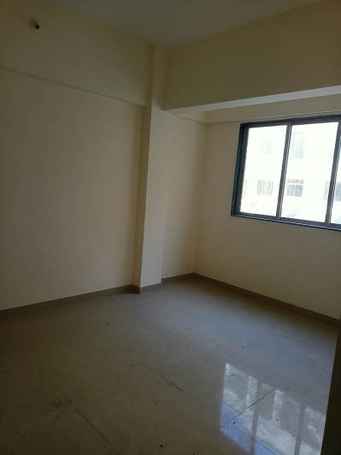
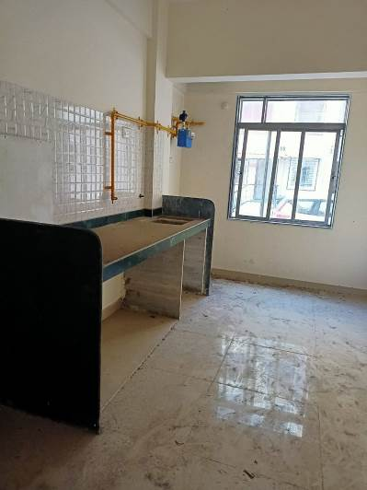
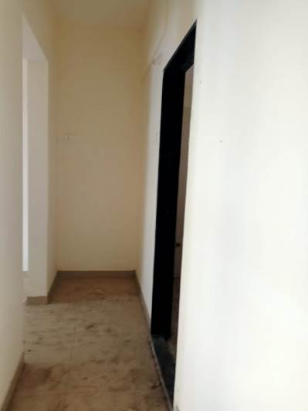

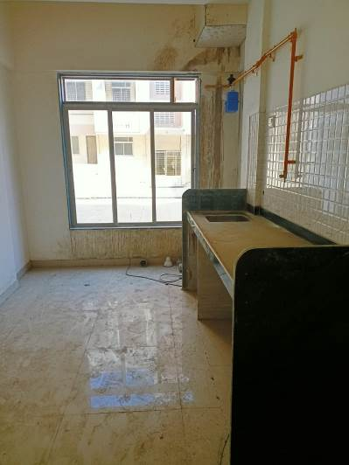
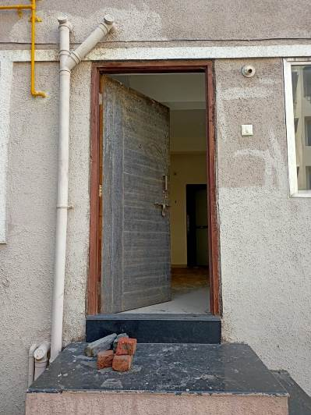
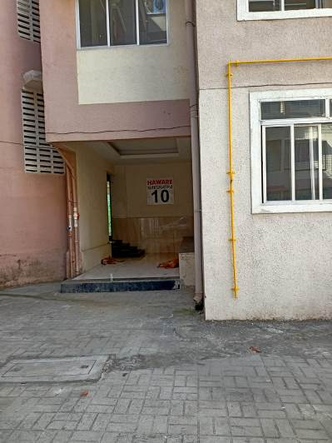

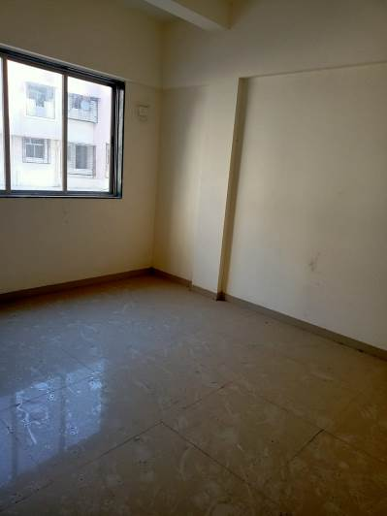
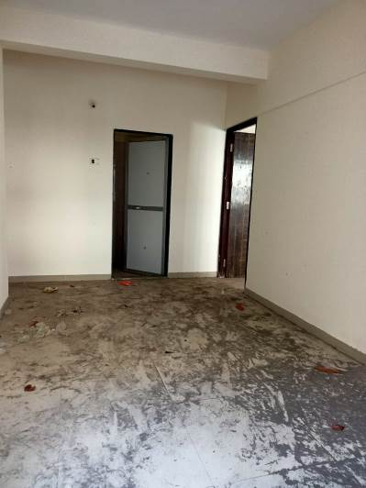
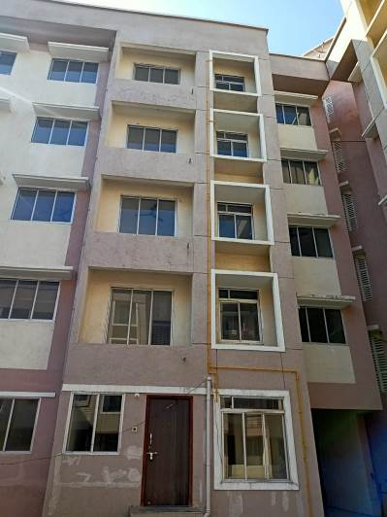

Actual site photographs

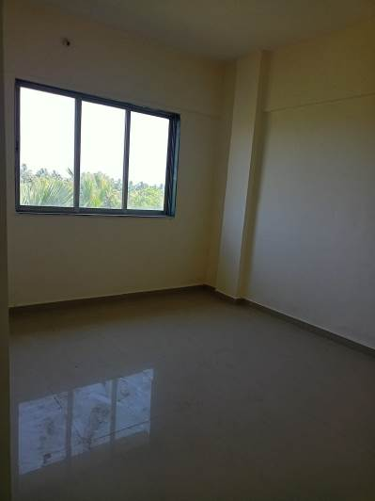
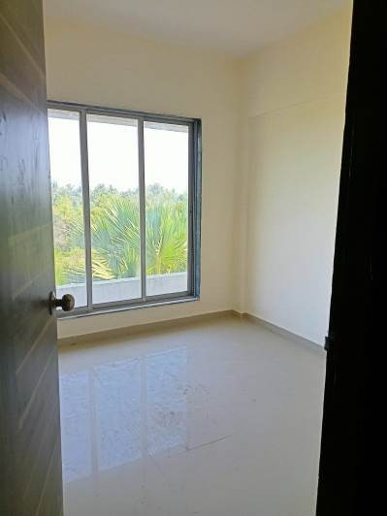
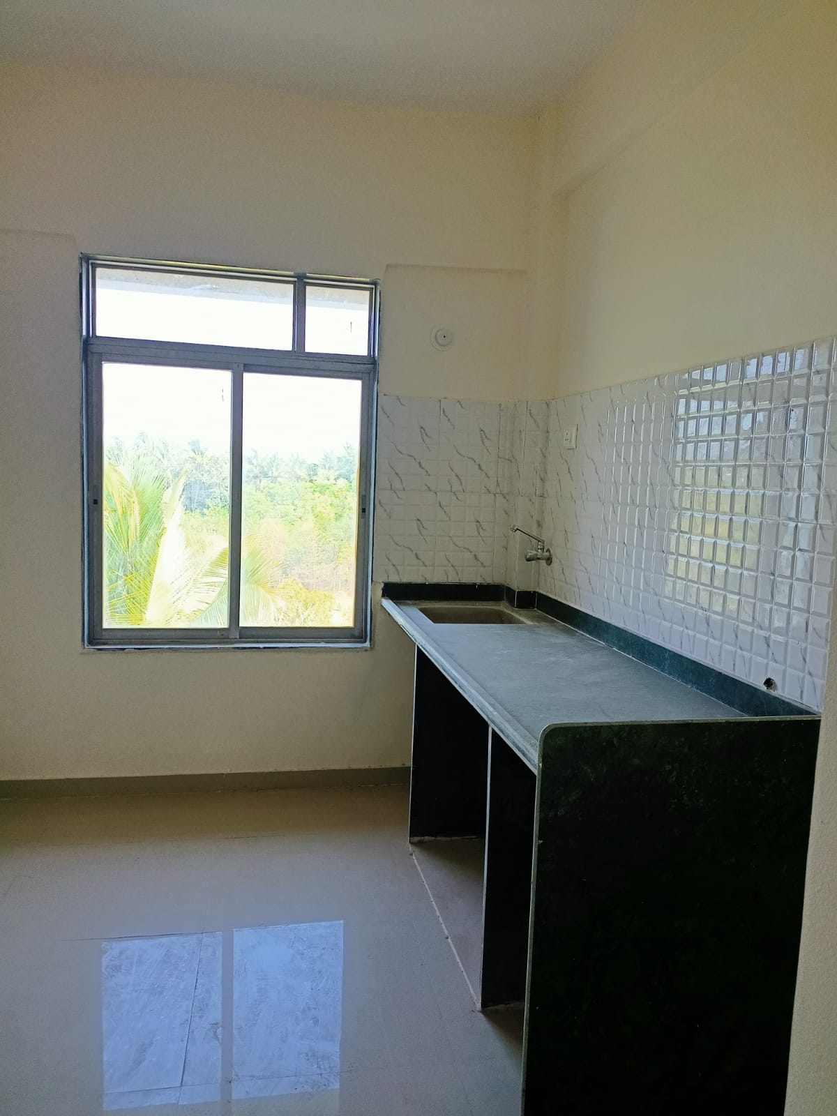

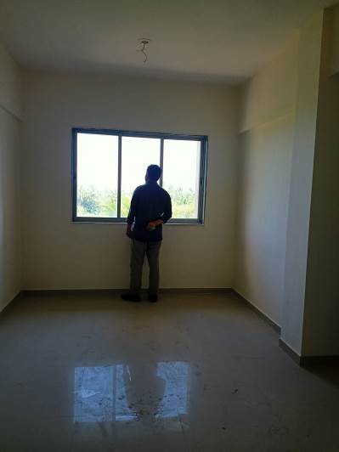
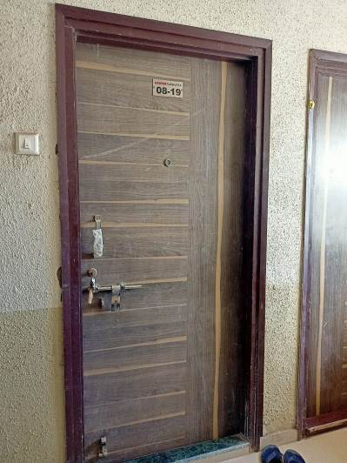

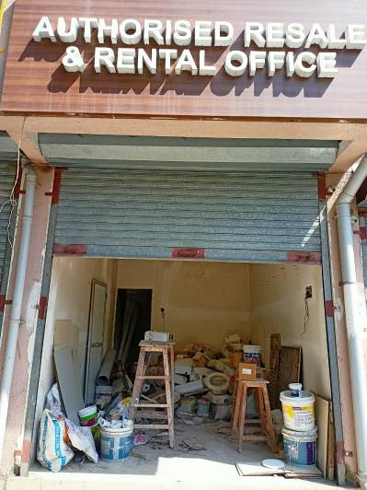
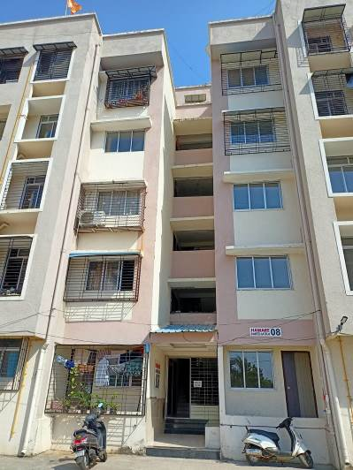

Actual site photographs

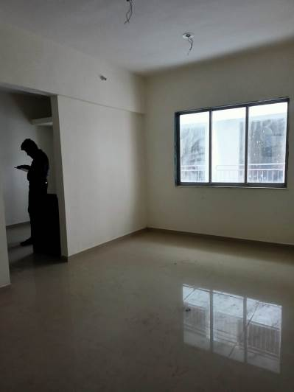
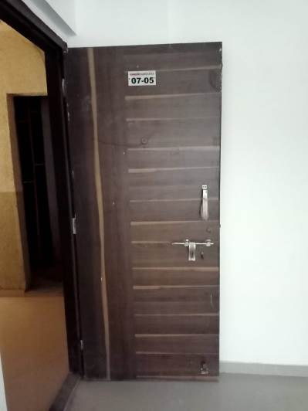
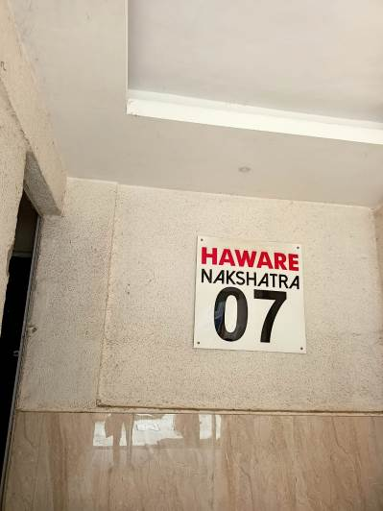

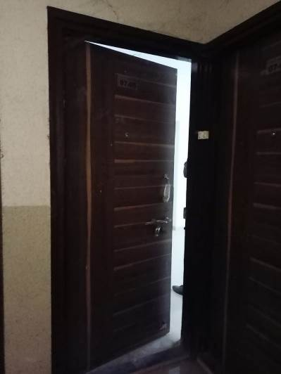
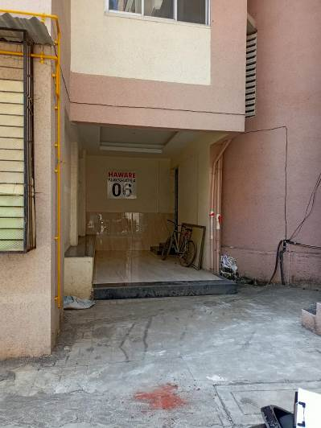
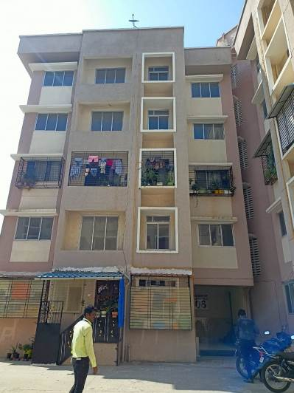

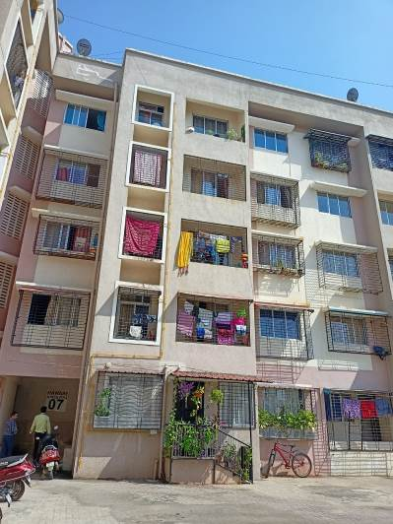
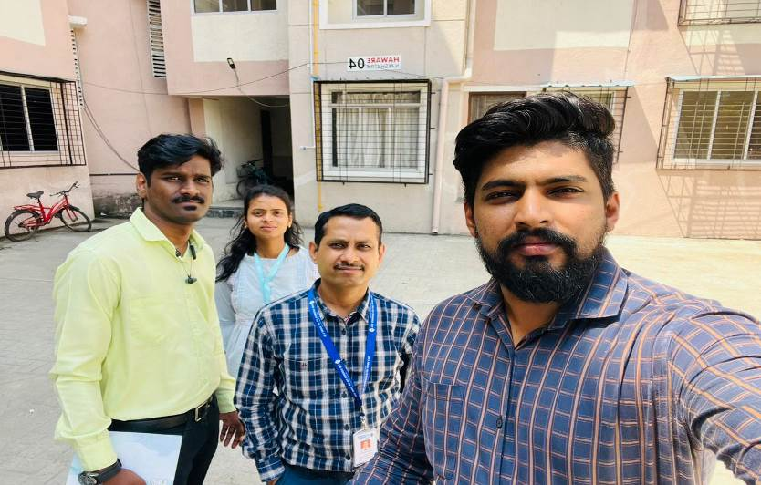
Route Map of the property
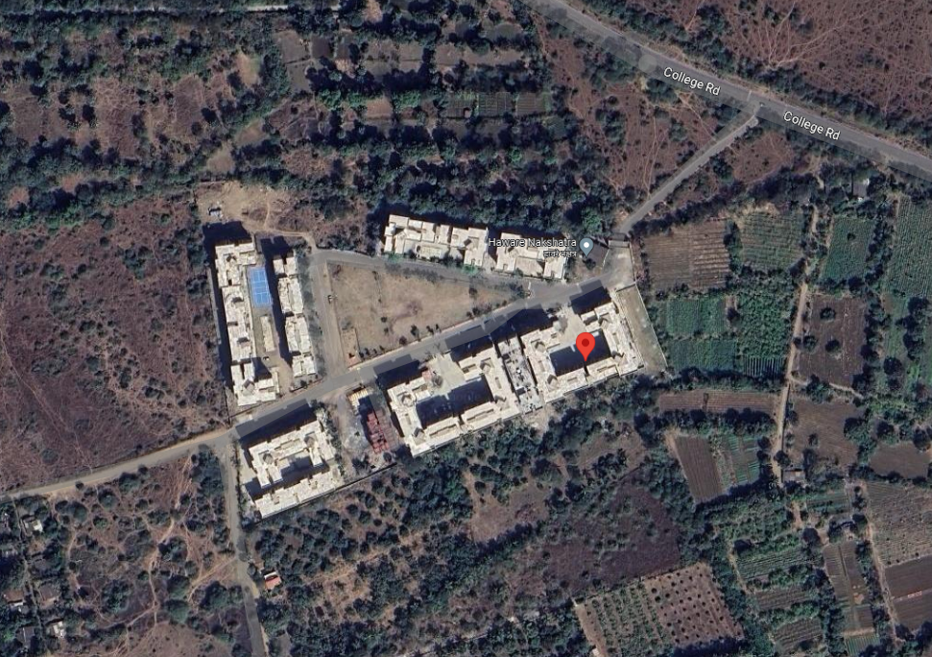
Site u/r

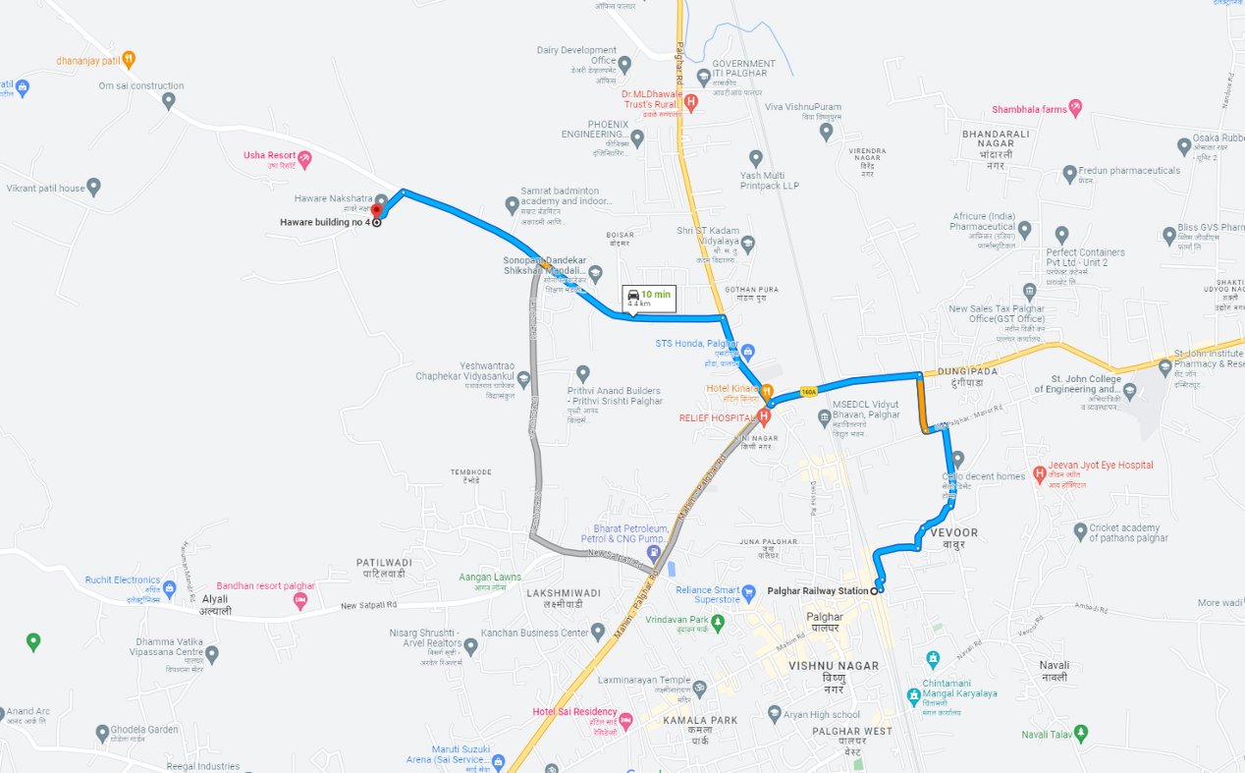

Latitude Longitude - 19°42'48.5"N 72°44'60.0"E

Note: The Blue line shows the route to site from nearest railway station (Palghar– 4.4 KM.)

Ready Reckoner Rate

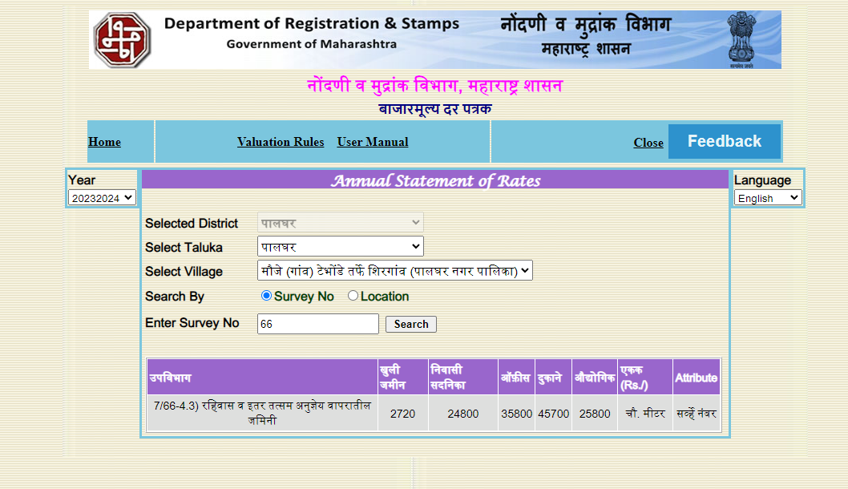

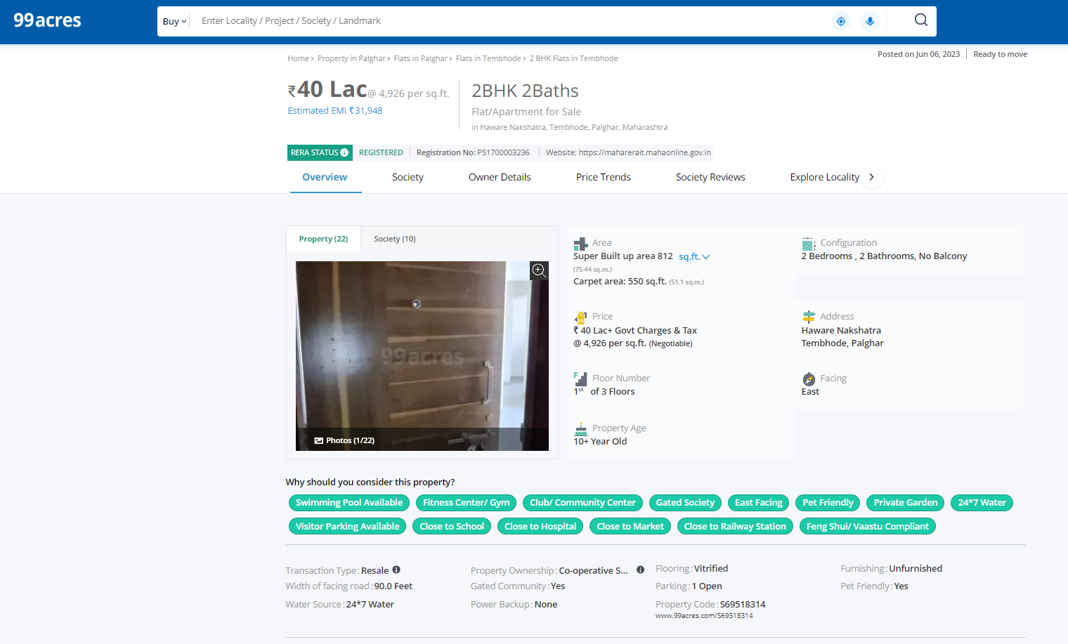
Price Indicators

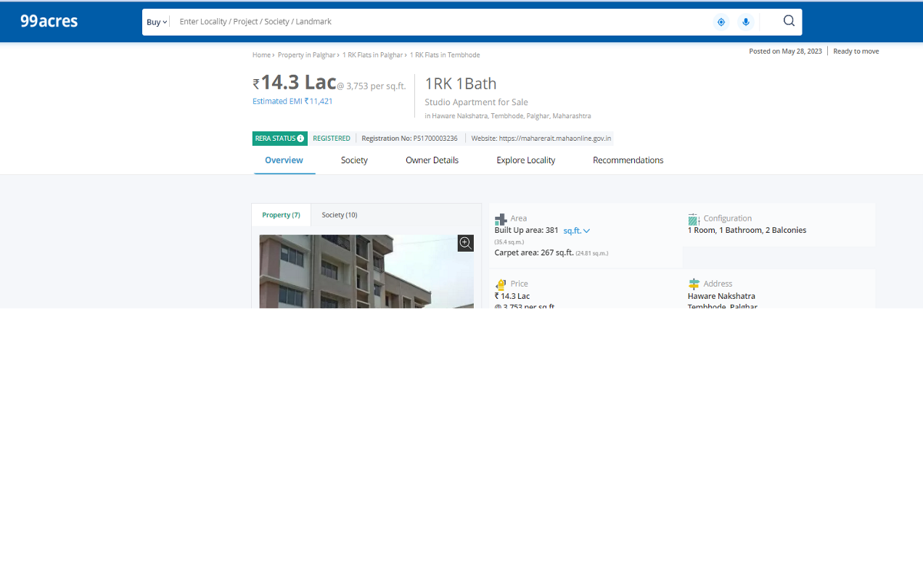

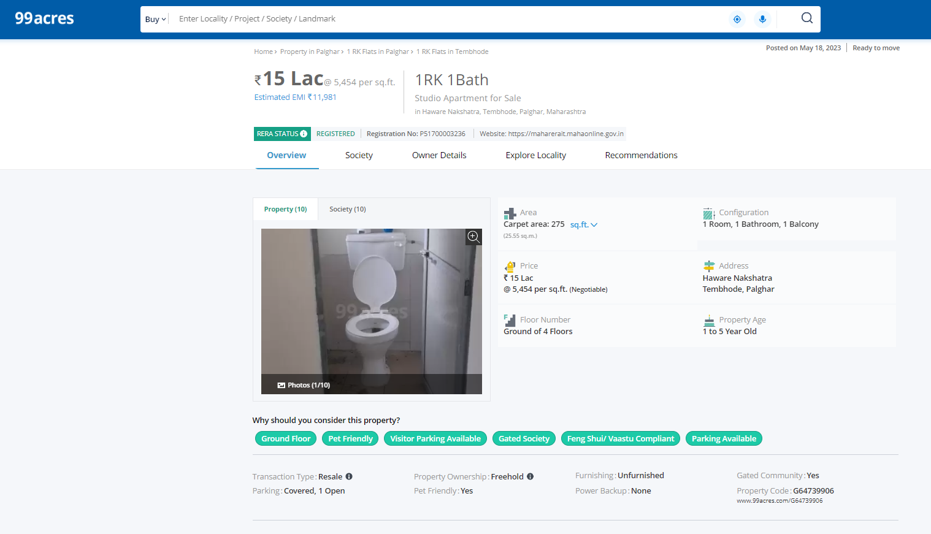
Price Indicators

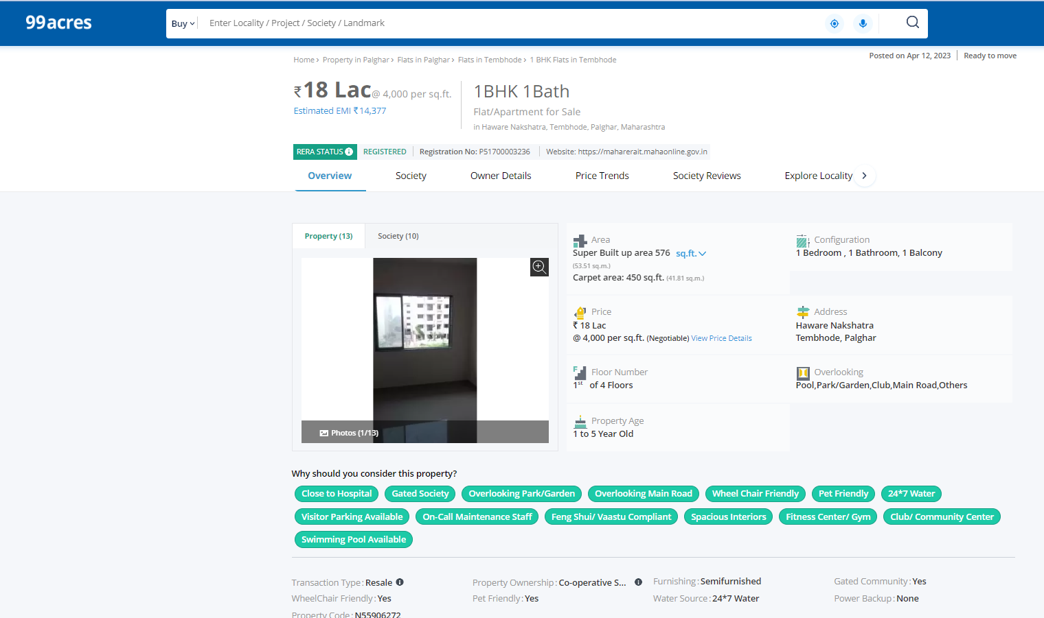

DEFINITION OF VALUE FOR THIS SPECIFIC PURPOSE

This exercise is to assess Fair Market Value of the property under reference as on 17th June 2023.

The term Value is defined as

“The most probable price, as of a specified date, in cash, terms equivalent to cash, or in other precisely revealed terms for which the specified property rights would sell after reasonable exposure in a competitive market under all conditions requisite to a fair sale, with the buyer and seller each acting prudently knowledgeably and for self interest assuming that neither is under undue duress”.
Fundamental assumptions and conditions presumed in this definition are:

1. Buyer and seller are motivated by self-interest.

2. Buyer and seller are well informed and are acting prudently.

3. The property is exposed for a reasonable time on the open market.

4. Payment is made in cash or equivalent or in specified financing terms.

UNDER LYING ASSUMPTIONS
1. We assume no responsibility for matters of legal nature affecting the property appraised or the title thereto, nor do we render our opinion as to the title, which is assumed to be good and marketable.
2. The property is valued as though under responsible ownership.
3. It is assumed that the property is free of liens and encumbrances.
4. It is assumed that there are no hidden or unapparent conditions of the subsoil or structure that would render it more or less valuable. No responsibility is assumed for such conditions or for engineering that might be required to discover such factors.
5. There is no direct/ indirect interest in the property valued.
6. The rates for valuation of the property are in accordance with the Govt. approved rates and prevailing market rates.

DECLARATION OF PROFESSIONAL FEES CHARGED

We hereby declare that, our professional fees are not contingent upon the valuation findings. However, if the statute AND/OR clients demands that, the fees should be charged on the percentage of assessed value then, with the full knowledge of the AND/OR end user, it is being charged accordingly.

VALUATION OF THE PROPERTY PREMISES

Considering various parameters recorded herein above, existing economic scenario, and the information that is available with reference to the development of neighborhood and method selected for valuation, we are of the opinion that, the property premises can be assessed and valued for banking purpose as on day.
Sr. No. | Floor | Rate On Saleable Area as per builder | Shop | 1 BHK | 2 BHK
1 | Ground Floor | 2,700/- Per Sq. Ft. | 6.5 – 7 Lac | 16.25 – 19.00 Lac | 24.50 – 24.75 Lac
2 | First, Second & Third Floor | 2,600/- Per Sq. Ft. | - | 15.50 – 18.50 Lac | 23.75 – 24.00 Lac
3 | Fourth Floor | 2400/- Per Sq. Ft. | - | 15.00 – 17.00 Lac | 21.75 – 22.00 Lac

Manoj B. Chalikwar

Registered Valuer

Chartered Engineer (India)

Reg. No. CAT-I-F-1763

Cosmos Emp. No. H.O./Credit/67/2019-20

